BA (Hons) Business Management
LCBB5013 Entrepreneurship Portfolio
Selected Business: Gymshark
Submitted By: Andreea Cocoveanu
Student ID:

Submitted To
Submitted By
Date of Submission

Table of Contents
Introduction 3
Element 1: Business Idea, Products/Services, Objectives and USP 3
1.1 Company Background and Business Idea 3
1.2 Products and Services 4
1.3 Business Objectives 4
1.4 Unique Selling Proposition (USP) 5
Element 2: Business Environment and Competitor Analysis 5
2.1 SWOT Analysis 5
2.2 Competitor Analysis 7
Element 3: 4Ps, Market Segmentation and Marketing Strategies 9
3.1 Market Segmentation and Target Customers 9
3.2 The 4Ps of Marketing 10
3.3 Online Marketing Strategies 11
Element 4: Financial Planning 12
4.1 Start-up Funding 12
4.2 Financial Growth 12
Part 2: Business Plan Presentation 13
Part 3: Reflection 17
References 20

Introduction
Entrepreneurship is acknowledged as one of the primary forces to drive economic development, innovation and competitive advantage in today's business world (Sarasvathy and Wheatley 2025). Entrepreneurial ventures that are successful find unmet customer needs, bring innovation to create value, and continuously adjust to changes in the market (Ngo 2025). This business plan examines Gymshark, a top fitness brand in the UK that has gone from a small start up to become one of the world's fastest-growing direct-to-consumer sportswear brands. Established in 2012 by university student Ben Francis, Gymshark has revolutionised the way people think about sportswear, offering high quality fitness wear, a digital-first approach, and an influencer marketing strategy (Foley 2023).
This business plan covers Gymshark's entrepreneurial journey in terms of business idea, products and services, strategic goals, competitive advantage, business environment, marketing strategy and financial development. The theories and marketing concepts relevant to entrepreneurship such as SWOT analysis, market segmentation and 4Ps of marketing are used to assess the performance of the company. The report ends by evaluating the financial growth, as well as the entrepreneurial success of Gymshark and the extent to which innovation and customer engagement have helped to gain sustainable competitive advantage.

Element 1: Business Idea, Products/Services, Objectives and USP

1.1 Company Background and Business Idea
Gymshark is a British fitness brand located in Solihull, England that was founded in 2012. The business was established in 2012 by Ben Francis and Lewis Morgan who invested £1000 or so (Donnelly 2025). Francis realised at the age of nineteen that there was a need for fashionable, affordable high quality workout apparel made specifically for the younger age groups of fitness enthusiasts that visit the gym (Lalindra 2026). Gymshark didn't focus on entering the market with a better product because there were already dominant global brands, but rather on building a community, engaging with their audience digitally and utilising social media marketing (Foley 2023).
Initially it was a fitness supplement business, but they saw a larger demand for performance apparel and the company made the switch. This entrepreneurial switch is a good example of the opportunity recognition that is one of the key traits of successful entrepreneurs (Ngo 2025). Instead of using “the old retail distribution system”, Gymshark chose to switch to a direct-to-consumer (DTC) model, which means that it sells its products directly to consumers through its own e-commerce website and has more control over their customer experience, pricing and branding (Donnelly 2025).
The company's entrepreneurial concept was to establish a fitness lifestyle brand, not just a clothes company. Gymshark wanted to create an online community for customers worldwide that could resonate with them, based on common values such as self-improvement, motivation and healthy living (Lalindra 2026). It's an emotional bond that is one of Gymshark's greatest strengths. Today Gymshark has expanded to reach more than 180 countries and has millions of customers, and it continues its digital-first approach (Cook 2020).

1.2 Products and Services
Gymshark's strategy is to offer a selection of fitness products instead of an extensive product line. It specializes in men's performance apparel, women's activewear, training leggings, compression wear, hoodies, shorts and joggers, sports bra, jackets and gym accessories (Lalindra 2026). Products combine functionality with fashion, using high-quality materials and ergonomic designs to enhance performance and style. In addition to clothes, Gymshark builds customer relationships with international shopping, mobile apps, training content, community events, athlete partnerships, customer support, flexible return policies and fitness inspiration (Foley 2023).

1.3 Business Objectives
Business objectives guide and help organisations measure performance (Joise and Sodhi 2025). Gymshark's aims can be broken down into short term and long term strategic goals.
Short-Term Objectives
The company's short-term goals involve boosting online sales annually, delivering better experiences for its customers and enhancing its digital presence on social media. However, Gymshark continues to release new collections, according to market demand, and optimize their stock and operations (Cook 2020). An additional key goal is to improve customer retention by implementing loyalty initiatives, customizing marketing efforts and enhancing customer support. More international expansion and growth can be regarded as another objective of the company through localization of website, more language options, and local fulfillment centers in more countries (Donnelly 2025).
Long-Term Objectives
Gymshark's ultimate goal is to become a fitness lifestyle brand, expanding beyond the sportswear company. The firm aims to go head-to-head with the industry giants, such as Nike and Adidas, setting itself big goals. They include the opening of flagship shops around the world, growing international market share and the investment in sustainable production (Cook 2020). Gymshark also emphasises data analytics and artificial intelligence in the digital arena, and strives to be a promoter of customer loyalty. Gymshark's growth in revenues and profitability exemplifies a sustainable and strategic approach to entrepreneurship, where innovation and the ability to maintain a competitive advantage play pivotal roles in shaping the brand's image as a fitness market leader (Donnelly 2025)

1.4 Unique Selling Proposition (USP)
Unique Selling Proposition (USP) refers to a marketing strategy that enables a company to distinguish itself from others by offering something unique and hard for rivals to copy (Aziz et al. 2025). Gymshark's USP is based on four core strengths that are integrated together. It is a community-centric brand, and values that engender a sense of emotional loyalty. Digital First means that there should be no intermediaries, competitive pricing and good margins (Bhoora 2024). Gymshark is a trailblazer when it comes to influencer marketing and create a true bond of trust with relatable fitness content creators. Last but not least, products are differentiated by the feedback from the customer that is used for innovation. All of these benefits combine to ensure long-term competitiveness, allowing Gymshark to sustain its growth amidst the competition from larger players (Arnold 2020).

Element 2: Business Environment and Competitor Analysis

2.1 SWOT Analysis
A SWOT analysis can be used to assess an organisation's internal strengths and weaknesses, as well as the external opportunities and threats, to support strategic decisions and identify a competitive advantage (Benzaghta et al. 2021). The following table summarises Gymshark's SWOT analysis.
Table 1: SWOT Analysis of Gymshark
Strengths | Weaknesses
Strong global brand recognition among young fitness consumers | Heavy dependence on online sales
Effective direct-to-consumer (DTC) business model | Limited physical retail presence compared to competitors
Highly successful influencer and social media marketing | Product portfolio narrower than multinational competitors
Loyal customer community and high brand engagement | Premium pricing may discourage price-sensitive customers

Opportunities | Threats
Expansion into emerging international markets | Intense competition from global sportswear brands
Growth of e-commerce and digital fitness | Counterfeit products damaging brand reputation
Sustainable product innovation | Rising production and logistics costs
Artificial intelligence and personalised shopping experiences | Rapid changes in fashion and consumer preferences
One of Gymshark's greatest strengths is the fact that it is a digital-first company (Arnold 2020). This is because Gymshark, unlike traditional sportswear companies, that rely on wholesale and retail sales, has a majority of their sales online, where they have more control over the price, customer service and brand (Arnold 2020). This also allows for the collection of valuable data from customers, which can be used for product development and custom marketing strategies (Bhoora 2024).
It has the clear potential to create a loyal community of fitness enthusiasts, including influencers and social media as a huge positive (Ndasi and Abina 2026). Instead of spending a lot of money on conventional ad campaigns, Gymshark partners with fitness athletes and content producers whose lifestyles complement the brand's values. This approach fosters genuine connections with customers and enhances brand loyalty among the younger generation (McKeever 2021).
However, there is still some room for improvement within Gymshark. As an e-commerce company, it is susceptible to website outages, cybersecurity threats and disruption of the global supply chain (Ndasi and Abina 2026). Also, Gymshark has recently started to launch flagship shops, however, its retail expansion is still relatively small compared to other brands like Nike and Adidas and this reduces options for shoppers that enjoy visiting physical stores (Arnold 2020).
On the outside, Gymshark is enjoying a surge of interest in health and fitness, and active lifestyles, throughout the global (McKeever 2021). The increasing membership in gyms and home fitness plans have fueled the global demand for performance apparel. Furthermore, innovative technologies like artificial intelligence and predictive analytics, along with virtual shopping experiences, offer opportunities for enhancing customer engagement and efficiency (Bhoora 2024).
The company is also in a tough competitive landscape, however. Large multinationals have significantly more capital, products and retail locations (McKeever 2021). In addition, raw material price volatility, supply chain uncertainties and shifting consumer tastes and preferences pose constant strategic risks. In the long-term, Gymshark must double down on innovation, operational resilience and customer experience (Arnold 2020).

2.2 Competitor Analysis
Competition is an important factor in determining the entrepreneurial strategy. When companies analyse their rivals, they can distinguish the opportunities and also benchmark their performance and establish sustainable competitive advantages (Kardes et al. 2020). Gymshark will face both direct and indirect competition in the global sportswear market.
Direct Competitors
Nike
Nike is Gymshark's biggest direct competitor, as they are the market leaders in athletic apparel, footwear and sports equipment globally. Nike has an excellent brand recognition, research and development capabilities and retail distribution worldwide. The company also sponsors top athletes and sports events, further boosting its international exposure (Business Model Analyst 2024). Gymshark, however, seems to have a more specific focus of younger fitness enthusiasts and is closer to the customer with their digital engagement and influencer-led marketing. Whereas Nike has a wide breadth of sports, Gymshark has a much more focused approach on the gym and fitness culture which can allow for specialisation and community building (Ndasi and Abina 2026).
Lululemon
Lululemon is a direct rival of Gymshark in the premium activewear market, especially regarding those who want to purchase stylish, quality fitness clothing. The company is known for its high quality products, loyal customers and commitment to wellness and healthy lifestyles (Lululemon 2022). Gymshark is dominating the market with a trendy performance wear, with a relatively more affordable price tag, and a strong online presence. Additionally, Gymshark's digital marketing efforts have created a significant amount of engagement with younger demographics, as Lululemon has a stronger focus on physical retail stores and community events (Foley 2023).
Indirect Competitors
Adidas
While Adidas is a direct competitor in sportswear, it is an indirect competitor as well since it has many other sporting areas associated with it that it does not directly compete with, such as football, running and lifestyle fashion. Adidas has good global brand awareness and a well-established retail network (Adidas 2026). Gymshark stands out because of its specialisation on fitness fans and quicker reaction to the latest fashion trends. Unlike many of its larger multinational counterparts, it has an agile organisational structure that allows for faster product launches and greater customer engagement (McKeever 2021).
Under Armour
Another indirect competitor is Under Armour, which makes athletic apparel for a variety of sports. The company has established a reputation for both technical innovations and compression wear, meeting the technical performance needs of technically savvy consumers (Under Armour 2024). However, Gymshark has already grown an emotional bond with younger digital consumers with influencer collaborations, social media communities and lifestyle branding. Despite Under Armour's technological prowess, this customer-centric strategy fosters increased engagement and deepens the company's brand loyalty (Arnold 2020).

Element 3: 4Ps, Market Segmentation and Marketing Strategies

3.1 Market Segmentation and Target Customers
Market segmentation is the process of dividing a large market into smaller segments of customers with similar characteristics, which allows organisations to create products and marketing strategies to meet the specific needs of consumers (Cortez et al. 2021). Gymshark is using a focused segmentation strategy that's helped it succeed in quickly expanding throughout the world (Carreño 2021).
Table 2: Gymshark's Market Segmentation
Segmentation Type | Gymshark's Target Market
Geographic | Customers in over 180 countries, with major markets in the UK, USA, Canada, Australia and Europe (Carreño 2021)
Demographic | Men and women aged 18–35 with middle to high disposable incomes (Ozuem and Willis 2025)
Psychographic | Fitness enthusiasts, health-conscious individuals, athletes and consumers seeking an active lifestyle (Carreño 2021)
Behavioural | Regular gym users, online shoppers, loyal customers and consumers influenced by social media trends (Carreño 2021)
Gymshark's key demographic is Generation Z and Millennial consumers, who are digital technology and social media-savvy. These customers like the trendy sportswear that equates to a balance of performance, comfort and style (Ozuem and Willis 2025). Gymshark doesn't only appeal to the pro athletes but to those fitness enthusiasts who wish to improve their health and wellbeing on a regular basis. The company is positioned in this niche to foster more emotional relationships with its customers than more generic sportswear brands (Harju 2023).
Gymshark's success is greatly dependent on their psychographic segmentation. The products are not only favored by customers, but they also motivate customers by offering a fitness community and a motivational culture within the company (Apaza and Jahan 2021) Core values such as discipline, confidence and self improvement, give Gymshark customers a sense of belonging which will keep them loyal to the brand in the long term. This approach, which is centered on the customer, is distinct from those brands that can only focus on the product or the celebrity endorsements (Ozuem and Willis 2025).

3.2 The 4Ps of Marketing
The 4Ps (Product, Price, Place and Promotion) of marketing mix can be called the effective marketing mix which would satisfy the customers' needs and achieve the organisation's goals (Abedian et al. 2022).
Product
Gymshark is a brand that offers great performance and fashion fitness apparel and accessories. It offers leggings, sports bras, T-shirts, hoodies, shorts and joggers and gym accessories. The company is always launching new collections, based on customer suggestions, fashion trends and technological advances in fabrics (Apaza and Jahan 2021). Gymshark's strong points are its innovative nature. Product designs are oriented towards comfort, durability and functionality, and they are still modern. Limited edition launches and seasonal collections spark excitement among customers, which can lead to repeat business. It's a continuous product development that allows Gymshark to stay competitive in the rapidly changing sportswear market (Harju 2023).
Price
Gymshark operates as a value-priced brand; falling somewhere between the premium brands like Lululemon and lower-priced sportswear companies. It offers products at an affordable price that are of good quality, and are accessible to young consumers who have moderate income levels (Apaza and Jahan 2021). Direct to consumer (DTC) helps the brand in the sense that Gymshark can offer a competitive price to the consumers without reducing the profit margin as it is not selling through a retail outlet. The company also utilizes promotional pricing on big sale occasions like Black Friday, drawing in new consumers and boosting sales volumes (Fabric Academy 2023).
Place
Gymshark is one of the few sportswear brands to mainly sell its items via its own website and mobile app. This ‘direct distribution' strategy gives the company better control over how customers experience their products, inventory management and brand uniformity (Fabric Academy 2023). Instead, the online platform allows Gymshark to connect with customers around the world in more than 180 countries without numerous third-party retailers. Digital activities are also being expanded, with the company opening “flagship stores” in specific cities abroad, enabling customers to have a real-life experience (Harju 2023).
Promotion
One of Gymshark's greatest assets is promotion. The company is changing the way that the sport's wear business advertises by focusing on digital communication instead of conventional advertising. It is a marketing strategy that relies on social media such as Instagram, TikTok, YouTube and Facebook, which allows them to communicate with their audience of millions around the world directly (Enclaverse 2025). Gymshark works with fitness influencers, athletes and content creators that truly align with the brand. These partnerships generate user-generated content; brand demonstration videos and fitness inspiration; and a great deal of trust on the part of consumers. The company also hosts fitness events and product launches/experiences, further reinforcing the brand as community oriented (Deloitte 2026).

3.3 Online Marketing Strategies
Gymshark's core business is its innovative marketing approach with a digital twist, engaging its customers. Instead of traditional advertising methods, the firm concentrates on developing valuable online interactions to draw in, catch the interest of, and maintain their customers (Deloitte 2026).
At the heart of Gymshark's business is its innovative digital marketing strategy, focusing on customer engagement. Instead of traditional advertising methods, the firm concentrates on developing valuable online interactions to draw in, catch the interest of, and maintain their customers. Social media marketing continues to be Gymshark's strongest marketing weapon. This has included motivational fitness articles, workout videos, behind-the-scenes product development video and customer success stories. It's the kind of content that will let people connect with it, connect it with the brand on a more emotional level (Enclaverse 2025).
Another important strategy is that of influencers. Gymshark collaborates with fitness influencers that are true to its brand. These influencers offer genuine product suggestions, which are more likely to be trusted than conventional ads, boosting customer trust and conversions (Shotton 2025). Gymshark also uses email marketing and personalised recommendations to enhance customer retention. Their data on purchase history and browsing habits is analysed, which enables their customised product recommendations and exclusive promotions, resulting in customer satisfaction and higher return purchasing. Moreover, the streamlined mobile application and user-friendly website make it easy for customers to buy, minimizing friction and enhancing the overall buying experience (Deloitte 2026).

Element 4: Financial Planning
Financial planning plays an important role in any business as it enables it to secure financing, manage its resources well and ensure sustainable growth (McManus 2024). Gymshark's financial journey is a testament to the company's strategic investments, innovation, and prudent financial management, propelling it to become a recognized global brand.

4.1 Start-up Funding
With a £1000 startup loan, Ben Francis and Lewis Morgan started the business called Gymshark back in 2012 when they were already doing part time jobs. In its early days, the founders ran the business from their family garage, and handled the product design, customer service and order fulfilment themselves (Deloitte 2026). This was a lean start-up approach that allowed them to cut down on their operating cost and invest in development and marketing than significant external borrowing (Shotton 2025).
Most notably, the largest achievement of 2020 was Gymshark’s sale to private equity firm General Atlantic (Apaza and Jahan 2021). This investment had a significant impact on the company's valuation as it valued them above £1 billion, becoming one of the few unicorn start-ups in the UK. The funding enabled the company to accelerate its international expansion, enhance its online presence, invest in technology and acquire the necessary professional management team (Enclaverse 2025).

4.2 Financial Growth
Gymshark has been extremely financially successful since it was started. It has seen the company move from being a small online start-up with modest sales and revenues in 2012, to revenues of more than £600m per year in just over 10 years (Shotton 2025). This development has been fueled by its direct-to-consumer model, its worldwide e-commerce strategy and its extremely effective digital marketing campaigns (Enclaverse 2025).
Table 3: Summary of Gymshark's Financial Development
Financial Indicator | Development
Initial Investment (2012) | Approximately £1,000
Funding Source | Personal savings and business profits
Major External Investment | General Atlantic (2020)
Company Valuation | Over £1 billion
Recent Annual Revenue | More than £600 million
International Presence | Operations in over 180 countries
Gymshark's impressive financial results indicate that the company is able to scale efficiently and effectively, keeping its brand value and profitability intact. The company spent more time and money on innovation, technology and customer engagement than on raising money from outside; in many cases, the approaches of many rapid growth start-ups fell on their heads in a manner similar to this (Enclaverse 2025). This approach to finance has helped it to be competitive and to grow sustainably. Gymshark is anticipated to sustain its investments in foreign markets, digital capabilities, and sustainable product development, which will further improve its financial performance and strengthen its standing in the global sportswear market (Deloitte 2026).

Part 2: Business Plan Presentation

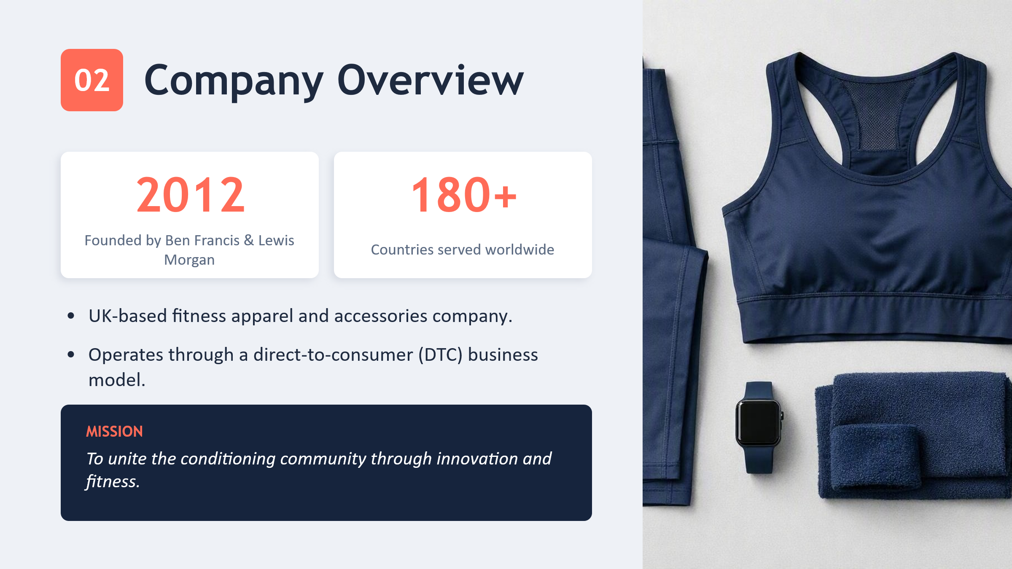
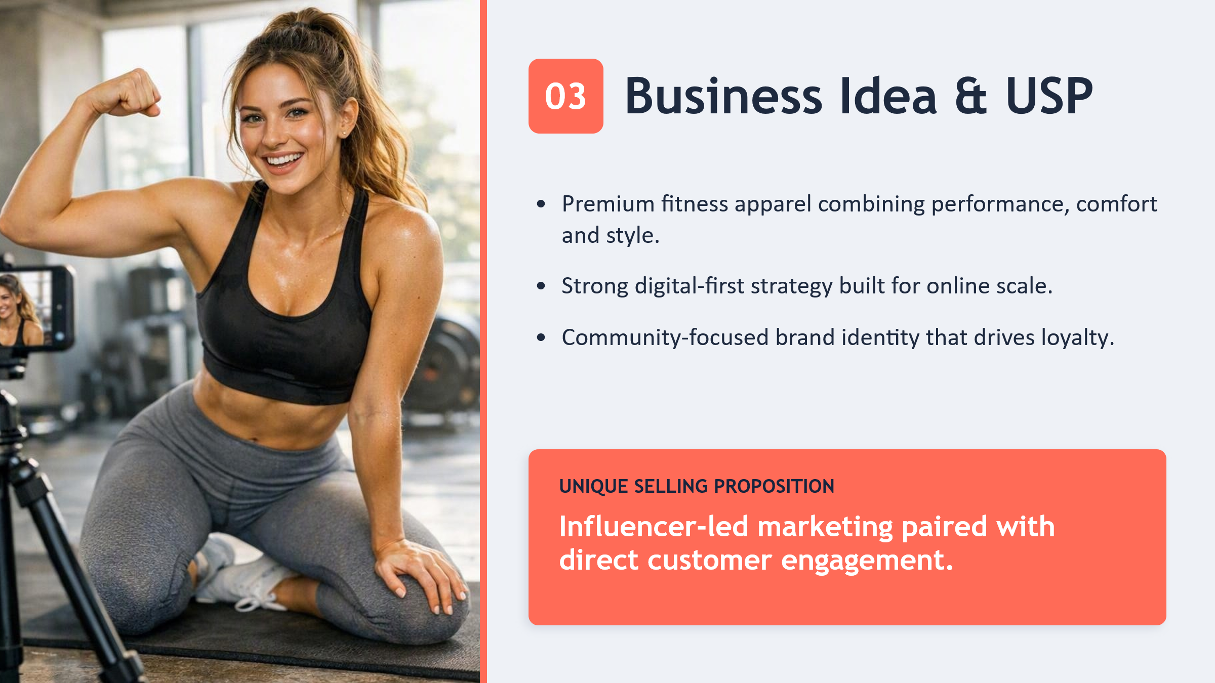
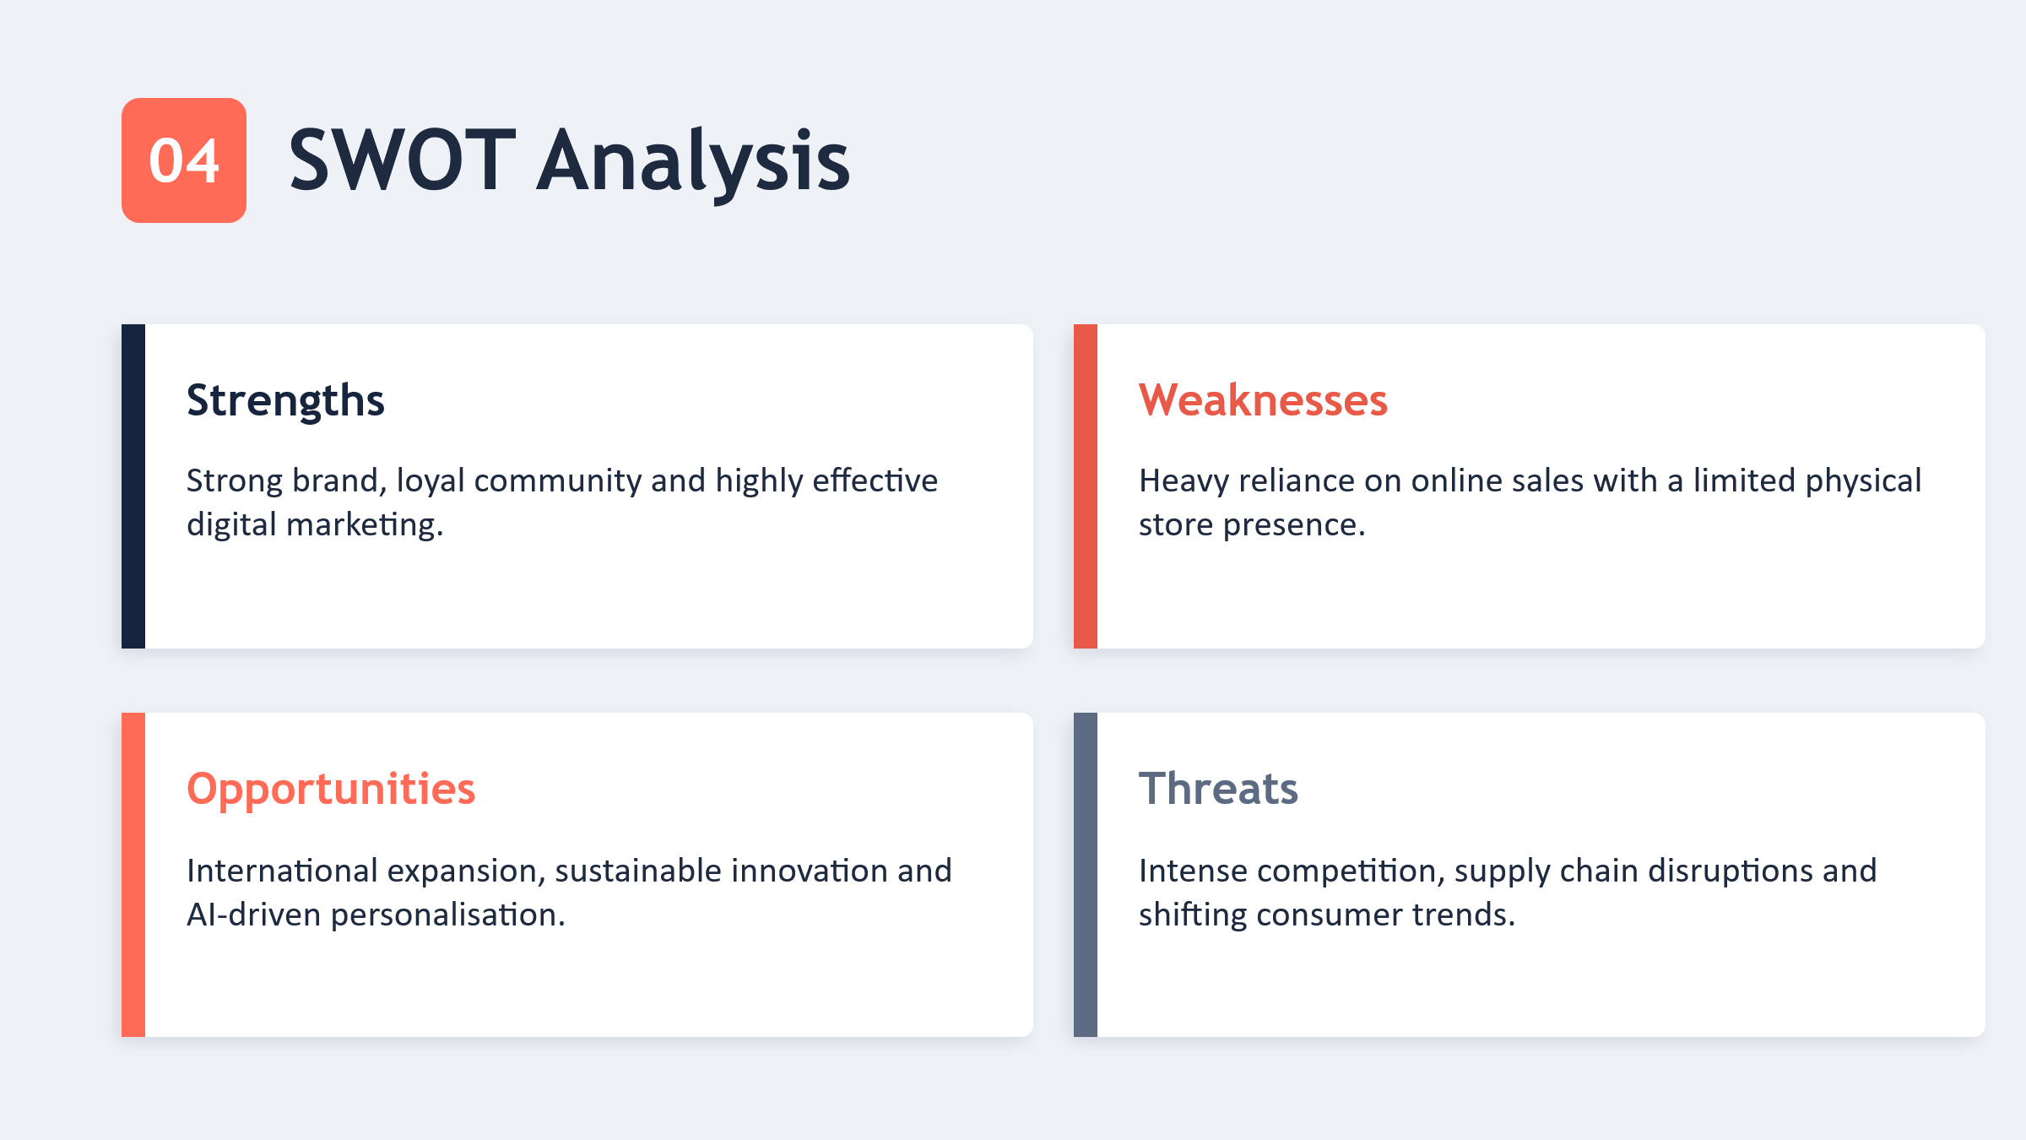
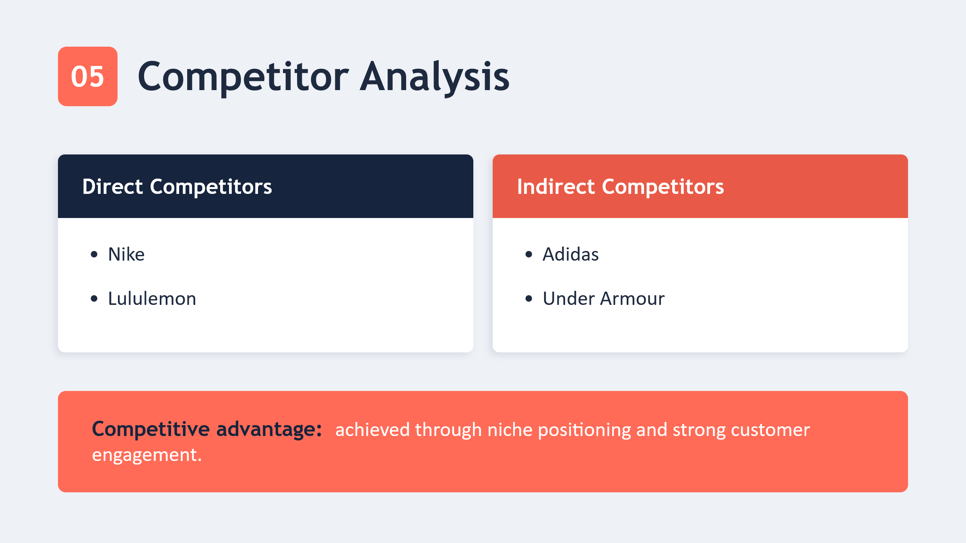
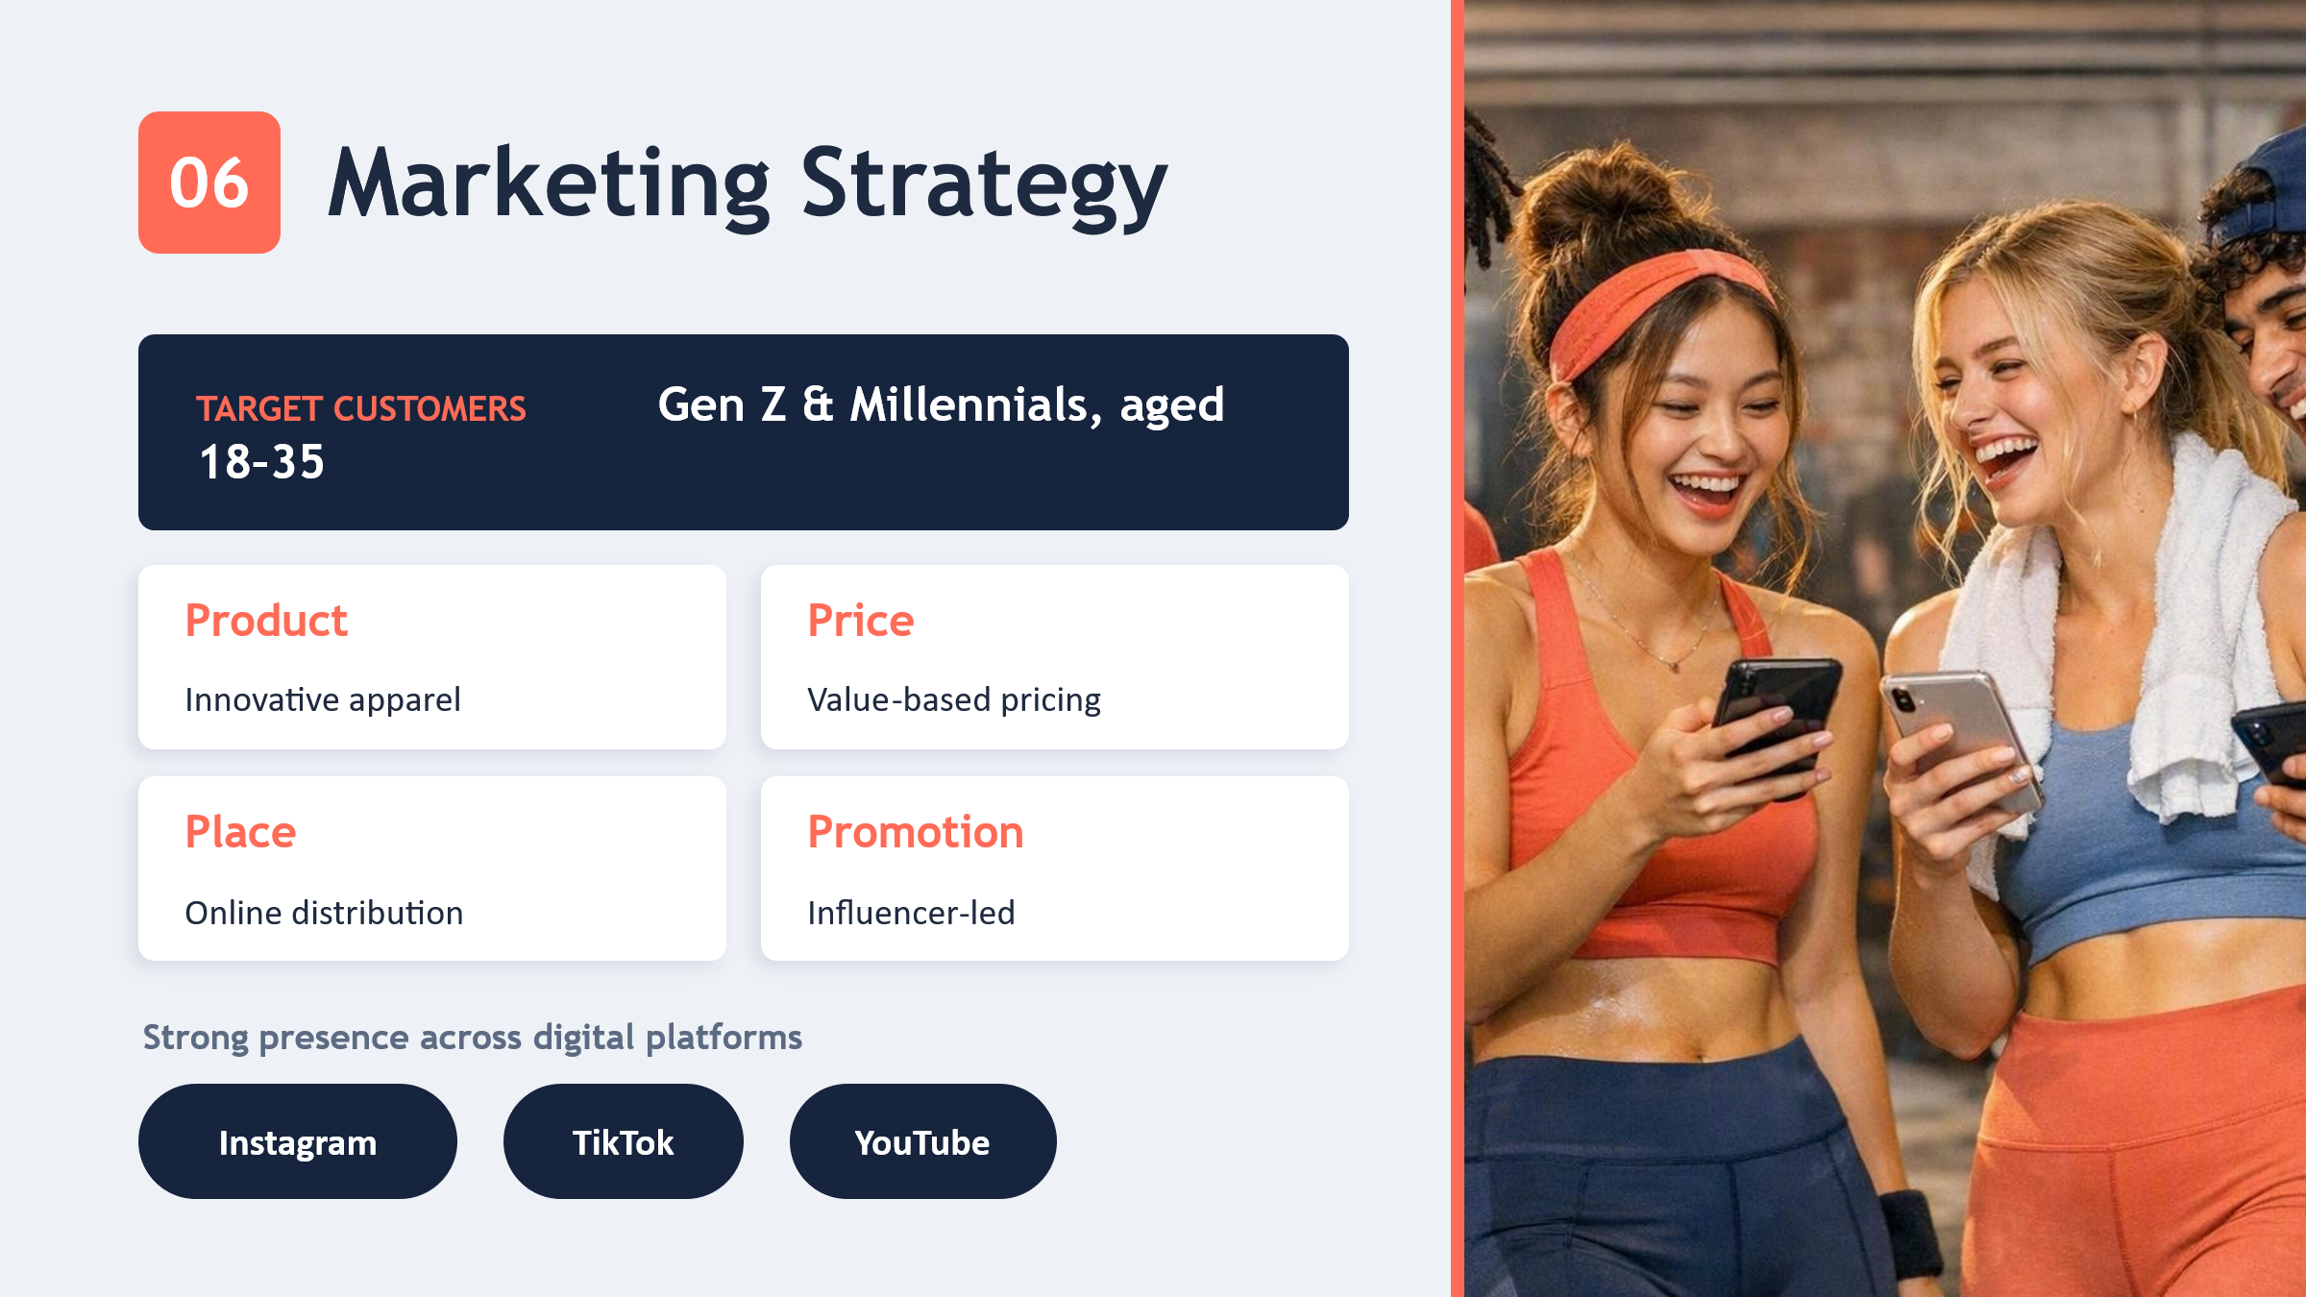

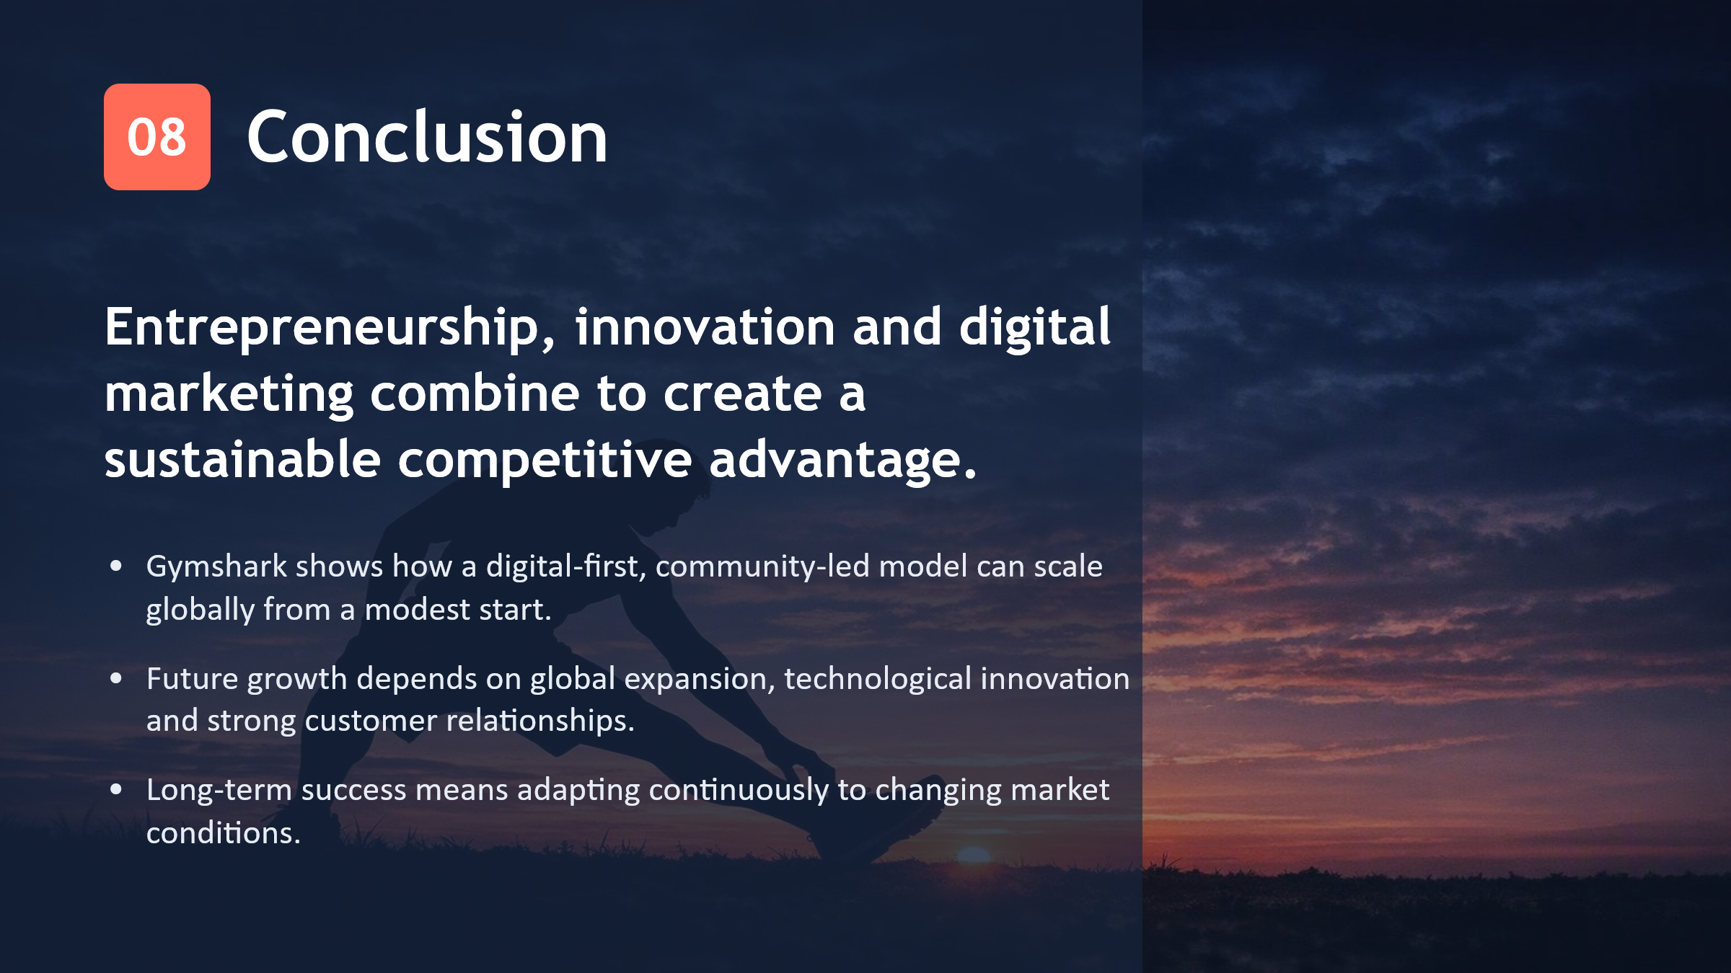

Part 3: Reflection
Reflection on Gymshark's Entrepreneurial Journey
Gymshark's journey of entrepreneurship has been a great example of the traits, decisions and strategies that are essential for a successful entrepreneurial venture. The opportunity to study the development of this company from their humble beginnings in a family garage to become a global recognised fitness apparel company has improved my insight into entrepreneurship as an ongoing process of identifying opportunities, managing risks and continually evolving based on customer feedback and market demand (Abu-Rumman et al. 2021). The trajectory of Ben Francis' business journey highlights the essential importance of resilience, customer insight, and the willingness to pivot and make errors in the world of entrepreneurship (Shotton 2025).
The most important thing I have learnt is how important it is to find a niche market. Rather than following the conventional model, which involves competing with established sportswear brands, Gymshark recognised a gap in the market for trendy, high-quality, and accessible activewear among young fitness enthusiasts—usually a group that’s either neglected or overlooked by companies (Carreño 2021). The customer-centric approach has helped this company develop products that resonate with customer preferences, and build affinity with customers via fitness community. Following this is the entrepreneurship concept of gaining a competitive edge in a business by offering solutions to customers' problems in a way that is superior to the competition (Joise and Sodhi 2025).
I appreciate Ben Francis because he's willing to innovate and embrace a different business-model approach. Gymshark started as a fitness supplement brand with the realisation that there was a bigger opportunity in the sportswear industry (McKeever 2021). It's the signal pointing towards the strategic turnaround, which implies that an entrepreneur must not get romantically tied up to the idea of bad business; he has to be flexible, and listen people. Product development and investing in digital technologies and customer experience have kept Gymshark competitive with brands such as Nike and Adidas throughout Gymshark's evolution (Arsawan et al. 2022).
The one way that affected my perspective on Modern Entrepreneurship the most in the company was Marketing. Where many fitness brands are still struggling to embrace the social media market, Gymshark was already on the bandwagon by forming authentic connections with fitness figures rather than high-budget, traditional marketing campaigns (Enclaverse 2025). It shows the need to appreciate evolving consumer behaviour and how new technologies can be used to engage customers in a meaningful way. It's also taught me how important it is to build a loyal base of loyal customers, which can be as important as creating a high quality product. When making buying decisions, customers do not just compare prices anymore, but they buy brands that they value and match their lifestyle (Abedian et al. 2022).s
While Gymshark's entrepreneurial journey is a very successful one, analysing the company has also shown a number of potential areas of improvement. The company's reliance on ecommerce puts it at risk for cybersecurity, website failures and global supply chain disruptions (Ndasi and Abina 2026). Moreover, the growing competition in the sportswear sector will require Gymshark to pursue innovation and stay at the forefront of the competition, which will be an ongoing requirement. As a result of this reflection, it has been highlighted that entrepreneurship is a process that should be sustained and continuously strategically adapted and not just a result (Arnold 2020).
There are a few methods I would utilize if I started my own company, inspired by Gymshark's success. One thing I would do is put in a lot of effort trying to know what customers want before creating any product or service (Abu-Rumman et al. 2021). Periodic interactions with customers and market research would help ensure that the business is attuned to the changes in the market needs. Secondly, I'd take a digital first approach and embed e-commerce, social media and data analytics into business processes from the ground up. Digital technologies offer cost-effective options to access international markets and develop sustainable customer relationships (Harju 2023).
I would also focus on building a very good organisational culture to promote innovation, collaboration and learning. Gymshark's focus on community goes beyond customers and to its employees and business partners, which helps the company to grow continuously. Fostering a culture where workers are encouraged to put forth their own thoughts and suggestions would help boost innovation and enhance the overall functioning of the business (Arsawan et al. 2022).

References
Abedian, M., Amindoust, A., Maddahi, R. and Jouzdani, J. 2022. A game theory approach to selecting marketing-mix strategies. Journal of Advances in Management Research 19(1). doi: 10.1108/JAMR-10-2020-0264.
Abu-Rumman, A., Al Shraah, A., Al-Madi, F. and Alfalah, T. 2021. Entrepreneurial networks, entrepreneurial orientation, and performance of small and medium enterprises: are dynamic capabilities the missing link? Journal of Innovation and Entrepreneurship 10(1), p. 29.
Adidas. 2026. Roadmap to Success. Available at: https://report.adidas-group.com/2025/en/group-management-report-our-company/roadmap-to-success.html [Accessed: 28 June 2026].
Apaza, W. and Jahan, T. 2021. Consumer engagement in online brand communities: A netnographic study on Gymshark’s Facebook brand page.
Arnold, E. 2020. What Ben Francis’s Billion Dollar GymShark Teaches Us About Entrepreneurship. Available at: https://themakingofamillionaire.com/what-ben-franciss-billion-dollar-gymshark-teaches-us-about-entrepreneurship-40a951847a52 [Accessed: 28 June 2026].
Arsawan, I.W.E., Koval, V., Rajiani, I., Rustiarini, N.W., Supartha, W.G. and Suryantini, N.P.S. 2022. Leveraging knowledge sharing and innovation culture into SMEs sustainable competitive advantage. International Journal of Productivity and Performance Management 71(2), pp. 405–428.
Aziz, C.A.F.F., Alifa, Y., Dwiyantoro, P. and Grahita, B. 2025. Development of Destination Branding with Unique Selling Proposition Approach: A Case Study at Kampung Adat Ratenggaro, NTT. Jurnal Kepariwisataan: Destinasi, Hospitalitas dan Perjalanan 9(1), pp. 128–144. doi: 10.34013/jk.v9i1.1864.
Benzaghta, M.A., Elwalda, A., Mousa, M.M., Erkan, I. and Rahman, M. 2021. SWOT analysis applications: An integrative literature review. Journal of Global Business Insights 6(1), pp. 54–72.
Bhoora, R. 2024. Ben Francis: The entrepreneur behind Gymshark’s peak fitness. Available at: https://www.retail-week.com/people/ben-francis-the-entrepreneur-behind-gymsharks-peak-fitness/7046629.article [Accessed: 28 June 2026].
Business Model Analyst. 2024. Top 10 Nike Competitors & Alternatives (2024). Available at: https://businessmodelanalyst.com/nike-competitors-alternatives/ [Accessed: 13 June 2024].
Carreño, A.G. 2021. A Cognitive-Axiological Analysis of Gymshark’s Adverts. Available at: https://www.semanticscholar.org/paper/A-Cognitive-Axiological-Analysis-of-Gymshark%E2%80%99s-Carre%C3%B1o/f1aa26c5efadd6c6435295e38c4f44d342624f74 [Accessed: 28 June 2026].
Cook, J. 2020. How Gymshark Became A $1.3 Billion Brand, And What We Can Learn. Available at: https://www.forbes.com/sites/jodiecook/2020/08/17/how-gymshark-became-a-13bn-brand-and-what-we-can-learn/ [Accessed: 28 June 2026].
Cortez, R.M., Clarke, A.H. and Freytag, P.V. 2021. B2B market segmentation: A systematic review and research agenda. Journal of Business Research 126, pp. 415–428.
Deloitte. 2026. Strengthening Gymshark’s data-led growth strategy | Deloitte UK. Available at: https://www.deloitte.com/uk/en/Industries/consumer/case-studies/strengthening-gymsharks-data-led-growth-strategy.html [Accessed: 28 June 2026].
Donnelly, G. 2025. Humble beginnings: The Gymshark story, from garage to global. Available at: https://www.1stformations.co.uk/blog/humble-beginnings-gymshark-story/ [Accessed: 28 June 2026].
Enclaverse. 2025. Gymshark Marketing Strategy: An Analysis of a £1 Billion Success. Available at: https://enclaverse.com/case-studies/how-gymshark-built-a-fitness-empire-with-influencer-marketing/ [Accessed: 28 June 2026].
Fabric Academy. 2023. Gymshark’s marketing strategy and how to build your own. Available at: https://fabric-academy.com/insights-tools/gymshark-marketing-strategy [Accessed: 28 June 2026].
Foley, H. 2023. The Official Gymshark Story: How Ben Francis Created Gymshark | Gymshark Central. Available at: https://row.gymshark.com/blog/article/the-official-gymshark-story [Accessed: 28 June 2026].
Harju, M. 2023. Impact of branding & social media marketing in the digital era: Sports apparel brands.
Joise, I. and Sodhi, G. 2025. How innovation driven companies balance business objectives with stakeholder needs. International Journal For Multidisciplinary Research 7(2), p. 40055. doi: 10.36948/ijfmr.2025.v07i02.40055.
Kardes, I., Reinecke Flynn, L. and Dugan, M. 2020. Online retailing: determinants of competition between multinationals and local firms in emerging markets. International Journal of Retail and Distribution Management 49(2), pp. 263–280. doi: 10.1108/IJRDM-07-2020-0236.
Lalindra. 2026. 7 Things Ben Francis Would Do Again to Build Gymshark. Available at: https://medium.com/illumination/ben-francis-gymshark-7-lessons-427294718634 [Accessed: 28 June 2026].
Lululemon. 2022. lululemon Reveals Power of Three ×2 Five-Year Growth Strategy. Available at: https://corporate.lululemon.com/media/our-stories/2022/lululemon-reveals-power-of-three-2-five-year-growth-strategy [Accessed: 28 June 2026].
McKeever, V. 2021. How Ben Francis built $1 billion fitnesswear brand Gymshark in his 20s. Available at: https://www.cnbc.com/2021/08/24/how-ben-francis-built-1-billion-fitnesswear-brand-gymshark-in-his-20s.html [Accessed: 28 June 2026].
McManus, K. 2024. Build Your Business by Building Relationships: Five Best Practices for Strategic Networking. Journal of Financial Planning 37(3), pp. 32–33.
Ndasi, W.N. and Abina, B. 2026. Scaling sweat: Gymshark’s market expansion dilemma. The CASE Journal, pp. 1–7. doi: 10.1108/TCJ-10-2025-0352.
Ngo, A.-T. 2025. Entrepreneurship and innovation in business economics: A global bibliometric analysis from 2015 to 2024. CTU Journal of Innovation and Sustainable Development 17(2), pp. 136–147. doi: 10.22144/ctujoisd.2025.042.
Ozuem, W. and Willis, M. 2025. Brand and customer loyalty in online brand communities. In: Digital Marketing Strategies for Value Co-Creation: Models and Approaches for Online Brand Communities. Springer, pp. 137–162.
Sarasvathy, S. and Wheatley, G.B. 2025. Effectual Entrepreneurship. 3rd ed. London: Routledge. Available at: https://www.taylorfrancis.com/books/9781003364016 [Accessed: 28 June 2026].
Shotton, R. 2025. Why It Works: How Gymshark employs behavioural science to form a habit. Available at: https://www.marketingweek.com/why-it-works-gymshark-behavioural-science-habit/ [Accessed: 28 June 2026].
Under Armour. 2024. History. Available at: https://about.underarmour.com/en-us/our-company/history.html [Accessed: 29 April 2025].

