Factors Affecting Motivation

Abstract:

This study aims to examines the factors that influence motivation in university students. Motivation is referred to a force that influences someone’s behaviour (Green & Kelso, 2006). It has been found that there are many factors that affect motivation such as teacher and parental support (Descals-Tomás et al., 2021) and peer support (Allahqoli et al., 2019). Four participants were asked to participate in a focus group and then the transcript was analysed using a Thematic analysis. When analysing the results, three themes were identified: Extrinsic motivation, self-improvement and environmental factors each of these had their own subthemes that have been interpreted when analysing the data. The findings of this study suggest that support from family and friends, as well as your surroundings, can increase motivation. Further developments for the research are discussed within.

Introduction:

Motivation is a force that influences behaviour (Green and Kelso, 2006).The self-determination theory is a motivation theory, arguing humans are predisposed to personal growth, but will only remain motivated if interacted with conditions such as feelings of belonging (Ryan & Deci, 2020). Maslow’s hierarchy of needs outlines how needs motivate behaviour, such as physiological or self-esteem needs, which can all motivate behaviour (Maslow, 1943).There are many factor that affect Motivation For example: Teacher and parental support (Descals-Tomás et al., 2021) and peer support (Allahqoli et al., 2019)

Friendships and feeling of relatedness affect levels of motivation (Ryan & Deci, 2020). It is necessary to feel a sense of belonging, For example, through friendships; this must occur reach self-actualisation (Maslow,1943) this would improve students motivation since they are surrounded by individuals who they aspire to be like; however, if students feel they don’t belong their motivation may decrease as they lack a personal association with their university (Allahqoli et al., 2019). Further support by Teodorescu et al., (2022) as during the pandemic these feelings of social isolation had a negative impact on motivation.

According to research, family has an impact on a student’s motivational levels, as university student who still live with family are more motivated to engage in physical activity (Yoncalis, 2023). However, the level of involvement necessary from family to have a positive impact on motivation could be questioned, as when students professions are chosen by family, motivation is reduced. (Sarimehmet et al., 2021) As a result, students may need emotional support from parents through encouragement which has had a positive impact on motivation (Woldekidan et al., 2020). However, they require autonomy to choose their courses.

Furthermore, research has implied that teachers have more of a positive effect on motivation than family support does (Descals-Tomás et al., 2021). This has been supported as Many students look up to their teachers as role models for achieving their learning goal (Descals-Tomás et al., 2021) this could be because students are more likely to remain motivated if their teachers communicate their progress with them (Teodorescu et al., 2022) As a result, receiving reassurance can encourage students as acknowledgement from things like certificates, reassuring that they have done well, increases levels of motivation (Divakar et al., 2023) .Therefore, this supports the SDT theory as it implies individuals need external stimuli to keep them motivated (Ryan & Deci, 2020). It could also be because individuals desire feelings of self-worth and capability which only occur if self-esteem needs are met (Maslow, 1949).

Method:

Participants:
Four university students were recruited: two males, two females. Sarah, 32 years old female, Alex 20 years old male, Mark 45 years old male and Emily 22 years old female. A volunteer sample was used to recruit participant’s. Participants were chosen for the study based on expressions of interest noted by a group of university applicants over the previous two years. Email communication was sent including a brief outline of the studies purpose and the focus group was arranged. The four participants outlined above were those that were able to attend on the date and time, and at the location of the focus group.
Data Collection
A semi-structured interview schedule was created that aimed to explore motivation in university students. Ten open-ended questions were developed with some additional prompts included to elicit specific examples from participants. The interview schedule was used to conduct one 60-minute audio-recorded focus group with the four participants. Following completion of the focus group, the researcher transcribed the information provided by participants verbatim to use for data analysis. Participants names were replaced with pseudonyms to maintain anonymity in the final report, and any identifying information within the final transcript was removed or replace with another pseudonym to further ensure anonymity from any quotes used. Students were given the final transcript to analyse for a second-year research report.
Data Analysis:
Thematic analysis was chosen as the method to identify patterns/themes within the data from a focus group conducted. Braun and Clarke’s (2006) sixphase framework was followed to analyse the data. First, the transcript was read through multiple times to ensure familiarity with the data. Next, comments and initial codes were noted in the margin to reduce large data to smaller, meaningful codes, followed by an attempt to search for patterns from the codes and notes to develop themes. Single statements were reviewed regarding their relevance, to critically review if it was only one person’s opinion or a general opinion. The fourth stage involved reviewing and modifying the preliminary themes and memoing/cutting and pasting of data to support the themes being developed. At this stage, data that was proposed to relate to each of the themes was considered to decide whether the data really did support that theme. The fifth phase involved defining themes and constructing a final list of themes and associated sub-themes
Results:

Self-improvement: | Self-esteem: | MARK:  - “feels a bit of an honour to go to uni (page 10, line 252)”  EMILY:  - “I have to do it to get good grades (page 23, line 591)”
Self-improvement: | Career ambitions: | EMILY:  - “I needed something more (page 21, line 537)”  SARAH:  - “Stepping stone to get into a career (page 30, line 791)”
Extrinsic motivation: | Pressure from Family | SARAH:  - “I just want to set an example for them and do better for them (page 5, line 119)”  MARK:  - “me dad wasn’t the brightest and me mum wasn’t around (page 4, line 78-79)”.
Extrinsic motivation: | Teacher support: | EMILY:  - “his passion for it made me really excited (page 13, line 342-343)”
Extrinsic motivation: | Pressure from Friends: | SARAH:  - “I used to dread going into class because I used to think I just don't belong with these people(page 24, line 631-632)”  ALEX:  - “you get all of us or you get none of us(page 25, line 663-664)”.
Environmental influences: | University environment | EMILY:  - “really nice to see the cows over there on a clear day (page 11, line 287-288)”
Environmental influences: | Pressure from Home life | MARK:  - “anything is better than being sitting in the house (page 23, line 607)”

Theme 1: Self-Improvement

The first theme captures the significance of self-improvement in motivation; this concept was shown to effectively motivate university students. This theme can be divided into the sub-themes of self-esteem and career aspirations.

Sub-Theme 1: Self-Esteem

Self-improvement can be interpreted when participants have expressed feelings of self-esteem. Mark discusses the importance of feeling positive self-esteem and says it “feels a bit of an honour to go to university (page 10, line 252)”. This indicates that attending university gives him a sense of pride, which may explain why he continues to attend. Emily supports this further in the following extract: “I have to do it to get good grades (page 23, line 591)”. This could imply she feels she needs to stay in university because she needs academic validation to be content within herself, which could explain why she chose to stay.

Sub-Theme 2: Career Aspirations

Another area of feelings of self-improvement that have been interpreted is when participants have expressed their career aspirations. Sarah discusses her degree as being a “Stepping stone to get into a career (page 30, line 791)”. This suggest that the Sarah’s aim is to focus on her career and utilise university as an assistance in reaching her ultimate goal, which is necessary for her. Thus, can explain why she dedicates so much time to university. Emily holds similar values “I needed something more (page 21, line 537)”.This can imply that the participant’s motivation for attending university was because she was dissatisfied with her previous situation and desired something that would make her feel more pleased within herself and a sense of accomplishment and challenge.

Theme 2: Extrinsic Motivation

The second theme captures the importance of extrinsic factors influencing motivation, extrinsic factors have been significant in motivating some students to continue in university. This theme is divided into sub-themes: Family, teacher support and pressure from friends.

Sub-Theme 1: Pressure from family

One area of extrinsic motivation that can be interpreted is when participants have expressed the importance of family; Sarah states that her family is important in her motivation to attend university and says “I just want to set an example for them and do better for them (page 5, line 119)”. This can imply that her family/ children inspired her to attend university because she felt this need to be a role model for them. As a result, the pressures of being a parent and raising children can encourage her to remain in education as she feels this would provide a better life for her family. Mark further implies that family was influential, but that this resulted in his lack of attendance at university earlier in his life: “me dad wasn’t the brightest and me mum wasn’t around (page 4, line 78-79)”. This can suggest that Mark took a long time to attend university because he lacked a role model like Sarah is trying to be. This absence of academic role models may imply he never got encouragement to attend, explaining why he originally never considered university.

Sub-Theme 2: Teacher Support

Another area of extrinsic motivation that has been interpreted is the importance of teacher support. Emily states “his passion for it made me really excited (page 13, line 342-343)” This emphasises the significance of having teachers who enjoy what they teach. As this has shown to encourage Emily to attend lessons.

Sub-Theme 3: Pressure from friends

An area of extrinsic motivation that could be interpreted within this transcript was the importance of pressure form friends in motivating attendance in students. Sarah discusses the influence of friends on motivation “I used to dread going into class because I used to think I just don't belong with these people(page 24, line 631-632)” As a result, there is a need to feel a sense of relatedness and belonging in order to be motivated, since Sarah’s lack of feeling of belonging demotivated her to attend class, implying that the more individuals surround themselves with people they can relate with, the more comfortable education is. This is future supported by Alex when he states “you get all of us or you get none of us(page 25, line 663-664)”.This suggests that attendance is greatly influenced by friends. Because a sense of belonging can make individuals feel more comfortable and encourage them to attend university, as Alex has stated that they only show up to class together.

Theme 3: Environmental influence

The Third theme captures the important environmental influences in motivating students. This theme is divided into sub-themes: universities environment and pressure from home life.

Sub-Theme 1: University environment

An area of Environmental influence that could be interpreted within this transcript was the influence of a universities environment on motivation. Emily expresses the importance of her environment “really nice to see the cows over there on a clear day (page 11, line 287-288)” This emphasises the importance of having something good to look at nearby, since it can significantly influence attendance, as Emily feels more motivated because she has somewhere nice look at. This emphasises the importance of having a healthy, calm environment.

Sub-Theme 2: Pressure from home life

Another area of environmental influence that has been interpreted is the influence of home life mark states the influence this has had on his motivation when arguing: “anything is better than being sitting in the house (page 23, line 607)” This could suggest the feeling of usefulness encourages motivation, as mark has stated he prefers being out the house, which could be interpreted as the fact he feels more productive and useful when he’s out, making him more likely to attend university.
Discussion:

Overall, it has been discovered that family and friends have a significant influence on motivation, which can be linked to the need for feelings of relatedness (Ryan & Deci, 2020) as it helps reach self-actualisation (Maslow, 1943). This has been supported because some participants felt it made the course easier and more likely attend with this feeling of belongingness but when Sarah lacked this feeling it demotivated her supporting the idea this is due to lacking a personal association with university (Allahqoli et al., 2019).

However, it has been interpreted that there may be a link between individuals with family who did not attend university and the detrimental influence this has on motivation. For example, one of the participants had little academic influence from his family, which may explain why it took him so long to attend university as he lacked this encouragement which has been seen significant in increasing motivation (Woldekidan et al., 2020). This suggest future research is needed to establish if there is a relationship between parents who have not attended university and their children’s motivation levels. Furthermore, despite this being a factor influencing motivation, gender differences have not been recognised as studies have found on/ of site courses influence females motivation more than males in learning (Green & Kelso, 2006), implying more research is needed to look at how factors may affect males and females motivation in different ways.

However, there are many positive aspects to this study for example, the findings have supported Maslow’s hierarchy of needs, (1949) and how many individuals feel they need to achieve well in order to feel good within themselves this could imply many people attend university to feel this self-worth and reach self-actualisation and this need is actually what motivates them to strive and attend university. Despite the positives, it may also have been more beneficial to obtain a larger sample rather than four participants, implying the use of more than one focus group to ensure broader representation for the wider population. As the study may lack generalisability because a small sample size was used, suggesting it wouldn’t be the best representation for the public.

Overall, The result support previous literature and this may be influential for the future as these results and the support from previous literature can emphasise the importance on extrinsic factors such as family and teacher support and also the need to feel a need for self-improvement. This also puts further emphasises on the necessity for employing teachers who love their job as this clearly has an impact on how students then perceive education.

References:

Allahqoli,L., Nithyanantham, V., Rahmani, A., Allahveisi, A., Gheshlagh,G. R., Fallahi, A. & Nemat-Shahrbabaki, B. (2019). Exploring the factors affecting the motivation for learning from the perspective of public health students: A qualitative study. Journal of Mind and Medical Sciences, 6(2), 319–326. https://doi.org/10.22543/7674.62.P319326

Descals-Tomás, Rocabert-Beut, E., Abellán-Roselló, L., Gómez-Artiga, A., & Doménech-Betoret, F. (2021). Influence of Teacher and Family Support on University Student Motivation and Engagement. International Journal of Environmental Research and Public Health, 18(5), 2606–. https://doi.org/10.3390/ijerph18052606

Diwakar, Kolil, V. K., Francis, S. P., & Achuthan, K. (2023). Intrinsic and extrinsic motivation among students for laboratory courses - Assessing the impact of virtual laboratories. Computers and Education, 198, 104758–. https://doi.org/10.1016/j.compedu.2023.104758

Green, T. M., & Kelso, C. M. (2006). Factors that affect motivation among adult learners. Journal of College Teaching & Learning (TLC), 3(4).

Johanna Havia. (2013). Factors affecting the motivation of Chemistry university students. LUMAT, 1(1). https://doi.org/10.31129/lumat.v1i1.1121

Maslow. (1943). A theory of human motivation. Psychological Review, 50(4), 370–396. https://doi.org/10.1037/h0054346

Ryan, & Deci, E. L. (2020). Intrinsic and extrinsic motivation from a self-determination theory perspective: Definitions, theory, practices, and future directions. Contemporary Educational Psychology, 61, 101860–. https://doi.org/10.1016/j.cedpsych.2020.101860

SARIMEHMET, D., CANDAS ALTINBAŞ, B., GÜMRÜKÇÜOĞLU, N., & UZUN DURAN, S. (2021). Students’ Professional Motivation Levels, Factors Affecting Their Motivation, and Their Views Regarding Their Professions: A Vocational School of Health Services Example. Journal of Education and Future, 19, 75–84. https://doi.org/10.30786/jef.605861

Teodorescu, Aivaz, K. A., & Amalfi, A. (2022). Factors affecting motivation in online courses during the COVID-19 pandemic: the experiences of students at a Romanian public university. European Journal of Higher Education, 12(3), 332–349. https://doi.org/10.1080/21568235.2021.1972024

Woldekidan, Mohammed, A. S., & Belachew, E. A. (2020). Pharmacy Students Motivation, Preparation and Factors Affecting Pursuing Postgraduate Education in Ethiopian University. Advances in Medical Education and Practice, 11, 429–436. https://doi.org/10.2147/AMEP.S244326

Yoncalık, M. T. (2023). EXAMINATION OF UNIVERSITY STUDENTS' MOTIVATIONS TO PARTICIPATE IN PHYSICAL ACTIVITY. [EXAME DAS MOTIVAÇÕES DOS ESTUDANTES UNIVERSITÁRIOS PARA PARTICIPAR DA ATIVIDADE FÍSICA] Conhecimento & Diversidade, 15(36), 340-353. https://doi.org/10.18316/rcd.v15i36.10799

Appendices

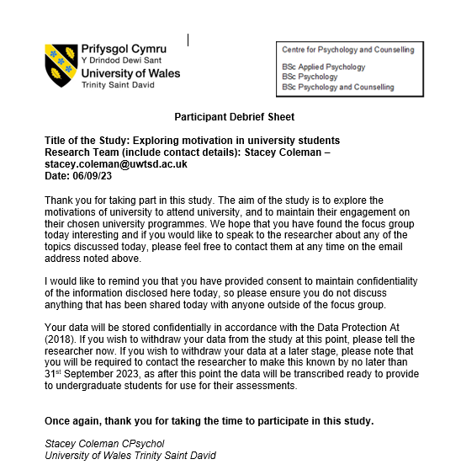

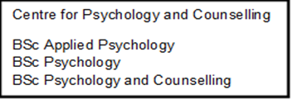


Participant Consent Form

Title of the Study: Exploring motivation in university students
Research Team: Stacey Coleman
Date: 06/09/23

Please review the statements below and indicate your response by circling either 'Yes' or 'No':

- I confirm that I have read and understand the Information Sheet for the above study. | Yes | No
- I had an opportunity to ask questions and have them answered satisfactorily. | Yes | No
- I understand that I may ask further questions at any time. | Yes | No
- I understand that my participation is voluntary, and I am free to withdraw from the study at any time without penalty or giving any reason. | Yes | No
- I understand that my fully anonymized data will be utilized for a second year research methods project whereby students will be provided with the focus group transcript to analyse. | Yes | No
- I understand that I may decline to answer any particular questions. | Yes | No
- I agree to the interview being recorded for transcription purposes. | Yes | No
- I understand that I have the right to ask for the recording to be turned off at any time during the interview. | Yes | No
- I understand that any data collected will remain confidential and that any identifiable information provided by me will be removed or replaced with a pseudonym. | Yes | No
- I understand that I may withdraw my consent at any time during the focus group and up to one week later (up until 13/09/23). After this point, my data will be stored anonymously and confidentially. | Yes | No
- I understand that the anonymised data provided will be securely stored and accessible only to the members of the research team directly involved in the study, and that confidentiality will be maintained. | Yes | No
- I give my permission for the anonymised transcript of the focus group to be used for learning activities by students. | Yes | No
- I agree to maintain the confidentiality of all members involved in the focus group and will not discuss any of the conversations had during this focus group with anyone outside of the focus group. | Yes | No
- I confirm that I am over 18 years old. | Yes | No
- I agree to take part in the above study. | Yes | No
Participant Name Date Participant Signature
________________________ __________ ________________________

Researcher Name Date Researcher Signature
________________________ __________ ________________________

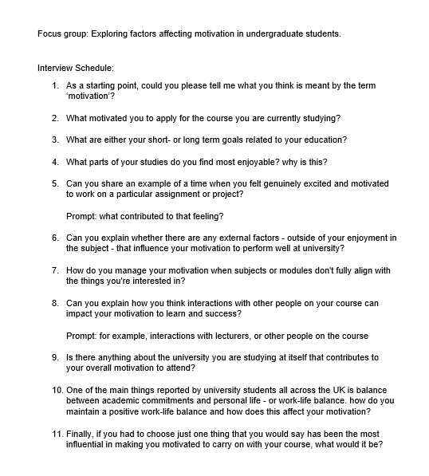

Self-improvement: | Self-esteem: | MARK:  - “feels a bit of an honour to go to uni (page 10, line 252)”  EMILY:  - “I have to do it to get good grades (page 23, line 591)”
Self-improvement: | Career ambitions: | EMILY:  - “I needed something more (page 21, line 537)”  SARAH:  - “Stepping stone to get into a career (page 30, line 791)”
Extrinsic motivation: | Pressure from Family | SARAH:  - “I just want to set an example for them and do better for them (page 5, line 119)”  MARK:  - “me dad wasn’t the brightest and me mum wasn’t around (page 4, line 78-79)”.
Extrinsic motivation: | Teacher support: | EMILY:  - “his passion for it made me really excited (page 13, line 342-343)”
Extrinsic motivation: | Pressure from Friends: | SARAH:  - “I used to dread going into class because I used to think I just don't belong with these people(page 24, line 631-632)”  ALEX:  - “you get all of us or you get none of us(page 25, line 663-664)”.
Environmental influences: | University environment | EMILY:  - “really nice to see the cows over there on a clear day (page 11, line 287-288)”
Environmental influences: | Pressure from Home life | MARK:  - “anything is better than being sitting in the house (page 23, line 607)”

