A report aimed for all teaching staff highlighting the impact of digital poverty as a barrier to learning for learners and offering effective solutions to a positive change in practice that aims to benefit learners who are impacted by digital poverty in our school community which is a mixed secondary school in south Wales.

This report will be written in two sections: the first section Part A will be defining and critically examining poverty and in particular, digital poverty. Then this report will be exploring measures in place within our school setting that we as teachers do within our practice to identify and then help support those learners who are in digital poverty. The second part of this report, Part B, will be providing you with a complete critical review of the whole systems approach towards tackling poverty in our school, mainly that of digital poverty and how this impacts and affects our teaching practice. Finally, this report then will be offering all teaching staff an effective plan, implementation, and a measurable evaluation of a change in practice that aims to benefit learners who are impacted by digital poverty in our school community.

Part A:
Section 1:1
The Joseph Roundtree Foundation (2025) (JRF) defines poverty as “When a person’s resources (mainly their material resources) are not sufficient to meet their minimum needs (including social participation).” Therefore, unable to have enough money to purchase items such as food, or access to certain key items to function successfully in society, such as digital devices.
JRF (2025) notes that:
“More than 1 in 5 people in the UK (21%) were in poverty in 2022/23 – 14.3 million people. Of these, 8.1 million were working-age adults, 4.3 million were children and 1.9 million were pensioners.”
That means, that 14.3 million people in the UK do not have the means to have the basic of needs such as food, to pay their bills and to participate in social activities required to succeed in society such as broadband. They are not meeting the requirement living standards. 4.3 million of those people are children. In Wales, 29% of children are in poverty. (ibid). The Royal College of Paediatrics and Child Health (2020) reported that child mortality rates in Wales were 70% higher for children in poverty that those who were not defined as being within poverty and “children living in poverty are four times more likely to develop a mental health problem by the age of 11” (Joshi, H. and Fitzsimons, E, 2016). In school, we as teachers see this and know too well being at the frontline of society the damage poverty can do to our learners.
Understanding how poverty is identified and measured is key to tracking progress in overcoming such an unnecessary social issue. In the UK, poverty is measured in a variety of different ways: as absolute and as relative. Absolute poverty is when basic needs (food, rent, energy bills etc) are not met due to household income being below the agreed line of living standard set by a country. Whereby relative poverty is when households receive a percentage below the median income, therefore, are in deep poverty or in very deep poverty. As an example, in the UK in 2024 the Office of National Statistics (2025) (ONS) reported the median disposable household (after tax, council and income national insurance contributions have been deducted) was £36,700 with the poorest fifth of the population receiving a disposable income of £16,800, with the poverty line set at 60% below the median equivalised disposable income (ONS 2025). Yet, due to the complex and subjective nature of poverty, “there is no single best measure of poverty.” (JFR 2025), therefore, elements of poverty can remain hidden in secret spaces out of sight such as period poverty (Harmless, 2025) and digital poverty (Digital Poverty Alliance, 2025). In particular, children experiencing poverty can also remain hidden and it is important to keep our knowledge up to speed with reports such as The Good Childhood Report (2024) that using young peoples experiences and voices to shed light on their lived lives. Therefore, using a collective of reports from charities that track a variety of social issues alongside Government data can help us understand and ‘see’ poverty in all its forms. In schools we use the measuring tool of Free School Meals data (eFSM) as a way to identify and track our learners who are in poverty. However, we as teachers know that this alone is subjective and does not capture learners who are in poverty who have working parents, who are perhaps refugees (migration status), children whose parents are disabled, children who are from ethnic minority backgrounds. In Wales, Welsh Government’s recent implementation of one of its tackling child poverty policies, the introduction of Universal Primary Free School Meals (UPFSM) (Welsh Government, 2024), also now impacts this eFSM data and has created a difficulty of tracking and identifying learners who are at risk or who are in poverty. This is something we need to be mindful of when those learners arrive in the next few years to secondary school. Again, this support JRF’s argument that poverty is complex and difficult to measure. As teachers know this and we see this daily basis. Knowing our learners and using data alongside knowing our learners helps to plug any gaps that may emerge or may be hidden in view. An example of hidden poverty within our schools is digital poverty. Digital poverty is defined as an “inability to access the online world when and how you need to” (DPA, 2025). The DPA explains the diversity of digital poverty using an impact cycle (Appendix A).

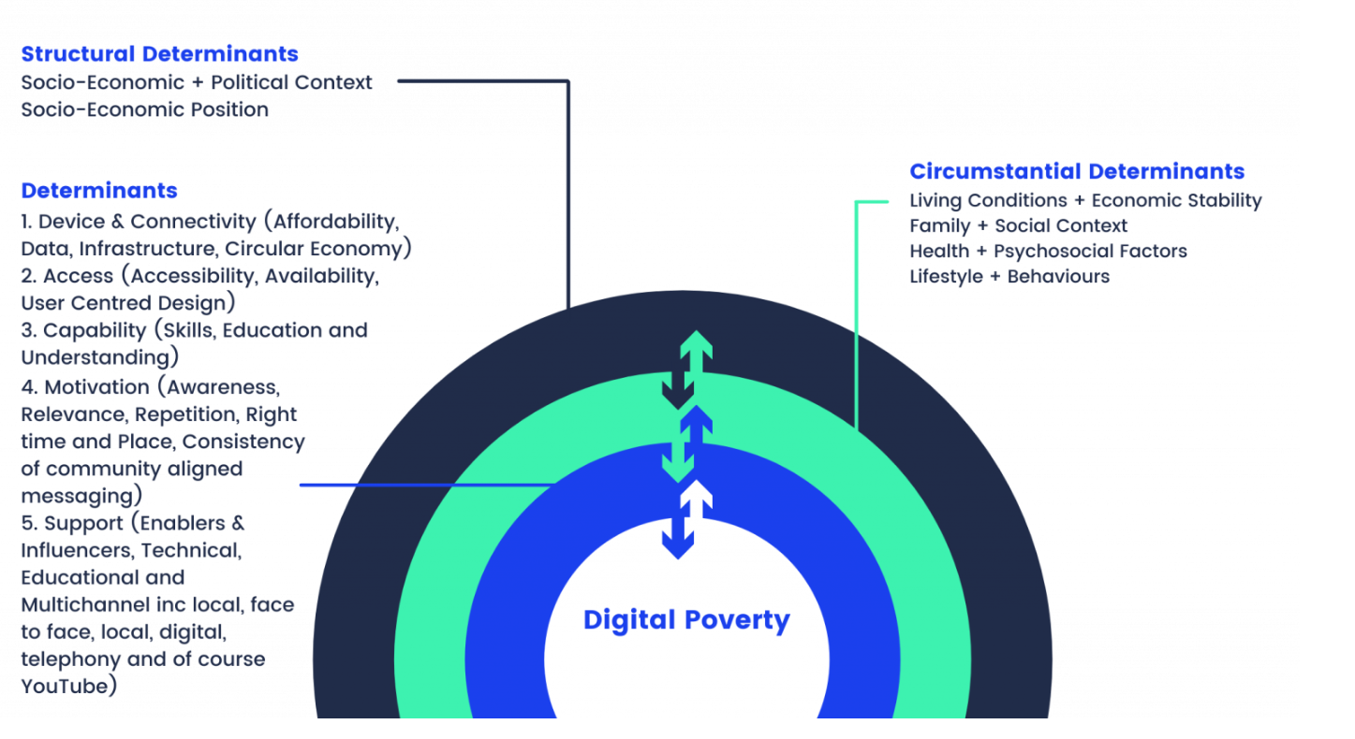
Image 1. The Digital Poverty Cycle. (The Digital Poverty Alliance, 2025)

An example from Image 1 above could be: someone has a low-income job due to the political context of the country (previous Conservative Governments cutting funding to Education as an example) and therefore this person has left school, got a low paying job because that is all they can get. As this person how a low income, they must prioritise other outgoings (living conditions) over having broadband, such as food, rent, clothing etc and therefore it becomes unaffordable to have broadband and therefore to access the online world. Thereby they are in digital poverty. The impact is huge as it now means this person is socially excluded from the community due to unable to access the online community for support and information as the modern world is far more online than it ever has been. This can have economic, health and lifestyle impacts which can be hugely detrimental.
There can be so many reasons why someone is in digital poverty and as teaching staff we must be aware of what is happening in society so we can fully understand and support our learners.

Section 1:2
Our school community is a mixed secondary school in south Wales with 1,676 learners on roll and 18.4% of these learners are defined as eFSM learners which is below the average in Wales of 21.1% (Estyn, 2025). 2.9% of learners have English as an additional language at home and 1.5% of learners are defined as having Additional Learning Needs which is 9.7% lower than the national average (ibid).
However, as teaching staff, we are accustomed to reviewing and discussing ways to identify learners who are in poverty and enhance the learning environment and experiences for our learners with recently in our Research and Development Focus being on understanding what life is like for our learners in poverty in our local community (The Central Club Podcast, 2025). Recent learning walks have been insightful with many of you ‘seeing’ for the first time what our eFSM learners have to go through in a full timetable day in our school and the challenges they face, as an example constantly explaining to staff why they don’t have equipment etc and how deflating this can be for them. We (hopefully) have been more mindful in our teaching practice when approaching these issues with our learners since completing these learning walks, reflecting and sharing our findings within our Areas of Learning Experiences (AoLEs).
Learners who have been identified within our school setting as being in poverty have been identified using the eSFM data. Data from National Reading Tests and National Numeracy Tests have also been used to help identify those learners in poverty (Appendix A). However, this is not always useful and accurate for identifying and measuring digital poverty as again, this is a hidden and complex aspect of poverty. Therefore, there are gaps in helping those learners who are in digital poverty due to the outdated and ineffective measuring approach we use as a school. This report aims to dig deeper and focus on digital poverty. Having recently defined digital poverty in the previous section (1.1) it is imperative that we reflect on observations made regarding our learners who are in digital poverty and how we as a school identify, measure and approach such learners (Zwozdiak-Mayers, 2012).
As an example, in our school setting digital poverty has been identified as:
- Unable to access the internet at home to complete homework set on Google Classroom (Google 2025); or,
- A parent unable to access the internet to pay for up and coming school trips through the parent pay portal (Parent Pay 2025); or,
- A parent unable to access their child’s school report issued through Classcharts or a learner unable to read communications from staff (TES 2025); or,
- A learner unable to access their learning through Hwb (Hwb 2025) due to not having internet or digital device access.
These are just a few examples and are not limited to how digital poverty can be presented in our education setting.

Firstly, the biggest issue we face is access to digital devices. Under the guise of the Digital Competency Framework (DCF), the school granted all Key Stage 3 learners an iPad to aid with their learning. Since the school-wide implantation of the DCF and The Curriculum for Wales (2021) we as a school have failed to identify and come up with school-wide approaches to issues around access. Yet, the school has not developed a plan about how to approach learners who cannot use such devices at home due to accessibility issues, i.e, no broadband. Therefore, these learners are unable to complete homework set by teaching staff and are further behind in their learning and end up with detention: therefore, being punished by the school system because of this barrier. This also then can at times generate challenging behaviour from the learner due to frustration and impact their well-being, mental health which in-turn can impact their development (Bronfenbrenner, 2000). In a particular case, one learner in Year 7 was persistently not doing homework and arguing back to teachers because simply they were unable to complete the work due no internet at home due to being in digital poverty (this has since come to light since his exclusion), and they felt ‘attacked’ by teachers when challenged on missing schoolwork. Had we as a school stopped, reflected and asked questions around support the learner would have not perhaps acted out so much and not ended up being excluded. This whole experience for this learner is going to have a negative impact towards their attitude to learning and asking for help. Learners need to feel safe in order to flourish (Maslow, 1943).
From my observations and upon reflecting (Schӧn 1987 and Woods 2012), I have seen some teachers who allow learners to attend their classroom lunchtimes or breaktimes to complete homework, therefore enabling access to the online world so to complete said learning, although this is not a school-wide policy and is few and far between. However, a great portion of teaching staff assume that all learners just know how to use a digital device such as an iPad and perhaps overlook the need to offer time within lessons to guide learners through the process of using such devices. This is also clear in attitude under the school’s Digital Plan (Appendix B): it is not inclusive of helping to identify and overcome barriers to learning, it needs to be holistic and not ridged in implementation and approach operating without assumption of digital knowledge in our learners.
Furthermore, every half term as a school we conduct pupil voice surveys in form time or set as homework to help inform our curriculum. However, this is done digitally by learners scanning a QR code and completing said form. Again, access is a major issue here and knowledge how to operate such a task is again an issue, especially with the lower ages in the school. Those learners who do not have access as they do not have a digital device such as a provided for iPad (if they are KS3) or allowed to us their mobile phones, it is clear that those learners without a digital device are not therefore having their voice heard and recorded, yet it is these learners who we desperately need to hear from and every child has the right to be heard (Unicef, 2016, Children’s Commissioner for Wales, 2021). There appears to be no alternative to capturing pupil voice within our school setting therefore, these learners who are in digital poverty are not having their needs met or supported.
Overall, teacher to teacher the approach and attitude towards digital devices and access to the online world outside of the school setting varies which can be confusing and exhausting for our learners: we need to have open minds and change our cultural approach towards learners who might be in digital poverty and find ways we can best support them and aid their development by being ‘change agents’ (Brown, White and Kelly 2021).

Part B
Section 2:1

Welsh Government (2022) strives for all schools in Wales to become Community Focused Schools so to help create an inclusive, solid society that has collective visions and understandings of each other who participate in our shared community. However, the problems that can arise from such an approach is that it needs to be an authentic holistic approach that is not driven from a top-down approach but from the bottom up. Furthermore, a top-down approach may hinder essential educational reforms required for the development of our learners. The blanket approach of such top-down approaches threatens the development and progress of bespoke needs of educational settings unique to their locality (Fullen and Gallagher, 2022). The proposed action plan in this report aims to create a community focused project meeting the needs of our community unique to our setting. However, a system change of view is required within our professional setting towards digital poverty as what has been observed in Part A is that many teaching staff either do not have an awareness of digital poverty, what it entails, and the far-reaching complexities involved within poverty. As such, it is always important to reflect and change our own world view so we can encompass those around us and better support our school and wider community (ibid). Freire (1973) states that “One cannot expect positive results from an educational or political action program which fails to respect the particular view of the world held by the people” (Freire, 1970, p.95). therefore, it is essential tat we as teaching staff are all on the same page and are operating collectively with a shared vision to drive change and bring about positive changes that are lasting and stick. As Rittel and Webber (1973) identified that poverty is a wicked problem that requires all systems to work together, therefore, to tackle such problems we encounter in our professional setting it is vital that we work collectively with each other, with the community and keep challenging the narrative identity of poverty. In our case, digital poverty. This digital drop-in hub aims to drive into the heart of Welsh Government’s (2022) community focused schools but offering the opportunity for teaching staff to gain professional development, support the needs of our local community by integrating the school environment as a place of formal and informal provision by measurable outcomes generating positive change. As teachers we understand the importance and the problems around family engagement for our learners and the effects it can have (Goodall, 2018). By using positive language, creating a safe, friendly not self-imposing space for our community we can then begin to help drive a collective vision bringing about positive change of helping to tackle a different aspect of poverty in our community.

Section 2:2
The proposed action plan to help support and help identify those learners who are ‘hidden’ within digital poverty by creating a digital drop-in hub available to all learners and their parents/carers. The issues identified in Part A of this report have been carefully reflected and the biggest impact to help overcome such issues woud take the form as a regular weekly digital drop-in hub. This digital drop-in hub would enable learners and their parents/carers access to the online world, allow them to learn new skills on digital devices such as how to use Applications used in school and in everyday life, enable them to build confidence in seeking support to access the online world, and most importantly, build stronger community relationships which are fundamental in tackling poverty. The aims would in-turn see positive results in our classrooms for those learners who are anxious using digital devices, help identify those learners who would need the school to provide a digital device every lesson and us as teachers would be able to provide adaptive alternatives in our planning to those who may not always be able to access the online world outside of the digital hub. Most importantly, it would give a voice to those we need to be heard and we as teaching staff would be able to respond effectively.

However, it is essential that any action plan has been critically and thoroughly thought through in design, in implementation and in in follow-up. Firstly, it is important to be mindful of the intersectionality theoretical framework brought about by Crenshaw (1989) which argues how interwoven social identities such as race and gender can impact and frame an individual’s experience as these identities are interconnected and intersect. Thus, highlighting the complex nature of poverty and those who are within poverty as not ‘fitting’ a one size fits all approach. Indeed, by reflecting and being mindful of this framework we can begin to create an action plan that encompasses this intersectionality therefore, being inclusive and capturing more learners who are in digital poverty that perhaps may have previously been overlooked through the school’s digital action plan measuring tools of using eFSM, NRT and NNT data alone (Appendix A and B). However, Schildkamp and Datnow (2020) note that teachers are more open to use data to inform their practice when there is a focus on equity versus accountability: the digital drop-in hub offers the opportunity to collate more data to help us inform our practice for equity in our school community. This approach is also important to be mindful of, as teachers we know this and understand that a learner is surrounded by external factors that impact and influence their lives. Furthermore, this is highlighted in the Exosystem within Bronfenbrenners Ecological Theory (1979) revealing the complex societal problems that children encompass within their life, therefore, impacting their development and limiting their experiences creating exclusion within aspects of society, consequently, becoming out of reach for them to develop and flourish. However, this theory does not take into consideration that despite children living within the same community that their lived experiences can vary vastly. An example of this being one child may live in the same community and attend the same school as another, yet they may be living in digital poverty, thus, being excluded socially from the online world, thus, having a different lived experience from their peer and hence socially excluded. It is important to dig deeper upon such theories and move with social developments, in this instance, the development and access to technology in society for children. This is something that has been carefully reflected upon when creating the proposed plan of action to help support and crate positive change within our school regarding our learners who are in digital poverty. Furthermore, by creating a digital drop-in hub with an open-door policy, so open to all learners, under a guise of a ‘veil of ignorance’ (Rawls, 1971) we are enabling a learner and their parents/carers an opportunity to shape their future by providing an opportunity of inclusive, fair and a level playing field of access to the online world for our community. It is also important to consider how a learner in digital poverty may view themselves, not as someone vulnerable, but as someone who is resilient and defiant of allowing their circumstances to define their identity of who they are (Haines, 2019). Again, this open-door inclusive approach enables this. Darling-Hammond (2013) argues that one of the major issues facing education systems is the unequal distribution of school resources which in-turn generates a gap of learning and progress for our learners, especially those in poverty. This action plan seeks to combat such a divide by helping to support, enable access to resources (in this case, the online world and digital resources), thus, helping to narrow the digital poverty gap for our learners. Therefore, it is important that we as a school have enough digital devices during the digital dop-in hub to reach all those who require them.

The Action Plan:

 | Plan | Deadline
Phase one | Raising awareness amongst teaching staff of the definition of digital poverty, sharing best practices already in place (SMART working).  Researching SMART ways to approach the digital drop-in hub, where it would be located and seeking volunteers to help run and support it. A clear understanding needs to be framed of what the digital hub is to all teaching staff and to all users of the hub. It is not a place to come and mess about online/ play games. Needs to have clear boundaries and create a safe space.  Questionnaire sent to all learners and parents/ carers about what they would like to see from a digital drop-in hub. What would they like to access, skills to develop and times/ days of the week. Lunchtimes and after-school? This is to be collected through paper questionnaires and digital questionnaires: both methods are to be sent out so to make sure all voices are captured. | Inset or twilight, whichever comes first.  End of September 2025  End of September 2025
Phase two | Analysing the feedback data and putting into practice the needs of learners and parents/carers from the feedback questionnaires.  Results to be discussed with the SLT, tackling poverty working group and with all teaching staff.  Inviting all learners and parents/ carers to the digital hub. This must be communicated in physical paper form as well as digitally so not to provide a barrier to access and awareness.  Clear signage across the school environment, mentioned in form-time and school assemblies.  Implementation of the digital hub based on the needs and requirements from the feedback questionnaire and what we as a school/ teaching staff have also identified. | By October half-term  Twilight  Send invites out before October half-term and reminders again after October half-term/ shortly before it opens.  Before October half-term and again after October half-term.  After October half-term.
Phase three | Measure and evaluate progress. This will be achieved through a feedback session in a twilight amongst teaching staff. All teaching staff will be asked to complete a review form detailing any changes in access, behaviour and support learners previously identified in initial meeting as being in digital poverty.  Feedback form sent to all learners in form time so to capture pupil voice of those who might have accessed and used the digital hub.  Paper feedback forms sent home to all parents and carers to fill-in regarding the digital hub- this will allow inclusivity and overcome any communication barriers that may have been present due to the digital comms previously used.  Analyse the feedback form data and implementing any changes that are required. | February half-term 2026  February half-term 2026  February half-term 2026  Before Easter holiday.
Phase four | Sharing results with all teaching staff and taking onboard feedback so to reform and develop the digital hub to better support our learners who are in digital poverty. | After Easter holidays so to allow for feedback changes to be implemented so to keep developing the digital drop-in hub for users needs.
Phase Five | Keep reviewing the needs and requirements of the digital drop-in hub for all users. This is to be captured verbally and with a feedback questionnaire every other term so to keep adapting and reforming for the needs of the users of the hub. | Ongoing review.

This digital drop-in hub aims to help combat the issues we as teachers have identified within the classroom: the learners who are anxious using digital devices, providing extra support to help guide them and develop their skills, to allow learners and their parents/carers a space to achieve their needs in the online world outside of the classroom, to help manage challenging behaviour from learners who are in digital poverty by enabling them an opportunity to access the online world and provide support to them, allow us as teaching staff to be mindful of ‘hidden’ aspects of poverty and use our position to provide support and guidance. Although there will be more data collated to help us inform our practice moving forward, it is paramount to stress that we will also ‘know’ our learners better too. As Brown and Duguid (2000) state that “knowledge lies less in its databases than in its people” (Brown and Duguid, 2000 p.121 in Fullen, 2020, p.92). To challenge the stigma around poverty and show how that by working closely with our community we can help provide support and a safe space where everyone is seen without prejudice (JRF, 2025 and Freire, 1970).

References:

Bronfenbrenner, U., (1979) Ecological Systems Theory. Massachusetts: Harvard University Press
Brown, C., White, R., Kelly, A., 2021. Teachers as educational change agents: what do we currently know? findings from a systematic review. Emerald Open Research 3, 26. doi:10.35241/emeraldopenres.14385.1
Centre for Longitudinal Studies (2025) Millennium Cohort Study, Available at: https://cls.ucl.ac.uk/cls-studies/millennium-cohort-study/ Accessed on 20th June 2025.
Children’s Commissioner for Wales (2021) The Right Way: A Children’s Human Rights Approach to Education in Wales. Available at: TheRightWayEducation_ENG.pdf (Accessed on 1st December 2024).
Children’s Society (2024) The Good Childhood Report 2024. Available at: https://www.childrenssociety.org.uk/information/professionals/resources/good-childhood-report-2024 Accessed on 20th June 2025.
Crenshaw, Kimberle (1989) "Demarginalizing the Intersection of Race and Sex: A Black Feminist Critique of Antidiscrimination Doctrine, Feminist Theory and Antiracist Politics," University of Chicago Legal Forum: Vol. 1989, Article 8.
Available at: https://chicagounbound.uchicago.edu/uclf/vol1989/iss1/8

Darling-Hammond, Linda. ‘Inequality and School Resources. What will it take to close the opportunity gap’, in Prudence L. Carter and Kevin G Welner, Kevin G, (eds). (2013) Closing the opportunity Gap: What America Must Do to Give Every Child an Even Chance. New York, Oxford Academic Press.
Digital Poverty Alliance (2025) About Us. Available at: https://digitalpovertyalliance.org/about-us/ Accessed on 20th June 2025.
Digital Poverty Alliance (2025) It’s all poverty: Poverty, Digital Poverty and why it matters. Available at: https://digitalpovertyalliance.org/news-updates/its-all-poverty-digital-poverty-why-matters/ Accessed on 20th June 2025.
Estyn (2025) Inspection Report for Redacted Comprehensive School 2025. Available at: https://estyn.gov.wales/app/uploads/2025/03/Inspection-report-REDACTED-Comprehensive-School-2025.pdf Accessed on 20th June 2025
Freire, Paulo (1970) Pedagogy of the Oppressed. London: Bloomsbury Publishing
Fullen, Michael., and Gallagher, Mary Jean. (2022) The Devil is in the Details. System Solutions for Equity, Excellence, and Student Well-Being. California: Corwin
Goodall, J. (2018) A toolkit for parental engagement: from project to process. School Leadership and Management, 38(2), pp.222-238. Available at: https://doi.org/10.1080/13632434.2018.1430689 Accessed on 13th July 2025
Google Classroom (2025) Where teaching and learning come together: Google Classroom. Available at: https://edu.google.com/intl/ALL_us/workspace-for-education/products/classroom/ Accessed on 25th June 2025
Harmless (2025) The Hidden Cost of Periods: Unpacking Period Poverty in the UK on Menstrual Hygiene Day. Available at: https://harmless.org.uk/the-hidden-cost-of-periods-unpacking-period-poverty-in-the-uk-on-menstrual-hygiene-day/ Accessed on 20th June 2025
Joshi, H. and Fitzsimons, E. (2016). ‘The Millennium Cohort Study: the making of a multi-purpose resource for social science and policy’. Longitudinal and Life Course Studies, volume 7, issue 4, doi: /10.14301/llcs.v7i4.410.
Maslow, A.H. (1943) “A Dynamic Theory of Human Motivation”. Psychological Review, 50, 370-396.
Office for National Statistics (2025) Average household income, UK: Financial Year Ending 2024. Available at: https://www.ons.gov.uk/peoplepopulationandcommunity/personalandhouseholdfinances/incomeandwealth/bulletins/householddisposableincomeandinequality/financialyearending2024 Accessed on 13th July 2025
Parent Pay (2025) Leading Cashless Payment System for Schools
Available at: https://www.parentpay.com/ Accessed on 13th July 2025
Public Health Wales and Bangor University (2023) The rising cost of living and health and wellbeing in Wales: a national survey. Available at: PHW-Cost-of-Living-report-Eng-04_10_23.pdf (phwwhocc.co.uk) Accessed on 13th July 2025
Rawls, John (1971), A Theory of Justice. Massachusetts: Harvard University Press
Rittel, H.J.W and Webber, M.H. (1973) Dilemmas in general theory of planning. Policy Sciences, 4, (2) pp.155-159. Available at: https://doi.org/10.1007/BF01405730 Accessed on 14th July 2025.
Schildkamp, K., & Datnow, A. (2020). When Data Teams Struggle: Learning from Less Successful Data Use Efforts. Leadership and Policy in Schools, 21(2), 147–166. https://doi.org/10.1080/15700763.2020.1734630
Schӧn, D.A. (1987) Educating the Reflective Practitioner: Toward a New Design for Teaching and Learning in the Professions. San Francisco: Josse Bass Higher and Adult Education.
State of Child Health (2025) State of Childhood Health Wales. Available at: https://stateofchildhealth.rcpch.ac.uk/evidence/nations/wales/ Accessed on 20th June 2025.
TES (2025) TES Class Charts: Classroom Management System. Available at: https://www.tes.com/en-gb/for-schools/class-charts (Access 30th July 2025).
The Central Podcast: Bridgend: The Infamous Wildmill Estate, YouTube, 2025.
Unicef (2016) United Nations Convention on the Rights of the Child. Available at: https://www.unicef.org.uk/wp-content/uploads/2016/08/unicef-convention-rights-child-uncrc.pdf (Accessed 10th July 2025).
Thomas., Gareth and Thomas., Sian, Senedd Research, Welsh Parliament (2023)
Consultation on the draft Child Poverty Strategy for Wales 2023. Available at: “The biggest issue affecting children in Wales” – tackling child poverty (senedd.wales) Accessed on 13th July 2025.
Welsh Government (2022) Community Focused Schools. Available at: https://www.gov.wales/community-focused-schools-html Accessed on 20th June 2025
Welsh Government (2021) Framework on embedding a whole-school approach to emotional and mental well-being. Available at: https://www.gov.wales/sites/default/files/publications/2021-03/framework-on-embedding-a-whole-school-approach-to-emotional-and-mental-well-being.pdf (Accessed on 1st July 2025).
Welsh Government (2025) Hwb. Available at: www.hub.gov.wales Accessed on 20th June 2025.
Welsh Government (2025) Relative income poverty: April 2022 to March 2023. Available at: https://www.gov.wales/relative-income-poverty-april-2023-march-2024 Accessed on 13th July 2025.
Welsh Government (2022) Universal Primary Free School Meals (UPFSM). Available at: https://www.gov.wales/universal-primary-free-school-meals-upfsm Accessed on 20th June 2025.
Woods, P. (2012) Critical Events in Teaching and Learning. Oxon: Routledge.
Zwozdiak-Mayers, Paula. (2012) The teachers reflective practice handbook. Becoming an Extended Professional through Capturing Evidence-Informed Practice. Oxford: Taylor & Francis.

Appendix:
Appendix A:
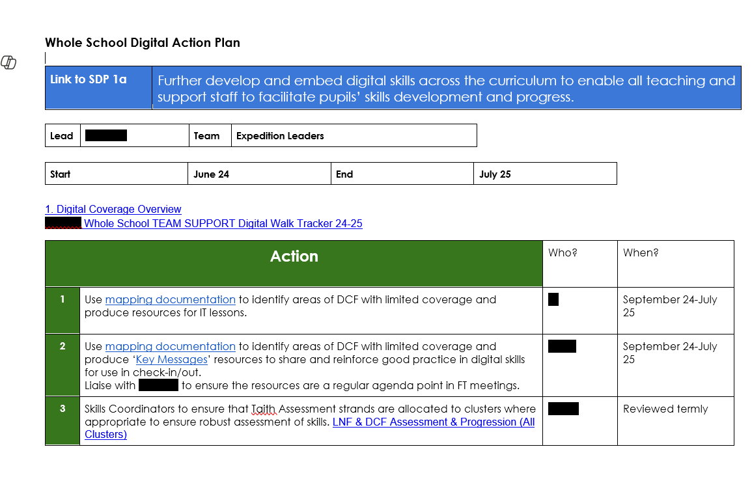
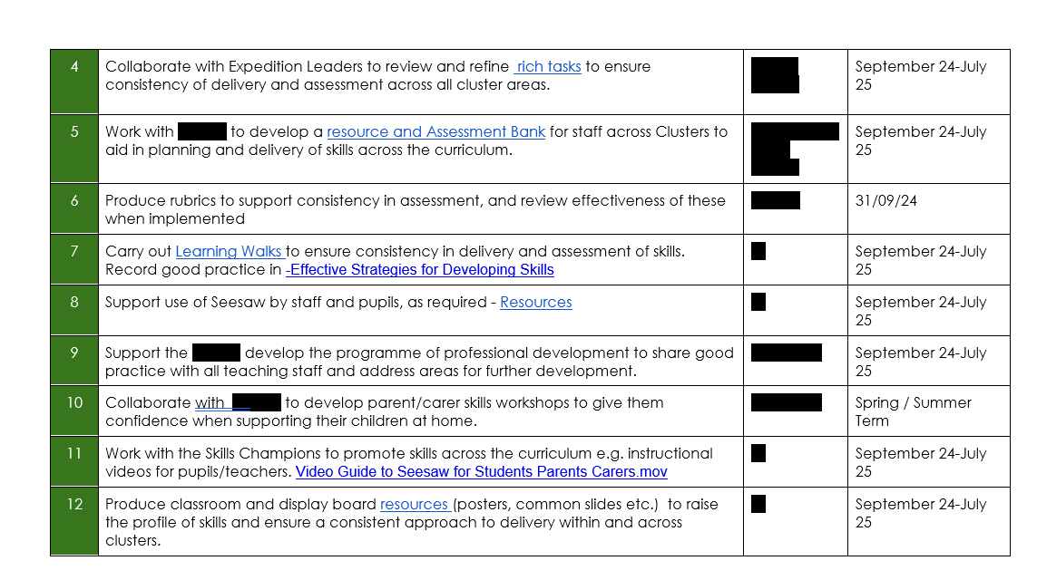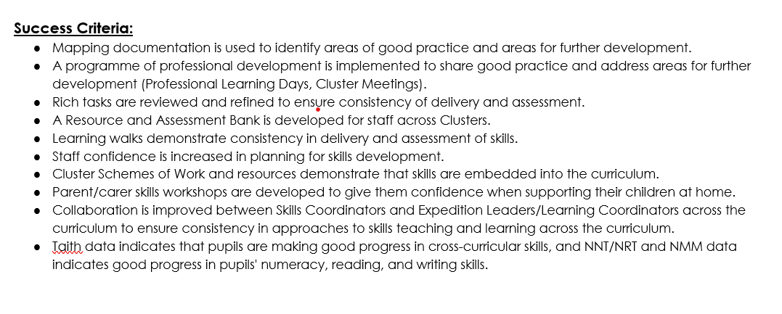

Appendix B:


