5/5/2024
Assessment
Portfolio Report on Contemporary Software Applications for Business


Student Name: Paul John Hudson Synnot
Student ID: 2533495

Module NaMe: Software solutions for business
Module Code: ACCA 4026
Lecturer: Amitave Banik
Trinity saint david University of Wales (London Campus)

Table of Contents
Introduction 2
Main Body 2
Task 1 2
e-Commerce Website builders/software solutions 2
Task 2 2
Mind-map of Contemporary Software Applications 2
Task 3 3
Office Applications for Creating, Storing, Presenting, and Analysing Data 3
a. 3
b. 3
Task 4 3
Communication and Collaboration applications 3
a. 3
b. 4
Conclusion 4
References 4
Appendices 4

Introduction
Hello my name is Paul John Hudson Synnot, student number 2533495. This is Software Solutions for Business assignment one.

Main Body

Task 1a
(10 marks)

e-Commerce Website builders/software solutions
(Approx. 500 words)

A t-shirt company is looking to make a website. They are a business to customer-based ecommerce business. The website needs to be appealing to the eye, stylish, memorable. No one will want to spend their time on a website that is unattractive. People generally make up their mind with in one minute of being on a website or even less if they want to browse thoroughly or not. There needs to be automatic stock maintenance software available as inventory is critical to success. Sell to many and you could end up with bad feedback. It should allow for the option of drop shipping. Drop shipping is an e-commerce retail model where you sell products without holding inventory or handling shipping. This can greatly increase revenue as it brings more customers. Secure payment is a must for requirements. It should be fast, accurate, and easy to use for the customer. Returns are another thing facing the t shirt company. They should be straight forward, easy to understand, and quick. Lastly There is one of the most important, customer feedback. Customer feedback is a make-or-break area for ecommerce. Bad feedback can ruin a company. It should be easy to use, customers are encouraged to write in it, quick and easy.

The answer to a good-looking web page using Wix or Shopify is exploring the themes selection. They give businesses total control over all aspects of the front end of their website including HTML, stylesheets, and scripts. These themes can be downloaded from Shopify or Wix, sourced from a third party, built custom from a freelancer, or developed in house by merchant. [1]

Stock automation maintenance software is set to tell you everything you need to know about your sales. Inventory reports are included which will let you know quantity and percentage of inventory sold per day. You can view the last 180 days of inventory history to stay on top of previous orders and data. This includes tracking tricky things like committed orders, items that are part of an unfulfilled order. [2]

Secure payments mean Shopify and Wix are PCI compliant by default (a key standard for handling card data). Shopify uses firewalls, regular security audits, and undergoes SOC 1 and SOC 2 audits every six months to help protect and store customer data. For card payments they use 3D secure (a verification with the card issuer) to help reduce fraud. [2]

Customer reviews and feedback are covered by many third-party product review apps making sure your reviews are viewed by the most available views. There is product feedback, service feedback for improving shipping returns and overall experience, and internal tracking which takes notes on customers outcomes. [2]

Dropshipping uses a POD (print on demand) app to source and help automate fulfilment. When a customer places an order, they go from them to your Shopify Wix store then straight to the supplier. The supplier chooses, packages, and ships the product to the customer. Only needing to now deal with customer service and order tracking. [2]

Returns are broken down into return you receive items back, refund you send money back, exchange you send a different item (size/colour) sometimes with an amount owing to the customer for the difference. You also have return window how long they must return an item, return shipping cost how much it will be to return the item, with optional restocking fee, final sale items that cannot be returned. [2]

Task 1b

Task 2
(15 marks)

Mind-map of Contemporary Software Applications
(Approx. 500 words)

- Describe mind mapping and explain the benefits of using mind mapping in business operations (approx. 2/3 sources). 5 marks

The smart card with an embedded integrated circuit chip. It combines plastic and magnetic cards used for identification purposes in one card, used to access multiple services, networks, and the internet. The smart card offers three factor authentication for verification of the user. There is (PIN) personal identification number, digital signature, fingerprint, and biometric. This method increases the security of the transaction. As credit cards, debit cards, and prepaid card make up most of the marketplace when it comes to making online payments. [3]

Mobile phone-based payment system allows customers to make payments via their mobile phone.

End to end encryption (E2EE) is the best-known way to protect users’ digital communication as it disguises them from everyone. E2EE has been adopted by the popular messaging systems WhatsApp and iMessage. Using a key to decode the information at either end preventing information from escaping into the hands of hackers. [4]

3D Secure is the most prominent user authentication protocol for cred card based online payment. It relies on risk assessment whether to challenge the payment indicator for second factor authentication (through a passcode). The standard itself does not specify how to implement transaction risk assessment. [5]

Blockchain enables users to verify, preserve, and synchronize the contents of data (a ledger) replicated by multiple users. Blockchain technology has provided considerable advantages and incentives to industries in terms of enabling better services. [6]

b. Create a mind map of contemporary software applications that are used to support day-today business/Organisation operations. 10 marks

Mind Map Link: https://mm.tt/map/3957059449?t=H8a4aeTmj5

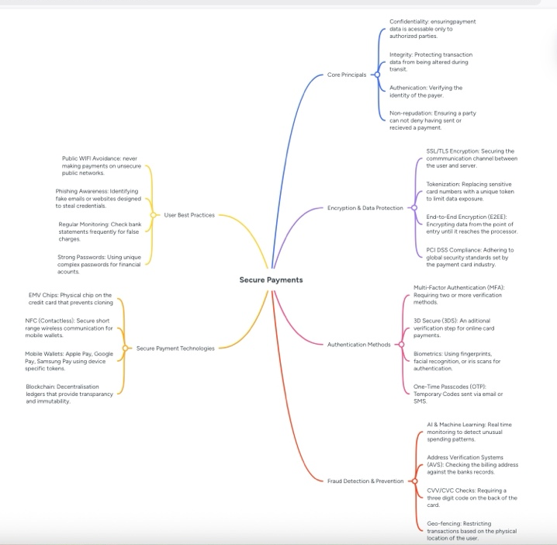
Figure 1: Mind Map
[7] [8] Mind mapping is a visual technique used to organize information, ideas, and concepts. It starts with a single central topic placed in the middle of the page, from which related ideas radiate outwards as branches. These branches can further divide into subbranches, using keywords, colours, and images to create a hierarchical yet nonlinear structure.
By mirroring the way, the human brain naturally associates ideas, mind maps allow for a more intuitive flow of thought compared to traditional linear note taking.
mind mapping offers numerous advantages that streamline and improve business operations across all levels. When used for project planning, it allows teams to visualise an entire initiative in one place, breaking complex objectives into manageable tasks while making it easier to identify dependences, allocate resources, and set realistic timelines. During brainstorming sessions, its nonlinear structure encourages free flowing thought and lateral thinking, helping employees connect disparate concepts and generate more innovative solutions than traditional methods. For strategic decision making, mind maps enable leaders to weight variables, risks, and potential outcomes side by side, providing a clear big picture view the supports a more informed and confident choices. They also play a key role in knowledge management by condensing lengthy documents, procedures, or training manuals into concise, visual summaries that are simpler to understand and retain, which speeds up onboarding and improves information sharing. Finally, as a communication tool, mind maps create a shared visual reference that aligns all stakeholders, ensuring everyone understands goals, responsibilities, and expectations clearly, which reduces confusion and enhances collaboration.

Task 3
(50 marks)

Office Applications for Creating, Storing, Presenting, and Analysing Data
(Approx. 2000 words)

a.
30 marks
Explain four office software solutions for business operations (MS Word, MS PowerPoint, MS Excel, and MS Access), highlighting their major features, benefits, and limitations (if there are any). You can use some images in addition to text (approx. 4/5 sources).
- Please try to avoid using bullet points. Rather, describe them in separate paragraphs.

In the contemporary corporate landscape data is often described as the new oil. How ever data only holds merit when it can be organised and changed into actionable insights. Microsoft Excel is the most ubiquitous and versatile tool for achieving this, serving as a foundational tool for businesses of all size and structure. From small startups to multinational corporation. Excels benefits reach across financial management, data visualization, and operational efficiency.
One of the main advantages of Excel is unmatched capability in financial modelling and budgeting. For finance departments Excel is unmatched for creating balance sheets, cash flow projections, and profit loss statements. Its well-built library of mathematical and financial formulas lets users complete complex calculations instantly. Features like What-If Analysis and Goal Seek enable managers to simulate various business scenarios, like this increase of price or shift in market conditions making for proactive rather than reactive decision-making.
Beyond simple arithmetic, Excel serves as a powerful data management and analysis tool. As businesses generate vast amounts of information, the ability to sort, filter, and categorize data becomes critical. Excels PivotTable feature is perhaps the most potent analytical asset allowing users to summarize thousands of rows of data into a concise table in seconds. By identifying trends, patterns and outlier’s businesses can gain a better understanding of customer behaviour, inventory turnover, and sales performance. This level of insight allows that resources are allocated efficiently, and growth opportunities are not overlooked.
Furthermore, Excel plays a vital role in enhancing productivity through automation. Through the use of macros and visual basic for applications (VBA). Repetitive tasks like generating weekly reports or cleaning data sets can be automated with a single click. This not only saves man hours but also reduces the risk of human error, which is often present in data entry. By streamlining these mundane processes employees are freed to focus on high level strategic tasks that drive the business forward.
Data visualization is another area where Excel excels. Raw numbers can be difficult to interpret but excels extensive charting and graphing tools allow businesses to present information visually. Dashboards created in Excel provide a real time snapshot of key performance indicators (KPIs), making it easier for stakeholders to grasp complex information at a glance. Clear visual communication is essential during board meetings and investor pitches, where the ability to tell a compelling story through data can influence major corporate outcomes.
Finally, the accessibility and cost effectiveness of Excel can not be ignored. Unlike specialized enterprise resource planning (ERP) software that may require expensive licences and extensive training. Excel is relatively affordable and features a user interface that most professionals are already familiar with. Its compatibility with other software and the ease in which files can be shared make it a universal language in the business world.
In conclusion, Microsoft Excel is far more than a simple spreadsheet program, it is a comprehensive business tool. By facilitating complex financial planning, enabling deep data analysis, automating workflows, and providing clear visualizations, Excel empowers organizations to operate with precision and agility. In an area where efficiency and data driven strategy are the keys to success, Excel remains an essential asset for any competitive business. [9]

Microsoft Word remains one of the most widely used software applications on the corporate world, decades after its initial release. Despite the rise of cloud-based alternatives, it continues to be an indispensable tool for businesses of all sizes. Its popularity stems from its versatility, reliability, and wide range of features that streamline daily operations.
The primary advantage of word is its ability to create polished, professional documents. In business presentation matters, and word provides extensive formatting tools such as fonts, styles, headers, footers, and bullet points that ensure reports, proposals, and contracts look consistent and credible. The use of templates is particularly valuable, businesses can create standardised templates for invoices, memos, letter heads, ensuring brand consistency across all external communications.
Word is packed with features and designed to increase productivity. Tools like spell check, grammar check, and thesaurus help prevent errors and maintain high standards in writing. The track changes feature is essential for collaboration work, allowing team members to edit a document, leave comments, suggest modifications without permanently altering the text. This makes the review process much faster and more organised. Additionally, the auto corrects and auto text functions automate repetitive tasks, saving significant amounts of time.
Interoperability is crucial in a business environment. Word files are universally accepted, meaning documents can easily be shared with clients, partners, and suppliers regardless of the software they use. It also integrates seamlessly with other Microsoft Office applications, such as Excel and PowerPoint. For example, data charts created in Excel can be embedded directly into a Word report, ensuring information is accurate and up to date.
Word offers robust security options. Businesses can password protect sensitive documents, restrict editing permissions, and use encryption to protect confidential information such as financial data or employee records. Furthermore, the version history allows users to recover previous versions of a file, reducing the risk of data loss or mistakes.
Finally, word is intuitive and easy to learn. Most employees are already familiar with the interface, which minimises training time costs. It is also compatible with various accessibility tools, ensuring that all staff members can use the software effectively.
In conclusion Microsoft Word is far more than just a word processor, it is a fundamental business tool that enhances communication, improves efficiency, and maintains professional standards. Its combination of powerful features and ease of use makes it vital for effective business management. [10]

In the modern corporate landscape, communication is the bridge between strategy and execution. Microsoft Power Point has established itself as the industry standard for visual communication, evolving from a simple slide deck creator into a sophisticated tool for storytelling, data visualization, and branding. Its benefits extend beyond mere aesthetics, impacting how information is retained and how decisions are made within an organization.
One of the primary advantages of PowerPoint is its ability to enhance information retention through visual story telling. Humans process visual information significantly faster than plain text. By integrating charts, infographics, and high-quality imagery, PowerPoint allows presenters to distil complex data into digestible knowledge nuggets instead of overwhelming an audience with dense reports a well-structured presentation highlights key performance indicators (KPIs) and core messages, ensuring the audience walks away with the most critical take aways.
Furthermore, PowerPoint serves as a powerful tool for professionalism and brand consistency. In business, first impressions are vital. PowerPoints robust library of templates and design themes allows companies to maintain a unified visual identity When every presentation from internal team updates to high stakes investors pitches aligns with corporate, colours, fonts, logos, it reinforces brand authority. Features like slide master ensure the formatting remains consistent across hundreds of slides, saving time while maintaining a polished professional standard that reflects well on the organization’s attention to detail.
Versatility and collaboration are also central to PowerPoints value. The integration with Microsoft 365 enables real time co-authoring, allowing global teams to work on the same file simultaneously. The collaborative environment reduces version control errors and accelerates project timelines. Additionally, PowerPoint’s versatility means it is no longer just for live speeches. It’s frequently used to create digital brochures, interactive training modules, and self-running kiosks. The ability to export presentations as PDFs or high-definition videos ensures that the content is accessible across various platforms and devices.
Moreover, the software significantly improves speaker confidence and structure. For a presenter the slide deck acts as a logical road map. Features such as presenter view allow the speaker to see upcoming slides and private notes which help s maintain a steady flow and reduces the reliance on scripts. This structured approach ensures that the narrative remains focused, preventing meetings from drifting off topic, a common issue that impacts corporate productivity.
Finally with the recent integration of advanced AI and Data tools, PowerPoint has become more intuitive. Features like Design Ideas suggest professional layouts automatically, while the ability to embed live Excel data ensures the charts update in real time. This reduces the manual labour involved in deck preparation allowing business professionals to focus more on the quality of their insights rather than the mechanics of the slide design.
In conclusion Microsoft PowerPoint is much more than a digital chalkboard, it is. A fundamental business asset. By facilitating better comprehension, ensuring brand alignment, and fostering seamless collaboration, it empowers professionals to communicate with impact. In a n era where clarity is a competitive advantage, PowerPoint remains an indisputable tool for turning ideas into persuasive, actionable business outcomes. [11]

In the data driven era of modern business, the ability to organize, manage, and retrieve information is a core competitive advantage. While spread sheets are of then the first tool businesses turn to, they frequently fall short when handling complex interrelated data. Microsoft Access a relational database management system (RDBMS) bridges the gap between simple spreadsheets and expensive enterprise level SQL servers. Its benefits for business lie in its ability to provide structure, scalability, and customized reporting at a fraction of the cost of specialized software.
One of the most significant advantages of Microsoft Access is its relational database structure. Unlike a flat spread sheet where data is often duplicated and prone to human error, Access uses related tables to store information. This relational aspect ensures data integrity, for instance a customer’s address only needs to be updated in one place to be affected across all orders, invoices, and shipping logos. By reducing data redundancy, Access ensures that business decisions are based on accurate, consistent, and up to date information.
Another primary benefit is customizability and ease of use. Access is designed for power users who may not be professional programmers but need sophisticated data tools. Through its user-friendly interface, businesses can build custom forms for data entry, ensuring that employees input information in a standardized format. These forms can include validation rules the prevent common mistakes, such as entering a text string into a currency field. This Level of control streamlines internal workflows and significantly improves the quality of data collected.
Furthermore, Access offered powerful reporting and querying capabilities. In a business environment, the ability to ask specific questions of your data such as, “which products had the highest profit margin in the north region last quarter?” – is essential. Access allows users to create complex queries that filter and combine data for multiple sources instantly. These results can then be formatted into professional, automated reports that are ready for distribution to stakeholders. This automation saves hours of manual data manipulation, allowing management to focus on analysis rather than assembly.
Cost effectiveness and integration also make Access an ideal choice for small to medium sized enterprises Most business workstations already include Access as part of the 365 Office suite, meaning there is no additional licencing cost to deploy a database solution. Additionally, access integrates seamlessly with other Microsoft Office applications. Users can import data from Excel, mail-merge names into word documents, or export reports to PDF. This interoperability ensures that the database becomes a central hub for the company’s existing digital ecosystem.
Finally, Access provides a clear path for scalability. While it is powerful enough to manage the daily operations of a small business, it also serves as an excellent front end for larger enterprise systems. As a company grows the back-end data can be migrated to Microsoft SQL Server while keeping familiar Access front-end interface for employees.
In conclusion Microsoft Access is a versatile tool that transforms raw data into a strategic asset. By offering superior organization, customized user interfaces, and robust reporting, it enables businesses to operate with greater precision and efficiency. For any organization looking to move beyond the limitations of spreadsheets, Access provides a professional, scalable, and highly integrated solution for information management. [12]

b.
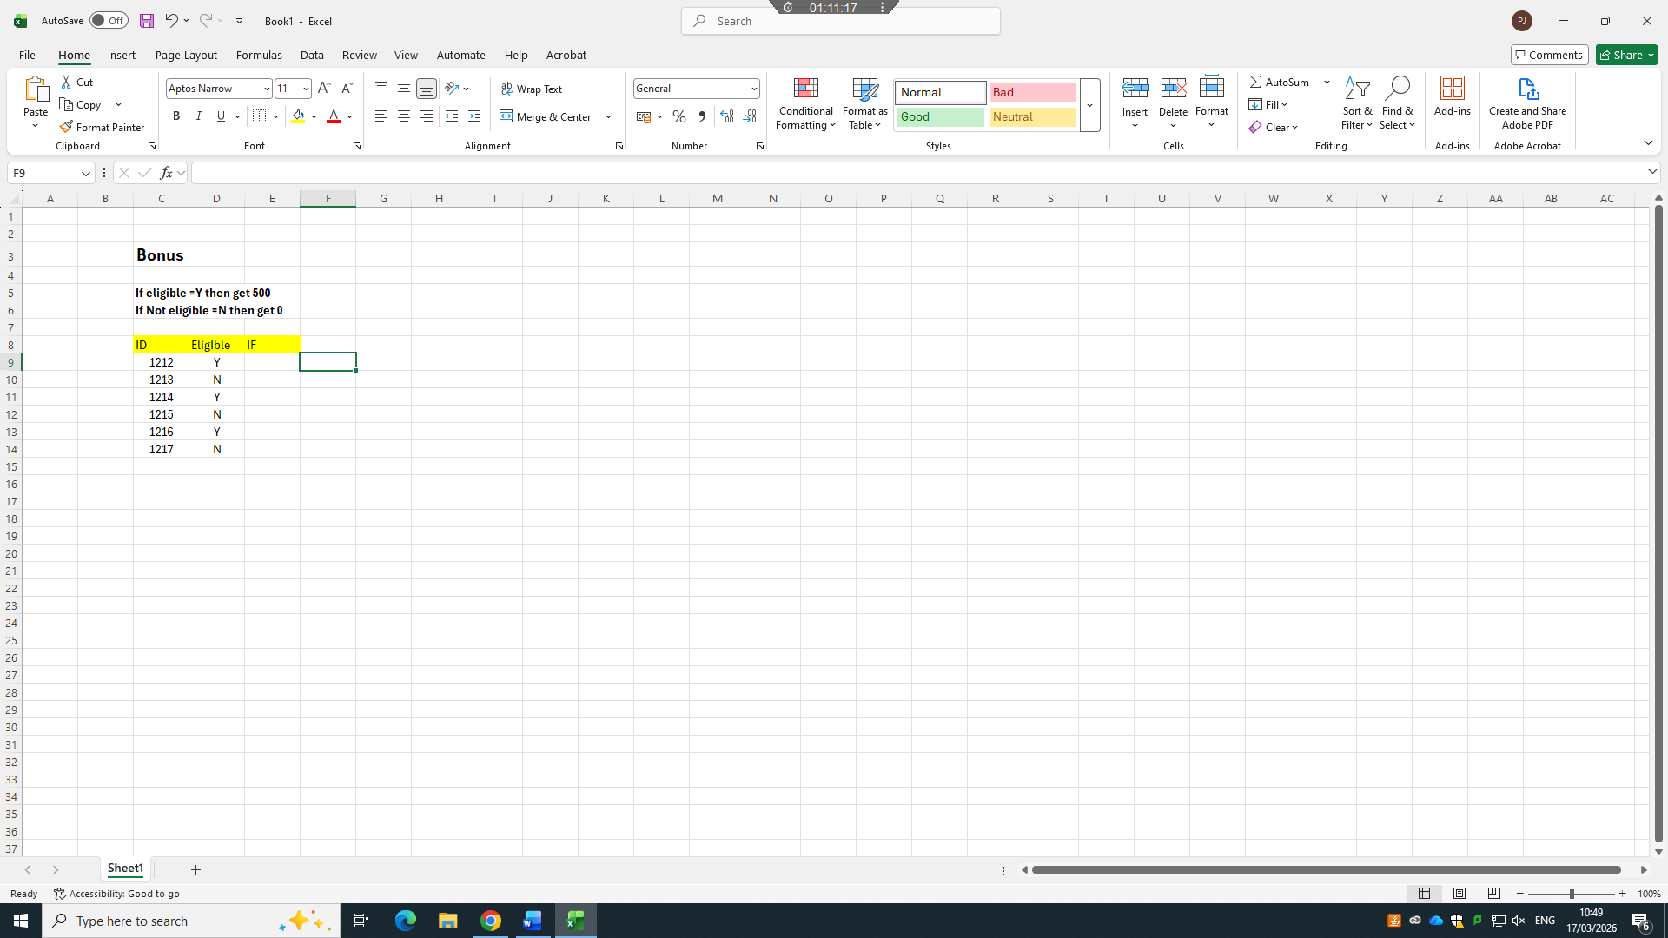
Figure 1: IF Function Excel
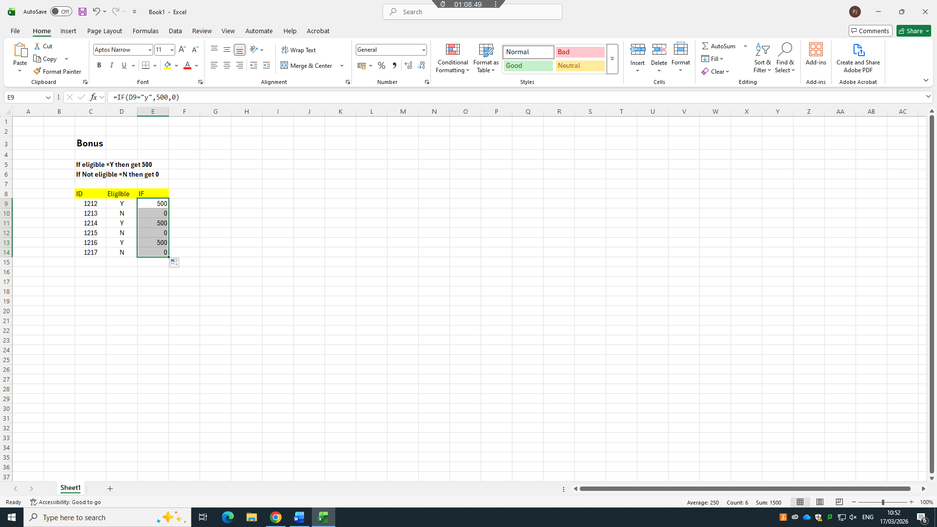
Figure 2: IF Function Excel
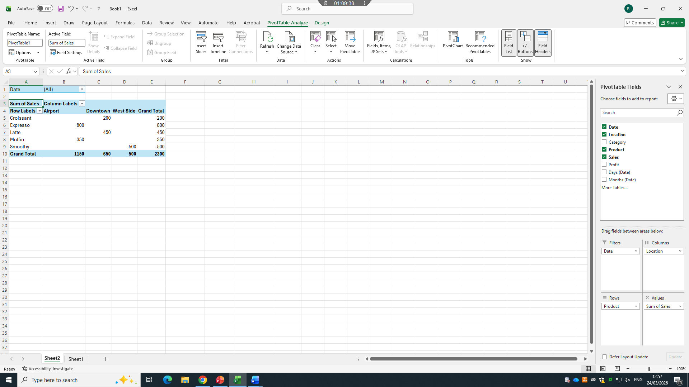
Figure 3: Pivot Table
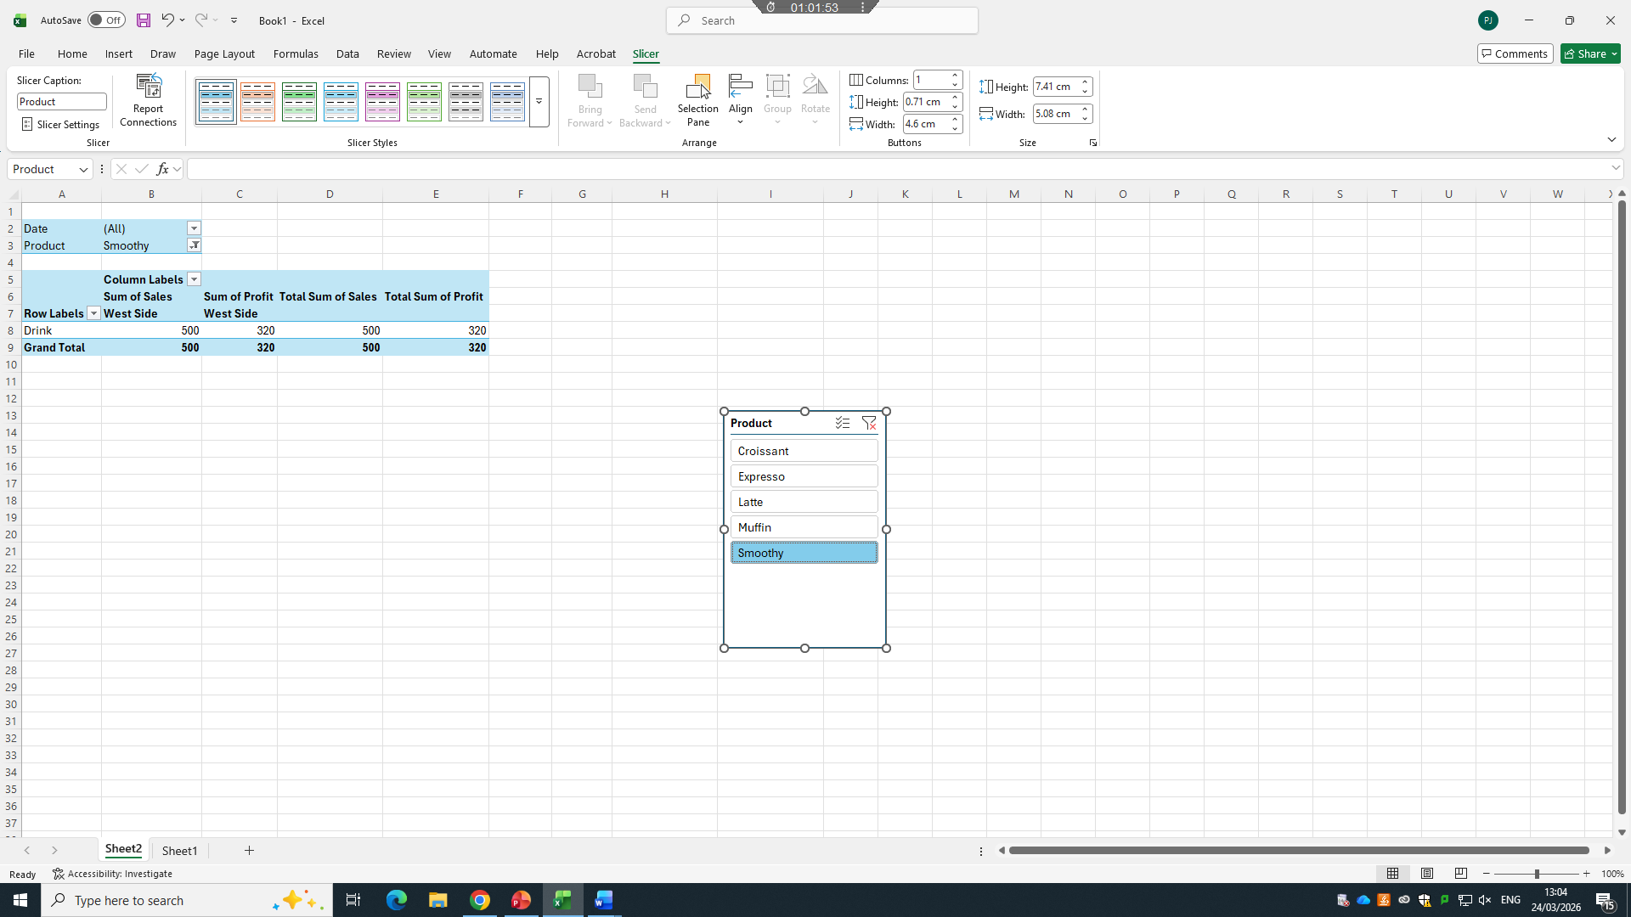
Figure 4: Pivot Table
20 marks
Test some (Two different functions/tools from two different software applications. Show the process step by step through screenshots) business-related features of Office Applications (e.g., Mail merge, IF Function, VLOOKUP, Pivot Table, Goal Seek, Database concept using MS Access) and document several screenshots with accompanying description to provide evidence of practical use.
-Note: This task is based on your own practical activity.

Mail Merge is an automation process used to create personalised, bulk documents, emails, or labels by combining a single template (master document) with a structured data source, such as an excel spreadsheet or contact list. It replaces place holders with unique data to generate personalised letters, envelopes, or emails at scale

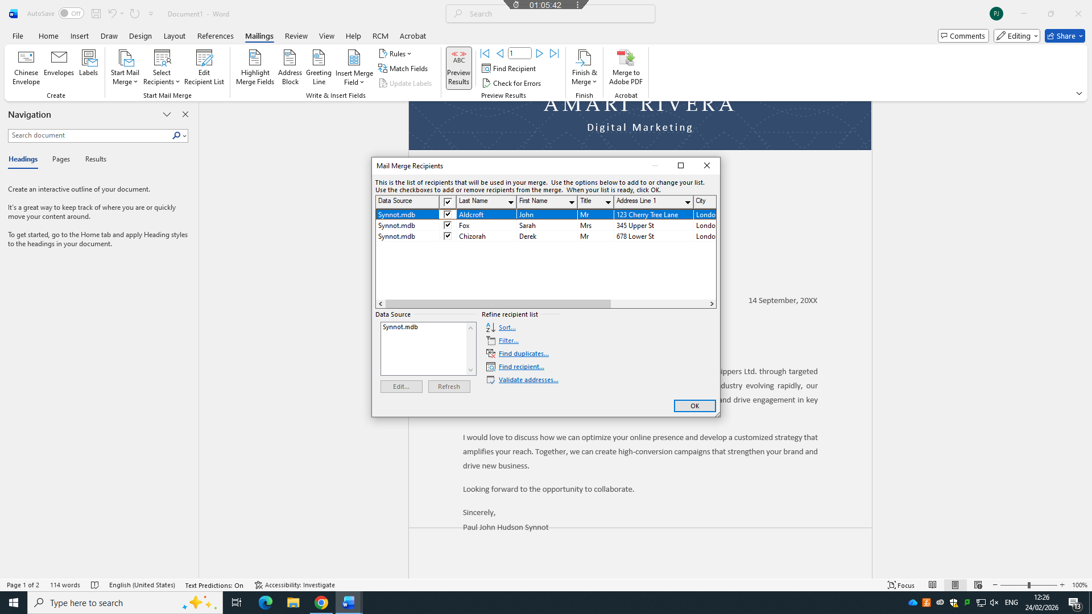
Figure 1: Mail Merge Recipient List
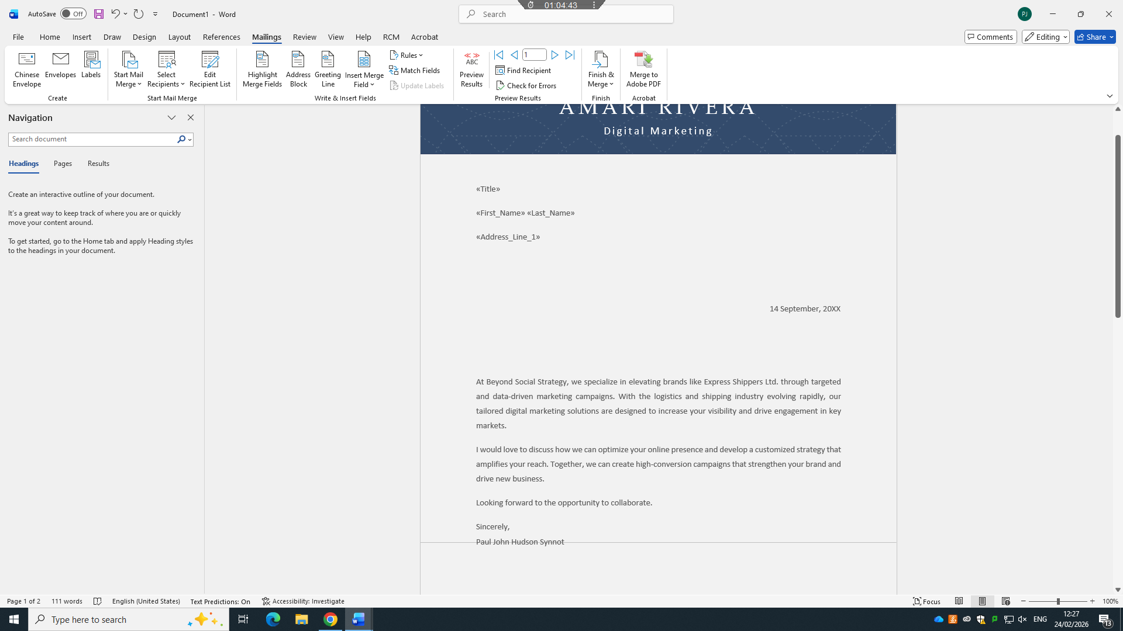
Figure 2: Mail Merge Insert Fields
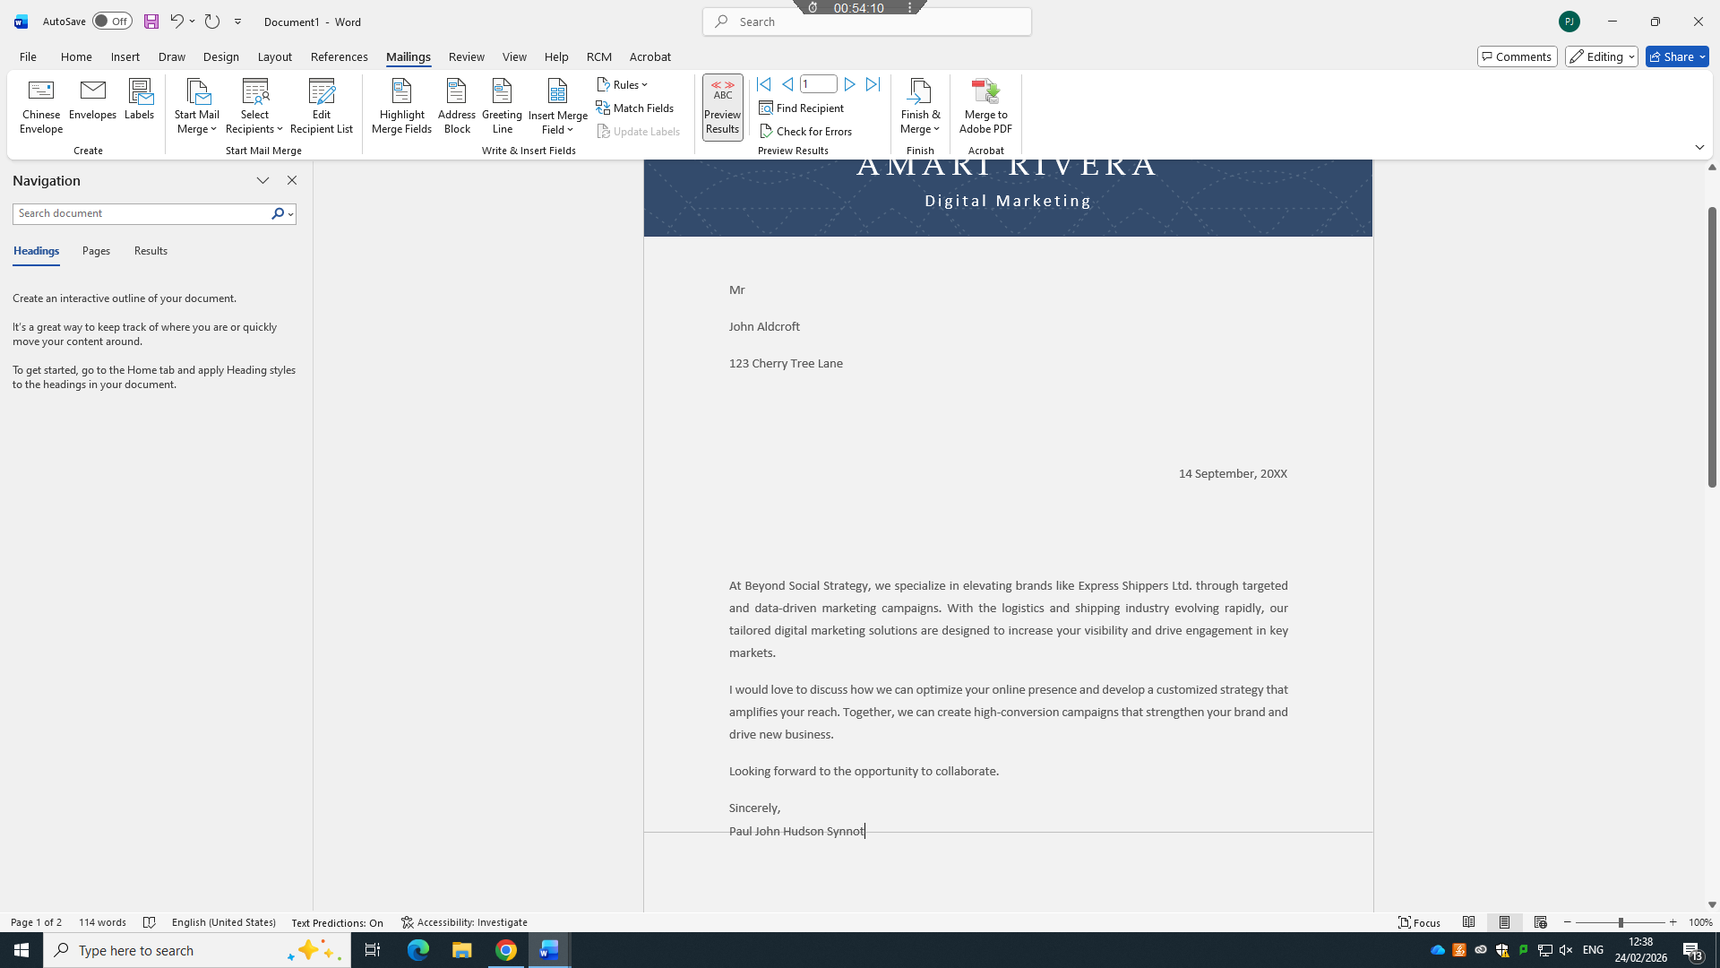
Figure 3: Mail Merge Preview Results

Task 4
(25 marks)

Communication and Collaboration applications

(Approx. 1000 words)

Re

Communication

a. 13 marks
Analyse one contemporary Communication (Email, MS Teams etc.) and one Collaboration (SharePoint, One Drive etc.) applications/tools used frequently in modern business world and document a summary of their key features, benefits and limitations using written text with some images and relevant citations. (approx. 2/3 sources)

In the modern digital workplace and personal computing landscape, productivity is no longer defined by individual software capabilities but by how seamlessly tools connect to streamline workflows. Two of Microsoft’s most enduring and widely used cloud integrated applications, Microsoft Outlook and Microsoft OneDrive define this shift. Initially launched as separate solutions for email communication and file storage, respectively, they have evolved into interconnected pillars of Microsoft 365 ecosystem, redefining how users manage information, collaborate with others, and secure their digital assets. While each tool serves as a distinct core function, their integration creates a unified environment that addresses the complex demands of remote work, cross team collaboration, and data accessibility, making them indispensable for individuals, small businesses, and global enterprise alike.
Microsoft outlook first emerged in 1997as part of Microsoft Office Suite, combining email management with calendar scheduling, contact organization, and task tracking. At its inception it was a desktop-based client designed to centralize personal information management (PIM), replacing fragmented tools that force users to switch between different programs for communication and planning. Over decades of development Outlook has transformed from a simple email application into a comprehensive communication hub. Today it exists as a desktop app, mobile application, and web-based service, all synchronized through cloud infrastructure. Its core features remain essential, robust email filtering and categorization, shared calendars that enable teams to coordinate meetings in real time, contact lists to integrate with organizational directories, and task managers that link deadlines to email conversations. For professionals, Outlook is more than an inbox, it is a command centre where work is initiated, discussed, and scheduled. It adapts to diverse use cases, from a student organizing assignment deadlines to a corporate executive managing global stakeholder communications. [13]
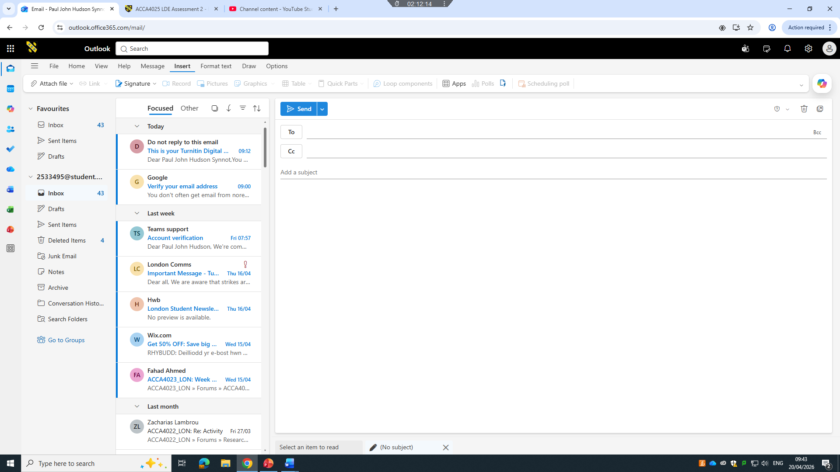
Figure 1: Outlook

Parallel to this evolution, Microsoft OneDrive was launched in 2007 as SkyDrive later rebranded to align with Microsoft’s “One” vision of unified services. Initially conceived as a consumer-focused cloud storage solution, it expanded rapidly to serve enterprise needs, becoming the backbone of file management within Microsoft 365. OneDrive’s primary purpose is to provide secure, accessible storage for documents, photos, videos, and other digital files, eliminating the limitations of physical storage devices such as hard drives and USB sticks. Its defining feature is synchronization, files saved to one drive are available across every device linked to a user’s account, allowing someone to start editing a report on a work laptop, continue on a smart phone during a commute, and finalize at home on a computer without transferring files manually. Beyond storage One Drive has become a collaboration platform, enabling multiple users to edit documents simultaneously, leave comments, and track version history capabilities that have become critical in a era where remote and hybrid work are standard practices.
The true power of these tools, however, lies in their deep integration, which breaks down traditional barriers between communication and file management. Before this integration, sharing files via email was often cumbersome, users had to download files from storage, attach them to messages, and deal with issues such as file size limits, outdated versions and cluttered inboxes. Today Outlook and OneDrive work together to solve these problems seamlessly. When composing an email in Outlook, users can choose to attach a file from OneDrive directly instead of uploading a static copy. This action creates a sharable link rather than adding bulk to the message, ensuring that recipients always access the most recent version of the file. Permissions can be adjusted instantly, users can grant view only access, editing rights, or restricting access entirely, direct from the outlook interface. This not only reduces email size but also enhances security, as it can be revoked at any time even after the email has been sent.
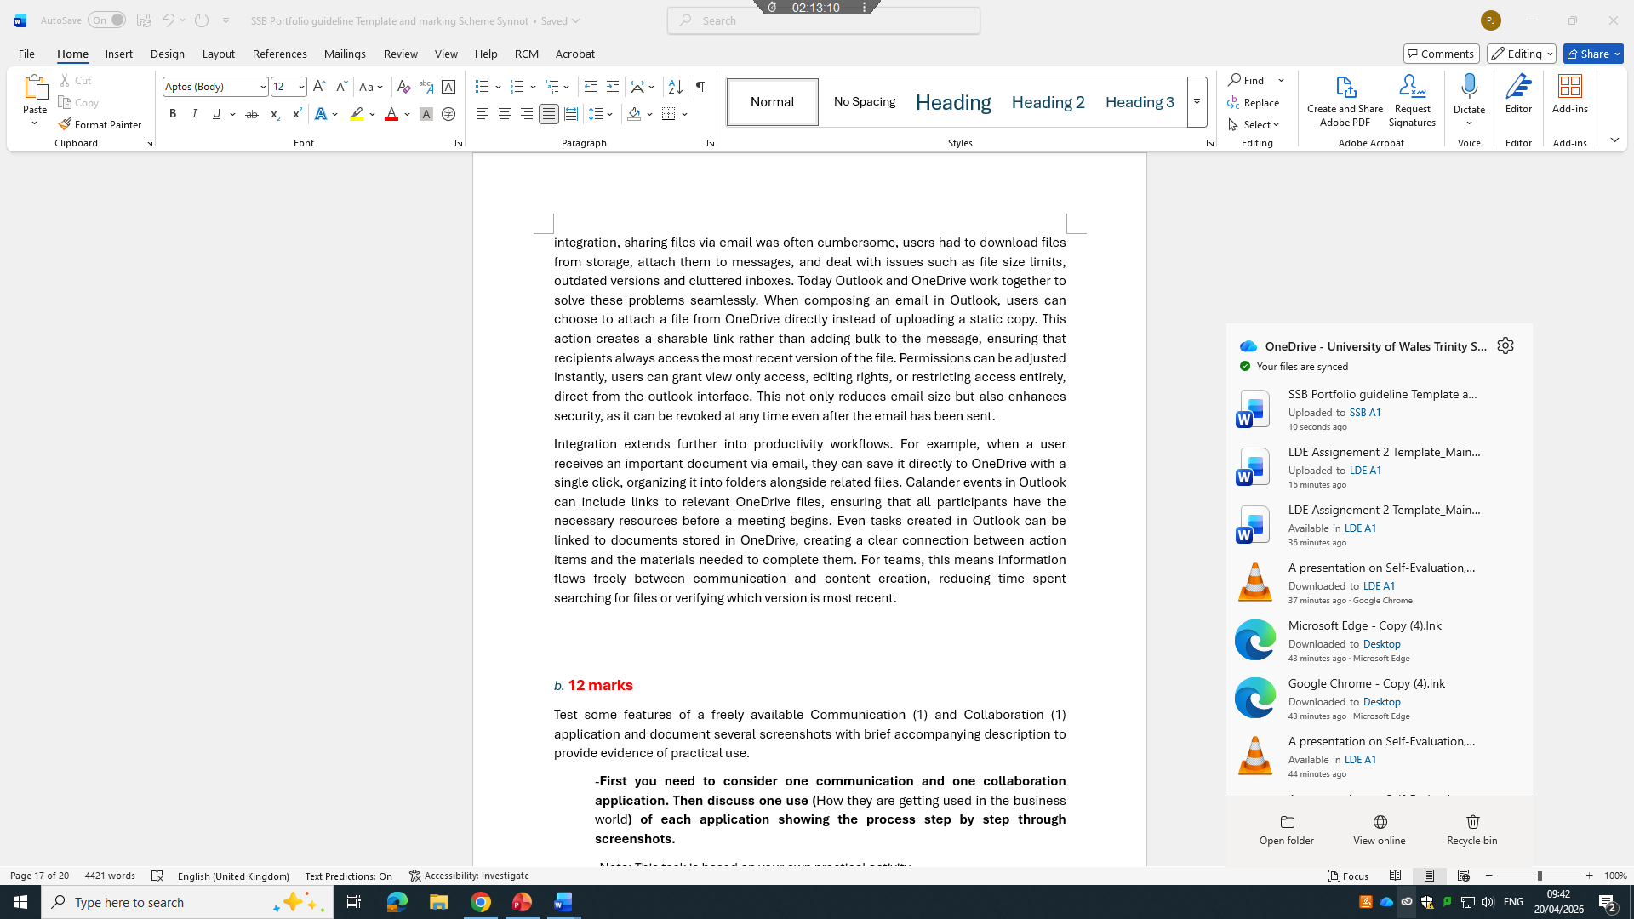
Figure 2: OneDrive

Integration extends further into productivity workflows. For example, when a user receives an important document via email, they can save it directly to OneDrive with a single click, organizing it into folders alongside related files. Calander events in Outlook can include links to relevant OneDrive files, ensuring that all participants have the necessary resources before a meeting begins. Even tasks created in Outlook can be linked to documents stored in OneDrive, creating a clear connection between action items and the materials needed to complete them. For teams, this means information flows freely between communication and content creation, reducing time spent searching for files or verifying which version is most recent [14].
Security and data management are additional areas where their combination delivers significant value. Outlook includes built in protections such as spam filters, phishing detection, and encryption, while OneDrive offers features like ransomware recovery, file restoration, and compliance tools that meet global regulatory standards. When used together, they create a layered security framework. For instance, sensitive documents shared via Outlook links benefit from OneDrive’s access logs and data loss prevention policies, allowing organizations to track who views and edits files and prevent unauthorized distribution. For individual users, this integration means personal and professional data is not only accessible but also protected against loss or misuse.
Despite these strengths, the tools are not with out challenges. Some users struggle with managing storage limits, especially when combining large email archives with extensive file collections. There can also be a learning curve for those transitioning from traditional desktop usage to cloud-based workflows, particularly when adjusting to permission settings and version control. However, Microsoft continues to refine the user experience, adding features like intelligent search that works across both Outlook emails and OneDrive files, and AI powered suggestions that recommend relevant documents based on email conversations [15].
In conclusion, Microsoft Outlook and OneDrive are far more than stand alone applications, they are complementary components of a modern productivity ecosystem Outlook organises how we communicate and plan, while OneDrive governs how we store, share, and develop content. Their integration has redefined efficiency, turning disjointed tasks into streamline processes that support collaboration and flexibility. As work and personal life become increasingly digital and interconnected, the symbiotic relationship between these two tools will remain a cornerstone of how people manage information and achieve their goals. Whether used by a student, professional, or organization, mastering Outlook and OneDrive means mastering the skills needed to thrive in todays connected world.

b. 12 marks
Test some features of a freely available Communication (1) and Collaboration (1) application and document several screenshots with brief accompanying description to provide evidence of practical use.
-First you need to consider one communication and one collaboration application. Then discuss one use (How they are getting used in the business world) of each application showing the process step by step through screenshots.
-Note: This task is based on your own practical activity.
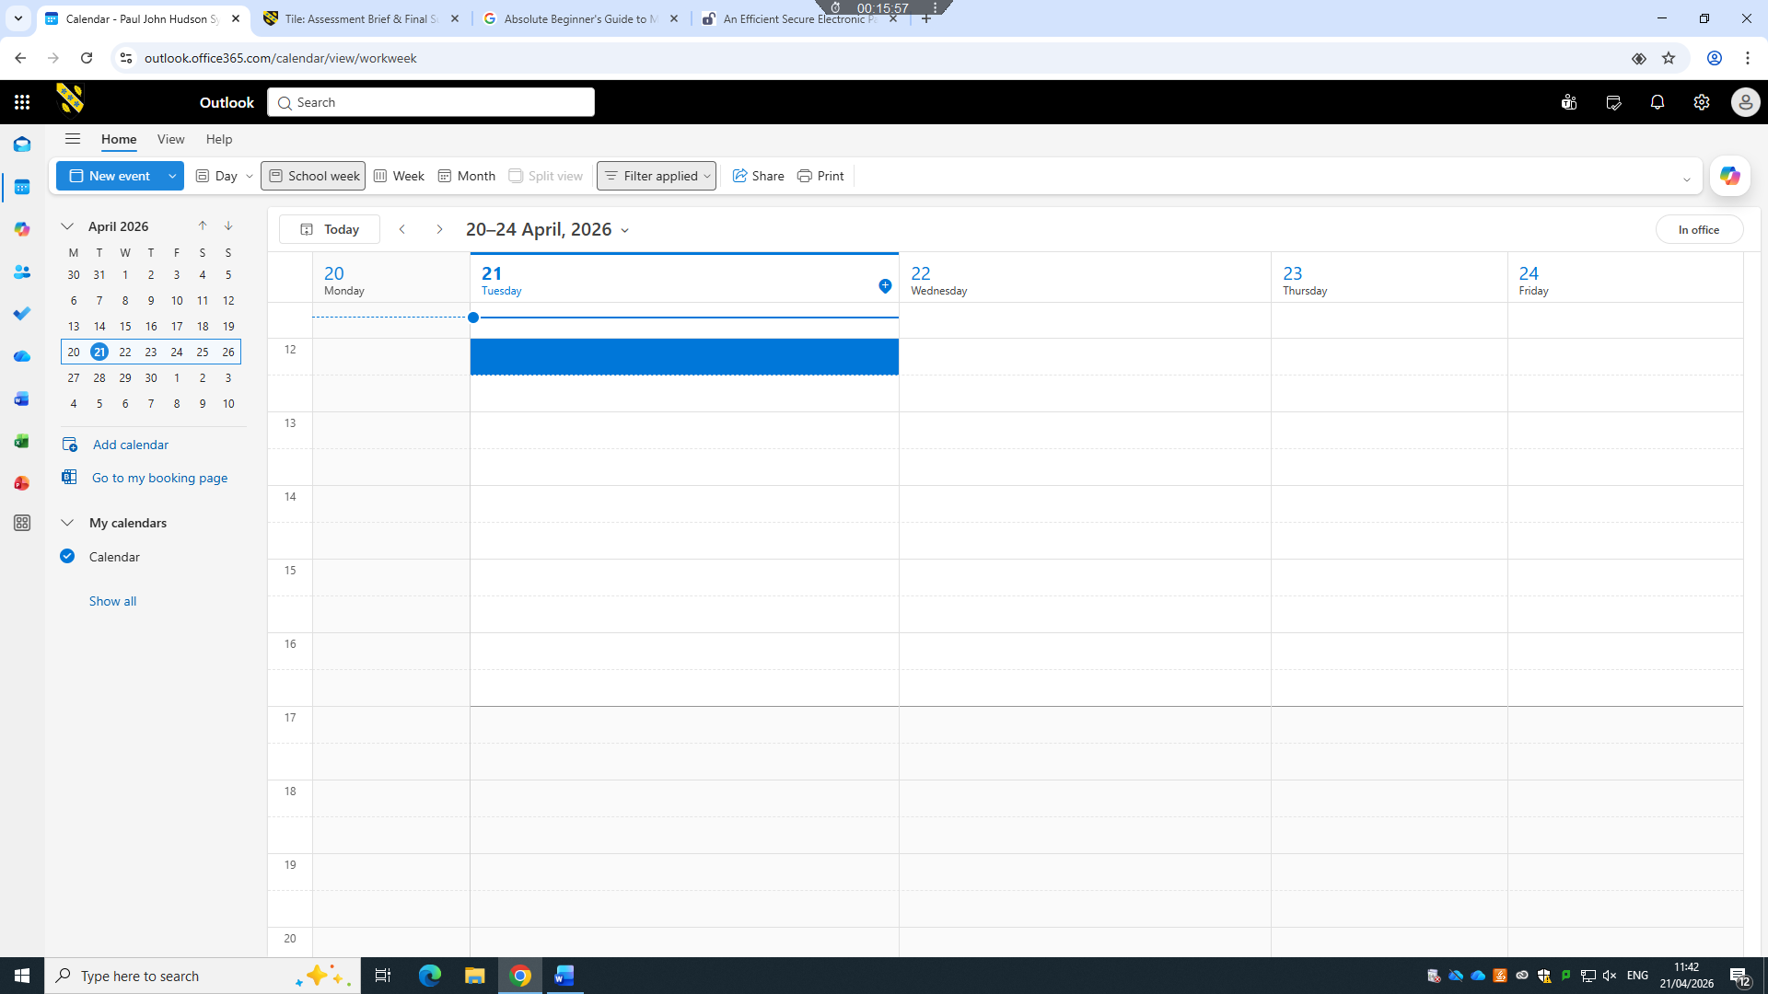
Figure 1: Outlook – Open calendar
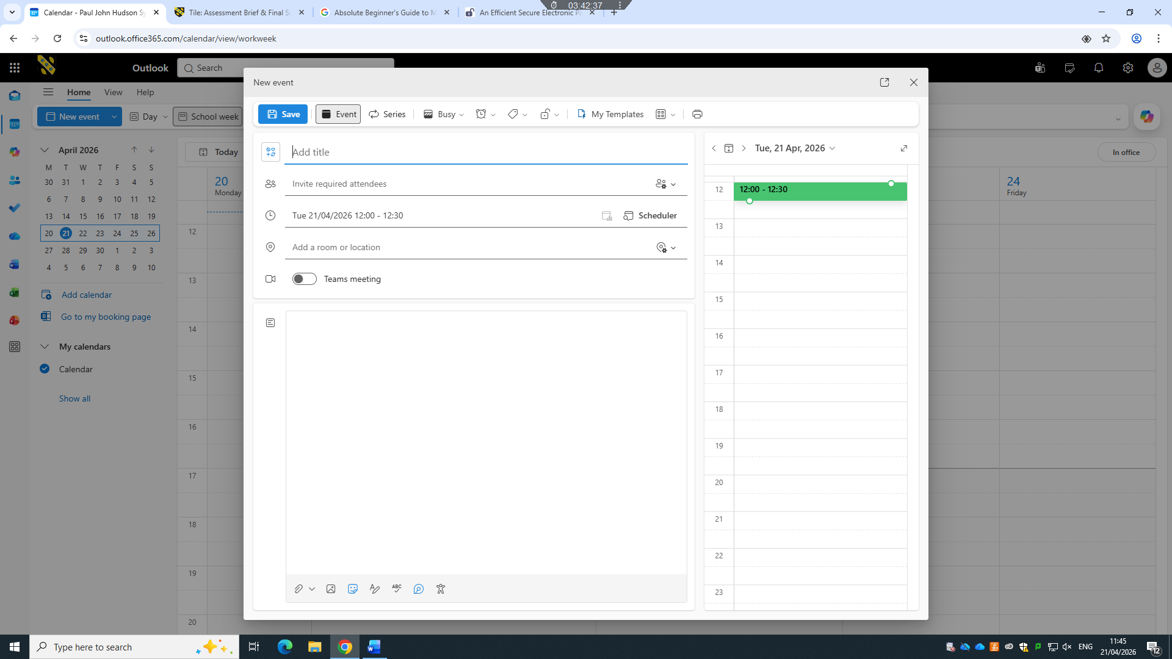
Figure 2: Outlook – Start new event
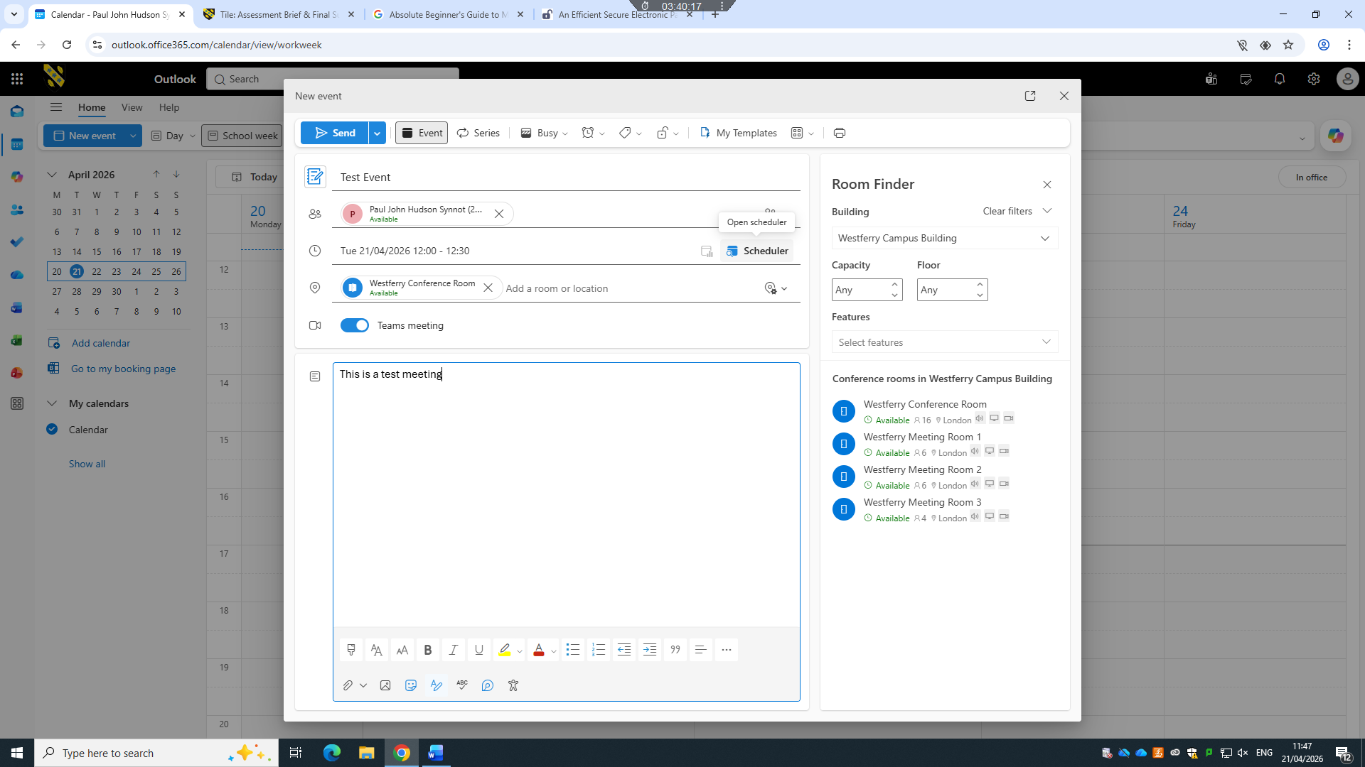
Figure 3: Outlook – Fill in all details
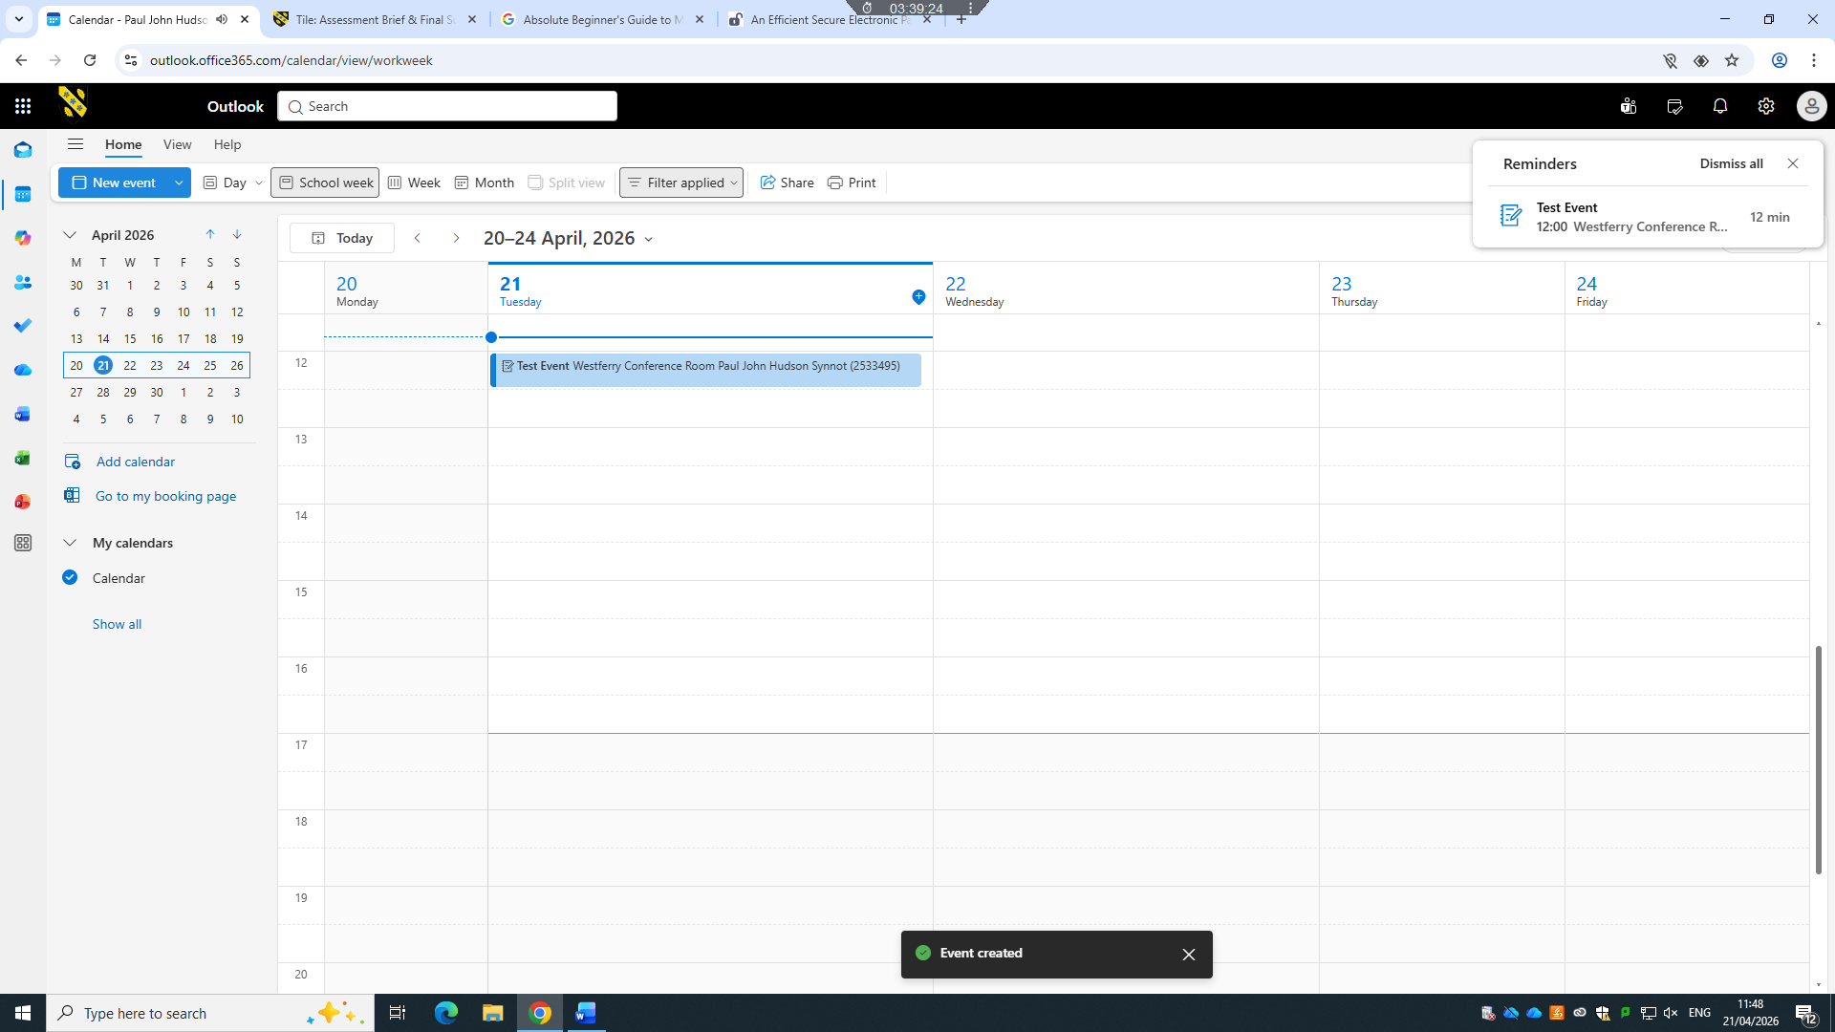
Figure 4: Outlook – Send event now seen in the calendar
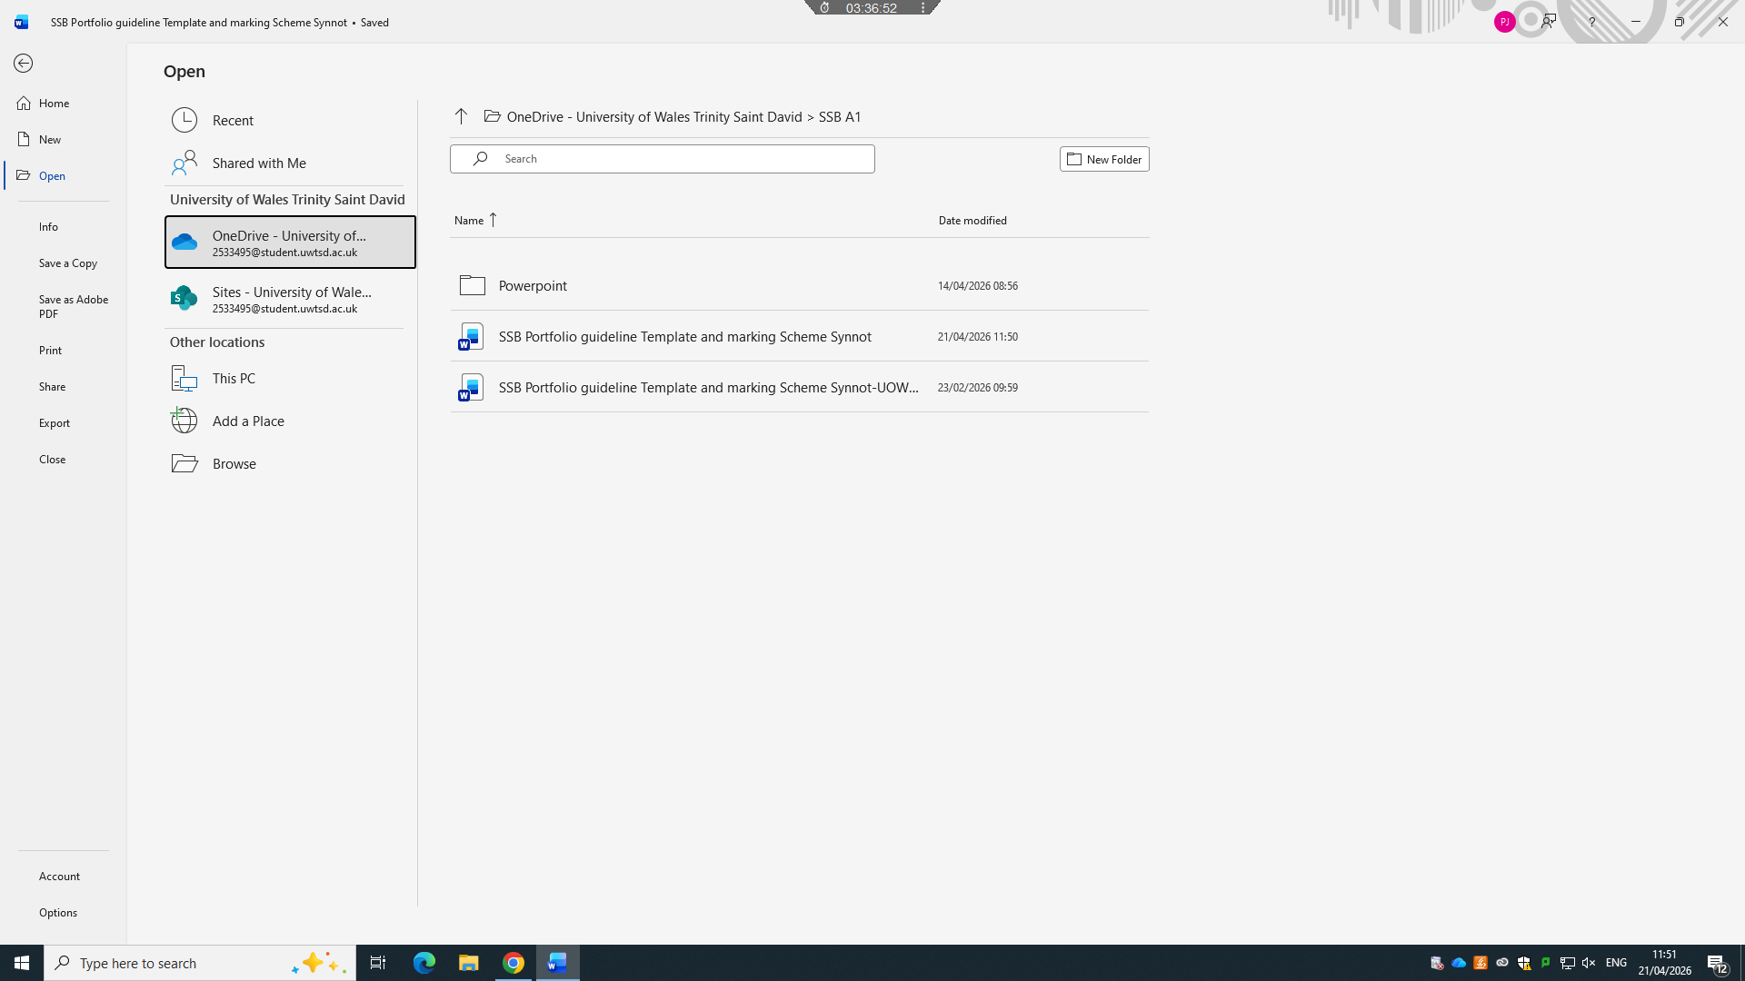
Figure 5: OneDrive – Open file
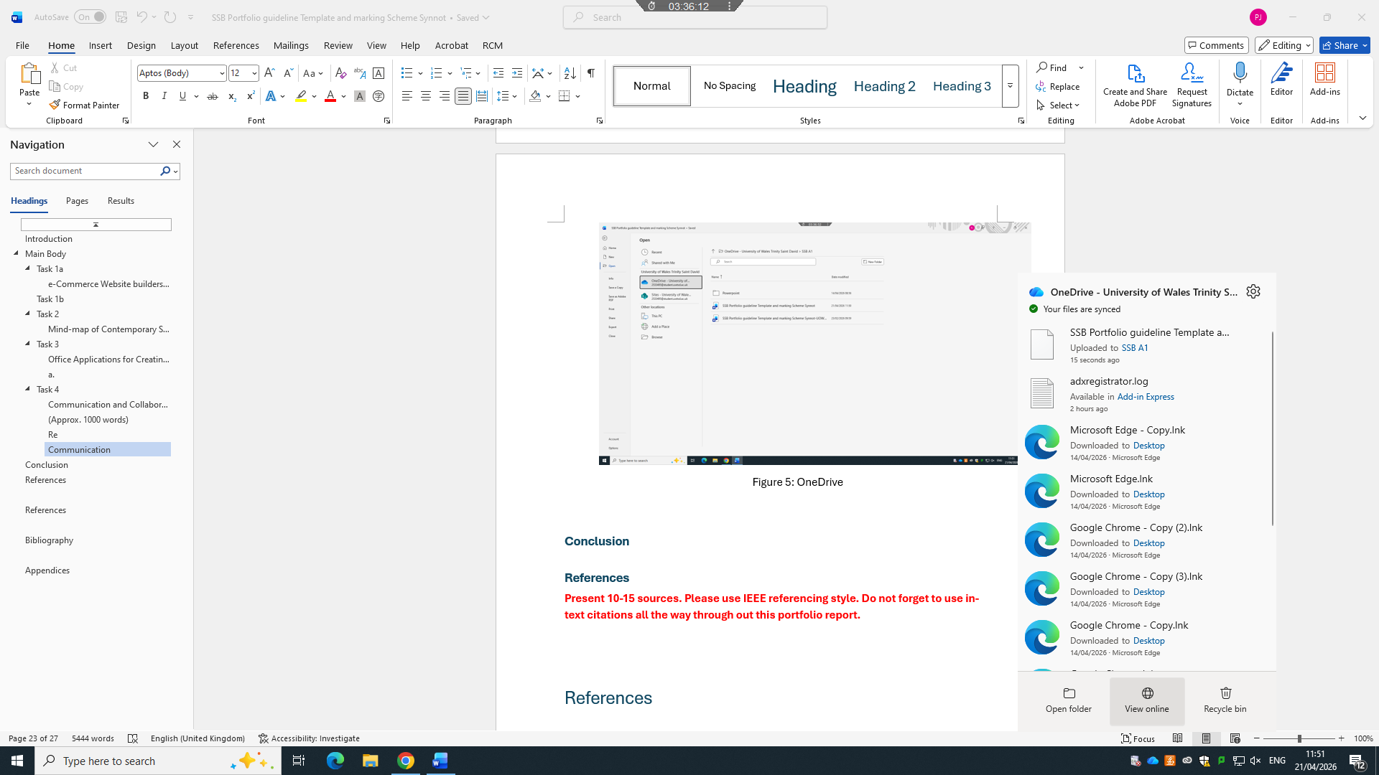
Figure 6: OneDrive – Alternate open file option

Conclusion
In conclusion software solutions have evolved from simple operational tools into fundamental drivers of business efficiency, innovation, and long-term growth. AS explored through out this course work, technologies such as mind mapping application, enterprise management systems, and collaborative platforms address core operational challenges by streamlining workflows, improving information sharing, and supporting data driven decision making. By integrating these solutions strategically, organizations can reduce costs, enhance productivity, and respond more effectively to changing market demands. Ultimately, the successful adoption of appropriate software not only optimises daily processes but also creates a scalable foundation that empowers business to remain competitive and achieve their strategic objectives in an increasingly digital landscape.

References
Present 10-15 sources. Please use IEEE referencing style. Do not forget to use in-text citations all the way through out this portfolio report.

References

Bibliography

[1] | G. Ballard, themes, The difinative guide to shopify, Melbourne : Apress, 2017.
[2] | Shopify, “Shopify,” [Online]. Available: https://help.shopify.com/.
[3] | B.-A. URS, SECURITY ISSUES AND SOLUTIONS IN E-PAYMENT SYSTEMS.
[4] | W. Bai, M. Pearson, p. kelley and M. Mazurek, “Improving Non-Experts’ Understanding of End-to-End Encryption: An Exploratory Study,” 2020. [Online]. Available: https://ieeexplore.ieee.org/abstract/document/9229664.
[5] | M. A. Ali and a. von morsel, “Designed to Be Broken: A Reverse Engineering Study of the 3D Secure 2.0 Payment Protocol,” 2019. [Online]. Available: https://link.springer.com/chapter/10.1007/978-3-030-32101-7_13.
[6] | o. Ali, “A Comparative Study: Blockchain Technology Utilization Benefits, Challenges and Functionalities,” [Online]. Available: https://ieeexplore.ieee.org/abstract/document/9317729.
[7] | Z. Shukur, “A Review on Electronic Payments Security,” Symmetry, 2020.
[8] | A. Hassan, “An Efficient Secure Electronic Payment System for E-Commerce,” Computers, 2020.
[9] | D. James, A User Manual for Benefit Cost Analysis Using Microsoft Excel, 2006.
[10] | J. J. MArshal, Beginning Microsoft Word Documents From Novice to Professional, 2006.
[11] | B. R. Gabrielle, Speaking PowerPoint The New Language of Business, 2010.
[12] | J. Eckstein and B. R. Schultz, Introductory Relational Database Design For Business With Microsoft Access, 2018.
[13] | K. Slovak, Absolute Beginners Guide to Outlook, 2003.
[14] | K. Frederiks, Outlook Business contact manager for dummies, 2007.
[15] | T. Negrino, Microsoft Office for Ipad, 2015.
[16] | T. Buzan, Mind Maps For Business.
[17] | C. Gargouri, Naatus and M. Kate, An Experiment in Mind-Mapping and Argument-Mapping: Tools for Assessing Outcomes in the Business Curriculum, 2017.
[18] | R. Rezapour-Nasrabad, Mind Map Learning Technique: An Educational Interactive, 2019.

[1] | G. Ballard, themes, The difinative guide to shopify, Melbourne : Apress, 2017.
[2] | Shopify, “Shopify,” [Online]. Available: https://help.shopify.com/.
[3] | B.-A. URS, SECURITY ISSUES AND SOLUTIONS IN E-PAYMENT SYSTEMS.
[4] | W. Bai, M. Pearson, p. kelley and M. Mazurek, “Improving Non-Experts’ Understanding of End-to-End Encryption: An Exploratory Study,” 2020. [Online]. Available: https://ieeexplore.ieee.org/abstract/document/9229664.
[5] | M. A. Ali and a. von morsel, “Designed to Be Broken: A Reverse Engineering Study of the 3D Secure 2.0 Payment Protocol,” 2019. [Online]. Available: https://link.springer.com/chapter/10.1007/978-3-030-32101-7_13.
[6] | o. Ali, “A Comparative Study: Blockchain Technology Utilization Benefits, Challenges and Functionalities,” [Online]. Available: https://ieeexplore.ieee.org/abstract/document/9317729.
[7] | Z. Shukur, “A Review on Electronic Payments Security,” Symmetry, 2020.
[8] | A. Hassan, “An Efficient Secure Electronic Payment System for E-Commerce,” Computers, 2020.
[9] | D. James, A User Manual for Benefit Cost Analysis Using Microsoft Excel, 2006.
[10] | J. J. MArshal, Beginning Microsoft Word Documents From Novice to Professional, 2006.
[11] | B. R. Gabrielle, Speaking PowerPoint The New Language of Business, 2010.
[12] | J. Eckstein and B. R. Schultz, Introductory Relational Database Design For Business With Microsoft Access, 2018.
[13] | K. Slovak, Absolute Beginners Guide to Outlook, 2003.
[14] | K. Frederiks, Outlook Business contact manager for dummies, 2007.
[15] | T. Negrino, Microsoft Office for Ipad, 2015.
[16] | T. Buzan, Mind Maps For Business.
[17] | C. Gargouri, Naatus and M. Kate, An Experiment in Mind-Mapping and Argument-Mapping: Tools for Assessing Outcomes in the Business Curriculum, 2017.
[18] | R. Rezapour-Nasrabad, Mind Map Learning Technique: An Educational Interactive, 2019.

[1] | G. Ballard, themes, The difinative guide to shopify, Melbourne : Apress, 2017.
[2] | Shopify, “Shopify,” [Online]. Available: https://help.shopify.com/.
[3] | B.-A. URS, SECURITY ISSUES AND SOLUTIONS IN E-PAYMENT SYSTEMS.
[4] | W. Bai, M. Pearson, p. kelley and M. Mazurek, “Improving Non-Experts’ Understanding of End-to-End Encryption: An Exploratory Study,” 2020. [Online]. Available: https://ieeexplore.ieee.org/abstract/document/9229664.
[5] | M. A. Ali and a. von morsel, “Designed to Be Broken: A Reverse Engineering Study of the 3D Secure 2.0 Payment Protocol,” 2019. [Online]. Available: https://link.springer.com/chapter/10.1007/978-3-030-32101-7_13.
[6] | o. Ali, “A Comparative Study: Blockchain Technology Utilization Benefits, Challenges and Functionalities,” [Online]. Available: https://ieeexplore.ieee.org/abstract/document/9317729.
[7] | Z. Shukur, “A Review on Electronic Payments Security,” Symmetry, 2020.
[8] | A. Hassan, “An Efficient Secure Electronic Payment System for E-Commerce,” Computers, 2020.
[9] | D. James, A User Manual for Benefit Cost Analysis Using Microsoft Excel, 2006.
[10] | J. J. MArshal, Beginning Microsoft Word Documents From Novice to Professional, 2006.
[11] | B. R. Gabrielle, Speaking PowerPoint The New Language of Business, 2010.
[12] | J. Eckstein and B. R. Schultz, Introductory Relational Database Design For Business With Microsoft Access, 2018.
[13] | K. Slovak, Absolute Beginners Guide to Outlook, 2003.
[14] | K. Frederiks, Outlook Business contact manager for dummies, 2007.
[15] | T. Negrino, Microsoft Office for Ipad, 2015.
[16] | T. Buzan, Mind Maps For Business.
[17] | C. Gargouri, Naatus and M. Kate, An Experiment in Mind-Mapping and Argument-Mapping: Tools for Assessing Outcomes in the Business Curriculum, 2017.
[18] | R. Rezapour-Nasrabad, Mind Map Learning Technique: An Educational Interactive, 2019.

Appendices
-Supplementary information (Optional)
An appendix page/section can be used to include relevant supplementary information such as indirect supporting information to task answers, tutorial activity answers, any other evidence.
NB: Also, look at your assessment brief to see the guidance for students in completion of the tasks section, students’ feedback form for overall marking criteria and assessment criteria to understand your level of work for grading.
Thanks, and good luck.

