

University of Wales Trinity Saint David
School of Engineering
Steady State Load Transfer and Aerodynamic Loading
Jeffrey Elliss
1802644
Motorsport Engineering BEng
15 March 2020
Vehicle Dynamics, M5X00407

Contents

Table of Contents
Contents 1
Introduction 3
1.0 Aerodynamic Loading 3
1.1 Data Collection 3
1.2 Downforce 3
2.0 Load Transfer 8
2.1 Theory and Equations 8
2.1.1 Weight Transfer 8
2.1.2 Roll Angle 9
2.2 Results 9
2.3 Low Speed Tests 9
2.4 High Speed Tests 15
2.5 Antiroll Bar Testing 18
3 Analysis and Improvements 20
Conclusion 20
Maths Channels 21
Results Tables 22
References 25

Introduction

During this assignment data was collected using a simulator in two sessions. The first consisted of coast down tests to measure drag and lift forces created by a range of splitter and rear wing settings. The second test was to collect steady state cornering data with varying front and rear spring and antiroll bar stiffnesses. This data will then be compared to a set of prediction equations to determine their usefulness and errors.

1.0 Aerodynamic Loading

1.1 Data Collection
For the aerodynamic loading test, the car was allowed to coast down from a set velocity. This deceleration period will give a total resistance force figure which when the rolling resistance is taken out will give the drag force. To find the rolling resistance, for a small number of the runs the coast down was done until the car came to a halt. The very low speed part of the run is the rolling resistance as at low speeds the drag force is negligible.
For the lift data the values will be taken from the steady speed data just before the coast down test. In each test the front and rear downforce settings were varied between their minimum, middle and maximum settings.

1.2 Downforce

As the vehicle has a large rear wing the majority of the downforce is towards the rear of the car. The rear wing can be adjusted by a significant angle; much more so than the splitter at the front. Figure 1 shows the front slitter setting has a significantly smaller effect on the aerodynamic balance than the rear wing setting.
The center of pressure never exceeds 0.5 meaning that the car will always have more grip at the rear in mid and high-speed corners. As well as this according to Katz (2006) as the center of pressure is behind the center of gravity of the vehicle, the car will be inherently stable when travelling at high speed and affected by cross winds.

Figure 1-Centre Of Pressure
The centre of pressure moves with the varying settings; the greatest factor for moving it is the rear wing setting. The rear wing creates the majority downforce and has many more setting positions than the front aerodynamic devices. This is because on a production-based car it is more difficult to apply aerodynamic devices such as wings than at the rear. On the Aston Martin DB9 Race car the front devices include, canards and a large splitter. Contrastingly the rear devices include a large rear wing and a large diffuser, this combination giving a much greater surface are for aerodynamic devices. The rear focused centre of pressure will produce mid to high speed understeer, making the car easier to drive as it will be less sensitive to throttle inputs due to the higher rear vertical loads generating more traction.

Figure 2-Aerodynamic Loads Compared With Total Tire Loads
Figure 2 shows how significant the aerodynamic loads are when compared with the total vertical tire forces. At peak aerodynamic loads the forces contribute 28% of the total loads. These measurements are taken at 128 mph. This can be considered to be a high cornering speed at about 10 mph slower than going up eau rouge.

Figure 3-Cla against aerodynamic settings

Figure 3 shows the increase in negative lift as the front and rear settings are becoming more aggressive. It also shows that the overall coefficient of lift is predominantly dictated by the rear wing setting.

Figure 4-Aerodynamic Efficency Against Front and Rear Settings
Figure 4 shows the efficiency of the vehicles aerodynamic package. The more aggressive the settings the lower the efficiency. As the higher downforce settings rely on changing the angle of attack of the rear wing.

Figure 5-Cda against front and rear aerodynamic settings
The drag of the vehicle increases with both front and rear aerodynamic settings changes, more so with rear changes as there is greater range of adjustment available there.

2.0 Load Transfer

When changing direction or accelerating in any way the balance of forces on a vehicle’s contact patches. The work following will describe how this movement of loads changes according to the distribution of roll stiffnesses. This will be changed by varying the antiroll bar and spring stiffnesses. The test performed is a steady speed test, which will prevent the dampers from having an effect on the data by ensuring that the suspension is not moving. The dampers do not affect the data when the suspension is not compressing or elongating as they work by passing liquid through an aperture, the resistance is based on the speed which the damper either compresses or expands.

2.1 Theory and Equations

2.1.1 Weight Transfer
The prediction equations used can be split into three components: elastic, sprung geometric and unsprung geometric weight transfers.

$WTe=\frac{Kw*T*θ}{2}$ Equation 1-Elastic Weight Transfer

Equation 1 describes the force created by the relationship between wheel rates and roll angle. The wheel rate includes both spring and antiroll bar rates measured in N/m. When changing these rates, the amount of force transferred by the cars roll will change. By adjusting spring and roll bar rates an engineer can tune the balance of a car to suit driver preference. This equation is applied individually to both the front and rear of the vehicle, however, does not account for chassis flex as it assumes that the roll angle for both ends is the same.

$WTGs=\frac{Ms*a_{y}*h}{T}$Equation 2-Sprung Mass Geometric Weight Transfer

Equation 2 describes the weight transfer resulting from the sprung mass acting about the cars roll centre. This form of weight transfer depends on the sprung mass and its roll centre height at each end of the car, adjusting the ride height will increase or decrease the total geometric weight transfer. Equation 2 also assumes that the mass all acts about one axis which is not true. Heavy parts like the engine, driver and gearbox will act at different heights. (Deakin, 2000 p5) This varying height of masses will change the way that the chassis twists due to lateral acceleration and create inaccuracies in our equations which assume the mass acts around the front and rear roll centres only.

$WTGus=\frac{M_{us}* a_{y}* r_{w}}{T}$ Equation 3-Unsprung Mass Geometric Weight Transfer
Equation 3 assumes that the unsprung mass acts around the centre of the wheels, this is reasonable as the majority of the unsprung mass is the wheel, tire, brake disk and hub. An error may occur here also as during cornering the effective radius of the tyre will change as the sidewall deflects. The amount of deflection will change with tyre pressure, total lateral forces and the rigidity of the tyre carcass. Another possible source of error here is the geometry of the suspension systems, the Aston Martin DB9 studied here uses double wishbone suspension. This means that as the suspension moves up and down the wheel will move through an arc defined by the length of the upper and lower wishbones. Thereby changing the track of the vehicle and the angle of the contact patch to the ground.

2.1.2 Roll Angle

Theoretical roll angle is calculated by Equation 4. Motec outputs a gyro measured roll angle from the simulator data, the two figures follow the same trends when the vehicle corners however theoretical roll angle is calculated to be much less than the gyro roll angle. As shown in equation 4 the theoretical roll angle is calculated based on the vehicle track, the difference in height between the roll centre and the centre of gravity and the front and rear wheel rates. Other factors that may affect the roll angle measured such as tyre deflection, the geometry of the suspension system and the fact that the roll centre will migrate laterally as the suspension deflects and the car rolls.

$θ=\frac{M_{s}*a_{y}*H}{\left(\frac{T_{f}^{2}*K_{wf}}{2}\right)+\left(\frac{T_{r}^{2}*K_{wr}}{2}\right)}$Equation 4-Theoretical Roll Angle

2.2 Results
The following sections detail the results of the steady state load transfer tests and suggest why errors occur.

2.3 Low Speed Tests
These tests were at a set speed of 27.6 m/s, this value was set in the test plan, however during the testing process it was realised that using a speed below the cars limit at a given corner radius would not show meaningful results for understeer and would show smaller changes in weight transfer than running more quickly.

Figure 6-Comparison of measured and predicted front load transfer for the first data set
The trends shown on figure 6 are as expected, the roll stiffness distribution moving forward produces more load transfer at the front as the same roll angle will produce more force from the higher spring rate springs. The majority of this change comes from the elastic element of the weight transfer. There is a significant error in the total amount of weight transfer seen between the measured and predicted numbers. This is a result of the simplifying assumptions made when constructing the prediction equations.

Figure 7-Percentage error of front Load Transfer

Note that as the total load transfer on the front axle increases the percent error between the predicted and the actual load transfers reduces.

Figure 8-Rear Load Transfer and Percentage error
As the roll stiffness distribution moves forwards the rear weight transfer reduces in both measured and predicted data sets. This trend is expected as in equation 1 the load transfer at each axle is dependent on the wheel rate at that axle. Once again the percentage error between the measured and predicted values reduces as the total weight transfer at the axle increases.

Figure 9-Magic Number, predicted and calculated with percentage error.
Magic number represents the distribution of load transfers across the front and rear axles. It is useful in determining the balance of a vehicle and thereby predicting the effects of setup changes. The prediction equations over predict the value of the magic number, although they show the same trend as the magic number calculated from the measured load transfers.

Figure 10-Magic Number and understeer for test 1
Only this graph for this data set has understeer as it is a constant value. This is due to the speed of the test being too low for the vehicle balance to begin affecting the required inputs from the driver. The value for understeer is not 0 this may be an error in the calculation of theoretical steer percentage, most likely in the calculation of Ackerman angle.

2.4 High Speed Tests

Figure 11-Raw front load transfer data and understeer figures from the high speed tests.
The raw data appears to show the front load transfer decreasing as roll stiffness decreases, this contradicts the trend shown in figure 6 and also the trend of magic number for this data set shown in figure 13. This is not an error in the maths channels or in the way this data was plotted. The odd behavior is due to the total weight transfer of these runs increasing skewing the data shown. This is evident when looking at the trend of the magic number. This can be overcome by correcting the front load transfer values all to be relative to the same total weight transfer.

Figure 12-Front weight transfer figures corrected for the fluctuations in total load transfer.
Figure 12 re plots the front load transfer data, it corrects for the change in total weight transfer by taking a mean of the total weight transfers and using the ratio between that mean and each runs load transfer and multiplying the front load transfer by that factor as shown in equation 5. The new trend shown matches with the trend of the first data set for both predicted and measured load transfers. The same idea was applied to rear weight transfer but as the changes in rear weight transfer are significantly smaller the trends shown did not change.

${WT}_{corrected}={WT}_{f}*\frac{Mean Total WT}{Total WT}$Equation 5 -Corrected Front Load Transfer for Total Load Transfer Changes

Figure 13-High Speed rear load transfer and error figures
Again, here the percentage error is lowest when the load transfer is maximum. The trend shows between data sets as well with the higher loads transfers in figure 13 being 23.6% from the predicted number. With the smallest error of the lower speed data set being 30.9%.
It is important to note that in these high-speed tests there are only three data points to discern trends from and as such any trends identified may be incorrect. However, comparing the trends of the high and low speed tests suggests that there is not a gross error in the high speed data.

Figure 14-Magic Numbers understeer
When vertical load is applied to tyres the total lateral force they can provide increases until a certain point. At which tyre deformation begins reducing the efficiency with which they react to lateral forces. The efficiency with which they react to these forces can be plotted as a performance curve (Rowley, 2004 ch2,p9). This means that where the load transfer occurs will change which tyres are loaded. More weight transfer at the front creating a more understeer dominated handling as the tyres are further along the performance curve. Figure 14 shows magic number, the ratio between the front and total weight transfers of a vehicle.

2.5 Antiroll Bar Testing
This range of test were also at too low a speed to gain meaningful understeer data and as such it is not included in the graphs.

Figure 15-Antiroll Bar Predicted and measured front weight transfers
The same trend with roll stiffness and load transfer happens in this data, to a greater degree as the changes in roll stiffness are more pronounced.

Figure 16-Plot showing the effects of changing antiroll bar and spring settings on magic number.
Figure 16 shows the effects of changing antiroll bars on the balance of the car. The weight transfer shifting about significantly according to the antiroll bar settings, the effect of the antiroll bar changes on steady state cornering are much the same as the spring rate changes.

3 Analysis and Improvements
It is possible to model a vehicle more accurately than the prediction equations used here describe, accounting for suspension geometry characteristics, tyre deflection etc. For example, a “Linkage model” which defines the way in which the wheel moves according to the way in which they are constrained relative to the vehicle. (Blundell, 2004 p335) Using a model like this and including a method for modelling in more detail the location of heavy objects such as the engine would more accurately represent the roll forces induced when cornering as each produces a moment at a different distance from each axle and at a different height.
Understanding how a tyre carcass will deflect when loaded laterally and vertically has been subject to significant amount of research. When lateral loads are applied tyres are subject to shear stresses and the sidewall will deflect, reducing their rolling radius.(Rowley, 2005 ch2 p17). Finite element analysis could be applied to each tyre in each loading scenario to find the tyres new shape. (SAE International, 1997). Applying this in a model would be very computer intensive, a better way may be to create the model and plot the deflections and reaction forces at a set of points and use the plot as an approximation of the actual deflection in a vehicle model.

Conclusion

The predictive equations used are an effective method of determining the effects of a setup change with regards to vehicle balance, although numerically they do not give accurate values, they represent the trends of the measured data effectively.

Maths Channels
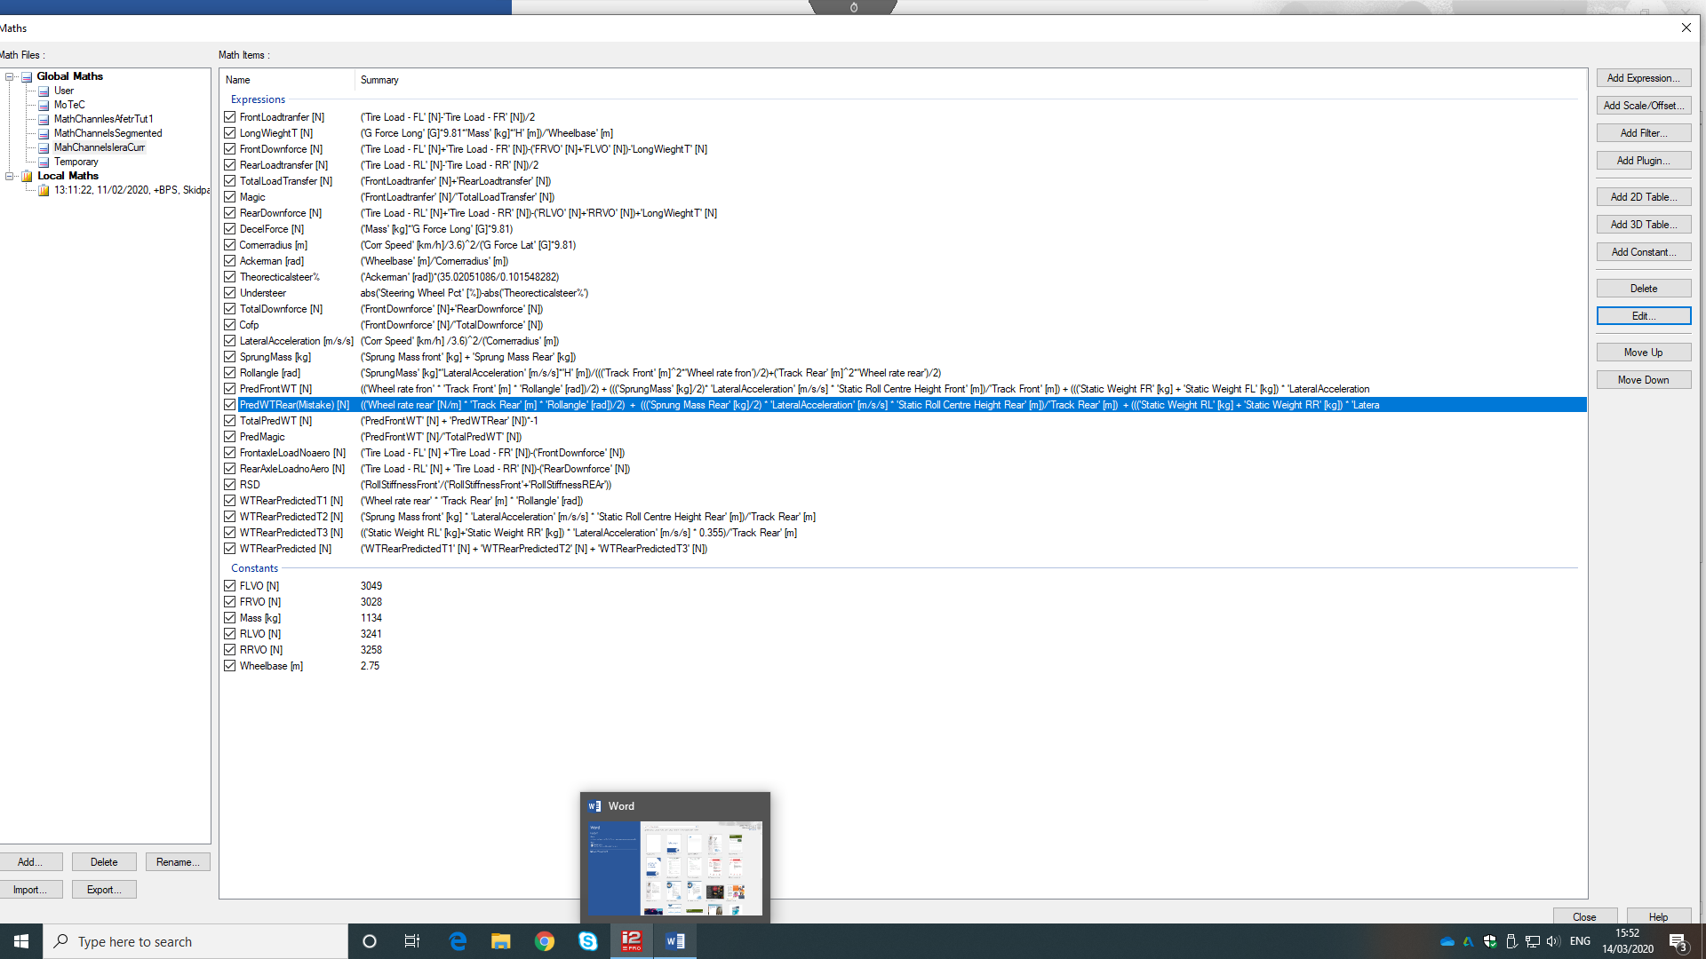
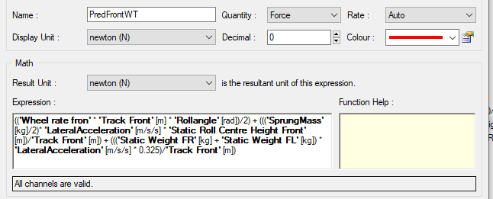

Results Tables
Table 1-Front Load Transfers
75m Radious |  | Measured | Pred
 | Rs Dist | WT Front | WT Front
min/max | 0.6737 | 1450 | 1269
mid/max | 0.6876 | 1471 | 1290
max | 0.7006 | 1484 | 1309
min/mid | 0.7056 | 1495 | 1320
mid | 0.7187 | 1488 | 1316
max/mid | 0.7309 | 1526 | 1358
min | 0.74 | 1529 | 1365
mid/min | 0.7521 | 1582 | 1411
max/min | 0.7633 | 1599 | 1430
50 Rad
min/max | 0.6737 | 2434 | 2074
mid | 0.7187 | 2450 | 2036
max/min | 0.7633 | 2374 | 1921
ARB
min/max | 0.5401 | 1386 | 1089
min | 0.7031 | 1543 | 1332
mid | 0.7036 | 1523 | 1325
max | 0.7146 | 1516 | 1340
max/min | 0.8347 | 1700 | 1548

Table 2-Rear Load Transfers
75m Radious |  | Measured | Pred
 | Rs Dist | WT rear | WT rear
min/max | 0.6737 | 1099 | 759
mid/max | 0.6876 | 1077 | 734
max | 0.7006 | 1054 | 710
min/mid | 0.7056 | 1055 | 703
mid | 0.7187 | 1016 | 667
max/mid | 0.7309 | 1008 | 657
min | 0.74 | 985 | 636
mid/min | 0.7521 | 987 | 628
max/min | 0.7633 | 970 | 609
50 Rad
min/max | 0.6737 | 1514 | 1156
mid | 0.7187 | 1437 | 1033
max/min | 0.7633 | 1311 | 885
ARB
min/max | 0.5401 | 1281 | 1033
min | 0.7031 | 1036 | 715
mid | 0.7036 | 1035 | 710
max | 0.7146 | 1033 | 689
max/min | 0.8347 | 857 | 485

Table 3-Magic Numbers And Total Weight Transfers
75m Radious
 | Rs Dist | Pred Magic | Magic | Pred total | Total
min/max | 0.6737 | 0.626 | 0.569 | 2028 | 2549
mid/max | 0.6876 | 0.637 | 0.577 | 2024 | 2548
max | 0.7006 | 0.648 | 0.585 | 2019 | 2538
min/mid | 0.7056 | 0.652 | 0.586 | 2023 | 2550
mid | 0.7187 | 0.664 | 0.674 | 1983 | 2504
max/mid | 0.7309 | 0.674 | 0.602 | 20156 | 2534
min | 0.74 | 0.682 | 0.608 | 2001 | 2514
mid/min | 0.7521 | 0.692 | 0.616 | 2039 | 2569
max/min | 0.7633 | 0.702 | 0.622 | 2039 | 2569
50 Rad
min/max | 0.6737 | 0.642 | 0.617 | 3230 | 3948
mid | 0.7187 | 0.663 | 0.63 | 3069 | 3887
max/min | 0.7633 | 0.685 | 0.644 | 2806 | 3685
ARB
min/max | 0.5401 | 0.513 | 0.52 | 2122 | 2667
min | 0.7031 | 0.651 | 0.598 | 2047 | 2579
mid | 0.7036 | 0.651 | 0.595 | 2035 | 2558
max | 0.7146 | 0.66 | 0.595 | 2029 | 2549
max/min | 0.8347 | 0.761 | 0.665 | 2033 | 2557

References

Warren J Rowley. (2004) An Introduction To Race Car Engineering. 3rd Edition

John C Dixon. (1991) Tyres, Suspension And Handling

Blundell and Harty. (2004) Multibody Systems Approach to Vehicle Dynamics Oxford: Elsevier Butterworth-Heinemann

SAE International. (1997)Validation of a FEA Tire Model for Vehicle Dynamics Analysis and Full Vehicle Real Time Proving Ground Simulations Available at: https://saemobilus-sae-org.ezproxy.uwtsd.ac.uk/content/971100/

Andrew Deakin. (2000) ‘The Effect of Chassis Stiffness on Race Car Handling Balance’ SAE Motorsports Engineering Conference & Exposition 2000 Deaborn Michigan Available at: https://saemobilus-sae-org.ezproxy.uwtsd.ac.uk/content/2000-01-3554/

Joseph Katz. (2006) New Directions In Race Car Aerodynamics. 2nd Edition

