building information modelling
BIM Theory

Mark Preston – ID 2223676
HND / BSc Construction Management

Contents Page

BIM Maturity Measures Letter for Ysgol Clasdir Project - Pages 2, 3, 4

Appendix: Level of Information Need (LOI) and Level of Detail (LOD) – Pages 5, 6, 7, 8, 9, 10, 11,12

Reference Pages 12,13

ProForm Consultants Ltd
IQ Building,
Swansea,
SA1 8EW,
United Kingdom,
Tel: 01792 481000
Email: pfc@uwtsd.co.uk

01 January 2025

Merthyr County Council Civic Centre,
Castle Street,
Merthyr Tydfil,
CF47 8AN

RE: BIM Maturity Measures for Ysgol Clasdir Project

Dear Mr J Bloggs,

We are privileged to have been commissioned by Merthyr County Council as lead consultant to deliver the ‘state of the art’ Welsh medium infant school and adjoining community hall through the Sustainable Communities for Learning Programme. ProForm Consultants Ltd. is committed in making sure that this project meets the appropriate standards of Building Information Modelling (BIM) maturity and provides value throughout its development.

BIM maturity is a vital part of modern construction projects, making sure that everyone involved works together effectively and making sure that the project information is accurate as well as accessible. For this project at Ysgol Clasdir, we will aim on attaining BIM Level 2 maturity, which is in line with the UK BIM Framework standards of ISO 19650.

To show our competency in achieving BIM maturity requirements, we will apply the following measures:

- Experienced Professionals – we boast a diverse team of experienced professionals in BIM, to include architects, engineers and project managers. They all practise BIM tools and processes on a regular basis and have delivered many successful projects. We always make sure all the necessary expertise is in place to meet the projects’ needs.

- BIM Execution Plan (BEP) – A complete BEP will be produced to define the project-specific BIM objectives, roles, responsibilities and processes. This BEP will assist the basis of our BIM implementation strategy, making sure everybody involved are in sync and that project information is effectively managed. This plan will be consistently updated and communicated to make sure everything in is line with the project objectives. (National Institute of Building Sciences, 2024)

- Training & development – Our team will undergo Continuous training and development meetings will be run for all our professional employees to make sure they keep up to date with the newest BIM standards and technologies such as ISO 19650 which was brought in in 2019. This will be in the form of online seminars, workshops and even practical training sessions to enrich their BIM skills and knowledge. This will make sure we uphold a high level of competency through the project lifecycle. (BIM COMPETENCY FRAMEWORK, 2018).

- Quality Assurance and Control – A high quality and control practise will be integrated to make sure that all project information is correct, reliable, in line with BIM standards and shares one truth. This will entail recurring audits, reviews and validation checks right through the project lifecycle. Any inconsistencies will be addressed quicky to uphold the integrity of the BIM processes. (Ocean J, 2024).

Taking into consideration the requested need for whole life monitoring of the asset via a COBie-compatible CAFM system and access to the virtual federated model in Revizto, we will use the below measures to make sure information will be shared, coordinated and managed appropriately.

- Common Data Environment (CDE) – This platform will allow us effective information exchange, version control and collaboration between everybody involved. The CDE functions as the central place for all project information, making sure all parties involved have access to the most up to date information and can work together resourcefully. This platform will operate as the source of one truth for all project-based data. (AUTODESK, 2024).

- COBie Date Drops – Repeated COBie data drops will be scheduled all the way through the project lifecycle to make sure that all asset information is taken and shared in an organised approach that works with the CAFM system. COBie Date Drops will happen at key project milestones, making sure that all important information is accessible for asset management and decision making. (Dobrowolska K, 2023).

- Revizto Integration – Revizto is where the virtual federated model will be kept, giving real time access to clash detection, project information and collaboration tools for everybody involved. Revizto will allow us to visualise and manage the project model, detect and fix clashes and make sure that all stakeholders are working together and up to date. (revizto, 2025).

- Information Management protocols – we will build and apply thorough information management protocols to make sure that all project information is managed efficiently and complies with BIM standards. This will include practises for data exchange, version control, document management, and information security. (UK BIM FRAMEWORK, 2020).
Throughout all the RIBA stages, we will deliver the essential Level of Information Need for this project. This will include specifying the Level of Information Need (LOI) and Level of Detail (LOD) for each stage, from the initial concept, right through to construction, all the way to handover and in use. Our method will make sure that the right information is readily accessible at the right time, assisting educated decision making and lowering project risks.

Appended to this letter, you will find examples of LOI and LOD at different stages of the project, in line with the RIBA Plan of Work 2020. We have also provided recommendations to be conveyed in the Employer’s Information Requirements (EIR) and Asset Information Requirements (AIR).

We look forward to working closely with Merthyr County Council and all project stakeholders to deliver a successful and sustainable project that meets the appropriate standards of BIM maturity requirements. Please do not hesitate to contact us if you have any questions or require further information.

Yours sincerely,

Mark Preston

Lead Consultant, ProForm Consultants Ltd.

Appendix: Level of Information Need (LOI) and Level of Detail (LOD)

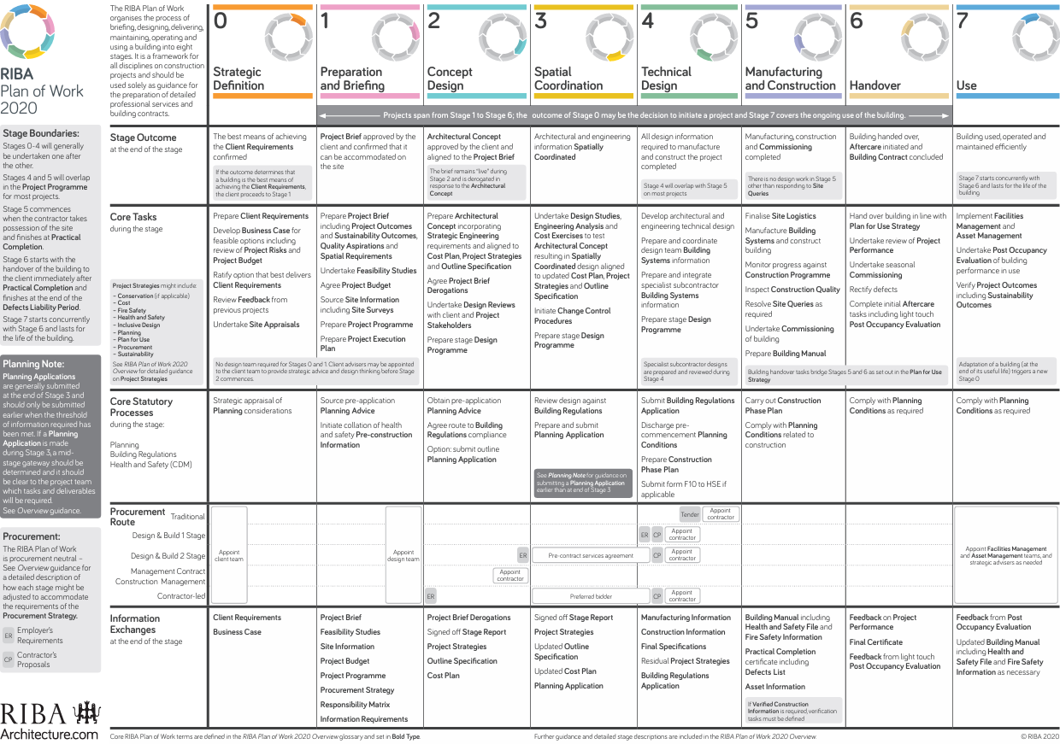

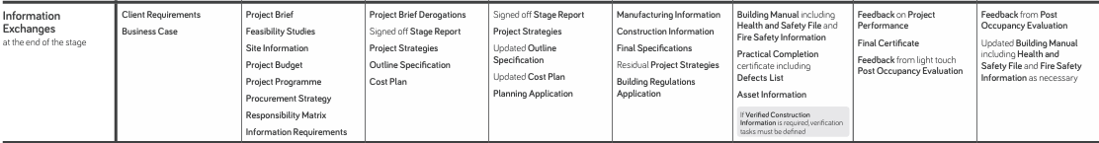
(RIBA, 2020)

RIBA Stage 0 – Strategic Definition

The first stage focuses on building a picture of Merthyr County Councils requirements and exploring possible solutions. At this primary stage, the Level of Information (LOI) and Level of Detail (LOD) is commonly low. LOI includes collecting high level information such as Merthyr County councils’ aspirations, project feasibility and original risk assessments. This information is normally non graphical and written based, offering a comprehensive overview of the project’s objectives and limitations. (NBS, 2022). LOD includes models or illustrations that are extremely basic, often concepts without detailed geometry or specifications. This is done to express the overall shape, size & location of components rather than detailed design data. (Trimble MEP, 2023).

The below picture is an example of an initial brief with a modest amount of information.

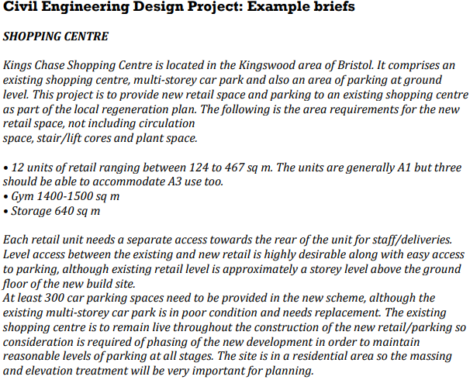

(University of Bristol, 2025)

RIBA Stage 1 – Preparation and Briefing

This stage includes understanding Merthyr County Councils’ requirements and creating the project brief. LOI includes high level spatial requirements, purposeful criteria and the whole project scope. LOD includes theoretical models showing basic geometry and key fundamentals, such as site boundaries and room layouts. We would apply this by running stakeholder workshops to gather the requirements, producing a high-level project brief and concept design, creating original 3D models using necessary geometry to visualize spatial arrangements and making sure that key project information is taken in the CDE. (NBS, 2022).

An example would be a detailed project brief outlining Merthyr County Councils’ vision, objectives, and requirements for the school and community hall.

RIBA Stage 2 – Concept Design

This stage concentrates on progressing the concept design based on the project brief. LOI includes detailed spatial layout, preliminary structural and mechanical, electrical and plumbing (MEP) designs. LOD includes initial design models with clear geometry and primary systems. We would apply this by fine tuning the concept design with involvement from the stakeholders, creating 3D models with in depth geometry to show the spatial design, developing initial structural and MEP designs, carrying out clash detection using Revizto to detect and solve possible conflicts and updating the CDE with detailed design information as well as maintaining version control. (NBS, 2022). Please see below a researched diagram of a fabric (left) and services plan (right) example at stage 2.

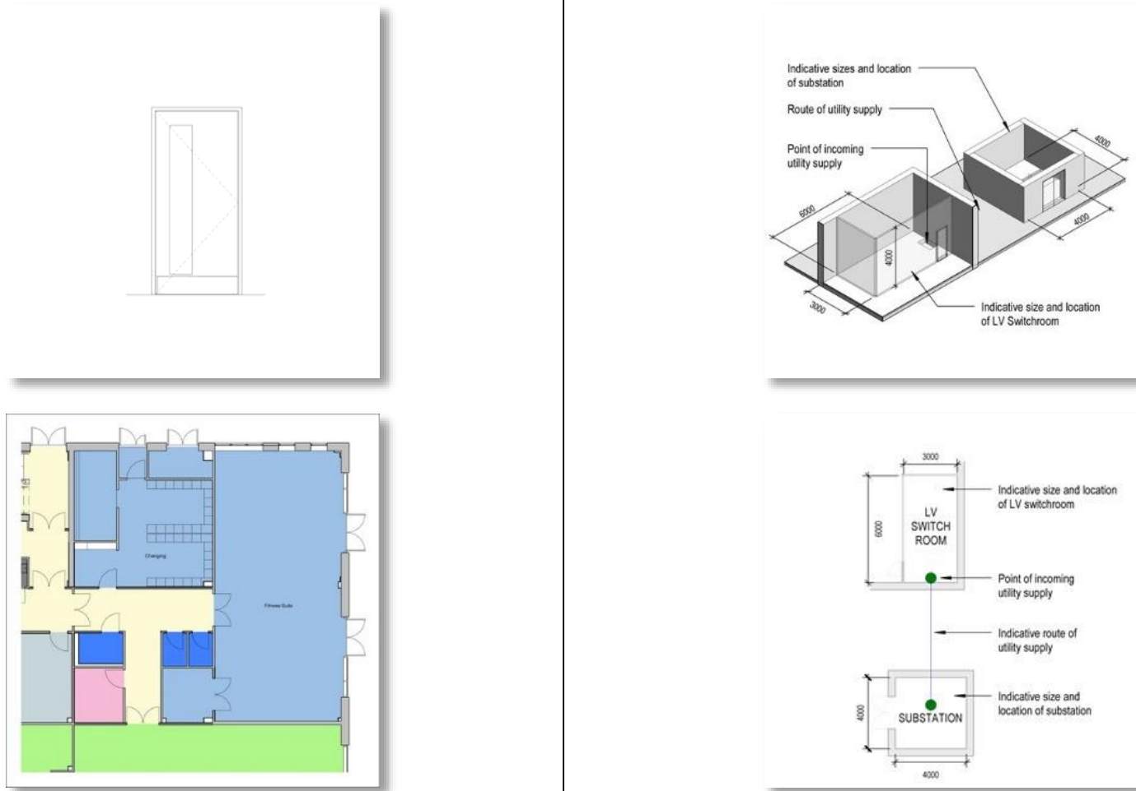
(NBS, 2022).

RIBA Stage 3: Spatial Coordination

This stage entails coordination of all the building systems and comprehensive design development. LOI includes coordination of architectural, structural and MEP systems. LOD includes coordinated models with comprehensive geometry and system interactions. We would apply this by working together with architects, engineers, and consultants to make sure that all systems are coordinated, creating coordinated 3D models showing in depth geometry and system interactions, carrying out clash detection and solve possible conflicts in the virtual federated model using Revizto, and making sure that all coordinated information is accessible in the CDE for appraisal by stakeholders. (NBS, 2022). Please see below a researched diagram of a fabric (left) and services plan (right) at stage 3.

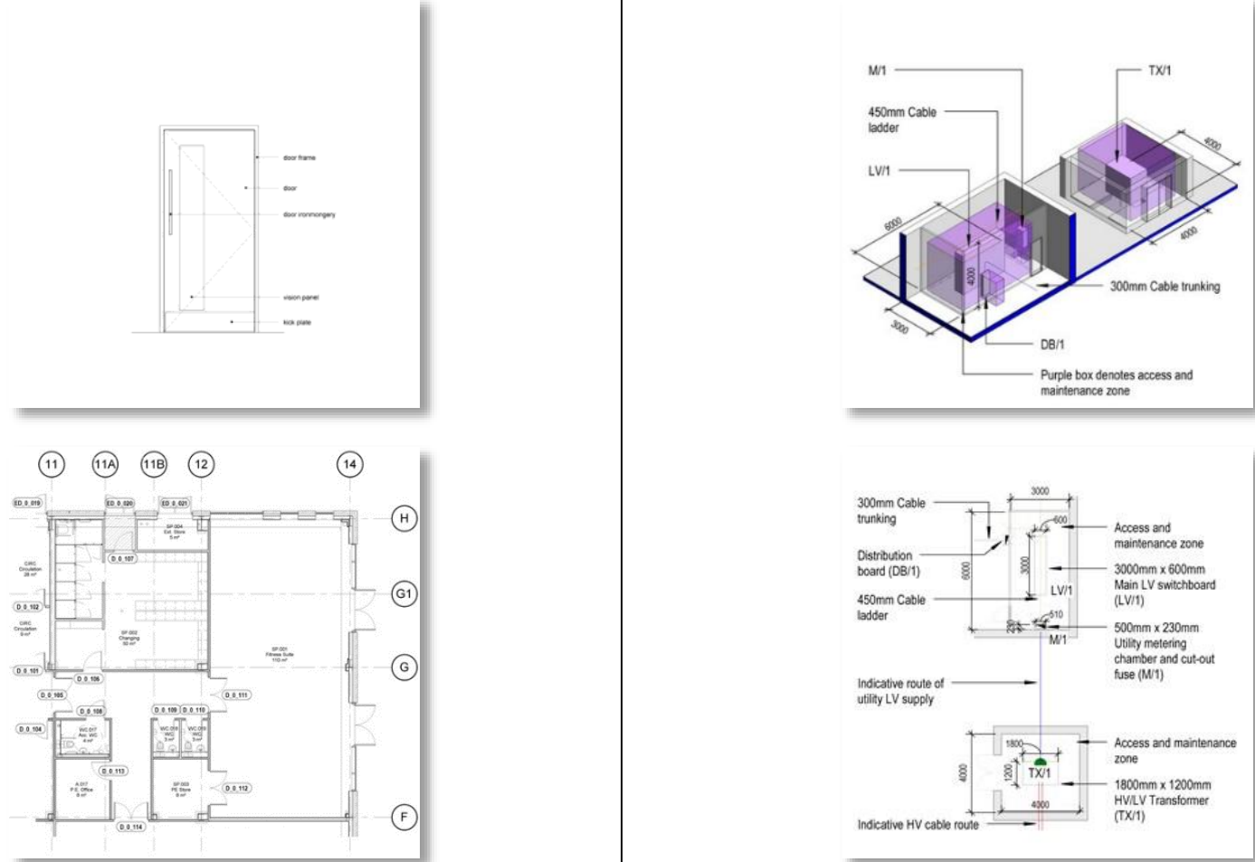
(NBS, 2022).

RIBA Stage 4: Technical Design

This stage involves developing thorough technical specifications and construction details. LOI includes developed technical specifications, construction details and final design documents. LOD includes fully developed models with accurate geometry and essential details. We would apply this by concluding the technical design with contribution from all stakeholders, producing fully developed 3D models with accurate geometry and essential details, developing comprehensive construction documents and technical specifications, carrying out final clash detection making sure all conflicts are fixed and revising the CDE with final construction details, technical specifications and design information. (NBS, 2022). Please see below a researched diagram of a fabric (left) and services plan (right) example at stage 4.

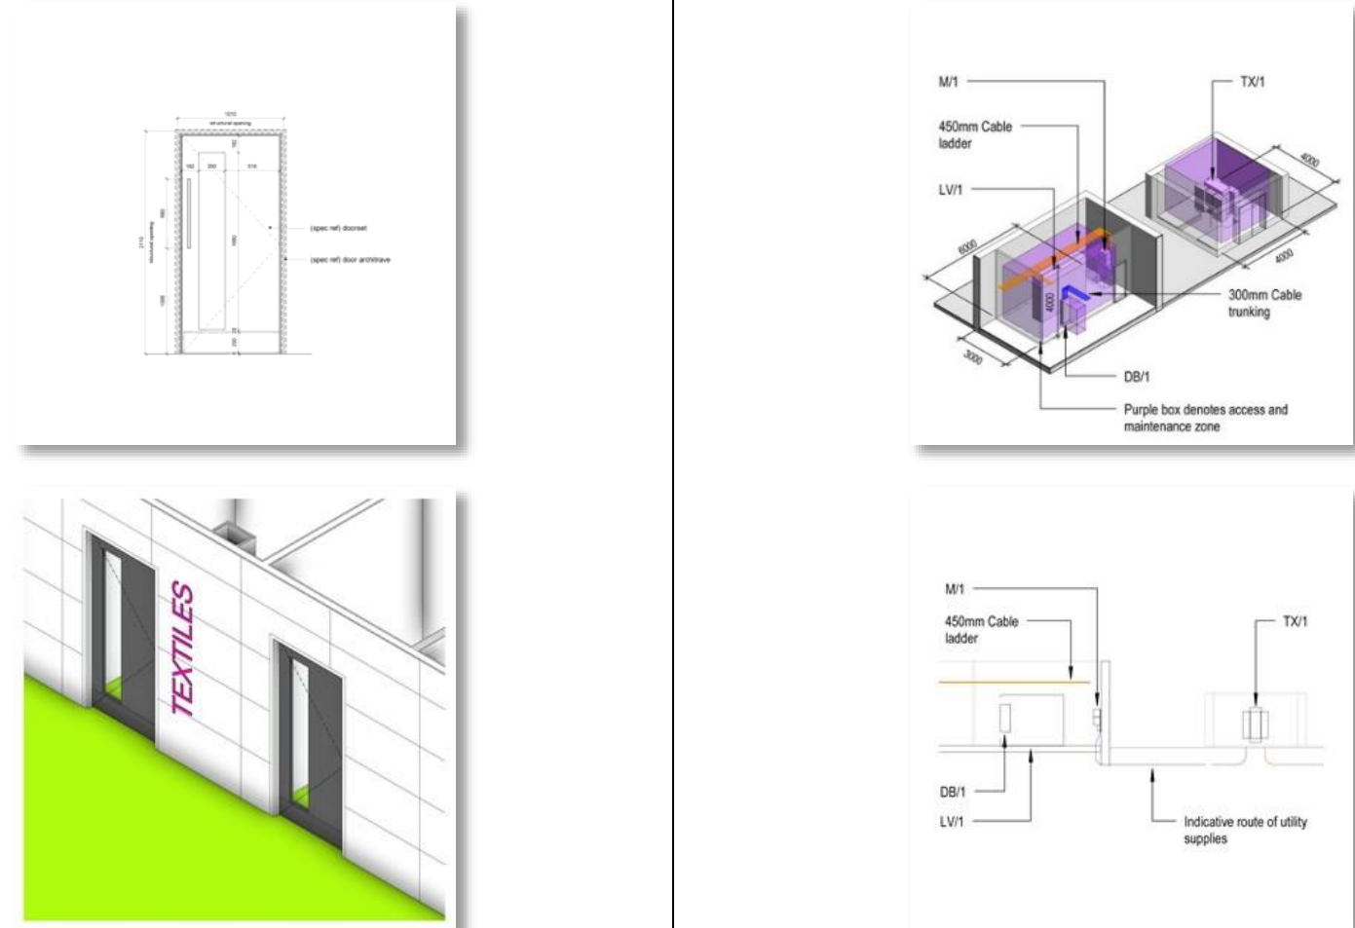
(NBS, 2022).

RIBA Stage 5: Manufacturing and Construction

This stage includes covering the manufacturing, off site fabrication and on-site construction events. LOI incudes fabrication and installation data and as-built documents. LOD includes construction ready models with precise as-built information. We would apply this by producing detailed fabrication drawings and specifications for all building elements, working together with contractors and fabricators to make sure there’s good understanding and implementation, monitoring the construction development to make sure designs and specifications are followed correctly and revising the CDE with construction development and any adjustments to the design. (NBS, 2022). Please see below a researched diagram of a fabric (left) and services (right) example at stage 5.

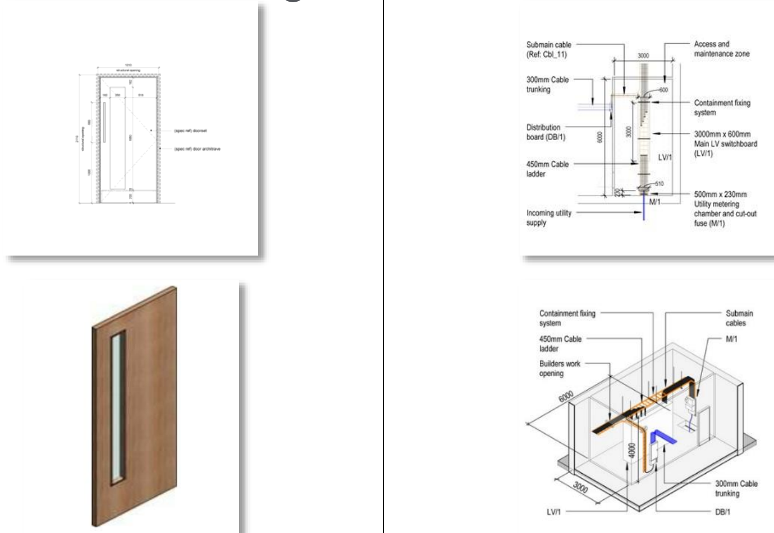

(NBS, 2022)

RIBA Stage 6: Handover

The penultimate stage includes the completion of construction, handover to Merthyr County Council. LOI includes all asset information as well as maintenance and operation information. LOD includes as built models with comprehensive asset information and COBie data. We would apply this by doing final inspections and quality checks to make sure everything is carried out like the design, providing Merthyr County council with detailed operation and maintenances (O & M) manuals, revising the CDE with as built information and final project documents and handing over the project to Merthyr County Council making sure there is a smooth transition through the operational phase. (NBS, 2022). Please see below a researched diagram of a fabric (left) and services (right) example at stage 6.

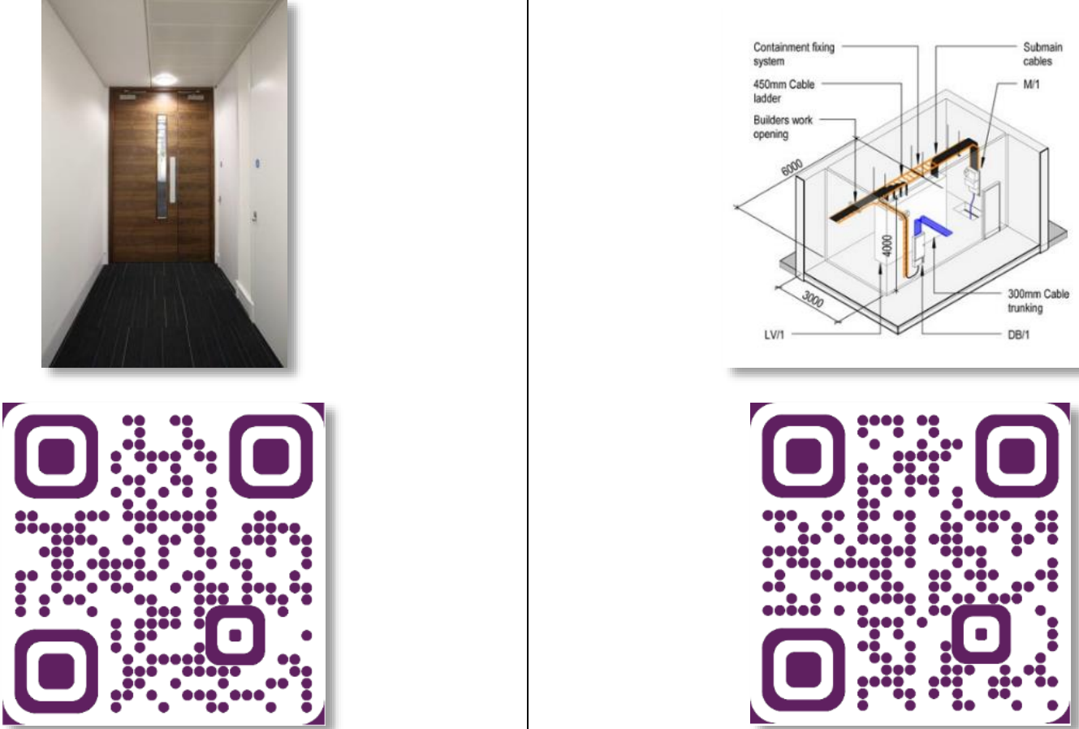
(NBS, 2022).

An example of a naming convention in the asset information would be:

5016_YsgolClasdir_ArchitecturalPlans_GroundFloor_V1
(Project Number_ Project Title_Document Type_Specific Information_Version Number)

More examples would be:

5016_YsgolClasdir_StructuralDrawing_RoofStructure_V1
5016_YsgolClasdir_ElectricalPlans_MainHall_V2
5016_YsgolClasdir_MechanicalSystems_HVAC_V3

RIBA Stage 7: In Use

LOI includes post occupancy evaluation feedback and updated building manuals including Health and Safety file and fire information as necessary. This includes feedback mechanisms (systems and processes) for collecting user feedback to make future improvements and address any operation issues. (RIBA, 2020) LOD is like Stage 6 but making sure as built highly detailed models have been verified on site, accurately representing the building as it was constructed. These models should include precise geometry and specification for all building elements. (Trimble MEP, 2023).

Recommendations to be conveyed in EIR & AIR

The Project Life Cycle through EIR, AIR and BEP
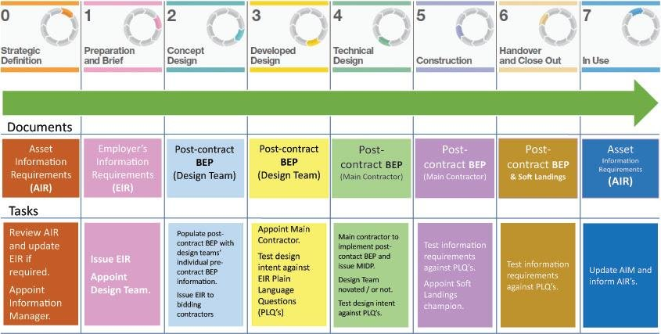
(ResearchGate, 2018)

Our recommendations to be conveyed in EIR (Employer’s Information Requirements) include:

- Clearly defining the Level of Information Ned (LOI) and Level of Detail (LOD) for each RIBA Stage
- Stipulating the use of COBie-compatible CAFM systems for asset management.
- Including procedures for information sharing, coordination and management using the revizto platform.

Our recommendations to be conveyed in AIR (Asset Information Requirements) include:

- Outlining the requirements for capturing and maintaining asset information all the way through the building’s lifecycle.
- Making sure that the CAFM system is combined with the CDE to offer a smooth flow of information.
- Determining processes for updating and maintaining the as-built models throughout the operational phase of the building.

We recommend involving all stakeholders including the facility managers and maintenance teams early in the process. This is to make sure everyone is familiar with the BIM model and the CAFM system, which in turn will make more efficient the handover and ongoing asset management.

By following these recommendations and making sure there’s close collaboration between all parties, we will make sure that the Ysgol Clasdir project meets both the technical and operational requirements for BIM maturity and provides long-term value through effective information management and long-term asset monitoring.
References

AUTODESK. (2024). ISO 19650, the Common Data Environment, and Autodesk Construction Cloud. [Online]. AUTODESK. Available at: https://www.autodesk.com/autodesk-university/article/ISO-19650-Common-Data-Environment-and-Autodesk- [Accessed 01 January 2025].

RIBA. (2020). RIBA Plan of Work. [Online]. architecture for london. Available at: https://architectureforlondon.com/news/the-riba-plan-of-work/ [Accessed 01 January 2025].

BIM COMPETENCY FRAMEWORK. (2018). Developing a BIM Competency Framework RESEARCH & KEY PRINCIPLES. [Online]. SCOTTISH FUTURES TRUST. Last Updated: July 2018. Available at: https://www.scottishfuturestrust.org.uk/storage/uploads/bimcompetencyframeworkresearchjul18.pdf [Accessed 01 January 2025].

Dobrowolska, K. (2023). Data Exchange in Construction: How to Get it Right. [Online]. ARCHDESK. Last Updated: 20 May 2023. Available at: https://archdesk.com/blog/data-exchange-construction/ [Accessed 01 January 2025].

NBS. (2022). Level of detail (LOD) and digital plans of work. [Online]. NBS. Available at: https://www.neilstoolbox.com/harvard-generator/reference-website.htm#result [Accessed 01 January 2025].

National Institute of Building Sciences. (2024). Project BIM Execution Planning (BEP) Standard. [Online]. NATIONAL BIM STANDARD. Available at: https://www.nibs.org/nbims/v4/bep#:~:text=A%20Project%20BIM%20Execution%20Plan,implementing%20BIM%20 [Accessed 01 January 2025].

Ocean, J. (2024). How to Ensure BIM Quality Assurance and Validation: Best Practices and Key Steps. [Online]. revizto. Last Updated: 14 October 2024. Available at: https://revizto.com/en/bim-quality-assurance-validation/ [Accessed 01 January 2025].

ResearchGate. (2018). The project life cycle with BIM requirements. [Online]. ResearchGate. Available at: https://www.researchgate.net/figure/The-project-life-cycle-with-BIM-requirements-source-BIM-riba_fig [Accessed 01 January 2025].

revizto. (2025). Industry-Leading Partnerships and Integrations. [Online]. revizto. Available at: https://revizto.com/en/integrations/ [Accessed 01 January 2025].

Trimble MEP. (2023). Ready for LOD & RIBA: The Power of Content-Enabled Modelling. [Online]. Trimble MEP. Last Updated: 4 May 2023. Available at: https://mep.trimble.com/en-gb/resources/mep-blogs/ready-for-lod-riba-the-power-of-content-enabled-mo [Accessed 01 January 2025].

UK BIM FRAMEWORK. (2020). Information protocol to support BS EN ISO 19650-2 the delivery phase of assets. [Online]. UK BIM FRAMEWORK. Last Updated: May 2020. Available at: https://ukbimframework.org/wp-content/uploads/2020/06/Information-Protocol-to-support-BS-EN-ISO19650 [Accessed 01 January 2025].

UK BIM FRAMEWORK. (2025). UK BIM Framework – Frequently asked questions. [Online]. UK BIM FRAMEWORK. Available at: https://www.ukbimframework.org/faq/ [Accessed 01 January 2025].

University of Bristol. (2025). Civil Engineering Design Project: Example briefs. [Online]. bristol.ac.uk. Available at: https://www.bristol.ac.uk/media-library/sites/engineering/ilo/documents/Civil%20Engineering%20Design [Accessed 01 January 2025].

