

Reflective Portfolio
By Jessica Hill

University of Wales Trinity Saint David
Coaching and Mentoring (BMPF7303D)

Assessment Component (task) 2 - Portfolio (3000 words equivalent)

Produce a portfolio comprising six elements:

i) A Coaching or Mentoring Contract that outlines key information, identifies responsibilities and expectations, and incorporates ethical considerations. (Appendix A)
ii) A Coaching/Mentoring Log that records planned and actual activities with clients. This must incorporate at least 6 hours of coaching and/or mentoring practice. (Appendix B)
iii) A reflective journal outlining at least six hours experience of planning and implementing the identified coaching or mentoring process. This should encompass feedback from your clients. (Appendix C)
iv) A recorded coaching or mentoring session of at least 30 minutes duration, utilising the model(s) identified from assessment component 1.
(Submitted via Turnitin)
v) A critical reflection (1500 words) on coaching/mentoring performance in the workplace identifying strengths and areas for improvement. Your reflective essay should consider your coaching or mentoring experience. You should be able to show that you understand the main skills and behaviours of effective coaching and evaluate your own performance against these. Pay particular attention to the ethical frame in which you have operated. Refer to your records and your personal reviews of coaching or mentoring you have undertaken (you should have completed pro-formas provided or devised by yourself) and include in your appendices. In conclusion, you should identify your development needs and draw up a personal development plan focussed around your coaching and mentoring development needs. There are templates on Moodle you could use.
vi) A personal development plan addressing the identified development needs from the activities above and your critical reflection.

A critical reflection

Tarrant (2013) discusses that in reflective practice there is the act of questioning or self-questioning to break down what has happened or to look at what might happen, enabling the teacher to move from novice to expert. In this coaching and mentoring experience, as the coach, I find this statement an interesting assessment as I navigate through the complexities of my own coaching practice. Similarly, Bolton and Delderfield (2026, p.29) argue that “questions determine directions, and what might be discovered, rather than destinations.” Throughout this critical reflection, I will reflect on what I have learned from this situation whilst also discussing how to improve for future and professional development.
The course has enabled me to push the boundaries and be challenged so that I can continue to explore ways of supplementing existing knowledge and skills. The model I use most regularly is Gibbs Reflective Cycle (1988) to help me work through my insights in a logical way, as has been demonstrated in my reflections in appendix C. I intend to align my critical reflection with Gibbs due to the clarity and stages of the model. It enables an understanding of the situation, whilst also looking at the actions taken (Bolton and Delderfield, 2026).

Description
Ethically, I aimed to create a safe and welcoming environment for my coachees in order that they felt respected, valued and comfortable to share their areas of focus. This then gave us a foundation to work from and establish a connection from the beginning. The places that I chose to conduct our coaching sessions were in a private, safe space as logistically this provided convenience and a viable setting. Passmore and Crabbe (2021) argue the need for creating a trustworthy relationship that allows for a shared discovery in a safe space. Through achieving this, the coachee was able to ask any questions that they may have had without feeling judged. It soon became apparent that both coachees felt comfortable and relaxed in the environment as feedback demonstrated (see reflections post session in appendix C). The sessions lasted approximately an hour, and I was exploring a variety of key themes from a transition into a potential new role during a restructure to support on CV writing and potential new job offers that will be present in the future. My role was to guide the conversation using a range of coaching principles such as open questioning, clarifying ideas and concepts, as well as utilising coaching models such as OSCAR. The OSCAR model was developed by Andrew Gilbert and Karen Whittleworth, and focusses on solutions rather than problems. The acronym stands for Outcome, Situation, Choice, Action and Review (Bates, 2015). I used this model during the recorded coaching session, which laid the basis for the session.

Feelings
As a developing coach, initially I felt nervous and apprehensive about the experience as I was not quite sure how the process was going to go. I felt aware of my own tendencies such as wanting to offer advice or perhaps jump in but over time I harnessed these and I began to feel more comfortable throughout the course of the coach–coachee relationship.
The learning that I had received from the practice sessions during role-play helped me get out of my comfort zone early on and I realised that I could explore ways where I was able to be more assured, such as taking a deep breath to give myself time to think and adopting strategies and tools such as ‘what I am hearing is’, in order to listen actively and repeat back what the coachee had said. This took some practice but by keeping in mind the 80/20 rule, giving the coachee the space to speak 80% of the time I was able to become more proficient and adapt to the situation (LinkedIn, 2026).
During the sessions, my body language was contracted due to feeling unsettled at times and self-conscious in the situation, but I tried to concentrate on sitting upright and focussing on the job in hand. I explained to the coachee in the initial meetings that it was my first time coaching so to bear with me whilst I adapted to the practice. This made me feel calmer, although I feel fortunate as both my coachees were very comfortable in talking and they were open about their challenges. I utilised some of the skill development from the action-based learning sets and took it forward into my own practice (appendix C, pp. 31-32). With these sets in mind, I think there were lots of different elements to be proud of. For example, initially I felt uncomfortable having to relay a particular issue that was occurring for me at the time, but I remained resilient and adapted to the job in hand. The hardest part of this activity was to choose the questions that my colleagues had presented to me afterwards to see if they could help me to resolve the issue. I took actions from these questions and the issue that I put forward has now been resolved so I feel satisfied about the outcome. Equally, listening to others speak about their task was enlightening and at times somewhat emotive as I was taken on a journey through engaging with their experience. The actions that were gained from these learning sets can be transformed into real-life coaching.

Evaluation
The sessions were positive in several ways, including my ability to create a rapport with my coachees and maintain a good relationship throughout their development. I felt I adapted to the coachees’ style; I listened attentively and aimed to focus the sessions. I also sustained a supportive environment. My use of Cognitive Behavioural Coaching (Tee and Passmore, 2022) enabled them to explore their thoughts more deeply by reframing them into thoughts that they could use moving forward and I challenged them by asking questions such as ‘what evidence do you have?’ (see appendix C, p.22). During the session, they used self-critical language and seemed unaware of the impact that this was having on their confidence. So, with coachee 1, I encouraged them to write the unhelpful thoughts down and reframe them more positively, almost like positive affirmations.
In sessions, I used a variety of models to get the most out the coachees, but also to enable growth and development for myself as a coach. I felt more at ease certainly in the earlier stages to have a framework to work with and then I could ask further open-ended questions as the sessions developed. However, I noticed moments where I was unsure how to close a session and I wanted to make sure that the coachee was comfortable that the session was coming to an end.
Additionally, upon reflection on my work with coachee 2, I realise that I explored mentoring without realising due to the nature of the support. I guided this coachee on CV writing and preparing for potential future job roles (see appendix C, p. 27). Nemanick (2019) reviews that mentoring is personalised one-to-one support that enables an individual to shift their thinking and make meaningful changes. I felt as though this was achieved within the sessions, and we also explored the STAR (Situation, Task, Action and Result) (El-Amin 2022) method for interview questions to come up with a format that was usable to take into interviews and to develop the coachee’s confidence.

Analysis
Reflecting on the coaching experience, I realise that I could have looked at a broader range of questioning techniques as there were times that I was relying on more questions than others. I also had guidance from some of the models such as GROW and OSCAR. This aligns with coaching literature from Garvey et.al. (2009), who argues that particularly within coaching there is likely to be a diverse range of models and perspectives. I used the GROW model in the early stages to help maintain focus and direction. GROW stands for Goal, Reality, Options, and Will or Way forward (see appendix C, p.18).
I created a pictorial summary account (appendix C, p.23 and p.30) for both coachees to broaden my reflective capacities and to see how it would help me develop as a coach. I found the exercise cathartic and relaxing. I was thinking about the meaning behind my decisions and portraying the images in a constructive manner, for example, the sunflower represents hope and optimism, which I feel that both coachees demonstrated because of the coaching experience. I also enjoy visualisation so seeing the layout displayed in such an organic way supported these preconceived beliefs. However, I prefer a written reflective style as I have always appreciated the power of language and putting the sessions into context.

Conclusion
This experience has highlighted greater communication and my ability to draw the necessary information out of the coachees. I believe that they both felt grounded and at ease when in the session. My confidence has increased in applying coaching techniques that I was not familiar with at first. Recording a session and listening to it back was especially helpful to understand what I would effectively need to do to support learners and colleagues in future (appendix C, p.20).

Action Plan
On reflection, the coaching went well and I was pleased with the feedback I received from the coachees in validating the experience (appendix C, p.16, p.18, p.20, p.21, p.29). I believe it helped that I knew them both quite well. If I were to repeat the process, it would be useful to coach someone who I did not know to assess and reflect on how I would feel in an unfamiliar scenario. To improve future practice, I would develop my active listening skills by allowing even more time for coachees to express their thoughts without interruption. This is reflected in my Personal Development Plan in appendix C, p.33. De Haan (2008) suggests that it is these critical moments such as listening that make a difference.
Established goals at the start of each coaching session may support keeping the experience even more focussed. Through implementing these actions, I also aim to develop stronger coach-coachee relationships.

Reference List
Bates, B. (2015) The Little Book of Big Coaching Models. Harlow: Pearson.
Bolton, G. and Delderfield. (2026) Reflective Practice Writing and Professional development. London: SAGE.
De Haan, E. (2008) ‘I Doubt Therefore I Coach: Critical Moments in Coaching Practice’, Consulting Psychology Journal: Practice and Research, 60(1), pp. 91–105. https://doi.org/10.1037/1065-9293.60.1.91 [Accessed 30 Jul 2026].
El-Amin, A., 2022. Be ALL-STAR! Situation, Tasks, Action, Results (STAR): Handling Tense Situations. The Midwest Quarterly, 64(1), pp. 47-57. Available at: https://www.proquest.com/docview/2724915545/fulltext/6C890C66BE1E4CF5PQ/1?accountid=130472&sourcetype=Scholarly%20Journals [Accessed 4 Aug 2026]
LinkedIn (2026) How can you balance listening and talking during coaching conversations? Available at: https://www.linkedin.com/advice/1/how-can-you-balance-listening-talking-during-vopwc [Accessed 24 Jul 2026].
Nemanick, R. (2019), Mentoring executives and directors. David Megginson and David Clutterbuck. New York: Routledge, 2018, 160 pages, Personnel Psychology, 72: 482-484. https://doi-org.uwtsd.idm.oclc.org/10.1111/peps.12350 [Accessed 24 Jul 2026].
Passmore, J. and Crabbe, K. (2023) ‘[Building a coaching culture: The LEAD framework]’, The Coaching Psychologist, 19(2). https://doi.org/10.53841/bpstcp.2023.19.2.13 [Accessed 30 Jul 2026]
Tarrant, P. (2013) What is Reflective Practice? In: Reflective Practice and Professional Development. London: SAGE Publications, Ltd. pp. 1-17 Available at: https://doi.org/10.4135/9781526402318.n1 [Accessed 20 Jul 2026].
Tee, D, Passmore., J (2022) Coaching Practiced. John Wiley & Sons, Incorporated, Newark, United Kingdom. Available at: https://ebookcentral.proquest.com/lib/trinity/reader.action?docID=6953655&c=RVBVQg&pp.=222 [Accessed 4 Aug 2026]
The University of Edinburgh (2024) Strengths and weaknesses | Reflection Toolkit. Available at: https://reflection.ed.ac.uk/reflectors-toolkit/self-awareness/strengths-weaknesses [Accessed Jul 24 2026].

Appendix A
(A Coaching or Mentoring Contract)

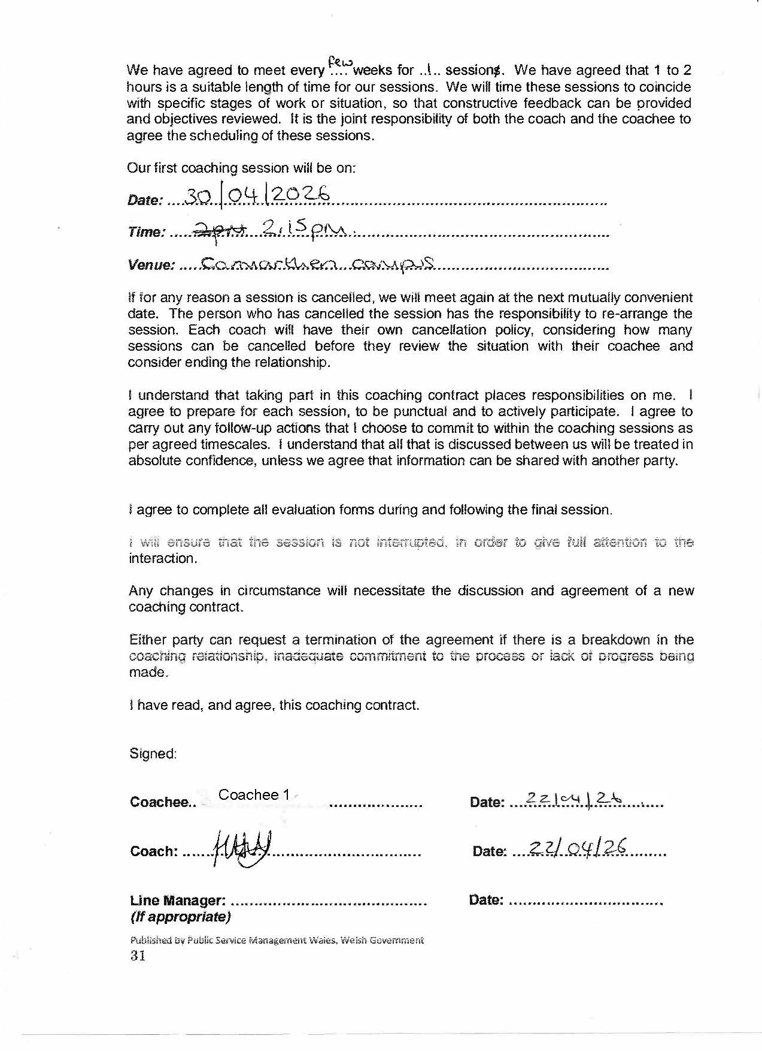
Coachee 1
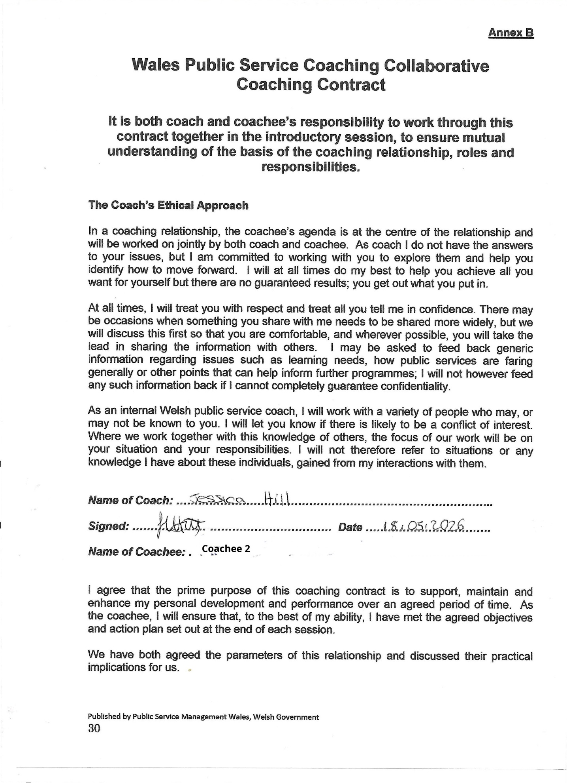
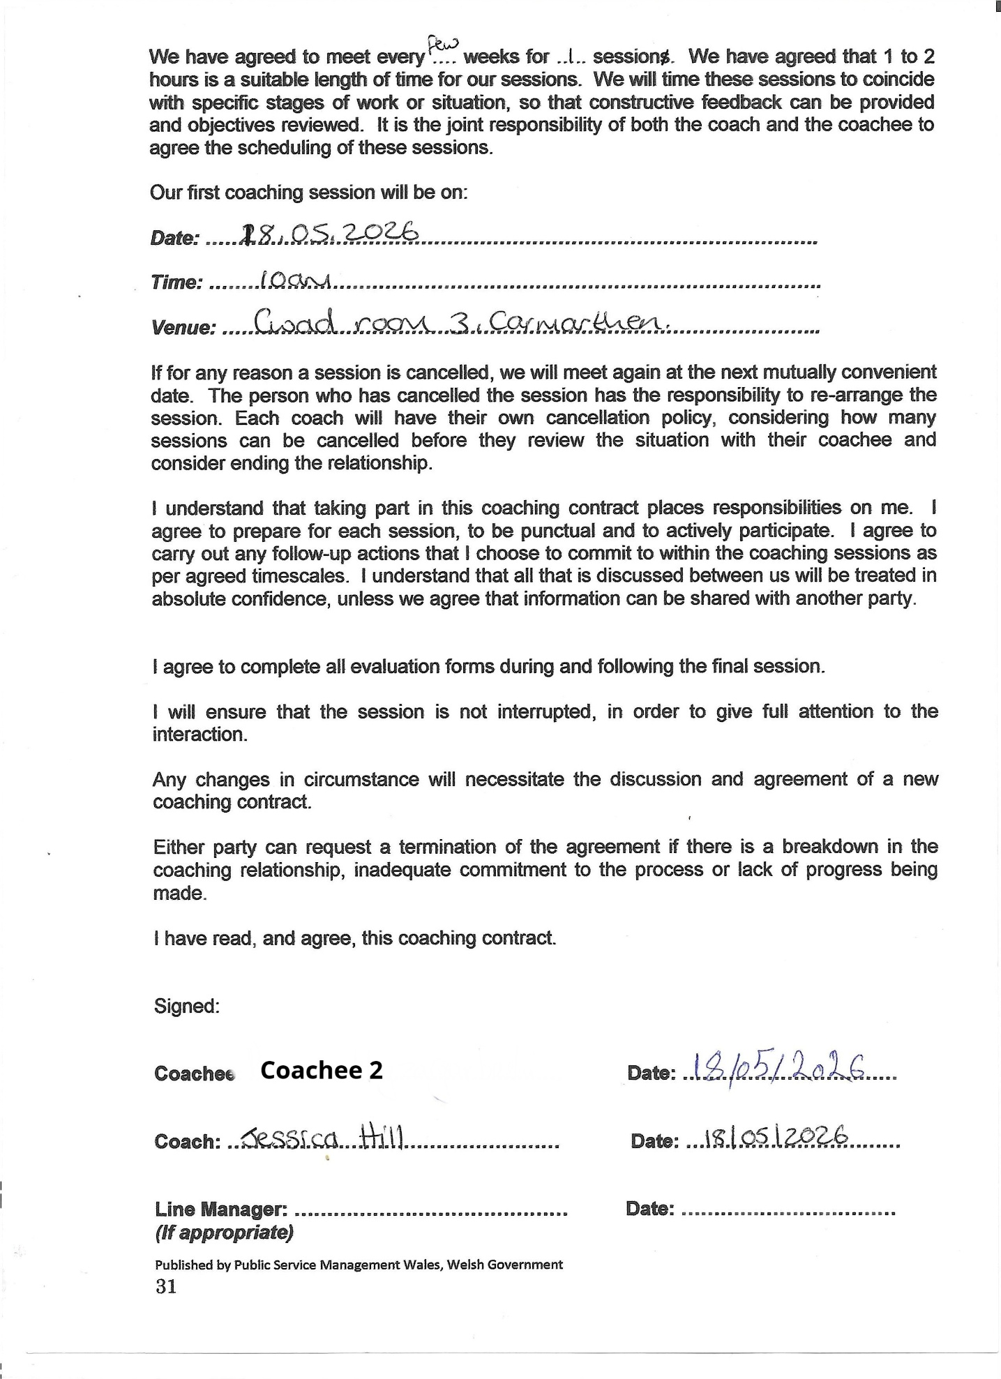
Coachee 2

Appendix B
(Coaching/Mentoring Log)

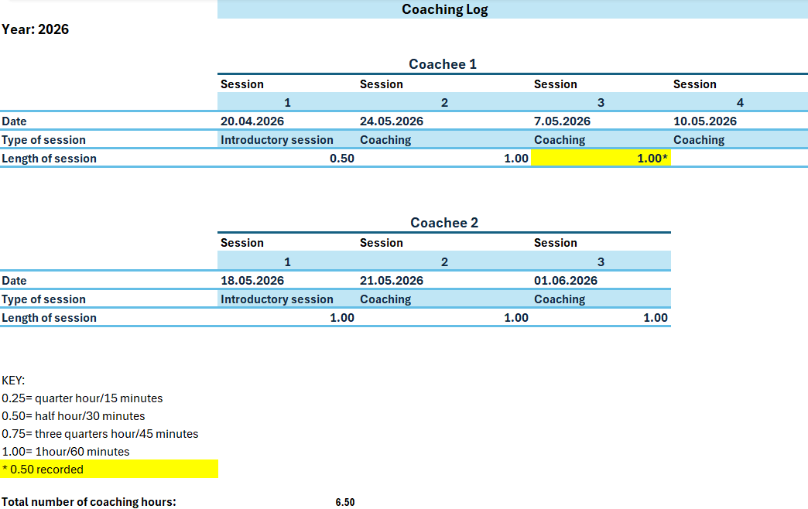

Appendix C
(Reflective Journal)

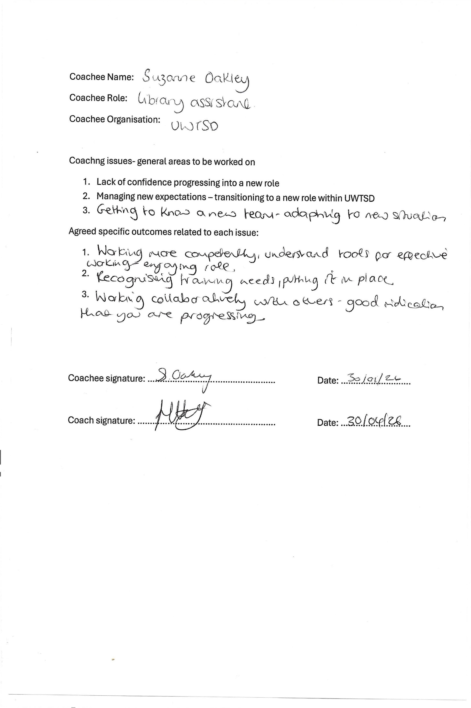
Coachee 1
Coachee 1

Reflective report
Coach: Jess Hill
Coachee 1
Date: 20.04.2026
Session: 1
Duration: 30 minutes

Description
The coachee and I met in a safe space where we both felt comfortable to undertake our initial introductory coaching session together. We both sat down in relaxed chairs as we gathered our thoughts. I presented to the coachee the contract and as she had read through the document before was able to sign and date it. I had also given her a link to the ethics and code of conduct that she could read in her own time.
The coachee shared her feedback:-

“Our first session took place during the interview stage of the process. It was useful to have the space in which to air my thoughts, allowing me to voice my hopes for getting the position I wanted - something that was difficult to do within the department as colleagues were competing for the same role.”

Feelings
I was thinking about how nervous I was feeling, posing questions in my head – was I going to come across okay? What questions to ask? Was the conversation going to flow? However, when I laid the cards on the table so to speak and said that “I was new to coaching so to bear with me during this process” I began to relax and get into my stride. There was a moment where I paused and said “I am just trying to think of the next question”, but it didn’t last for long and I carried on. I was naturally a little nervous and I wanted to do well but I also felt that this didn’t hinder me too much.
Evaluation
What went well was that the conversation kept going along a valuable path of self-discovery. The coachee gave detailed answers to the questions and so I followed her lead, which prompted me to ask the next question. I felt as though I demonstrated Socratic questioning and kept to the 80/20 rule of allowing the coachee to speak 80% of the time.
What didn’t go so well was that I wasn’t sure how to wrap up the session – I think I could have thought about the conclusion a little better. I may think about asking “is there anything else you would like to bring up today?” before drawing the session to a close.
Analysis
I can make sense of the situation by analysing how I was feeling. I was worried about how I was going to perform on the day and whether I was going to come across okay. I wanted to make the coachee feel at ease and relaxed. I am not sure if she picked up on my idiosyncrasies portraying the uncertainty. It was a learning curve that will lead into making small changes to improve and get better as a coach. I am willing to take this learning and further develop my skills and aptitude for the role.
Conclusion
I could have ended the session in a cleaner way rather than feel that it was an abrupt ending. I could have also discussed the outcomes with the coachee at the beginning, but these will be addressed in the next session.
Action plan
In the next session, I would address the outcomes and lay out some questions for discussion based on the topic that was presented in this introductory session.

Reflective report
Coach: Jess Hill
Date: 24.05.2026
Coachee 1
Session 2
Duration: 60 minutes

Description
The coachee and I met in the same space as previously for our second coaching session. It was a more relaxed setting. The coachee had just finished the last of her interviews in amidst the restructure that the library is currently going through. So that was a topic of discussion initially, which was carried along that trajectory.
Feelings
I felt more confident and self-assured in delivering the questions and opening the conversation to see where it led. I also considered the coachees emotions and feelings after a difficult time of interviews that the coachee has been party to that day.
In addition, I was feeling a little stumped and concerned on whether I was asking the correct questions. I guess the doubt was creeping in. Having used the GROW model, this helped to alleviate some of the concerns and shape the coaching session on this occasion.
The coachee shared some of her feelings at the time of the second session: - at the time of the second session: -

“By the second session, I had discovered I was successful in my bid for my preferred post. However, it felt difficult to express my gratitude and happiness at gaining the job I wanted when others were unhappy at the positions they had been given. Hearing some people express why they thought they or others may have been more suited to the role made me question my abilities. Through the coaching session we investigated these fears, looking at how I could reframe my thinking to more allow a positive viewpoint, as well as plan a framework to mitigate some practical concerns.”

Evaluation
What went well was that the conversation flowed and the coachee felt that she could be open about her experiences and felt comfortable. On the other hand, I found it difficult not to give too much advice and attention to the emotive side of the two-way conversation. For example, when the coachee was talking about the worries and concerns, she had regarding the current environment so if she had positive news but someone else didn’t have the outcome, they wanted then it was about navigating around that effectively.

Analysis
Overall, it was a good coaching session and the feedback I received from the coachee was positive in realising her goals and building her confidence. She felt as though she could be open to me as a coach as I am outside of the current situation. She had concerns around talking to others openly as it may prompt feelings or emotions that are aired not necessarily in the best light when colleagues are feeling uneasy about the restructure and they may have not been given the choices that they desire after interview. I used the GROW model to help shape the process, therefore asking specific questions based on each part of the model. I felt as though this helped the conversation to flow and prompted any gaps that needed filling in.
Conclusion
Overall, this experience taught me that I can deliver an effective coaching session that the coachee responds well to. I have learned that I need to develop my Socratic questioning techniques, but I believe that this will come in time.
Action plan
In the future, I will improve this by developing Socratic questioning techniques further, possibly reframing on a deeper level what the coachee has to say about their experiences. I will use further theories and models to enhance the session.

REFLECTIVE COACHING THIRD SESSION
Coach name ……Jessica Hill……………………………………….
Coachee name: ……Coachee 1……………………………
Recorded session of 30 minutes.
Date …07/05/26………………..

Session information (duration, issue, theme etc.)
Duration: 30 minutes
Issue: Successful at interview so transitioning into a new role. Feeling apprehensive.
Theme: Doubts and worries creeping in so how to override these.

What 3 words best describe the session?
Mindset, success, positivity

How did you build a rapport with the coachee?
I think having an existing connection with the coachee helps us both feel relaxed and comfortable. I asked the opening question of ‘how are you?’ at the beginning of the session to create that that safe space and then drew upon points noted in the previous session, whilst prompting the conversation. It appeared that Coachee felt comfortable as she did the majority of the talking and came to her own conclusions.
The coachee’s feedback supports this as she highlights that:

“My coach Jess has been enormously kind and supportive in encouraging me to think about my situation, asking gentle questions that have helped me reconsider my assumptions.”

What went really well?
The conversation flowed and I adapted to changes in Coachee’s tone of voice and mood, so I could either make some suggestions or provide a level of comfort. I used the OSCAR model, which scaffolded the session nicely.

Did you do anything completely new?
I used some cognitive behavioral coaching techniques, which seemed to work well.

Did anything surprise you? (For example, about something you discovered about yourself, working with others, the way you reacted to anything that happened etc.)
What surprised me was that I remained calm throughout the session, and I felt as though the questions guided self- discovery. I wanted to provide and give advice and at times had to hold back from going down this route too much. The information that I did give was taken on board and reworked so that Coachee came to her own conclusions…

“Advice from Jess - such as taking a negative thought, interrogating it, and finding evidence in my past career to suggest a contrary view - have been a great help..”

Review session (Reflection)
Questions I asked the coachee during this session…
Coachee 1
- What would you like to bring to the session today?
The session was centred around the new job role and the feelings surrounding this new undertaking. The emotions are that feeling of excitement and a little trepidatious about what’s to come. Overall, really looking forward to learning new things and the training that will be involved.

- What were your biggest insights from our time together?
Recognising existing strengths moving forward and the importance of prioritising goals. Also, an awareness of increased confidence since starting the coaching and a recognition of support networks including myself to navigate the transition smoothly.

- Looking back over the progress we’ve made, what are you most proud of?
The coachee mentioned that she was proud of her coach due to making her feel at ease and for being a good listener. The ability to create a safe space for the coachee to really be open and express herself in a way that perhaps she may not have under different circumstances.

- What challenges are you likely to overcome?
The negativity of other people can make it hard to counteract. Comments such as “well what experience do you have?” Should the coachee respond directly to the question or should she respond differently and more indirectly. It is difficult to think on the feet at the time but feels like she wants to prove a point, which she shouldn’t have to.

- How can you use your new tools independently?
Reframing thoughts using some CBC techniques to allow for a more positive mindset. Any negative thoughts that creep in e.g.” I am not sure if I can do this job.” Coach responds, “what evidence do you have?” The thought reframed as “I have the experience and the knowledge to support my new role.” Also, using analogies such as driving a car to get to places using a sat nav – the more I do the more used to the journey I will become.

Summary for Coachee 1
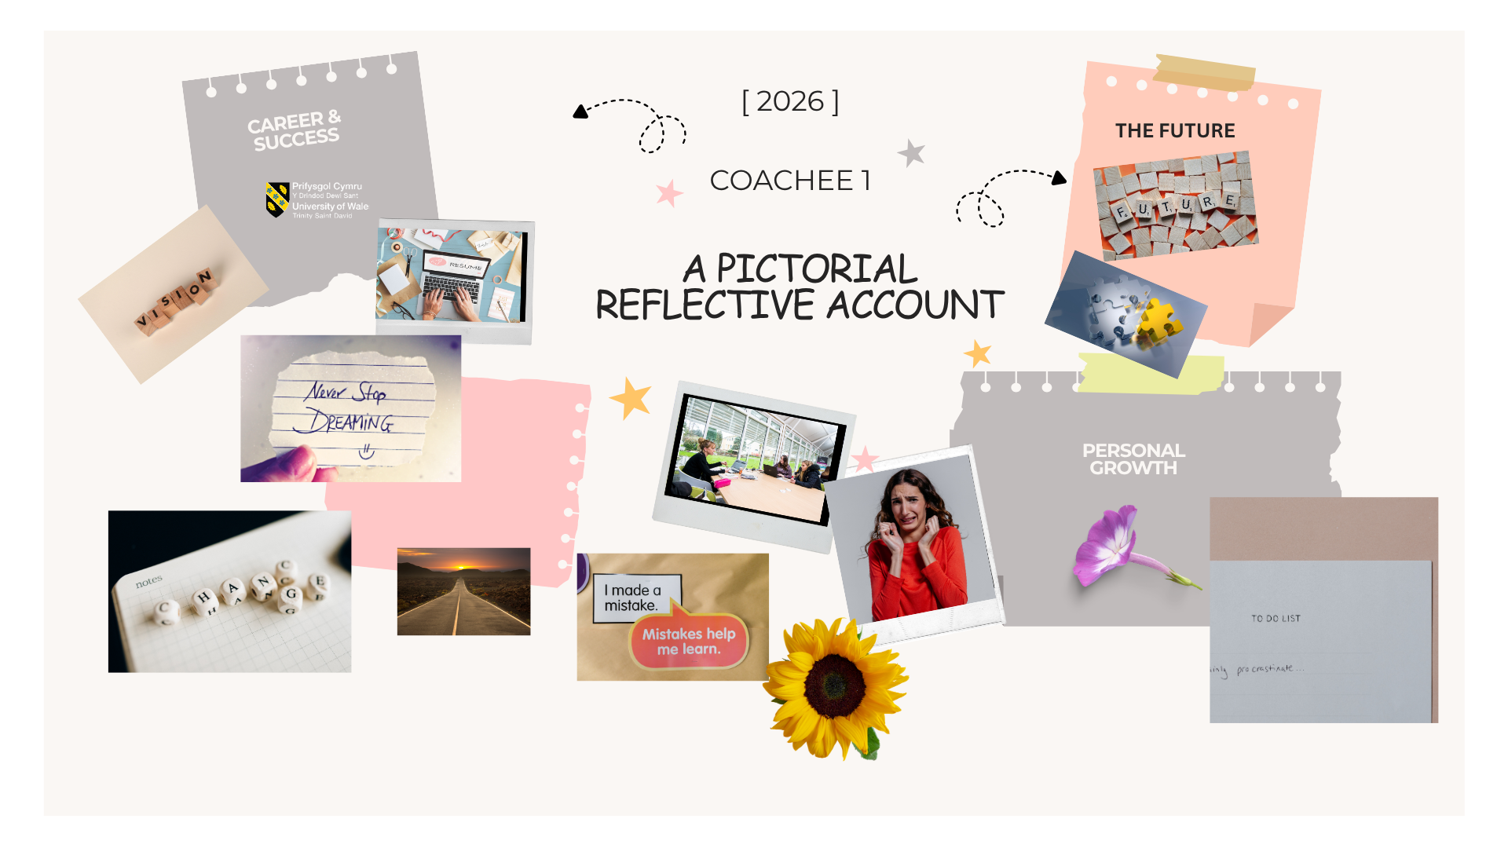

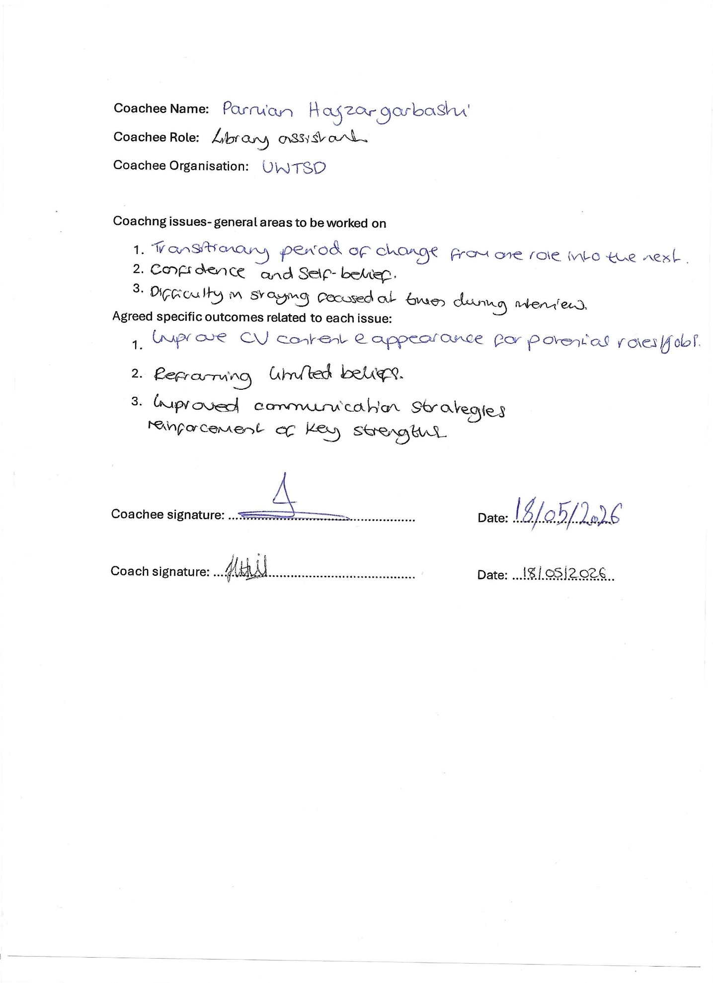
Coachee 2
Coachee 2

First introductory coaching session reflective report
Coachee 2
Date: 18.05.2026
Session 1
Duration: 60 minutes

Description
The coachee and I met in a safe space, where we both felt comfortable. The coachee read through the contract first and signed the agreement. We also looked at some of the issues and outcomes that the coachee was bringing to the session so that they were documented. The coachee wanted support with rebuilding her confidence into a potential new role as she was nearing the end of the UWTSD contract during the restructure process within the library. She is successful on paper and secures an interview, but this doesn’t always necessarily follow through to the result of getting the role she wants.
I lay out some ground rules such as confidentiality and being new to the role as a coach. This set the precedent for the session and allowed me to relax as coach as we began the meeting.
Feelings
I felt okay but also acknowledged how the coachee was feeling as after the opening question of “how are you doing today?” it became evident that her confidence and moral was low. This was due to the current situation that is going on now, which is the restructure at UWTSD library throwing the teams feelings into disarray.
I was thinking how could I adjust my questioning techniques to align to the coachee’s needs and requirements to be able to provide enough support that would develop her confidence not only in herself but also in me. This is because the coachee has been let down in the past and continues to feel like she is not progressing to where she needs to be and in the role she wants ultimately.
I felt as though I had to adapt quite quickly to this and provide empathy and compassion when needed the most (see appendix C, p. 29). I provided a level of comfort and support to my coachee utilising the GROW model to scaffold the session accordingly.
Evaluation
What was good about the experience was that I felt that my coachee developed trust in me from the start and was able to be open with me during the session. There was also a good connection established allowing us to progress steadily throughout the course of time. I could see that the coachee showed some emotion of which I adapted to by providing some guidance and comfort through certain gentle questioning. She responded to these well and we spoke about some actions and necessary steps to take that would help this situation.
What didn’t go so well was that it was an introductory session, which I had planned for around thirty minutes, but it was around an hour. Although, I don’t think that this can be seen as a negative point as it allowed the coachee to disclose anything she was comfortable with. I used the GROW model as previously mentioned, however I didn’t have the questions immediately to hand, so I had to look in my file for them, which interrupted the flow of the session.
Analysis
I can sense that the coachee was visibly upset by the ongoing situation and just wanted to talk with someone who is outside of the instability that is happening at the time. I just wanted to provide a level of reassurance and satisfaction that everything will be okay. However, I knew that I couldn’t be 100% reassuring as I don’t know exactly what will happen, so it was also an unnerving experience for me and surprising in that I wasn’t sure if I was saying the correct things. I just wanted to fix the situation but knew that it was out of my control and what I could control was in that moment providing some comfort.
Conclusion
I felt as though I could have done more to have supported the coachee in a way, but I also allowed them to do 80% of the talking and with a little guidance came to her own conclusions ultimately.
Action plan
The coachee is going to refine her CV so that she feels more comfortable when applying for further jobs based on templates. Look at the UWTSD Career Centre guidance for some ideas on how to move forward when looking at applications and not to feel too overwhelmed.

Reflection – second session
Coachee 2
Session: 2
Duration: 60 minutes
Date: 21.05.2026
Description
Reconvened in the Cwad which was a safe place to meet and where we both felt comfortable.
Feelings
Coachee 2 seemed to be more positive about job applications. I felt that I was embracing the energy and feeling good about the session.
Evaluation
What was good about the experience was that the trust and connection had deepened and the coachee felt more encouraged to be more open about their feelings. I felt supportive and guided her in refining her CV so that she felt more confident when applying for jobs. I realise, however, that this may have overlapped with mentoring so moving forward I will be more aware of this next time and perhaps provide a more structured approach using one of the models as before. After having explored a few, I am now more aware of what is working so will endeavour to put this in place.
Analysis
The sense I can make from the situation is that I was engaged throughout the session and my coachee mentioned that I am a ‘good listener’, which took me a little by surprise as I always try and display active listening as a skills but I wasn’t aware that it was overtly translated to the other person. I think if my mind does wander from time to time or I do get distracted then I always try to negate those feelings by bringing my attention back to the present moment.
Conclusion
I could have provided more of a scaffolding framework for the coachee by perhaps asking more socratic questioning but I think due to the nature of the issue that the coachee brought to the session it presented perhaps a more different set of tools that I had to come up with, therefore crossed over a little into mentoring territory. Positively, though, I have had the opportunity to learn from both styles and I feel that I can utilise these skills in the future.
Action Plan
The actions taken forward after this session was that the coachee was going to refine their CV and I was going to aid this by providing some guidance on format. The coachee was going to think of the types of questions that she has been asked in interviews and the answers to them. Then let me know and we were going to think about in our final session how to add some further detail or reframe some of the content. The final session will be our review session.

Reflection – third (review) session
Coach: Jess Hill
Coachee 2
Session: 3
Duration: 60 minutes
Date: 01.06.2026

Description
The coachee and I had our review session in a safe space on campus, where again we both felt comfortable.

Feelings
For me it was slightly different as we were in a safe space near the library and the blind was half open so as a coach I was positioned facing out towards the library so could see people coming out of the library, which did present a bit of a distraction. In hindsight, I should have closed the blind before we started, but the coachee was quite emotional to begin with so the thought left my mind. I provided comfort to the coachee in this situation.

Analysis
I was unsure how to handle the emotion at the start as the coachee was visibly upset, but I just provided some gentle and supportive words that hopefully grounded the situation. What went well was that the coachee seemed pleased with the re-working of the CV and will accept the changes. Again, I realise that there was an element of mentoring that came into play, but on the other hand I was attending to her needs, so I was following her lead. It is a learning experience, and I guess you are not going to get it right every time, but I will take forward this acquired knowledge and implement it in future sessions.

Evaluation
We spoke about using the STAR framework for interview questions in creating a format to work with when formulating answers to the questions.

Conclusion
Overall, the coaching session was productive and positive and there is learning that I can take from the session. I created trust and stability for the coachee. The session reinforced the importance of adapting my approach to the needs of the coaching even when this has involved moving towards coaching and mentoring techniques. I take on board that there was more mentoring guidance given but it was the information that I was presented with.

Action Plan
- Looking at LinkedIn profile in more detail to build the page and future proof it for employability.
- Look at job applications.
- Timescale – after a month once the coachee has had a break from work

Feedback from Coachee to summarise the experience:

I really enjoyed my coaching session with my coach and found it very helpful. She is very knowledgeable, professional, and approachable, and she listened to me with great empathy.
My coach helped me go through my CV, updated it, and gave me very positive and constructive feedback, which gave me confidence to start improving it further. She also supported me with ideas around applications, LinkedIn Learning, and the overall CV process.
In general, I really enjoyed our session together, and I appreciate how she guided me through everything so clearly. I am very grateful for the time she gave me and for the opportunity to work with her.

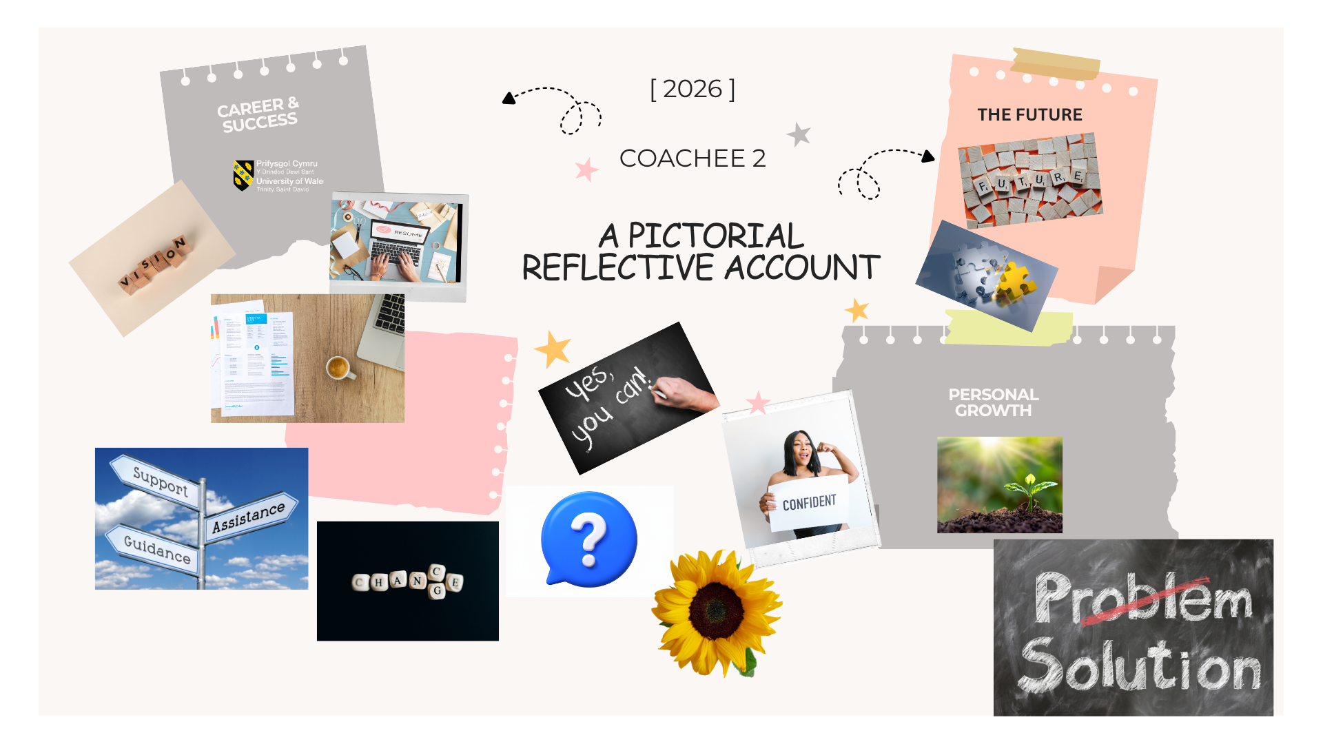
Summary for Coachee 2
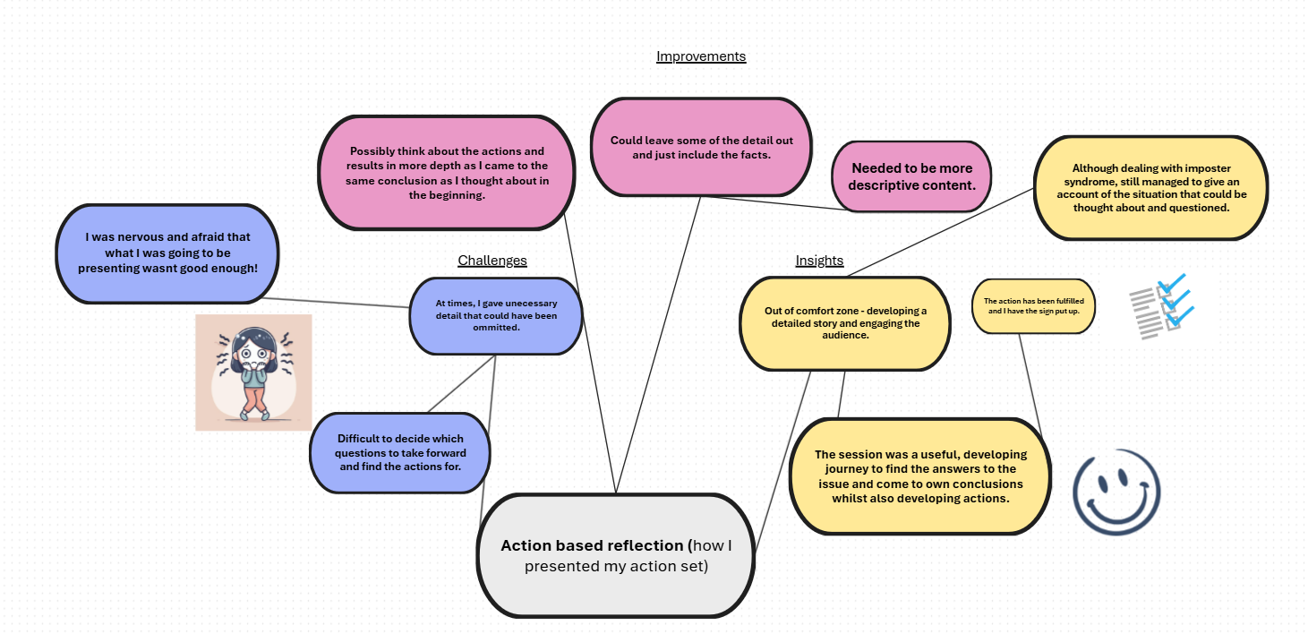
Action based learning sets
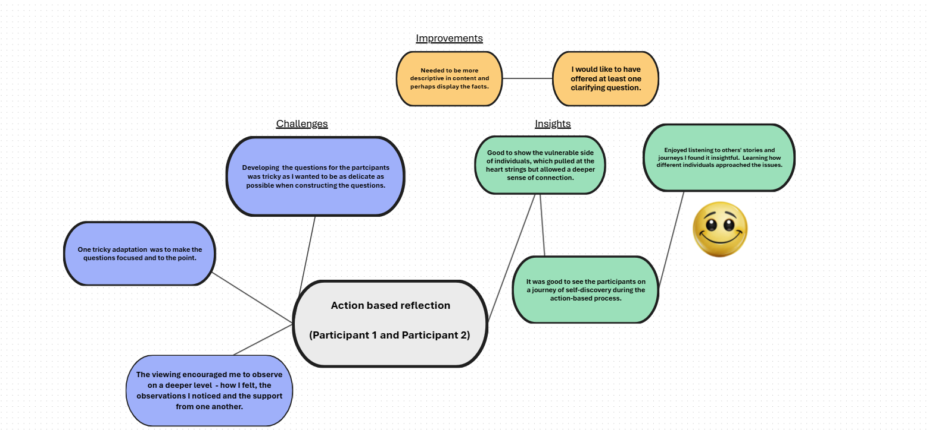

Appendix D
(Personal Development Plan)

Area  for  development | Activity required | Resources / support required | Measure of success (CSFs) | Review method | Review Date
Increase knowledge of coaching and mentoring techniques | Attend a coaching workshop and continue with action – learning sets. | Arrange meeting with fellow colleagues to develop my coaching practice. | Contribution to action – learning sets and increased confidence. Demonstrates support for fellow colleagues during their challenges. | Liaise with colleagues monthly to organise a meeting for active action – learning sets practice. | Scheduled every 3 months if possible when colleagues can all be together at the same time.
Create boundaries and expectations with the coachee, reviewing the coaching contract and adapting where necessary. This is to ensure that I am aligning the sessions with ethical considerations and tailoring to the coachee’s needs. | Review sample coaching contracts to get ideas for where I can develop a contract suitable for the coachees. | Look at documentation online and from facilitator. Ask if I am not sure of anything. Possibly join EMCC for any further resources and support. | I use the updated coaching contract in my next coaching session and assess how it works. | Feedback from coachee will determine if they feel that the contract aligns to their needs. | I will schedule the next coaching session within the next 6 months.
Area  for  development | Activity required | Resources / support required | Measure of success (CSFs) | Review method | Review Date
Improve active Listening skills | My colleagues and I are scheduling regular action-learning set practice to continue to upskill. | More practice developing the skills during action learning sets. | Feedback and inner confidence. Reflect on the experience using a consistent approach and note down improvements made throughout the process. | Feedback from colleagues will support or determine the growth and development. | Every three months
Look at protecting my own mental health and wellbeing throughout the coaching process. | I will aim to continue to exercise to alleviate any pressure that I may have put on myself to succeed in this practice. | Dedicate at least 30 minutes a day to some form of physical activity to support my mental health. | I able to take time out for myself and turn my attention to some protected time, which is ensured that it is respected. | I will feel the benefit of giving myself this ‘me’ time. | Check in daily.

Area  for  development | Activity required | Resources / support required | Measure of success (CSFs) | Review method | Review Date
Build confidence in providing developmental feedback for the coachee. | Reflect after each session. | Prepare feedback notes in advance to ensure alignment with goals. established at the start of the session. Seek mentor guidance for a feedback proforma or style. | The coachee is satisfied after reviewing the feedback. | Gather verbal reflections on how the feedback felt and whether it made a difference to the coachee’s experience. I could also ask coachee to summarise some key points to check understanding. | Over the next 2-3 coaching sessions.
Key:
High priority
Medium priority
Low priority

