January 15, 2021
katrina sheppeard
bmpf7008

Soprano resonance strategies
an exploratory case study of soprano resonance strategies and their representation in voice pedagogy literature
TABLE OF CONTENTS
Proposal |  | 2
 | Context | 2
 | Justification | 3
 | Intended impact | 3
 | Outlined intention | 4
 | Methodology | 4
 | Method | 5
 | Ethics and insider research | 6
 | Expected learning outcomes | 7
Project |  | 8
 | Introduction | 8
 | Literature review | 8
 | Methods | 11
 | Findings | 15
 | Reflections and observations from the case study | 24
 | Conclusion | 27
 | Bibliography | 28
 | Appendices | 32
 | Appendix 1. Table of collected data | 32
 | Appendix 2. Detailed vowel chart | 33
 | Ethics Form | 34
 | Letter of Consent | 50
Presentation Slides |  | 51
List of Figures
 | Table 1. Gantt Timeline | 6
 | Fig 1. Flow chart showing experimental method using the /i/ vowel as an example. | 13
 | Fig 2. Measuring the first formant of the vowel /i/ sung on the note B4 using the LTAS in Voce Vista Pro (581Hz or D5) | 13
 | Fig 3. Measuring the second formant of the vowel /i/ sung on the note B4 using the LTAS in Voce Vista Pro (2002Hz or B6). Glottal fry is circled in white. | 14
 | Figure 4. /i/ Vowel Formants | 15
 | Figure 5. /e/ Vowel Formants | 16
 | Figure 6. /ɛ/ Vowel Formants | 16
 | Figure 7. /a/ Vowel Formants | 17
 | Figure 8. /ɔ/ Vowel Formants | 17
 | Figure 9. /o/ Vowel Formants | 18
 | Figure 10. /u/ Vowel Formants | 18
 | Figure 11. From Deme (2014, p. 92) | 19
 | Figure 12. From Henrich (2011, p.1028) | 20
 | Figure 13. First Formants of all vowels | 21
 | Figure 14. First Formants Notated Musically | 22
 | Figure 15. First Formants Notated Musically (Doscher, 1997, p.152) | 23
 | Figure 16. First Formants Notated Musically (McCoy, 2004, p.45) | 23
 | Figure 17. First Formants Notated Musically (Bozeman, 2013) | 24
 | Figure 18. Speech Formant Map (Miller, 2008, p. 27) | 25
 | Figure 19. Speech and Sung Formant Map (Deme, 2014, p. 92) | 25

PROPOSAL

Context

The proposed research project will be investigating the published formant values for sopranos in pedagogical literature compared to the values for a trained classical soprano with a view to this information being of pedagogical value for the training of young sopranos. The published values of soprano formants used in pedagogical texts are derived from speech; this research will therefore endeavour to show formant values that are more representative of the formant values of the classically trained soprano which require a different vocal tract posture than that of speech. Formant values for the soprano voice will be described from several published pedagogical texts and compared to the formant values collected in this project as well as values found in peer reviewed research.

The researcher is a self-employed singing teacher with a private studio in central London currently teaching students online due to the pandemic and has a special interest in the training of soprano voices. There is further interest in the use of technology, specifically Voce Vista, being incorporated as a teaching aid adding to the authors more than 15 years of teaching and singing experience. A further reason for specifically wanting to map the formants of soprano voices is what is perceived by the author to be a lack of study of the formants of elite classically trained soprano voices, as rather, the current maps of formants quoted in acoustically informed pedagogical text books; Vennard (1967), Doscher (1993), McCoy (2006), D. Miller (2008) and Bozeman (2016), appear to have been derived from speech values which one could argue are more relevant for the male singing voice, as male singers spend more time singing in their speaking range. Classically trained sopranos tend to sing well above their speaking range a greater proportion of the time. Further, it has been observed by the author that the majority of the primary research on the acoustics of the voice that has informed the acoustics pedagogy literature, has been performed by male researchers on the male voice with Johan Sundberg’s and Ingo Titze’s work heavily drawn upon. Explorations by the author on her own voice using Voce Vista show a possible mismatch between the formant values documented in these pedagogical texts and the formants of her own singing voice and therefore point to the lack of relevant information for formant maps for training the soprano voice.

Justification

This project is being undertaken primarily to aid understanding of the formant structure of the authors own singing voice to better understand the difference between classically trained sopranos formant values and the young student soprano who will perhaps present with formant values that are more aligned with speech formant values. Further justification of this project is to gain hands on experience of the use of Voce Vista Pro and thus training in the practical use of this software in the teaching studio.

Intended impact

The expected impact of this project is a greater understanding of acoustics and familiarity of acoustic language by building on current knowledge and utilising Voce Vista software. This would facilitate further learning by enabling the author to participate in discussions with other pedagogy colleagues, particularly US based, who are far more advanced in their knowledge and training. In the authors experience, there is a lack of training available in the UK for acoustic based pedagogy and the use of Voce Vista and an observed lack of use of the technology, particularly among classically trained pedagogues. Consequently, it has been difficult to not only learn how to use the technology but also discuss its merits or otherwise with other classically trained UK based pedagogues. Greater confidence in the use of acoustic knowledge, Voce Vista software, and collaboration with US based pedagogues would add to the skill set needed to be able to perform acoustic based pedagogy research that could contribute to the authors pedagogical knowledge and teaching methodology. The wider ramifications of this project may be to help build a UK based acoustic informed teaching community and perhaps a training course of acoustic based voice pedagogy.

Outlined intention

The intention of this project is to map the formants of the seven Italian vowels /i ,e, ɛ, a, ɔ, o, u/, which are the primary vowels used in classical singing training, across the two octave range from A3 to A5 which encompasses both of the soprano passaggi and all of the speech first formants of the vowels. The results of this study will then be compared to results found in research literature and compared to formant values presented in current pedagogical texts.

Methodology

The world view, or paradigm (Guba, 1994) of the practitioner researcher acts as the bridge between the aims of the study and the methods with which the researcher achieves their aims (Houghton, 2012). A voice practitioner researcher may be more aligned with a subjectivist paradigm, but within an inductive exploratory research design describing quantitative primary and secondary data, a more pragmatic approach (Davies, 2020) can be utilised. A small scale, micro case study will support professional development through self-reflection (Bolton, 2014) and acknowledge that expertise is gained through in-depth case study where researchers place themselves into the study (Flyvbjerg, 2006). This investigation will be a provisional pilot study to reveal themes on which a larger study can be based while being mindful of a feminist epistemology that supports the acquiring of knowledge relevant to the soprano voice and used by female pedagogues.

A case study can use a mixture of qualitative and quantitative methods to examine a typical instance (Denscombe, 2014); this case study will be largely quantitative as is an examination of spectrographic data collected from a classically trained soprano voice compared to secondary data from published research to discuss possible differences and their ramifications for soprano classical voice training. Feminist epistemology recognises the lived experience of women (Landman, 2006). Within the current acoustics research, speech formant values are used to evaluate the female classical singing voice which may not be as relevant for a female voice practitioners understanding of acoustics and its application to pedagogy; if the narrative, and indeed data, is not representative of our lived experience, then female voice teachers and researchers will not have an holistic body of knowledge to draw upon. The criticism that case studies do not produce generalisable findings (Denscombe, 2014) can be mitigated by the researcher giving ample detail about the project in order that the reader can relate the findings to their own teaching (Bassey, 2001) and by using self-reflective journaling for transparency (Laverty, 2003).

Method

The method proposed for this project will be based on Dann Mitton’s (2020) DMA research in which he mapped his own formants for lower male voice (LMV) for ten Russian vowels. Mitton’s (2020) research project is relevant as there is a lack of peer reviewed research on the collection of classical singing formants by voice pedagogues. Mitton (2020) is a respected voice pedagogue who has used acoustics research methods to determine his own formant values, and he gives a detailed description of his method of data collection within a context of thoroughly researched acoustical pedagogy literature.

The four step method used by Mitton (2020) had the subject (himself) speak a familiar English word that contained the target vowel, followed by speaking the Russian word from the song text containing the vowel, then singing the isolated vowel on the pitch G2 (98Hz), and finally while maintaining the vocal tract posture performing the vowel using vocal fry as per the technique outlined by Donald Miller (1997, 2008). Mitton (2020) used the spectrographic software ‘Voce Vista Pro’ to collect his formant data, as this project will do. As a deviation from Mitton’s (2020) method, this project will be using seven Italian vowels /i ,e, ɛ, a, ɔ, o, u/ which will be sung and then vocal fried on pitches throughout the soprano range. The formant values collected will then be compared to the formant values found through desktop research. The author will be the soprano subject, analysing her own voice using the Voce Vista Pro spectrographic software program installed onto a Mac Air computer with an external USB microphone.

Table 1. GANTT TIMELINE
ACTIVITY/DATE | 19th Oct | 26th  Oct | 2nd  Nov | 9th  Nov | 16th  Nov | 23rd  Nov | 30th  Nov | 7th  Dec | 14th  Dec | 21st  Dec | 28th  Dec | 4th  Jan | 11th Jan | 18th Jan
Proposal
Pilot study on own voice and discussion with Kelly Hijleh to refine method
Literature review
Collection of data
Analysis of data and discussion of findings
Submit draft
Final submission 15th Jan
Prepare presentation
Presentation 21st January

Ethics and insider research

When considering the ethics of undertaking a work based research project, it must be ensured that data is collected and processed in a lawful manner and used solely for the purposes originally specified by only collecting the data that is needed for a study, making sure it is accurate, and keeping it secure and anonymised where possible while controlling the distribution and not keeping it longer than needed (Denscombe, 2014). It should also be made clear to the respondent that they have the right to withdraw at any time (Cohen, 2007).

An insider researcher shares characteristics with the people studied and has an innate understanding of them as a member of that group, having the advantage of common knowledge of the life of the subject studied and all its challenges and issues as well as helping to gain access (Saidin, 2016). Criticisms of insider research are to do with lack of objectivity and bias based on the researchers’ prior knowledge and assumptions as well as the balancing of the dual roles of practitioner and researcher (Unluer, 2012). These criticisms can be mitigated by maintaining a detailed journal of decisions made during the project showing clear awareness of any issues (Laverty, 2003).

Expected learning outcomes

Expected personal, specific learning outcomes are:
- proficient use of Voce Vista Pro software technology
- greater fluency in the language of acoustics; the harmonic/formant crossings, where the soprano voice ‘turns’ (Bozeman, 2013 and 2017) and the application of this knowledge to teaching
- to develop a resource that can be used for teaching soprano voices that will clearly show where the acoustic ‘turns’ of the voice will be for a trained soprano
- through presenting this information, finding a clear and concise way to explain acoustics to students and colleagues with a view to being able to teach this information in the UK to other teachers/students

PROJECT

Introduction

Resonance strategies of operatic sopranos are important because they sing unamplified in large theatres over large orchestras (Chapman, 2005). Acoustic voice science now informs traditional teaching models and several pedagogical texts use speech acoustic theory to explain the relationship of vowel formants and voice source harmonics to the resonant sound heard in a well-trained classical voice (Bozeman, 2013, 2017; Doscher, 1997; D. Miller, 2008; Vennard, 1967). But how representative is this speech acoustic theory of the trained soprano voice, and why might this be important? Voice science research has demonstrated resonance strategies that are used by classically trained sopranos and spectrographic software, such as Voce Vista, is readily available to enable teachers to be able to ‘see’ these strategies, yet this technology is not readily used by Western classically trained soprano pedagogues. Might a more soprano centric acoustic model give greater accessibility and make the use of Voce Vista and similar software a more relevant tool in the teaching studio? This case study uses Voce Vista Pro to determine the formant values of an operatic soprano with over 20 years of training, comparing this data to current soprano resonance strategy research, and showing how the formant values change throughout a trained soprano range. These resonance strategies are then discussed in light of current acoustic pedagogical literature arguing that because the majority of acoustically informed pedagogical texts are written by male pedagogues and draw upon male led primary research, a more soprano centric epistemology that is representative of the soprano classical singing experience might broaden acoustic pedagogical knowledge and improve accessibility of this important resource.

Literature Review

Acoustically informed pedagogical texts use speech acoustic theories to explain resonance strategies of the Western classical singing voice. The relationship of the vowel formants to the sung pitch and its harmonics are described by imminent pedagogue authors such as D. Miller (2008), Doscher (1993), Bozeman (2013, 2017), McCoy (2006) and Vennard (1967) who describe the formant frequency values of the vowels for speech and relating this speech acoustic theory to singing. Bozeman (2017) and D. Miller (2008) both describe a simplified model of speech acoustic theory to explain the resonances of the vocal tract, with the pharyngeal cavity responsible for R1 (first formant) and the oral cavity for R2 (second formant). Bozeman (2017), D. Miller (2008) and Doscher (1994) all describe R1 tracking of fo (first harmonic frequency or sung pitch) by sopranos with Bozeman (2017) describing passive vowel migration and the ‘turning’ pitches of vowels, where the harmonic moves through the first formant, or an octave below. Doscher (1994) describes in detail the relationship of the articulators to the vowel formants and D. Miller (2008) gives a spectrographic illustration of the relationship of the sung vowel and its formants to the sound source harmonics using examples from his Voce Vista software program. Recent studies elucidate more detailed descriptions of soprano resonance strategies informed by earlier studies on resonant tuning.

An early model of formant tuning from Lindblom and Sundberg (1971) calculated formant frequencies from area functions derived from the x-ray’s of one male subject producing the vowels /i, u, a/. This study showed that the opening of the jaw increases R1 lineally for these vowels and that the tongue, specifically the amount of constriction with the palate and where the constriction is, influences R2. Lindblom and Sundberg (1971) further observed that R2 is most sensitive to the position of the body of the tongue, specifically the tongue hump; for example, when the tongue hump slides back towards the pharynx, the R2 is lowered with some raising of R1. Sundberg (1997) went on to confirm this model in his 1975 and 1985 studies that investigated the tuning of R1 to fo by jaw opening. Sundberg (1975) used an external low pitched vibrator as the sound source with the soprano subject miming the vowels with a closed glottis. In the second study, Sundberg (1985) used roentgenographic images to calculate the formant’s from the measured area at different pitches for two soprano subjects. Sundberg’s (1997) study measured vowel formants at low pitch from spectrographic information for the ten experienced singers including one soprano subject and then found that for /a/ vowels, singers widened the jaw opening when fo approached R1. With other vowels this jaw opening was shown at higher pitches with relation to R1, indicating the R1 can be also be increased by a reduction of tongue constriction (Sundberg, 1997).

These vocal tract adjustments of sopranos were observed in real time MRI studies. Echternach (2010) studied four student sopranos of approximately four years training, looking for vocal tract changes that occur when moving through an ascending scale on /a/ over the lower and then upper passagio. Echternach (2010) observed vocal tract modifications when the fo reached the R1, noting that singers avoid fo>R1 by lip widening, jaw opening and tongue dorsum elevation. Elevation of the uvula and widening of the pharynx was also observed with some subjects making these vocal tract changes at a pitch well below the R1 [speech] value, assumed to be approximately 750Hz or F#5 (Echternach, 2010). Bresch (2010) also used real time MRI to investigate resonance strategies of five sopranos to measure the formant frequencies of five vowels, using area calculations, at various pitches over a two octave scale. Subjects were asked to sing without vibrato, Bresch (2010) did not describe the training or experience of the sopranos but was exploring the resonance strategies of trained opera singers. Bresch (2010) found a high correlation between the fo and R1 of /u/ and /i/ vowels for all subjects, as consistent with other studies, but this correlation was not clear for the other vowels. The front cavity was observed to open with the fo, this effect being strongest on the /i/ and /u/ vowels.

Several studies have utilised acoustic broadband current injected into the vocal tract via the mouth whilst singing to measure the acoustic strategies of sopranos. Joliveau (2004a, 2004b) confirmed soprano resonance tuning of R1 to fo above the R1 speech value for the respective vowel. Eight sopranos were studied by Joliveau (2004a, 2004b), four professionals and four students, singing a two octave diatonic scale on four vowels. Henrich (2011) also used the broadband technology to study the resonance strategies of 22 classically trained singers who were observed to tune R1 to fo for all vowels over the part of their range when the fo reached the R1 value for speech (Henrich, 2011). The sopranos were also observed to use R2:2fo tuning from the notes C5 to C6, sometimes simultaneously with R1:fo tuning, as well as R1:2f0 tuning from C4 to C5 (Henrich, 2011). Garnier (2010) used the same technology to compare the resonance strategies of 12 sopranos, investigating the influence of expertise. Garnier (2010) studied four professional, four advanced students and four non-experts sopranos singing from the note A4 to top of their range. An /a/ vowel was sung with ascending and descending glissando and it was found that all the advanced and professional sopranos adjusted R1 to fo over the range D5 to C6 (Garnier, 2010). The advanced and professional singers were observed to begin R1:fo tuning at a lower pitch (B4-D5), and from A4 to B4, R1 was close to 2fo (Garnier, 2010).

Deme (2014) cited methodological concerns with the acoustic broadband studies as the singers were asked to sing softly and without vibrato. Deme (2014) investigated the resonance strategies of three professional Western classically trained operatic sopranos using nine vowels on various pitches from F3 to B5 using an external vibratory sound source with a closed glottis and had the singer maintain the vocal tract posture of the pitch just sung, then using inverse filtration to determine the R1 and R2. In her study, Deme (2014) agreed that the R1 is parallel to the raising of fo and that the lower limit of this relationship is dependent on closeness of the vowel.

The methods used in the papers covered by the literature review confirmed the authors preferred research design of using a two octave, diatonic scale covering the majority of the soprano range as seen in Joliveau (2004) and Deme (2014), studying the seven Italian vowels that are frequently used in classical singing training (Bozeman, 2013). This literature review has highlighted the R1:fo coupling resonance strategies for sopranos and is explained by Titze (1988, 2008) where if fo is slightly below R1, the inertive load on the vocal folds may improve their vibration and stability. A further advantage of this resonance strategy is described by Sundberg (1997) stating that R1:fo resonance tuning enables the singer to increase sound pressure with little extra vocal effort.

Methods

This project is following an inductive exploratory research design as a small scale, micro case study; a pragmatic approach embracing Flyvbergs (2006) recognition of expertise gained through in-depth case study. Acoustically informed pedagogy textbooks present speech acoustic theory that may be more relevant to the experience of a male Western classically trained singer. This study investigates a more soprano centric feminist epistemology, observing who are the agents and validators of the current [acoustic] knowledge (Landman, 2006), exploring research that supports the soprano experience of resonance strategies and compares this research with the collected case study data. The experience of being a soprano and teacher of sopranos will impact the lens through which this study views soprano resonance strategy research and its subsequent representation taking into consideration that ontology is related to the viewpoint of reality of the researcher (Houghton, 2012) and the fundamental nature of the phenomenon being studied (Cohen, 2007). Within this project, primary data that is quantitative in its nature will be compared to quantitative data in other research as a provisional pilot study that may reveal themes on which a larger study could be based, using journaling to observe and question data collection decisions for transparency (Laverty, 2003).

In designing the method for this study, other acoustic pedagogical researchers can be referenced; this is an emerging field and there are few studies by Western classically trained pedagogues with acoustic knowledge to draw upon, and none that are soprano pedagogues presenting soprano acoustic resonance strategies. The method used by Mitton (2020) in his DMA study investigating low male voice resonance strategies is a useful guide; using Voce Vista software to investigate the formants of his own voice to analyse Russian song repertoire. Mitton (2020) cites the method developed by D. Miller (1997, 2006) who determined that nonperiodic pronation (glottal fry) could reveal formants when the posture of the sung note is maintained. D. Miller (1997, 2006) developed spectrographic software, Voce Vista, to allow the user to determine the long term average spectra (LTAS) and gain an average measure of the formants of the vowel sample. Titze (2017) showed the use of ‘at home’ equipment for singers to be reliable in determining a formant map, therefore a strict laboratory set up is not a necessity for obtaining useful formant frequency data.

In the literature review for this project, researchers used several different methods to investigate the resonance strategies of sopranos. These investigations were under laboratory conditions using equipment such as real time MRI (Bresch, 2010; Echternach, 2010), x-ray (Sundberg, 1975), and acoustic broadband technology (Joliveau, 2004; Garnier, 2010; Henrich, 2011). However, following Titze’s (2017) study and the example of Mitton (2020), data collected for this case study using Voce Vista Pro technology can be compared to data collected under more formal laboratory conditions. The research on soprano resonance strategies used for comparison to collected data in this study has been led by female researchers, this is in keeping with an awareness of a more feminist epistemology (Landman, 2006).

The data for this study was collected using Voce Vista Pro software installed onto a Mac Air computer with a USB microphone placed 30 cm from the subjects mouth. The vowel formants of seven vowels, /i, e, ɜ, a, ɔ, o, u/ were used as these are representative of the Italian vowels used in classical vocal exercises and are also the vowels used for the first formant values given by Bozeman (2013, 2017) and so able to be compared. The notes covering a two octave, diatonic scale from A3 to A5 were used as these notes cover the majority of the soprano range and both of the traditionally recognised passaggi events. For each note, a familiar word with the target vowel was spoken, then the vowel sung three times on the pitch with the subject (the author) instructed to ‘find’ the best sound, mindful of best technique practice for optimum vocal production. The subject was positioned to watch herself in the mirror for tell-tale muscular and postural tensions that can affect technique. After intoning the third pitch, the subject used vocal fry phonation while maintaining the vocal tract posture of the note and vowel just sung (see Figure 1). This process was repeated across all notes of the two octave diatonic scale in A major and recorded using Voce Vista Pro to ascertain the formant frequency of each of the seven vowels for all notes of the studied range.

Fig 1. Flow chart showing experimental method using the /i/ vowel as an example.
Maintain vocal tract posture and perform glottal fry
Record ‘/i/’ sung 3 times (approx 3 sec)
Determine formant frequencies from the LTAS
Speak word containing target vowel

‘heed’

Fig 2. Measuring the first formant of the vowel /i/ sung on the note B4 using the LTAS in Voce Vista Pro (581Hz or D5)

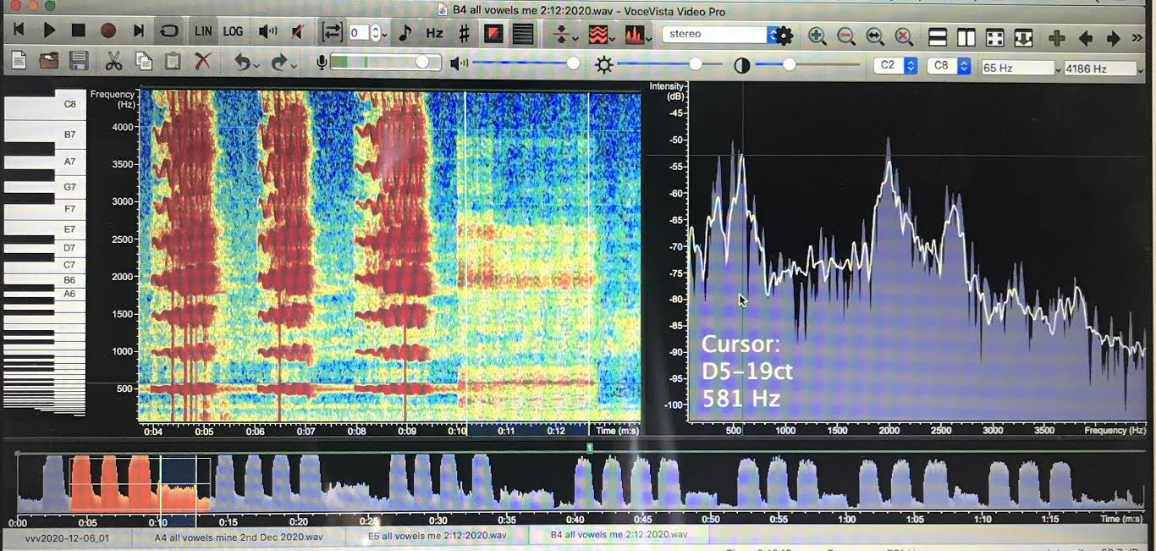

Fig 3. Measuring the second formant of the vowel /i/ sung on the note B4 using the LTAS in Voce Vista Pro (2002Hz or B6). Glottal fry is circled in white.
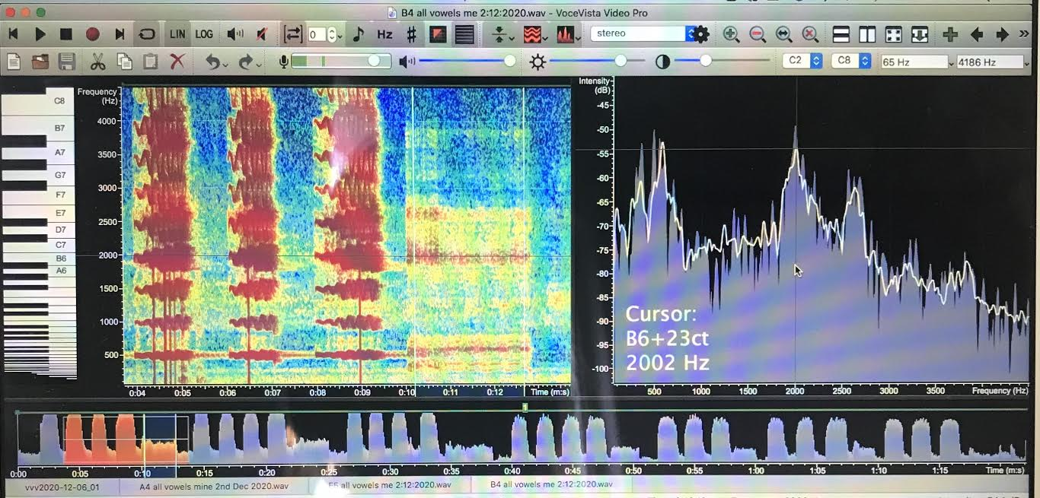

Figures 2 and 3 show screenshots of Voce Vista Pro capturing the sung pitch and then the glottal fry for each vowel, in this example, for the sung pitch B4 with the /i/ vowel. The left panel is the spectrograph for the vowel /i/ with the glottal fry area circled in white on Figure 2. The right panel is the LTAS with the cursor in Figure 1 measuring the first formant frequency (R1) and in Figure 2 the second formant frequency (R2). Formants 1 to 4 were measured and recorded but only the data for formants 1 and 2 have been displayed and discussed in the Findings section (full data can be seen in the Appendix 1 table).

With the subject of a mini case study also being the researcher, the ethics of undertaking a research project must be considered; lawfully and accurately collecting and processing data, not using it for another purpose and making sure it is kept securely and anonymised (Denscombe, 2014). The issue of insider research has also been considered, where ease of access to the subject helped gain access to research data and the advantage of an innate understanding of the subject (Saiden, 2016). Lack of objectivity and bias are criticisms of insider research that have been considered as has an awareness of balancing both the roles of practitioner and researcher (Unluer, 2012). These criticisms can be mitigated by transparency showing clear awareness of any issues by maintaining a detailed journal of decisions made during the project (Laverty, 2003).

Findings

The case study data collected shows the results for each of the seven vowel’s first (R1) and second (R2) formant across the two octaves measured. These results will first be described and then discussed within the context of the research outlined in the literature review. The first formant locations from this study’s data will then be shown as musical notation and compared to the values given in pedagogical textbooks with the implication of this representation discussed.

The results for R1 and R2 have been plotted for each sung vowel as shown in Figures 4 through 10. The horizontal axis shows the notes sung across the two octave range and the vertical axis shows the frequency values for the fundamental pitch, with (fo) plotted as a solid black line and the subsequent five harmonics of each pitch (2fo, 3fo, 4fo, 5fo) shown as dotted lines. The R1 is a thick green line and the R2 is a thick blue line.

Figure 4. /i/ Vowel Formants
/i/
For the sung vowel /i/, a low first formant and high second formant can be seen, as would be expected for this vowel. The speech value for the R1 of the subjects /i/ vowel is 322Hz, or E4, which matches approximately the sung value of R1 from the notes A3 to F#4, after which the R1 ‘tracks’ the sung fo as the voice ascend through the rest of the two octaves. The R2 descends as the fo ascends and there appears to be a relationship of R2 to its closest harmonic with the R2 of each note in close proximity to a harmonic. From G#5, R2 appears to track the 2fo and so the doubling coupling of R1:fo and R2:2fo can be observed.

Figure 5. /e/ Vowel Formants
/e/
For the /e/ vowel the R1 matches closely to the subjects speech R1 value, which is 568Hz or C#5 from the beginning of the scale until F#4. The R1 of /e/ appears to have a relationship to the 2fo until E4 where R1 descends below the 2fo and then tracks the fo from F#4 to the top note of the scale. R2 remains fairly constant across the two octaves with no obvious relationship to the harmonics or tracking of 2fo above the stave as seen for /i/ until A5 where perhaps doubling coupling can be seen.

Figure 6. /ɛ/ Vowel Formants
/ɛ/
For the /ɛ/ vowel, the R1 is slightly higher and R2 lower than for the /e/ vowel with the R1 speech value for /ɛ/ being 617Hz or D#5. For the lowest sung note of A3, the R1 is close to the 3fo but then remains constant until the fo approaches the R1 speech value where it rises, tracking the fo. The R2 appears to mirror R1, remaining fairly constant until the fo reaches the R1 speech value where there is a gradual increase. Apparent double coupling can be observed on the top note of the scale.

Figure 7. /a/ Vowel Formants
/a/
The vowel formants of the /a/ vowel are closer together than those of the previous three vowels. The speech R1 value for /a/ is 788Hz, or G5, but when sung on the lowest note of this scale is a tone lower. This might be explained looking at the interaction with the 3fo and 5fo harmonics where R1 may be utilising the 3fo and R2 the 5fo at this low sung pitch. The sung pitches D4 to E4, R1 moves to 2fo and on F#4 there is a coupling of R1:2fo and R2:3fo. On the sung note A4 there appears to be no coupling with either vowel formant to a harmonic, from C#5 there is an apparent tracking of R2:2fo and from E5, R1:fo with both formants ascending with the pitch from this note, and an apparent uncoupling of R2:2fo on the top note.

Figure 8. /ɔ/ Vowel Formants
/ɔ/
The /ɔ/ vowel has a fairly constant R1 throughout the ascending scale until C#5 which is the approximate speech formant value for this vowel of 530Hz, or C5. From C#5 we can see tracking of the R1:fo. The R2 appears to gradually decrease across the scale until B4 where we see some tracking of R2:2fo until F#5, after which R2 decreases and appears to move away from 2fo for the last two notes of the scale.

Figure 9. /o/ Vowel Formants
/o/
The /o/ vowel of the subject has a speech R1 of B4, or 475Hz. The R1 of the sung notes for the ascending scale remain fairly constant until C#5 where R1:fo tracking occurs to the top of the scale. The R2 descends gradually, showing some relationship to its closest harmonics, until the note B4 where it then ascends with the fo of the scale, loosely coupling the 2fo. For the top two notes of the scale, the R2 descends, bringing the two vowel formants closer together.

Figure 10. /u/ Vowel Formants
/u/
The /u/ and /i/ vowels both share the lowest R1 for speech which for this subject is E4 or 324Hz. For the lowest two notes of the scale, R1 is coupling with 2fo and then descends to meet fo on C#4 which it then tracks to the top of the stave. At F#5, R1 descends below the sung pitch, with R2 also descending at this point. R2 maintains a loose relationship to its nearest harmonic throughout the range until the top of the stave.

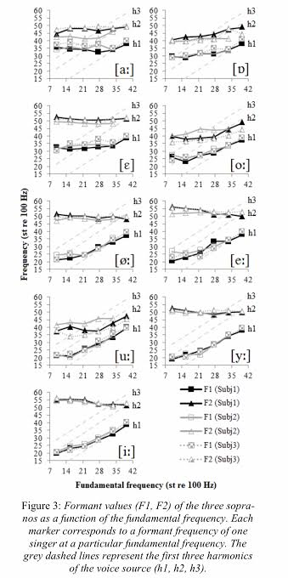
The results from this mini case study can be compared to the results found by Deme (2014) shown graphically in Figure 11 and reflect the results collected by this study where the R1 rises with fo from approximately the R1 speech value. Deme’s (2014) results showed the R2 to be more independent of pitch, with /e, i/ showing a slight decrease of R2 when fo:R1 tuning begins, /o,u/ stronger decrease of R2 at R1:fo, and /a, ɛ/ independent of pitch. These findings are similar for the /i/ and /ɛ/ vowels in this case study, but not for the other vowels. In comparison, the /e/ vowel of this study appears to show an independence from pitch and the /a,o,u/ vowels show an increase with R1:fo coupling (/ɔ/ was not included in the Deme study).
Figure 11. From Deme (2014, p. 92)

The results of this study can also be compared to Joliveau (2004a, 2004b) who observed that when the fo is lower than R1 for speech, both R1 and R2 varied little and were consistent with the vowel formant values of speech; above this, at higher pitches, R1 increased and stayed approximately equal to fo, as also seen in this study’s results. The R2 was observed by Joliveau (2004) to increase once R1:fo tuning began, but to a lesser degree, which did agree with this study’s results for the vowels /a/, /ɔ/, /o/ and /u/.

Garnier (2010) also used broadband technology to study the /a/ vowel on ascending and descending glissandi finding that all the advanced and professional sopranos investigated adjusted R1 to fo over the range D5 to C6. This strategy could also be seen for the /a/ vowel in this case study. The advanced and professional singers in Garnier’s (2010) study were observed to begin R1:fo tuning at a lower pitch (B4-D5), and from A4 to B4, R1 tuned to 2fo. In this case study, R1:2fo coupling was also observed but at E4 and F#4 (Garnier (2010) did not study pitches below A4).
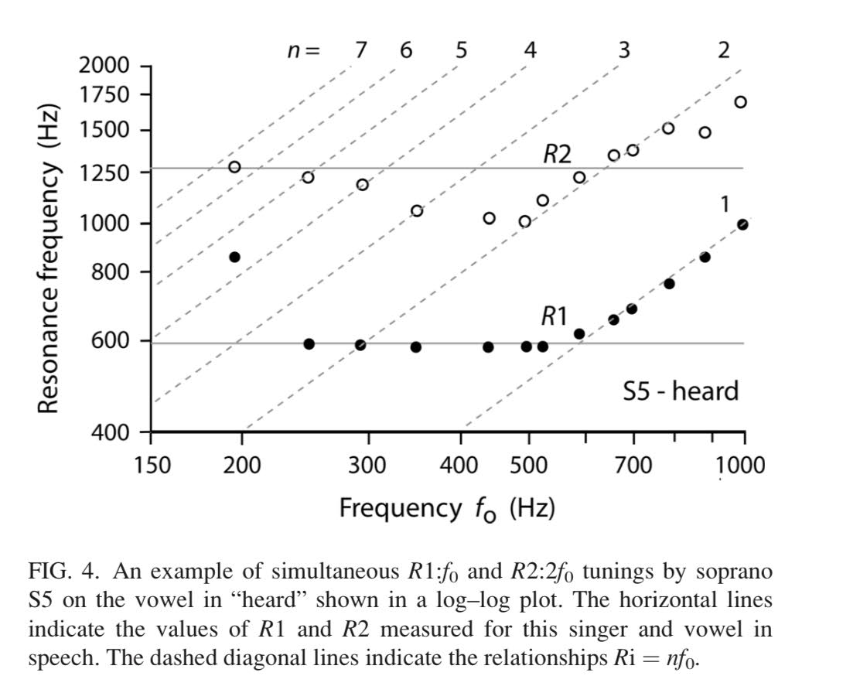
Henrich (2011) observed sopranos in her study to use R2:2fo tuning from C5 to C6, sometimes simultaneously with R1:fo as was observed in this study on /i/, /e/ and /ɛ/ vowels. Henrich (2011) also observed R1:2fo tuning from C4 to C5 which was corroborated by this study for the /i/, /ɔ/, /o/ and /u/ vowels (R1:3fo tuning for the /a/ vowel of this study on C#4 and D4).
Figure 12. From Henrich (2011, p. 1028)
From the comparisons of research of soprano resonance strategies to this case study, a consistency can be seen of R1:fo tuning once the fo reaches the R1 of speech, indicating that this is the major resonance strategy of the classically trained soprano voice, with some discrepancies for R2 tuning that could be further investigated. Looking closely at the R1 values collected in this study, Figure 13 below shows the tracking of R1:fo from speech R1 values and their convergence at F#5, or the top of the treble clef stave. Joliveau (2004) comments on this established phenomenon where many previous studies report that the R1 of different vowels converge above E5 (Joliveau, 2004).

Figure 13. First Formants of all vowels
Figure 13 shows all first formants displayed together along with the first three harmonics. This is a useful representation to compare all the R1 values of the vowels as the sung pitch ascends through the range. The lowest two R1’s, the /i/ and /u/ vowels, ascend earlier in the scale to stay above fo; the higher R1 vowels do not move until D5 where all vowel R1’s are ascending and merge as the voice ascends through the passagio, as also described by Deme (2014) and Joliveau (2004a, 2004b). The /u/ vowel is the outlier at the top of the scale for this study with its R1 not maintaining the upward trajectory, possibly due to lip rounding as discussed in Joliveau (2004a, 2004). It is also noted by the author that maintaining an /u/ vowel lip posture at this pitch becomes challenging if an optimal resonant sound is to be maintained.
Another way to show this movement of first formants is as music notation, shown in Figure 14 below where the formant values for speech and then several notes throughout the scale are compared.

Figure 14. First formant Locations Musically Notated
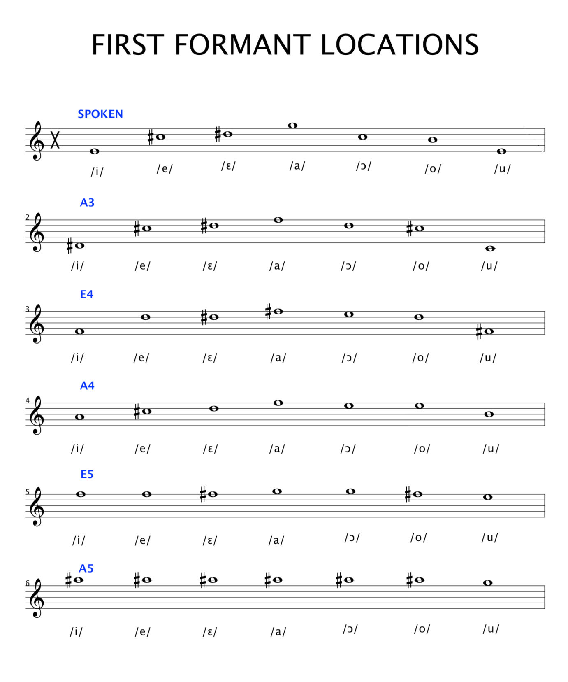

Presenting first formant data in this way shows clearly the location of R1 is pitch dependent for sopranos. The second stave displaying the first formants for vowels sung on the note A3 follows the arched curve seen for speech R1’s where there is an interval of a tenth between the lowest R1 value and the highest. This curve becomes less pronounced as the sung note moves up the scale, with the interval between the lowest and highest R1 at A4 being a sixth, at E5 a third, and at A5 only a semitone. These first formant values differ from what we see in the pedagogical texts as shown in the examples below in Figure 15. to 17. which represent only speech R1’s (and also R2’s in Figure 16.).
Figure 15. First Formants Notated Musically (Doscher, 1997, p.152)
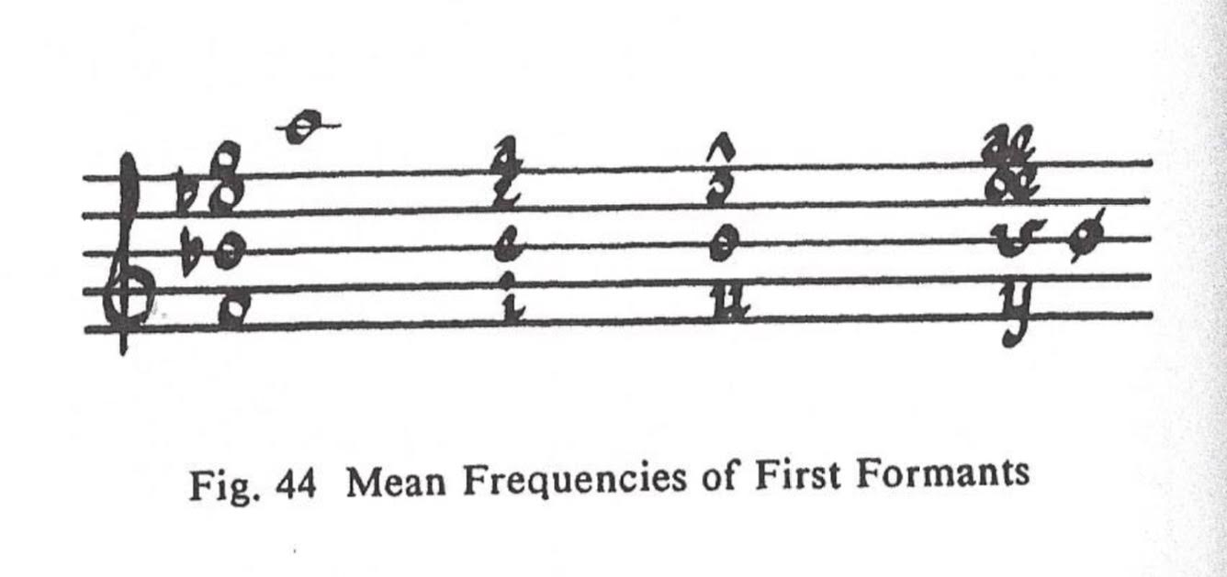
Figure 16. First Formants Notated Musically (McCoy, 2004, p.45)
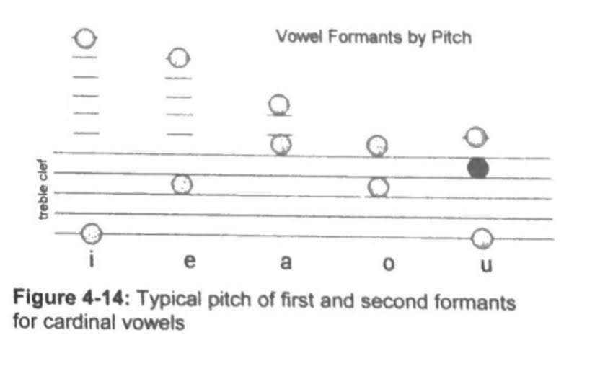
Figure 17. First Formants Notated Musically (Bozeman, 2013)

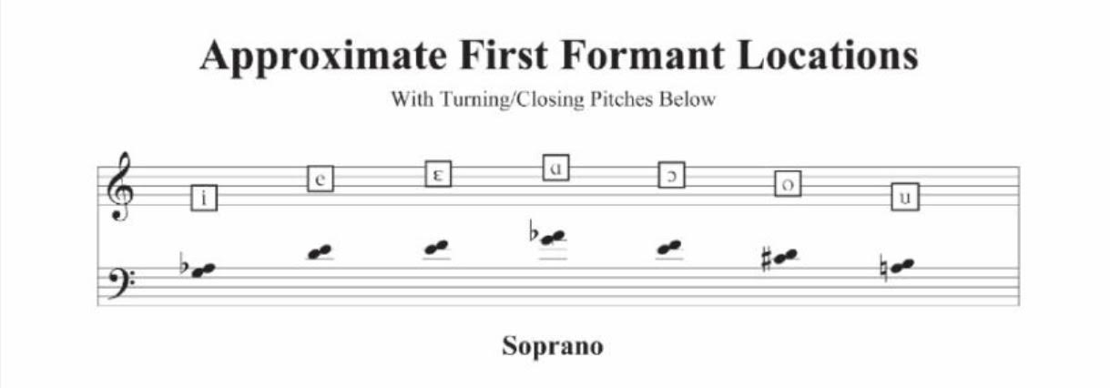
As a soprano, giving only the speech R1 and not clearly defining that these values move with the pitch of the voice as an important soprano resonance strategy can be a confusing representation for a soprano when exploring acoustic voice theory. This common pedagogical representation, in the opinion of the author, does not relate to the experience of a soprano classical singer where all vowels are trained to be clear and resonant throughout the range. The musical notation presented in Figure 14 is a clearer representation of the soprano experience and perhaps further studies might enhance the data collected in this study.

Speech formants are also represented in pedagogical texts as a formant map, an example of which can be seen in Figure 18 below from D. Miller (2008) with similar maps displayed in other acoustic pedagogical texts such as Doscher (1993) and Vennard (1967).
Figure 18. Speech Formant Map (Miller, 2008, p. 27)
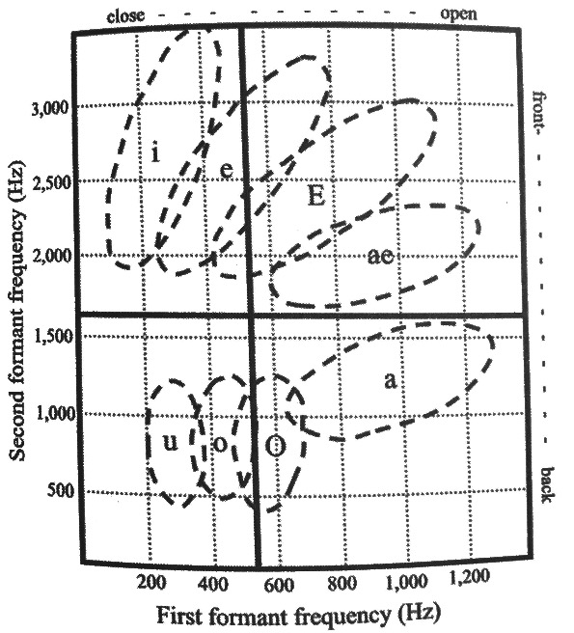
This backward ‘c’ shape of the vowel formants is a common representation but this is not the whole story for the soprano. Deme (2014) shows this map format for vowels in Figure 19 below where the vowel map on the right shows a convergence of all vowel formants in the height of the soprano range.

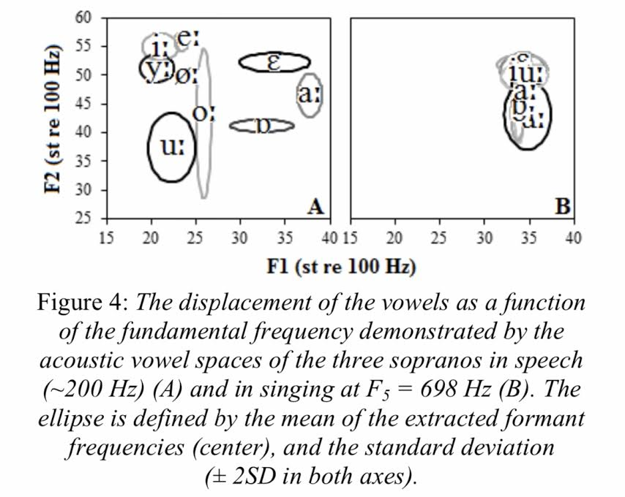
Deme’s (2014) diagram shows the difference between speech formants on the left, and sung formants (at the top of the stave) on the right; an important representation of the soprano experience.
Figure 19. Speech and Sung Formant Map (Deme, 2014)

The speech formant model is also seen in Vennard (1967), McCoy (2006) and Doscher (1993) and is a very useful starting point to the understanding of the relationship of vowel formants and pitch but based on the authors experience and the soprano resonance strategy data presented in this paper, it does not give the whole soprano story and can therefore make acoustic theory, that is already abstract and challenging, more inaccessible for Western classically trained soprano singers and pedagogues.

Reflections and observations from the case study

The main articulatory influence on R1 is jaw opening or more specifically, the oral space in front of the tongue hump which can also be altered by the amount of constriction between the tongue hump and palate (Sundberg, 1997; Garnier, 2010). Knowing that the first formant ascends with the pitch once fo approaches R1 of speech for the vowel (Deme, 2014; Joliveau, 2004; Titze 2008), and that the jaw opening and tongue constriction are both responsible for ‘tuning’ this formant, the teacher could employ different resonance strategies to find the most resonant vowel on each pitch for the student both aurally, and visually using Voce Vista software. Bozeman (2017) describes R1:fo tuning in sopranos as ‘whoop’ timbre, and the idea of acoustical ‘turns’ where the fo moves through the R1 of the vowel (in the male voice, higher harmonics will move through the R1’s), is represented as musical notation as shown in Figure 17. Bozeman (2017) emphasises that singers should maintain the vocal tract posture and allow passive migration ‘through’ these turnings. However, for a soprano the idea of passive vowel migration and ‘turning’ is difficult to relate to as shown in this papers research, sopranos do not cross through the R1 but rather ‘move’ the R1 with the pitch.

Doscher (1993) describes in detail the relationship of the vocal tract spaces and their relationship to vowel formants using speech formant acoustic theory to describe vowel migration and its relationship to tongue articulation (Doscher, 1993). Bozeman (2017) also describes the speech formant model describing the R1 perceived in the ‘back room’ or pharyngeal space and R2 is perceived in the ‘front room’ or oral space in front of the tongue hump. This simplified model (D. Miller, 2006) is very useful for a basic understanding vowel acoustics, not wholly representative of soprano resonance strategy where there is a more complex relationship between jaw height, tongue constriction and lip rounding (Sundberg, 1997). The spaces and shapes these components form from articulation of text in singing could be described from a more soprano centric epistemology, grounded in researched soprano resonance strategy and displayed to help inform more traditional soprano voice training methods.

Harmonics are widely spaced in the height of the soprano voice (D. Miller, 2006), thus a strategy that might be expected is R2:2fo with R1:fo as the two strongest harmonics of the voice would be boosted by the vowel formants. This strategy was indeed seen in Henrich’s (2011) research where sopranos were observed to use R2:2fo tuning from C5 to C6, sometimes simultaneously with R1:fo tuning. In the case study data collected for this paper, the /i/, /e/ and /ɛ/ vowels also showed this strategy (Fig 4. and 5.); although loud, this is not an aesthetically pleasing sound for the authors dramatic soprano voice and would not be her choice of ‘best vowel’ above the stave. Therefore,
decoupling of R2 from 2fo might be a better resonance strategy for a soprano above the stave where R1 is already tuned to the fo. This is seen in the vowels /a/, /o/ and /ɔ/ in Figures 6 to 8 of this case study’s data. Bozeman (2017) also discusses this strategy, observing that the first formant dominates the timbre from D5 and tracks the sung pitch, as well as detuning R2 away from the higher harmonics to avoid ‘shrillness’ (p.71) indicating that this can be done by changing the shape of the tongue.

R2 soprano strategies are explored in the Deme (2014) and Joliveau (2004) studies but are inconclusive and need further investigation. However, it is notable that the acoustic broadband technology used for several of the studies cited in this paper (Joliveau, 2004; Garnier, 2010; Henrich 2011) requires soft singing. Bozeman (2017) observes that close vowel posture [ie R1:fo with R2:2fo] can be used to sing a ‘soft, silvery float timbre’ that would otherwise be shrill if louder (p. 72) which may explain the R2 discrepancies across the studies. If the authors R2 strategy above the stave is a commonality for trained sopranos, and the tongue, specifically the location of the tongue hump, is responsible for R2 tuning, then this would be an important pedagogical consideration above the stave. Further investigation with other professional sopranos would need to be undertaken to identify this as a definitive resonance strategy.

When collecting data for this case study, the author found it challenging to maintain the sung vowel vocal tract posture for the glottal fry, particularly in the higher notes. When in the upper range, it was also observed that it was difficult not to tune the vowel heard during glottal fry as the target vowel vocal tract posture produces a manipulated version of the vowel; when the pitch is removed and the glottal fry is the sound source this is quite disconcerting as aural feedback is so important to resonance tuning of sopranos who learn R1:fo tuning by the sound of their own voice and the feeling of less effort (Jeanetteau, 2020). It would be interesting to investigate the vowel perception heard with glottal fry for the vocal tract postures in the higher soprano range and this could perhaps be a useful tool for learning articulation for the higher soprano range. Bozeman (2020) has also discussed the use of chiaroscuro whisper to help tune R2 which would be an important pedagogical tool to explore.

This project has highlighted the importance of the contribution tongue movement makes to articulation of the resonances throughout the range, and an in depth exploration of the research, from scientists such as Kerri Obert who have published research in this area, would be worthwhile. Knowledge of how articulation affects vowel production is described in phonetics texts and applied to singing by pedagogues such as Doscher (1993) and Bozeman (2017), thus further exploration of phonetic theory and is application using a soprano centric epistemology in light of the soprano resonance strategies discussed in this paper requires investigation. In the authors training, keeping the jaw height constant throughout the mid-range with the tongue used to change vowels has been an important technique model from several teachers; the tongue is therefore responsible for maintaining the vowel throughout the pitches of mid-range. Pedagogical instruction to ‘maintain the vowel’ or ‘sing into the resonance’ across these pitches can now be understand from this study to mean that the teacher is listening for R1 tracking of fo to maintain the resonance.

The listening of the teacher for this resonance strategy could also be visually aided with the use of a software program such as Voce Vista either directly or indirectly using technology to enhance traditional technique training. Spectrographic tools might enhance learning for students with biofeedback (Moss, 2019) by ‘seeing’ formant/harmonic interaction, but with limited time in a singing lesson and the amount of background theory needed to interpret spectrography, it might be the application of knowledge through vowel choice and articulatory directives that could be more valuable. Developing a protocol so pedagogues can compare results between studios would be a worthwhile project with a view to a soprano pedagogue led investigation for relevant and useful data. For the information to be relevant and usable for pedagogues in the teaching studio, studies based on software such as Voce Vista would be an appropriate choice, perhaps sacrificing accuracy for accessibility.

Conclusion

This project has achieved key aims set out in the proposal; developing a proficiency with Voce Vista Pro and becoming more fluent in the language of acoustics. However, a new understanding of soprano resonance strategies has changed the perception of the importance of learning the ‘turns’ described by Bozeman (2017) where harmonics cross the first formants of vowels (or the octave below), thus the other aims of this project have become redundant as they do not reflect the soprano experience. This project has shown that as a soprano, it is more useful to see how the R1’s move with pitch throughout the soprano range rather than that they are fixed at the speech values with the harmonics moving through the first formant speech resonance. Having information available that is representative of the soprano resonant strategies may make the understanding of the relationship of formants, vowels and harmonics more accessible to sopranos that wish to use this knowledge in their singing and teaching. Being able to understand the relationship between vowel, pitch, harmonic and formant and then utilising a software program to further display and see these relationships could help bridge the gap between traditional voice training and voice science knowledge for pedagogues and students. Taking into account a feminist epistemology looks at who are the creators of knowledge; the pedagogical texts cited in this paper have made abstract, acoustical knowledge more accessible for singing teachers, but for sopranos to have greater understanding and access, it can be argued that a more representative map of what happens to the formant/harmonic interactions throughout the soprano range, and not just at speech level, needs to be included to tell the whole story. This case study has shown some ways this knowledge may be represented and also the necessity for a more extensive future study.

Bibliography
Bassey, M., 2001. A Solution to the Problem of Generalisation in Educational Research: fuzzy prediction. Oxford Review of Education, 27(1), pp. 5-22.
Bell, J. W. S., 2018. Doing Your Research Project. London: Open University Press
Bolton, G., 2014. Reflective Practice: Working with Professional Development. London: Sage Publishing.
Bozeman, K., 2007. A case for voice science in the voice studio. Journal of Singing, 63(3), pp.265-270.
Bozeman, K., 2017. Kinesthetic voice pedagogy: Motivating acoustic efficiency. Inside View Press.
Bozeman, K.W., 2013. Practical vocal acoustics. Hillsdale, NY: Pendragon Press.
Bozemen, K, 2020. Personal communication.
Bresch, E. and Narayanan, S., 2010. Real-time magnetic resonance imaging investigation of resonance tuning in soprano singing. The Journal of the Acoustical Society of America, 128(5), pp.EL335-EL341.
Chapman, J.L., 2016. Singing and teaching singing: A holistic approach to classical voice. Plural Publishing.

Cohen, L. M. L. M. K., 2007. Research Methods in Education. Oxon: Routledge.
Davies, C., 2020. A Quick Guide to Quantitative Research in the Social Sciences, s.l.: s.n.
Deme, A., 2014. Formant strategies of professional female singers at high fundamental frequencies. In Proceedings of the 10th International Seminar on Speech Production (ISSP) (pp. 90-93).
Denscombe, M., 2014. The Good Research Guide. 5 ed. London: Open University Press.
Doscher, B., 1993. The functional unity of the singing voice. Scarecrow Press.
Echternach, M., Birkholz, P., Traser, L., Flügge, T.V., Kamberger, R., Burk, F., Burdumy, M. and Richter, B., 2015. Articulation and vocal tract acoustics at soprano subject's high fundamental frequencies. The Journal of the Acoustical Society of America, 137(5), pp.2586-2595.
Echternach, M., Sundberg, J., Arndt, S., Markl, M., Schumacher, M. and Richter, B., 2010. Vocal tract in female registers—a dynamic real-time MRI study. Journal of Voice, 24(2), pp.133-139.
Feilzer, M. Y., 2010. Doing Mixed Methods Research Pragmatically: Implications for the Rediscovery of Pragmatism as a Research Paradigm. Journal of Mixed Methods Research, 4(1), pp. 6-16.
Flyvbjerg, B., 2006. Five Misunderstandings About Case-Study Reseach. Qualitative Inquiry, 12(2), pp. 219-245.
Garnier, M., Henrich, N., Smith, J. and Wolfe, J., 2010. Vocal tract adjustments in the high soprano range. The Journal of the Acoustical Society of America, 127(6), pp.3771-3780.
Guba, E. L. Y., 1994. Competing Paradigms in Qualitative Research. In: Handbook of Qualitative Research, 2. s.l.:s.n., pp. 163-194.
Henrich, N., Smith, J. and Wolfe, J., 2011. Vocal tract resonances in singing: Strategies used by sopranos, altos, tenors, and baritones. The Journal of the Acoustical Society of America, 129(2), pp.1024-1035.
Houghton, C. H. A. M. P., 2012. Linking Aims, Paradigms, and Method in Nursing Research. Nurse Researcher, 20(2), pp. 23-39.
Jeanneteau, M., Hanna, N., Almeida, A., Smith, J. and Wolfe, J., 2020. Using visual feedback to tune the second vocal tract resonance for singing in the high soprano range. Logopedics Phoniatrics Vocology, pp.1-10.
Joliveau, E., Smith, J. and Wolfe, J., 2004. Tuning of vocal tract resonance by sopranos. Nature, 427(6970), pp.116-116.
Joliveau, E., Smith, J. and Wolfe, J., 2004. Vocal tract resonances in singing: The soprano voice. The Journal of the Acoustical Society of America, 116(4), pp.2434-2439.
Kakkori, L., 2009. Hermeneutics and Phenomenological Problems When Applying Hermeneutic Phenomenological Method in Educational Qualitative Research. Paideusis, 18(2), pp. 19-27.
Landman, M., 2006. Getting Quality in Qualitative Research: A Short Introduction to Feminist Methodology and Methods. Proceedings of the Nutrition Society, Volume 65, pp. 429-433.
Laverty, S. M., 2003. Hermeneutic Phenomenology and Phenomenology: A Comparison of Historical and Methodological Considerations. International journal of Qualitative Methods, 2(3), pp. 21-35.
Lindblom, B.E. and Sundberg, J.E., 1971. Acoustical consequences of lip, tongue, jaw, and larynx movement. The Journal of the Acoustical Society of America, 50(4B), pp.1166-1179.
McCoy, S.J., 2004. Your voice, an inside view: Multimedia voice science and pedagogy. Inside View Pr.
Miller, D. G., Sulter, A. M., Schutte, H. K., & Wolf, R. F. (1997). Comparison of vocal tract formants in singing and nonperiodic phonation. Journal of Voice, 11(1), 1–11. https://doi.org/10.1016/S0892-1997(97)80018-5
Miller, D., 2008. Resonance in Singing. New Jersey: Inside Press View.
Mitton, D., 2020. Sung Russian for the Low Male Voice Classical Singer: The Latent Pedagogical Value of Sung Russian with a Fully Annotated Bibliography and IPA Singers’ Transcriptions for Musorgsky’s Sunless and Kabalevsky’s Op. 52: Ten Shakespeare Sonnets on Translations. Doctoral Dissertation, University of Toronto.
Morgan, D. L., 2007. Paradigms Lost and Pragmatism Regained: Methodological Implications of Combining Qualitative and Quantitative Methods. Journal of Mixed Methods Research, 1(1), pp. 48-76.
Moss, H., 2019. Mobile Apps and biofeedback in vocal pedagogy. To be published in Journal of Singing (made available in personal communication with the author)
Ness, H., 2017. Italian pronunciation: the ultimate guide. Date viewed 20.12.2020 <https://www.mimicmethod.com/italian-pronunciation-the-ultimate-guide/>
Robinson, C., 2011. Mixed Methods Data Collection in Dementia Research: A "Progressive Engagement" Approach. Journal of Mixed Methods Research, 5(4), pp. 330-344.
Saidin, K. Y. A., 2016. Insider Researchers: Challenges and Opportunities. Malaysia, ICECRS.
Smith, J. and Wolfe, J., 2009. Vowel-pitch matching in Wagner’s operas: Implications for intelligibility and ease of singing. The Journal of the Acoustical Society of America, 125(5), pp.EL196-EL201.
Story, B.H., Laukkanen, A.M. and Titze, I.R., 2000. Acoustic impedance of an artificially lengthened and constricted vocal tract. Journal of Voice, 14(4), pp.455-469.
Sundberg, J. and Skoog, J., 1997. Dependence of jaw opening on pitch and vowel in singers. Journal of Voice, 11(3), pp.301-306.
Sundberg, J., 1975. Formant technique in a professional female singer. Acta Acustica united with Acustica, 32(2), pp.89-96.
Sundberg, J., 1989. The Science of the Singing Voice. Cornell University Press.
Swerdlin, Y., Smith, J. and Wolfe, J., 2010. The effect of whisper and creak vocal mechanisms on vocal tract resonances. The Journal of the Acoustical Society of America, 127(4), pp.2590-2598.
Titze, I.R., 2008. Nonlinear source–filter coupling in phonation: Theory. The Journal of the Acoustical Society of America, 123(4), pp.1902-1915.
Titze, I.R., Baken, R.J., Bozeman, K.W., Granqvist, S., Henrich, N., Herbst, C.T., Howard, D.M., Hunter, E.J., Kaelin, D., Kent, R.D. and Kreiman, J., 2015. Toward a consensus on symbolic notation of harmonics, resonances, and formants in vocalization. The Journal of the Acoustical Society of America, 137(5), pp.3005-3007.
Titze, I.R., Maxfield, L.M. and Walker, M.C., 2017. A formant range profile for singers. Journal of Voice, 31(3), pp.382-e9.
Titze, I.R., Worley, A.S. and Story, B.H., 2011. Source-vocal tract interaction in female operatic singing and theater belting. Journal of Singing, 67(5), pp.561-572.
Unluer, S., 2012. Being an Insider Researcher While Conducting Case Study Research. The Qualitative Report, 17(29), pp. 1-14.
Vennard, W., 1967. Singing: the mechanism and the technic. Carl Fischer, LLC.
Vos, R.R., Murphy, D.T., Howard, D.M. and Daffern, H., 2018. The perception of formant tuning in soprano voices. Journal of Voice, 32(1), pp.126-e1.
Wolfe, J., Garnier, M. and Smith, J., 2009. Vocal tract resonances in speech, singing, and playing musical instruments. HFSP journal, 3(1), pp.6-23.

APPENDICES

Appendix 1. Collected data from case study
Appendix 2. Vowel chart from https://www.ipachart.com
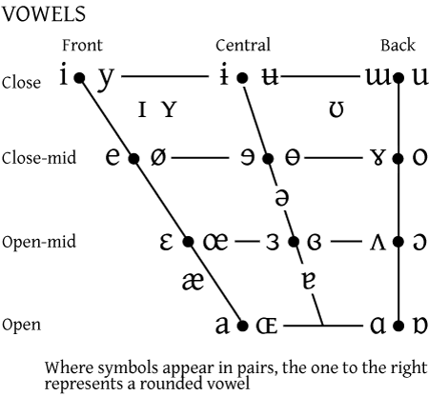

APPLICATION FOR ETHICAL APPROVAL

In order for research to result in benefit and minimise risk of harm, it must be conducted ethically. A researcher may not be covered by the University’s insurance if ethical approval has not been obtained prior to commencement.

The University follows the OECD Frascati manual definition of research activity: “creative work undertaken on a systematic basis in order to increase the stock of knowledge, including knowledge of man, culture and society, and the use of this stock of knowledge to devise new applications”. As such this covers activities undertaken by members of staff, postgraduate research students, and both taught postgraduate and undergraduate students working on dissertations/projects.

The individual undertaking the research activity is known as the “principal researcher”.

Ethical approval is not required for routine audits, performance reviews, quality assurance studies, testing within normal educational requirements, and literary or artistic criticism.

Please read the notes for guidance before completing ALL sections of the form.

This form must be completed and approved prior to undertaking any research activity. Please see Checklist for details of process for different categories of application.

SECTION A: About You (Principal Researcher)

Full Name: |  |  | Katrina Jane Sheppeard
Tick all boxes which apply:
Member of staff: | ☐ | Student: |  | ☒ | Honorary research fellow: | ☐

Faculty/School/Centre: | WIWBL
Campus: | Carmarthan
E-mail address: | wbl@uwtsd.ac.uk
Contact Telephone Number:
For students:
Student Number: | 1817559 | Undergraduate | ☐
Programme of Study: | MA in Professional Practice (Voice Pedagogy) | Taught Postgraduate | ☒
Director of Studies/Supervisor: | Debbie Winter | Research | ☐

SECTION B: Approval for Research Activity

Has the research activity received approval in principle?  (please check the Guidance Notes as to the appropriate approval process for different levels of research by different categories of individual) |  | YES | ☐ | NO | ☐
 |  |  |  | Date
If Yes, please indicate source of approval (and date where known): | Research Degrees Committee |  | ☐
 | Faculty Research Committee |  | ☐
 | Other (write in) |  | ☐
Approval in principle must be obtained from the relevant source prior to seeking ethical approval.

SECTION C: External Ethical Guidance Materials

Please list the core ethical guidance documents that have been referred to during the completion of this form (including any discipline-specific codes of research ethics, and also any specific ethical guidance relating to the proposed methodology). Please tick to confirm that your research proposal adheres to these codes and guidelines.
ESRC Ethical guidelines for research | ☒
WIWBL Ethical guidelines | ☒
 | ☐

SECTION D: External Collaborative Research Activity

Does the research activity involve collaborators outside of the University? |  | YES | ☐ | NO | ☒
If Yes, please provide the name of the external organisation and name and contact details for the main contact person:
Institution
Contact person name
Contact person e-mail address

Where research activity is carried out in collaboration with an external organisation
Does this organisation have its own ethics approval system? | YES | ☐ | NO | ☒
If Yes, please attach a copy of any final approval (or interim approval) from the organisation

SECTION E: Details of Research Activity

Indicative title: | Measurement of formants of elite operatic sopranos
Proposed start date: | 22nd October 2020 | Proposed end date: | 15th January 2021
Purpose of research activity (including aims and objectives)
Outline the purpose, aims and objectives of the research activity, including key research questions. Show briefly how existing research has informed the proposed activity and explain what the research activity will add and how it addresses an area of importance. (Maximum 300 words)
Background: I am a classically trained professional soprano and self-employed singing teacher with a private singing studio based in London, currently using the same teaching methods and basic technology I was trained with, as were my teachers and those before them. I have an interest in the use of spectrography as a tool for training singers and have taken two acoustics courses this year that also offered an introduction to the use of Voce Vista software. As well as these formal courses, I have undertaken self-study by working through the textbook by the Voce Vista developer, Donald Miller, with one of my MA cohort colleagues. During this study I have become aware that the formant values cited in the acoustic texts are for speech values and these vary a lot for treble voice classical singing where vowels are manipulated for the greatest acoustic benefit.

Aims:
The aims of the research will therefore be;
- to measure the formants of elite operatic sopranos and compare these to the speech values given in the texts
- to become familiar with the expected formant values for trained voices with a view to use within my teaching
- to understand the relationship between the different cardinal vowels and how they can be manipulated by sopranos for the greatest acoustic affect
- to become proficient in the use of Voce Vista software and its use as a teaching tool with a view to being able to teach other voice teachers in the UK
- to challenge my current teaching methods
- to aid my professional development

Previous research: Much of the research of vowel formants has been based on speech values. This is relevant for the lower male voices as they mostly sing in their speaking range with the same modal registration used for speech. Soprano’s sing using primarily mode 2 and need to manipulate the vowel formants for the best acoustic outcome as well as intelligibility. In the upper part of the soprano range, the pitch is above the first formant value of all vowels for speech; soprano’s must raise these formants in order to utilise these first formant resonances, this is the primary strategy for trained sopranos above the second passagio. In the middle range of the soprano voice, there is a use of first formant strategy for forward vowels and second formant strategy for back vowels with a change of strategy happening as they ascend through the passagio through to the upper voice for back vowels, with front vowels becoming less intelligible and also less desirable for a bel canto, chiaroscuro sound. Soprano’s traditionally learn to ascend through the passagio with an expert teacher who helps them find the best strategy using their well trained ears. Voce Vista offers a way to ‘see’ these strategies and a way to better understand the use of vowel and vowel migration throughout the soprano range. From my reading, I have not to date found formant values based on classically trained sung sopranos throughout their range.

References:

Miller, D., 2008, Resonance in Singing, Inside Press View, Princetown; NJ

Titze, I.R., Maxfield, L.M. and Walker, M.C., 2017. A formant range profile for singers. Journal of Voice, 31(3), pp.382-e9.

Bozeman, K., 2017. Kinesthetic voice pedagogy: Motivating acoustic efficiency. Inside View Press.

(this box should expand as you type)
Proposed methods
Provide a brief summary of all the methods that may be used in the research activity, making it clear what specific techniques may be used. If methods other than those listed in this section are deemed appropriate later, additional ethical approval for those methods will be needed. (Maximum 600 words)
Methodological Approach

My research will be to discover the formant values of elite operatic soprano’s using Voce Vista and compare these values to the speech values given in texts. As this is a measurement, my methodological approach will be primarily quantitative using a rigorous and structured protocol that can be replicated and audited. There is also an element of feminist methodology within my framework; the majority of the acoustic research that has been done so far has been by male researchers and male voice practitioners who use the formant values of speech within their research. As a soprano, the values given do not always correlate with what I have found in my own exploration with my voice while learning to use Voce Vista. My research will therefore be through the lens of a trained operatic soprano, a voice teacher and a voice researcher in a field underrepresented by women in acoustics research.

Participants

I will use myself as a participant in this study but also other elite, operatically trained soprano’s of my acquaintance. Because the data I am collecting is quantitative, it will be statistically significant to have as many willing participants as possible to be able to draw meaningful conclusions, tempered with the time constraints of a 30 credit research paper. I intend to ask soprano colleagues to participate and hope to obtain at least 10 subjects.

Methods

Titze (2017) used non laboratory conditions to allow subjects to collect recording of their voices and measured formant values from these using Voce Vista and Praat software. Mitton (2020) used himself as a subject to measure his own formants for his study into low male voices using Voce Vista. Both of these studies used the Donald Miller suggested ‘vocal fry’ method to measure formants; keeping the posture of the vocal tract used on the various vowels. I propose to use Voce Vista to record and measure each subjects formant values on cardinal vowels throughout their sung range in real time using zoom so I can monitor visually that they maintain their vocal tract shape between the sung vowel and the vocal fry vowel. These sessions will be held remotely as per social distancing requirements during the Covid-19 pandemic. Any recorded material will be with the permission of the participant and destroyed after measurements have been recorded.

I will also keep a journal to note observations and reflections during my research.

Analysis
I will record the formant values obtained on a spreadsheet and use a statistician to average the values so I can then compare these to the speech values traditionally used in acoustic text. I will discuss the values and interpret them with respect to vowel migration, particularly the ascent from middle voice through the passagio into the upper voice. The comparison of these values will be of interest and how they can be used for training young sopranos in the classical technique.

(this box should expand as you type)

SECTION F: Scope of Research Activity

Will the research activity include: | YES | NO
Use of a questionnaire or similar research instrument? | ☐ | ☒
Use of interviews? | ☐ | ☒
Use of diaries? | ☒ | ☐
Participant observation with their knowledge? | ☒ | ☐
Participant observation without their knowledge? | ☐ | ☒
Use of video or audio recording? | ☒ | ☐
Access to personal or confidential information without the participants’ specific consent? | ☐ | ☒
Administration of any questions, test stimuli, presentation that may be experienced as physically, mentally or emotionally harmful / offensive? | ☐ | ☒
Performance of any acts which may cause embarrassment or affect self-esteem? | ☐ | ☒
Investigation of participants involved in illegal activities? | ☐ | ☒
Use of procedures that involve deception? | ☐ | ☒
Administration of any substance, agent or placebo? | ☐ | ☒
Working with live vertebrate animals? | ☐ | ☒
Other primary data collection methods, please explain in this box | ☐ | ☒

If NO to every question, then the research activity is (ethically) low risk and may be exempt from some of the following sections (please refer to Guidance Notes).
If YES to any question, then no research activity should be undertaken until full ethical approval has been obtained.

SECTION G: Intended Participants

Who are the intended participants: | YES | NO
Students or staff at the University? | ☒ | ☐
Adults (over the age of 18 and competent to give consent)? | ☒ | ☐
Vulnerable adults? | ☐ | ☒
Children under 18? | ☐ | ☒
Prisoners? | ☐ | ☒
Young offenders? | ☐ | ☒
Those who could be considered to have a particularly dependent relationship with the investigator or a gatekeeper? | ☐ | ☒
People engaged in illegal activities? | ☐ | ☒
Others (please identify): | ☐ | ☒

Participant numbers and source
Provide an estimate of the expected number of participants. How will you identify participants and how will they be recruited?
I expect no more than 10 participants for this study, including myself, but if there is greater interest for participation in my project I will need to be mindful of the time involved but also greater numbers would add to the statistical significance of results obtained. I will involve my operatic colleagues who show an interest in this project via social media and then formally email them to gain written consent providing an explanation of the project in writing. Because of the pandemic and the now widespread use of zoom, I will have a worldwide pool of subjects to draw upon. I will also provide a letter of permission from my singing studio as I am self-employed. All participants will be made aware in writing that they can withdraw at any time and of the protection and anonymity of all data obtained.

this box should expand as you type)

Information for participants: | YES | NO | N/A
Will you describe the main research procedures to participants in advance, so that they are informed about what to expect? | ☒ | ☐ | ☐
Will you tell participants that their participation is voluntary? | ☒ | ☐ | ☐
Will you obtain written consent for participation? | ☒ | ☐ | ☐
Will you explain to participants that refusal to participate in the research will not affect their treatment or education (if relevant)? | ☒ | ☐ | ☐
If the research is observational, will you ask participants for their consent to being observed? | ☒ | ☐ | ☐
Will you tell participants that they may withdraw from the research at any time and for any reason? | ☒ | ☐ | ☐
With questionnaires, will you give participants the option of omitting questions they do not want to answer? | ☐ | ☐ | ☒
Will you tell participants that their data will be treated with full confidentiality and that, if published, it will not be identifiable as theirs? | ☒ | ☐ | ☐
Will you debrief participants at the end of their participation, in a way appropriate to the type of research undertaken? | ☒ | ☐ | ☐
If NO to any of above questions, please give an explanation
(this box should expand as you type)

Information for participants: | YES | NO | N/A
Will participants be paid? | ☐ | ☒ | ☐
Is specialist electrical or other equipment to be used with participants? | ☒ | ☐ | ☐
Are there any financial or other interests to the investigator or University arising from this study? | ☐ | ☒ | ☐
Will the research activity involve deliberately misleading participants in any way, or the partial or full concealment of the specific study aims? | ☐ | ☒ | ☐
If YES to any question, please provide full details
I will be using Voce Vista, a computer software programme that displays voice acoustics visually in real-time. I will also be using a recording device in the form of an app on my personal iphone as well as my personal computer to journal and analyse data.

(this box should expand as you type)

SECTION H: Anticipated Risks

Outline any anticipated risks that may adversely affect any of the participants, the researchers and/or the University, and the steps that will be taken to address them.

If you have completed a full risk assessment (for example as required by a laboratory, or external research collaborator) you may append that to this form.
No risks are anticipated
Risks to participants
For example: emotional distress, financial disclosure, physical harm, transfer of personal data, sensitive organisational information
No risks are anticipated

(this box should expand as you type)
If research activity may include sensitive, embarrassing or upsetting topics (e.g. sexual activity, drug use) or issues likely to disclose information requiring further action (e.g. criminal activity), give details of the procedures to deal with these issues, including any support/advice (e.g. helpline numbers) to be offered to participants. Note that where applicable, consent procedures should make it clear that if something potentially or actually illegal is discovered in the course of a project, it may need to be disclosed to the proper authorities
None of these issues are appropriate.

(this box should expand as you type)
Risks to investigator
For example: personal safety, physical harm, emotional distress, risk of accusation of harm/impropriety, conflict of interest
No risks are anticipated

(this box should expand as you type)
University/institutional risks
For example: adverse publicity, financial loss, data protection
No risks are anticipated

(this box should expand as you type)
Adverse outcomes
List measures put in place to limit any adverse effects or outcomes of research activity where appropriate. Include any emergency protocols.
- My inability to measure formants accurately across many different voices – I have experts I can ask for help
- Subjects withdrawing – I have a large pool of soprano’s that I can ask to participate, if some do drop out or have other commitments I will be able to replace them.
- Subjects not fully participating by singing at their best or following instructions or completing the exercise – I will need to be very clear and consistent in the instructions I give and also expect that having myself as an ‘audience’ and being recorded will encourage subjects to sing to a high standard. I will use myself as the initial subject to be able to gauge time required and if more than one session might be needed or best practice.
- The stress involved for myself learning a new and very unfamiliar technology to collect data – use of a self-reflection journal as well as asking for help from experts should mitigate this possibility.

(this box should expand as you type)

Disclosure and Barring Service
If the research activity involves children or vulnerable adults, a Disclosure and Barring Service (DBS) certificate must be obtained before any contact with such participants. | YES | NO | N/A
Has a DBS certificate been obtained? | ☐ | ☐ | ☒
SECTION I: Feedback, Consent and Confidentiality

Feedback
What feedback will be provided to participants, how will this be done and when?
Verbal feedback will be available to all participants if asked for. I will also offer to explain acoustics to any subjects that are interested and they will have their own formants mapped and I can show them ways that may be useful to use this for their singing.

(this box should expand as you type)
Informed consent
Describe the arrangements to inform potential participants, before providing consent, of what is involved in participating. Describe the arrangements for participants to provide full consent before data collection begins. If gaining consent in this way is inappropriate, explain how consent will be obtained and recorded.
I will contact subjects known to me initially via social media to gauge interest and then formally write a description of the project and their involvement in it to send as an email to gain their permission. I will also approach colleagues through an online forum to ask if they would like to take part and if so write to them formally via email to gain consent. I will make sure they are fully aware that any recordings are for my own use only and will be anonymised and destroyed at the end of the project and that they can withdraw at any time.

(this box should expand as you type)
Confidentiality / Anonymity
Set out how anonymity of participants and confidentiality will be ensured in any outputs. If anonymity is not being offered, explain why this is the case.
Journal: I will anonymise any names in journal diary entries made by myself about students.
Recording: this will be securely stored on my computer and phone app and stored as anonymised files to be destroyed at the end of the project.
(this box should expand as you type)

SECTION J: Data Protection and Storage

In completing this section refer to the University’s Research Data Management Policy and the extensive resources on the University’s Research Data Management web pages (http://uwtsd.ac.uk/library/research-data-management/).
 | YES | NO
Does the research activity involve personal data (as defined by the Data Protection Act)?  “personal data” means data which relate to a living individual who can be identified—  (a) from those data, or  (b) from those data and other information which is in the possession of, or is likely to come into the possession of, the data controller, and includes any expression of opinion about the individual and any indication of the intentions of the data controller or any other person in respect of the individual. | ☐ | ☒
If YES, provide a description of the data and explain why this data needs to be collected:
(this box should expand as you type)
Does it involve sensitive personal data (as defined by the Data Protection Act)?  “Sensitive personal data” means personal data consisting of information as to –  (a) the racial or ethnic origin of the data subject,  (b) his political opinions,  (c ) his religious beliefs or other beliefs of a similar nature,  (d) whether he is a member of a trade union (within the meaning of the Trade Union and Labour Relations (Consolidation) Act 1992),  (e) his physical or mental health or condition,  (f) his sexual life,  (g) the commission or alleged commission by him of any offence, or  (h) any proceedings for any offence committed or alleged to have been committed by him, the disposal of such proceedings or the sentence of any court in such proceedings. | ☐ | ☒
If YES, provide a description of the data and explain why this data needs to be collected:
(this box should expand as you type)

Will the research activity involve storing personal data on one of the following: | YES | NO
Manual files (i.e. in paper form)? | ☐ | ☒
University computers? | ☐ | ☒
Private company computers? | ☐ | ☒
Home or other personal computers? | ☒ | ☐
Laptop computers/ CDs/ Portable disk-drives/ memory sticks? | ☒ | ☐
“Cloud” storage or websites? | ☐ | ☒
Other – specify: | ☒ | ☐
For all stored data, explain the measures in place to ensure data confidentiality, including details of password protection, encryption and anonymisation:
All written data will be stored on my personal computer, which is password protected, and backed up on a hard drive only accessible to myself. Recordings will be made on an app on my phone and on the Voce Vista program which is password protected with the files anonymised. I will ensure confidentiality by also anonymising the data that is transcribed.

(this box should expand as you type)

Will the research activity involve any of the following activities: | YES | NO
Electronic transfer of data in any form? | ☐ | ☒
Sharing of data with others at the University? | ☐ | ☒
Sharing of data with other organisations? | ☐ | ☒
Export of data outside the European Union or importing of data from outside the UK? | ☒ | ☐
Use of personal addresses, postcodes, faxes, emails or telephone numbers? | ☐ | ☒
Publication of data that might allow identification of individuals? | ☐ | ☒
Use of data management system? | ☐ | ☒
Data archiving? | ☐ | ☒
If YES to any question, please provide full details, explaining how this will be conducted in accordance with the Data Protection Act (and/or any international equivalent):
Importing of data from outside of the UK may include the recording of voices via zoom from subjects in other countries. All data will be anonymised and destroyed at the end of the project.

(this box should expand as you type)

List all who will have access to the data generated by the research activity:
The researcher only.

(this box should expand as you type)
List who will have control of, and act as custodian(s) for, data generated by the research activity:
All data will be destroyed once analysis is complete.

(this box should expand as you type)
Give details of data storage arrangements, including where data will be stored, how long for, and in what form. Will data be archived – if so how and if not why not.
Data generated by this research will be stored on my computer which is password protected. Data will be anonymous, and used only for the research purposes outlined. All data will be erased/ destroyed once analyses are complete.

(this box should expand as you type)

SECTION K: Declaration

The information which I have provided is correct and complete to the best of my knowledge. I have attempted to identify any risks and issues related to the research activity and acknowledge my obligations and the rights of the participants.

In submitting this application I hereby confirm that I undertake to ensure that the above named research activity will meet the University’s Research Ethics and Integrity Code of Practice
Signature of applicant: |  | Date: | 14th August 2020

For students:
Director of Studies/Supervisor:
Signature:
Date:

For staff:
Head of School/Assistant Dean:
Signature:
Date:

Checklist: Please complete the checklist below to ensure that you have completed the form according to the guidelines and attached any required documentation:
☒ | I have read the guidance notes supplied before completing the form.
☒ | I have completed ALL RELEVANT sections of the form in full.
☒ | I confirm that the research activity has received approval in principle
☒ | I have attached a copy of final/interim approval from external organisation (where appropriate)
☐ | I have attached a full risk assessment (and have NOT completed Section H of this form) (where appropriate)
☒ | I understand that it is my responsibility to ensure that the above named research activity will meet the University’s Research Ethics and Integrity Code of Practice.
☒ | I understand that before commencing data collection all documents aimed at respondents (including information sheets, consent forms, questionnaires, interview schedules etc.) must be confirmed by the DoS/Supervisor, module tutor or Head of School.

RESEARCH STUDENTS AND STAFF ONLY
All communications relating to this application during its processing must be in writing and emailed to pgresearch@uwtsd.ac.uk , with the title ‘Ethical Approval’ followed by your name.
You will be informed of the outcome of your claim by email; therefore it is important that you check your University and personal email accounts regularly.

STUDENTS ON UNDERGRADUATE OR TAUGHT MASTERS PROGRAMMES should submit this form (and receive the outcome) via systems explained to you by the supervisor/module leader.

This form is available electronically from the Academic Office web pages: http://www.uwtsd.ac.uk/academic-office/

Application Process

All staff research projects and all research students must submit the Ethical Approval Form to the University Ethics Committee via the Academic Office (pgresearch@uwtsd.ac.uk). Staff research directly in relation to personal study for taught undergraduate or Masters programmes should be submitted via the Faculty procedures explained below.

Taught masters and taught undergraduate research Ethical Approval Forms are considered within Faculties. Faculties will provide details of the specific processes for this. Where the Ethical issues within any single ethical application are of particular concern the Faculty will refer these to the University Ethics Committee. Any student activity that involves the collection of primary data needs to undergo Ethical approval, this includes assignment work as well as dissertations.

Notes for guidance in completion of this form

Section A: About You
Please complete all relevant sections

Section B: Approval for research activity
Research proposals must be approved in principle before applying for Ethical Approval. The proposal approval only becomes final when the ethical approval is received.

The process for proposal approval varies according the individual and programme of study:
- Research students, by application on form PG1 to the Research Degrees Committee
- Taught students by review of research proposal within Faculties (Faculties provide specific details of these processes)
- Staff, by agreement by the Head of School/Assistant Dean

Section C: External Ethical Guidance materials
Many discipline areas are required to operate with the discipline specific codes of research ethics (for example health, psychology, education etc.), any such codes must be listed and you must tick to confirm that you have consulted with these.

Section D: External Collaborative Research Activity
Provide details of the external collaborative partners, where appropriate you might want to submit a copy of the external collaboration agreement with the Ethical Approval Form. If the partner requires the research to be subject to its own internal Ethical approval process then please provide details of that process and a copy of any final (or interim) approvals received from the organisation.

Section E: Details of Research Activity
Remember that the individuals reviewing this Ethical Approval Form may not have seen your research proposal, and also may not be experts in the specific area of your research. The information provided should therefore be jargon free and clearly stated.
Indicative Title: please use the same title as used on the research proposal.
Purpose: the Ethical approval process will want to ensure that the methods you propose are adequate and appropriate to address the research aims and objectives. Excessive additional data collection can be seen as unethical.
Proposed Methods: the Ethical approval process seeks to ensure that you understand the methods that are intended, and that the implementation of those methods will be appropriate and without unnecessary impact on respondents. Please be specific.
Location: this needs to mention geographical location and also local situation (for example, within Local Authority Offices in Cardiff, using a private room but close to other individuals). If you are collecting data within an organisational setting then you need to explain the permissions that you have obtained to do this.
Research Activity outside of the UK: please complete this section in detail, and note any guidance you have received. Also describe your own familiarity (or not) with the location that you will be utilising.

Section F: Scope of Research Activity
Please tick ALL of the research activities that might be undertaken. If any additional types of activity are intended then please add an extra box and describe these.
If you have answered no to all questions in F then sections G and J do not need to be completed. Section H should be considered, and may be completed. Signatures are still required in section K.

Section G: Intended Participants
Please tick all categories that might apply.
Numbers & Source: if you are using a series of different methods or research activities please list numbers for each stage/phase. Be clear about how you will find respondents. Will you use intermediaries, and if so how? How will you ensure compliance with your sampling strategy?
Information for participants: all participants should be appropriately informed about the research, what is expected of them and what will happen to the information that they provide. The Ethical review process does not ask to see this documentation, but requires this to be reviewed and approved by the Director of Studies in the case of research students, the supervisor/module tutor in relation to students on taught programmes and the Head of School/Assistant Dean in relation to staff research.

Section H: Anticipate Risks
All research carries some level of risk. The answers you provide to questions in this section will be reviewed to ensure that you have an appropriate understanding of the type of risks involved and how you can mitigate against these risks. If you have completed a full risk assessment, as required for example for laboratory work, field work, clinical tests, diving operations, or by a collaborative partner, you may append that to this form. In that case, please tick the box indicating this has been provided. You will not then be required to complete Section H.
Risk to participants Think very carefully about how your actions/questions/discussions might affect the people you are involving as participants. You might identify the risk as small but it would still be a risk. Many types of question have the potential to make respondents less content with their life / job; you need to recognise and try to ameliorate any such effects
If these are business owners, time with you may reduce profit.
In some locations physical risk is very real to both participants and yourself, please consider this.
Risk to you, the researcher Think about where you will meet people, if there are any dangers involved in the location. If you are meeting people as individuals think about using a public place. In general do not visit people in their own homes or remote locations. If you are talking to individuals about certain issues think about how their responses might affect you emotionally. What about the risk of collecting insufficient data?
Risk to the University When undertaking your research, you are acting as a member of the University (student or staff). Professionalism is important, so it is important to be well organised and well prepared. Punctuality, clarity etc. are all part of this. What will you do to ensure this? You must ensure you do not harm the good name of the University in any way and do nothing to undermine the reputation of the research it conducts and sponsors. Upholding high standards of conduct and integrity are vital in this regard. You must also conduct the research in such a way to minimise the potential for claims of negligence made against the University, its researchers and any collaborating individual or organisation. In this respect you should always comply with ethical, legal and professional frameworks, obligations and standards as required by statutory and regulatory authorities, as well as the university’s Research Integrity and Ethics Code of Practice. Research misconduct in this respect can take many forms, including:
- fabrication: making up results or other outputs (eg, artefacts) and presenting them as if they were real
- falsification: manipulating research processes or changing or omitting data without good cause
- plagiarism: using other people’s material without giving proper credit
- failure to meet ethical, legal and professional obligations: for example failure to declare competing interests; misrepresentation of involvement or authorship; misrepresentation of interests; breach of confidentiality; lack of informed consent; misuse of personal data; and abuse of research subjects or material
- improper dealing with allegations of misconduct: failing to address possible infringements such as attempts to cover up misconduct and reprisals against whistle-blowers

Adverse Outcomes. Think carefully about the possibilities, and cover here

Section I: Feedback, Consent and Confidentiality
Feedback to participants: outline your approach. Will interview transcripts be shared with respondents to check accuracy? Will summaries of questionnaire analysis be made available to respondents in some way? Will an overview report be provided? How and when?
Informed consent: Draft letter / e-mail / or heading (or footer) section of questionnaire must be approved by DoS/supervisor (if research student), supervisor/module tutor if taught student, or Head of School / Assistant Dean if a member of staff.
Confidentiality/Anonymity. Explain clearly how you will ensure confidentiality and anonymity.

Section J: Data Protection and Storage
Before completing this section it is necessary to read the University’s Research Data Management information. The questions that follow are designed to ensure compliance with the Data Protection Act as well as established research protocols.

Many research activities will involve electronic transfer of data and use of data management systems in the summarisation and analysis of data. You will need to explain these in relation to compliance with the Data Protection Act.
Think carefully about who will have access to your data, this will include supervisors and examiners. Also that a thesis will be made available via the University library and the British Library system. If you are seeking an access bar for a period of time after completion then mention it here. If you will provide a copy of your findings, or intend to give a presentation, to a facilitating/ supporting/accessing organisation then explain that in this section. But also think about the general principle of data sharing, as explained in the Research Data Management information.
In terms of storage of data please ensure security, and also mitigate against loss of data.

Section K: Declaration
Ensure the appropriate countersignatures have been provided
Look carefully at the checklist and ensure that you comply with and tick all that are relevant to your research.

Letter of Consent to Conduct Research

23rd August 2020

Katrina Sheppeard
17 R Eccleston Square
London
SW1V 1NS

To whom it may concern,

I am a self-employed singing teacher with a private studio where I will be undertaking research that involves myself as well as up to 10 professional singing colleagues. The research is mapping the formant frequencies of professionally trained opera sopranos and comparing these values to the speech values traditionally used. I will be conducting this research online from my private studio in London and using Voce Vista software. As a voice teacher I have a duty of care and have completed an ethics approval form for my University, UWTSD.

Best wishes,

Katrina Sheppeard

Presentation Slides


