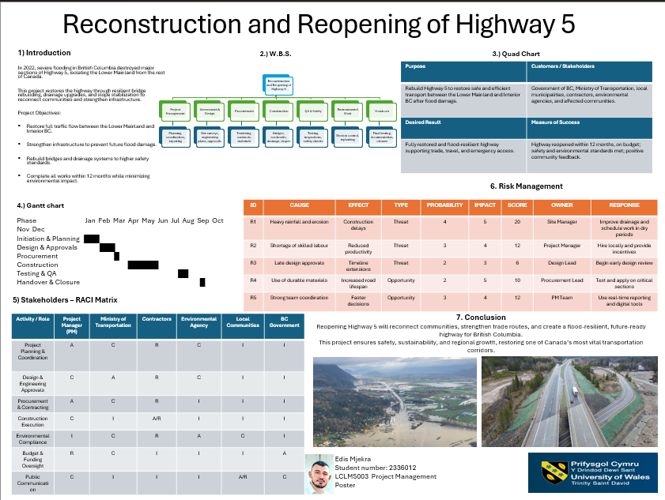

Reflection on Poster Presentation – Reconstruction and Reopening of Highway 5

This reflection evaluates my experience of presenting the poster titled *Reconstruction and Reopening of Highway 5* for the Project Management module. The project focused on restoring a vital transport route in British Columbia following severe flooding in 2022. The poster applied key project management tools, including a Gantt chart, Work Breakdown Structure, RACI matrix, Quad Chart, and risk management plan. Gibbs’ Reflective Cycle is used to reflect on the presentation content, delivery, and learning outcomes.

The poster presentation involved explaining a twelve-month infrastructure recovery project aimed at reconnecting the Lower Mainland with Interior British Columbia. I presented the project objectives, timeline, stakeholder responsibilities, and identified risks while standing beside the poster. The task required clear explanation of technical information within a limited time while maintaining audience engagement and professional communication.

Before beginning the presentation, I felt nervous, mainly because the presentation was being recorded and involved complex project management concepts. As the presentation progressed, I became more confident, particularly when discussing the project objectives and overall timeline. These sections felt familiar and well prepared. However, I still felt some pressure near the end of the presentation, especially when explaining risk management, which affected my pacing.

One strength of the presentation was the clear structure of both the poster and my verbal explanation. The logical flow from introduction to conclusion helped the audience follow the project easily. I maintained eye contact and used the visuals effectively to support my explanations. The use of recognised project management tools added credibility and demonstrated a strong link between theory and practice. A weakness was time management, as some sections were explained in more detail than necessary, limiting the time available for discussing risk mitigation.

The presentation showed effective application of project management theory to a real-world infrastructure problem. Tools such as the Gantt chart and RACI matrix helped simplify complex planning information. However, the rushed explanation of risks highlighted the importance of rehearsing spoken delivery, not just preparing written content. In professional project management, clear communication of risks is essential for stakeholder confidence, making this an important learning point.

In conclusion, the poster presentation was a valuable learning experience that strengthened my understanding of infrastructure project planning and professional communication. Reviewing my performance helped me recognise strengths in organisation and clarity, while also identifying weaknesses in pacing and prioritisation during delivery.

For future presentations, I will rehearse with a timer to improve time management and ensure balanced coverage of all sections. I will practise simplifying complex topics, particularly risk management, to improve clarity. Recording practice presentations and seeking peer feedback will further help me develop confidence, communication skills, and professionalism.

PROJECT MANAGEMENT PLAN
Reconstruction and Reopening of Highway 5, British Columbia

1. Introduction

Highway 5 is one of the most important transportation corridors in British Columbia, connecting the Lower Mainland with the Interior region and supporting passenger travel, freight movement, and regional economic activity. In 2022, extreme weather conditions caused by an atmospheric river resulted in severe flooding, landslides, and infrastructure failure along several sections of Highway 5. Bridge collapses, damaged drainage systems, and unstable slopes led to prolonged road closures, isolating communities and disrupting supply chains.

This Project Management Plan presents a structured approach for the reconstruction and reopening of Highway 5. The plan demonstrates the application of recognised project management approaches and techniques, including scope management, scheduling, resource allocation, stakeholder management, and risk analysis. The purpose of this document is to provide relevant stakeholders with a clear, realistic, and controlled plan to restore full traffic operations while improving long-term resilience against future climate-related events.

2. Project Description

The project involves the reconstruction and reopening of damaged sections of Highway 5 following the 2022 flooding event. The works focus on rebuilding critical bridges, upgrading drainage systems, stabilising slopes, and improving road resilience to withstand future extreme weather conditions. The project is designed as a twelve-month programme to minimise prolonged disruption while ensuring safety, sustainability, and compliance with regulatory requirements.
The project objectives are as follows:
• Restore full and safe traffic flow between the Lower Mainland and Interior British Columbia.
• Rebuild damaged bridges and road sections to higher structural and safety standards.
• Upgrade drainage and slope protection systems to reduce flood and landslide risk.
• Minimise environmental impact and comply with environmental regulations.
• Complete the project within the approved schedule and budget constraints.

The project operates in a complex environment involving multiple stakeholders, including government agencies, contractors, local communities, and environmental bodies. Effective coordination and structured project management are therefore essential to project success.

3. Project Scope

The scope of the project defines the boundaries of the work to be delivered and ensures clarity for all stakeholders. Clear scope definition reduces the risk of scope creep and supports effective planning and control.

In-scope activities include:
• Structural assessment and demolition of damaged bridges.
• Design and construction of new flood-resilient bridges.
• Roadway repairs and resurfacing.
• Drainage system upgrades and improvements.
• Slope stabilisation and landslide protection works.
• Testing, quality assurance, and safety inspections.
• Final handover and reopening of the highway.

Out-of-scope activities include:
• Expansion of Highway 5 beyond its original alignment.
• Long-term maintenance beyond the project handover stage.
• Unrelated regional transport infrastructure upgrades.

Key assumptions include stable funding availability, timely regulatory approvals, and suitable weather conditions during construction phases. Key constraints include environmental regulations, limited construction windows, and public safety requirements.

4. Work Breakdown Structure (WBS)

The Work Breakdown Structure divides the project into smaller, manageable components to improve planning, scheduling, monitoring, and control. By decomposing the overall project into defined deliverables and activities, the WBS ensures clarity of responsibilities, accurate cost estimation, and effective resource allocation.
At Level 1, the project is defined as the Highway 5 Reconstruction Project. This represents the total scope of work required to restore and reopen the highway.

At Level 2, the project is divided into the following major phases: • Initiation and Planning • Design and Approvals • Procurement • Construction • Testing and Quality Assurance • Handover and Closure

At Level 3, each phase is further decomposed into detailed work packages. For example, Initiation and Planning includes site inspections, damage assessments, stakeholder coordination, and project scheduling. Design and Approvals include engineering design, environmental assessments, regulatory submissions, and approval reviews. Procurement covers contractor selection, material sourcing, and equipment mobilisation. Construction includes bridge reconstruction, road resurfacing, drainage upgrades, and slope stabilisation. Testing and Quality Assurance involve structural testing, safety inspections, and compliance checks. Handover and Closure include final documentation, stakeholder sign-off, and public reopening activities.

The WBS enables effective monitoring of progress, supports risk identification at task level, and ensures that all project activities are aligned with the defined scope and objectives.

5. Quad Chart

The Quad Chart provides a high-level summary of the project and supports clear communication with stakeholders.

Purpose: | Stakeholders:
Restore and reopen Highway 5 while improving resilience to future flooding and landslides. | Provincial government, transport authorities, contractors, local communities, road users, and environmental agencies.
Desired Outcomes: | Measures of Success:
• Safe and reliable transport corridor.  • Reduced risk of future flood damage.  • Improved regional connectivity and economic stability. | • Highway reopened within twelve months.  • Project delivered within approved budget.  • Compliance with safety and environmental standards.  • Positive stakeholder feedback.

6. Gantt Chart

The Gantt Chart presents the project schedule across a twelve-month timeframe and illustrates the sequencing, duration, and interdependencies of key activities. It supports effective time management by identifying milestones, overlapping tasks, and the critical path.

The project begins with initiation and planning activities during the first two months, including damage assessment, feasibility analysis, and stakeholder coordination. Design and regulatory approval activities follow and overlap with planning to reduce schedule delays. Procurement activities commence during the later design stage to ensure timely availability of materials and contractors.

Construction represents the most time-intensive phase and spans several months. This phase includes bridge reconstruction, road repairs, drainage system upgrades, and slope stabilisation works. Testing and quality assurance activities are scheduled once construction activities reach completion, ensuring all infrastructure meets safety and regulatory standards. The final phase involves handover, documentation, and reopening of the highway to traffic.

The Gantt Chart supports proactive schedule control by enabling progress tracking, identification of delays, and implementation of corrective actions when required.

7. Stakeholder Involvement

Stakeholder involvement is critical to project success due to the public importance of Highway 5. Key stakeholders include government authorities, contractors, local communities, road users, and environmental regulators.

A RACI matrix is used to define roles and responsibilities: • Responsible: Construction contractors and engineering teams. • Accountable: Project sponsor and transport authority. • Consulted: Environmental agencies, local councils, and emergency services. • Informed: Road users, local businesses, and the public.

Regular communication, public updates, and stakeholder consultations are planned to manage expectations and maintain trust.

8. Allocation of Resources

Effective allocation of resources is essential to ensure that the project is delivered safely, efficiently, and within budget. Resource planning aligns closely with the WBS and Gantt Chart to ensure availability at the appropriate stages of the project lifecycle.

Human resources include project managers, civil and structural engineers, environmental specialists, quantity surveyors, construction supervisors, skilled labourers, and health and safety officers. Each role is assigned based on technical expertise and project phase requirements. Clear role definition supports accountability and reduces coordination risks.

Physical resources include construction machinery, bridge components, drainage materials, road surfacing materials, temporary traffic management systems, and monitoring equipment. Equipment usage is scheduled to minimise idle time and reduce costs.

Financial resources are allocated across major cost categories, including design, construction, environmental mitigation, labour, equipment hire, and contingency allowances. Budget allocation is monitored regularly to control expenditure and address cost variances promptly. Contingency funds are reserved to manage unforeseen risks such as weather delays or supply disruptions.

9. Risk Analysis

Risk analysis is a critical component of the project due to the environmental, technical, and operational uncertainties associated with large-scale infrastructure reconstruction. A structured risk management approach is adopted to identify, assess, and mitigate potential threats to project objectives.

Key risks include adverse weather conditions, supply chain disruptions, environmental compliance delays, safety incidents, and stakeholder opposition. Each risk is assessed based on likelihood and potential impact on cost, schedule, safety, and quality.

Mitigation strategies include incorporating buffer time into the schedule, securing alternative suppliers, implementing strict health and safety procedures, conducting continuous environmental monitoring, and maintaining transparent stakeholder communication. Risk reviews are conducted regularly to identify emerging risks and update mitigation plans.

A proactive risk management strategy supports project resilience, minimises disruptions, and enhances the likelihood of achieving successful project outcomes.

10. Conclusion

This Project Management Plan provides a structured and practical approach to the reconstruction and reopening of Highway 5. By applying recognised project management techniques, the plan supports safe delivery, stakeholder coordination, and long-term infrastructure resilience. Successful implementation of this plan will restore a vital transport corridor and strengthen regional connectivity in British Columbia.

11. References

Aaltonen, K. and Kujala, J. (2016) ‘Towards an improved understanding of stakeholder dynamics’, International Journal of Project Management, 34(8), pp. 1537–1552.

APM (2022) APM Body of Knowledge. 7th edn. Association for Project Management.

British Columbia Ministry of Transportation (2023) Climate resilience in highway infrastructure. Victoria: Government of British Columbia.

Kerzner, H. (2022) Project Management: A Systems Approach to Planning, Scheduling, and Controlling. 13th edn. Hoboken: Wiley.

PMI (2021) A Guide to the Project Management Body of Knowledge (PMBOK Guide). 7th edn. Newtown Square: Project Management Institute.

Turner, J.R. (2014) The Handbook of Project-Based Management. 4th edn. New York: McGraw-Hill.

Winch, G. (2010) Managing Construction Projects. 2nd edn. Oxford: Wiley-Blackwell.

Zidane, Y.J.T. and Olsson, N.O.E. (2017) ‘Defining project efficiency, effectiveness and efficacy’, International Journal of Project Management, 35(6), pp. 1226–1239.

