
Skills for the Workplace
Module Assignment Submission
Student Name: | Caroline Lewis
Student Number: | 1917865
Module No: | BMSK4006
Module Title: | Part 2 Reflection

Statement of Confirmation of Authenticity
By the act of making this submission, the student declares that this is the work of the student named above. The work has not, in whole or in part, been knowingly presented elsewhere for assessment, or where assessment has been built on a previous assessment, this has been identified. Where materials have been used from other sources it has been properly acknowledged. If this statement is untrue, the student acknowledges that an assessment offence has been committed.
Attention is drawn to the plagiarism and unfair practice policies of both the University and of ILM.

Table of Contents
Part 2: Reflection on Skills developed during the Business Plan Project 3
2.1 Description 3
2.2 Feelings 5
2.3 Evaluation 7
2.4 Analysis 8
2.5 Conclusion 8
2.6 Action Plan 9
Appendix…………………………………………………………………………………….….10
References 15

Management synopsis
I am a 47-year-old single mum of two grown up daughters. I have worked for the local council for 10 years in different departments, such as business rates and council tax. Currently I am a rent officer. Before I joined the council, I ran alone a post office for 3 years. In my spare time I enjoy interior design and rock music.
I have completed a business plan to start up an all Welsh coffee trailer, and this report is my reflection of my experiences. I have used Gibbs’ reflective cycle (Appendix 1) to analyse what I have learnt from completing the plan. This reflection has a SWOT and a SMART objective, a Self-analysis chart, and a Mind map diary exploring the skills I have gained in this process. These objectives also identify my weaker points, and I have set an action plan to improve them.

Part 2: Reflection on Skills developed during the Business Plan Project

2.1 Description

This business plan assignment filled me with excitement, as I am interested in new ideas and entrepreneurship. I often watch the tv show Dragons’ Den and imagine what it would be like to be one of the pitchers. I think of myself as a creative and problem-solving individual, for example, making a washing basket that weighed your dirty clothes to prevent overloading or breaking the washing machine. Another idea is petrol caps with square holes for diesel, or triangular holes for unleaded, with matching hose adapters, to prevent incorrect fuelling. This small error has a £100.00 cost to pump the fuel out. Although I liked these two ideas, I believed they would be too complicated in factory machines, distribution, and patented rules. I decided to keep the venture small. I had previous experience of working in the rates department, I thought I would avoid this added cost, and after some discussions with friends, I came up with a coffee trailer idea.
I researched small coffee trailers on Gumtree and found a suitable red one. As it was red, it reminded me of my nations colour, and I decided to investigate if I could somehow link this trailer to Wales. Welsh cakes are a well-known produce from Wales, but I was surprised when I discovered Wales has three coffee manufacturers. This enabled me to have the unique selling point of being an all Welsh themed coffee trailer. Once I established this idea, the entrepreneurship flowed with thoughts of adding Welsh Penderyn whiskey, iced coffees, slushies, and lollies which would double up as stirrers. The final idea, Welsh hampers, came from friends who have bought gifts such as this in recent lockdown times. One friend ordered a seafood platter for her and her husband as an anniversary treat, as they could not spend a weekend away. They were happy to pay £90.00 for a platter from The Cornish Fish Monger to be delivered to their door, demonstrating people will pay a premium for this type of service.
I researched all aspects of the coffee business. The internet gave me a wealth of information for the plan. I was able to discover how many cups of coffee you can make from a 1kg bag, which helped in my costings and profit tables. The Welsh Government had lots of information regarding set up loans. The gov.uk website gave me the correct set up procedures to become a sole trader, taxation rules, fees for noncompliance and how to name and declare a business. I researched competitors of the market, analysing the differences between the businesses.
To help my time management for this plan, I set aside three hours a night after work and twelve hours a weekend. I would prepare what was discussed after each lesson to ensure it was still fresh in my mind.
My planning skills complied of a SWOT and a STEEPLE analysis to highlight the ventures strengths and weaknesses. From these results, I was able to scrutinise each part and put these points into the plan. I completed a mind map to ensure all aspects were researched, from licencing, law, and costs.
My strategic planning included a costing chart and a potential profit table. I then was able to predict at what point in time would the business break even. Through the results of the SWOT, I was able to complete a SMART objective, where future goals were set and a plan of how to monitor them.
I used my interpersonal skills where I directly emailed many of the companies mentioned in the plan. These included Swansea Council for licencing rules, a magazine for a marketing quote and a design company for a cost of a website. I have sent and received emails from my friends for advice on pricing and marketing for the plan. As lockdown is difficult to see friends and colleagues, I used Facebook to get their thoughts through a discussion, to see if there was interest in my idea and what they thought costings should be. I also spoke to my local shop owner for advice on licences, as they sold alcoholic slushies.

2.2 Feelings

I felt happy that my idea was unique, yet I also had a daunting feeling as I did not have much experience of coffee, or what skills are needed to make it. As I researched it further, I thought the idea contained lots of legality in setting it up, which made me feel that I would not put an accurate plan together. As I investigated the potential arears of company growth, I became more comfortable at being able to put my creative side into making hampers.
I felt my research skills were adequate for this business plan. All costings were researched and logged. As I investigated some webpages for new businesses, there would be links to further sites beneficial to the set up. Business in Focus is a site to help new businesses, they had links to the Welsh Government for grants. The Welsh Government, intern, would have links to sell2wales, a company that provides a search engine or advertising for services. e.g. hospitals requiring coffee services.
I set aside three hours each night to research coffee and the business plan, however, the subject needed more research than expected. My lack of IT skills has been a weakness; I wasted too much time unsuccessfully attempting graphs, which cut into my allocated writing time. The more research I did, I realised there were points I had not covered. I felt pressured to complete this assignment in the given time. I would also store information I had discovered under unclear titles, and I would spend too much time in looking for the information again, when I needed it.
My SWOT and STEEPLE analysis helped in the planning of the assignment, and their findings gave me a good basis on what information I needed to include. e.g. coffee training required. I made notes after every lecture to ensure I applied all the important points into the plan, I then shaped them into a mind map as a visual aid.
I felt overwhelmed with how in depth the business plan was becoming. Once I was able to set a costing table and a progress chart, I felt the plan started to look more professional and I felt more at ease. I had acquired so much research, however, I failed to store it structurally. After the assignment was turned in, I noticed a whole page of referencing I had not included in the final plan.
I believed my interpersonal communication skills were used well for this plan. I had online discussions with my Facebook friends for their input on pricing. I emailed companies for expert advice on licences, quotes for marketing and competitors for their costings. I found however, when I emailed the local council asking them for advice on selling alcohol and trade licences, I was passed from section to section and back again, this was frustrating and time consuming.
I felt my decision making was weak at times: I was unsure where to put my information in the document structure, and how much information I needed to include. I felt my business plan looked unprofessional in parts, purely due to its layout. I would often look at business plans on the internet to see if my plan followed their structure. I was unsure of my choice of venture but had made a commitment and decided to be dedicated to it. I wish I had the courage to investigate into the washing basket idea.

2.3 Evaluation

I have included a graph that visually represents my self-assessment of the skills used for this business plan. (Appendix 2)
Overall, I am happy with how the business plan looked. I especially liked my advisor section, with their professional advice, quotes, and experience of how I should market the venture. I was pleased with my STEEPLE content which I linked into the coffee industry, especially the ethical point of fair trade. I thought my finance section looked well planned and my costings were accurate. In my previous employment as a post mistress, I had to balance cash, sales, and stock each week. I believe this experience helped in the costing side of the plan, however, it could have been more concise. I lacked the decision making of what to remove and what to keep, as I believed it was all relevant to the plan.
I hoped to have completed more questionnaires, but due to COVID and lockdown, conducting these are more difficult than usual. I, therefore, used my Facebook update as a way of testing out my ideas, and found the feedback from friends and family very useful. Many said they could imagine me doing this as a real business and wished me luck.
When shopping, I could imagine my hamper in the window of the high-end Welsh gift shop in my local town, or in garden centres in their gift aisle.

2.4 Analysis

After successfully completing the plan, I felt I had gained skills that would help me in the future, in both my assignments and in my career. I kept a diary in a Mind Map form, to note the skills I was gaining along the way. (Appendix 3)
My research skills improved greatly; I gained confidence to be able to contact marketing organisations and competitors to get quotes. I was able to collect data to predict a break even point of the profit and make a graph of the results.
In completing the plan, it helped me understand how I can use the academic skills I have learnt and put them in a real-life business situation. It showed my critical thinking is improving and how useful this skill is in a business.
It taught me how important facts and figures are in a plan, to enable to set out loans and predict profits.
I also learnt how important market research is to a business plan, for feedback on ideas and in setting a cost to an item.

2.5 Conclusion

“By failing to prepare, you are preparing to fail.” – Benjamin Franklin
I believe this quote accurately describes how important a business plan is. I have learnt organisation is key to the plan. To help my structure and time management, I should have made clear notes and references , filed in one place on my computer, under individual titles, e.g a reference page on licences, another on marketing and another of costing of items.
I thought my Facebook discussions on pricing and ideas helped the plan be realistic. I found this way of gathering market research quick and easy, reaching a larger audience than I would have, under normal questionnaire circumstances, e.g. email, handouts. Going forward, I plan to use this method again as I believe it was productive. According to Patino, A et al (2012) social media has taken over previous research methods such as the telephone and email, as their capacity to reach consumer subjects had reduced. Social media research techniques have overcome the problems that were starting to affect the old methods of collecting data.
I have gained a lot of respect for local businesses in taking the courage to start their own venture. It can be both a rewarding experience and a worrying one, especially with fluctuating markets and COVID implications. Due to my research, I now feel I could have a discussion with a business owner and talk about red tape, licencing, and taxation laws. I believe this has broadened my knowledge in law, licencing, health, and safety, as well as a cup of good coffee! I felt proud of what I had accomplished, what I have learnt, and it will come in useful if I should ever think of starting my own business venture.

2.6 Action Plan

With the results of the SWOT analysis (Appendix 4), I have been able to complete a SMART objective (Appendix 5). This contains an action plan to improve my skills in completing future business plans. These skills can also be transferred to other academic areas.
Firstly, I needed to improve my filing system for the referencing. Preparation is key to this plan. Setting up files and naming them will take time at first but will reap the rewards as the project unfolds. I have researched websites and will follow their guidance (File management tips 2020). This action will not only help with the time management, but also in the structure of the plan.
I need to be more concise in my writing skills. This is due to my lack of practice and experience in recent years. I plan to be more critical of my work and remove unnecessary script. Cottrell,S 2008 p. 195, suggests to use certain words to link ideas, shortening paragraphs and making them more precise.
I will also experiment with IT in my spare time, to enable me to use more complex graphs and ways to measure data. I hope to do this by the next assignment.
My last action is to have more courage in my entrepreneurship. My wish was to complete the plan initially on the washing basket, but the amount of unknown territory regarding making a product from scratch was daunting and fear the idea of the product was thought foolish.
“As we mature, we acquire quite an inventory of fears to barricade our willingness to try new things...” Express, M.B., (2008)
With this quote in mind, my fear may be due to my age and being one of the oldest students in the group, however, I am overcoming this with each assignment.
Setting these goals for myself, I hope to improve my academic skills and to one day start my own venture.

Appendix 1

Gibbs (1988)

Appendix 2

Self-assessment of the skills used in completing the business plan.
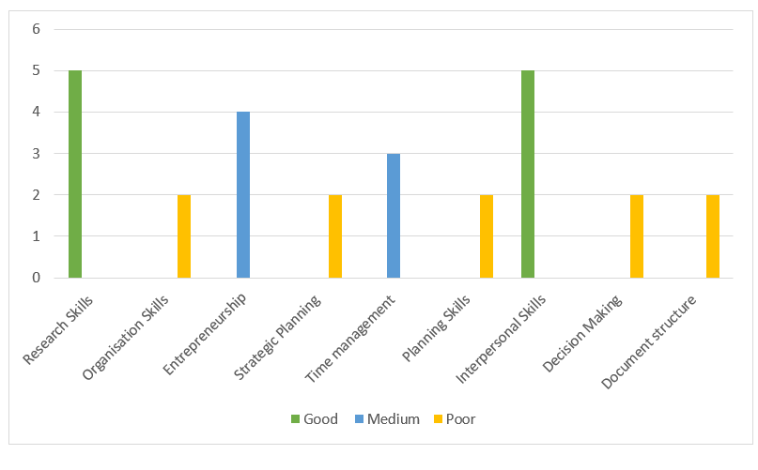
The table above contains the results of myself critique on the skills used to complete the business plan. The results show that my research skills were good, and my organisational skills were poor. Questionnaire completed 10.07.20.

Appendix 3

Mind map of the skills developed in completing the business plan and evidence of where they were used.
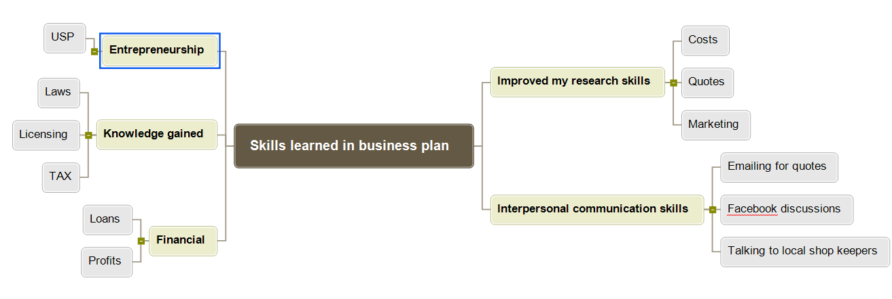

Appendix 4

SWOT

Strengths | Weaknesses
- Good in-depth research skills: researched all aspects of plan  - Dedication used in getting the correct information to the business plain e.g. emails sent to companies for quotes.  - Good feedback from friends who are in the business of marketing on the depth and content of the plan  - Attention to detail: plan included all costings | - Organisation skills: were weak. Lots of content in the plan but poor structure of it. Researched of pages were not files in one place.  - Time management: extremely slow on setting up IT graphs. Worked long hours on her plan and tiredness made errors in grammar.  - Decision making : unhappy with the layout but unable to focus on how to improve it.  - Professional writing: this is a weakness as I am unexperienced and little practice in this field.  Essay writing is not clear and concise enough for academic writing.
Opportunities | Threats
- Entrepreneurship: thought of exciting new ideas on how to progress her business e.g. making lollipops, hampers.  - Lots of interest from family and friends on the venture and perhaps an opportunity to start this as business  - Due to the financial predictions of the plan this could be a profitable part time job | - The plan was unprofessional in parts and may fail to pass assignment.  - Lack of IT skills made the plan look weak. Several hours trying to make a chart the progression of the profit but could not get the figures to reflect the information, this my produce a low mark for her assignment.

Appendix 5
S | M | A | R | T
Specific | Measurable | Achievable | Realistic | Time-bound
To be more organised with my referencing. | By monitoring the number of files with clear headings. Not to have random documents on my computer. | This is easily done. Set time to make the files and attach each night’s work to the relevant file. | This is realistic. I have investigated websites for advice on this. | 30.07.20
Being clearer and more concise in my assignment writing. | By improving in my assignment marks and in its feedback. | This is achievable with practice and reading over my work to cut parts out. I will also read ‘The Skill Study Handbook’ that has tips to be precise. | This is realistic as; I have more assignments to get an improvement. | 01.09.20
Improving my IT skills to be able to do more complex graphs and tables. | I will measure this by adding one more graph to the next assignment. | I will need to practice with the computer layout for graphs. I will ask for help from family and friends. | It is difficult to ask for help in lockdown or attend courses for IT. However, with a little help and practice, this is achievable. | 01.09.20
To have more courage and push myself in developing my new ideas. | By completing another business plan in my own time on my washing basket idea. | With the experience I have gained in completing this business plan, I will be more able and confident to complete another, more in-depth business plan. | This is realistic if I manage my spare time for research and file this research in an orderly manner. | 01.03.20

References

Cottrell,S. (2008) The Skills Handbook 3rd edt p.p 195 Hampshire :Palgrave Macmillan
Express, M.B., 2008. Push yourself to new limits. The Times - Transcript, pp.The Times - Transcript, 2008–05-09.

File Management Tips: How to Organize Computer Files Available at:
https://blog.wps.com/file-management-tips-how-to-organize-computer-files/ [Accessed 16.07.20]
Gibbs, G. (1988) Learning by doing; A guide to teaching and learning methods. London: FEU

Patino, A., Pitta, D.A. and Quinones, R. (2012), "Social media's emerging importance in market research", Journal of Consumer Marketing, Vol. 29 No. 3, pp. 233-237. Great Britain:Emerald Group Publishing Ltd.

The Cornish fishmonger. (2020) Available at:
https://thecornishfishmonger.co.uk/seafood-larder/gift-ideas [Accessed 16.07.20]

Bibliography

Oxbridge essays. A complete guide to writing a reflective essay (2020) Available at:
https://www.oxbridgeessays.com/blog/complete-guide-to-writing-a-reflective-essay/ [Accessed 17.07.2020]

