Appendix Contents
Appendix 1- p.2- School Consent Form Template
Appendix 2- p.3- Continued Assent Colour Cards
Appendix 3- pp.4-15- Ethics Form
Appendix 4- pp.16-19- Blank Questionnaires
Appendix 5- pp.20-21- Blank Interviews
Appendix 6- pp.22-23-Teacher Consent Form Template
Appendix 7- p.24- Blank Observation Schedule
Appendix 8- pp.25-26-Completed Pupil Questionnaire
Appendix 9- pp.27-28-Completed Teacher Questionnaire
Appendix 10-pp.29-30- Completed Teacher Interview
Appendix 11-pp.31-32- Completed Pupil Interview
Appendix 12- pp.33-34- Completed Observation Schedule



Appendix 1- School Consent Form

ECAD5010 Consent Form
Student teachers must gain the following written consent of the head teacher before trialling their research tools.
To be completed by the school:

I agree to Keanna Emily Dayman as a representative of Yr Athrofa to:

-Take photographs (Tick accordingly)
-Interview
-Take video
-Observe
-Quote school policy documents
-Questionnaires
Name of Head teacher ________________________ Signed _____________________
Name of school _______________________________

To be completed by the student teacher:
If I am granted such permission, I agree to abide by the ethics embodied within the EWC Code of Conduct and BERA Ethical Guidelines (2018) and will not distribute any such material to audiences beyond the University authorities without their permission.
Name of student teacher: Signed:

Student teacher UWTSD e-mail address:

Programme (e.g. BA Ed/PGCE Primary):

Date:

Appendix 2- Continued Assent Colour Cards

I withdraw my assent.

I would like to stop being part of the study.

I give my assent to continue in the study.

Appendix 3- Ethics Form
APPLICATION FOR ETHICAL APPROVAL
In order for research to result in benefit and minimise risk of harm, it must be conducted ethically. A researcher may not be covered by the University’s insurance if ethical approval has not been obtained prior to commencement.
The University follows the OECD Frascati manual definition of research activity: “creative work undertaken on a systematic basis in order to increase the stock of knowledge, including knowledge of man, culture and society, and the use of this stock of knowledge to devise new applications”. As such this covers activities undertaken by members of staff, postgraduate research students, and both taught postgraduate and undergraduate students working on dissertations/projects.
The individual undertaking the research activity is known as the “principal researcher”.
Ethical approval is not required for routine audits, performance reviews, quality assurance studies, testing within normal educational requirements, and literary or artistic criticism.
Please read the notes for guidance before completing ALL sections of the form.
This form must be completed and approved prior to undertaking any research activity. Please see Checklist for details of process for different categories of application.
SECTION A: About You (Principal Researcher)
Full Name: |  | Keanna Emily Dayman
Tick all boxes which apply: |  | Member of staff: | ☐ | Honorary research fellow: | ☐
Undergraduate Student | ☒ | Taught Postgraduate Student | ☐ | Postgraduate Research Student | ☐

Faculty/School/Centre: | Initial Teacher Education, Yr Athrofa
Campus: | Carmarthen
E-mail address: | 1800391@student.uwtsd.ac.uk
Contact Telephone Number: | 07923 496983
For students:
Student Number: | 1800391@student.uwtsd.ac.uk
Programme of Study: | BA Primary Education with QTS
Director of Studies/Supervisor: | Dr. Sioned V. Hughes
SECTION B: Approval for Research Activity
Has the research activity received approval in principle?  (please check the Guidance Notes as to the appropriate approval process for different levels of research by different categories of individual) |  | YES | ☒ | NO | ☐
 |  |  |  | Date
If Yes, please indicate source of approval (and date where known): Approval in principle must be obtained from the relevant source prior to seeking ethical approval | Research Degrees Committee |  | ☐
 | Faculty Research Committee |  | ☐
 | Other (write in) ECAD5010 Module Lead |  | ☒ | 27.02.20

SECTION C: Internal and External Ethical Guidance Materials
Please list the core ethical guidance documents that have been referred to during the completion of this form (including any discipline-specific codes of research ethics, and also any specific ethical guidance relating to the proposed methodology). Please tick to confirm that your research proposal adheres to these codes and guidelines.
UWTSD Research Ethics & Integrity Code of Practice | ☒
UWTSD Research Data Management Policy | ☒
BERA Guidelines  British Educational Research Association [BERA] (2018) Ethical Guidelines for Educational Research. 4th edn. London. Available at: https://www.bera.ac.uk/researchers-resources/publications/ethicalguidelines-for-educational-research-2018 (Accessed:27/02/2020). | ☒
 | ☐

SECTION D: External Collaborative Research Activity
Does the research activity involve collaborators outside of the University? |  | YES | ☐ | NO | ☒
If Yes, please provide the name of the external organisation and name and contact details for the main contact person and confirmation this person has consented to their personal data being shared.as part of this collaboration.
Institution
Contact person name
Contact person e-mail address

Has this individual consented to sharing their details on this form? |  | YES | ☐ | NO |  |  | ☐
Are you in receipt of a KESS scholarship? |  | YES | ☐ | NO |  |  | ☐
Is your research externally funded |  | YES | ☐ | NO |  |  | ☐
Are you specifically employed to undertake this research in either a paid or voluntary capacity? | Voluntary | YES | ☐ | NO |  | ☐
 | Employed | YES | ☐ | NO |  | ☐
Is the research being undertaken within an existing UWTSD Athrofa Professional Learning Partnership (APLP) | If YES then the permission question below does not need to be answered. | YES | ☒ | NO |  |  | ☐
Permission to undertake the research has been provided by the partner organisation | (If YES attach copy)  If NO the application cannot continue | YES | ☐ | NO |  |  | ☐

Where research activity is carried out in collaboration with an external organisation
Does this organisation have its own ethics approval system? | YES | ☐ | NO | ☒
If Yes, please attach a copy of any final approval (or interim approval) from the organisation

SECTION E: Details of Research Activity
Indicative title: | To what extent is written feedback used by pupils to support progression?
Proposed start date: | 28.02.20 | Proposed end date: | 01.04.20
Introduction to the Research (maximum 300 words)
Ensure that you write for a Non-Specialist Audience when outlining your response to the three points below:
- Purpose of Research Activity
- Proposed Research Question
- Aims of Research Activity
- Objectives of Research Activity
Demonstrate, briefly, how Existing Research has informed the proposed activity and explain
- What the research activity will add to the body of knowledge
- How it addresses an area of importance.
Purpose of Research Activity
The purpose of my research activity is to investigate the assessment for learning strategy of written feedback to understand how written feedback is used by pupils to support their learning. I will work within this study to further my understanding of the effect of written feedback on pupil progression and understand if it is in line with the views of research. For instance, Hattie (2009) who regarded feedback as the most influential factor on enhancing achievement. Furthermore, within the research day, I hope to develop my understanding using the research tools of questionnaires, interviews and observations to examine if there are any barriers to written feedback. For instance, as highlighted within Brooks et al (2019) who stated despite feedback being given from the practitioner does not mean that learning is guaranteed. Furthermore, Hattie, Gan and Brooks in Brooks et al (2019) stated that it is necessary to develop the way feedback is “received” by pupils rather than how it is provided by practitioner (Brookes et al, 2019). Finally, the research day will also provide the opportunity to implement a range of research tools such as, questionnaires to understand their effectiveness in collecting both qualitative and quantitative data to answer my research question.
Research Question
To what extent is written feedback used by pupils to support progression?
Aims of Research Activity
- To investigate the different assessment for learning perceptions to understand the views of pupils and teachers.
- To critically evaluate written feedback and pupils’ engagement with written feedback for progression.
- To implement a range of research tools to understand their benefits and limitations in collecting data.
- To further develop my knowledge of assessment for learning to aid my professional practice.
Objectives of Research Activity
- To investigate the support of written feedback regarding pupil progression.
- To interview year 5/6 pupils to understand their views on written feedback and its impact on their learning.
- To explore the assessment for learning strategy of written feedback used by pupils to support their knowledge and understanding using a questionnaire.
- To observe the use and effect of written feedback within a classroom setting.
- To critically reflect on the implementation of a range of research tools to collect qualitative and quantitative data.
Proposed methods (maximum 600 words)
Provide a brief summary of all the methods that may be used in the research activity, making it clear what specific techniques may be used. If methods other than those listed in this section are deemed appropriate later, additional ethical approval for those methods will be needed.
To aid my research numerous research tools will be used such as, observations, questionnaires and interviews. The research tools will be used with both practitioners and pupils to collect data to answer and analyse the research question.
Questionnaire- The questionnaires will be given to both pupils and educational practitioner to collect further data surrounding the research question. The questionnaires will be conducted with a group of Year 5/6 pupils with a sample size of 6. Moreover, the questionnaire will be conducted online unless a paper copy is required. Before the participants participate in the questionnaire both assent and consent will be gained from the pupils, teachers and the school to ensure the pupils are happy to participate in the study. Furthermore, within the questionnaire a consent/ assent box will be used to reiterate to the pupils that strict confidentiality will be used and that pupils can withdraw their assent at any time. The questionnaires will be completed online within google forms in which the data is kept under password protection to ensure the data is safe.
Interviews- The interviews will be conducted with the pupils and teachers from the year 5/6 class. The interview will be semi structured and will involve the participants answering a range of questions surrounding the theme of written feedback. For example, “how often do you respond to the written feedback?” The interview will be provided to the same sample group as the questionnaire to enable the pupils to provide further information on their views of written feedback. At the start of the interview I will explain that their participation is voluntary and that they can withdraw from the study at any point both stating this verbally and using the withdraw cards. Finally, the pupils’ responses will be notes in a notebook which will be destroyed following writing up of the responses on a word document which will be saved under my OneDrive account which is password protected.
Observations- I will conduct an hour observation within the Year 5/6 class. I will work to observe the use of feedback within the classroom and if the feedback is used and supports pupils’ progression. Furthermore, an observation schedule will be used to collect both qualitative and quantitative data of the types of written feedback used such as, steps and a star to understand the effect they have on the learning of the pupils. Furthermore, the observation will be limited to four pupils to allow me to effectively observe the impact of feedback on a smaller sample size. The time of the observation was selected to enable a long enough period to fully understand the feedback and impact within the observation class. The observed pupils will be asked for their assent before the observation to ensure the pupils are happy to participate in the study as well as consent being gained from school X to conduct research. To ensure the pupil are continuously happy to participate in the study the I will explain that they can verbally express their desire to withdraw, use the withdrawal colour cards as well as checking that they feel they want to continue or withdraw throughout the lesson.

Location of research activity
Identify all locations where research activity will take place.
The research day will take place in a small school on the outskirts of Swansea with approximately 180 pupils. The school is within a high deprivation area in which there are 50 percent free school meals.
Research activity outside of the UK
If research activity will take place overseas, you are responsible for ensuring that local ethical considerations are complied with and that the relevant permissions are sought. Specify any local guidelines (e.g. from local professional associations/learned societies/universities) that exist and whether these involve any ethical stipulations beyond those usual in the UK (provide details of any licenses or permissions required). Also specify whether there are any specific ethical issues raised by the local context in which the research activity is taking place, for example, particular cultural and/or legal sensitivities or vulnerabilities of participants.
N/A
Use of documentation not in the public domain: Are any documents NOT publicly available? | NO | ☒
 | YES | ☐
If Yes, please provide details here of how you will gain access to specific documentation that is not in the public domain and that this is in accordance with prevailing data protection law of the country in question and England and Wales.

SECTION F: Scope of Research Activity
Will the research activity include: | YES | NO
Use of a questionnaire or similar research instrument? | ☒ | ☐
Use of interviews? | ☒ | ☐
Use of diaries? | ☐ | ☒
Participant observation with their knowledge? | ☒ | ☐
Participant observation without their knowledge? | ☐ | ☒
Use of video or audio recording? | ☐ | ☒
Access to personal or confidential information without the participants’ specific consent? | ☐ | ☒
Administration of any questions, test stimuli, presentation that may be experienced as physically, mentally or emotionally harmful / offensive? | ☐ | ☒
Performance of any acts which may cause embarrassment or affect self-esteem? | ☐ | ☒
Investigation of participants involved in illegal activities? | ☐ | ☒
Use of procedures that involve deception? | ☐ | ☒
Administration of any substance, agent or placebo? | ☐ | ☒
Working with live vertebrate animals? | ☐ | ☒
Other primary data collection methods, please explain in this box  For example, ‘focus groups’. Please indicate the type of data collection method(s) in this box and tick the accompany box. | ☒ | ☐
Details of any other primary data collection method:  A focused group will be used to interview a group of Year 5/6 pupils. | ☒ | ☐
If NO to every question, then the research activity is (ethically) low risk and may be exempt from some of the following sections (please refer to Guidance Notes).
If YES to any question, then no research activity should be undertaken until full ethical approval has been obtained.
SECTION G: Intended Participants
Who are the intended participants: | YES | NO
Students or staff at the University? | ☐ | ☒
Adults (over the age of 18 and competent to give consent)? | ☒ | ☐
Vulnerable adults? | ☐ | ☒
Children and Young People under the age of 8? (Consent from Parent, Carer or Guardian will be required) | ☐ | ☒
Prisoners? | ☐ | ☒
Young offenders? | ☐ | ☒
Those who could be considered to have a particularly dependent relationship with the investigator or a gatekeeper? | ☐ | ☒
People engaged in illegal activities? | ☐ | ☒
Others (please identify specifically any group who may be unable to give consent) please indicate here and tick the appropriate box. | ☐ | ☒
Other – please indicate here:  Pupils within a Year 5/6 class. | ☐ | ☒

Participant numbers and source
How will you identify participants and how will they be recruited?
How many participants are expected? | Within the study there will be 8 participants involved.
Who will the participants be? | The participants will include both teachers and pupils across a year 5/6 class. There will be 2 teachers and 6 pupils. The pupils will consist of three Year 5 and three Year 6 pupils with a cross section of abilities.
How will you identify the participants? | The participants will be identified from my previous experience within the school within my second year of professional teaching experience. I will identify the participants from the year 5/6 class I worked with.

Information for participants: | YES | NO | N/A
Will you describe the main research procedures to participants in advance, so that they are informed about what to expect? | ☒ | ☐ | ☐
Will you tell participants that their participation is voluntary? | ☒ | ☐ | ☐
Will you obtain written consent for participation? | ☐ | ☐ | ☒
Will you explain to participants that refusal to participate in the research will not affect their treatment or education (if relevant)? | ☒ | ☐ | ☐
If the research is observational, will you ask participants for their consent to being observed? | ☒ | ☐ | ☐
Will you tell participants that they may withdraw from the research at any time and for any reason? | ☒ | ☐ | ☐
With questionnaires, will you give participants the option of omitting questions they do not want to answer? | ☒ | ☐ | ☐
Will you tell participants that their data will be treated with full confidentiality and that, if published, it will not be identifiable as theirs? | ☒ | ☐ | ☐
Will you debrief participants at the end of their participation, in a way appropriate to the type of research undertaken? | ☐ | ☐ | ☒
If NO to any of above questions, please give an explanation

Information for participants: | YES | NO | N/A
Will participants be paid? | ☐ | ☒ | ☐
Is specialist electrical or other equipment to be used with participants? | ☐ | ☒ | ☐
Are there any financial or other interests to the investigator or University arising from this study? | ☐ | ☒ | ☐
Will the research activity involve deliberately misleading participants in any way, or the partial or full concealment of the specific study aims? | ☐ | ☒ | ☐
If YES to any question, please provide full details

SECTION H: Anticipated Risks

Outline any anticipated risks that may adversely affect any of the participants, the researchers and/or the University, and the steps that will be taken to address them.

If you have completed a full risk assessment (for example as required by a laboratory, or external research collaborator) you may append that to this form.
Full risk assessment completed and appended? |  | Yes | ☐
 |  | No | ☒
Risks to participants
For example: emotional distress, financial disclosure, physical harm, transfer of personal data, sensitive organisational information
Risk to Participant:  - Pupils may feel they have to continue with the study following their initial agreement.  - Pupils may feel they have to answer the questions with correct answers which may cause distress to the pupils.  - The transfer of personal data is also a risk as pupils’ names will be known as well as data being collected through research tools.  - Physical harm from an unethical researcher. | How will you mitigate the Risk to Participant  - The researcher will explain that the pupils’  can withdraw from the study at any time with no explanation necessary. Furthermore, withdrawal colour cards will be provided and explained to enable the pupils to withdraw from the study at any time.  - I will discuss the study with the pupils and explain that the pupils can provide open and honest answers and there will be no consequence to their answers. It will be made clear that the pupils have the freedom to answer the questions in the way they find fit and that there will be no effect on their education or teaching as a result of the answers provided in the research.  - To mitigate the risk of the pupils’ data being disclosed all information will be kept confidential and anonymised and stored in a secure password protected file on OneDrive.  - Finally, to avoid any potential harm to the pupils I will always conduct myself in a professional manner.
If research activity may include sensitive, embarrassing or upsetting topics (e.g. sexual activity, drug use) or issues likely to disclose information requiring further action (e.g. criminal activity), give details of the procedures to deal with these issues, including any support/advice (e.g. helpline numbers) to be offered to participants. Note that where applicable, consent procedures should make it clear that if something potentially or actually illegal is discovered in the course of a project, it may need to be disclosed to the proper authorities
N/A
Risks to investigator
For example: personal safety, physical harm, emotional distress, risk of accusation of harm/impropriety, conflict of interest
Risk to Investigator:  A possible risk to the investigator is allegations from pupils when completing research. | How will you mitigate the Risk to Investigator:  This can be mitigated through another staff member being present while completing the research.
University/institutional risks
For example: adverse publicity, financial loss, data protection
Risk to University:  A possible risk to the university is that behaving in an unprofessional manner may affect the relationship between the university and school. | How will you mitigate the Risk to University:  I will mitigate this risk through conducting myself in a responsible and appropriate manner within the school.

Disclosure and Barring Service
If the research activity involves children or vulnerable adults, a Disclosure and Barring Service (DBS) certificate must be obtained before any contact with such participants. | YES | NO | N/A
Does your research require you to hold a current DBS Certificate? | ☒ | ☐ | ☐

SECTION I: Feedback, Consent and Confidentiality
Feedback
What de-briefing and feedback will be provided to participants, how will this be done and when?
N/A
Informed consent
Describe the arrangements to inform potential participants, before providing consent, of what is involved in participating. Describe the arrangements for participants to provide full consent before data collection begins. If gaining consent in this way is inappropriate, explain how consent will be obtained and recorded in accordance with prevailing data protection legislation.
To gain consent I will discuss my research project with the head teacher, my class teacher as well as the senior mentor to ensure they are fully informed on the purposes of the research and what I will be undertaking. This will enable the head teacher to provide their information consent for the pupils to participate in the study as they are aware of what the data will be used for as well as the ethical implications of the research. Furthermore, I will gain the informed consent from any educational practitioners in which I will interview, observe or provide questionnaires to. Furthermore, I will verbally ask the pupils for their assent to participate in the study. This will be done through a clear explanation of the study and how the data will be used to enable the pupils to provide their assent to participate or communicate that they would not like to participate. Furthermore, to ensure that the pupils are happy to participate in the study throughout the observation, interview and questionnaire colour withdraw cards will be used to enable the pupils to withdraw their assent at any point. The green cards will indicate that the pupil is happy to continue and the red cards indicating that the pupils would like to withdraw their assent. Gaining the pupils assent will be done individually to ensure pupils do not feel pressured to participate in the study and thus, ensuring that their wellbeing is maintained.
Confidentiality / Anonymity
Set out how anonymity of participants and confidentiality will be ensured in any outputs. If anonymity is not being offered, explain why this is the case.
To ensure confidentiality is achieved within the research project numerous factors will be considered and implemented. For instance, regarding confidentiality all names, locations and responses will be anonymised to ensure pupils and their answers cannot be identified. For example, the school and pupils will be identified as school x and pupil A, B etc. Furthermore, any information collected will be placed within a secure password protected file on OneDrive. This will be done to reduce the possible risk of data being lost or confidentiality being broken. Finally, I will ensure that no individual data will be released or available to the general pupils to further maintain confidentiality.

SECTION J: Data Protection and Storage
In completing this section refer to the University’s Research Data Management Policy and the extensive resources on the University’s Research Data Management web pages (http://uwtsd.ac.uk/library/research-data-management/).
Does the research activity involve personal data (as defined by the General Data Protection Regulation 2016 “GDPR” and the Data Protection Act 2018 “DPA”)? | YES | NO
“Personal data” means any information relating to an identified or identifiable natural person (‘data subject’). An identifiable natural person is one who can be identified, directly or indirectly, in particular by reference to an identifier such as a name, an identification number, location data, an online identifier or to one or more factors specific to the physical, physiological, genetic, mental, economic, cultural or social identity of that natural person. | ☐ | ☐
If YES, provide a description of the data and explain why this data needs to be collected:
Does it involve special category data (as defined by the GDPR)? | YES | NO
“Special category data” means sensitive personal data consisting of information as to the data subjects’ –  (a) racial or ethnic origin,  (b) political opinions,  (c ) religious beliefs or other beliefs of a similar nature,  (d) membership of a trade union (within the meaning of the Trade Union and Labour Relations (Consolidation) Act 1992),  (e) physical or mental health or condition,  (f) sexual life,  (g) genetics,  (h) biometric data (as used for ID purposes), | ☐ | ☐
If YES, provide a description of the special category data and explain why this data needs to be collected:
Will the research activity involve storing personal data and/or special category data on one of the following: | YES | NO
Manual files (i.e. in paper form)? | ☐ | ☐
University computers? | ☐ | ☐
Private company computers? | ☐ | ☐
Home or other personal computers? | ☐ | ☐
Laptop computers/ CDs/ Portable disk-drives/ memory sticks? | ☐ | ☐
“Cloud” storage or websites? | ☐ | ☐
Other – specify: | ☐ | ☐
For all stored data, explain the measures in place to ensure the security of the data collected, data confidentiality, including details of password protection, encryption, anonymisation and pseudonymisation:
All Data Storage
Will the research activity involve any of the following activities: | YES | NO
Electronic transfer of data in any form? | ☐ | ☐
Sharing of data with others at the University? | ☐ | ☐
Sharing of data with other organisations? | ☐ | ☐
Export of data outside the European Union or importing of data from outside the UK? | ☐ | ☐
Use of personal addresses, postcodes, faxes, emails or telephone numbers? | ☐ | ☐
Publication of data that might allow identification of individuals? | ☐ | ☐
Use of data management system? | ☐ | ☐
Data archiving? | ☐ | ☐
If YES to any question, please provide full details, explaining how this will be conducted in accordance with the GDPR and DPA (and/or any international equivalent):
List all who will have access to the data generated by the research activity:
List who will have control of, and act as custodian(s) for, data generated by the research activity:
Give details of data storage arrangements, including security measures in place to protect the data, where data will be stored, how long for, and in what form. Will data be archived – if so how and if not why not.
Please indicate if your data will be stored in the UWTSD Research Data Repository (see https://researchdata.uwtsd.ac.uk/ ). If so please explain. (Most relevant to academic staff)
Confirm that you have read the UWTSD guidance on data management (see https://www.uwtsd.ac.uk/library/research-data-management/) | YES | ☐
 | NO | ☐
Confirm that you are aware that you need to keep all data until after your research has completed or the end of your funding | YES | ☐
 | NO | ☐

SECTION K: Declaration
The information which I have provided is correct and complete to the best of my knowledge. I have attempted to identify any risks and issues related to the research activity and acknowledge my obligations and the rights of the participants.

In submitting this application I hereby confirm that I undertake to ensure that the above named research activity will meet the University’s Research Ethics and Integrity Code of Practice
Signature of applicant: | K. Dayman | Date:  27.02.20

For STUDENT Submissions:
Director of Studies/Supervisor: | Dr. Sioned V. Hughes | Date:  27.02.20
Signature: | S.V.Hughes | Date:  27.02.20

For STAFF Submissions:
Head of School/Assistant Dean: |  | Date:
Signature: |  | Date:

Checklist: Please complete the checklist below to ensure that you have completed the form according to the guidelines and attached any required documentation:
☒ | I have read the guidance notes supplied before completing the form.
☒ | I have completed ALL RELEVANT sections of the form in full.
☒ | I confirm that the research activity has received approval in principle
☐ | I have attached a copy of final/interim approval from external organisation (where appropriate)
☐ | I have attached a full risk assessment (and have NOT completed Section H of this form) (where appropriate) ONLY TICK IF YOU HAVE ATTACHED A FULL RISK ASSESSMENT
☒ | I understand that it is my responsibility to ensure that the above named research activity will meet the University’s Research Ethics and Integrity Code of Practice.
☒ | I understand that before commencing data collection all documents aimed at respondents (including information sheets, consent forms, questionnaires, interview schedules etc.) must be confirmed by the DoS/Supervisor, module tutor or Head of School.
☒ | I have deleted the guidance notes before submitting the PG2 for consideration

Appendix 4- Blank Questionnaires
Teacher Feedback Questionnaire
Consent to participate

By completing this questionnaire, you consent to participate in Miss Dayman’s research project in which the findings will be used to answer the research question. “To what extent is written feedback used by pupils to support progression?" All information will be kept strictly confidential and anonymised. At no time will individual questionnaires be released to the general public. Furthermore, your participation in this questionnaire and research project is completely voluntary and you can withdraw from the questionnaire at any stage with no explanation necessary. I understand that your time is at a premium but, your opinions are very valuable to me. If you would like to participate in the study, please complete the questionnaire.

- What types of written feedback do you implement within the classroom?

- Stars and a step
- SPAG (Spelling, Punctuation and Grammar)
- Only Positive comment
- Only a step forward
- Immediate written feedback
- Marking code e.g. I- independent / M- modelled
- Other

- How often do you provide written feedback to the pupils within the class?

- Per piece of completed work
- Daily
- Twice a week
- Three or more times a week
- Weekly
- Never
- Other

- In your opinion, how often do pupils use the written feedback to improve their learning? Please explain your answer.

- In your opinion, how do pupils use the written feedback to improve their learning? Please explain your answer.

- On a scale from 1 to 5 stars, in general, how effective is written feedback in developing pupils’ understanding? (1 star- very little effect 5- very effective)

5
1

- Please explain your answer to question 5.

- Complete the feedback statements stating what level you would agree/disagree with the statement.

 | Strongly agree | agree | Neutral | Disagree | Strongly disagree
The pupils respond to feedback independently.
The pupils respond to the feedback when directed by a teacher.
I believe written feedback is an effective approach to develop pupils’ knowledge and understanding.
Written feedback allows the pupil to understand their strengths and areas of improvement effectively.
Written feedback allows the pupils to understand how to improve their knowledge and understanding.

Pupil Feedback Questionnaire
Assent to take part

By completing this questionnaire, you give your assent to take part in Miss Dayman’s research project in which the findings will be used to answer the research question. “To what extent is written feedback used by pupils to support progression?" All information will be kept strictly confidential and anonymised. At no time will individual questionnaires be released to the general public. Furthermore, your participation in this questionnaire and research project is completely voluntary and you can withdraw from the questionnaire at any stage with no explanation needed. I understand that your time is at a premium but, your opinions are very valuable to me. If you would like to take part in the study, please complete the questionnaire.

- What types of written feedback are you given?

- Stars and a step
- SPAG (Spelling, Punctuation and Grammar)
- Only Positive comment
- Only a step forward
- Immediate written feedback
- Marking code e.g. I- independent / M- modelled
- Other

- How often do you receive written feedback?

- Per Piece of completed work
- Daily
- Twice a week
- Three or more times a week
- Weekly
- Never
- Other

- How often do you respond to the written feedback?

- Daily
- Twice a week
- Three or more times a week
- Weekly
- Never
- Other

- What ways do you respond to written feedback?

- On a scale from 1 to 5 stars, in general, how effective is written feedback in developing your understanding?
(1 star- very little effect 5- very effective)
1
5

- Please explain your answer to question 5.

- Complete the feedback statements stating what level you would agree/disagree with the statement.
 | Strongly agree | agree | Neutral | Disagree | Strongly disagree
I am able to act on written feedback independently.
I am able to act on written feedback when directed by the teacher.
I believe written feedback is an effective way to develop my learning.
Written feedback allows me to understand my strengths and areas of improvement effectively.
Written feedback allows me to understand how to improve my knowledge and understanding.

- Which type of feedback do you find more helpful, written or verbal feedback? Please explain your answer.

Appendix 5- Blank Interviews
Teacher Feedback Questionnaire

- How effective do you believe written feedback is in supporting pupil progression within your class?
Prompts
- Do you see an improvement in pupils progress as a result of written feedback?
- Can you explain further how you use written feedback has developed pupil learning and understanding?
- Can you give an example of this?

- How do pupils respond to the written feedback you provide?
Prompts
- Are pens or comments used to demonstrate the pupils have seen and responded to written feedback?

- What barriers do you believe there are to the pupils engaging with written feedback?
Prompts
- Is time a limitation of the pupils’ engagement with the written feedback due to other work to complete?

- What action would you put in place to combat the barriers identified within question 3?
Prompts
- Are there any potential areas such as, dedicated time or more structured responses that would benefit the pupils’ development as a consequence of the written feedback?

- Does the pupils’ engagement with written feedback effect the progression made as a result of that feedback?
Prompts
- How do you measure the amount of progress made by pupils as a result of written feedback?
- Do you find that poor engagement leads to poor progression from the written feedback?

- Do you think that the type of written feedback used has an effect on the pupils’ engagement and thus, progress?
- E.g. does more difficult feedback have little response due the amount of work involved?
- Does the detail of the written feedback limit the engagement?

Pupil Feedback Questionnaire

- What do you believe are the benefits of using written feedback?
Prompts
- What examples can you give of written feedback supporting your learning?
- What are the positive points of written feedback?

- In your opinion, do you feel that written feedback has helped you to learn? Can you give an example of this?
Prompts
- Do you see an improvement in your progress as a result of written feedback?
- Can you give an example of this?

- What would you say are the challenges of using written feedback to support your learning?
Prompts
- Is time a limitation of the pupils’ engagement with the written feedback due to other work to complete?

- What is the cause of your interaction with written feedback? Please explain your answer.
Prompts
- Is teacher direction the cause of your interaction with written feedback?
- Do pupils complete written feedback independently at a pupil selected opportunity?

- What would you do to improve your interaction with written feedback?
Prompts
- E.g. dedicated time to complete feedback e.g. five-minute feedback or feedback Fridays.

- Do you think that the type of feedback used has an effect on your involvement and thus, progress?
- E.g. does more difficult feedback have little response due the amount of work involved?
- Does the detail of the written feedback limit the engagement from pupils?

Appendix 6- Teacher Consent Form Template

Dear participants,
My name is Miss Dayman and I am a student on the BA Primary Education (QTS) course at the University of Wales Trinity Saint David Carmarthen.

On Friday 28th February, I will be conducting research surrounding the research question “To what extent is written feedback used by pupils to support progression?” I would like to invite you to participate in my research study with the hope to ascertain different KS2 and practitioners’ views on feedback. I will use a variety of research tools such as, questionnaires to gain data regarding the research question. All questionnaires/interviews will be kept strictly confidential to the researchers involved and at NO time will individual questionnaires be released to the general public. Your participation in this research is completely voluntary and you can withdraw from the interview/ questionnaire at any stage using withdraw colour cards or verbally with no explanation needed.

The research tools that will be used to gain data:

- Questionnaires with the pupils and the class teacher.

- Observations of the pupils and the class teacher.

- Interviews with the pupils and the class teacher.

The questionnaires and interviews should take 5-10 minutes to complete however, there is no time constraints. There are no correct or incorrect answers with the results hopefully developing my understanding of the impact of feedback on pupil progression.

I understand that your time is at a premium but, your opinions are very valuable to me. If you would like to participate in my research project, I kindly ask you to complete the attached consent form to agree to participate. Following my analysis of the data acquired from the questionnaires, interviews and observations, I will be happy to provide a copy of my finding at your request.

I thank you in advance for your time and participation. If any questions do arise, feel free to contact me at your convenience.

Thank you very much for your time and consideration,

Miss Dayman

28/02/20

CONSENT FORM

PARTICIPATION IN THIS RESEARCH STUDY IS VOLUNTARY
I have read and understood the study information dated [28/02/20], or it has been read to me. I have been able to ask questions about the study and my questions have been answered to my satisfaction. | YES / NO
I consent voluntarily to be a participant in this study. I understand that I can refuse to answer questions and that I can withdraw from the study at any time, without having to give a reason. | YES / NO
I agree to maintain the confidentiality of the focus group discussions. | YES/NO
I understand that the information I provide will be used for the researchers’ research project and any information e.g. personal information will be anonymised and confidential. | YES / NO
I agree that my (anonymised) information can be quoted in research outputs. | YES / NO
I agree to joint copyright of the questionnaire to Miss Dayman. | YES / NO
I give permission for the (anonymised) information I provide to be deposited in a data archive so that it may be used for future research. | YES / NO

Please retain a copy of this consent form.
Participant name:

Signature: _______________________________ Date ________________

Interviewer name:
Signature: ________________________________ Date ________________

Participants | Types of written feedback  Appendix 7-Blank Observation Schedule  Lesson Observation Schedule (1 hour) |  |  |  |  | Observations on the feedback given | Observations on the effect of feedback on the pupils
  Immediate written feedback | Stars and a step  (Marking scheme) | Target setting  (Feed forward) | Positive feedback | Other
Pupil A
Pupil B
Pupil C
Pupil D

Appendix 8- Completed Pupil Questionnaire
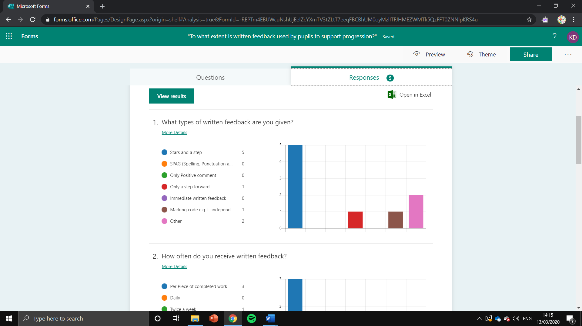
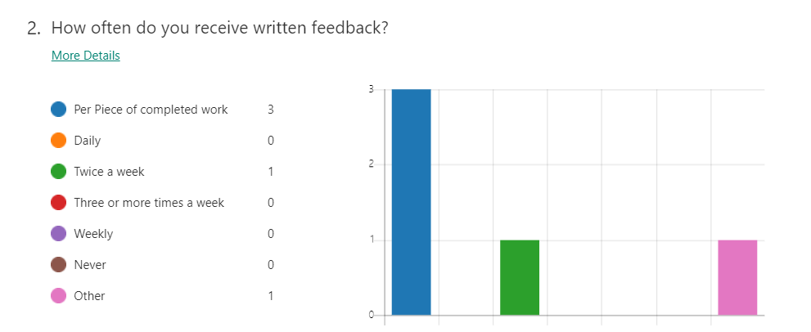
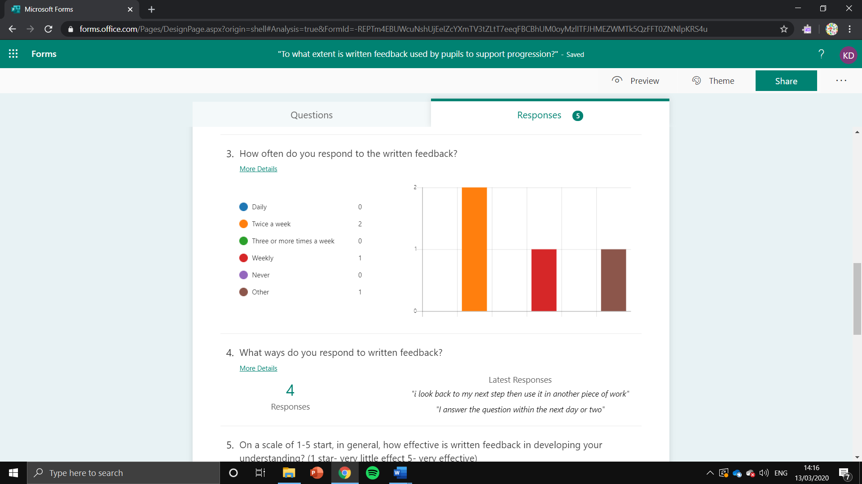

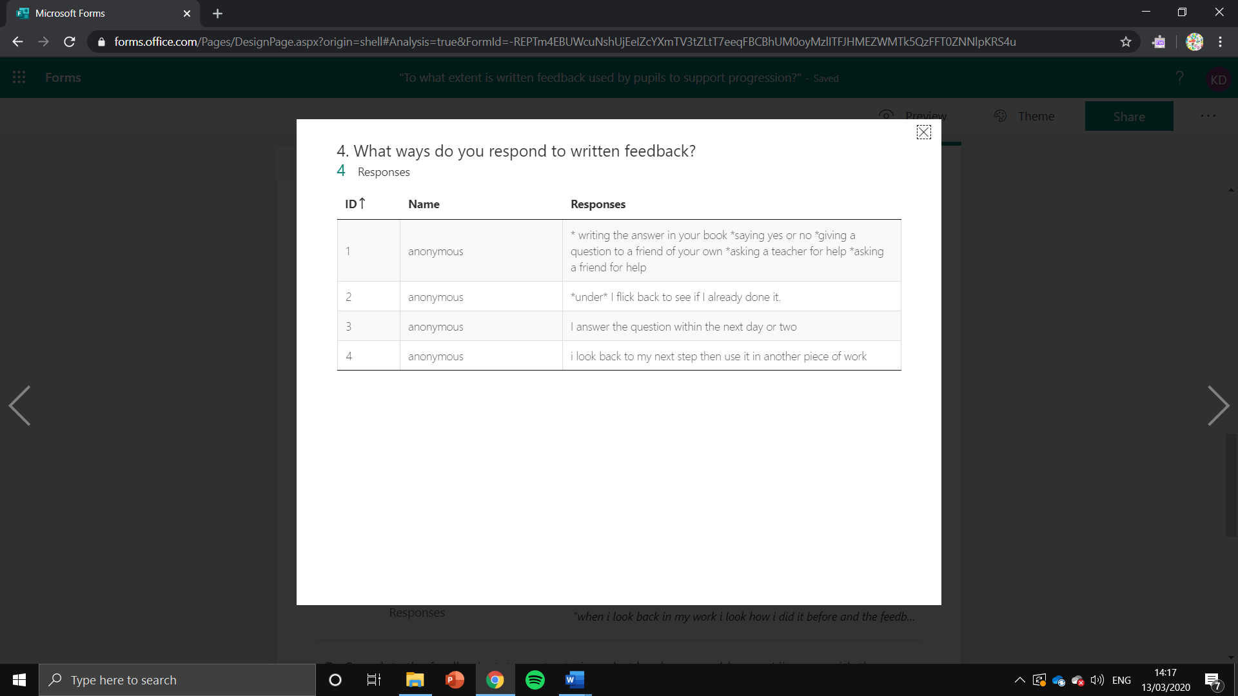

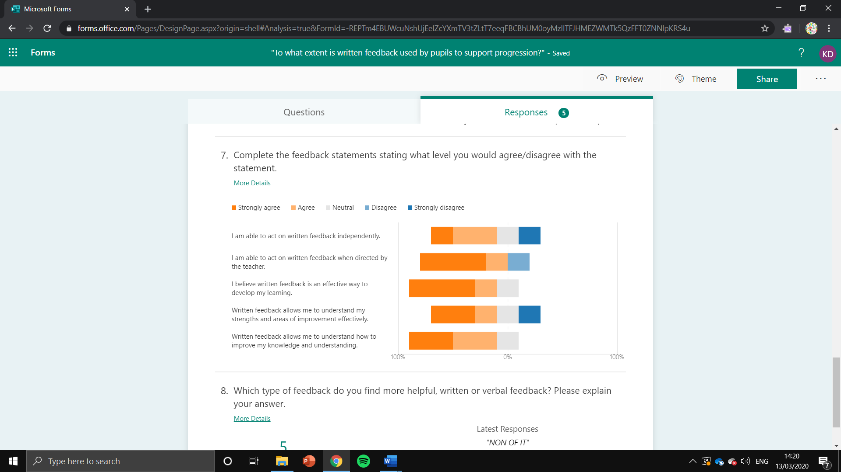
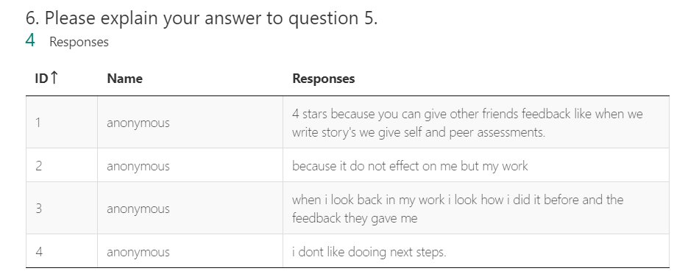
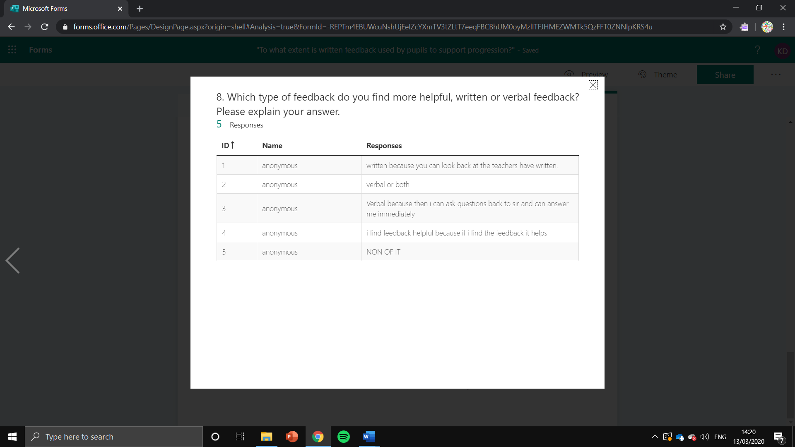
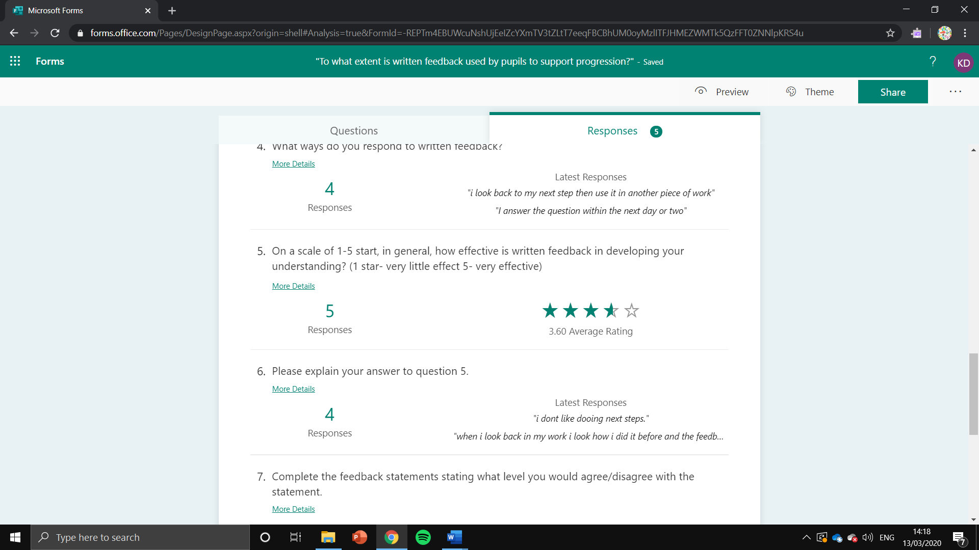

Appendix 9- Completed Teacher Questionnaire
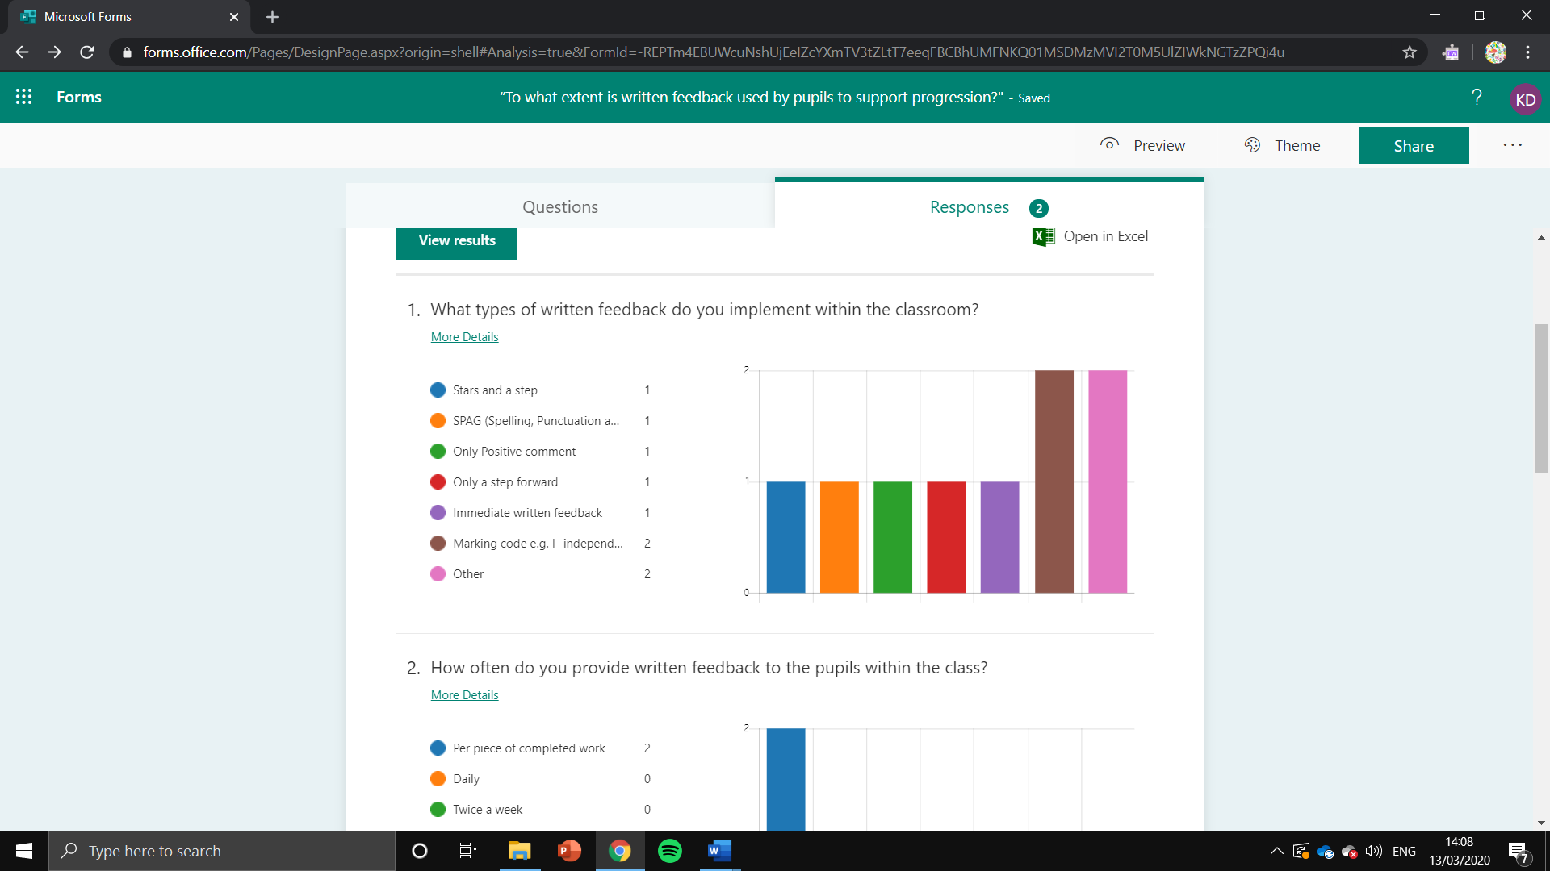

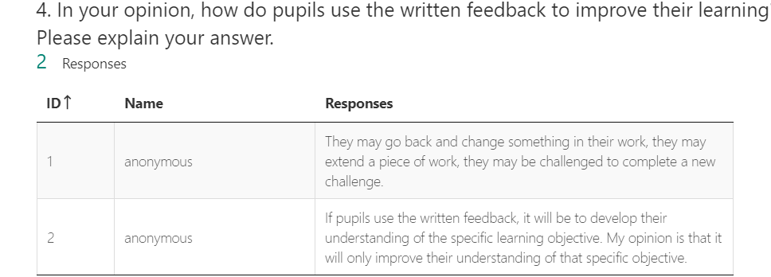
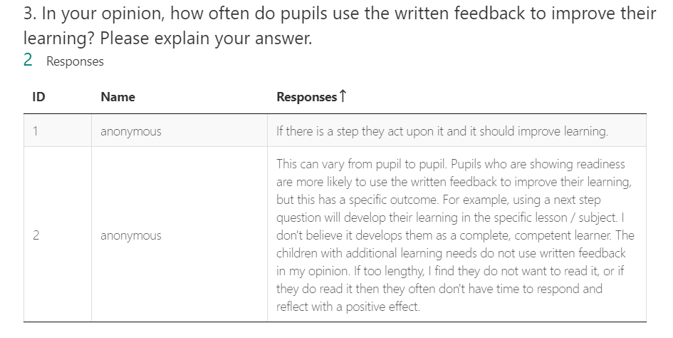
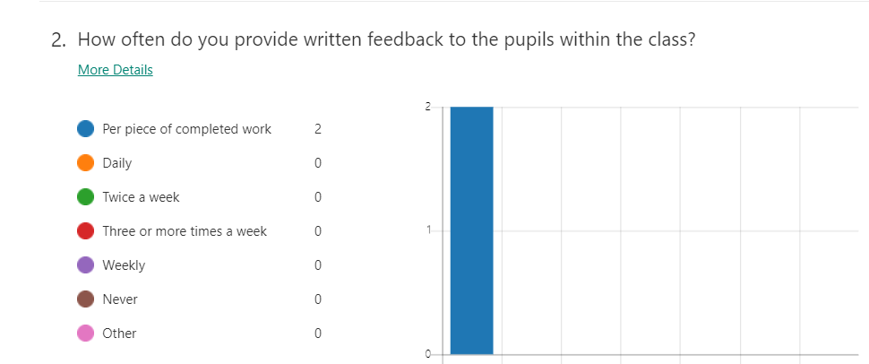

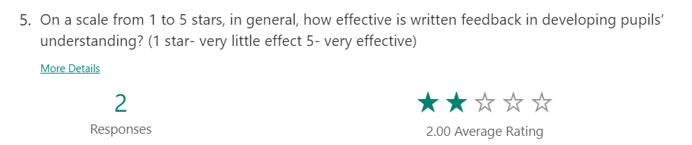

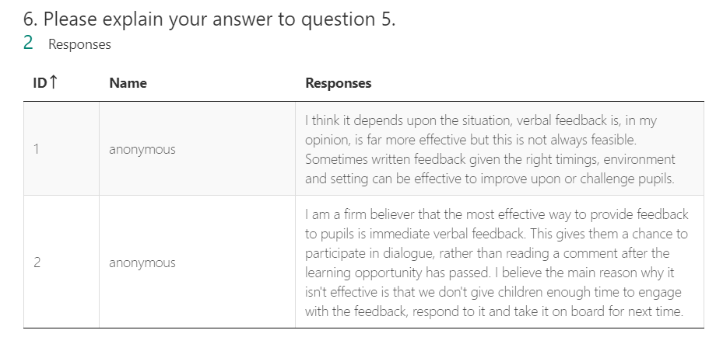

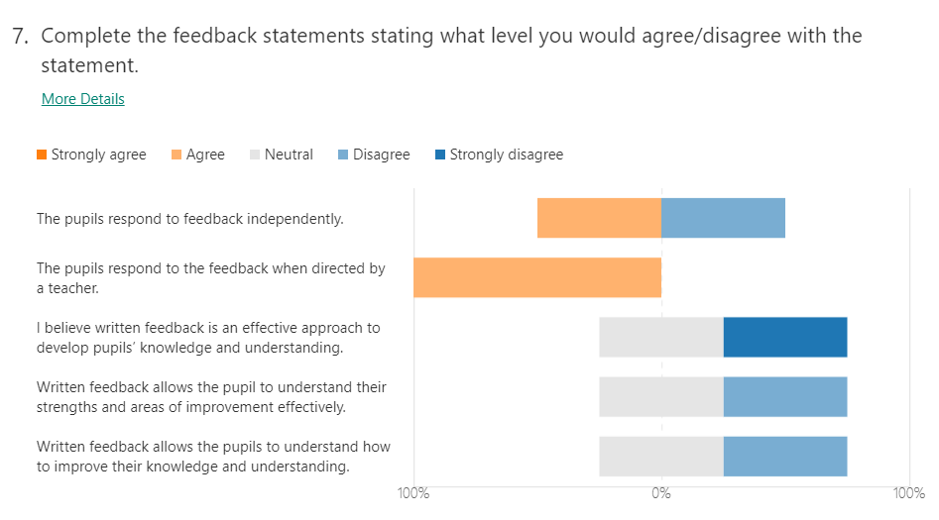

Appendix 10- Completed Teacher Interview
Teacher Feedback Questionnaire
- How effective do you believe written feedback is in supporting pupil progression within your class?
Prompts
- Do you see an improvement in pupils progress as a result of written feedback?
- Can you explain further how you use written feedback has developed pupil learning and understanding?
- Can you give an example of this?
Teacher A response: | - Depends on the type of work.  - Verbal feedback is more effective but has time constraints.  - Extended written feedback in literacy.  - Next step- go back to reflect. Teacher directed.  - Example- if descriptive language has not been used. Can certain words be used.  - Example- add in particular…
Teacher B response: | - Don’t like extensive feedback.  - Depends on the pupil.  - Effective for some.  - Specific for the class not progressive.  - Won’t use. Specific feedback which does not keep going doesn’t help progress.  - Verbal feedback - dialogue about work immediately can help learning.  - No point going back then moving on.  - Verbal feedback- more beneficial being there.  - Verbal feedback- allows pupils to articulate understanding.

- How do pupils respond to the written feedback you provide?
Prompts
- Are pens or comments used to demonstrate the pupils have seen and responded to written feedback?
Teacher A response: | - Complete the work.  - Example- five time counted within the work.  - Completed back in the piece of work, underneath the feedback or check work.
Teacher B response: | - Example- Welsh. Verbal feedback is better as not enough time to go back and reflect because of the curriculum being extensive.

- What barriers do you believe there are to the pupils engaging with written feedback?
Prompts
- Is time a limitation of the pupils’ engagement with the written feedback due to other work to complete?
Teacher A response: | - SEN/ALN pupils.  - Poor readers/ poor understanding.  - Time- time from leading/teaching.  - Reflection time is provided on a Friday morning (half an hour)- less effective this year but, being worked on.  - Articulate understanding with verbal feedback but, written feedback is disconnected. (Ignored).
Teacher B response: | - Time- especially within a job share classroom.  - Pupils abilities, poor readers, SEN/ALN pupils face challenges from written feedback. Verbal feedback is better.  - To provide written feedback to 30 pupils is strenuous.  - Using codes is beneficial to teachers to look back and understand if the work was completed independently etc. Pupils also recognise codes.

- What action would you put in place to combat the barriers identified within question 3?
Prompts
- Are there any potential areas such as, dedicated time or more structured responses that would benefit the pupils’ development as a consequence of the written feedback?
Teacher A response: | - Support from the teaching assistant to look at next steps.  - Teacher explanations of next steps.  - Build quality feedback time into timetable.
Teacher B response: | - Cut down written feedback to what is needed.  - Having conversations with pupils instead of marking time.  - Record conversations e.g. on seesaw to gain true reflection.  - Adapt timing to your lessons to make time for written feedback.  - More appropriate to have verbal feedback.

- Does the pupils’ engagement with written feedback effect the progression made as a result of that feedback?
Prompts
- How do you measure the amount of progress made by pupils as a result of written feedback?
- Do you find that poor engagement leads to poor progression from the written feedback?
Teacher A response: | - They still make same mistakes even if feedback is understood good.  - If responded, targets met or by levelling to understand if progress has been made.
Teacher B response: | - No, doesn’t support progression. If it does support, it is for a select few of fully engaged pupils.  - A lot can’t understand the link with feedback and future work. (Class specific).  - Measure progress through assessment. KWL grid.  - Measure knowledge at the beginning.  - Apparent in the work if the conversation (verbal feedback) used.  - Immediate verbal feedback more effective.
- Do you think that the type of written feedback used has an effect on the pupils’ engagement and thus, progress?
- E.g. does more difficult feedback have little response due the amount of work involved?
- Does the detail of the written feedback limit the engagement?
Teacher A response: | - Questions more likely to answer if you want to extend.  - If statement not as proactive.  - Stars important but, in engagement.  - Stay to language used in class for feedback. (Consistency).
Teacher B response: | - If the feedback is lengthy the pupils won’t reflect back.  - Topic work doesn’t support written feedback.  - Keep short simple code, comment, next step.  - In the participants experience, pupils don’t look back unless teacher specifically directed.  - Verbal feedback is for the pupils. Written feedback is for book scrutiny and other people.

Appendix 11- Completed Pupil Interview
Pupil Feedback Questionnaire
- What do you believe are the benefits of using written feedback?
Prompts
- What examples can you give of written feedback supporting your learning?
- What are the positive points of written feedback?
Group participants responses: | - Written feedback lets you do the improvements in your book.  - Feedback of previous work helps support future work.  - If wrong, shows and pushes you to do better.  - More confident.  - Some examples are given to improve and model the question.  - If the work went really well with support, try and do it independently next time.  - Written in book, so can look back to remember and can work on across the week.  - Used feedback to improve.

- In your opinion, do you feel that written feedback has helped you to learn? Can you give an example of this?
Prompts
- Do you see an improvement in your progress as a result of written feedback?
- Can you give an example of this?
Group participants responses: | - Next step gives you more of an idea of what was the problem and how to improve.  - Next step- what you need to do. Better understanding work.  - Next step for the next lesson to push you. For example, practice angles for the next lesson.  - Next step angles challenge- if exceeding expectations to grows in difficulty.  - Handwriting- look back and see so, gives an example of what to do next time.  - “Finish this work” comments.  - Marking codes are used.  - Da iawn/ well done give a happy feeling.  - Every piece of work gets feedback.  - Target time gives a once a week look back at work.  - If classwork is finished then look back at feedback.  - Underneath feedback complete work.

- What would you say are the challenges of using written feedback to support your learning?
Prompts
- Is time a limitation of the pupils’ engagement with the written feedback due to other work to complete?
Group participants responses: | - Says needs to improve but, not specific.  - If too complex don’t know what to do.  - Writing difficult to read (cursive).

- What is the cause of your interaction with written feedback? Please explain your answer.
Prompts
- Is teacher direction the cause of your interaction with written feedback?
- Do pupils complete written feedback independently at a pupil selected opportunity?
Group participants responses: | - Teacher directed.  - Target time.  - Finished work then, can go back.
- What would you do to improve your interaction with written feedback?
Prompts
- E.g. dedicated time to complete feedback e.g. five-minute feedback or feedback Fridays.
Group participants responses: | - Check independently to see if any feedback received.  - Example- check if any feedback before final newspaper report write up.  - Use feedback time to go back to work and improve time for this.  - Catch up/feedback time instead of fun Friday.

- Do you think that the type of feedback used has an effect on your involvement and thus, progress?
- E.g. does more difficult feedback have little response due the amount of work involved?
- Does the detail of the written feedback limit the engagement from pupils?
Group participants responses: | - Unspecific feedback causes pupils to need verbal reassurance.  - Verbal simple explanations.  - Different teacher feedback causes altering complexities causing the pupils to restart.  - Consistent feedback to help progress.

Participants  Appendix 12- Completed Observation Schedule | Types of written feedback |  |  |  |  | Observations on the feedback given | Observations on the effect of feedback on the pupils
  Immediate written feedback | Stars and a step  (Marking scheme) | Target setting  (Feed forward) | Positive feed-back | Other
Pupil A |  |  |  |  |  | Positive feedback- positive feedback was provided following the lesson on the completed work.  Other (verbal feedback)- verbal feedback was used throughout the lesson to support the learning. | Positive feedback- the positive feedback provided a piece of encouragement to the pupils when they viewed the feedback.  Other (verbal feedback)- verbal feedback developed the pupils understanding through further explaining the activity.
Pupil B |  |  |  |  |  | Immediate written feedback- spelling, punctuation and grammar.  Stars and a step- positive praise and a step was provided to the pupil in the form of written feedback.  Other (verbal feedback)- verbal feedback was used to push for deeper understanding. | Immediate written feedback- the immediate written feedback was beneficial in creating immediate support and guidance to the pupil in relation to SPaG. Which were implemented within the work following the feedback.  Stars and a step- this step was not viewed within the lesson; however, I was informed that these will be viewed and implemented within the next lesson to support their progression in their work.  Other (verbal feedback)- deeper understanding was able to be gained from the verbal feedback which was evident within the work.
Pupil C |  |  |  |  |  | Stars and a step- starts and a step used with marking codes.  Other (verbal feedback)- verbal feedback used to deepen understanding and provide examples to promote learning. | Stars and a step- There was no apparent benefits within the lesson from the written feedback due to it being provided at the conclusion of the lesson. The main form of feedback with immediate impact was verbal feedback.  Other (verbal feedback)- the pupil developed their work and answers through the use of the provided examples.
Pupil D |  |  |  |  |  | Stars and a step- written feedback was provided in the form of a next step and a star at the end of the lesson.  Other (verbal feedback)- verbal feedback was used to provide positive praise. | Stars and a step- the next step was not used within the lesson; however, these will be implemented within the next lesson. (Not observed).  Other (verbal feedback)- the positive praise was beneficial in providing confidence to the pupils within their work.

