
APPENDIX GA36c

LEVEL 6 ASSESSMENT SPECIFICATION

Student name: | James Craddock-Jones | Student ID number: | 256515
Programme: | BSc Applied Computing
Module: | Usability Engineering
Module code: | ACCB6017 | Contribution to Overall Module Assessment (%): | 50%
Lecturer: | Dr Nik Whitehead | Internal Verifier: | Bev Holland
Assignment Title: | Vending Machines | Word count (or equivalent): | 3000
Submission deadline: |  | Return date of provisional marks & written feedback:
Submission method: | All written assessments, where practical and possible, must be submitted via Turnitin unless otherwise instructed by the Lecturer. (Please DO NOT put this assessment specification into Turnitin or it will match many similarities with other students’ submissions.)  Alternative submission method (if applicable):  Late submission of the assessment will result in a late penalty mark. Penalties for late submission: Up to one week late, maximum mark of 40%. Over one week late, 0%. Only the Extenuating Circumstances Panel may approve a change to submission dates.
Academic honesty / referencing: | Academic honesty is required. In the main body of your submission you must give credit to authors on whose research and ideas your work is based. Append to your submission a reference list that indicates the books, articles, etc. that you have used, cited or quoted in order to complete this assessment.

Module Learning Outcomes
(from module syllabus)
Upon the successful completion of this module, the student should be able to:
- Research and evaluate cognitive and social information processing
- Select, apply and analyse critically techniques of interface evaluation
- Synthesize a solution to a complex design problem from the concepts and principles of usability engineering and software development
- Critically analyse, individually and as part of a team exercise, input and output hardware appropriate for specialised applications, for example for use by disabled people, and for three-dimensional modelling applications

TASK DESCRIPTION

Background
You are required to apply usability theory and practice to the design of electronic vending machines. These include the normal machines for vending food and drink but could also include travel ticket machines or car parking ticket machines. Any electronic machines that allow you to buy a physical object or a local service are acceptable. If in doubt, ask your lecturer about a machine’s suitability.

Usability review of three machines
Select two machines of different types, one of which has what you consider to be a good design and the other a poorer design.

Give an overview of the displays, including rough sketches or photographs as appropriate. Outline the information and concepts they are communicating.

Prepare a comparison of the two including the following topics as well as any other usability topics you consider relevant:
- Human vision, hearing and touch
- Metaphor
- Affordance
Make brief suggestions to improve the usability of the less effective display.

How helpful is it to apply usability theory developed from the design of desktop computer systems to specialised machines such as these?

Interface Evaluation
Design a recommended interface evaluation strategy for examples of new vending machines of the styles you have researched. Include reference to interface evaluation studies from the literature to justify the evaluation strategies.

Guidelines and Accessibility
Apply a set of general usability guidelines, such as Dix’s or Schneiderman’s to the interfaces of your chosen machines. Which guidelines are applicable to the vending machines and which are not? Draw up a set of recommendations for accessibility for vending machines of the styles you have researched.

To what extent does accessibility advice aimed at web designers (such as the W3C Web Accessibility Initiative) apply to designers of vending machines?

GUIDANCE FOR Students IN THE COMPLETION OF TASKS

NOTE: The guidance offered below is linked to the five generic assessment criteria overleaf.

- Engagement with Literature Skills
Your work must be informed and supported by scholarly material that is relevant to and focused on the task(s) set; you should make use of scholarly reviews and primary sources, where appropriate (for example, refereed research articles and/or original materials appropriate to the discipline). You should provide evidence that you have accessed a wide range of sources, which may be academic, governmental and industrial; these sources may include academic journal articles, textbooks, current news articles, organisational documents, and websites. You should consider the credibility of your sources; academic journals are normally highly credible sources while websites require careful consideration/selection and should be used sparingly. Any sources you use should be current and up-to-date, mostly published within the last five years or so, though seminal/important works in the field may be older. You must provide evidence of your research/own reading throughout your work, using a suitable referencing system, including in-text citations in the main body of your work and a reference list at the end of your work.

Guidance specific to this assessment: You need to justify your decisions related to good design and poor design by suitable reference to the literature.

- Knowledge and Understanding Skills
At level 6, you should be able to demonstrate coherent and detailed knowledge and a systematic understanding of the subject area, at least some of which is informed by the latest research and/or advanced scholarship within the discipline. You should be aware of the uncertainty, ambiguity and limits of knowledge. Your work must demonstrate the growing extent of your knowledge and systematic understanding of concepts and underlying principles associated with the subject area. Knowledge relates to the facts, information and skills you have acquired through your learning. You demonstrate your understanding by interpreting the meaning of the facts and information (knowledge). This means that you need to select and include in your work the concepts, techniques, models, theories, etc. appropriate to the task(s) set. You should be able to explain the theories, concepts, etc. meaningfully to show your understanding. Your mark/grade will also depend upon the extent to which you demonstrate your knowledge and understanding; ideally each should be complete and detailed, with comprehensive coverage.

Guidance specific to this assessment: You’re analysing the systems to identify strong points and weak points relating to human factors, usability, accessibility and user experience. Remember to include each of these fields in your answer.

- Cognitive and Intellectual Skills
You should be able to: critically evaluate evidence, arguments, assumptions, abstract concepts and data some of which are at the forefront of a discipline (and that may be incomplete) to devise and sustain arguments, to make judgements and/or solve problems; describe and comment upon particular aspects of current research, or equivalent advanced scholarship, in the discipline Your work must contain evidence of logical, analytical thinking, evaluation and synthesis. For example, to examine and break information down into parts, make inferences, compile, compare and contrast information. This means not just describing what! But also justifying: Why? How? When? Who? Where? At what cost? At all times, you must provide justification for your arguments and judgements. Evidence that you have reflected upon the ideas of others within the subject area is crucial to you providing a reasoned and informed debate within your work. Furthermore, you should provide evidence that you are able to make sound judgements and convincing arguments using data and concepts. Sound, valid conclusions are necessary and must be derived from the content of your work. Where relevant, alternative solutions and recommendations may be proposed.

Guidance specific to this assessment: Once you’ve identified problems with your chosen systems you need to fix those problems. Make sure that your fixes don’t introduce new problems.

- Practical Skills
At level 6, you should be able to apply the methods and techniques that you have learned to review, consolidate, extend and apply your knowledge and understanding, and to initiate and carry out projects. You will deploy accurately established techniques of analysis and enquiry relevant to the discipline, and apply them in complex and unpredictable contexts, to devise and sustain arguments and/or to solve problems. You should be able to frame appropriate questions to achieve a solution - or identify a range of solutions. You should be able to demonstrate how the subject-related concepts and ideas relate to real world situations and/or a particular context. How do they work in practice? You will deploy models, methods, techniques, and/or theories, in that context or circumstances, to assess current situations, perhaps to formulate plans or solutions to solve problems, or to create artefacts, some of which may be innovative and creative. This is likely to involve, for instance, the use of real world artefacts, examples and cases, the application of a model within an organisation and/or benchmarking one theory or organisation against others based on stated criteria. You should show awareness of the limitations of concepts and theories when applied in particular contexts.

Guidance specific to this assessment: N/A

- Transferable Skills for Life and Professional Practice
Your work must provide evidence of the qualities and transferable skills necessary for graduate-level employment requiring the exercise of initiative and personal responsibility and decision-making in complex and unpredictable circumstances. This includes demonstrating: the learning ability for professional development to advance existing skills and acquire new competences of a professional nature that will enable you to assume significant responsibility within organisations; that you can initiate and complete tasks and procedures, whether individually and/or collaboratively; that you can use appropriate media to effectively communicate information, arguments and analysis in a variety of forms to specialist and non-specialist audiences; fluency of expression; clarity and effectiveness in presentation and organisation. Work should be coherent and well-structured in presentation and organisation.

Guidance specific to this assessment: Document presentation is important. Remember to use technical English, to stick to the numerical referencing method, and to caption all of your illustrations.

Student FEEDBACK FORM

This section details the extent to which the assessment criteria are demonstrated by you, which in turn determines your mark. The marks available for each category of skill are shown. Lecturers will use the space provided to comment on the achievement of the task(s), including those areas in which you have performed well and areas that would benefit from development/improvement.

Generic Assessment Criteria | Marks available | Marks  awarded
1. Engagement with Literature Skills
.
Research and application as shown in identification of suitable machines to analyse and references to appropriate literature and industry practice  Research conducted into suitable good and bad designs of vending machines.  No reference made to human factors theory, metaphors, affordances in providing overview of selected machines.  Interface evaluation is discussed in relation to Nielsen’s Heuristics but references are all from the same source. What about interface evaluation studies? Research undertaken into new systems that could benefit from the evaluation strategy selected.  Reference made to Shneiderman’s rules of interface design during the analysis of both poor and good vending machine interfaces.  Consideration of web standards in relation to accessibility of interfaces is mentioned but no evidence of research. |  | 16
 | 30 | 16
2. Knowledge and Understanding Skills

Application of usability engineering concepts to the machines analysed.  Functionality of both good and bad designs are explained and Nielsen’s Heuristics have been applied in analysing the designs selected with reasons for scoring included. However, no comparison conducted in relation to human factors, metaphors nor affordances.  Nielsen’s Heuristics used for interface evaluation are discussed in relation to additionally selected interfaces.  Initially selected designs have been analysed with reference to Shneiderman’s rules of interface design, with all considered applicable. |  | 17
 | 30 | 17
3. Cognitive and Intellectual Skills

Explanation of choices made and designs produced.  Recommendations for improving both designs have been included and this has been informed by the heuristic evaluation conducted although these should have been more extensive in relation to the poorer design.  No justification of selected interface evaluation strategy ie Nielsen’s Heuristics although the stages have been explained and some illustrative examples included.  Recommendations in relation to accessibility of these vending machines have been included but not justified. |  | 18
 | 30 | 18
4. Practical Application Skills

 | 0
5. Transferable Skills for Life and Professional Practice

Good technical writing and referencing.  Generally, well-expressed throughout, with discussion being suitably organised. However, I would have liked to have seen a wider variety of sources included to support your discussion. More extensive research could have been conducted to enable this. Also, avoid use of the first person within your discussion. | 10 | 7

Assessment Mark (Assessment marks are subject to ratification at the Exam Board. These comments and marks are to give feedback on module work and are for guidance only until they are confirmed. ) | Late Submission Penalties (tick if appropriate) |  | 58%
 | Up to 1 week late (40% Max) |  | 58%
 | Over 1 week late (0%) |  | 58%

GENERIC ASSESSMENT CRITERIA

Level 6
In accordance with the Framework for Higher Education Qualifications, at the end of Level 6 students should have coherent and detailed knowledge and a systematic understanding of their subject area, at least some of which is informed by the latest research and/or advanced scholarship within the discipline. They will be able to accurately deploy established techniques of analysis and enquiry within a discipline, using their conceptual understanding to devise and sustain arguments and/or to solve problems. They should be aware of the uncertainty, ambiguity and limits of knowledge. They should be able to critically evaluate evidence, arguments, assumptions, abstract concepts and data (that may be incomplete), to make judgements, and to frame appropriate questions to achieve a solution - or identify a range of solutions. They will apply the methods and techniques that they have learned to review, consolidate, extend and apply their knowledge and understanding, and to initiate and carry out projects. They will have the ability to manage their own learning, and to make use of scholarly reviews and primary sources (for example, refereed research articles and/or original materials appropriate to the discipline). They will demonstrate the qualities and transferable skills necessary for employment requiring: the exercise of initiative and personal responsibility; decision-making in complex and unpredictable contexts; the learning ability needed to undertake appropriate further training of a professional or equivalent nature.

Level 6 | FAIL | MARGINAL FAIL | SATISFACTORY  (3rd / Pass) | GOOD  (2.2 / Pass) | VERY GOOD  (2.1 / Merit) | EXCELLENT  (1st / Distinction) | EXCEPTIONAL  (1st / Distinction)
Category | 0-29% | 30-39% | 40-49% | 50-59% | 60-69% | 70-84% | 85-100%
Engagement with literature (including reading, referencing,  academic conventions and  academic honesty) | Little or no evidence of reading and/or reliance on inappropriate sources.  Views and findings mostly unsupported and non-authoritative.  Referencing conventions used incoherently or largely absent. | Poor engagement with essential reading. No evidence of wider reading. Reliance on inappropriate sources, and/or indiscriminate use of sources. Heavily reliant on information gained through class contact. Inconsistent and weak use of referencing. | Engagement with a limited range of mostly relevant and credible sources. Some omissions and minor errors.  Referencing conventions evident though not always applied accurately or consistently. | Engagement with an appropriate range of research-informed literature, including sources retrieved independently. Some over-reliance on texts. Referencing may show minor inaccuracies or inconsistencies. | Engagement with a wide range of research-informed literature, including sources retrieved independently.  Selection of relevant and credible sources. Very good use of referencing, with no/very few inaccuracies or inconsistencies. | Engagement with an extensive range of relevant and credible literature, informed by the latest research. Consistently accurate application of referencing. | Exceptional engagement with an extensive range of relevant and credible literature, informed by the latest research. High-level referencing skills consistently and professionally applied.
Knowledge and understanding (Coherent and detailed knowledge and systematic understanding of the subject area, at least some of which is informed by the latest research and/or advanced scholarship within the discipline.) | Major gaps in knowledge and systematic understanding of the subject matter. Substantial inaccuracies. No awareness of knowledge of the latest research and/or advanced scholarship within the discipline. | Gaps in knowledge, with only superficial systematic understanding. Some significant inaccuracies and/or irrelevant material. No awareness of knowledge of the latest research and/or advanced scholarship within the discipline. | Limited knowledge and systematic understanding of the relevant concepts and principles within the subject area which to some limited extent, is informed by current research and scholarship. | Knowledge is reasonably detailed, accurate with a good systematic understanding of the field of study and to some extent, current research and scholarship. | Knowledge is reasonably extensive coherent and detailed. Exhibits very good understanding of the breadth and depth of established views, and the work is, at least in part, well-informed by current research and scholarship. | Excellent coherent and detailed knowledge and systematic understanding of the principles and theories of current research and scholarship. Clear awareness of challenges to established views and the limitations of the knowledge base. | Exceptionally coherent and detailed knowledge and systematic understanding of the principles and theories of the subject, well-informed by current research and scholarship. A critical, sophisticated and nuanced awareness of the ambiguities and limitations of knowledge.
Cognitive and intellectual skills  (Conceptual and critical thinking, analysis, synthesis and evaluation of research, assumptions, abstract concepts and data (that may be incomplete); logic, argument and judgement.) | Wholly or almost wholly descriptive work. Little or no analysis, synthesis or evaluation.  Failure to develop arguments, leading to illogical or invalid judgements. Unsubstantiated generalisations, made without use of any credible evidence. | Largely descriptive work, with superficial use of critical evaluation. Weak development of arguments and judgements. Information accepted uncritically, uses generalised statements made with scant evidence and unsubstantiated opinions. Ideas sometimes illogical and contradictory. | Limited attempt at critical thinking, analysis, synthesis and evaluation, tending towards description.  Some evidence to support emerging arguments and judgements but these may be underdeveloped or with a little inconsistency / mis-interpretation.  Asserts rather than argues a case. | Some critical thinking, analysis, synthesis and evaluation. Can analyse new and/or abstract concepts and data without guidance.  An emerging awareness of different stances and ability to use evidence (that may be incomplete) to support the argument.  Mostly valid arguments and logical judgements. Some tendency to assert/state opinion rather than argue on the basis of reason and evidence. | Sound critical thinking, analysis, synthesis and evaluation demonstrating critical thinking. Ability to devise and sustain persuasive arguments, and to review the reliability, validity and significance of evidence (that may be incomplete) to make mostly appropriate and valid judgements. | Excellent critical thinking, analysis, synthesis and evaluation. Ability to investigate contradictory or incomplete information and make strong, persuasive, arguments and sophisticated judgements. Some evidence of independent thought and ability to ‘see beyond the question’, suggesting a grasp of the broader field and wider concepts. | Exceptional critical thinking, analysis, synthesis and evaluation based on judiciously selected evidence.  Ability to investigate contradictory or incomplete information and make strong, persuasive, arguments and sophisticated, nuanced, judgements. Evidence of independent thought and ability to ‘see beyond the question’, suggesting an outstanding grasp of the broader field and wider concepts.
Practical skills  (Apply/deploy accurately established tools and techniques; initiate and carry out projects; formulate solutions to solve problems in complex and unpredictable contexts.) | Limited or no use of methods, materials, tools and/or techniques.  Little or no appreciation of the context of the application.  Limited understanding of the application of theory to practice or making appropriate links between the two.  Very weak problem-solving skills in complex and unpredictable contexts. | Rudimentary application of methods, materials, tools and/or techniques but without consideration and competence. Flawed appreciation of the context of the application.  Weak understanding of the application of theory to practice, with only occasional evidence of making appropriate links between the two. Weak problem-solving skills in complex and unpredictable contexts. | An adequate awareness and mostly appropriate application of well-established methods, materials, tools and/or techniques.  Basic appreciation of the context of the application. Theoretical knowledge and understanding applied in practice, but not always making logical links between the two.  Can identify problems and propose basic solutions in complex and unpredictable contexts without fully appreciating the complexity. | A good and appropriate application of standard methods, materials, tools and/or techniques.  Clear appreciation of the context of the application. Mainly consistent, accurate and logical application of theory to practice, making appropriate links between the two  Can identify problems and propose mostly appropriate solutions in complex and unpredictable contexts. | A very good application of a range of methods, materials, tools and/or techniques.  Very good consideration of the context of the application, with perceptive insights. Can identify problems and propose appropriate solutions in complex and unpredictable contexts.  Evidence of some innovation and creativity. | An advanced application of a range of methods, materials, tools and/or techniques.  The context of the application is well considered, and insightful.  Application and deployment extend beyond established conventions. Can identify complex problems and propose excellent solutions. Innovation and creativity evident. | Exceptional levels of application and deployment skills in unpredictable, practical contexts, drawing skilfully on the latest research within the discipline. Can identify complex problems and propose sophisticated solutions. Assimilation and development of cutting edge processes and techniques.
Transferable skills for life and professional practice  (Exercise of initiative and personal responsibility; professional development; initiate and complete tasks and procedures: individually and/or collaboratively; use appropriate media to communicate effectively; fluency of expression; clarity and effectiveness in presentation and organisation.) | Communication medium is inappropriate or misapplied.  Work is poorly structured, disorganised and/or confusingly expressed. Very weak use of language and/or very inappropriate style. Little or no evidence of autonomy (or collaboration, where relevant) in the completion of tasks. Little or no evidence of the skills required in graduate employment. | Communication medium is poorly designed and/or not suitable for the audience.  Work is poorly presented in a disjointed manner. It is loosely, and at times incoherently, structured, with information and ideas often poorly expressed. Weak use of language and/or inappropriate style. Weak independent initiative (or collaboration, if relevant). Limited evidence of the skills required in graduate employment. | Can communicate in a suitable medium but with some room for improvement.  Mostly ordered presentation and structure in which relevant ideas / concepts are reasonably expressed. Work may lack coherence in places. Can work as part of a team, but with limited involvement in group activities.  Demonstrates the basic skills required in graduate employment, with some areas of minor weakness. | Can communicate effectively in a suitable format, but may have minor errors.  Mostly coherent, organised work, in a suitable structure and is for the most part clearly expressed. Can work effectively independently and/or as part of a team, with clear contribution to group activities.  Demonstrates the skills required in graduate employment, with some areas of strength and some of minor weakness. | Can communicate well, confidently and consistently in a suitable format.  Work is coherent, fluent, well-structured and organised. Can work very well autonomously and/or as part of a team, with very good contribution to group activities.  Demonstrates very good graduate employment skills, with just occasional minor weakness. | Can communicate professionally confidently and consistently in a suitable format.  Work is coherent, very fluent and is presented professionally. Can work autonomously with initiative. Where relevant can work professionally within a team, showing leadership skills as appropriate, managing conflict and meeting obligations. Demonstrates excellent graduate employment skills and an appetite for further development. | Can communicate with an exceptionally high level of professionalism.  Work is exceptionally coherent, very fluent and is presented professionally. Can work exceptionally well and professionally within a team, showing advanced leadership skills. Demonstrates exceptional graduate employment skills and an appetite for further development.

THIS DOCUMENT IS ALSO AVAILABLE IN WELSH

Assignment 2
-
Usability Engineering

James Craddock-Jones
256515
19/05/2022
Contents
Machine Interface Review 3
Good Design 3
Interfaces 3
Usability Heuristics Review 6
Bad Design 8
Interface 8
Usability Heuristics Review 9
Interface Evaluation 11
Visibility of system status 11
Match between system and the natural world 11
User control and freedom 11
Consistency and standards 11
Error prevention 11
Recognition rather than recall 12
Flexibility and efficiency of use 12
Aesthetic and minimalist design 12
Help users recognise, diagnose, and recover from errors 12
Help and documentation 12
Guidelines and Accessibility 12
Strive for Consistency 12
Enable Frequent Users to Use Shortcuts 12
Offer Informative Feedback 13
Design Dialog to Yield Closure 13
Offer Simple Error Handling 13
Permit Easy Reversal of Actions 13
Support Internal Locus of Control 13
Reduce Short-Term Memory Load 13
Summary of Recommendations 14
User Interfaces and Web Standards 14
References 14

Machine Interface Review
Below will go over two designs, one being a good design and one being a bad user interface design. An explanation of each will be given, a heuristics evaluation using the same format from the last assignment that was provided to Aaron to give feedback on my design, and a few recommendations on how they could be improved.

Good Design
The first design reviewed is a ticket machine created for Transport for London. This new iteration of the system was redesigned to be modernised and improved. This was created by MT Design. (1)
The previous design used older computer graphics that had since become outdated and no longer served their purpose. When doing this, MT Design conducted a significant amount of research to find the requirements of the current system and the user. They also had access to previous research conducted by Transport for London (1)

Interfaces
The below image is one of the interfaces the users are greeted with when trying to buy a ticket to use the London underground. The menu provides the user with options to purchase tickets on a destination base, buy a day ticket, or buy a group or family tick. In addition, it provides the users to switch languages and buy a new Oyster card.
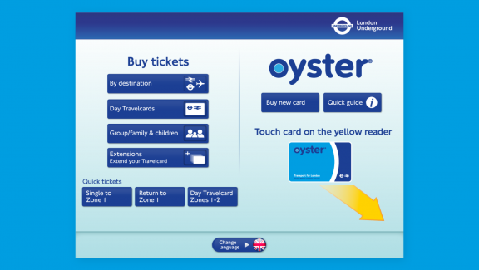
(1)
The below interface shows the options when selecting the Oyster card. These options include a top-up system for the card with eight predefined options with the ability to choose a custom amount. The interface also allows users to renew old passes and check their journey history.
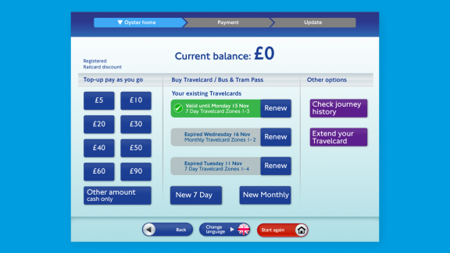
(2)
The following image shows the menu where the user can select their payment preferences using the external buttons at the side of the screen with points pointing to the right buttons to press. This menu also allows the user to print off a receipt, return to the previous menu, and start again. The menu also clearly shows the amount of money that will be placed onto the Oyster card and the amount the user must pay.
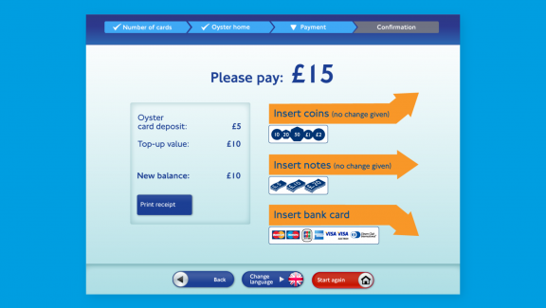
(2)
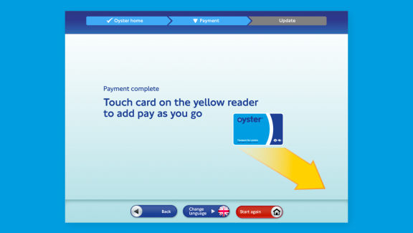
(2)
The below is now the design in action. One issue that could come up with the design being implemented is that not all of the machines are the same, with interface input placements all being different, which may hinder usability in that, for example, the user would not be able to use recall on the physical side of the system making it a steeper learning curve.
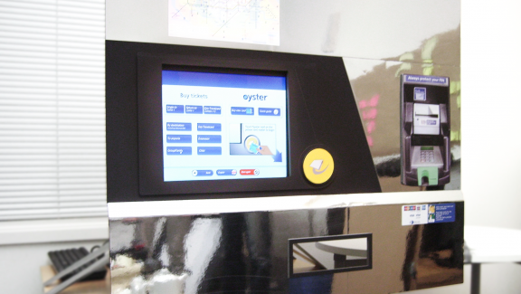
(2)
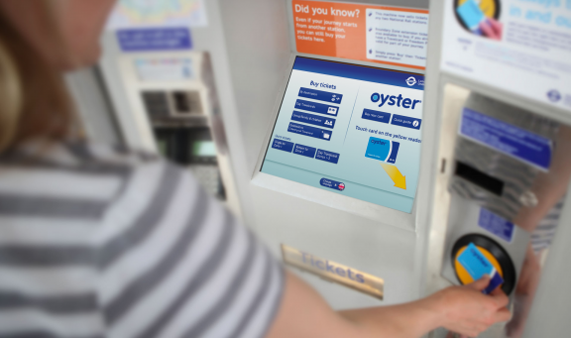
(3)

Usability Heuristics Review

Visibility of system status
Severity score out of 5:
1 | 2 | 3 | 4 | 5
Reasons why:
The design shows the system’s status when booking a ticket or topping up their Oyster allowing them to know where they are in the process. No loading screens could be found throughout the final design or mock-up designs, so that no comment can be made on that.

Match between system and real world
Severity score out of 5:
1 | 2 | 3 | 4 | 5
Reasons why:
The design uses rounded buttons, which match how a button would somewhat look in the real world.

User control and freedom
Severity score out of 5:
1 | 2 | 3 | 4 | 5
Reasons why:
The user can go back to the previous menu or start all over again easily throughout the many processes within the system. In addition, the user can change the interface’s language to their prefered option.

Consistency and standards
Severity score out of 5:
1 | 2 | 3 | 4 | 5
Reasons why:
The system design is consistent throughout all the menus aiding in the users’ ability to recall from memory how the interface should work.

Error prevention
Severity score out of 5:
1 | 2 | 3 | 4 | 5
Reasons why:
The user can go back to the previous menu or start all over again quickly throughout the many processes within the system.

Recognition rather than recall
Severity score out of 5:
1 | 2 | 3 | 4 | 5
Reasons why:
As said previously, the design is constant throughout, aiding the user in recalling from memory. The design also uses buttons in a style that makes them look similar to buttons in the real world.

Flexibility and efficiency of use
Severity score out of 5:
1 | 2 | 3 | 4 | 5
Reasons why:
The system provides shortcuts to the user by renewing previous purchases to avoid going through the whole process again.

Aesthetic and minimalist design
Severity score out of 5:
1 | 2 | 3 | 4 | 5
Reasons why:
In some cases, it could be argued that more options are provided at one time than what is required. An example of this is the eight amount options when you also have an opportunity to select a custom amount.

Help users recognise, diagnose, and recover from errors
Severity score out of 5:
1 | 2 | 3 | 4 | 5
Reasons why:
No error message screens are shown within the final design or the mock-ups, so it has to be assumed that there are only a few or none.

Help and documentation
Severity score out of 5:
1 | 2 | 3 | 4 | 5
Reasons why:
Documentation and help are limited, if not wholly absent from the design. The only provided documentation is a quick guide to the Oyster card.

Recommendations:
Even though the design is mainly good, many recommendations could be made. The first recommendation would be to add more help options for inexperienced users who may have never used the London underground before.
Another would be unifying the physical interface of the digital vending machine, so there is a relatively small learning curve needed to use any of the devices across the whole London underground.

Bad Design
The next vending machine is a pay and display ticket machine in Buxton, Derbyshire. Many elements are generally wrong with the design of this interface. For example, one would be the vertical keyboard which hinders recall as keyboards are laid out horizontally on computers.

Interface
There is only one interface for this electronic vending machine. As you can see, the interface consists of a tiny display, a slot to insert coins, a keyboard to enter car details, and a slot where the parking ticket is dispensed.
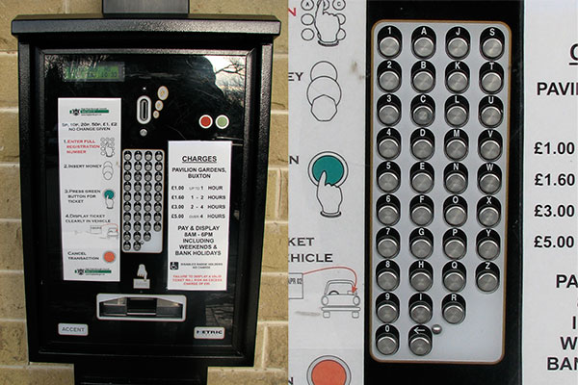(3)

Usability Heuristics Review

Visibility of system status
Severity score out of 5:
1 | 2 | 3 | 4 | 5
Reasons why:
The display is too small with no backlight, making it hard to read.

Match between system and real world
Severity score out of 5:
1 | 2 | 3 | 4 | 5
Reasons why:
The interface uses a keyboard but does not use a traditional keyboard layout which entails a learning curve for the user.

User control and freedom
Severity score out of 5:
1 | 2 | 3 | 4 | 5
Reasons why:
There is no way to move backwards in steps which limit control.

Consistency and standards
Severity score out of 5:
1 | 2 | 3 | 4 | 5
Reasons why:
Even though the design is terrible, it is consistent with using the keyboard as a form of input.

Error prevention
Severity score out of 5:
1 | 2 | 3 | 4 | 5
Reasons why:
There’s very little error prevention due to the nature of the design. Once the car’s registration number has been entered, the user cannot go back to change it if the user entered it wrong.

Recognition rather than recall
Severity score out of 5:
1 | 2 | 3 | 4 | 5
Reasons why:
Using a keyboard helps with recall, but the keyboard’s design hinders this as it uses a vertical design rather than the traditional horizontal design used with computers.

Flexibility and efficiency of use
Severity score out of 5:
1 | 2 | 3 | 4 | 5
Reasons why:
The interface is not flexible, nor is it efficient in handling user input with a big keyboard.

Aesthetic and minimalist design
Severity score out of 5:
1 | 2 | 3 | 4 | 5
Reasons why:
The keyboard can cause more confusion when the user enters details into the system.

Help users recognise, diagnose, and recover from errors
Severity score out of 5:
1 | 2 | 3 | 4 | 5
Reasons why:
No help is provided to help the user recover from an error.

Help and documentation
Severity score out of 5:
1 | 2 | 3 | 4 | 5
Reasons why:
There is documentation on how to use the system, but it does not show the user what they need to do in the event errors occur.

Recommendations:
Many recommendations could be made. The general guidance would be to fully digitalise the system to like what is used by Transport for London. This would include using a large display with a digital interface that could be interacted with either by touch or simple external buttons.
This design would allow the process to be much more allowing for error prevention as the user would be able to go back to the previous steps and alter what they have been inputted.
In addition, a system could be implemented where the system could recall previous parking tickets for a car’s registration number it remembers to speed the process up for the user. This may be hard to do given GDPR, but an alternative would be to use a system like Oyster cards.

Interface Evaluation

Visibility of system status
When designing a user interface, the design should always keep the user up to date on what is occurring within the system quickly and appropriately. Whenever the users are aware of the present state, they might understand the outcomes of prior activities and anticipate their future steps. Predictable interactions aid in the development of trust. (4)
An example of this is setting up a new device such as a smartphone. You are always shown where you currently are within the set-up procedures, whether selecting a language, WiFi network, signing into your Apple or Google account, or setting up security features such as a Touch ID or a passcode. You are also allowed to go back or skip the menu.
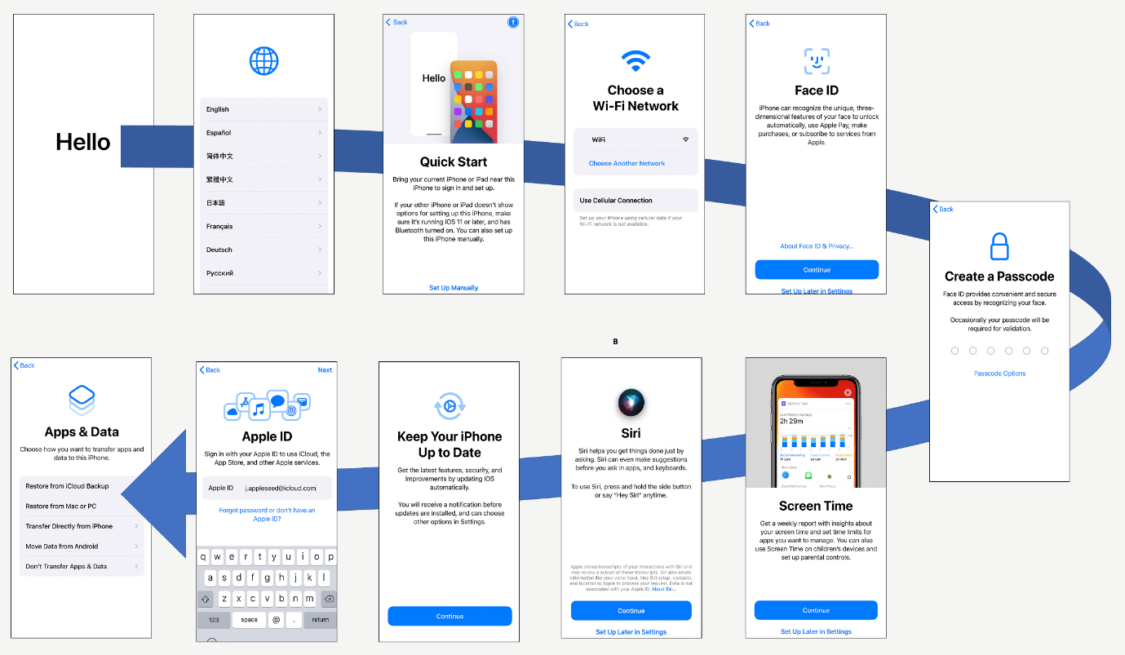
(7)

Match between system and the natural world
When creating a new user interface design, the design should communicate with the users. Instead of using jargon known internally or by experts, utilise language and ideas that the user is acquainted with. To display facts in a typical and easy sequence that follows real-world conventions. (4)
The way an interface is designed is highly dependent on who you are trying to reach. Language, thoughts, signs, and pictures that appear entirely prominent inside could be unfamiliar to or confusing to others. (4)
An example of this would be to use buttons that look like real-life buttons. This allows the user to understand that the element is clickable.
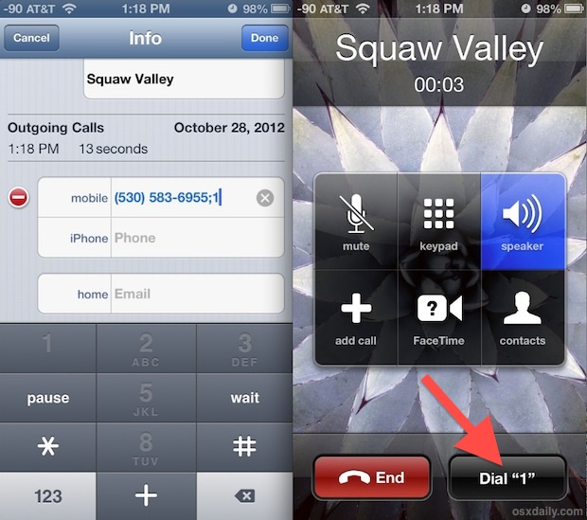 (6)

User control and freedom
When performing tasks, the user might regularly make errors. They demand an indicated method of exiting the uncomfortable task without going into a long-drawn-out process. People can back out from a function or delete an action. They feel more independent and secure. Exits allow users to maintain control over their encounters and prevent being trapped and frustrated. (4)
An example of this is shown below with the old iOS 6 contact list menu. It allows the user to completely remove the phone number, edit the number, and edit the contact’s name, among other tasks such as adding or deleting associated emails.

Consistency and standards
It should never be necessary for the user to assume whatever new phrases, conditions, or actions mean. More contemporary designs must adhere to platform and industry standards. The user’s expectations are based on their previous encounters with various services. Failing to keep consistency could increase the overall mental workload of users by forcing them to learn new knowledge. (4)

Error prevention
Although excellent error indicators are essential, the best designs undertake precautions to minimise problems in the first place. It is best to either delete any error-prone situations or inspect them and offer users a verification option once they engage in an activity. (4)

Recognition rather than recall
Reducing the user’s cognitive load by making actions and selections apparent. While designing an interface, remember that users must and should come first. While creating an interface, it is essential to remember that users should not have to recollect facts from one section to the next. We humans have limited short-term memory. Using interfaces that improve recognition reduces the user’s cognitive workload. (4)

Flexibility and efficiency of use
Shortcuts concealed from newer users may enable more knowledgeable users to engage faster, enabling the user interface to suit new and experienced users. (4)

Aesthetic and minimalist design
When designing user interface design, it should be kept in mind that it should not include information that is either worthless or rarely utilised. Each extra data element in a user interface might clash with the relevant pieces of data, reducing relative visibility. (4)

Help users recognise, diagnose, and recover from errors
Error warnings presented to a user must be written in plain English. This means that it identifies the problem and provides a helpful solution. (4)

Help and documentation
When creating an interface, it is best if the process does not require any further clarification. However, it is not always possible. Thus, documentation may well be necessary to help the user understand how to complete activities. (4)

Guidelines and Accessibility
For this section, I will be using Schneiderman’s interface guidelines to form the bases of my recommendation.

Strive for Consistency
It is critical to maintain consistency through the graphical interface design, whether it uses the same layout, button style, or colours. This uniformity will help establish the brand and prevent people from leaving your service. (5)

This applies to the interfaces that have been researched at the beginning. These machines must use a uniform design throughout the many processes required to reach the end goal. The parking ticket machine falls here as it does not use a standardised keyboard format. It would be recommended to use a standardised computer keyboard layout to reduce the users’ cognitive needs regarding short term memory.

Enable Frequent Users to Use Shortcuts
When designing a user interface, allow the user to navigate the entire interface with only a few clicks. (5)
This principle does not apply to the parking ticket machine because the user has to input their car registration number, which would require many clicks to input it to continue navigating to the next stage.
However, this is appliable to the London Underground ticket machine. I believe it does an excellent job by allowing the user to reorder a previous ticket to save going through the whole process again.

Offer Informative Feedback
Suppose the user has finished or is presently doing activities while using the interface. In that case, it is essential to offer quick feedback to know exactly when in the processes they are and how far they need to go to the finish. (5)

Design Dialog to Yield Closure
It is important to remember that every user interaction should be closed based on the interactions made by the user. For example, displaying a message of gratitude, a notice of validation, or a message sent throughout the buying process. (5)
It is also important to remember that the user must see the route of their actions throughout the interface. This can be done by providing feedback after an activity. You minimise the user’s mental burden and improve their interface UX experience. (5)
This applies to both vending machines as a thank you message could be displayed when making a purchase or when an issue occurs with the data they have inputted.

Offer Simple Error Handling
When creating exemplary user interfaces, keep in mind that you want to remove as many errors as possible. If something goes wrong, the UI should enable easy identification to correct the problem. (5)
This also applies to both, as any interface should provide the user with the necessary information to solve issues if any were to crop up while trying to buy a train or parking ticket. This may be hard to do on interfaces with a small display like the parking ticket machine, but it is still necessary.

Permit Easy Reversal of Actions
In addition, when designing an interface, it is an excellent option to allow the user to easily pick “Reset” or “Cancel” after making errors. This allows the user to be less worried and eager to investigate choices, provided they understand there is a simple solution to address an issue. (5)
Both systems allow for this easily. It is always recommended that the user reverse any decision they have made within the system, especially those requiring the user to pay.

Support Internal Locus of Control
When designing an interface, it is crucial to provide the user power and control so that the user feels like they are overseeing the system. This can assist in comforting them. (5)
The parking ticket system does allow for this as it is all set out for the user in a strict manner. It would be recommended to design a system like the London underground ticket system, which provides the users with many options that can be altered to their needs.

Reduce Short-Term Memory Load
Due to human’s poor short-term memory limitations, graphical interfaces must be simple and easy to use. If a design uses multiple-page displays, they must be unified, so users rely less on their short-term memory. It is essential to avoid flooding interfaces with similar quantity content. (5)
This also applies to both designs. The London underground system works well by using a consistent design throughout and taking design cues from the real world with objects such as buttons. On the other hand, the parking ticket system does not do an excellent job because the keyboard uses an unorthodox layout.

Summary of Recommendations
- Keep the user interfaces as consistent and straightforward as possible.
- Provide the user with enough information to perform a task.
- Do not use unorthodox designs or layouts. Use standard layouts to help the users.
- Take design cues from popular and commonly used designs to aid users learning curve.
- Provide simple and effective error handling.
- Allow for shortcuts to speed the process up for more experienced users.
- Allow decisions to be easily reversible.

User Interfaces and Web Standards
Going forward, designers must look at web standards for accessibility. This is due to our ever-growing reliance on using the internet for day-to-day tasks such as working, using search engines to find new information, online shopping, and many more like entertainment such as Netflix and YouTube.
The more we use these interface designs, the more we learn and understand them, which is vital to consider when designing new user interfaces by looking into what is commonly used by users. This keeps the interface’s design close to the user’s expectations and allows for a more lenient learning curve.

References
- MT Design, TICKET MACHINE REDESIGN – LONDON UNDERGROUND, https://mt.design/portfolio/ticket-machine-redesign-london-underground/ Date Accessed: 12/04/2022
- Fool Proof, Improving the daily lives of millions of people with TfL, https://www.foolproof.co.uk/services/case-studies/tfl/ Date Accessed: 11/04/2022
- D. Travis, What car park payment machines can teach us about usability, What car park payment machines can teach us about usability (userfocus.co.uk) Date Accessed: 12/04/2022
- J. Nielsen, 10 Usability Heuristics for User Interface Design, https://www.nngroup.com/articles/ten-usability-heuristics/ Date Accessed: 16/04/2022
- Capian, Shneiderman’s Eight Golden Rules of Interface Design, https://capian.co/shneiderman-eight-golden-rules-interface-design Date Accessed: 18/04/2022
- OSX Daily, Add a “Dial Extension” Button to Contacts on iPhone, https://osxdaily.com/2012/10/28/add-dial-extension-button-to-contacts-iphone/ Date Accessed: 23/04/2022
- A. Robertson, Set Up iPhone and iPad For Your Family, Set Up iPhone and iPad For Your Family (askaboutgames.com) Date Accessed: 25/04/2022

