Component 1 - Individual Report
Student Name: Mirela Oprea
Student Number: 2107120
Lecturer Name: Yousuf Kamal
LCBB4006_BIRM
Academic Skills

Table of Contents
1. Introduction 3
2. Analysing the importance of resources and referencing for students 3
2.1 Explanation and demonstration of the research skills in higher education 3
2.2 Explanation and demonstration of the referencing in higher education 4
3. Conclusion 5
References 6
Appendix……………………………………………………………………………………..7

1. Introduction
Academic skills refer to the abilities and strategies acquired by students to gain success in the learning environment by achieving the goals of different modules. It is very important for students in order to improve different academic skills to get chances to pursue different courses as well as improve their efficiency and performance to enhance their potential in the academic field (May et al., 2022, p.1256). The major issue faced by students in high education is in researching different topics and collecting information in order to increase the quality of projects and get higher marks in different courses. Students also face difficulties in maintaining academic integrity because of the lack of knowledge about referencing which create challenges in maintaining academic integrity and project success in higher education. The purpose of the study is to analyse the importance of developing research skills and referencing for students in order to ensure their success in higher education. It will demonstrate the way research skills and referencing help to improve the performance of students in the academic field.

2. Analysing the importance of resources and referencing for students

2.1 Explanation and demonstration of the research skills in higher education
Research skills refer to the capability of students to search different topics by locating their sources, extracting information, and organising them in a way which helps to evaluate the collective information in a successful way as well as maintain the releasing of collected information to the selected topics (Mahasneh, 2020, p.13). It helps to maintain the flow of information throughout projects and different research papers in order to demonstrate the understanding of students in higher education, especially in business management courses.
Academic writing is an integral part of high education which help to maintain a professional tone and incorporated quality information in different projects and research papers in order to present the understanding of students about different topics. The major steps of academic writing include pre-writing, drafting, revising, and editing (Huisman et al., 2019, p.876). In the pre-writing stage, students focus on research topics. gathering information, and outlining projects. In the drafting stage, students connect information to ideas and plan the process of business management projects. The dividing stage review the collected information and design of projects whereas editing focuses on grammar and spelling of writing.
It is important for students and developing research skills because it provides opportunities for researchers to find relevant information related to different topics and incorporate them in successful ways in order to develop strategies on the basis of collective information (GUVEN and BABAYIGIT, 2020, p.54). It also allows students to find the solution to different problems and investigate different issues in order to fill their knowledge and skill gaps in higher education to ensure their success in the academic field. By developing this skill, students analyse different information and the way of selected reliable sources to increase the quality of projects in different courses.
It is very important for students to understand the process of applying research skills and implementing them to get higher marks in higher education. For example, if a student is developing a project on leadership in Amazon he/she needs to research the official website of Amazon and the way they maintain leadership in the organisation (Huisman et al., 2019, p.870). The student also needs to collect information from different authentic journals including BBC, Forbes, The Guardian and many more to analyse the interview of the CEO of Amazon to understand their leadership vision and practices in the organisation. It is very important to use keywords and understand the reliability of different sources while researching any topic which ensures the success of students in implementing research skills and project development.

2.2 Explanation and demonstration of the referencing in higher education
Referencing is a process which helps to present the way students can acknowledge different sources from where information has been collected and used in project development. It provides opportunities for students to maintain academic integrity and ethical considerations in project development by presenting the way students have used the work of different scholars in order to make the project argumentative and evaluative (Brundiers et al., 2021, p.17). It is very important for students to provide proper referencing in academic writing to avoid academic misconduct and provide credit to scholars whose information they use to develop quality projects.
In a project, referencing has two parts including a reference list and in-text citation which ensure the project's success and maintain the code of ethics in research development. In reference lists, students need to present the citation that includes the name of authors, the date of publication, the title of literary sources, the journal name, and the page numbers (García-Peñalvo, F.J., 2021, p.223). In the in-text citation process students need to put the name of the authors and the year of publication in brackets at the end of the line where the opinion of the author has been evaluated. To avoid plagiarism, students need to present the opinion of scholars in an evaluative manner and follow different methods including Harvard, APA, MLA and MHRA as per the requirement of tasks.
Referencing is important for students in developing different projects and research papers because it shows the effort of students behind developing the project and the authenticity and reliability of research papers by presenting facts and evidence in project development. It is also very important for students to present they have research skills and understanding level about different topics by incorporating the opinions of scholars in an evaluative manner.
In order to understand the importance of reference in higher education, it is very important to analyse it’s impact on maintaining the quality of research papers and projects as well as ensuring the success of students. In order to get success in the business management course, it is very important for students in order to present authentic information about market research and changing company practices to evaluate different business management-related topics (Brundiers et al., 2021, p.12). For example, if a student collects information about the market size and revenue growth of Tesco from the official website of the company it is very important for the student to provide a citation of the company in the reference list and incorporate in-text citation in the line where the fact has been presented to maintain academic integrity.

3. Conclusion
Thus it can be concluded that the current study has focused on the importance of developing different Academic skills in higher education in order to increase the potential of students in the learning process to ensure their success in business management courses. It has been focused on understanding the importance of developing research skills and referencing ability in high education in order to maintain academic integrity and a code of ethics in developing academic writing in higher education. It has demonstrated the way of applying research skills and references in developing academic writing to explore different topics of business management in successful ways.

References
Brundiers, K., Barth, M., Cebrián, G., Cohen, M., Diaz, L., Doucette-Remington, S., Dripps, W., Habron, G., Harré, N., Jarchow, M. and Losch, K., 2021. Key competencies in sustainability in higher education—toward an agreed-upon reference framework. Sustainability Science, 16, pp.13-29.
García-Peñalvo, F.J., 2021. Avoiding the dark side of digital transformation in teaching. An institutional reference framework for eLearning in higher education. Sustainability, 13(4), p.223.
GUVEN, M. and BABAYIGIT, B.B., 2020. Self-regulated learning skills of undergraduate students and the role of higher education in promoting self-regulation. Eurasian Journal of Educational Research, 20(89), pp.47-70.
Huisman, B., Saab, N., van den Broek, P. and van Driel, J., 2019. The impact of formative peer feedback on higher education students’ academic writing: a Meta-Analysis. Assessment & Evaluation in Higher Education, 44(6), pp.863-880.
Mahasneh, O.M., 2020. The effectiveness of flipped learning strategy in the development of scientific research skills in procedural research course among higher education diploma students. Research in Learning Technology, 28, pp.1-15.
May, R.J., Tyndall, I., McTiernan, A., Roderique‐Davies, G. and McLoughlin, S., 2022. The impact of the SMART program on cognitive and academic skills: A systematic review and meta‐analysis. British Journal of Educational Technology, 53(5), pp.1244-1261.

Appendix

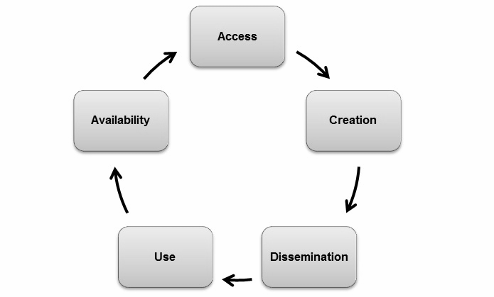
Figure: Process of Research in Higher Education

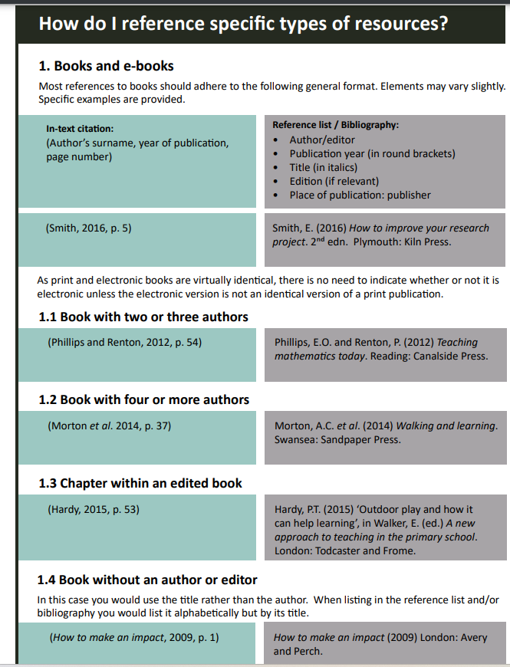
Figure: Referencing Process

