Assignment Title: Designing and Implementing an Active filter to reduce noise.
Student Name: Alexander David Hall
Student Number: P151746
Module Lecturer: Dr Steve Mosey
Module Title: Circuit Design and Analysis
Module Code: M5X01136

2018

Contents
Abstract 2
Introduction 2
Background Theory 2
Passive and Active filters 2-3
Filter Design techniques (Sallen and key and MFB) 3
Designing the Active filter 3
Method/Calculations 3-7
Results 7
The whole frequency response 7
Frequency response of low frequency noise 8
Frequency response of wanted signal 8
Frequency response of high frequency noise 9
Oscilloscope readings 9-10
Table of Frequency responses 10
Analysis of Results 10-11
Conclusion 11
References 12
Appendices 12-13

Abstract
A bandpass active filter was designed using the Sallen and key topology and was used to show how the values of the components used within the circuit can change the level of noise being filtered out or reduced, when low frequency noise was injected at 9kHz it was reduced by -36.3dB and when high frequency noise was injected at 165kHz, it was reduced by -37.6dB, also when testing a specified wanted signal of 78kHz after the filtering process it was found to be at a level of -848mdB. This was done using filter design software which gave a frequency response which displayed that the Active filter managed to filter the high and low frequencies so that the signal had a reduction of -30dB and lower.

Introduction
The purpose of this report is to design an active filter that can decrease the amount of noise within a given signal by -30dB or lower, this must be done when that signal has been injected with a certain amount of noise at low and high frequencies, this must be done utilizing the circuit designing software Proteus 8.1. the Sallen and Key method of filter design must be researched so that an adequate amount of noise can be eliminated from the given signal and all results from the testing of the active bandpass filter must be presented and analysed to show a high level of understanding.

Background Theory

Passive and Active filters
An electronic filter is used within electronic circuits to recieve a range of electrical signals mainly high and low frequencies so that they can be processed or “filtered” depending on what type of response is being looked for, the way that frequency responses meet specified requirements is to create a filter that takes an input signal that is altered to give a response that meets all requirements within a passband [1].
The Passband is defined as that is a band of frequencies between upper and lower defined limits, it is also the frequencies that have successfully been fed through a filter that has ideally a low amount of loss from the original signal and the max amount of gain and is usually the result of a Band-pass filter.[2]
The basic type of electronic filter is a RC (Resistor-Capacitor circuit)/ RL(Resistor-Inductor) or passive filter which is named as the filter employs the use of the passive components resistors, capacitors and inductors.
There is examples of three Passive filters, the first being a RC lowpass filter (Appendix 1) this circuit is used to filter out high noise from a signal meaning that the low frequencies are free to “pass” through, the second example is a LR high-pass filter (Appendix 2) which is used in electical filter design to filter out low frequncies while passing the high frequcies, the third example is a RLC Bandpass filter (Appendix 3) this circuit encoperates the use of all three passive components to filter out frequencies that are out of a specific band and pass the frequencies in the band to give a specifc response[3, p. 620].
Active filters can be described as Passive filters or RC networks that are combined with components that are active, within the case of this report an operational Amplifiers (OP-Amps) is the prominent active component, active filters have many advantages when compared with passive filters such as they can be better when the frequency of a filter must be tuned, this is because the inuput signal within active filters does not have any attenuation when the op-amp produces voltage gain and the range of filter functions for an active filter is typically wider than passive filters, this is important during the realiaztion of filter circuits.[4]
There are also some disadvantages or limitations to using a active filter over a passive filter such as active filters can produce elctrical noise as there is a combination of passive components namely resistors and Active components like operational amplifiers, Active filters are highly relliant on the use of power supplies and also because of the use of active components, active filters can have a limited bandwidth which can give them Application limitations.[4]

Filter Design techniques (Sallen and key and MFB)
There are many methods of circuit design that can be used to filter frequencies these filter circuits are normally a type of active filter, the topology of active filter that was used to make the active filter within this report was the Sallen and Key topology.
The Sallen and Key topology or voltage-controlled voltage source (VCVS) within the subject of active filter design is a second order filter topology, it is worth mentioning there is other topologies such as multiple feedback (MFB) second order filters.
These topologies are often used the most and each have their own advantages such as the Sallen and key topology is better when it come to the accuracy of gain within the filter as the gain is not affected by the changing of component vales, the advantage of using the MFB active filter topology is that it is more sensitive to the alteration of component values therefore can give a better response at higher frequencies. The decision of which topology that needs to be used is determined by the effectiveness or specified performance that is needed by the designer of the active filter to get a good frequency response.[5]

Designing the Active filter
Below are the calculations that were used to work out the vales for low-pass and high pass components of the active filter used to reduce the amount of noise coming out of its output.

Method/Calculations
The Values that were given from the assignment specification were as follows: -
The high frequency noise – 165 kHz
Wanted signal – 78 kHz
Low frequency noise – 09 kHz
Now we have those values the high and low pass frequencies can be worked out, the way this is done is simple: -
The high pass is the low noise taken away from the wanted signal so, fHp= 78-9 = 69 kHz.
The low-pass frequency is the high noise take away the wanted signal so, fLp=165-78 = 87 kHz.
These give us our initial cut-off frequencies for the bandpass filter output response.
Once this was calculated the value for the resistors in the low pass could be figured out this was done by using the equation below: -
$$\frac{1}{2•π•fLp•C}=R$$
A reasonable figure was given for the capacitor within the low pass filter, C=680pF.
When all values are put into the formula it looked like this: -
$$\frac{1}{2•π•87ₓ₁₀³•680ₓ₁₀¯¹²}=R=2.69kΩ$$
As 2.69kΩ is not a common resistor value it must be rounded up to make a 2.7kΩ which is a common resistor value.
Now we have the common value of resistor a new high-pass cut-off frequency can be calculated by using the following equation: -
$$\frac{1}{2•π•R•C}=\left(new\right)fLp$$
This is what the equation looks like once the common resistor values are put into it: -
$$\frac{1}{2•π•2.7ₓ₁₀³•680ₓ₁₀¯¹²}=86kHz$$
The value of the new cut-off frequency for the low pass filter is 86kHz, which is within 1kHz range of the initial cut off frequency.
The values of the capacitor and resistor mentioned above were inserted into the low-pass component of the active filter to look like this: -

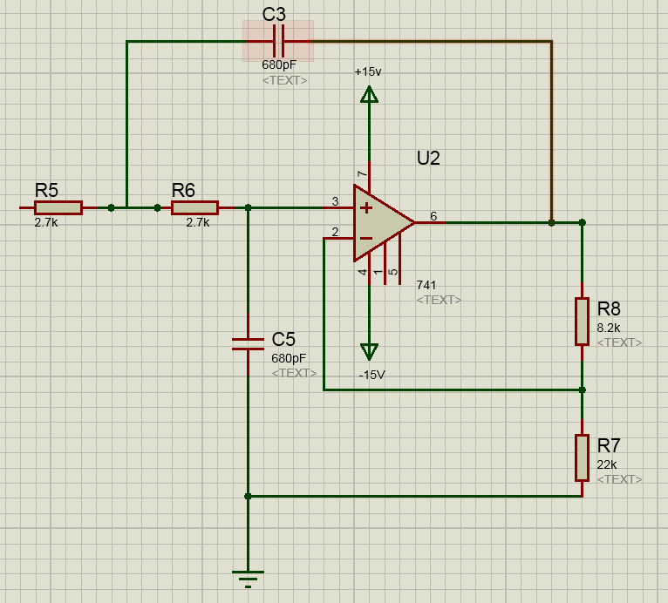
Figure 1-Low-Pass filter

Then as the components positions are switched for the high-pass component the resistor value had to be calculated again, this was done with the following equation: -
$$\frac{1}{2•π•fHp•C}=R$$
The value of the Capacitor was kept the same within the high pass filter therefore the resistor had to be calculated, the value for the capacitor is as follows C=680pF.
When the values are put into the formula the equation looked like this: -
$$\frac{1}{2•π•69ₓ₁₀³•680ₓ₁₀¯¹²}=R=3.39kΩ$$
As 3.39kΩ is not a common value of Resistor, it had to be rounded down to 3.3kΩ which is a common value of resistor.
Now we have the common value of resistor a new high-pass cut-off frequency can be calculated by using the following equation: -
$$\frac{1}{2•π•R•C}=\left(new\right)fHp$$
This is what the equation looks like once the common resistor values are put into it: -
$$\frac{1}{2•π•3.3ₓ₁₀³•680ₓ₁₀¯¹²}=70kHz$$
The value of the new cut-off frequency for the high pass filter is 70kHz, which is within 1kHz range of the initial cut off frequency.
The value for the capacitor and resistor were then put into the high-pass component of the active filter which made the circuit look like this: -
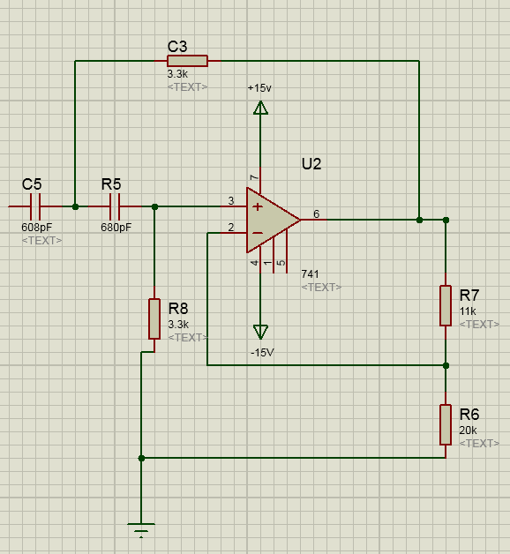
Figure 2- High-Pass Filter

The gain must also be worked out for each component of the active filter to get an ideal response of -30dB, the gain can be calculated by using the following equation: -
$$G=1+\frac{R2}{R1}$$
Where the values for the resistors low pass filter are R1=22kΩ and R2=8.2kΩ, when these values are put into the equation above it looks like this: -
$$G=1+\frac{8.2ₓ₁₀³}{22ₓ₁₀³}=1.37 \left(or rounded up\right) 1.4$$

The values for the resistors of the high pass filter component of the active filter are R1=20kΩ and R2=11kΩ, when the values of R1 and R2 the gain equation looks this: -
$$G=1+\frac{11ₓ₁₀³}{20ₓ₁₀³}=1.55 \left(or rounded up\right) 1.6$$

When both the high pass and low pass components of the active filter are combined with each other they become a bandpass filter system, here is the entirety of the system built to get a reduction of -30dB or lower: -
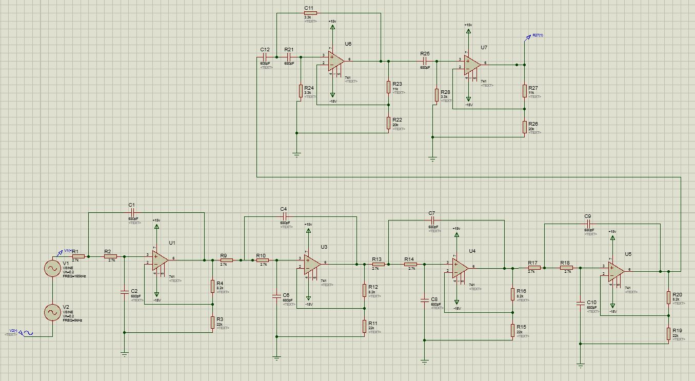
Figure 3- Entire 11th order Bandpass Active filter
Above shows an 11th order Sallen and Key bandpass active filter which is made up of four 2nd order low pass filters, one 2nd order high pass filter and one 1st order high pass filter.

Results
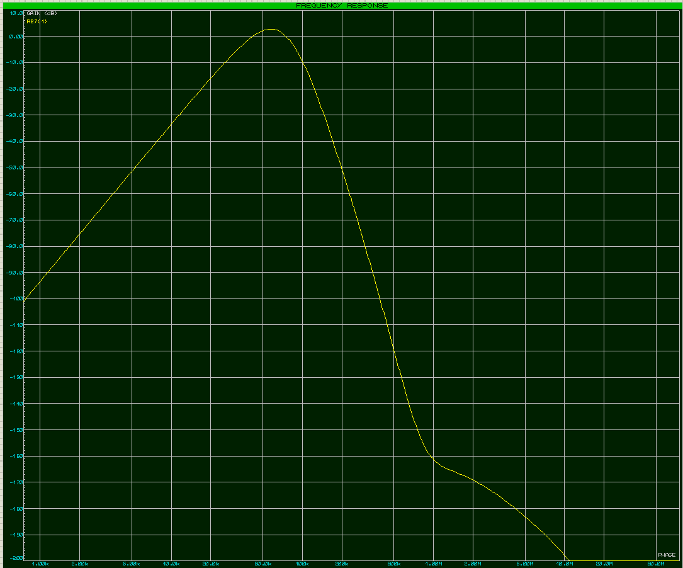
Below the frequency response of the Sallen-Key Bandpass filter, an oscilloscope output screen, as well as a table with the pure figures taken from the frequency response detailing the reduction in dB’s of the bandpass active filter.
Figure 4- General Frequency response

The whole frequency response

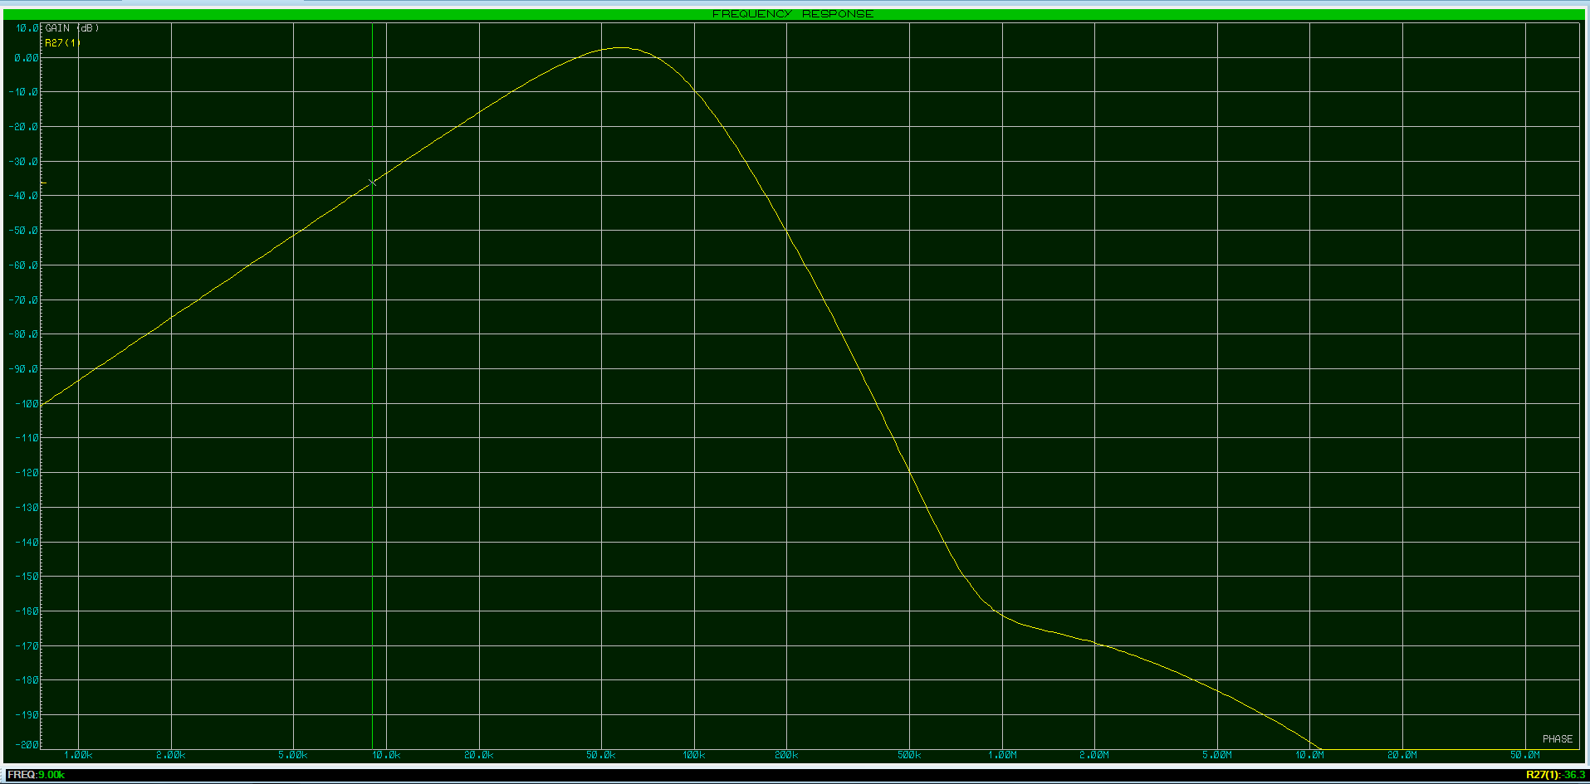
Frequency response of low frequency noise
Figure 5- Frequency at the low noise level

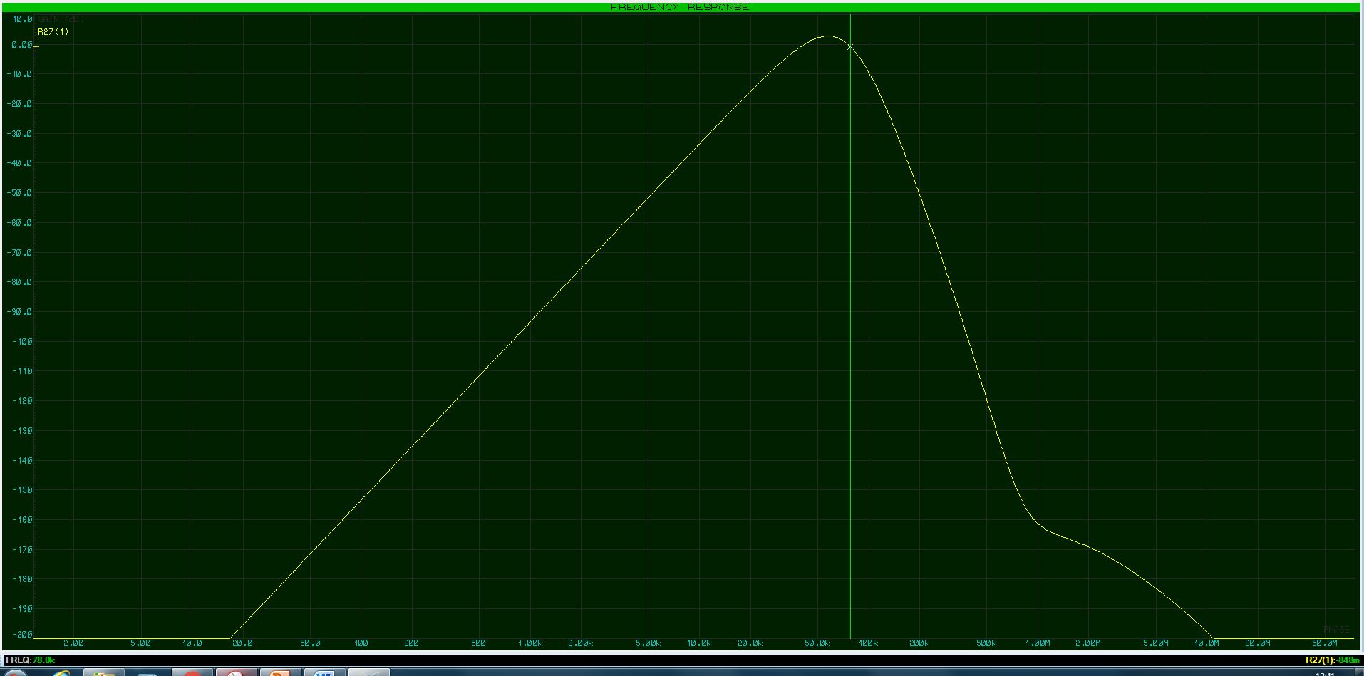
Frequency response of wanted signal
Figure 6- Frequency at the wanted signal level

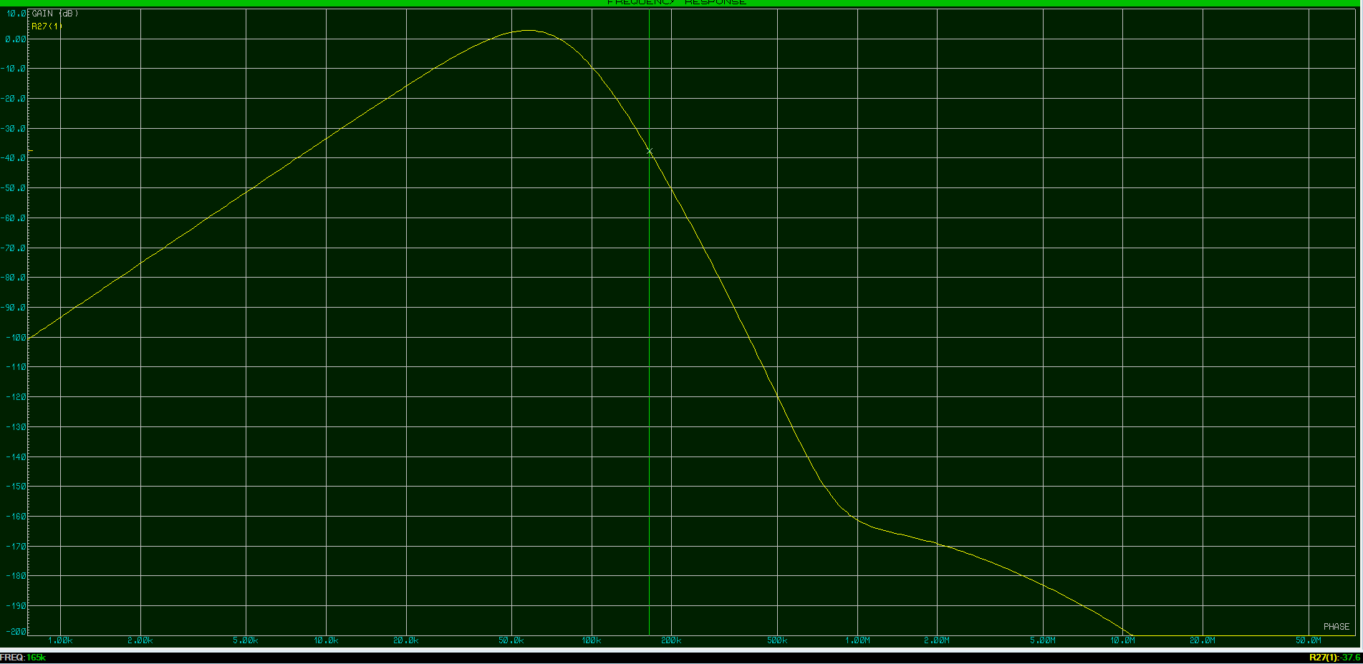
Frequency response of high frequency noise
Figure 7 - Frequency at High noise level

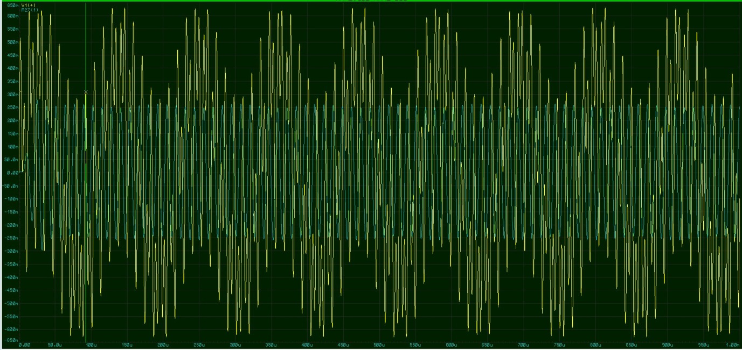
oscilloscope readings
Figure 8 – Analogue analysis (oscilloscope) readings of Active Filter

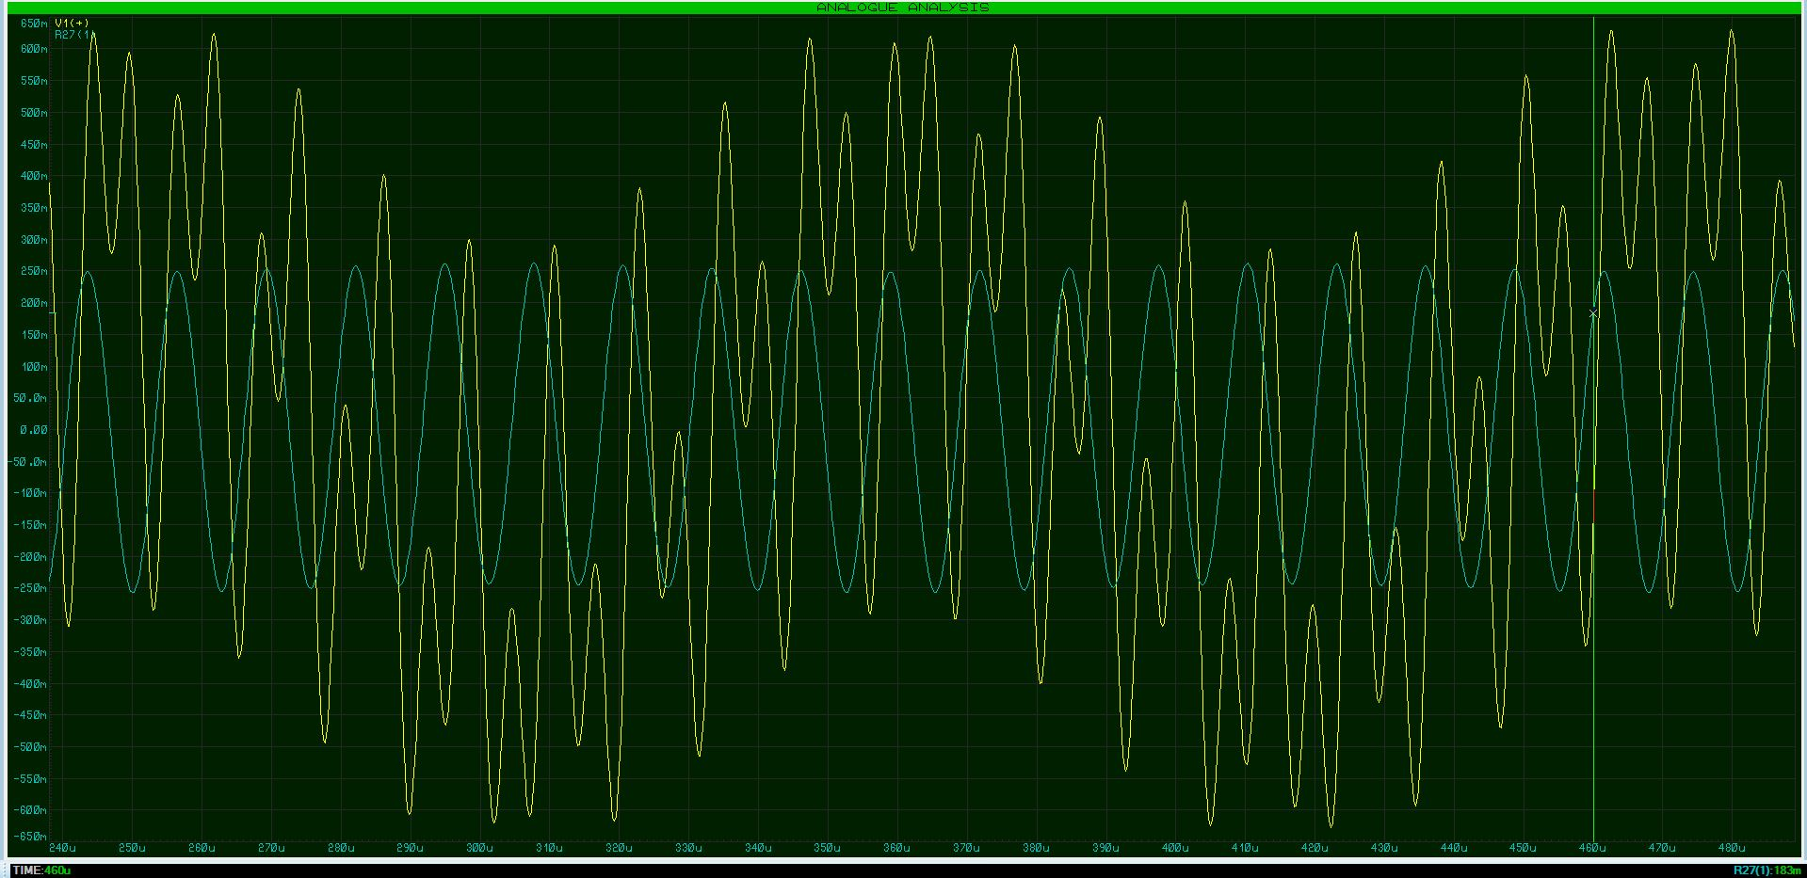
Table of Frequency responses
Figure 9- Analogue analysis (oscilloscope) readings of Active Filter (zoomed in)
Frequency Response | Frequency (kHz) | noise Reduction (dB)
Low Frequency Noise | 9 | -36.3
Wanted frequency | 78 | -848m (or 0dB if rounded up)
High Frequency Noise | 165 | -37.6

Table 1- Results of reduction at all frequency levels

Analysis of Results
While testing the bandpass active filter shown in Figure 3 it was determined that the filter works efficiently at reducing noise to a level of -30dB or more, this was proven by testing the frequency response at three different levels the level that sets the peak or the frequency that is wanted is the wanted signal that is shown to be at a level of 78kHz (shown in figure 6) which gives a noise reduction of -928mdB which if round up becomes 0dB which is what was expected.
The second frequency level that was tested was at the low Frequency noise level which was at 9kHz (shown in Figure 5) this gave a result showing that the active filter worked to have a reduction of -36.3dB which means that the bandpass worked slightly better than was needed when outlined in the requirements.
The last frequency level that was tested was at the high frequency level which was at 165kHz (shown in figure 7), the result as shown in Table 1 is that the active filter reduced the noise by -36.7dB, when means that the bandpass active filter worked effectively when filtering and reducing the high frequency noise added to a level of slightly below -30dB which is the wanted noise reduction specified in the design requirements.
Also, during the testing of the bandpass active filter an analogue analysis window or (oscilloscope) was added in the design workspace on Proteus, this is shown as two sets of sinewaves on a graph, see a normal view of the sinewaves above in figure 8 and there is also a zoomed in version of the graph figure 9 this is to get a better view of the sinewaves.
The traces in figure 8 & 9 are as follows, the yellow/green trace is the three input sinewaves into the bandpass filter network, the three sinewaves are the wanted signal, the low frequency noise and the high frequency noise, these are all combined which gives the yellow/green trace its shape, showing that the input signal has a large amplitude, but sill follows the shape of a sinewave.
The blue trace is the output sinewave after the input signals have been fed through the bandpass filter network, while examining the blue trace it is shown that there is still a small amount of low noise coming out of the filter but is considerably shorter in amplitude than the yellow input trace.

Conclusion
In conclusion the eleventh order bandpass active filter is functioning as required and is showing to be effective at reducing the noise from the initial input signal, this was proven above within the results showing that when the frequency response of the circuit was tested at the following points it achieved the filter specification that the filter had to filter out the noise to -30dBs or lower.
At the low frequency noise point of 9kHZ a reduction of -36.3dB was recorded.
On the response the Wanted frequency was recorded near the target of 0dB as it was at -848mdB.
At the high frequency noise point of 78kHz a reduction of -37.6dB was recorded.
Also shown in the results was a graphical view of the input waveform and output waveform from an analogue analysis and that there is a noticeable decrease in the amplitude of the output waveform when compared with the input waveform.

References

[1] H. G. Dimopoulos, Analog electronic filters : theory, design and synthesis, 1st ed. Dordrecht: Springer Netherlands, 2012.

[2] B. S. Slayford, “The Difference Between Baseband & Passband,” Online Artic., pp. 4–6.

[3] J. D. Irwin and R. M. Nelms, “Filter Networks,” in Basic engineering circuit analysis, 10th ed., Hoboken: John Wiley, 2011, pp. 627, 620.

[4] M. H. (Muhammad H. Rashid, “Active filters,” in Microelectronic circuits : analysis and design, 2nd ed., Stamford, CT: Cengage Learning, 2011, p. 804.

[5] L. K. Maheswari and M. M. S. Anand, “Active Filters,” in Analog Electronics, New Delhi: Prentice-Hall of India Pvt. Ltd, 2005, p. 202.

[6] A. P. Godse and U. A. Bakshi, “Electronic circuits - II,” in Electronic circuits - II, 1st ed., Pune: Technical Publications, 2010, pp. 22, 33.

Appendices
Appendix 1-
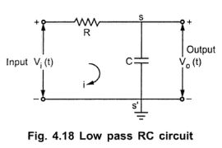

Appendix 1- Example of Low Pass RC Circuit[6, p. 22]
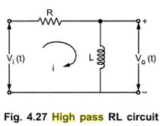
Appendix 2-

Appendix 2- Example of a High Pass RL Circuit[6, p. 33]

Appendix 3-
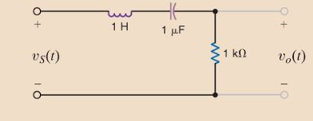
Appendix 3- Example of RLC Bandpass Circuit[3, pp. 627]

