

Assignment Title: Component 2: Written Assignment (Poster and Pitch)

Module Code: BMHP5014

Student Name: Sajna Ahmed

Student Number: 2431225

Lecturer Name: Soban Sadiq
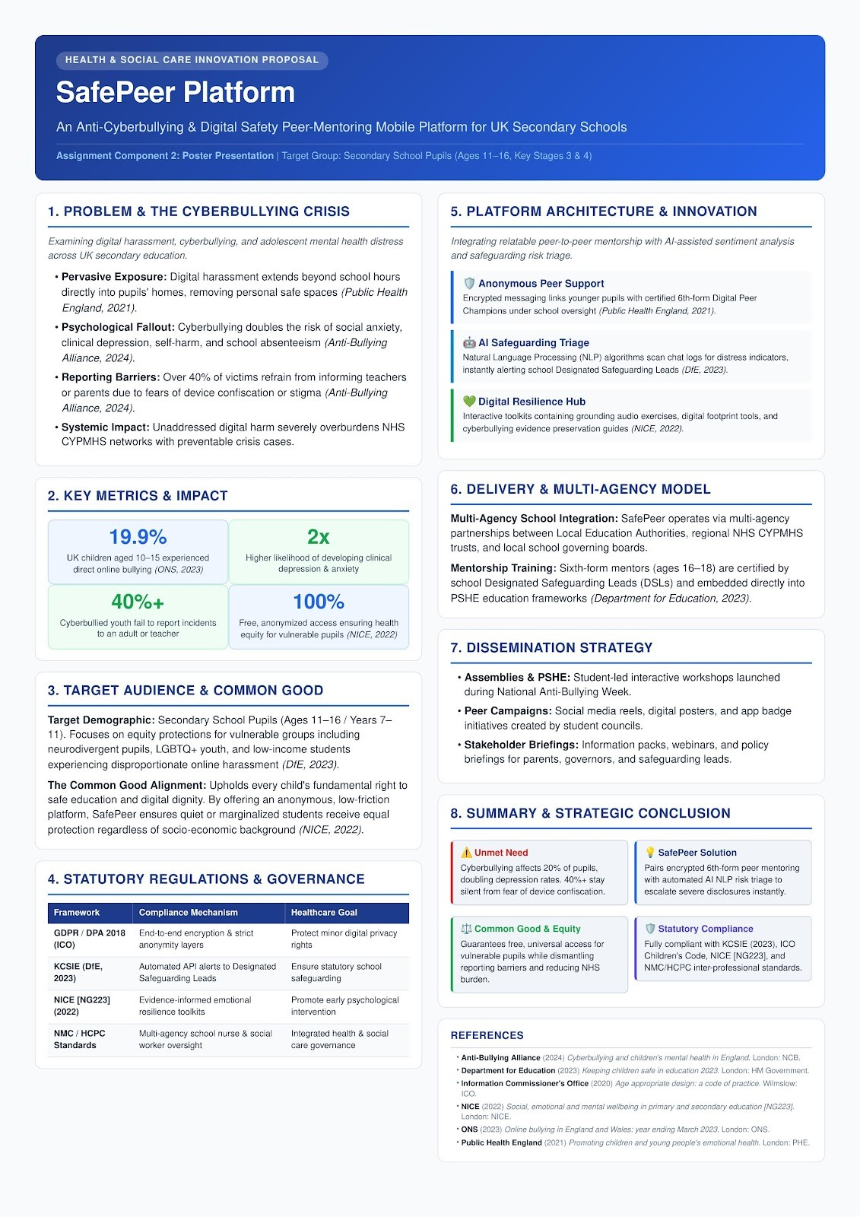

Written Pitch
Innovation Title: Safe Peer An Anti-Cyberbullying & Digital Safety Peer-Mentoring Mobile Platform for UK Secondary Schools

1. Introduction
Adolescent digital technology usage in the United Kingdom has transformed social interaction, yet it has simultaneously exposed young people to unprecedented levels of cyberbullying, digital harassment, and acute online distress (Public Health England, 2021). Safe Peer is an innovative school integrated mobile platform designed to bridge the critical gap between adolescent online lives and formal institutional safeguarding. By combining anonymized peer to peer mentorship from accredited sixth form "Digital Peer Champions" with background AI sentiment triage, Safe Peer creates a low friction, early intervention environment for secondary school pupils aged 11–16 (Key Stages 3 and 4). This innovation directly benefits vulnerable students, empowers students, and supports school designated safeguarding leads (DSLs). By dismantling barriers to reporting online harm, Safe Peer protects adolescent psychological well-being, upholds digital dignity, and reinforces the common good across educational communities.

2. Background
The psychological impact of digital harassment on UK children represents a growing public health crisis. According to the Office for National Statistics (ONS, 2020), approximately 19% of children aged 10 to 15 in England and Wales experience direct online bullying, with harassment persisting beyond school hours into the home environment. Unaddressed cyberbullying doubles the risk of clinical depression, social anxiety disorders, self-harming behaviors, and chronic school absenteeism (Anti-Bullying Alliance, 2024; The Children's Society, 2023).
Despite the severity of online harm, traditional school reporting mechanisms often fail. The Anti-Bullying Alliance (2024) reports that over 40% of cyberbullied pupils do not disclose incidents to teachers or parents due to fears of device confiscation, social stigma, or perceived adult inaction. This silence leaves young people isolated during critical developmental stages.
Furthermore, this unaddressed digital trauma places a severe burden on NHS Children and Young People's Mental Health Services (CYPMHS), which face record referral volumes and prolonged waiting lists. Statutory frameworks, including the Department for Education’s Keeping Children Safe in Education (KCSIE, 2023) guidance and Public Health England’s (2021) whole school approach, explicitly mandate that educational institutions adopt proactive, technology aware safeguarding solutions. Safe Peer directly addresses these policy imperatives by offering a scalable, preventive health model that intervenes before digital distress escalates into complex mental health crises.

3. Innovation Description
Safe Peer is a custom designed cross platform mobile application (iOS/Android) hosted on secure, NHS compliant cloud infrastructure (AWS Health Scribe UK). Unlike static advisory websites or generic national youth hotlines, Safe Peer is embedded directly into local school ecosystems, offering a three-tier operational model:
- Anonymized Peer Mentoring Layer: Younger pupils (ages 11–16) access encrypted, one-to-one text messaging with certified sixth form digital peer champions (ages 16–18). These mentors receive formal training in active listening, mental health literacy, and digital safety, offering a relatable, non-judgmental space that removes the fear of device confiscation associated with reporting to adults.
- Automated AI Triage & Safeguarding Escalation: The platform utilizes Natural Language Processing (NLP) sentiment algorithms to continuously scan self-reported chat logs for high-risk distress indicators (e.g., self-harm, physical threats, severe harassment). When a threshold is breached, the app automatically generates high-priority API alerts sent directly to school Designated Safeguarding Leads (DSLs) for immediate human triage, fully preserving statutory oversight.
- Interactive Digital Resilience Hub: Pupils can independently access self-guided mental health tools, including audio grounding exercises, digital footprint auditing guides, and step-by-step evidence preservation toolkits for documenting cyberbullying incidents for formal reporting.
By combining empathetic peer connection with automated safeguarding technology, Safe Peer delivers immediate psychological relief while maintaining rigorous statutory safety standards.

4. Impact on Health and Social Care
Safe Peer delivers transformative benefits across individual, institutional, and societal health frameworks. At the individual level, the platform provides immediate emotional validation and grounding tools, reducing symptoms of acute social anxiety, burnout, and school refusal (NICE, 2022). Peer mentors gain accredited leadership experience, mental health literacy, and civic empathy, creating a positive culture of peer support throughout the school.
Crucially, safe peer advance health equity and the common good by protecting marginalized and high-risk student populations. Data demonstrates that neurodivergent pupils (including autistic youth and those with ADHD), LGBTQ+ adolescents, and pupils from low-income households suffer disproportionately higher rates of targeted online harassment (Department for Education, 2023). By offering a universally free, anonymous, and accessible mobile interface, Safe Peer removes financial, physical, and social barriers to support. It guarantees that quiet or marginalized students receive equal protection and digital dignity, regardless of socio-economic background.
At the health system level, Safe Peer acts as an effective early-intervention buffer. By triaging mild-to-moderate emotional distress within the school environment, it prevents psychological decompensation, thereby reducing avoidable, crisis-level referrals to overstretched NHS CYPMHS networks and community social care teams.

5. Public and Stakeholder Involvement
To ensure high acceptability, ethical rigor, and user engagement, Safe Peer is built upon principles of multi-stakeholder co-production. During initial development, student councils, youth advisory panels, and peer champion cohorts actively participate in UI/UX design, ensuring app terminology remains authentic, youth centric, and non-stigmatizing.
Furthermore, an advisory governance panel comprising parents, school governors, designated safeguarding leads, school nurses, and clinical psychologists oversees mentor training curricula and data privacy protocols (Public Health England, 2021). Dissemination and public advocacy efforts include interactive student led workshops launched during national anti-bullying week, social media digital safety campaigns created by student councils, and informative briefing webinars hosted for parent teacher associations (PTAs) and local safeguarding children’s partnerships (LSCPs).

6. Policies, Services, and Professional Links
Safe Peer is strictly aligned with UK legislative and regulatory frameworks. It complies with the Data Protection Act 2018 / GDPR and the Information Commissioner’s Office (ICO) Age-Appropriate Design Code (Children's Code, 2020), enforcing end-to-end encryption and anonymized data handling for minors. The platform fulfills statutory duties under Keeping Children Safe in Education (KCSIE, 2023) and the Equality Act 2010 by providing targeted protection against online harassment for protected characteristic groups.
Operationally, Safe Peer integrates with existing local healthcare infrastructure, creating streamlined referral pathways between school safeguarding teams, primary care GPs, school nursing services, and regional NHS CYPMHS crisis routes. Multi-agency supervision adheres to professional governance codes set out by the Nursing and Midwifery Council (NMC) and the Health and Care Professions Council (HCPC) for inter-professional safeguarding practice.

7. Conclusion
Cyberbullying represents a severe, pervasive threat to adolescent mental health and educational attainment across the UK. Safe Peer provides a scalable, technology enabled solution that bridges the gap between young people's online realities and formal safeguarding structures. By pairing empathetic, anonymous peer mentorship with sophisticated AI risk triage, Safe Peer delivers rapid early intervention, protects psychological well-being, and reduces pressure on NHS tertiary care. Investing in Safe Peer upholds student dignity, promotes health equity, and advances the common good across secondary educational communities.

8. References
Anti-Bullying Alliance (2024) Cyberbullying and children's mental health in England: National inquiry report. London: National Children's Bureau.
Department for Education (DfE) (2023) Keeping children safe in education 2023: Statutory guidance for schools and colleges. London: HM Government.
Information Commissioner's Office (ICO) (2020) Age appropriate design: a code of practice for online services. Wilmslow: ICO.
National Institute for Health and Care Excellence (NICE) (2022) Social, emotional and mental wellbeing in primary and secondary education [NICE Guideline NG223]. London: NICE.
Office for National Statistics (ONS) (2020) Online bullying in England and Wales: year ending March 2020. London: ONS.
Public Health England (PHE) (2021) Promoting children and young people's emotional health and wellbeing: A whole school and college approach. London: PHE.
The Children's Society (2023) The Good Childhood Report 2023. London: The Children's Society.

