FTL: Faster Than Light
Rose Plumley – 2218443 – Richard Morgan
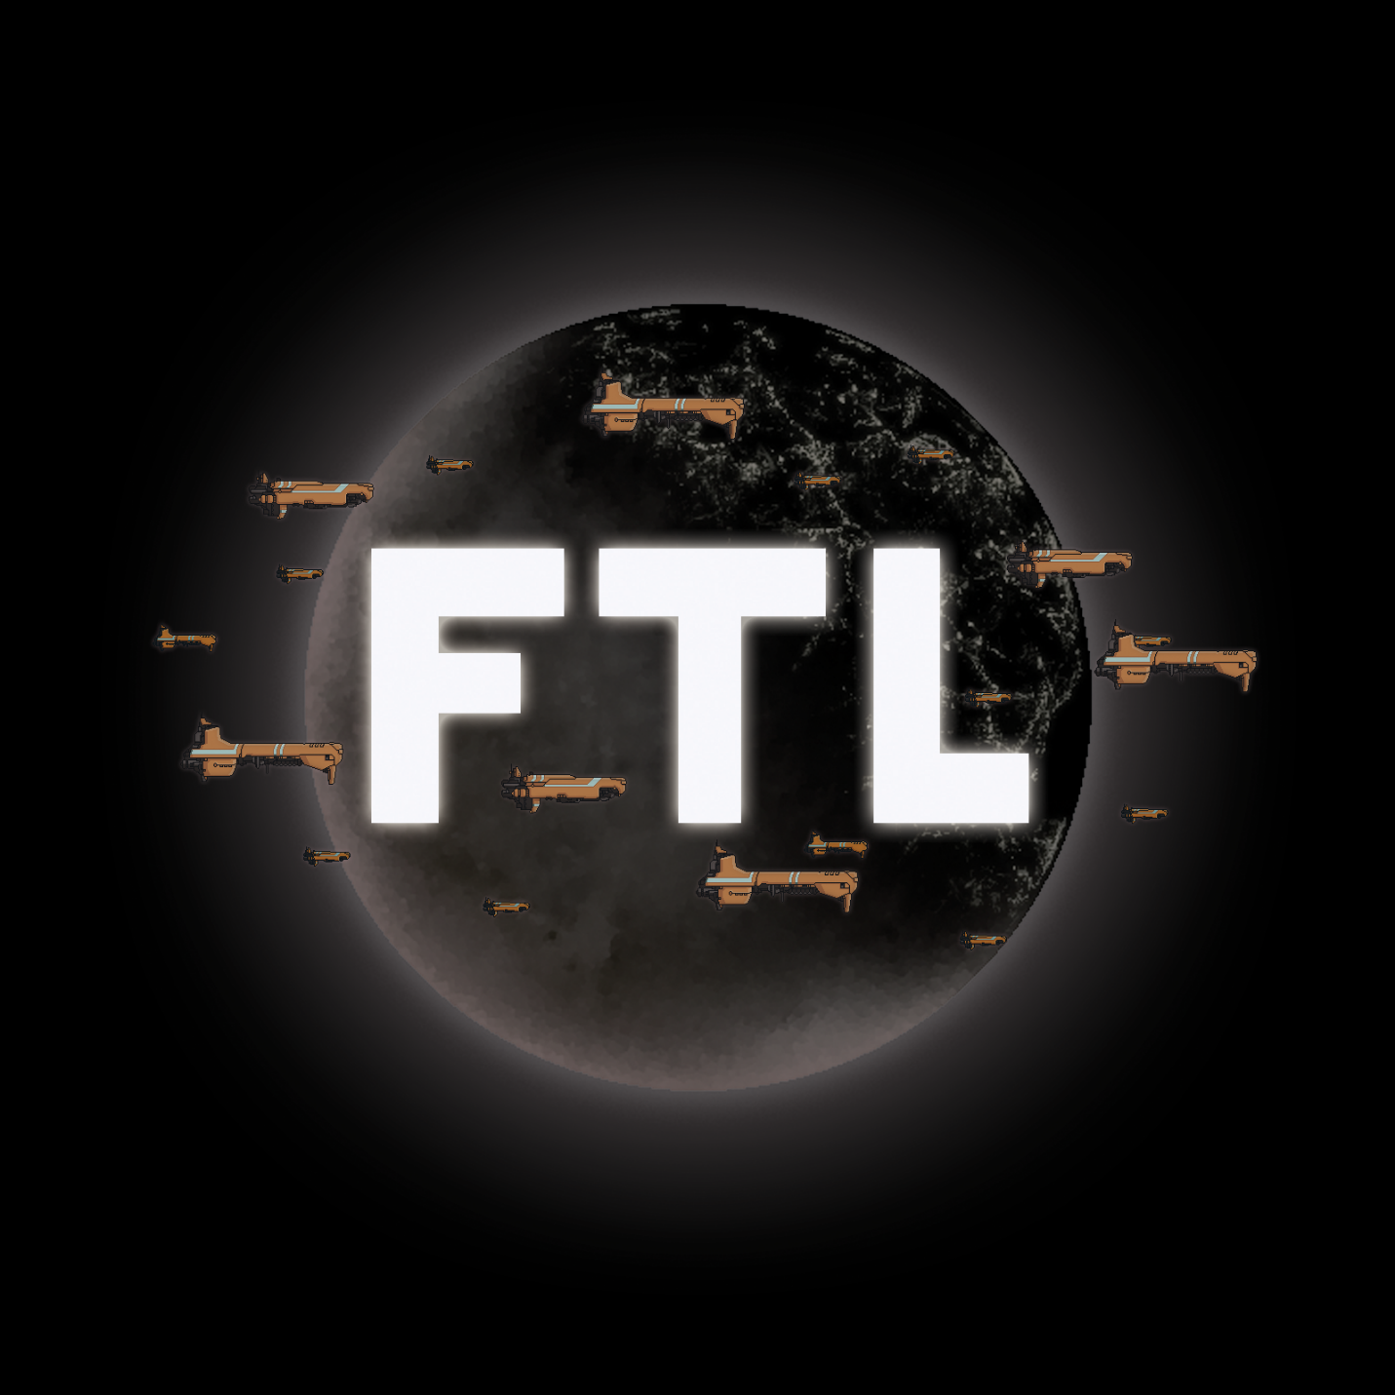[1]

INTENDED PLATFORMS | PC – Windows, Mac OS, Linux  iOS – iPhone, iPad

TARGET AGE / DEMOGRAPHIC OF PLAYERS
Late adolescents/adults
Anyone with an interest in science fiction, turn-based games, strategy games, roguelike games, etc.
May be attractive to those that enjoy roleplay – players take an active role in “commanding” their ship, giving orders and formulating strategies, assigning and diverting power to subsystems, etc.

INTENDED PEGI / ESRB RATING
ESRB Rating – Everyone +10 for fantasy violence and slight language [2]. ESRB describes this rating as “Content is generally suitable for ages 10 and up. May contain more cartoon, fantasy or mild violence, mild language and/or minimal suggestive themes” [3].
PEGI Rating – 12 for (infrequent) use of mild language [4]. PEGI describes this rating as “video games that show violence of a slightly more graphic nature towards fantasy characters or non-realistic violence towards human-like characters would fall into this age category. Sexual innuendo or sexual posturing can be present, while any bad language in this category must be mild” [5].

CONTRIBUTING TEAM MEMBER: | Rose Plumley

SECTION 2: GAME OUTLINE

GAME STORY SUMMARY
The game follows a Galactic Federation crew on the run from the Rebellion fleet. The crew has intercepted a data packet from the rebel fleet containing vital information that could potentially skew the war between the Federation and the Rebellion into the former’s favour. Armed with limited fuel for faster-than-light travel, limited crew and limited technology, this small Federation ship must travel across the galaxy to reach Federation Headquarters, all while avoiding the pursuing rebel fleet.

Along the way, the crew must avoid destruction from hostile ships, rebels, drones and pirates, whilst maintaining adequate stock of scrap, fuel, weapons, and so on.

The crew may also encounter several events and scenarios, which the player must make decisions, which may reward or hinder the player. Should the crew answer a distress call? Should the crew honour the surrender of an opposing ship? Should the crew explore the desolate station?

The game terminates at the final sector, where the crew must fight the Rebel Flagship, a final boss that will result in either victory or defeat for the Federation.

GAME FLOW
FTL is a top-down roguelike spaceship simulation strategy game following you and your makeshift Federation crew jumping from sector to sector using an FTL drive to deliver critical information regarding the Rebellion to the Galactic Federation Headquarters. All the while, the Rebel Fleet follows in hot pursuit, seeking to destroy you, and all remaining traces of the Federation in the galaxy.

CONTRIBUTING TEAM MEMBER: | Rose Plumley

SECTION 3: MAIN CHARACTER(S)
& PLAYER CONTROLS

CHARACTER APPEARANCE
Faster Than Light is a top-down game – thus, actual crew member details can be reliably low, focused more on silhouette than intricate detailing. The pixel art style also helps this, partially to obfuscate extant detail, but also to allow the player to use their imagination, filling in any gaps themselves.

Humans:
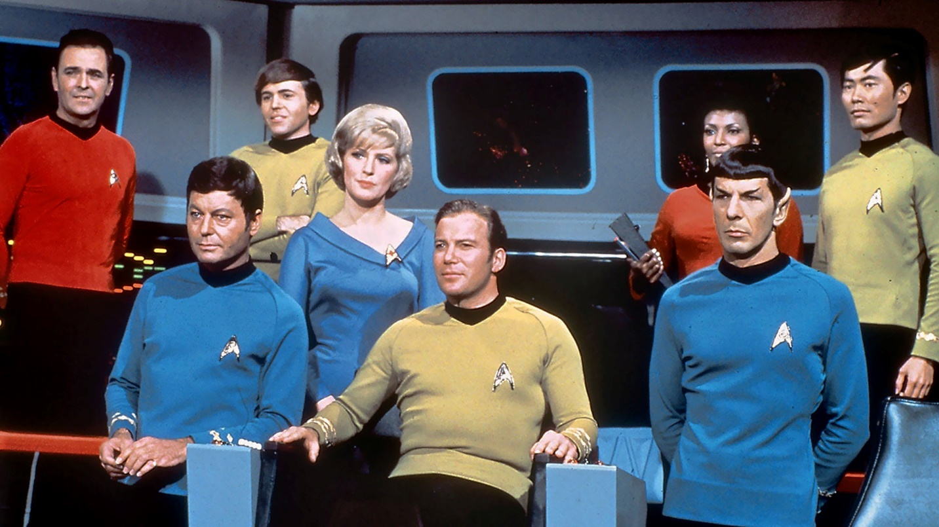
[6]
Note the uniforms, mainly. Star Trek embodies the idyllic Federation space explorer, which FTL should be most inspired by. In this way, as mentioned above in Section 1’s Target Audience box, FTL should appeal to medium/hardcore science fiction fans.
Human uniforms may not be different colours as suited to role, however.

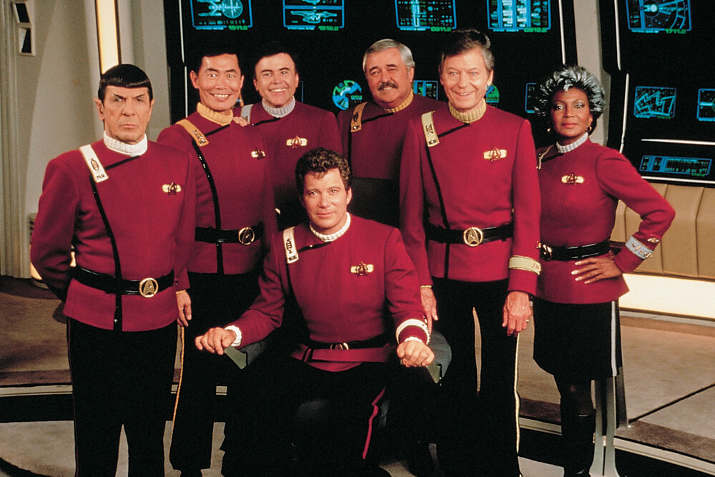
[7]
Alternative uniform example, also Star Trek. Note that this uniform variant is of a singular design, rather than the more classical colour-role denomination of the previous reference.

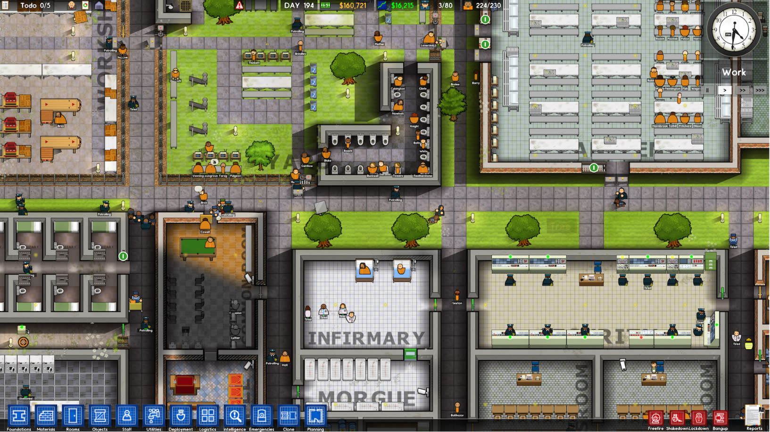
[8]

[8]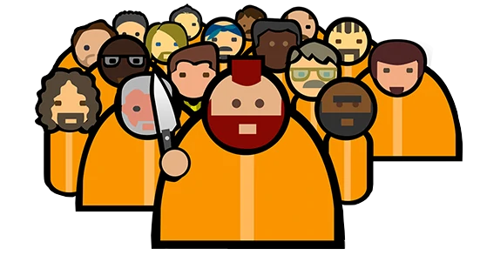
Screenshot and artwork from Prison Architect. As FTL is a top-down game, focus should be more on the spacecraft than the crew members. Referenced to instead show “silhouetting” mentioned earlier. Shapes are simple and recognisable, existing more like placeholder, to give the player an idea of presence, rather than a focus on.

Spacecraft Design:
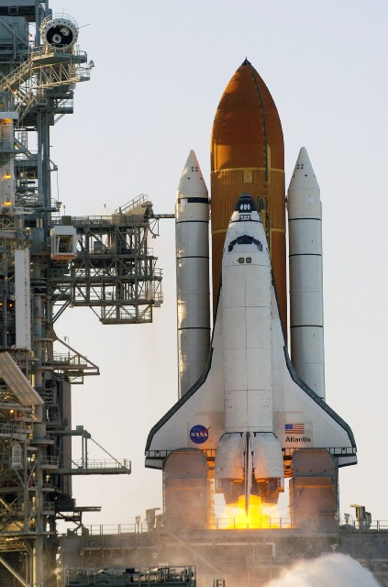
[9]
Picture of NASA Space Shuttle. One of the most recognisable designs for spacecraft. Note the sleek, “plane-like” appearance of the main shuttle orbiter, disregarding the external tank and solid rocket boosters. The Federation should embody this – recognisably human architecture in shape and silhouette, albeit design wise with more of a sci-fi flair.

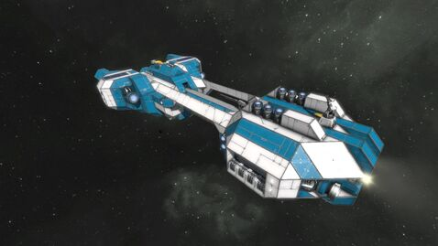
[10]
Example of aforementioned sci-fi flair. This ship retains the main body and wings shape/silhouette, while using a simple paint job and some hull plate detailing to emphasise the more science fiction aspects.

CHARACTER DOSSIER / DETAILS (Add/adjust categories as appropriate)
NAME: | If crew: player choice
GENDER/DETAILS: | Male/Female sprites, conveyed through different hairstyles. Other than hair colour and skin tone, uniform does not change colour or design.
SPECIES: | Human
FACTION: | Federation/Rebellion
ABILITIES: | Humans are common and uninteresting – however, they learn skills faster than most.

CHARACTER DOSSIER / DETAILS (Add/adjust categories as appropriate)
NAME: | If crew: player choice
GENDER/DETAILS: | None – Engi are, more or less, completely robotic.
SPECIES: | Engi
FACTION: | Federation
KNOWN ASSOCIATES: | Rebellion – nonaggression pact  Zoltan – Allied through mutual opposition to the Mantis race.
ABILITIES: | Despite being primarily robotic, made up of nanobots, an Engi’s body is very fragile, and thus not suited to combat. However, a knowledge of mechanics makes them well suited to repair tasks.

CHARACTER DOSSIER / DETAILS (Add/adjust categories as appropriate)
NAME: | If crew: player choice
GENDER/DETAILS: | None – Only sprite difference is colour. Mantis, like their namesake, appear as giant, man-sized praying mantises.
SPECIES: | Mantis
FACTION: | None, though some have been known to work with the Federation
KNOWN ASSOCIATES: | None – most Mantis tend to be pirates  However, one could argue an association with Engi?  Mantis ships are known to take Engi slaves.
ABILITIES: | Mantis exist as the diegetic opposite to the Engi – incredible agility paired with sharp exoskeletal appendages and extremely acidic saliva make them unparallelled fighters and boarding crew, but of all the races, they are the least technologically adept.

CHARACTER DOSSIER / DETAILS (Add/adjust categories as appropriate)
NAME: | If crew: player choice
GENDER/DETAILS: | Like Mantis, only difference is in colour. Also like their namesake, Rockmen must look vaguely bipedal, consisting mostly of rock/rocklike material.
SPECIES: | Rockmen
FACTION: | None – Rockmen are a rare sight, being more isolationist and xenophobic in nature, and much less adventurous than the other races in the galaxy. Thus, they tend to stay on or close to their home world of Vrachos IV.
KNOWN ASSOCIATES: | Zoltan – Tolerant of their wisdom. May even cooperate with Zoltan in stores, for example.
ABILITIES: | The Rockmen’s unique skin makes them the most resilient race, having the most health and defense. To this end, if the Mantis are the offensive boarding crew, the Rockmen are the defensive variant. However, their rock-skin makes them incredibly slow.

CHARACTER DOSSIER / DETAILS (Add/adjust categories as appropriate)
NAME: | If crew: player choice
GENDER/DETAILS: | Difference in colour. Zoltan appear as bipedal, but mainly green tones, being made entirely out of energy.
SPECIES: | Zoltan
FACTION: | None – The Zoltan remain ambivalent towards the Federation, mainly inhabiting their own home systems. However, instead of being more isolationist like the Rockmen, the Zoltan will often appear alongside Engi-controlled sectors and homeworlds.
KNOWN ASSOCIATES: | Engi – Close alliance, possibly due to a mutual opposition to the Mantis.
ABILITIES: | Being comprised of pure energy, the Zoltan can provide a single block of power towards any system or subsystem they are stationed in.

CHARACTER DOSSIER / DETAILS (Add/adjust categories as appropriate)
NAME: | If crew: player choice
GENDER/DETAILS: | Colour difference in sprites. Otherwise, Slugs look like their namesake as well, with two antennae poking out of their head.
SPECIES: | Slug
FACTION: | None – Slugs are incredibly xenophobic, and have been shunned by the Federation for constant thievery and attempts at manipulation. Thus, most Slug ships are pirate vessels.
KNOWN ASSOCIATES: | None
ABILITIES: | Slugs are telepathic, able to see into adjacent rooms connected to those they are stationed in. Their telepathy also enables them to detect enemy crew members on the player ship, or their own. However, this evolutionary advantage means slug ships tend to not be equipped with sensors, and thus outside of a nebula, they exist at a disadvantage.

CHARACTER DOSSIER / DETAILS (Add/adjust categories as appropriate)
NAME: | If crew: player choice
GENDER/DETAILS: | Colour difference in sprites. Should appear similar to the Rockmen, being distant ancestors, albeit with a more smooth, crystalline appearance and colouration.
SPECIES: | Crystal
FACTION: | None – The Crystal are an ancient ancestor to the Rockmen, existing as a splinter group who rejected their species’ violent ways a long time ago. In part of because of this, they remain one of, if not the rarest species in the galaxy.
KNOWN ASSOCIATES: | None – See aforementioned rarity.
ABILITIES: | Crystals have the unique ability to “lock down” a room, growing crystals in and around it, preventing anyone from entering or exiting the room the ability was activated in. These crystals wear off over time, lasting ~12 seconds, with a 50 second recharge time. These crystals can be broken down. Additionally, the crystals are not airtight – crew (or trapped enemies) can still suffocate in the locked down room.

CHARACTER DOSSIER / DETAILS (Add/adjust categories as appropriate)
NAME: | If crew: player choice
GENDER/DETAILS: | Colour difference in sprites. Lanius are primarily metallic, harsh creatures, designed to survive the vacuum of space for long periods of time. They appear bipedal like the majority of races.
SPECIES: | Lanius
FACTION: | None – The Lanius are a scavenger race, appearing most commonly in the wake of intergalactic war.
KNOWN ASSOCIATES: | None, though some diplomatic races (likely the more pacifistic Zoltan) suggest they can be reasoned with.
ABILITIES: | The Lanius possess the curious ability to drain any room they exist in of its oxygen. Logically, it follows that Lanius do not require oxygen to function. Thus, while they make potentially deadly boarding crew and adversaries, suffocation holds no allegiances. A multi-race crew may face difficulty synergising with these lifeforms.

CHARACTER CONTROLS / PLAYER CONTROLS
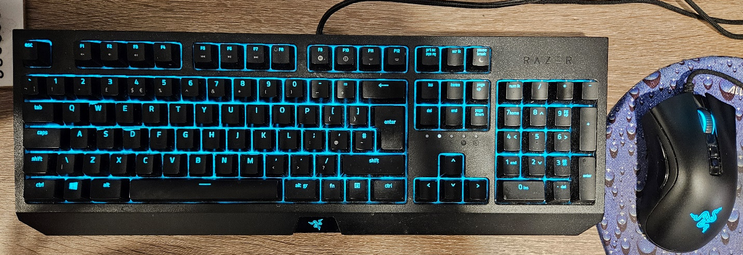
Above: Standard 104-key full-size UK keyboard with mouse, both wired.

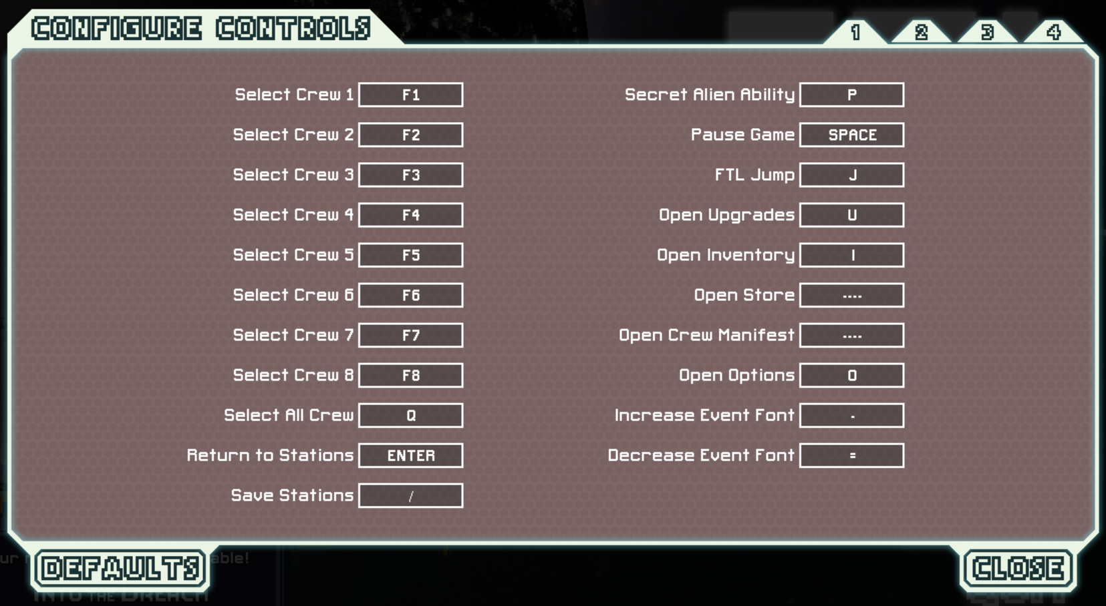
[1] Page 1 of controls, mapped to keyboard.

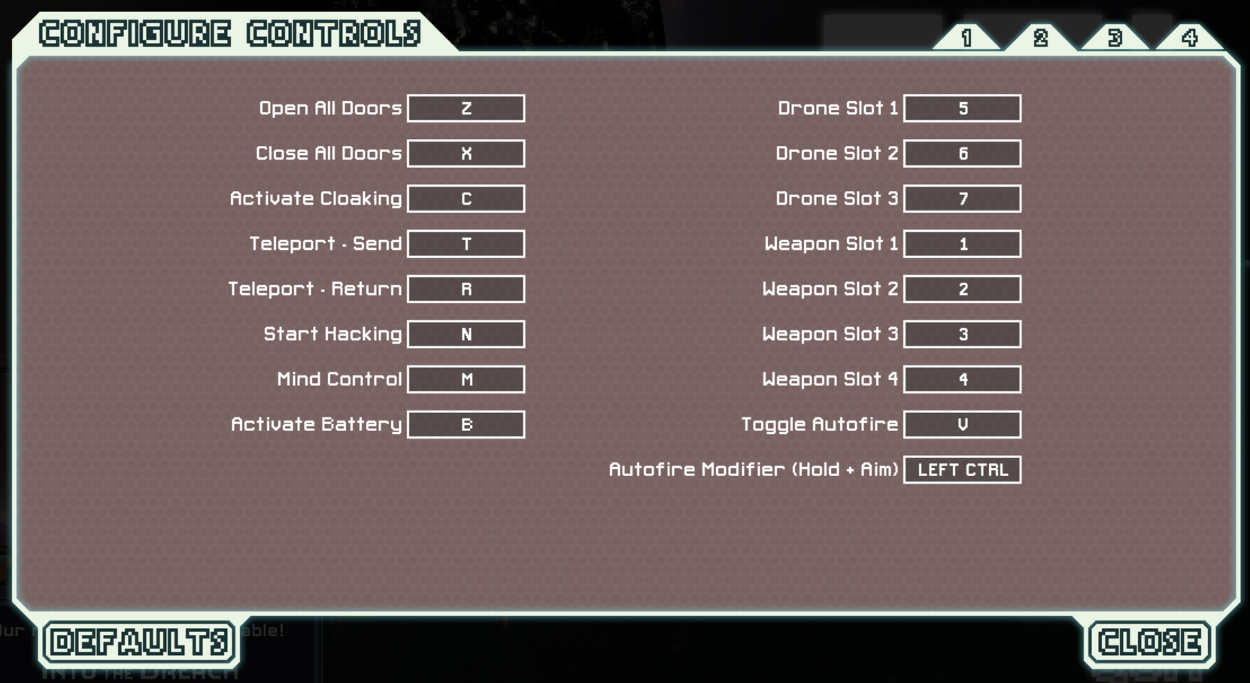
[1] Page 2 of controls, mapped to keyboard.

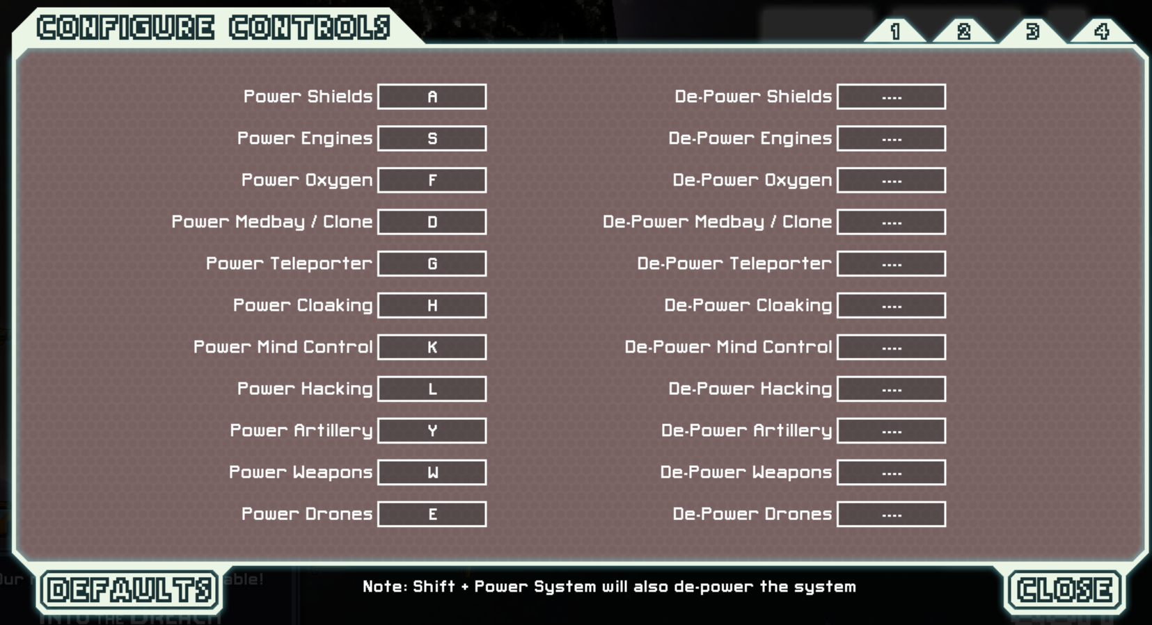
[1] Page 3 of controls, mapped to keyboard.

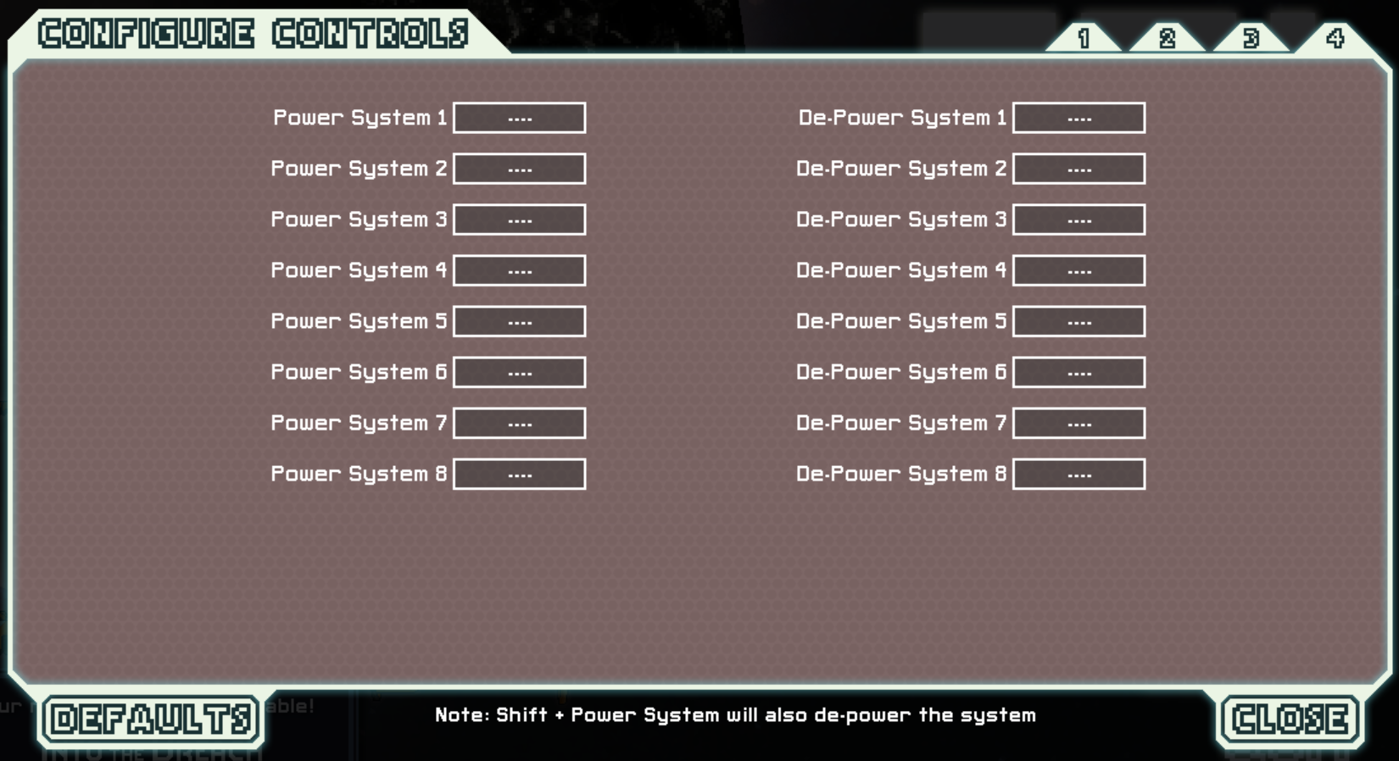
[1] Page 4 of controls, mapped to keyboard.

All in-game menus can also be interacted with using the mouse. Left click usually selects or activates, while right click is mainly used to de-power systems the cursor is hovering over (on the UI).

CONTRIBUTING TEAM MEMBER: | Rose Plumley

SECTION 4: GAMEPLAY

SEQUENCE OF PLAY
- FTL separates each event instance or combat encounter into individual nodes on a map, which are themselves separated into sectors
- The goal is to make it to the exit node, to travel to the next sector
- However, the player is always under a jump limit, both through limited FTL fuel, and through the in-universe pursuing rebel fleet. If a player lingers for too long in a sector, the fleet will gradually appear on the map, potentially catching up to the player. Should the fleet catch up, the player will be constantly under threat from rebel forces.
- There are 8 sectors in total, with the last sector culminating in a final boss encounter with the Rebellion Flagship
- Alternatively, the flagship may destroy the Federation base before the player can beat the flagship, resulting in a game over.

- During combat, a player will first power their weapon systems if they have not done so already. Weapons are powered in the order they are arranged on the UI, from left to right. To this end, when systems are damaged, weapons on the right will lose power first.
- Once powered, a player selects their chosen weapon, and targets an enemy ship room of their choice. Certain weapons, such as the ion beam, allow the player to target multiple rooms in a line.
- If powered, a weapon will charge up over time, and if a player has input a target, the weapon will discharge.
- At any point during combat, a player may choose to pause time. This has the affect of allowing the player to strategize and input all desired targets, as well as queuing up any additional actions, such as moving crew. Once time resumes, actions will be performed as soon as they are able. Note however, weapons will not charge when time is paused.

- During events, a dialogue box will appear in the middle of the screen, automatically pausing time to allow the player to read. A player can then choose a corresponding displayed action. Time resumes once dialogue is exhausted, with any event/player action consequences playing out immediately after.

UNIQUE SELLING POINTS (USPs)
- Roguelike – No two sessions of FTL should be the same. While certain events may become recognisable, this should be a reward to the attentive player, rather than a source of boredom. Individual sector node maps should appear randomised, with each jump feeling as blind and unknown as the one before. Encounters will differ, events will change, combat and rewards will vary, and with a bit of luck and skill, a player will be able to use every resource to their advantage.
- Pause feature – As a strategy game, FTL should give the player time to think, to prioritise and strategize, adapting to every new and unexpected encounter. Unlike other more common strategy games however, the player has the choice to pause time, letting them choose between real-time, active strategy, and more passive, thoughtful planning. In this way, the player can choose the pace of the game, prioritising and rewarding a more careful, managed playstyle over a frantic and reactionary one.
- Roleplay elements – Individual events, narrative significance or otherwise, allow the player to interact with the world they are participating in. The player takes on the role of acting captain of their Federation crew, and is thus responsible for any executive decisions the crew should take. Additional options and actions may also reveal themselves if a player has certain crew or augmentations aboard, rewarding a player for certain previous decisions. In this way, even if a player should encounter a familiar event (as covered in the roguelike bullet point above), they may be presented with new, unique paths to take.
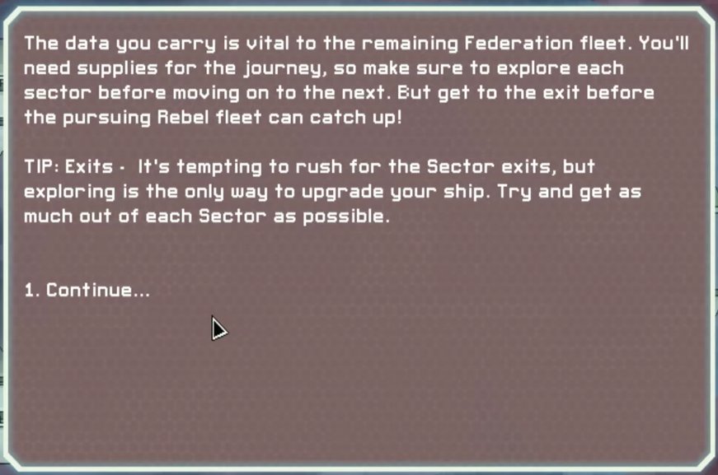
[1]
Example of event dialogue box. Events and encounters should be introduced using this pop-up text box.

PLATFORM-SPECIFIC FEATURES
iOS versions of the game will use touchscreens
- Because iOS devices do not utilise a keyboard, versions of FTL on these devices will need a dedicated pause button, as well as some slight UI changes
- E.g.: more space between event scenario options, buttons, etc
- Mainly done to avoid accidental selections, which if not implemented may provide difficulties when playing the game
PC platforms will not need any platform specific features – almost every option can be selected and interacted with through mouse and keyboard inputs.
Mouse may be optional as well – keyboard shortcuts can be utilised for most functions, such as allocating power to given subsystems.
Keybinds do not exist for individual ship door selections, however.

CONTRIBUTING TEAM MEMBER: | Rose Plumley

SECTION 5: GAME WORLD

GAME WORLD
(Present images and descriptions of the game world here, with short descriptions that outline what the player will find in the environments they are placed in. How do these locations fit into the story?)

Three main sector groups:
- Civilian (coloured green on the sector map)
- Hostile (coloured red on the sector map)
- Nebula (coloured purple on the sector map)
Two unique sectors:
- Hidden Crystal Worlds
- The Last Stand
Each sector has individual beacon nodes within. Each node contains different events, enemies, scenarios, or even a lack thereof.
Beacon examples:
- Store
- Various Items
- Distress
- Neutral Encounter
- Hostile Encounter
- Nebula Space
- Empty
- Quest
- Random Event
Depending on the sector group, a different array and spread of beacons will be available. For example, a civilian sector will typically contain more stores and neutral encounters, whereas a hostile sector will usually contain a higher concentration of, like its namesake, hostile encounters and environments. While this is a general rule of thumb, it is not a static rule.
Additionally, a sector group can be narrowed down into specific subtypes. For example, a hostile sector may specifically be a Pirate Controlled Sector, which will contain a higher percentage of Pirate Controlled Sector Events.
Subsectors:
- Civilian
- Starting Sector
- Civilian Sector
- Engi Controlled Sector
- Engi Homeworlds
- Zoltan Controlled Sector
- Zoltan Homeworlds
- Hostile
- Abandoned Sector
- Mantis Controlled Sector
- Mantis Homeworlds
- Pirate Controlled Sector
- Rebel Controlled Sector
- Rebel Stronghold
- Rock Controlled Sector
- Rock Homeworlds
- Nebula
- Slug Controlled Nebula
- Slug Home Nebula
- Uncharted Nebula

LOCATION DETAILS
NAME: | Civilian Sector
WHAT DOES IT LOOK LIKE? | Average space background. Civilian sectors are intended to appear as some of the more “safe” and inviting sectors. To this end, backgrounds should have a variety of colourful options, not just stars in a dark void. Unique, vibrant planets may appear in the background, or strange yet inviting nebulas and galaxies may feature.  E.g.:    [11]  Above: Hubble Space Telescope image. Note that, while this is a long-exposure image, the universe shouldn’t be entirely realistic. Aesthetics should not be sacrificed over simulation realism. Thus, civilian sector space should look colourful and full!
WHAT MOOD IS BEING INVOKED IN THIS LOCATION? | Civilian sectors should be focused more on light-hearted exploration and resource management, appearing as the lesser of all evils in comparison to the more dangerous Hostile sectors, and the more unknown Nebula sectors. While any sector should never be completely safe, a civilian sector embodies the more lax, un-stressful aspects of FTL’s gameplay. A civilian sector, for example, may present the player with the option to rest and recuperate damages incurred in previous sectors. The mood should be lighter, embodying the idea of giving the player a foothold, building resources and gaining advantages in weapons, augmentations and crew.
WHAT KIND OF MUSIC WILL BE USED FOR THIS LOCATION? | Civilian sectors should typically play some of the more inviting music tracks in the game, albeit NOT uplifting. Unlike media like Star Trek, where the future is idyllic and almost utopian, the player should always be under some kind of stress, either from gameplay (e.g.: resource management) or from narrative reasons (the player is being constantly pursued by the rebel fleet). Thus, music should cycle between electronic, almost chiptune composition, and more atmospheric tracks, especially ones with droning noise, reminiscent of a deep space engine.
HOW ARE THE LOCATIONS CONNECTED IN THE GAME WORLD? | Linear progression. The player should always start in a civilian sector, but a player can always encounter additional civilian sectors by travelling through the exit beacon to new sectors.  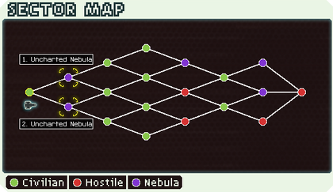  [1]

LOCATION DETAILS
NAME: | Hostile Sector
WHAT DOES IT LOOK LIKE? | Hostile sectors will appear almost identical to civilian sectors. The main gameplay change is just the weighting towards more neutral, or even negative events and encounters. For example, a player in a pirate controlled sector will typically encounter more pirate spacecraft.
WHAT MOOD IS BEING INVOKED IN THIS LOCATION? | Similar to civilian sectors, however due to aforementioned weighting towards combat and negative events, hostile sectors should feel much more dangerous in comparison. All sectors will inevitably feel foreboding and challenging, but a hostile sector should embody the more antagonistic aspects of gameplay.
WHAT KIND OF MUSIC WILL BE USED FOR THIS LOCATION? | Much greater emphasis on atmospherics. If a civilian sector can be accompanied by more chipper, major-key electronic soundtracks, hostile sectors should be characterised by long, droning, atmospheric scores. Music that is reminiscent of deep space diegetic sound should be prioritised, with tracks that may feature noise reminiscent of space engines, or deep space signals, echoes, and so on. Music may have recognisable motifs, but this should be kept to a minimum.
HOW ARE THE LOCATIONS CONNECTED IN THE GAME WORLD? | (example: via central hub, linear progression, open world, unlocked by quests, etc.)  Linear Progression – players should never start in a hostile sector, but may encounter one of these as a choice on the sector map as soon as sector 2.

LOCATION DETAILS
NAME: | Nebula Sector
WHAT DOES IT LOOK LIKE? | Nebula sectors are covered in strange, pink dust and clouds, obscuring ship sensors. Unlike the other two sectors, most nodes in this map variant feature an animated background of floating space dust, clouds slowly flowing in and through each other. A nebula sector may have the occasional beacon node outside the nebula cloud, though this should be a rarity.
WHAT MOOD IS BEING INVOKED IN THIS LOCATION? | Nebula sectors embody the unknown, uncharted aspects of space travel and exploration. To this end, a Nebula should feel foreboding, even claustrophobic. The player should feel like anything could come out of the fog in the background, constantly flying blind through uncharted space.
WHAT KIND OF MUSIC WILL BE USED FOR THIS LOCATION? | Music can be shared with hostile sectors – deep, atmospheric ambiance should feature, with a relative lack of outright melody.
HOW ARE THE LOCATIONS CONNECTED IN THE GAME WORLD? | Linear Progression as well – A nebula, like a hostile sector, can be encountered on the sector map as early as sector 2, but as FTL is a roguelike at its core, this should be random. A Nebula won’t always be encountered as early as this, but a player should always have an option eventually to tread this route.

GAME FLOW
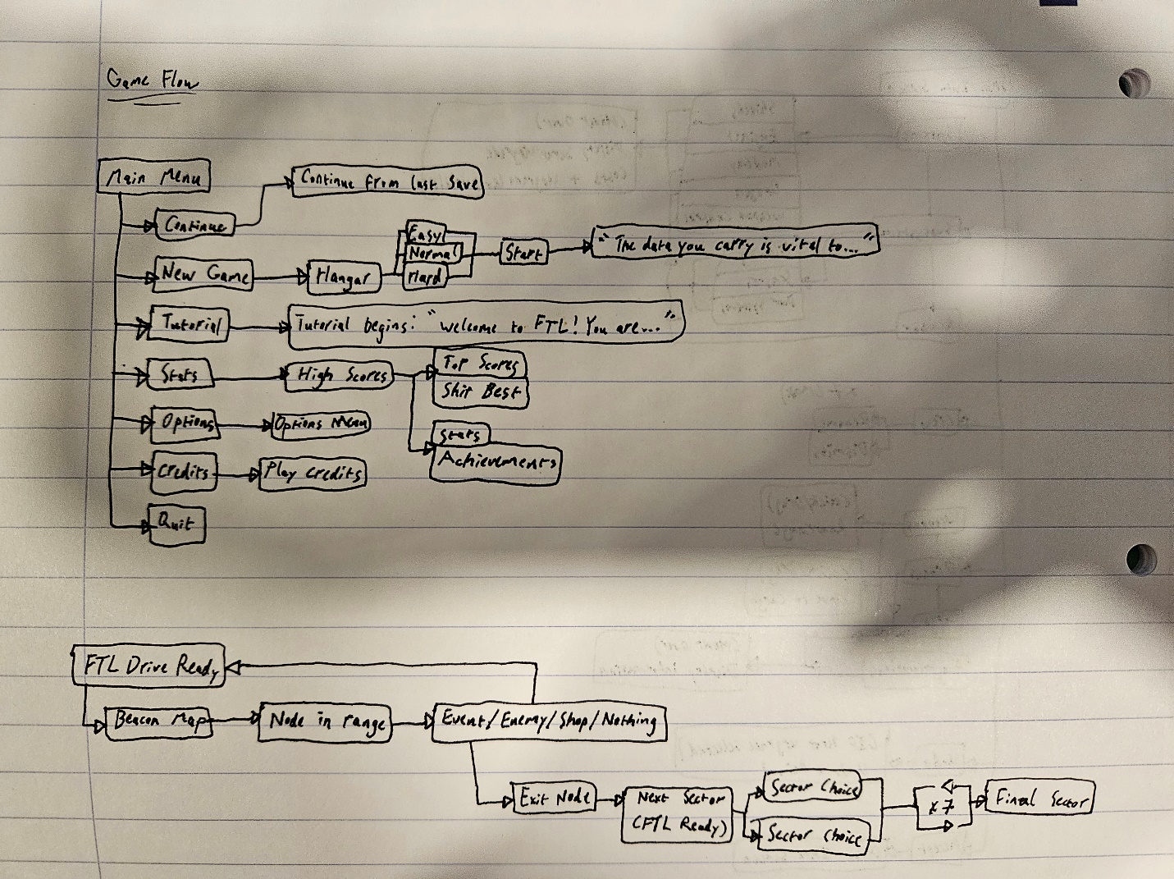
Above: A flowchart depicting general game flow, as well as options from the main menu. Typically, FTL revolves around charging the FTL drive and moving through the sector node map to an exit node, where a player can then move to the following sector. This continues until a player reaches sector 8 – the Last Stand.

CONTRIBUTING TEAM MEMBER: | Rose Plumley

SECTION 6: GAME EXPERIENCE

GAME EXPERIENCE
The game is designed to place strategy above all else, with some help from immersion.
To this end, thematically, there must be a constant sense of tension – stemming from the in-universe urgency to return to the Galactic Federation Headquarters as fast as possible, while also being conveyed through the constant resource management of hull integrity (player health), FTL fuel, missiles, drones, crewmembers (and crewmember experience), scrap, and so on. Players must be constantly weighing costs and benefits to certain actions and chartered courses on the node and sector maps.
Because of the emphasis on strategy, though not necessarily real-time strategy (due to the existence of the pause button), the game may potentially be presented as a more calm, cerebral pastime. Some players may find the experience to be consistently tense and stressful, while others may enjoy the more placid, “play at your own pace” feel. While there is pressure from resource management, the player can ultimately control the pacing as preference dictates.

HOW IS THIS FEELING GOING TO BE PRESENTED TO THE PLAYER?
Resource management – Icons may flash red, a siren may play on low hull integrity, warnings should feel diegetic in that sense. The screen may even shake or vignette briefly red upon taking hull damage. Ultimately, the player should have decent warning when running low on resources (scrap, drones, missiles, FTL fuel), and should simultaneously be a source of stress, on top of combat encounters and unforeseen circumstances.
Score (music) – Composition should be mainly atmospheric. Faster Than Light, although designed to be a challenging roguelike experience, should also be immersive. Thus, most music tracks should be focused less on melody and tune, and more on environmental emphasis – the hum of engines, the pings and electronic blips of radars and deep space communications should blend seamlessly into the more active sound design of weapon discharges, shield regeneration, repair ratcheting, and so on. In this way, FTL should feature less recognisable motifs and melodies, and more immersive soundscape composition.
Environment – ((See earlier descriptions of individual sectors))

ARE THERE ANY SPECIAL MODES OR INTERFACES FOR GAMEPLAY?
Interfaces – Wouldn’t the combat screen count?

WHAT DOES THE PLAYER FIRST SEE WHEN THEY START THE GAME?
(Rough sketches / images can be used here to help convey this.)

Players should be presented with a “hangar” – a place to customise their ship and crew.
Players should be able to choose their ship class, choose a ship layout (changes subsystem room sizes and positions), hide the rooms (to preview the outside ship design), rename their ship, rename their crew members, choose game difficulty, and select Advanced Edition content.

The hangar should also provide a preview of starting subsystem power levels, weapons and weapon slots, crew slots, augmentations, and achievements.

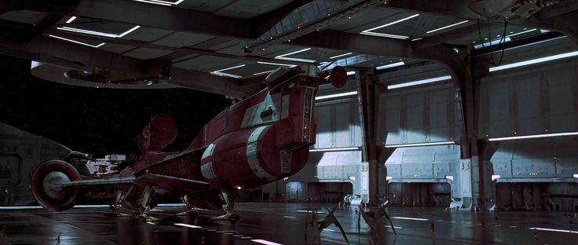
[12]
Above: Screenshot from the opening of The Phantom Menace. Note the panelling and aesthetics. In game, the hangar should be displayed from a top-down perspective, with Federation colouring and aesthetics, maybe even with a few moving parts to simulate hangar busywork.

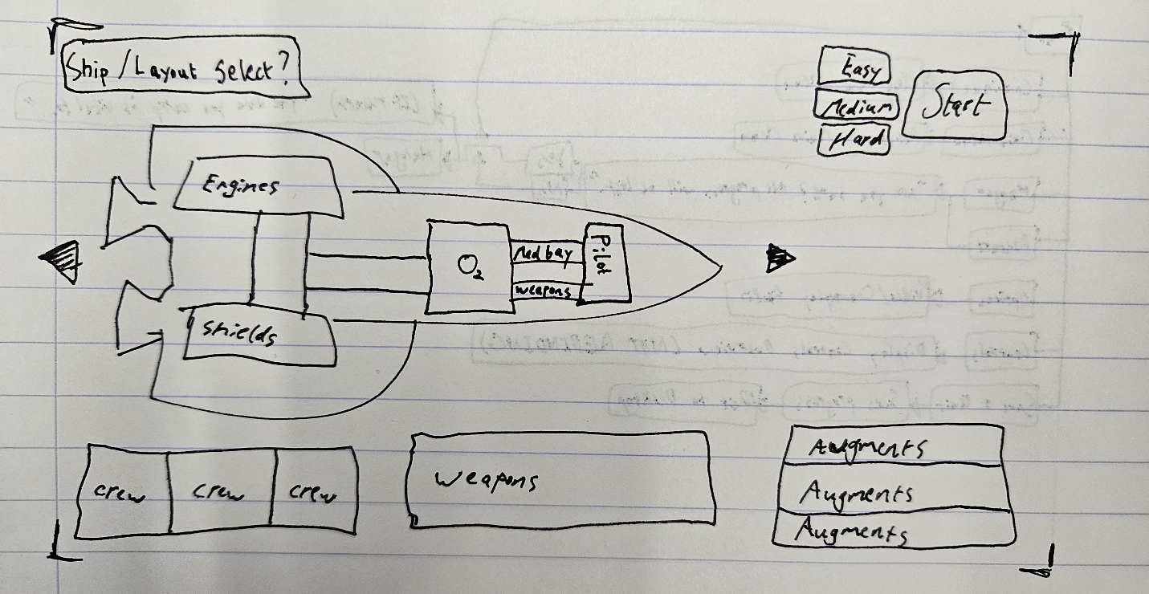

Above: Potential example of top-down hangar view. Player should be able to select their ship, customise crew, weapons, layout, etc.

Once the game starts, the player should be presented with the main scenario as an event text box, describing who they are, what their mission is, and the desperate/secretive nature of their mission (see Section 4, Unique Selling Points box – the event box displayed is the scenario introduction).

WHAT EMOTIONS ARE MEANT TO BE INVOKED BY THE GAME?
Players should be immersed in a world where they act as the captain of their Federation crew. To this end, while previous Games Design Document boxes placed an emphasis on stress and tension, the player must also be able to experience moments of “downtime”, where they can explore a sector’s node map, hunting for resources and unique event encounters. The player must thus be encouraged to feel curious, both for gameplay reasons (risk/reward of finding resources versus being engaged by enemies) and for immersion reasons.

This only applies for gameplay in general, however. Different sector types should convey different feelings, especially in relation to their apparent risk.
For example, Civilian sectors (Civilian, Engi and Zoltan) should be some of the more safe, prioritising exploration and questing above other sectors. While combat and resource management will never be exempt from gameplay, the civilian sectors should feel like some of the more inviting areas. Note however, that a civilian sector shouldn’t be “safe” – the game still needs to be challenging. But of the three sector types, the civilian sector should be the lesser of all evils.

In Hostile Sectors (Abandoned, Mantis, Pirate, Rebel, Rock), players should feel much more on edge. As Federation-aligned crew, these sectors should feel dangerous and chaotic, especially in rebel-controlled sectors. Debris may float by, or enemy ships should be present in the background. As opposed to civilian sectors, which exist as the “open frontier”, hostile sectors should embody the dangerous and threatening aspects of space travel.

Nebula Sectors (Slug and Uncharted) however should strike a balance between safety and hostility – akin to heavily misty waters. Gameplay-wise a nebula will slow down the pursuing Rebel Fleet, albeit less if it is a beacon node (20% instead of the regular 50%). A nebula is just as likely to present challenge and enmity as it is to offer rest and reprieve, and may present neutral events/encounters, or even completely empty nodes altogether. In this way, a nebula sector should characterise the mysterious and unknown/uncharted nature of space as an experience. Nebulas are risky, unknown frontiers, and should be approached with a healthy does of caution. After all, who knows what’s lurking beyond your ship’s impeded sensors?

Two sectors however, are unique;
The final, Last Stand sector, and the Hidden Crystal Worlds sector.

The Last Stand should be the culmination of everything, both gameplay and plot-wise. To this end, there should be a healthy dose of threat and foreboding, emphasised by the in-universe final battle occurring in the background. Multiple Federation and Rebel ships should populate the background, facing off against each other. The Last Stand sector should be the crescendo of everything in the game, especially when facing off against the Rebellion Flagship.

The Hidden Crystal Worlds sector is the “deep space” equivalent of the game, even more mysterious or even alluring than the Nebula sectors. However, while the latter should characterise the unknown, and fear of, the Hidden Crystal Worlds should instead be more “active” in a sense. This could mean that the player may feel curious, wanting to explore this unknown territory, but this sector is nevertheless more hostile than others, despite the Crystal race being more docile in comparison to their more common Rockmen descendants.

HOW ARE MUSIC AND SOUND GOING TO BE USED?
(Think of how audio effects can help invoke a mood. Do you want players to feel a rush of adrenaline, a feeling of dread, to feel heroic, romantic, etc? You could provide example links of audio here to help your team understand your intentions for sound design.)

We’re obviously including Ben Prunty’s work – cheating a little since FTL is already a released game, but could use the opportunity to showcase more of Prunty’s work, if that exists.
Could also draw comparisons to similar-sounding compositions?
Maybe even compare to other space games and media!

HOW DOES THE PLAYER NAVIGATE THE SHELL MENUS/ SCREENS OF THE GAME?
Shell menus and screens are navigated using the mouse, for the most part. If one includes event text boxes however, the player may also select options using the numbers on their keyboard instead.

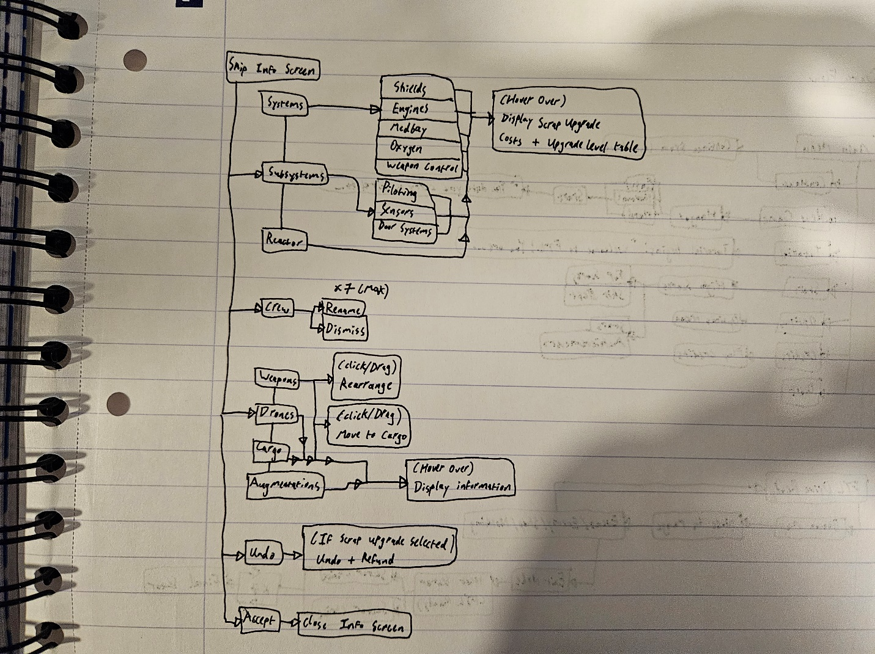

Above: Flowchart depicting the Ship Information Screen. Here, a player will typically spend scrap to repair their hull, or purchase various upgrades to their system. Augmentations, modifications and additional weapons and crew can only be obtained through random events, or purchased using scrap from shop beacon nodes.

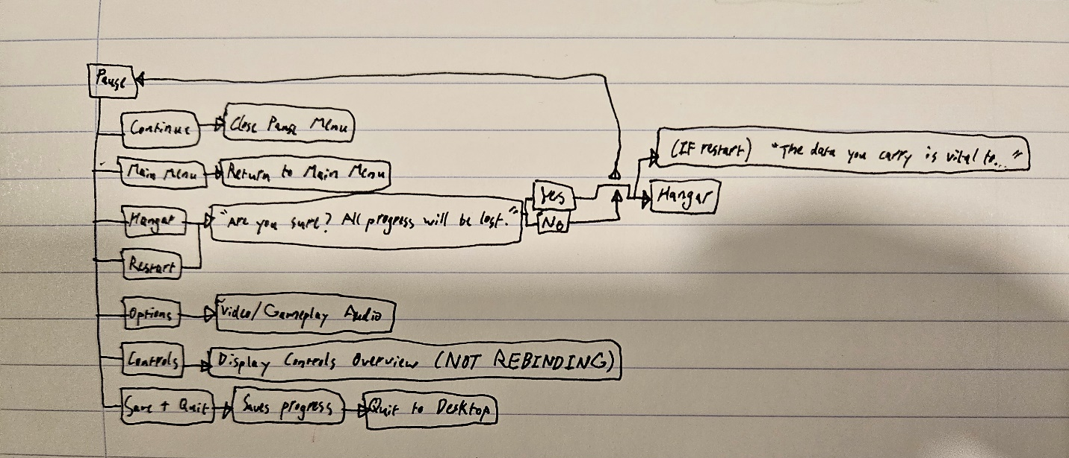
Above: A flowchart depicting the pause menu shell screen. Here, a player can access an options screen, as well as suspend or restart their run. Notably, the options menu here is delegated to video and gameplay audio options. A player cannot, for example, edit their keybinds from this shell menu.

CONTRIBUTING TEAM MEMBER: | Rose Plumley

SECTION 7: GAMEPLAY MECHANICS

GAMEPLAY MECHANICS
MECHANIC: Something the player interacts with to create or aid gameplay e.g. moving platforms, opening doors, slippery ice.
- Shields – recharges passively, unless systems are damaged.
- Crew manning – If a crew member is stationed in a sub/system room, they provide a passive bonus to the system. For example, a crewmember in the shields system will provide faster shield regeneration. Crew are also able to repair damaged systems. Note, some systems must be manned to function, e.g. FTL Jump can only be activated if a crewmember is stationed in the pilot subsystem.
- Drones – some drones are defensive, shooting down enemy missiles and drones, while some are offensive, occasionally peppering an enemy’s shields with laser fire. Some drones may even be used for boarding.
- Boarding – a player can choose to send crew members to assault an enemy vessel, if they have the relevant crew teleporter system installed.
- Missiles – Players can hoard a supply of missiles and flak artillery, weapons that bypass enemy shields.
- Cloaking – If a player ship is installed with a cloaking system, they can choose to activate this, turning the ship invisible. Gameplay—wise, this provides a flat evasion bonus to the ship (i.e., enemy attacks have a much greater chance of missing the player ship).

HAZARD: A mechanic that can harm or kill a player but doesn’t possess intelligence e.g. spike pits, swinging blades, jets of fire. Describe SOME – not every one!
- Asteroid field – A player may FTL jump into a node with an asteroid field. Here, the player will be subject to random debris, which has a chance to damage the ship hull.
- Nebula – Will disrupt player sensors. Unless crew is stationed within a room or system, the room will be obscured.

POWER-UP: e.g. Ammo, extra lives, invulnerability, etc. Provide examples of power-ups and what they do.
- Ammunition – Missiles and drones are limited.

GAME ECONOMY
Players will always collect various amounts of scrap from events and encounters. This scrap acts as an economic resource, allowing shop exchanges for new crew, weapons, ammunition, subsystems and augments.
Additionally, scrap can be used on hull repairs and ship upgrades, namely reactor power and subsystem power capacity. At various upgrade levels, a subsystem will improve (e.g., a fully upgraded door subsystem will upgrade the doors to “Super Blast Doors”, which impede enemy boarder movements and slow the spread of fires).

CONTRIBUTING TEAM MEMBER: | (YOUR NAME HERE)

SECTION 8: ENEMIES

LIST OF ENEMIES
(Provide an overview of in-game enemies here. Further details of each can be provided by using the table below.)

We have a fair few enemies to go over!
Rebel Ships
- Rebel/Pirate Fighter
- Rebel/Pirate Invader
- Rebel/Pirate Rigger
- Rebel/Pirate Disruptor
- Elite Fighter
- Elite Assault
((Worth including list of possible weapons/drones? Or save that for the following table/box?))

Federation Ships ((Do Federation ships only come as pirate variants?))
- Federation/Pirate Scout
- Federation/Pirate Outrider
- Federation/Pirate Bomber
- Federation/Pirate Hacker
((Same weapons query as above))

AI-Controlled Rebel Ships
- Auto-Scout
- Auto-Surveyor
- Auto-Assault
- Auto-Hacker
((Weapon query))

Engi Ships
- Engi Scout
- Engi Outrider
- Engi Bomber
- Engi Hacker
((Weapons/Drones Query))

Mantis Ships
- Mantis/Pirate Scout
- Mantis/Pirate Interceptor
- Mantis/Pirate Fighter
- Mantis/Pirate Assault
- Mantis/Pirate Bomber
- Mantis/Pirate Aggressor
((Weapons query))

Zoltan Ships
- Energy/Pirate Fighter
- Energy/Pirate Instigator
- Energy/Pirate Bomber
- Energy/Pirate Hacker
((Weapons/Drones Query))

Rock Ships
- Rock/Pirate Scout
- Rock/Pirate Investigator
- Rock/Pirate Fighter
- Rock/Pirate Interceptor
- Rock Assault
- Rock Aggressor
- Rock Aggressor (Elite)
((Weapons query))

Slug Ships
- Slug/Pirate Interceptor
- Slug/Pirate Scout
- Slug/Pirate Light-Cruiser
- Slug/Pirate Light-Surveyor
- Slug/Pirate Assault
- Slug/Pirate Instigator
((Weapons query))

Lanius Ships ((ADVANCED CONTENT))
- Lanius Scout
- Lanius Bomber
((Weapons query))

Crystal Ships ((ADVANCED CONTENT))
- Crystal Scout
- Crystal Outrider
- Crystal Bomber
- Crystal Instigator
((Weapons query))

The Rebellion Flagship
- 1st Stage
- 2nd Stage
- Final Stage

ENEMY DETAILS
NAME:
WHAT DOES IT LOOK LIKE?
ATTACKS:

WHEN WILL IT FEATURE IN THE GAME?
HOW DOES THE PLAYER DEFEAT IT?
WHAT DOES THE PLAYER EARN FOR DEFEATING THEM?

LIST OF BOSS CHARACTERS
The main “boss character” is the final fight of the game, the Rebellion Flagship, located in the final sector. This is a multiple phase fight designed to be the final, and thus biggest challenge a game session can offer. Players will need to carefully build their vessel along their journey and strategise based on their available systems and resources.

BOSS CHARACTER DETAILS
NAME: | Rebellion Flagship
WHAT DOES IT LOOK LIKE? | The Biggest ship in the game. Shares the colour scheme of other rebel ships (orange body, pale teal detailing). Also like other rebel ships, the flagship bears an eagle insignia with a shield, with the letters “MFK” inscribed in the center of the latter.  Being the biggest of the Rebel ships, the flagship must appear imposing and strong – many layers make up the outer hull, though done purposefully, not patchwork.  Outside of this, the general shape should also include two “wing” sections, and a large cockpit area at the front.  Once the player reaches the 2nd phase of the fight, the left wing should be destroyed, with multiple layered pieces of charred scrap metal poking out from the missing extremity.  Likewise, the final stage of the fight should destroy the right-hand wing, leaving a similar line of scrap, foundations, and general broken machinery. Only the main body section should remain.
ATTACKS: | 1st Phase:  Boss Ion (system level 3)  Artillery system with 3 system levels (maximum). Charge time decreases with system level (35 seconds at 1, 28s at 2, 21s at 3). Shoots 3 times per volley, each shot dealing 1 damage.  Boss Laser (system level 3)  Artillery system with 4 system levels (maximum). Charge time decreases with system level (25s at 1, 20s at 2, 15s at 3, 10s at 4). Shoots 3 times per volley, each shot dealing 1 damage, with a low chance of fire or breach.  Boss Missile (system level 3)  Artillery system with 4 system levels (maximum). Charge time decreases with system level (28.75s at 1, 23s at 2, 17.25s at 3, 11.5s at 4). Shoots 3 missiles per volley, each missile dealing 1 damage, with a more moderate chance to cause a fire. Lower chance at causing a breach.  Note, the flagship will never run out of missiles.  Boss Beam (system level 3)  Artillery system with 3 system levels (maximum). Charge time decreases with system level (32.5s at 1, 26s at 2, 19.5s at 3). Beam length of 2.2 tiles diagonally. Deals 2 damage per room hit.  Sensor limit  The flagship caps player sensor functionality at level 2, necessitating a hack to reveal more information (e.g. enemy system power use or weapon charge progress).  Cloaking  The flagship has access to a cloaking subsystem, which when activated, prevents the player from locking on with their weapons. Additionally, the flagship gains an extra 60% evasion while activated.  Hacking  The flagship has access to a hacking subsystem, which can target a single system, locking its doors and disrupting, or outright disabling said system.  Drones  The flagship has access to a drone subsystem, stocked with 10 drone parts. Like the player, the flagship can deploy attacking drones, or repair drones. The Flagship may also send over boarding drones, to allow for enemy boarding.  2nd Phase:  Power Surge  The flagship gains the ability to deploy multiple beam and combat drones (Mk. I, random assignment), with number of drones deployed scaling with difficulty (4 drones on easy, 6 on normal, 7 on hard). Power Surge cooldown varies between 20s and 30s, with a warning siren 5s before activation. Drones have limited shots – 2 shots before despawning. Power Surge acts as an environmental hazard – hacking or disabling the flagship’s drone subsystem does not affect Power Surge drones.  Boss Laser (system level 3)  Boss Missile (system level 3)  Boss Beam (system level 3)  Drones  Equal phase 1 functionality, however, now the system is revealed and vulnerable to the player. Drone parts are restocked to 10.  Final Phase:  Boss Laser (system level 4)  Boss Missile (system level 4)  Teleporter  Similar functionality to boarding drones mentioned above, however, much like the drone subsystem in phase 2, the teleporter systems can now be hacked and/or destroyed by the player.  Mind Control  The Flagship gains access to a mind control subsystem, allowing it to temporarily turn player crewmembers into rebel allies. This follows the same logic as player Mind Control systems (e.g., slugs cannot be mind controlled).  Power Surge  Instead of deploying drones, the flagship will now either shoot 7 laser shots simultaneously, or bring its Zoltan shields back online. Each shot deals 1 damage, with moderate chances of dealing fire, breach, and/or stun. Cooldown is similar to phase 2, varying between 20s and 30s, with a 5s warning before activation. Power Surges will usually shoot lasers, with shield regeneration occurring every 4th activation. As the shield is Zoltan, any player crewmembers will be stranded aboard the flagship, until either the shield is broken again, or the player has a Zoltan Shield Bypass.
WHEN WILL IT FEATURE IN THE GAME? | Featuring as the final boss of the game, the Rebellion Flagship spawns in the final “Last Stand” sector. Additionally, the flagship will appear as a silhouette on the player’s node map, hovering around a beacon, changing positions for every 2 player FTL jumps.  Additionally, the flagship will attempt to pilot to the Federation Headquarters. Once reaching the HQ beacon node, if the ship remains for 3 consecutive turns, the HQ will be destroyed, resulting in a game over.
HOW DOES THE PLAYER DEFEAT IT? | Despite being a multiple phase fight, it follows similar logic to any other enemy ship encounter. However, the flagship will never surrender, and killing all crewmembers aboard the flagship will result in the ship AI taking over the ship instead. Thus, victory can only be achieved by destroying the rebel flagship entirely.
WHAT DOES THE PLAYER EARN FOR DEFEATING THEM? | Once the player defeats the Flagship, the game ends, resulting in a victory screen! The game will display the player’s ship name and surviving crew, accompanied with a short conclusion:  “The Rebel’s flagship was destroyed, throwing their fleet into chaos and ensuring a Federation victory”  After which, the credits play.

CONTRIBUTING TEAM MEMBER: | Rose Plumley

SECTION 9: CUTSCENES

CUTSCENES
Not Fully Applicable – FTL does not contain conventional cutscenes. The closest it has is event text boxes, such as at the start of the game, after leaving the hangar and beginning a session.
However, one could count the ending screen/credits as a cutscene.

CUTSCENE DETAILS
VISUAL STYLE: | Text on background
BRIEF DESCRIPTION OF SCENE: | After defeating the Rebellion Flagship, the player should be presented with a congratulatory screen, which scrolls down to display the game credits.
WHEN WILL IT FEATURE IN THE GAME? | Immediately following a successful session, where the player beats the final boss.
PURPOSE: | Congratulations and credits!

CONTRIBUTING TEAM MEMBER: | Rose Plumley

SECTION 10: BONUS MATERIALS

BONUS MATERIALS
Faster Than Light is, at its core, a roguelike game. This means that, while replayability is mostly achieved through random events, encounters, nodes, sectors, and so on, there are a variety of unlocks that should be available to the player.
Main examples of which include:
- New Ships – containing different starting crew members/races, subsystems, weapons, and layouts.
- The Engi Cruiser
- The Federation Cruiser
- The Zoltan Cruiser
- The Stealth Cruiser
- The Rock Cruiser
- The Slug Cruiser
- The Mantis Cruiser
- The Lanius Cruiser (Advanced Edition)
- The Crystal Cruiser (Advanced Edition)
- Advanced Edition Content – Major update content that can be enabled or disabled at the hangar before a session begins. Content includes new subsystems, sectors, events, weapons, a new race, new ships, layouts, augments, and a variety of additional features and balance changes.
- New Ship Layouts
- Layout A (and thus the ship) is unlocked through either a ship’s respective quest/achievement, or by beating the Rebellion Flagship (each ship can be unlocked sequentially, starting from the default Kestrel, Engi, Federation, Zoltan, Mantis, Slug, Rock, and finally, Stealth).
- Layout B is unlocked by earning 2 of 3 ship-related achievements. For example, Slug Cruiser Layout B is unlocked by completing 2 of the following, using the ship:
- Have vision of every room on an enemy ship without functioning sensors
- Jump to 30 nebula sectors before sector 8
- Kill 3 enemy crew members with one shot from the anti-bio beam
- Layout C is unlocked by reaching sector 8 with layout B and Advanced Edition Content enabled.

REPLAY VALUE
Challenge and score.
At the end of an FTL session, the player will be rewarded with a final score based on actions taken during a run. These scores will be saved, and a player should be able to view their highest scores in a table.
Additionally, as FTL is a roguelike game, replayability stems from the randomly generated/selected events and encounters throughout the game, offering potential new challenges and scenarios for a player to explore. On top of providing differing and varied experiences, this may also provide the more roleplay-focused players with inspiration for stories and retellings to share with other likeminded players.

CONTRIBUTING TEAM MEMBER: | Rose Plumley

References
[1] FTL: Faster Than Light, [Software], Shanghai: Subset Games, 2012
[2] “FTL: Faster than light,” ESRB Ratings. [Online]. Available: https://www.esrb.org/ratings/36247/ftl-faster-than-light/. [Accessed: 06-Dec-2023].
[3] “Ratings guide,” ESRB Ratings. [Online]. Available: https://www.esrb.org/ratings-guide/. [Accessed: 06-Dec-2023].
[4] “Search,” Pegi.info. [Online]. Available: https://pegi.info/search-pegi?q=FTL%3A+Faster+Than+Light&op=Search&age%5B%5D=&descriptor%5B%5D=&publisher=&platform%5B%5D=&release_year%5B%5D=&page=1&form_build_id=form-aQ_ZIBgoJXN7e9eL0eLS7H_Chs3T1CUBmNCzrJk0nQc&form_id=pegi_search_form. [Accessed: 06-Dec-2023].
[5] “What do the labels mean?”, Pegi Public Site. [Online]. Available: https://pegi.info/what-do-the-labels-mean. [Accessed: 06-Dec-2023].
[6] G. Roddenberry, Creator, Executive Producer, Star Trek: The Original Series, [Television Broadcast], United States: Norway Corporation, NBC.
[7] N. Meyer, Director, Star Trek II: The Wrath of Khan, [DVD], Los Angeles: Paramount Pictures, 1982.
[8] Prison Architect. [Software], Stockholm: Paradox Interactive, 2015.
[9] “What was the space shuttle? (grades K-4),” NASA, 26-Nov-2013. [Online] Available: https://www.nasa.gov/learning-resources/for-kids-and-students/what-was-the-space-shuttle-grades-k-4/ [Accessed Dec. 12, 2023].
[10] Space Engineers. [Software], Prague: Keen Software House, 2013.
[11] T. Metcalfe, “New Hubble Space Telescope photo is a ‘living history book’ of our universe,” NBC News, 11-May-2019. [Online]. Available: https://www.nbcnews.com/mach/science/new-hubble-space-telescope-photo-living-history-book-our-universe-ncna1004406. [Accessed: 12-Dec-2023].
[12] G. Lucas, Director, Star Wars: Episode I – The Phantom Menace, [DVD], San Francisco: Lucasfilm Ltd., 1999.

