3/24/2025
University of Wales Trinity Saint David
London campus
E-Portfolio Link: https://2513123.wixsite.com/my-site-3/copy-of-task1-a
Module Name: Learning In the Digital Era
Module Code: ACCA 4025

Student Name: Berkay Demirbash
Student ID: 2513123
Group: 1

Lecturer’s Name: Koushik Modak

LDE Assignment 1
E-Portfolio
Table of Contents
Introduction 2
Main Body 2
Task 1: Essential Academic and Employment Skills for the future career Path 2
Task 1 (a): Report on Essential Academic and Employment Skills 2
Task 1 (b): Evaluation of Task 1 (a) based on Similarity report 2
Task 2: Collaborative Mind Map and Individual Poster 3
Mind Map (Collaborative) 3
Poster (Individual) 3
Task 3: Virtual Collaboration and RefWorks 3
Report on Virtual Collaboration 3
Step-by-step process of using RefWorks with visuals 3
Task 4: E-Portfolio Creation and Evaluation 3
Task 4 (a): E-Portfolio Creation 3
Task 4 (b): Illustrative Review of E-Portfolio tool Selection 3
Conclusion 3
References 3
Task 1 References: 3
Task 3 References: 4

Introduction

Strong academic, professional, and teamwork abilities are critical for success in postsecondary education and future careers. This assignment intends to assist the evolution of these qualities by directing students through a series of organised tasks that integrate independent study, teamwork, digital literacy, and reflective practice. Each exercise is intended to assist students gain confidence in using technology and academic standards while also helping them comprehend and apply the basic competencies required for productive study, virtual collaboration, and professional communication.
Task 1 focusses on fundamental academic and employment abilities, asking students to provide a researched summary supported by trustworthy sources and referenced using the IEEE style. Academic writing, critical reading, precise reference, and self-evaluation are all fostered by this assignment.
Task 2 uses the development of an academic poster to highlight the value of teamwork. Students investigate how cooperation promotes academic and professional success by investigating the idea that "Life is a Team Sport." This task also includes a hands-on team exercise where participants create a mind map to show that they grasp the fundamentals of productive teamwork.
In order to facilitate correct citation and reference management, Task 3 presents the usage of automatic referencing systems like RefWorks.
Lastly, Task 4 calls for compiling all finished work into an online e-portfolio. Students are encouraged to consider the tools utilised and their entire learning process as they work on this exercise, which also helps them build their digital presenting skills.

Main Body

Task 1: Essential Academic and Employment Skills for the future career Path

Task 1 (a): Report on Essential Academic and Employment Skills

Academic and employment skills are, as everyone knows, of great importance. Each of these skills is extremely significant, because if one is lacking, the others are less effective. Everyone needs these abilities, and they create new responsibilities. Based on this, individuals who develop and apply these skills correctly are likely to achieve a bright future, as they understand what they are doing. In summary, they can find a way to handle almost any situation. These skills are particularly important for students, and once they become habitual, they can lead to significant achievements.
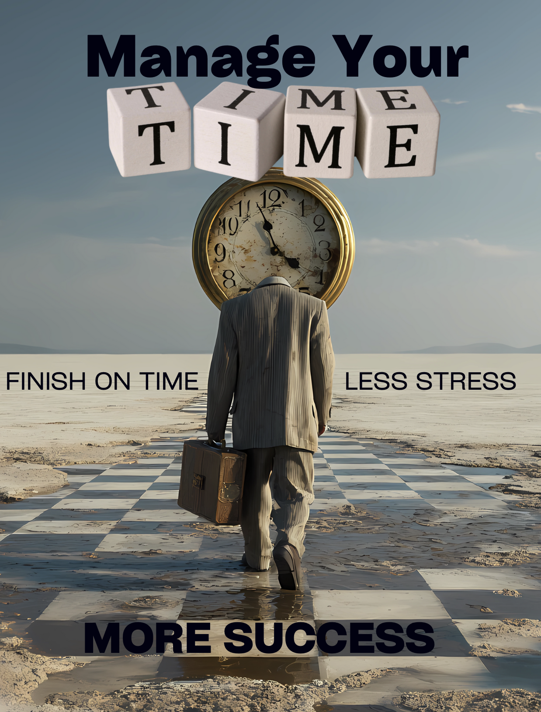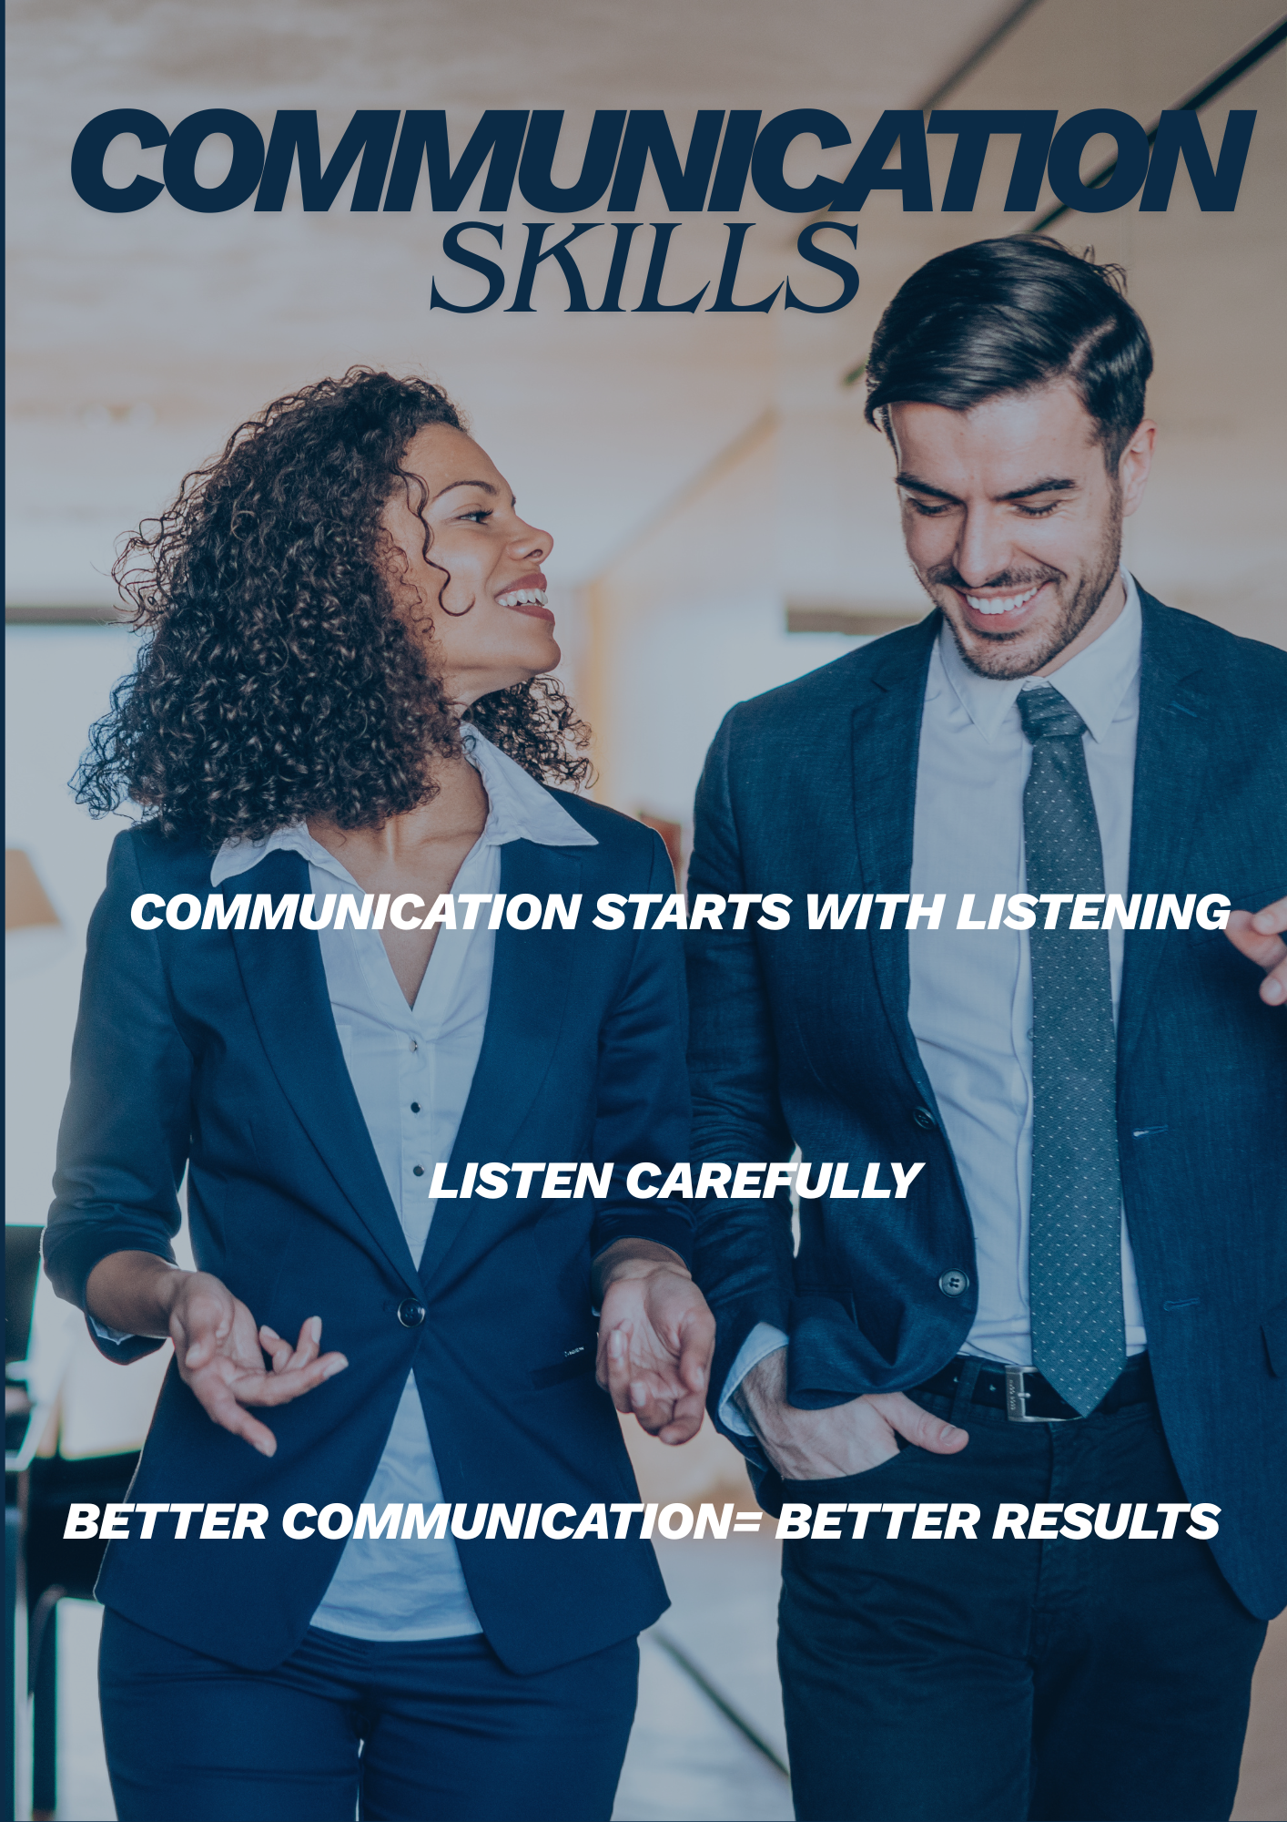

For instance, time management is one of these skills. It reduces stress and allows tasks to be completed on time, proving highly effective when used correctly. Similarly, strong communication skills enable individuals to stand out in various contexts and make a difference in society, allowing them to express themselves more confidently during meetings. Another important example is teamwork. Sometimes multiple challenges occur simultaneously, and effective teamwork is the best solution. Good communication skills naturally lead to being part of a strong team. In fact, all these skills are interconnected. A well-functioning team also enhances problem-solving abilities, because a person with good communication skills contributes to a strong team, and a strong team further develops problem-solving capabilities. In conclusion, mastering these skills contributes to personal respect, recognition, and professional success.

Task 1 (b): Evaluation of Task 1 (a) based on Similarity report

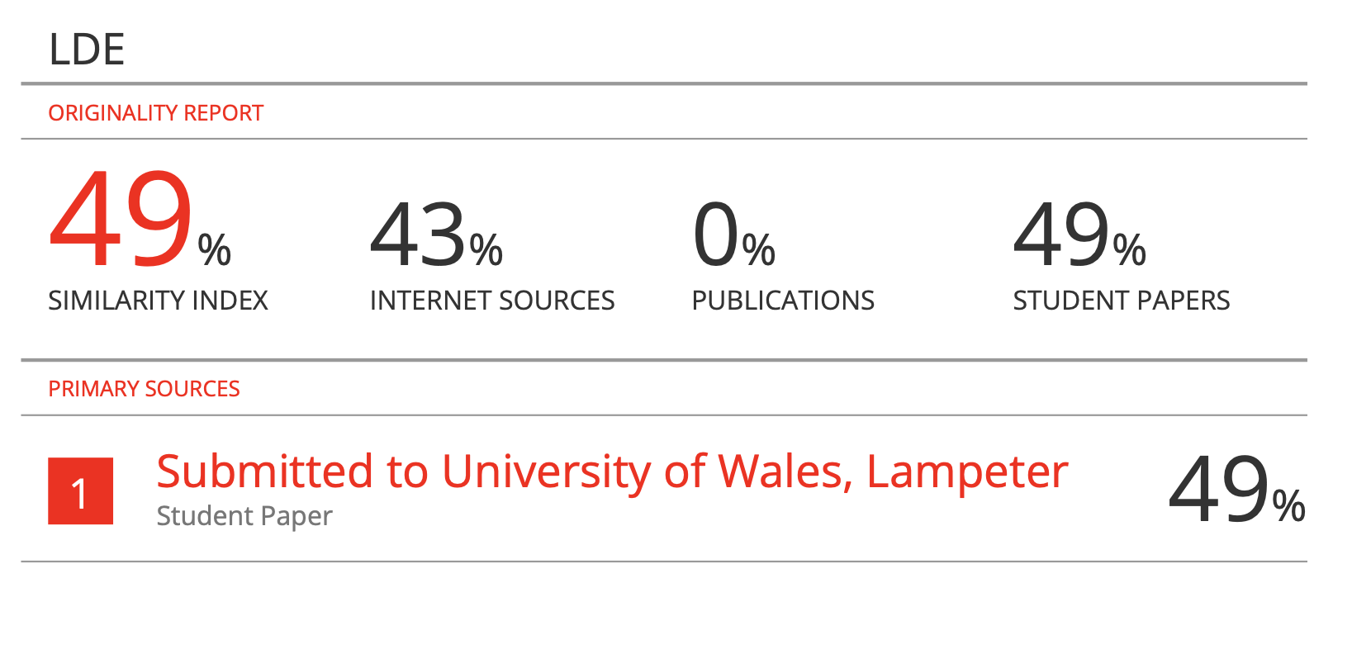

The similarity report for my assignment showed a rate of 49%, which I believe was largely due to the use of standard assignment titles. When I reviewed the report, I noticed that there were not many highlighted sections indicating direct copying, which suggests that all my content was written in my own words. However, the similarity score could have been lower. In the future, I plan to improve this by incorporating more academic vocabulary and phrasing, which will enhance the originality and academic quality of my writing. I had expected the similarity percentage to be around 20% because I consciously expressed my own ideas and avoided copying from sources. Overall, while the similarity rate appears high, it does not accurately reflect the originality of my work, and I will take steps to reduce it in future assignments.

Task 2: Collaborative Mind Map and Individual Poster

Mind Map (Collaborative)

Mind Map Link: https://mm.tt/map/3868524843?t=rnmZskQP5C

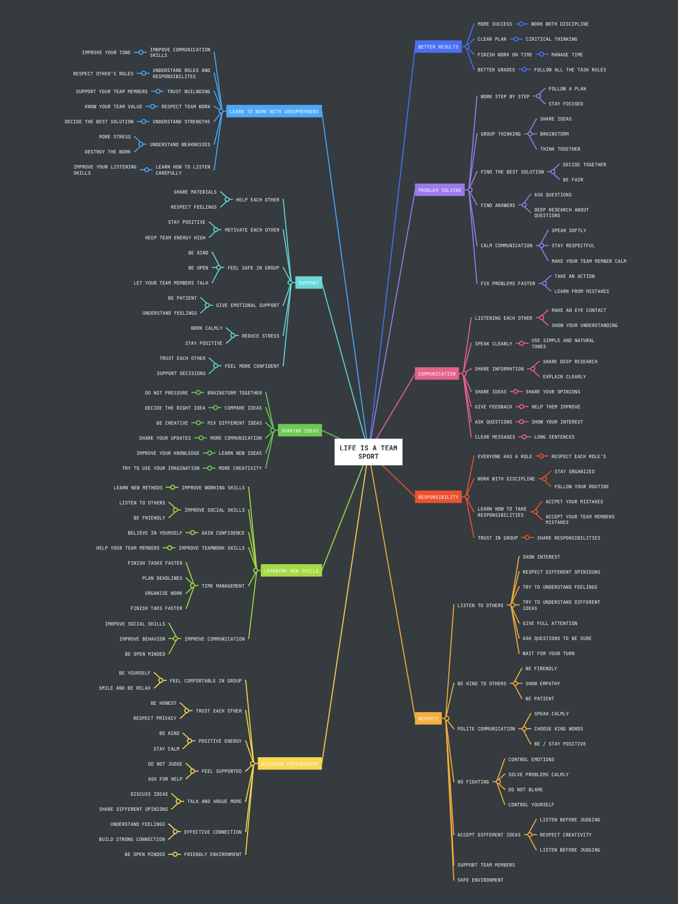

Poster (Individual)
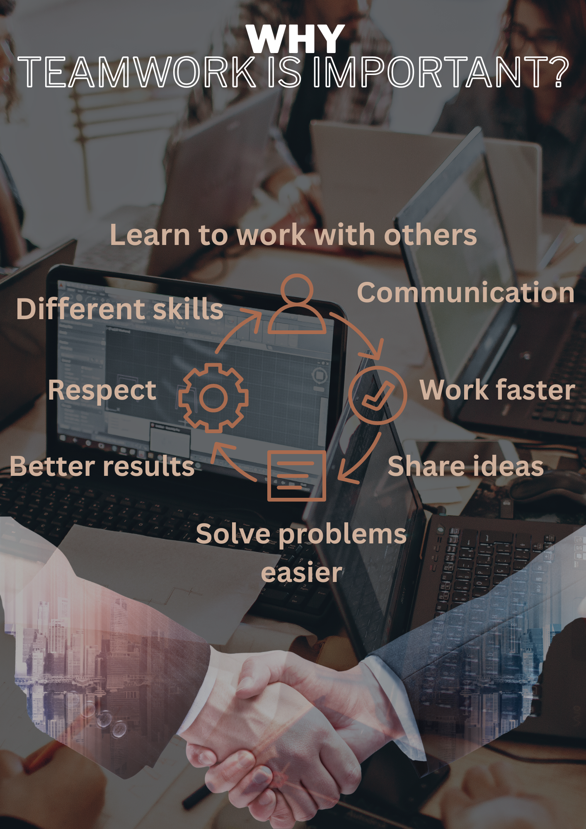

PosterLink: https://www.canva.com/design/DAG4_yrKwNs/FYOS6fh2pUyWoKRh6luTig/view?utm_content=DAG4_yrKwNs&utm_campaign=designshare&utm_medium=link2&utm_source=uniquelinks&utlId=h8362be49a6

Task 3: Virtual Collaboration and RefWorks

Report on Virtual Collaboration

Lights, Camera, Action!

The Light, Camera, Action theme in virtual collaboration emphasises recognising and addressing two significant obstacles that often impact team effectiveness: Inattention to Results and Groupthink. Such issues can greatly hinder the effectiveness of any team. Still, they become even more apparent in virtual settings where communication is less intuitive, accountability may decline, and managing group dynamics becomes more challenging. Understanding how to tackle these issues enables teams to uphold clarity, productivity, and effective decision-making when collaborating online.
In attention to Results happens when team members become distracted from the shared objectives of the team. Rather than focusing on collective goals, individuals might focus on personal tasks, comfort, relationships, or steering clear of challenging obligations. In virtual teams, this challenge can arise more frequently since members might feel detached from the groups goal and be less cognizant of how their efforts impact the overall result. To address this issue, teams need to set explicit goals, quantifiable objectives, and frequent check-ins to guarantee that all members stay aligned and responsible. When the team continually highlights outcomes, members feel more inspired to engage significantly and assist each other in reaching shared goals.

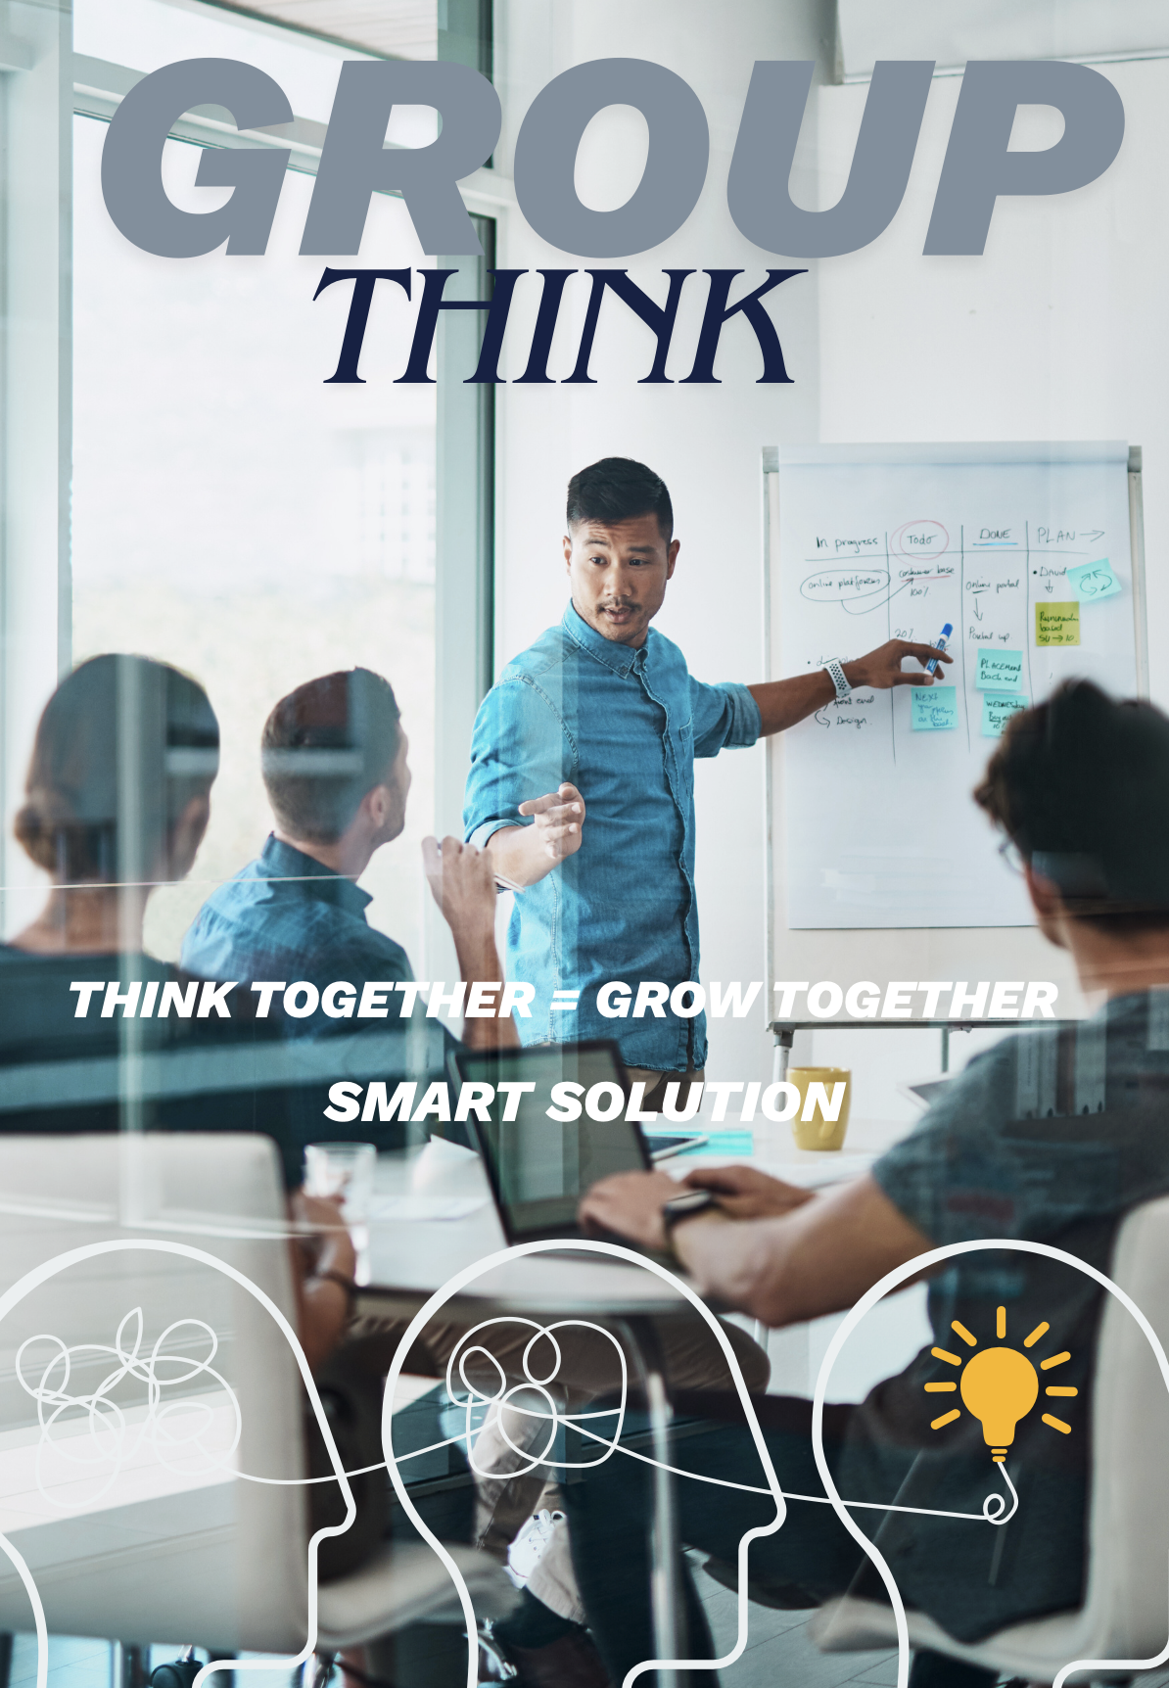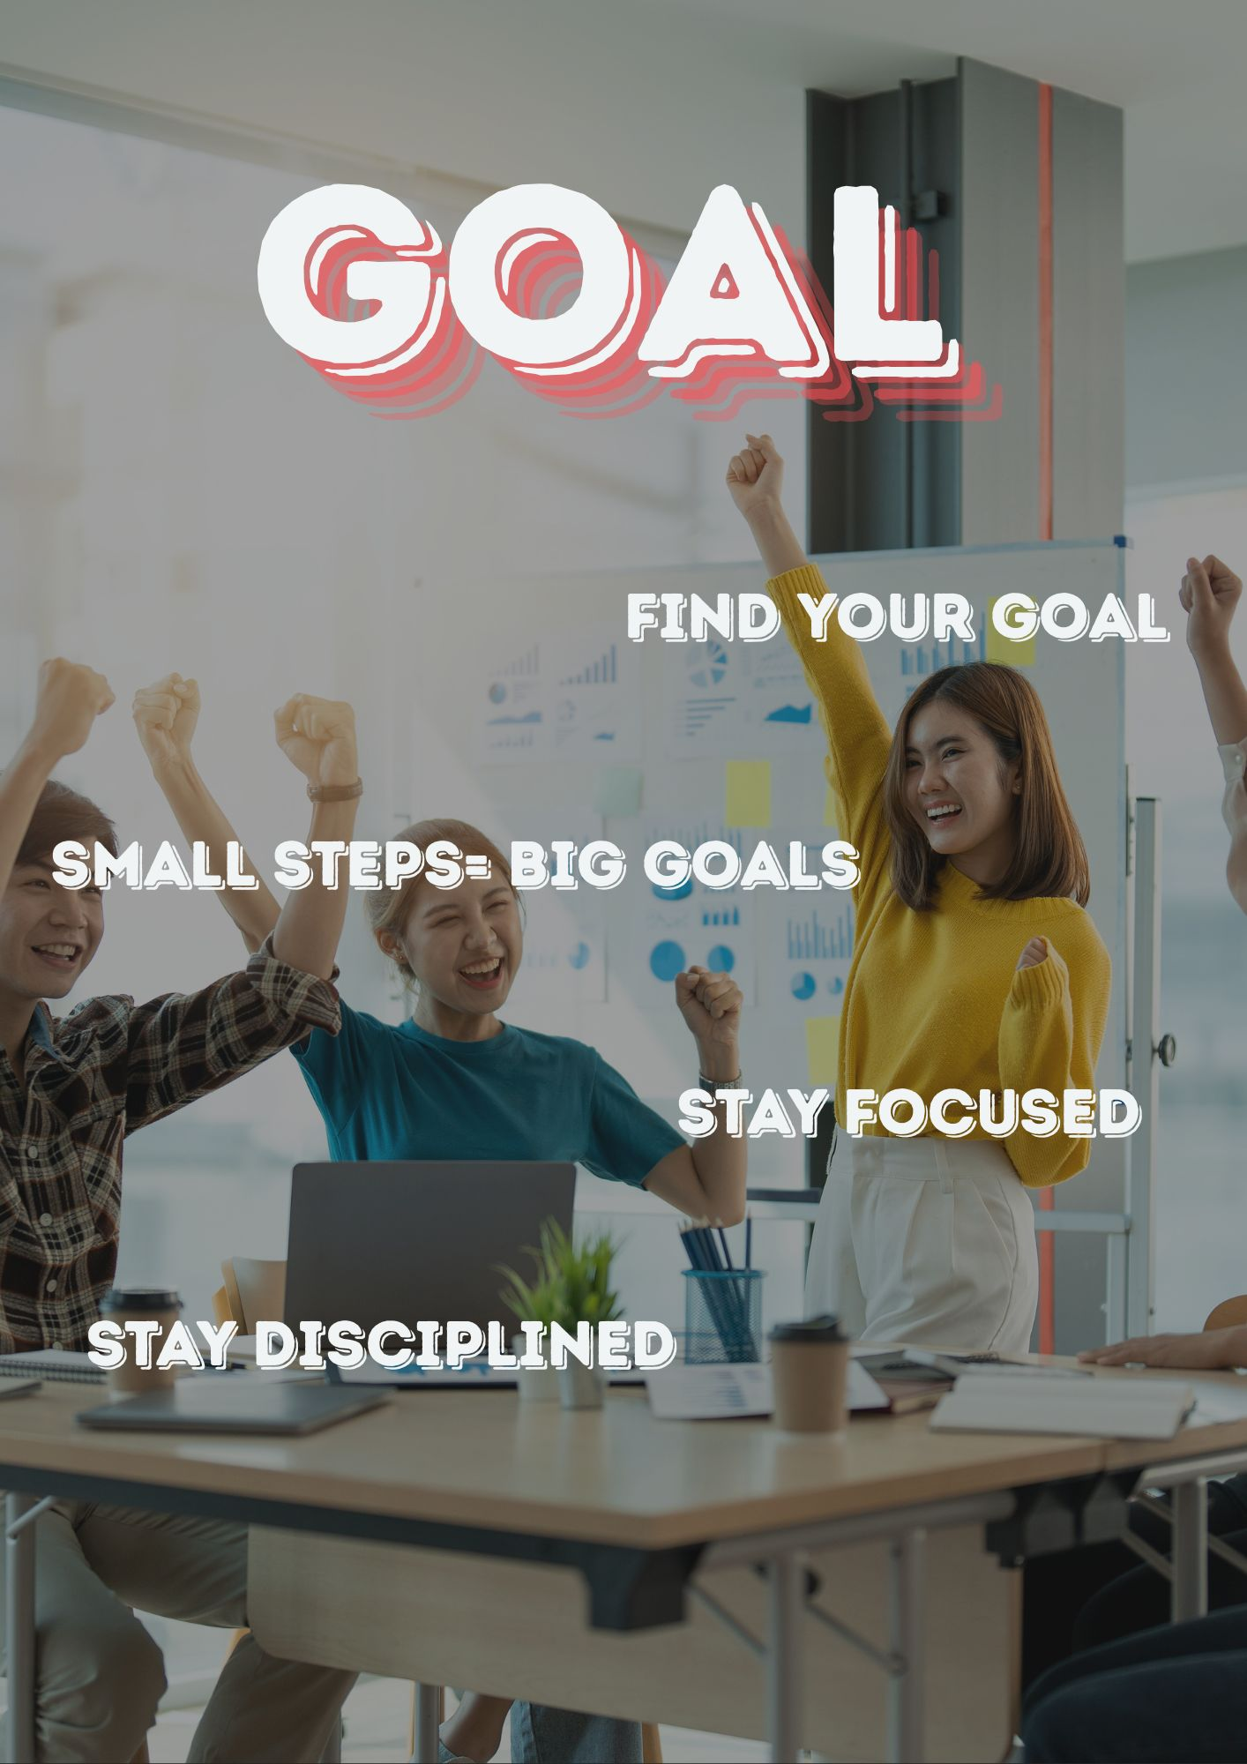

Groupthink, in contrast, is a psychological occurrence where teams favour consensus and unity over critical analysis and open dialogue. This frequently results in flawed choices as differing opinions are overlooked, conflicts are stifled, and potential dangers are disregarded. Virtual settings can inadvertently increase the likelihood of groupthink, as participants may be reluctant to voice their opinions, meetings without cameras diminish involvement, and silence can seem more pleasant than discussion. To prevent Groupthink, teams need to promote open discussions, seek varying viewpoints, and welcome constructive conflict. Leaders may alternate speaking roles, directly invite quieter members to share their thoughts, and foster an environment where challenging ideas are viewed as constructive instead of obstructive. Another significant issue with virtual collaboration is groupthink, which goes beyond inattention to results. Groupthink is the result of teams prioritising harmony over critical thinking, which prevents individuals from raising issues or suggesting different solutions. This can worsen in virtual settings, as it is more difficult for people to disagree with the prevailing view due to a lack of nonverbal cues, delayed communication, and the need to maintain online unity. Teams should promote open communication, welcome a range of perspectives, and establish organised debate opportunities in order to combat this. Using anonymous feedback mechanisms and designating positions like "devil's advocate" can also help guarantee that decisions are well considered, inclusive, and in line with the teams overarching objectives.

Step-by-step process of using RefWorks with visuals

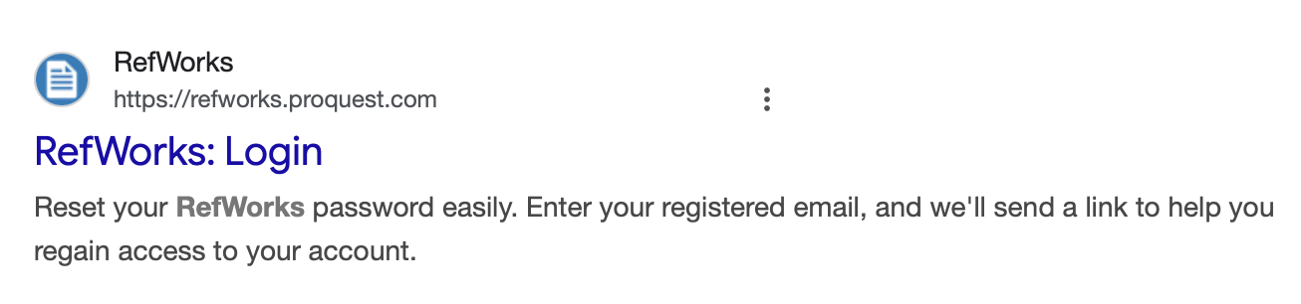
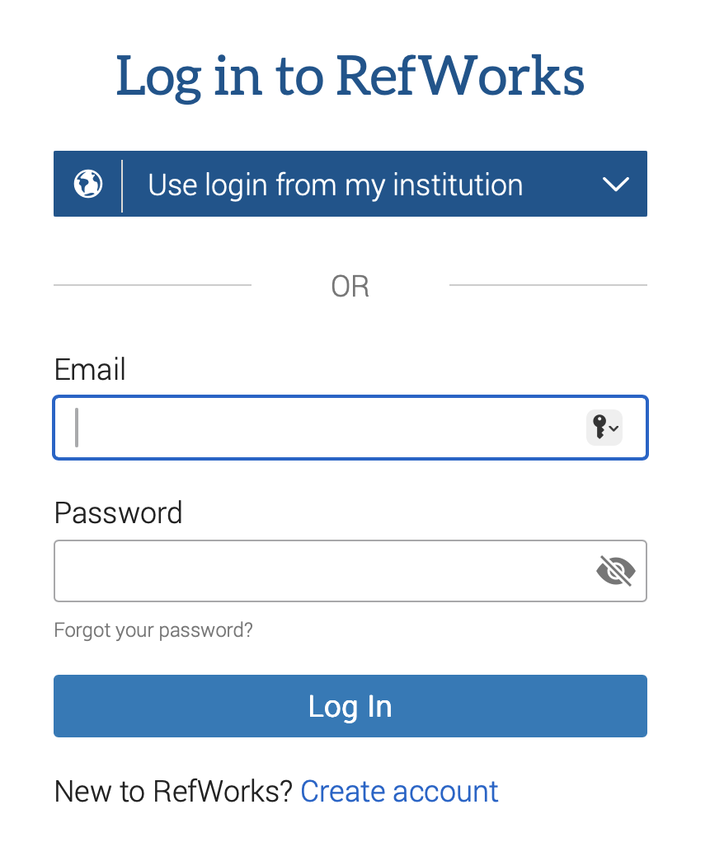
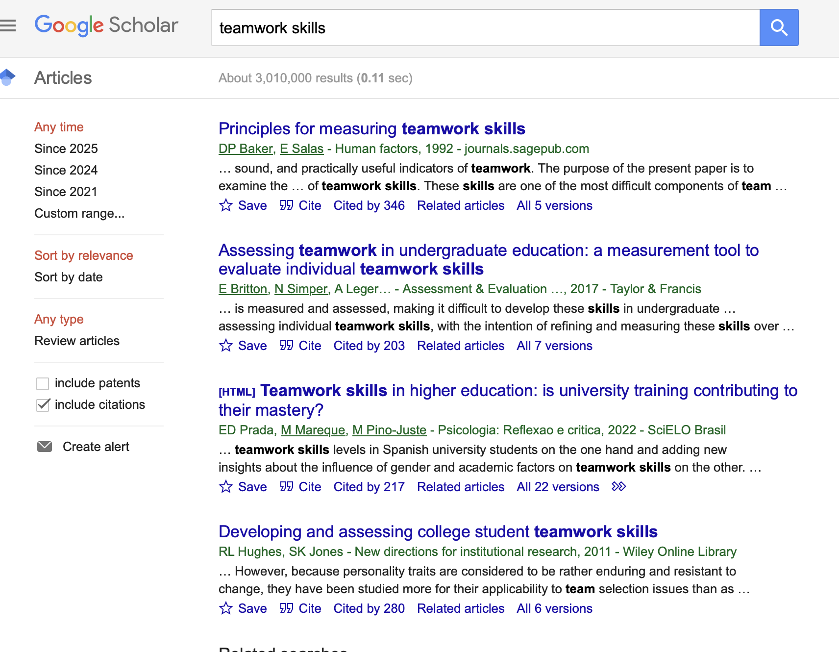

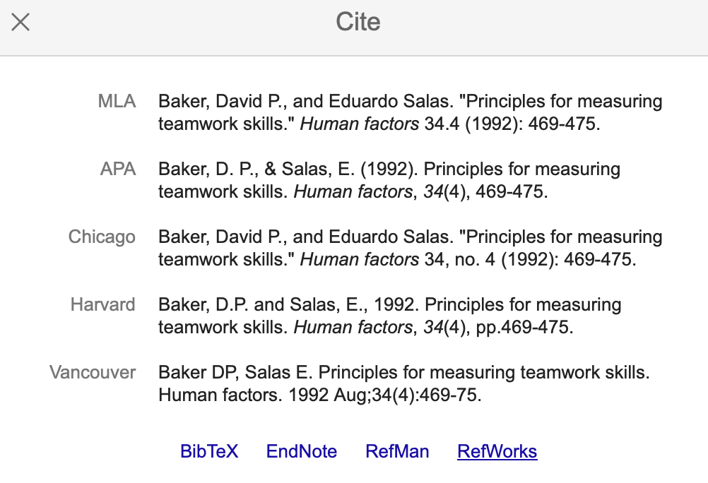
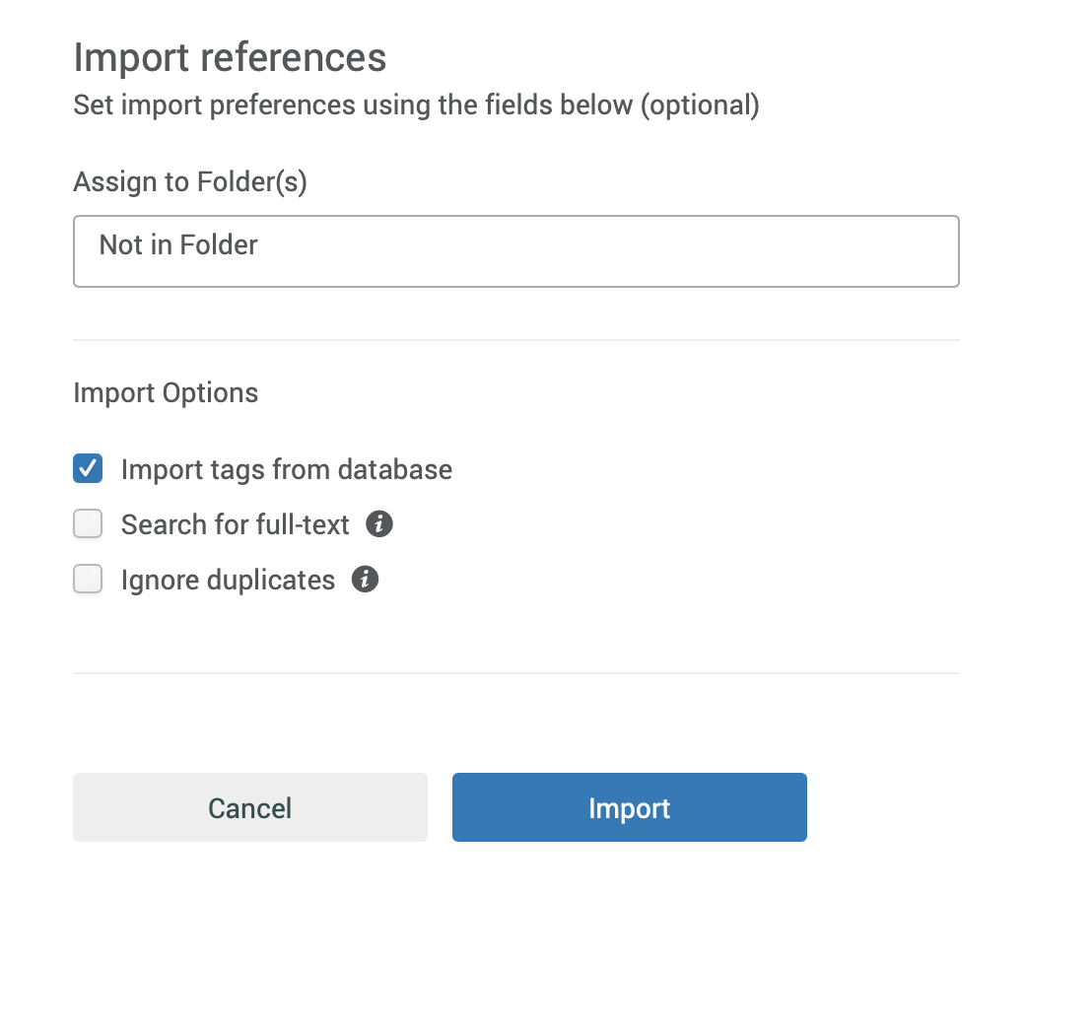
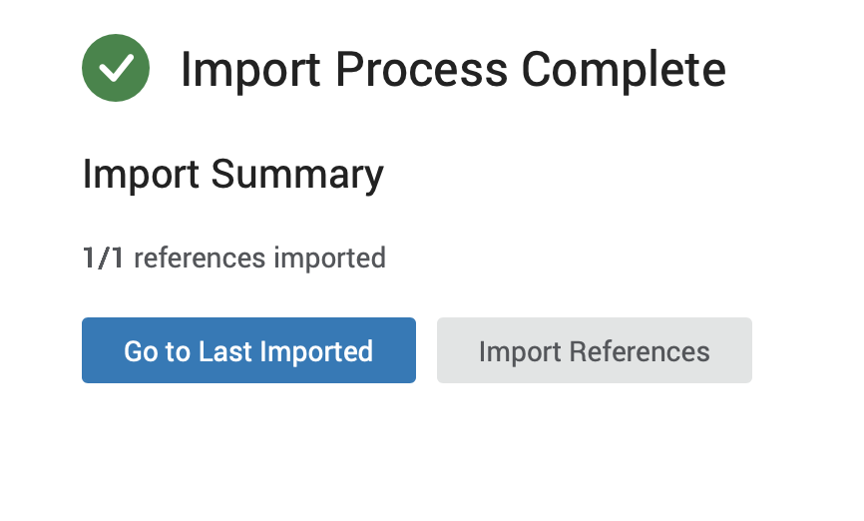
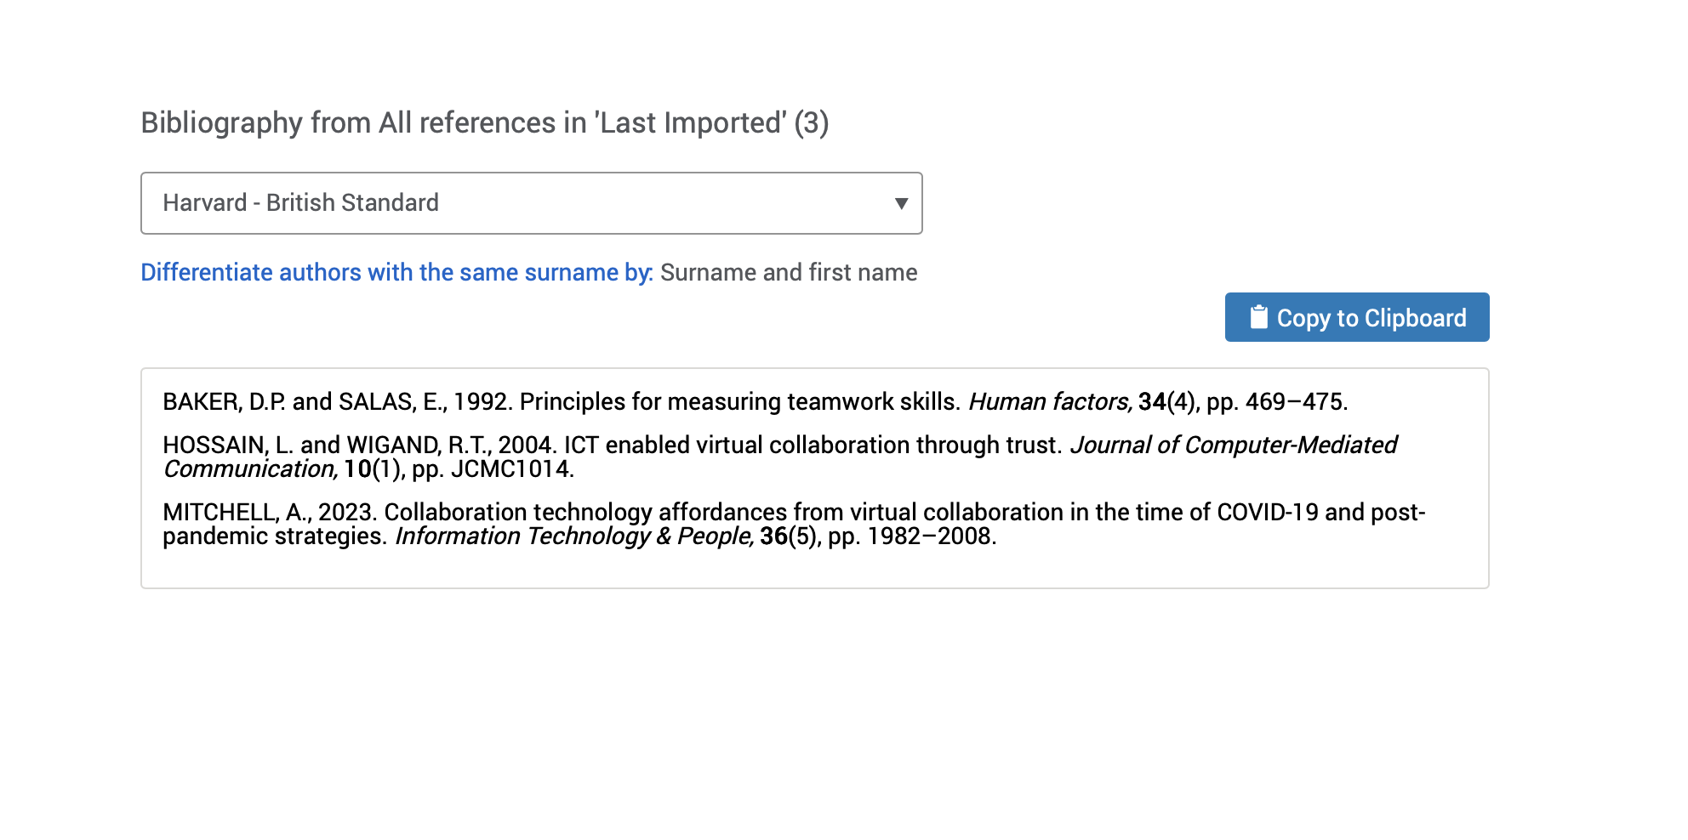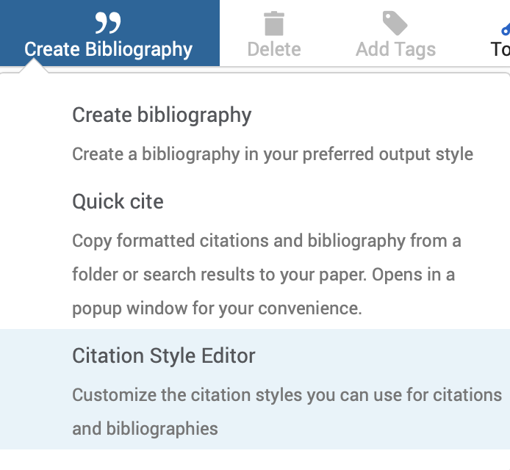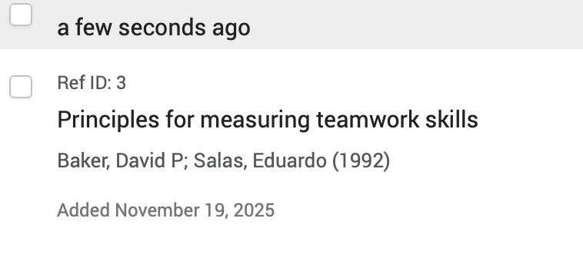

Task 4: E-Portfolio Creation and Evaluation

Task 4 (a): E-Portfolio Creation
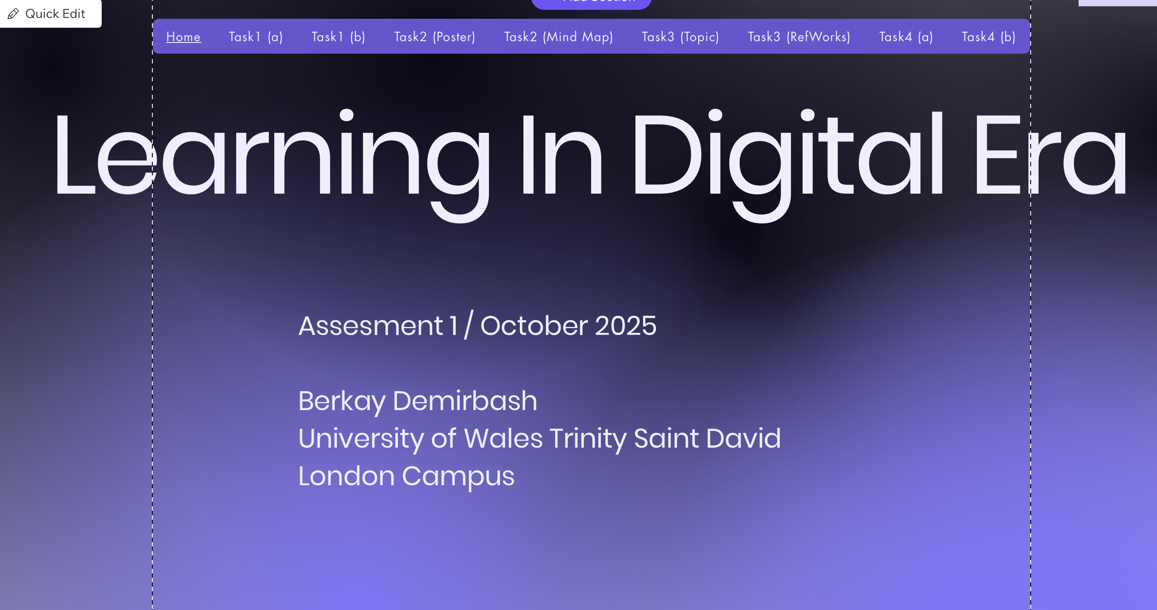
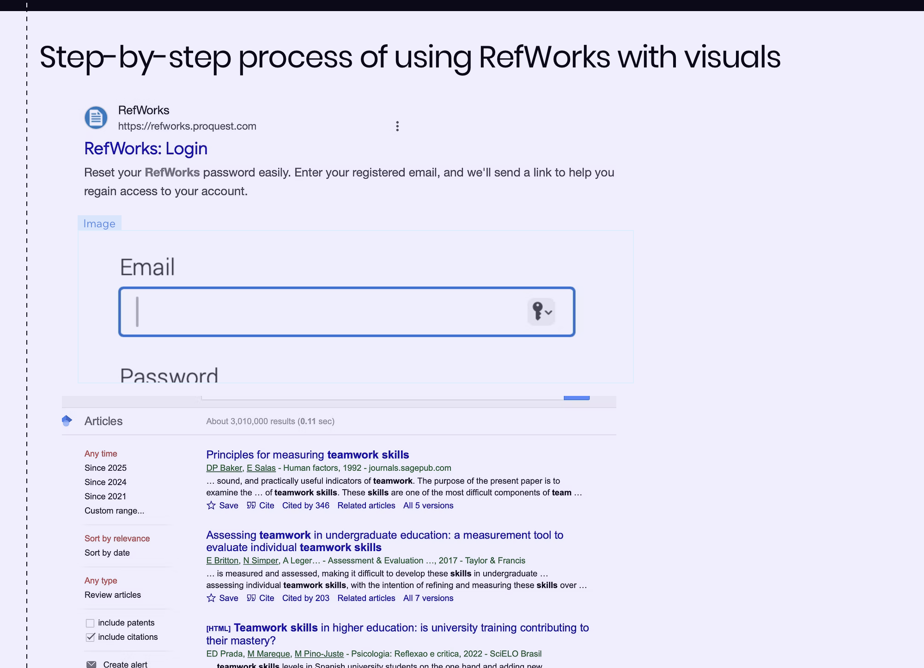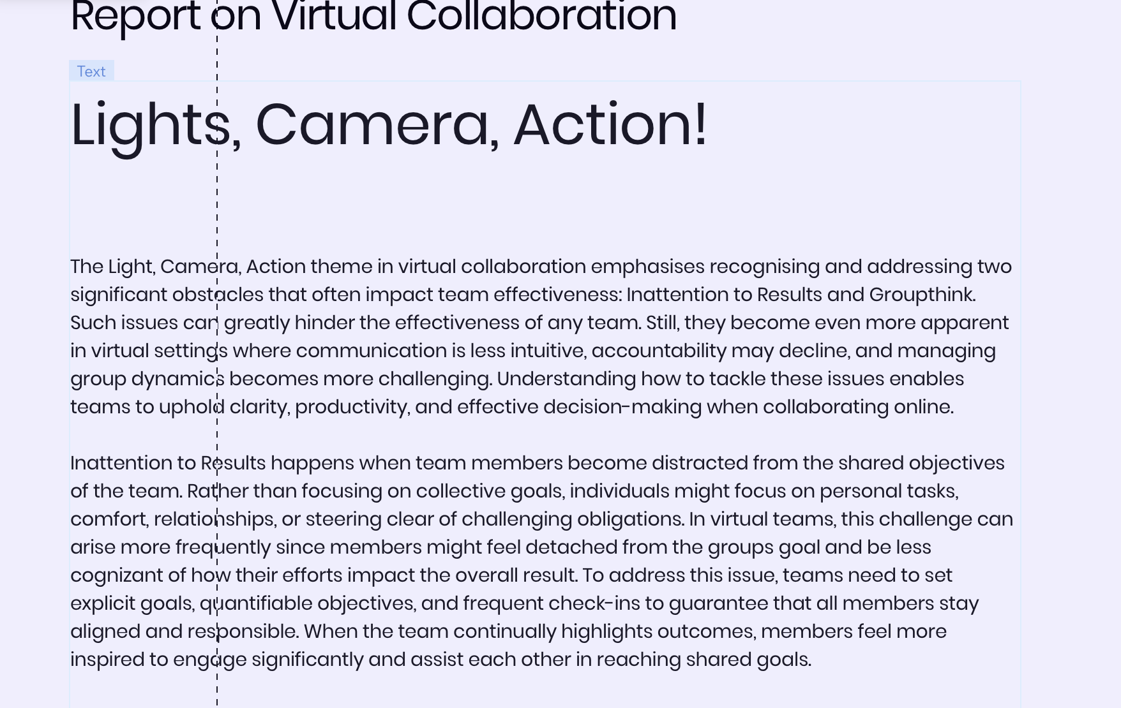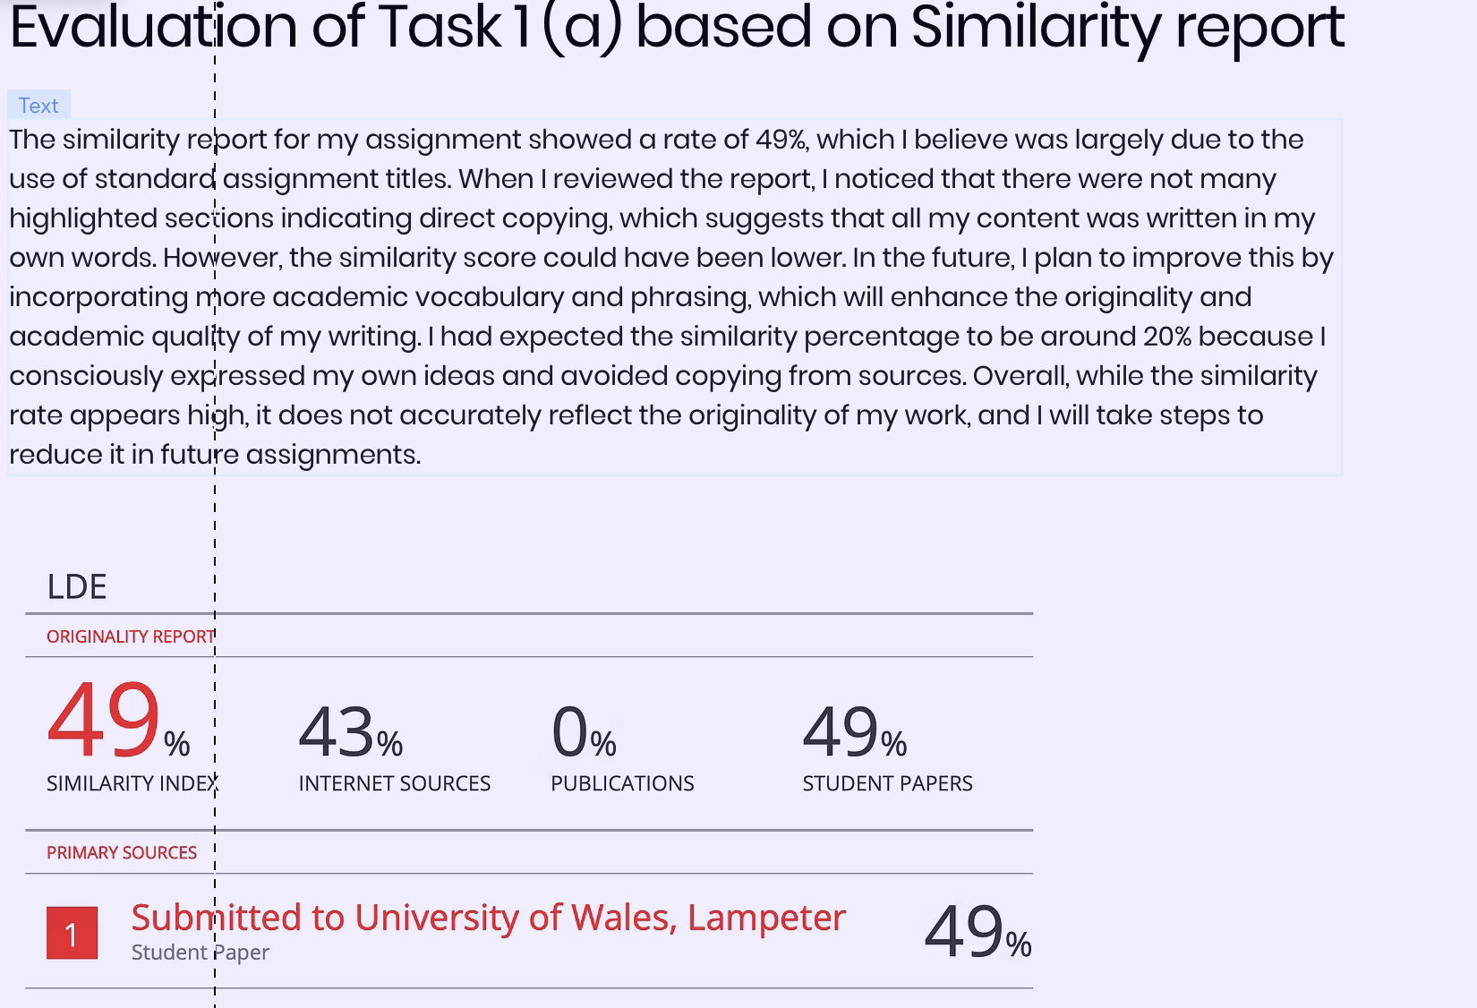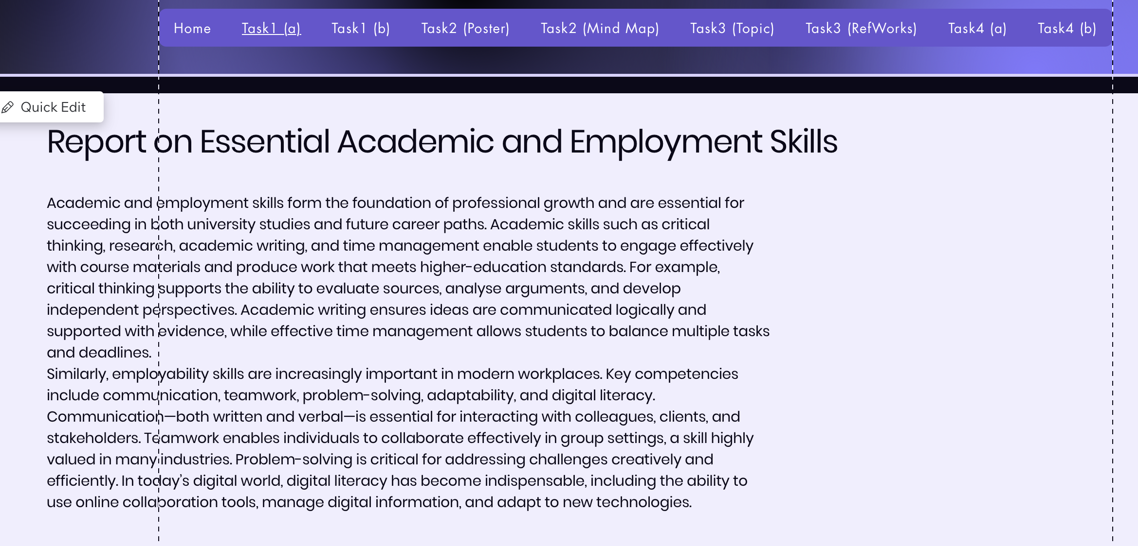

Task 4 (b): Illustrative Review of E-Portfolio tool Selection

I have used Wix to create my own portfolio. Overall, I had an enjoyable experience using Wix to build my portfolio, and I found the site to be both creatively flexible and easily accessible. Although I'm not an expert in website design, one of the things I valued the most was how simple it was to use the interface. I didn't need to know how to code to quickly create pages thanks to the drag-and-drop features, and the large number of templates made it easier for me to choose a starting point that suited my desired visual style. The process went more smoothly, and I felt more in control of the finished website thanks to the instant preview feature.

Conclusion

All things considered, finishing this task has strengthened my comprehension of the professional and academic abilities necessary for success in both university studies and future career. I was able to better understand how these skills directly support my chosen job path and long-term goals by exploring critical thinking, communication, teamwork, digital literacy, and time management. I was able to put these abilities into practice by making the academic poster and taking part in the teamwork exercise, which highlighted the value of cooperation and shared accountability while pursuing a shared goal. My capacity to properly organise references, which is crucial for writing respectable academic work, has improved as a result of using RefWorks and other digital tools. My digital communication abilities were further enhanced by creating my e-portfolio on an online platform, which provided me with a formal setting in which to showcase my work and evaluate my development. Also, this assignment has not only helped me better comprehend academic requirements but has also equipped me for real-world business situations where coordination, collaboration, and clear communication are crucial. It offers a solid basis for me to keep honing these abilities throughout my education and eventual profession.

References

Task 1 References:
References
[1] S. Drew and R. Bingham,The guide to learning and study skills: For higher education and at work, Routledge, 2017.
References
[2] D. P. Baker and E. Salas, "Principles for measuring teamwork skills," Hum.Factors, vol. 34, no. 4, pp.469–475, 1992.
References
[3] D. P. Baker and E. Salas, "Principles for measuring teamwork skills," Hum.Factors, vol. 34, no. 4, pp.469–475, 1992.
References
[4] M. Alvarez Sainz, A. M. Ferrero and A. Ugidos, "Time management: skills to learn and put into practice," Education Training, vol. 61, no. 5, pp.635–648, 2019.

Task 3 References:

References
[5] E. Glikson, et al., "Visualised automatic feedback in virtual teams," Frontiers in psychology, vol. 10, pp.814, 2019.

References
[6] J. Nemiro, et al., The handbook of high performance virtual teams: A toolkit for collaborating across boundaries, John Wiley & Sons, 2015.

References
[7] P. M. Lencioni, The five dysfunctions of a team: A leadership fable, John Wiley & Sons, 2002.

