

Programme: Certificate of Higher Education in Skills for the Workplace

Assignment Title: Problem Solving and Decision-Making
Module Code: BMSW4004

Submitted By:
Mr Syed Mustafizur Rahman
Student ID: 1818484

Table of Contents
Introduction 3
Overview of communication problem in Tesco 3
Analysis 4
Tesco SWOT analysis 4
Fishbone analysis of the problem 4
Possible solutions to the problem 5
Evaluation of the solutions 6
Implementation of the social intranet in Tesco 8
Communicating with stakeholders 8
Monitoring and review techniques 9
Conclusion 9
References 10

Introduction
In every place of work, we face a range of problems every day some of which might be severe as compared to the others. Problem solving is the act of defining a problem, establishing its root causes, identifying the possible solutions, prioritizing it and finally implementing the best solution to the problem. Good problem-solving skills are important for both personal as well as professional life. Having good problem-solving skills is therefore very important for every individual in the places of work since it allows one to identify a problem and solve it with much ease and effectively and in a timely manner (Skills you need, 2020).
Tesco was founded in 1919 and it is an international British agency which deals with both the groceries and general merchandising retail chain. Its headquarters is in Cheshunt and has been listed under the London Stock exchange operating many branches all over the world which operate both offline and online. It is made up of more than 472, 000 employees with a revenue of £62.54bn by 2010 which has risen over time. Tesco is a member of the Global Social compliance programme (Tesco, 2020). This report aims at using a range of problem-solving tools and techniques to analyse the communication problem at Tesco, identifying the possible solutions, evaluating the best solution, implementing it and review as well as monitoring it to ensure that the best results are obtained from the solution.

Overview of communication problem in Tesco
Over the recent times, Tesco has been facing a very big problem of poor communication among the employees, the management and other stakeholders especially during this period of the pandemic where some of the workers are working from home. The problem is majorly caused by various factors which includes inadequate application of technology in communication, the diverse workforce in the company which makes it hard to communicate effectively among other causes. The problem of communication has not only been facing Tesco but has also affected other companies across UK such as Mitel, HSBC among others and has caused major impacts on various dimensions of the business.
The problem of poor communication has not only led to poor interpersonal relationships among the employees and even the management but has also caused the company to lose a lot of revenue over the recent times. The poor communication has been the major cause of poorly made decisions in the company. The poor communication has also led to lowered motivation among the employees which has lowered the general productivity of the company as well as the performance of the employees. The poor communication has also led to negative impact on the service user’s satisfaction. If left unchecked, the problem poor communication might lead to a further drop in the profits of the company and further negative implication on the employees and service users.

Analysis
In the place of work which is made up of an increasing tendency of remote working, diverse workforce, increased teamwork approach, where technology is applicable, communication is among the major facts of productivity and performance. Good communication is required for every business firm to thrive and achieve its goals. Poor communication can have major negative implications on businesses which includes lowered employee morale and motivation, poor interpersonal relationships in the places of work, poor customer satisfaction, lowered productivity, lowered profits among other negative implications on the business firm. Poor communication problem also leads to increased stress in the place of work (Anne, 2019). Therefore, it is important of Tesco to deal with the problem of poor communication before it causes more harm to the company.

Tesco SWOT analysis
Strengths  - Great financial turnaround  - Big market share  - Ability to adapt well to various conditions  - Well trained staff  - Good location which attracts many customers | Weaknesses  - Poor technology usage  - Poor communication  - Poor leadership changes  - Poor quality control  - Safety issues on foodstuffs
Opportunities  - Expand its online stores  - Promote good communication practices  - Employ better use of technology  - Employ more employees | Threats  - COVID-19 pandemic  - Competition from other firms  - Brexit has led it to lose some of the customers  - Economic recession  - Online scammers

Fishbone analysis of the problem

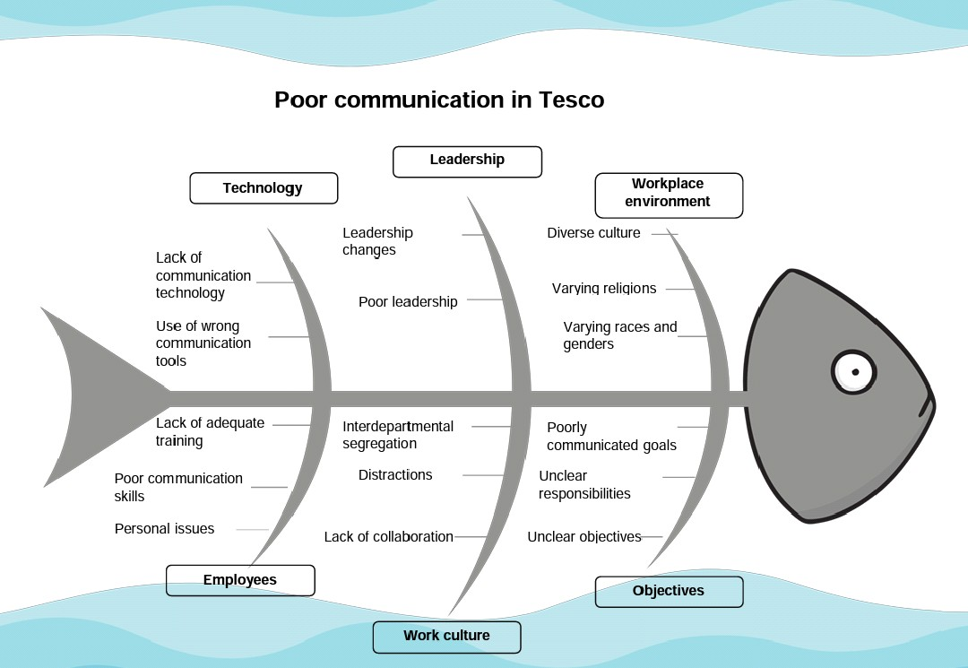

Possible solutions to the problem
Good communication is among the major foundations of a positive and a transparent culture in the place of work (Person et al., 2007). Solving the problem of poor communications in Tesco should be a priority in order to ensure that the employees are engaged, motivated as well as promoting better interpersonal relations in the place of work which shall enhance employee performance, motivation and increased productivity in the company. There are various possible solutions to poor communications in Tesco, these includes:
- Communications training for staff and leaders- there are various communication skills training which are available and the staff in all levels as well as the Tesco leaders should be trained on the various skills required for effective communication in the place work. Training all the staff as well as the leaders in all the levels of Tesco enables them to develop listening skills needed in business, both verbal and non-verbal communication cues, to build their rapport and to be empathetic in-service provision. It also enables them to communicate in a short and a simple manner and most importantly boosting their confidence while communicating.
- Development and implementation of an internal social intranet (social technology)- one of the major ways towards improving communication in Tesco is through development of a platform used to foster collaboration through better means of communication through implementation of an internal intranet. The intranet will provide a single means of communication which all the stakeholders of Tesco can use for communication thereby avoiding the problems arising from the use of multiple channels of communication in the company.
- Promoting diversity in the place of work- microaggressions, segregation, harassment and discrimination created a tensed place of work, promoting diversity in the place of work ensures that every individual in the place of work is respected and valued regardless of the different backgrounds (Kerri, 2019). Tesco should ensure that the employees and the leaders are trained to promote a diverse place of work. Through this strategy, Tesco can promote an inclusive workplace thereby improving the flow of communication from one place to another.

Evaluation of the solutions
Good communication is very important for every organizations for it to not only thrive but also to stay competitive in the highly competitive business world. Good communication allows for better engagement of the employees which bring out better results into the company. With the rising digitalization and increased use of technology, getting to engage people effectively in the organization has become very difficult and requires the use of innovative means to get the employees and other stakeholders engaged in the business (DeIuliis, 2016).
The solutions provided above are some of the major ways in which Tesco can solve the poor communication in the company. Each of these possible solutions have its advantages as well as disadvantages which are discussed below.
Communications skills training for staff and leaders as the first solution to the problem of communication in Tesco has various advantages and disadvantages. The advantages include: Overall enhancement of skills, it enhances the performance of the employees, it also enhances their productivity, improves staff and service user's satisfaction, provides a way for employees to share knowledge and skills, boosts employee morale, lowers the need for supervision and keeps the staff up to date with the new communication skills. However, training the staff on communication skills requires a lot of time as well as money, it also requires experts, interest from employees and a combined effort. Besides that, some of the employees who receives the training might leave for better employment (Chitra, 2017).
On the other hand, the other solution on promoting diversity toward improving on communication in Tesco also has varying advantages as well as disadvantages. One of the advantaged is that it will provide a communication friendly environment, allows all the staff to be free towards communicating effectively and openly. This also provides a cross-cultural understanding to communication while promoting creativity and innovative means of communication. However, creating a diverse environment is so challenging and takes a lot of time to bear the desired results. Promoting diversity also comes with various costs (Linda, 2019).
On the other hand, the use of internal intranet to promote communication also has its advantages and shortcomings. One of the advantages of this solution is that the use of a single communication channel not only promotes collaboration but also lowers confusion in the place of work which is usually brought about by the use of many communication channels. Besides that, the application of the social intranet in Tesco allows for storage of information for future use. This intervention also allows the employees and even other stakeholders to access the information, processes, news, notices and events anywhere in the world (Chantelle, 2019). Intranet will also allow Tesco to keep a database of the loyal customers and to segment them in accordance with the products and services in which they acquire from the company which makes it easy to communicate specific information such as promotion services to specific service users without overwhelming the staff. The use of mobile based intranet shall not only allow easy access to the services, products and information but also keep the remote workers connected whenever they are without even having the stress or costs of acquiring a personal computer to work from home during this period with a complete access to information just as their colleagues who are based in the offices. However, this intervention also comes with various disadvantages such as high costs required to implement it, the need for skilled labour and it also requires training, time support from all levels of the organization. Switching completely to this system will also take some time. It might also be complex.
The Plus Minus Interesting analysis of the use of intranet is shown below:
Plus (+) | Minus (-) | Interesting
Foster collaboration (+6) | High costs (-5) | It can be enhanced to perform more functionalities besides communication such as online services (+4)
Lowers confusion (+4) | Requires skills personnel (-4)
Access from anywhere (+4) | Need for training (-3)
Easy access (+3) | Time consuming (-3)
Promotes remote working (+5) | It comes with complexity (-4)
Easy to pass information to specific people (+3)
Total = +25 | Total= (-19) | Total = (+4)
There are many positives that comes with the implementation of the social intranet in Tesco as compared to the other solutions as from the analysis of its pros, cons as well as results from the PMI analysis table. This implementation of the intranet as a social technology therefore the best choice which shall be used to solve the poor communication problem in Tesco.

Implementation of the social intranet in Tesco
Implementing this solution shall take the following steps:
- Planning- here the actions needed to put the intranet in place shall be planned as well as how the actions shall be implemented. This includes coming up with objectives, goals and the desired outcomes from the solution. Here the timelines shall also be established, and all the resources needed acquired including the financial, materials, information and labour. A risk management plan shall also be put in place in this step. Besides that, a monitoring and a review technique shall be put in place in this place to ensure that the desired results are acquired.
- Implementation and monitoring- The second step is the actual implementation of the action where everyone tasked with any responsibility put the plans into action to put the intranet in place under close supervision to ensure that the work is up to the required standards while following the specified timelines. The actions shall also be monitored in this step to ensure that the requirements are met and correcting anything which might bring about negative results.
- Review and analysis- at the completion of the plan, the success shall be measured and analysed to establish if the implementation of the intranet solved the problem of communication in Tesco or not and if it can solve similar problems in future.

Communicating with stakeholders
Stakeholder | Influence | Message | Communication channel | Frequency
Staff | 3 | To attend to the weekly meeting to give their views and to learn on the use of the intranet | Notice on the noticeboards and email | Twice a week
Management | 4 | Request for financial support and all-round support | Email and word of mouth | Once in a month
Service users | 3 | Information on the planned changes and timelines | Email and messages | One in a month
Public | 2 | Any information on their interest | Advertisement | Once in two months

Monitoring and review techniques
To review this solution, the success of the solution shall be established and compared with the expected results from the plan. Besides that, feedback shall be acquired from various stakeholders through surveys while benchmarking with other units.

Conclusion
Workplaces face numerous problems every day from the workforce, service users, processes, leadership, communication and other aspects of the organization which might have a negative implication on the organization. Problem solving allows the organization to deal with these problems effectively by coming up good solutions to these problems and keep the companies thriving and competitive. This report made use of a range of problem-solving tools and techniques to analyse the communication problem at Tesco, identifying the possible solutions, evaluating the best solution, implemented it and provided the means of reviewing the solution as well as monitoring it to ensure that the best results are obtained from the solution.

References
- Anne Kinsey (2019) Impact of poor communication in the place of work [Online] Available at: <https://smallbusiness.chron.com/effects-poor-communication-business-345.html> [Accessed 17th December 2020]
- Chantelle Corbin-Herbison (2019)4 ways to fix poor communications in the workplace [Online] Available at: <https://www.interact-intranet.com/blog/4-ways-fix-poor-communications/> [Accessed 15th December 2020]
- Chitra Reddy (2017) Staff training [Online] Available at: https://content.wisestep.com/staff-training-importance-benefits-advantages-disadvantages/ [Accessed 15th December 2020]
- DeIuliis David (2016). Workplace Communication". Communication Research Trends. 35 (1).
- Kerri Harris (2019) Communication and diversity [Online] Available at: https://www.writingassist.com/resources/articles-3/communicating-for-diversity/ [Accessed 14th December 2020]
- Linda Emma (2019) Promoting diversity in the place of work, advantages and disadvantages [Online] Available at: <https://smallbusiness.chron.com/advantages-disadvantages-diversity-workplace-3041.html> [Accessed 16th December 2020]
- Person Sharon, J. Person and Steven M. (2007). Workplace communication: process and product. Upper Saddle River, NJ. Pearson Prentice Hall
- Skills you need (2020) Problem solving [Online] Available at: https://www.skillsyouneed.com/ips/problem-solving.html [Accessed 16th December 2020]
- Tesco (2020) About us [Online] Available at: <https://www.tescoplc.com/about> [Accessed 16th December 2020]

