Festo Cyber Physical Production System
Elliot Jenkins
October 5, 2022


Contents
Abstract 3
Introduction 4
Main Body 5
Current Gripper and Problem 5
System Requirements. 6
DFA – Design for Assembly 7
DFM- Design for Manufacture. 7
Current Market Designs 9
Quality Function Deployment 10
Fishbone Diagram 11
Design Failure Mode and Effects Analysis (DFMEA) 12
Design for Manufacture (DFM) 13
Final Design 14
Evaluation 16
References 18

Introduction

Within the industry of manufacturing robotics have become essential in improving and increasing productivity. The impacts of robotic manufacturing has spread worldwide, improving throughput and achievement for many companies (Matt, 2020). Jefferies (2020) highlights that the industrial revolution introduced the thought of using machines to improve production whilst decreasing costs. Due to the increase in use of robotics, human personnel are released from duties that robots can quite easily execute. Employees can now use more of their time to give to much necessary knowledge and ideas within superior managerial roles. As Schatsky (2021) suggests by taking advantage of the use of robotics within manufacturing, “not only improve efficiency by taking on tasks that humans used to do, but they also have the potential to enhance it.” Robotics in industry can have many uses, in this reports the main function of the robot will be material handling, additionally robotics in industry can be used for other tasks such as welding, assembly, dispensing and processing.
Firstly, the aim of this report is to discuss the development of designing and producing a robotic gripper arm, which will be attached to a Festo manufactured collaborative robot (cobot). With the cobots main intended function to unload a completed product from the dispatch station of the CP Lab, and subsequently load them onto an autonomous guided vehicle for transportation. The goods being transported are mobile phones. Secondly, the report will show research into the current designs available for a FESTO robotic gripper, with the benefits and limitations of the current market and the requirements that need to be met in this case. By using the research available, designs can be made to maximise the potential for the gripper to be made to suite the design specification available. Thirdly, within this report the method will be shown in which the design was implemented, using principles such as design for manufacture, failure mode effects analysis to ensure that the robotic gripper arm meets the design specification provided.
The gripper arm is part of a production line producing mobile phones, run by a computer software called CP Lab systems. This is a software in which controls several stages of a production line, in which the cobot transports the mobile phone in various stages of manufacture. There are various stages in production such as the fuses being attached to the PCB, or the phone covers being pressed together. The software system requires all parts to work efficiently together in order to make the process run smoothly, if there was to be an issue with the gripper securely lifting or moving the product, the whole production line would stop, thus potentially costing profits to decrease with production stoppage.

Main Body

Current Gripper and Problem

The current gripper that is being used within the production line is as shown in Figure 1.The current problem with the gripper is that when picking up the product which is a mobile phone Figure 2, the top half section of the phone detaches itself. This is due to the gripper not fully gripping the full depth of the product, with this occurring it will lead to downtime in the production process. As IGAM (2020) mentions “downtime is the period in which any machine is not in production for any reason, and unplanned downtime can have disastrous effects on the productivity of the entire facility”. The customer desires the gripper to be able to pick up and place the product with precision so that the whole product is able to be transported to the next stage of the production line. The gripper must be robust to withstand continual use to able to achieve this function numerous times in order to keep the production line going.

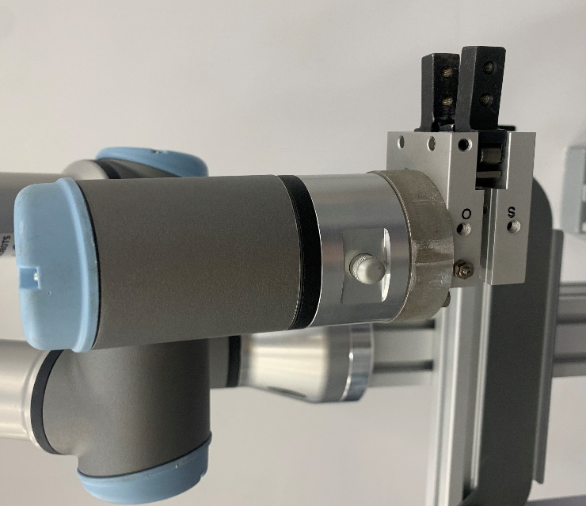
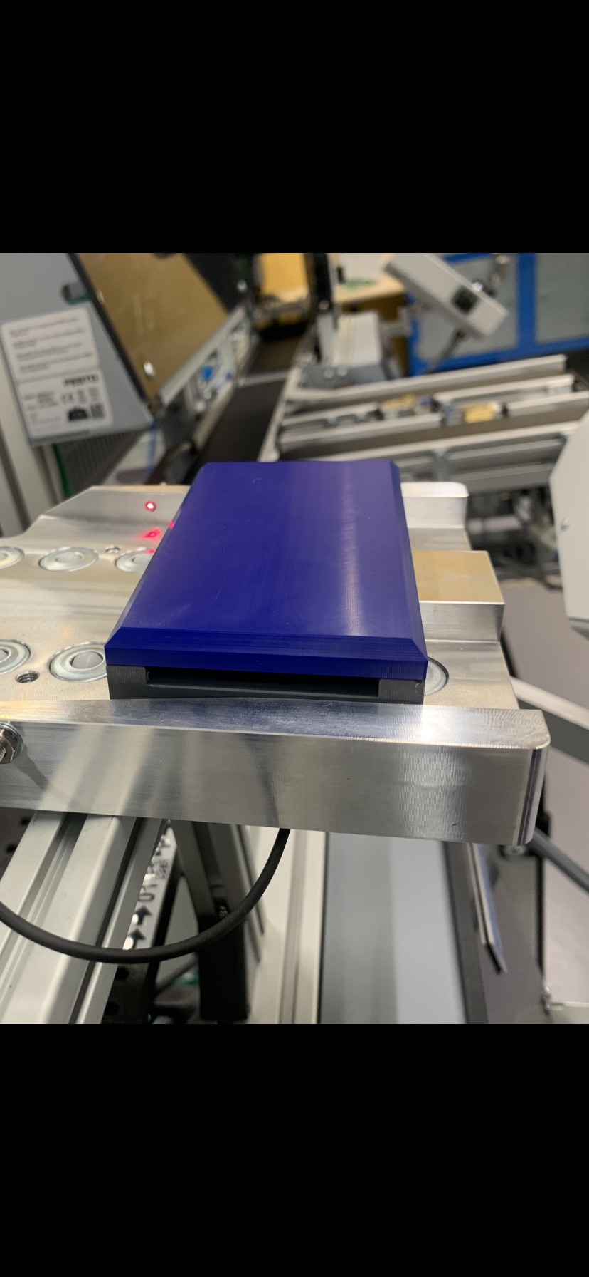
Figure 1 - Own Author- Current Gripper
Figure 2- Own Author – Product/ Mobile Phone

System Requirements.

As previously mentioned, there are system requirements that must be met in order for the new gripper to be successful within the production line. The customer has also given us requirements in which must be met to ensure it meets its design criteria. Design criteria are very important objectives that must be met for a project to be achieved, it is essential not to be unclear and make the design criteria short and detailed as possible (King Edward VI Foundation, 2022).
The system requirements are shown below in which the gripper would need to meet.
- Should be able to pick and place the product/mobile phone from the output station and load them onto the autonomous guided vehicle for transportation of inventory.
- The gripper must be made from a process for high volume manufacturing.
- Must be made from a material that can withstand being in constant loading without failure.
- Must be made from a hard-wearing material.
- The gripper must be able to grip the product without damaging it.
- The gripper must fit the current FESTO cobot.
- The gripper must be actuated as stated in the design criteria.
- Should be made from a non-corrosive material.
- Will be made from a lightweight material.
- Should have sensor limits installed in order from the gripper to detect where the mobile phone is located.
- The gripper must be made from a material that can be cleaned and maintained with ease.
- The gripper must have a cushioning in order for the product not to get damaged when being gripped.
- The jaws must be able to pick up the entire phone when loading.

DFA – Design for Assembly

When constructing a new product, part or component, the DFA Design for Assembly is a design process that is used to look at ways to simply a products design but reducing the number of parts. Which leads to decreasing costs and increase the easy of assembly (rapiddirect, 2021). The overall aim is to make the manufacturing process quicker, easier and becoming extra productive. When starting a DFA the designer should think about the following considerations:

- Reducing the number of parts
- Built in fasteners such as pins or clasps.
- Part Proportion.
- Error proofing.
- Use of standardised components or parts.
- The use of reasonable tolerances.
- The amount of materials being used within the part.
- Will that part be able to be reused once its performed its function.
- Is there need for automation to assemble or can it be done by hand.
By considering all of these factors throughout the design phase will help reduce the manufacturing costs, which will lead to improving the overall profits ( Velling, 2021).

DFM- Design for Manufacture.

Design for Manufacturing is a tool used to help enhance a product or parts design, to make it more cost effective and easier to manufacture. DFM includes efficiently designing a product usually during the products design stages, when its more practicable and cheaper to do so, which leads the reducing manufacturing costs. This helps the manufacturer to detect and avoid mistakes or inconsistencies (TWI,2022). The overall aim of DFM is to reduce costs without lowering performance, below are a few ways in which can affect the design for manufacturing process:

- Lower the part count – By reducing the number of components within your product will be the quickest way to reduce costs, due to reducing the quantity of material needed, the amount of engineering, product and labour required.
- Design for effective joining – Seek out ways to join parts without the need for pins, screws or fasteners. If needing to use fasteners, it is vital to use standard fasteners where it is achievable, try to use self-tapping or chamfered screws for better location. Also, reduce the number and variations of fasteners to its lowest.
- Standardise materials and parts - By using standardised quality parts will help lower production time, this is due to parts being more available and are able to rely on their consistency .By lowering production time will ultimately help lower your overall cost.
- Reduce the reorientation of parts during machining and assembly – Designs of parts should be constructed where there is a limited manual interaction required during the production and assembly.
- Streamline “ acceptable” finishes of surfaces - It is key to go with a part that has a surface function over a surface for aesthetics, this could lead to lower cost in manufacturing and production times (Rasmussen, 2018) .

Current Market Designs

There are several types of cobot grippers on the market, the main types are:
- Pneumatic grippers – Ideally using compressed air to open and close fingers or jaws. Normally designed using 2 fingers configurations for smaller products such as our mobile phone or a 3-finger configuration for larger products. The 2 fingers gripper is more suitable for roles that require gripping and dexterity over a 3-finger gripper that can pick up more weight. One of the biggest advantages of using this type of gripper is that they are inexpensive to make whilst still having the ability to grip products with adequate force (Robert, 2021).
- Vacuum Grippers- These are constructed with a number of suctions cups. Using an air pump to create an airtight seal between the cups and a flat surface that they pressed to, which creates a suction removing any air inside. A pressure difference is created, which is what allows these grippers to lift heavy items with somewhat ease. These types of grippers are extremely popular, although due to their vacuum pumps and power compressed air required these types of grippers will use a vast amount of electricity resulting in added costs. (Davis, 2021)
- Hydraulic Grippers – These type of grippers are used mainly where strength is required, where they can generate up to 2000psi, usually these are used in operations where a large gripping power is required for heavier objects. Hydraulic fluid is required when using this operation therefore the process can be a lot messier due to the oil, also these type of grippers require more maintenance due to the large forces used in its operation.
- Electric Grippers – Normally used for light to moderate operations with high speed of operations. They are used ideally in pick and place production lines, with two or three jaw configurations, by using force sensors they are good at handling various part types. These can be expensive compared to other types of grippers and provide least gripping force.

Quality Function Deployment

A QFD or Quality Function Deployment is another process or set of tools that can be used to help define a customer’s requirements, converting them into detailed engineering specifications and procedures to produce the products that fulfil those requirements. Below is a basic QFD table on the four types of grippers on the market.
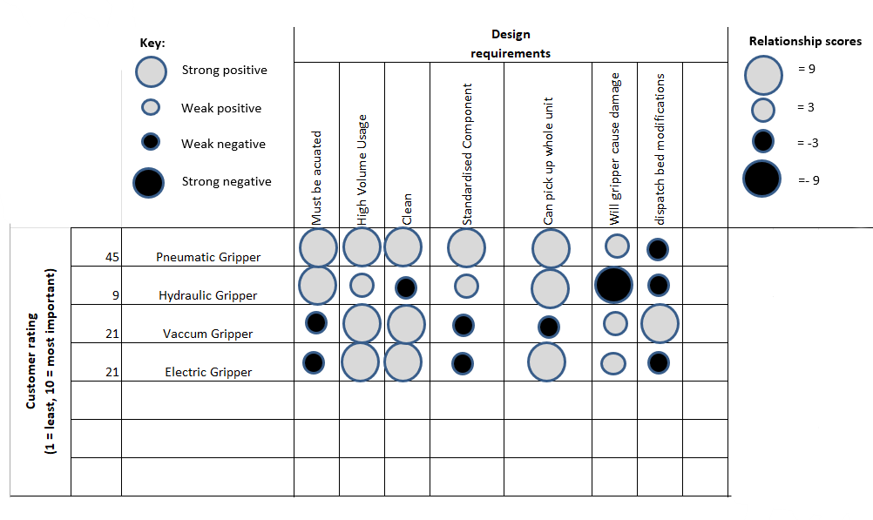
Figure 3 - Own Author QFD table.

The basic QFD show can give us a quick display of what grippers are most suitable to take forward to the next design phase. With the Pneumatic gripper scoring the highest and hydraulic gripper scoring the lowest against customer requirements. As previously mentioned, the product/ mobile phone cover has a flaw that when being picked the top cover removes itself from the bottom cover, this itself calls for specific gripper to be used. Therefore, a device such as the vacuum gripper will not be suitable due to the gripper creating a suction with the top part of the product which will most likely leave the bottom cover on the bed plate. Also, parts for the vacuum grippers are not standardised and may have to be tailored for the specific task.
The customer requires that the product is actuated with the electric gripper being powered by a small motor and a vacuum gripper being controlled by a suction pump, meaning neither of these grippers can be used in the next design.
Hydraulic Grippers scored the lowest, this is due to hydraulic grippers being tailored to lift heavier objects this could potentially damage the product, also being powered hydraulically there is an element of mess that can be associated with hydraulic oil.
The highest scoring gripper is the Pneumatic gripper, this is mainly due to meeting most of the customers’ requirements, such as being actuated, able to pick up the whole product, would be sustainable in high volume usage and having standard components used. The only negative point for the pneumatic gripper would be that the dispatch bed may have to be modified, as stated the top half of the product can separate from the lower easily, additionally I would suggest the gripper be made so that it can pick up the product from underneath to achieve more security when transporting. Also, by adding rubber grips to the inside of the jaws it would add another layer of security when transporting. Pneumatic grippers have the option of having either 2 or 3 jaws in its make up. In this type or production, a 2 jaws would be more suitable as the load of the mobile phone is little, and the cost is lower than a 3 jaw gripper, for more heavier objects a 3 jaw gripper may be more suitable.

Fishbone Diagram

“A fishbone diagram or Ishakawa is a visual graphic display or representation of potential causes of a given problem or defect”( Kanbanize 2022 ). This diagram helps groups to display their ideas of potential issues or root causes. The diagram is to help brainstorm or brain shoot quality related issues. The visualization of the diagram is efficient for overall process enhancement. Below is a fishbone diagram of the pneumatic gripper, showing the potential causes, defects, problems or potential issues. The fishbone diagram is shaped as the name suggests, the defects as located at the display the head of the fish and bones t the biggest identified root cause, the sub causes are presented as the ribs.

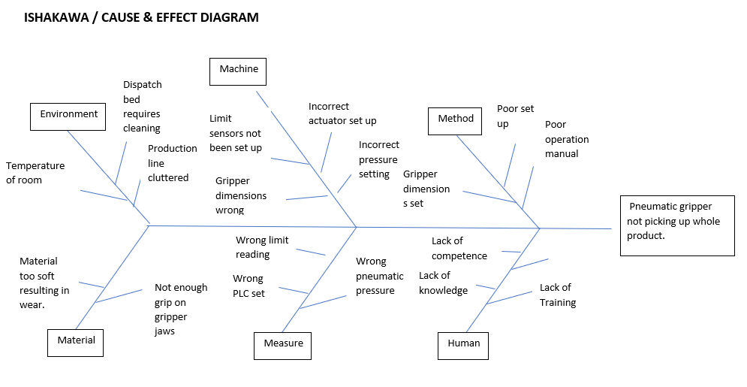
Figure 4 - Own Author Fishbone diagram

Design Failure Mode and Effects Analysis (DFMEA)

Design failure mode and effects analysis is a logical approach used for recognising potential risks into a new or changed product. “The DFMEA initially identifies design functions, failure modes and their effects on the customer with corresponding severity rankings or dangers of the effect” (Quality-One, 2022.) DFMEA helps eliminates or lessens the failures, by completing an DFMEA is also provides a written account of the work performed. DFMEA helps engineers detect failures at the earliest points, which can then be correct without causing significant costs, It is essential in manufacturing to lower risk reduction and failure prevention (Montgomery, 2019). Below is a DFMEA for the pneumatic gripper.
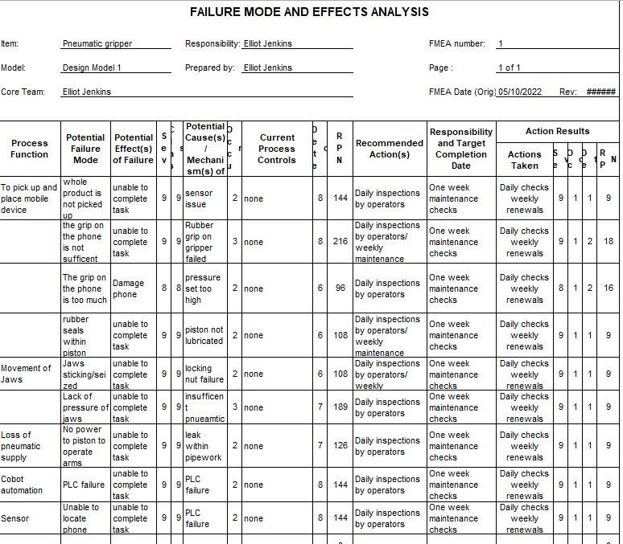

Design for Manufacture (DFM)

Design for manufacture is the engineering practice for constructing products in certain way that it is simple to manufacture. The end goal of creating a better product that will be produced at a lower cost, for example making the pneumatic gripper in a refined design for it to be mass produced at lower cost. DFM ideally needs to occur at the beginning of the design process, including all stakeholders and designers to ensure that the design is optimal, not incurring any costs that are not necessary (Manufacturing, 2022.). Normal principles of DFM include such as designing products for efficient assembly, standardisation of material and components, decreasing the number of parts , and decreasing the amount of manufacturing functions required on parts during assembly (www.twi-global.com, 2022.). The gripper will be designed with minimal parts needed, with easy of assembly in order for it to be inspected or replaced if needed. Creating a design that can be mass produced easily to reduce overall costs, with standard fasteners such as hex screws and bolts, by using standard fasteners there shouldn’t be any downtime for looking for unstandardized parts to repair it.

Final Design

By using the previous tools such as the QFD, Fishbone Diagram, DFMEA , and DMA information is provided on what type of Gripper is required, pneumatic that has suitable grip to grip and transport the whole product continuously. By using replaceable rubbers grip pads on the gripper will help not only with grip but with the overall cost of just replacing the pads over the actual gripper jaws.

The gripper arm should be constructed from the manufacturing process of Aluminium Die Casting. The reason for this is due to its rapid solidification rates which then allows for mass volumes in production to be attained in a short space of time, as well as achieving good surface finishing at a low cost (Alteams, 2019). Characteristics and Advantages of Aluminium Die Castings include:
- Lightweight and Durable
- Good Strength-to-Weight Ratio
- Great Resistance to Corrosion
- Excellent Electrical Conductivity
- Fully Recyclable and Reusable in Production. (PHB Inc., 2022).

Below in figure 5 is a possible improvement of design of a pneumatic gripper, by using standardised parts such as cap head bolts, and by using the aluminium die casting for producing the gripper arms it will reduce overall cost of production.
With the design brief stating that the top half of the mobile phone detaches itself when the current grabber picks the product, it was decided that if hooks were designed on the bottom of the jaws it could pick the product more securely. Additionally, rubber grips were also attached to the jaws which will add to improving the grip the jaws have when picking the product. These can be attached using adhesive after the jaws have been through the casting process.
The same size diameter holes have been used in the new design as shown in figure 6, they can be transferred onto the original actuated bracket. Reducing the need and cost of replacing the old mechanical system with knew, as the jaws were the original issue not the mechanically actuated system. The Jaws can be attached using the same cap head bolt as previously used before, so the same parts should already be held by the maintenance team.
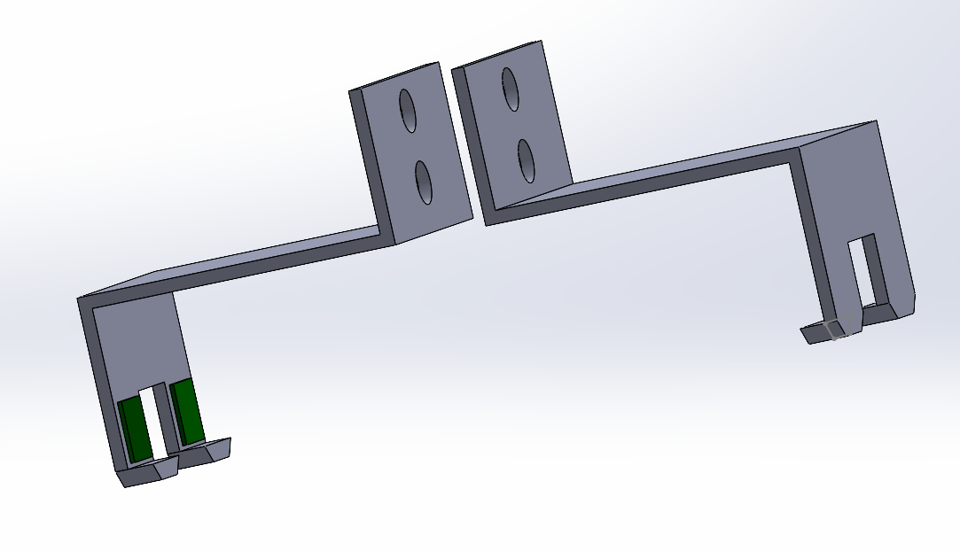
Another improvement that can be made it by adding sensor alongside pneumatic grippers to monitor and control the operating position of the fingers. Sensor switches can be mounted on the pneumatic grippers. Sensors can detect the open or closed position of the fingers. Proximity sensors can detect the proximity by sensing the object and provide the information back to the controller. By using these devices, it should prevent any damage to the product by over gripping and potentially marking the product (Tameson, 2022).
Figure 5 Own Author - Final Design Gripper

By having the hooks attached to the bottom of the jaws would not work with the current dispatch bed, therefore a new design bed has been drafted as a first design as shown in figure 7 . By having these notches machined out of the bed will help the gripper pick the mobile phones from the dispatch area with ease, and as a whole unit.

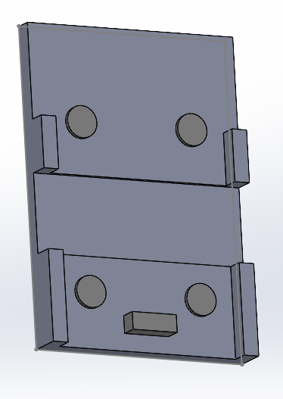
Figure 7 – New Design Bed Plate.
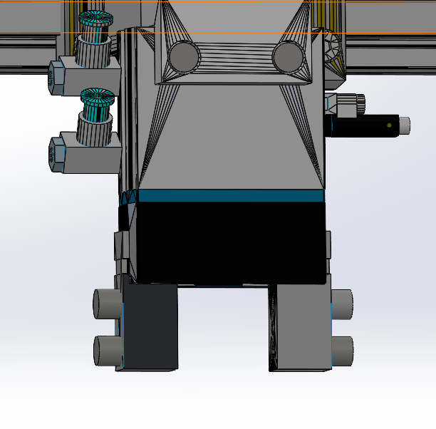

Figure 7 - Own Author - Existing Actuator

Evaluation

The aim of the assignment was to design an end effector, that would be to operate at a high manufacturing level. By mass producing the product using aluminium dye casting, using standardised parts off the shelf, and applying the previous mechanical actuated system, the ability to lower costs has been achieved. The manufacturing process has been enhanced where more time and money can be reinvested back into the process. Using failure analysis, the design has be improved to reduce the previous failures in the process. Aluminium dye casting is 100% recyclable , meaning that both the moulds and the jaws can be recycled when they have degrading within the process. By using failure analysis tools it has also led to the potential redesigning of the bed plate, to lead to more efficient picking by the jaws during the process.

References

Alteams. (2019). Aluminium casting method comparison – Pros and cons of different casting methods for aluminium parts - Alteams Aluminium casting method comparison - production volume matters. [online] Available at: https://www.alteams.com/aluminium-casting/.
David Schatsky (2021.). Robots uncaged. [online] Available at: https://www2.deloitte.com/us/en/insights/focus/signals-for-strategists/next-generation-robots-implications-for-business.html [Accessed 15 Jun. 2022].
Davis,L. (2021). 4 Types of robotic grippers and their Pros and Cons. [online] Available at: https://metapress.com/4-types-of-robotic-grippers-and-their-pros-and-cons/.
iGAM (2020). How to Prevent Downtime in Your Manufacturing Process. [online] blog.igam.com. Available at: https://blog.igam.com/how-to-prevent-downtime-in-your-manufacturing-process#:~:text=If%20you%20run%20a%20manufacturing%20plant%2C%20then%20you [Accessed 4 Oct. 2022].
Jeffries, M. (2020). How are Robots Used in the Manufacturing Industry? [online] www.maderelectricinc.com. Available at: https://www.maderelectricinc.com/blog/how-are-robots-used-in-the-manufacturing-industry.
Kanban Software for Agile Project Management. (2022.). What Is A Fishbone Diagram? [online] Available at: https://kanbanize.com/lean-management/lean-manufacturing/root-cause-analysis/fishbone-diagram#:~:text=The%20fishbone%20diagram%2C%20also%20known%20as%20the%20cause-and-effect.
Manufacturing, E.W. (2022.). What is Design for Manufacturing or DFM? [online] news.ewmfg.com. Available at: https://news.ewmfg.com/blog/manufacturing/dfm-design-for-manufacturing#:~:text=Design%20for%20Manufacturing%20%28DFM%29%20is%20the%20process%20of
Matt (2020). Impact of Robotics in Manufacturing. [online] Mantec. Available at: https://mantec.org/robotics-manufacturing/.[Accessed 15 Jun. 2022].
Montgomery, C. (2019). What Is DFMEA? [online] Ansys.com. Available at: https://www.ansys.com/blog/what-is-dfmea.
rapiddirect. (2021). Design for Assembly and its Use in Product Manufacturing. [online] Available at: https://www.rapiddirect.com/blog/design-for-assembly/.
Rasmussen, P. (2018). What is Design for Manufacturing or DFM? [online] Ewmfg.com. Available at: https://news.ewmfg.com/blog/manufacturing/dfm-design-for-manufacturing.
Robert (2021). 10 Types of Robot Grippers | Types of Grippers Used in Robotics. [online] Robotics Shop. Available at: https://roboticsshop.net/types-of-grippers-in-robotics/#:~:text=Types%20of%20Mechanical%20Grippers%201%20Two-Jaw%20Gripper%202 [Accessed 4 Oct. 2022].
The Schools of King Edward VI in Birmingham. (2022.). KS2 Design - DESIGN CRITERIA - 2. Design Criteria. [online] Available at: https://www.schoolsofkingedwardvi.co.uk/ks2-design-design-criteria-2-design-criteria/#:~:text=Design%20criteria%20are%20the%20really%20important%20goals%20that [Accessed 4 Oct. 2022].
Velling,A. (2021). Design for Assembly (DFA) Principles Explained. [online] Available at: https://fractory.com/design-for-assembly-dfa/.
www.twi-global.com. (2022.). What is Design for Manufacturing (DFM)? [online] Available at: https://www.twi-global.com/technical-knowledge/faqs/faq-what-is-design-for-manufacture-dfm#:~:text=Design%20for%20Manufacturing%20or%20Design%20for%20Manufacturability%20%28DFM%29 [Accessed 5 Oct. 2022].
www.twi-global.com. (n.d.). What is Design for Manufacturing (DFM)? [online] Available at: https://www.twi-global.com/technical-knowledge/faqs/faq-what-is-design-for-manufacture-dfm.

