Drama Provision in Rural Wales
‘Exploring the link between mental health and the performing arts industry’
Introduction
Drama can be used to aid in people’s learning, wellbeing and develop essential skills that they can use in the future. It doesn’t just have to be for those who want to go into acting, it can be available to all in many different ways, “drama is considered an all-inclusive medium. It embraces all types of topics and represents all kinds of people and situations.” (Mittal, 2018) As someone who grew up in a rural area of Wales, I’ve seen first-hand the lack of opportunities young people have faced getting into the creative industry and believe more should be done for young people to access these facilities who can sometimes be forgotten about because they don’t live in the big cities or well-developed areas. This is why I decided to do my independent project on drama provision in rural Wales and how it can benefit those that struggle with mental health issues, as poor mental health is getting worse within society; “current levels of good mental health are disturbingly low”. (Mental Health Foundation, n.d.)
Mental health has become a big problem within the UK according to a survey commissioned by the Mental Health Foundation in 2017 which suggests that “nearly two-thirds of people (65%) say that they have experienced a mental health problem”. (Mental Health Foundation, n.d.) This is also backed up by Natasha Devon that states that “in the 1960s the average onset age for depression was 45. Today it is 14.” This is quite shocking to see how mental health has changed and how big of a problem it has become within our society. (Devon, 2016) This is down to a lack of services, support and digital connectivity especially in rural parts so providing a space that uses drama as a way to explore an individual’s emotions and experiences that they find difficult to talk about could be really useful for people to not take the weight of the problem on themselves, which has a negative effect on their mental health, but be able to communicate through expression to get help and relieve the pressure.
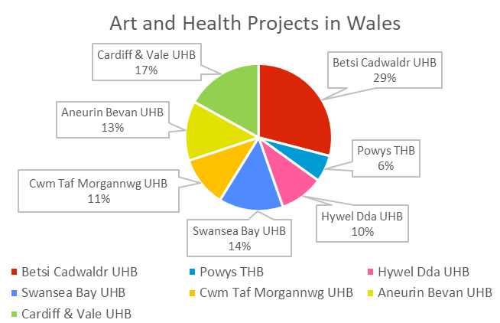
The Arts Council Wales declared that in Wales “1 in 4 people will experience mental ill health at some point in their lives”, I believe this can be down to many different factors for people living in rural areas of Wales from a lack of opportunities to socialise with other people outside of work or school and having poor services with not much support close to where they live. (Arts Council Wales, 2018, p.30) This paired with poor public transport infrastructure in rural areas put children and people at a huge disadvantage with them facing “prolonged insolation, exclusion and insecurity” because it makes it harder for them to access facilities that are not being provided where they live so having to travel further and therefore leading to making their mental health worse. (Centre for Mental Health, 2020)
Figure 1: Pie Chart showing percentages of Art and Health projects across the different Health Boards in Wales. (p.58)
I decided to focus mainly at the county of Powys not only because its where I grew up but because it’s the “most rural county in Wales and among the sparsest in the UK” according to Powys Public Service Board. (Powys Public Service Board, 2017)
From looking at the Arts Council Wales document, I noticed from the statistics that Powys and other rural areas in Wales have less arts and health projects for people to get involved with compared to North and South Wales. I created this pie chart (Fig: 1.) showing the percentage of art and health projects available in each area of Wales from the statistics I found in the ACW document. Considering Powys is the biggest county in Wales it has the least amount of creative opportunities and projects for people to benefit from with only 17 projects provided by Powys Teaching Health Board whereas there are 84 in North Wales and 160 projects in South Wales because they have more developed and established support in the health boards. (Arts Council Wales, 2018, pp.58-60) This makes it seem like mid-Wales and other rural regions in Wales are being left behind, overlooked, not supported and have a lack of funding going into organisations or projects that could potentially help improve mental health rates throughout Wales not just in the big cities of North and South Wales. All people in Wales should receive similar amount of support and opportunities when it comes to improving their mental health however this isn’t the case, as people in the countryside are feeling isolated and not thought about enough which is having a negative effect on their lives and on future generations. The lack of funding for “Arts and Health commitments has resulted in unwitting inequality across the Health Board areas”. (Arts Council Wales, 2018, p.82)
I wanted to look into drama provision that is in rural Wales currently to see if there are more drama facilities in Powys than I originally thought and if there is a lack in the number of drama provision in Mid-Wales compared to more urban areas. I specifically looked at the county of Powys as its where I’m from and where I noticed the lack of provisions available for young people to get involved with the arts while growing up. According to the Powys County Council website there are a few theatre establishments across Mid-Wales that provide the opportunity for communities to watch shows performed by touring companies national and international as well as both amateur and professional groups, comedians, singers and orchestras. The council help fund 4 theatres across Powys which are Theatr Brycheiniog in Brecon, The Wyeside in Builth Wells, Theatre Hafren in Newtown and The Welfare Theatre in Ystradgynlais. Also from this website, I came across a scheme called Arts Council Night Out which I haven’t heard of before but it’s a scheme that “supports professional performing arts events in Powys”. (Powys County Council, n.d.) This suggests that the scheme will hopefully allow for more performances to happen in the area through the support of funding, providing more platforms for performers and to make the most out of the venues available in order to bring the arts to communities that have little access to them.
I came across 2 more websites which provided a list of amateur dramatic groups and performance/theatre spaces across Wales generated by Keith Morris (n.d.). Even though some of the groups and venues listed no longer exist, I calculated quite a few within Mid-Wales and Mid-West Wales that still offer drama provision for people in the areas. I found that out of 108 theatre and performance venues listed in this website, only about 25 of them were provisions within Mid and West Wales. These include the 4 from Powys website as well as The Albert Hall in Llandrindod, Theatr Felinfach in Ceredigion, The Willow Globe Theatre which is an open-air theatre in Mid-Wales between Rhayader and Llandrindod, Aberystwyth Arts Centre, Torch Theatre in Milford Haven and Lyric Theatre in Carmarthen to name a few. (Morris, n.d.) While in the other website on drama groups in Wales, out of 213 only about 35 were drama provisions in Mid and West Wales. These include: Mid Powys Youth Theatre, Mid Wales Opera in Newtown, Newtown Amateur Dramatic Society, Small World Theatre in Cardigan, Guilsfield ADS in Welshpool, Carmarthen Amateur Operatic Society and more. Many of these companies are community drama groups for young people to get involved with and some do Theatre in Education workshops as well. (Morris, n.d.) However, most if not all of these venues and drama groups are based in big towns within the rural communities so those that live in outlying villages still would have to travel to get access to these, therefore I believe more use should be created in village halls to provide art activities in less populated places in the rural areas.
I decided to look into the main factors that contribute to mental health problems. Mind UK is a mental health charity that specialises in supporting and raising awareness of mental health so people gain an understanding of what mental health is, stop the stigma surrounding it and develop strategies to cope. The charity states that there are many different mental health problems including: depression, anxiety, personality disorders, schizophrenia to name a few which left untreated can have a huge impact on everyday functioning leading to other problems like sleep problems, eating problems, self-harm etc. and interfere with your work, social and relationships with others. I took time to consider the causes of bad mental health in order to help me develop a workshop that can be beneficial for people who struggle with mental health issues and create techniques to manage them in a safe way. Again, there are many ways in which poor mental health can surface. These can factor from childhood such as abuse, neglect or trauma, loneliness or social isolation, money troubles like debt or poverty, bereavement, drug or alcohol addiction, domestic violence, bullying, significant trauma, stress, homelessness or physical health problems. (Mind UK, 2017) A lot of hospitals, clinics and charities are using art therapy with their patients because they’ve found that that it helps to explore thoughts and feelings that are difficult to put into words, to understand those feeling and themselves better, encourage positivity and allows people to connect with others who are going through similar situations. (Mind UK, 2021)
I’ve personally felt that doing drama has allowed me to cope with and slight improve my mental health in certain ways. I took time to consider how other countries use drama as therapy to help improve mental health in people.
An arts therapy psychotherapist Emma Rasalingam states that having done psychotherapy drama workshops with hundreds of children, she has seen first-hand the benefits the models have on their mental health and well-being. As many children and young people spend so much of their time learning in school, this becomes the place in which they cause trouble and act up because of problems they aren’t able to deal or cope with on their own so they seek attention in order to get help. Drama creates a safe and creative space where children can express themselves freely and resolve problems in a playful setting. Having put art therapy workshops on with Year 6 boys who had been referred to her for bullying and showing intimidating behaviours, she noticed that they became comfortable showing emotion with the rest of group and were willing to play different characters even females in scenes. Rasalingam also witnessed children who were silent and struggled to vocally express themselves with others become self-assured and want to play lead roles in productions to fill the space with their voice. (Rasalingam, 2018) Many business organisations are using theatre-based workshops for soft skills training to develop “leadership, communication, creativity, team building, and emotion management skills” that will enhance business competencies. (Mittal, 2018)
While doing my research, I started to think about what I could do to show how drama can benefit people’s mental health and this encouraged me to look into dramatherapy. Dramatherapy is “a form of psychotherapy that involves using drama and theatre techniques to help people resolve conflicts and problems” to share and communicate how they are feeling which gives them the opportunity to explore what they’ve gone through in a way that’s not verbal. Many people find it difficult to understand how they are feeling and talk about things they’ve had to go through which is very painful or upsetting, so using this intervention helps them communicate these things in a different way and provides many benefits of using drama techniques in order to help people resolve various issues and challenging life experiences they are currently facing or have faced such as “trauma, mental illness, relationship problems and personal goal-setting”. (Medical News Today, 2022) Dramatherapy isn’t just for creative artists but for everyone and “provides a safe place to explore and process any difficult thoughts and emotions” and is effective for people suffering with many different mental health conditions such as depression, anxiety, addiction, abuse etc. by using drama exercises and techniques like role-play, improvisation, games, storytelling, masking and creative writing to name a few. (Northern Healthcare, n.d.) Kate McCormack, who works as a drama therapist in the NHS reflected on a case with a patient who came from a troubled background and stated that the use of dramatherapy was rewarding for that person because the person could “imagine themselves outside of their ordinary environment” just from doing an everyday movement that reminded them of an exercise they did in one of their drama therapy sessions. (Maudsley NHS, 2022)
I came across an article that claims the use of dramatherapy can help those with learning difficulties and mental health issues. Dramatherapy can be really helpful for staff to gain an “insight into some of the difficulties people they support have experienced” which the patients may not want to verbally communicate, through observations and interactions. This allows the staff to have more of an understanding and provide help in the best way. The results from dramatherapy sessions claimed that everyone felt equal and confident to share their experiences in a safe space without being judged “drama and role-play helped bonds to develop and broke down any hierarchical ‘us and them’ status”. Also, one participant in a workshop said that the group felt “like a ‘family’” as they also felt supported and encouraged to get involved, valued and work with each other. (Bourne, Selman & Hackett, 2020)
I found that in 2007, an actor turned psychologist, Zeina Daccache, applied the method of dramatherapy into Lebanese prisons. She said that the use of dramatherapy “helps build bridges between those incarcerated in the prison and the outside world” in order to raise awareness of what issues inmates have to face when in prison. She established an organisation called Catharsis that became the first drama therapy centre in Lebanon and provides this facility to “all members of Lebanese society, including prisoners, refugees, domestic violence survivors, students and individuals with mental illness.” (Santhanam, 2022)
Whilst researching dramatherapy, I came across another form of intervention called psychodrama therapy. This is similar to dramatherapy but psychodrama is “an action-based therapy in which people explore issues by acting out events from their past” using exercises that focus more on people’s real-life experiences in order to gain insight into their problems and works more inwardly on personal healing rather than focusing on expression through exploring fictional stories or situations that dramatherapy does. (Cherry, 2022) It was developed by psychiatrist Jacob Levy Moreno near the beginning of the 20th century and “helps to make visible the closeness and distance, sympathy, antipathy or indifference, repulsion and attraction that exists between people.” It uses the technique of role reversal in order to get people to face themselves through someone else to confront their issues and enhance their full potential on cognitive and emotional levels. As well as gaining new insights and perspectives to spark life changes. (Psychodrama Association for Europe E.V., n.d.) “Psychodrama has become a major part of the mental health provision” by a variety of different groups including people with learning difficulties, people with family problems and with survivors of abuse and sexual abuse. (Karp, Holmes & Bradshaw, 1998, p.27) Like with dramatherapy, psychodrama provides people with many benefits through just a 3-step approach that can help someone understand the roles of others in the situation and find alternative ways to overcome the problem they’ve faced through different action or emotion. The benefits to this intervention can include: “improving emotional intelligence and awareness, fostering empathy, helping a person work through trauma, offering a path to navigate conflict, providing a safe outlet for painful emotions or working through relationship issues and managing grief.” (Medical News Today, 2022) The TedTalk video conducted by Jean Campbell on psychodrama was really interesting because I was able to see an example of psychodrama being done and understand its function on how it can work. The protagonist of the piece was able to work through his two conflicting choices, with others of the group taking on the character of another person and acting out that situation, in order to reach an outcome and offer a path that could help him move forward and not feel negative about the choices he makes. (TEDx Talks, 2012)
Dramatherapy and psychodrama can be really beneficial for survivors of domestic violence as a way to promote healing, relieve psychological illnesses, improve quality of life and “reduce internalised sexism” by allowing them to understanding their feelings to develop techniques to overcome low self-esteem that they experienced while with their abusive partner. (Luiggi-Hernández, 2020) People who have gone through domestic violence end up having many psychological effects from depression and anxiety to panic attacks, post-traumatic stress disorder and suicidal attempts. In an article by Jennifer Campbell Kirk (2015), “abused women are at least three times more likely to experience depression or anxiety disorders than other women”. She also stated that the use of role and role-play in dramatherapy can help survivors understand “different roles they play in life, helping them to re-engage with their true self” because most victims tend to become supressed by their abuser so end up internalising their emotions and withdrawing as the only way to cope. Dramatherapy allows for them to let loose by “enable clients to remove blocks to become fully expressive” and “help to untangle identity from the abuser”. (Campbell Kirk, 2015, pp.30-35) In the article by Luiggi-Hernández (2020), researchers in Spain wanted to investigate how drama therapy could help those going through domestic violence. They created programmes using a mixture of dramatherapy, psychodrama and theatre of the oppressed for women who have suffered intermate partner violence. The results were said to be quite positive as it was found that the dramatherapy approach led to “significant reduction of depressive symptoms in participants and increased life purpose while increasing communication, camaraderie with other participants”. ****
As I was exploring into dramatherapy and psychodrama, I came across a research paper by Yitzchak Gal (2020) which claims that both of these therapy styles have possible connections with Viola Spolin who educated children through the development and creation of theatre games. There are many ways in which Spolin’s work is similar to that of Moreno’s, both putting spontaneity at the heart of their work and inspired by watching how children play. Both practitioners use improvisation and spontaneity to create scenes in the moment and encourage growth by working through problems. “The undeniable elements of the therapeutic nature of her games have caused much of her work to be found in the therapy world” but it wasn’t Spolin’s intention for her practice to be used as therapy even though she saw “the growth of her player’s mental health”. In this paper, it states that many therapists have used elements of these 3 practices using the technique of improvisation and role-play in couples therapy, clients with depression and anxiety as well as children in order to enhance personal development. (Gal, 2020) Spolin uses games to put “players in a child-like, open frame of mind” which will allow them to access their intuition. Spolin encourages participants to focus on physical communication because inner emotions and ideas aren’t on display unless they are physically visible so expressing those through gestures, facial expressions and speech allows for connection with others. (Otto, 2020)
This led me to research into Theatre in Education (TIE). “TIE is using the techniques of theatre arts to educate”. This makes learning in school more engaging and attracts students’ attention to subject matters in a fun way. (Wooster and Taylor, 2016, p.57) In the early 1900s, the Department of Education noticed the benefits of drama activity in schools from children creating theatre and putting on play performances which became an important part of the school curriculum. This allowed for students to develop social skills, confidence, ability to use their voices and understand the plays they were performing. Drama activity in school wasn’t drama exactly, instead it was part of the English subject but these activities became “momentum for Drama to become a subject in its own right”. However, drama was still struggling to make it into the curriculum as in the 1960s the Department of Education established that the drama activities they saw before were not the same as what would be taught if drama became a significant subject and instead said that “drama was a teaching tool” rather than a subject. A few educators and writers stated that “play was the natural mode of children” and so should be a driver in learning and education should be embracing it rather than squashing it. (Burt, 2020)
There used to be a drama facility where I lived called Theatr Powys who would go into schools and create theatre in education workshops for students of all ages as well as put on community performances to young people and locals in locations across Powys such as village halls, community centres and theatres. According to BBC News (2011), Theatr Powys used to make “theatre extremely accessible and affordable for people of all ages and backgrounds" by touring throughout the communities so that people wouldn’t have to travel long distances to access theatre. However, “once the decision to cut funding by 53% was taken” by Arts Council Wales who helped support the organisation, Powys County Council claimed they were unable to hold onto the company which had been running for almost 40 years. (BBC News, 2011) In a petition to the Welsh Government, Chadwick (2012) stated that due to the funding cuts by both the Arts Council and Powys County Council as well as the loss of an organisation that encouraged and allow thousands of young people to be creative, has left the county with “no investment in the provision of theatre or drama in Powys to call our own, no Theatre in Education programme for our schools and a seriously compromised Youth Theatre.” This had an effect on the young people who went to the groups as they were “made to feel disenfranchised and powerless in the face of the financial decisions.” The TIE projects inspired many of young people to gain an interest in doing drama outside school by joining Mid Powys Youth Theatre. It was stated that the Youth Theatre provided a life-changing and rewarding artistic experience for young people in the area where they felt valued, accepted for who they are, included for their talents and supported to make high quality productions. However, with these facilities being taken away less people are having a passion for the arts or resulting in traveling long distances to access equivalent provisions, “without these local quality provisions, young people may have to undertake journeys averaging a minimum of 35 to 40 minutes”. (Chadwick, 2012) There are still finding cuts being made within the arts sector which has an impact on many rural provisions leading to many of our big venues having to close, “funding for arts and culture in Powys could eventually see the county's biggest venues close”. These provision that said to be “the centre of our communities.” (Hearn, 2022)
This led me to conducted research into community drama and how it benefits not just people’s health but the connection to the community as a whole. Community drama brings people from many backgrounds together to form one community, be entertained and builds relationships not just the performers but allows connection with the audience as well by socialising which many people from rural areas may not have down to the isolation they face, “it creates a community of its own that’s founded on passion and love for the arts. Theatre gives us a form of entertainment that’s focused on being around people.” Having drama groups within communities has many benefits especially for young people because it can allow for them to develop or enhance their skills for the future such as building confidence, develop team working skills by collaborating with many people on productions, being creative to overcome problems and creates a safe space to express themselves without judgement “gives them a voice, build empathy, gain problem-solving skills, practice teamwork and so much more.” (Morrison, 2021) Cassandra Morrison (2021) also states that “theatre helps to deter youth crime” which suggests that community drama provisions create a safe place for people to become part of something that helps them work through or learn healthier ways for dealing with issues as well as being able to express themselves in a way that they feel they can’t anywhere else in order to be heard and listened to. (Morrison, 2021) I also found that there are other ways in which community drama can be beneficial through self-improvement and bringing change to societies. According to the Main Stage Community Theatre, theatre allows us to look more inwardly at ourselves and “see our surroundings with new eyes, to see how we affect those around us” so that we can improve the ways in which we do things and open up more with others to overcome problems. They also state that “we can create innovative solutions to societal issues and try to make the world a better place” through the skills, knowledge of drama, being creative and working on bettering ourselves to see the world differently and work to make it better. (Main Stage Community Theatre, n.d) Both of these websites show that not only does theatre help us with our mental health but also helps us to create a better and safer environment around us for the future.
Primary Research
As part of the research process, I conducted an interview on Zoom with Greg Cullen who used to work as writer in residence, later became Director of Community Projects at Theatr Powys and founded Mid Powys Youth Theatre (MPYT). I found this interview to be really interesting on what those 2 organisations provided for people and the community in and around mid-Wales. I wanted to find out more about how Theatre in Education can be used for young people in order to develop skills through the use of drama. Greg Cullen (2023) stated that people in rural areas would have to travel long distances to see show productions and so both these companies provided drama right on their doorsteps and brought theatre to the community. He thought passionately about “everyone having the right to experience art of the highest quality, no matter where they lived” and this allowed for the creation of projects to involve communities, not just for people to see but with and by them. I believe this brought a sense of community to the area and developed strong connections with people and businesses as everyone would be involved such as providing materials to help with set or costumes.
He wrote and put on a few community shows called ‘Mary Morgan’ and ‘Tarzanne’ as well as ‘Ranging Angels’, ‘Little Devils’ and many more. Greg stated that “the first production of ‘Mary Morgan’ we did for MPYT, we won the Best New Expressionist play in the UK award”, this shows that a small youth theatre from a rural area who normally get overlooked won a big award against some of the big theatre companies in the rest of the UK. They also then went on to take the show to London and performed it at the Riverside Studios as well as the National Theatre so their show became a huge hit. Greg also declared that in many of their shows, they had to put on more matinee performances for schools and people to see because “many of the shows would sell out, people realised what we were doing was amazing and kids loved it”. This was down to young people doing something that others thought they wouldn’t be able to do or the audience themselves hadn’t had the experience to do but wish they had. (Cullen, 2023)
He used the work of Augusto Boal and Dorothy Heathcote because what those two practitioners wanted was for children to learn through real-life experiences and through what excites them “to ask the questions they can't ask in other lessons, freedom to stretch their understanding, and practise how to deal with the world”. (Passmore, 2021) Greg claimed that schools “treated children as if they were empty vessels” as they were being taught abstract knowledge through the school curriculum, given information and tested on things to see if it stuck in their heads rather than allowing them the freedom to explore and learn from actual experiences. Greg told me of his experiences developing productions with the children and being part of Theatr Powys TIE group, which I found really interesting because it allowed me to understand how the use of TIE can help children connect with each other as well as the older generation of “instead of having abstract pieces of knowledge, real-life situations give kids an emotional reason to learn or want to learn”. (Cullen, 2023) This is because they feel involved in what they are creating and find ways to overcome problems, which liberated children to explore and discover how things in the society work while also “subconsciously learning about the subject matter”. This allowed for the children to be actively immersed in the drama rather than just being observers. He also wanted to set up MPYT because he wanted to provide young people with the tools to create whatever they wanted, allowing them to have freedom to express and provide “a safe place in which to be dangerous”. This allowed for the children to step out of their shells, develop skills like communication and confidence, to connect with all sorts of people from different of backgrounds. They sometimes created shows that dealt with serious subjects like drug and alcohol addiction where the children would develop their own characters from inspiration as a starting point for the story so they created the storyline and piece themselves rather than from an already scripted play. This gave them the permission to be really creative, develop skills in script writing and be in control of what they wanted to do rather than being told. (Cullen, 2023)
I reached out to some theatre companies across Powys to find out what their companies provide for the community and why they wanted to provide this opportunity for people to experience drama in an area where it’s difficult to access facilities. I also wanted to find out how they believe that drama and theatre can be used to benefit their mental health and development. I emailed a friend of mine, Ben Williams, who works at a small theatre where I live and since leaving school has developed with other members of the community a theatre group called ‘Ah Players’ to provide a place where everyone is welcome in order to experience something new and develop new skills. These were some of his responses to a couple of questions I had asked him:
What benefits have you noticed by providing this facility for people to get involved in? “We have noticed an increase in young people wanting to get into theatre, both onstage and offstage. There is now a great buzz in the local area for young people wanting to perform on stage. We have seen many of our members grow greatly in confidence, with some even planning to now ‘go to Hollywood!’ Many of them arrived and wouldn’t speak to anyone, now they’re willing to sing alone on stage. We have also noticed a great increase in locals attending the theatre.”
Do you think the creative arts can help with mental health? How & why? “Definitely, as being with your friends and performing on stage, keeps your morale high. You also get to be a different person when on stage, meaning you have the opportunity to escape, and lead a different life for a while. As the brain gets active during improvisation, anxiety is lessened.” (Williams, 2023) (See Appendix 1 for full response)
I found it really lovely reading the response because it’s nice to know that by providing this facility in an area where there is a lack of a lot of things, people are getting an experience to try drama and provides such a positive outcome in child development where they can develop skills which they can use in the future, understand how they and others feel so developing empathy and creating dreams for themselves and what they want to be in the future which they may never have thought about before.
I contacted my previous college tutor from NPTC group of Colleges Newtown, Ruth Calvert, who previously worked within the industry to ask her thoughts to some questions. She grew up and lives in a rural area of Wales and said that she “really struggled growing up trying to access drama facilities” and when she was able to “there was no proper training available.” This suggests that there should be more access to theatre within rural areas especially for those that can’t drive or don’t have enough transport links for young people to try different opportunities that could possibly be easy access for those that live in cities and therefore the generations growing up in the countryside feel cut off from the rest of society. Ruth also stated that her dad had to “take me on a 4 hour round trip to attend professional singing lessons” this shows that to get experience and developing her skills further and to a professional standard, Ruth had to travel far and long distances rather than locally in order to do something she enjoyed, had a passion for and wanted a career in. (Calvert, 2023) (See Appendix 2 for full response)
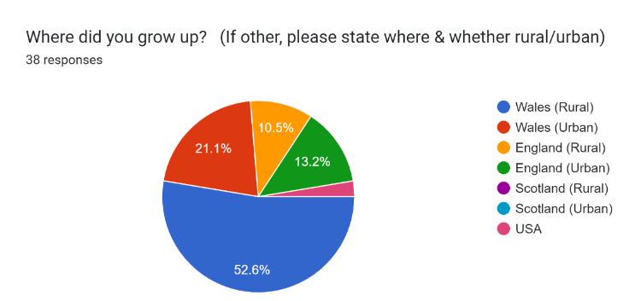
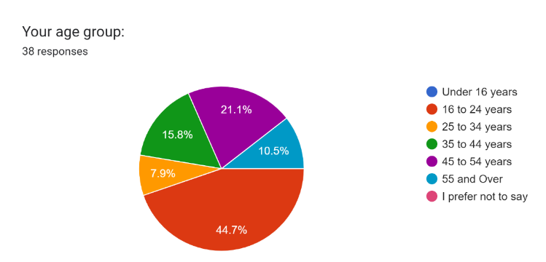
I constructed a questionnaire in order to receive a range of opinions on how others perceive the creative arts to have an impact on people’s mental health because I want to be able to compare generations on their access to drama whether that be theatre companies into school or drama provision in their community. I uploaded this both to my Facebook and Instagram profiles to reach a wider audience and I was surprised at how quickly I got responses to it. Key parts of the questionnaire are broken down below: (See Appendix 3 for full questionnaire)

I asked these questions because I wanted to know where people grew up in order to work out whether those from urban areas thought or knew about the lack of opportunities people from rural areas have. This enabled me to make a comparison between the amount of theatre groups, distance travelled and accessibility to drama facilities for both urban and rural areas. Having a variety of people from different age groups and regions answering my questionnaire, allowed me to consider the different viewpoints and determine if those living in urban localities with better accessibility to drama facilities compared to those from rural communities.
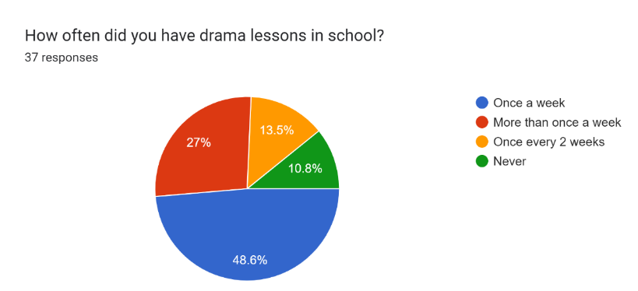
I noticed from these responses that approximately 25% never or rarely had drama lessons whilst in school. This was interesting as when I was in school I had 2 or 3 lessons a week dedicated to drama, so it’s sad to see that there is a small number who had little or no opportunity to study drama let alone have it as an option. This suggests that students may have never considered it as a career because it wasn’t part of their school curriculum. When choosing GCSEs, the year below me weren’t offered drama as an option. This was either down to location, lack of trained drama teachers or appeal in drama as it was regarded less important than Maths, English and Science, which were having more time dedicated to them. The government proposes to cut the Arts claiming they’re “not among its strategic priorities” (BBC News, 2021) wanting school curriculums to “focus on the “core” subjects of literacy, numeracy and science”. (Wightwick, 2019) This is backed up by the Guardian article which states “arts subjects such as music and drama has fallen to the lowest level in a decade as a result of government policies and education cuts”. (Adams, 2017) I also found an article which claims that in 2019 there was a decrease of 19.5% compared to 2018, in the number of students taking drama for their A-levels. (Wightwick, 2019)
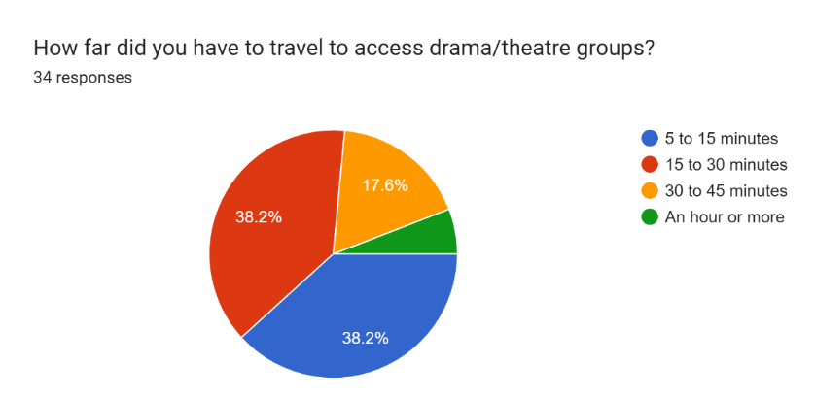

I wanted to ask this question in order to see how people living in different areas had access to theatre groups and whether those living in rural areas experienced what I did having to travel further to get the opportunity to do acting. I was quite surprised seeing these results because more people that answered my questionnaire grew up in a rural area of the UK so I was expecting results to show people having to travel further to access drama groups but over ¾ travelled between 5 and 30 minutes. This made me consider that some rural areas are gaining in having more drama facilities available to them so having to not travel so far. On the other hand, it could be based on the different generations that there could have been more around before than there is now or vice versa.
In your opinion, how does drama and the creative arts help with people's mental health?
I received a lot of the responses to this question that were similar stating drama as “a form of self-expression” so allows you to understand about yourself, how you feel by becoming different characters and experimenting through movement. Someone decleared that it “relieves stress by providing a different way to express themselves without the use of words”, this could be through the use of movements, sounds or facial expressions. A lot of the responses talked about drama bringing people together, helps to develop social skills and build confidence in people by them stepping out of their comfort zones and working as part of a team. I also found this in a blog by Amanda Griffiths where she states that drama “helps to boost confidence and make us feel more engaged and resilient” as well as “connecting and engaging with the world, escaping the everyday and even expressing their own thoughts and feelings”. (Griffiths, 2020) One person said that doing drama really helped them with their mental health because it allowed them to “develop social skills, boosted my mood. It’s a fun outlet where I got to do what I was good at and what I loved, whilst constantly making new friends”.
Do you think theatre/drama should be made more accessible in rural areas? Why? (Please elaborate if possible)
I wanted to discover if those that lived in more urban areas as well as those in rural areas had the same opinions on making theatre and drama widely more accessible so that everyone could experience forms of creativity. Again, a lot agreed and had similar reasons as to why they believed theatre should be made more available in rural communities. Someone said that people living in rural communities “often are forgotten about and have limited career pathways to go down” so that by “providing this opportunity allows them to… find interest in something they haven't done or have little experience in doing.” A few individuals talked about how people in rural areas can feel isolated which leads to loneliness but drama produces a chance to go out and meet others. According to the Mental Health Foundation website, “arts activities can help increase social interactions” by bring community together. (Mental Health Foundation, 2019)
Collaborations
I knew I wanted to do something along the lines of developing a workshop to really see for myself how drama can be beneficial for people’s mental health. As I found the dramatherapy area of my research really interesting and something I want to explore further, I wanted to create and develop a workshop using the style of dramatherapy to work through problems through expression of the body as well as incorporating Viola Spolin techniques of games because this “stimulate actors to unlock creativity and attain a high degree of presence in the moment” which makes the participants relax and allow for spontaneity through improvisation. (Timoney, 2016)
I contacted a mental health organisation Mid & North Powys Mind to see if I could put on a workshop with some patients, however I was unable to do this because I’m not a trained drama therapist or qualified health care professional so instead I spoke to with a few of my peers to see if we could collaborate on establishing a workshop. While I was researching dramatherapy, I found a book called ‘Dramatherapy with women survivors of domestic abuse’ which led me in the direction of collaborating with Jade, who is doing her project on domestic violence. Dramatherapy techniques can help reduce psychological distress caused by abuse through self-expression, connecting with others, “self-discovery and emotional growth in a non-judgmental atmosphere”. (Phillips, n.d.)
When in school, I remember a TIE company coming in where they put on a performance raising an awareness of an issue and got the audience to share their thoughts and understanding on what they believed the message to be behind the performance. This inspired me and gave me the idea of creating something similar by collaborating with Jade and Jake to incorporate Jake’s project of writing a small script, Jade’s project of domestic violence being the narrative of the performance and then adding my project into it on how domestic violence affects mental health to show awareness and how it can be overcome or diffused sooner. We decided to want to start the performance with a family dynamic of a child being verbally abused by parent to show the initial stages of abuse then witnessing a physical assault and showing the aftermath that has on the child’s mental health and relationship with friendships and their school life; “they may internalise their distress and withdraw from other people” (Women’s Aid, n.d.) and have a “impact on school attendance and achievement: some children will stay home in an attempt to protect their mother or because they are frightened.” (The Women’s Centre, n.d.) This is why drama is useful and important to share serious problems to make people more aware and help anyone that is going through something similar. We will pause the performance at different moments to get audiences’ participation and interaction so that they feel involved and can share their thoughts. End with a few exercises in small groups to devise or use tabloids to create how domestic assault can be stopped or prevented sooner and how to get support if someone is going through this.
There are issues on how we can show this safely for the audience which we are going to talk to another tutor Ali Franks, who does TIE, to see how we show this without it being too intense or hard-hitting for the audience but to keep the realism and truthfulness of the serious topic. I believe audience members who struggle with mental health concerns can feel less alone when seeing performances that address mental health issues and possibly encourage personal reflection as well as empathy for those struggling with mental health. **** (See Appendix 4)
I have also collaborated with Charla to develop a workshop which combines both my project and hers on actors with disabilities and additional learning needs. Our plan was to create a workshop and record elements of it to include another element of my project of the lack of accessibility to do drama for people living in rural areas so by recording snippets of the workshop, I can put it up online for those who live in more isolated areas can access it and give it a go themselves. This could allow for people to develop an interest in drama and find a passion for performing which they may not have experienced before. We were thinking of using games and play therapy to get an understanding of how the participants were currently feeling as well as help them express themselves from the off through improvisation in a fun and exciting way. The aims we wanted for the workshop were for the participants to have fun, be creative, step away from the struggles and problems of their lives for just a few minutes or even work through those issues with others to come up with solutions through the use of role play. This would allow for the participants to gain insight of looking at things differently and tackle the problems so they no longer have to worry about them. We wanted to be able to create a safe place for the participants to explore freely and share their feelings with others to connect and without being judged. The target audience for this workshop is for anyone but specifically those that are struggling with a disability or mental health. I not only want to put this on for schools but also in community-based theatres and centres, to mental health patients and in hospitals so that it allows for everyone to have the opportunity to do drama-based workshops to tackle issues in their lives by developing techniques to cope with mental health or disabilities. We decided that we would choose our own exercises we wanted to do for the workshop and then come together to create a plan by combining the exercises we each chose in order to incorporate both our projects. Charla’s exercises were very much game based using game therapy whereas mine were more drama, drama therapy and psychodrama focused using exercises such as mirroring and role-playing. I chose mirroring because I believe using movements through the body can show how a person is feeling rather than them verbally communicating if they don’t want to, don’t know how to describe how they feel or even understand how they feel. This will also allow others who are copying to understand and connect with someone else to develop a relationship as stated in an article from Frontiers in Psychology that mirror games “enhance empathy and emotional understanding of others”. (Feniger-Schaal et al. 2018)
I also chose role-playing because I want to encourage the participants to possibly share any problems that they’ve had to go through or currently going through to use as a scenario in order to explore feelings, try find solutions to overcome it and see it from different perspectives to understand how everyone in the scene is feeling and why they do what they do. Role-playing activities can be really useful in many ways to help with people’s mental well-being because according to Jeremy Sutton, role-playing “can be particularly effective… to revisit earlier experiences through re-enactment” which can help lead to learning “coping strategies to avoid impulsive and aggressive behavior, social anxiety” as well as many other mental health problems. (Sutton, 2022) (See Appendix 5)
I was able to put on my workshop with Charla which went okay because I was able to see how each exercise worked with people. When I come to do this workshop again, I will add additional exercises in to have more big group activities such as forum theatre to develop trust and not just mental health but physical health.
With Jade, Jake and I’s workshop it turned more into a focus group down to not having many participants and having only one draft of the script. I learnt that in order to put on a performance with a script written by someone else, there needs to be strict deadlines so that we could prepare and establish a well conducted workshop for people to experience and learn about a serious topic in a safe but realistic way.
Conclusion
To conclude, I established that drama can have positive outcomes for people to help improve their mental health in many different ways. This project was really interesting to investigate as I learnt more about the creative arts industry in Wales as well as noticing the impact deprived areas have on people’s mental health.
I found there to be a lot more drama groups within my area and around Mid-Wales than I realised but most are for certain age ranges. So, I still believe there needs to be more diverse groups for all ages groups so that everyone has a chance to experience drama and creativity. Some areas of my project were difficult to find information or statistics for because I wanted to focus more on Powys as the rural area of Wales but because there not being an actual hospital and rural areas are perceived as less important than urban so trying to find statistics for mental health in that county was difficult as other health boards had the numbers in their results.
I found looking into dramatherapy and psychodrama really interesting for using drama as a form of therapy in order to help, support and improve people’s mental health through the use of different drama techniques and exercises. I had never heard of psychodrama before so it was really intriguing learning about it and its benefits to help people overcome problems.
I enjoyed talking to Greg Cullen to find out more about Theatr Powys and what they provided for the community as I was only young when it shut down so I didn’t experience it as much as I should have but I found that it was a big asset to the area.
I’ve noticed the benefits drama has had on myself growing up as I used to be a very unconfident, shy, insecure and self-conscious girl when I was younger and I still am slightly in situations but it has improved down to the use of performing. My parents have also seen a huge change in me where they’d say they could never see me doing something like performing on stage but when they have seen me they now say I’m like a different person that they don’t recognise like I become someone else. They’ve seen my growth as a person from me performing in shows and that signifies the benefit drama has on people.
I plan to next go on to do a degree course in dramatherapy which is an area that really interested me during this project in order to help people with their mental health in an area where a lot of people feel quite isolated, to put on workshops in form of drama and later develop and set up my own group where anyone can go to experience and get help.
If I conduct this project again I would focus more on other rural areas rather than just mainly Powys in order to back my research up a bit more especially the mental health state because it was difficult trying to find statistics for Powys as there isn’t a proper hospital and the numbers were included in other health board statistics. Even though I used a wide range of sources as research I used a lot of online resources, so I would try look at more offline resources like books to back up my points further.
Words –
Quotes –
Bibliography & Appendix – 904

Bibliography
Adams, R., (2017) ‘Proportion of students taking arts subjects falls to lowest level in decade.’ The Guardian. [Article] Available at: https://www.theguardian.com/education/2017/sep/21/proportion-of-students-taking-arts-subjects-falls-to-lowest-level-in-decade (Accessed: 26 February 2023).
Arts Council Wales, (2018) Arts and Health in Wales: A Mapping study of current activity. Welsh Government. Vol. 1 pp 18-60. Available at: https://arts.wales/sites/default/files/2019-02/Arts_and_Health_Volume_1_0.pdf (Accessed: 08 October 2022).
BBC News, (2011) ‘Theatr Powys and Theatr Gwaun close over funding issues’, BBC News. [Article] Available at: https://www.bbc.co.uk/news/uk-wales-mid-wales-12923979 (Accessed: 06 October 2022).
BBC News, (2021) ‘Arts figures criticise plan to cut university funding for creative subjects’ BBC. [Article] Available at: https://www.bbc.co.uk/news/entertainment-arts-57006961 (Accessed: 4 February 2023).
Bourne, J., Selman, M. & Hackett, S., (2020) ‘Learning from support workers: Can a dramatherapy group offer a community provision to support changes in care for people with learning disabilities and mental health difficulties?’ British Journal of Learning Disabilities. Vol.48(1) pp.59–68. DOI: 10.1111/bld.12312.
Burt, K., (2020) ‘History of Drama in Education Part 1: Splitting definitions of Drama.’ Burt’s Drama. [Blog]. 15 April. Available at: https://burtsdrama.com/2020/04/15/why-we-teach-drama-and-not-theatre-part-1/ (Accessed: 28 November 2022).
Burt, K., (2020) ‘History of Drama in Education Part 2: Peter Slade & Child Drama’. Burt’s Drama. [Blog]. 29 April. Available at: https://burtsdrama.com/2020/04/29/history-of-drama-in-education-part-2/ (Accessed: 28 November 2022).
Calvert, R., (2023) Facebook Messenger to Bethan Margetts, 5 February.
Campbell Kirk, J. (2015). ‘Dramatherapy with Women Survivors of Domestic Abuse: A Small Scale Research Study.’ Dramatherapy, Vol.37(1), pp.28–43. DOI:10.1080/02630672.2015.1101480
Centre for Mental Health, (2020) More support needed for children’s mental health in rural areas, says Centre for Mental Health report. [Online] Available at: https://www.centreformentalhealth.org.uk/news/more-support-needed-childrens-mental-health-rural-areas-says-centre-mental-health-report (Accessed: 06 October 2022).
Chadwick, M., (2012) The campaign4creativity case in support of Theatr Powys. Welsh Senedd. Available at: https://business.senedd.wales/documents/s1155/P-03-314%20Save%20Theatre%20Powys%20Mid%20Powys%20Youth%20Theatre.pdf (Accessed: 06 October 2022).
Cherry, K., (2022) What Is Psychodrama? [Online] Available at: https://www.verywellmind.com/what-is-psychodrama-5193006 (Accessed: 11 January 2023).
Cullen, G., (2023) ‘Interview on Theatr Powys and TIE’. Interview by Bethan Margetts, [Zoom]. 18 January.
Devon, N., (2016) ‘Here's the proof that British mental health is worse than ever.’ Independent. [Article] Available at: https://www.independent.co.uk/voices/here-s-the-proof-that-british-mental-health-is-worse-than-ever-a6876921.html (Accessed: 15 January 2023).
Feniger-Schaal, R. et al. (2018) “The body speaks: Using the mirror game to link attachment and non-verbal behaviour”. Frontiers in Psychology. Vol.9. Available at: https://doi.org/10.3389/fpsyg.2018.01560 (Accessed: 26 February 2023).
Gal, Y., (2020) SEARCHING FOR SPOLIN IN DRAMA THERAPY. MA Thesis. Concordia University. Available at: https://spectrum.library.concordia.ca/id/eprint/987682/1/Gal_MA_F2020.pdf (Accessed: 7 January 2023).
Griffiths, A., (2020) ‘The impact of theatre and the arts on mental health’ Life Seeker. [Blog]. 15 July. Available at: https://lifeseeker.wales/the-impact-of-theatre-and-the-arts-on-mental-health/ (Accessed: 28 December 2022).
Hearn, E., (2022) ‘Powys arts centres suffering a 'slow death' as budgets cut, councillors warn’ Powys County Times. [Article] Available at: https://www.countytimes.co.uk/news/19892540.powys-arts-centres-suffering-slow-death-budgets-cut/ (Accessed: 20 October 2022).
Karp, M, Holmes, P, & Bradshaw, TK, (1998) The Handbook of Psychodrama. London: Taylor & Francis Group.
Luiggi-Hernández, J.G., (2020) ‘Drama Therapy as Psychosocial Support for Survivors of Domestic Abuse’. Mad In America. [Article] Available at: https://www.madinamerica.com/2020/10/drama-therapy-psychosocial-support-survivors-domestic-abuse/ (Accessed: 18 February 2023.)
Main Stage Community Theatre, (n.d) 5 Reasons Community Theatre is So Important. [Online]. Available at: https://www.mainstagecommunitytheatre.org/news-blog/5-reasons-community-theatre-is-important (Accessed: 4 December 2022).
Maudsley NHS, (2022) Drama Therapy: Kate McCormack. [Video] Available at: https://www.youtube.com/watch?v=eEJEWQLxtdw (Accessed: 28 November 2022).
Medical News Today, (2022) What to know about drama therapy. [Online] Available at: https://www.medicalnewstoday.com/articles/drama-therapy (Accessed: 9 October 2022).
Medical News Today, (2022) What to know about psychodrama therapy. [Online] Available at: https://www.medicalnewstoday.com/articles/psychodrama-therapy (Accessed: 28 November 2022).
Mental Health Foundation, (2019) How arts can help improve your mental health. [Online] Available at: https://www.mentalhealth.org.uk/explore-mental-health/blogs/how-arts-can-help-improve-your-mental-health (Accessed: 3 December 2022).
Mental Health Foundation, (n.d.) Surviving or Thriving? The state of the UK's mental health. [Online.] Available at: https://www.mentalhealth.org.uk/explore-mental-health/publications/surviving-or-thriving-state-uks-mental-health (Accessed: 14 January 2023).
Mind UK, (2021) Arts and creative therapies. [Online] Available at: https://www.mind.org.uk/information-support/drugs-and-treatments/talking-therapy-and-counselling/arts-and-creative-therapies/ (Accessed: 14 January 2023).
Mind UK, (2017) What causes mental health problems? [Online] Available at: https://www.mind.org.uk/information-support/types-of-mental-health-problems/mental-health-problems-introduction/causes/ Accessed: 14 January 2023).
Mittal, R., (2018) Theater as a Medium for Soft Skills Training. [Online] Available at: https://trainingindustry.com/magazine/jul-aug-2018/theater-as-a-medium-for-soft-skills-training/ (Accessed: 16 January 2023).
Morris, K., (n.d.) Amateur theatre and drama groups in Wales. Available at: http://www.theatre-wales.co.uk/amdram/ (Accessed: 10 October 2022).
Morris, K., (n.d.) Theatre, dance and performance venues and other performance spaces. Available at: http://www.theatre-wales.co.uk/venues/ (Accessed: 10 October 2022).
Morrison, C., (2021) The Importance of Community Theatre. [Online] Available at: https://marqueetp.com/the-importance-of-community-theatre/ (Accessed: 28 November 2022).
Northern Healthcare, (n.d.) How drama therapy can assist with mental health recovery. [Online] Available at: https://www.northernhealthcare.org.uk/news-resources/how-drama-therapy-can-assist-with-mental-health-recovery (Accessed: 11 October 2022).
Otto, D., (2020) ‘An Interdisciplinary Conducting Curriculum: Selected Theatre Games from Viola Spolin’s “Improvisation for the Theatre.”’ SAGE Open, Vol.10(4). Available at: https://doi.org/10.1177/2158244020954927 (Accessed: 7 January 2023).
Passmore, E., (2021) The process of practice: Using drama to improve student mental health. [Online] Available at: https://www.dramaandtheatre.co.uk/features/article/the-process-of-practice-using-drama-to-improve-student-mental-health (Accessed: 6 January 2023).
Phillips, R., (n.d.) ‘Using Art to Help Individuals with Mental Illness’. The Healing Power of Art & Artists. [Article] Available at: https://www.healing-power-of-art.org/art-helps-victims-of-mental-illness/ (Accessed: 6 January 2023).
Powys County Council, (n.d.) Arts and theatres in Powys. [Online] Available at: https://en.powys.gov.uk/article/1725/Find-arts-and-theatres-in-Powys (Accessed: 27 October 2022).
Powys Public Service Board, (2017) Well-being Assessment. Available at: https://powys.moderngov.co.uk/documents/s16472/1%20Powys%20Wellbeing%20Assessment%20Final%20V1.1.pdf (Accessed: 25 March 2023).
Psychodrama Association for Europe E.V., (n.d.) Psychodrama by Jacob Levy Moreno – the art and philosophy of living and a method of therapy. [Online] Available at: https://psychodrama-for-europe.eu/psychodrama-2/ (Accessed: 6 March 2023).
Rasalingam, E., (2018) ‘How Can Art and Drama Therapy Help Young People?’. Welldoing.org [Article] Available at: https://welldoing.org/article/how-art-drama-therapy-help-young-people (Accessed: 6 October 2022).
Santhanam, M., (2022) Lebanon: Drama therapist helps inmates with mental illnesses while pushing for reform. [Online]. Available at: https://www.middleeasteye.net/discover/lebanon-drama-therapist-plight-forgotten-prisoners-mental-illness (Accessed: 6 March 2023).
Sutton, J., (2022) Role Play in Therapy. [Online] Available at: https://positivepsychology.com/role-playing-scripts/ (Accessed: 7 February 2023).
TEDx Talks, (2012) TEDxConejo 2012 - Jean Campbell - Psychodrama: Voices Together. [Video] Available at: https://www.youtube.com/watch?v=OdvErKtIVUE (Accessed: 28 November 2022).
The Women’s Centre Cornwall, (n.d.) The effects of domestic abuse on children. [Online] Available at: https://www.womenscentrecornwall.org.uk/information-support/domestic-abuse/the-effects-of-abuse-on-children/ (Accessed: 7 February 2023).
Timoney, B., (2016) Spolin’s ‘Improvisation’ Technique. [Online] Available at: https://www.briantimoneyacting.co.uk/spolins-improvisation-technique/ (Accessed: 3 February 2023).
Wightwick, A., (2019) ‘A level entries in Wales have fallen this year. Here's why and these are the subjects that suffered’. Wales Online. [Article] Available at: https://www.walesonline.co.uk/news/education/level-entries-wales-fallen-year-16730250 (Accessed: 25 February 2023).
Williams, B., (2023) Email response to Bethan Margetts, 25 January.
Women’s Aid, (n.d.) The impact of domestic abuse on children and young people. [Online] Available at: https://www.womensaid.org.uk/information-support/what-is-domestic-abuse/impact-on-children-and-young-people/ (Accessed: 7 February 2023).

Appendix
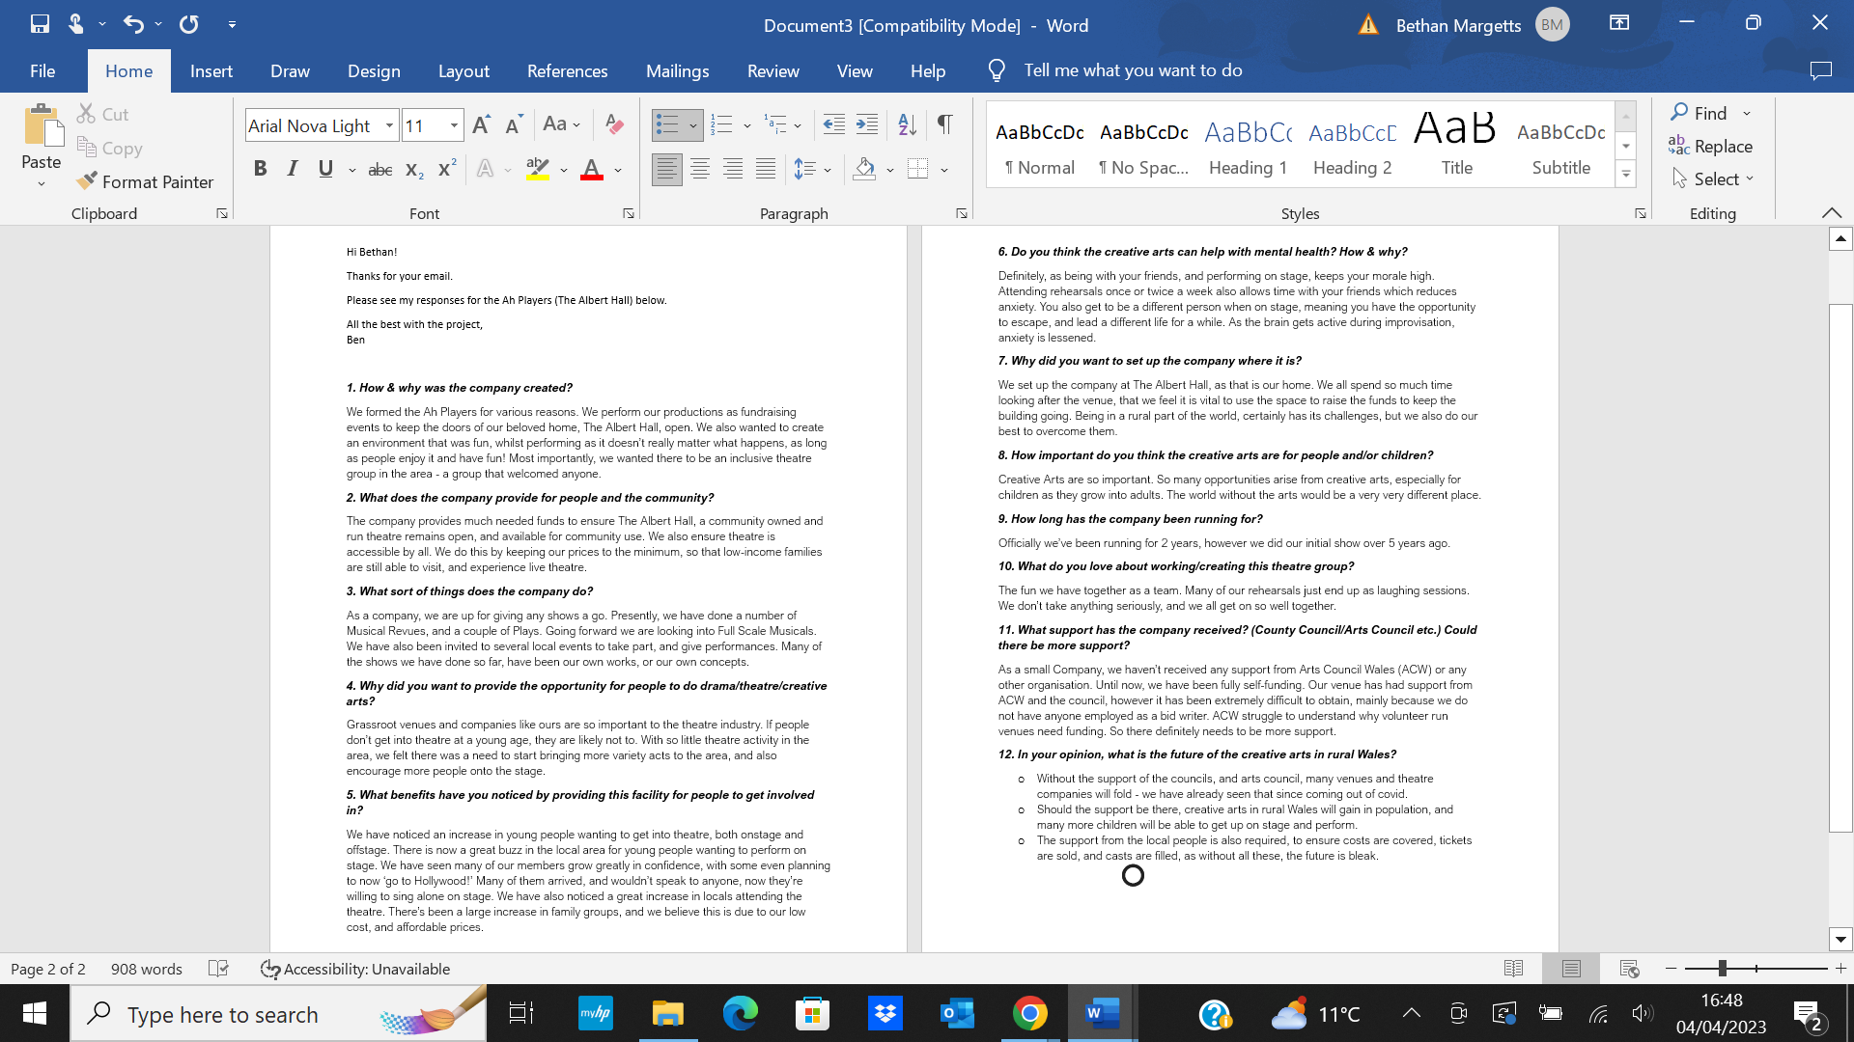
1 – Email from Ben Williams at ‘AH Players’ Company

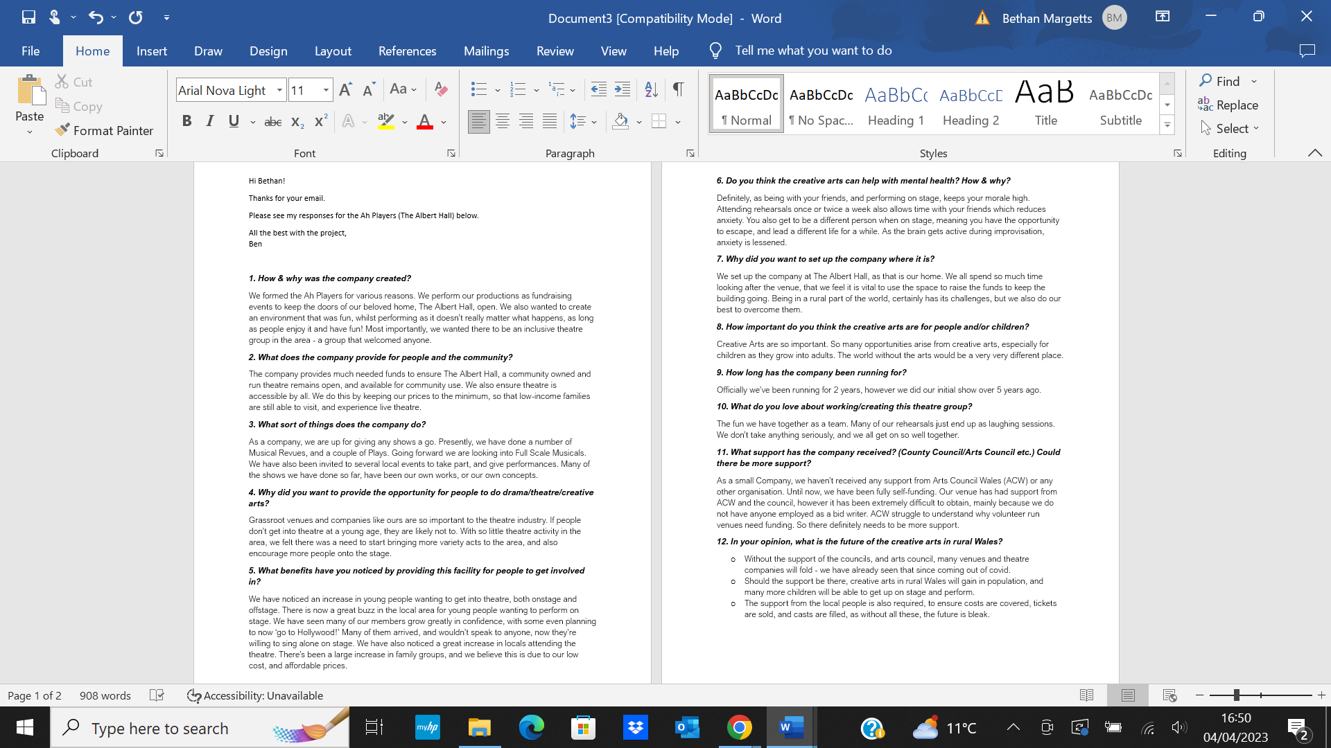

2 – Message from Ruth Calvert (College Tutor)
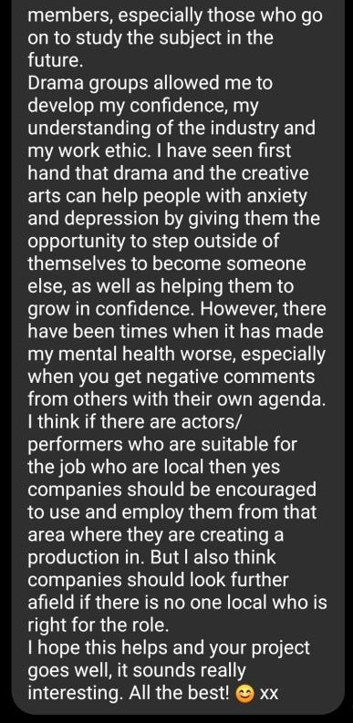
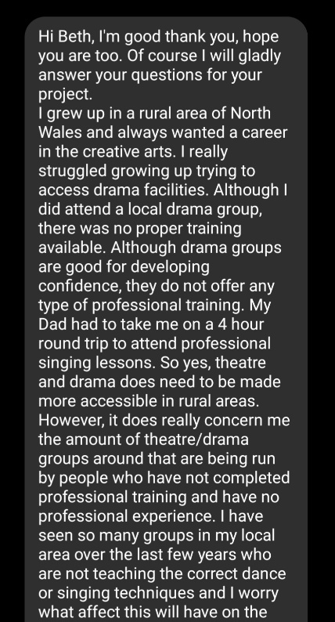

3 – Questionnaire
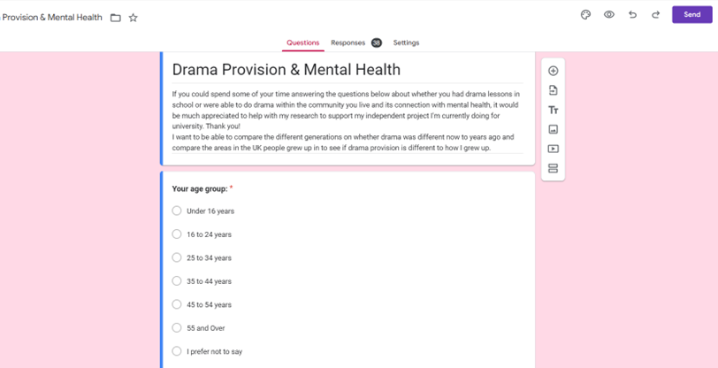
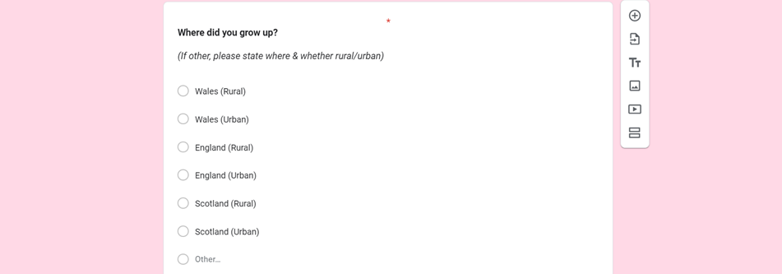
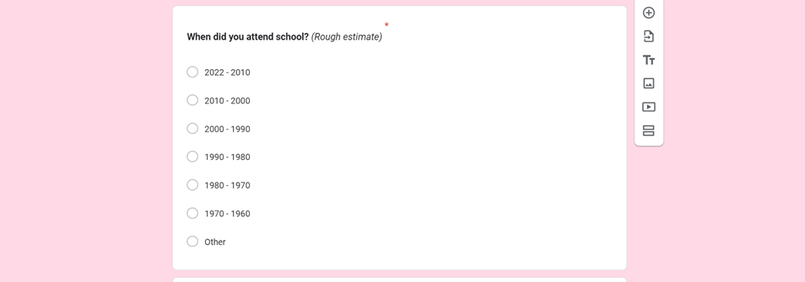
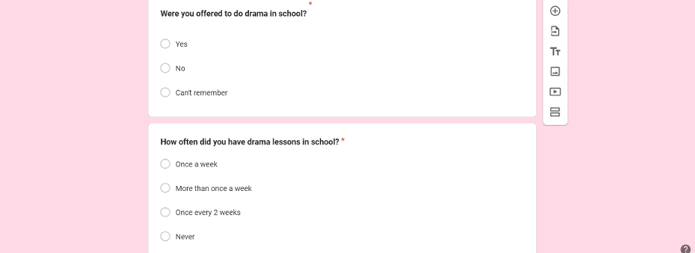
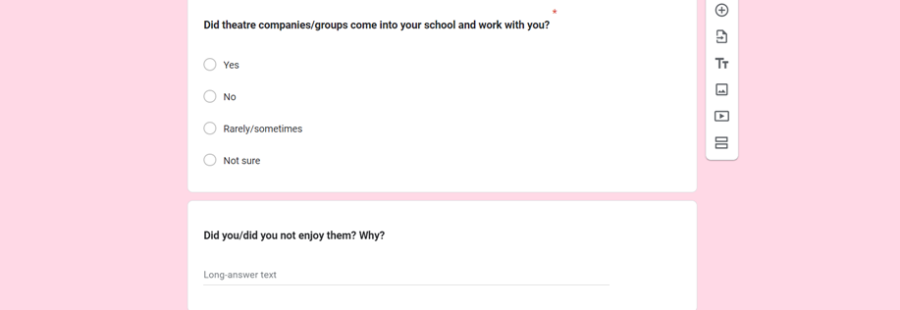
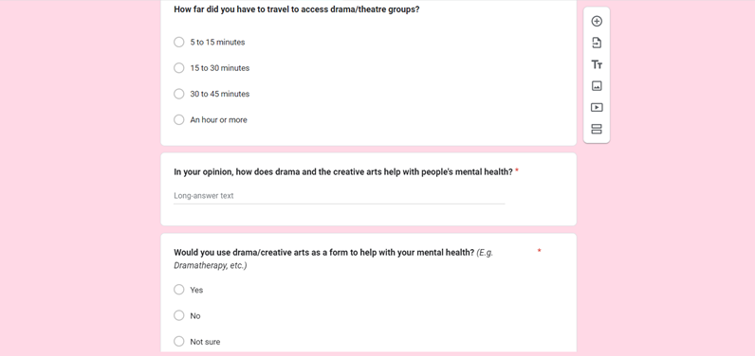
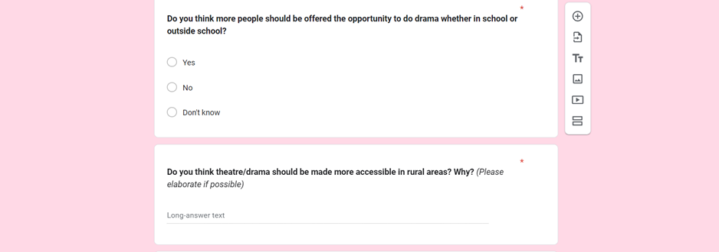
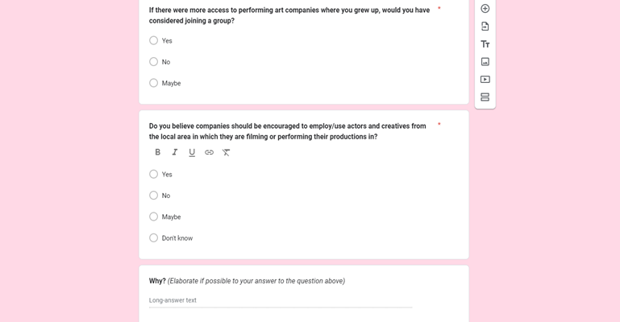

4 – Jade, Jake & I Initial Workshop Plan
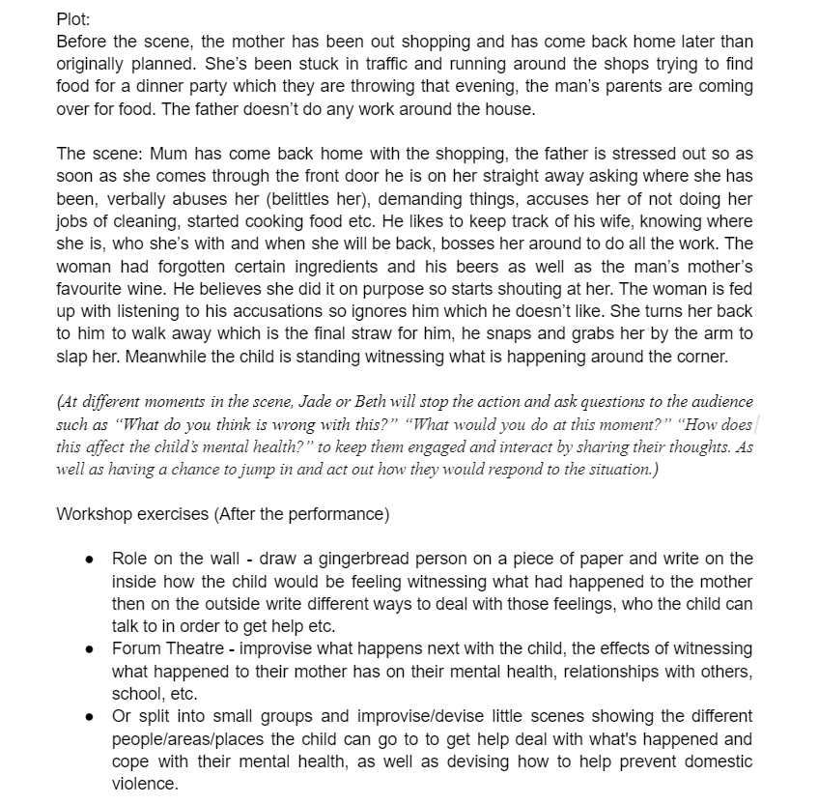
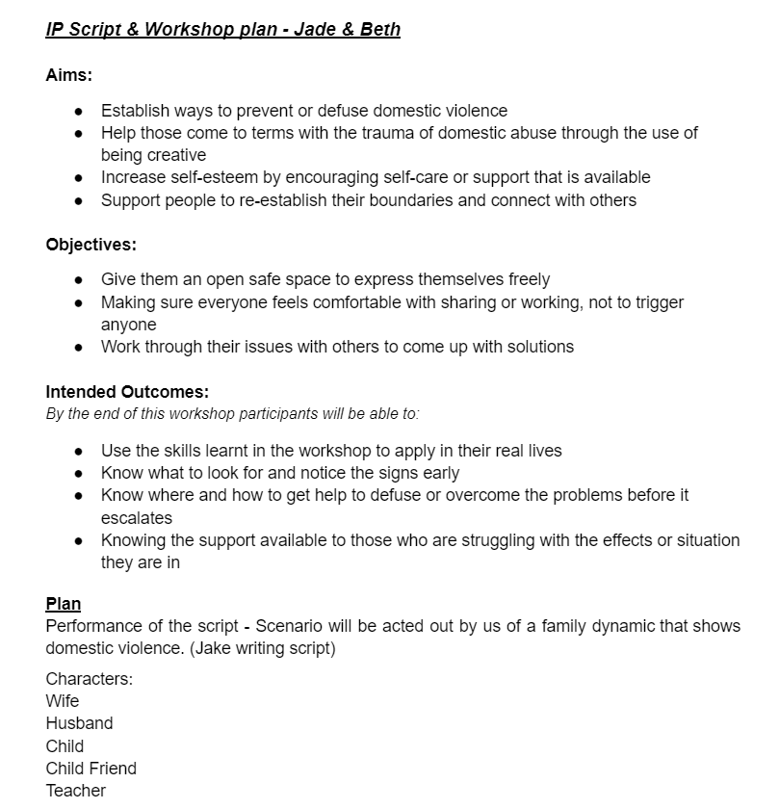
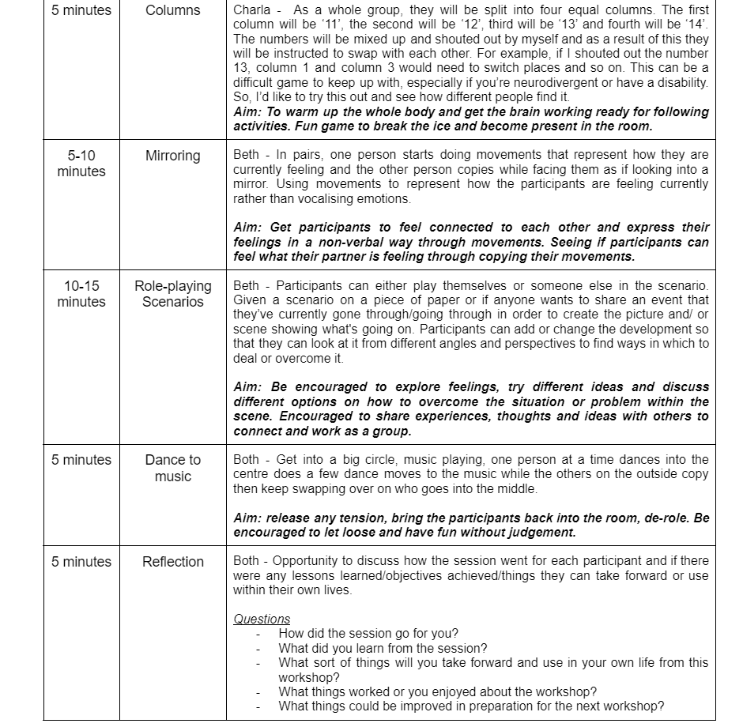
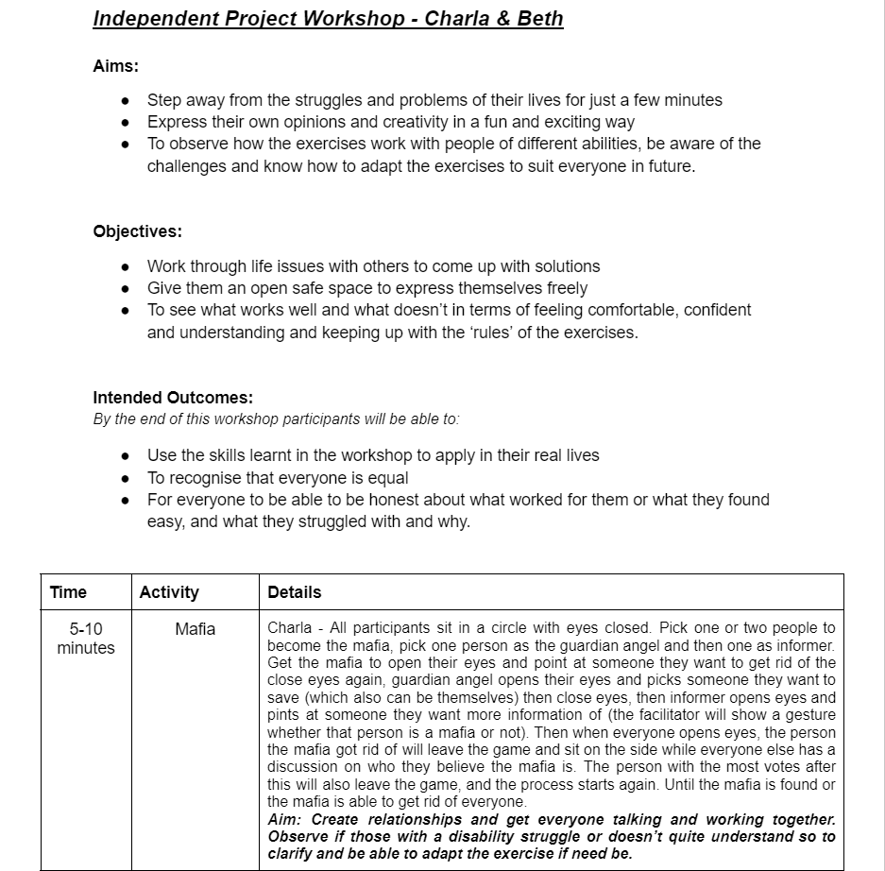
5 – Charla & I Workshop Plan

6 – Viola Spolin’s Theatre Games
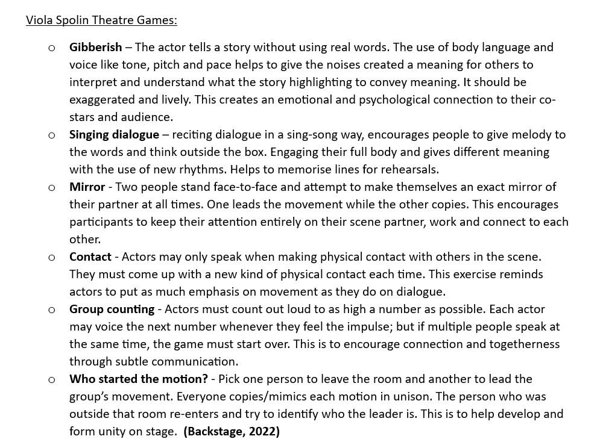
7 – Contact Sheet
Name of contact | Via | Responded
Greg Cullen | Email: gregcullen29@icloud.com | Yes
Ben Williams | Email: hello@thealberthall.co.uk | Yes
Ralph Bolland | Email: mpyt@mail.com | No
Ruth Calvert | Facebook – Ruth Calvert | Yes
Mandy Davies | Email: lw.theatrecompany@gmail.com | No
GHOST LIGHT Company | Email: ghostlightperformers@gmail.com | No

