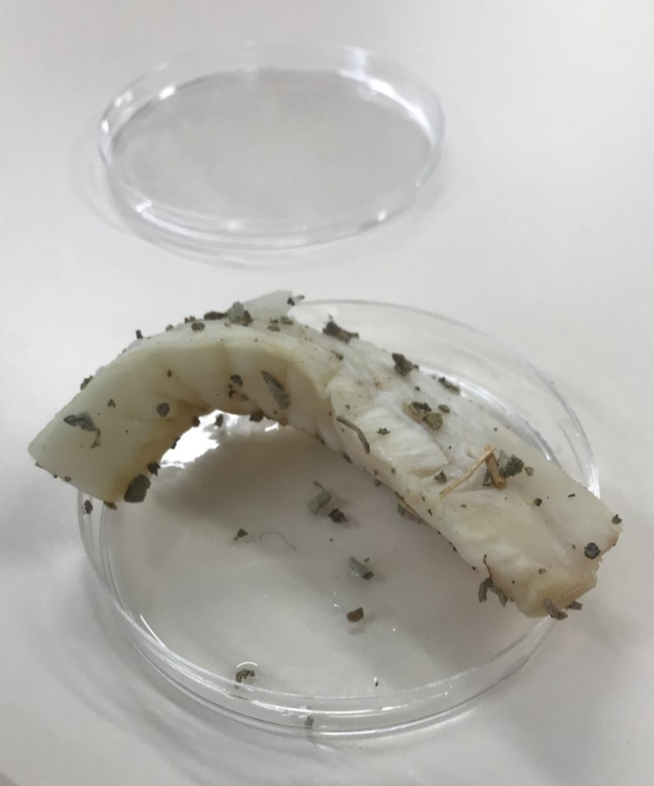
Figure 1: (kirk,2021) Prepared Pharoah Fish

Report Title
  - Salt Mummification experiment
Bronwyn kirk | Ancient Lives in Death HPAN 6007 | 10/10/21

Abstract
This lab report explains how my experiment using two pieces of fish are treated different. One being the control fish that has been left in a jar. The other piece of fish, referred to as pharaoh fish, has been treated similar to the drying processes using in Ancient Egypt. The hypothesis that the control fish will decay, whereas the pharaoh fish will be persevered. This will be measured through observations and also weight and measuring the length of the fish.

Introduction
The mummification process is one that we know little about because there is no written evidence about the embalming process, what we do know is through scientific experiments, experimental archaeology, and material culture, like wall scenes found on tombs and the book of the dead.

Aim and Hypothesis
The aim of this experiment is to see how a piece of fish will change throughout the mummification process. The different changes can be anything from colour, smell, size, weight, and texture. Using the approach of experimental archaeology.
My hypothesis is that the control fish will start to decay over the four weeks, whereas the mummified fish with change weight and length due to the process of drying the fish out.

Design
The experiment was designed to explore and understand the ancient Egyptian mummification process. The way this experiment was done follows experimental archaeology methods. The focus of this experiment was to see how two types of salt together affects the decay of the fish, using an unaltered fish as a control variable, and comparing it to the pharaoh fish that has been treated similarly to the mummification process used on the ancient Egyptians. This experiment measures and compares the weight changes and size changes of the fish.

Materials / Equipment
- Gloves (optional)
- 2 glass jars
- 2 labels and a pen
- 1 filleted fish (cut in half)
- Scales
- Herbes (two pinches)
- Tap water
- White malted vinegar
- Cooking salt (half a jar) x2
- Epsom salt (half a jar) x2

Method
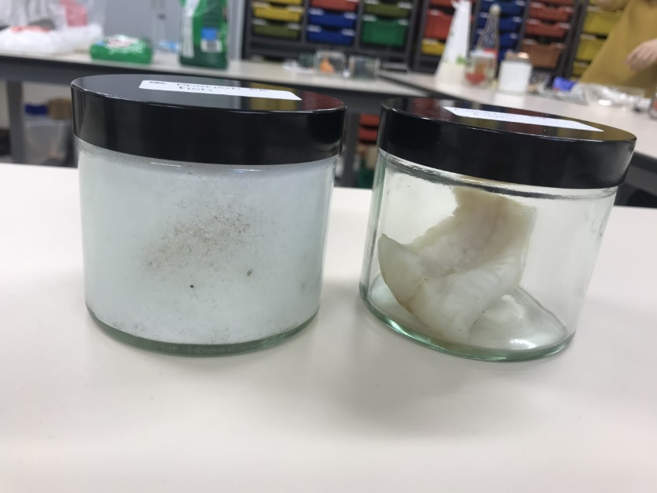
Two jars were labelled, ‘Control fish’ and ‘Pharaoh fish’. One fillet of fish was cut in half, roughly the same size. Each piece was measured in length and weighed, and the measurements were recorded. The first piece of fish was placed in the control jar without any treatment. Whereas the second piece of fish, the Pharaoh fish, was washed in tap water for ten seconds on each side. A pinch of herbs was rubbed in the palms until the herbs were smaller in size. These crushed herbs were rubbed into the pharaoh fish by hand. A small bowl was filled with white malted vinegar and the second piece of fish was placed in the bow while the jar labelled ‘Pharaoh fish’ was filled ¼ full with Epsom salts. The pharaoh fish was removed from the vinegar and was allowed to drain for 15 seconds. More crushed herbs were rubbed into both sized of the fish. The fish was then placed into the salt in the jar named ‘pharaoh fish’. Cooking salt was then added to the jar filling it to the half-way mark. A further ¼ of the jar was filled with Epsom salt and the final ¼ was filled with cooking salt. The lid was replaced, and the jar was shaken for 15 seconds. As seen in figure 2. Both jars were left in the lab and observed at intervals.
Figure 2: Day one of control fish and pharaoh fish (kirk,2021)

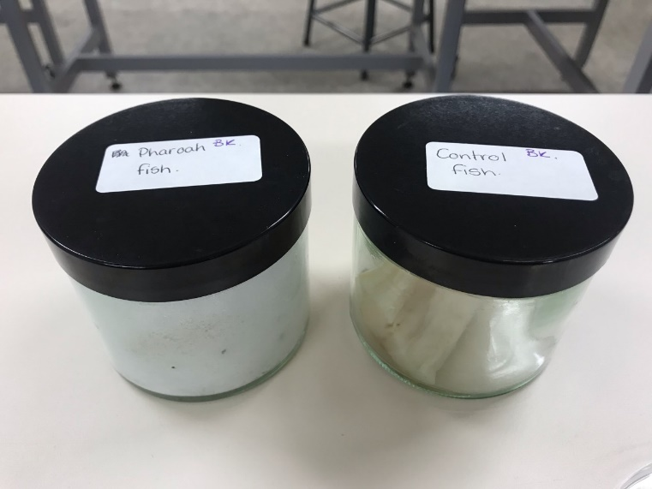
Procedure
Figure 3: Day 8 of control fish and pharaoh fish. (kirk,2021)
The fish was prepared following the method above. The control variable is that both fishes were kept in identical conditions, and where only observed after 8 days. The jars where only open on day 15 and 22. On day 15^{the} the jars were open, and the pharaoh fish was removed from the salt and weight and measured. Then the salt was replaced. A final measurement and weight check was done on the final day. The whole experiment was conducted over a period of 22 days.

Results
Table 1 and 2 contain the information of weight changes the table shows the weighting of the fish on day 1, 15 and 22 in grams. The table also show the difference in weight between day 1 and 15, then day 15 to day 22. By using the formula:
$\frac{wieght loss }{starting piont } x 100=\%of weight lost$
It makes the result clearer and allows for this information to be placed into graphs. For example, graph one contains table 1 and 2 and compares them more clearly.
Table 1 - Pharoah fish result table of weight
 | Day 1 | Day 15 | Day 22 | Overall
Weight of fish (g) | 39.28g | 27.4g | 25.5g
Weight loss (g) |  | 11.88g | 1.9g | 13.78g
Percentage weight loss (%) |  | 30.25% | 6.9% | 35.08%

Table 2 - Control fish result table of weight
 | Day 1 | Day 15 | Day 22 | Overall
Weight of fish (g) | 28.95g | 24.4g | 21.2g
Weight loss (g) |  | 4.55g | 3.2g | 7.75g
Percentage weight loss (%) |  | 15.71% | 13.11% | 26.77%

Table 3 - Pharoah fish result table of length
 | Day 1 | Day 15 | Day 22 | Overall
Length of fish (cm) | 12.1cm | 10.2cm | 9.8cm
Length loss (cm) |  | 1.9cm | 0.4cm | 2.3cm
Percentage of length loss (%) |  | 15.7% | 3.9% | 19.01%

Table 4-Control fish result table of length
 | Day 1 | Day 15 | Day 22 | Overall
Length of fish (cm) | 8.6cm | 8.5cm | 8.4cm
Length loss (cm) |  | 0.1cm | 0.1cm | 0.2cm
Percentage of length loss (%) |  | 1.16% | 1.18% | 2.33%

Observations
Day 15
It was observed that the control fish had started to break down, this could be seen because there was cloudy liquid in the jar. This is muscle tissue breaking down. The smell of the fish had changed, it smelled like rotting fish, compared to when it was first placed in the jar. The colour of the fish had change. Originally the fish was white and had a light-yellow strip going down where the spine of the fish would have been. On day 15 the colour had changed to a darker yellow with flecks of brown, this is again due to the fish breaking down. From looking at the fish I could not see any difference in size, until I measured it and found that it had lost 0.1 cm in length. The weight of the fish did not feel too different from when it was originally placed in the jar.
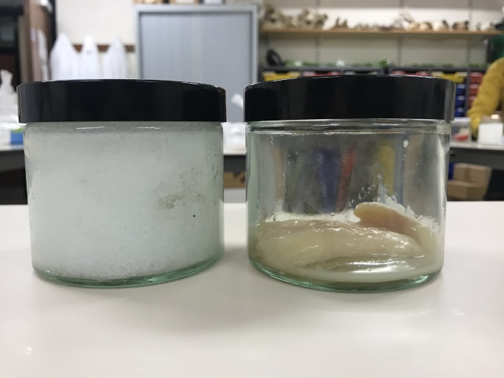
By removing the salt from the pharaoh fish, it revealed that the fish had curled upon itself making it seem smaller in length. The colour of the fish did not change, if anything the fish looked whiter, possibly because the salt had closely bonded with the fish. When picking up the fish there was a significant weight change with it being lighter. Much of the water contained in the fish had been lost during the drying process. The texture of the fish had changed with it becoming harder and less malleable than when it was originally placed in the jar. When the salt was removed from the jar it came out in clumps and the salt stuck to the sides of the jar, indicating that the moisture from the fish had been absorbed by the salt.
Figure 4: Day 15 control fish and pharaoh fish (kirk,2021)

Day 22
The control fish had changed significantly over the 22 days. When holding the fish, it was clear that it had lost all the muscle with only the membrane between the skin and muscle left. When holding the fish up to the light it was slightly translucent even with the colour of the fish being a dark yellow with prominent brown sections on the fish. The texture of the fish had become slimly and felt sticky. The smell of the fish was a potent rotting smell.
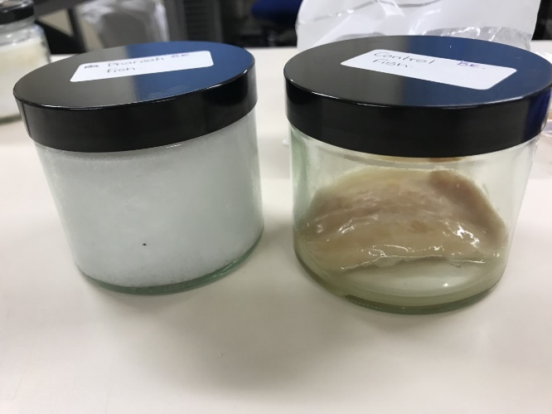
The pharaoh fish, once removed from the salt, looked remarkably similar to the observations made on day 15. The only differences were that the fish had become more solid in texture and had lost weight. The fish was lighter than the start by a significant amount. The length of the fish has also changed and the fish had curled upon itself. The smell of the fish was surprisingly fresh. It smelled very salty with a hint of the herbs, which were used to prepare the fish. The colour of the fish was still white, the same as day 15.
Figure 5: Day 22 control fish and pharaoh fish (kirk,2021)

Discussion of results
When looking at the control fish there is a clear steady decline in weight with the fish originally weighing 28.95g but by day 15 reduced to 24.4g which is a weight loss of 4.55g and a decline of 15.71 % of weight. Whereas on day 22, the weight of the fish was 21.2g and a reduction of 3.2g from day 15 to day 22 and a percentage loss of 13.11%. In total the fish lost 7.75g in weight and when produced as a percentage this measured a total 26.77% weight loss of the fish.
The pharaoh fish shows a higher weight loss with the most weight being lost in the first 15 days. This is seen because the start weight of the pharaoh fish is 39.28g and by day 15 the fish weighed 27.4g which is a reduction of 11.88g. Which, as a percentage, amounts to 30.25% of the total weight of the fish. By day 22 the fish weighed 25.5g which is only a reduction of 1.9g and a percentage loss of 6.9g. Throughout the whole experiment the pharaoh fish lost 13.78 g and with a percentage weight loss of 35.08%.
Looking at the difference in length of the control fish over the period of 22 days there is a small change in length with the starting length being 8.6cm and by day 15 the length only changed to 8.5cm which is a difference of 0.1cm, a percentage length loss of 1.16%. By day 22 the length of the control fish was 8.4cm which between day 15 and 22 is only a length loss of 0.1cm again, which gives a percentage length loss of 1.18%. in total. The overall length loss was 0.2cm and a percentage length loss of 2.33%.
The pharaoh fish length loss was more than that of the control fish. On day 1 the pharaoh fish length was 12.1cm and by day 15 had decreased to 10.2cm which is a length loss of 1.9cm and percentage length loss of 15.7 %. By day 22 the length of the fish was 9.8cm showing a length loss of 0.4cm and only a percentage length loss of 3.9%. In total the pharaoh fish loss 2.3cm in length and a percentage length loss of 19.01%

Interpretation
Overall, the experiment demonstrated that salt was effective in reducing the moisture content of the fish. Salt also prevented the fish from quickly decaying as seen in the control fish. When clearly looking at % of weight lost of both fish it clear to see that pharaoh fish is 35.08% and control fish is 26.77. This show that the salt allowed more water to be removed from the fish whereas the control fish lost muscle mass instead of water.

Conclusion
To conclude the results, show that the hypothesis that the control fish will start to decay over the four weeks, and the pharaoh fish will change weight and length due to the mummification process was proven correct. as seen with the control fish it did lose a small amount of weight and length but ended up decay a significant amount. Whereas the pharaoh fish stay well preserved by lost a 1/3 of its weight and around 1/5 of its length due to the drying out process. With using this experiment we can say that salt works as a preservative and with further experiment can be defined the way that majority of the ancient Egyptian mummies were persevered.

References
Kirk. B (2021) images of experiment.

