Charles Jones (2030806)
2030806@student.uwtsd.ac.uk

This is a logbook for the building of a double LED basic astable circuit. The logbook will take you through what an astable circuit is and how it is operated. The equipment that was required to be able to build the circuit. The calculations that were conducted to ensure the correct component values were utilized. The use of Proteus 8 Professional to simulate the circuit and confirm that the circuit would operate. Graphs, tables, and photographs were produced and used as visual aids throughout the logbook. Finally, how the circuit was built on the breadboard and whether it operated as intended.
fundamentals of electrical and electronic systems HNC
Circuit Build Logbook

Contents
1. 555 Timer, Circuit Description and Operation: 2
2. Equipment and Materials Used: 2
3. Completed Proteus Circuit: 3
4. Design Calculations: 4
5. Proteus Results: 4
6. Breadboard 555 Timer Circuit: 6
7. References 10

555 Timer, Circuit Description and Operation:
The circuit built was a basic astable circuit using a 555 timer. The 555 timer is a crucial component of embedded system architecture and is frequently employed in various electrical and electronic projects to generate clock pulses. The most widely used chip ever produced. This small circuit has stood the test of time, independently produced by more than ten manufacturers, still in use today, and about 40 years old. Although it has undergone numerous redesigns, upgrades, and reconfigurations, the original design is still available from a wide range of suppliers. Everything, from toys to spacecraft has used it. It continues to be a hobbyist favourite due to its adaptability, accessibility, and affordability [1].
The term "astable" refers to a circuit that lacks a stable state. A "square" wave (See fig. 6) red wave, is the output that continuously alternates between high and low states without any human input. This kind of circuit works well as a "clock" pulse for other digital ICs and circuits as well as a means of flashing bulbs and LEDs [2].
To achieve “astable” mode pins two and six were connected, this creates the square waves from pin three. (See fig.1) for pin layout.
The output of the timer is turned on when pin 2 detects a voltage that is less than one-third of the supply voltage and turned off when Pin 6 detects a voltage that is more than two-thirds of the supply voltage. This can be seen in the graph below (See Fig. 7). The output pulses generated at pin three can have their frequency changed by adjusting the values of resistor one, resistor two, and capacitor two [3].
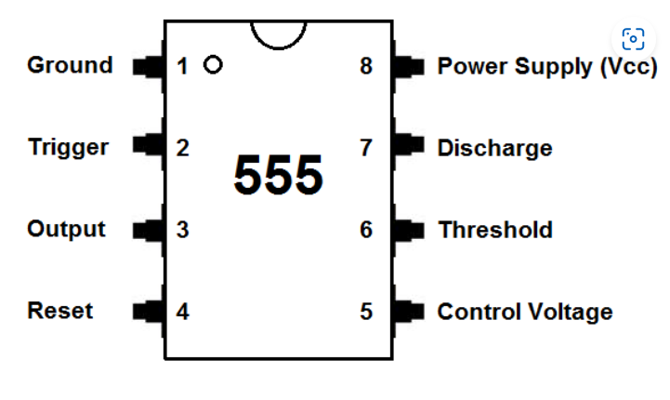
Fig. 1 Snip of pin layout on 555 timers [4].

Equipment and Materials Used:
- Proteus Professional 8 program
- 555 Timer
- 1k resistor
- 10k resistor
- 470k resistor x2
- 100 milli-farad capacitors
- 100 nano-farad capacitors
- DC power supply and ancillaries
- Breadboard
- Wire
- Snips
- LED x2 Red and Green

Completed Proteus Circuit:
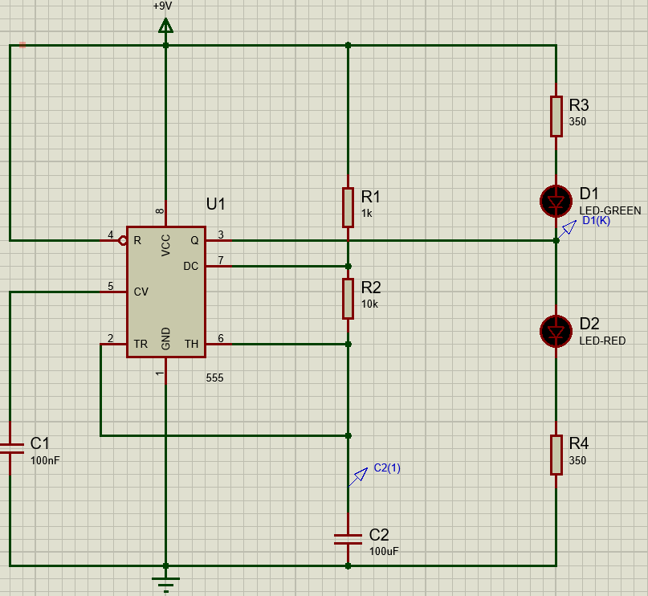
Fig. 2 Screengrab of 555 timer circuit completed on Proteus.

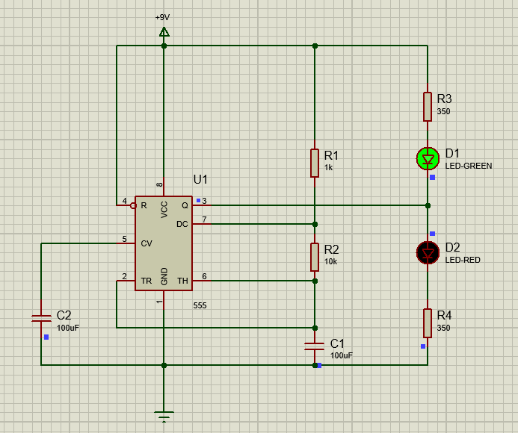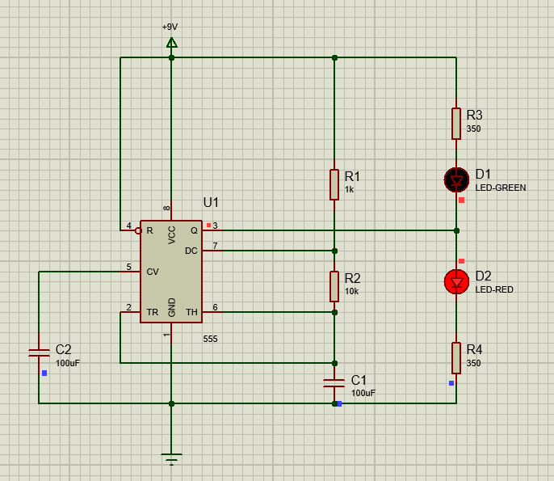
Fig. 3 Screengrabs from Proteus show the green and red LED in operation.

Design Calculations:
The student received a schematic of the circuit that was to be created on Proteus. The values for resistors three and four needed to be calculated, the student conducted calculations using Ohm’s law to identify the values. A nine-volt power supply was used, the LED had a forward voltage drop of about two volts and the LED required a current of twenty milli-amps to run. So 7V/0.02A equals three-hundred and fifty ohms. Resistors three and four were given the value of three-hundred and fifty ohms on the Proteus simulation.
The time-on was calculated using the equation, natural log of two, multiplied by the values of resistor one plus resistor two, multiplied by the capacitance. The equation used was ln (2)x(1+10) x0.001.
The time-off was calculated using the equation, natural log of two, multiplied by resistor two, multiplied by the capacitance. Ln (2)x(10x0.001).
The period of the circuit was calculated by adding the time-on and time-off results.
The frequency was calculated using the sum of time on and time off, divided by one.
Time On (seconds) | 0.76246
Time Off (seconds) | 0.69314
Period (seconds) | 1.4556
Frequency (Hertz) | 0.687
Fig. 4 Table of the design calculations.

Proteus Results:
Having produced the circuit on Proteus and conducted the simulation the green and red LEDs flashed on and off independently. A graph was produced (see Fig. 6), to show the voltage at capacitor two and the output. An analogue graph, with a ten-second run time set in the parameters. The voltage probes were dragged from capacitor two and the output and placed in the graph.
The time-on, time-off, period and frequency were then checked by moving the cursor of the mouse to the corners of the peak for time-on, the gap between two peaks for time-off and the distance across one peak and trough to the next peak. These areas are shown on the graph, yellow for time-on, red for time-off and blue for period (See Fig. 8).
Time On (seconds) | 0.76
Time Off (seconds) | 0.70
Period (seconds) | 1.46
Frequency (Hertz) | 0.68
Fig. 5 Table of the Proteus calculations.
The results taken from the graph on Proteus were almost identical to the results calculated at the design stage. This confirmed that the circuit had been built correctly on proteus and no mistakes were made at the design stage.

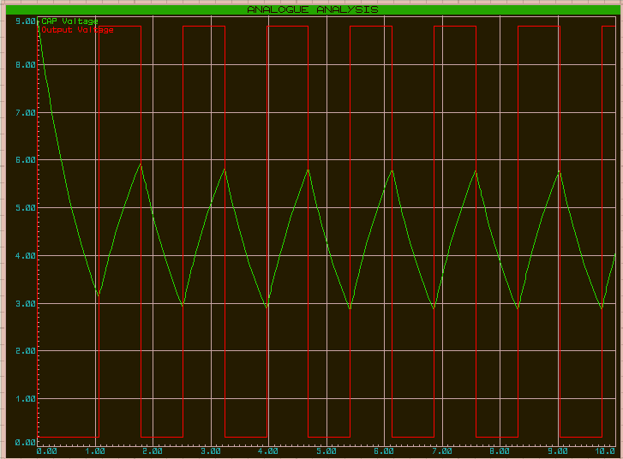
Fig. 6 Proteus screengrab of capacitor two and output voltage.
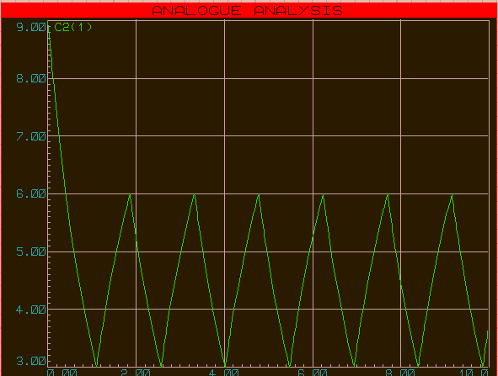
Fig. 7 Screengrab showing capacitor two voltage.
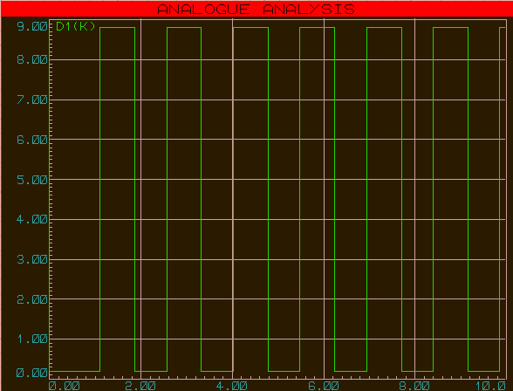
Fig. 8 Proteus screengrabs of output voltage.

Breadboard 555 Timer Circuit:
The circuit was designed on an A4 sheet of paper for the breadboard layout before beginning the actual practical build of the circuit (See Fig. 9). This was done since the breadboard is a little object and mistakes are simple to make.
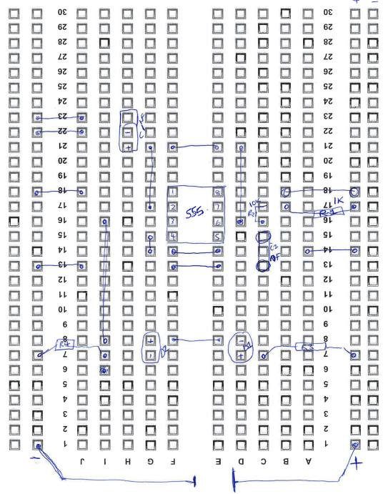
Fig. 9 Screengrab of circuit layout prior to build.

Due to there being no three-hundred-and-fifty-ohm resistors available for the practical, two four-hundred-and-seventy-ohm resistors were used and were positioned either side of the diodes (See Fig. 10). All other components were of the same value as used in the Proteus simulation.
The circuit was built by starting at pin one and working through each pin in numerical order. Pin one was connected to ground. A wire was the inserted at pin two, with the other end connected to the positive terminal of the one-hundred microfarad capacitor and a wire taken from the negative terminal to ground. Two wires were then used to connect the wire from pin two to pin 6 to allow the on off function of the diodes. A wire was inserted at pin three and positioned below the timer to allow space for positioning of red diode and resistor. Pin 4 was connected using three wires to the positive rail. The one-hundred nano-farad capacitor was then inserted with the positive terminal at pin five and wires used to connect the negative terminal to ground. The two one K resistors were then positioned from the positive rail to pins six and seven. One of the four-hundred- and seventy-ohm resistors was inserted in the positive rail and connected to the green diode. A wire was used to connect the green diode to the red. The final four-hundred-and-seventy-ohm resistor was then inserted next to the negative terminal of the red diode and in the same line as the wire from pin three and connected to the negative rail. (See Fig. 10) for completed breadboard circuit.
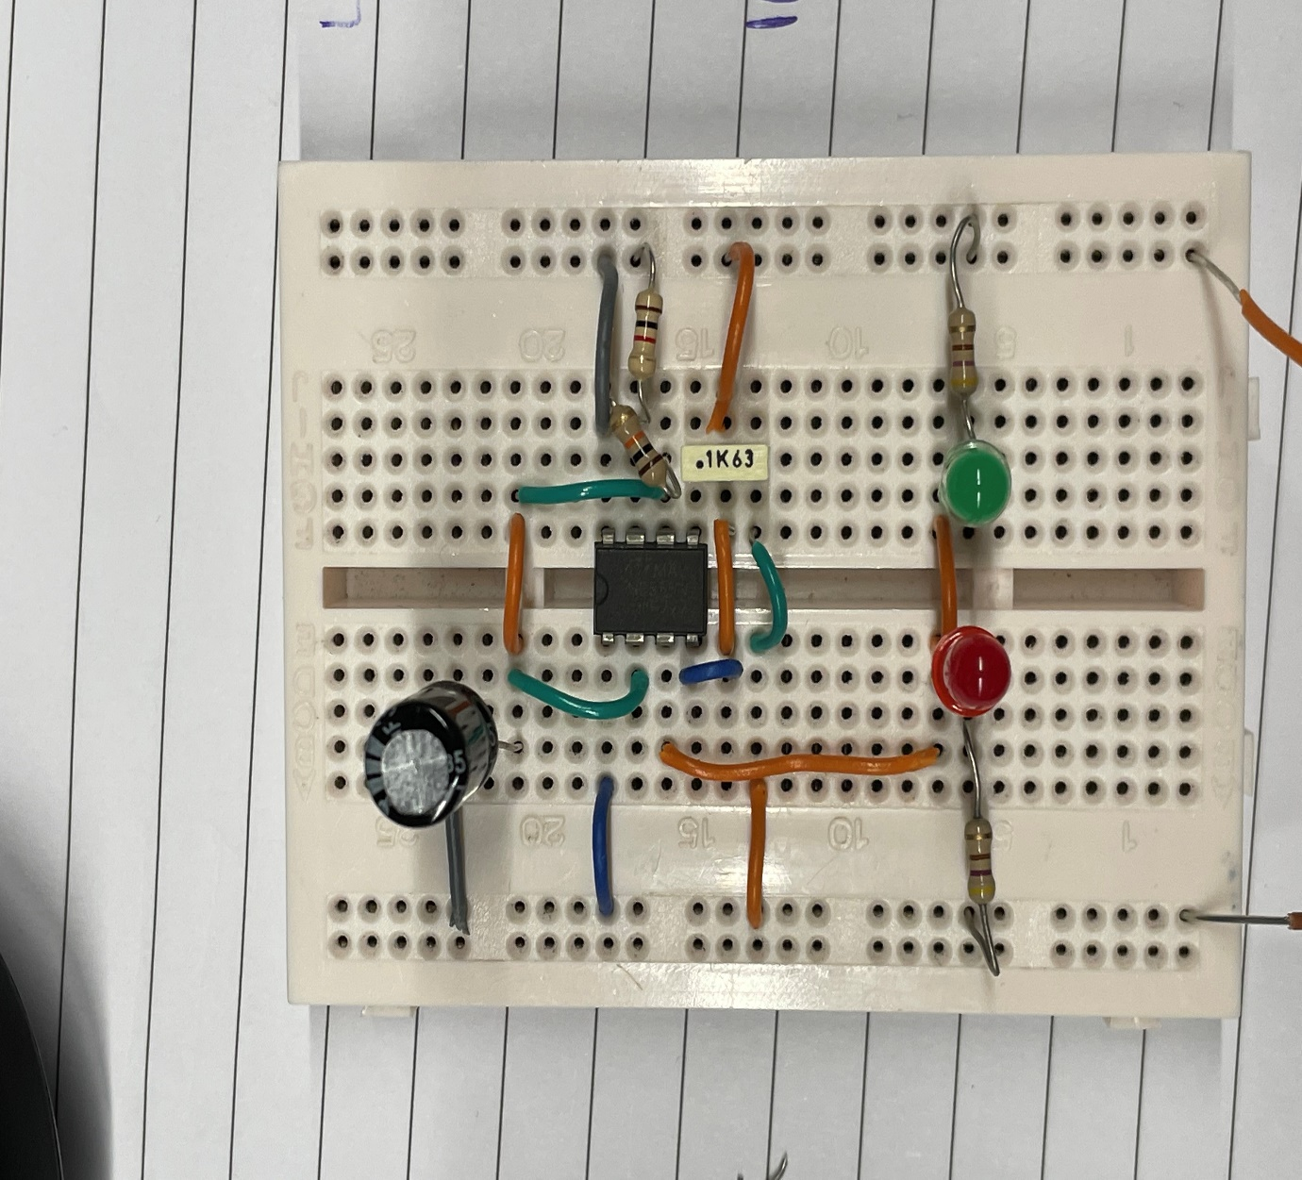
Fig. 10 Photograph of the student’s completed breadboard.
Having completed the breadboard build it was time to test the circuit. Two wires were connected to the breadboard, one on the positive rail and one at the negative. A bench DC power supply was utilised with an output of nine volts (See Fig. 11). The leads were connected to the wires on the breadboard using crocodile clips. Both diodes lit up but at the same time and were very dimly lit. The cables were disconnected, and the breadboard circuit and circuit layout conducted prior to build were interrogated to try and locate the issue. It was found that there was a connecting wire missing from pin eight to the positive rail. A wire was inserted, and the circuit was retested this solved the issue and both the green and red diodes functioned independently. (See Fig. 12) for photographs of red and green diodes in the on and off positions.
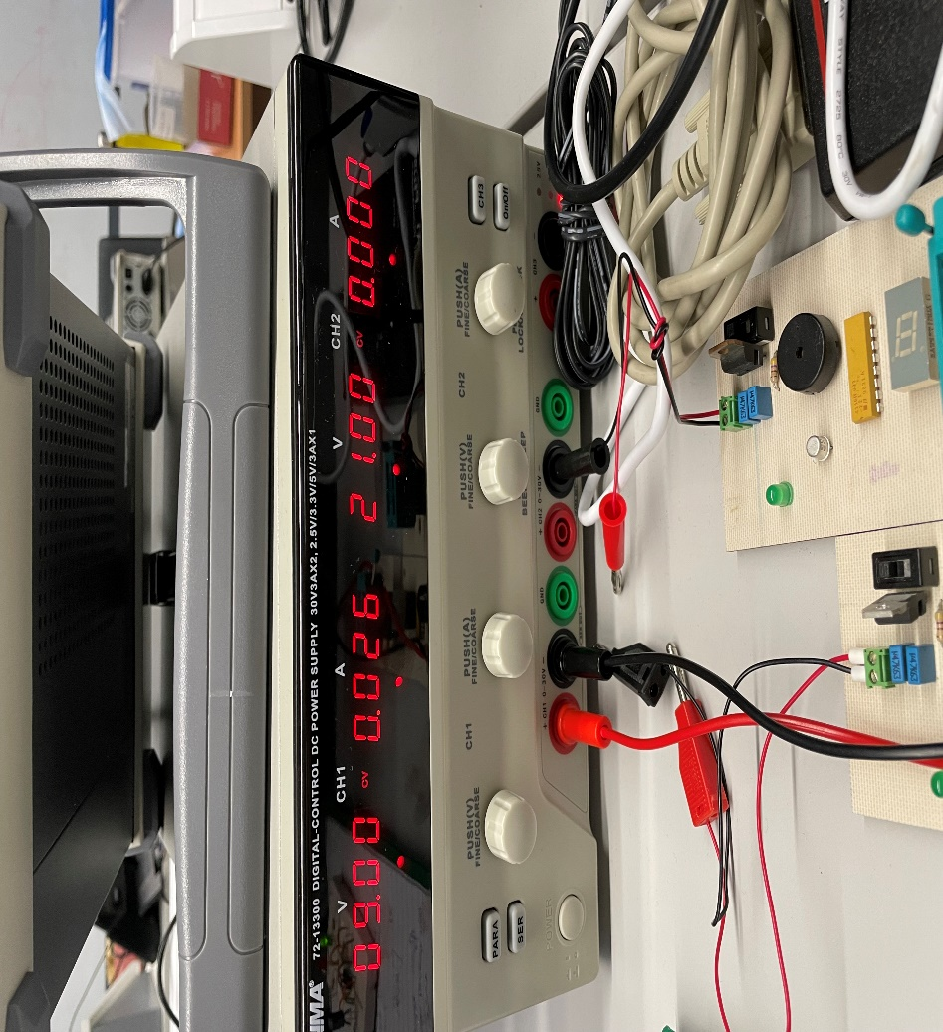
Fig. 11 Photograph of DC power supply.

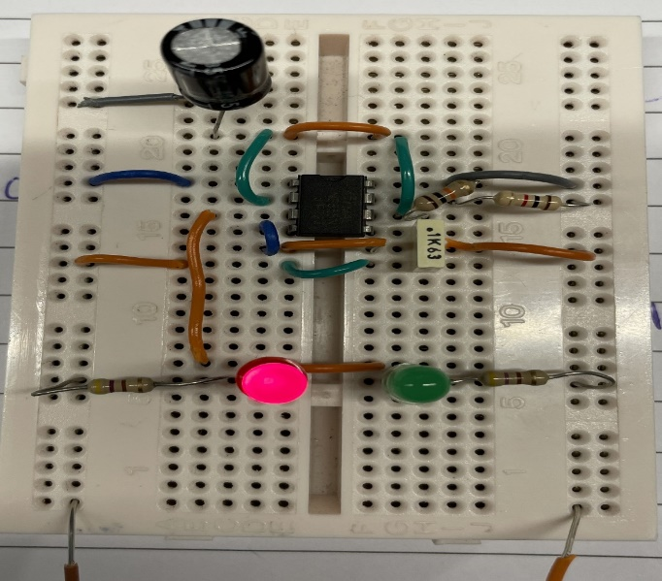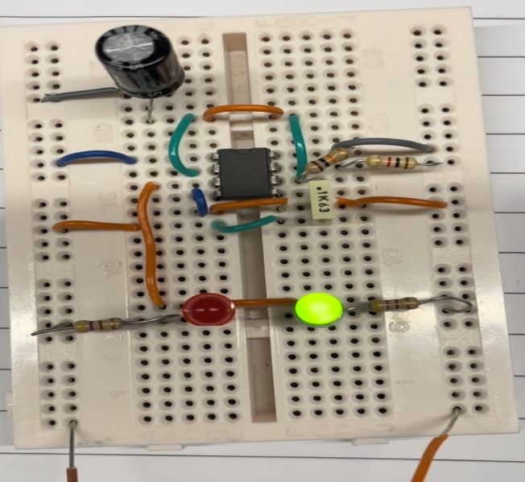
Fig. 12 Photograph of the breadboard with green and red LED in operation.

References

[1] | T. R. Kuphaldt, “555 Timer Circuits,” in Lessons In Electric Circuits, Volume VI – Experiments, 2010, p. 365.
[2] | “www.555-timer-circuits.com/555-timer-basics-astable-mode/,” 2010. [Online]. Available: www.555-timer-circuits.com/555-timer-basics-astable-mode/. [Accessed 10 12 2022].
[3] | Tarantula3, “www.instructables.com,” Autodesk Instructables, 2022. [Online]. Available: https://www.instructables.com/Adjustable-SingleDual-LED-Flasher-Using-555-Timer-/. [Accessed 10 December 2022].
[4] | 555 timer pinout, learningaboutelectronics.com, 2018.

