9b Exercises for lists in Python (3)

1. Top Songs Tracker
A music app wants to track how many times songs were played today.

Write a program to:
- Ask the user to enter the names of 5 songs.
- Store them in a list.
- Ask the user to enter the number of plays for each song.
- Store the play counts in a second list.

Analysis:
- Print the songs and their play counts.
- Print the most played song
- Print the total number of plays (across all songs)
- Print songs with more than 20 places

Sample Output: (note: write the program a little at a time – do not attempt to do everything straight off!)

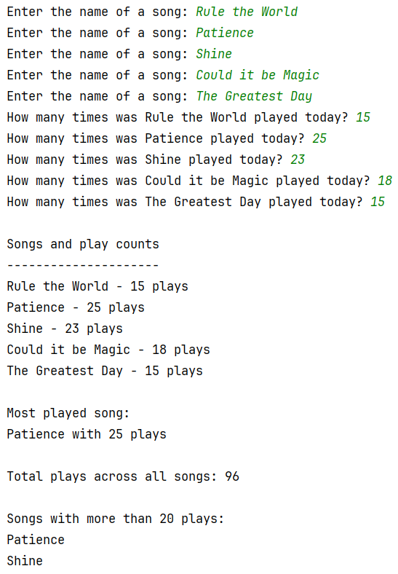

2. School Quiz Results
A teacher is recording scores from a classroom quiz.

- Ask the user to enter the names of 5 students.
- Store the names in a list.
- Ask the user to enter each student’s quiz score.
- Store the scores in a second list.
- Print the results

Analysis:
- Print the highest score overall
- Print the name of the student with the highest score
- Print the name of the student with the lowest score
- Print all the students: if the score is 6 or higher, print “Pass” alongside, otherwise print "Fail".
- Calculate and print the average quiz score.

Sample Output:
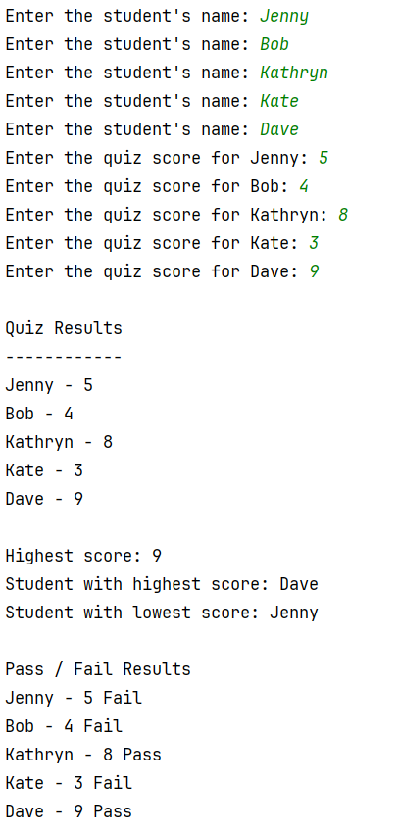
3a. Monster Battle Tracker
In a game, the player fights several monsters. Each monster has a name and a health value.

- Ask the user to enter the names of 5 monsters.
- Store them in a list.
- Ask the user to enter the health points for each monster.
- Store the health values in a second list.
- Print out all monsters and their health.
- Print the strongest monster (highest health).

Sample Output:

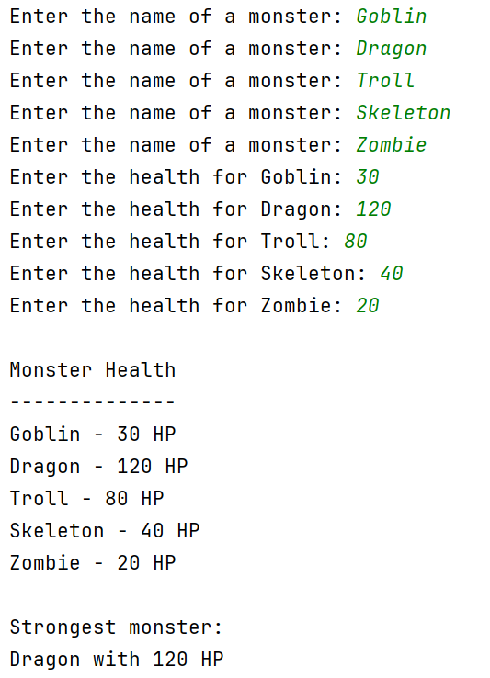

3b More monster tasks

- Print monsters with less than 40 HP.
- Calculate the total health of all monsters.
- Monster attack: ask the user for a monster name and then reduce its health by 10 HP damage. Print the updated health for the monster.

Sample output:



