

Programme: Master of Business Administration
Module: International Marketing: Principles and Practices
Module code: LCMB7026
Assignment Title:
International Marketing:
Principles and Practices
Name: Fazal ullah
ID: 2426570

Table of Contents
Introduction 4
Brand Overview 5
Starbucks in the UK 5
Starbucks in China 6
Comparative Perspective 6
Comparison of Socio-Cultural Context (PESTLE) 6
PESTLE – United Kingdom 7
Political 7
Economic 7
Social 7
Technological 8
Legal 8
Environmental 8
PESTLE – China 9
Political 9
Economic 9
Social 10
Technological 10
Legal 10
Environmental 11
Comparison 11
Comparison of STP Strategies 12
Starbucks in the United Kingdom 12
Starbucks in China 13
Comparison of Marketing Mix (7Ps) Strategies 14
Product 14
Price 15
Place 15
Promotion 16
People 16
Process 17
Physical Evidence 17
Evaluation of Performance 17
Evaluation of Marketing Ethics Practices 19
Recommendations & Conclusion 19
Recommendations 20
Conclusion 20
References 21
Appendices 24

Introduction
Starbucks Corporation is among the most well-known coffeehouse chains throughout the world, as it was founded in 1971 in Seattle, Washington. Starbucks started as a small company with a single store, but now it has grown to more than 36,000 stores in different countries of the world, covering six continents. Its brand name is closely linked with high-quality coffee, novel drinks and the establishment of a third place between life and work where consumers can abandon their homes and workplaces and unwind and socialise. Starbucks is more than a product; it is a symbol of the global coffee culture, and this fact is evidence of how a brand can change its tactics to fit different markets and still have a similar global identity.
International marketing is an important aspect of the contemporary interdependent economy, as it guarantees the continuation of the business. In the case of multinational companies such as Starbucks, the only way to succeed is not only to standardise the core brand values but to adjust and associate with the host countries according to their cultural, social and economic environment. Global marketing policies allow companies to manoeuvre through the varying consumer preferences, competitive environment, and governmental policies. An effective global approach enables brands to attain market penetration, customer loyalty and competitive advantage in the regions.
In this report, the authors have concentrated on the activities of Starbucks in the United Kingdom and China due to the differences in market characteristics. The UK is a developed and western market with a well-developed coffee culture, with stiff competition and high levels of sustainability concerns among consumers. Conversely, China is a representative of an emerging Asian market, where the culture of drinking tea has historically dominated the market, there is a high rate of urbanisation, and the growth of the middle-income population with aspirational lifestyles and consumption is on the rise. The comparison between the two contrasting environments can offer useful information about the ways Starbucks can adjust its strategies in various socio-cultural settings.
The report will provide the background of Starbucks' operation around the world and then discuss macroenvironmental (PESTLE) analysis, segmentation-targeting-positioning (STP) analysis and marketing mix (7Ps) in the UK and China. It will also check the performance outcomes, ethics, and make recommendations on the international marketing strategies that should be used in future.

Brand Overview
Starbucks Corporation is a small company that was established in Seattle, Washington, in 1971 as a small retailer of whole bean coffee, tea and spices. It started to turn into a global powerhouse in the late 1980s with Howard Schultz, who reoriented Starbucks as a retail coffee bean store to a cafe chain that was inspired by the Italian culture of the espresso bar. It centred its identity around this concept of a hospitable social space between home and work, the third place. Starbucks has been aggressive over the decades to spread its tentacles all over the international markets, developing a uniform but locally flexible brand (Yang, 2023). The company is the biggest coffeehouse chain across the globe with more than 36,000 stores in over 80 countries, as of 2024. A mix of company-operated stores and licensed partners has supported Starbucks in the course of its international expansion, which is assisted by an excellent emphasis on product innovation, digital technology, and sustainability endeavours.

Starbucks in the UK
In 1998, Starbucks acquired 60 stores in the UK, which formed the then-leading chain in the United Kingdom, Seattle Coffee Company. It has since expanded to have about 1,200 stores within the country. The UK market is marked by the developed coffee culture and a competitive environment that consists of the local chains: Costa Coffee and Pret a Manger, and international competitors: Caffè Nero. In the UK, Starbucks markets itself as an exclusive but affordable brand, with the addition of seasonal products, customisability, and plant-based substitutes, so as to meet the evolving consumer trends (Bisello, 2021). Nonetheless, the competition has increased with the hegemony of Costa, the largest market shareholder. Moreover, Starbucks has received legal criticism in the UK on tax practices, which not only hurts the brand in the short term, but also. Its success notwithstanding, it still has a base of loyal customers, especially professionals and students in urban areas.

Starbucks in China
Starbucks was introduced in China in 1999, and the first shop was opened in Beijing. Growth has seen the company expand to over 6,500 stores, making it its largest market outside the United States. The coffee culture in China is still rather new and is not as old as in the UK, where tea was an established beverage. Starbucks has managed to establish itself as an aspirational lifestyle brand, attracting young professionals, students and the rising middle class who have related the consumption of coffee to modernity and social prestige. Digital platforms are extensively implemented in the strategy of the company in China, and mobile ordering, delivery cooperation, and loyalty programmes are integrated into popular applications, like WeChat and Alipay. Starbucks, too, has launched culturally specific products like red bean Frappuccinos and mooncakes during the Mid-Autumn festival to appeal to the local palate (Zhang & He, 2024). Its major rival during the recent years has been Luckin Coffee, which is a homegrown chain that takes advantage of convenience, affordability, and technology-driven models.

Comparative Perspective
Although the brand essence of Starbucks is consistent all over the world, its approaches to the UK and China say a lot about the differences. In the UK, Starbucks is concentrating on product innovation, sustainability, and customer experience as its areas of differentiation to compete with the saturated market. Conversely, Starbucks can use its international credibility, cultural localisation and digital first in China to attract an increasing aspirational consumer base. Therefore, the UK is a consolidation and brand-strengthening market, but China remains a growth engine within which Starbucks tries several localisation and scale experiments.

Comparison of Socio-Cultural Context (PESTLE)

PESTLE – United Kingdom

Political
In the UK, Starbucks can enjoy a fairly stable political environment to conduct business, although some developments have been a challenge. Brexit has affected the supply chains, tariffs on imports, and the labour supply. Since the UK is no longer a member of the EU single market, customs checks and delays at the borders have increased the costs of imports to Starbucks in the form of coffee beans, packaging materials and other types of supplies. In addition to this, a constraint on the free movement of labour has inhibited the supply of EU citizens who have traditionally worked in the hospitality sector, resulting in increased recruitment and training expenses. However, the UK government still favours foreign direct investment, which offers a conducive institutional environment that helps global companies such as Starbucks to remain active in the market (Sobirjonova, 2024).

Economic
The UK economically is facing increasing inflation and a long-term cost-of-living crisis, which has a big impact on consumer expenditure on non-essential goods and services. Starbucks coffee is considered a luxury item, and when it comes to economic pressure, people will tend to turn to cheaper options like Greggs coffee or supermarket coffee. Regardless of this, Starbucks has an advantage in that it can target middle-class professionals and students, who are comparatively immune to economic shocks. Moreover, in the UK, there is a significant number of urban labourers and the lifestyle is convenience-oriented, which favours the takeaway coffee. The saturation of the coffee market is, however, high, meaning that Starbucks has to compete hard in terms of promotions, loyalty programmes and seasonal products to retain its customers.

Social
The UK has a strong, established coffee culture with chains of cafes installed in the daily life of the urban areas. Consumers perceive the coffee shops as social and workplaces, as well as places where they can buy drinks. Ethical consumerism is also being prioritised highly; consumers are becoming more and more demanding of the brands to show their inclinations toward fair trade sourcing, inclusiveness, and corporate social responsibility. Some of the responses that Starbucks has provided include fair-trade coffee beans, dairy alternatives, and diversity promises in the workforce (Sherpa, 2021). Furthermore, veganism and health awareness are also becoming social trends, which Starbucks exploits with vegan food and lower-calorie menus.

Technological
The market in the UK is highly technological, and digital applications and loyalty programmes are used by people. The Starbucks mobile ordering system, as well as the Starbucks Rewards application, have played a key role in keeping technologically advanced consumers who seek convenience and customisation. Digital innovation in the UK also expands to connection to contactless payments, which boomed during and after the COVID-19 pandemic. Promotion and reward programmes can be personalised to the customers with the help of customer data analytics, which strengthens the consumer interest in a highly competitive setting.

Legal
The UK is a strong regulatory place that has a direct influence on Starbucks. The advent of the Soft Drinks Industry Levy (commonly referred to as the sugar tax) has forced the business to remake drinks that contain a lot of sugar or label them in a clearer manner to meet the requirements. Also, there are health and safety laws, stringent employment policies and minimum wage regulations that raise the cost of operations. Other controversies that have engaged Starbucks include corporate taxation in the UK, which attracted negative publicity as well as being scrutinised by the regulators. These are legal considerations indicating that there ought to be clear and ethical operations to enable consumers to trust them (Musonera, 2021).

Environmental
The UK market is strongly driven by sustainability as people are very conscious about environmental matters. Starbucks has also launched a number of programmes, including reusable cup reductions and promises of single-use plastic straw eradication, which are in line with the increasing societal anxiety about waste minimisation. Moreover, the demand to use environmentally friendly packaging and reduce the footprint is increasing. Starbucks has been committing to carbon neutrality and investing in green energy to meet the UK environmental policies and customer demands. These are necessary sustainability efforts that ensure competitiveness and reputation in an environmentally sensitive market.

PESTLE – China

Political
In China, the political environment is more challenging to the business environment of Starbucks, mostly because the state is involved in business regulation. To be successful in the country, foreign businesses have to enter into joint ventures or form partnerships with the local enterprises to ensure that the government regulations are adhered to. Starbucks has survived in this environment through establishing strategic partnerships, like with Alibaba, to increase digital capability and delivery options. Economic development and urbanisation by the government have mostly favoured the growth of Starbucks, although the company needs to be flexible to the unforeseen changes in regulatory priorities, like food safety or limiting foreign ownership. Sound state planning coupled with political stability offers Starbucks a predictable, but well-controlled, expansion framework (George, 2023).

Economic
The fast economic growth, urbanisation and emergence of the middle class in China have provided a favourable environment to Starbucks. Disposable incomes have increased significantly, particularly in the urban centres, which has increased the spending on lifestyle and leisure products. Coffee is being sold as a high-end, aspirational product, and Starbucks' pricing strategy is based on this fact, as it sells coffee at prices higher than its local competitors. Nevertheless, sluggish economic growth, including that which occurred due to the COVID-19 pandemic and recent trade tensions, is problematic for consumer confidence and household spending. However, the long-term perspective is bright, and China is likely to be among the biggest sources of growth for Starbucks worldwide.

Social
Tea has been the main drink in China, though there is a growing consumption of coffee, especially by the younger generation in the urban centres. Starbucks has established itself as a coffee shop but also as a fashion brand that is linked to modernity, sophistication and the Western culture (Zhang & He, 2024). The third-place idea of the café has been quite popular among urban millennials and people in professional environments who are looking for a social or business meeting place. Also, the cultural values of collectivism promote group consumption, and Starbucks outlets are, in most cases, transformed into socialisation opportunities and not for individuals. Culturally sensitive products like mooncakes during the Mid-Autumn Festival are also seasonal products, which show how Starbucks is sensitive to cultural requirements.

Technological
The digital innovation of Starbucks has great opportunities in China, which has thoroughly become a mobile-first society. It has been integrated with other applications such as WeChat and Alipay, allowing smooth mobile payments and reward programmes. Starbucks has also used the Alibaba food delivery platform Ele.me to increase its coverage by delivering goods to homes through this service model that is vastly appreciated by urban residents (Lu, 2022). The Chinese market is described as highly using e-commerce, digital promotion and influencer marketing (KOLs), which Starbucks has adopted successfully. Data analytics will enable personalised offers, which will enhance the loyalty of the customers in an environment where digital experiences influence consumption patterns.

Legal
The Chinese legal environment is highly restrictive to foreign firms, which are required to have local partnerships and protection of intellectual property. Starbucks has managed these conditions generally, but faces threats concerning the changing food safety regulations, consumer protection legislation, and labour regulations. The problem of intellectual property protection is also rather problematic, and sometimes the brand image is compromised by fake merchandise. In order to reduce these risks, Starbucks spends a lot on compliance and brand protection programmes.

Environmental
The government of China has put a strong emphasis on environmental sustainability, which puts the burden on businesses to minimise emissions and go green. Starbucks has reacted by launching programmes like recyclable packaging, energy-saving store designs and sustainable sourcing of coffee (Sobirjonova, 2024). The environmental issues are becoming more of a concern among the masses, and especially the younger consumers, in conjunction with government policies that encourage people to consume green. The fact that Starbucks can incorporate sustainability in its business activities enhances its credibility in the government and consumer perspectives.

Comparison
PESTEL analysis indicates that the situation of Starbucks in the UK is in stark contrast to that in China. Starbucks operates in a saturated and mature market in the UK where the consumers are price-sensitive and ethically aware. The presence of political stability and a well-regulated environment fosters transparency in business, whereas the pressures of an economy like inflation and stiff competition force the process to innovate constantly. The UK also has a much higher sustainability expectation that influences products, packaging and strategies in operations.
In comparison, China is a high-growth, technology-driven market where Starbucks can position itself as a lifestyle brand of high quality. The firm uses digital ecosystems, cultural localisation, as well as aspirational branding to win over a growing middle class. Chinese politics and legal systems are stricter, and mean that they have to form partnerships and adhere to state policies, yet they provide opportunities in the form of state-led urbanisation and digital infrastructure. The concept of environmental awareness is on the increase, but consumer demands are based on modernity and convenience, which leaves Starbucks with more room to operate than the high environmental demands of the UK (Kullenberg et al., 2023).
On the whole, the UK needs Starbucks to work on consolidation, sustainability, and reputation management, whereas China needs the company to expand quickly, use digital innovations, and integrate into the local culture. Such distinctions demonstrate the necessity of very specific international marketing approaches that would balance the global brand image with the local modulation.

Comparison of STP Strategies

Starbucks in the United Kingdom
The UK market segmentation of Starbucks is in accordance with the features of a highly competitive and mature coffee market. The company focuses mostly on the urban professionals, students and middle to upper class consumers who place a premium on convenience and also the brand identity. Starbucks targets geographically the metropolitan regions like London, Manchester, and Birmingham, as there is a high foot traffic and where takeaway coffee is in great demand. Demographically, it targets working adults and younger consumers who often want comfortable working, studying or socialising places. Psychographically, the UK market is becoming health-conscious and sustainability sensitive, i.e. Starbucks' focus on plant-based drinks, energy-conscious drinks, and socially responsible coffee makes a lot of sense to the customers (Zhang, 2022).
Starbucks has a differentiated marketing strategy in terms of targeting. It is able to provide a variety of beverages, including the regular espresso beverages as well as special beverages every season to fit the different needs of consumers. The dairy-free options and sugar-free options are offered to health-conscious consumers, whereas mobile ordering and loyalty apps are offered to busy professionals to make it more convenient. The promotion also tends to emphasise sustainability efforts like offering discounts to those who bring their own reusable cups, which is consistent with the high ethical consumer culture of the UK.
The UK positioning of Starbucks is based on the positioning of the company as a premium but affordable coffeehouse. Although it demands a higher price than some of its competitors, it compensates for it with quality, consistency and atmosphere. It has also consolidated through focusing on ethical sourcing ( Fairtrade coffee, C.A.F.E. practices) and corporate social responsibility. With the threat of substitutes being high in a saturated market full of local rivals such as Costa Coffee, Starbucks can distinguish itself as a company which combines the prestige of global brands with a measure of ethical, health and socially responsible behaviour (Zhou, 2024).

Starbucks in China
The segmentation of Starbucks in China is conditioned by the emergence of a new consumer group. The target market that the firm targets is young professionals, millennials, and the aspirational middle class, who are mainly in Tier 1 and Tier 2 cities, including Shanghai, Beijing and Guangzhou. Such consumers are generally aged between 20 and 40 years old, and are experiencing growing disposable incomes and the need to be more cosmopolitan and modern in their lifestyles. The psychological attribute of Chinese consumers toward drinking coffee is that they equate it with sophistication, social status, and Western cultures. Starbucks also exploits the collectivist social facet whereby group consumption and socialisation hold the key to making buying decisions.
In targeting, Starbucks is a digital-first and lifestyle-driven company. The brand targets image-conscious consumers who are keen on indicating their status and making a statement of modernity by choosing their consumption (Xu, 2023). Starbucks can serve the high-tech Chinese market through a seamless integration with other mobile applications, like WeChat and Alipay, and mobile ordering, delivery, and tailored loyalty programmes. It also partners with local firms (e.g. Alibaba to deliver goods and instead to integrate the digital aspect in order to enhance its relevance. Premium items that are associated with cultural holidays (like mooncakes or New Year-themed drinks) enable Starbucks to target those consumers who want to obtain cultural authenticity but experience the global brand recognition.
The positioning of Starbucks in China is very different from that in the UK. In this case, it is positioned as a third-place lifestyle brand that is a representation of modernity, social status and desires. Luxury is usually stressed in the stores; there are large seating areas and high-quality interior furnishings that are used for socialisation or business meetings, and study. The company has positioned itself as a company that not only sells coffee but also represents Western sophistication and success. Starbucks is a company that enjoys global recognition and aspirational value in a market that is still in the maturity phase of coffee culture and is therefore able to use such a competitive edge to establish brand dominance (Lin, 2025).

Comparison of Marketing Mix (7Ps) Strategies

Product
The product line of Starbucks in the UK focuses on seasonal flavours, vegetarian-based, and classic Western foods. Beverages like Pumpkin Spice Latte and Toffee Nut Latte have become seasonal during the fall and winter, which fits the interests of the British consumers in terms of festive and seasonal tendencies. Moreover, the increasing vegan and vegetarian population of the UK has necessitated the company to increase its menu to cater to oat, soy, coconut, and almond milk substitutes, along with plant-based food items. This is in line with the wider social trends towards healthier living and responsible consumerism. The UK menu is fairly similar to that of Starbucks worldwide, which guarantees the knowledge of the brand and includes healthy variants.
Starbucks has used a localisation strategy in China, incorporating its global identity with locations that are customised to the local culture (Detian et al., 2025). Some of the modifications in the menu are the red bean frappuccino, green tea lattes, and mooncakes that are served during the Mid-Autumn festival. Beverages made out of tea are particularly visible, as the population is highly traditional in drinking tea. These regionalised things enhance the cultural relevance of Starbucks and the brand itself as a blend of East and West. In such a way, the UK strategy is based on dietary tendencies and lifestyle changes, whereas the Chinese strategy is built around cultural adaptation and innovation.

Price
Starbucks in the UK has a mid-premium pricing strategy that positions it among the direct competitors of Costa Coffee and Pret a Manager. The prices will be slightly higher than those of the fast-food chains and the supermarket coffee, yet affordable enough to have middle-income customers who buy premium quality coffee. Since the cost-of-living crisis is now present, Starbucks has launched loyalty programmes and targeted discounts as value-for-money perceptions. Its objective is to continue with an approachable high-end image without scaring off price-sensitive parties.
On the other hand, Starbucks employs a high-end pricing mechanism in China, which is aimed at conveying exclusiveness and prestige. The perception of coffee as a luxury product still exists, especially in Tier 1 and Tier 2 cities, and Starbucks takes advantage of this due to the strategy of keeping the prices well above the national average provided by the competitors, including Luckin Coffee (Nguyen et al., 2025). This is a strategic move that supports the role of Starbucks as an aspirational lifestyle brand. Although it may expose it to loss of lower-class consumers, it reinforces the position among the middle-income and high-income urban consumers who consider Starbucks as a brand of modernity and a social status.

Place
Within the UK, Starbucks is located in the high streets of the major cities, transport hubs and retail centres. Airports and train stations have locations that serve commuters and travellers who need convenience, which resonates with the high demand for takeaway coffee. Although Starbucks also provides seating, it is possible that many stores are focused on high traffic and serving customers to go.
Starbucks has been strategic in locating its outlets in shopping centres, busy city centres and in the elite business areas in China (Bao & Wang, 2024). The design of the stores is such that they act as the third spaces where individuals get to interact, learn or hold business meetings. The company also has several flagship stores known as Reservation Roastery, which are luxurious outlets that are a mix of a cafe atmosphere and a retail experience. This practice underscores the way Starbucks has been keen on positioning itself as not just a drink producer but as a lifestyle.

Promotion
Starbucks in the UK uses traditional media, digital and sustainability campaigns. Advertising is also promoted through seasonal campaigns (such as the use of Christmas beverages), the use of reusable cups with discounts, and the reward being incorporated into the Starbucks app, which is in line with the ethical consumer culture in the UK. Starbucks also collaborates with other delivery services, such as Uber Eats, to reach further.
Starbucks in China is a big digital-first promoter with a heavy investment in the popularity of the WeChat, Weibo, and Alipay platforms. The buzz is created about new products and limited editions with the help of Key Opinion Leaders (KOLs) and social media influencers. Promotions are also very interactive and culturally aware since Starbucks operates gamified loyalty programmes embedded within WeChat. This digital focus serves China with its mobile-first population, whereby consumers want a seamless way of marketing and daily digital life (Su, 2024).

People
The UK Starbucks has trained baristas who concentrate on products and service delivery. The staff is also pushed to make things personal, like writing the names of customers on cups, and this gives them the feeling of being appreciated. Training also focuses on keeping with ethical and inclusive practices, which are relevant in the socially conscious environment of the UK.
In China, Starbucks has hired local employees, who have been trained on the Western culture of service provision but modified to the collectivistic culture. The employees are taught to establish a social atmosphere in a welcoming group-oriented manner, which is significant in the Chinese culture of social gatherings (Jiang, 2024). The areas of staff training are hospitality, engagement with customers, and cultural sensitivity. Starbucks has also strengthened the aspirational positioning of its brand through in-store sales efforts in flagship stores, where the company uses the term coffee masters to educate customers on superior brews, thereby boosting its aspirational positioning.

Process
Starbucks UK has reduced its operations, making them fast and convenient. Customers are mostly interacting with mobile ordering, click-and-collection and making payments without touching anything. The market is very efficient, and as such, consumers are commonly buying coffee on the run (Kun, 2022).
In China, Starbucks combines AI-based and app-based ordering systems with partnerships with the delivery service Ele.me, based on Alibaba, and with the ordering systems through WeChat and Alipay. The ordering is usually delivered within minutes, and the delays are minimal. This will provide a smooth digital-to-physical flow that will satisfy the Chinese consumer's need for speed, personalisation and online interaction. The process design indicates the high level of digital ecosystem in China, which is the opposite of the less immersive and more efficiency-focused approach of the UK.

Physical Evidence
Starbucks cafes in the UK are generally relaxed yet practical, with sufficient seating and a warm atmosphere, but can often be approached with efficiency in mind. Store layouts prevail with takeaway service, with constant branding with the Starbucks global visual.
Starbucks stores in China are luxurious flagships which are usually culturally designed. Most of the stores introduce local art, architecture and spacious layouts that make people want to spend longer periods in the stores (Aduana et al., 2024). The Reserve Roastery outlets, including those in Shanghai, provide immersive experiences including on-site roasting, crafted food and high-quality beverages. This gives a powerful physical presence that helps Starbucks with the aspirational and lifestyle-based positioning.

Evaluation of Performance
In the UK, Starbucks has been a well-known brand, but it is struggling with a given level of competition in an already saturated market. It is the third biggest market share with Costa Coffee and Caffes Nero, which have a high brand loyalty and a wider coverage of commuter-prone areas. The UK has experienced a stable but small growth since the market is mature and characterised by stiff competition. Starbucks has experienced reputational damage as well because of the scandals of tax avoidance, hurting its image among people and leading to consumer boycotts in the early 2010s. The brand equity of the company has been constrained to some extent by the fact that there is still a perception of corporate irresponsibility, even though the company has made efforts to enhance its transparency and sustainability (Huang, 2025). However, Starbucks still has a base of an urban professional and student consumer, and the emphasis on digitalisation and menu innovation based on plants has served as an aid to remain relevant. Starbucks' strategy in the UK is mainly one of consolidation and differentiation, considering it is competing to maintain market share as opposed to realising rapid expansion.
However, the Chinese performance of Starbucks is of a different order. The company has taken the lead position in the Chinese coffee industry despite the increased competition posed by the local brand Luckin Coffee. By 2023, the market share controlled by Starbucks was at about 36 per cent, which is quite an achievement for the dominance the company has had in a market that is still in its evolving stages. Starbucks has still recorded growth of its revenues in China in the double digits, owing to the expansion of its stores, localisation of its products, and the integration of technology with the local e-commerce platforms, including WeChat and Alipay. Its capability to position itself as a high-end lifestyle brand has enjoyed a high customer base, especially among the youthful professionals and the aspirational middle-income earners. Despite the fast rate of expansion of Luckin Coffee due to its cheaper and more conveniently oriented alternatives, the prestige of Starbucks and its premium positioning have enabled it to continue leading (Wang, 2023).
On the whole, the performance of Starbucks reveals the dual strategy because, in the UK, the company seeks consolidation in a mature and saturated market, prioritising ethical and digital efforts, but, in China, the company pursues an aggressive expansion strategy, taking advantage of unexploited demand, aspirational consumption, and technological integration as a growth driver.

Evaluation of Marketing Ethics Practices
Starbucks has been an issue of high ethical performance in the United Kingdom, especially concerning controversies of tax avoidance. Disclosures about the fact that the company paid little in terms of corporation tax in spite of the large sales in the UK have resulted in negative publicity and boycotts, which hurt its brand image (Petrova et al., 2024). Although Starbucks has taken actions to overcome transparency since then, it has been a significant black spot on its moral image. The other significant issue is connected to the waste of single-use cups because the environmentally aware consumers in the UK require more serious efforts in terms of sustainability. Despite reusable cup discounts and cup-return initiatives, critics claim that Starbucks has not done enough and fast enough to combat the crisis of waste.
In China, ethical issues are played differently. The primary issues of Starbucks are ethical sourcing and environmental packaging. As the company emphasises its practices of C.A.F.E. (Coffee and Farmer Equity) on an international level, the transparency of sourcing practices in China is less obvious. Besides, as the government has increased its focus on sustainability, Starbucks has been pressured to minimise waste levels in packaging and become more environmentally friendly. Regulatory control in China, however, is not consumer-focused as compared to the UK, which means that Starbucks has a greater leeway but also faces the new standards of the government (Sanchez Herrera et al., 2022).
In general, the UK environment implies increased transparency and accountability, and in China, ethics and environmental compliance sourcing are prioritised as a state-regulated system.

Recommendations & Conclusion

Recommendations
In the UK, Starbucks needs to concentrate on enhancing its sustainability programmes to match consumer needs. Reusable cups programmes, deposit-return systems, and eco-friendly packing would help to improve its eco-friendly image and competitive edge. Starbucks also needs to expand its products with more functional drinks like protein-based smoothies or health-related drinks to cater to the health-conscious market, to be able to compete better with Costa Coffee.
In China, Starbucks ought to focus on the further development of local collaborations to establish a solid position in the market in relation to the fast development of Luckin Coffee (Balakleiets & Kovalevska, 2025). Partnerships with Chinese technological and retail giants will be effective in terms of efficiency, reach and strong local incorporation. Moreover, Starbucks needs to keep on investing in its digital-first loyalty schemes, where AI-delivered personalisation and gamification can keep the tech-induced consumer engaged with their brand and ensure brand loyalty in the long run.

Conclusion
The success of Starbucks all over the world proves that balancing between a uniform brand image and tailoring marketing approaches to the local context can be effectively used. The UK needs an ethical responsibility, sustainability, and differentiation strategy in a densely saturated market, whereas China needs an aspirational, technology-oriented, and collaborative strategy in a fast-growing market. It is these unique socio-cultural and economic environments that make Starbucks relevant and resilient both in developed and undeveloped markets. Finally, its capability to combine global uniformity and local sensitivity will be the key to its further global development.

References
Aduana, I.G., Angeles, E.R., Angeles, D.R.G. and Fabian, D.R.B., 2024. Marketing mix strategies toward customer satisfaction of Yufiro Coffee in tanza, cavite: Basis for enhancement plan of marketing mix strategies. International Journal of Research in Education Humanities and Commerce, 5(01), pp.265-273.
Balakleiets, K. and Kovalevska, A., 2025. MARKETING MANAGEMENT: AN APPROACH BASED ON THE DEFINITION AND CONSIDERATION OF CORPORATE CULTURE. The actual problems of regional economy development, 1(21), pp.234-247.
Bao, T. and Wang, Q., 2024. Cafe and Creativity: Evidence from Starbucks Expansion and Innovation in China. Available at SSRN 5180654.
Bisello, G., 2021. Starbucks and Illycaffé: different strategies to successfully enter the Chinese coffee market.
Detian, X., Wongkumchai, T., Chaiwiwat, U. and Tarndamrong, P., 2025. Optimizing M Coffee's Marketing Strategies for the Chinese Coffee Market. Journal of Public and Private Issues, 2(2), pp.104-115.
George, A.R., 2023. A Cooperative Business Analysis of Starbucks Corporation & Reflection by Principal Financial Investigator.
Huang, Q., 2025. A, In Localizing A Global Brand: Starbucks’s Marketing Strategy In China. Ratio: Reviu Akuntansi Kontemporer Indonesia, 6(2).
Jiang, M., 2024. Analysis of Market Positioning and Brand Competitiveness of Starbucks and Luckin Coffee in China. In SHS Web of Conferences (Vol. 208, p. 04006). EDP Sciences.
Kullenberg, R., Friman, V. and Forslund, K., 2023. Brewing Up a Storm: The Rise of Stars Coffee. LBMG Corporate Brand Management and Reputation-Masters Case Series.
KUN, L., 2022. THE SERVICE QUALITY AND MARKETING MIX AFFECTING CUSTOMER SATISFACTION IN COFFEE INDUSTRY IN NANNING, CHINA (Doctoral dissertation, SIAM UNIVERSITY).
Lin, Y., 2025. THE ANALYSIS OF DIGITAL MARKETING STRATEGY OF STARBUCK IN SHANGHAI, CHINA (Doctoral dissertation, Universitas Pendidikan Ganesha).
Lu, D., 2022, April. Analyze the marketing strategies of new-tea drinks industry by the SWOT and PEST tools-take Nayuki as an example. In 2022 7th International Conference on Social Sciences and Economic Development (ICSSED 2022) (pp. 98-101). Atlantis Press.
Musonera, E., 2021. Strategic marketing case analysis: Starbucks. Journal of Business and Social Science Review, 2(11), pp.12-22.
Nguyen, K.M., Dinh, L.T.K., Ngo, T.T., Phan, T.T.T., Nguyen, P.D.H., Tran, H.P.M. and Nguyen, N.T., 2025. The Impact of 7Ps Green Marketing Mix on Customer Commitment and Willingness to Pay a Premium Price: Evidence from Vietnam. Journal of Promotion Management, pp.1-42.
Petrova, A., Karintseva, O., Tarasenko, S. and Wojciech, H., 2024. Business ethical aspects for sustainability: contemporary analysis and assessment.
Sanchez Herrera, J., Pintado Blanco, T. and Lopez Aza, C., 2022. Corporate Activism and Quality of Life: Starbucks Corporation Case Study. In Applied Social Marketing and Quality of Life: Case Studies from an International Perspective (pp. 363-379). Cham: Springer International Publishing.
Sherpa, N.L., 2021. The Application of Marketing analysis: A case study of Starbucks in the US.
Sobirjonova, K., 2024. IDENTIFYING EFFECTIVE STRATEGIES AND INDEPENDENTLY EVALUATING EACH ANALYSIS USING THE EXAMPLE OF THE PREEMINENT GLOBAL ENTITY IN THE COFFEE INDUSTRY, STARBUCKS. International scientific journal of Biruni, 3(1), pp.249-255.
Su, S., 2024. Research on Starbucks marketing strategy and future development means based on 4P model. In SHS Web of Conferences (Vol. 207, p. 01006). EDP Sciences.
Xu, Z., 2023. The Marketing Strategy Analysis of Starbucks.
Yang, C., 2023. A Comparative Study of Starbucks and Luckin Coffee’s Market in China. In SHS Web of Conferences (Vol. 163, p. 02008). EDP Sciences.
Zhang, H., 2022, April. Methods for Luckin Coffee to Develop its Core Competence. In 2022 7th International Conference on Social Sciences and Economic Development (ICSSED 2022) (pp. 1527-1532). Atlantis Press.
Zhang, J. and He, Y., 2024, May. The Effectiveness of Starbucks’ Loyalty Program Across Different Culture (UK: Edinburgh; China: Kunming). In 9th International Conference on Financial Innovation and Economic Development (ICFIED 2024) (pp. 601-611). Atlantis Press.
Zhaozhe, W.A.N.G., 2023. Analysis of Starbucks in China. Psychology, 13(5), pp.223-228.
Zhou, Q., 2024. The Impact and Investigation of Starbucks’ Profit Generation Strategies. In SHS Web of Conferences (Vol. 185, p. 03020). EDP Sciences.

Appendices
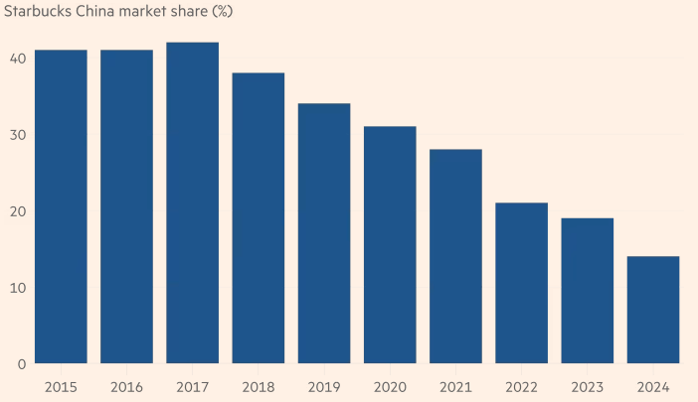

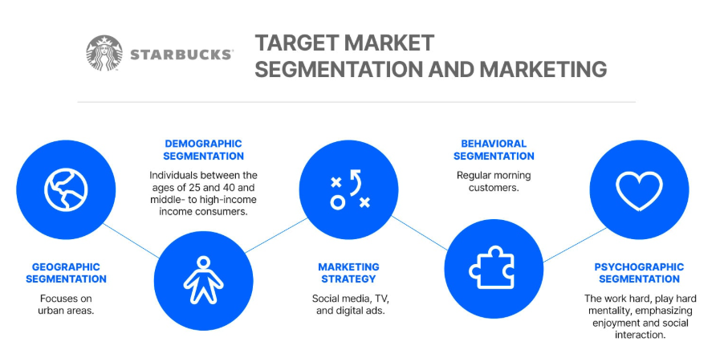
Source: https://businessmodelanalyst.com/
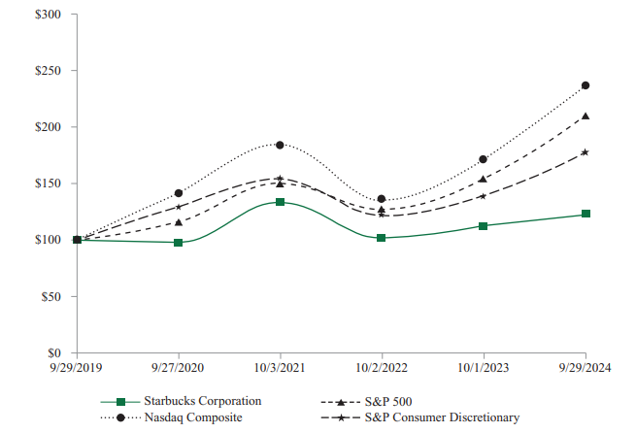
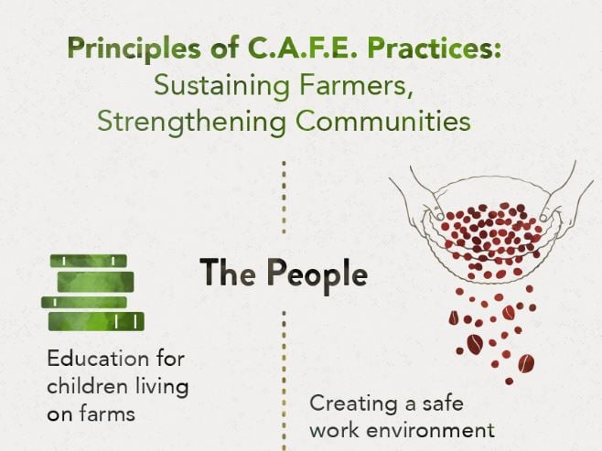
Source: starbucks.com

