Matthew Owen Williams
P137421
Dissertation Proposal
A critical evaluation of how intense competition within the UK car insurance market influences the business practices of Admiral Car Insurance.

Table of contents

- Introduction …………………………………………………………………………………….. Page 3
  - Background…………………………………………………………………………… Page 4
- Rationale…………………………………………………………………………….……………. Page 3
- Aims and Objectives…………………………………………………………………………. Page 5
- Research Design and Methodology………………………………………………..…. Page 6
  - Epistemology…………………………………………………………………………. Page 7
  - Phenomenology……………………………………………………………………. Page 7
  - Inductive qualitative approach ……………………………………….……. Page 8
  - Survey ………………………………………………………………………………….. Page 9
  - Mixed Methods…………………………………………….………………………. Page 9
  - Cross sectional …………………………………………………………………….. Page 9
- Sample…………………………………………………………………………………………….. Page 9
- Validity and reliability……………………………………………………………………….. Page 10
- Ethics…………………………………………………………………………………………..……. Page 10
- Resources and Planning……………………………………………………….……………. Page 11
9.0 Bibliography…………………………………………………………………….……………….. Page 13

- Introduction

1.1 Background

The market for motor insurance is seen by many as being dysfunctional (Black, 2013). Premiums rise and fall sharply and unpredictability. Fraud against the industry is widespread, but the relationship between the industry and car hire specialists, repairers and legal firms seems equally dubious (Edmonds, 2017). For these reasons the industry has attracted the attention of public opinion, the competition authorities, and parliamentary enquiries (Ibid). The industry, however, points out that the market is fiercely competitive, driven by price comparison websites, and is periodically unprofitable. According to Smith et al (2014) as a result of complaints about the sector, the Competition Commission investigated the market, and concluded that there were ‘features of the UK market for private motor insurance and related goods or services that either alone, or in combination, prevent, restrict or distort competition such that there are adverse effects on both competition and consumers’.

According to data by the Association of British Insurers (hereafter, ABI) (2017) the UK insurance market is the largest in Europe and the fourth largest in the world. It is an essential part of the UK’s economic strength as a result of paying over £12 billion in taxes, adding over £35 billion to the economy and employing over 320,000 people (Ibid).

Insurance policies, unlike most other consumer products are contracts that promise to make certain payments under certain conditions at some point in the future (White, 2017). Unlike tangible products, consumers have a very limited opportunity to research all elements and features of an insurance product, often due to a lack of knowledge or understanding as a result of the complexities of insurance products (Llewellyn, 2015). It is down to the complicated nature of insurance policies that consumers have a heavy reliance on the insurance industry to not only bridge the gap of knowledge, but also to act appropriately by offering suitable, appropriate products (Hunter, 2005). As a result, regulation exists to prevent competition that fosters the sale of unfair and deceptive policies, sales and claims practices (Ibid)

According to the ABI (2018) ‘motor insurance is a contract by which the insurer assumes the risk of any loss the owner or operator of a car may incur through damage to property of persons as a result of a motor accident’. It could be argued that the car insurance industry, as a whole are adhering to the needs of society by offering a product required by law, and mitigating the financial risk of consumers, and therefor could be considered as an ethical industry. However, despite meeting the basic needs of society, and acting within the law to limit the financial risk to consumers, there is significant evidence to suggest that business practices of the motor industry have more of a focus on its shareholders than its consumers. For example, According to data attained by money-supermarket the average price of a car insurance policy for a 17 year old stands at £2896.72 (Carr, 2018), despite the vast amount of teenagers being paid minimum wage, often making the insurance unaffordable (Pratt, 2015). Further examples include insurance companies setting policies up for automatic renewal and increasing premiums when their due for renewal leading to the insurance industry charging its consumers over £1.3 billion more than they should, leading to consumers paying on average £113 more than they would if they had looked elsewhere (Ibid). Furthermore, there’s also evidence of competitors purposely inflating costs of claims at the cost of its competitors leading to a reduction of profit amongst the industry leading to higher premiums for consumers.

Immanuel Kant is best known for his theory of duty ethics. Kant believed that individuals owe moral duties based on universal rules. (Cheesman, 2009). Considering the high level of competition within the motor industry, economic responsibilities of businesses and a number of regulators, one could assume a number of justifications for the business practices of a UK car insurance firm.

2.0 Rationale

The justification of this dissertation is to give consumers a greater understanding of the industry by justifying why these business practices are in place, how intense competition amongst car insurance firms are, and as a way of creating a greater level of transparency amongst consumers and insurance firms.
The potential benefits for this research could mean a greater understanding of the insurance industry from consumers, leading to consumers having less reliance on the industry, and being more vigilant to the practices of insurance firms. In the short term, this could mean consumers are less likely to be loyal to their insurance companies and as a result will look elsewhere for insurance policies. The long term results could potentially mean a more competitive market meaning lowered premiums for consumers and a more stringent approach from regulators as a way to limit unethical business practices.

As a direct result of a paucity of research into the competition, and business practices of the motor insurance industry, this dissertation will not look to test any existing models or framework of competition or ethics, but will instead take and explorative approach and seek answers to the research question, which is a critical evaluation of how intense competition within the UK car insurance market influences the business practices of Admiral Car Insurance.

3.0 Aims and Objectives

The aim of this dissertation is to determine the morality and reasoning for the business practices of Admiral car insurance and to identify whether these business practices are necessary.

The objectives of study are as follows.

- Critically analyze industry literature relating to business practices amongst UK car insurance firms
- To critically evaluate how competition within the UK car insurance market influences the business practices of Admiral car insurance
- To make practical recommendations for a more effective regulation of the UK motor industry

- Research design and methodology

In order to construct the research design, it is vital that an appropriate philosophy be decided on. In order to establish an appropriate, effective research philosophy the author will analyse a number of paradigms including, but not limited to literature set out by Saunders (2012) and, Collis and Hussey (2009).

Whilst there are several definitions of research, Collis and Hussey define it as;
“a process of enquiry and investigation, it is systematically methodical and ethical and can help solve practical problems and increase knowledge” (Collis & Hussey, 2009, P3)

The research onion displayed below as set out by (Saunders et al, 2012) will dictate the structure and research design and methodology.

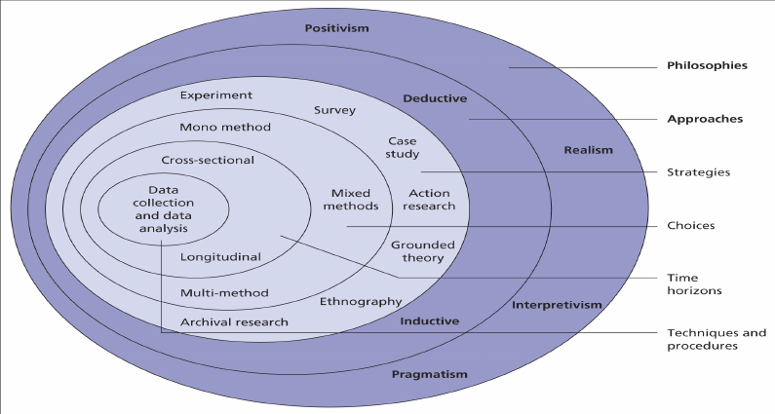

Figure 1 – The research Onion (Saunders et al, 2012)

4.1 Epistemology

Despite the usefulness of the research onion as a way to dictate the methods and structure of research, it fails to address the process of research in its entirety. Factors such as epistemology, axiology and ontology are elements of research that are not covered by the research onion. Despite this Horn (2012) argues that there is a need for these in that they also define the knowledge, background and directional base for the survey element.

According to Jawad (2017) a popular division of modern epistemology argues that knowledge results from the construction of fundamental models of reality to solve problems. Epistemology has been defined by Crotty (1998) as being the study of knowledge, defining ‘how we know what we know’. This could be developed further by arguing that an epistemology is concerned how we know something to be the case rather than believing it to be the case.

Considering this aims of this dissertation is the acquiring of knowledge in an area subject to a paucity of research with the aim to aim to give a greater understanding along with justifiable claims about the world in which we live in, an epistemological approach has been deemed appropriate.

4.2 Phenomenology

A phenomenological approach, often referred to as an interpretive approach considers and assumes that the social world is constantly changing and the researcher and research is part of this change (Collis & Hussey, 2003, p66-67). according to (Collins, 2010):

‘Thanks to adaption of interpritivism, qialitative research areas such as issues of ethics, leadership and analysis of factors impacting leadership can be studied in a great deal of depth.’

Further to this point, considering there is no underlying theory as to why motor insurance firms behave in a way often considered to be unethical, the purpose of using a phenomenological approach is to analyse both primary and secondary date in order to allow findings to emerge, rather than be imposed by the researcher.

4.3 Inductive qualitative approach

It was decided on that the researcher choose a qualitative method of data collection, which is more commonly associated with an inductive approach. This method of research starts with the observations and theories being proposed towards the end of the research process as a result of observations (Goddard and Melville, 2004).

The justification for this approach is that there will be no form of hypothesis in relation to the research, instead the researcher aims to generate meanings from the data collected on the business practices of Admiral in order to identify patterns and relationships as a way to identify a deeper understanding of the phenomenon, rather than conclusive solutions (Dudovskiy, 2018)

4.4 Survey

Jackson (2011) defines the essence of a survey method of research as ‘questioning individuals on a topic or topics and then describing their responses’. Collis & Hussey (2003, p168) dictate that “one aim of the interviewer is to develop an understanding of the respondents ‘world’ so that the researcher might influence it”.

a semi structured approach to the interviews has been decided on. The reason for this decision is that it will allow the researcher to question topics, and give the researcher the opportunity to engage the interviewee through additional questions to draw out themes and more detailed answers in order to draw theories, whilst laying down the foundations for future research (Kawulich, 2012).

By using this type of semi structured approach, the researcher will benefit from a consistent set of questioning throughout the interview, adding to the validity of data, but also allow for a more organic discussion. The intention of this approach is to gain answers that could be relied on as valid and meaningful to the research.

4.5 Mixed methods

In order to conduct a thorough investigation the researcher will foster a mixed method approach in relation to primary data collection for both qualitative and quantitative data sets. According to (Saunders et al, 2009, P152) “Mixed methods approach is the general term for when both quantitative and qualitative data collection techniques and analysis procedures are used in a research design “. It is anticipated that through use of the mixed methods approach it will allow the researcher to gain a greater understanding of opinions and perspectives for analysis.

4.6 Cross sectional

According to Saunders et al (2000) most research projects undertaken for academic courses are necessarily time constrained”. The general view is that a cross sectional approach takes a sample from the overall population and is only collected once, usually by way of survey and or questionnaires. The justification for this choice of research is firstly down to the limited time of completion for this dissertation, but also down to the fact that it is the intention of the researcher to make inferences about possible relationships, and to gather preliminary data to support research in an area somewhat suffering from a lack of research.

5.0 Sample

Careful consideration has lead to the researcher deciding on a purposive sampling methods as it considered cheaper and in fitting with the time constraints of a cross sectional method. Furthermore, with most of the population being consumers of car car insurance, it is anticipated that there will be a lack of barriers to have access to data collection. Purposive sample is a typical of qualitative research and its ‘logic and power lies in selecting information-rich cases for study in depth’ (Patton,2002, p169). It is anticipated that as a result of the data collection, although the sample could not be considered as a representation of the whole industry, it should lead to justification of further research. Further justification for purposive sampling is identified by Jawad (2017) who states that information-rich cases as attained through a purposive sample, provide a significant contribution about the central issues of importance to the purpose of the research.

6.0 Reliability and validity

Considering this dissertation will include a variety of research methods to attain data, whether it be primary or secondary, it is important to note that every attempt will be made in order for this dissertation to be considered both reliable and valid. As previously eluded to, whilst there are a number of disadvantages to qualitative data collection, including personal bias as a result of personal opinion, at no point during this research will any leading questions be asked. Instead the literature review will dictate the questionnaire questions, which in turn will direct the researcher into a semi structured interview process.

The intended target for the questionnaire will be a wide range of private car insurance consumers, varying of all ages and experiences as a way to attain the widest range of data. It is anticipated that as a result, the researcher will be able to identify to what extent the ethical expectations of consumers differ, with a view to addressing the results with senior management to identify how the ethical standards differ amongst conflicting stakeholders. Furthermore, provisions will be made in order to firstly make myself available for respondents to ask any questions relating to the questionnaire, which in turn will hopefully lead to the questionnaire not being misinterpreted, but will also allow for the chasing up of completion.

7.0 Ethics

The main ethical risk derived from this research has been identified as the collection of sensitive data, it is for that reason that all data collected will be done so anonymously and voluntarily. Furthermore, a completed ethics form will be attached along with the proposal to maintain that ethical considerations have been addressed in the correct manner. Furthermore, considering that this dissertation includes data collection, data safety will also be taken into consideration. Collected data will be saved on a personal memory stick that will be encrypted and protected.

8.0 Resources and planning

Due to time constraints, being in full time employment, and family commitments, it has been considered vitally important to indicate a time frame for the completion of this dissertation. The following Gant chart highlights the intended tasks and the proposed completion dates.

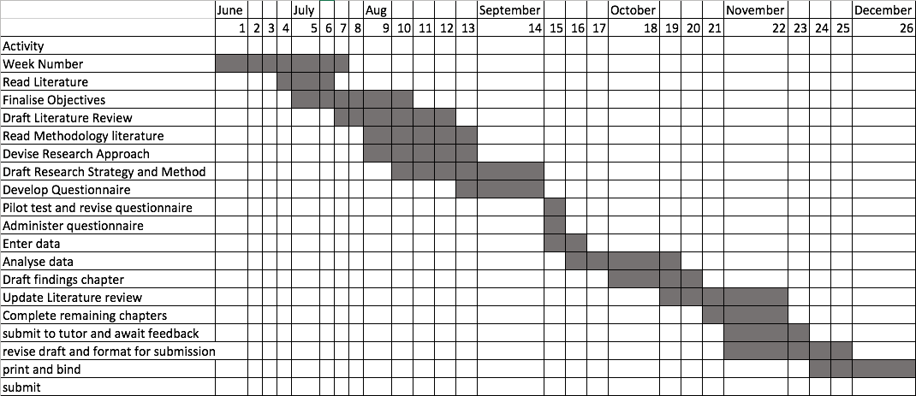

Again, to add to the validity and reliability of this dissertation, it is important that the correct resources be utilized. As a result, the following will be used:
- Bibliographic database searches of psychology, education and business research databases accessed through UWTSD online library.
- Textbooks and peer reviewed journals available either physically through a library, purchased or available online.
- Internet searches conducted through search engines such as Google, Yahoo or Bing. Due to the sheer mass of readily available information on the internet, careful consideration will be taken when using these sources in relation to whom the author was, when it was written, whom published the document and for what reason the work was published in order to maintain an un biased, balanced review.
Time Scale | Considering that theories of ethics have been in existence for many centuries, there will be reference to work from the early the 1700’s. However, the main focus will be work published within the last 50 years.
Focus | Investigative, empirical research and wider reading that provides the key principles of theory along with critiques of the relatable models and theories ethics in business
Geographical Scope | This search will utilize sources that cover business ethics, personal ethics and consumer demand. However, the application of theory and primary research data will be conducted in relation to the business practices of the UK motor insurance industry
Sources | Published Journals, Literature reviews, articles, news publications, books, internet sources, newspapers and reports.

9.0 Bibliography

ABI. (2017). UK Insurance and Long-Term Savings The state of the market. London: Association of British Insurers.

ABI. (2018, February 19). Motor Insurance. Retrieved May 27, 2018, from https://www.abi.org.uk: https://www.abi.org.uk/products-and-issues/choosing-the-right-insurance/motor-insurance/

Black, J. (2013). Creating an ethical framework for the financial services industry. London: The London school of economics and political science.

Carr, P. (2018, January 9). Compare motor insurance quotes for 17 year olds. Retrieved May 27, 2018, from https://www.moneysupermarket.com: https://www.moneysupermarket.com/car-insurance/17-year-olds/

Cheesman, H. (2009). The The Legal Environment of Business and Online Commerce: The Legal Environment of Business and Online Commerce International Version. Essex: Pearson.

Collins, H. (2010). Creative Research: The Theory and Practice of Research for the Creative Industries. New York.

Collis, J., & Hussey, R. (2009). Business Research: A Practical Guide for Undergraduate and Postgraduate Students (3rd ed.). Palgrave Macmillan.

Crotty, M. (1998). The foundations of social research: Meaning and perspective in the research process. Sydney: Allen and Unwin.

Dudovskiy, J. (2018). The ultimate guide to writing a dissertation. London.

Edmonds, T. (2017). Motor car Insurance. 3. London: House of Commons Library.

Goddard, W., & Melville, S. (2004). Research Methodology: An Introduction. New York: Blackwell Publishing.

Horn, R. (2012). Researching and Writing Dissertations: A Complete Guide for Business and Management Students. London.

Hunter, J. (2005). TASK FORCE ON LONG-TERM SOLUTIONS FOR FLORIDA’S HURRICANE INSURANCE MARKET. Consumer federation of America , 1 (1), 1-15.

Jackson, S. (2011). Research Methods and Statistics: A Critical Approach (4th Edition ed.). New York: Cengage Learning.

Jawad, C. (2017). A PRAGMATIC MIXED METHODS ANALYSIS OF EXPERIENCES, BEHAVIOURS AND PERCEPTIONS OF GAMBLERS TOWARDS THE EFFICACY OF RESPONSIBLE GAMBLING IN MINIMISING ‘PROBLEM GAMBLING’. Swansea: University of Wales Trinity Saint David.

Kawulich, B. (2012). Doing Social Research: A global context. Philadelphia: McGraw Hill.

Llewellyn, D. (2015). Trust and confidence in financial services: a strategic challenge. Journal of Financial Regulation and Compliance , 13 (4), 333.

Patton, M. (2002). Qualitative Research and Evaluation Methods. London: Sage Publications.

Pratt. (2015, February 24). Let’s stop wasting £1.3 billion a year auto-renewing car insurance. Retrieved Mat 27, 2018, from https://www.moneysupermarket.com: https://www.moneysupermarket.com/car-insurance/articles/lets-stop-wasting-1-3-billion-a-year-auto-renewing-car-insurance/

Saunders, M., Lewis, P., & Thornhil. (2009). Research Methods for Business Students. Essex: Pearson Education Limited.

Smith, A., Aaronson, R., Finbow, R., Oram, S., & Stern, A. (2014). Private motor insurance market investigation. London: Competition and markets Authority.

White, L. (2017). UK Supermarkets Analyze Customers' Shopping Habits to Price Insurance Products. Insurance Journal , 1.

