Database course work submission

Student details Name; abbas Abdullahi ahmed

Student ID; 2512870

Model; introduction to web and database

Lecturer; Anum Paracha
Datab
Table of Contents
1. Introduction 3
2. Website Overview 3
3. Design Choices 4
4. Development Tools 4
5. Features Implemented 5
6. Testing 6
7. Validation 7
8. Evaluation 8
9. Conclusion 9
References 9

1. Introduction
The goal of this project was to make a simple website for a restaurant called Spice Garden. The major goal was to make a website that makes it easy for people to find out what the restaurant has to offer and move between pages.
There are three primary pages on the website:
Pages:
Home page
Menu
Page
Contact
The structure was easy to follow because each page has a clear purpose.

2. Website Overview
The website layout was planned before coding to ensure everything is organised clearly.
Some key layout decisions:
- A navigation bar placed at the top of every page
- A large hero image used on the homepage
- Content divided into sections (intro, menu, contact)
- Use of grid layout to display menu items
The homepage focuses on visual appeal, while the menu page is more information-based.
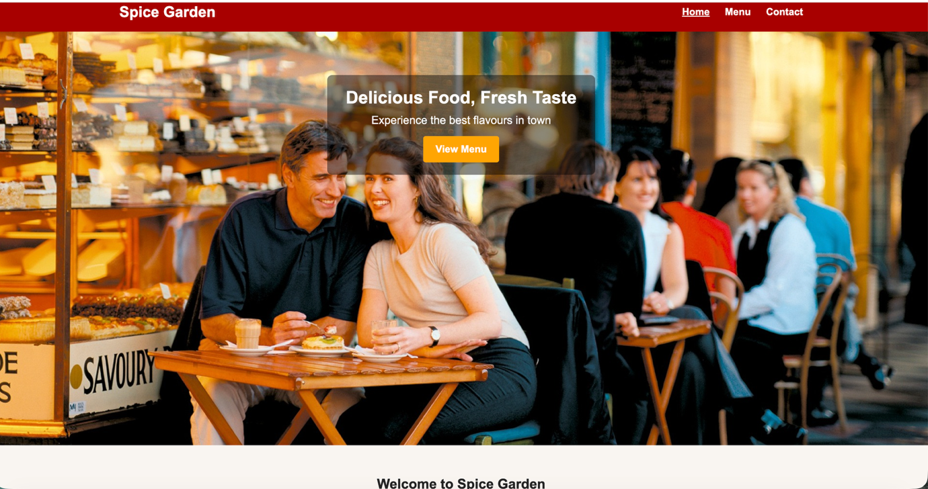
Figure: Homepage showing navigation bar.

3. Design Choices
The design was kept simple but effective. A red colour theme was used to represent a restaurant style and create a strong visual identity.
Other design choices include:
- Consistent font style across all pages
- Use of images to make the site more attractive
- Clear headings to guide the user
- Proper spacing between sections
The hero image was adjusted using CSS so that the main area (people sitting and dining) is clearly visible instead of being cropped randomly.

4. Development Tools
The website was built using:
HTML → for structure
CSS → for styling
Visual Studio Code → for coding
No external frameworks were used, which helped in understanding basic web development concepts.

5. Features Implemented
The website includes the following features:
- Navigation links between pages
- Responsive layout using CSS
- Image-based menu display
- Contact form for user input
- Consistent header and footer
Responsive design ensures that the website adjusts properly on different screen sizes (MDN, 2025).

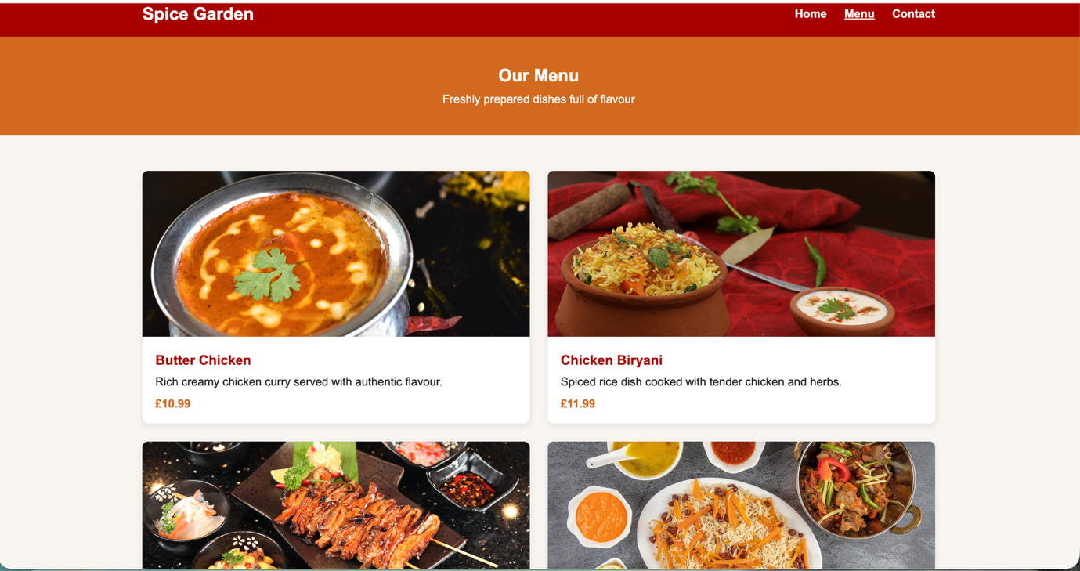
Figure2: Menu page showing food items, images, and prices

6. Testing
The website was tested to make sure all pages worked correctly. Each link in the navigation menu was checked to ensure it opened the correct page. Images were checked to confirm that they loaded properly from the local folder. The layout was also reviewed in the browser to make sure the text, pictures, and sections were aligned correctly.
The website was also tested by resizing the browser window to check if the responsive layout worked properly on smaller screens. This helped confirm that the grid layout changed appropriately and the pages remained readable.
Usability testing is commonly used to observe whether users can complete tasks successfully and understand an interface clearly, which supports the value of checking site navigation and page behaviour during development.
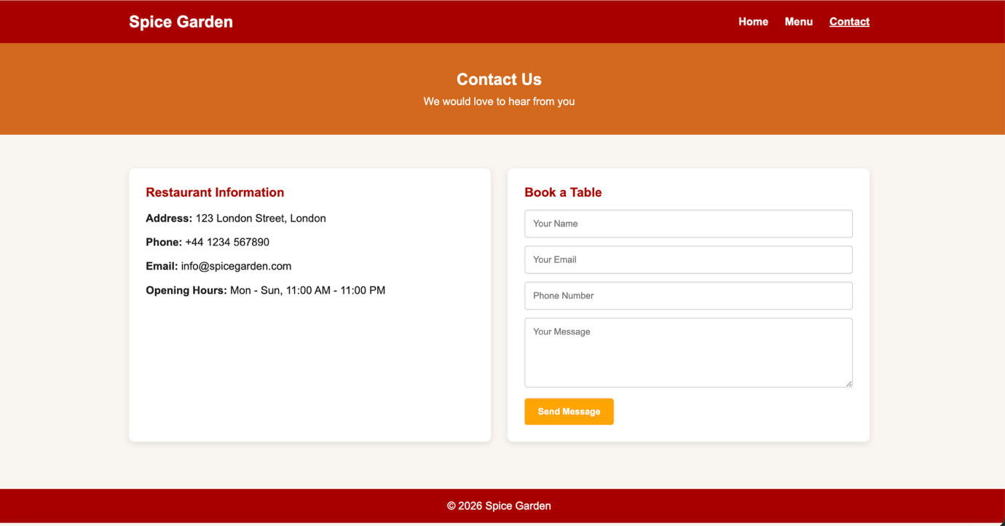
Figure 3: Contact page showing form and restaurant information

7. Validation
The W3C validation tools were used to check the code. We used the W3C Markup Validation Service to examine the homepage HTML file. This service checks to see if web publications match the right markup syntax and standards. The W3C CSS Validation Service validated the CSS file to make sure it followed W3C guidelines.
Validation is helpful because it finds mistakes and makes code more reliable, compatible, and of higher quality. W3C also says that its validation services assist make sure that websites follow open standards.
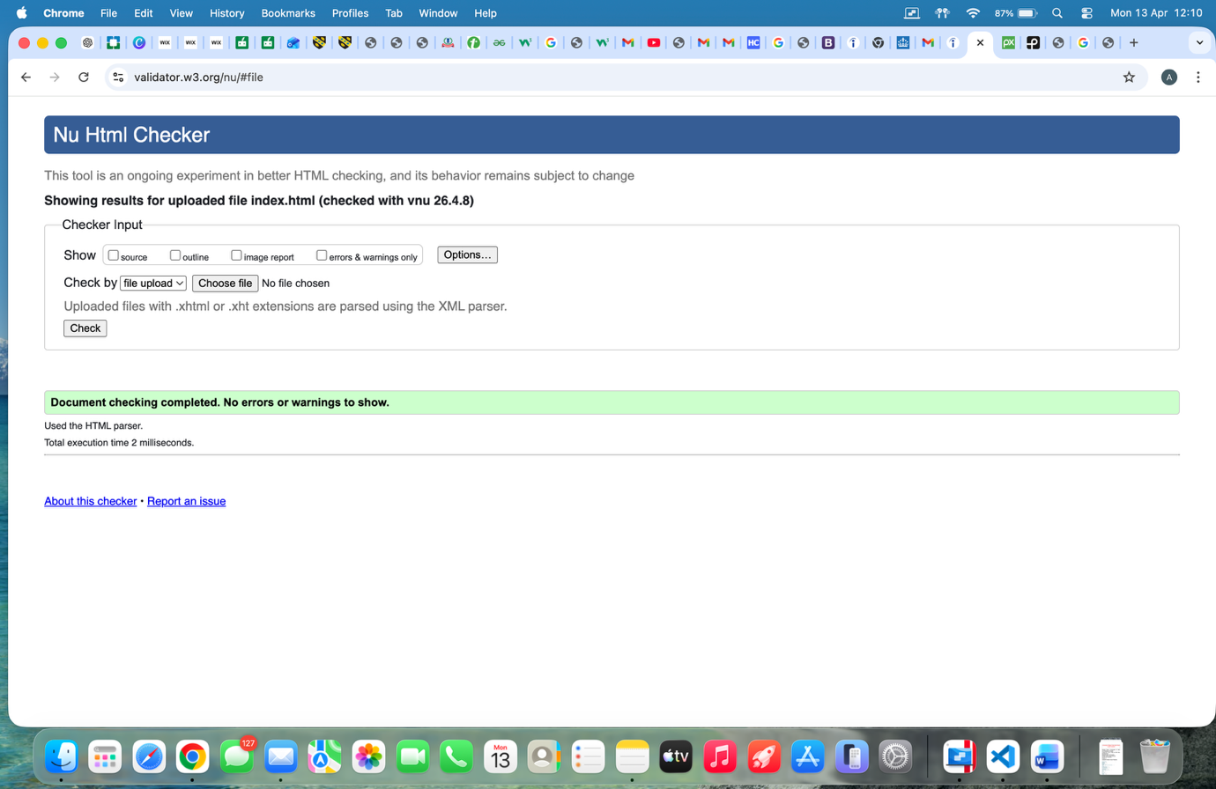
Figure 4: HTML validation result of homepage

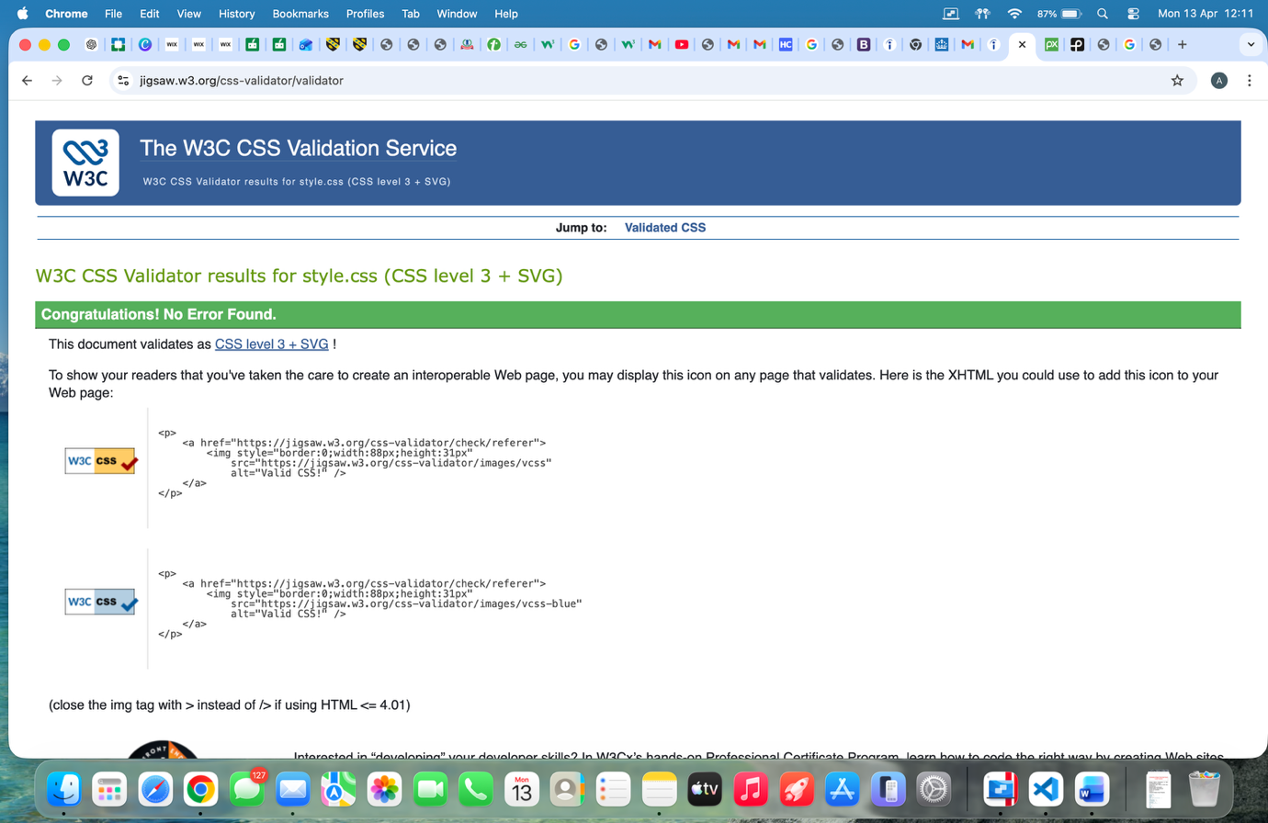
Figure 5: CSS validation result

8. Evaluation
In general, the website did what it was supposed to do. It is easy to read, explore, and find restaurant information in a clear and attractive way. The website looks better with pictures, and the same design on all pages makes it look neat.
The website is easy to use, which is a plus. Users may easily figure out what the website is about and get to the most important parts without any trouble. The responsive design is another good thing about the site because it makes it easier to use on different screen sizes. The hero image on the homepage also makes the site look better and helps set the mood for the restaurant.
But there are still some things that could be better in the future. For instance, you may include additional interactive features, like hover animations, table booking confirmation, or a larger menu with categories. The form could also be connected to a real backend system so that messages can be submitted properly. Even without these advanced features, the current website provides a strong basic solution for the assignment.

9. Conclusion
In conclusion, the Spice Garden website was successfully made with HTML and CSS. The website has all the basic features that a small restaurant website should have, such as a menu, contact information, and a layout that works on all devices. The design is simple but effective, and the testing and validation processes made sure that the website works well and meets web standards. This project taught me how to plan, code, design, and test websites in a way that works.

References
MDN Web Docs (2025) Responsive web design. Available at: https://developer.mozilla.org/en-US/docs/Learn_web_development/Core/CSS_layout/Responsive_Design (Accessed: 13 April 2026).
MDN Web Docs (2025) Using media queries. Available at: https://developer.mozilla.org/en-US/docs/Web/CSS/Guides/Media_queries/Using (Accessed: 13 April 2026).
Nielsen Norman Group (2012) Usability 101: Introduction to usability. Available at: https://www.nngroup.com/articles/usability-101-introduction-to-usability/ (Accessed: 13 April 2026).
Nielsen Norman Group (2019) Usability testing 101. Available at: https://www.nngroup.com/articles/usability-testing-101/ (Accessed: 13 April 2026).
W3C (n.d.) About the W3C Markup Validation Service. Available at: https://validator.w3.org/about.html (Accessed: 13 April 2026).
W3C (n.d.) About the W3C CSS Validation Service. Available at: https://jigsaw.w3.org/css-validator/about.html (Accessed: 13 April 2026).
W3C (n.d.) Validation services. Available at: https://validator.w3.org/services (Accessed: 13 April 2026).
Index.html
<!DOCTYPE html>
<html lang="en">
<head>
<meta charset="UTF-8">
<meta name="viewport" content="width=device-width, initial-scale=1.0">
<title>Spice Garden | Home</title>
<link rel="stylesheet" href="style.css">
</head>
<body>

<header>
<div class="container nav">
<h1 class="logo">Spice Garden</h1>
<nav>
<a href="index.html" class="active">Home</a>
<a href="menu.html">Menu</a>
<a href="contact.html">Contact</a>
</nav>
</div>
</header>

<section class="hero">
<div class="hero-content">
<h2>Delicious Food, Fresh Taste</h2>
<p>Experience the best flavours in town</p>
<a href="menu.html" class="btn">View Menu</a>
</div>
</section>

<section class="intro">
<div class="container">
<h2>Welcome to Spice Garden</h2>
<p>
We serve fresh and delicious food made with quality ingredients.
Our restaurant offers a warm and friendly environment for everyone.
</p>
</div>
</section>

<section class="featured-dishes">
<div class="container dishes-grid">
<div class="dish-card">
<img src="images/grilled-chicken.jpg" alt="Grilled Chicken">
<h3>Grilled Chicken</h3>
<p>Juicy grilled chicken cooked to perfection.</p>
</div>

<div class="dish-card">
<img src="images/butter-chicken.jpg" alt="Butter Chicken">
<h3>Butter Chicken</h3>
<p>Rich creamy curry with soft chicken pieces.</p>
</div>

<div class="dish-card">
<img src="images/veg-pulao.jpg" alt="Veg Pulao">
<h3>Veg Pulao</h3>
<p>Flavoured rice with fresh mixed vegetables.</p>
</div>
</div>
</section>

<footer>
<p>&copy; 2026 Spice Garden</p>
</footer>

</body>
</html>

Menu.html
<!DOCTYPE html>
<html lang="en">
<head>
<meta charset="UTF-8">
<meta name="viewport" content="width=device-width, initial-scale=1.0">
<title>Spice Garden | Menu</title>
<link rel="stylesheet" href="style.css">
</head>
<body>

<header>
<div class="container nav">
<h1 class="logo">Spice Garden</h1>
<nav>
<a href="index.html">Home</a>
<a href="menu.html" class="active">Menu</a>
<a href="contact.html">Contact</a>
</nav>
</div>
</header>

<section class="page-banner">
<div class="container">
<h2>Our Menu</h2>
<p>Freshly prepared dishes full of flavour</p>
</div>
</section>

<section class="menu-section">
<div class="container menu-grid">

<div class="menu-card">
<img src="images/butter-chicken.jpg" alt="Butter Chicken">
<div class="menu-info">
<h3>Butter Chicken</h3>
<p>Rich creamy chicken curry served with authentic flavour.</p>
<span>£10.99</span>
</div>
</div>

<div class="menu-card">
<img src="images/chicken-biryani.jpg" alt="Chicken Biryani">
<div class="menu-info">
<h3>Chicken Biryani</h3>
<p>Spiced rice dish cooked with tender chicken and herbs.</p>
<span>£11.99</span>
</div>
</div>

<div class="menu-card">
<img src="images/grilled-chicken.jpg" alt="Grilled Chicken">
<div class="menu-info">
<h3>Grilled Chicken</h3>
<p>Perfectly grilled chicken served hot and fresh.</p>
<span>£9.99</span>
</div>
</div>

<div class="menu-card">
<img src="images/veg-pulao.jpg" alt="Veg Pulao">
<div class="menu-info">
<h3>Veg Pulao</h3>
<p>Light and tasty rice dish with mixed vegetables.</p>
<span>£8.99</span>
</div>
</div>

</div>
</section>

<footer>
<p>&copy; 2026 Spice Garden</p>
</footer>

</body>
</html>
Contact.html
<!DOCTYPE html>
<html lang="en">
<head>
<meta charset="UTF-8">
<meta name="viewport" content="width=device-width, initial-scale=1.0">
<title>Spice Garden | Contact</title>
<link rel="stylesheet" href="style.css">
</head>
<body>

<header>
<div class="container nav">
<h1 class="logo">Spice Garden</h1>
<nav>
<a href="index.html">Home</a>
<a href="menu.html">Menu</a>
<a href="contact.html" class="active">Contact</a>
</nav>
</div>
</header>

<section class="page-banner">
<div class="container">
<h2>Contact Us</h2>
<p>We would love to hear from you</p>
</div>
</section>

<section class="contact-section">
<div class="container contact-grid">
<div class="contact-box">
<h3>Restaurant Information</h3>
<p><strong>Address:</strong> 123 London Street, London</p>
<p><strong>Phone:</strong> +44 1234 567890</p>
<p><strong>Email:</strong> info@spicegarden.com</p>
<p><strong>Opening Hours:</strong> Mon - Sun, 11:00 AM - 11:00 PM</p>
</div>

<div class="contact-box">
<h3>Book a Table</h3>
<form>
<input type="text" placeholder="Your Name" required>
<input type="email" placeholder="Your Email" required>
<input type="tel" placeholder="Phone Number" required>
<textarea rows="5" placeholder="Your Message"></textarea>
<button type="submit" class="btn">Send Message</button>
</form>
</div>
</div>
</section>

<footer>
<p>&copy; 2026 Spice Garden</p>
</footer>

</body>
</html>

CSS
* {
margin: 0;
padding: 0;
box-sizing: border-box;
font-family: Arial, sans-serif;
}

body {
background-color: #f8f5f0;
color: #222;
}

.container {
width: 90%;
max-width: 1100px;
margin: auto;
}

/* Header */
header {
background-color: #a80000;
color: white;
padding: 18px 0;
}

.nav {
display: flex;
justify-content: space-between;
align-items: center;
}

.logo {
font-size: 24px;
}

nav a {
color: white;
text-decoration: none;
margin-left: 20px;
font-weight: bold;
}

nav a:hover,
nav a.active {
text-decoration: underline;
}

/* Hero */
.hero {
height: 85vh;
background-image: url('images/hero.jpg');
background-size: cover;
background-repeat: no-repeat;
background-position: center 85%;
display: flex;
justify-content: center;
align-items: flex-start;
padding-top: 70px;
}

.hero-content {
background: rgba(0, 0, 0, 0.45);
color: white;
text-align: center;
padding: 20px 30px;
border-radius: 8px;
}

.hero-content h2 {
font-size: 28px;
margin-bottom: 10px;
}

.hero-content p {
font-size: 18px;
margin-bottom: 15px;
}

/* Button */
.btn {
display: inline-block;
background-color: orange;
color: white;
text-decoration: none;
padding: 12px 20px;
border: none;
border-radius: 4px;
cursor: pointer;
font-weight: bold;
}

.btn:hover {
background-color: #e68a00;
}

/* Intro */
.intro {
padding: 50px 0 30px;
text-align: center;
}

.intro h2 {
margin-bottom: 15px;
font-size: 22px;
}

/* Featured dishes */
.featured-dishes {
padding: 20px 0 50px;
}

.dishes-grid {
display: grid;
grid-template-columns: repeat(3, 1fr);
gap: 25px;
}

.dish-card {
background-color: white;
padding: 15px;
text-align: center;
border-radius: 8px;
box-shadow: 0 3px 10px rgba(0, 0, 0, 0.1);
}

.dish-card img {
width: 100%;
height: 220px;
object-fit: cover;
border-radius: 6px;
}

.dish-card h3 {
margin: 12px 0 8px;
}

/* Page banner */
.page-banner {
background-color: #d2691e;
color: white;
text-align: center;
padding: 40px 0;
}

.page-banner h2 {
margin-bottom: 10px;
}

/* Menu */
.menu-section {
padding: 50px 0;
}

.menu-grid {
display: grid;
grid-template-columns: repeat(2, 1fr);
gap: 25px;
}

.menu-card {
background-color: white;
border-radius: 8px;
overflow: hidden;
box-shadow: 0 3px 10px rgba(0, 0, 0, 0.1);
}

.menu-card img {
width: 100%;
height: 230px;
object-fit: cover;
}

.menu-info {
padding: 18px;
}

.menu-info h3 {
margin-bottom: 10px;
color: #a80000;
}

.menu-info p {
margin-bottom: 12px;
}

.menu-info span {
font-weight: bold;
color: #d2691e;
}

/* Contact */
.contact-section {
padding: 50px 0;
}

.contact-grid {
display: grid;
grid-template-columns: 1fr 1fr;
gap: 25px;
}

.contact-box {
background-color: white;
padding: 25px;
border-radius: 8px;
box-shadow: 0 3px 10px rgba(0, 0, 0, 0.1);
}

.contact-box h3 {
margin-bottom: 15px;
color: #a80000;
}

.contact-box p {
margin-bottom: 10px;
line-height: 1.6;
}

.contact-box form input,
.contact-box form textarea {
width: 100%;
padding: 12px;
margin-bottom: 12px;
border: 1px solid #ccc;
border-radius: 4px;
}

/* Footer */
footer {
background-color: #a80000;
color: white;
text-align: center;
padding: 16px 0;
margin-top: 20px;
}

/* Responsive */
@media (max-width: 768px) {
.nav {
flex-direction: column;
gap: 12px;
}

nav a {
margin: 0 10px;
}

.hero {
height: 70vh;
background-position: center 65%;
padding-top: 50px;
}

.dishes-grid,
.menu-grid,
.contact-grid {
grid-template-columns: 1fr;
}

.hero-content h2 {
font-size: 22px;
}

Top of Form

