Greek Singing Timbres:
a Pedagogical Exploration

Appendices

Practice-Based Research Project for
BMPF7010

Anna Tsipa
Student Number: 2016787 University of Wales Trinity St. David

Table of Contents
Appendix 1: Interview with P1. 3
Appendix 2: Interview with P2. 28
Comments 52
Appendix 3: Interview with P3 54
Appendix 4: Interview with P4 80
Appendix 5: Interview with P5 95
Appendix 6: Participant’s comments on Greek singing timbres 107
Appendix 7: The Greek singing styles 118
Demotic/Traditional Singing 118
Rebetiko 118
Smyrneiko 119
Piraeus-rebetiko 119
Elafró 120
Laiko genre 121
Tsitsanis’s style 121
Archontorebetiko 122
Chiotis’s style 122
Heavy of grieving laiko 122
Post-1960s transformations - skyladiko 123
Entechno 124
Mikis Theodorakis 124
Manos Hadjidakis 124
The entechno of the composers 125
The entechno of boîtes and songwriters 125
Post-1980s entechno 125
Paradosiaká 126
Pista scene 127
Further Hybridization 127
References: 128
Appendix 8: Ethics Approval 135
Appendix 9: Participants’ Consent Forms 149
P1 149
P2 151
P3 153
P4 155
P5 157

Appendix 1: Interview with P1.
The interview took place in Athens, in July 2024 and was conducted in Greek. The left column includes the transcription of the interview, translated in English. The right column includes summaries of the original text in black color, categorization of the summaries in red color and comments by the author in blue color. The author chose a different font for the commentary and coding column for reasons of page layout economy and to allow the reader to easily follow the commentary in relation to the original text of the interview.
-What was your musical starting point? Which singers were your vocal role models? Who do you think shaped your sound?  -My starting point had nothing to do with personal choice, because I found myself in a house. So, the first influences were what they heard at home: Kazantzidis, Bithikotsis, Dalaras, Alexiou, Moscholiou, Poly Panou, and demotic music. Later, Stelios' popularity was replaced for my dad by Terzis. But I was never 100% convinced by Terzis that he was a ‘birth’, while Lidakis convinced me that he was a ‘birth’ from this region. So, they shaped me, they were the ones I used to hear.  -Mostly male voices, huh?  -Yes, I really love men's songs, really. Let's say, Stratos Dionysiou. This purity... He wasn't epic. He had a dynamism and a tenderness, ‘softness’ together. He was perfectly balanced. So later these first sources led me to voices like Aleka Kanellidou. I also listened a lot to Jenny Vanou who I consider a top teacher to study, at all technical levels. Then I started discovering other voices. Voices, capable of singing, of course, but focused more on interpretation, lyrics, emotion. Tania [Tsanaklidou], Kanellidou... And it started to build in a way.  -Was this rendering of emotion done more by timbre or musical articulation? Where do you find it?  -I'll tell you how I studied. I wasn't interested in imitating Stelios [Kazantzidis], Moscholiou, Bithikotsis, Jenny Vanou. For me, each of them created a feeling for me. In a phrase, in a word, in a climax or in a low dynamic. So, this feeling that it created for me, I was trying to create it in me when I was singing. Not to imitate vibrato, placement or timbre. Of course, I went through a period of imitation, which we all go through in the beginning, in building. I figured it out early and tried to cut it off. Specifically, I stopped singing Alexiou for 5 years. Really, because I realized, ‘Hey, what's going on here, this is not me!’ So, this is what I did and have been looking for from a young age. So, I didn't do this [she sings ‘Anoikse petra’ with a glottal attack with bright vowels, convincingly imitating the sound of Marinella], but this [she sings it with synchronized onset and less bright timbre], because that's how I felt that I was inviting the stone to open [the meaning of the song title].  -It was as if you were reproducing the physical sensation that you felt the singer had?  -Exactly. As if I were adapting his code to me. I wasn't stealing it, I was looking for it in me.  -So are you saying that the timbre has a corporeal aspect that the listeners feel in their own body?  -Exactly. And not only in the laiko and entechno genre that I represent. I will tell you an example that I believe and support. I believe that the great worldwide success of Maria Callas, although she is a classical singer, was this corporeal vibration that she had. It wasn't cerebral. It was corporeal. And she was laiki in her art. That's why she shook the whole world and not just those who understood the language she sang or listened to the music she sang. When I put on Maria Callas at home, I feel that I hear at some point, in her outbursts, or in her quiet ones, Poly Panou, and Rosa Eskenazy... I see parts of it emotionally, that it gives me physically, that are familiar to me, recognizable, even though I do not know her material, even if I do not have a classical education. This is the magic of art. 10 people listening to a song are moved and connected to it at different points. I believe that.  -Are these points of connection points of affinity that the listener recognizes with the world, the ethos, the identity that the voice represents?  - Yes, of course. I believe that 100%.  -Is the timbre of the voice the imprint of the way one sees the world and experiences it?  - It should. We don't find it in many voices, but it should. For example, Maria Callas that we mentioned before. I believe that this is the only way to move and connect with others. Because that's what the listener wants. To connect, not to admire. He can admire one, two, but eventually he will get bored. He wants to be moved. So, this cannot be a cerebral thing. It's a feeling, it's a body. It is all that makes up this vibration called the voice. And then it needs some other features to make it more perfect.  - What role does the listener's starting point play in this connection? I read, for example, Leonidas Kavakos, identifying Western music with light, Greekness, Plato and Aristotle and rebetiko with absolute decadence.  -Humanity had selective memory and selective opinion anyway.  -Do you think that the listener's background has nothing to do with how he perceives a [voice] timbre?  -The framework that they enter and create exclusions. The background is a starting point, but that doesn't mean that one should remain locked and immobile there. Whatever doesn't move and evolve in life, dies. So, I don't justify any background, it's purely a matter of elitist behavior of any artist who, either out of fear or because they need to elevate their art to the highest level to feel good, cancels out expressions of other art.  -Couldn't it also be a lack of understanding? Because what you're talking about is ideology, the way one sees and classifies the world.  -But as we see the world we act.  - So, the place where one categorizes a timbre and whether or not they connect with it, you don't believe it has to do with their own perceptions and prejudices?  -Yes, but these are not acceptable. What we talk about as an observation does not mean that it is also acceptable. Because, with the same logic, I would also say to you, ‘ah... of course, since he doesn't have blue eyes like me, or since he wears breeches that I don't, I can't connect with him, I don't see that he's human...’.  -Maybe it's a way for the other person to emphasize their own identity.  -Yes, but to feel the need to emphasize your own identity by excommunicating, it means that you are not sure of your own and you should question yourself. For example, I may not like or be expressed by pop. I was never a pop figure. I found myself in an environment and was ‘built’ as rock, completely related as a code to the laiko music that I do. For me, it's the same thing. That is, Tsitsanis's ‘ta ksena xeria’, ‘tis tavernas to roloi’, create the same emotion for me, the same deep feeling, and I have the same code when I sing ‘Soldier of Fortune’, for example.  -Would you sing them in the same way?  -I would sing them in the same way, paying attention to the language, but with the same feeling. Because with the feeling I go.  -So, wouldn't you modify your sound?  -Not at all. No, no, no. I would not modify it. I would perhaps become more tender, more epic or more aggressive, but through me again. Not through imitation.  - Great. I want to mention a categorization I made from the bibliography of Greek sub-genres [of song], tell me if you agree or if you have objections. Folk song of the countryside, an umbrella term that covers various local idioms, and urban song: Smyrneiko, which comes from Ottoman music, then Piraeus rebetiko which evolves post-war into laiko, with patriarchs Tsitsanis, Papaioannou, Kaldaras, and '50-'60 heavy laiko, Kazantzidis, Grey, Lydias, Angelopoulos, Perpiniadis. Also, at the end of the 40s and mainly from the 50s, from Sougioul and Chiotis, archontorebetiko begins, a...  -…mix  -… yes, of the older laiko with western elements and a change in the way it's presented... Linda sings standing up in nice dresses etc.  -Well, yes, because Hollywood drowned us there, that's why. Because the general [situation] also plays a role.  -Then we go to the art-folk. Hadjidakis...  -Poets...  -... Theodorakis, with differences between them, of course, and the efafro-laiko then through cinema, with Katsaros, with Plessas... And in the 80s comes the skyladiko. Do you agree?  -I fully agree, but in observing how things turned out we should not leave out the socio-political progressions that gave birth to them. They are very important, because they justify every evolution, even up to the skyladiko. The colorful tradition, the islands, Epirus, Macedonia, the Peloponnese, the Ionian Islands, the Dodecanese -where there are of course common lyrics and common melodies that vary by region- is a universe. What came from the coast, enriched even with the philharmonic bands, which came and gave birth here to rebetiko, which reached the most urban, where electricity came in... These had a more natural progression. The mixing of peoples, the movement of populations from villages to cities, let's not discuss why, because this story hurts... In there we have gone through civil war, we have gone through occupation, Gyaros and Makronisos. We have won, we have been betrayed, political song was born, we have gone through so much that it was logical for cheapness and skyladiko to come, because we had to say, ‘to hell with it!. And because we were being bombarded from the outside with this. From the glamour that America was giving us.  -You say that urbanization brought westernization of lifestyle and economic prosperity...  -Even if it was fictitious, it led to making profit the top priority, losing too much as a society, losing too many ties and essential things. And since we lost them from our lives, wouldn't that be reflected in the expression of our music?  -I want you to identify if and how the voice changed within all of this, with an emphasis on its timbre. Leave the lyrics aside. Of course there is an interconnection. But what interests me is how the voice changes, for example, from the cosmopolitan Smyrneiko to the rebetiko of Piraeus of the refugees?  -Ahhhh... How it changes...? Let me think a bit.... I have a thought. The need to be heard and the need to play with all the non-equal tempered [instruments] that these voices played with, brought only sopranos and tenors on stage. Because they could nail those notes and because there was no need for particularly low ranges to be heard. Coming here, perhaps because the situation shrank, and because the cannons left and the bouzouki dominated, which had room to play... The music stopped being as monophonic as it was in the orchestras of Smyrna.  -You mean the [Smyrneiko] music was more voice-centric?  -It was also instrumentally monophonic. They were playing tutti, same stuff. Here, then, alongside Westernization, the treaty allowed other voices to be able to sing.  -But Georgakopoulou does not sing [piu] piano.  -Yes, buts she doesn't sing high. And I can be heard without a microphone in my middle and high range. But Roza would sing Kokkinoplitis, let's say Re, because the Re [in the instruments] was open. I wouldn't be able to do that in Smyrna. I can do it in La, the bouzouki could cover me in La and I could do it. Because my high A is my mountain, and everyone has their own mountain.  -What you hear in Eskenazi, you hear it as a chest voice...? [I sing a phrase from Roza's amane with M1 and the same higher with M2 and LMN]. In the first I did chest and in the second falsetto or head voice, I don't know how you call it. What of the two do you hear in Roza?  -Something in-between, but more upwards.  -So, she played between the two, but mainly it was up?  -With today's standards, a bit of a classic mix with chest, it was there on the edge.  -In that era, the sound color is a mystery because they recorded on wax cylinders and the sound is distorted...  -I put this very close to both the classic and our demotic singing. If you listen to demotic singers, they sing like that too.  -Are you talking about men or a women?  -Both sing there, at that edge.  -So after the Smyrneiko, the registration became heavier, we went to a more chesty voice.  -Yes, the spaces shrank, and the instruments allowed it orchestrally.  -Let me add another parameter to the discussion and tell me your opinion. Roza was already a diva of the ‘East’. Georgakopoulou didn't have the same life. The refugee experience, the working-class neighborhood, the illegality and the whole ethos of rebetiko, which I now see more romantically, but it was harsh.... I have the feeling that we moved away from a somewhat ‘refined’ delivery and went to a more experiential art and not so much technical skill.  - For the period you are talking about, yes.  - Also, the fact that the voice went down, didn't it also somehow reduce the rhythm of the melismas? I mean, I hear Eskenazi as a roller coaster... For me to do a transcription...  -No, we're talking about two different things. This one here is not an objective sample. Her view is not to do melisma, her construction is not to do melisma. Her voice, her construction is not to do melisma. Think of Bellou, think of Ninou. This is not horizontal because we are talking about specific personalities and specific constructions of voices. Not all voices are the same. I can't do the voice you just did here. I haven't been trained and it's not my construction either.  - I'll tell you. You could make a similar transition from one register to another, but we wouldn't sound the same.  -And it wouldn't satisfy me physically in my search. My search is the corporeal. That's the big difference then.  - I am very interested in what you said, I want to make it clear. In other words, you feel the chest sound as more corporeal.  -Yes, it has vibration. The cerebral sound.... how can I put it....  -Is it a compromise?  -No... It's half for me. I'll explain what I mean. I like to hear a violin playing a melody and in the high ranges, but when I'm talking about a person who sings words, who conveys emotions, and who reaches out to me to connect, I need their touch, their vibration, their breath to connect. I don't need to admire the perfection of the voice and the melisma at a height, I need them to mean and hear what they are telling me, to tell me the truth.  - Do you want a voice close to that of speech?  - No, I don't care about that! I care that any voice, whether soprano, alto or mezzo, speaks to me through their own body. Because not all sopranos are the same. I mean, Elly Paspala is a different kind of soprano...  -She's a mezzo. But she doesn't have the classic mezzo sound.  - J.’s soprano is corporeal. Q.’s is more towards the head.  -Ok.  - Anyway, in everything I hear, without examining where the voice stands, at what height it goes, I need the vibration. This moment when I'm talking to you and looking you in the eyes, you have the feeling that I'm here and telling you  - Don't just be technical singing.  -Bravo! Don't just be technical.  - That it should bring the communicative intention.  -That it should be body, that it should be an expression that has been built, improved with technique. That is, to be born a child who can play basketball, to have it, to be able to become a coach, to think of systems, and because they want to play basketball because they have it, and their body has it, and they want it, they love it, to go and train constantly so that their body can follow what their mind and soul want.  -I understand.  - Because if I know basketball theoretically and I don't train, I won't be able to catch up to the basket. The technique, which for me, in my own field, is the health of the voice, my real sound, the endurance [of the voice] at 100%, comes to embrace the longing for expression. It is necessary for me to express myself in the best way that I can, and to give you the best version of the melody and the lyrics and the emotion that you deserve, for your soul and your ears. Technique alone is a thing without root. Expression alone also carries risks.  -The untamed voice.  -The tamed and trained voice can repeat it, evolve it, even stop if it wants and do something else. That's how it is for me. That's how I see my art. I like to compare our art to sports, because it's exactly the same thing. Because, if your legs don't carry you, it doesn't matter if you're thinking about systems... You want to be a jumper, and you say I'll take 14 steps like this, one, two, the big one and then I'll jump. You say it well. Go ahead and do it, if you don't train! And you know what the thing is, when our fellow artists don't understand the need for training? Later we'll talk about what training is, because it's a big discussion… Because we humans have this trait. What we can do, up to where we can reach without training, we make it a flag and say ‘this is it!’.And we try to impose it on others as main.  - As a standpoint?  - No! It's like telling me that someone was born with a problem with their tongue and can't say /ð/, /s/ or /r/ and trying to impose on me that this is how I should speak. No! Things are distinct.  -Put a full stop so I can note down three very important topics you opened up, so I don't forget to ask you about them. You said a phrase that intrigued me: ‘real voice’. One of the goals of the technique you mentioned is for someone to find their ‘real voice’. A second topic was ‘Bellou-Ninou’ which I want to look at. And the third, which I would like to start with, so we can move on to the others: In our trade of Greek singing now, you pointed out a distrust of the value of training? Is this a dominant view?  - Distrust, what do you mean? That it's not needed?  -Yes.  - No, I didn't notice a distrust on the surface. It's politically correct to say that you have a teacher, but we don't really know what teachers we choose, what teachers we have available and where they lead the voices.  - Tell me more about it.  -There are teachers who have never been on stage, whose training is completely cerebral and theoretical, and of course the training they give is too. Because the needs of the stage are completely different. And because we are not just a megaphone, we are whole beings, whole universes, in my expression is my body, are my eyes, are my ears, to hear what I say. It's not just about impressing, to sing in a certain key, to go very low, to go very high or not to sing off-key, or to be an acrobat. So, there are teachers who have never been on stage. They haven't experienced how they will deal with, say, the bad sound of a concert. A basic issue. They don't know how to set up their microphone, what to mix in their microphone from the orchestra, where to step on, they think that the volume is everything and in essence they go deaf. There is no training in the universe of the thing, it's not just the voice. And the... [imitates staccato exercises and lip rolls], it's not just that! That's fine. As much as it's good to walk to strengthen my legs to dance. But the fact that I walk doesn't mean I know how to dance. There are also teachers who have been trained for a different kind of song and take on singers who represent a different kind of song that requires different things. I have had students come to me who want to sing pop. I don't take them on. I can't guide them, I send them to… [a teacher of western musical] I send them elsewhere. It's a matter of awareness and honesty. I am going crazy when I hear the light ‘t’ in lyrics, the English one, which these teachers omit, when their singer wants to sing a Greek song.  -And /matia/ [a usual phonetic error for the word /matça/, meaning eyes...]  -It’s /matça/, it’s /kaɾðʝa/ /mu/! [meaning ‘my heart’, which is pronounced as /kaɾðia/ by classically trained singers]!  - Some ‘light’ singers also used to do it, Vogiatzis for example.  - It is a sign of the times and the borrowings.  - It was a fashion then, so to speak. Did it make the song seem more sophisticated? Did it give seriousness to the singer?  -However, don't forget that Yiannis Vogiatzis created different emotions... He also served the socio-political need. We were coming out of somewhere... somewhere heavy...  - What do these lighter voices, Mouskouri, Dantonaki, represent in relation to the era?  - Before Vogiatzis, let's say, we had no idea about this way, the need had not been created, we were in another era. The era brought forth this way. Wanting to get out of the war and with the borrowings and all the other elements we took, a lighter feeling was created that we needed and which we incorporated [into the song].  -The voice there became more.... How would you describe it?  -Lighter, more delicate and not rough.  - More ‘refined’?  -Yes, with a tendency and a need to get away from the barbarity we had experienced. To live more romantically, more tenderly. To develop this side of us that we all have. And as you notice, after all this succession that we discussed up to the trash of the 80s and 90s that started - let's take it up to there - today we have all these elements.  - So a singer today must be aware of these idioms that have pre-existed in Greek song in order to create their own narrative today?  - Comprehensive knowledge and many influences never hurt anyone. But I can't say it as a given. There are people whose interest, whose need for expression... We can't all be everything. But to know this too - you never know how you will use it and if it will interest you - yes, of course it's positive and I sign it 100%.  -You talked about the real voice. What is the real voice for you? How do you extract it from your students?  -With my students, the first and foremost - I like to make analogies - I tell them [the voice] is like a car. And they have the exhaust pipe, the gas, the brake. What we need to do is a good service so that each car can deliver the horsepower it has. We won't take a De Chevaux and make it a Mercedes. But we will take a De Chevaux and polish it so it can perform at 100%. Not all students have the same abilities, neither in perception nor in vocal abilities. Nor physically. People come who can't even breathe. They don't know, they haven't learned. I always start with breathing. Always. And the truth is that I have discovered many things of my own. For example, a student comes to start the first exercises. We talk about breathing; I explain what happens. I tell them, imagine the voice as a ping pong ball over a tube that delivers air steadily. And we put the air on 3, let's say, and the ball stays steady. As the melody progresses, the ball gets heavier. Either it goes down or it goes up. And it starts to fall. So, what should we do to bring it back to the same point? -Open the air. -Bravo, I tell them! So, you are the air column and your voice is the ball. You also need to open your mouth, form the Greek vowels, because you want to sing Greek songs. Then, I eliminate anything I see as a sign of imitation. For example, a young man came, and he was identical to Ploutarchos. Another young woman came, she did the...  - In phrasing or sound?  - Sound imitation. So, in phrasing too. Phrasing is a bit common in a way. But the sound, the vibrato, the tremolo... some elements of some singers that are very characteristic, these are not yours. What I can do as a teacher at that moment is to ask them to tell me it flat, just the words, or to tell me just the vowels, without meaning. Without crying, without interpretation. Interpretation, first of all, is not needed if you don't have your voice trained 100%, if you don't understand the words you say and how you should express them. If you don't fix these, the interpretation is a cherry that has no cake to sit on. What are you going to interpret? If you haven't understood what you're singing, how you're making the sound, what the hell are you going to interpret, when they go and do interpretation seminars?! And if they don't know how to breathe… how?! So... I make them not make sense [of the lyrics] and become aware of the air. I bug them, so to speak. I deconstruct them.  -You break their pattern, so to speak.  -Exactly. And they begin to discover their own voice and love it.  -So, if I understand correctly, they create their own sound when you free them from their preconceptions about their sound.  - The hats they've been given.  - They come from imitation or from how they think they should sound.  - Yes, my friend. Because Kardashian is like this [duck face], they come to me like this. I tell them, honey, this is not your expression, it's this. That's what I do. Also, in the exercises [sings a step exercise 1-2-3-4-5-4-3-2-1 in a major scale with her sound in open timbre in flow chest) and they do [sings the same with nasality and poor articulation]. I see that I can't change it, first, second lesson... I search... so I have them sing ‘I love you, you love me’ and mean it, put someone across from you, mean it. And he starts and says [sings the desired] and starts and hears his sound. I find such tricks to be able to unlock them and not stay dry, to make them understand. Because what I care about is not [just having the students] coming to class.... When I went to my teacher, I was already a singer, I had problems. Health problems. I had lost notes, wear, nodules and stuff like that... Basically I had [vocal fold] thickening. My teacher didn't make me a singer. She polished my instrument, kept it strong and to this day it hasn't weighed down.  -Let me ask, your teacher was not a laiko singer, right?  - Laiko, no. It was more...  -Elafro?  -It was a bit more elafro.  -But she sung Greek music, right?  -Yes!  -Was that important, you think?  -Of course it was important.  -A., wasn't she [your teacher]? And if I'm not mistaken, she was the first teacher in Greece...  -She was the first that taught contemporary [singing] and has produced armies of singers. Not all acceptable... anyway. But she gave me the first stimuli.  -I ask because I have a very good friend who studied with a teacher that A. [your teacher] brought out. But her repertoire and sound respectively have nothing to do with...  -Who did she study with?  -With N.  -Yes but N. sung this genre, she knows this genre.  -What I want to understand is how such drastically different singers came from the same teacher.  -This proves the true voice of each. And not the routing to a cliché way.  -To ask a hypothetical question. If N.– the same anatomy, the same instrument - had been born in your environment, with your own sounds and influences, your own experience, would she be the same?  -With me?  -No, with what she is today.  -She would have the sound of the music she would serve. It's a different field. She followed this, she developed this, she liked this. But if she wanted to sing a song by Moscholiou, or Alexiou Galani, she would have studied this thing, the phrasing, the consonants, the openings.  -So, what is common in your technique which is genre-independent?  - Let me put it another way. There are two athletic kids, training with the same coach. But they have different abilities. Along the way, one becomes a jumper, the other a runner. But each one's body is built correctly. My teacher wouldn't teach me to sing lightly, even if she wanted to. She wouldn't have N. sing Mitropanos [laiko-genre singer], because she didn't want to. It plays a very big role in the teacher to understand, to be clear to him, that what he takes in his hands is not to guide where to go, but how to walk.  -So the teacher has to adjust his approach according to where the student wants to go.  -No! The teacher listens to the student and tries to discover his true voice!  -Ok.  - In our field, right? I always talk about what I experience, not in general. I don't know the other [genres]. But I imagine that in all other genres and techniques of special expression, something similar must happen. You take out the impurities, the imitations. Because from below, you hear the voice. When he speaks, when something escapes him, you hear it. He doesn't hear it. He has in mind what he thinks. He thinks when he does this [sings a phrase] it's the same as Y. who does this [sings the phrase correctly], but you hear that he is bleating, and that the melisma is not from here [shows the diaphragm] he is doing it from here [shows throat]. This is not a laiko melisma, it's something else.  - An experienced classical singer-teacher, couldn’t do it [bring out the real voice] ?  -He could do it in his own field. Why could I, being a teacher and having gone on stage, do what a classical does? Neither in the same area, nor with the same lightness, nor with the same purity. Nor his piano on high notes can I do. And I don't aspire to everything. It's another sport for me. We must learn, understand in our country, which is so rich in expressions and ways, that very important universes of expression have developed over the decades, we must finally understand -finally!- that everyone must be in what he wants and can do.  - So you don't agree with the general label ‘contemporary’ singing that exists as a direction today in conservatories.  -Only to differentiate it from classical training.  - But it needs further specialization, you think?  - Yes, it couldn't be said otherwise. I'll give you an example. In a previous course of mine, a student came to me. I discerned in her, and I really liked a coarseness she had. This was natural, her own, she wasn't imitating anyone. That's how her voice was when she came to me.  -Coarseness, do you mean roughness?  -Yes, a nice little grit. I personally liked it. So, she came to me and told me that she wants to understand her voice, to fix it, to prevent strain, to train it, etc. She came to me, for some reason obviously. Coming here, I say to her, which song do you want to sing? Which do you think I can teach you correctly or [help you] understand [it] better. And she tells me the ‘Kafene’. Do you know it and love it very much? Yes, she tells me. Let's go. And she starts and tells me the ‘Kafene’ completely disconnected. I tell her, ‘Very good, you didn't go wrong anywhere, a little awkwardness, ok... but my love, why do you want to say it, since you can't see the cafe at the edge of the harbor? If you don't see the Kafene [café], how will you allow me to dream about it? Laiko song - all songs, but especially laiko song - is this. You can't distance yourself from laiko songs. Kazantzidis did not distance himself - whether you like it or not - when he sung ‘in the factories of Germany’. Nor did Vicky [Moscholiou], let's say, ‘and the ribbon alone on the clothesline’. You could see the damn ribbon in front of you! And so, the student began, and this coarseness she had, began to round out. To exist, but to have flexibility and confidence. Step, step, and another, and another. For my own personal reasons, I had to stop the lessons at some point. So, the girl went to C. [another voice-teacher]. I saw her then, we talked. How are you doing, I say, what's going on? I don't know, damn it, she says, she makes me suck my voice in and I can't do it and I tell her that this is something else from what I did and I had found. And C. says to her, fine, show me what P1 did to you so I do it too. And I told her, it's not possible for the student to tell the teacher what to do.  - If that were the case, she would do it herself...  - Exactly. It's not what vowels we used. With what position, with what breath, with what emphasis, with what development, how...?! She leaves this teacher and goes to R.S., she is a fine teacher. I have also taken four lessons with her to broaden my scope. And I also went to G., like that, as a colleague. And at some point, I hear her having become one of all the voices, light, with high notes, good for her, more high notes, but she lost the range, she narrowed. What do I need the high ones for... When the girl came out, she was singing ‘I want you’ and it was corporeal, now...  -So, what did she gain and what did she lose? She gained high notes and lost...?  -Size, volume... Resonance, physical vibration she lost, it all went up, head. There is no emotion. Now she can say the ‘kafene’, but again she can't see it. Her voice changed. If I continued, she would have a different timbre, which she wanted. She likes that one too, I'm not saying, it's fine. And it's easy for her, very easy. But I see the difference. Because personally she doesn't vibrate me vocally as she used to. What I hear is whole, complete, but it leaves me coldly indifferent.  - So you talk about a real voice, but you say that the role of the teacher in shaping [the timbre] is decisive.  -Of course it is decisive!  - So is his taste.  - No! It's not just that! It's also what he wants to do. There are teachers who want to produce the same voices. Same!  - Because they like something specific?  -Because that's what they know. I didn't hear the same voices in my teacher. I did not hear a way of imitating vowels from any student. Each had her own world. Everyone shapes their world.  -So, the teacher must be flexible in her approach from student to student.  -She needs to be clear about what she wants from student to student. It's completely different to dress you in the same clothes and ask you to walk the same way, and it's completely different to put you in a row and each one wears what she wants, and you walk each one as she walks, but to walk softly. Some teachers want to create schools. But this does not have a background. And I don't think it's fair either. I mean, you're going to be a teacher in a school and you're going to have the requirement that all the kids have the same understanding of maths and you're going to ignore the kid who rocks in writing? What kind of teacher are you? Do you understand what I mean? The teacher's job is to smell and allow passage to what each student can develop, not to create homogeneous soldiers.  - What proportion do exercises have in your lesson compared to repertoire?  - Half and half. Half an hour is exercises and the other half is songs that, depending on the level of the exercise, we do the practice.  - Regarding the educational reality, you as a teacher are also on examination committees. Do the exam-programs include many styles in contemporary singing? Is it Greek and foreign repertoire, is it exclusively Greek, is it Greek from different styles?  - Usually, they try to have as big a fan as possible. That is, to say a couple of ballads, to say two foreign ones, to say a traditional one, if they can, to say a laiko one. The other day when I went to G.’s exams for some degrees, I encountered something that I had never encountered before, it puzzled me at first, but... I found it right. Everyone was in what they wanted to sing. That is, he had a student who sang traditional songs with his lute because he wanted to do that, he had a pop singer, he had a heavy metal. It had more specialized stuff. I was surprised, but I accepted it because I observe it in our time in general. That is, the stylist is the one who can exist and keep a portion of the audience that concerns him. That's where things are headed. The voice that can say many things is fading. This existed until the time of Haroula and Galani, and even Protopsalti and Lidakis.  -Well, no, if we take, for example, P. which is very popular...  -Well, she's an old ‘birth’ too...  -Old is it?  -Older. It leans towards a generation that each one had his way but shared a core.  -They were carriers of a common tradition.  -Exactly, and there were the endings of each. But today there is no core because everyone creates their own, supports it and goes, and is indifferent to the others.  -Have we become more personas than singers?  - As we have become like people. More alone, more ‘me’, ‘we’ not together at all. It's the same thing. Everyone builds their own kingdom. Once upon a time there was a train and Stelios, Stratos, Haroula got on it... and it went. Now everyone is on his own train.  - Well, there's no work like there used to be.  - No, expressively, stylistically, he is on his own train, you understand?  -It is also ignorance due to lack of education, I believe. For example, they come to me with renditions of Mikroutsikos from the U. (she laughs). Or from M., who, okay, is popular as a songwriter, but he is not a singer...  -Well, when you want to study singing, you listen to Manolis Lidakis!  -And I say, ‘-do you know Dimitriadis’, ‘no’, ‘-do you know Kana’, ‘no’...  -Well, it's like you want to become a classical singer and I ask you, ‘Do you know Schubert’, ‘no’, ‘Bach, do you know him?’, ‘no’, ‘Do you know Callas?’, ‘no’. Well, what the fuck do you want to do, you just wanna make a name, nothing else.  - But I'm another generation and I got to see these people in their prime. But when, for the reasons you pointed out earlier, these people are no longer promoted by the media...  -It's not that...  - You say it's not? I mean I had the chance to listen to these people.  - And it's not just in our art, it's in our lives in general. The chain of succession has been broken. The chain of succession from the 20s to the 80s never broke. It was changing, but it continued the same basic material. Whether the link was round, oblong, smaller, or larger, it was the same material, and everyone made their own shape. Just as the same material had in succession, so did societies, which changed, but slowly. We, here in Greece, we don't have a material problem, we have a dosage problem. When we started borrowing, as all cultures do, it was an open vineyard. The foreign elements came and were not incorporated, but expelled entire Greek genres.  - A cultural colonialism, in other words.  -Exactly. That is the problem. And in our society, where both the family and social fabric have been broken – with the internet, which is too structured to be, because ‘we’ is power, ‘I’ is not. So is our art.  -In other words, you identify a problem of ‘pseudo-individualization’....  -Not pseudo, very real it is and does a lot of harm.  - I mean that for the sake of a ‘personal’ sound that is marketed, we no longer carry anything from the past.  - Yes, and we don't owe the continuity! While previous generations owed continuity. When Haroula [Alexiou] sang Rosa [Eskenazy], she was creating a continuum. When I sang Haroula and my own [songs], I had [Haroula] built in. I had on my shoulders when I was singing, when I understood a little bit about myself, Poly Panou, Haroula, Deep Purple, Hadjidakis, Dalaras, Dimitriadis. I had them here! I had my materials and colored my core with my materials. Do you understand? I was not suddenly born with a core, ignorant of any past and flow of artistic work, musical tradition, culture and said, ‘what can I do?’. A didn’t do a ‘boooo...’ and made that music, and said, ‘This is me’ and found another 15, 50000, 100 to say, ‘hey man, I like this’, for everyone's reasons. To exist without continuity, without root, without leaves, without a reason, without understanding. I mean, what? What exactly is this art? This, of course, is always relevant to socio-political changes, I say again. These today allow us to talk about things we did not talk about, for people who were forbidden to demonstrate to demonstrate, and these are the good things. But there are always those who will exploit this.  -The system incorporates diversity as well, you want to say, in a conservative way.  -Yes. And a diversity that doesn't even know if it is diversity and why it is. It is a need for existence, in a world of general non-existence, which happens, but without meaning and creates tendencies. And this is very dangerous for the cultural traditions and the cultural continuity of each one. We here have taken a very large dose. The medicine from the poison, they differ only in the dose.  -Does the teacher have responsibility for this?  -He has a huge responsibility!  -When, for example, you teach Tsitsanis, whom the student may have heard from Plutarchos, do you explain what this is, how it is performed, what is the ethos of the voice?  -And what is it that he wants to tell us. He didn't make a song for you who have a good voice to take these intervals, these notes and this melody to sing it as you like. He didn't leave it to you to abuse it. He left it to you to serve it, not to serve you.  -So, this is also a shortcoming. Is the history of [Greek urban] singing included in the curricula? Because abroad, in contemporary commercial music studies, there is the history of pop, rock, blues. And in conservatories, in classical singing there is a course in the history of Western art music.  - No, there is nothing. It's everyone whatever for their own sake.  -Do teachers know the background, the ideological and social background of each Greek genre? Okay, they may not all be singers of Greek laiko style, but they live here...  - No, they don't know.  -How many teachers sing and have good knowledge of the genres they teach in Greek laiko song. How many do you know?  -Two? Maybe I'm wrong... Three? I don't know any others... Also, we have to examine what is the framework that allows someone to be a teacher, and if there is a framework. Currently, everyone does a study, pays some tuition fees, pays a course of study, gets a diploma, a degree...  - Which [diploma] is not recognized...  -Yet. And I don't think it will ever be recognized.  -Here they downgraded the diplomas of classical [which have been recognized by the Ministry of Culture for so many decades].  -Exactly. And he can use this to announce that he is a teacher, while there is no other safeguard, evaluation, not only of the knowledge of the subject, but also of the philosophy of what a teacher is! A teacher is not someone who has merely attended a course of study and arrogantly finds the opportunity to exercise power and misinform every kid who wants to learn or who does not know what he wants to learn.  -Have you noticed such phenomena?  -If you think about how we humans are, surely there are not even teachers among teachers who should not be teachers, out of philosophy? Like some shouldn't if they are police officers, doctors...?  -For your part, if you were on an advisory board that would create a pedagogical framework for Greek song, what would you have to suggest?  -To this question, I am looking for the answer... We are not only talking about specialization and knowledge of the subject, which is also a big talk. Here we must speak in terms of society in general. How he builds a man and gives him in his hands a gun, a degree, a piano, a bouzouki, to distribute... his ignorance?... His complex? The need for power?  -There is also the phenomenon of people teaching who have never taken a lesson in their lives...  -That! But singers do interpretation lessons, and I ask the kids who went to the seminar, ‘what did you gain? what did [the teacher] focus on? how did she handle it? And they laugh. She did interpretation with the body, she says. Where will the head go, the hand... Didn't she tell you anything about breathing? No. And where did she base the interpretation, on what technique?  -Technique is therefore the basis for interpretation. But doesn't interpretation also create technical needs? Aren't they sides of the same coin?  -Well, of course!  -It's not that I'm done with one and I'm starting the other...  - No, it's a universe! It's like what I was telling you about the athlete. Education, study, training will allow him to make the system a reality in the game. To run to the basket when he needs to at the speed he needs to. And this ability will bring a more complex system. It's the same thing.  -So what should be included in the training of a Greek singer and what a teacher should know in order to teach?  -Again, I'll talk to you with a model. Like a born athlete, a long-distance runner, who has stamina, long legs and gets on the tartan with the coach, the coach corrects his body so that his abilities are at their peak. To prevent bad posture from impacting [the performance]...  -To correct technical problems.  -Exactly. He doesn't interfere with how he's going to run, because you see that! He's wound up! He hears a melody and can reproduce it. Nice. Let's go to the sound now: Breathing, support, resonance, air channeling and then human factor.  - Content, artistic gesture.  -Yes. But all this you have to find, polish and incorporate. I used to tell my students that we don't come here to put the exercises in the song, but the song in the exercises. That is, I don't want you to say ‘/a/, /ε/, /i/, /ɔ/’ and, having no other way, put it in the song. I want you to sing ‘/a/, /ε/, /i/, /ɔ/’ to me. From your singing to discovering your sound and put this whole universe into the song. Because, if I take the exercises and put them in the song, I dehydrate it. I make it absolutely technical. I want to bring the music to the exercises to create a universe while doing the exercise.... the time, hey Anna - I say it and I get emotional - she does the exercise and has concentrated and sings the fermata and says ’-ah! That was it?! -That was it! -Teacher, I got it! -You don't get it yet, but you got it. If we get it once, twice each time, you will be able to choose it.’ This is a great thing. This same thing, you keep it, remind her of it and tell her ‘give it now’ [sings a phrase]. This is it! That's how I work. Because that's how I understood singing, that's how I understood my exercises, that's my universe.  -So you use the communicative intention, the emotion, the phonemes of the spoken language.  -Yes, only when you mean what you say do you hear your real vowels. And that's what you polish.  -in summary, the teacher must be able to understand the technical problems, what hinders the economical, healthy production of sound.  -And not to have a specific picture of what he wants to make, to see what the student needs. He is not a sculptor who makes his own jugs.  -From there on, you say that the timbre must be connected with the communicative dimension...  -The timbre is a whole universe. The timbre is composed of the person himself, his own sound, his physical vibration and what the technique can bring out of what it is.  -And from what she says, isn’t it modified?  -And from what she says, of course.  - Will you not make timbre adjustments if you sing e.g. Hadjidakis or if you sing Kazantzidis?  -Timbre...  -Won't you be softer or maybe even breathy  -Wait. [she sings Hatzidakis' ‘ela se mena’ in a soft way], yes?  -Yes, you made it breathy.  -Yes, but I can also say [sings Kaldaras' ‘gyalinos kosmos’ in the same soft way]. You know what I mean? Of course, I will say ‘feggari maya mou kanes’ [sings with greater subglottic pressure and richer chest].  -Yes, but the soft way in Kazantidis here concerns a rendition [involving different orchestration]. Can you sing like that when you have the orchestra behind you with the sound of heavy laiko?  -But I won't look to change the timbre in relation to the song. I will bring out the timbre of the emotion that the song wants, but I will try to find the student's way. To avoid the misunderstanding of imitating the timbre. That's why I'm not very much with the timbre, as I understand it... That's why I separate it, because everyone has their own.  -Would you say that you change placement?  -No. None. This is the way. The way doesn't change in my school. That's why I don't touch other genres. In your case though, having studied more, your voice does more things, it may be happening. I don't know if I agree. Because I, maybe it has to do with where I come from, I don't want 4 Annas, I want one.  - This is a central issue.  - I don't want 4, I want one. What one can do. That is what I want. Because that's how I'm going to connect with Anna. Because I know that the range she will give me, the choices she will make, will have that familiar connection that has drawn me. I don't want to hear anything else that will surprise me. That doesn't interest me as a listener.  - I have a different take on this because I needed to sing drastically different things, which couldn't be done the same way.  -I understand completely. That's why I'm clarifying my position from my side as well.  - Your position is absolutely respected.  - I admire that very much in you. Because this is also an art and a complete world.  -Let’s listen to some samples and comment on how you, both in relation to the head-chest, but also in relation to what you told me, the most primo, the most interior... Eskenazi from a 1957 recording. Listen to the vowels a little...  -What are the notes she sings?... It's another school! Another school!  - The highs here are up to C, C#, but she’s old here. She is over 60.  - Yes, I can hear that she is old. t's all up. It can't be otherwise...  -And it has projection [I sing M2 with LMN]  - Yes, but she doesn't quite do it that way. It's also supported, though! Listen to the melisma! Melisma is not from the throat; it is from here [it shows the belly].  - Yes, I understand what you mean. Would you describe it as a mixed voice?  - Yes, I would describe it as mixed, with very sweet transitions, but you can see the narrowing! It seems, it cannot maintain the same volume. That's why I, in my case, because I'm a different ‘birth’, my goal was to have exactly the same body from top to bottom. Same! I wasn’t fascinated by the passaggio [management], I wasn’t interested in learning it.  -This has been the reason I went to the voice-teacher.  -It didn't concern me. I wanted to do this.  -Does it have to do with that you grew up with these voices?  -Yes! And also, that I embraced them, they suited me. I could have a sister who doesn't fit in, she doesn't vibrate with it.  -They fit your psyche.  -Exactly.  - Do you hear this way [of Roza] in singers afterwards? Or is it something that stayed there?  - Let me think... I hear it from Anatoli Margiola, although it's rougher...  -Is this a girl who did a master's degree in Eksenazy [D.P.]? Is this sound the same?  -No, for me it is not the same.... A! Now here it is closer.  -You are convinced by the high area, but not by the low... Maybe it's because she doesn't transit into chest when she descends. Let's listen to Dalgas and then the same piece from other performances. These voices... I envy them a lot.  - Don't forget that their own environment colored them. Turn it off a little! You can only remember the tomato you ate in the 70s. [I smile] Don't laugh... The point is to decode it and make it a world inside you, if it doesn't exist outside you. You'll tell me, what are you going to do with it, who will understand it... That's another conversation. These were built with all these grassroots sentiments, all this society, the events... Even the difficulty of meeting with each other to play, compared to today's ease, and that colors! It colors the vibration, the longing, the intensity, the imagination...  -And where you play, who you play for... The function of the song also changes. And since we mentioned it, the function of the song, that is, that then they danced, they had to lift the other one to dance, while the song has now become [passive] spectacle.  -The conversation you are opening is very long now! Very important!  - I notice in Bellou, what we were saying about the melismas, that she was killing!  - She was grooving! She was dancing inside her.  -Such phrasing, I have never heard before!  - Exactly! I totally agree! She was dancing! Without narcissism, without anything. A laiko singer is unconceivable not to dance inside him [while singing]. I have my kids dance, even the waltz. Take it in the body first. You know most of them can't dance?  - Yes, I have noticed it myself. What is up-beat, what is down-beat...  - The singer cannot sing if he does not dance, and the dancer cannot dance if he does not sing inside him.  - Do you address a tendency for disembodiment of the singing and a tendency for an ‘analytical’ approach?  - Completely. Everything is guided by the brain. Because this is dangerous, man! This has power, it has charm, it has a direct connection! You shouldn't... you shouldn't...  - You shouldn't, huh?  - No, you shouldn't... you shouldn't. You shouldn't be able to tell the other person ‘Dude, I have a problem!’. You should be ashamed and afraid and left alone. Because if you say, ‘I have a problem’ and he happens to say ‘I'll help you, let me get Antonis! Antonis, come here man, she has a problem, come on let's solve it’, the three-four of you will solve it. You shouldn't gather three, four. It's dangerous for power. It's not a conspiracy theory, I've been reading a lot of history lately.  -Is false consciousness cultivated?  - This had been always happening, it's just that nowadays, they've ended it. Because they built us little by little and we are apathetic, and we are so scared that we don't admit it, and they've ended it. That's it, nothing else. [We listen to Antonis Dalgas in Mane of Kalinychta] How to characterize this, my Virgin Mary... Everything is round...  -Round; What do you mean?  -All the melismas.  -You mean it is...?  -Round, round, like little monkeys jumping from tree to tree, round. I can't do this…  -You mean that everything is articulated, distinct?  - Distinct, fast, homogeneous... what I call round.  - From the low area to the high, do you hear this narrowing that you mentioned to me in women? He may not switch to falsetto, but you do hear a narrowing or it is the same sound, as you described to me before? [We listen for a long time; a very quick melisma is sung in the high part of the range]  -Did you hear what he did?  - [Smiles] I heard it.  -Didn't he make it [the sound] smaller?  - Wow, and his handles are so clear... There are handle notes, which you hold on to spin around. You catch on and spin around again. But he doesn't shrink, anywhere. I don't hear him narrowing, no.  - What did he do here to make his turn?  - This is interpretative in nature... This [the melisma] cannot maintain the same size, it is too fast! But it does not constitute a point of change.  -You say that it is only in the melismas.  -Exactly! It's within the code of the specific melisma, in the specific area and at the specific speed. That's how I perceive it. I don't perceive it as differentiation, it's the moment.  -Let's put the same piece from Y.  - What to say now here... different school, first of all, different code!  - That's what I want you to tell me. I hear a lower larynx, a back tongue…  -This is not his real voice. He imitates the code.  -Do you hear too a lower larynx here and back tongue?  -Yes.  -[I sing with low larynx and low APN].  -This, this, this! Yes, because he is not the tenor of this era! And he's just trying to adapt and fit into something that's not 100% [himself]. Which is cool for Y. to do, that he also sings … [entechno-laiko song], but it's not the same thing! It's like me singing Nina Simone, which I sing just fine, but I'm not Nina Simone either, what can we do?! [laughs]  -I do not wish to point out the differences to criticize people, but to examine how in each genre the voice changes, and in each genre the timbre element has its own character.  -Yes, like every sport it has its own body set-up. Yes, absolutely.  -Can all this be put under the general label ‘contemporary’?  -No.  -Look at an element that we haven't seen in singers until now, but we do it a lot in modern singing to sound soft. Breathiness.  - Let me see... [Imitates a breathy phrase]. Well, he's a master at this! He brought it! He does it all the time!  - What I understand is that, because he doesn't make thinner the vocal folds as he goes up [in pitch], but keeps them fairly thick, he introduces air to sound softer....  - Exactly! ... I, for example, to try to render, as close as possible, if I want to do it, the way of Ntalgkas, I will have to choose an area for me to be able to do both the piano and the... [sings to me a melisma between A3-F4 piano]. I can't do it... [sings the same a third major above, piano and the voice tends to transition to falsetto in this dynamic] I can't do it here. It's incomplete. I'll put it in my area, let's say.  - I understand what you are saying.  -Where I have my greatest flexibility, and I can move in fluctuations of dynamics and melismas.  -Listen a little bit to A.B. [in the same piece].  -Demotic [singer]  -He's a phenomenon... [He sings sharp at one point]  -Come on, sit for a while.... I am not touched by that. At all.  -What is the difference with the other timbre?  -My problem is not timbre.  -Is it phrasing and approach?  -It is that I understand from what I hear that whatever the song said, four butterflies were sitting, he would say it the same way. That bothers me. It doesn't convince me on its content. While Dalgas convinces me.  - Yes, I understood.  -And Y. convinces me more than A.B. I know he's lying to me, but he's trying to present it to me as true.  -Yes, yes... [I laugh]  -To make the differences... Y. tries to tell me it as the truth, this one has no awareness of what he is saying. None. He is just a great tool  -Could it be that Y. comes from this environment, the rebetiko, while AB comes with a different ethos from the demotic tradition?  -Very likely. But it is also a matter of man.  -It is also a matter of man...  -Because there are singers who tell you ‘give me the phone book, I don't care, I'll do an amané ‘. And others who tell you ‘I don't like this amané, I want this amané’. This is the difference. In other words, I consider A.B. to be a tool. He's like D.B. An admirable tool. That's it. I also need the content. Even if melismas break somewhere, I don't care at all. I'm analog, you understand?  -I understand. I agree that the basis is the communicative dimension.  -Well, why do we make art, eh? To show off skills? No. So?  -I agree. [Ν.R.]. Smyrnaic Minor. [We listen] Is this sound corporeal?  - Give me some time. Yes. [Pause]. No, the sound is not necessarily corporeal, it has content. It has content.  - I understand what you're saying, but I'd like us to try to focus on the sound.  -You now want us to distinguish it technically. But that's what I'm doing and I'm having a hard time now.  -Is roughness a criterion?  -Um, it's not just a matter of sound, damn. I can't explain... It's not my look like that and... [pause and continue listening]  -Ok.  - I don't know how to tell you, I just know that I like it.  -That voice you heard, up or down [I mean laryngeal chest or falsetto].  -Up. Up isn't it?  -It's too high to be chest.  -But it is in a way... robust, how can I tell you, I don't know... [laughs]. And construction plays a role sometimes.  -What you say helps me. Has she put this element [I sing something in M2 adding roughness] and gives a somewhat more chest feel?  -Yes! Yes! You help me!  -These are high harmonics that, while you're in the ‘other’ voice [M2] give a chest feel. It's not primo overall, it's rough. Is this type of roughness an element of what you call somatic sound? I don't want a definitive answer, just think about it...  -Eh... [reluctantly]  -It's hard. These are quality things, multiparametric...  -And you know, it has to do with the prism and the feeling of each one and their origins and it is not easy to decode.  -Exactly, exactly.  -That is, to tell you something now, with a lot of love, don't get it wrong. All these details that are useful for what you do, to me are completely indifferent.  -Absolutely understandable.  -You understand? But since I - that's why I tell you you've studied much more than me - I haven't dealt with it so comprehensively by analyzing all these ingredients, I can't distinguish them either...  -And you can't find interest.  -Exactly! That is, it's not any of my coolness, it's just a lack, but right now my prism is turned more... throwing out some elements.  -These issues are like the blind men with the elephant. Another catches the tail. Another the trunk, another the ears and each has a very real, but very different picture.  -They are very useful, but I wonder how useful they can be for me? [laughs] Because I don't know them.  -And because you may have another way of approaching. The polymorphism of the voice always puzzled me, that's why I became a singer, I think.  -You had another quest.  - I could not exist in one genre.  -Neither could I in one genre, but I move in related ones and touch, on the fringes.  - I am curious.  -You fly from flower to flower with a childlike wonder 100% every time. It's part of your temperament though. That's you! And it's YOUR way. And that's not open to criticism. It's your own way. It's like you're telling me, I did my hair bob and come on…  -I believe very much in what you say that everyone's interest in the matter of singing is very personal.  -And it doesn't go on the scale, it's enough that everything you do or show, or express is honest, to be 100. If it's 100 and honest, it has a reason for existence and a usefulness for someone who is interested in it. The other one will be interested in something else. For me things are so clear and simple!  - I totally agree with what you say.  -That's why I'm against this, which we were discussing with Kavakos, with the exclusions and the boxes. That's why I'm not in the boxes, because my criterion is honesty. And the 100. That I didn't keep something because I'm bored. Or ‘why should I show you this’, no. If you are 100 and honest, I respect your art, whether I like it, or not! A well-cooked meal, whether you like it or not, it's a well-cooked meal, that’s it!  -After all, art is an interaction.  -This! Just that!  - Listen now in relation to the previous timbre this [H.R., Manes Kalinihtias].  -A little nasality...  -I would call this Greek entechno-laiko timbre... so what? It doesn't have the roughness that bothers us, it has the mass that we like and it's ‘sweet’...  -And it also resembles. Because she could say /ɐmɐn/, but she doesn't say that! She says /ʌmʌn/, she does this! Which, however, is not that she chose it only for the reasons you say. It is that this, from where it comes, in order to come and stick and resemble the timbre, makes her do it. She does this to be more convincing in the specific school!  -You say she adapted.  -That. Because this voice, H.R. only does it in ….[P1 refers to a 1992 record] in the high notes. In her other laiko-songs, she doesn't do it!  - It is [the vowel] more closed.  -Yes, and it's half nose, half resonator. [I press playback to locate this element, we hear two phrases without detecting it]. She doesn't have it here. Here she is normal [B3-F4]. Because it is her privileged area. Ok, here [B3]. Now she'll put it back on [in F4].  -So she detected this [element] in Dalgas, while A.B. didn't, that [the phonemes] are more closed...  -I agree. Because A.B. has his school and the note. He doesn't care. At all.  -Eskenazy, same tune.  - Ah... How the fuck does she do this thing?!  -I don't know. I suspect, but I don't know. She goes up to F5, because she is on thin folds, but the way she mixes is amazing.  -She passes very softly.  -And they had a more closed mouth then, huh?  -Yes. It's another school, another thing!  -Tell me your opinion on something. I read in an article by Varelopoulos, a musicologist, about the genre that we call entechno. The genre that appeared after the ’80s, and which comes from Hadjidakis, Theodorakis, Loizos, etc. He therefore argues that entechno is not a distinct musicological style...  -Yes.  -... ...but a studio practice, a studio aesthetic that had as its components traditional and urban folk idioms that were sung and orchestrated in a different way and combined – ‘I change the rhythms in the sounds and from rock n 'roll I make them tsamika’ [lyrics in a song by Peridis]. And he brings as an example Peridis, Ioannidis who put elements of Western medieval music in it, first Papazoglou-Xydakis-Savvopoulos with ‘the revenge of the gypsies’.  -I agree. It is as if they exculpated then the demotic, the laiko and the rebetiko-laiko.  - Here I am going to ask a question that includes a personal opinion of mine. On the one hand because it was the songwriters' song [they sang them themselves], and on the other hand because there was more emphasis on this hybrid character of the genre...where did the voice go…?  - [laughs meaningfully]  -I listened to this song first and through that I listened to Alexiou, Galani... My listening was from there and back. And as I went back, and I heard the voices...  - You're right about that. You're quite right about that!  -And then the singers entered – in relation to what you said before that H.R. was forced to modify her way – in this aesthetic and we operated with this standard.  -Songwriters you mean?  -With this standard, with this writing, here's the easy breath for you, ‘I'll do it breathy here’ to get rid of the roughness, but without being forced to find another way.  -Yes, yes, yes, yes, yes! They opened up spaces for all this in the absence of voices.  -At least my generation had the chance to listen to quality songs from this era. The next generation [with the collapse of the discography], found scorched earth.  - Well, of course!  - Do you agree, that is?  -Certainly! I fully agree. It's the breaking of the chain that I said. Other elements came in. And there was room left for the other items, huh? Because there was no strong continuity.  -So, in recent years there are a lot of groups that take traditional songs, Smyrneika, rebetika, but the way they are incorporated into their repertoire is mainly through arrangement. Is there adaptation to the sound of the voice and depth in the study of the idiom?  - Yes, I agree! I agree, it's purely through arrangement.  -I bring some examples to look at them comparatively [we hear ‘apano stin triantafyllia’ initially from a traditional-like performance]. What would you notice here, how would you describe that voice?  -It has a presence.  -Projection, you mean?  -Yes, but without being harsh, edgy. [We listen to a highly popular singer of the contemporary entechno style, A.C.].... This has nothing. It has no projection, nor any reference to code...  -Melismas?  -There are no melismas. There is only a vibrato that I do not understand.  -Does the lower key affect the agility of the voice?  -The key is definitely lower, but if her placement was further out, more present, brighter, this would not be seen. It's the way she makes her sound...  -Would the voice of the traditional singer pass into the discography today?  -Yes, if the packaging was suitable and well-polished.  -My question is whether the aesthetic has changed due to the factors we discussed, and the voice follows it. Maybe we want the ‘closer’, the more ‘intimate’, the breathier perhaps...  -No, because it is not generalized. It is within the framework that we said that everyone builds their own train, their own world and sells what they can do. That's what I believe. I don't think this is something that creates a trend. It is an isolated characteristic of the specific expression.  -One last hype. [we listen to Z., in a Halkidiki folk song]  -This now... This makes an idiom of its own. Which has nothing to do with the old, but the elements she puts in create a more traditional... From all that we listened to, except for the grandma [the traditional version], the wrapper she puts on is closer [to tradition]. But I don't see that as a [singer’s] voice. What do you think of it?  -For me it's a bit of a Netflix aesthetic. Cinematic…  -I agree.  -Have you seen ‘Xena, the warrior princess’, ‘300, this is Sparta’ at all...? Have you noticed the ‘Greek voices’? They are Bulgarian! [I do the yodeling feature].  -Correctly!  -So I see it as a narrative more influenced not by how outsiders see us. That is my view.  -That's very correct!  - And here is another approach.  -Is she a student of A.C.?  - Oh, I don't know. I got it from [a festival].  -A lot of interpretation, my friend! The misunderstood interpretation. It's the ‘me’ in front. Me. I am above the song.  -Yes, but I can't assume that this is the intention of the young singers. Maybe that's what they see...  -That's exactly what they see!  -How is this voice?  -Like A.C. [We hear P., a highly popular female singer in ‘Cloudy Sunday’]... Ouch! [Listens and comments by imitating a sung /ɐ/], which is modified due to low APN, as I perceive it]. That's what helps her do the high the way she does... But she can't do the lows.  - [I repeat the sound, using low APN]. It helps her strengthen a specific area... [I repeat the note with high tongue position]. Is that what you would like? [She shakes her head positively].  -Have I killed [tired] you?  - Not at all.  - So this sound [intense low APN], you don't prefer it.  -No, what to do with it? You'd say, ‘Come on, re malaka!’ [she says it with a pronounced low APN and a low larynx].  - I ask you.  -No. Because the Greek song is the Greek language, and it is as we pronounce our language and the meanings we give to these words and feelings. Like when we talk. That's my opinion on Greek laiko and entechno song, I'm talking exclusively, okay?  -Now let’s go a little bit to Hadjidakis, Theodorakis and the approaches there. There was a fuss with the Epitaph that took place with Mouschouri and then with Bithikotsis and there was a difference of opinion and an intense discussion. What do these two trends represent to you?  -What trends?  -This is one approach [we hear Mouskouri]. Do you see it as an attempt to combine east and west? Βourgeoisie and laiko culture?  - I don't see laiko culture in the voice.  -It is present in the form.  -Yes, it is in the form.  -So the vocal delivery is western?  - You want to analyze it this way now, huh? It's nothing. Nana Mouskouri is Nana Mouskouri and it was nice to sing his work.  - Yes, but he chose this one.  -Because she was Nana Mouskouri.  -Hadjidakis chose it. Hadjidakis also chose to do this [we listen to ‘Leitourgika’ with Flery Dantonaki]. It's a whole record.... Isn't that a statement when you do it at the time?  -I know it [the record]. Look. This is my own opinion, right? When I hear this voice, I recognize the personality, the being, the behavior, the being of the singer anyway. If you ask me to talk to you about the content of what she says, it doesn't cover me personally.  -Do you feel a disconnection from the material?  -From the material... I have to find a model now for you to understand. It's not invalid. It's another opportunity to admire this sound, this voice and this possibility, it's a subversive conception of Hadjidakis, but all this is more on a cerebral level. It's a conception, it's a construction, it's not a creation for me, primary.  -I understand.  - I think maybe I'm quite aphoristic and I don't know how useful this is.  -I want you to tell me your opinion genuinely and unreservedly.  -Because I, for my part, tell you. They are not established, nor am I a musicologist, nor do I have a global view.  - I don't believe in the Truth with a capital T, anyway. I believe that there are interpretations, more or less informed.  -The truth is one, we never saw it, and everyone gives his interpretation.  -Do you think that this vocal approach has an origin in the urban song that was before Hadjidakis that had more reference to bel canto. Let's say Danae or Vembo? [We hear Vembo]  -Yes, they are related, they have. Just in the use of vowels and consonants.  -Registers?  - Yes, and the registers, they have, yes. However, in the case of Flery, the way they have done the Leitourgika gives her a lot of freedom, so she adds elements. But, yes, there are certainly affinities.  - Do you hear elements of this world in Vanou?  -Hmm [she smiles and we listen to Vanou, ‘min ton rotas ton ourano’].  -Could Vanou, if she sang in English, be a ‘Western’ voice? I mean, not to understand that she is Greek?  -100% she could. Vocally, yes. But though she has this way, the tessitura, a corresponding lightness, she also has many other materials next to her, she has elements of laiko, it's another admixture  -This is where the marriage took place, that is, you think.  -Exactly. And it also has more pronounced consonants, another element of laiko. She says it! ‘Min ton rotas ton ourano’. She says it, she beats it! And the vowels are all lighter, brighter, simpler, not beautified.  -And does the voice have more ‘body’ than the previous ones? So is it a ‘lighter’ way but is the voice fuller?  -A lot of body!  -Would you put Linda in the same category?  -Well, Linda now... (smiles). No, I would put her under Vanou myself.  -Category and this... Archontorebetiko and you hear a European type voice.  -But that's why they called it archontorembetiko. [We listen to ‘perasmenes mou agapes’]. It has sweetness, it has... Here again it has a beautification.  -A beautification?  - A beautification. Which is also of the era. Don't forget that he [Chiotis] came, put on the fourth string, put on a suit, dyed his hair, it's a completely different thing than bouzouki.  -Another ethos?  -Another ethos. New, western.  -So the ethos is also reflected in the timbre.  -Yes. It's all that politeness and nobility that we longed to have, coming out of where we said.  -What about Europeanism? Because we felt peasants here?  -Yes, that we could [be that] too, I think. Not consciously I believe, as a need.  -Today what is a Greek singing for you?  -Today it's everyone's opinion. The castles have fallen. For me, because I am absolutely connected to the previous generation and my continuation, my chain did not break - maybe I didn't have time because of my age or because I stayed in my own framework, the safe one, I maintained my continuity in a way. Today Greek song, if you ask, is everyone's world.  -It is a personal narrative now and has lost its collective reference.  -Yes, because when Greek songs are considered to be so different expressions that borrow elements and create hybrids, the original has been lost.  -Does this concern ethos or musicological elements?  -It concerns everything. The language, the sound, the mixing of the orchestration... That is, we went with a mosaic song to Eurovision as a representation of Greece, which had found five different tracks and welded them together to say that what lasts 4 minutes, is also a song. It wasn't. If you ask all those who celebrate and Marina herself, which now gathers 5000 and 6000 listeners at the concerts... If you take all this as reality, come and tell me what the Greek song is. I can't answer you. I have a view of Greek singing, you have another, Marina Satti another, Miltos Paschalidis another, Natassa Bofiliou another. Other... Other... There's not an umbrella anymore. No quota, no dosage... The trend has changed. Laiko song today, if you ask all Greeks of Diaspora, is Foureira, Remos, Argyros.  -We didn't comment on them at all.  -This is the hybrid we allowed to grow without guarding our culture. The elements that we allowed to exist and altered... And they baptized themselves ‘laiko singers’ they are not.  -What are they in your opinion, how would you characterize them?  -Most of them are not even singers. They don't know how to preserve the language at all, they don't know how to breathe, it's not the real voice of most of them – of the laiko, I say.  -Is it an amalgam of imitations?  -It is.. (pause) Look and see, the continuity of things happened as follows, for me at least. Simply. There used to be composers who determined what would be recorded and who would sit next to them on the stage. These composers and in the socio-political situation that lifted them – because from what we had experienced these songs were born – the companies got rich. So, since they got rich, the companies did not want to have every creator, every barefoot from Egaleo, on their necks. And they said to the singer, ‘Hey, Malaka, people are coming for you! You and I will do it!’ So, they took the narcissism of the singer, turned it into a flag, and we started for profit and success, to decline. They dismissed the creators...  -And we started the singers' personal records instead of the project records.  -We also christened singers – because we liked him? because we...? because we needed someone to bring money to us?– people that wouldn't stand on any stage, next to Zambeta, they wouldn't stand! Or next to Repanis, who? Well, John treats, John drinks. We created the idols. At the same time, of course, the whole situation helped, the western influences that were coming, all the lying, to become polished too, to have a good time... And we went from humor to jest. And the quota from humor to jest began to change. We didn't understand it. And it kept changing, changing, and here we are today. The skyladika are full, the trap is sweeping, our kids are listening to trap from 3 years old and we fucked everything. From what? Out of indifference? Tolerance? The need to profit? Because we were bored? Because we got tired? Because we stopped being educated, why did our education not even exist? Why was there no neighborhood, no family, no television? Why did women say, ‘Hey, you can be men, hey, come out, they've got you down!’ And they didn't understand how we went out to work, produce and consume. Which woman? The position of women is the same.  -You know what came to mind now that you said ‘they wouldn't stand’? It reminded me of Hadjidakis who might choose waiters for his singers.  -Because I have met his descendants – I may be wronging him, or my opinion may be very subjective and I may be ignoring other clues - I believe that such behaviors like Hadjidakis's, the reason they happened was that he wanted to prove to everyone and to himself that his work was above any performer.  -Do you have any objections to the interpretations of e.g. the Magnus Eroticus?  - No, I have no objections to this project. But more generally, the way he chose voices... That is, with many voices I do not agree listening and I think that they did not really highlight... I do not understand it, that is. I think Hadjidakis could have found nicer voices. Of course, I don't know why he did it.  - Could it be that he wanted voices with a laiko [not of the genre laiko, of the people] character, an unstudied laiko character, not the one that has shaped his sound from the singers who preceded him. Maybe he actually wanted this ignorance of the past?  -Yes, maybe, if he didn't like that, I don't know. But it seems to me too large the quota of voices that could be... He could find more charming, beautiful, malleable and more important voices. Why didn't anyone do something, I wonder? And why did he want these voices? Yes, he wanted an innocence. I hear it.  -I guess.  - And me. But let's not forget that when Hadjidakis started, the empire of voices and companies was in full bloom. This would surely cause an opposing awe, and to whom? To the most anarchic, bourgeois creator. Maybe that was the reason too. Will I put everyone in my head with their demands or with their money? No. Maybe that was it too. But I think he wasn't interested in the vehicle; he had his work above all else. And because I saw it in two or three other cases as well, I think it's possible.  -Finally, I want you to comment on the sound of Maria Dimitriadis [we are listening to Anisycha Paidia].  -This now, is not my world. But what do I recognize in it. What I told you before. The entity colors the attribute, and they cannot be opposites. Maria Dimitriadis as a personality, as a vocal construction and as a way, what she does here, does not function only as a sound object. It also carries the content. And she carries the content with such conviction - you'll tell me this doesn't help you - but this makes her go up there [D5] and do it with ease. That is, if she herself didn't find content in what she does, I wouldn't be able to connect.  -Do you recognize a rock influence?  -Yes. But I'm not burning to characterize it as rock either. The framework is not clear. If I had to characterize it somehow, I would definitely lean towards rock.  -Do you find any origin from the Greek laiko song?  -No, no, no, I don't. I don't find a connection to laiko here, it's a completely western thing to my ears. But what I told you, her sound is not disconnected from her being. This is very important. And that makes it Greek. SHE [emphasis] makes it Greek. And even if you sit as an analyst to find the elements of rock. It is the ethos and the content that makes it. It contains it! And since it contains it morally, yes, it also steals some elements and can do it. But it doesn't do it to be rock. It does it with the content, because it is identified. She does not apply a sound technically, it serves the creation with everything she has and everything that is there, everything she perceives. This is fundamental in our music.  -And in every music, I think.  -Ι don't know because I haven't studied. But in our music, the ‘I am’ with the ‘I do’ is fundamental. In all aspects: in laments, in weddings, in Epirote songs, in the folk songs of the basements, in Hadjidakis himself who had this perception... This is for me! And this is all my art.  - Thank you very much. | Vocal influences:  P1 vocal models were Kazantzidis, Bithikotsis, Dalaras, Alexiou, Moscholiou, Panou, Lidakis, singers of the laiko, and entechno-laiko genre.  Timbre ideology: P1 values tradition and authenticity.  Timbre perception/Vocal influences: Dionysiou had a perfect balance of dynamism and tenderness. P1 considers Vanou the top vocal model from all technical aspects. Emotional timbre and phrasing, Tsanaklidou, Kanellidou.  Role of the singer/vocal influences: singers go inevitably through a phase of imitation from which they need to get away. The singer must not imitate the vocal model, but convert the emotion she gets from the model to her own emotional/corporeal timbre.  Timbre as ideology:  Singing, regardless of style, moves the listener through corporeal empathy. This corporeal communication through familiar physical cues is fundamental element of laiko art. Callas was laiki in her art. Laiki (female for laikos) has multiple meanings in Greek. In this context, it means addressing ordinary people not to a niche audience.  Timbre ideology/Role of the singer:  Timbre corporeal must be the expression of the ethos, identity, and worldview of the singer. Otherwise, there can be no connection to the audience.  Corporeal timbre aims in getting admiration, while corporeal timbre aims in emotional connection.  Timbre as ideology:  P1 considers the devaluation of rebetiko music, expressed by some cycles, an expression of elitism, selective memory, and a flawed personal identity that seeks validation by belittling and dismissing other forms of expression.  I am trying to pose again the constructed nature of emotional timbre perception.  Timbre perception/ideology:  Laiko genre and western rock share the same emotional world/ ideology. P1 would sing both genres without adapting her singing timbre, but paying attention to the language.  Role of the singer:  P1 disapproves imitation as a means to approach diverse singing styles. For her, timbral adjustments are emotion-related and not style-related.  Break of tradition/ideology:  ‘Drowned us’ is a suggestion of cultural colonization by P1.  Music styles categorization:  P1 fully agrees with the categorization of the urban Greek singing styles I presented to her, and she highlights the importance of the socio-political progressions from which they arose.  Break of tradition:  P1 views all Greek urban styles as natural transformations of a versatile, yet common Greek tradition, evolving under the influence of Greek social and political ferment. This tradition breaks with ‘skyladiko’, an expression of social, moral and aesthetical cheapness, that emerged as a psychological counterbalance to previous harsh social realities, fueled by American-imported materialism and consumerism.  Timbre perception/explanation: P1 identifies Smyrneiko singers with soprano and tenor voice types and postulates that the genres’ monophonic character and the non-equal tempered instruments required exclusively such voice types. The polyphony of laiko genre, the bouzouki and the smaller live stages allowed other voice types that sung in lower tessituras to sing. I have serious doubts that Abatzi was a soprano.  P1 sings exclusively in M1.  Timbre perception: P1 perceives Eskenazy timbre as being a on the edge mix between classical and chest. I would say, a Μ2 dominant mix with roughness (Zhang, 2023; Howel, 2017). Interestingly P1 uses the label ‘classical’ for M2. P1 finds Smyrneiko timbre close to classical and demotic timbre for both genres. P5 perceives old female demotic singers singing clearly in chest.  Timbre as style:  Original rebetiko and laiko singers were more chesty than Smyrneiko  Timbre as style/ideology:  The interwar rebetiko had a more robust delivery, it was technically less demanding.  Timbre perception/explanation/ideology:  P1 considers the richness of ornamentation to be an intrinsic ability of a singer, available by vocal physiology, but also dependent on her view/personality and training. P1 considers singing in M2 an option that not all voice-types have. She states that singing in M2 wouldn’t satisfy her physically, as it is a cerebral and not a corporeal timbre. The original word used for physical and corporeal is ‘somatikos’ meaning ‘of the body’. Head voice is labeled in Greek voice pedagogy as ‘kefaliki phone’, meaning the same thing, voice of the head. Interestingly, instead of ‘kefaliki’, P1 uses the word ‘egkefaliki’ meaning of the brain, cerebral, intellectual.  Timbre perception/ideology:  P1 however does not identify timbre corporeal with the chest register.  Paspala is an entechno singer of lyrical training, singing with an audible M1-M2 transition.  J. is a laiko and entechno singer with a light registration, non-audible transition. Q. same as J., but more flutey. Again, M2 is identified with the soprano voice-type.  Role of the singer:  Technique must serve the corporeal expression of the soul. Talent and/as expressive thirst is essential for a singer, as is vocal training.  Role of the teacher/vocal health:  Training in laiko and entechno styles aims at the discovery of the real voice, and at its health and endurance at the 100% of its ability.  Break of tradition/ideology: P1 notes that some technically inadequate Greek singers, instead of working on their vocal inefficiencies, they legitimize them, presenting them as standpoints and turning them into general trends.  Role of the teacher/what we need:  Teachers must be experienced professional singers of the style they teach. Voice building cannot be separate from interpretation, language, understanding of the cultural context and the technical challenges in the performance context. Ethical practice dictates to the teacher to acknowledge her/his limits and teach only those styles in which she/he is expert as a singer.  Timbre as ideology:  Though P1 expresses great annoyance by faults in Greek diction by contemporary singers, which singers-teachers of western styles neglect to correct, she is much more lenient with singers of the elafro-genre in the 50s-60s who also altered Greek diction. She sees the latter as an element of a western-influenced music style, which however was a romantic antidote, much needed by the Greeks, to the preceding harsh socio-political collective experiences.  Timbre perception/timbre as style:  Mouskouri, Dandonakis, Vogiatzis have a lighter timbre, more delicate, not rough.  Timbre as style/ideology:  P1 suggests that elafro (meaning light) urban singing, incorporating western influences and more lyrical timbre was a singing way we didn’t know before Vogiatzis, that is before the 60s’. However, western-influenced elafro song existed from at least the 20s’ ELAFRO (LIGHT STYLE) (vmrebetiko.gr). Maybe it was not the social need, but the Greek cinema industry that wished to appeal to all social classes. Greek cinema movies were the first place where laiko and western orchestras co-existed (Poulakis, 2018). Contemporary Greek singing genres incorporates all this emotional, timbral gamut. P1 believes that comprehensive understanding of this gamut can be useful for contemporary Greek singers, however we cannot all be, thus sing, everything.  Teaching method:  P1 employs metaphor and imagery as teaching tools.  1.Breath-to-folds-coordination  2.Articulation of the Greek vowels.  3.Elimination of patterns that come from imitation of other singers, so that the real voice comes out.  4.Singing as speaking without interpretation, which is not possible unless solid technique and understanding of the song is achieved.  5.Adding words in the arpeggios and scale exercises and perform them while singing the words in a meaningful way.  My question and vocabulary here reflect my understanding of timbre as constructed, though she considers it natural.  Vocal studies:  P1 started training being already a professional singer due to vocal folds’ thickening. Her teacher is well known, as she was the first teacher of non-classical singing in Greece, and has trained very popular artists. P1 holds certification in ‘Contemporary Singing’ from the National Conservatory.  P1 voice hasn’t weighed down at all, indeed, despite her long singing career.  The singer I refer to sings western CCM with high mixed-belting.  Timbre ideology:  P1 acknowledges that the music genre shapes timbre. She suggests that the ‘real voice’ is shaped by aesthetic preference, physical features, and is discovered after the removal of elements coming from imitation, and study. Which is the timepoint then that timbre construction consolidates into what P1 perceives as the real voice?  Role of the teacher: The teacher must not shape the voice of student, but to discover his/her true voice. P1 resembles the voice-teacher as a sports-coach, that focuses on building the body correctly, so that the athlete can choose the sport he/she desires and fits his/her abilities. However, to build the body correctly for each sport, as P1 says, the coach would have to develop drastically different training programmes for the two athletes. This presupposes a deep understanding of the technical requirements of the two sports, and of physiology in general. The teacher must only teach the genres he is expert in. If voice-building is not separate from coaching, as stated before, uncovering and strengthening the real voice is genre specific. Thus, the real voice is genre specific. What’s the real voice of the singers interested in more than one singing styles? Who should take over the real voice unveiling?  The true voice can be understood when the student speaks, when he/she is not trying to imitate a model. P1 seems to voice-build upon the already shaped attractor state of the student, increasing its efficiency. In this context, imitations are non-consolidated attempts of altering the timbre beyond the attractor state.  What we need: The label ‘contemporary singing’ in conservatory courses is too general and serves only in differentiating vocal training from classical. It requires further specialization on music genres.  I am not sure what she refers to by ‘coarseness’, but though it may be an expressive tool when selectively and purposefully employed, permanent coarseness could be an indication that the student should be referenced to an ENT. It seems that the real voice is indeed the attractor state.  Timbre as ideology:  You can't distance yourself from laiko song. You need to experience it to deliver it.  Role of the teacher/ what we need: P1 emphasises that it’s not the exercises that build the voice, it’s the guidance and feedback of the teacher as expert-listener. Thus, the role of the teacher is decisive in bringing out the individual, real voice of each student. Some teachers, however, prioritize the establishment and promotion of their own, off-the-shelf singing methods, apply them indiscriminately to all their singers, and thus they produce identical, non-emotional, artificial voices.  Timbre as style/ideology:  P1 expresses an aesthetic preference to a vocal timbre that does not get thin in order to access higher notes, as she finds a voice that keeps size and volume more physical.  Role of the teacher: The case P1 reports, indicates that students, even when professionals, do not always have clear goals regarding timbre, but rely much on the teacher’s decisions.  Role of the singer:  The teacher must detect and allow passage to what each student can develop. I interpret this as: the attractor state of the student, the ease and limitations that this state entails within the context of the singing style, indicates to the teacher the direction in which the voice must be developed.  Teaching method:  Half of the lesson is exercises and the other half application of exercises in song repertoire.  Role of the singer/role of the teacher/break of tradition:  P1 reports that in exam programs of conservatories in contemporary singing, used to include songs of different genres. Now, some students’ exam programs are more style specific. P1 notes that singers who were familiar with the Greek singing tradition were stylistically versatile. In contrast, the new voices are more idiosyncratic, voice-personas, who have no reference to this common core of the Greek urban singing tradition. P1 attributes this changes to the decline of collectivism and the promotion of individualism.  My experience coincides with P1’s observation that most young students are not aware of the urban Greek singing tradition. P1 attributes this ignorance to levity and ambition.  Break of tradition/western cultural colonialism:  Young Greek singers are alienated from Greek vocal tradition which had been preserved through gradual, respectful, transformations from ‘20s to ‘80s.  Foreign influences and the dominant ideology of individualism led to the declination of Greek singing tradition.  Role of the singer/ideology: There is no art without continuity, reference to the past, and contextual understanding.  While promoting individualized diversity is positive for marginalized groups, it can also be a tool for dissolving social bonds, collective memory, and shared cultural identity. Shared cultural identities are a threat to power structures, thus cultural traditions are under attack.  Role of the teacher: The teacher has duty to familiarize the student with the ethos and cultural context of the singing style.  Role of the singer: The singer must serve the ethos and cultural context of the song, not to abuse it.  What we need: P1 reports that the history of folk urban singing is not included in the curricula of contemporary singing courses, that very few teachers are expert-singers in the laiko style and that most singing teachers are unaware of the ethos and social background of urban folk Greek genres. P1 finds the existing educational framework commercialized, unable to guarantee not only the knowledge and specialization of the graduate, but also his/her pedagogic adequacy and ethical teaching practice.  What we need/Role of the teacher: Pedagogic ethics are a central issue for P1, as she acknowledges the power that the role of the teacher comes with.  Role of the teacher: P1 does not find ethical the practice of singers that deliver lessons or seminars on interpretation, as interpretation and technique are dialectically linked.  Role of the teacher:  The teacher builds upon natural abilities, improving breathing, support, resonance, airflow and nurturing the artistic personality. But what if there are intonation issues, vocal hypofunction and hyperfunction? What if the student is not a ‘natural’ athlete? Where is the line between natural and trained?  Teaching method:  Exercises should always be performed as meaningful singing, with emotion and communicative intention, not as a technical routine that dehydrates the expressive dimension of singing.  Work on resonance practically involves a further elaboration and consolidation of each person’s emotional timbre on Greek phonemes.  Timbre as style:  In P1’s approach, there is no change of placement, there is one voice placement that adapts in terms of softness, breathiness, dynamics and musical phrasing.  Timbre ideology/Role of the singer:  1.Timbre is the vocal identity of the singer that reflects also her inner, emotional and cultural universe, her self-identity.  2. Vocal identity is thus single, not multiple.  3.Changing timbres is like adopting fake identities.  Timbre perception/explanation:  P1 perceives Eskenazy’s singing coming from a school of singing much different from her own.  P1 perceives Eskenazy to sing in a mixed head voice, with a lot of support. P1 is right. Eskenazy, probably used more subglottal pressure than when I sung here in M2.  Timbre as style/ideology: P1 notes that Eskenazy’s voice becomes narrower as it ascends. P1 finds this approach inappropriate for the laiko genre, which requires according to P1 the same vocal size and volume across the range.  This is a timbral preference of most laiko-genre singers, in my experience, also expressed in Tsipa (2022) by another female singer of the laiko genre. Conversely, the singer of Smyrneiko style that had been interviewed in the same study, sought for a lighter, mixed vocal quality, considering the strategy that P1 describes here limiting and unhealthy.  Timbre perception: P1 finds D.P.s’ timbre similar to Eskenazy’s at the high range but not at the low. I too perceive D.P.’ s timbre less rough in her lower notes, as she keeps singing in M2 while descending in pitch. I think that Eksenazy employed a transition between laryngeal registers.  Timbre ideology:  Our vocal influences are timbres that resonate with our soul.  Timbre perception/explanation/ideology:  To approach voices of the past, you need to decode the feeling and bring it in your world, in your ethos. There is no point in decoding the timbre because this was shaped by a life experience that cannot be reproduced. A reasonable implication of the idea that vocal timbre is the expression of the Self.  Teaching method:  A folk singer must dance inside while singing and P1 encourages her students to do so.  Timbre as ideology/break of tradition: P1 addresses a general disembodiment of singing. The corporeal timbre has power, charm and direct connection, thus power structures wish to control or limit it.  Timbre perception/timbre as style:  P1 expresses admiration for the distinct, fast, homogeneous tones in Dalgas’s singing. She cannot do them, she says.  Timbre perception: P1 perceives the sound becoming smaller during melismas in Dalgas’s singing, but overall, his timbre is consistent throughout his range.  Timbre as style: Laiko and entechno are different schools from Smyrneiko, with different timbral requirements. Y. to approach ‘Manes tis Kalinichtias’ deviates from his real voice and attempts an imitation of the Smyrneiko timbre, incorporating lower larynx and APN. I agree that he has modified his usual timbral approach.  Timbre as style:  P1 agrees with me that every Greek singing style has different, distinct timbral qualities. The question for me is how a teacher of ‘contemporary singing’ or even ‘Greek singing’ in general, can approach all those genre-specific timbres? P1 has answered clearly; through real timbre, as alterations of real timbre will never be corporeal and convincing. P1 agrees with my suggestion that many Greek entechno and entechno-laiko singers incorporate breathiness to soften or sing piano in their M1 quality, instead of thinning the vocal folds and/or transiting in M2. To avoid registration imbalances in the transition area during piano dynamics and melismas, P1 reports that she would transpose lower the key. The suggested strategy would change dramatically the sound color of Smyrneiko, as P1 would have to sing the repertoire about a fifth lower than the original female keys of the lower in tessitura Smyrneiko singers, such as Abatzi (C5# Abatzis’s top note, while Eskenazy’s F5).  Timbre as style:  Y. ‘lies’ in Smyrneiko Minore as he does not sing with his ‘real’ voice, but he is somehow connected with the material.  A.B. is a virtuoso that does not put any effort/investment into singing this material.  Role of the singer:  Virtuosity is pointless without emotional connection to the material.  Timbre perception: N.R.’s sound is not necessarily corporeal, it has content. I perceive her timbre being M2 based, with a nonaudible register transition, and auditory roughness.  Timbre perception:  Auditory roughness that adds a chest-like character to M2 seems to make M2 more acceptable aesthetically to P1. But corporeal sound is something else…  Teaching method/ timbre as ideology:  P1 considers physiology and acoustics useful for what I do -singing diverse styles probably- but non-relevant to her singing and teaching practice.  I am suggesting that all forms of knowledge are valuable and that expanding one’s view through other people’s experience is constructive.  What we need/Role of the teacher/Teaching method:  Singers and teachers cannot be ranked as each one has a different focus and artistic stance. Honesty and dedication to one’s area of interest are the criteria of a singer-teacher’s value.  I absolutely agree with P1. However, if teaching is based solely on singer-teacher’s individual experiences, focus and understanding, I wonder what kind of safeguards can there be as to who is teaching, as P1 suggested?  ‘We’ refers to both P1 and me. H.R. is a common major influence for both.  Timbre as style/ timbre perception: P1 notes that H.R. modifies the /ɐ/ vowel to a more back placement and that she also uses nasality to resemble the Smyrneiko style. P1 also notes that  H.R. does not use back vowels and nasality when singing laiko.  Timbre as style/perception of timbre:  P1 notes that A.B., a demotic singer, did not use the same vowel modification as Dalgas, as he is capable of hitting the high notes through ‘his school’. Well, Dalgas’s recording is too old for such a direct comparison.  P1 cannot figure out how Eskenazy manages to move with such agility and timbral consistency from high to lower notes. She agrees with my observation on a more closed mouth in comparison to laiko and entechno styles. Smyrneiko is another school, she says.  Music style’s categorization:  P1 agrees with Varelopoulos’s (2019) view on entechno. She comments on an exculpation of demotic, laiko and rebetiko genre during the 80s, in accordance with Kallimopoulou (2009).  Break of tradition/new vocal input:  P1 agrees with my opinion that a great amount of the entechno production after the ’80s was of low technical demands and vocal standards. P1 acknowledges this lowering of vocal standards as a factor that contributed to the break of the tradition-chain that she talked about before. I agree. I think however that is was the collapse of the Greek record industry that contributed to the lowering of quality in all aspects of Greek music production.  Timbre perception/timbre as style:  P1 perceives the singing timbre of the traditional singer as a timbre with presence, but without harshness and edge. The presence of a sound is defined by frequencies of 4kHz-6kHz. I agree. I perceive a light laryngeal registration and some pharyngeal narrowing.  A.C.’s entechno rendition has no melismas, a vibrato that P1 finds inappropriate, and a back placement that makes the timbre too dark, without presence. The approach has no reference to the traditional vocals. I agree in everything. I perceive A.C. using low larynx, back vowels, low APN, dark sound, a non-functional and aesthetically inappropriate set up for this agile, melismatic, light, wedding-song.  Break of tradition/timbre as style/ideology:  P1 does not think that approaches such as A.C.’s result from a generalized change in taste regarding singing timbre, nor that the timbre of the traditional singer is outdated. She attributes them to a generalized tendency of most contemporary singers to sell what they can do, as they can do it, without owing any reference to Greek vocal tradition. P1 also addresses a tendency to melodramatic interpretations that are completely irrelevant to the content of the songs in contemporary Greek singing of the entechno line. I agree.  Timbre perception/explanation/as style:  P1 strongly disagrees with P.s’ modification of /ɐ/ due to low APN in a laiko song by Tsitsanis. P1 prefers a high tongue position and a brighter sound, that would keep the phonemes speech-like. P1 strategy when singing incorporates lip spreading and high tongue placement, probably to keep always F1 above her H2, what Bozeman labels as ‘yell timbre’.  Tradition as a cohesive narrative of an invented past.  Timbre perception/as style:  Mouskouri’s voice is alien to laiko culture. She was chosen for Epitafios just because she was a famous singer.  Timbre as style/ideology:  No connection of Dandonakis’s voice to the core material of Leitourgika, a collection of rebetiko-laiko songs reappropriated for piano and voice by Hadjidakis. The project is a subversive conception of Hadjidakis, that works more on an aesthetic, cerebral level.  Timbre perception/as style:  P1 considers Mouskouri’s timbre related to the urban song that was influenced by western classical; same pronunciation of phonemes and registration. Flery adds elements in this lineage with Leitourgika.  Timbre perception/as style:  P1 perceives Vanou’s timbre lighter than laiko singers, her tessitura higher, but also incorporating a laiko quality: Crisp consonants, bright, simple, not beautified vowels and much more ‘body’ in her sound compared to preceding elafro-singers.  Linda comes after Vanou in P1s’ preference. Lighter registration, ‘beautification’ of articulation according to the elafro aesthetics.  Timbre as ideology:  Archontorebetiko introduces a new, western ethos in urban folk music. It wished to transfuse laiko style with politeness, nobility, and cosmopolitanism.  Break of tradition:  P1 feels that Greek singing today does not have shared references to Greek urban singing tradition.  The multiple hybrids led to the loss of the original. However, the timeline we reviewed was full of hybrids. What was supposed to be the original?  Break of tradition:  P1 reports that Greek diaspora considers pista [commercial, low quality Greek popular music] singers as representative of Greek urban folk music. Most of them, according to P1, are personas, not singers, recruited and turned to idols by the Greek music industry, to disempower the composers. When composers were powerful, they determined who will record or sing next to them on stage. Spectacle industry, consumerism and western lifestyle eroded both the society and music art, P1 suggests.  Timbre as ideology:  P1 states that she finds it difficult to understand Hadjidakis' aesthetics in terms of his choice of singers. She believes that he could have found more important voices; charming, beautiful and malleable. She speculates that this choice expresses an opposition to the star system. Hadjidakis’s stance view and stance regarding the function of the song and the role of the singer, does not coincide, I believe, with that of most singers then and today.  Timbre as style/ideology:  P1 cannot comment Dimitriadis’s from a technical standpoint. Her timbre is not just a sound object, but the expression of a deep ideological connection with the content of the song. That makes high notes [belting in D5] possible. Physical construction, personality and ideology shape the sound.  P1 finds no lineage from Greek urban folk tradition, there is a rock influence, which Dimitriadis’s ethos makes it a distinct Greek genre. The rock element is not ‘applied’ technically, but integrated to express the singer’s ideological world.  Timbre ideology:  Doing as being is the fundamental principle.  Vocal-identity is self-identity.

In a follow-up phone call with P1 in August 2024, I asked her to describe her perception of Kaity Grey's vocal production in terms of ease. She characterized it as comfortable.

Appendix 2: Interview with P2.

The interview took place in Athens, in July 2024 and was conducted in person and in Greek. The left column includes the transcription of the interview, translated in English. The right column includes summaries of the original text in black color, codes of the summaries in red color and comments by the author in blue color. The author chose a different font for the commentary and coding column for reasons of page layout economy and to allow the reader to easily follow the commentary in relation to the original text of the interview.
In the beginning of our meeting and before starting the recording, I reiterated to P2 the topic that this research focuses on. For the differentiation of timbre as a stylistic element, P2 suggested that I interview a singer-teacher of traditional and folk singing, a student of his own, who knows very well, from a musicological point of view, the diverse of the various stylistic idioms, an element that P2 himself considers very important.  -Thank you very much for accepting this interview.  -You're welcome. I know what a Master's degree means.  -You've done two yourself, as I've seen in your CV.  -The two are Bachelor’s degrees, I've also done a Master's degree, and many further training courses... I've done 7 diplomas. So, you understand...  -So, you have a great understanding, that's why you accepted me immediately. Generally, there is some difficulty.  -I write a thesis in no time, I'm telling you the truth.  -Great! I may also then ask advice from you on possible dead ends. [we laugh] So. Traditionally, teachers, voice-builders in Greece come from classical singing.  -Not all of them.  -Not anymore.  -Not anymore, we are few. At this moment, that is, the portion of teachers who teach other genres and are from classical singing, we are few. Not to say, very few.  -Oh, yes?! Really?!  -We are talking now about acknowledged teachers, who are supposed to have a career and a body of work. There are not many teachers who have graduated from classical singing.  -I, for example, have students who have Master's degrees in traditional singing, who have knowledge of the idioms, etc., but for the functionality of the voice, they tell me, they have no guidance in their schools.  -No, they don't. That's also the reason why I did the postgraduate teaching seminar.  -I want you to tell me about that. With what logic did you create it?  -Exactly to fill these gaps and to stop singing from being a chaotic condition, to explain it scientifically. Because singing is also science. It is the result of a musculoskeletal, respiratory, and emotional process. The emotional, even though I am a psychologist, I do not put it first, I put it last. I am interested in the purely structural, functional, and technical aspects of voice production. And so, my team and I have done extensive research on this part, physiology, anatomy, breathing, muscles, respiratory muscles, support muscles, accessory respiratory muscles and many other things in absolute detail. And I have divided the continuing education seminar into modules. How to build, that is ,what you say, which starts with what a vertical tube means. I first build the vertical axis, the singing tube, which I divide into the shape of a question mark. And then I go to the lateral support, the horizontal axis that is. Then I teach the classical mask, then I teach the lower jaw and tongue as separate units, and then I do belting and twang. And contemporary Greek singing. So, there is all the anatomy and the entire process of building the voice. And of course, there are also guest speakers who are scientists in each field and teach.  -Is your team made up of people from different genres?  -Completely different. And from this year the seminar will be two years. The first year will be general technique, which will be basic. And the second year will be advanced and will be for teaching, i.e. more advanced exercises and explanation.  -What do we do with these exercises, that is, what are we aiming at.  -It is important, not only to identify the problem –which is also where there is a weakness, in identifying the problem– but how this problem that you identify relates to the musculoskeletal-respiratory [system].  -And how you will change the motor pattern...  -Exactly! So that it gets going and the problem goes away, and what exercises you need to give, so that the specific one goes away and is resolved. Where? On the axis of building the voice. Under what conditions? In those I told you.  -Is the research you are referring to research done by practitioners or is there also evidence from quantitative research?  -Exactly. We do both. That is, whatever we find, it must also agree with the corresponding scientist who is a specialist in the specific field. So, we collaborate with ENT, with ENT for the ears, with a larynx physiotherapist –with X.S. that is– with physiotherapists, with orthopedists, pulmonologists, with pelvic floor physiotherapists, in general we have very specialized things. And of course, we also have many teachers who represent the different genres. In musical theater... Of course, I also do musical [theater]. Each of us has one or two [genres].  -You don't teach all, then.  -No. I demonstrate the technique of contemporary Greek singing, which, mine, leans more on belting, twang and according to how the vowels should be pronounced. And since we're talking about timbre, timbre is very important - which you said is also a psycho-emotional... no, you said it differently...  -Psychoacoustic...  -What does psychoacoustic mean in sound? For me, it is about each language in which the message is communicated. That is, the Greek wants to hear the Greek vowels and phonemes. Notice the difference. You will understand it in reverse. That is, you will see that Greek singers who sing English songs, their vowels are Greek. And that's wrong. Eh? So, the Greek wants to hear the Greek vowels the way he speaks them. Not to be far from the speaking voice. Through there the message is conveyed and rests quietly in his heart, in his soul and in his mind. Otherwise, it alienates him, it does not concern him.  -So, we have different phonemes and not as intense vowel modification as we do in musical theater or classical singing?  -It's not just that, there are also technical differences.  -Yes, of course. As for the language, I mean.  -Yes, of course. Yes, because the techniques of musical theater, let's say, concern mainly the American language, which American language is by its nature twang. Do you understand? And you will see that their vowels are small and nasal, eh? And in the English language it's oral. And in opera we have this differentiation. The German language is different, the Italian is different. But it's not just about language. You will see in Germany, Goethe, on whom Schubert wrote - German romanticism that is - or Brahms in the lieder Sontag, spoke of a boy who waited on Sunday to go to church to see his beloved. And in Italy Ferretti writes in Rigoletto, the music of which was made by Verdi, about a little girl who is raped by the Duke, and the other goes to kill the Duke, kills his daughter, there is also a prostitute [we laugh] ... We live the Mediterranean drama! So, you see that language, together with the cultural and together with the orchestration and the music... there is a connection.  -Which shapes the timbre.  -Exactly. There is the corresponding music, the orchestra, which has to do with how extroverted or introverted people are, how dramatic or undramatic, whether they think or feel more. It has to do with culture, that is. With the climate? With the way people communicate? This is also evident in their language. So, the techniques of singing basically concern the way of speaking, the language with which each genre of song is addressed. So, Greek song, where the vowels are low, are pronounced in a low way - think that as we move towards the South, they are pronounced even lower, in Asia let's say, in the Arab countries...  -When you say low, what exactly do you mean?  -Low vocal placement.  -You mean not so nasal, then?  -No, no, we go further down, eh? That is, we say /a/, we say /wa/ [the second with twang]...  -I think of the IPA chart where our /a/ has it open and front, compared to /α/, let's say.  -Yes, it's more chest, and more... in the throat area, more laryngeal, eh? As we move towards the Arab countries, the vowels are even more open and wide. As we move towards Central Europe, they are narrower and more oral. As we move towards America, it's nasal. That is, if you hear an American on the tram in the summer, you want to take a fly swatter and kill the bees, let's say, you can't stand it. /wawawa/ [with twang], this thing, eh? Well, belting and twang were discovered to serve the American language on top of the song. We don't have that ability. So –and I can say that I brought this to Greece, in the sense that all the protagonists of the musical, 80% are my students– when I started teaching musical, without having the technical knowledge, I took in front of me a score that I heard in the American language, and I had to render it in Greek. And I went to have a stroke, I say this is not possible! And so, I took elements of the classic and brought, married, what we call today mix-belting, which currently dominates everywhere.  –When you say mix-belting, are you referring to a laryngeal mechanism falsetto or otherwise thin folds - I don't know how you call it - with twang?  –Yes, yes, a mix. We are moving away from pure chest-belting, which is pure chest, eh? So, these are the differences. The pure, pure chest-belting, which is our own, we will say, corresponding heavy laiko-skyladiko. Do you understand?  -Yes.  -Imagine, then –I'll talk to you technically now– a clock. In classical singing, we want the clock to make the whole turn, in the sense that it covers the whole range. We say ‘per voi’ [sings with low larynx, in M1, low APN and convergent resonator]. We cover it all. Imagine then that this clock, as the vowels become more open, begins to stay in other places. Imagine that in belting it's somewhere here [shows something more than a semicircle from the base of the neck to about the front of the hard palate]. We say ‘on my own’ [sings with higher larynx, in M1 with divergent resonator].  -Is the resonator more open, more divergent?  -The idiom, exactly! When we go to the entechno song we say ‘A, ti ntropi, tetoia ntropi’ [sings with neutral larynx, in thin M1 with vertical resonator]. And when we go to the laiko song, we say ‘Vorias ein’ h agaph mou’ [sings in M1 with a larger closed phase, neutral larynx and lips], eh? We go further down.  -Do we have any ‘covering’?  -In laiko music?  -In Greek singing, the non-classical one.  -It depends. It has to do with the period. Speaking of Greek song now and getting into it, it has to do with the period, but also with the genre. Let's say Attik's songs are all lyrical, right?  -You mean western-style?  -Exactly. Western-style. For Greece, before the rebetiko came, it was the dominant genre.  -In urban singing.  -Yes, it was the dominant one. The rebetiko broke it. Which didn't have many followers. It had a specific audience. All the lumpen, the lumpen elements concerned the rebetiko song.  -The female voice –I interrupt you so as not to infer things on my own– was more in light laryngeal register? Was it more in head voice? Or I don't know what terminology you use...  -Then?  -Yes. That is, if we go to Vembo, if we go to Danae...  -Marika Ninou, let's say...  -Ah, you mean for Tsitsanis.  -Yes, for Tsitsanis and the others, or before, eh? All these singers had done classical singing. Most of them. Or by their nature, due to the dominant sounds, they sang lyrically. And you will see that because they also sang plain...  -You mean without a microphone?  -Without a microphone, they had developed such support techniques, that it was as if they were lyrical singers. It's incredible, if you watch this. I had started some research on this, qualitative research, to interview all these old singers.  - How beautiful!  - None of my students did it, I didn't have the time, half of them died and the other half have dementia, so I can't find them... Anyway, they had developed techniques, out of necessity, like opera singers had. When the microphone came in, those techniques changed and became lowered. The era changed too, it didn't want a big range, it wanted a smaller range, a more conversational voice, and a more everyday, simple lyrics.  - So the female voice resided more in the chest.  - They all went down. I mean, you saw sopranos going down to the chest, let's say. All of them. As many as they could, they wanted chest, chest, chest. Everyone chest. And we say it for the female voice because there the transition is more pronounced compared to the male voice. That. So, if the song is lyrical, Western-style, it has to do with the era, the genre, but also the artist, how they transition it, right? What pleases them.  - Since you're also a psychologist, I'll ask you this question too. I read that in the social constructivist approach, emotions are like syndromes. They are social roles that we feel as if they are ‘happening’ to us because they don't have an active character. If emotion is synonymous with a social role –how we love, how we are disappointed– could the timbre reflect this role?  - Hmm! [laughs] In relation to whom? In relation to the creator or the performer?  - In relation to the performer. They choose timbre.  - Not always. Usually, the timbre and how you will sing is imposed on you by the composer. Because they tell you ‘I want it this way’.  - Aren't they products of an era though too?  - Even so. The composers would say ‘I want it this way, you won't tell me how you want it, I'll tell you how to say it.’  - Yes.  - That's right. The singers were like instruments.  - In Theodorakis' epitaph, however, we have two performances. One was done by Hadjidakis and we have Mouskouri and an [western] urban orchestration and on the other hand we have Bithikotsis, with that wooden, laiko voice. And these were two different gestures, by the same composer.  - Yes. It can be done. Let me tell you, if you take Akis Panou and put a different orchestration on him, and put all his songs together, you create a beautiful Italian opera of the Verdian era. Beautiful! I mean, what is Di Provenza il Mare el Suol? It's a folk song with a good orchestration. Take a song by Akis Panou and the lyrics, which are stunning, and put a different orchestration and lyrical voices on them...  - Doesn't this happen often in today's entechno Greek song? I mean, I've noticed a lot of covers where the [vocal] timbre changes drastically based on the orchestration. Drastically.  - I'll tell you. The main differentiation in the genres of song, always - for me - has to do with the lyrics. The lyrics differentiate the genre. And we've seen miracles and monsters here [laughs]. We've seen composers who want to be high-quality, and they take Seferis and Elytis and Cavafis and destroy them, in order to be high-quality. And we've seen the opposite too. We've seen artists who write simple melodies, which could be laiko, putting nice lyrics and a good orchestration, immediately this is transformed, not the music. The music, that is, serves the lyrics. Many times, people take lyrics and write music on it. The opposite also happens. It has to do with the chemistry of... how shall we call him, the librettist?  - The lyricist.  - The lyricist, excuse me. Along the way, they learn each other's tricks and write for each other. Anyway, it's the lyrics that differentiate the genres. In relation to the emotion, you're talking about... Well now, if you scratch it, scratch it, scratch it, scratch it, everything goes back to the mother... you'll find the mother! [We laugh] The longing for the lost embrace of the mother! Usually, artists are either deficient or Oedipal.  - [Laughing] Do you hear that in the voice?  - I hear it in the lyrics. In the lyrics. I don't hear it in the voice. I don't hear it.... I don't observe it like that. Because the artist can sing and not feel anything, right? It doesn't mean they always feel it.  - Thay ‘act’ the emotion.  - Yes, they act the lyrics. They may be bored, let’s say. From a certain point onwards, they may not feel anything.  - Yes, if you have 100 performances... I've experienced it! [we laugh] In your approach then, when a singer whose goal is to acquire a wide repertoire and technical ability to cover this range in Greek singing, comes to you, do you teach them one sound or many alternative sounds? That is, do you emphasize creating a characteristic voiceprint with which the listener will connect...?  - I don't go based on the sound. And that's the difference.  - Tell me.  -I go based on... First of all, it depends on who comes to me, at what point they come to me... I usually take on difficult cases, which are before the end.  - Do you mean that they have serious vocal problems?  - They have serious problems. They have sung incorrectly for years, without techniques, with bad techniques, or with wear and tear, with the wear and tear that the voice of Greek singing, Greek lyrics, the Greek language has, in bad conditions...  - I don't want to interrupt you, but I don't want to miss this. Is Greek song more taxing?  - Yes, it's much more taxing. It's not just because the Greek language is in a low placement. It has to do with the conditions in which people sing. And it's not just about the conditions. It has to do with the fact that a singer has to sing so many different genres during a performance, with such different demands. It has to do with the fact that composers don't know how to write for the voice. [smiles] Well, they don't know how to write for the voice, excuse me, they're not Mozart and Bach! [laughs]. Well, that's the way it is, people don't know. You see, they stress the articles, you know, ‘the...’, ‘because...’ interrogative pronouns.  - My favorite is the stressed syllable on the upbeat!  - Yes, yes... Or they put full percussion where the voice is in a tonality... People don't know how to write! Few people know how to write for voices. Anyway...  - We were talking about your approach, and you were telling me that you don't go by the sound.  - Yes, I don't go by the sound. What interests me is –I'm telling you for myself– to improve the vocal condition in which the artist is.  - To be functional, that is.  - To be functional, to restore the instrument from any injuries or pathologies, to create space, so that afterwards they can go, and then to show them how with technique to close the spaces like this, up to the point where it doesn't create a problem. To bring the vowels out. So, it's a whole process. First, I bring the instrument to the right position, the vocal folds are stretched correctly, I do speech therapy exercises along with singing, and then I proceed to the genre that each one wants. Which means that I can then go and work more on the low area, right?  - You mean chest?  - Chest and so on, which I explain and show how it should be done, and then I do belting, I do mixed-belting and then I go down again and I do contemporary Greek song, with Greek lyrics. So, in essence, to understand, the lesson for a laiko singer we could say that it's classical at the beginning, belting, twang. And then repertoire in Greek.  - Are you referring to a man or a woman at this moment?  - Both. It's just that with women, with laiko singers.... Of course, it depends. I'll take P. up to C5, I won't take her higher, even though she has it. I'll take her there rarely, it depends on what she has to sing.  - With what reasoning?  - That, I don't want the voice to become too round. I try to keep a mixed-belting, without doing cupo.  - By cupo you mean going into falsetto?  - Into head voice.  - To change laryngeal mechanism?  - Yes, yes, yes, to go into tilt, that thing. I don't want it to go completely there, so I keep a balance, you understand? Generally, I try to keep a balance. But, if the other person gives me, if they have natural belting... e.g. I take W. up to the high Eb, he has a 3-octave voice, I have no problem. Or D.D., let's say, whom I've had since she was a child and has gone through classical singing, her voice has the cupo anyway, right? So, she then brings the voice out, does the belting and then I bring her back... [we laugh]. Look, it's like the tree, imagine the trees in Miami that the hurricane passes through, and I take the ropes and pull them back again, you understand what's happening?  - I understand. So in women especially - because in men the resonance changes, but the laryngeal mechanism remains the same....  - Yes, the chest voice of the man can hold up high and especially if it's a heavy voice.  - Now you are referring to professionals who already have an established way, depending also on the genre they sing...  - No, also kids who are beginners. Usually in recent years I take on people who can't find the belting and they come because they do pop or musical etc., so I build their belting. Or people come who have problems with their voice, so I try to conquer those. But in contemporary Greek song, I can't say that I'm the main representative. I mean, I do it, but...  - I'm talking to you as a technician.  - I'm more of a technician of [vocal] technique.  - And you're also a teacher of teachers who deal with Greek song.  - Exactly. Most things have been taught to me by the singers themselves. For example, Q., whom I taught for 6 years, taught me how to deliver the lyrics, where the voice resides in laiko singing... or my other kids who have done it, they tell me ‘this is how it is,’ ‘this is what it's called,’ let's say.  - Q... is that chest what she does?  - Eleftheria has a huge range. Her songs can have two octaves.  - She doesn't do belting though. She has a different kind of mix.  - She has a mixed-belting that often becomes head voice directly.  - So your model is, in relation to the student... how shall I put it...  - Individualized.  - Individualized, and you also take information from the student for how...  - Exactly. I'm interested in the health of the voice. That's my main motivation. Not to violate health, to restore health by opening the spaces, stretching the vocal cords, and being able to support well. From there, I try to show them techniques and ways so that they can simulate the Greek vowels and phonemes, but without harming the instrument.  - I understand.  - Do you understand? [He shows me schematically with his hands] Here are the vocal folds at rest, here they are in classical where the thyroid and cricoid make this movement [tilting of the thyroid cartilage forward and downwards in relation to the cricoid], and here they are in belting [tilting of the cricoid back and upwards in relation to the thyroid]. When this happens - imagine that here where the hyoid bone and the digastric muscle are, they do this thing [I didn’t note what he showed] and it's a bit dangerous. You have to know how to work with the arytenoid cartilages on the right and left, to imitate the laiko sound and the shouting, without actually doing it.  - To lighten the mass from below, right?  - Exactly. Not to make a hard attack, right?  - So synchronized onset.  - Exactly. Greek singing is very difficult to teach. Of course, what usually happens in Greece is the hard attack and very outward vowels. As a result, people also have problems with range in the first place, they don't have range. The teachers don't dare to take them above the chest area. And they also have pathologies.  - Yes, I had read a relevant publication that came out of the [voice clinic]. That Greek folk singers ignore much about vocal health.  - I was at the [voice clinic] for many years as a voice coach.  - As someone who has produced teachers...  - Many  -... you also have a, certainly not ‘official’ mapping, but definitely an image of who teaches laiko singing today. How is it taught, for better or worse? What is the landscape?  - The reason I created the continuing education seminar, I created it 7 years ago, is exactly this. So that people can get basic principles and important things in technique and in the knowledge of physiology and anatomy, so that they can save things. I mean, the ‘/a/, /e/, /i/, /ɔ/’ [with high larynx and roughness], that's not phonation! That's shouting at the market, at the stadium. This thing has to be able to become art, without harming. And until now, what predominantly prevails is this.  - Where do you attribute this to, have you identified the root of the evil?  - I'll tell you. There was a teacher in the past who first started this school of ‘outward voice’. Another teacher took it and made her own school, so her students who also became teachers follow this ‘outward voice’. Which –because I've dealt with it– doesn't have technique behind it, it's exercise-ology. That is, first-level exercise-ology do-re-mi-re-do, then second-level mi-fa-sol-fa-mi-re-do, then third-level do-sol-mi-do-sol-mi-do, without explaining anything and we just shout out. And let the chips fall where they may!  - I think I understand what you mean, but so that I don't make an arbitrary interpretation, would you like to tell me exactly what is meant by ‘outward voice’?  - ‘Outward voice’ is wrong in the sense that they say it.  - What do they do that's wrong?  - I'll tell you what ‘outward voice’ is and what they do wrong.  - Even better.  - ‘Outward voice’ essentially concerns the projection of the voice, the perspective of the voice, where it is addressed. So according to anatomy, physiology and the basic principle of singing technique, where each frequency is produced has to do with the cavities, the amplifiers we have in the area of the mask. And the amplifiers in the chest area. But here we don't have cavities that can regulate the tonality or give the timbre to the voice. The voice below the neck sounds ‘zzzzz’. Here you hear the timbre, in the resonances of the mask, in the oropharyngeal and nasopharyngeal cavities. From there comes the projection of the voice. So, the voice comes out. For us in classical singing, you know very well, it comes out of the mask and goes - imagine the frequencies as circles, as bubbles that descend to the audience and pass through the barrier of the orchestra. For people who do the outward wrong, it's outside the neck and the mouth.  - You mean they want to give volume, but they don’t tune the voice in terms of frequencies in order for it to project.  - Exactly! Bravo! They're shouting!  - With a lot of subglottic pressure, excessive adduction…  - With a hard attack, with a lot of subglottic pressure, exactly. Without going through the positions of the registers, the positions of resonance, that is. And this is the biggest mistake that exists in the schools of contemporary Greek song. And everyone teaches it too. And why is all this a big problem? Because most teachers, the good ones, of classical singing - and I for the first 10 years of my teaching only did classical singing, I didn't deal with anything else, I've given 40 diplomas in solo singing, imagine, so far, a lot. But it was very tiring, and I stopped it, I mean I have one or two that I struggle with every year because you know how it is...  - But now haven't you gone on autopilot after so many years of experience?! [we laugh]. By ‘autopilot’ of course I don't mean it in a derogatory way, God forbid.  - No, never, I'm in every lesson... it's not possible. And in classical, you know very well, that you take the student on your shoulders, and you go for 6-7 years... He bends, unbends, you have to be a rock and get him to the other side of the river. Which I can't stand to do anymore. It's very difficult. Of course, that's my life. And as soon as I hear a voice [exclamation of enthusiasm], I take them and I do it, because there I tune in.  - As a singer, is that your privileged space? Is your soul there? Your taste?  - There, there.. That's where my soul is, you said it very well.  - And what are the vocal models? Because there are different sounds there too.  - In opera?  - Yes.  - Well, there's no discussion. One is the singer!  - Maria!  - Of course. My goddess. And from men I have several. Bastianini, let's say. But I'll say something to finish with this. The good teachers of classical singing, they have never entered this field. Because if you look for singing technique, you will find it in the good [emphasis] teachers of classical singing. Pay attention to what I'm saying. In the good [emphasis] teachers of classical singing! In Giannakopoulou, in Tsirakidis, in me, in... two or three others. These people never came here to do other genres.  - They weren't interested.  - They weren't interested. You understand? I was forced to do it.  - What forced you?  - How did this happen? Many actors came. And I fell in love with the actors. Because I saw people with a lot of mental health –more than ours, I mean, of the classical space [we laugh] –and a lot of talent, more than ours also in their general population, as a sample. So, that's how I came into contact with all these genres. I didn't intend to. I had no aesthetic quest for this space.  - I want to ask you about something that I found interesting, and I interrupted you before. People who don't like the classical sound, who don't have a relationship with this music, consider it very cerebral...  - It alienates them...  - Yes. About Maria Callas, they have commented to me that they recognize a physicality in the sound.  - Are these teachers we're talking about now?  - Both teachers and audience. I mean, I had sung abroad –another genre –and they told me ‘you, Greek women have this chest voice... like Callas’. Do you recognize any such element, did she have a warmer characteristic [in the timbre]?  - Callas?  - Yes. Callas would go down to the chest voice, quite a bit.  - Yes, today many don't go down. Today, the aesthetics of sound, what does it forbid? It forbids overdramatization. Our era is like that. You understand? You will also see the way speech is delivered. You will also hear how the prime minister and his ministers speak. Who say ‘today the government did this, blah blah blah...’  - Like robots.  - You will see that the messages are passed like.... as in computer science. That is, the brain starts to listen and understand... It wants short sentences, without big prosodic changes.  - Because these also show an emotional charge?  - Yes. We avoid it, because - what is emotion? And now I'll take you to a bit of psychology.  - Please!  - Imagine the world divided into Consuelas, that is, maids, and the rich. In the urban world, in the Western world, excessive emotionalism, intense emotionalization was synonymous with individuals of low culture, intelligence, and education.  - And social class?  - And social class So, for your social advancement, you were not supposed to show emotions. Only the maids who raised our children had emotions. That's why I call them Consuelas. For the sake of this, many wars have been fought. You are an emotional people, you are carried away by your emotions, you don't know what is good for you. We know what is good for you, who don't express ourselves, don't function in the same way as you, because we have brains. It is one of the basic ideological propagandas of the Western world towards the rest.  - Rationality vs. emotion.  - Exactly. Rationality vs. emotion. So, a successful Harvard scientist, or a successful businessman, when communicating will speak in this way, the robotic way. So, overdramatization today is not an element...  - That we appreciate.  - That we appreciate. It's bass-class. It's B. So, people don't want to hear such things. And you see this in opera too, right? They don't go into chest voice - I mean lyrically, not screaming...! From the inside, from the middle layer, from the inside layer...  - So, is chestiness - the healthy kind always - an element of popular quality?  - But opera is a popular genre! Callas understood this very well. It's a popular genre, it's not for the salon.  - Yes. For Greece it is [for the salon].  - Yes, because Greeks, anything that is unfamiliar, they block it. You see, we are not a multicultural country, we have one language, we listen to what is close to our ears, close to our culture and our mentality. Anything that is different, we block it. Generally.  - I detect in contemporary entechno song –in my opinion– an interpretive over-expressiveness, to the extent that it touches on word-painting.  - Really?  - I feel it, yes.  - These artists have a specific audience and they don't have the large audience. Quite the opposite. The large part of the audience now, especially the new generation, is into rap and trap. They have nothing. Α speech as if they are bored to talk. They have nothing. I mean, E. has a specific audience. It's not small, but it's not big either. G.B., who we were with just the day before yesterday, we were discussing this. She tells me, K. etc., these people have about 10% of the population that goes to concerts.  - Which was their privileged space, the concerts, because the others [the pista singers] used to sing in the beach night clubs...  - Yes. So, a percentage that goes to the big nightclubs, a 30% - and it's very natural, Eco also says this, that there is no high and low culture, a person needs different kinds of culture throughout the day. Very true. You will listen to opera, but you want, when you break up with someone, to listen to Dalaras singing La minore, let's say, and cry, to identify with it. It doesn't mean you're of low culture at that moment. Just as in food there is high and low culture, in all our expressions. But beyond that, because there are people who represent specific genres, you will see that these people ‘steal’ some from the mass population that goes to the laika, very laika, skyladika. So, what do they have? What we call low aesthetics lyrics.  - They also have a consumerist relationship with music, they are not people who will choose...?  - They don't have lyrics that will make you think. First level of thought. First level. ‘You broke up with me, you broke up with me, you so-and-so, you so-and-so’, that's it!  - Does that make a difference in the sound of the voice? Do the skylades sing differently from the folk singers who have their reference, I don't know, in Tsitsanis?  - Well, yes, definitely. Definitely. A person who sings a lyric written by Akis Panou or Gatsos, or Elytis, has a more internal and emotional sound than a person who sings... - I don't even know them. I'm not saying it derogatorily, I don't know them.  - I also notice a mixture of elements though. Because there is also the show and perhaps the need for more danceable, Western-style music, elements of English-language pop also come in. I see it in singers like... who shall I say now... Paparizou?  - Paparizou is a pop singer. Foreign pop. She was never folk. She sings some laiko songs wonderfully, but you can't say she's a laiko singer.  - What differentiates her in terms of sound?  - Both her technique, which is very twangy, but also... Look where the difference is seen. It is seen. I'll tell you two examples now, do you want?  - Yes, of course!  - I have two girls who have come now. One from folk singing and she has a stunning contralto voice, where I've been struggling to make her do classical. I tell her ‘my love, no’.  - So you haven't given up yet.  - No, if you hear this voice...  - Well, these voices are rare!  -That's why I tell her, ‘You can now have an international career globally.’ If you hear her, you'll get goosebumps, right? It's incredible! To sing a counter E and hear that round sound in a woman's voice?! Where? So, for this girl who has a laiko delivery, because she comes from laiko singing, I teach her a lyrical way of singing and culture. And now a girl from the Ionian University has come, who has graduated in classical singing and wants to do laiko. And she says, you know - pay attention, it has to do with understanding the rhythm, but also with understanding how I go from one note to another. We, for example, make a jump to go from one note to another, we have a lyrical way inside us [he sings ‘auti h nihta menei’ with laiko and lyrical phrasing]. Do you understand? The bel canto!  -You should have her listen to Sotiria Bellou. It will do her a lot of good.  -Yes! It's very difficult. So, there it has to do with understanding and grasping the rhythm, its doric character, but also how I go from one note to another. I don't want bel canto, I don't want legato, you understand? So now we come to laiko and we put in the technique of the sob, to save situations there. We also use it in belting. [Sings ‘aiones pagomenoi’ with a sob] so that we have chest, but not get stuck in the chest. Things like that. But did you ask me something that I got off track on?  -You were telling me that you work differently, depending on...  -Depending on everyone's background and where they want to go. You can listen to, for example [sings] ‘esu eisai to tuxero mou asteri’, have you heard it?  -No.  -‘...oli h nixta ki o kosmos to kserei’, by Vita. This song played in Maestro. And he sings it very nicely - in fact, R. takes lessons with my student, H.B. - he sings it very nicely, which is not lyrical. And then another one takes it, who has become totally famous, who does [sings with heavier laryngeal registration, sob, ornamentation and glissandi in the melodic movement] ‘dika sou ola t’astra pou vgenoun stous dromous’, he has made it laiko. He made it famous, let's say.  -It resonated more with the common sentiment.  -Exactly. He ruined the song for me, because it doesn't have that form.  -I haven't heard it to tell you.  -You can listen to it, you can see it. I mean, I want to tell you that it has a different delivery, it has a lot of sob, it has a lot of tsalimi, it has a lot of amane, which again, they don't want it too emotional. You'll see, if you notice, I was watching the MAD awards yesterday, and they don't participate, both physically and communicatively.  -They are somewhere else?  -They are somewhere else. It's like they're taking pictures and signing autographs. They have no connection to the lyrics and the music. They don't like this overdramatization.  -Has the function of the song changed?  -But the audience is not interested in the singer. They go to the clubs and they are interested in drinking and being with their friends and being the protagonists themselves. They don't particularly want the singer to be the protagonist. Today, in the narcissistic age we live in, everyone wants to be the protagonist.  -Does this result in the decline of vocal standards? I mean, a singer from the 60s-70s had a reference to Kazantzidis, to Panou...  -Yes, you would say, Kazantzidis.  -...and the voice was molded on such models. Dionysiou, for example. Today, when studio practices have dominated, I think - I come from a generation that grew up with singer-songwriters.  -Yes, that's right.  -The ‘entechno’ song - what we call ‘entechno’, perhaps the term is not pertinent, I think - was essentially a studio practice that created hybrids and amalgams of various idioms with an interesting and experimental sound. But the protagonists were the singer-songwriters.  -Yes. Now, as you say very correctly, the protagonists are the music producers. They direct everything. That is, they take a musical idea, and between the musician and the singer, the whole game takes place in the music production.  -In all these years that you have been teaching, have you seen that it has an impact on the material that initially comes to you?  -Of course! Of course! A song that is nonsense, with an amazing music production, can become a super hit, and a song that is excellent with a non-contemporary music production may not even pass 5000 views.  -In the initial material of the students, in their level, have you seen a difference over the years? That is, when kids come to me and I ask them which singers they have listened to, they answer, for example, Foivos Delivorias. And I answer that Foivos Delivorias is a very nice singer-songwriter, he is not a singer. Or other names, who may be interesting, have a personality, but neither their sound nor their virtuosity is their strong suit.  -No....most of them...depending on the period. Because among my students are F.D., P., and D.D. - I'm telling you now from the girls, right? - in each period they tell me different ones from these. That is, they have them as a model, let's say. But in general, I don't see what we had. For example, I started singing because I wanted to be like Haroula Alexiou. Then I heard Callas and fell in love... And I finished - no, I never finished with Alexiou. No one finishes with Alexiou.  -No one in this country! [we laugh]  -But I knew Alexiou! Today there is no such identification with singers. Only a few have managed to achieve this and they have a specific and small audience. For example, Haroula Alexiou was once an institution. As was Giorgos Dalaras.  -This woman has been at the forefront for so many decades…  -She was! Pay attention now, when I was a kid, that is, elementary school up to 1st grade of high school, the following three pop artists dominated: Paschalis, Elpida, and Bessy Argyraki. They were the top! That is, pop, pop, pop music came out for the first time then. They took American songs...  -Different types of voices, these?  -Yes!  -Completely Western-influenced.  -Yes, yes, yes!  -Paschalis was good, I liked him!  -Yes, very much! And Elpida has a very beautiful voice, and Bessy Argyraki, a spectacle then, eh? Who took the Bee Gees and made them in Greek. We, all the kids back then, listened to them! They were hugely successful.  -Well, when I was 5 years old, Paschalis was at his peak again?  -Really?!  -It's true. In his later years...  -Yes, okay... Tournas, alternative, like Foivos Delivorias today, Tournas was back then, and he was a hit. I want to tell you that this whole thing started then. There in 75-76.  -The successors of these singers today are...  -In pop. For example, Elena Paparizou, Christos Mastoras... These are the artists. There's Sakis Rouvas, right?  -Yes, that's right.  -These are the artists. This genre became a big umbrella afterwards. Anna Vissi came along and swept everything away...  -An amazing hybrid, that one.  -Yes, Anna Vissi swept everything away. She was a phenomenon! A tremendous artist, an incredible talent. Then Vandi. So, a lot of pop music was played.  -Yes, the 90s when I was in school, we had the ‘bareladika’ [pubs], where they played ‘pote Voudas, pote Koudas’ [Nikos Papazoglou, of the entechno style] and then Vandi. Crazy!  -Bravo, that's it. We had it all. We had a great wealth of different genres and many good songs from each genre.  -The landscape today? I want you to tell me more about the vocals.  -Look, people don't want the high notes. What I told you. That is, they can't stand the overdramatization. Things are more minimal, more conversational. All artists, even very famous artists, today try to bring their voice into a prose on the song, to be closer to trap and rap so that the audience can listen to them. This thing is a hit today, the speaking voice in the song, that is, to speak on the notes and not to sing. So, things are going in that direction.  -Things are bad then.  -Well, bad or not, you know, as scientists we don't judge. We observe the phenomenon and say ‘this is happening, it wants to tell us something’.  -Yes, but we are also people and insider researchers though [I laugh].  -Maybe. But as my clients tell me, if I believe, I tell them ‘scientists don't believe, we research’ [laughs]. Because if we start believing, you’re screwed [laughs].  -You're right about that.  -We have to observe the phenomenon and say that this is a phenomenon that is starting to become massive, so it's telling us something and we have to go and see it without prejudice, no matter how much we don't like it. We have to go and see what this thing is telling us.  -What is the role of the teacher in this reality? That is, I will confess to you that it is not enough for me to do this. And if the first requirement is this, I would like to expose the student to other stimuli as well. Take this record, listen to that one, let's see the differences in these performances. What do you think about this? Is it the teacher's job, not to impose, of course, in any case, but to suggest and show direction?  -The teacher today cannot fight against the barrage of information that a young person has.  -That's what you say, huh?  -Every day they are bombarded with thousands of cultural, stigma, direction, ideology and aesthetic information. They can't cope. I don't interfere. I'm sorry to tell you that.  -You're sorry?  Yes. But I've come to terms with it. I do it in a different way. That is, we may be talking about technique, and you may hear me talking about labor rights. How technique fits with labor rights, I don't know, but I want to tell you that you may hear me doing it. I may be talking about gender equality through it, or I may be talking about what solidarity means. Suddenly you may hear me talking about these things.  -But that's political. Isn't what we do political?  -But what is politics today? It's the everyday life of each of us. This is a political act. This. Because what we see is not politics, it's a mockery, everyone has realized it. So, consciences are shaped through our daily lives and our practice. And it's very important. If we influence 20, 30, 50, 100 people, these people should take this thing. We may seem like caricatures, we may seem old-fashioned, we may seem like dreamers or frivolous, it doesn't matter. But you can move them emotionally. Because, if you distance yourself and see what's happening, all this that comes from there, from what is called television and media and social, it does the same thing. So, it addresses and attacks. It attacks and stimulates wild instincts in the pituitary gland, which are inside people. People have everything. The point is that until recently, culture made sure that you came into contact with your beautiful instincts and perhaps silenced the others. Today the opposite is happening. That's why you see this brutality. So, people resort to art in order to soften their souls, more than ever. The thoughtful people. But they also create a huge mass of people, which exists anyway, it always existed in the same percentage...  -And it causes a civil war around Eurovision.  -I was at Eurovision this year [laughs].  -Yes, I know, that's why I'm telling you.  -Yes, okay. That. Eurovision is fine. We're not talking about Eurovision.  -No, for me the passion of the people and the ease with which...  -I didn't experience it because I was abroad, and I didn't experience what happened here.  -Oh, better...  -I learned that there was a big uproar, uh, and I was living in my own uproar... Anyway. The point is that they stimulate these instincts and there are armies of people like that now. The journalists first of all - the bastards -, the politicians... everyone. Degradation and wild instincts. Do we wonder why violence has increased? Why do we wonder? Take a look at what's happening on television. One day I was watching this idiot... this... Evangelatos [popular tv presenter], at 4 o'clock in the afternoon - I sat down to eat. And he was showing a stabbing in a souvlaki restaurant in Thessaloniki, and I pressed mute because I couldn't listen to him, because I was eating and the parasympathetic system was working and he was addressing the sympathetic -–look what's happening– so, and he was showing the knife going back and forth for 14 minutes!  -What are you saying…  -Damn it, how long is he doing it, I'm curious to sit and watch, to time it! 14 minutes a knife going back and forth like that! Tell me, who are you showing it to, what time are you showing it, who are you addressing and what do you want to achieve! What do you want to achieve?! What? At the time when families gather to eat, at 4 o'clock in the afternoon? For the little one to grab the knife and stick it in his father, let's say, or his mother? What do you want to achieve?! Look how close this act is, it is stimulated there in the pituitary gland. Do you think they don't know it?  -They are ruthless.  -Excuse me for shouting, my indignation gets to me. And now we come, the artists, who address the thinking public, which is not small, but it is not the majority. To be clear. It never was. It's max 35-40%.  -To tell you the truth, I'm not sure that it's as much of a minority as we think, because what they call the ‘spiral of silence’ is also imposed, where people don't express their opinion if they feel that it's contrary to the dominant one.  -Well, of course. They're afraid. Here you're afraid to speak anymore. You're afraid to speak, you'll get it from all sides. So now art comes, to come and soften your instincts, to bring you into contact with the healthy human nature, not with the wild and that.  -I would like to play to you some samples and tell me how you would describe the voices, as technically as you want, or not at all technically, qualitatively, emotionally.  -Yes, of course.  -First of all, let's listen to Roza a little.  -Do you know that Roza Eskenazi was my neighbor?  -Really?! I adore her!  -She was my neighbor. When I was a kid. I grew up in Peristeri, Roza lived there in Kipoupoli and before her last years she was there. I remember her like it was yesterday. She also had dementia, in her last years.  -I read that...  -And she would dress up...  -With the costumes she wore in her performances?  -She would dress up and put on makeup and wear her bracelets.  -Wow...  -And she fell from the roof of the house.  -Oh, I didn't know that...  -She went to hang the clothes... Imagine that the bus drivers would take her, because they knew who she was, and they would bring her home. Because she was lost, she had dementia. And she lived alone, one day she went up to hang the clothes on the roof and she fell and...  -...I love her.  -Yes. And she was behind the door and shouting ‘open for me, open for me’. They locked her inside, they wouldn't let her out. But before she lost it, my mother would say to her ‘Hey, Roza! Sing me that song!’, and she would sing.  -Really, have you heard her live?  -‘Roza the flirtatious with the curly hair...’, she would sing everything, the sweetheart... Before she lost it completely.  -Here now she sings a demotic song...  -My mom told me, I lost her recently, that Roza had stopped a war.  -What did she do?  -Stopped a war.  -Meaning?  -With her beauty and her voice. What she was telling me, you see.... In Smyrna, Roza had stopped a battle. Now these are word of mouth... Roza told her.  -Who also hid her age, right? She was probably born before 1900 and said '10... [we laugh] Listen. Now here she is old, it's 1957... What do you hear in this? Is it chest?  -This is what we call twang. That is, it's head... It's resonances, which have to do with the technique of the sob and the resonances of the bones. The diaphragm is activated along with the larynx, the neck, the meteoponiakoi [???] muscles, and the mask and all this gives this result, which becomes the ornamentation. These things will be explained to you very well by… [a student of his] as well.  -Is the research you have in mind published somewhere?  -Which research?  -This physiological documentation.  -These are what I teach in the seminar.  -Ah, I see!  -It's not MAT to Pearson 0.05, but it's not just experiential observation either.  -Yes, yes. It's what you told me before.  -Yes.  -So it's all one laryngeal register, you say, the same, you don't feel it passes...  -It passes!  -I mean from chest. [I show a descent where I go from M2 to M1 step by step, without turns] I passed.  -No, it's [he shows me M1, with the larynx going up and down in melismatic movement]. The larynx also moves, the neck also gives, and the ‘metoponiakoi’ [not sure about the correctness of transcription] muscles also work.  -Ok.  -It has the entire trajectory of singing, but it just doesn't have the voicing from above. It's held down. Do you understand?  -Now these things are about feeling and vocabulary, so not absolutely, but...  -Approximately.  -I'm keeping that it's a head voice [M2] for you with twang.  -Yes. We keep the thin line of vibrations in the head... [I sing a note in M2 with LMN).  -Would you say that?  -Yes, yes, yes, exactly. And I also work the larynx and the chest, do you understand? And the neck and the diaphragm. That. It passes through the whole question mark. The whole parting.  -Let's go to Dalgas.  -[After 3 seconds of listening] The same. It's all a mask. A mask.  -The vowels, aren't they a bit more closed than in laiko songs?  -It's also the recording you're listening to.  -Yes, it's a wax cylinder, I know.  -Do you understand? So you don't have the natural voice.  -That's true.  -But it's the same technique as Roza's that we heard before. She's doing exactly the same thing.  -In relation to classical singing, where does it differ here?  -In the spaces. [sings in the two different ways].  -Lower larynx.  -Full low larynx and tilt. I'm forced to do this [sings a higher note and ‘tilts’]  -Here it has a more neutral position and lets it rise to the higher notes.  -It has to rise, and the tongue rises too. It has to rise; it can't be held...  -Look at a Byzantine singer here. He doesn't open his mouth at all, even when he goes up.  -Yes.  -Does this have to do with the classical ‘coupage’?  -This is oral twang. But it's with an open space inside. It fits with classical singing, it's just that the voice circulates in the oropharynx, with the vibrations we have from above. It's the same as the previous technique, but the voice doesn't come out as much, it's in the oral cavity.  -Would you say it's more convergent then…  -In the oropharynx, here.  -The resonator doesn't open like this, you mean? [I demonstrate a divergent resonator]  -It doesn't open the space inside much. It's an open space inside, but the projection is here [shows me the hard palate]. It's not outside, like in the others. So the tilt is here [I didn't note the description].  -Is the larynx lower here? Is the resonator more vertical?  -Exactly. It's more vertical, while Dalkas is calmer.  -Differences, here? (Epirotic song ‘Xenitimeno mou pouli’)  -[After 3 seconds of listening] Everything I told you, Roza's technique.  -I hear more mass here, for example.  -Psarras will tell you these things in detail. But it's in the same family, close to Roza. It's just that the ornaments differ from region to region. Here we have other ornaments that definitely require more condensed sounds and more condensed, faster ornaments. And more held, let's say I see here, diaphragm.  -More diaphragm tells me better closure of the vocal cords.  -Yes, yes, yes, because it doesn't have time to do much. But again, the larynx is not tilted, it's in a neutral to upward position here too.  -It doesn't have a sob, it doesn't have this [I do a sob].  -No, it does. It doesn't have the intense sob, but it's done with the activation of the bones, that's what I want to tell you.  -I'm not aware of that, to be honest. I'll have to look into it [same song by H.R.]. Do we have the same approach here?  -Here now we hear H.R. lowering her voice a lot, forcing it down, with a wild chest.  -She's pushing it?  -She's pushing it with the chest, which we don't want. That's why she blew it. Do you understand?  -Yes. We had Dalgas who sang Smyrneiko Minore and now we have Y. I hear a lowering of the larynx.  -Yes, right? He keeps his larynx there, but he holds a lot in the diaphragm, and he also works a lot with this sense of bone vibration, like before. That is, their voice is not in the soft tissues. In all of them.  -Now this is a matter of terminology...  -What do I mean by soft tissues, let me explain. Look. Once I was on a committee at the Athens Festival for ancient tragedy. And I asked the actors to have an elaborate song, Hadjidakis and a folk, traditional one. To see the soft tissues and the bony path of the voice. And since then, they've established it and they all curse me together [laughs]. That is, you say, for instance ‘paei o kairos, paei o kairos...’ or ‘ax, ti ntropi tetoia ntropi’ [with open pyriform sinuses and without auditory roughness]. More sotto voce. My voice is not very much resting anywhere, okay?  -Yes, yes, now I'm starting to understand.  -And that's why I say soft tissues. I don't have ‘ah, what a shame, such a shame’ [he sings it in a laiko style].  -I would say that this sound has more buzz or roughness.  -Eh, yes. Riffs and runs as they say in pop, which is exactly the same technique [sings ‘itia, itia, louloudiasmeni’ with melismas]. It's all neck! It's here, bone! [shows me the back of the oropharynx].  -Does this concern a stretching oropharyngeal layout?  -No. Lyric singing is extensive, where it also gives the larynx downwards. I take this technical knowledge, reduce the space and simply move my voice on the bony path. That is, in the technique of sobbing (Makes a sob going down with a glissando with a closed mouth)  -Now this is a kinesthetic model, which I will have to study to be able to understand it...  -How is baroque? [singing] ‘Toglietemi la vita ancor’ we say. Or lied, let's say. It's softer tissues, I don't have bone.  -I think I understand what you're saying now.  -Imagine the German with the Italian school. To understand, which is more familiar to you.  -Ok.  -The German school which is more internal, in lied let's say and the Italian school. Imagine Hadjidakis to be Schubert and… Ahdonidis to be Rigoletto. Do you understand?  -I think I understood some qualitative things, now to fully understand it kinesthetically...  -If you study them in the classical form, what happens, you will understand what these do too technically. Let's say Tannhäuser, ‘O, du mein holder Abendstern’ you will see that it's all cupo, inside. While let's say ‘la donna immobile’ is open and aperto, it rests more on the bone, it has chest.  -So you told me this is more bony [Y.].  -Bony, yes.  -It also has open moments...  -Of course, it can't be done any other way. Naturally!  -Breathiness?  -Yes, they use... Do you know what the whole story is? It is the relationship of the back wall of the tongue with the nasopharynx. Not being able to hit [shows with his hands the tongue hitting the back of the throat]. To maintained, in any kind of song, a space where an A4 sheet can pass, back here. Not to be beaten.  -What will this bring to the sound? If it gets hit, that is?  -Injuries.  -Injuries. Is this what they call muscle tension at the back of the tongue?  -Exactly.  -Well, here's another approach. I'll try to hold back and put a few... [A.B., manes tis kalinixtias]  -However, you mainly put traditional ones.  -I'm going chronologically, I'll put more.  -These are the same  -This looks the same to you, huh?  -Let's see... Do you see the support? Of course here, we have a tight larynx. [repeats a turn] Do you see that it is from above form?  -Yes, huh?  -Huh? It's from above. It's a mask here, we have a mask.  -I hear greater subglottic pressure here, closes well...  -Yes, but it doesn't close properly technically. That is, it closes the larynx more to hold the air. It doesn't do it from the diaphragm with the larynx to be more flexible.  -Do you mean the larynx rises?  -He holds it with epiglottic air. That is, it closes the throat with the larynx and holds it down under pressure, with the air from below, and does not move larynx on the air with space.  -Do you see a tightness in the surrounding muscles?  -There is a tightness, in the arytenoids, yes.  -Compared to before I would say that he doesn't use airy voice anywhere...  -No, that is, it blocks the air.  -And I hear a larynx higher than before.  -Eh, sure!  -And a more horizontal speaker than before.  -More horizontal, yes, that's right.  -Now, as for the feeling I want you to comment. Were these 3 sound colors other worlds?  -Which one do you mean?  -A.B., Y., Dalgas.  -Yes.  -I want a more artistic view now, not so technical.  -Look, the people who sang back then, the people who went to listen to them sing, were in an emotional era. Now you see this singer, who is a mere performer.  -You're talking about A.B. now.  -Yes. I mean, he sings, they listen to him or not, it's the same thing. In the old days, people would go, have a glass of wine with a snack - retsina, don’t think of something fancy... - and listen to the singer. They paid attention to the singer, they saw him as a whole. Now people go and don't pay attention. Just as he doesn't pay attention to the people below. He cares about making his own effect, getting through the night, getting his money and leaving. I don't want to say anything about the person, I don't know him.  -The interview is anonymous anyway, as you know. Since that's what you're getting...  -I mean, it's the current time. It's the mutual lack of importance.  -It's a different function.  -Yes, exactly. [Smyrneiko Minore by N.R.] The same. Very nice twang with that bony path I told you about earlier.  -It's close to Roza. I've insisted because this is a bit more virtuoso and has the difficulty of the transition.  -Yes, yes. [Smyrneiko by H.R.].  -Goddess. Wow wow wow...  -This ‘gets’ you, huh?  -It has space, you understand? By its nature. Listen to how beautiful everything becomes, eh? Here it's like the child is singing in the baptismal font and you hear it in the dome. It's not in the baptismal font on the dome where you saw the previous one... You understand?  -Yes, I understand what you're saying...  -The previous one had taken the baptismal font and brought it up.  -But it has come fully chest.  -And twang!  -In the high part and twang... And air low down that makes it warm... So this mass doesn't rise up...?  -This era –both Q. and H.R.– sang with this center of the chest. With this breathy ‘ha’ here in the lows, which was moving. And it came from entechno.  -You mean the breathy sound, the breathy chest.  -That. You put it very nicely. Breathy chest. They took it from the entechno and brought it in there, you understand?  -The stage didn't allow it before the microphone.  -It didn't allow it. exactly.  -And another one, my favorite [Savvina Yannatou]  -Now, this is another virtuosity... Put on a little, let me suggest someone? A student of mine who is now young, who has come out. Listen to her a little bit and tell me how you hear this child.  -Is it R.?  -Yes!  -I know her, we've played with R. together.  -Really?  -She's excellent.  -H. is my student.  -Very good singer.  -So you know her.  -I know her. We played last year in a project that was experimental.  -Really?  -Yes. I hear head [I mean M2] with twang.  -In R.?  -Yes.  -It's all passed here in the mask.  -Which head I call falsetto, referring to the laryngeal mechanism, not the overall sound.  -The technique I've given her is for the voice to be passed here, pinned to the mask, support and everything happens in here. You understand? That.  -Very nice singer, very very nice singer!  -Oh, yes. Of course she has this from nature, the laryngealizations, I didn't make them.  -She has tremendous flexibility and I would tell her ‘how do you do this, dear?’  -We don't know, we don't know. Nobody knows.  -It's many hours of study in childhood. She told me that she was oriented towards Thracian music from a young age. I asked her at some point, to understand what she's doing, to switch to chest, she says I can't, I don't know how it is. I mean, her voice has been unified up there. I like it a lot! And she has good taste!  -Tremendous musicality.  -Let's go a little here [Mouschouri ‘Mera Mayiou’]  -You see? ‘You loved’ [sings with vertical resonator, low larynx with open pyriforms], it's not [sings the same with neutral larynx], it's what I'm telling you, in the soft tissues, which has the lyric, this cupo, but it doesn't touch hard tissues, it doesn't touch bones much.  -It has no roughness at all.  -That. Yes, yes. It has no twang.  -It has no ‘buzzing’ in the bones, that's what you mean.  -Yes, yes, yes, yes. That's what I mean.  -But how beautiful! Let's bridge this conceptual gap from teacher to teacher and singer to singer! [we laugh] Do you hear the same in Linda?  -The voice is passed in the mask. Here it's purely lyrical, Western.  -It was interesting that she was self-taught.  -Yes. Kolasis told her, come to the conservatory and I'll give you a scholarship to study classical. Why, she says, to starve?  -Right! [we laugh]  -Natural voice, natural placement.  -Natural means she did it on her own?  -With the influences, what you say about H. At that time, for these singers, their influences were these. Danae...  -Which had their roots in bel canto.  -In bel canto and this... So, they imitated these and this happened. They had it from their nature and bam! If you heard my mom sing, for example, that's how she sang.  -She sang like that, huh? And my grandmother too, even though she grew up in the province. She would listen to the serenades, the other things, she would tell me, I don't like them... Listen to this one too [Flery in the Fragosyrianni].  -Flery?  -Another favorite of mine...  -Only [yours]...?  -This one goes off a bit into a breathy, unsupported falsetto...  -It's that Hadjidakis school. Psarianos, the... what's the other one's name...?  -Liougos, Lekkas....  -Lekkas, those ones. When I say soft tissues, I mean exactly that. Put on, let's say, the... what did you call the last one?  -Lekkas.  -Yes.  -Lekkas roughened up in his post-Hadjidakis period. I've played with Vassilis.  -Great artist, and a great performer.  -And a very good colleague.  -Very good performer, I've seen him, I was blown away, but it's that. Psarianos... Lyric voices.  -Are there such voices in our references today, do you hear them?  -D.D. is like that.  -Yes. Does that come from her classical training?  -Yes, it comes from her classical training.  -Here? [Jenny Vanou ‘Min ton rotas ton ourano’]  -Jenny?  -Do you find a difference here?  -Well, a lyric coloratura, they took her, they lowered her voice to chest, and all these problems happened.  -Tell me about that. Chest here (G4-Bb4)?  Here it is [I didn't note what he pointed to].  -Chest.  -Yes. That's what ate her up though. Because she didn't know how to do it, she did it naturally. A coloratura soprano now that you've brought her down.  -And I want this too [E. ‘Mera Mayiou’]  -Who is it?  -E.  -E.? This is oral twang.  -The twang you're referring to, the oral twang, has to do with the tongue?  -The nasal twang is Jenny Vanou. The oral twang is E. There you hear the sharp sound, here the sound is heard more inside.  -So you mean this [I sing low APN with slightly low larynx]?  -No. Oral twang is [he sings to me].  -[I sing a note with LMN]  -Nasal twang.  -[I sing the same note with low APN, but higher larynx.]  -Oral.  -Ok, now I got you.  -Okay? You understand?  -Yes.  -And further inside is the classical.  -[I point to high APN with lower larynx and more open, vertical resonator].  -That, which is all passed inside, ok?  -Yes. Excuse me, what time is it?  -It's 5:30, 6 to...  -Oh, I'm leaving! One last question and I'm gone!  -Okay.  -Thank you very much!  -Me too! I hope I helped you a little.  -A lot! [Maria Dimitriadis ‘H balada tou ksesikomou’]  -Who is it?  -Maria Dimitriadis.  -That's what I would tell you. Belt. Awesome belting.  -It's impressive how intact her vowels are. I say this because I've studied her a lot because I worked with Mikroutsikos. It's awesome.  -Awesome belting! Awesome belt!  -Do you hear a chest that starts to lighten as it goes up?  -I would say that Dimitriadis goes towards the pure chest-belt technique.  -Heavy belting, let's say.  -Heavy belting, yes. I hear that in Dimitriadis.  -Do you hear a rock influence here?  -Yes. Full, full!  -It's clear, right? It's not the same line from the Greek, laiko genre...?  -It's the revolutionary genre.  -Do you recognize this as a distinct genre in the 70s?  -Yes, revolutionary genre. Which is I think a rock song, right?  -Is Dimitriadis one of the voices that introduced this song?  -Yes, yes, of course. And there weren't many, either. Papakonstantinou, for example, you could say is in the same. But that's it.  -Mr. P2, thank you very very much!  -And you, my sweet girl, be well!  -You helped me immensely!  -And I thank you, you gave me a lot too.  -I will transcribe the interview and send it to you to review. Thank you! | Vocal influences/education:  P2 states that he has no stylistic specialty in Greek singing styles.  P2 is familiar with academic research, not in the field of music.  Greek voice teachers/what we need:  P2 reports an increasing number of Greek voice teachers of non-classical background. P2 emphasizes that the acknowledged teachers of classical singing, with a career and a body of work, that teach other vocal genres are very few.  P2 confirms my notion that teachers with academic background in Greek music have poor understanding of the vocal function. He characterizes the current landscape in vocal education as chaotic, and he underlines the need for a science-based approach.  What we need/Teaching method:  P2 suggests that all voice teachers must have fundamental knowledge of the structural, functional, and technical aspects of the voice. P2 has created a two-year program of continuing education separated in modules, which, as he states, covers extensively the anatomy and physiology of singing and provides singing and teaching scientific explanation, exercises, and guidelines about the entire process of voice building:  - Vertical axis-the singing tube, divided into the shape of the question mark  - Horizontal axis-lateral support  - Classical mask  - Lower jaw  - Tongue  - Belting, Twang  P2 also teaches Contemporary Greek singing technique, which leans more on belting and twang, with respect to Greek phonemes.  What we need/Role of the teacher: P2 has created a research team of singers-teachers from different genres. If the research team is the teaching team of the post-graduate educational program, most of its members are P2’s former students, as I have seen in the program’s website. The validity of the research relies on cross-checking the findings with the opinions of ENTs, physiotherapists (general, larynx, and pelvic floor), orthopedists, and pulmonologists. As P2 reports later, the team has not published their research findings, but these findings form the science-based body of the two-year program material. Gill and Herbst (2016) would suggest that a vocologist, or other specialists- researchers of the singing voice, would be a useful addition to this research team. P2 reports that voice-teachers have difficulties identifying vocal problems, their musculoskeletal and respiratory correlates, and figuring out how to resolve them.  Timbre perception/explanation:  P2 suggests that belting and twang concern mainly the American language, which is by its nature twang, with small and nasal vowels. Are these objective acoustic features of American vowels (Herbst and Švec, 2016)? Dialectic twang is about the ‘bending’ of the vowels during speech Twang: the variability of vowels across accents | Cambridge English, concerns specific Southern US regions, not all Americans, and is different from twang as a singing technique which is related to pharyngeal narrowing (Perta, Bae and Obert, 2020; Jelinger et al., 2024). P2 perceives British-English as oral. According to Potter (1998, p.151) British RP, which has clear class connotations, uses a lower larynx position. Could this make British English perceived as more oral?  Timbre ideology: P2 suggests that language, orchestration and the wider cultural context shape timbre. Though I agree with P2’s idea in general, I find this geographic/national, language-based classification of singing timbre, ideology and aesthetics stereotypical and selective. In Germany there was Schubert, but also Wagner later and Bach before.  In Greek, vowels have low, ‘chesty’, in the throat, more laryngeal vocal placement. Both American and British English just have greater phonetic-vowel inventory than Greek (Arvaniti, 2007; Hawks and Fourakis, 1995). This narrower range of acceptable vowel sounds in Greek may pose some limitations regarding vowel modification for formant tuning in comparison to English. Does this render the voice ‘chestier’?. P2 perceives Arab vowels being more open than Greek and wide and Central European as narrower and more oral. I found no evidence for this.  Timbre perception/explanation:  P2 suggests that belting and twang were discovered to serve the American language on top of the song. Research and pedagogic publications that concern mainly western classical, CCM and musical theater styles discovered the employment of diverse substyles of belting and twang in those genres. The scarcity of relevant literature on non-western singing styles, however, does not mean that these techniques are not employed by non-western singers (Henrich et al., 2007).  Teaching method:  P2 reports that he developed a mix-belting technique to help Greek musical theater singers, by using elements of classical technique adapted to the Greek language.  Timbre perception/explanation/as style:  Pure chest-belting is the Greek heavy laiko-skyladiko. P2 uses the image of a clock to represent visually proprioceptive sensations of sympathetic vibrations. Timbre is classified around this clock. Classical timbre covers the whole cycle, while in other styles the cycle is partly covered. P2 perceives ‘closed’ or ‘covered’ sound as a feature of both male and female classical singers, thus he signifies these terms differently than Bozeman. P2 perceives covering being employed in the western-influenced elafro singing (such as Attik’s) that was most popular before the arrival of rebetiko. P2 also perceives a western classical vocal influence in Ninou. I perceive no influence from western classical, just a lighter M1 laryngeal registration comparing to other laiko singers. He attributes the adoption of this timbre to western classical vocal training or/and the dominant vocal influences of that era, but also to the absence of microphone that dictated such support techniques.  Timbre as style: P2 notes that when the microphone came in, the voices lowered, the singing styles did not require a big range, but a conversational voice, and more every-day, simple lyrics.  Voices, even of the soprano voice-type, became chestier and chestier.  Timbre perception: The register transition from chest to head is more pronounced for female voices. Yes, because it is of laryngeal nature, not of acoustic.  Role of the singer/ Timbre as ideology/as style: Composers choose the appropriate vocal timbre; singers are instruments following the composers’ directives. Yes, but composers’ aesthetics, taste and artistic gesture are also situated and culturally shaped, and they also choose singers for their timbre among other features. Akis Panou’s ‘popular’ laiko song can be transformed to a classical aria, by modifying orchestration and vocal timbre. Thus, alteration of orchestration and vocal timbre defines the music style (Potter, 1998).  P2 suggests that emotion and ideology is expressed through the lyrics. P2 also comments on the quality of a songs, as I used the term ‘entechno’ meaning art song. In Greece there is a frequent debate on the validity of distinction between the entechno genre, which is supposed to be a high quality-song, and commercial Greek song. P2 suggests that the quality is defined by the content of the lyrics. Consequently, the ideological and emotional world that the song expresses defines its quality.  Timbre as ideology: Emotional singing timbre is an ‘acting’ of the lyrics.  Role of the teacher: P2 reports working with singers coming with serious vocal problems.  Timbre as style/ideology/What we need:  P2 considers Greek singing much more taxing because:  - Greek language has a low vocal placement.  - Bad professional conditions.  - Singers have to navigate many different genres during a performance with different demands  - Few composers know how to write for voices.  Role of the teacher/teaching method:  P2 states that his pursuit as a teacher is not a timbral ideal, but the improvement of the vocal condition of the artist.  - Restoration from injuries and pathologies, proper stretching of the vocal folds to make the voice functional  - Creation of [vocal] space  - Closure of [vocal] spaces with proper technique and up to a point to bring the Greek vowels out  - Practice on the singing style of the singer  Teaching method: The lesson of vocal technique for a laiko singer, both male and female it's classical at the beginning, belting, twang. And then Greek repertoire. P2 usually avoids working with P. above C5 because he doesn’t wish the voice to become very round, to turn over to ‘tilt’ [thyroid tilt apparently –an echo of CT-TA dominant vocal timbre classification] or head voice. Classical technique for females would normally dictate a laryngeal register transition from M1 to M2, no higher than F4. So, it seems that in female voice, what P2 refers to by ‘classical technique’, does not include this laryngeal register transition. On the other hand, male classical technique would dictate the maintenance of a low larynx position and of a convergent resonator in C4-G4, depending on voice type, while belting is a higher larynx and divergent resonator that allows F1-H2 tracking . D.D. has a cupo anyway because she is classically trained from a young age, according to P2. Being familiar with P.’s and D.D.’s voices, since they are both very popular, I interpret that by ‘cupo’ P2 means [probably smooth] transition from M1 to M2 or whoop timbre for females and an acoustic register transition for males by allowing H2 crossing F1 . He considers classical technique the safe base to which singers must return during lessons to ensure vocal balance.  Timbre perception/explanation:  P2 describes the timbre of Q. [another highly popular singer, and a vocal influence of mine] as mix-belting which transits smoothly to head voice. I perceive a smooth register transition too on a thin vocal fold setting.  Teaching method/timbre explanation/vocal health: The restoration of vocal health is accomplished, according to P2, by the opening of the [vocal] spaces. These spaces can be compromised up to a certain point to approach Greek phonetics, but not further, as they would impact vocal health.  Classical singing employs thyroid tilting, while belting cricoid tilting and the latter is dangerous, so the teacher must know how to work with the arytenoid cartilages to simulate a laiko-yelled sound without actually doing it. This explanation is based on laryngeal physiological schemas that are under question.  Greek voice teachers/Vocal health:  Hard attack and very outward vowels are common mistakes in Greek singing that reduce vocal range to the chest area and cause pathologies. Teachers of Greek genres lack fundamental understanding of voice anatomy and physiology. P2 attributes these bad teaching practices to the teaching approach of the ‘outward voice’ developed by the first teacher of contemporary singing in Greece. Teachers coming from this lineage, have created their own schools, applying the same set of exercises with the ‘outward voice’ directive, without understanding and explaining the physiological process of singing.  Timbre explanation:  Timbre is shaped in the mask, in the oropharyngeal and nasopharyngeal cavities and these areas allow the voice to pass through the orchestra and  to ‘project’ to the audience.  People that are shouting, emit the sound from the neck and the mouth. I interpret and rephrase in an evidence-based language: people that are shouting are not tuning the frequencies of the voice to gain projection, but increase laryngeal effort, with excessive adduction and subglottal pressure. P2 confirms the accuracy of my interpretation.  Vocal ideology/vocal method/timbre explanation: Vocal technique must go through the position of registers, that is the position of resonance. Good teachers of classical singing understand and can teach that, but most of them do not teach other genres. So, contemporary Greek singing is taught mostly by unqualified teachers that lack this fundamental knowledge. In other words, there is a single, healthy registration management strategy that the teacher has to adapt to non-classical styles.  P2 states that after 40 diplomas on singing that he has given, he now takes over only a few students that wish to study classical singing, as this path requires great effort and commitment by the teacher.  Vocal influences:  P2’s soul resonates with classical singing.  Greek voice teachers/timbre as ideology:  P2 emphasizes that good vocal technique can only be taught by very few accomplished teachers of classical singing, who however are in their majority not interested in teaching non-classical styles. This statement implies that classical vocal training is also problematic in Greece, as very few teachers are good.  Vocal influences/Role of the teacher:  P2 had no aesthetic quest in non-classical genres. He entered this field due to his appreciation for actors that asked his help in improving their vocal technique.  I ask P2’s opinion as an expert-listener of classical singing and fan of Callas, about the ‘corporeal’ timbre that P1 identified in her. What was special about her sound?  Timbre as ideology:  P2 suggests that in our time, the aesthetics of vocal timbre forbids emotionality. He notes that in the western urban world, emotionalism was synonymous with low culture, intelligence, education and social class.  The western colonization was based on the ideology of supremacy of rationality over emotion.  Timbre as ideology:  Opera is a popular (laiko) genre.  The reason why it remains somewhat removed from the Greek mainstream is, according to P2, because Greeks in their majority are conservative and non-receptive to other cultures.  Role of the teacher:  P2 reports that the large part of the audience now, especially the new generation, is into rap and trap. Only about 10% of the audience attends entechno concerts, as entechno singers report to him.  Ideology:  there is no high and low culture dichotomy in people’s life. We all need and resort to all forms of culture.  Timbre as ideology:  Skyladika are of low quality because of their shallow and low aesthetics lyrics. This shallowness affects timbre; a person who sings lyrics of high quality has a more internal and emotional voice. P2 identifies low quality songs with skyladika, which are ‘very laika’. Such low-quality lyrics however are present in western-pop pista songs too, not exclusively in the laiko-influenced skyladiko.  Timbre as style:  Paparizou is a western pop singer, not a laiko singer, because of her twangy technique and her musical articulation. In this context, laiko refers to pista-song with bouzouki. The style is defined by timbre, but also with music articulation.  Teaching method:  P2 teaches sob to laiko singers, so that the chest is less heavy and flexible. Sob is also used in belting, he says.  Timbre as ideology:  P2 sees singers nowadays being disconnected from the content of the song and the audiences being uninterested in singers. He notes that in the narcissistic age we live in, everyone wants to be the protagonist themselves.  Role of the singer/teacher/tradition: P2 agrees with my notion that music production has become more important today than the singing voice and that the role of the singers as vocal model has been compromised. However, he reports that some of his very popular students are role models for the younger students that come to work with him.  Vocal influences:  Alexiou was the major influence for P2 before he encounters classical singing, as for most laiko-entechno Greek singers.  Music style categorization: P2 reports that in the 70s’, top western pop music started taking a large part of the market. Paschalis, Elpida, Bessy Argyraki, Tournas were on top. (Papageorgiou, 1997)  Music style categorization: Some of the successors of the 70s’ pop are Rouvas, Paparizou, Mastoras. P2 reports that the pop genre became a big umbrella during the 80s’ and 90s’ with Anna Vissi, Despoina Vandi. P2 states that we had a great wealth of music-genres and good songs from each genre then. If lyrics define quality, as P2 suggested before, I do not think that the pista artists mentioned here contributed good songs.  Break of tradition/Role of the singer:  P2 reports singing leaning today on the speaking mode and that very famous artists try to come closer to rap and trap to attract the audience.  Role of the teacher:  P2 has a double professional occupation. His professional ethics dictate to him to be an objective, external, neutral observer and overcome his personal biases. P2 believes that ‘the teacher today cannot fight against the barrage of information that a young person has’. Thus, P2 selects the stance of the neutral voice-technician as a voice-teacher too and does not interfere as he says, in issues of aesthetics, ideology and power dynamics within art. However, he believes that consciences are shaped through our daily lives and practice, so he tries to counterweigh the brutality cultivated by media and power structures by promoting humanistic values to his students.  Role of the singer:  P2 suggests that art's function is to connect humans with their nobler nature and subdue their wilder instincts. He observes a prevalence of brutality, underscoring the heightened necessity of art, especially for the thoughtful segment of the people, who have always been a minority.  This year's participation in Eurovision was the subject of intense and fanatical confrontations in Greek media. Though not interested in Eurovision, I found the ideological features of this public debate regarding Greekness, cultural identity, tradition etc. very interesting. P2 seems not willing to discuss about this. Respected.  Ideology:  TV is deliberately stimulating wild instincts to people and causes moral degradation and violence explosion.  P2 shares some anecdotal stories about Rosa Eskenazy, who was a neighbor of his when he was a child.  Timbre as perception/explanation:  P2 perceives Eskenazy’s timbre as head voice, sob [meaning low larynx, thin folds and thyroid tilt as in Estill?] and the resonances of the bones [high harmonic partials]. The diaphragm is activated along with the larynx, the neck, ‘metoponiakoi’ muscles [my search on this term result in no results. I considered the possibility of wrong transcription, and refined my search, with no results. I further asked P2 for clarification via email, but he did not reply] and the mask in ornamentations [I interpret this as: that subglottal pressure is maintained, the larynx moves upwards and downwards, while sympathetic vibrations are felt in the mask].  So, can these muscles of the neck be controlled to facilitate melismas, or they have just been found active during melismas? None of this research-findings of P2’s team is published, as it is part of his seminar teaching material.  From what we have discussed so far, I think that what P2 labels as ‘chest’, is not the laryngeal register M1, but a proprioception of sympathetic vibrations.  Timbre perception/explanation  ‘The thin line of vibrations in the head’ corresponds to M2+LMN, but P2 refers also to a route, a trajectory that passes from the diaphragm to the chest, the larynx, the neck, the mask.  Eskenazy and Dalgas sing exactly the same way, according to P2. [thus, male and female registration management strategies are the same?]. P2 suggests that my perception of ‘closed’ vowels and nasality in Dalgas and Eksenazy were not features of the original voices, but artefacts of the recording technology.  Timbre perception/explanation:  Smyrneiko timber differs from western classical in spaces. P2 prefers to demonstrate the difference instead of describing it physiologically or acoustically. Conclusively, P2 perceives Dalgas as having a higher larynx, no or little tilt, and a higher tongue placement in comparison to western classical.  With the sample of the Byzantine chanter, I wish to understand how P2 perceives close and open timbre. The singer’s setting is in my perception mid larynx, low APN, very small mouth opening, which P2 describes as oral twang with an open space inside. P2 comments that the timbre fits with western-classical, but ‘the voice circulates in the oropharynx’, as in Dalgas, with the difference that the voice does not come out that much.  P2 perceives Epirotic demotic belonging to the same timbral family as Smyrneiko and Byzantine with small differentiations mostly regarding ornamentations. I am suggesting an increased vocal fold mass in Epirotic in comparison to Smyrneiko, but by ‘mass’ P2 thinks I am referring to ornamentations. P2 also comments in Epirotic style  - a more held diaphragm  - no laryngeal tilt  - a sob quality, though non-intense  Sob according to Estill has most of acoustic energy in the low harmonic particles and a very steep negative harmonic slope. Physiologically, Estill sob quality involves thin v.f.+lower larynx+thyroid tilt+high tongue. For P2 sob does not necessarily involve tilt. From all our previous discussion, I believe that by ‘tilt’ P2 refers to a high CT activity that is supposed to make the folds thinner towards a head-dominant [M2] laryngeal mode. That’s why he perceives the ‘tilt’ is Rosa, but in the male voices that sing in M1, he perceives a sob quality, but not M2 laryngeal mode. However, this theory is outdated, as CT activity is pitch related and not register related (Kochis-Jennings et al., 2014).  Activation of the bones.  What does P2 mean by that? Do the sympathetic vibrations of the bones actively contribute to the sound produced, or do they indicate the presence of specific frequencies in the vocal spectrum? In the latter case, do all bones respond to the same frequency range, or does their response vary depending on their size and position relative to the vocal tract?  Timbre perception/explanation:  P2 perceives H.R. in the specific sample lowering her voice a lot, forcing it down with a wild chest. A metaphor employed again, apparently based on proprioception.  Y. ‘holds a lot in the diaphragm’ and, similarly to all singers reviewed before, he works with this sense of bone vibration.  Timbre explanation:  P2 classifies timbre coming from ‘the path of soft-tissues and the boney path of the voice’. I interpret that the bony path has some auditory roughness, while the path of soft tissues has not, as ‘the voice is not very much resting anywhere’.  Buzz and roughness are again correlated by P2 with and neck muscles’ employment and melismas, which he considers being technically the same with western-pop riffs and runs. Does he mean that oropharyngeal tissues are stretched to allow vibrations to reverberate? No, he says, this is a classical feature that comes with a lowered larynx.  P2 contemporary approach reduces the space of classical singing and simply moves the voice on the bony path, probably meaning that he allows a more neutral larynx and maintains roughness. Well, allowing the larynx to ascend, is a way of increasing roughness as all formants rise.  Timbre perception/timbre as ideology/what we need:  To understand what folk singers do technically, one may study the timbres of classical singing.  P2 classifies close timbre as ‘of the soft tissues’ that is less rough, and open timbre as more ‘bony’, more chesty, that is more rough.  Vocal health:  P2 emphasizes that there must always be at least a minimum space open between the back of the tongue and the nasopharynx, so that the tongue does not ‘beat’ it. The tongue cannot contact the nasopharynx, so I suppose P2 meant oropharynx.  Otherwise, there can be vocal injury, he says. P2 refers to muscle tension at the back of the tongue. Obert has said much on this over-diagnosed ‘muscle tension’.  Timbre perception:  P2 comments that I only show him ‘traditional’ songs and that all these samples employ the same technique. P2 perceives A.B.’s timbre as ‘from above form…’, of the ‘mask’. Meaning vibrations felt in the mask, a brighter color probably, LMN, APN, increased auditory roughness?  Timbre explanation/vocal health:  Pressed voice is attributed to non-proper diaphragmatic management [breath to folds coordination], which results in arytenoid tension. Though P2 attempts physiological explanations of timbre, his language is not physiologically accurate, e.g. ‘he holds it [the larynx] down with epiglottic air’.  P2 perceives A.B.s’ voice pressed. He does not comment the lip spreading nor the higher larynx that A.B. employs, a strategy that raises all formants and thus increases auditory roughness.  Timbre as style/ideology:  The era of Smyrneiko was more emotional, people paid attention to the singer, they saw him as a whole. Now the singer and audience don’t pay attention to each other.  Timbre perception/explanation:  P2 perceives N.R.’s timbre similar to Eskenazy’s, twang on the ‘bony path’.  Timbre perception/explanation: P2 perceives H.R. having space in this sample, with chest+twang. P2 seems to prefer aesthetically a lower larynx position. P2 notes that breathy chest came from entechno. I absolutely agree. And entechno singers started using this quality when singing older genres too.  Despite the employment of breathiness, H.R. and Q. are very different singers, in my view. I perceive Arvanitaki operating on thin folds, having a smooth laryngeal register transition, and H.R. singing with thick vocal folds, sometimes too thick, throughout her M1 range, and never transiting in M2, nor exceeded C5.  Timbre perception/explanation:  P2 suggests that I listen to H., a student of his. I already knew H., as we had collaborated as singers and discussed about her vocal technique, at the time she had just started lessons with P2. P2 describes her timbre as ‘pinned to the mask… and everything happens here’ meaning probably that proprioception of vibrations is present there throughout the range of the singer. I know from my discussion with R. herself that she has a thin vocal fold’s setting and a smooth laryngeal transition, she cannot ‘switch’ laryngeal registers. Judging from her tessitura, she is M2-based. The ‘mask’ is presence of roughness, it seems.  Timbre perception/explanation: P2 describes Mouschouri’s timbre as ‘of the soft tissues’, without twang and demonstrates an example of the alternative, ‘bony’ path. In contrast, Linda’s voice is passed in the mask, it’s purely western-classical.  Timbre of soft tissues has no twang, it cannot be felt in the mask. It starts becoming clearer now. Mouschouri’s sound which is labeled as ‘of the soft-tissues’ has no auditory roughness, that is her spectrum’s energy is concentrated in the first harmonic partials, in contrast with Linda that has some auditory roughness [and probably another H1-H2 relative dynamics – it would be interesting to explore this].  P2 acknowledges that timbre is shaped via imitation of dominant vocal models.  Timbre as style/ideology:  P2 notes that Hadjidakis initiated a distinctive school of timbre. P2’s term ‘soft-tissues’ sound applies to this exactly.  Timbre perception/ as style/ideology:  P2 finds D.D.’s timbre [a highly popular Greek pop-trap singer who has studied classical singing with P2] similar to the Hadjidakis’s timbral aesthetics and he attributes this resemblance to her classical training. I think that the ‘bony’ or ‘of the soft tissues’ categories of timbre can be very useful in pedagogy, but too broad to determine timbre as style.  Timbre perception/explanation/vocal health: P2 perceives Vanou as too ‘chesty’ for her coloratura voice type, and attributes the vocal issues she encountered later to her singing technique. How sure can we be about the root of the vocal problems of singers when we ignore important information about their lifestyle and general health? Did she smoke? Was she on medication? Hormonal problems in menopause? She died of larynx cancer. Was this irrelevant to her previous vocal issues? Though P2 does not identify chest with laryngeal registration, but with proprioceptive sensations, I perceive that Vanou employed mixed laryngeal strategy. I perceive /a/ and /i/ sung in C5 and /e/, /i/ in B4 in thinner folds [probably well adducted M2] here ΑΝ ΕΙΝΑΙ Η ΑΓΑΠΗ ΑΜΑΡΤΙΑ - Τζένη Βάνου 1974 (HQ) (youtube.com)  Timbre perception/explanation:  P2 labels as nasal twang the LMN+M2 sound I demonstrated.  E.’s timbre employs oral twang which P2 found similar to a neutral larynx position, M1, low APN setting that I demonstrated to him.  P2 identified as classical timbre what I demonstrated; well adducted M2, high APN with lower larynx and a more open, vertical resonator.  P2 does not relate oral and nasal twang with physiological modifications of the tongue position and pharyngeal walls, as Obert et al. (2023). He does not use the term in Estill’s sense, either (Steinhauer, McDonald Klimek and Estill, 2017). He describes it in terms of sympathetic vibration perception, which in oral twang ‘more inside’, while in nasal twang, it is more projected.  Timbre perception/explanation/timbre as style: P2 finds Dimitriadis belting, pure-chest/heavy, but absolutely awesome! He perceives her timbre as rock influenced and, along with Papakonstantinou, he notes that she represents a distinct Greek genre, the ‘revolutionary’.  Dimitriadis belting reaches up to D5. Moreover, she has impressively clear diction. If the voice has to pass physiologically through the positions of acoustic registers, as P2 suggested earlier, what makes Dimitriadis’ timbre , perceived as pure-chest, heavy-belting strategy up to D5 ‘healthier’ than Vanou’s perceived use of chest in C5? It would be interesting to check in a spectrogram.

Comments
Contraction of the cricothyroid muscle, the mechanism for laryngeal tilt, approximates the thyroid and cricoid cartilages. The cricoid cartilage, being firmly attached to the trachea and the consistently contracted cricopharyngeal muscle – the only extrinsic muscle with a direct attachment to the cricoid – precludes independent movement of the thyroid and cricoid cartilages (Unteregger et al., 2017). This anatomical constraint challenges the feasibility of distinct tilting mechanisms for different singing styles. Moreover, cricothyroid muscle activity has been consistently found to be associated with pitch regulation, not voice quality modification (Kochis-Jennings et al., 2012), further weakening the argument for its role in distinct tilting actions for different singing styles. Therefore, the change in voice quality that teachers label as ‘tilting’ is most probably not a literal physical tilt, but a combination of adjustments that affect the radiated voice spectrum, potentially involving modification of cartilaginous or/and membranous adduction (Herbst et al., 2011), a shift of laryngeal mechanism (Roubeau, Henrich and Castellengo, 2009), or a change in laryngeal position via extrinsic laryngeal muscles resulting in the observed increase of the anteroposterior dimension of the vocal folds during laryngoscopy (Mathias, McGlashan and Sadolin, 2019). Thus, the argument that belting can be risky for vocal health due to cricoid tilting (appendix2, pp.7-8) is based on a pedagogic metaphor rather than on valid scientific evidence.
References:
Arvaniti, A. (2007) ‘Greek Phonetics. The State of the Art’, Journal of Greek Linguistics, 8(1), pp. 97–208. Available at: https://doi.org/10.1075/jgl.8.08arv.
Hancock, M. (2017). Twang: the variability of vowels across accents. Available at: URL Twang: the variability of vowels across accents | Cambridge English (Accessed: 28 September 2024).
Hawks, J.W. and Fourakis, M.S. (1995) ‘The Perceptual Vowel Spaces of American English and Modern Greek: A Comparison’, Language and Speech, 38(3), pp. 237–252. Available at: https://doi.org/10.1177/002383099503800302.
Henrich, N. et al. (2007) ‘Resonance strategies used in Bulgarian women’s singing style: A pilot study’, Logopedics Phoniatrics Vocology, 32(4), pp. 171–177. Available at: https://doi.org/10.1080/14015430600891504.
Herbst, C. and Švec, J. (2016) ‘Basics of Voice Acoustics–A Tutorial’, in Sataloff’s Comprehensive Textbook of Otolaryngology: Head and Neck Surgery (Laryngology) -Volume 4. Jaypee Brothers Medical Publishers (P) Ltd., pp. 63–63. Available at: https://doi.org/10.5005/jp/books/12711_7.
Jelinger, J. et al. (2024) ‘Oropharyngeal and Aryepiglottic Narrowing for Twang: A Magnetic Resonance Imaging Study’, Journal of Voice [Preprint]. Available at: https://doi.org/10.1016/j.jvoice.2024.06.014.
Kochis-Jennings, K. A., Finnegan, E. M., Hoffman, H. T., & Jaiswal, S. (2012). Laryngeal muscle activity and vocal fold adduction during chest, chestmix, headmix, and head registers in females. Journal of Voice, 26(2), 182–193. https://doi.org/10.1016/j.jvoice.2010.11.002
Obert, K. et al. (2023) ‘Voice quality: Interactions among F0, vowel quality, phonation mode and pharyngeal narrowing’, in Proceedings of the 13th International Conference of Nordic Prosody. Sciendo, pp. 190–199. Available at: https://doi.org/10.2478/9788366675728-016.
Perta, K., Bae, Y. and Obert, K. (2020) ‘A pilot investigation of twang quality using magnetic resonance imaging’, Logopedics Phoniatrics Vocology [Preprint]. Available at: https://doi.org/10.1080/14015439.2020.1757147.
Potter, J. (1998). Vocal Authority. Cambridge University Press. https://doi.org/10.1017/CBO9780511470226
Roubeau, B., Henrich, N. and Castellengo, M. (2009) ‘Laryngeal Vibratory Mechanisms: The Notion of Vocal Register Revisited’, Journal of Voice, 23(4), pp. 425–438. Available at: https://doi.org/10.1016/j.jvoice.2007.10.014.
Steinhauer, K., McDonald Klimek, M. and Estill, J. (2017) ‘The Estill Voice Model: Theory & Translation’, in. Pittsburgh, Pennsylvania: Estill Voice International, pp. 1–226.

Appendix 3: Interview with P3

The interview took place via Zoom, in July 2024 and was conducted in Greek. The left column includes the transcription of the interview, translated in English. The right column includes summaries of the original text in black color, codes of the summaries in red color and comments by the author in blue color. The author chose a different font for the commentary and coding column for reasons of page layout economy and to allow the reader to easily follow the commentary in relation to the original text of the interview.

-First of all, I would like you to tell me a few things about yourself. Who were your vocal role models and your musical starting point before you started teaching?  -That's going to throw me off now. For me, my first influences were Sting, Ray Charles, and then the first one I got really into was Mariah Carey... Perfect! [laughs] And it was essentially Erikah Badu who made me want to study music. It's going very well so far... I haven't said a single Greek name!  -Why, they're all great!  -And honestly, the only Greek music I knew was Protopsalti, that album she did with Bregović, that's where my knowledge ended. Because my mom, who is Polish, had it. That's as far as we went.  -You grew up here, right? You didn't grow up abroad...  -Yes, but with my mom, had her own, pro-American influences.  -Ok, I get it. Alright, that's great. And you go to the Netherlands for your bachelor's?  -Yes, jazz singing.  -As an artist, did you sing that genre afterwards, did you sing other genres? What would you say you feel is your privileged space vocally?  -Nothing. That's the problem. Because I did a bit of jazz at the beginning, then I did a bit of world music, then I did my own project, which was more pop, somewhere I feel that... I mean I have this problem with jazz too, that some people say I don't know that so-and-so sings with a more pop sound and I'm like ‘I don't understand what you mean, it's fine...’ [laughs]  -Why, is there one sound in jazz? I've heard a lot of sounds.  -Big discussion. That will be for the next master's thesis you'll do because it's a huge topic.  -So, to summarize, you were a person with various influences, all of which played a role, and so you can't describe your identity in terms of a single artistic tradition.  -Yes.  -Was it more of an attempt to blend all the influences and vocal influences you had?  -Now it might be a bit strange to say this as half Polish-half Greek, but if there is perhaps one common factor it's a more Afro-American influence in my tendencies.  -What's your relationship with Greek music now?  -Bregović- Protopsalti, I've heard that quite a few times, it used to play in our house. And then basically whatever I've heard while being in Greece - which you basically can't get in a taxi and not hear some things - having friends who listened to more Greek music, I've even been to a concert by Bofiliou and the... ‘my clothes smell of fire’. Him, whose clothes smell of fire...  -Malamas.  -Yes! [laughs]. His clothes smell of fire, so I've been to him. In general, I can tell you that with what I saw with your playlist, my horizon opened a bit as to what I ultimately thought was the Greek sound. That is, I saw that I had heard some specific things, which are not necessarily representative in the end.  -But you have worked with Greek singers.  -Yes  -Professionals and amateurs?  -Professionals and what we call semi-professionals. And the only part where I do the traditional stuff, with drama school candidates. Otherwise, it's more the 'entechno' repertoire.  -Nice. What do these people come to you looking for?  -It's a lot of things. The main thing with the students is that they have pitch issues. So, we start from very basic things.  -The drama school students, you mean.  -Yes, the drama school candidates. Then the semi-professionals come to improve their technique, and we try different things together. The professionals are of two kinds. There are the maintenance ones, the ones who come because ‘-I heard you're good - What do you do? -This - What do you think I need? -Nothing, I hear you fine. What does the ENT say? -I'm fine -We're ok!’, something like that. And then I see what attractor state they have, what pattern they have in their speech, in their singing, if something pulls too much in one direction, even if we don't have a problem, I might do the opposite for balance. And then we also have those who come with problems. Which depends on the problem.  -Let's note that you're also a speech therapist.  -I have a second degree in speech therapy where we did very few things for the voice. We barely did the assessment in our studies and some basic anatomy of the voice. Yes, you don't [do more], unfortunately. That's why I went there. Big disappointment. But you do phonology, which is very useful in singing after all, and things like that which are similar.  -Phonology is about the pronunciation of phonemes, right?  -Bravo, bravo! Which, however, concerns us because sometimes phonology gives away something that may also be happening behind the language, e.g. See our friend Bozeman [laughs].  -We'll talk about that...  -Alright, never mind. Although in this specific case it was interesting to think a bit like Bozeman about certain things, there's a lot of vowel distortion going on after all, more than I had imagined. Anyway... And I did my thesis, it was the only thing I went into depth on the voice, with Obert - I think I even called you then - where I did this research on how twang is done. And it was the first time back then I had seen the difference between the epiglottis and the pharyngeal walls.  -Ah, you had seen that with Kerrie back then, eh? It was quite a few years ago...  -That was in 2016. It was just at the beginning then.  -Yeah, it was quite a few years ago. She published it this year. In '21, and this year she published a paper on the LMN and APN...  -Yes, yes, yes... I mean, back then I had run the first protocol where we didn't even know that there were two types of APN and such. She just wanted to disprove that twang is an epiglottis movement.  -I see. You're also very experienced with Estill.  -Yes.  -How has this journey you've taken changed your perception of timbre? What am I saying timbre now... Timbre is whatever isn't pitch and loudness. Or whatever can't be attributed to room reverberation or spatial location of the source.  - Well, I think it's what we call quality.  -Quality. Which in the end, if you exclude intonation - which is linked to timbre – [smiles and nods in agreement], that's what we do, isn't it? We voice-builders, we're timbre-builders, aren't we?  -Yes.  -So how has your perception changed? Have you felt that each of these steps you took in your training has enriched your perception of timbre?  -A lot! Especially, I would say, from Estill onwards. I mean, from the moment I started working more with Estill and afterwards, that led me to Obert. I think sometimes I wrote ‘has a cry character’, without necessarily meaning that the singer is doing the cry quality, but what it gives me is that and, okay... ‘there is like some thyroid tilt, it has some elements’... I'll think a bit like that too, but most of the time I'll think - I think now this is more Obert - a bit about how the space inside them is, if it's going for a bigger or smaller space, what's the sharpening strategy they'll choose, what body-cover they're more in. Which marginally, I'm starting to not think so much about the thyroid tilt and the cricoid tilt, it's like they're of very secondary importance. It's like the other things are bothering me more now.  -Without having read a specific paper on this, this tilting thing is being questioned....  -Ultimately what the thyroid tilt does is being questioned. That something happens there, and the thyroid tilts, and we always see a movement of the epiglottis like this from above [she gestures with her hand], okay. But even Kerrie herself says it could be the geniohyoid that does it. Also, ultimately for pitch, do you necessarily have to stretch with the thyroid? Kerrie is no longer very much into cricoid tilt, or at all I would say.  -Yes, yes.  -She thinks that cricoid tilt is just something that happens because you raise the larynx.  -I've heard that from Ragan too...  -And I have to tell you that I kind of... Of course, I have the intention of, kind of shouting, but is it because... you know, you've done it many times in your life, and when you shout you go very high up the larynx, so as soon as you think ‘I'm shouting’, you end up doing what's needed, you know...? I don't know. And I didn't write cricoid and thyroid for you, I wrote it for very few, when I thought that [she pretends to cry], it was very intense. ‘Okay, I'll put it on you, come on!’ [laughs]. Yeah, it wasn't wherever I saw vibrato, let's say it has thyroid, because I was kind of [she lip rolls] ‘okay, I don't know now’.  -Well, the work you did is incredible! It's incredible, what can I say?!  -It was very educational, man. And somehow... For example, for B. [a student of hers], it did her a lot of good, because we had a lesson today and I told her ‘B., don't let anyone tell you anything about the APN and that you have to bring the sound more forward, because I have a lot of people here who do it!’ [laughs] You should thank Linardou! So, here we go…  -So, you work more by interpreting what you perceive acoustically to a physiological movement, then you see how you want to improve the movement, if it's problematic/unhealthy, or the sound and bring it close to the desired one.  -And I go a lot with what the client wants. I mean, from the semi-professionals and above, I don't think that... I mean, from the moment you haven't come to me because you heard my album and you really liked what I do artistically, then I don't exactly have the right to tell you what I think you should be doing artistically. I'll tell you that, if you do this all the time… say you want to do constriction all the time, I don't know. I'll tell you ok, do it, these are the rules, but know that if you only do this forever, you'll lose some abilities. So, you'll have to do what we were saying before, counteracting strategies, techniques, say it however you want. But my aesthetic bias kind of goes out the door. Only if someone allows me to. I mean, I have a professional student who, I don't know why, he listens to me [she makes the sign of a cross, meaning she finds this extraordinary], I have no idea! He has a lot more experience than me - basically I have no experience in this genre, this is my experience [she shows me the paper with her notes on the playlist I sent her] - thank you Anna! [laughs] It's just - for example, what I identified there - that it was as if he had two sounds. One sound that I, with my American-influenced aesthetical bias that loves thinner [vocal] folds more, low subglottal pressure, a nice light ring in the voice - you know? Fully American my preferences, ‘long live musical theater!’ and such - I prefer it. And I find it a lighter, more flexible sound.  -In what repertoire is this?  -In Greek ‘entechno’ music. So, one is more [sings in neutral, light laryngeal registration, high tongue position] and the other [sings with low larynx, low tongue position and low APN], which I call ‘the skyladiko'’ [Greek slang for low quality laiko-pista music].  -Ok.  -Sorry, I'm biased. And I heard it here [in the playlist] and in others who weren't 'skyladiko' in this direction.  -I’ve included 'skyladiko' in there though.  -I know. But I didn't get there. So, what’s the issue with him. Because of this thing the effort levels increased a lot and somewhere the intonation got messed up too. So that's the only person I put an aesthetical bias on, and I say no 'skyladiko' for now, until the intonation is ok, the effort is low again. It’s because of dysfunction. Dysfunction... Fatigue!  -Talk to me a bit about the relationship between timbre and intonation.  -There is a limit! [laughs] Pull the timbre too low and you'll become out of tune. Pull it too high... And this has to do with everything. Mainly the larynx does the damage. I mean, you can lower the larynx to a point. If you overdo it, you sound flat. Same thing with going up. Although in Greece, I wouldn't say the tendency is upwards. When I hear something, it's that someone is pulling downwards a lot.  -Does mass have to do with intonation? A heavy registration...  -That goes the other way around. If you pull a lot of mass upwards, at some point it will pull you downwards too. But I don't see that as... You see? This is a very good question, because I for example don't... I think of timbre as the filter. While this...  -By filter, you mean…  -What’s above. The space. Space for me is timbre. What happens down here [points to her throat] is volume and a bit of function. I mean, from a certain pitch and above, you have no choice, you got to let go.  -But it's also timbre. It's here too.  -It is. It defines. You're absolutely right about that. Here I'll say it's the power-source-filter bias. Just as timbre is also airflow and air-pressure. I had some people I noted for their timbre that they had too much subglottal air-pressure and that's what makes the hoarseness. I didn't write constriction because for me I don't think they were doing very active constriction. I think they were doing a little bit more pressure to have that hoarseness. You, see? [smiles]. Anna, we'll hang out together! I've got goosebumps a bit [laughs]. Anyway. Man, but all this - you understand now - again though, I have a bias there. I don't agree with too much subglottal...  -Look, we all have biases. Whoever thinks they don't have biases is sorely mistaken. Because even if you're in the genre… I know these genres, but I also have my preferences. And I also have ideological starting points, right? For what is ‘laiko’ [Greek popular music], let's say.  -That's very interesting.  -Let me ask you now; how much guidance do your students expect from you? You told me that the professionals are more settled, but how much do the younger students expect you to shape their timbre? Or how much do they tell you ‘I don't like this, teacher. I want it this way, I want it another way. Just help me do it’.  -Well... I'll just have to think of non-Greek repertoire now too. It depends on the level. For those who barely tune, let's say that I take the bias somewhat on myself and say that we'll go for a more middle position, we'll work the mass as comfortably as possible for the range and let's find a base. And then I'll start talking about how from this you can go a little bit that way, a little bit this way, a little bit more like this, a little bit more like that.  -So, you find a middle ground that's functional for the things they want and that you consider healthy, and from there you work on variations by teaching them the different features?  -Very good, now that you're asking me more things; I have, for example, a student who came very out of tune, we tuned, I was going based on his attractor state which was higher larynx and now we've reached a point where he has pretty good pitch –because, what's the issue... when someone doesn't get in pitch well and you go to change the height of their larynx, it becomes a massacre! Everything falls apart, the pitch, the larynx, you don't know what to pick up! So, I kind of wait until they can keep the pitch steady. Now with him, because his larynx is constantly high –and you'll tell me what your bias is there? I'm afraid that if you're constantly high, maybe because it happened to me, at some point you lose the ability to go to your top end. Because you lose a bit of the sense of what it means to have the larynx high and low. So, it's good to have a mid-position, to know what the low-position is too. And with him, for example, I'm working on lowering his larynx a bit, to go to a more mid position. Which again comes from some kind of bias of mine.... But also being like Kristin Chenoweth [she says it with a high larynx position] all the time, I don't know if it's good forever. Kristin, let's say, can change her sound. He talks like that, he sings like that. So, with him I made an intervention in the song. But generally, around the attractor state and we go. And with a little more advanced kids, I just teach them the model. And then I tell them... Miley Cyrus does this, the other one does that, what would you like to try?  -So you teach them a la Estill. You teach them to be able to choose for themselves. How important do you think it is for a student to be able to self-direct their sound? Or in other words, what are the pros and cons? I mean, it gives a freedom...  -That's the pro [laughs]  -...which may also be chaotic.  -I'll tell you honestly. I don't know if this is very good to say publicly, I'm not sure that Estill is suitable for everyone. What I mean is that as a way of thinking it requires a certain mental capacity and above. I mean, you have to, especially if you want to grasp the full picture and not be at the a, b, c, which usually has wrong results too, it takes a mental capacity.  -I remind you that whatever you say is anonymous, right?  -Great! Good thing! [laughs] If you have that mental capacity, it's super.  -Would you say mental capacity or kinesthetic experience?  -No. I would say the ability for more scientific thinking.  -A more analytical way of thinking.  -Bravo. It takes a different... The truth is that I've encountered two or three cases in all these years of teaching who couldn't follow. It's not that it happens very often, but I have encountered two or three cases. And there you say ‘okay, forget it! Well, it's a rectangle...’ [laughs] And whatever else you can imagine. You say, I'll get him somewhere, it's not possible!  -You give fewer options and build it more gradually.  -Yes, and you don't talk about anatomy anymore, you forget that. But you know why it's useful, I think? Because beyond the freedom you have, you can do problem-solving on your own. Basically, you become independent.  -Is that a goal for you as a teacher?  -Yes, yes. And it's important to be able to enter into a dialogue with the student. I mean, when I can talk to the student as if we were colleagues, that's when I think I've done my job very well.  -To what extent do you think it's desirable for a student to create their own voiceprint, their own recognizable sound...  -100%  -...or to what extent to be able to become a chameleon.  -Both!  -Do you think both can be combined?  -Not in discography. Not in discography... In discography it's... You'll tell me, Yannatou is the chameleon, let's say. But do you always recognize her?  -I do.  -You do, eh? I don't know if I would always recognize her.... maybe more because of aesthetic choices and musical context. I mean, if you played me her voice, just an ‘ah’, a sample, I might not recognize her.  -Funny story. We were playing together the other day, doing a soundcheck, and I did an ‘ah’ and for a moment she thought she was hearing herself! [we laugh] I mean that I've listened to her a lot and I love her a lot... So, you're telling me that the student decides this? What do they have as a goal? I mean, as a singer who grew up with Greek music, and not only - also with MTV, and with Mariah Carey who I was like ‘what the hell is this woman doing?!’ - looking back at my practice, both artistic and teaching, I realize that it's an attempt to blend all these voices, which are all part of my heritage. Not just the Greek one. Of my childhood years. Whatever has influenced me because I've heard it a lot and I've felt it. Do you feel something like that? Is there such a pursue?  -On a personal level, I don't know if this... Lately what I'm looking for more for myself is for what I do to be as easy as possible. I mean, I once went through a phase where I wanted to sing with much thicker folds and I found that, for example, more difficult for me. And you'll tell me ‘Go practice’. Well, I practiced, that's why I sing low. But if you ask me, what feels easiest in your body, it's not that. And somehow, that's what I feel the need for lately, to feel a fairly great ease in how my mechanism works, so that it's not an obstacle to what I'm thinking. Maybe that's why I studied technique after all. Because it was an obstacle for many years.  -Do you have students who want to do ‘laiko’, and pop, and traditional, and, and, and...  -B.! B. is one of them and I also have a little girl, L., who... I have a few. And these should be anonymous too! [laughs]  -Of course, all names will be deleted.  -Although B. told me, I don't give a shit, excuse my language! But okay now. I have some and I'll tell you very honestly - oh, oh, this will really be a bias that I'll tell you now - usually these kids who have more curiosity for different genres, are also the ones who have a greater... musicality, let's say? I don't want to say talent [laughs]. Let's call it musicality.  -They have greater comprehension?  -Yes.  -And how do you handle them?  -Whatever they want. That's the only good thing about Estill. Whatever they want, just tell me in advance, let me hear it, let me know what we're going to do and let's go!  -I see. Great. Nice. The role of the teacher now... You'll tell me, you don't get into interpretation issues. Is interpretation a goal? Do they ask you...  -Sometimes it's necessary to work on technique. I mean, what do I mean [pause]. With the exception of one girl, I'm thinking of now, most of my students are helped more with some technical issues if we also connect a bit with the meaning of what we're doing. That is, you want to be whiny with thin folds, it helps to be generally a bit whiny in what you're going to do, you understand. You want attitude, thick folds, it's good to mean it a little bit that you're going for that attitude. With the exception of this girl, who luckily doesn't do Greek music because she would have burned us. Specifically, we were doing, I don't know, ‘she used to be mine’ and I was telling her something about the lyrics and I show it to her, that I do it more like this, not legato, I do it more spoken, put in some tricks like that and then she goes and does it right away. And I tell her, ‘very nice, bravo! See now that you focused on the lyrics?’ and she says ‘I didn't focus on the lyrics, I just copied what you did’. And the girl - I also had her as a student in [a college], she has a lot of issues with performance stress, but she managed it there - and she made them cry at ‘she used to be mine’, except for me who was sitting there and was a bit annoyed and was like ‘now what's happening is so fake that I'm completely turned off’. Okay, I was very proud of her, because the others next to her were bawling and I was like ‘she is faking it’.  -With Greek singers do you ever get into interpretation, does such a need arise, to show them?  -Sometimes, yes. You can't say some things with some techniques. That is, something that is very painful for example – strange, in Greece is usually expressed with an increase in intensity. You understand. So, we have to go with that necessarily, we can't do it in the other direction so easily. But how you express things plays a bit of a role. It's just a combination of technique and... it's not that I go from the lyrics. I see that there's perhaps a technical deficit or that we could do better somewhere, so I'll also talk about the intention.  -Does interpretation dictate technique and technique dictate interpretation?  -Technique hinders interpretation, if it's wrong. Here, I'll quote our friend Bozeman who said, more or less, that we ultimately do technique to be able to free the soul of the singer.  -I've read that paper. [we laugh] The muscle of the soul.  -Yes, bravo. Well, I agree with that a bit. That technique shouldn't be an obstacle. If technique is an obstacle, you need to work on it. Or if you feel that your instrument could be giving you more anyway.  -Since you did this detailed work, which I'm impressed with, is Roza's registration strategy dictated by the music?  -Last name?  -Eskenazy.  -Thank you [laughs]. I have them by their last name, sorry! [laughs] I didn't have time to learn them, dear! I've heard Eskenazy as a last name, a student of mine says it to me very often. You'll tell me, and you never sat down to listen to her? She didn't bring me her song! Let's do one of her songs too. You throw her at me as a name, you think I'll sit around listening to names...  -She's very famous.  -Eskenazi, my friend, is a very nice discussion, I've probably written - when I write probably, I'm really not sure - she sometimes has a mid-palate...  -They do that in the ornaments.  -Bravo, and the back vowels!  -The ornaments all have a closed mouth...  -Friend, I get a bit like this, you know. I have a bit of an allergy to this, I'm not a big fan.  -You can't do ornaments that fast with an open mouth.  -In R&B they do it with a lighter sound.  -Lighter? Tell me, because I hear the registration being thin on top.  -It is thin. I think the difference is... Yes. For example, I wouldn't work on this thing. ‘This thing’, how did I say it like that! In R&B you would do aspirate, abrupt onsets to make it very very light with a higher airflow. You wouldn't do it like this.  -They used to sing without microphones.  -That's true! You see?! And that's why they all have brightening strategies. It's awesome! Everyone uses something to have ring.  -But they need a light laryngeal registration.  -Yes.  -It has subglottal pressure, it's well closed...  -Thinner, my friend, and what I wrote is that I think she has traditional twang. What Kerrie calls, the LMN. While the others, Dalkas and Abatzi - are they from the same period…?  -They're all from the same period. Abatzi was Eskenazi's rival, she just had a more... she must have been a mezzo, while Eskenazi was a soprano.  -And this friend does more APN I think.  -Abatzi reaches up to C5, but not with belting, she maintains the same agility...  -Bravo. And it's in Abatzi that I write ‘again I hear back vowels in the ornaments, I'm starting to wonder if this is a stylistic element.’ [laughs] On the third one I started thinking about it!  -What do you mean by ‘back vowels’?  -What Bozeman says, it's not /a/, it's /ʌ/. It's also what you say with the nasality, but maybe it's also a lower larynx there, in the ornaments.  -I feel when I sing that in the ornaments the larynx does this [I show a quick up and down movement]. That is, we don't keep it stable.  -Bravo! And I've written that too that in laryngealizations... but I also see different kinds of such things, that is, some people do what I wrote ‘abrupt laryngealizations’, it's like they're almost doing something like body-cover [shows quick, deliberate vocal breaks]  -Almost like yodeling.  -Bravo! That's what I wrote ‘abrupt laryngealization’ - I like that I'm coming up with terms gradually! But somehow, I had to, man, to note it down. The first time I wrote it ‘abrupt laryngealization, probably the body-cover and larynx position change’ and then I was writing ‘the smooth laryngealization’, which I mean that I don't hear the body-cover changing so much. And the speed is slower somehow...  -In general, would you call the registration light or heavy?  -I would say at the beginning it was light. The first heavy one I identified... is Pagioumtzis. And we start, Pagioumtzis, Grey are very heavy! I was shocked!  -Eskenazi, Frantzeskopoulou, Abatzi, Dalgas...  -Light!  -...are in the Smyrnaic school.  -Ok. It's more the sound of my aesthetic, I'll tell you the truth. It would fit my aesthetic more and I also found it a healthier vocal use, because I'm biased.  -What do you have to say about the passaggio between chest and falsetto?  -I would say that I hear no chest…  -You’re talking about women…  -Yes, I don't particularly hear chest... I don't hear falsetto here, I hear it later. But I mean chest as [sings an arpeggio in M1, without thinning the mass going up], if you do [sings an arpeggio in M1, decreasing the mass as going up] I consider this thinner.  -Okay. I understand. So, it's thinner-thick?  -No. For me it's thin, which is a little thinner, a little thicker, but it's on the thin side. And if they do something to get louder it's not that they do this [shows with her hands the fords getting thicker], it's that they increase the subglottal pressure a bit.  -We have a difference in terminology. That is, for me it's chest/thick/M1 and falsetto/thin/M2.  -No, for me it has quite a bit of variation. That is, for me it's chest, which can also be a bit thinner, and can also be a bit breathy. Then you have thin which can also be a bit thicker, and in which pressure plays a big role, if you put more subglottal pressure on it, it will behave like thicker, but in reality, it's thin. And here again it becomes breathy. And then you have what they call stiff folds, which is something more like what you mean by falsetto, and there's always this big difference, which is that the arytenoids are raised... I mean, the arytenoids have to be raised for me to consider it falsetto. And I only heard that in Q., as far as I got and in the other one that I didn't expect to sing like that... was it L.? That I was shocked that they sounded alike, I thought she would be heavier. I think it must have been L..  -It was L., yes.  -Yes, I wrote ‘resembles Q.’  -Just to be clear, I agree with your classification, it's just that I call M1 with all the variation in thickness, from thicker to thinner, and when the break happens, when the mode of vibration changes, I call it M2, which again, with high subglottal pressure, yes, it simulates, it sounds like thicker.  -And the situation with the arytenoids rising, does it exist separately or is that also in M2?  -Look, I've felt that kinesthetically, but from the research I've done, it's debatable whether there's a distinct mechanism. And the second passaggio we have in classical singing where we supposedly go from thin to falsetto [I mean M3], they attribute it to acoustic changes.  -I accept that. And Kerrie says that the passaggio probably has more to do with the APN than with the body-cover. But, I can tell you that I can do these modes of vibration independently. And also, when you hear people like Caroline Polachek, who of course is English-speaking pop, these [sings with intentional register breaks], which are these abrupt shifts, these are shifts. That is, they've seen that a movement happens. And Kerrie, of course it's a case-subject, but they also caught it on the MRI.  -Yes, I know she's researching that...  -Mostly because of the dysfunctions I see - because there are some girls who are stuck there when they sing [shows falsetto with loose closure] –for me this is a distinct mechanism...  -You know what puzzles me? That I can go from thin to falsetto by increasing the adduction.  -Me too. We've discussed it with Kerrie too. Because they tell you about an abrupt shift. I can shift between thin and shift very slowly. It doesn't have to be abrupt. But I feel like I'm letting go of something when I go into stiff and then like I'm pulling it back again.  -The flip has to do with a critical [vibrating] mass and it's multiparametric, it has to do with the [cartilaginous] adduction, subglottal pressure, pitch, how tensed the cords are, and how intense the membranous adduction is, so I suspect it's an abrupt ‘it broke’, you know? That it just goes out of balance.  -Yes, that you're letting go of something.  -And that it's not necessarily a distinct vibrating mode resulting from a distinct, different position of the arytenoids. I'm saying it as a possibility… Just like a break...  -Which at that moment gives that image [of the arytenoids], you mean, because something breaks abruptly...  -Yes.  -But that’s how it feels. That you're letting go of something and it happens, like you're losing your balance, and it happens. But, if you learn do that on purpose, it's useful.  -Of course!  -I mean, I see it, it's the way you jump up quickly. And they, that's why I think they use it. Because they're generally in thinner folds, so it's convenient for them to change the mass and go into that break for a quick passage upwards.  -Who are you talking about now?  -L. and Q.  -Ah, yes, yes... Yes, L. hasn't worked on [smoothening] the transition that much. Because I know her well as a singer, she sings chest [I mean M1], so the transition to thin...  -The song you sent me, however, is in a thinner mode...  -Yes. She's also younger.  -Does everyone in Greece get heavier? Is that the tendency?  -I think the tendency is chestier... [I mean M1 dominant]. So, if you also put in the hormonal and the, and the and [...use of the voice] and that you don't do counterbalance... I suppose.  -I hear it.  -Georgakopoulou, how do you hear her?  -I hear she has high APN, maybe she also has a bit of LMN in the higher parts, in her very low parts it might even be low APN. And she's on thinner vocal folds I believe. Also, the larynx is more middle and maybe slightly lower in some places. I've written down a specific syllable at 2:35 that impressed me, it must be ‘erotas’ [love] there, because I have written ‘-tas’.  -Compared to the previous ladies, do you see a difference?  -They all have a difference. The only common thing I see in these ladies is that they're all on thinner cords, that none of them has a high larynx...  -Wait a minute, when Eskenazi does LMN isn't it a bit high? Now what is high, you'll tell me, it's relative...  -No, for me high, it has to be a bit ‘high’ [speaks with a very high position]. With the pitch it will necessarily go up and down, so at the points where it has the highest and most LMN, I don't find it much higher, you understand?  -So, you would call it like a speech- level in that pitch range.  -Yes, yes, yes. I would say that for all of them, and if they do anything it's downwards, not upwards. That is, this thing with the ornaments that we were saying, I hear this with the vowels all the time which makes me think of this thing with Bozeman who says, if you keep it low... Well, he doesn't say it exactly like that, if you press him too much, he'll say that if you keep it lower, essentially that's what makes the vowels sound more back when they go up. That when the larynx doesn't travel with the pitch like we do in more pop singing, you'll have this effect of /ʌ/ in the upper part.  -Well, these recordings were made on wax cylinder, so they are distorted.  -That's what I thought. That I might be losing a lot of high frequencies now from what I'm hearing...  -Yes, we are losing. It's just that you might be able to understand how the [laryngeal] registration moves, from where they go as a range, and because there's also agility, you can deduce a bit how heavy...  -For me they're all on thinner folds. And there's also the big difference I saw with the song afterwards, that this changed gradually.  -Georgakopoulou also towards thin?  -Her too, towards thin.  -Would you call it M1 thin or M2 thin?  -M2 is falsetto, right?  -The thin, yes, the falsetto.  -I would call it thin thin, that is, for me it's a thin base in all of them, with mechanisms on top that give them greater intensity, and when they go to get louder, they play more with the subglottal pressure and not so much with actually thickening. That is, I don't hear any Lady Gaga, anywhere.  -Ok.  -Which for me this is I keep mass, and I go... More mass than I want.  -And Pagioumtzis then you say starts to get heavy, right?  -Not only heavy, it's the first constriction I hear. Abrupt laryngealizations and I wrote that here too. I believe he has a bit of LMN, and again middle to lower larynx. That is, the very forward, high sound I don't hear it as much as I had imagined I would.  -In Kazantzidis?  -Ah, I really liked Kazantzidis! I like him more than Payioumtzis. I found it a better use of voice.  -Payioumtzis was considered one of the best in his generation, you know.  -Really?! I found him a bit heavy... and unwieldy.  -It was rebetiko. It was the refugees of Piraeus.  -Ok... So Kazantzidis is on thicker folds - but you see, I wrote thicker, that is, it's on the thick spectrum, but I find him a bit flexible, LMN, maybe also a bit of nasality - what we were saying when they do ornaments...  -You hear LMN?  -Yes, yes. Listen, this is what I believe, and I could be wrong.  -But no, I can't know either.  -I hear that it has a little ping, but that it's in a more middle position.  -Let me ask you, do you conclude the LMN from the roughness of the sound? Is the sound a bit rough?  -A bit. I've written a little LMN...  -Why not APN and [yes] LMN?  -I found it more chiaro and less chiaroscuro.  -Have you seen his mask?  -No, how is it? [I show a horizontal mouth opening]. If it's like that, then it could be LMN. That justifies the LMN, ok. You see? If I had more time, I would have looked them up to see them live.  -[I sing ‘thee, mou, ti defteri fora’ - the highest note F#4, imitating the sound that I think Kazantzidis makes. I do not feel I incorporated LMN, but a bit of high APN and lip spreading]  -LMN! That's clearly LMN, I take back the maybe.  -LMN or APN what I did?  -It's not this [shows intense low APN], it's [shows what I also feel as a higher frequency buzz in the nose]. It's more penetrating. But this is a song I heard, somewhere among all of them. And don't forget that I had just come from Payioumtzis and Grey. It always matters a lot where you're coming from in this life. Because it's not a coincidence that I wrote ‘balanced air pressure’. Because after the others I said ‘Oh, my God’ [finally]. So, I was a fan of his. I also saw that his laryngealizations were smoother... Yes. My bias was in his favor. He's more American.  -Perpiniadis?  -Thicker. LMN and maybe also APN. And! Here I heard something that I hate - sorry, guys, you can burn me, but these are the bad habits that I find - the offsets with pitch lowering and glottal slack ending. He did this quite a bit [demonstrates]. The very painful one.  -Have you heard this before?  -I didn't note it on anyone before.  -We're in the period of heavy laiko.  -Ugh, you see, I don't like heavy laiko! The more laiko, the more I kick aesthetically.  -Heavy laiko is not more laiko. It's just a category.  -It doesn't have a social... [connotation] It's not more working class...  -Look, rebetiko is lumpen, it's not [the wide] working class. It's margin, it's illegality.  -Come on, man.  -Yes, pre-war rebetiko. Imagine that if they caught you in '38 with a bouzouki, they'd probably take you to jail.  -That was Payioumtzis, right?  -That was Payioumtzis. Rebetiko starts transforming into laiko with Tsitsanis, after the war and mainly in the 50s. Papaioannou, Kaldaras... And then with Kazantzidis, Kaiti Grey etc. we enter heavy laiko, which is more about its themes, it talks about the factories of Germany, about immigration...  -Ok, the constriction is justified then. I mean, what I mean. It kind of goes with this subject, the heavy one, which brings out the constriction.  -It's a song, let's say, that couldn't be beautified.  -Yes! Ok, anyway it's the first time I'm hearing it. I didn't hear Grey do this way...  -No, no... not all singers are the same.  -And also, for Perpiniadis I have to tell you that I wrote balanced air pressure, I didn't find him ‘pressed’, like I found Grey.  -Listen to something amazing now. This song was written by Kostas Yiannidis, the artistic name of Giannis Konstantinidis, who is a scholar composer, Greek, amazing, and he wrote in the style of classical art music. He has written amazing song cycles for classical singers. Amazing composer [looks at me with surprise]. And at the same time, he wrote as Kostas Yiannidis elafro songs, those that were kind of like this [I imitate the sound of ‘elafro’] urban song. And he made this album with laiko songs. Incredible?  -I would never have guessed that it wasn't Tsitsanis for example who had written it. Of course, I'm also clueless, but oh well, it doesn't matter.  -Let's move on. Angelopoulos, Giota Lydia.  -Thicker, balanced again, I hear APN again, I hear calm laryngealizations, pitch again this thing [shows downward glide] which I didn't like, I'm not a big fan.  -It's a trend there then...  -Ah, and sometimes he does some aspirate offsets, with constriction [imitates it]. A lot of pain this boy! Mid larynx here too.  -A lot of pain you say, eh?  -Yes. These last boys weren't having a good time, I have to say... [laughs]  -Bravo. I want you to tell me, so far, do you also feel a change of emotional world with the timbre?  -From the Smyrneiko [music style], from Payioumtzis onwards, definitely. The game has changed! The difference for me, and now I'll sound very biased, between Payioumtzis, Grey, and Kazantzidis, Perpiniaidis, Angelopoulos, is that Payioumtzis and Grey seem like they don't know how to sing very well, while the other three know how to sing better [she says it while doing a humorous sketch of embarrassment).  -Ok [I laugh], great!  -Sorry, I feel awful [laughs].  -Well, I don’t take it personally…!  -I'm biased, I keep saying it.  -No. Let me tell you, we're all biased and that's why it's very important what each person hears! Very important!  -I mean, I would definitely give lessons to the first ones. The others I think would be ok.  -Tell me about Linda.  -Oh my, the bias will hit red! She was my favorite so far from these last ones that we changed seasons and got into the more laiko ones. I found that she had a much better use of voice, with thinner folds, high APN, a wonderful mid larynx, a bit breathy sometimes, but [gesture that it's very good] perfect! I found her ornaments very legato, compared to the other, previous women I had heard who were abrupt...  -Do you find her ornaments similar?  -No. I found them more familiar to my own. Yes. And it's not just that. From here on, a strange thing with articulation begins. For which the first one I blamed was Mary Linda. And I'm like ‘why does the girl sound like she's not from Greece?!’ /matia/ my... [laughs]. I mean /matça/! I wrote that phonologically what she says is wrong based on the pronunciation of the Greek language. It's like you brought her from America, ‘I came to sing for you!’ [ with an americal accant]. Anyway, it's just that this bad thing continues afterwards, it doesn't stop!  -Where did you see this again?  -Oh, hoo, hoo! Wait: Mouschouri - a bit of diction like Mary Linda, but to a lesser extent, I wrote, Dantonaki - again this foreign-influenced articulation... ha, ha, my comments are very bad, right? Olympians, again a bit of this strange diction, I wrote... Ah, and from Psarianos onwards, the phase changes. Ah, no, Vogiatzis has a foreign diction. Farantouri I put in exclamation marks ‘relatively normal articulation’ (laughs). It seems I didn't have a good time with the articulation of the others, this reveals my psychological state when I get there.  -Do you find common aesthetic characteristics in the timbre, beyond the pronunciation?  -Wait, because we also have Bithikotsis who is more similar to the previous ones. He also does those offsets.  -We'll talk about him later, since you brought up the subject of articulation.  -Mouschouri and Mairi Linda, strangely, I find they are more similar than, I don't know, Dantonaki. They're a bit thinner, they have this nice high APN, they're more legato types. At least in this recording you sent me, of Mouschouri. Dantonaki, strangely, I wasn't crazy about her. Yes. She does this thicker thing in the lows, which is very correct and has a nicer volume down there, she does a very nice transition to thinner in the highs and her breathiness is very nice that she puts it in and takes it out, high APN ok... Listen to me now, [I am such a] judgmental person. The range of her vibrato bothers me.  -Ok.  -Great. That's aesthetical bias.  -What do you have to say about vibrato before?  -I didn't write about anyone. Although many had vibrato. I saw straight tones later on. The previous ones were more... the men maybe not. But since I didn't write it down, I can't tell you for sure. And here you see how much I don't consider it that important, while in reality one could say that aesthetically it is, I only note it when it bothers me. And also, vibrato is something I don't correct or change in my students. Once it has a good rate and it's not too fast, too slow, whatever comes out. Something like that.  -Tell me, do you recognize in all these voices - you told me about Linda that she's closer to your own...  -Yes, and Mouschouri I would say strangely, which I didn't expect. Dantonaki, for me, is on the verge of liking it. Then Olympians of course I liked because they're wimps like me, and it's that American thing.  -It's the [western-]pop of the time that's just in Greek, but it's obviously a different root, right?  -That's why I was excited.  -As an ethos let's say, ‘Mera Mayou’ - Theodorakis, Hadjidakis and with Psarianos...  -Wait, Psarianos is a different phase. Psarianos reminded me a lot of Y.. Which of course probably happened the other way around, Y. probably copied Psarianos a lot, unless they're in a different [chronological] order... [laughs]  -No, it's the era. Wait, because... Okay... you're amazing. So...  -No, I'm so clueless that I know very few people. So I say, ‘Y.!’, ‘Q.!’, you understand?  -Tell me, what's the difference between Psarianos in terms of aesthetic timbre - you'll tell me now that female and male voices can't be directly compared technically, but as aesthetic timbre - what's the difference with the previous era that you distinguished...  -Mouschouri and co.?  -Yes.  -First of all, this strange pronunciation has changed. He has different vowels. He has peculiar vowels, I think they all must be logical with a slightly higher tongue...? Although this thing with the tongue is always my weakness to distinguish it only acoustically, I usually also look a bit at what they do. But I think they're all a bit higher tongue...  -A more natural pronunciation, then?  -Yes, I would say... the pronunciation is more Greek, it doesn't distort some /tia/ and such so much. And, now I haven't written this down, but because I listened to Psarianos more recently, the others, if you have to say chiaroscuro, lean more towards the scuro. He leans more towards the chiaro. And I think it has a lot to do with these vowels.  -Voyiatzis has, let's say, more open pyriform sinuses, would you say? That is, a little lower...  -Yessss! For Vogiatzis I wrote lower larynx, we start from the basics, that the friend is definitely darker. And back vowels, that is, everything is a little bit lower. In the other one everything is a little bit higher.  -Is it more of a speaking voice and less lyrical?  -Yes, but Psarianos is lyrical though, he has legato.  -Yes, but a soft voice.  -Bravo! That is, he's not Kazantzidis! [smiles in agreement]. I liked Farantouri a lot and I can't believe I liked her! So, for Psarianos I wrote cry. He's crying. That's why I'm telling you, I hear him more legato. And for Farantouri I wrote, if that is ever possible, a mix between sob and speech. It's like you put it in the blender and Farantouri came out. And I liked it a lot!  -She's a mezzo... She sings thin, she never goes down! Never... Occasionally. But because she has a big voice, it sounds very warm.  -Yes, and I also wrote that she goes up to medium thickness in the lows, she doesn't go thick, but her sound sounds full. And she has perfectly normal articulation. Which, apparently, because of the exclamation marks I put, I was tired! More normal than Psarianos. They're normal vowels. Psarianos's vowels are a bit high. A la Y..  -Let's go to Maria Dimitriadis a bit.  -Middle to higher larynx. Here are the first larynxes that go up a bit. A little bit of APN, and in the higher parts maybe also LMN. Here I couldn't resist, I wrote it: cricoid tilt, because I kind of wanted to say that she's shouting, but in a polite way. And she doesn't shout badly, the girl shouts fine.  -Does she belt?  -Not the Estill belt, any other person's belt you want, yes. She has this characteristic... [shows with her hand a direction]  -Does she mix a bit at the top?  -It's not very heavy. Again, I'll say, it's not Lady Gaga.  -It's not heavy belting, it's a mixed belting, you say. But it doesn't go very high. Maybe a C5, D5 passing through.  -And why should it? As Dorte says, why necessarily go higher...?  -I mean that it has a difference with what we see in American musical theater which is lighter.  -Yes. Just to be very honest, there at C#5, D5, how much mass can you keep anymore? What Dimitriadis does is much more sustainable. And again, I wrote about the vibrato. I didn't like the vibrato, it's a bit bleep [imitates it].  -Is it epic?  -Oh, I didn't like it... It's na na na na na na [very intense].  -Do you hear something different here?  -Yes. It's not so lyrical anymore. Things are more straight, apart from this vibrato that I mentioned.  -Is it a bit more rock?  -Not yet. But I understand what you mean. That somehow the [sings something light and lyrical] has started to go away.  -Could it be that what you're hearing isn't even Greek?  -Yes! That's what I wanted [to say]... Dimitriadis could not even be Greek. Just like Papakonstantinou could not be Greek.  -Okay. Tell me, how did you hear Papazoglou? )  -LMN, slightly higher larynx, I would say thinner vocal folds, not thin! Thinner. A little APN on some vowels, on /e/ for example it impressed me that he was putting some of that, I would have expected it more on /a/ and /ɔ/. I found it interesting that he puts APN on /e/. And in his softer vowels I hear too high subglottal pressure, and I think that's what makes his hoarseness, and not breathiness.  -Let's go a bit more qualitatively now and not too much... If you had to make a stylistic reference, because this album is from the 80s...  -Okay. [looks for her notes] It's Psarianos with... I'll find you someone else too - because he has this higher position –with a bit of Kazantzidis... I like that we're doing blending! And someone laiko, I want a laiko too.... A little bit. What I'm telling you, the hoarseness is neither Psarianos, nor Kazantzidis. I hear a bit from those you told me, the rebetes. Where are they? Payioumtzis!  -You hear rebetiko.  -I hear this a little bit... I'm a man and I'll do what I want. The Greek way. The slightly hoarse one.  -Okay. Now we've entered the era of the so-called ‘entechno’. The term ‘entechno-laiko’ was first used by Theodorakis to characterize this genre where the composer was a scholar, the poet was a scholar, but the form was popular, the scales were popular and often the voice and the instruments used were popular. And with a popular appeal. From there on, the so-called ‘entechno’ song begins, without the ‘laiko’ next to it. Why without the ‘laiko’? Because, as you saw, it could have rock influences...  -Yes, yes, yes...  -In reality, Greek ‘entechno’ is not a genre, it's a hybrid that has a reference to and roots in the previous popular Greek music, but it uses it in an amalgam with many other influences, and thus creates many, different sounds. It's a studio project, in other words.  -Ok. As you describe it and thinking of the more contemporary ones that I know a little bit, it kind of makes sense.  -X.A. for example, belongs there.  -Okay. The problems start here again. And I'll tell you why. X.A. sings with a wonderful setup, thinner vocal folds, high APN, maybe slightly lower larynx, but... again a strange thing with the pronunciation starts. Which I heard in a couple of people who were putting in something like ‘/tuo/’ [instead of /to/], what is this /uo/? ‘/mua/’, why this /u/ in the middle all the time? What is this /u/ doing, tell me what this /u/ is doing?!  -Is this accompanied by the fact that they grab the note from below?  -They often do that too; it goes with it. But it's not always. There are times when it's just the /u/, for some reason! /mua/, /mua/ instead of /ma/ [frustrated]. And I think he's the first one I hear doing it and I have to tell you that once I identified it, it started to bother me. Maybe I have another bias there. I don't like it when you change the pronunciation too much, if it's not absolutely necessary for your technique. /mua/, /mua/ /mua/, /tua/ /tua/ /tua/, no, no, no!  -I agree.  -While otherwise bellissimo setup. I've written cry character for him too. By the way, this intense scooping [in pitch] that we're talking about, is the first time I'm hearing it in X.A. And also, I hear again what I told you about the increased subglottal pressure plus the hoarseness.  -In the highs?  -I wrote it for 1:56. I like that I heard him do this just for a second and I noted it down. Because I said, ah it's this sound that I can't stand! Another bias. It's just, you know what? The too high subglottal pressure, if you don't work counteractively... [looks for her notes] Look, Y. does this with the /u/! I wrote it down for Y.!  -What do you hear in Y. from previous influences [90s’ entechno-political song]?  -Psarianos [laughs].  -Do you hear the rebetiko? Do you hear the laiko?  -I should, right?  -No, I'm asking.  -Only when he does that hoarseness. The only common thing I hear that reminds me of laiko in all these boys is that they get hoarse. They do this pressed hoarseness, and that's the connection. And from the tone of my voice you can tell that I wasn't thrilled about this effect in general.  -Did you see in Y. if this alternates with breathiness? Well, this particular one is a dynamic piece, but even there he does it. When he wants to be smooth, he doesn't thin out.  -I don't understand this! I don't understand this! If you want the hoarseness, why don't you make it breathy and do this thing that's dangerous sometimes!  -But the man has a career for so many years! He lasted!  -My friend, in general, and P., who I heard live the other day, I almost had a stroke. I almost fainted.  -Tell me.  -Too much subglottal pressure. But I also learned from someone who works with her that the girl not only never has a problem, but she hardly even gets tired. Ok. I know that my own voice wouldn't last. And if mine wouldn't last and a couple of people I had from time to time didn't last, it means that this strategy is do it, but know the risks. And there might be risks involved. And it definitely needs something, just to be on the safe side. Counteracting mechanisms with higher airflow, low subglottal pressure, for the mechanism to see both. Of course, Y...  -Wait a minute, to understand this clearly. If you worked with P., regardless of the style she sings, you would work on thin folds and you would go higher in the range for counterbalance?  -Yes, yes. But listen now. X.A. and Y. who do this macho thing, have very good voice use. Such good voice use that I don't think they had a problem. And perhaps the counterbalancing mechanisms, because I don't think either of them had regular coaching, because these things weren't in fashion back then, they did them on their own by singing. That is, if you go [sings different qualities in terms of subglottal pressure and mass], and you go from one to the other when you sing, and you go back again, then in reality you're working on an amazing flexibility in your voice.  -So, you see [in the entechno style] a voice that does more? We have breathiness first of all, which we didn't see before.  -Yes. [nods emphatically]. Thinner, thicker...  -We have this laiko sound that you described as increased subglottal pressure, especially in the highs…  -Yes.  -...but we also have softer qualities.  -Yes, yes... And excellent management of the soft [quality]. That for me is an indication that the voice is in good condition. I mean, the soft usually betrays when the problems start. I mean, I would say, as awful as this sounds, they're good singers. As if I said the others were bad...  -Why as awful as this sounds...?  -Because it's a bit judgmental. It's like saying the previous ones aren't as good. But what I mean is that the way I hear them in the recordings shows great flexibility, they use a wide range of their vocal capabilities, okay, good for them.  -Tell me, as a feeling - now we also have L., Q., S., J.- do you see a change?  -The larynxes went up. They're from the same period, right?  -Yes.  -These have some things in common, that they'll be sweeter, they'll be more young sounding, this with the higher larynx, they'll also be breathier, but S. for example is heavy.  -Yes, she is heavy.  -And she's from the same period! Maybe that's why the boys had more variety, it's like things opened up a bit.  -It's also the repertoire of each one. Q. did more world music things...  -I found a lot of similarities between L. and Q. L. is just a bit heavier than Q.  -L. is a bit more chest-based [I mean M1].  -In what you sent me, she competes with Q. just fine, just fine! She doesn't lose anywhere there, I mean I was impressed. The only thing I wrote, and this is again my bias, is sometimes the larynx is too low for the pitch. Remember I told you there's a limit? I feel like L. is marginally looking for the limit. How low can I keep it before I go out of tune? She doesn't go out of tune, but it's what I'm saying... [now she's going to go out of tune]. You know, it gets me, a little more and you'll be gone!  -So, a bit a more laiko [color]... Listen to H.R. a bit. Have you heard her?  -I didn't get that far, but as far as I remember H.R. is more like S., is it this breathy thicker sometimes? Here I would say the word chesty! For me H.R. is more chesty.  -Is it Y. logic?  -No. S. logic, I find her closer. Neither Q., L.. Based on the one L. I heard. Ah, stiff folds also, appear for the first time. In L. and Q....  -J. is all up, right? All thin.  -Thin though, I haven't written stiff. And I wrote a lot about J., she impressed me the most out of these three.  -Tell me.  -She does a lot of things. Breathy thicker, breathy thin, a little constriction, without constriction, mid-higher larynx, LMN, high APN, high larynx, she does it all! Her belt, she also has a bit of low APN a few times, sometimes she does it with a slightly lower larynx... So far I think after Vissi, she's the second one I've heard with the greatest variety in sound.  -What would you say about Ε.?  -Oh, my God... That's what I would say. No, okay, I'll be a nicer person. I don't like it. And I'll tell you why. I'm generally not a fan of making voices sound older than they are. E. sounds too old for her age. And I'll say that P. is heading that way too. It's a big mistake of trying to apply classical technique in a contemporary context. It doesn't work! It needs to be done with a dropper, like, wait, I have it, Mary Linda did. I'm a fan of Mary Linda now.  -Mary Linda used to sing in a different tessitura. Higher and with thinner vocal folds.  -For me, Mary Linda is closer than anyone else to the Western singing tradition. And she did it in a way that didn't bother me at all. Only if the /matia/ was /matça/ and I would be happy.  -Do you see H.R., S. in E., P.?  -You want to hear it, right? Yes, I see their worst characteristics. You said it's anonymous [the interview], right?  -Of course. What would you change?  -In E. I would definitely raise the larynx and reduce the drama of the situation, there's no need for everything to sound like it's a bad opera. And in P., I would reduce the subglottal pressure.  -Listen to G.B. a bit and tell me. She's with F.D. on the playlist. And F.D. is very hot right now.  -I don't like F.D.  -Why?  -I don't think she's a very good singer.  -And what do you base that on?  -On the fact that she has very limited timbre change capabilities. And you'll tell me, but didn't we say... Yes, yes, yes, good singers have some. I like J. because she doesn't do one or two things. For example, in E. I can't stand this, she has two speeds, either she cries, or she whispers. Well, you can't sing like that all the time! Now I've let the judgment loose. With the anonymity, I got bolder [laughs]. Anyway, let's listen to them. Is the blonde one G.B.? [listening] You see what the issue is with F.D.? That I'm not sure if what she's doing is a choice or if it's just that she couldn't do it any other way. Just now, what she did didn't convince me at all. I mean, that sudden flip to the high notes... And I found it out of style too. [listening] You see, that's terrible instability that happened there, and it wasn't even a difficult note. Well, I think F.D. is a very nice girl from what I can see in general, she's definitely very sweet and must be very easy to work with, but I don't think her voice is her biggest asset. Was she a songwriter?  -I don't know. The reason I'm bringing them up is not to gossip, but because I've noticed that the students who come to me to learn singing haven't heard of J., Q., H.R., Moscholiou, Bellou, Ninou, Linda.  -You know, the only one missing from your list for me is Marinella.  -Yes, she's a special case. But her repertoire hasn't survived that much either...  -I just find her very unique.  -Yes. But H.R., for example, her repertoire and her career in general... She's our national singer, how can I put it.  -Yes, I understand.  -Or L., for my generation. The girls now have listened to E., F.D., that's the dominant vocal model.  -And that's a problem, you see? Because F.D. and E. aren't very strong singers, with all due respect. And they both have a certain tendency, like this [demonstrates back vowels] that I... For example, G.B. doesn't have it.  -In G.B. you find that ‘forward’ placement?  -I find what people call ‘being forward.’ I find that the girl definitely has a bit of LMN. Also, I'm watching her now, she has an excellent tongue position.  -High.  -Yes.  -G.B. is a singer who never goes into thin [meaning M2], she has never worked above the chest voice.  -Yes, she also has a bit of an incomplete closure.  -I think she does that when she wants to go high but stay soft.  -She does it a lot here. She does it too much. Look, this is a bit... See Nefeli Fasouli a bit. It's quite common in Greece not to close their vocal cords. H.R. also does it.  -Yes, but I think that's because she doesn't quit the chest voice. Like Y., he won't thin out to go into a softer quality, he'll open the vocal folds.  -I think Y. is in a thinner registration and thickens sometimes.  -Okay. Maybe it has to do with him being a tenor and her being a mezzo.  -Comparatively then, she's heavier than him. In terms of the mechanism they have, he's lighter. He uses it [the mechanism] lighter, she's heavier.  -Do you like G.B. voice?  -From the little I've heard, yes. And as a voice, despite the incomplete closure. I found F.D. almost out of style here. If I'm allowed to know what this style is. Which I don't...  -I want you to watch Chronis Aidonidis now and then the same song by D.D.  -Oh, my God... I saw this on the list, maybe that's why I ignored this point you put there... Wait. [listening] Wow... Okay, I've heard D.D. a bit, something tells me the old man nailed it here.  -I want you to listen to A.B. and Z. next. There's a generation, a revival of traditional music...  -Yes, but it's a pop revival.  -What survives from the voice in the end? And what changes do we have in the art of singing, in the melismas, in the legato, in the registration management, meaning where timbre is heading and how from the previous root...  -Look, because I remember D.D's, listen. The first thing, it's the tradition. Now for D.D. specifically, it's what Rosalia did with flamenco. It's this phase, the pop-ification of tradition. Which you either like or you don't. Sometimes it works, sometimes it doesn't. I'm not crazy about autotune on the ornaments, I find it kills the vibe of the ornament. Anyway, you guys don't do the microtonal stuff, some weird things there, so when you hit autotune, you've logically burned that.  -The tuning has changed drastically, it's different.  -You see? So, autotune on ornaments doesn't make sense to me. Now, doing an arrangement with vocoder like D.D. did might be interesting.  -I'm not talking about the production though. I want to map out the vocal trends a bit.  -Okay. For me, Giannatou's approach was a very nice modern approach, okay? For me, that's a modern approach. This one now, is too pop. It deviates from tradition, you understand? But, there is a place for that it seems nowadays. To commercialize tradition, can you say it like that? Z., on the other hand... I will listen to the original.  -A.B. is one of the most important singers of demotic music at this moment.  -High APN. I have to say it, I can't help it. This specific one does it so much... Let's see the young girl now... Listen. Of the two, I find that Z. tries harder to stay close to tradition. I mean, I find her less pop than D.D. You disagree, right? Maybe because it reminds me of English-language folk, you understand? For me, it has a folk element.  -We don't have this yodeling as an idiom. It exists in Eastern Romelia, in Thrace, in the polyphonic songs which is an idiom common with Bulgaria, but it's not an idiom of Halkidiki. You also see that the function of the song changes. A.B. has a legato phrase in a fast, rhythmic tempo.  -Yes, yes, no relation... While this is the opposite, it breaks it constantly.  -...it's all lowered, lower registration...  -Yes, yes, yes...  -...more ‘seated’ [tempo], no melismatic character and a different color!  -No, completely! The only thing that has remained similar is that both are a little brighter. Only that is similar.  -Yes, but one is with an open mouth...  -While the other is with APN, it finds its brightness from elsewhere.  -I want you to also see A.C., an ‘entechno’ approach to tradition.  -Kaiti Grey! Very pressed, everything low... You'll kill me, but if I have to choose between the two, I prefer Z.  -No, I won't.  -Really, no, no. This specific sound, I can't stand it! It's that overly heavy sound.  -E., P., S.?  -P. Even more P., I would say. And even though she has that darkness, it's that very pressed sound that P. also does. I can't. This excessive subglottal pressure causes me psychological problems. And also, she will swallow her tongue along with the vowels. Where is the tongue? I didn't see it anywhere. No.  -Okay, great. Summarizing, you now have an image, a timeline...  -The timeline is strange by the way. In the beginning, it was one thing, then it changed. I think that now we are in the best phase chronologically, because you could say that everything we saw together today, they're a game. You can choose. Do you want to sing like Georgakopoulou, like Grey, like Eskenazi? I think that's happening now.  -The question is this then… My perspective is that yes, to do a cover, of course, and ultimately isn't that what education aims for? For everyone to create their own narratives.  -That's true.  -Not to become a mimic. But what does vocal training in Greek singing means today? Does the training include familiarity with the repertoire, the social context, and the timbral context?  -I think saying you study jazz is a bit like studying a tradition, right? But when we did Jazz, we did jazz history, the different eras, we learned the characteristics of each style. Of course, now in jazz it's fully accepted that you don't have to play bebop, nor do you have to play only free, nor do you have to play anything exclusively.  -But is it necessary to know it?  -It is necessary to know it. And it's impossible not to know the history of music. I'm not telling you to become a professor, but...what you told me now. That friend, these guys you're listening to now were rebetiko musicians outside of prisons. It's important to know that this thing has such ‘magkia’ behind it. It justifies the constriction. As soon as you told me, I said, okay, let it be constricted, it doesn't matter.  -I don't know if you have a picture, but to the extent that you do, the students who come to learn today [Greek song], what are their vocal role models?  -It depends. It also depends a bit on age. I mean, around my age, or a little older or younger, they ask me more - most of them have their own repertoire.... Oh, I messed up now! [laughs]  -What do they bring you? I mean, do they bring Tsitsanis's ‘Axaristi’ from Ninou or from E.? –  -Probably from E.  -Do they know Ninou's version?  -I'm not sure. B., maybe. But B. knows quite a few things. And B. will bring me Vissi or Garbi or Hatziyiannis.She won't bring me...  -Let’s see this repertoire now. This belongs to pista. Commercial. CCM.  -It's a mix of anglophone music and laiko music, I would say. Vissi, that's what I hear, that she has clear anglophone influences and also clear laiko influences.  -So, you hear differences in timbre compared to what we've heard so far.  -I hear more variety. Vissi is more of today's style, the mix and match.  -I put in the playlist a recording of Vissi from 1974. She was a contemporary of Y., she sang with Y. and H.R. And then she made this pop turn in the '80s. You'll see a very different style.  -Look, some of the songs B. put on for me, within one song I hear pop, I hear heavy laiko, you know? I also hear traditional influences sometimes. She's the most flexible one I know. And then J. was the next one who really impressed me.  -Vissi is technically excellent. Do you have any Christodoulopoulos at all?  -Damn, not at all.  -Have you heard this ‘skyladiko’ style at all?  -Well, as for ‘skyladiko’, I've been to a bouzouki club once, once!  -Or Argyros? Who, okay, isn't ‘skyladiko’, he's the current ‘pista’ style.  -Well, I've heard two kinds of male ‘pista’ singers. The slightly brighter ones, who maybe have picked up more from the traditional style?  -Like who?  -There was one who was a bit chubby... You'll tell me they're all a bit chubby... Remos for example! Remos is brighter and reminds me more of the one you put on with the rose bush as an influence.  -Really?  -I don't hear the heavy laiko.  -The legatos in the phrases? Long phrases or short ones?  -Pfffff... I haven't noticed. Listen, he doesn't have the flexibility of the guy you put on, but I'll tell you something and you'll have a stroke. Because of the thing with B., I've been googling various things on YouTube and YouTube has gone crazy now, it's showing Mazonakis from '95. And I see a Mazonakis that I didn't recognize. He was a normal boy, thin, young, I'm like no way, I have to go in and listen to him. He was lighter than a feather! What's going on?! He had flexibility like the guy you put on! He was very good. I can't believe I'm saying this. And he was more traditional, rather than ‘skyladiko’. And then he became super ‘skyladiko’ though! He's one of those examples [says it with a heavy voice and half-closed jaw].  -How would you codify the ‘skyladiko’ timbre?  -Back vowels, usually slightly increased subglottal pressure, lower placement [makes quotation marks], meaning the larynx is a bit lower in relation to the pitch. I think the tongue in ‘skyladiko’ isn't as high either, it's not like Psarianos and Y., I think the tongue is lower in ‘skyladiko’.  -Is the articulation more ‘melted’, more argot?  -Look, the consonants are there. The vowels are a bit back. It's not that ping so much. Nor it has the natural articulation that Farantouri has. I emphasize, for the second time, I'm not a fan of this ‘skyladiko’ thing. It's like the evil cousin of laiko music, ‘skyladiko’. Things didn't go well there.  -Maybe this genre isn't your domain. But when [students] bring me a version of a song, I go back to the original, I discuss the differences, I discuss the social context, and I also discuss the [artistic] gesture. Which for me, is reflected in the timbre a lot.  -I don't know how to tell them all these things you're saying. The only thing I always suggest is that when you want to sing a piece, it's good to do a little research. And that's something they used to tell us in jazz, that hey man, don't just listen to one version, search and see how many you'll find. Every performance has something to tell you.  -Well, and when someone comes to you, that you are essentially a vocal technician, they probably expect that from you too. But in a broader educational context, and drawing parallels with the genres that are your domain, can the teacher ultimately only be a fixer?  -Depends. I'd say they're a fixer for someone who already has their artistic training and has understood some things and has an identity. If someone has a discography... you know. Who are you to say. If it's someone who has sold records, what are you going to tell them? Wait, let me tell you what you should do? [laughs] I mean, there you have to weigh who has more experience in the genre, you or them. Now, if a kid comes and does [sings ‘ti sou ‘kana kai pineis’ with a pop sound and English phonemes], I'll say, are you sure this is the genre you want to sing? But that's it. I specifically, especially in this genre, am not the one to speak. Only if something really strikes me [rolls her eyes] and I say dude, even I know you shouldn't be doing it like that. And I also have biases. I'm not in favor of scooping the pitch. I believe you should study the pitch straight, and then, if you have it straight, if you want, scoop a little. But generally, if we scoop too much, we sound out of tune.  -And your suggestion in a hypothetical conversation about improving vocal training in Greek song? What have you identified from your experience as the biggest challenge, both for students and teachers?  -First, we need to overcome the nonsense that classical singing is the basis of technique. It's not the basis of technique, it's the basis of classical singing technique.  -So, you've seen that in voice-building, classical teachers dominate?  -Yes, yes, yes... In the year 2024, classical singing still dominates. Or, even worse, people who essentially teach classical singing and claim to teach contemporary. I find this worse than being straightforward and saying, 'I do classical'. With rules that apply in classical singing that when you go to apply them to contemporary singing, they don't work at all. This thing with the huge spaces, for example. What huge spaces? If you have huge spaces, you won't have that ring that we saw in everyone.  -By spaces you mean the low larynx and the back tongue.  -Yes, yes. And open the pyriform sinuses in the back and open everything. Or, even better, the tongue low, never projecting anything. No vowel, no nothing. No sound... For me this is almost murderous. And this is a problem I've often encountered with students who have gone through classical teachers. Because classical is the basis of everything. And I start... Come on, let's go close the cords...  -Do you have a picture from the other side? That is, those who have experience as singers in the genre, what skills do they have in voice building? As much as you can tell by your experience because, yes, obviously you're not omnipresent and all-knowing...  -I'll tell you honestly, I've met, but I've never sat down to talk in depth with a colleague from the traditional style. A girl I met at the seminar who had come to Estill, the things we were telling her were making her brain explode. But she really liked that we were thinking that way. She appreciated that we gave her the tools to understand what's happening. But I really can't say that I have a picture. I usually get a picture when I'm picking up the damage someone has done, so I have a negative picture. But also, the ones who come to me are the ones who couldn't find a solution elsewhere. I'm not your first choice if you want to do ‘entechno’. I'm the choice you end up with if you had a problem and the others didn't help you. Except for B. who doesn't have a problem, all the other professionals I have are in this situation, I tried to find a solution, no one helped me, and they told me you're good [laughs].  -They must know something! Perfect, my friend. I don't know, would you like to say anything else or add anything? I'm covered and I thank you very, very much!  -I think for start it's very good that there are people like you who deal with this kind of singing, so that there can gradually be a more structured education. In the next 10 years, Anna, don't worry, no pressure, you have time.  -I believe it's useful to start a dialogue, because every practitioner... I mean, even those who are from classical singing, they've done something too, if they've been teaching for 30 years...  -Yes, but... Really... no! If someone comes to you who sings, for example, with a high larynx, say Y., if you work on him to lower, lower and lower the larynx, he will lose his color!  -Yes, yes.  -It's very important to know what you're doing. That's where my bias in favor of Estill comes back. This way of analysis, if you want to teach technique, is essential. If you want to teach style and there's someone else who takes care of the technique, maybe it's not.  -I hope we discuss these things now at the association.  -Okay, Anna, put in another decade... don't rush! | Vocal influences:  American pop, R&B, soul and neo soul. P2 reports not listening to Greek music as a child.  Vocal studies:  Bachelor’s degree in jazz, performance experience in pop with afro-american vocal influences  Vocal influences: P3 reports her listening of Greek music being very limited, and mainly via social interactions.  Role of the teacher:  P3 reports that her students of Greek styles are:  -professionals and semi-professionals, mainly of the entechno style, who either have vocal health issues or need coaching for maintenance of skills  -candidates of drama schools, most often with pitch issues, with whom she also works on traditional repertoire.  Her teaching objectives are:  -to resolve pitch problems  -to resolve technical issues that have impacted or will impact vocal health  -to preserve the vocal balance and health of the well-coordinated singers-students, using counteracting vocal tasks  Vocal education:  P3 reports that during her second bachelor studies in speech therapy, the knowledge she gained was disappointingly limited. Knowledge on phonology has been an essential learning outcome for her.  Vocal education:  P3 has had a research project on twang and private lessons with Kerrie Obert, and also some private lessons with Ken Bozeman on practical voice acoustics.  Vocal education:  P3 reports that Estill and the most recent work by Obert have shaped her understanding of timbre. P3 acknowledges that some features of Estill pedagogic model are questioned by most recent voice-science evidence.  Teaching method:  P3 acknowledges and reports that sensory-motor associations drawn from everyday life can be usefully incorporated into voice learning.  Timbre perception/explanation:  P3 made detailed notes commenting on the videos in the playlist I sent her based on Estill and Obert’s voice model.  What we need:  P3 found this process very educational and useful for her students.  Role of the teacher:  P3 follows the aesthetic preference of the client in Greek repertoire, unless she recognizes potentially risky motor patterns for their vocal health and longevity. If functional problems or increased effort levels are identified, P3 takes decisions affected the originally preferred timbre, in order to restore balance.  Timbre as style/perception/explanation:  P3 labels as ‘skyladiko’, [laiko-pista style] timbre: low larynx, low tongue position, low APN.  Timbre explanation:  P3 reports that low larynx and lots of vocal fold mass impact on intonation. My knowledge on action coincides with P3’s.  Timbre explanation:  P3 reports considering timbre mostly resulting the resonator’s shape. After my suggestion that vocal fold’s configuration play important role in timbre, she adds that airflow and air-pressure contribute to timbre too. P3 attributes some cases of vocal hoarseness in my playlist to excessive subglottal pressure, rather than active constriction. Too much subglottal pressure would pre-suppose increased glottal adduction, or partial false vocal folds’ constriction, no?  What we need: P3 states excited that she can share her understandings of the physiology of vocal timbre with a colleague.  Teaching method:  P3 reports that when her students have pitch issues, she starts working on a mid-larynx position with a light v.f. setting and consequently on variations.  P3 suggests that when there are pitch issues, changing the height of the larynx will make singing in pitch even more challenging, thus she starts working from the attractor state of the student. Once the pitch accuracy is sufficient, she works towards a mid-larynx position, that facilitates, in her view, the singer to access higher and lower larynx positions. P3 is aware that her own experiences may be a potential source of bias, and she is mindful of that, judging from the number of times she used the word ‘bias’.  Teaching method/timbre perception/explanation:  According to P3’s experience, thinking in terms of physiological structures and their acoustic correlates requires ability for scientific thinking. Some students cannot work in this model, as she reports. In this case, the teacher must abandon anatomy-oriented language and employ imagery and metaphors.  Role of the teacher:  P3 reports that she feels she has done her job really well, when she manages to converse with her students as if they were colleagues.  Timbre as ideology:  P3 believes that being a vocal chameleon and having a distinct voiceprint are technically possible for a singer to combine, but not desirable in discography.  Timbre ideology/preference:  P3’s personal vocal goal is to increase ease and efficiency. She reports her vocal setting being on thicker vocal folds in the past, a strategy she has now revised as non-efficient. Her studies in vocal technique were the result of her effort to overcome her own technical barriers.  P3 suggests that the singers-students who are interested in many styles usually have greater musicality and comprehension.  Estill is ideal for these students.  Teaching method:  P3 reports that connecting the technical aspects of the song with its emotional, communicative dimension facilitates most of her students.  P2 reports that imitation may also be way of vocal learning for some students.  Timbre as style/ ideology:  In Greece, painful emotion is usually expressed with an increase in intensity. P3 reports that she goes with that necessarily in interpretation. I agree with P3 that this emotional pain-vocal intensity identification is an interpretative current trend. However, I consider this to be most often the result of a shallow interpretative approach, not a stylistic element. Bellou, Dandonakis, Dimitriadis did not do that. Addressing the intention of interaction in singing can be an alternative way to resolve technical issues. Technique, if inadequate, hinders expression.  Timbre perception/explanation:  P3 perceives singers of the Smyrneiko style singing on thin vocal folds, employing abrupt laryngealizations with body-cover change. She also notes mid-palate position and back vowels in ornaments, for which she expresses an aesthetic dislike, ‘I wouldn’t work on this thing’, she says.  She wonders why these turns are not following the R&B technique, which employs aspirate, abrupt onsets to make phonation very very light with a higher airflow. Because such a sound would be inefficient. Smyrneiko singers did not use amplification in performance.  P3 notes that all Smynreiko singers use ‘brightening’ strategies to project their unamplified voices.  She perceives Roza using LMN, and Abatzi-Dalkas APN  Timbre as style:  P3 notes that she had to listen carefully to three Smyrneiko singers to start suspecting that nasality and back vowels are a stylistic element. She also had difficulty in justifying this strategy technically, having as reference contemporary western singing styles. P3 reports that she had to come up with new terms to note down the stylistic differences she was coming across her listening. She noted ‘abrupt laryngealizations’ in Smyrneiko, during which laryngeal registration transiting deliberately between body-cover [M1-M2] and the larynx position changes and ‘smooth laryngealizations’ where no changes of laryngeal registration are perceived, the speed of the ornaments is slower.  Timbre as style/ideology/vocal health:  P3 states that Smyrneiko style, except for nasality and back vowels, fits closer to her aesthetic and she finds it of healthier vocal use in comparison to rebetiko style.  Timbre perception/explanation:  P3 does not identify chest with M1. She labels as chest a thick v.f. setting in M1 that does not get thinner as it ascends.  Timbre as style/ perception/explanation:  P3 perceives no laryngeal transition in Smyrneiko. She perceives female singers singing in thicker and thinner v.f. on M2. She suggests that Smyrneiko singers adjust [perceived] loudness with an increase in subglottal pressure, rather than with an increase in TA activity. Yes, this is theoretically possible (Sundberg, 2018; Sundberg et al., 2005), if singers can indeed vary vocal loudness and F0 without changing membranous glottal adduction. As Sundberg (2018) notes though, there is no scientific evidence supporting this assumption, which is based, not on physiological data, but on the perception of a flow phonation when singers are singing loudly or in the upper part of their pitch range. Computational studies have shown that the maintenance of glottal closure in high subglottal pressures is most efficiently achieved by increase of v.f. vertical thickness (Zhang, 2023). I think that the strategy of female Smyrneiko singers, given their tessitura, involves a fine adjustment of membranous and cartilaginous adduction, along with pharyngeal narrowing, APN and maybe LPN too (Herbst, Howard and Švec, 2019).  Timbre explanation: P3 labels as stiff/falsetto a quality distinct from M2, as it results from arytenoid lifting according to laryngoscopic and unofficial, non-published MRI data. P3 considers that a distinct laryngeal mechanism also because she encounters many cases of females being ‘stuck’ there. What we perceive acoustically is a breathy quality, not the lifting per se. Steinhauer of the Estill Voice Model in Herbst et al. (2019) labels as stiff, both abducted chest [M1] and abducted falsetto [M2]. Moreover, we cannot be sure whether the observed lift is the cause or a result of an audible laryngeal register break. The reason why many females are stuck in a breathy quality does not prove the existence of a distinct vocal mechanism; cartilaginous adduction is more difficult for women as their thyroid cartilage is in analogy wider than the male, and this may be the root of breathiness.  Timbre perception/explanation  P3 perceives L. and Q. being on thin v.f., employing also stiff vocal folds to jump up quickly in the higher notes. I perceive L. [a major vocal influence of mine] singing in the specific sample on thinner M1, and transiting in M2, both with complete and incomplete membranous adduction. I perceive her laryngeal transition clearly in both cases. I perceive Q. singing on M2 in most of her range, probably transiting in the lower range D4-B3, non-audibly.  Timbre as style/vocal health:  When I suggest that L.’s timbre is heavier, thicker in later recordings, P3 wonders if all singers in Greece get heavier with age. Only in Greece?  Timbre perception/explanation:  P3 perceives Georgakopoulou singing in thinner v.f. in M2, with a middle larynx position and sometimes slightly lower, and using a bit of LMN hight notes and probably low APN in low parts. Georgakopoulou was singing clearly in M1, judging from her later discography. This recording is old and probably lacks roughness.  P3 suggests that LMN can be achieved in the speech-level larynx position for a given pitch, interesting point for further research.  Timbre perception/explanation:  P3 perceives rebetiko singer Payioumtzis heavy and constricted. She perceives a bit of LMN and middle to lower larynx position.  P3 likes Kazantzidis setting which she perceives to be on the thick spectrum of v.f., but flexible, employing a bit of LMN and maybe a bit of nasality in ornaments. He also perceives ‘smooth laryngealizations’, a smoother laryngeal movement during ornamentations. Kazantzidis is considered more flexible than Payioumtzis, though he could not sing the highly melismatic amane style that Payioumtzis could sing, ranging a forth higher than Kazantzidis. Marinella reports being taught by Kazantzidis this laiko aesthetics of more minimal and ‘smooth’ ornamentations. Η ΜΑΡΙΝΕΛΛΑ ΜΙΛΑ ΓΙΑ ΤΟΝ ΣΤΕΛΙΟ ΚΑΖΑΝΤΖΙΔΗ ΣΤΗΝ ΕΚΠΟΜΠΗ «ΤΕΤ-Α-ΤΕΤ ΜΕ ΤΟΝ ΤΑΣΟ ΤΡΥΦΩΝΟΣ» - YouTube  Timbre perception/explanation:  P3 attributes a ‘chiaro’ voice quality to LMN, while a more chiaroscuro quality to APN. It depends also on the pitch and other acoustic parameters. P3 perceives LMN as more penetrating. But, what about formant tuning? The H1-H2 relative amplitude, as well as the relation of the first two harmonics with F1, F2 are contributing a lot to the perceived timbre. P3 considers lip spreading an indication of LMN employment. Nashville squint is, according to Obert an indication of LMN, but lip spreading is just an F1 raising strategy, independently from pharyngeal narrowing. Useful to check these perceptions in a spectrogram.  Timbre as perception/explanation:  Perpiniadis is perceived as thicker, yet with balanced air-pressure, LMN, maybe also APN, offsets with pitch glissando downwards and glottal slack ending. The last element was not present in the previous videos. Interestingly, Georgakopoulou, who did not use that element earlier, started using it in this era.  Μητσάκης, Γεωργακοπούλου - Το καπηλειό - YouTube;  ♫ Ιωάννα Γεωργακοπούλου - Το καπηλειό (youtube.com)  Timbre as style:  P3 was unaware of the time era and social context of smyrneiko, rebetiko and laiko genres. When informed, she commented that the social and ideological context can justify constriction in rebetiko.  P3 comments that, though both in the laiko genre, Grey is pressed and doesn’t do the offset glissandi, while Perdpiniadis, though thicker, has balanced air pressure.  P3 perceives Angelopoulos, Giota Lydia, on balanced thick v.f., APN, smooth laryngealizations, downward pitch glide on offsets. Angelopoulos also does aspirate, constricted offsets. ‘Lot of pain!’, P3 comments for Angelopoulos, Perpiniadis, Kazantzidis. This is the first time she commented in emotional terms. P3 finds Payioumtzis and Grey being technically deficient, while Kazantzidis, Perpiniadis Angelopoulos singing better. She perceives all of them belonging to the same emotional world. Payioumtzis first recording appears in 1931 and his career ends by his death on stage in 1971. He is widely considered a legendary voice and during 1934-1955 he performed consistently, at a time when voice amplification was not available. Payioumtzis was also a hashish smoker. Grey’s discography starts in 1952 and she stops recording and performing in 1996. She had been the most well-paid singer during 60s’ and collaborated with important composers and singers of rebetiko, laiko, elafro and entechno genres. In this context, what does ‘they didn’t know how to sing’ mean?  Timbre as style/ perception/explanation:  P3 is unaware that Linda belongs to a different genre, yet she picked up all the differences in timbre.  P3 likes Linda’s vocal setting very much. She perceives her singing on thinner vocal folds, high APN, mid larynx, bit breathy sometimes, legato western-like ornaments in terms of vocal production, and judges her voice use as very good. She notes however a very strange, annoying non-Greek diction, which she cannot explain. P3 notes this non-Greek diction, though in lesser extent, to Mouschouri, Dantonaki, Olympians, Vogiatzis. Modified pronunciations in singing is an expression of cultural dominance, according to Porter (1998).  Timbre as style: P3 perceives Bithikotsis timbre being like the laiko singers. She also notes downwards pitch-glides in offsets. Correct, he is a laiko singer recruited by Theodorakis in his entechno-laiko songs.  Timbre perception/explanation:  P3 finds Mouschouri, who was classically trained, quite similar to Linda; thinner v.f., high APN, legato production. P3 states that she liked both, except from the non-Greek diction. She notes that  Dantonaki has greater variation from thicker in the low to thinner in the higher part, high APN, but also a bad rate of vibrato, that is why she states on the verge of liking her. There is also what P3 labels as ‘slack’ or falsetto.  Teaching method:  P3 does not correct vibrato unless the rate is too slow or too fast.  Timbre as style:  P3 states excited with the Olympians which she finds completely American-style.  I tried to suggest the different timbral aesthetics of the two versions of Mera-Mayou and their ideological implications, but P3 didn’t pick this up, she was focused on psychoacoustic-physiological timbre analysis.  Timbre perception/explanation:  According to P3 Psarianos is more chiaro than the previous men we listened too, probably because of a higher tongue position, that results in peculiarly bright vowels. She perceives thinner vocal folds. She characterizes him lyrical, singing in legato with a crying, soft quality, with a mid-larynx position.  P3 perceives Vogiatzis having lower larynx and back vowels. Vogiatzis had western vocal influences, as he reports. He also received one year of classical vocal training, but he was expelled from the conservatoire as he deviated from the western-classical timbral aesthetic during the exams towards an elafro approach. Ενώπιος Ενωπίω: Γιάννης Βογιατζής2 (youtube.com).  Voyatzis was the official singer of the palace 1958-1962. Ηε had a surgery for vocal polyps in 1970, and continued singing after 1978.  Timbre perception/explanation:  P3 perceives Farantouri’s timbre as a mix of sob and speech. She notes that Farantouri goes up to medium thickness in the low and that she has a normal articulation. P3 liked it.  P3 perceives Dimitriadis singing with a middle to higher larynx position, APN, LMN in the high notes, cricoid tilt. Good, sustainable use of voice in belting, which is not the Estill belt, the heavy belt. P3 doesn’t like Dimitriadis’s vibrato.  Timbre as style:  P3 notes a change in Dimitriadis’s and Papakonstantinou’s timbre in comparison with the previous samples; a more straight, non- lyrical, non-light element, that is not yet rock, but could be non-Greek.  Timbre perception/explanation/ideology:  P3 perceives Papazoglou using LMN, slightly higher larynx, thinner-thick vocal folds, a little APN on some vowels [I do not perceive a vowel-specific APN]. P3 also notes high subglottal pressure on soft vowels that results in hoarseness. I perceive breathiness on a thicker v.f. resulting with a bit of constriction. When P3 was asked to trace vocal influences from previous styles, she correlated Papazoglou with Psarianos (entechno) and Pagioumtzis (rebetiko). She detects rebetiko influence as a ‘magkia’ in timbre, ‘I’m a man and I’ll do what I want. The Greek way, the slightly hoarse one’.  Timbre perception/explanation:  P3 assesses X.A. vocal setup as wonderful; thinner vocal folds, high APN, maybe slightly lower larynx, cry quality. I do not consider X.A.s’ vocal technique his strongest asset. I think that his timbre though is s typical one of contemporary entechno. She addresses though problematic articulation without a technical reason, scooping in pitch, and increased subglottal pressure in soft notes which results in hoarseness. I perceive this hoarseness as breathiness in combination with a slight constriction that results from an attempt to soften through cartilaginous abduction without thinning the membranous part of the v.f. This is an expressive element that many entechno singers employ, me included. However, I like this element only when I feel that it is an appropriate expressive choice, not a technical one-way for the singer.  P3 perceives Y. as more chiaro, probably because of a higher tongue position, with thinner vocal folds, he is lyrical meaning legato and crying, with a mid-larynx position. She also notes vowel distortion, hoarseness.  Vocal health/Timbre perception:  P3 suggests that singing with high subglottal pressure is risky and requires counteracting techniques to maintain a balanced vocal mechanism. Counterbalancing mechanisms can be worked during voice training but also during singing, when the singer employs a variety of vocal qualities in different pitches and dynamics.  I would follow the same strategy that she suggests, if I were working with P., as I perceive too much v.f. membranous adduction in her higher notes. P3 reports feeling great discomfort when she perceives high subglottal pressure. However, she acknowledges that some singers do not experience vocal problems of fatigue, despite their thicker v.f. setting.  Timbre as style: P3 notes that in entechno more vocal qualities are employed. Singers are more flexible and use a wide range of their vocal capabilities.  Vocal health: Management of soft qualities is an indication of vocal health.  Timbre perception/explanation:  P3 finds S. heavy, with a higher larynx position. She perceives L., Q., J., singing with a higher larynx, being sweeter, breathier, and young sounding. She notes stiff folds in L., Q.. L. is perceived a bit heavier than Q., but thin and sometimes she lowers the larynx too much for the intended pitch.  Timbre perception:  H.R. is chesty, breathy thicker sometimes.  P3 perceives J. having great variety in sound; breathy thicker, breathy thin, a little constriction, without constriction, mid-higher larynx, LMN, high APN, high larynx, belting, a bit of low APN a few times, sometimes she does it with a slightly lower larynx...  Timbre perception/as style:  P3 perceives E. sounding too old for her age, and having no timbral variety; she either shout-cries or whispers. P3 as a voice teacher would raise P.s’ larynx and reduce the drama. However, E.s’ vocal timbre does not seem inefficient for her so far; her pitch is good, her range is good, and her timbre fits her over- [in my opinion]- dramatic interpretative approach. So, it is an aesthetic choice, which has created a unique timbral voiceprint and led to a successful career. Above P3 stated that when a teacher works with professionals, she must follow the aesthetics of timbre that the singer chooses, unless they impact vocal health. So, what is the role of the teacher finally?  P3 suggests that P. needs to reduce subglottal pressure, as she also tends to sound older than she is- I’d say vocal fold mass, which is the other side of the coin. Same question here regarding the role of the teacher.  Timbre ideology/as style/Greek teachers: P3 states that applying classical technique to contemporary context is a big mistake, as it often makes the voices sound older than they are, such as E. and P. The classical technique here, refers most probably to lower larynx, and low APN, since the singers she refers employ thicker vocal folds’ setting than classical singers would. P3 comments that Linda is closer than anyone to the western singing tradition, [singing in a thinner vocal fold setting and employing high APN].  Marinella is an extraordinary singer and performer, with a long career. I did not include her because indeed she is a unique case and not that much a representative of a style. As Alexiou put it, we didn’t love Marinella’s songs as much as her. Αλεξίου: «Δεν αγαπούσες τα τραγούδια της Μαρινέλλας όσο την ίδια» | 19/05/2020 | ΕΡΤ (youtube.com)  Timbre as style/ideology: P3 does not like F.D. because she finds her technique inadequate, and her timbral choices not convincing interpretatively and sometimes out of style.  P3 sees as problematic F.D. and E. being current popular vocal models, because she does not consider them strong singers and she does not like this tendency for back vowels.  Having a ‘lower’ voice type, does not mean that the laryngeal setup you employ is heavier. Being a soprano coloratura voice type, I had to employ greater TA activity and a low larynx to approach the timbre required for Theodorakis’s Mauthausen, in comparison with Maria Farantouri, a big, mezzo voice singing in a thin v.f. setting.  Timbre perception/explanation:  G.B. has what people call ‘forward placement’, bit of LMN, excellent high tongue position. A bit of incomplete closure, a common thing in Greek singers.  Break of tradition: P3 notes that pop-ification of tradition is not a Greek, but an international tendency. Sometimes it works, some other times no, as she says, but there is slot for this in the market. P3 though notes a difference between approaching tradition with a modern view and pop-ifying tradition.  Timbre perception:  A.B., high APN.  Z. reminds P3 of English-language folk elements in her approach of Greek tradition. No similarity to the original version.  Timbre perception: P3 finds A.C.’ s timbre pressed as Grey’s. I perceive nothing in common.  A.C. is perceived pressed, with a very heavy registration and very low, back tongue. I perceive her resonance strategy being most inefficient, not her laryngeal setting, though the former impacts the later. I perceive too a low larynx position and a low, back tongue position that darkens the sound too much and creates intonation issues. P3 sees in A.C. an exaggeration of P.s’ adverse timbral strategy.  Role of the singer/teacher/What we need:  P3 notes that a Greek singer can choose from a variety of diverse timbres and styles. She acknowledges that the singer must be aware of the Greek styles’ history, different eras, and the characteristics of each style. Timbral choices presuppose understanding of the broader context and vice versa, the social context can justify timbral choices that may be generally considered as non-proficient.  Break of tradition: P3 reports that most probably her students use as reference current versions of older songs, and she is not sure if they are aware of the original versions. Her more knowledgeable student is oriented towards the pista repertoire.  Music categorization/timbre as style:  P3 labels pista as a mix of western influences and Greek laiko influences. She perceives greater timbral variety in this genre, a mix and match.  P3 considers Anna Vissi most flexible in terms of timbre, combining pop, heavy laiko and traditional.  Male pista singers are either slightly brighter, resembling traditional timbre style, or of the skyladiko style, which is back vowels, usually slightly increased subglottal pressure, the larynx is a bit lower in relation to the pitch, the tongue is low, there is no ping.  Timbre as perception: P3 reports having listened to an old video of Mazonakis, a pista singer and having found him light as a feather. I searched for videos of the singer of that era. Ελίνα Κωνσταντοπούλου & Γιώργος Μαζωνάκης - Θα σε γελάσω (Ποσειδώνιο 1994) (youtube.com)  ΓΙΩΡΓΟΣ ΜΑΖΩΝΑΚΗΣ-- ΚΑΤΑΣΤΡΟΦΗ ΜΟΥ-- ΜΠΡΑΒΟ (youtube.com)  I perceive Mazonakis breath-to-folds coordination far from optimum. I perceive, not heaviness, as he is young, but definitely some pressure despite that his songs are of small range, non-legato, and with minimal ornamentations. I do not understand what P3 means by ‘light’. For me a timbre is sufficiently light when it allows breath-to-folds coordination throughout a wide range, throughout long musical phrases, dynamic variations, and ornamentations. In pista repertoire, the phrases are usually short, legato is not the norm, and ornamentations are far simpler than in traditional music, there cannot even be a comparison, in my view. Example of what I would call light M1: Αντώνης Κυρίτσης & Πέτρος Λούκας Χαλκιάς ~ ‘Σήκω, Μαριόλα 'μ, απ' τη γή’ (youtube.com)  Timber as style/ideology:  Skyladiko is the evil cousin of laiko. P3 strongly dislikes it.  Timbre as style/ideology:  Listening to multiple versions of a song is a useful thing.  Role of the teacher:  The voice-teacher cannot be more than a fixer when the client is an accomplished artist with an artistic identity. In novice singers P3 will make stylistic suggestions if there is a bold deviation from style. What about the cases of the established P. and E. that P3 addressed above? Is this ‘objective’ stance possible when the teacher decides what is efficient and what is not, what is a bit or boldly out of style? Given the Grey, Payioumtzis and Mazonakis examples, how objective is the teacher’s perception of efficiency, after all?  Teaching method:  Pitch should be studied straight and then you may scoop a little if you wish. Couldn’t agree more.  What we need:  P3 argues that we need to overcome the dominant nonsense that classical singing is the basis of technique. It's not, it's the basis of classical singing technique and can be harmful to students when applied in contemporary context.  Timbre as style: P3 notes that low larynx and back tongue eliminate the ring we see in contemporary music. However, a low larynx and a back tongue position is not a default classical setting, but rather a caricature of the classical male timbre (Bozeman, 2015). If the vocal folds do not close properly and the voice is breathy, for instance, it’s not the classical technique to blame. It’s the inadequate pedagogic approach, the limited or non-systematic time the student invested in lessons and practice or other factors. Singers who do have classical technique can adapt to non-classical techniques such as belting quite quickly, according to my teaching experience.  Greek teachers/What we need: P3 reports that singers of Greek styles usually end up to her because other teachers either caused or haven’t managed to resolve their vocal problems.  P3 is not optimistic about the future of Greek vocal education and the cultivation of understanding between Greek voice-teachers.  P3 discriminates teaching vocal technique and teaching singing style and emphasizes that the voice-builder must know what she is doing; analysis of vocal sound in physiological terms is essential, if one wants to teach vocal technique.

After transcribing all the interviews, to triangulate some video observations, I contacted P3 via email to ask how she evaluates the singing timbre in some additional YouTube videos; Sofia Kollitiri, performing a demotic song, A.B. demotic singer performing a Smyrneiko song, and elafro-laiko singer Jenny Vannou. She replied:

Regarding Ms. Kollitiri... Generally, she's not pressed. There are some moments where she sounds like she is (e.g., 1:26), but you had sent me others who were constantly pressed. I don't know if I'd say she has a crazy register transition. I don't think of it that way anyway. The vocal mass always changes a bit in relation to the range. Here, our friend is a little thicker in the lower register and a little thinner in the higher register. Just smart choices, not a particular transition. The thinning that is necessary, which she might not do in some places and keeps mass, so for this reason she pushes (hypothesis on top of hypothesis, oh hypothesis!).
I'm not sure what to answer you about the functional aspect. I don't think she sings with an incredibly large amount of mass, even in her strong parts. I believe she gives more pain with APN and LMN than with mass. She has a thyroid tilt, but she also does what we call in Estill, a cricoid tilt. I think I hear a slight difficulty in the very quiet parts to keep the vocal cords closed, as if she's comfortable from a certain intensity and up, not in the very pianissimo (I wonder if Vanou could do a sob...?). But in general, a very functional voice!
[A.C.] seems ‘harder’ to me than the old one. It has more ‘pressure’ (call it false vocal folds, subglottic pressure). Basically, it reminds me more of flamenco in sound, although the melismas seem similar to the old one [Dalgas’s version]’.

References:
Herbst, C. T., Howard, D. M., & Švec, J. G. (2019). The Sound Source in Singing. In The Oxford Handbook of Singing (pp. 108–144). Oxford University Press. https://doi.org/10.1093/oxfordhb/9780199660773.013.011
Sundberg, J. (2018). Flow Glottogram and Subglottal Pressure Relationship in Singers and Untrained Voices. Journal of Voice, 32(1), 23–31. https://doi.org/10.1016/j.jvoice.2017.03.024
Sundberg, J., Fahlstedt, E., & Morell, A. (2005). Effects on the glottal voice source of vocal loudness variation in untrained female and male voices. The Journal of the Acoustical Society of America, 117(2), 879–885. https://doi.org/10.1121/1.1841612
Zhang, Z. (2023). Vocal Fold Vertical Thickness in Human Voice Production and Control: A Review. In Journal of Voice. Elsevier Inc. https://doi.org/10.1016/j.jvoice.2023.02.021

Appendix 4: Interview with P4
The interview took place via Zoom, in August 2024 and was conducted in in Greek. The left column includes the transcription of the interview, translated in English. The right column includes summaries of the original text in black color, codes of the summaries in red color and comments by the author in blue color. The author chose a different font for the commentary and coding column for reasons of page layout economy and to allow the reader to easily follow the commentary in relation to the original text of the interview.

-First of all, I would like to ask you how singing started for you and who were your first vocal role models.  -I essentially started with music in general from the age of 5. With singing, somehow from a young age, schools, celebrations, etc.  -You were in a music school, right?  -I was in a music school from the first year of high school onwards, because there wasn't one before that. In Cyprus, we were the first students of the music school. It started as a pilot program from high school in Nicosia, it was experimental. And essentially, the music school in Cyprus was built upon us. Conservatory studies from a young age, piano, violin, percussion, theory, all of that.  -You also studied Byzantine music, if I'm not mistaken.  -And Byzantine music from the age of 10. Essentially, my relationship with vocal music, with a more organized education in relation to the vocal art, was Byzantine music from the age of 10.  -Since I have no experience in this, in Byzantine music, besides the music itself, is sound also taught with some technique? In other words, is it similar to classical singing where the teacher also shows you a vocal technique?  -Look, this usually doesn't happen. Because unfortunately most chanters, at least a few years ago, before a decade or so, didn't know much. And whatever has to do with sound, they knew it empirically. Whatever they knew, they knew it through oral tradition from their teacher, or from someone they happened to hear, etc., etc., so all of this worked somehow, in relation to sound, that is, with pronunciation and all these techniques... Even today, there is no educational framework that includes, let's say, the subject of vocal training or orthofonia. Now, I don't know if this subject has somehow entered the... , I think it exists in universities now, even as a side subject, but I don't know if it has also entered the curriculum of the Conservatories.  -In universities, you mean in Byzantine music?  -Yes, yes. In Byzantine music. Now, in relation to this, I was fortunate to have a teacher who is also a musician of European music, he studied in Corfu at the Ionian University, he played violin, clarinet, piano, he is a musician. But he chose to delve into Byzantine music. So, I had this teacher for many years, that is, from the age of 12 until 18-20. So, because he had a musical education in Western European music, and because of the University, he showed me or showed us some things, at least to those he saw were going somewhere in that direction, towards music, that we had a greater talent or a greater ease with our voice, etc. He showed us some things on the spot, not...  -Systematically.  -Yes, not systematically. He told us some things in relation to the diaphragm, in relation to placement, in relation to articulation, all of these things, let's say. Which were always related to the subject, that is, chanting. But the experience on the psalterion also helped me a lot. In other words, from a young age, from 14-15 years old, I had taken on, I had been appointed as a chanter officially in the village church. So, this was somewhat full-time. That is, every Sunday, every Saturday evening Vespers, big holidays, Holy Week, which is the biggest school for a chanter... I did this for years, so this thing helped me a lot technically, that is, gradually to realize what I'm doing wrong, what tires me, what doesn't tire me, all of that. That is, I recorded myself, I went home and listened to see what happened... The teacher also told us this, record yourself and go home to see what you did. This is very important.  -So you would say that this is your foundation?  -Vocally, yes.  -So, would you say that your sound in traditional and laiko singing is based on this foundation?  -Yes, yes. This was the foundation from the beginning. However, I always tried, because I was also involved in other genres of music -Greek music, traditional, laiko - to stylistically separate laiko and traditional music from the psaltic style. I always had this in mind. And this helped me a lot by recording myself both when I sing and when I chant. You know, many times, however, when you do both, when you chant a lot for a while and don't sing, or when the opposite happens –because generally lately the opposite happens, I sing more often than I chant– the switch from one mode to the other becomes a bit slower. Nevertheless, it happens. I believe it happens. I always have it in mind to do this, that is, I think about it. Because it's a different style!  -I included in the playlist, I don't know if you had time to see it, a chanter that we have in Larissa and I like him a lot, I don't know what your opinion is...  -I saw it. Yes, G.  -I have noticed a very closed sound, with a low larynx, but the sound never opens, that is, I have never seen him open his mouth, it's somewhat convergent. Is this a general characteristic in Byzantine music or is it idiosyncratic to him?  -Generally, in recent years, there is this mentality of the closed mouth in chanting, which I don't completely agree with. And there is also the mentality of deviating a bit from the style. Okay, G. is an excellent vocal technician, very correct, very tuned, his voice has many capabilities. However, I feel that sometimes, because I have heard him in various other things, it's not the first time I heard him here, I know him as a chanter, there is this mentality to sing a little, to deviate a bit in the church. Which I personally don't like. When you're supposed to chant, you have to chant. That is, improvisations and all that should always be done within a framework. Because Byzantine music, as much as we may think it has a relationship with traditional music, nevertheless it is a systematized music. For centuries. Yes, oral tradition is also involved, but oral tradition is always in relation to the systematization of this music.  -I understand. I got to know him as a singer, we collaborated on a project... and I really liked the way he sang an Epirotiko song, I included [in the playlist] a similar one that I found. My question is, in terms of sound, in terms of shaping, is traditional singing close to Byzantine? Beyond what you say, the liberties, etc. In terms of sound. Could Byzantine singing be the [technical] basis?  -It is and it isn't.  -What differences do you identify technically, in terms of timbre?  -I'll tell you. An experienced ear understands without hearing the introduction, understands that G. is a chanter when he sings the lament. Not from the beginning though! Later on, when he opens up his voice a bit, you realize he's a chanter. The point is not to realize it!  -Okay.  -You understand? That's where I stand. Not to understand, neither when you chant that you're singing, nor when you sing that you're chanting. It's understood that the influences will be apparent, it's impossible for them not to be, both in the intervals, the ornaments, the vibrato many times –because vibrato plays a very big role many times in the style between the traditional, let's say, way, the laiko and the psaltic–, in the opening of the mouth, in the articulation... All these things I think play a role. Now, what is the basic difference for me, because I think that was the initial question.  -Yes.  -The basic difference is that on the one hand we're talking about a music primarily vocal, I'm talking about the psalterion, while folk song is also instrumental music, right? In chanting, I believe that the chanter must be very clear in the matter of articulation because the word, the text, must be conveyed. On the other hand, he also needs to be more restrained because the music is liturgical, and this requires moderation. Moderation is often lost in chanting when, in recent years, essentially from the Ottoman occupation onwards, when the large choirs in the churches became a single chanter. So, a single chanter has more freedom to deviate a bit from the musical text. So, this somehow elevates the ego.  -Perhaps he also needs to project his voice more, so he modifies the sound more to project?  -Exactly, exactly. Which is clearly evident in the drone that G. sings.  -I see.  -Which is a drone of the 20th century. It's like that... a new composition. Normally drones are not like that. Drones have a steady rhythm, they don't have many flourishes, even none. Drones are mostly sung by choirs, they naturally also have some solo vocalizations, like I know ‘lege’, ‘kai palin’ etc. that are interspersed within the ‘terirem’ or the ‘a na ne a nes’, ‘ne na no’ and all these syllables that essentially make up the drone. And let's not forget that the drone, essentially, in the art of chanting is ‘art for art's sake’. It is something systematized between improvisation and composition. Which is very, very influenced by secular instrumental and organic music. That's why after a long lesson, you can attach a drone or insert, it's also called an interpolation, a drone in the middle and then continue with the next one that also has text, words in it. This happens a lot. And mainly in older compositions, from the 14th to the 19th century.  -I see. From there, if we now go to urban song, if we go to Dalgas, how do things change in terms of sound? Dalgas is a big influence on you, I read in another interview of yours. How much did he change your perception of sound and in what direction?  -Look, when I discovered Dalgas -I was young, a university student- I was somewhat surprised by this ‘wave’. His voice was like a tsunami. It takes you and lifts you up! I was amazed by his tremendous ease in going from one to the other without any problem, without any difficulty from one mode to another mode, from the western tempered to the eastern non-tempered, with the huge range of music and songs he could sing. Also, from his compositions. So, I started searching, searching and searching constantly for this man. And why this man today is not as well-known as he deserves. So, I realized that many later singers that we know today stepped on him. They stepped on his own interpretations, on his own way. It's a way, I imagine you also know, that these older singers had. They had a very easy bel canto. I think it starts from there. The base...  -So you're saying that the technique is closer to Italian bel canto, rather than Byzantine chanting? That's what you hear as sound, right?  -That's what I hear. And also, if you listen to old chanters -the first we have is Iakovos Nafpliotis, the first chanter of the Patriarchate, and Pringos of course and Stanitsas- they had a bel canto way. It wasn't all lowered, it was all high, it was all open.  -When you say open? It's something that interests me a lot -what language each teacher uses to describe these auditory and kinesthetic sensations that are so... elusive. When you say high, do you mean that the sound had a treble quality? Was it lighter?  -Full, that's what I mean. By open I mean full. That is, all the.... how to say it... the false resonators were open. Everything was open. The soft palate was high, the larynx was low, the pharynx was open, so the air went everywhere and could resonate everywhere.  -So it had a richer resonance, you say.  -They had this thing much easier, much more natural. And because of the way of life. And because of the absence of auditory interferences back then. They didn't have auditory interferences, they didn't have headphones, they didn't hear motorcycles and cars on the street and horns, you understand? They heard the birds, they heard the people, they heard natural sounds. So, this thing didn't close them off, it was a natural state. Especially when these people were trained vocally from a young age, during the change of voice, this thing wasn't such a big shock from the child's voice to the adult's voice. So, everything was a harmonious and natural continuation of things.  -As a musicologist, do you have information on how they were trained vocally? Alongside masters? Rosa, for example, said that she had gone to masters, oudists, and learned from them like that, by singing.  -First of all, I'm not a musicologist.  -Sorry. No? Is it [in] performance [the studies]?  -Yes, okay. I haven't studied musicology. Empirically. An empirical musicologist, maybe.  -Okay.  -However, I think that both folk singers and chanters didn't have this systematization in relation to technique. The West did this very early on, up until today. This doesn't exist, not even in traditional music. That is, a system, which is agreed upon and we say that you know, this is it! To become, I don't know, a folk singer you have to do these exercises, do these things, your voice has to be like this. You see that there are also 15000 schools, the school of so-and-so, the school of so-and-so... And it's all subjective. I think that the technique and the way these people apprenticed with their teachers was more empirical. That is, the older teachers showed it like this, listen and do it. Like the instrumentalists. Look at it once, I play it [and do it]. Especially with folk instruments, right? I'm not talking about Western instruments that were re-codified, like the violin, the clarinet, etc. Okay, especially for the violin, especially from Constantinople and Smyrna, they knew even then, most of them had gone to a teacher. But now we're talking about traditional instruments, folk instruments, I don't think there was... Especially in Greece. I play, you see, you do.  -Well, in classical singing it was somewhat like that in the past, master and student.  -Yes, but we're talking much further back. Much further back, isn't that, right?  -Look, even today it's often done like that... it depends [he looks at me with disbelief]. So today, a young person who doesn't grow up in such an environment as you pointed out...  –We didn't grow up in such an environment either.  -Yes. And who doesn't come from our childhood into this systematic listening so that the voice is patterned like that, how can one approach Dalgas, Rosa, Frantzeskopoulou, etc. in terms of sound?  -Frantzeskopoulou, by the way, is a case in point. I'm making a parenthesis. Because she has more lowered... she's more grounded compared to the others, for that era.  -Do you hear her as more chesty?  -Yes, yes, for that era.  -And Abatzi, I have the feeling.  -And Abatzi.  -While Rosa is more heady, would you say? I don't know what terminology you use...  -Yes, yes, yes, of course.  -But I have the feeling that all these [singers] are more head-dominant than we contemporary Greek female singers are.  -I believe that too. We shouldn't take for granted though that the sound we hear from these low-quality recordings is the actual sound they produced.  -Right, they were wax recordings.  -You hear one, then another, full medium-high [frequencies], let's say.  -But from the vocal range, because that's where the transition is in women, from chest to head voice...  -Yes, yes...  -...I understand that because they sit so much in this transition area, they must have a light laryngeal placement, to put it that way, otherwise they wouldn't be able to do those turns.  -That's right. That's right. I believe that too.  -You teach singing at the University if I'm not mistaken. Is that right?  -Yes, at the University.  -I also saw one of your students in the graduation exams and she was excellent. I don't remember her name. Very nice!  -Where?  -I saw it on YouTube, searching for Rosa and new performances...  -Ah!  -...and I came across one of your students who was excellent. With this high [placement].  -It must have been […]?  -Yes, yes. I really liked her sound. So how do you approach this lighter way? The kids come somewhat formed from their influences, you correct them, you point things out to them, how do you work? In terms of sound always.  -First of all, most kids are a little...scared? Tight? You'll rarely find an 18-year-old who is, you know, open and somewhat confident... And in general, but also in relation to the voice. I mean, it takes time to really understand their voice, that it's really theirs. However, the main thing we try to do with the kids is, first of all, to understand how they sing, that is, if they tighten up and where they tighten up. If they tighten up here [points to the throat], if they tighten up everywhere, if they're like this, you know [shows a closed body posture], it has a lot to do with the body issue too.  -Of course.  -And this thing is evident from a simple half-hour exercise on range. There you understand what's going on. Both in the low and in the high notes. When I sometimes tell them, ‘you don't [only] reach that far, you have other notes, higher,’ they say, ‘Me? No way! I've never done it.’ Okay, let's go again. And then the lesson essentially starts – now we're talking about the first lessons, right? The very first ones of the first year – we start with two or three anatomy lessons, for them to get to know, to understand how this thing happens, which muscles work, what the larynx is, what the pharynx is, what the soft palate is, how sound is produced, to understand which is the real resonator and which are the false resonators. Because now you know, as the years go by, internet, information overload, etc., there's a lot of misinformation circulating.  -Yes, yes...  -And you hear things that one or the other says here and there, and all these things are taken as gospel and ‘there, that's it!’  -Sorry to interrupt you. Do your own sources come from your own personal research or were you taught these things systematically at the University, when you were a student? Regarding physiology, anatomy and how the voice actually works?  -From personal research initially and from some lessons and seminars I did with Spyros Sakkas. Now these, not private lessons, in a workshop setting. And some private lessons I did with an opera singer for about 2-3 months. I may have done 8 lessons, but only technique, I didn't do repertoire. Technique to understand and open up and realize on my own... But at the same time, she was explaining to me that this is this, this is done like this... But now I'm telling you 6-7 years ago. I did these things somewhere around there. But basically, the pivotal moment for me was the workshops with Sakkas. There I unlocked a lot of things within me and in my way of thinking. Because I had reached a dead end. I had reached an impasse. I couldn't do things I wanted to do, which I thought were possible. I might achieve them once by accident, but I couldn't decode how these things are actually done. To do it intentionally, not to do it by mistake. That is the price we pay, singers who don't know and who haven't been systematically taught vocal technique.  -It would make it easier then, if technique were introduced in the University as a systematic course...  -Definitely, definitely.  -...including anatomy, physiology, acoustics and for things to be documented and not this misinformation you're talking about.  -Exactly. I, for example, technically consider myself self-taught. And I'm not at all proud of that. I mean, I could have done, dealt with it earlier and further back, but I didn't pay attention to it. But, if we take it from the point of view of systematic training in relation to vocal technique, to the way of singing voice production, etc., I'm an empirical singer. I haven't done systematic training.  -By ‘systematic’ you mean classical training?  -Classical or at least some basic principles of vocal technique, that's what I mean.  -I understand. In the absence of those then, you were telling me before I interrupted you how you see the problems of the students, the tensions they have, you try to resolve those first, and then you work with exercises for range. For the timbre? For the sound?  -Essentially this thing starts by trying to make them aware of what they're doing. The process of vocalization, in general. And we talk about everything. And I'm constantly studying for this thing. I read, YouTube videos that are accessible, etc., so I try to make them aware of how we essentially speak, how we sing, how we control the air, all these basic principles of vocal training. At the same time, however, because there is no course where the students deal only with this, we also have to do repertoire. We have to do style. We have to listen, to understand. We have to do lessons in relation to the modes, the intervals, with all these things.  -What to do first?! How many lessons do you have per week?  -It's one lesson a week, two hours. Okay, the lesson is private, it's not a class...  -But these are too many things that need to be taught...  -They are too many! So, the time has to be divided, to fit all these things into two hours. Gradually I have started to manage this, because in the beginning it was very difficult, because I had no experience at all. So, I had to somehow learn how to manage time, and to essentially put my thoughts and method in order. Because I might have made a lesson plan the previous day at my house and end up doing two of the five things I wrote down that I would do.  -Yes, yes..  -So gradually I started to learn how to manage these two hours, without it being tiring for the kids too. Because, okay, the voice gets tired. It's not like the instruments. That the more you play, the warmer you get. And it's also an instrument that's invisible. That is, you can say to the other person ‘lift the soft palate’ and they can say to you ‘yes, how do I lift it?’. It's not like an instrument where you'll say ‘put your finger there’.  -Indeed...  -You can't see!  -How many years have you been teaching?  -I've been teaching for 5 years.  -At the University or outside as well?  -At the University, in seminars that I've been doing for 2 years, now it's the third... I do some seminars here at [….],last year I went to […] in a new series of seminars that takes place there, I was in […], at the University there for a year, and some private lessons that I did at home for a while.  -In your lessons then, if we leave out the traditional because I want to focus more on urban song, do you teach Smyrneika, Rebetiko, Laiko? In which genres do you move?  -At the University, because the course is called Folk Song, we inevitably have to do some things of course that have to do with Greek traditional song. Of course, someone can't know everything and do everything and approach all the kinds of traditional song that exist in Greece because they are... they are too many! And very different from each other. So, I said to my colleagues but also to the students ‘guys, I will show you what I know. I can't show you something I don't know’. And something that I have tried, that I have studied. This period let's say, this summer, I started to study some Epirotic songs, and I plan in the next academic year to put this idiom, this stylistic landscape, into my curriculum.  -I understand.  -Because I will have studied it, I have sung it a couple of times live. Because, if I don't sing it in real conditions, well how will I show it to you? It's not possible! So, essentially with the kids we do things that I already know. Thrace, which I have studied in the past, Islands which are very close to the Cypriot culture, a little mainland Greece and Peloponnese which I have also studied, Macedonia where I lived there for so many years, I listened, I also sang in some more folk concerts and festivals. Things like that. Things I know. We listen to a lot of singers who come from the respective region that we are studying. A lot. So, we try to take from there as many stylistic elements as possible.  -Is timbre part of these stylistic elements?  -Yes.  -I haven't studied in a music University. In the research I did, however, for people who teach, who have a specialization in traditional and folk song, essentially Smyrneika, it struck me that I saw knowledge of the idiom, but -now I don't know how this will sound- I didn't hear [good/efficient] sound very often. That is, I heard people well educated, very correct, but I didn't hear a voice that in my perception, corresponds to a sound...  -Of a singer.  -Of a singer, yes. That would have projection and would be effective in a real situation. That's why I insisted a lot for this interview. Because I recognized this in you.  -That's the main thing.  -And I saw this [phenomenon] to a degree that puzzled me.  -What you say is very true these days, after all. That is, the singing personality is disappearing. That is, the other person must understand that you are a singer. You have to make them understand that you are a singer. You have to be like this [shows open], you shouldn't be like this [shows closed]. We singers have a very important role in the musical happenings. Because we have the word. Because we carry the word. The singer is the vessel of the word.  -I have the impression that there is an instrument-centric and musicology-centric approach in academia. That is, the voice as materiality, as physicality, I feel it is neglected.  -You are absolutely right, Anna. And it's something we're trying to change and bring back the way this educational current is taught and exists. To bring it back where it's needed. That is, for singers to actually be singers, without being celebrities and I don't know...  -That's another thing...  -But to actually be singers, to know what their job is, what their role is. Because it's nice to be an empirical singer like so many are. But when you also have the knowledge and the technique, you must also have the confidence, do you understand what I mean? You must also have the way.  -It's also a matter of attitude you mean?  -Clearly! Clearly it's also a matter of that. What do I need the degrees and the papers and the Universities for, if I don't have this attitude! That's how it is! You have to have an attitude! You have to know how to carry along both the orchestra - you're in the middle! - and the audience. You have to make them one. If you don't do it, no one will!  -Indeed. Do the students understand this?  -I've worn my tongue out talking about it! [laughs]  -You try...  -I try. There are many things we are called to do as singing teachers.  -Yes, yes, yes. It's a fact.  -Because we don't live in a protected environment, like that of Western music. It's all somewhat open. Western music has a more protected and ‘sterile’ environment in which everything happens...  -Defined, you mean? While ours is more chaotic?  -Yes, anyone can come and tell you anything and you at that moment... who will they go to? Will they go to the instrumentalist? They will go to the singer at the time when the situation is happening, to tell him I don't know in his ear this, this and this. The singer must - now I'm giving you an example - know how to answer him, whether to curse him out, whether to ignore him and all that. One of the many examples...  -Is it also an issue - beyond the attitude you mention - of additional difficulty that a contemporary Greek singer, let's not go to the traditional singer, has too many vocal idioms to reconcile, to sing, to perform?  -Yes, yes. That's true. Because the job has become so complex, you are constantly asked to do various things, and you have to know when to say no. To say that I can't do this. I don't know how to do it. Or that I will study it and do it in the future, but now that you're asking me, I can't do it. A singer can't possibly know everything and be able to sing it all. It's not possible!  -Nevertheless, there is also the need to have a large repertoire, to have a range. Because, if we take the urban popular tradition now, how it has changed from rebetiko, to laiko, to archontorebetiko, to entechno-laiko, Hadjidakis-Theodorakis and the more contemporary songwriting, shouldn't a Greek singer contain all these? I don't know, what's your opinion?  -Yes, to contain them. It's just that every time we sing something we need to be able, even a little, to approach it with a style each time. That is, not to say them, not to utter them all in the same way. Yes, there should be the personal imprint, of course, but you can't sing them all in the same way, that is, to flatten them all. To slaughter them all, to stab them all! Something which happens in our days very often. Right? We have many examples, there is no need to mention names, which are, my friend, since you don't have this now! If you don't have it, sit down, study it and say it! Superficially now, everything! And for this reason, there is this levity in the approach, not only to music, in general. It's just that music, because it's a bit more industrialized, like dramatic art, we live in a period of mediocrity in Greece. That's my opinion.  -You see then that there is no deepening in our musical tradition and in the perception that the idioms are different.  -No, no. And in general what I'm saying I'm not saying it only for Greek music. I also see that there is a mediocrity in the Greek reality. From the instrumentalists to the singers, the composers, the lyricists and the way this whole industry is played. It's sad.  -What do you think this is due to? Have you come to the root of the evil?  -Look, because we are moving forward, the situation is progressing and kids are coming out who are educated, from University, they are searching etc. etc.... Well, it's not possible, man! You also have to be able to explain what you're doing. Yes, folk music, oral tradition, yes, I am in! But you can't open your mouth and say whatever you want, and wherever it goes!  -Is the existing educational framework responsible for this?  -It doesn't help. Well, yes, of course it has responsibility. When at this moment, in 2024, we haven't even agreed, the discussion hasn't even opened in essence about a systematization of education in traditional music, even theoretically.  -And of folk music which is even more neglected.  -I'm telling you, it's all one thing. I see it as one thing.  -No, folk music is absent. I have read some articles by Ordoulidis, who plays folk piano...  -Yes, I know Nikos.  -... and he was saying that even in research and conferences, etc., folk music is treated as something inferior, even though traditional music has been somewhat recognized as an art.  -You mean urban music.  -Yes.  -You mean folk urban music.  -Yes. I'll tell you what I face as a teacher. Children come to me for lessons, and I say, ‘Okay, which singers have you listened to?’. And they tell me Foivos Delivorias, Nefeli Fasouli, Rizou. I say, guys, Moscholiou, Dimitriadis...? They haven't heard, not the old ones, Dalkas, forget it! But also, newer important singers for what they want to do.  -What ages are we talking about?  -20, 20 and something. And many of these kids come from musicology, right? So, where has the chain broken? Has it broken in the industry, has it broken in the media?  -It's very likely that all this ease that exists nowadays for promotion makes people want to become easily… whatever appears first on TikTok and YouTube, which has the most views, to follow that. And whatever has, let's say, 1 view or doesn't show it to them, leaves them completely indifferent.  -But could it also have to do with the fact that when someone wants to learn to sing they usually go to a classical teacher or who has studied Western-style technique, who doesn't know this music well and doesn't know how to refer to primary sources? A part of my research concerns this too.  -That too, that too, that too. But our era is very easy to confuse you. Young people are very confused, mixed up. They can't easily focus on something. You take your mobile phone, you want to do something - even us who are older and haven't grown up with a smartphone - and after a minute you've forgotten what you wanted to do because you have a notification on your mobile phone and you have to reply to a message or see a news item that so-and-so posted. And then you say - what did I want to do? Ah, I wanted to see what time it is.  -Yes, yes, yes...  -So, you understand that when you grow up in such an environment, it's easier to become superficial and not search, search, search to go further or the other, to become very meticulous. I think. But the easiest is to become superficial. It's good that they tell you they listen to Delivorias and Fasouli and such.  -I didn't mean that these are bad artists, I didn't say it like that. I mean that they are only current things.  -Because they are in the spotlight now. That is, on the surface. They are now. The point is that it's harder to develop critical thinking this way.  -Yes, you're right.  -And you know, we singers are also a bit, and especially - I'm not saying this in a sexist way, I'm saying it statistically - especially female singers have more increased psychological fluctuations. That's what I see anyway.  -I see that we are simply more. Male singers are rare. I'm talking about our generation.  -Yes, of course you [women] are also more. And at younger ages. But I see that I necessarily have to be a bit of a psychologist and psychoanalyst in the lesson with the singers. Because the whole thing is connected. That is, how you are psychologically with how you are emotionally and with what voice you will produce. That is, we must somehow learn to separate this thing. Necessarily. Because if we want to be called professionals, we must somehow learn to separate these things. To control them.  -Yes, you're right. Let's go now to some more technical things. Are you okay? Have I tired you out?  -No, not at all, I'm fine.  -You told me earlier about resonators and pseudo-resonators. I want you to describe to me how you feel these and how you communicate them with the students.  -Yes. Look, the basic awareness is the movement of the diaphragm. That the diaphragm goes down. What is the diaphragm? It is a thin muscular membrane that separates the viscera from the lungs and all that. Why does the diaphragm go down? Because the lungs fill with air, so this air is compressed. So the diaphragm works like a pump and you have to control this pump? How? With your muscles [shows the muscles of the torso] in front, sideways and behind. This whole thing works, this whole muscular system of the torso, to control the pump, to control the air. The first thing in relation to the control of the air that I try to convey to the students and that I explain, is this. Now the resonator. What is the resonator? It is the vocal tract that starts from the larynx, at the vocal cords and reaches the lips. Our real resonator is this. With all the moving and fixed parts that exist within it. And our vocal tract can either shorten or lengthen, it doesn't have a fixed shape, nor a fixed size always.  -Right.  -All these are fine. You explain them, you say them...  -How do you do them!  -How do you do them! And how you control all these things. And at the same time the children have to learn to do all these things together and sing too! That is, many times they tell me ‘these are too many things you're asking me to do now’. Well, I say, I understand, but okay, gradually. When you do this thing many times it becomes yours afterwards and you do it automatically. Or many times you may not do it automatically and you may have to think. Also, the other thing I tell them, everything is here! [points to the mind]. Everything starts from the mind. You have to realize... My main and basic exhortation to the kids is always awareness. To become aware of everything they do, to make everything conscious. That is, not to leave everything to chance, I open my mouth and whatever happens! To have an awareness. And within the framework of this awareness then, technically, essentially roughly as I told you now, these are the steps that I follow. Now in relation to the speaker and the pseudo-speaker, as you know, the real speaker is this, the vocal tract. And the pseudo-resonators are essentially those parts of the body that vibrate when we sing, depending on the frequency we sing at and the way the voice is produced.  -So it's the sympathetic vibrations, where you feel the vibrations depending on the pitch.  -Exactly.  -I understand. Very nice. So you use a little bit of this kinesthesia of the vibrations to guide the timbre? That is, you tell the student bring it a little here [I show mask], a little here [back oropharynx]...?  -The main thing is for the kids to get to know their voice. For all of us to get to know, not just the kids. Me, you and everyone who deals with their voice and is interested in it, right?  -This never ends!  -This thing never ends, this journey of discovery never ends! The point is to know your voice, to know its limits, and every time to try to expand these limits or to understand where the limit actually is. Or for how long I can be at the limit. And this happens mostly in the high pitches. To find the way. To find ways because each body works differently. Based on some general guidelines you can achieve this, but you have to make it your own, that is, you have to find your own way to do it. It's personalized in other words.  -So to develop your own kinesthetic reference to the instrument through practice, having some guidance.  -Yes, yes.  -I totally agree. From these videos that I have sent you - which I'm sure even if you didn't listen to them now, you have heard them, you know these singers...  -Some I knew, some I didn't, some I skimmed through because I had heard them before... tell me.  -I want you to tell me, between the sound of Dalkas - attention sound, I don't want you to tell me about scales, about tuning, about phrasing..  -sound, yes.  -...in the sound of Dalkas and in the sound of Payioumtzis, or in other words in the sound of Smyrneika and in the pre-war rebetiko of Vamvakaris, what difference do you see? Would you make any adjustment yourself as a singer, would you show an adjustment to the student, or not?  -Adjustment you mean between the two?  -I mean, if you have to sing a song like ‘Manes tis Kalinichtias’ and then ‘Zoula se mia varka bika’, will you change your timbre or will you only change your phrasing, let's say, or your melismas?  -I think that the basic element that it must have - I start a little earlier, I make a small introduction - the basic ingredient of a singer must be the clear voice. Clear and open voice. Both had an open and clear voice, but each had different stylistic elements. And different pronunciation. That is, we would somehow say articulation. Articulation [this time he said it in English, probably meaning musical articulation]. That is different between them. And different instruments, right? Nevertheless, they were both tenors. They had about the same range. Payioumtzis' voice a little more strained, possibly from drinks and cigarettes, while Dalkas' I don't know, maybe his instrument was like that, my friend...? I don't know. Was he a case? Such a great case after all? His voice sounds much clearer and much more open in general. Now, I think the difference between the two is stylistic and not...  - of timbre...  -...[not] mainly timbre. Okay, it's obvious that Dalkas may sing with a more open mouth than Payioumtzis, but I think they both know what bel canto is. First of all, both of them intervallically step on the East, and on the West in a way. It's this balance, which exists so easily, so easily at that time, very easily! It's also the songs that one and the other sang. We have a difference.  -It's a different ethos one, you say, then, a different ethos the other.  -Yes, yes, yes, yes. Because the bouzouki players wanted a somewhat more robust and more intense pronunciation of the syllables and phrases, the phrasing was different. While the phrasing of the song of Dalkas' era is different. It was more legato, more melismatic, longer breaths, it required very good air management... But both were exuberant. They were both very exuberant! That's it.  -Another dipole now. Bellou-Ninou. Ninou marks another [era]...?  -These two were very different singers. Ninou was a singer who also had the bel canto, she may not have shown it so much, but it's clear that she has it easily. The bel canto, we find it even up to Polly Panou, let's say. It exists. There is this ease, the comfort to sing both high and low, this thing exists. Ninou has it. Bellou we understand that she doesn't have it, her placement is more laryngeal let's say.  -I see a big difference, let's say between Rosa, Linda, etc. is what we call laryngeal registration, that is, they sang on thin folds [I demonstrate singing on thin folds], like your student Maria, let's say. While the others, have a very nice and easy vocalization, but I feel them a little more chest dominant, that is, like what I'm talking now [light chest], let's say.  -Yes. Well, you also have an ease.  -As a woman, it tortured me to unite these two voices, the head voice with the chest voice, and that's why it's one of the first things I pay attention to in female singers. I don't know how much your students are struggling with this.  -A lot, a lot! A lot, a lot... The thing is, it's even harder for men.  -Ah, yes?  -Even harder! Even harder for men to open up, to lower here [points to the larynx], to lift [points to the soft palate]. It's even harder. I'm talking about singers specifically, right? Because the vocal models we men have are Kazantzidis.  -What's different about Kazantzidis, tell me then. How do you describe this sound?  -Kazantzidis did have a full sound, he had a big voice, but... First of all, all the songs he sang helped him a lot. They were very helpful songs for his voice, the ranges, everything was where it resonated, my friend. There are also some songs in which he really shows that he has range, but his voice was so full of harmonics, a barrel!  -A great voice!  -Yes, my friend. It's no coincidence that there is all this love and all this recognition. Apart from the repertoire, because the repertoire also played a big role. But objectively, he was a great singer, he had a great voice, but he had a lower placement.  -I understand what you're saying, a more chest-dominant voice.  -Yes, yes. While Stratos Dionysiou let's say, was more... he had a slightly higher placement. Angelopoulos was also somewhat in the Kazantzidis model, but he had more low notes.  -Let me put it another way and you tell me if my description fits. You mean they didn't lighten up as they went up and they kept the same mass, the same volume. They didn't reduce the mass in order to go up, they went with all the...  -Yes, yes. Exactly. Yes. Exactly.  -Women of that era respectively? Grey, Lydia?  -Yes. Yes, these let's say had ease at the top, they had the ease. And indeed, a lot. Both Giota Lydia, and Kaiti Grey and Polly Panou... Marika Ninou! Because all these I think they stepped on Marika Ninou's way and then each one made it her own way.  -Isn't Linda something drastically different in sound?  -Linda is continuously there [points high].  -Do you hear a folk color there or do you hear a European-type voice?  -That. You hear a more European-type voice. However, you see that through the ornaments, the thing comes a little bit towards here too.  -It connects with the folk tradition. Let me ask you something else now, which is a central issue for me. In the entechno-laiko song as Theodorakis defined it, rightly or wrongly, a recording of Epitaphios was made with two different gestures, Mouskouri - Bithikotsis, on the same material. How do you see these gestures? Do you perceive it as two different statements, positions? I'm not talking technically, I'm talking ideologically.  -Yes, yes, I understand. Look. The soloist also plays a role. But in relation to the soloist, we see that there is also a different orchestration behind it.  -Yes, yes.  -One must support the other. That is, if Bithikotsis sang Epitaphios with the orchestration with the flute and the guitar and the piano as Mouskouri sang it, it wouldn't...  -Right.  -So, the choice of soloist and orchestration must converge. Now I don't know what happens first.  -First Hadjidakis orchestrates Theodorakis' Epitaphios with Mouskouri and then Theodorakis chooses to re-record it putting Bithikotsis and laiko instruments.  -I'm saying, I don't know if the orchestration is done first and then the choice of the singer or the other way around.  -Well, I imagine together. I perceive it as a different experiment, let me tell you.  -Yes, it is. But everything has its weight. But the use of laiko instruments in conjunction with the use of Bithikotsis' voice immediately brings the work much closer to the common people. To the simple people. Who knows that he will go to the tavern in the evening, to listen to a little bouzouki etc. etc. And he will also hear poetry! Ah! Bam! Bouzouki-poetry! You understand? The messages also get through. While the flute, the piano and with this way of orchestration by Hadjidakis -yes, excellent, very beautiful, very beautiful!- but I think it didn't finally address where Theodorakis wanted to. That is, Theodorakis probably wanted to address the people, the middle and the lower working class.  -To the working class, yes. So, timbre is a way to do this, right? Does timbre carry ideology in the sense of lived practice?  -Yes. Yes. Something which is not so true in our days. That is, you see that the working classes and the middle class will not necessarily go to listen to an orchestra, or a repertoire, or a concert that will include bouzouki or other folk instruments.  -Well, society is very different today. Yes. Tell me, how do you perceive Hadjidakis' voices in terms of timbre? That is, Psarianos, Dandonakis... If they called you to play such a work, would you modify the timbre and if so, in which direction?  -It depends, you know. It depends again on the context, on what the composer wants. We need to be flexible. It's this stylistic element that singers need to adapt to. We need to adapt too, not just the composer. I mean, the composer will indeed choose you and say ‘I want you because I want you to do what I imagine you do’, right? Now all this thing, meaning the singing, vocal approach, you must also have the ability to do it. That is to say that I will sing softer, I will sing more openly, higher, I will have a different placement, there are also aesthetic issues of course which play a role, you know... It's a lot, it's the placement, it's the ornaments, it's the articulation, the phrasing, the breaths, and when I say articulation, I mean all the issues of articulation, legato, staccato, all that.  -Yes, you're talking about musical articulation.  -Which you are called to create from scratch in an original composition.  -Right. Do these dictate timbre?  -That's it! Now it depends on what you mean by timbre. By timbre do you mean voice placement?  -Yes.  -Of course! And orchestration, right? What's playing in the background? The musical environment at that time, what's going on? Is it something that pushes you this way or that way?  -You know what the question is for me? And it's central to the research I'm doing. To what extent can and should technique and interpretation be taught separately by two different teachers.  -Normally, that's how it should be. I mean, I know for example in Turkey, at the Istanbul Conservatory that there is a separate teacher for technique, for theory and all that and a separate teacher for repertoire. And there is definitely someone who accompanies you in the lesson. Which may also exist in Europe, I don't know. But there are some educational strategies that we need to develop in Greece as well.  -With the experience you have academically and educationally, you suggest that the roles of voice-building and coaching should be distinct, in order to have time and systematization both in the technique of sound and in musical expression and performance?  -Yes, because in a two-hour lesson a week, you don't have time to teach technique and then practical application of it on the repertoire. I feel much more comfortable doing coaching and practical application of techniques on repertoire, rather than teaching technique, exercises and all that. I mean, I prefer and feel much more comfortable with the other.  -Because that's the emphasis your training had, I imagine.  -Yes, but let me tell you, I like the other one more too. I mean, it's also a bit of a matter of taste, of what you ultimately like to do. But unfortunately, the way the education system is in Greece, we are called to do both and unfortunately, we may not do either of them well in the end. Or we certainly do one better than the other.  -Well look, you can't be at the top of everything!  -It's not enough. It's not enough. And then there's the issue of talent in the student. Some may have greater ease, some less, what can we do?  -Where we don't have ease, you say, where we have great technical difficulties, what do we do?  -Exactly, exactly.  -One penultimate question. There is a big trend lately for young artists to include traditional pieces in their repertoire, I have included in the playlist some different approaches. How do you feel about these renditions, what thoughts do they bring to you? Do you enjoy them, do you consider them fruitful?  -I'll tell you. It's all a matter of aesthetics. I like some, I don't like some. I think some make sense, some I think don't. Regardless of whether I like them or not, right? I feel that some of the renditions don't even make sense. They may not even be renditions; they may be re-performances with a very personal element.  -Personal by choice or by necessity you mean?  -That's an issue. That's an issue I can't answer.  -Do you see interesting things vocally? I'm not talking about fidelity to the original, if it's ‘authentic’, it's a personal narrative anyway. But do you find interesting things vocally there?  -Sometimes I do, sometimes I don't. Depending on each person's perceptions, there is a need to reread and rewrite it.  -Let me put it differently. How informed do you find these narratives. They are personal, but through a search, a real transformation or are they a bit more ‘impressionistic’?  -It depends again. I mean, a lot of things are done just to get something done, without there being what you call depth and personal research, to be the fruit of a personal quest. But in some cases, there is that too.  -Last question. How do you see the Greek song today as a landscape. Do you hear voices that you say, ‘wow, yes!’ or has this personal expression made things a bit more ‘anything goes’, a bit ‘my ease is also my opinion’?  -Both of these exist. Both the good voices, the ones that are searching, but also the ones you said, the ‘anything goes’ and it's a bit ‘this is who I am and whoever likes it’ and somehow this whole confused perception of reality. What I find very encouraging is that there are composers, and lyricists, and musicians-instrumentalists of my generation and even younger, who are very good, searching, creating, even if they don't have the promotion I would like them to have. Nevertheless, these people exist. And, just the fact that they exist and create and are active, that's enough for me. Of course, there are also people who are content with what they are now, which is the same as what they were yesterday and the day before yesterday, without having any awareness of what is happening around us, without wanting to delve even a little into something, which is, in my opinion, a flat thing. Which doesn't have...doesn't do for me! These may be promoted more than I think they deserve. Basically, not they deserve it personally, their work!  -I understand what you're saying.  -That's what I believe, right? We're talking about me now. I'm speaking subjectively, not objectively, right? Okay, what can we do, these things happen!  -You covered me. Is there anything else you would like to add, to comment on?  -No, we said much. I hope I didn't tire you [we said that simultaneously].  -On the contrary! Thank you very very much! | Vocal education:  P4 had conservatory education in instrumental western classical music and systematic training and byzantine chanting from a young age.  Teaching method: Byzantine chanters do not have analytical knowledge of voice-building, vocal technique is built through experience. The academic and conservatory curricula on Byzantine music, which is exclusively vocal, do not include vocal technique. Byzantine vocal technique, vocal physiology and acoustics are not included in the academic curricula as a separate lesson.  ‘Orthophonia’ /ɔɾθɔfɔniɐ/ literally means elocution. This label may go back to teachers employed by discographic companies to ‘correct’ the regional diction of the first Greek demotic singers.  Voice teachers:  A teacher of Byzantine chanting with western academic musical background was the first who gave P4 some technical guidance, but not systematically. P4 was a professional chanter from the age of 14. Recording and listening to his own performances helped him a lot.  Vocal influences/ Categorization of styles/Timbre as style  P4 has also been involved in Greek traditional and laiko music. He finds that there are stylistic differences of which he constantly tries to be mindful when performing. He believes that a singer can adapt to multiple singing styles.  Timbre perception/ideology:  P5 reports that in recent years, byzantine chanters use closed mouth in chanting, which he doesn’t completely agree with.  Break of tradition/Music style’s categorization:  Byzantine music, in opposition to demotic music, is systematized since centuries ago and its oral tradition must work within it. However, P4 notes some deviations from authentic chanting style.  Timbre as style:  Chanting and demotic singing are different, in vibrato, in the opening of the mouth, in the articulation.  Role of the singer:  Being faithful to each singing style he performs is important for P4  Timbre as style/ideology/ break of tradition: Chanting requires very clear articulation and moderation in comparison to folk singing. Solo chanting replacing choir chanting led to an elevation of ego, increased the need for voice projection and led to deviations from style.  Vocal influences:  Listening to Dalgas was a highly influential experience for P4. He notes Dalgas ease in singing across a wide vocal range and adapting stylistically across a huge repertoire, including western and eastern tempered songs. Singers after him stepped onto Dalgas’s interpretations.  Timbre perception/explanation: Old singers had ease with bel canto, which is the base [of vocal technique]. Bel canto is a myth, an ideological invention, according to Potter (2018).  Timbre perception/timbre as style: Old chanters had the bel canto, which is a high, open placement; high soft palate, low larynx, full resonance. All false resonators are open (he clarifies later that false resonators are the places were sympathetic vibrations are felt; chest, mask etc)  Timbre explanation/ideology: singing was much more natural in the beginning of the 20th century, because life was more natural and there were less auditory interferences from the urban environment. Bel canto mythology (Potter, 1998).  Vocal training from a young age facilitated the singers to adapt more naturally to the voice changes during puberty. Research evidence is consistent with P4’s suggestion (Blat, 1983; Barlow, 2002)  Teaching method/ timbre ideology: P4 points out that to this day there is not a systematic, generally accepted educational method for traditional singing and byzantine chanting. The teaching tool is imitation, everything is subjective, and each teacher has their own view. P4 believes that Western classical vocal training has been systematized from very early on and there is consensus in the educational community, both in terms of the method and the desired vocal result. The last notion of P4 does not coincide with literature, neither with my personal experience. When I am suggesting that western vocal education is not exactly systematic in terms of voice-building, he seems disbelieving.  P4 notes that Frantzeskopoulou and Abatzi have lower placement than the other singers of the style. Indeed, Rosa also sings in higher tessitura up to F#, while Frantzeskopoulou does not sing above D5 and Abatzi above C5#, and has a lighter color. One parameter is the voice-type and another is the laryngeal registration, with Rosa probably singing in M2-dominant ‘mix’ while the other two in M1-dominant ‘mix’. P4 agrees with my suggestion that Smyrneiko singers had a lighter laryngeal registration than the majority of contemporary female Greek singers.  Teaching method:  P4 reports that university students are most often scared, tight and unconfident, which makes difficult for the teacher to understand their voice. P4 focuses on locating and resolving tightening and bad posture.  In the first 2-3 lessons, P4 talks about basic anatomic vocal features; larynx, pharynx, soft palate, and the physiology of voice production. He points out the difference between the  (true) resonator and the areas that sympathetic vibrations are felt, depending on the pitch and timbre (false resonators), to resolve the confusion that misinformation often produces.  What we need:  Non-evidenced information and anecdotal opinions and broadly circulating through internet and taken as facts.  Vocal education: Spyros Sakkas (a prominent western classical Greek baritone highly regarded for his significant contributions to contemporary art music) in a seminar context and a few lessons with another western classical singer focused exclusively on vocal technique, not repertoire, unlocked many technical obstacles that P4 experienced, which restricted his musical expression.  What we need: The lack of systematic training in vocal technique entails limitations for the singer. P4 agrees strongly that a separate, evidence-based course on vocal technique, including scientific knowledge on anatomy, physiology, acoustics is needed in University curricula of singing.  Vocal education: P4 considers himself self-taught in terms of vocal technique.  Teaching method/what we need: Timbre shaping comes through awareness of the vocal mechanism. P4 tries to expand his own knowledge and understanding on vocal physiology and singing technique via reading and YouTube. He reports though that the weekly, two-hour sessions with each student are not enough to teach vocal technique, microtonal folk modes, repertoire, style and ornamentation.  Teaching method/what we need:  Teaching voice is different than instruments. The voice is invisible, so directions regarding direct manipulations of the vocal features often do not work. Moreover, unlike the instruments, the voice gets tired after some time of singing. The wiring in the brain is different between singing and instrumental playing (Belyk, 2021). Analytic vs implicit knowledge, locus of attention (Verdolini, 2000; Helding 2015, 2016).  P4 has been teaching folk singing 5-years. He has taught in both academic undergraduate courses available in folk singing, in seminars and private lessons.  Role of the teacher: P4 suggests that the versatility of Greek folk singing makes it impossible for a singer-teacher to be expert in all styles. P4 does not teach repertoire that he has not performed live, and he studies on an ongoing basis to expand his performing and teaching repertoire. Teaching method: Listening to regional vocal idioms with the student during the lesson and incorporating their stylistic elements into singing is a key teaching tool. Timbre is one of them.  Role of the singer: P4 agrees with my impression that too many university graduates of folk singing lack the vocal efficiency required by a singer in a professional setting. P4 also strongly agrees that the musicology-centered and instrumental-centered orientation of academic folk music courses, do not help the students realize and develop the skills, vocal and performative, that that professional singing requires. Knowledge and technique must be combined with a singer’s attitude, the ability and the reflexes to lead a concert, P4 notes, otherwise academic degrees are useless.  Role of the singer: Communicative skills and reflexes are also necessary for folk singers, as the performing environment is open to challenging incidents, unlike the western-classical setting. Greek professional singers are required to perform a variety of styles, but given that nobody can sing all Greek styles, singers must acknowledge their limitations when choosing repertoire, while trying to expand the stylistic field in which they are competent.  Role of the singer/ideology:  P4 suggests that too often, contemporary professional Greek singers do not study and do not understand the diverse stylistic elements of Greek urban singing and sing all styles in the same way, in the name of a personal interpretation. P4 strongly disagrees with this superficial approach that results in levity and mediocracy. P4 perceives mediocracy and superficiality as dominant features in the Greece reality during this time.  What we need:  The lack of a systematic educational framework with the excuse that folk music is taught orally has allowed arbitrariness in performance. P4 suggests that there has to be a discussion regarding the systematization of education in folk music, so that the increasing number of young graduates will overturn the ruling mediocracy.  Break of tradition:  The ease of promotion through social media and the overabundance of new trends confuses and disorients young people, according to P4. P4 considers also possible my suggestion that singing teachers coming from other styles and teach technique are unable to guide singers stylistically, to reference them to original sources and help them develop critical thinking regarding stylistic issues. Eventually, trends in social media remain major stylistic influences.  Role of the teacher/singer: Since emotional states can impact negatively on the voice, P4 is often required during lessons to mentor his aspiring professional singers regarding emotional management.  Timbre perception/explanation/ teaching method:  P4 considers the movement of the diaphragm the basic element of which the singer must be aware of. The diaphragm has no proprioception, however; it can be contracted intentionally, but its relaxation can only be instant, not gradual (Watson, 2019). Hence, the singer cannot be directly aware of diaphragmatic movement. P4 talks about breath to folds coordination. The degree of vocal fold adduction, the major adjustor of airflow, seems to be regulated only indirectly while increasing awareness on breathing and postural musculature.  Teaching method/what we need:  P4 reports that direct, mechanical vocal-motor directions are challenging for singers to execute. Students are overwhelmed as they need to pay attention to too many physiological and musical features while singing. P4 acknowledges the difficulty, but he believes that by practice and repetition, awareness can be obtained. Increasing technical awareness is his core teaching objective. Cognitive science could improve this aspect of teaching practice.  Teaching method:  P4 does not use directions in reference to proprioception. Proprioceptive reference is subjective and personalized; thus, each singer has to build it for herself. The discovery of one’s own voice is an ever-going journey. Know/feel one self’s vocal limits while trying to expand them is P4’s philosophy.  Timbre perception/explanation:  Both Dalgas and Payioumtzis had an open [meaning fully resonant, as explained before] and clear voice, the fundamental element of a singer. P4 believes that both were familiar with bel canto. They differ in:  a)pronunciation  b)musical articulation  c)Payioumtzis voice sounds a bit more strained, due to alcohol and smoking, as P4 postulates, while Dalkas is clearer and more open considering possible a charismatic voice construction. He notes that Dalgas was obviously singing with a more open mouth. I do not perceive that as a general tendency. I perceive greater agility by Dalkas, indication that he was probably singing in thinner vocal folds than Payioumtzis, as P3 also perceives. Though P4 addresses those essential timbral differences, he considers timbre a minor stylistic difference between the two singers. The primary difference he notes is musical articulation: Rebetiko requires a more robust, intense pronunciation of syllables. Smyrneiko phrasing on the other hand is more legato, more melismatic, with longer phrases that require skillful breath management. [that is skillful v.f. adjustment during singing in terms of membranous and cartilaginous adduction]  What we need: P4 reports registration management to be very challenging for his female students, but and even more challenging for his male students.  Timbre perception/explanation:  The resonance strategy P4 finds most effective for male registration management is a lowered larynx, and a lifted soft palate. However, lowering the soft palate may is used both in Smyrneiko and in demotic singing during ornamentations (Tsipa, 2022). Male Greek singers are heavily influenced by vocal models like Kazantzidis and Angelopoulos [these singers allowed the F1 to rise both by larynx raising and lip spreading in open vowels, e.g. 1:15 Greek /ɐ/ is modified to /a/ along with lip spreading on Eb4 Καζαντζίδης - Πάρε τα χνάρια μου {LIVE} (youtube.com); 2:07 modification of /ɐ/ by lip spreading and jaw opening on a Eb4, ΜΑΝΩΛΗΣ ΑΓΓΕΛΟΠΟΥΛΟΣ ΤΑ ΜΑΥΡΑ ΜΑΤΙΑ ΣΟΥ 1983 (youtube.com)]. Dionysiou had a higher placement according to P4s’ perception [Dionysiou incorporated closer timbre e.g.1:11, pitch F4, on /ɔ/Καλύτερα μαζί σου και τρελός - Στράτος Διονυσίου - YouTube]. I think that all these three singers have flow phonation, however P4 seems to perceive yell timbre as heavier and more strenuous for the voice.  Lydia, Grey, Panou, influenced by Ninou’s way, had easy in the upper range. I perceive bold registration differences.  P4 perceives Linda singing continuously in the high register, and having a western singing technique. Through ornamentation though, she comes close to Greek style of singing.  Orchestration dictates timbre.  Timbre as ideology:  The use of laiko instruments and Bithikotsis laiko timbre was the means for bringing the poetry of Epitafios closer to the common people, the working class. Hadjidakis’s aesthetic choices wouldn’t reach this audience.  Timbre as ideology:  P4 agrees that timbre expressed ideology as lived practice. However, music styles are not that social-class specific nowadays.  Role of the singer:  The singer must adapt their timbre considering all musical elements; ornamentation, musical articulation, orchestration, the composer’s intention. Adaptability requires technical skill.  Role of the teacher/What we need: P4 suggests that in conservatory and academic courses, voice-building and vocal coaching-repertoire must be taught separately, because in the weekly two-hour lesson cannot both be both well taught. He also addresses the need for a professional accompanying musician during lessons. H finds the existing pedagogic framework insufficient, especially for the singers that experience greater vocal challenges. P4 would prefer that these two different tasks be undertaken by two different teachers, each specialized in a teaching area. P4 states that he would prefer teaching repertoire, and practical application of technique on repertoire rather than teaching technique, that is, as he says, mostly vocal exercises.  Break of tradition:  P4 is open to renditions of Greek folk songs. However, he finds that some of them do not make sense, as the personal elements added are non-coherent with the original material.  Role of the singer/role of the teacher:  P4 states satisfied and encouraged by the existence of passionate, creative, self-motivated, yet undiscovered young Greek artists. He finds most prominent artists to be stagnant, complacent, unwilling to delve into preceding music, uncurious and detached from the broader, current musical landscape.

References:
Barlow, C. A., & Howard, D. M. (2002). Voice source changes of child and adolescent subjects undergoing singing training--a preliminary study. Logopedics Phoniatrics Vocology, 27(2), 66–73. https://doi.org/10.1080/140154302760409284
Belyk, M., Eichert, N., & McGettigan, C. (2021). A dual larynx motor networks hypothesis. Philosophical Transactions of the Royal Society B: Biological Sciences, 376(1840). https://doi.org/10.1098/rstb.2020.0392
Blatt, I. M. (1983). Training Singing Children during the Phases of Voice Mutation. Annals of Otology, Rhinology & Laryngology, 92(5), 462–468. https://doi.org/10.1177/000348948309200509
Helding, L. (2015). Motor Learning and Voice Training: Locus of Attention MINDFUL VOICE. Journal of Singing, 72(1), 87–91.
Helding, L. (2016). MINDFUL VOICE Motor Learning and Voice Training, Part II. Locus of Attention: Internal or External? That is the Question. Journal of Singing, 72(5), 621–627.

Appendix 5: Interview with P5
The interview took place in Athens, in September 2024 and was conducted in Greek.
The left column includes the transcription of the interview, translated in English.
The right column includes summaries of the original text in black color, codes of the summaries in red color and comments by the author in blue color.
The author chose a different font for the commentary and coding column for reasons of page layout economy and to allow the reader to easily follow the commentary in relation to the original text of the interview.

-So, Eleni Kallimopoulou...  -Aaaa  -Do you know her?  -Of course, we were together at….[removed]  -So, I read her book on the Paradosiaka. Which is an urban genre, that blends many idioms of the Eastern Mediterranean, mainland Greece etc. And you are one of the main representatives of this genre, both as a singer and as a creator.  -I'm not at all sure if I agree. I'm not at all sure if I agree with what Eleni says.  -Ah, yes?  -It's Eleni's view on what has happened in music. It's very nice... Let me tell you, I haven't read it all, but from what I've seen, it's a very clever distinction she has made in the term Paradosiaka, as opposed to Demotic. But how each person experiences it, that's very subjective. Very subjective. And that's an issue with ethnomusicologists, generally with scholars in the humanities, that having access to publishers, they represent an entire community.  -Right.  -I mean, and what is this Paradosiaka? Yes, I have influences from the Eastern Mediterranean, from Bulgaria, from Greece and such, but I can't say that my influences exactly create a community with others who may also have influences from there. There may be some commonly known pieces, let's say.  -There is no homogeneity you say that justifies this term. This label is too general. How would you define your music and what you do? You are a singer, but also a creator of contemporary vocal music that combines many idioms, right?  -Yes.  -How would you define that?  -I don't know how to define it. I feel like a musician, not a singer. And I say this for many reasons. First of all, because I feel that for me many things are very difficult that are obvious and very easy for others. For other singers, I mean. From purely technical issues like breathing to the basic condition of being exposed in front of an audience. For me it's torture.  -This happens to me sometimes too.  -I imagine, I imagine. But you understand that there are some things that constitute basic differences, basic difficulties, let's say. I feel like a musician, yes, in the sense that my mind thinks musically. If I hear a melody, I will immediately translate it into solfege, and my mouth will start to ‘chew’ the notes ‘do, mi, fa, mi, re’ etc. I really like listening to music and writing new music. And there is a cauldron, let's say, in which there is input. And the input is mainly from here and eastwards. That's true. Without meaning that I don't listen to other things. And it's all this one thing.  -So you create a personal narrative with all the input you've received over the years. Nice. In relation to the voice. Okay, you state that you are not a singer, but...  -I'm very interested in the voice as an instrument!  -...and you've made records, you've written works for voice. I want you to tell me, in your approach, is timbre a stylistic element? Is it something you think about?  -Of course. Of course.  -Have you categorized it somehow? Some categorizations might be chest voice, head voice, folk voice, demotic voice, or I don't know what else...  -All these things you say exist as categories. It depends on what we're talking about, if we're talking about technical issues or if we're talking about stylistic ones. I mean, if our conversation was about style, we would talk about laiko voice, island voice, Thracian voice, entechno voice.  -In style, do you also include musical articulation, let's say? The articulation, i.e. how you go from one note to the other, right?  -Yes, of course. Of course. Everything.  -If we leave these out and talk only...  -And say only in terms of timbre?  -And say only in terms of timbre. Do you find that timbre is a stylistic element or not?  -Of course. Of course. Of course. Yes.  -In the formation of your own sound, what contributed? What were the vocal models? What have you heard that has impressed your own voice?  -With a very short trajectory, let's say, I started singing with traditional music, at school, at the music high school, traditional choir, Byzantine. And our teachers, [name of the teacher] Byzantine and [name of the teacher] demotic-traditional, let's say, choir. These two voices were the first I imitated. And imitation, especially at younger ages, includes the universe, and the timbre, and the ornaments, everything. I mean, you don't think now I'll say the melody and you sing with classical... you imitate what you hear. So, it's two voices, Byzantine and demotic, let's say. That was the beginning. And I was listening accordingly. And Domna Samiou a lot who is more.... with soft edges.  -Yes.  -But also, Aidonidis who is completely round, anyway. But very soon I started listening from Turkey and Bulgaria. Turkey mainly for the instruments. In Bulgaria, however, I became very interested in singing and studied for five years with three different teachers. For five years every week I had a two-hour lesson.  -Well, what are you telling me that you are not a singer! You had systematic [training]...  -Yes, but I don't feel like a singer. I feel like I studied... It's one thing to study, it's another to exist.  -You're referring more to an attitude...  -I don't want to say it in a derogatory way for people who enjoy it.  -Yes, I understand how you say it.  -I say it in a derogatory way for myself, that I can't enjoy it that much. That I do enjoy it, that is. I enjoy it when it happens in an [vocal] ensemble. That is, when I sing in an ensemble it is one of the highest experiences, emotionally, aesthetically... It fills me up more. So, I went and did Bulgarian singing, but I was lucky, let's say, my first teacher -it's also bad luck, I'll tell you why. The first entry into Bulgarian singing started with a teacher who wanted to show me the timbre, which is of course the first thing that draws you to Bulgarian.  -Yes, yes.  -I say this because even though we think that ‘ah, the Bulgarian voice’, we say it's one thing, it's not one thing at all. I had three different teachers; they had three different placements. And I've heard others, very different placements. I've heard full head voice, and it still sounds Bulgarian. So, it's not at all about the throat, or the chest, or nasal. Each one has its own, each region has a different style, men sing differently, women sing differently, men are always much softer, like Aidonidis is soft, let's say, that's how men are in Bulgaria, softer than women, women are more.... they have a lot of... pressure, it's narrowed the…  -They have roughness in the sound.  -I think it has to do with the atmospheric pressure [she obviously means subglottal pressure]. That is, they leave a very small gap for the air to pass through. Anyway, this first teacher of mine -I love her very much and she got me into this world, I entered with such joy and she embraced me too- showed me a way to produce this voice, which somehow strangled me. That is, for many years I suffered, in the sense that I had lost range, and I had also lost flexibility. That is, the ornaments that I could do in Byzantine music, in traditional music, I had started, and I couldn't do them. And it took me a long time to get out of it. And a vocal teacher, a classical one, V.M., helped me a lot, he was at the Lyric Opera, I think he's retired now. A small parenthesis, people who deal with traditional singing, they also seek help from tenors, from people from the classical world, but also from many ‘phonatzides’ let's say, who come from the jazz scene... that is, there are now also specialties that don't necessarily come from the classical...  -In recent years, yes.  -...and they do voice training that is not based on classical, it is based on chest voice, I don't know, or on Speech Level Singing.  -Ah, you've seen this group of teachers increase in recent years.  -A lot.  -Since when have you seen this change, can you pinpoint it?  -What can I tell you... They're opening up like mushrooms. I see it from my students too. Last year around this time, I lost my voice for a month. And I had a choir. It was a very difficult situation, I missed lessons, I missed seminars abroad, a tour abroad, I had lost a lot of work, a lot of money and years of my life. But in the midst of this, however, a network suddenly developed, where I was talking to people who had also lost their voices because it was a very... period with viruses and I don't know what, and from my students in the choir I learned about a lot of people who do this. The other one does that, the other one does this, he does massage, he does I don't know what. And so, I realized that this thing has increased a lot and there are a lot of people now who are very informed. I mean, even in this I feel that I'm lagging behind compared to professional singers.  -Come on P5, are you going to be doing everything?! [we laugh]  -No, about how informed I am. These things with belting, with I don't know what... Anyway, so I did it with [the classical teacher] and that was the last one.  -The choice of this particular teacher was made with what criterion?  -A classmate of mine told me ‘go to him, he's very good!’. And I went and he helped me a lot. And that was...  -Bravo. Nice.  -I would very much like to go to someone else, to see other things, and if you have any suggestions, I would be happy to hear them. And the last thing that has happened in terms of technique in my voice is that for a few years now I've been trying head voice, whereas it was something completely out of the question.  -With the classical voice teacher, you didn't do any head voice at all, he didn't take you there at all?  -We did, yes. We only did exercises; we hardly did any repertoire at all. Only if I asked him something.  -So there, what was modified? What did the teacher emphasize? What did he change in your way?  -He didn't give me instructions to make me click from chest to head voice. He just made me do exercises and told me ‘let it go there now’, let's say.  -He let it happen on its own, that is.  -He let it happen on its own, yes.  -And the choice not to use head voice in your singing, only in recent years as you said...?  -It's purely stylistic.  -It's purely stylistic. So, you consider it somewhat foreign to your influences, demotic, Byzantine?  -I'll tell you. It's a long journey of de-stigmatizing the head voice. That is, in the old days, I mean in high school -this is where the ideological part comes in, because you've cleared things up very nicely, the categorizations you gave to start us off were very nice- it was also a bit of a ‘what, you can't? You have to do it with the fake voice?!’ [emphasis of underestimation], because back then we called it fake voice, so the word already has a negative connotation let's say.  -Yes. Did the teachers of demotic and Byzantine music use this [term]? Did they have this aesthetic preference for chest voice?  -As performers. But I don't ever remember, from my own teachers, anyone criticizing us for using it...  -So where did this ‘you can't’ and ‘it's fake’ come from, do you remember? I experienced this too. And as a professional I experienced it later, because I started from the so-called ‘entechno’ Greek song, there was the ‘normal’ voice and the ‘fake’ one. And it was cool to do it all with the ‘normal’ one.  -There you go.  -It's pervasive [in the work]. But in a music school, where from?  -Look, the thing with traditional music is that the ranges are small. And we were always under the guidance of teachers, so they made sure that it was in ranges that were comfortable for the lower voice.  -So, it wasn't among the teachers' objectives to develop the instrument, but to teach repertoire, right?  -Of course.  -So, there was no directive at school regarding vocal health, the effectiveness of the voice?  -None at all. Nothing at all.  -I see. Nice. [laughs]  -And I continue to have it as a... That is, things that are completely obvious, like don't shout, I don't know, during rehearsal time because you won't have a voice in a bit! It doesn't cross my mind! It doesn't cross my mind when I'm singing to support. Never. I do support exercises and when it's time to sing, I think of something else. [we laugh]  -Well, you're not doing a few things. You usually play, conduct...  -Okay, yes.  -You do a lot! Okay, we were at the classical singing teacher who, through the exercises, let you find the way...  -If you want, I can complete the process of de-stigmatizing the head voice...  -Bravo! Yes, yes, yes...  -...which has to do with the stylistic here, because traditional voices, very good ones, that use head voice, started to multiply in Greece, one of them is Areti, who has a crystal clear, more in the style it can't be, but who uses head voice, and I don't see any of the very difficult critics criticizing her that ‘ah, how she sings like that, fake’, while the old demotic singers sing low voice. Clearly.  -Clearly you say, huh?  -Well, yes. Yes. I mean... [I open my computer] Do you want to tell me, huh?  -No, let's discuss. It's not that I know, and I want to tell you.  -If you have examples to put on for me, we can discuss it.  -You know what? The singers of Smyrneiko have occupied me a lot. And especially Roza, whom I listen to for upper voice, but who also had roughness and projection. That is, I find that this is a school -and Roza has also sung demotic songs later, who however said that she didn't know them at all [before], ‘I was from Constantinople’, she said, ‘I didn't know these things...’  -Yes, yes, yes...  -But, there you will see that there is this transition.  -That is, that it starts from a low voice and gradually begins to utilize...  -I would say that her base is the upper one.  -Ok.  -And she ‘connects’ based on the upper one. I have a suspicion that the perception we have of demotic music has been very much influenced by Domna Samiou and by Karras...  -Hmm....  -...that is, with the educators and musicologists who mediated...  -Not with words though, because never....  -Not with words, as vocal models. As you said, through imitation. Because that's how we learn, we're like birds, we learn through imitation... the most recent discoveries from neuroscience show that imitation is very effective. The issue of course is how you solve some problems and how you modify a motor pattern that the student can't understand properly, let's say. Tell me a little about the de-stigmatization because we digressed again.  -You start listening to voices that you really like and you realize that they are head voices. Turkey has a lot of head voice. A lot! Mainly the classical ones. There are the classical ones and there are also the ‘halk’ as we say, the demotic ones. The demotic ones sing mainly low and during their career they end up in male tones. And here comes the issue of health that you were talking about, because for me the choice to go to the head voice was purely a matter of...  -Health.  -...health and psychology. Because you have to push muscularly to get the high notes with a low voice and you may not have the mental fortitude some days. While with the head voice you can just let it happen. So, the classical ones, the ones who sing fasil that is, Safiye Ayla I know, well a lot of them... and new ones...  -I don't know them.  -Upper voice clearly, crystal clear classic. Some are perhaps a bit exaggerated let's say and perhaps aesthetically I don't like them, but the fact that you hear such a voice making the intervals you like, the ornaments you like and it's with this timbre, boop it gives it a stamp that it's ok to sing these intervals, these ornaments, these melodies with such a voice.  -I see. And then you also meet the other two Bulgarian teachers.  -Yes, they had a low voice. The last one also had an upper voice.  -That is, she jumped from one to the other?  -She did a mix. Well, I don't think it's conscious...  -Yes, yes..  -...no, [it’s not that] I don't think so, I know [emphasis] it's not conscious what they do, but many times she sang high, in head voice register with great ease and very softly. It was definitely head voice.  -Shall I put on for you to hear what I meant before...?  -Yes. [we listen to the intro of Mane's Kalinychta] Papagika?  -This is Dalgas.  -Ah, Dalgas! He was a classic, wasn't he? Wasn't he a tenor?  -Tenor as a range, yes.  -No, he also sang classical, I mean.  -I haven't read such a thing in his biography. I know that he was from Constantinople and he was a very great master. You know what, in these recordings, because they were with wax, we don't have a complete picture of exactly how the timbre was because it's distorted. After the 40s the technology changed. But you can tell from the ornamentations that he had a light way with his chords.  -Yes, yes...  -Let me ask you, in the turns he closes his mouth, doesn't he?  -He closes his mouth?  -Yes, he does [I do a turn in the Smyrneika way, with a closed mouth and nasality], while the folk singer will do [open mouth and well articulated /a/].  -The mouth is closed in general.  -Do you hear it closed here?  -I can't say for sure, but I think so.  -Because you also play with many singers who sing this genre, what do you observe as a trend? That is, what shape does the resonator have? Is it open or closed?  -It's closed, yes. And I have it very closed and I think it's wrong. No?  -Not necessarily.  -I mean technically. That you put in more effort.  -In general, I believe that it depends on what you want to do and that there is not a single [correct] technique. In this case, in what other way can you do it?  -Bravo, new de-stigmatization! Tell me!  -Well, how else to do this [I do Dalgas' turn]. You also hear the master [we listen to Dalgas]. He doesn't do [I sing] like Kazantzidis would, let's say.  -Yes, yes, yes, right, right...  -You also hear a larynx that goes up and down, it's not the [I sing the turn with a more stable larynx position] that Kazantzidis would do.  -Yes, yes... [laughs] You do them very well, Anna! [we laugh] I'm not even sure if I can tell the difference. I mean, now that you say it, I understand it, but it's not something I've noticed, that I pay attention to, let's say, if he has a closed or open mouth.  -In general, the resonance too... it's not just the folds, in what register they are, it's also the shape of the speaker above. How you shape the moving parts, the tongue, the lips, the pharyngeal sphincters, can give you projection without effort. So, a question arises, to what extent the resonance strategies of classical singers who use a low larynx, for example, work for us. Do we have a low larynx when we sing? Do we like that?  -Bravo Anna, tell us so we can learn...  -I have Frantzeskopoulou here.  -My most favorite of all! ‘Ola ta meri’! The most beloved piece.  -Masterpiece. How do you hear it?  -….  -Let me tell you what I hear in the ‘beautiful’ [/ɔɾɛɔ/] [I sing with convergent and divergent resonator in /ɛ/]  -Yes, yes, yes... I can't understand, I don't know Anna...  -Okay, okay. Stylistically, this is one school [Smyrneika]. I have made a categorization from the bibliography, but also with the social circumstances that brought these genres. Smyrneika is one school, with its idiosyncratic differentiations, Roza e.g. was more heady than Frantzeskopoulou and Abatzi. Let's go here now, to another expression, Interwar Rebetiko.  -Payioumtzis?  -Yes.  -I love him. He seems like a high larynx, open mouth, that's what I understand, but I don't...  -You see a change of world from Smyrneika to Rebetiko. Some see a continuity, that Smyrneika brought Rebetiko. How do you see it?  -I'm not that familiar. They all seem old to me.  -You haven't delved into these genres. Okay, accepted. But I want to ask you something because I have very different opinions from the teachers and the singers. How does this voice here seem to you, does it sound efficient to you? I know it's not your style at all. It's Kaiti Grey. [we listen to ‘anapse to tsigaro’]  -It's this pressure in the throat...  -But our friend goes up to D5.  -Of course they go. Of course.  -Listen here [chorus]. How does this sound to you, does it seem pressed?  -Yes. Yes, but it's a style though. I mean, the whole Konitopoulos family sings like that and even harsher. And we see the results though, right? I think it's very clear that this has... Let's say from the demotic songs, Kollitiri and Vera sing like that, Vera can't sing anymore, Kollitiri still sings perfectly in her 70s, 80s.  -Do they sing in the same way? Because I don't know them...  -It's this. It's this style. Put on Tasia Vera and Sofia Kollitiri to listen to. Tasia Vera couldn't sing at the end, she had stopped singing. Kollitiri still sings.  -[I'm searching on YouTube for Sofia Kollitiri].  -Put on the ‘loulio’  -The?  -The ‘loulio’  -[we listen] Do you hear this chest voice?  -Yes. You don't?! [with surprise]  -Here in the high part, I'm not sure. She may transit. I don't know. We can't know.  -Oh, of course.  -There are also some singers who have a smooth transition...  -Yes, yes...  -...and some others who don't. I don't have it, let's say. I hide it, but most of the times, I feel it.  -Well, me too, of course.  -Do you see a difference in color between rebetiko and laiko of Tsitsanis' era, and later Kazantzidis?  -Well, Kazantzidis, yes, is very different from the rebetiko singers, but also who, what is this voice that we call rebetiko song? Vamvakaris sings differently, I know, and...  -...you're right. I think Pagioumtzis is such a voice.  -Pagioumtzis is a world of his own. I like him a lot.  -How would you describe this voice? Is it comfortable or is it pressed?  -I consider it comfortable because it goes up and down with great ease and precision. But... [pause]  -I don't know.  -Is there multiple choice for me to choose from? [laughs]  -Many assume that the interviewer knows. I don't know [laughs], that's why I'm asking! And I don't believe that....  -There is also one answer.  -Exactly. So, the categorization I've made is Smyrneiko, rebetiko, where I have a more ‘grounded’ voice let's say, and then we have the laiko: Ninou, Kaiti Grey, Kazantzidis, later Angelopoulos. And at the same time we have the archontorebetiko.  -What is archontorebetiko?  -Chiotis, Sougioul...  -Chiotis, ok. Let's say Mary Linda, what do you consider her?  -Upper.  -Upper? Yes, right? Let me tell you something. The only reason I can agree that it's upper is because it has lasted so many years, and she sings. Because otherwise it has metal, it's like her voice is low.  -Yes... It's not just one parameter, it's many.  -They are many, yes.  -Do you see a change of world there? That is, does the timbre in laiko song, or in archontorebetiko, or in light music also signify another world, another social reality, another experience?  -Yes, yes. I don't perceive it exactly as timbre, I would say it more as articulation. Somehow that is, one is a little more shameless, the other a little more shy I don't know, something like that. But, yes, of course there is.  -And then we go to Mouskouri, Yannis Voyatzis.... Do you find elements of Greek sound there or could these be completely Western-style voices?  -They are, for me, Western-style voices, but it seems like there is, somewhere there in the 50s-60s, the counter resets to zero and we start again from the beginning.  -Tell me about it.  -It's like there are no more references and the singers pop up, and from Hadjidakis... Theodorakis also took laiko singers, but let's say Hadjidakis' singers, they are uncharacterizable, it's like children are singing, let's say. As if they came out without... There are no giants behind them. Eskenazi, I don't know, Vamvakaris... no one. And they sing as they please. Flery Dabdonaki. There is an innocence.  -Was this an intentional element of Hadjidakis, do you think?  -I don't know. But what I want to say is that so many years and so many generations have passed who have been brought up with these voices that, yes, even Voyatzis is something Greek now, of course. And this timbre is Greek, and Liougos is a Greek voice.  -But you see there the breaking of a chain, that something else is happening there. Where do you place this? In Hadjidakis?  -I've never thought about it. I just hear these voices, and I say, well, where did these people live? Had they never heard...? And I really think it has to do with the urban centers too. That is...  -Hadjidakis created a new urban song, which took elements of rebetiko, but added a naivety and a teenage innocence.  -Yes. And those who served it… he may have listened to demotic song, I don't know, those who sang it hadn't listened to it!  -So you don't hear anything there from the Greek tradition.  -Absolutely nothing! Absolutely nothing!  -Very interesting.  -And not only in the intervals and the ornaments. In the timbre!  -In the timbre.  -Yes. And what we were saying before about the closed mouth -and in Bulgaria, they sing like that too- that's social, right?  -Oh, tell me about it!  -Isn't it? I mean, a woman doesn't even speak, she's not supposed to open her mouth. So, an open mouth is a sign... rather a closed mouth is a sign of modesty, that you're shy, you know, in your place, you don't...  -I understand. Decorum.  -Decorum. That you look down and have your mouth closed, that's your place as a woman. But also, in general, a shyness.  -I see. Is the technique you saw there very different from our folk technique? By folk I don't mean traditional rural, I mean urban folk song.  -The technique I saw from Bulgarians?  -In Turkey and in Bulgaria. Do we share common technical things? Are we, closer to there or to the West, where are we?  -It depends on what you're talking about. Thrace is Bulgaria full, the Mikrasiatika are Turkey full and Pontos too.  -Our urban folk song?  -Our urban folk song is West... All the entechno seems to me a vast illiteracy. Vast illiteracy! They passed by and understood nothing! But they passed by though. That is, the entechno is interested in rhythm, 7/8, let’s say. It is interested in the musical modes that are not major-minor. It is interested in the themes of nature and the ‘my eyes’ and the ‘my pieces’, but it is too lazy to sit down and look at it thoroughly because it is enough for it. And not only that, but it appropriates it immediately, that is, that this is mine. That's what I had to say about entechno.  -Very nice, but since this is also a very broad term, which entechno are you referring to? Are you referring to songwriting from the ‘80s onwards, let's say?  -From the ‘90s onwards. Not Hadjidakis, of course.  -Yes, yes. I see.  -The term entechno started with Hadjidakis and Theodorakis, I don't mean that. I mean the entechno that we say now, which is like.... You know, another problem I have is that I don't have a specific profile as a musician, that I do this, ‘take me because I sing Mikrasiatika very well’. So many times... e.g. they had taken me from the Music Box [Highly popular music TV show] to go and sing, you'll tell me everything there is entechno, but they had paired me with an entechno singer. That is, they hadn't put me with someone demotic, you understand? So, you understand? Most people consider traditional and entechno to be related genres. And that these two genres are siblings. While they are like orthodoxy and heresies, the Jehovah's Witnesses! [we laugh] They look very much alike, but they're not alike at all!  -In terms of timbre, can you identify differences for me?  -Oh, of course!  -Tell me.  -Look, here again it's ideological. It's more... it has an individual extroversion. Because demotic also has extroversion, but it's a collective extroversion, it's not an extroversion of ‘let me tell you’, let's say. It's an extroversion that we all share. In entechno, creation is individual anyway, there is one composer, we know him, the lyricist too, we know him, he gets paid, he appears, he gives interviews and so does the singer. So, extroversion concerns these three.  -That is, you also identify an arbitrariness for the sake of, let's say, a personal expression...  -Well, isn't entechno personal expression? It is personal expression. And it's good that you said it because that's its main difference. That it is a personal expression.  -Isn't [personal expression the] laiko? The one with named creators, I mean.  -Crete also has named creators. We know that this Mantinada was made by someone. And even though he puts his signature - he considers it important to put his signature, while others don't - even though he puts it, yet the creation itself shows that his desire was not to stand out, it was to get lost in the crowd. Not to stand out, that is, so that you don't understand that this verse or this melody is not traditional.  -I see. Could this have to do with the fact that we are at a crossroads really? And we also have a past... you said Hadjidakis and Theodorakis for example. Does it perhaps have to do with the fact that we are somehow negotiating our identity? The communal way of life has been lost, because that's what the demotic was too. We are in the city. We create personal narratives, they cannot become collective except perhaps indirectly, through dialogue with what has been inherited to us. But isn't that too heterogeneous? That is, as a child who was very late in studying music - I did it [systematically] later, after I became a singer - I had very different influences. That is, there was MTV...  -I also listened to MTV.  -...there were my grandfather's demotic songs, there was whatever was playing on TV, our pop, the laiko... that was it! And then the things I learned from my experience and my systematic involvement. I can't feel that I express myself through a specific idiom, of Larissa let's say.  -That you want more. You want all these genres...  -Not necessarily all. How can I tell you… I can't identify with the lyric that I went to the fountain and blushed when I saw my beloved...  -Ah, okay. Well, let's leave the lyrics aside. But can you express yourself with the melody?  -In many cases, in very many cases. But I feel that I couldn't be a traditional singer because I would be impersonating something I'm not, even though I'm fascinated by many, many things. And I have studied things in fragments in great [detail], to do it the way it's done, etc. I want to say that it all perhaps has to do with the fact that we are trying to create a narrative in another context.  -That's true, of course. Of course. Alas.  -You teach. In a seminar setting, in choirs.... Through this role of yours, how do you guide the voices? Do you deal with this, or do you not touch it at all?  -We don't work much on timbre. When in polyphonic setting, I look at the timbre when there is a problem in terms of homogeneity of the choir and in terms of tuning. Because many times due to bad timbre the choir doesn't tune. There I will look at the timbre. Otherwise, it's not something I mess with. That is, a girl had come once to prepare her for Liava's postgraduate course in Athens [Postgraduate Ethnomusicology and Music Practice at NKUA], who was trap-influenced. And she sang me an Epirote song. She sang with [sings in a western pop way]. She had this... pop thing, somehow. But I tried to work on it stylistically, rather... the ornaments... and through musical instructions on how the melody should sound, how you will articulate the melody, I hoped that somehow something would change, but I don't go in to influence everyone's timbre.  -Does that work? Through articulation and [musical] stylistic guidance, do you also have a change in timbre, in getting it [where it should be]?  -I think so.  -So, it can work.  -And this has to do with what you said before that interests me a lot, about the issue of imitation and exercises. One of the things that fascinate me in the teaching of singing is how our basic tool is similes. The metaphors, they say in English, and...  -And imagery.  -Metaphor and imagery are important tools because they provide condensed information. That is, you will give something and the other person, through imitating the image you have given them, will work on many parameters simultaneously. That is, you won't break it down for them, that now I want us to do only the timbre, now to work only on the melody, now only the ornaments, now only the breathing, but all together, with a concentrated information pill. I think that's how timbre works too, through imitation.  -Nice. Now from your educational, academic, compositional experience, what weaknesses have you identified in the existing educational framework regarding voice training for Greek genres, for Greek music? If you have identified any...  -[Thinks about it] I don't know...  -What do we need?  -Vocal teachers.  -Who will come from….? What should a teacher know? What more do we need to learn? What should we know?  -I think that's it, health and placement... A little self-awareness of the instrument. I say it for myself too. Self-awareness and someone looking at you from the outside with a purely technical eye though.  -Anatomy, physiology you mean?  -Not necessarily. Because anatomy goes against what we were saying, the idea of image and imitation. Suddenly you create other images from this and the image of the hyperoid for example [probably means velum] that does the... It helps our curiosity, and it's good to know it, but I don't know how much this information will help in the practice of singing.  -My opinion is that it may not help the singer, but it helps the teacher. Because you need to know what...  -To understand what he's doing.  -...bravo. You hear something and you have to translate it [into movement], what's going on in there. You don't have to tell him, lift, do…you'll find the metaphor, but you need to know what you're doing...  -Hmm, yes.  -That. At school, at the University as well. I have students who have graduated from the Master's program and are asking for help with technique. But they get a degree with which they should be able to teach. Isn't that a lack? I feel that the academic education of singing is musicology-centric...  -It is of course...  -...and the physicality is neglected.  -Yes, I agree. You're absolutely right. Yes. Although, if we're talking about traditional music, the traditional way to learn traditional music is through imitation, anyway. So, all you need is a good singer, to listen to him and imitate him. That is, a student had come and interviewed me and asked me ‘who are the good teachers for you?’. And I will say all those I have listened to and imitated. People I have never met. Who can't even make a sentence, let alone explain what they do. Aren’t these people teachers, whom I have imitated and try [to sing like]...? Those are the teachers of course! So...  -Yes, yes...  -I want to say that what you're saying too... physicality is also imitating. It's just that the issue is that when you bump into problems that you can't solve on your own...  -That's it.  -There you need [the voice teacher]...  -Also, you know what else the metaphor has? The following scheme can work perfectly for person A - and I've seen it, haven't I? - they did it! And for the other person not at all.  -I'll tell you something else about the metaphor. It has an expiration date. You can use a metaphor on someone who is working and after a while the mind may hear the instruction, but the body becomes lazy and the metaphor loses its power. So, you have to constantly think of new things, new images to give to help the other person, even if it's for the same technical problem.  -I see. I'm covered. Would you like to comment on anything else, add anything?  -[laughs] No!  -Thank you very much!  -Thank you, Anna! | Before starting to record I outlined once again the content of the research, as described in the participant invitation that I had sent to P5 via email. The email also included the YouTube playlist that P5 didn’t have time to listen before the interview.  Music styles’ categorization:  Although P5 considers the distinction between Demotic and Paradosiaka to be clever, she doesn't believe that there is a distinctive contemporary style that can be labeled under the general term Paradosiaka  Role of the singer:  P5 considers herself a musician and not a singer because she doesn't enjoy the exposure that comes with singing, and because she doesn't feel that some basic technical elements of singing are fully automated for her.  Vocal influences:  P5 musical influences are from Greece and eastwards.  Timbre as style:  Timbre (as well as musical articulation) is stylistic element of Greek regional folk music and urban singing styles.  Vocal influences/studies:  P5 first vocal models were demotic and byzantine singers, teachers in music high school, and demotic singers from discography. In school, singing was taught in ensembles, traditional and byzantine choir, not in individual lessons.  Role of the singer:  Studying singing and being a singer are two different things. The latter requires a specific attitude. P5 enjoys singing in a vocal ensemble more than solo singing.  Vocal studies:  P5 studied Bulgarian singing with three Bulgarian female singers-teachers.  Timbre perception/explanation:  Although the ‘Bulgarian voice’ is stereotypically linked with a chesty, nasal sound, P5 has discovered a variety of timbres and laryngeal strategies between different regions and singers.  P5 attributes the Bulgarian timbre to great degree of glottal adduction that increases subglottal pressure.  Vocal health:  Teaching timbre without understanding its physiology and acoustics may lead to vocal problems; P5 experienced loss of range and agility.  Voice teachers/ Vocal health: Folk singers seek help from western-trained singers. The number of people teaching non-classical vocal technique and working in voice rehabilitation is rapidly increasing.  Vocal studies:  P5 states uninformed regarding vocal technique and rehabilitation.  Vocal studies/ vocal health  A classical singer-teacher helped P5 resolve the vocal problems that arose from Bulgarian singing.  Teaching method:  The lesson did not include repertoire, it consisted of exercises, with no specific registration strategy for bridging M1 and M2.  Timbre as style:  P5’s chest-dominant singing is a stylistic imperative.  Timbre as style/ideology:  P5 reports a stigmatization of head voice [M2], labelled as ‘fake’ in the Greek folk music cycles, as stylistically inappropriate. She passed through a long journey of de-stigmatization to incorporate head voice only recently in her singing.  Teaching method:  Teachers in music school, though never criticized the use of head voice [M2], they adapted the key of the songs to the M1 range of the students. The development of vocal range, registration management and vocal efficiency was not [and is still not, according to anecdotal reports from students of mine] an educational objective.  Timbre as style:  Good voices, musically true to the style, started multiplying in Greece recently.  The old demotic singers sung clearly in chest voice. How sure can we be of laryngeal registration? How sure can we be that what we have come to know through discography has always been the dominant way? Το δημοτικό τραγούδι από την εποχή του φωνογραφου μέχρι καί σήμερα...! (youtube.com). Smyrneiko singers were not specialists of the folk music of the mainland, though they recorded such songs, as Eskenazy reports in 1972;  However, their singing strategies – probably moving between M1 and M2, employing pharyngeal narrowing and semiocclusion during ornamentations (Tsipa, 2022) –allowed them both the projection required for singing without amplification and the agility that ornamentations required. They move in the same tessituras with folk singers of the mainland and are efficient timbres for the traditional performance setting prior to microphone.  I suspect that the employment of microphone in performance and the subsequent recordings by musicologists/keepers of tradition such as Samiou, along with vocal learning through imitation in music schools and academia have gradually led to the neglect of skilful registration strategies and the binary oversimplification of registration in real or fake voice. Skillful demotic singers, have both projection and bridging management, e.g. Σοφία Κολλητήρη - Στη Μέση Στα Καλάβρυτα (youtube.com)  Teaching method:  Traditional singers-teachers never expressed explicitly their timbral preferences.  Timbre as style/ timbre perception:  In Turkey female classical singers sing in M2, while folk singers sing mainly in M1 and during their career they end up in male tones.  Vocal health/ timbre perception:  Although M1 is dominant by style, P5 considers M2 a healthier, effortless way to sing.  Timbre as style/ideolody:  Authenticity and legitimacy of timbre is important for P5.  Peception/explanation of timbre:  P5 reports that the laryngeal ‘mix’ of her Bulgarian teachers was not a conscious strategy for them.  So, far timbre shaping seems larynx-centered for P5. Here, I wish to investigate how P5 approaches resonance strategies.  Dalgas is identified as a singer trained with western classical technique, though there is not such a biographical reference.  perception/explanation of timbre/ timbre as style/ vocal health  The mouth in Smyrneika is closed in general, reports P5. P5 also uses a ‘closed’ resonator shape, but she postulates that this is a technical error as it may require greater effort.  Timbre ideology/ timbre perception/explanation/vocal health.  ‘De-stigmatization’ used again.  The height of the larynx, its movement during ornamentations, the opening of the mouth are parameters that P5 does not pay attention to when listening to a singer.  Perception/explanation of timbre  P5 is most probably unaware of how the shape of the resonator affects acoustic parameters such as ‘open’ and ‘closed’ timbre. However, is it a coincidence her impression that Dalgas, a singer incorporating closed timbre and thinner M1, was a western-classical tenor?  Perception/explanation of timbre:  Pagioumtzis, high larynx, open mouth.  P5 is not much familiar with Smyrneiko and interwar rebetiko.  P5 finds Kaiti Grey’s voice pressed; however, she considers the timbre a stylistic element that doesn’t limit the singer singing up to D5 [Eb in other songs]. Such a harsh sound can be found in demotic music too. Some singers lose their voice, while some others have long careers.  Ο ΛΙΟΥΛΙΟΣ - ΣΟΦΙΑ ΚΟΛΛΗΤΗΡΗ (youtube.com)  I believe that in 0:50 and in 0:58 she sings in M2. Generally, she starts the high quick passages in M2 and bridges descending in M1. And this affects her phrasing. In 0:58 the lyrics are /mε/ /pοtisεs/. However, she sings /mε/ /εpotisεs/ breaking thus the G4-B4 interval on /ε/ to be able to switch laryngeal register and sing the B4 in M2. Moreover, in her M1 range, I hear that she decreases the vibrating v.f. mass as she ascends in pitch. In bold contrast with Alexiou in the same song. Χάρις Αλεξίου - Ο Λιούλιος - Official Audio Release (youtube.com). This is what I consider pressed high notes.  Pagioumtzis sings efficiently, as he moves throughout his range with great ease.  Timbre perception/explanation:  P5 is not very familiar with substyles of Greek urban popular music. P5 perceives Mary Lindas voice as chest, because of some metallic quality. She considers its longevity though an indication for head voice use. Linda, I believe, has a soft sound that corresponds to a thin v.f. configuration that wouldn’t be sufficient to sustain M1’s critical vibrating mass in a large part of her range. I also believe that she had a smooth register transition.  Timbre as ideology; non-verbal vocal cues: Articulation is more shameless in laiko, shyer in elafro.  Break of tradition chain/new vocal input around 50s-60s. Hadjidakis’s singers sing completely unaware of the Greek singing tradition up to then, they have no reference to the preceding Greek singing timbres. Yet, they influenced heavily the posterity, and thus they became part of the urban Greek singing tradition. Maybe coincides with P1 view that Hadjidakis did not use ‘important’ voices.  Timbre as ideology:  The closed mouth reflects a social imperative for decorum, intertwined with the position of women in Greece, Bulgaria and Turkey.  Timbre as style:  Regional Greek vocal idioms have similarities with eastern vocal traditions.  Timbre as style/ideology: P5 considers the contemporary entechno style that emerged in 90s’ until today, a vast musical illiteracy that superficially incorporates elements of Greek folk music and arrogates tradition without having delved into it.  Timbre as style/ideology:  Entechno from 90s’ and then is not related to Greek singing tradition. It’s a ‘heresy’. Εntechno is self-referential, and probably also narcissistic, while folk wishes to serve and express collectiveness. This difference reflects to singing timbre.  Role of the singer/Timbre as ideology:  P5 sees no tension between tradition and self-expression. Self-expression is not about standing out from the community; it flourishes through a deep connection to collectivity and heritage.  Timbre perception:  Timbre can affect choir intonation. Indeed (Saus, 2012)  Teaching method:  P5 does not work directly on timbre shaping, but indirectly through instruction on musical articulation and she reports that this method also brings timbre close to the singing style. Role of the teacher/singer: P5 reports a case of a trap and pop influenced student-singer wishing to apply in MA course in folk singing performance. P2 also reported cases of stylistic ‘mobility’ of young Greek singers.  Teaching method:  P5 does not find analytic knowledge and conscious manipulations of vocal mechanism efficient for singers. Instead, she appreciates imitation, imagery and metaphor that aim at holistic vocal coordination.  What we need:  Greek vocal education needs vocal teachers knowledgeable on vocal health and placement to help students obtain some awareness on the instrument. Knowledge of anatomy and physiology is not necessary as such knowledge cannot be directly applied by the singer and obstructs imagery.  Teaching method:  P5 agrees that academic programs in singing are musicology-centric. The development of the acknowledged, neglected physicality of singing in folk music though can be achieved through imitation of good singers, the traditional way of learning. Voice teachers, non-expert in the vocal style, are needed only when the singer bumps into technical problems that cannot resolve on her own.  Teaching method:  Metaphors have limitations, so the teacher must be continuously inventing new metaphors, even when targeting the same technical issue.

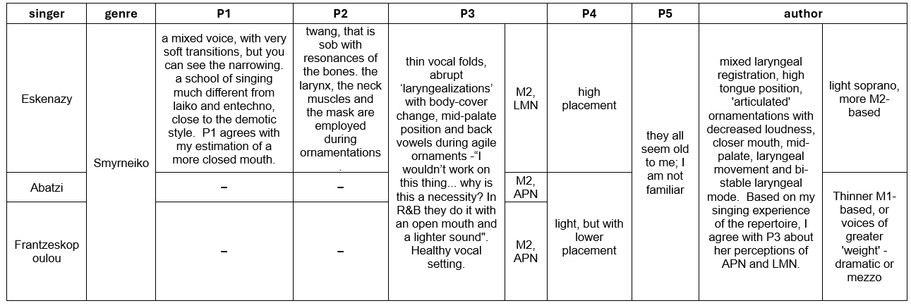
Appendix 6: Participant’s comments on Greek singing timbres
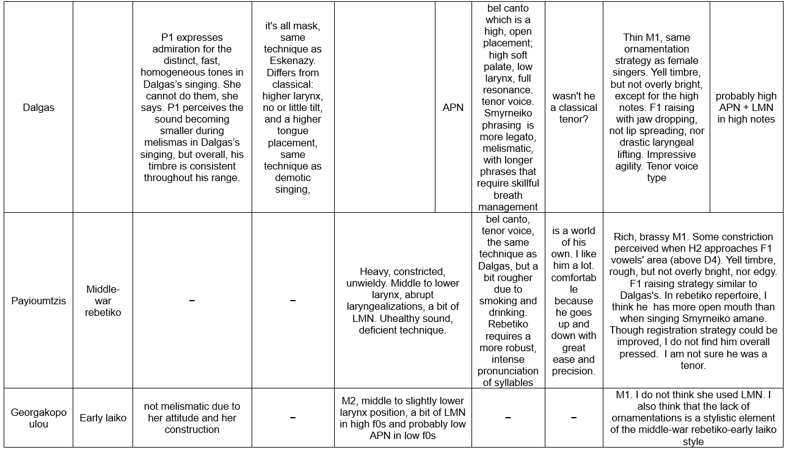

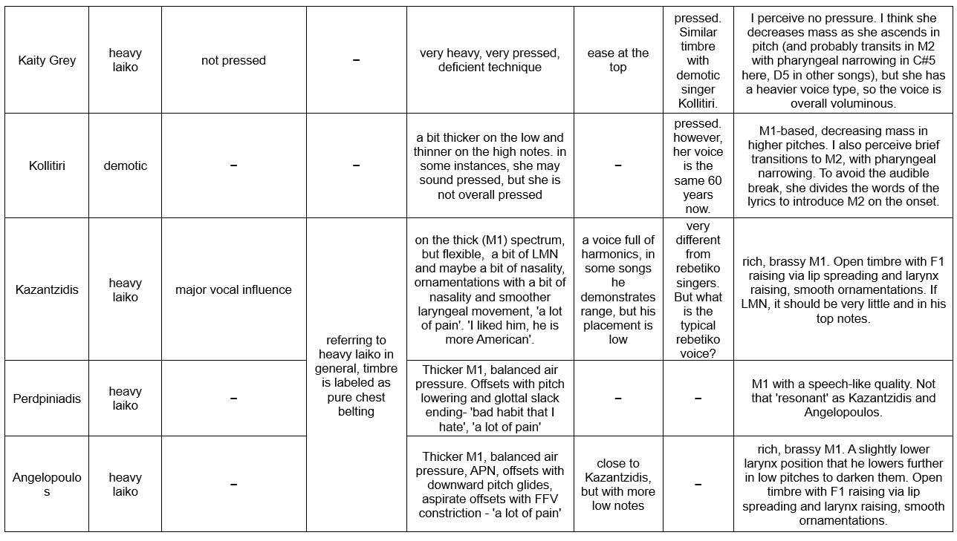

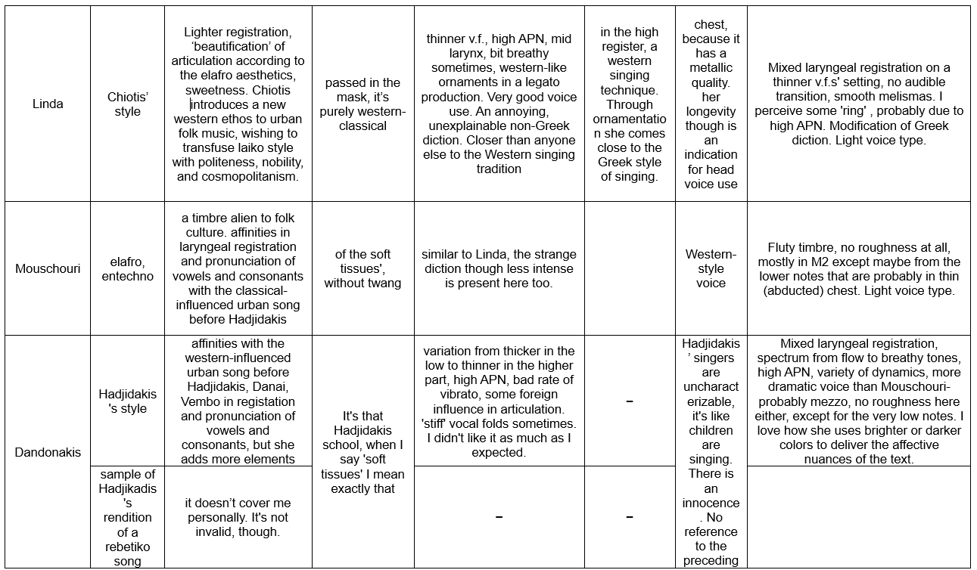

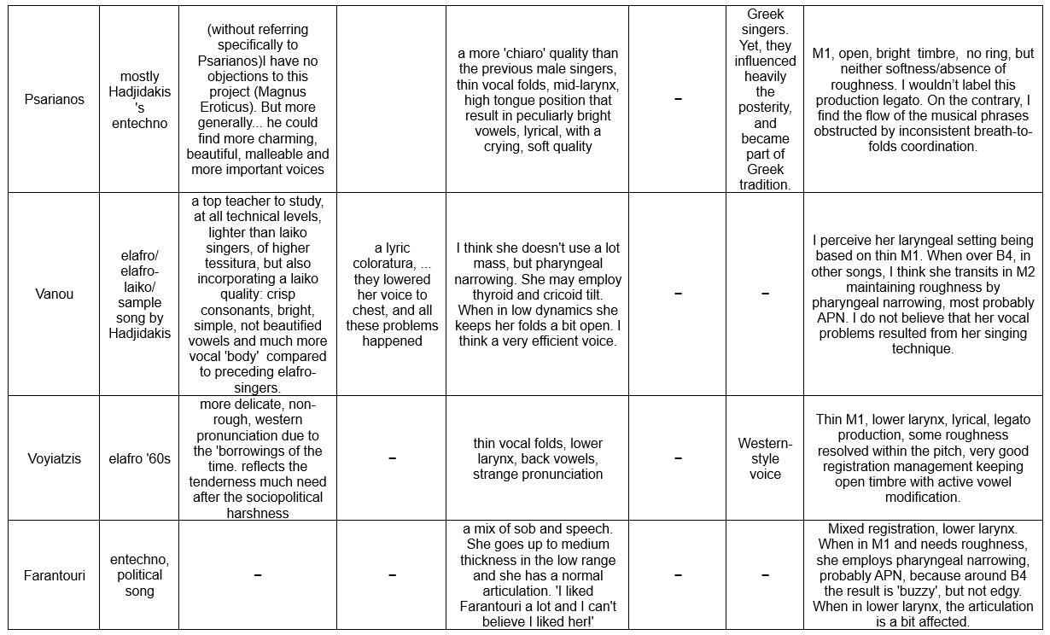

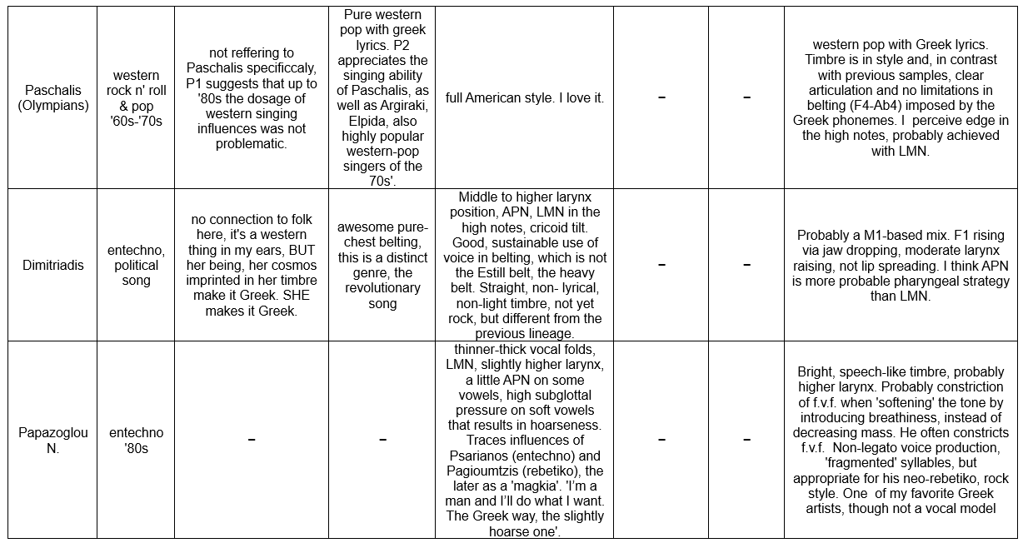

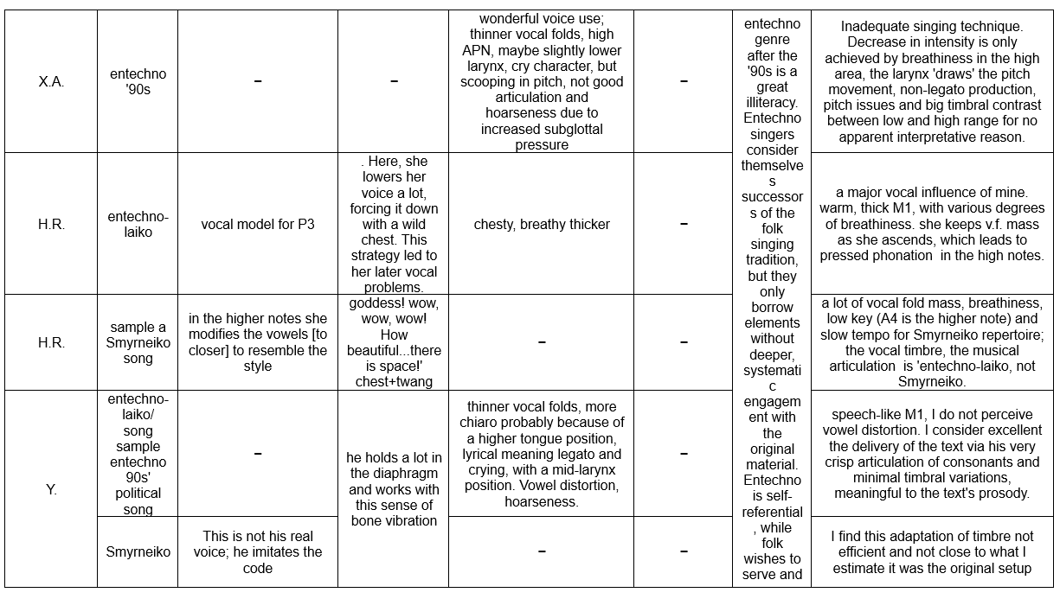

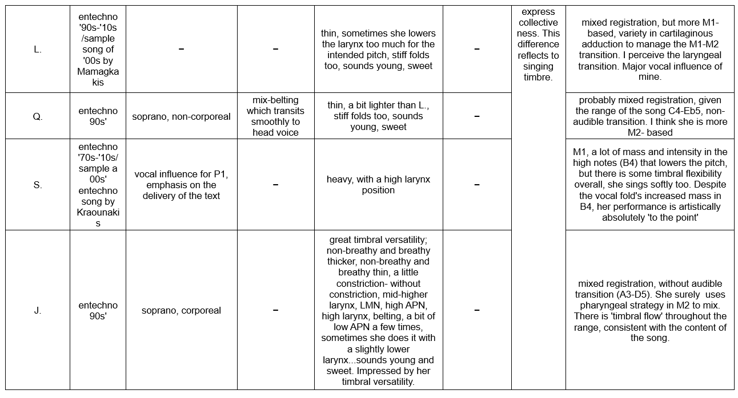

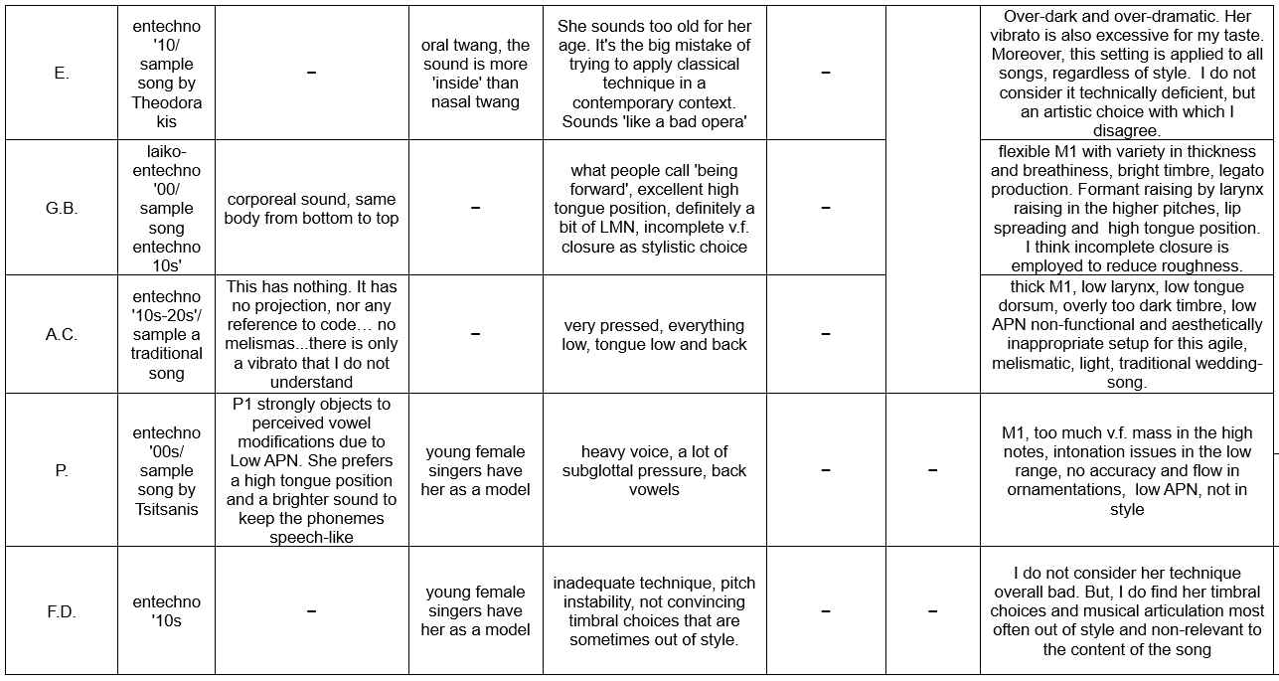

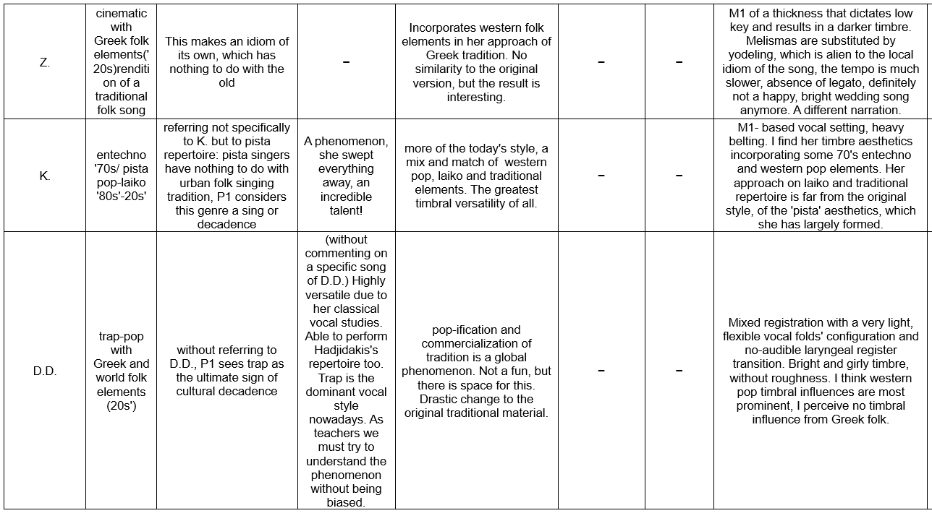

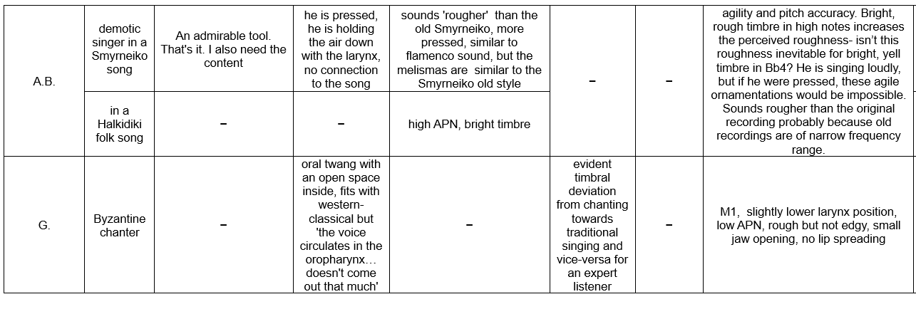

Appendix 7: The Greek singing styles

Demotic/Traditional Singing
Demotic music is the indigenous Greek music, and it comprises a diverse array of traditional regional singing styles. Traditional songs were collective creations of regional communities, each one reflecting unique cultural and historical influences. Despite a superficial homogeneity, closer examination reveals diverse vocal practices, scales, rhythms, and performance contexts (Chianis and Brandl, 2001). Mainland singing traditions often feature powerful vocal projection, as exemplified in the kleftika ballads and polyphonic songs of Epirus. Conversely, island singing frequently employs a more lyrical and ornamented approach, often accompanied by the lyra and laouto. Asia Minor displays a blend of Greek and Middle Eastern influences in its vocal styles.
Post-WWII societal shifts, including urbanization, emigration, and the rise of mass media, significantly impacted demotic music. By the 1970s, professional singers and amplified sound transformed village festivals, diminishing the need for powerful vocal projection and shifting audience roles from active participants to passive listeners (Sarris and Tzevelekos, 2008). The recording industry, employing professional singers and orchestras unfamiliar with regional nuances, along with mass media, contributed to dilution of regional distinctiveness (MUSIC VAULT). Nevertheless, demotic singing persists, embodying the rich cultural heritage and historical experiences of the Greek people.
Kleftiko Song
Kalamatiano-Mitaki
Tsamikos-Kollitiri
Tsamikos-Vera
Epirotic Lament
Epirotic Polyphonic
Pontic song
Aegean Islands' song
Traditional of Asia Minor-Aidonidis
Cretan Rizitiko-Stavrakakis
Macedonia-Lalezas
Thracian Gaida-like style (sample n.8)

Rebetiko
The term ‘rebetiko’ itself has a complex history and its meaning has evolved over time. Initially, it was associated with a subculture of ‘rebetes’ or ‘magkes’, individuals often on the margins of society who expressed a rebellious attitude towards mainstream social norms (Anagnostou, 2018). Rebetiko songs often dealt with themes of urban life, hardship, love, and loss, reflecting the experiences of the working class and marginalized communities. Rebetiko music, now registered in the UNESCO Intangible Cultural Heritage (no date) list, can be divided in two styles with distinct musical and timbral characteristics:

Smyrneiko
Smyrneiko is a musical style that flourished in the 1920s-1930s in Athens. It is characterized by elaborate vocal ornamentations and intricate melodic structures. It is performed with non-tempered instruments such as the oud, the santour, and the violin, distinguishing it from later rebetiko music that features the bouzouki and baglama.
While the term ‘Smyrneiko’ wasn’t widely used until the 1970s and 1980s, the music itself has roots in the late 19th century. Back then, dedicated performance spaces called cafés-santour or cafés-aman hosted musicians and troupes primarily from Smyrna and Constantinople. These cafés-santour were crucial for the development and performance of Smyrneiko, showcasing diverse performers and a mixed repertoire of songs in various languages, reflecting the cosmopolitan nature of the genre. In the 1920s, after the defeat of Greece in the Greek-Turkish war in 1922 and the influx of refugees from Asia Minor, new venues called ‘byres’ (beers) emerged, taking over the role of the cafés-santour. These byres became important performance spaces for Smyrneiko, particularly in the port city of Piraeus.
The term ‘Smyrneiko’ itself is linked to the city of Smyrna, which was once a major center of Greek culture and music, known for its cosmopolitan atmosphere and vibrant music scene. Smyrneiko can be seen as a bridge between Greek folk music and Ottoman music, incorporating elements of both traditions and reflecting the cultural exchange between Greeks and Turks in the early 20th century. Although initially associated with the ‘orient’ and viewed with ambivalence, Smyrneiko was later embraced by left-wing intellectuals in Greece during the 1970s and 1980s. They saw it as a symbol of Greece's cultural diversity and a way to challenge the conservative and nationalist narratives of the time. Today, Smyrneiko is recognized as an important part of Greece’s musical heritage, and its repertoire keeps being performed after its revival in the 1970s’.
Roza Eskenazy
Αntonis Ntalgkas
Rita Ambatzi
Kostas Roukounas
Marika Frantzeskopoulou

Piraeus-rebetiko
The port city of Piraeus played a crucial role in the development and dissemination of rebetiko during the interwar. The city’s diverse population, including refugees from Asia Minor that arrived in 1922, workers, and those on the fringes of society, contributed to the vibrant musical culture that fostered rebetiko. Piraeus rebetiko, sometimes referred to as ‘Pireotiko’ is a distinct style within the broader rebetiko genre. It is characterized by a raw sound, often featuring the bouzouki and baglama. The lyrics of Piraeus rebetiko often reflected the harsh realities of life in the city’s underbelly, including themes of crime, drugs, and social marginalization.
Hashish dens (tekedes) became important spaces for the performance and transmission of Piraeus rebetiko music. The association of rebetiko with Piraeus and its subculture contributed to its stigmatization during the interwar period. However, this same association also contributed to its later reappraisal as an authentic expression of the struggles and experiences of the Greek working class and marginalized communities.
While the term ‘rebetiko’, due to its social connotations, was not widely used during its early years, it gained prominence in the postwar period, particularly during the rebetiko revival of the 1960s and 1970s. Today, rebetiko is recognized as an important part of Greece's cultural heritage, and the foundation of Greek laiko (popular) music and is widely performed, especially in tavernas, small, traditional Greek restaurants and rebetadika, stages dedicated to the style.
Katsaros
Payioumtzis
Delias

Elafró
Elafró, the predominant genre of Greek popular music prior to the ascendancy of laiko, emerged in the late 19th century and flourished until the 1960s, mirroring Greece’s rapid modernization and its search for a cultural identity that balanced tradition with European aspirations. Elafró can be seen as the soundtrack to a uniquely Greek Belle Époque, reflecting a yearning for elegance, sophistication, and artistic expression (Rinas, 2014). Through elafró, Greece sought to define its place in the modern world, blending Western musical influences with Greek lyrical sensibilities.
Singers of elafró employed a light, non-rough, smooth vocal timbre, and interestingly often adapted their pronunciation of Greek language, likely to assimilate the sounds of European languages prevalent in genres like bel canto and French chanson. This phenomenon of modifying native language pronunciation to resemble the vocal timbre of culturally dominant music, as analyzed by Potter (2008), highlights the subtle influence of cultural dominance on language through music.
The trajectory of elafró was significantly shaped by influential figures like composer and performer Attik, whose artistic collective ‘Mantra’ in the 1930s fostered the genre's development. The advent of recording technology and radio broadcasting in the 1930s further propelled elafró into a potent commercial force. Record companies actively sought talented singers and composers, fueling a star system and a competitive market for popular songs (Tsampras, 2019). This commercialization led to a proliferation of elafró music, with songs frequently featured in films, theatrical productions, and radio broadcasts.
Despite its commercial character, elafró functioned as a chronicle of Greece's modernization, encapsulating its evolving cultural identity. The genre’s themes evolved alongside societal changes, reflecting shifting attitudes towards love, patriotism, and social norms. Elafró endures as a vital component of Greece's musical legacy, preserving the essence of a bygone era while retaining its resonance with contemporary audiences.
Danae
Fotis Polymeris
Nana Mouskouri
Yiannis Voyiatzis

Laiko genre
Laiko music emerged as the dominant genre of Greek popular music after World War II, as a gradual transformation of the interwar rebetiko, whose trajectory drastically changed by the Metaxas dictatorship in 1937. The regime’s intervention, aimed at ‘purifying’ the language and ‘Europeanizing’ the music, forced composers to adapt, leading to a broadening of thematic range and the incorporation of elements from the more mainstream elafro style (Economou, 2019). Tonal harmony was combined with Eastern modal systems, evident in its use of makam-related melodies, distinctive harmonies, irregular rhythms, and elaborate ornamentations. This gradual evolution, supported by social transformations, changing tastes, critical discourse and the music industry, saw the term laiko gradually replacing the term ‘rebetiko’ in mainstream use (Anagnostou, 2018; Economou, 2019). Thus, through laiko is often translated as ‘popular’ –which in English means ‘of wide appeal’– in Greek laiko refers to music specifically created by and for the working class, deeply rooted in their social experiences and cultural expressions (Anagnostou, 2018).
Unlike elafro popular style, which primarily adheres to Western tonal systems, laiko embraces both tonal and modal systems, incorporating elements from diverse musical traditions. This includes maqam-related modes, characteristic of Middle Eastern and Eastern Mediterranean music, resulting in a unique sonic identity of idiomatic harmony, uneven rhythms, and rich ornamentations (Pennanen, 1997).
Laiko transformations reflect the changing socio-political and cultural landscape of postwar Greece. This diversity can be seen in several, distinct substyles that developed within the laiko genre.

Tsitsanis’s style
One prominent substyle of laiko is led by the influential composer Vasilis Tsitsanis. Tsitsanis’s style, prevailing from the 1940s’ until the mid-1950s’, modernizes the rebetiko style, integrating western musical elements, as well as elements from Indian and Turkish music (Pennanen, 1997). His songs frequently employed allegorical narratives to depict wartime hardships and social struggles, conveying powerful themes of resilience and strength. This thematic focus resonated with a broad audience, transcending the political divisions of the Greek Civil War (1947–1949) (Economou, 2019). His early works featured a raw, rebetiko-influenced vocal delivery, while later compositions embraced a more expressive and flexible vocal approach. These diverse vocal styles, however, remained distinct from the western aesthetics of the elafro. Composers such as Papaioannou, Kaldaras and Mitsakis were also contributors the elevation of rebetiko to laiko.
Tsitsanis-Georgakopoulou
Tsitsanis-Ninou
Papaioannou-Haskil

Archontorebetiko
Archontorebetiko, often referred to as ‘posh rebetiko’, was an hybrid of laiko and elafro that emerged in the late 1940s and lived till the late 1950s. It featured melodies and rhythms reminiscent of rebetiko, with lyrics that utilized everyday language and was performed by western orchestras and prominent singers of the elafro style. Originating from the Greek cinema, archontorebetiko catered to the burgeoning middle class, offering an optimistic and escapist vision that resonated with the desire for normalcy and a forgetting of wartime traumas. Archontorebetiko often featured humorous lyrics and upbeat rhythms, providing a stark contrast to the heavier themes explored in other laiko substyles.
Tony Maroudas

Chiotis’s style
A radical westernization approach to rebetiko was that of Manolis Chiotis. Beginning in the mid–1940s, he pioneered the fusion of rebetiko and further expanded the bouzouki’s technical possibilities introducing the four-course bouzouki in the 1950s. This modification, along with the introduction of bouzouki amplification dominated and drastically transformed the sound of laiko music. His musical partnership with his wife, Mary Linda ─a voice of the elafro style─ popularized his fusion of laiko with jazz and Latin influences. Chiotis introduced the bouzouki to the bourgeoise, being the first laiko musician to perform in high-class nightclubs, and revolutionized laiko performance with a theatrical style that included stand-up singing, comedy, and dance routines inspired by the elafro genre (Economou, 2019).
Chiotis-Linda

Heavy of grieving laiko
This is a style characterized by sorrowful songs exploring themes of trauma, oppression, and injustice drawing heavily on oriental musical elements and non-functional harmony (Pennanen, 1997). During the 1940s it retains the raw timbre and the controlled sentimentality of the rebetiko style and is represented by singers such as Bellou and Binis (Economou, 2019). During the 1950s–60s heavy laiko becomes more ornamented, expressive and sentimental. Kazantzidis ─the most popular and commercial laiko singer─ defined laiko as the genre that expresses the lives, struggles, and perspectives of the poor. He actively resisted its westernization championing Eastern influences and traditional Greek culture, as well as its commercialization to the entertainment of the middle classes (Economou, 2019). Other popular singers like Grey, Aggelopoulos, Perpiniadis, and Lydia had similar artistic views and approaches to music as Kazantzidis.
Bellou
Kazantzidis
Grey
Aggelopoulos
Poly Panou
Lydia

Post-1960s transformations - skyladiko
The 1960s the emergence of new forms of laiko drawing influences from entechno and elafro, with artists like Zabetas, Kaldaras, Katsaros, and Plessas at the forefront of these transformations.
Zabetas-Moscholiou
Plessas-Marinella
Plessas-Dionysiou
In the post-1960s era laiko shifted towards a more cheerful and entertaining style, reflecting changing socio-economic conditions and the genre’s increasing appeal to the middle class. Nightclub performances started transforming into extravagant spectacles, incorporating elaborate choreography, and emphasizing visual performance alongside musicality. This increasing commercialization of laiko gave rise to the phenomenon now known as skyladiko. The term itself is derogatory, used to describe nightclubs (pistas) featuring a subgenre of laiko music often criticized for being overly commercial and lacking artistic merit. These venues, characterized by their emphasis on spectacle and consumerism, are often accused of prioritizing superficiality and entertainment over authentic cultural expression. Some even argue that they promote negative social values. The term ‘skyladiko’ thus reflects a cultural hierarchy within the Greek music scene, distinguishing between what is perceived as ‘authentic’ laiko and its more commercialized forms, highlighting ongoing debates about the nature and role of Greek popular music. Moreover, skyladiko is also used for non-prestigious, B class pistas.
Margaritis
Christodoulopoulos

Entechno
Meanwhile, the influence of rebetiko and early Tsitsanis style led to the emergence of a new urban style during the 1950s, known as entechno, which combined elements of Western art music, with laiko. The term originally used to describe this style, coined by Theodorakis, was ‘entechno-laiko’, meaning ‘art-popular’. Mikis Theodorakis (1925−2021) and Manos Hadjidakis (1925−1994) were the pioneers of entechno, which later evolved into diverse musical expressions with distinct stylistic nuances (Kallimopoulou, 2009). Both composers, educated in the Western art music tradition but driven by the desire to redefine ‘Greekness’, bridged ‘high’ and ‘low’ art, but with distinct approaches (Tambakaki, 2019).

Mikis Theodorakis
Theodorakis, with his patriotic-leftist and populist approach, aimed in democratizing access to high culture and to create a ‘truly Greek School of Music’, by employing ‘...true poetry, transformed into the living melody of our musical tradition, adorned with all the musical (rhythmic, orchestral, vocal) ornaments of contemporary, living folk music’ (Theodorakis, 1965, in Mikis Theodorakis Guide, 2020). Furthermore, Theodorakis significantly contributed to the development of political singing, a subgenre of entechno that emerged during the military junta of the Colonels (1967−1974) but truly flourished after its fall. While some songs of resistance and dissent were written and circulated clandestinely during the dictatorship, the genre experienced a resurgence in popularity after the restoration of democracy, becoming a powerful vehicle for expressing political views and social commentary. His songs resonated with a public eagerness to engage with political themes and reflect on the experiences of the recent past.
Theodorakis- Axion Esti
Mikis Theodorakis-Maria Farantouri
Τheodorakis- Sfageio

Manos Hadjidakis
Hadjidakis, through a modernist lens, sought to transcend mere popular appeal, aiming to reach a discerning and sensitive audience. He experimented with rebetiko, demotic song, and poetry to forge a new musical idiom. This idiom navigated the contradictions of post−war Greece: tradition versus modernity, nationalism versus internationalism, and elitism versus accessibility, creating a liminal space between these opposing forces (Kanelopoulos, 2009). This pursuit is evident in Hadjidakis’s vocal aesthetic, which envisioned a singer with the technical mastery of Elizabeth Schwarzkopf and the immediacy of laiko singer Marika Ninou, driven by a deep commitment to musical integrity and interpretive perfection (Hadjidakis, 1991).
Hadjidakis-Magnus Eroticus

The entechno of the composers
Following in the footsteps of Hadjidakis and Theodorakis, a generation of composers embraced entechno, which becomes essentially a music dedicated to poetry, further exploring the dynamic interplay between Western and Eastern Greek musical traditions (Kallimopoulou, 2009). Mamagkakis, Markopoulos, Xarhakos, Leontis, Loizos, Mikroutsikos and others are prominent figures of this composers’ live, each one with a very distinct stylistic fingerprint. Some common elements are the song-cycles based on poetry collections, the elevation of laiko and folk singers as conveyors of poetic passion, and a new form of audience engagement through large-scale concerts. Furthermore, large-scale entechno concerts became a platform for audience engagement, fostering a sense of shared cultural identity and often serving as a vehicle for political expression in the post-dictatorship era.
Mamagakis-Kana
Markopoulos-Xylouris
Loizos-Ntalaras
Mikroutsikos-Dimitriadis

The entechno of boîtes and songwriters
During the 1970s’ the tradition of entechno was expanded through the spread of boîtes (small music venues) to include singer-songwriters who compose their own music and lyrics and perform their own songs. During 1970s Greek rock also emerges, and starts being incorporated into entechno. Savvopoulos leads this advancement combining demotic and laiko music with rock (Kallimopoulou, 2009). In 1980s’ Lena Platonos introduces electronic music to entechno.
Savvopoulos-Ballos
Arleta
Platonos-Palamidas

Post-1980s entechno
The evolution of entechno after 1980 is marked by increasing hybridity, fusing Greek and international musical elements. Advancements in recording technology and practices, as noted by Varelopoulos (2019), facilitated this fusion, leading to diverse substyles like entechno-rock, entechno-folk, and entechno-paradosiako. This diversification transformed entechno into a codified musical canon, one that actively engages with tradition to create new narratives reflecting contemporary Greece. In this context, ‘entechno’ signifies a ‘quality song’, championed for its artistic integrity and poetic depth (Kallimopoulou, 2009). This perception contrasts with the perceived superficiality of commercial music, often associated with the pista nightclub scene. Entechno, conversely, is typically performed in concert halls, theaters, and open-air venues, further distinguishing it from the commercial music circuit.
However, this ‘quality’ has also led to criticism, particularly from those outside its core audience of educated youth and the urban middle class, who sometimes perceive entechno as pretentious. While the boundaries between 'quality' and commercial ‘superficiality’ are subjective and contested (Kallimopoulou, 2009; Mikroutsikos, in Ioannou, 2011), this study adopts the commonly used term entechno to denote post-1980s music that consciously draws upon the established entechno style and performance practices. This distinction is crucial for differentiating it from the pista repertoire.
Harris Alexiou
Eleftheria Arvanitaki
Papazoglou-Peridis
Tsanaklidou-Kraounakis
Lidakis-Malamas
Kana-Papakonstantinou

Paradosiaká
The hybridization of entechno was significantly propelled by a new generation of musicians emerging from the music high schools established in the 1980s. These schools adopted a unique pedagogic approach based on the work of Simon Karás (1903–1999), a prominent musicologist, Byzantine chanter, and researcher (Kallimopoulou, 2009). Karás proposed a theory of musical continuity linking ancient Greek, Byzantine, and folk traditions, creating a pedagogic system rooted in the Eastern Mediterranean’s musical heritage, with Byzantine music at its core. Notably, his framework also incorporated elements and instruments from the Ottoman musical tradition, which he recontextualized as Byzantine; Greek.
Musicians trained in this system pioneered a contemporary urban musical expression. Kallimopoulou (2009) labels this scene and its repertoire as paradosiaká (plural of ‘traditional’), to distinguish it from demotic music which has a regional character, as explained above. This vibrant scene, characterized by its syncretic nature, draws inspiration from various modal traditions of the Eastern Mediterranean. Beyond integrating existing repertoire from this broad geographic area, these musicians also create new works infused with these diverse influences, significantly enriching the modern Greek musical landscape
Ross
Papadopoulou
Mavroidi
Ketime
Takim

Pista scene
Pista (meaning ‘stage’) is a nightclub featuring live music performances, typically with a main stage and seating areas (Tsioulakis, 2019). Pista style emerged during the 1980s with the introduction of synthesizers and electric guitars in laiko style. During the 1990s’ pista style evolved into a fusion of Anatolian melodies and rhythms with Western pop arrangements, featuring catchy melodies, danceable rhythms, and modern production techniques appealing to a broad audience (Polychronakis, 2019). Pista is currently the most popular and commercially successful style in Greece. Its post-90s’ dominance across various media platforms, including radio, television, and nightlife venues, contributed significantly to the rise of prominent artists-stars like Vissi, Remos and many others.
Anna Vissi
Remos
Argyros
Mazonakis

Further Hybridization
The contemporary Greek musical landscape is a dynamic tapestry woven from diverse threads. Repertoire from all the genres above is broadly performed today. Moreover, Greek musicians keep on exploring new arrangements and reinterpretations of the traditional and historic urban Greek repertoire that create further stylistic hybrids. Through these renditions, the old repertoire is introduced to younger audiences.
Satti
Alkyone
Pagan
Klambanis

References:
Aetos 68 (2023) Τα ξένα χέρια - Καίτη Γκρέυ (Τραγούδια Κινηματογράφου). 14 May. Available at: https://www.youtube.com/watch?v=zQmI9ZrkH-8 (Accessed 17 July 2024)
Afthentikos42 (2011) Μαρούδας Παπαδάκης- Το τραμ το τελευταίο. 13 February. Available at: https://www.youtube.com/watch?v=6K1fqduUC9A (Accessed 17 July 2024)
Afthentikos42 (2012) Φραντζεσκοπούλου-Όλα τα μέρη σκοτεινά (Her yer karanlık). 29 May. Available at: https://www.youtube.com/watch?v=ADnbRko5Vhw (Accessed 16 July 2024)
Akanthos (2011) Κλαίν' οι πέρδικες στα πλάγια (Πολυφωνικό της Ηπείρου). 3 March. Available at: https://www.youtube.com/watch?v=nJOV2OE0Zz0&list=PLB73FE0F659C02C1E&index=15 (Accessed: 21 January 2024)
alekosg_GR. (2019). ΓΙΩΡΓΟΣ ΜΑΡΓΑΡΙΤΗΣ - Μη μου μιλάς με χείλη που καίνε (Καμικάζι τσαντάκιας, 1982). 3 May. Available at: https://www.youtube.com/watch?v=CbLQVMrvtW4 (Accessed 16 July 2024)
Alkyone (2022) Alkyone - Xenitemena mou poulia - [the studio sessions]. 31 October. Available at: https://www.youtube.com/watch?v=i9kckFUFFF0 (Accessed 17 July 2024)
Anagnostou, P. (2018) ‘Did you say rebetiko? Musical categories, their transformation, and their meanings’, Journal of Social History, 52(2), pp. 283–303. Available at: https://doi.org/10.1093/jsh/shy031.
Antonis Remos (2015) Metaxota Sou Heria Ta. 9 February. Available at: https://www.youtube.com/watch?v=Ia_cQs7tVkA (Accessed 16 July 2024)
Areti Ketime Official (2018). Areti Ketime | Mavra mou Matia | Live Session. 22 July. Available at: https://www.youtube.com/watch?v=2HYkFGZJvhc (Accessed 16 July 2024)
captainposi (2010) Ας ερχόσουν για λίγο - Δανάη. 17 December. Available at: https://www.youtube.com/watch?v=_IXR3aZ-9nA (Accessed 17 July 2024)
CDBaby (2015) Ivan's Rachenitsa. 14 November. Available at: https://www.youtube.com/watch?v=DbLWlWVV5yA&list=RDALqKtxl-CAQ&index=3 (Accessed 16 July 2024)
Chianis, S. and Brandl, R.M. (2001) ‘Greece: Traditional music’, in S. Sadie and J. Tyrell (eds) The New Grove Dictionary of Music and Musicians. 2nd edn. London: Macmillan, pp. 353–359.
Cobalt Eclectic (2008) Ελευθερία Αρβανιτάκη - Τα κορμιά και τα μαχαίρια | Eleftheria Arvanitaki - Ta kormia kai ta maxairia. 3 April. Available at: https://www.youtube.com/watch?v=EQnJ1BInoL8 (Accessed 16 July 2024)
Cobalt Eclectic (2016) Χάρις Αλεξίου - Δι' Ευχών - Live - Μάιος 1996. 14 February. Available at: https://www.youtube.com/watch?v=cMQoYwfoKpE (Accessed 17 July 2024)
dimitris pilatos (2013) Πολυμέρης Φώτης - Άσ' τα τα μαλλάκια σου. 29 May. Available at: https://www.youtube.com/watch?v=9rMECOgtBeU&list=PLGBZK1Py9dXKwje3bPgYcR_Q1ItIWl6Ur&index=26 (Accessed 16 July 2024)
Economou, L. (2019) ‘Sentiment, Memory, and Identity in Greek Laiko Music (1945–1967)’, in Made in Greece: Studies in Popular Music.
Faces of Classical Music – 1 (2015) Mikis Theodorakis: The Ballad of Mauthausen & Farantouri's Cycle - Maria Farantouri (Audio video). 2 July. Available at: https://www.youtube.com/watch?v=GvNm0F8L96Q (Accessed 16 July 2024)
fannatics (2009) Άννα Βίσση - Αλήτισσα Ψυχή (Official Video Clip). 3 June. Available at: https://www.youtube.com/watch?v=LUSMk7gpCL4 (Accessed 16 July 2024)
Fascinating Nana - Νάνα Μούσχουρη (2023) Νάνα Μούσχουρη: Κάνε λιγάκι υπομονή - Nana Mouskouri: Kane ligaki ypomoni. 9 December. Available at: https://www.youtube.com/watch?v=4GHv-psp15M&list=PLz6zSAl04aHYCeMJGgZixiMdDgHZHKPDY&index=9 (Accessed 16 July 2024)
G24 (2011) ΤΟ ΣΦΑΓΕΙΟ - ΜΙΚΗΣ ΘΕΟΔΩΡΑΚΗΣ - 17 ΝΟΕMΒΡΗ 1973. 16 November. Available at: https://www.youtube.com/watch?v=CKBvVYDviZ4 (Accessed 10 July 2024)
George Dalaras (2012) Γιώργος Νταλάρας - Αχ χελιδόνι μου. 2 September. Available at: https://www.youtube.com/watch?v=X5M-NssbQ4E (Accessed 10 July 2024)
gerodimos123 (2009) Η ΖΩΗ ΜΟΥ ΟΛΗ -ΣΤΕΛΙΟΣ ΚΑΖΑΝΤΖΙΔΗΣ. 25 January. Available at: https://www.youtube.com/watch?v=Q_x4OnCETRQ
GetGreekMusic (2012) Αργοσβήνεις μόνη - Βασίλης Τσιτσάνης (στίχοι). 6 November. Available at: https://www.youtube.com/watch?v=nsze6VcPAvs (Accessed 10 July 2024)
GetGreekMusic (2012) Βρέχει φωτιά στη στράτα μου - Στράτος Διονυσίου. 5 November. Available at: https://www.youtube.com/watch?v=oqRtE026bas (Accessed: 20 December 2024)

Giorgos Mazonakis (2023) Γιώργος Μαζωνάκης - Να Περνάς - Official Music Video. 21 December. Available at: https://www.youtube.com/watch?v=Z8tZBIEP7Rk (Accessed 10 July 2024)
Giwrgos T. (2012) Αντιλαλούνε τα βουνά Σωτηρία Μπέλλου-Σούλα Δάκη. 11 December. Available at: https://www.youtube.com/watch?v=79bXz4cq9l8 (Accessed 10 July 2024)
GPITRAL4 Greek Music Ελληνική Μουσική (2011) Νίκος Ξυλούρης Πόσα χρόνια δίσεκτα Μαρκόπουλος. [YouTube Video]. Available at: https://www.youtube.com/watch?v=dKjnFAeDqHQ (Accessed 10 July 2024)
GPITRAL4 Greek Music Ελληνική Μουσική. (2013). Μαρινέλλα Κρίμα το μπόι σου. 10 August. Available at: https://www.youtube.com/watch?v=VDwhSKs0tdI (Accessed 10 July 2024)
Hadjidakis, M. (1991). Η Φλέρυ Νταντωνάκη Στα "Λειτουργικά" Του Μάνου Χατζιδάκι. [CD]. Greece: Serious
HELIAS JORDANOPOULOS (2011) O ΧΡΥΣΑΝΘΟΣ ΤΡΑΓΟΥΔΑ ''ΜΑΤΣΟΥΚΑ''1986 ''ΑΡΩΘΥΜΙΑ Σ 'ΘΑ ΤΡΩΗ ΜΕ. 2 August. Available at: https://www.youtube.com/watch?v=bAPAm_lGiqQ (Accessed 10 July 2024)
Ioannis Tousias (2021) Παναγιώτης Λάλεζας / Απάνω στην τριανταφυλλιά-Σόφκα. 20 January. Available at: https://www.youtube.com/watch?v=5VxNjpJPtSo (Accessed 10 July 2024)
Ioannou, O. (2011) O Θάνος και ο Μικρούτσικος: Μία αυτοβιογραφία μέσα από 24 συναντήσεις. Αθήνα: Πατάκης.
ka1962gr (2011) ΜΑΝΩΛΗΣ ΑΓΓΕΛΟΠΟΥΛΟΣ – Μολυβιά. 8 August. Available at: https://www.youtube.com/watch?v=MJK9JKFMUqo (Accessed 10 July 2024)
Kallimopoulou, E. (2009) Paradosiaká : music, meaning and identity in modern Greece. Ashgate.
litsa686 (2011) ΠΕΡΑΣΜΕΝΕΣ ΜΟΥ ΑΓΑΠΕΣ - ΛΙΝΤΑ – ΧΙΩΤΗΣ. 17 March. Available at: https://www.youtube.com/watch?v=Ztum_6NoGXE (Accessed 10 July 2024)
Maira Eua (2015) Μάνος Χατζιδάκις - Ο μεγάλος ερωτικός. 20 August. Available at: https://youtube.com/playlist?list=PLeYcXETDsjQV5WOWJ8k9lhqGL6CkGnnp4&si=KudOHaCeP4rTSBgR (Accessed 10 July 2024)
Maria Doukaki (2012) Κατερίνα Παπαδοπούλου - Αποφάσισα να γίνω. 21 August. Available at: https://www.youtube.com/watch?v=As7qNYOhiQw&list=PLfbrxkQE_KWawsvQM7I6I42YH1JDb_v03&index=3 (Accessed 10 July 2024)
Marina Satti (2022) Marina Satti - YIATI POULI M'. 2 March. Available at: https://www.youtube.com/watch?v=vce6dbTtAzI (Accessed 12 July 2024)
Mikis Theodorakis Guide (2000) Μίκης Θεοδωράκης: Μαχόμενη κουλτούρα. Available at: https://mikisguide.gr/mikis-theodorakis-machomeni-koultoura/ (Accessed: 28 October 2024)
MUSIC VAULT (2021) Η ΕΠΟΧΗ ΤΟΥ ΦΩΝΟΓΡΑΦΟΥ | Ε06 | ΤΟ ΔΗΜΟΤΙΚΟ ΣΤΗ ΔΙΣΚΟΓΡΑΦΙΑ | ΕΡΤ2 | 1984. 23 September. Available at: https://www.youtube.com/watch?v=eVx_x96fuTU (Accessed 12 July 2024)
nikolakias (2014) ΑΣ ΤΡΑΓΟΥΔΗΣΩ ΚΙ ΑΣ ΧΑΡΩ.ΕΙΡΗΝΗ ΚΟΝΙΤΟΠΟΥΛΟΥ ΛΕΓΑΚΗ. 19 April. Available at: https://www.youtube.com/watch?v=Dkkx6Y5DpMA (Accessed 12 July 2024)
nikolakias (2014) ΕΝΑΣ ΟΥΡΑΝΟΣ Μ' ΑΣΤΕΡΙΑ.ΓΙΑΝΝΗΣ ΒΟΓΙΑΤΖΗΣ. 15 August. Available at: https://www.youtube.com/watch?v=Abl35gQWYtc (Accessed 12 July 2024)
Nikos Papazoglou Official (2022) Νίκος Παπάζογλου - Μάτια Μου | Official Audio Release (HQ). 23 January. Available at: https://www.youtube.com/watch?v=-LKbllGPcGs (Accessed 12 July 2024)
outis27 (2008) Poly Panou, Apostolos Kaldaras - Ferte mia koupa me krasi. 18 December. Available at: https://www.youtube.com/watch?v=oTMgxGrRuiY (Accessed 12 July 2024)
PAGAN (2022) PAGAN - Κοίτα με (kita me) (κοίτα με γλυκιά μου αγάπη)- Official video. 12 July. Available at: https://www.youtube.com/watch?v=0-XxtaKLZnA (Accessed 12 July 2024)
PanikRecordsTube (2023) Κωνσταντίνος Αργυρός - Ελπίδα (Panik Concert 2023 by opaponline.gr) - Official Live Video. 24 October. Available at: https://www.youtube.com/watch?v=O-S11SLg2qA (Accessed 12 July 2024) (Accessed 10 July 2024)
pankonstantopoulos: Το άπαν ρεμπέτικο (2011) ΜΠΑΡΜΠΟΥΤΙ, 1933, ΠΑΝΑΓΙΩΤΗΣ ΤΟΥΝΤΑΣ, ΚΩΣΤΑΣ ΡΟΥΚΟΥΝΑΣ. 26 August. Available at: https://www.youtube.com/watch?v=xwqFRP_HXRM (Accessed 12 July 2024)
pankonstantopoulos: Το άπαν ρεμπέτικο (2012) Ο ΠΟΝΟΣ ΤΟΥ ΠΡΕΖΑΚΙΑ, 1936, ΑΝΕΣΤΗΣ ΔΕΛΙΑΣ. 13 February. Available at: https://www.youtube.com/watch?v=FggiatAY5vY (Accessed 12 July 2024)
pankonstantopoulos: Το άπαν ρεμπέτικο (2015) ΛΙΛΗ ΣΚΑΝΔΑΛΙΑΡΑ, 1931, ΡΟΖΑ ΕΣΚΕΝΑΖΥ. 30 December. Available at: https://www.youtube.com/watch?v=QVgRFFFBcTw (Accessed 10 July 2024)
pankonstantopoulos: Το άπαν ρεμπέτικο (2016) ΑΜΑΝΕΣ ΠΕΙΡΑΙΩΤΙΚΟΣ, 1935, ΣΤΡΑΤΟΣ ΠΑΓΙΟΥΜΤΖΗΣ. 13 February. Available at: https://www.youtube.com/watch?v=FggiatAY5vY (Accessed 10 July 2024)
para_todo_el_mar (2009) Ακρογιαλιές Δειλινά - Στέλλα Χασκίλ Βασίλης Τσιτσάνης. 10 January. Available at: https://www.youtube.com/watch?v=YzVmzfWYjKI (Accessed 10 July 2024)
Pennanen, R.P. (1997) ‘The development of chordal harmony in Greek rebetika and laika music, 1930s to 1960s’, British Journal of Ethnomusicology, 6(1), pp. 65–116. Available at: https://doi.org/10.1080/09681229708567262.
Petros Klampanis (2023) XEHORÍSMATA | Petros Klampanis • Tora Collective (Official Music Video). 16 March. Available at: https://www.youtube.com/watch?v=8Is4IuY-kdU (Accessed 10 July 2024)
Pittakos79 (2010) Αντώνης Νταλγκάς - Μανές της καληνυχτιάς (1929). 30 June. Available at: https://www.youtube.com/watch?v=7SONjkJaDqI (Accessed 10 July 2024)
Polychronakis, I. (2019) ‘Anna Vissi: Singing Greece’s Contemporary Socio-Cultural History’, in D. Tragaki (ed.) Made in Greece: Studies in Popular Music. Oxon: Routledge.
ResearcherXM (2011) Αηδονίδης & Νταλάρας - Τρία καράβια πάνε. 23 May. Available at: https://www.youtube.com/watch?v=lCN0N5CocAg (Accessed 13 July 2024)
Rinas, F. (2014) ΤΟ ΕΛΑΦΡΟ ΤΡΑΓΟΥΔΙ. 18 January. Available at: https://www.paidevo.gr/kids/?p=2385 (Accessed: 15 August 2024)
Sarris, H. and Tzevelekos, P. (2008) ‘“Singing like the Gaida (Bagpipe)”: Investigating Relations between Singing and Instrumental Playing Techniques in Greek Thrace’, Journal of Interdisciplinary Music Studies, 2(1 & 2), pp. 33–57.
Journal of Interdisciplinary Music Studies (2017) Audio (Sarris & Tzevelekos 2008). 31 January. Available at: https://musicstudies.org/?s=tzevelekos (Accessed: 21January 2024)
sekarius87 (2016) Έλα όπως είσαι - Μαρίκα Νίνου 1953 (B.Τσιτσάνη). 1 December. Available at: https://www.youtube.com/watch?v=hsTx08p7Om0&list=PLOBc5tWycZzLSYBffmOnWIeowaUsT_lLZ&index=27 (Accessed 13 July 2024)
sekarius87 (2023) Το αίνιγμα - Γιώργος Κάβουρας 1936 (B.Παπάζογλου).1 July. Available at: https://www.youtube.com/watch?v=L9hhJxC8bx4&t=32s (Accessed 13 July 2024)
Sokratis Malamas Official (2019) Μανώλης Λιδάκης - Φύλλα αλκαλικά - Official Audio Release. 24 April. Available at: https://www.youtube.com/watch?v=UnKWfQlV6bs (Accessed 13 July 2024)
Tambakaki, P. (2019) ‘“Art-Popular” Song and Modern Greek Poets – Interactions and Ideologies: The Case of Mikis Theodorakis’, in D. Tragaki (ed.) Made in Greece: Studies in Popular Music. New York and London: Routledge.
Thanasis Papakonstantinou (2015) Μελίνα Κανά - Φεϊρούζ | Melina Kana - Feirouz | Official Audio Release. 28 January. Available at: https://www.youtube.com/watch?v=ud_IlJrBtVo&list=PL2X2Nqm8_qevFv8NqwIj5CnG7BAWCM6Ad&index=3 (Accessed 13 July 2024)
Tsampras, G. (2019) ELAFRO (LIGHT STYLE). Available at: https://vmrebetiko.gr/en/collection-en/?id=elafro (Accessed: 27 July 2024)
Tsioulakis, I. (2019) ‘No More Babes on the Dance-Stage: The Changing Modes of Spectatorship in Athenian Live Music Nightclubs’, in D. Tragaki (ed.) Made in Greece: Studies in Popular Music. Oxon and New York: Routledge.
Unesco Intangible Cultural Heritage (no date) Rebetiko. Available at: https://ich.unesco.org/en/RL/rebetiko-01291 (Accessed: 25 January)
Universal Music Group (2019) O Lioulios. 19 September. Available at: https://www.youtube.com/watch?v=7uBLb8TalWI (Accessed 12 July 2024)
Vicky Papaprodromou (2011) Οδ. Ελύτης & Μ. Θεοδωράκης, Με το λύχνο του άστρου. 25 October. Available at: https://www.youtube.com/watch?v=jx0NzDJgSF0&list=PL9471AB7075EDB802&index=6 (Accessed 13 July 2024)
World music (2013) Ross Daly - Μαύρα μου Χελιδόνια ( Mavra mou Helidonia ). 12 April. Available at: https://www.youtube.com/watch?v=oePqGzMOXwI (Accessed 13 July 2024)
Αεράκης Κρητικό Μουσικό Εργαστήρι – Σείστρον (2017) ΒΑΣΙΛΗΣ ΣΤΑΥΡΑΚΑΚΗΣ - ΜΗΤΣΟΣ ΣΤΑΥΡΑΚΑΚΗΣ - ΡΙΖΙΤΙΚΟ | Official Audio Release © 2001. 17 November. Available at: https://www.youtube.com/watch?v=UNaQNKr_wJw (Accessed 13 July 2024)
ΑΝΔΡΕΑΣ ΧΑΡΑΛΑΜΠΟΠΟΥΛΟΣ (2023) Συγκλονιστικός αμανές από τον Μάνο Κουτσαγγελίδη! 24 March. Available at: https://www.youtube.com/watch?v=hVFP4s0ZhmQ (Accessed 13 July 2024)
Ανοιξη για παντα (2011) Διονύσης Σαββόπουλος – Μπάλλος. 7 July. Available at: https://www.youtube.com/watch?v=47HDK0xTPpo (Accessed 13 July 2024)
Δημήτρης Βογιατζόγλου (2009) Βίκυ Μοσχολιού - ο χωρισμός / Γ. Ζαμπέτας. 29 September. Available at: https://www.youtube.com/watch?v=31PbRrB5voA (Accessed 13 July 2024)
Δημοσθένης 1943 (2017) Λεπενιώτης Κλέφτικο Γιώργος Παπασιδέρης Κλαρίνο Γιώργος Ανεστόπουλος. 18 November. Available at: https://www.youtube.com/watch?v=ZwKIxozsNr8&list=PLPuLkuPdMTPkHUXW5_o0ZUxG14ylFsd8I (Accessed 12 July 2024)
Ελληνικό Τραγούδι (2016) Γιάννης Παλαμίδας - Ραντεβού στην όαση - Official Audio Release. 5 September. Available at: https://www.youtube.com/watch?v=5L-A_gIDFWs&list=RDzol0TSlKznI&index=22 (Accessed 15 July 2024)
Ελληνικό Τραγούδι (2016) Μελίνα Κανά - Δύσκολα χρόνια | Melina Kana - Dyskola xronia - Official Audio Release. 15 August. Available at: https://www.youtube.com/watch?v=kpSa6ReXohk&list=PLw3Mt4FUg5YTxWahkbUpM1-aFJxnAMBPI (Accessed 13 July 2024)
Ελληνικό Τραγούδι (2018) Αρλέτα - Μια φορά θυμάμαι - Official Audio Release. 27 February. Available at: https://www.youtube.com/watch?v=H-m42WC0NMk (Accessed 13 July 2024)
Ελληνικό Τραγούδι (2018) Τάνια Τσανακλίδου - Γυφτάκι | Official Audio Release. 16 May. Available at: https://www.youtube.com/watch?v=yxwQiDya5cU (Accessed 13 July 2024)
Ελληνικό Τραγούδι (2019) Μάκης Χριστοδουλόπουλος - Να 'χαν οι καρδιές αμπάρεs | Official Audio Release. 15 January. Available at: https://www.youtube.com/watch?v=qOlyUl0VB34&list=RDEMW1YrNUboM4MRcjMKks7IwA&index=4 (Accessed 13 July 2024)
ΕΛΛΟΠΙΑ (2016) "Μαριόλα"(Ηπειρώτικο μοιρολόι) - Σάββας Σιάτρας / ΕΤ - 1, 1998. 8 November. Available at: https://www.youtube.com/watch?v=VlI23bqUpc4 (Accessed 13 July 2024)
ΕΛΛΟΠΙΑ (2018) "Σήκω Διαμάντω"(Τσάμικο) - Τασία Βέρα / Αρχείο ΕΡΑ 1997. 27 September. Available at: https://www.youtube.com/watch?v=QkkbTaFlWFE (Accessed 10 July 2024)
Κωστας Ρουμπος (2018) ΕΙΣΑΙ ΠΟΝΤΟΣ ΕΧΤΡΑ =ΣΜΥΡΝΕΙΚΟ==ΑΜΠΑΤΖΗ ΡΙΤΑ. 16 January. Available at: https://www.youtube.com/watch?v=DLffQ3PbTEc (Accessed 10 July 2024)
ΜΑΡΙΝΕΛΛΑ /marinelladiva (2016) Μαρινέλλα - ΑΜΑ ΔΕΙΤΕ ΤΟ ΦΕΓΓΑΡΙ (English Subtitles). 23 June. Available at: https://www.youtube.com/watch?v=QRJK-mtHsos (Accessed 10 July 2024)
Μουσικές Περιηγήσεις (2012) Γαμμαγραφία - Μαρία Δημητριάδη. 13 December. Available at: https://www.youtube.com/watch?v=WHYnhYPleW4 (Accessed 10 July 2024)
Χρήστος-5070 (2018) ΤΙ ΕΧΕΙΣ ΡΙΝΑ Μ' ΚΙ ΑΡΡΩΣΤΑΙΝΕΙΣ ~ ΓΕΩΡΓΙΑ ΜΗΤΤΑΚΗ. 13 December. Available at: https://www.youtube.com/watch?v=x61oj3u243s&list=PLPuLkuPdMTPkHUXW5_o0ZUxG14ylFsd8I&index=4 (Accessed: 12 July 2024)

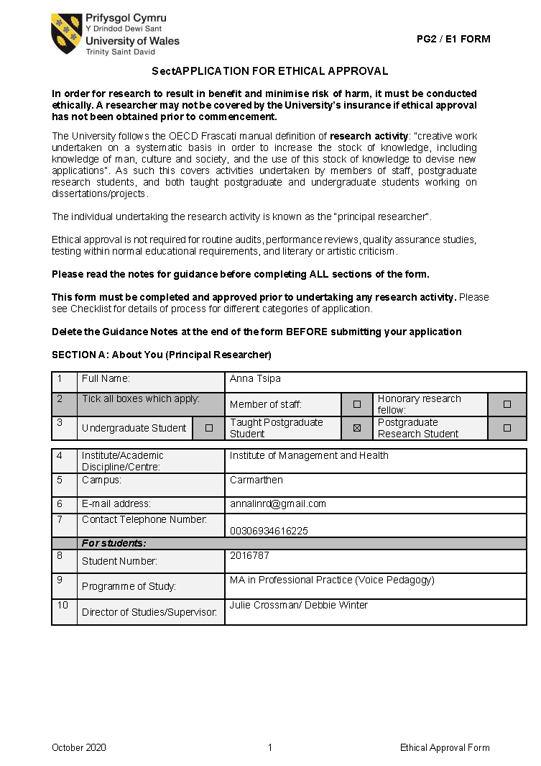
Appendix 8: Ethics Approval

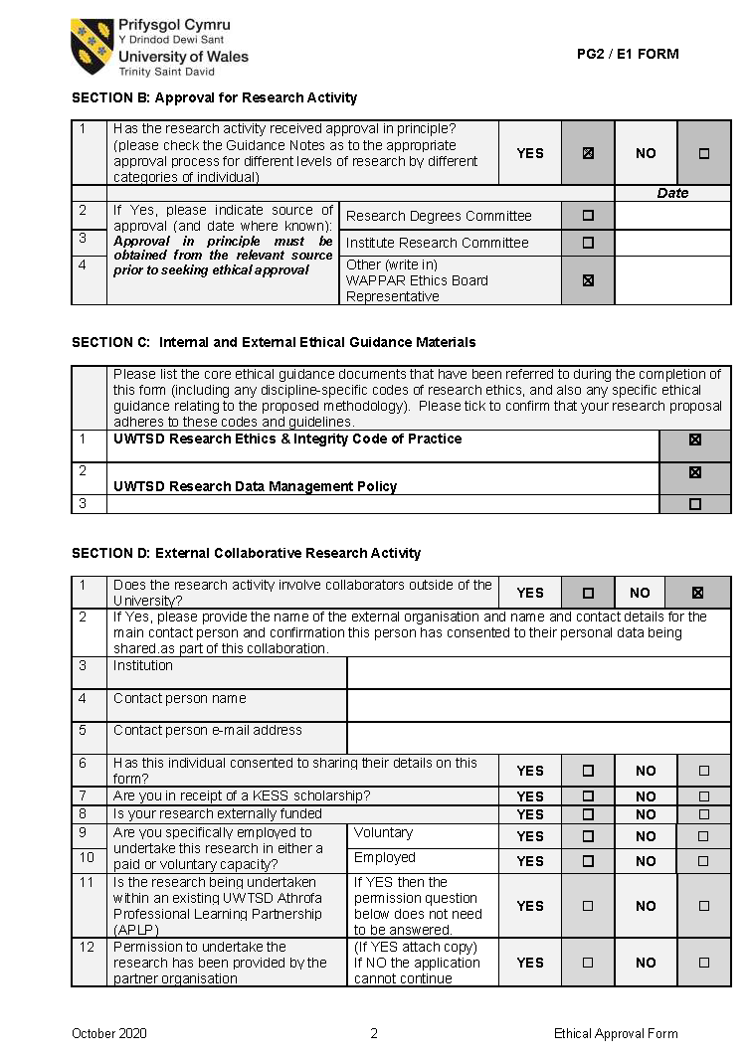
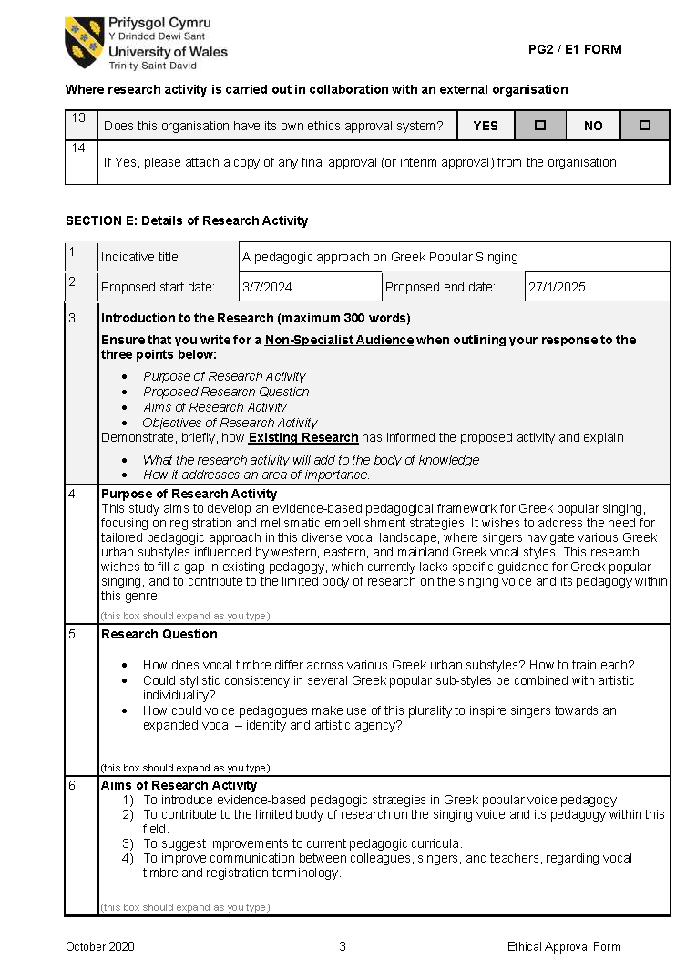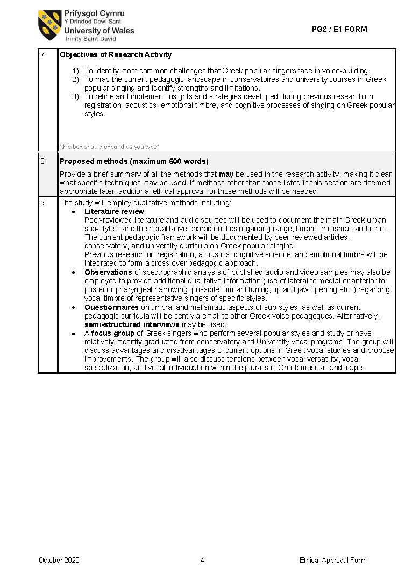
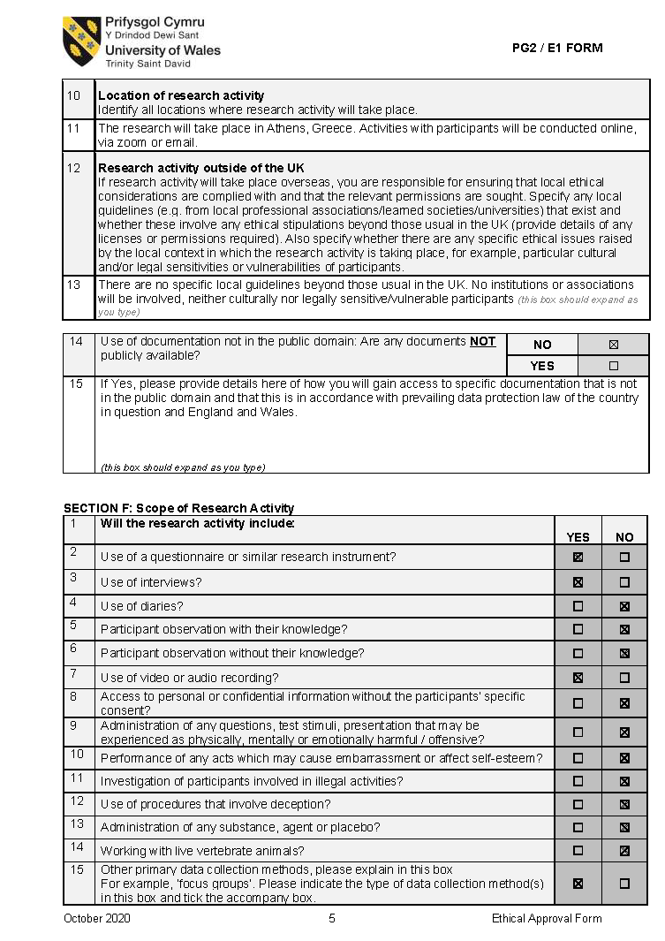
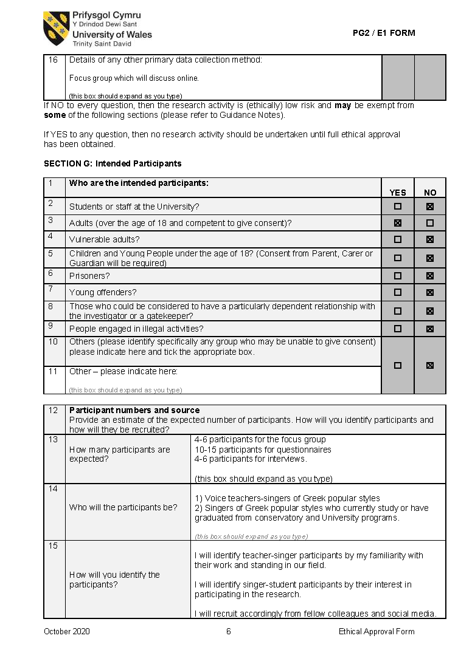

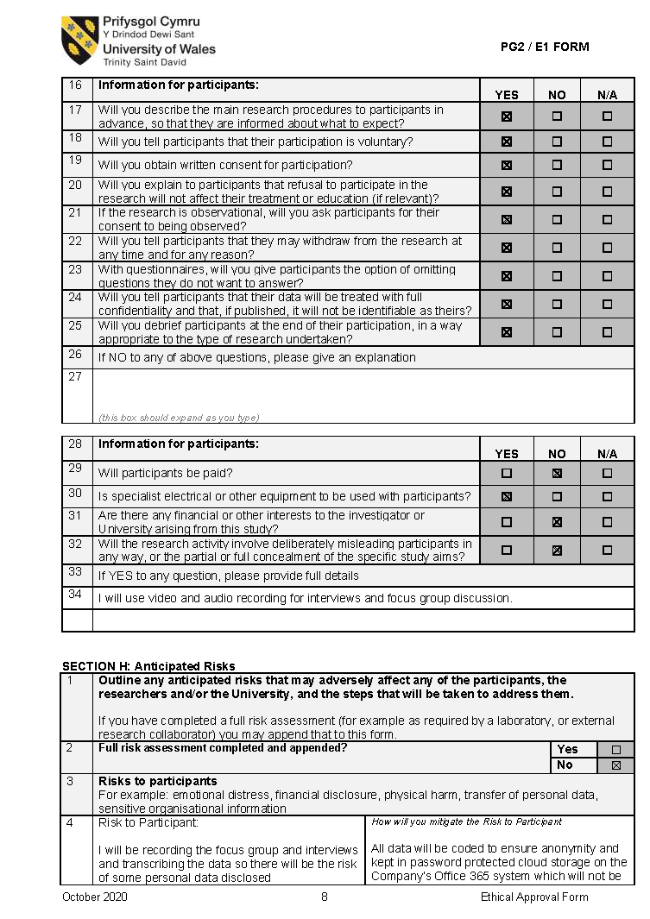
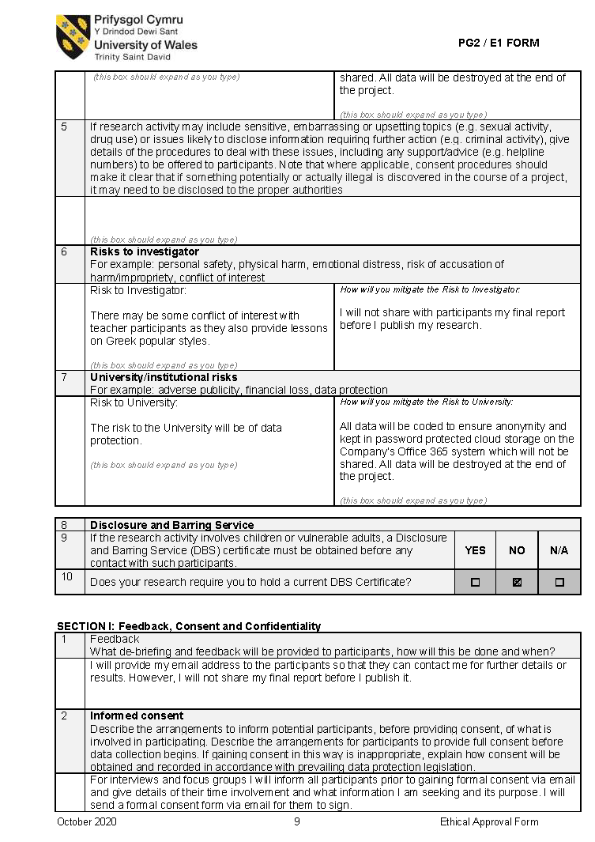
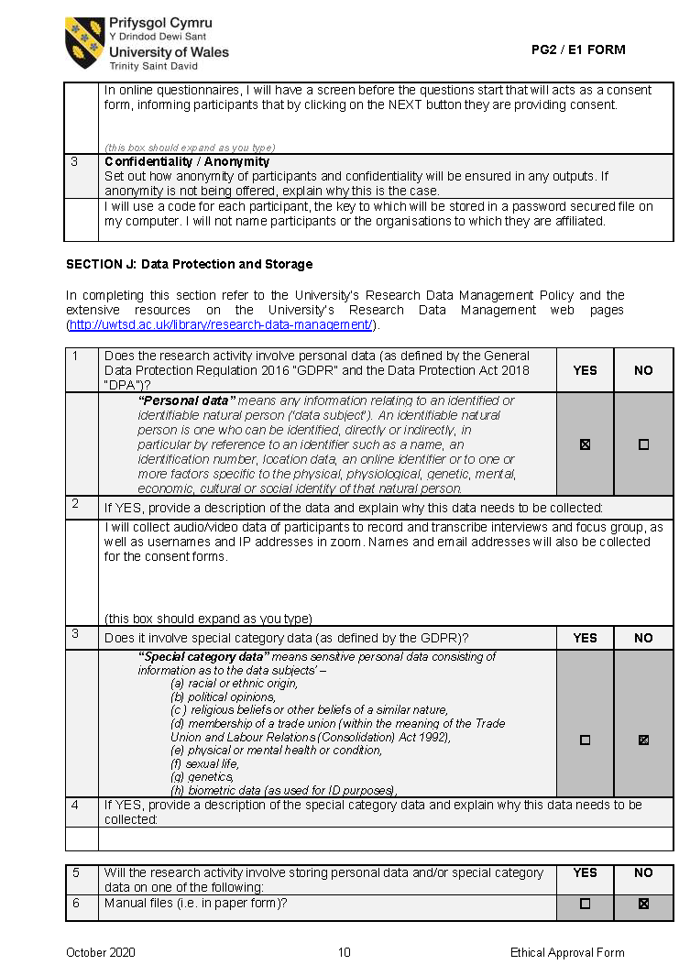
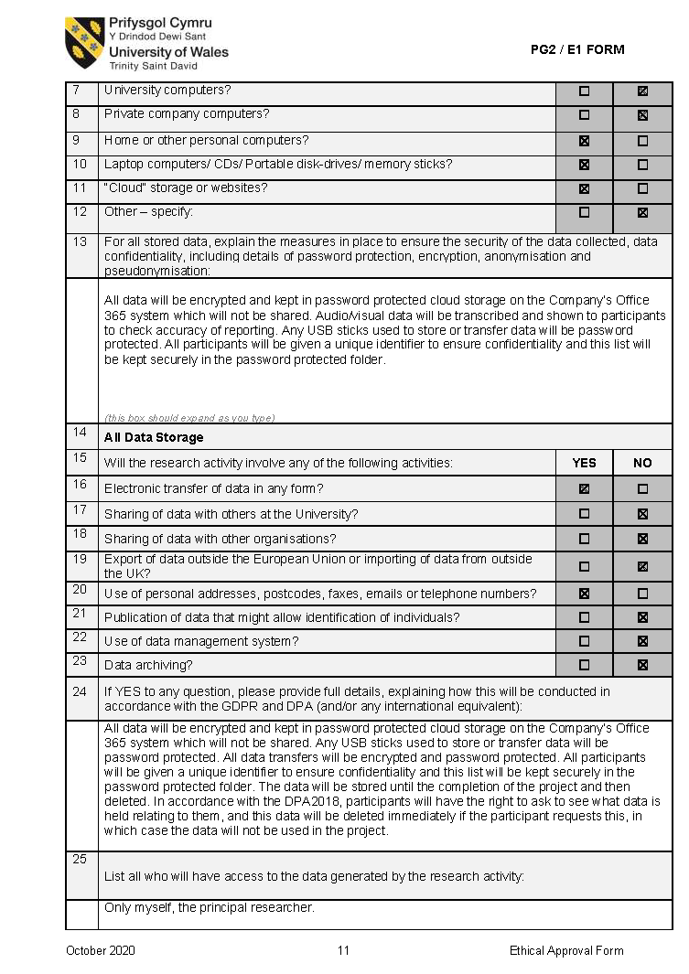
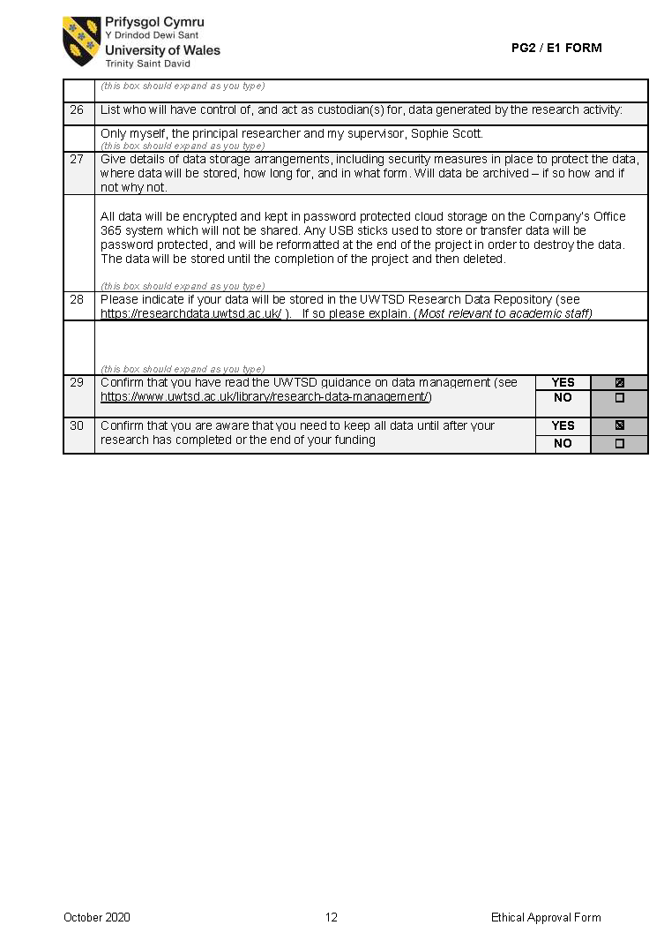
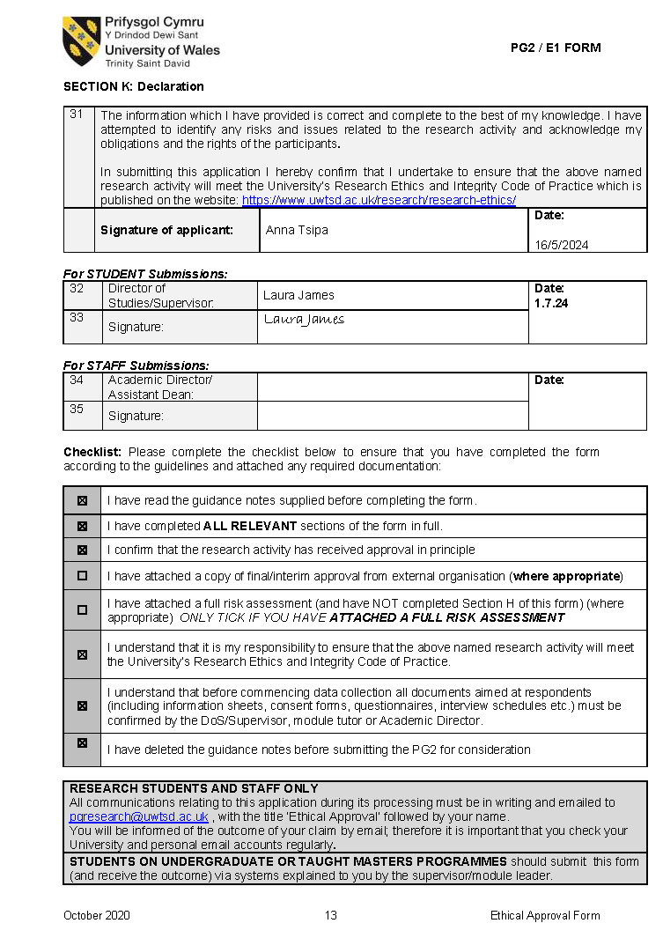
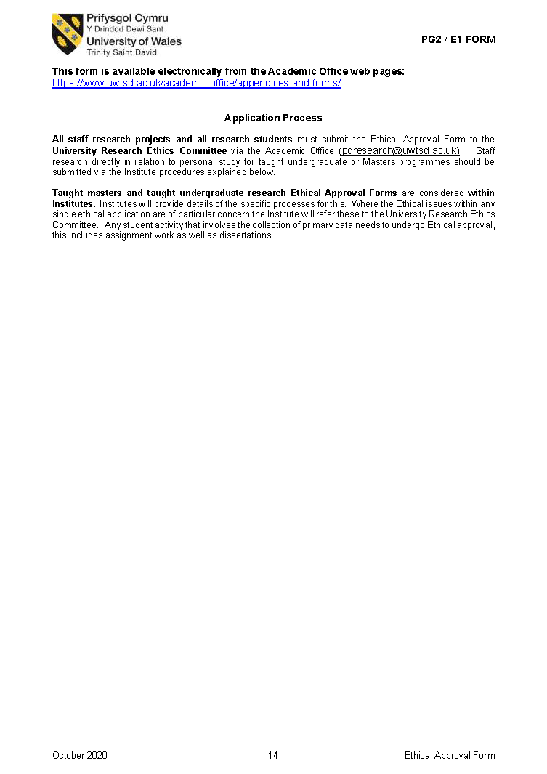

Appendix 9: Participants’ Consent Forms

P1

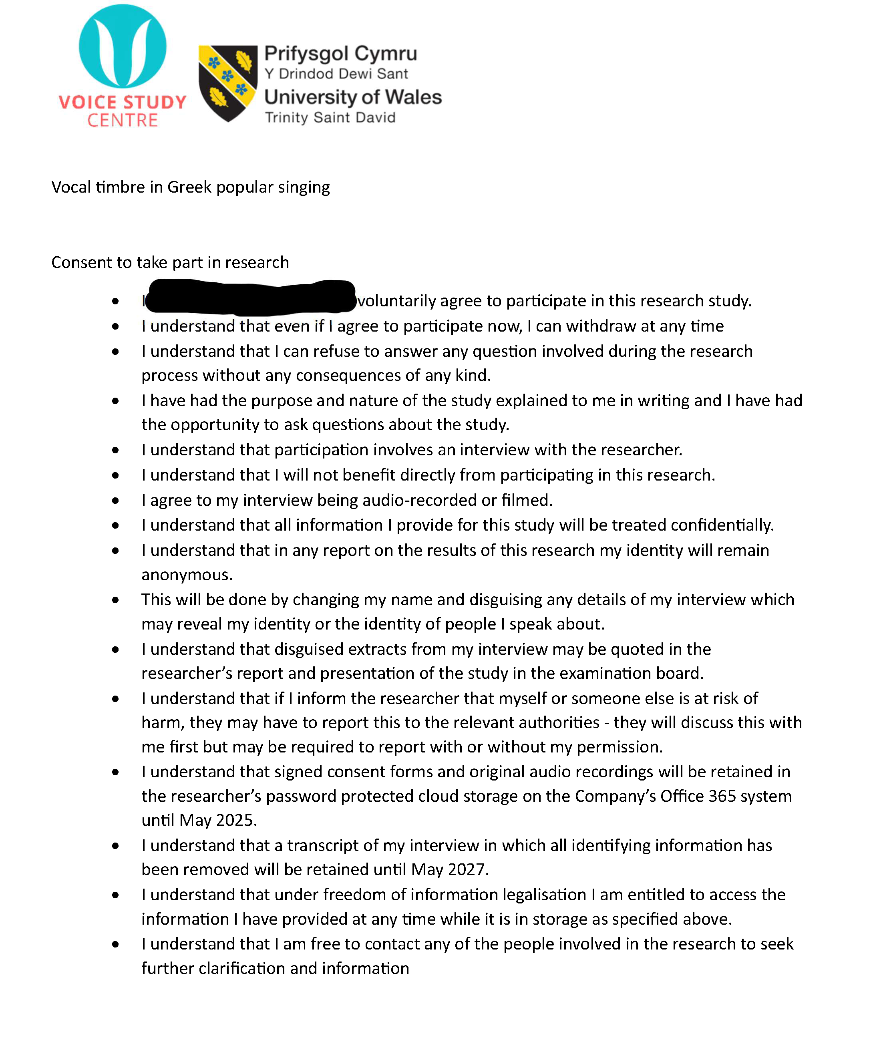
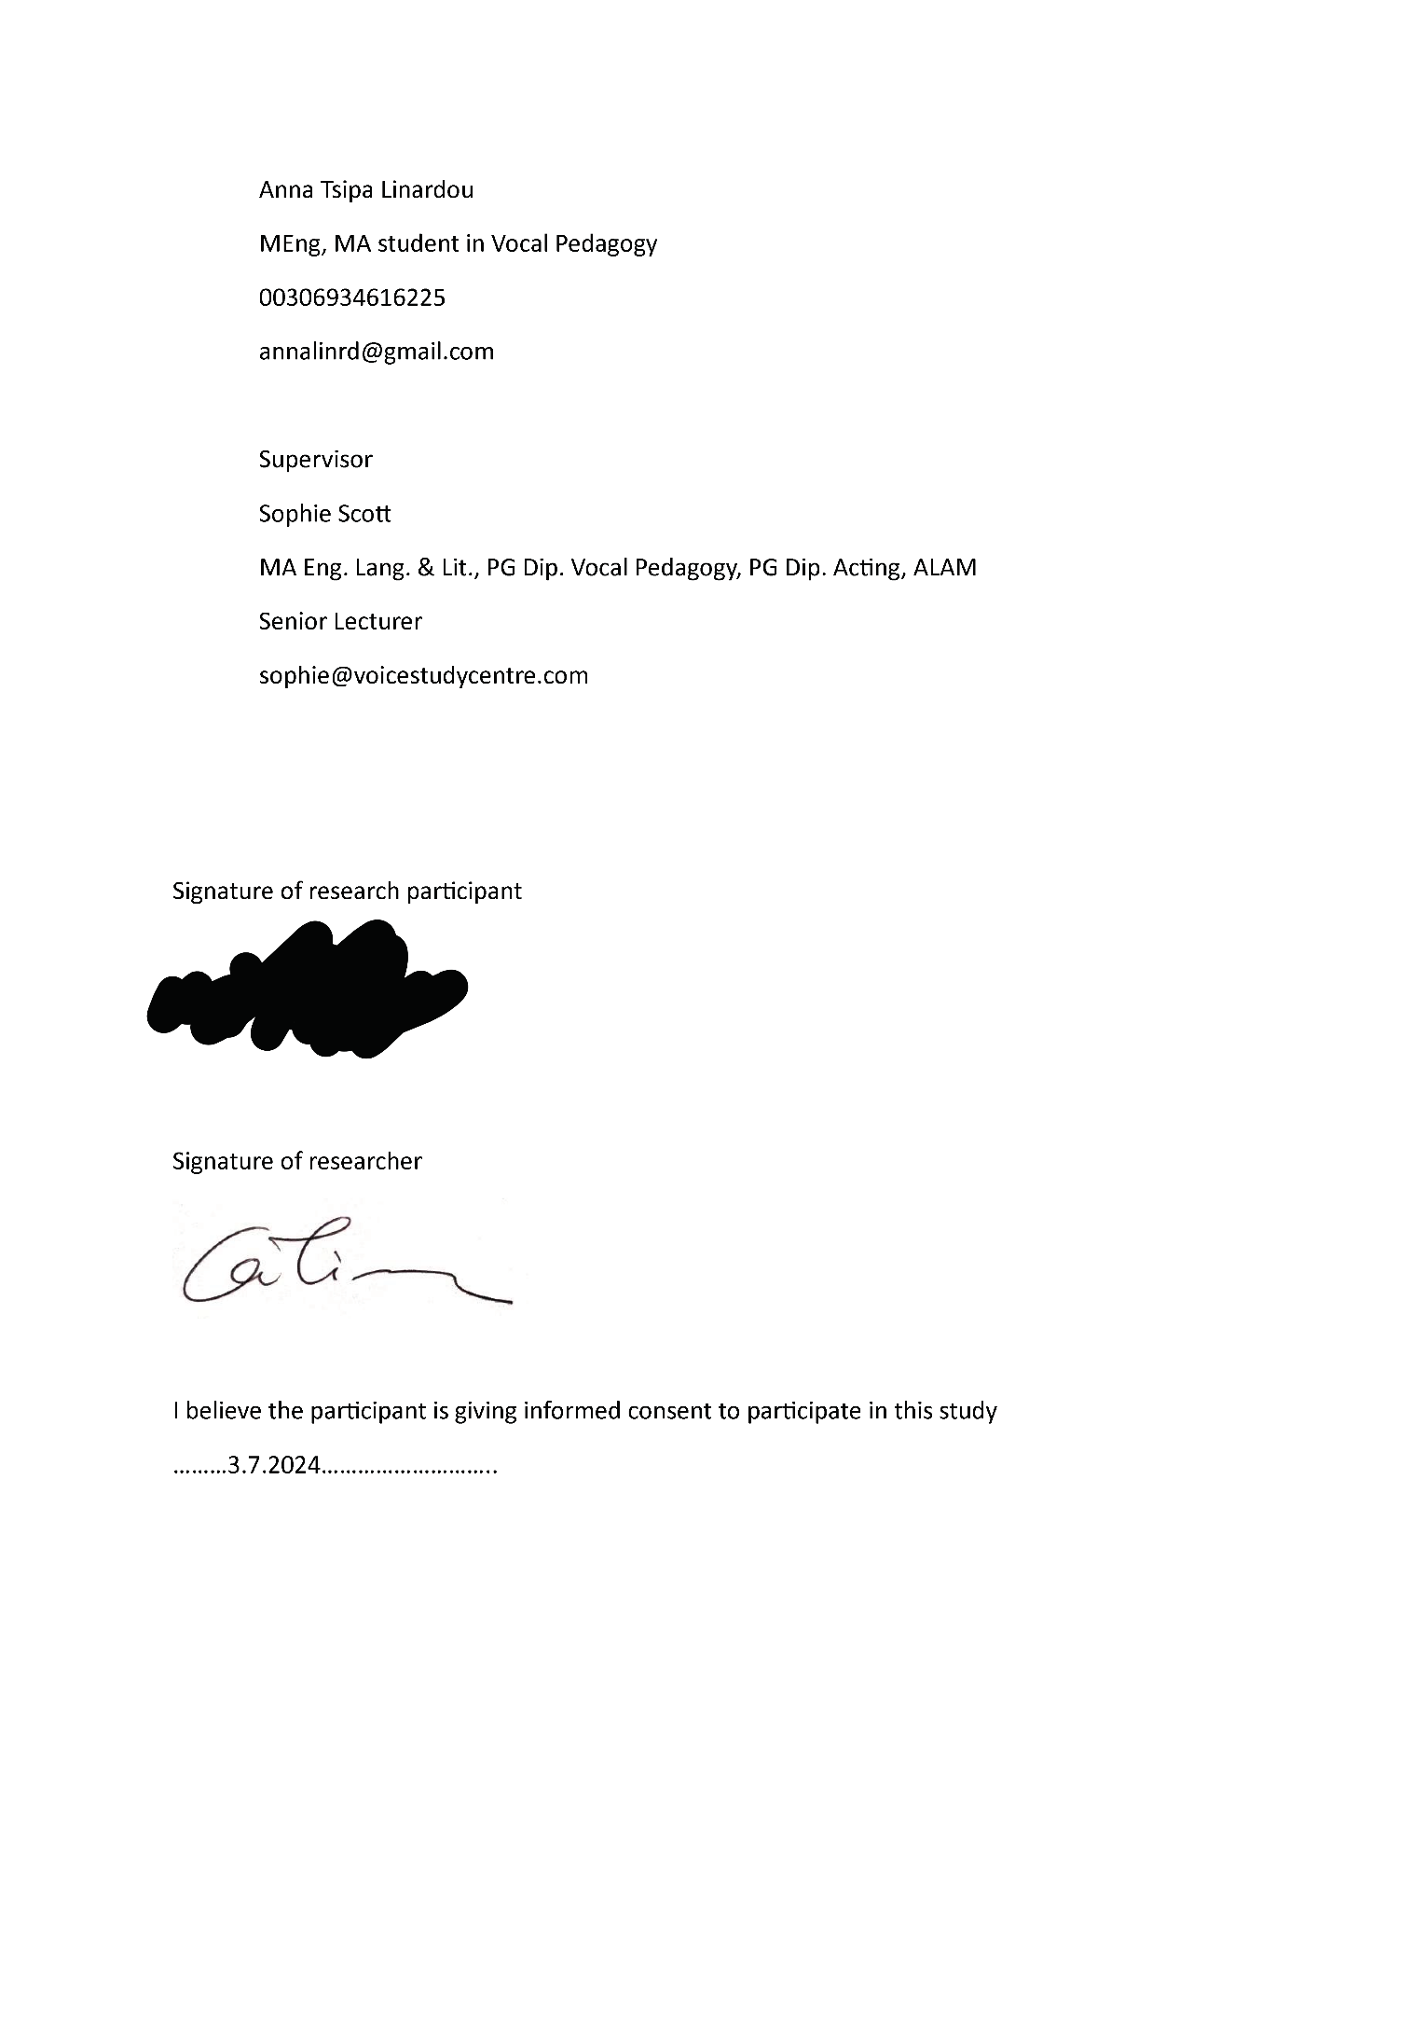

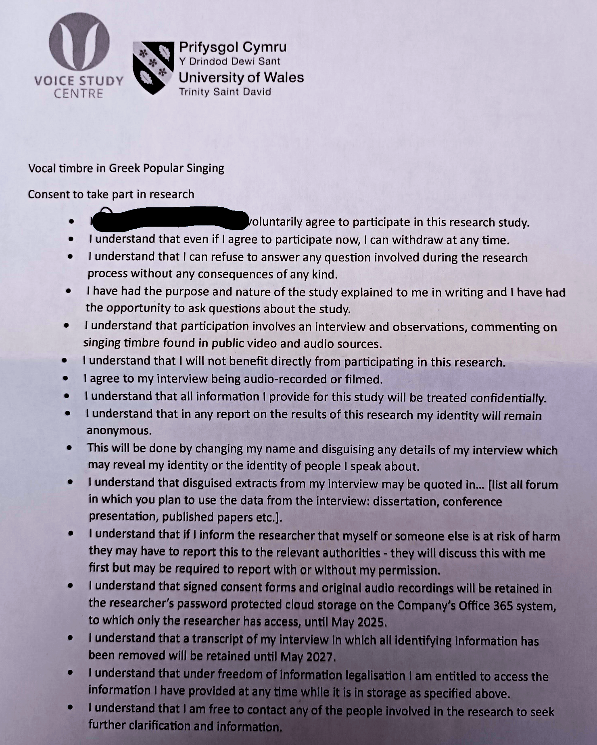
P2

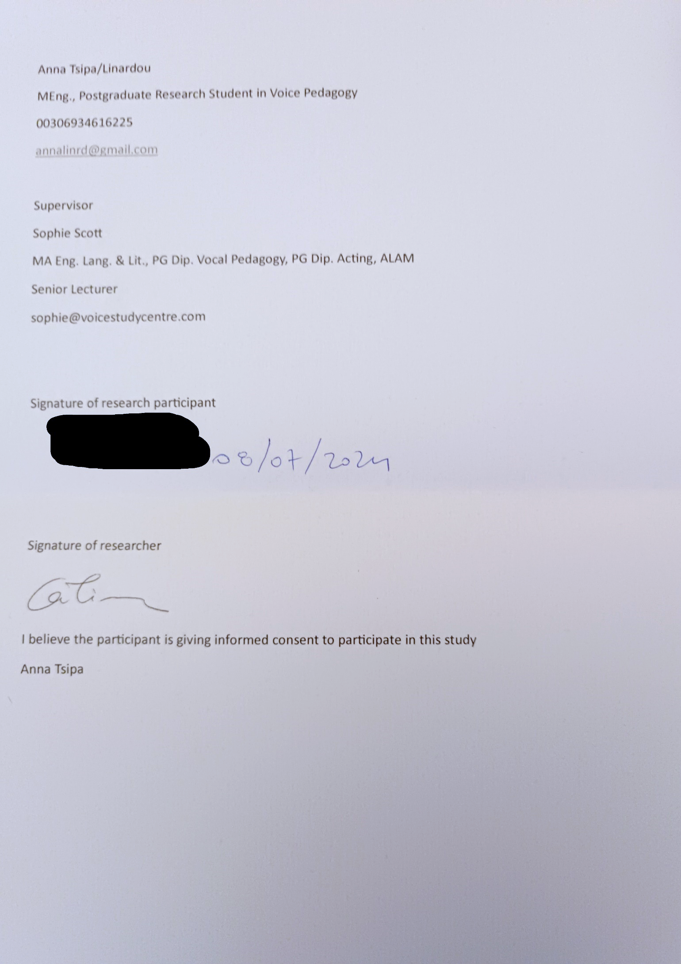

P3

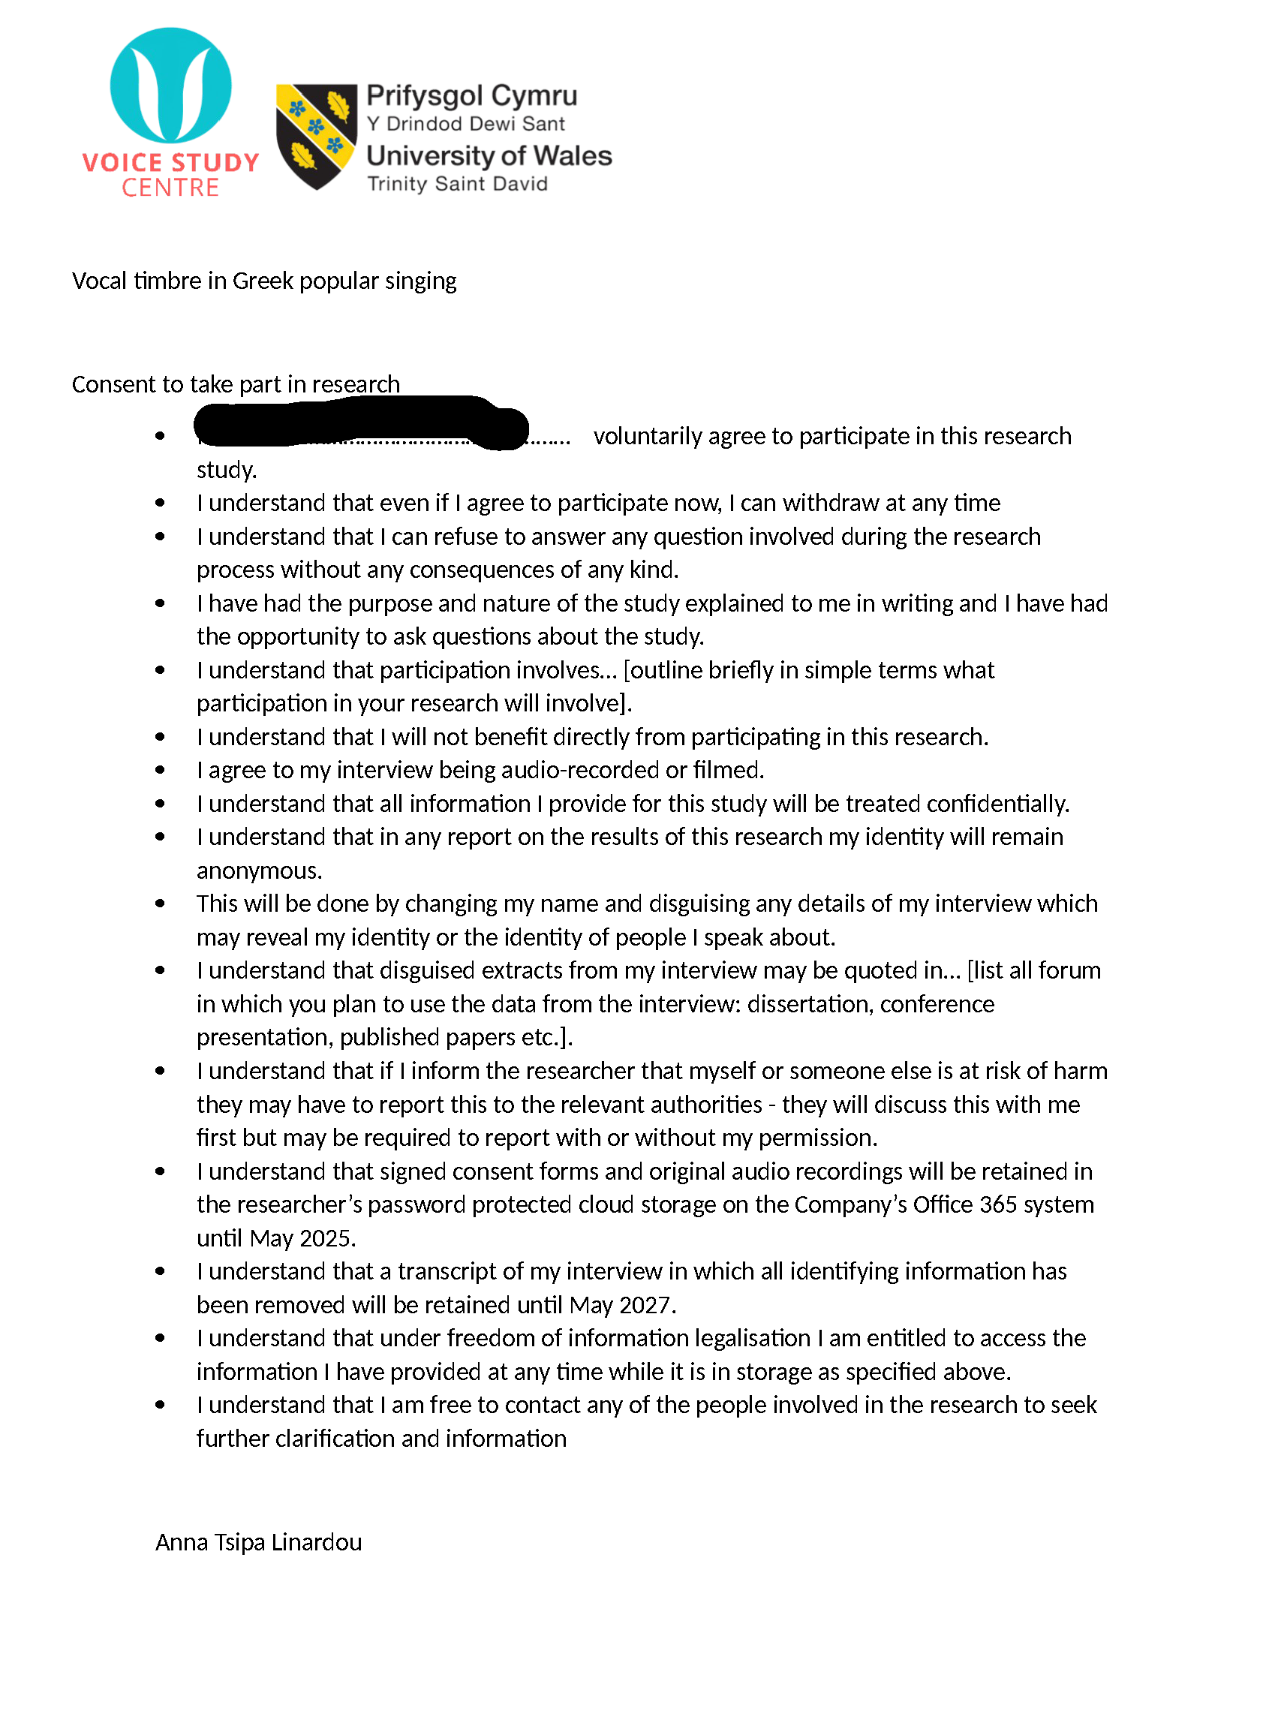

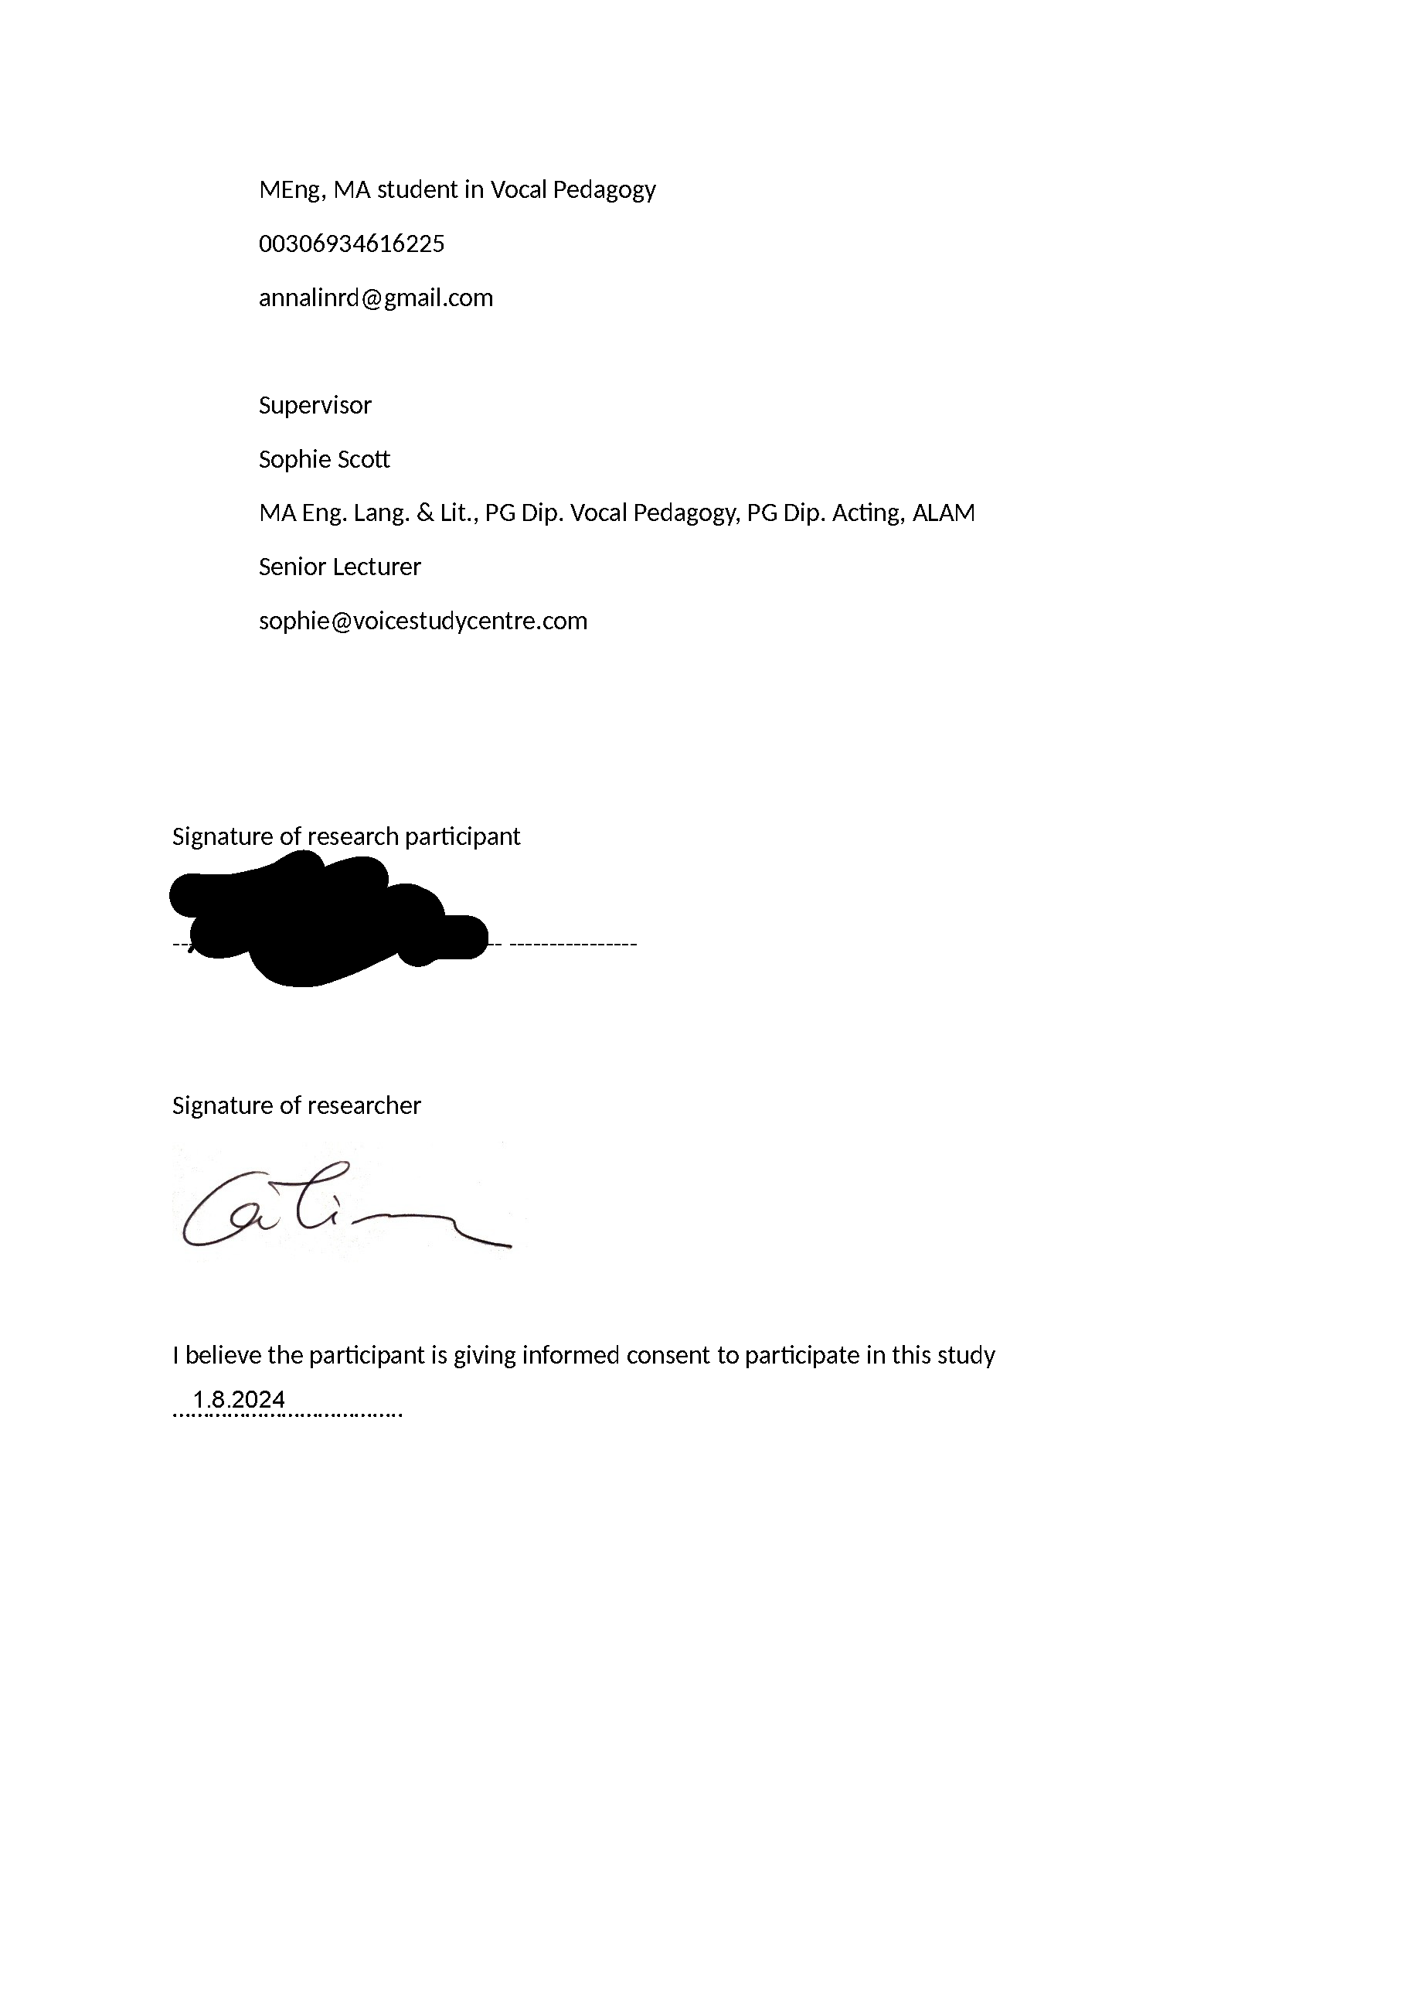

P4

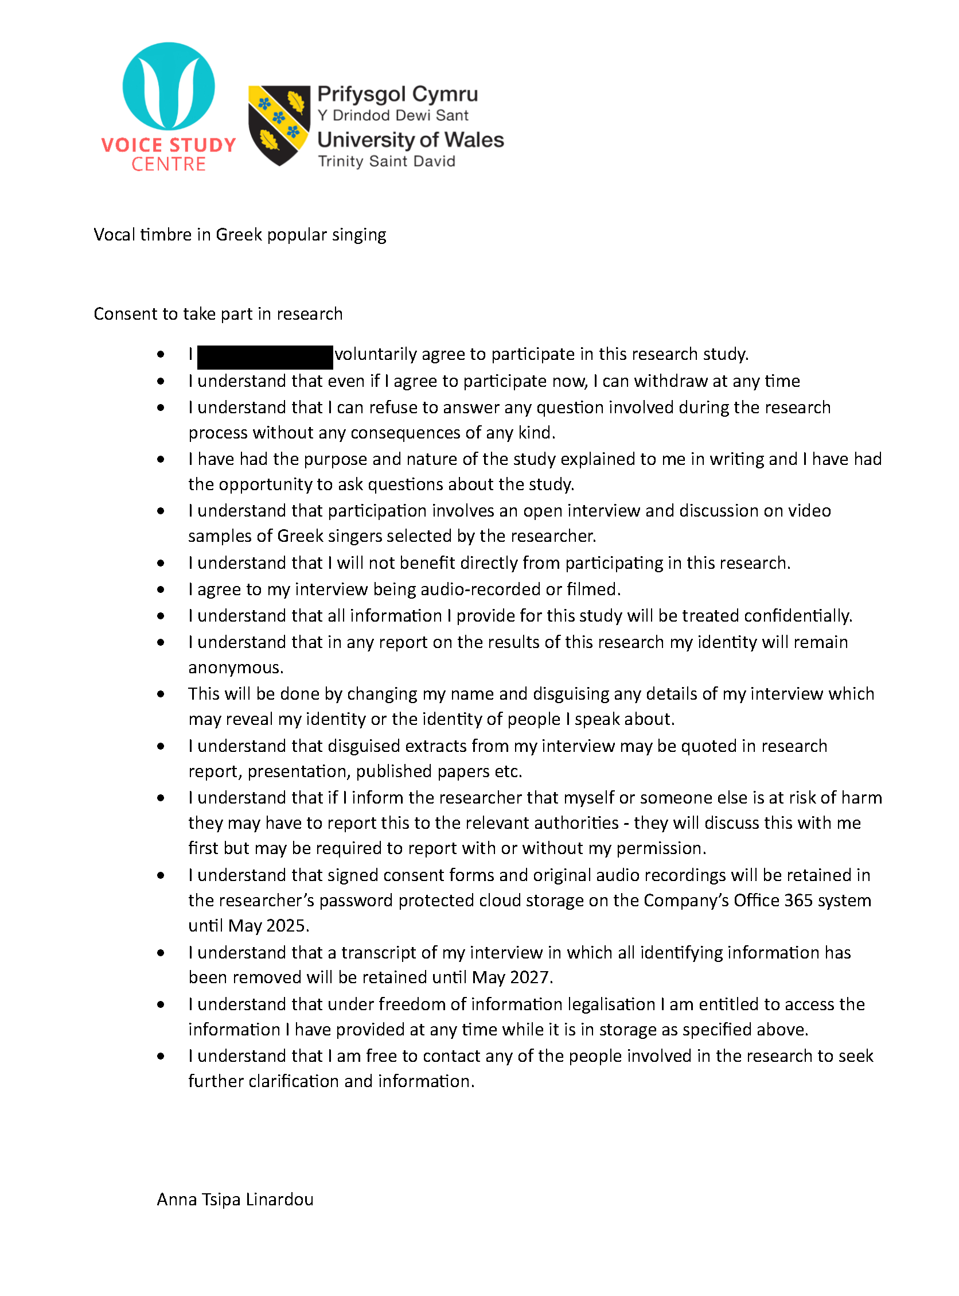

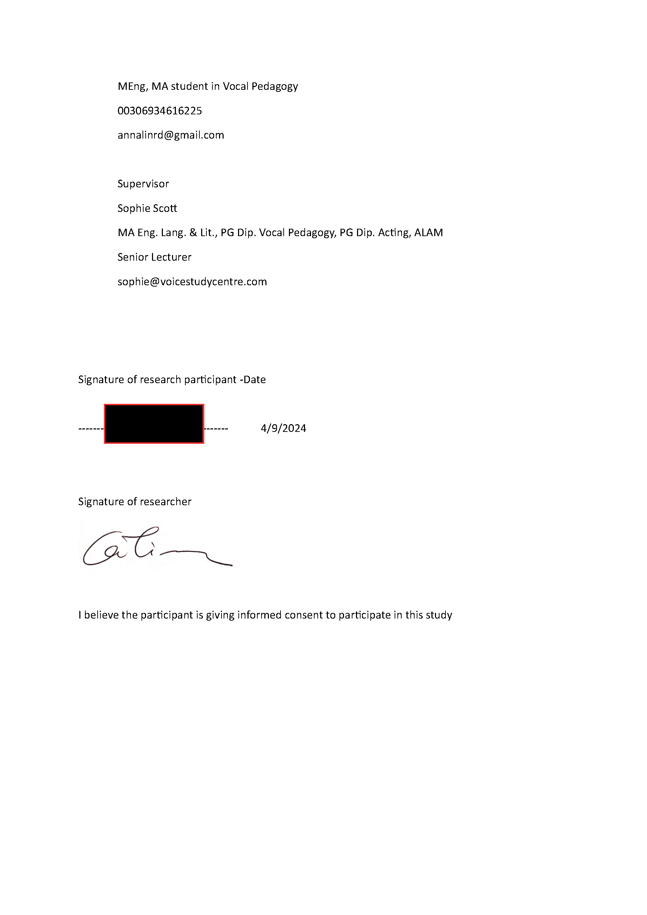

P5



