

Student Name: | Mariam Begum
Student ID: | 2324210
Module Code: | BMHP5015
Assignment Title: | Component 2 – Employability Report
Lecturer: | Caroline Salami
DSA Student extension | 08.05.2026
Word Count: | Approximately 2,000 words
AI Acknowledgement

I would like to acknowledge that this work utilised AI-generated tools and resources to enhance my research and improve its overall quality. Specifically, I used Grammarly (https://www.grammarly.com) to assist with grammar and style, which I accessed on May 1, 2026. These tools helped me refine my writing and present my ideas more effectively, as I am a DSA student.

Table of Contents
Introduction 2
2 Analyse the employability skills required 4
2.1Communication 5
2.2 Leadership and supervision 5
2.3 Safeguarding knowledge 5
2.4 Emotional intelligence and empathy 6
2.5 Digital Literacy 6
2.6 Kolb’s experiential learning theory 6
3 Evaluate my own skills 6
3.1 Reflective Account using Gibbs reflective cycle (1988) 6
3.2 SWOT Analysis 8
4. Building a Personal Brand and Professional Identity 8
4.1 My Unique Selling Point (USP) 8
4.2 How I Promote Myself 8
4.3 Theoretical Framework: CareerEDGE Model 9
5. Action Plan and Timeline 10
Conclusion 11
References 13

Introduction

This report focuses on the role of a SENIOR assistant Carer in the U.K health and social care sector. I found a real job vacancy for this role on (indeed,2025). This vacancy was advertised by Groveland Park Care Home in Bexleyheath and listed key responsibilities, including supervising junior care staff, administering medication, supporting care planning, and delivering high-quality person-centred care to residents with complex needs (Indeed, 2025).

I have chosen this role because it aligns with my long-term career goal of becoming a care home manager and eventually opening my own registered care home. I have over 19 years of experience in the care sector, supporting individuals with dementia, epilepsy, brain injuries, Huntington's disease and end-of-life care. This strong foundation makes a senior care role the natural next step for me.

This report will
1/Analyse the key employability skills required for the senior care Role,
2/evaluate and honestly validate my own skills using reflective tools,
3/explore my personal brand and professional identity,
4/set out a realistic action plan with a timeline for reaching my career goals. The job advertised below was found on Indeed (2025) and was used to inform this report.

Figure 1 senior care assistant job vancancy-groveland park care home (Indeed, 2025).

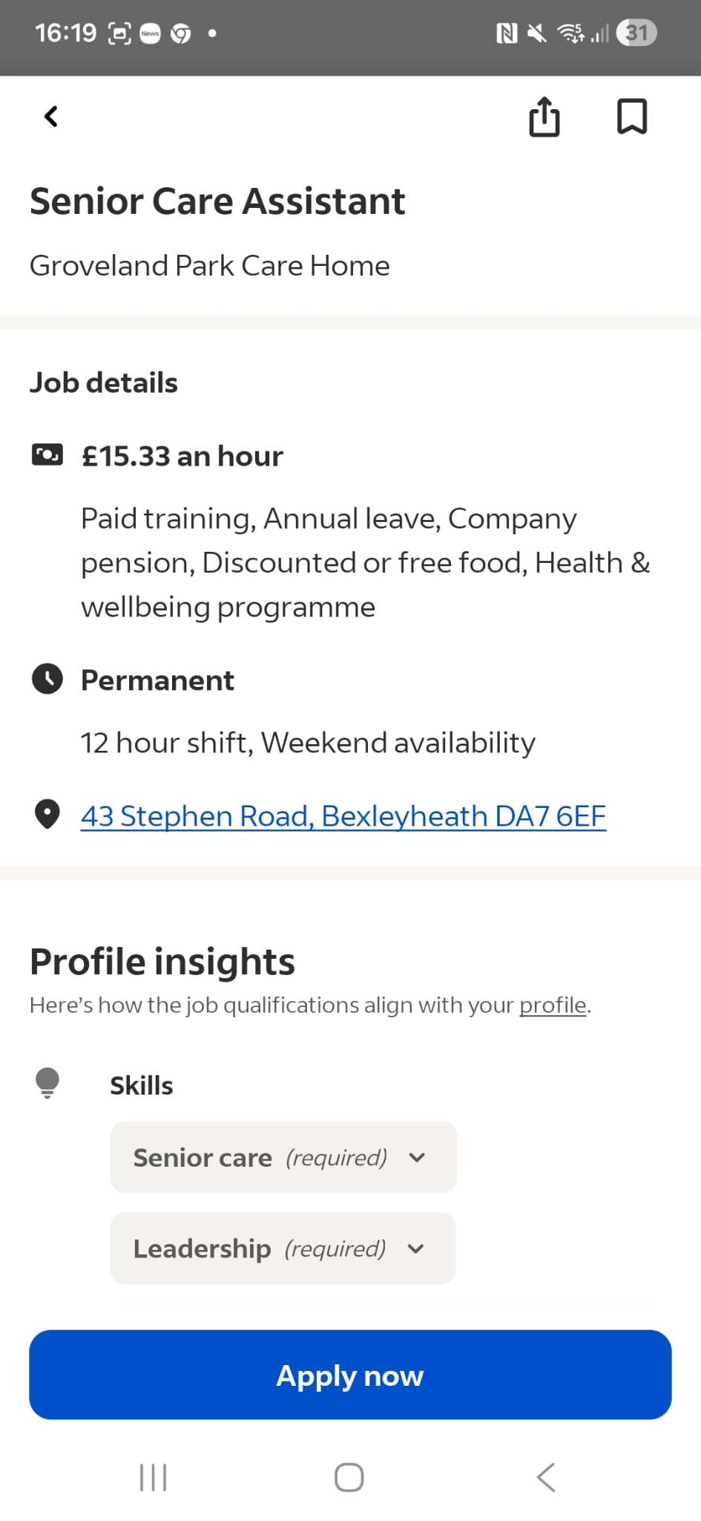
Source: indeed(2025) senior care assistant, Groveland Park Care Home, Bexleyheath

2 Analyse the employability skills required
The senior care role requires a wide range of skills. Below, I explain the most important ones using recognised frameworks and real examples from care practice.

2.1Communication
Good communication is one of the most important skills in care. Senior carers must share clear, accurate information with service users, their families and other professionals such as nurses and social workers. The NHS 6Cs framework, which stands for care, compassion, competence, communication, courage and commitment, places communication at the heart of good care delivery (NHS England, 2012).
For example, when supporting a resident with dementia who cannot always express themselves verbally, a senior carer must use simple language and body language, and exercise patience, to deliver person-centred care that places the individual at the heart of all decisions about their support (Kitwood, 1997). During my time at Cranmer Court care home (2021-2023), I regularly adapted my communication style to suit individual residents' needs, particularly those with cognitive impairment.

2.2 Leadership and supervision
Unlike a standard care assistant, a senior carer is responsible for supervising junior staff, delegating tasks, and ensuring that care standards are met at all times (Skills for Care, 2023). This requires confidence, fairness and the ability to lead by example. In practice, this might involve briefing care staff at the start of a shift, checking that care plans are being followed correctly or supporting a new member of staff through their introduction. Leadership in care is not about authority; it is about creating a safe, supportive team environment (Skills for Care, 2023).

2.3 Safeguarding knowledge
Senior carers have a legal and professional duty to protect vulnerable adults from abuse or neglect. The Care Act 2014 outlines the responsibilities of care providers in keeping service users safe (Department of Health and Social Care, 2014). Senior carers must know how to recognise signs of abuse, follow safeguarding procedures, and report concerns appropriately. For example, if a care worker notices unexplained bruising on a resident, a senior carer must act immediately, document the concerns, inform the manager, and follow the organisation's safeguarding policy.

2.4 Emotional intelligence and empathy
Emotional intelligence, the ability to understand and manage your own emotions while responding sensitively to others, is essential in care work (Goleman,1995). Senior carers often support people at the most difficult times of their lives, including at the end of life. This is particularly important when supporting people living with dementia, where emotional presence and person-centred approaches are essential to maintaining dignity and wellbeing (Mitchell and Agnelli, 2015). Being calm, kind, and emotionally present makes a real difference to service users and their families

2.5 Digital Literacy
Modern care settings use digital tools such as electronic care records and medication management systems. Senior carers must be trained to use these systems to record care accurately and communicate with colleagues (Skills for Care, 2023). Digital skills are becoming increasingly important as the sector moves forward with paperless systems

2.6 Kolb’s experiential learning theory
Kolb’s experiential learning theory (1984) explains how professionals grow by doing, reflecting, learning, and then applying their knowledge. This idea is supported by Schon (1983), who described reflective practice as the ability to think critically about one's own actions during and after practice, enabling continuous improvement. This is very relevant in care work, where every interaction is a learning opportunity. Senior carers must reflect on their experiences to continue improving their practice (Kolb,1984).

3 Evaluate my own skills

3.1 Reflective Account using Gibbs reflective cycle (1988)
I will use Gibbs's reflective cycle (1988) to evaluate a real experience from my care practice.

Stage | My Reflection
Description | While at Cranmer Court Care Home, I supported a resident with dementia who became distressed and aggressive during personal care, shouting and pushing me away.
Feelings | I was concerned for the resident's safety and my own. I felt pressured to manage the situation calmly to avoid further distress. I knew that other nearby residents could be affected if the situation escalated.
Evaluation | I stepped back and used a calm, gentle tone to give the resident some time and space to settle down. I chose simple words and employed distraction techniques, such as asking if she would like a cup of tea. This approach was effective, and the situation de-escalated without any need for physical intervention.
Analysis | This experience highlighted the importance of emotional intelligence, patience, and communication skills tailored for dementia care (Goleman, 1995). I provided person-centred care by prioritising the resident's immediate needs rather than focusing solely on completing the task at hand (NHS England, 2012; Kitwood,1997). However, looking back, I realise I could have sought advice from a senior colleague sooner.
Conclusion | I managed this situation effectively, but it highlighted my need to build confidence in seeking support when necessary. It also reinforced my commitment to pursuing further specialist training in dementia care and behaviour management.
Action Plan | I will complete specialised dementia care training and a leadership course in six months (see Section 5 Action Plan). Gibbs' model aids my improvement by allowing me to learn from real situations (Gibbs, 1988).

3.2 SWOT Analysis
To evaluate my skills, I have completed a SWOT analysis comparing my current profile with the requirements of the Senior Carer role.

Strengths  - 19 + years of hands-on care experience.  - Strong communication and interpersonal skills.  - Experience with complex conditions, dementia, epilepsy, and end-of-life  - Knowledge in safeguarding and person-centred care.  - Level 3 4 diploma completing level 5 | Weaknesses  - Limited formal experience supervising or managing staff  - Digital skills need to be developed for electronic care systems  - Less confident in senior-level decision-making  - LinkedIn profile exists but needs more details, including experience, qualifications, and achievements to be completed.
Opportunities  - The Level 5 Diploma opens doors to senior and management roles  - Growing demand for experienced senior carers in the U.K  - CPD courses available in dementia care and leadership  - Mentoring from current employer or placement supervisor | Threats  - High competition for senior care roles  - Rapid changes in digital care systems require constant updating  - NHS and social care workforce pressures may limit opportunities

My supervisor at Guardian Angel Care Agency has noted that I am dependable, calm under pressure, and skilled in managing residents with complex behaviours. This feedback reinforces my self-assessment and gives me confidence that I am prepared to take on a senior role with the appropriate additional training (Skills for Care, 2023).

4. Building a Personal Brand and Professional Identity
My personal brand is founded on three core values: compassion, dignity, and professionalism. These values have guided me throughout my 19 years in the care sector and are fundamental to what the NHS and the care industry expect from their workforce (NHS England, 2012).

4.1 My Unique Selling Point (USP)
What sets me apart from other candidates is my unique combination of extensive hands-on experience, specialised knowledge in complex care needs, and a strong desire to grow into a leadership role. While most care workers typically possess either experience or qualifications, I am actively developing both simultaneously while working full-time in the sector. Additionally, having my own car and full business insurance allows me to be highly flexible for community-based roles.

4.2 How I Promote Myself
I currently showcase my professional identity through my CV and LinkedIn profile. As illustrated in Figure 2 below, I have an active LinkedIn account under the name Mariam Begum, with the headline “Care Assistant: Health Care, Dementia, and Person-Centred Care.” My profile is associated with my current employer, Guardian Angel Carers, and with my studies at East Birmingham College. I am actively searching for Senior Carer roles on LinkedIn, as reflected in my job search activity. To further strengthen my personal brand, I plan to:

Figure 2: My LinkedIn profile (Begum, 2026)
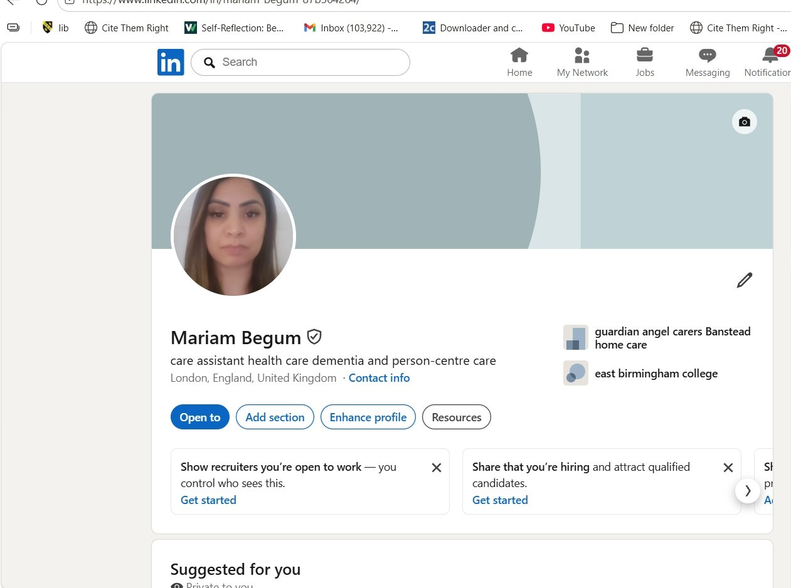
Source: Begum, M. (2026) LinkedIn profile. Available at: https://www.linkedin.com/in/mariam-begum (Accessed: 3 May 2026).

- Complete and enhance my existing LinkedIn profile to fully highlight my care experience, qualifications, and career goals
- Register on NHS Jobs and Indeed with a tailored profile for senior care roles
- Join professional networks such as Skills for Care and relevant LinkedIn groups for health and social care professionals
- Ask my current employer at Guardian Angel Care Agency for a written reference or testimonial to add credibility

4.3 Theoretical Framework: CareerEDGE Model
The CareerEDGE Model, created by Dacre Pool and Sewell in 2007, explains what makes someone employable. Employability is influenced by several factors: career development, practical experience, education level, general skills, and emotional intelligence.

When I evaluate my own situation using this model, I see that my strongest points are my practical experience and my emotional intelligence. My experience in the field has given me valuable skills, and my emotional intelligence helps me communicate well and build good relationships with others.
I also see areas where I need to improve. One important area is my education. I am currently working on this by taking a Level 5 Diploma, which will boost my knowledge and qualifications. Another area for growth is my professional networking. I recognise that I need to engage more with others in my industry to increase my visibility and explore new job opportunities (Dacre Pool and Sewell, 2007).
Additionally, Putnam's Social Capital Theory, published in 2000, highlights the importance of networking. By connecting with other care professionals, attending continuing professional development (CPD) events, and joining professional organisations, I can grow my network. Building these connections will open new opportunities and help me develop my career (Putnam, 2000). Engaging with a variety of professionals allows me to share knowledge and stay informed about industry trends, both of which are essential to my growth.

5. Action Plan and Timeline
Using SMART goals (Doran, 1981). and Bandura’s self-efficacy theory (1997), I have developed a structured action plan to help me achieve my career goals. Bandura (1997) argues that people who believe in their ability to succeed are more likely to take action and persist in the face of challenges. My 19 years of experience give me strong self-belief that I can achieve these goals

Timeframe | Goal (SMART) | Resources / Support | How I Will Measure Success
0–6 Months | - Complete level 5 Diploma in Health and Social Care  - Complete a CPD course in dementia care and challenging behaviour  - Complete and enhance LinkedIn profile and update C.V for senior carer roles  - Apply for at least 3 senior carer positions | University support skills for care CPD funding, employer reference, free LinkedIn account | Diploma completed, CPD certificate obtained, LinkedIn profile live, job applications submitted
1–2 Years | - Secure a senior carer position  - Develop leadership skills by supervising junior staff daily  - Gain experience in care planning and medication management  - Complete a leadership and management training course | Employer support skills for care leadership programmes, line manager mentoring | Senior carer job secured, positive supervision records, leadership certificate achieved
3–5 Years | - Progress to a care manager role  - Complete CQC registered manager training  - Begin planning to open my own registered care home | CQC guidance, business planning support, bank or grant funding for a care home | Care manager role achieved CQC registration, completed business plan, drafted

Bandura (1997) explains that individuals with high self-efficacy—defined as a strong belief in their own abilities—are more motivated and more likely to succeed. My extensive career in care, combined with my current studies and well-defined goals, boosts my confidence that I can achieve these objectives (Bandura, 1997).

Conclusion
This report demonstrates that I possess a strong foundation of skills, experience, and values that align closely with the requirements of a Senior Carer role. With 19 years of experience in the care sector—supporting individuals with dementia, epilepsy, Huntington's disease, brain injuries, and end-of-life needs—I have acquired practical knowledge that cannot be obtained solely through classroom learning.
Through my reflection using Gibbs' Reflective Cycle, I recognised my ability to manage complex and challenging situations with calmness and compassion. The SWOT analysis provided an honest assessment of my gaps, particularly in formal leadership experience and digital skills, which I have addressed in my action plan.
My personal brand is built on the principles of dignity, empathy, and professionalism. To enhance my visibility in the job market, I plan to develop my online presence and expand my professional network.
My action plan outlines clear, realistic, and time-bound steps for my progression from care assistant to senior carer, then to care manager, and ultimately, to opening my own care home. I am motivated, experienced, and committed to continuous learning. This journey has deepened my understanding of what it takes to be an effective leader in care and has strengthened my determination to achieve my goals.

References
Bandura, A. (1997). Self-efficacy: The exercise of control. New York: W.H. Freeman. Available at: https://www.uky.edu/~eushe2/Bandura/BanEncy.html (Accessed: 22 April 2026).

Begum, M. (2026). LinkedIn profile of Mariam Begum. Available at: https://www.linkedin.com/in/mariam-begum (Accessed: 3 May 2026).

Dacre Pool, L. and Sewell, P. (2007) 'The key to employability: developing a practical model of graduate employability', Education and Training, 49(4), pp. 277–289. Available at: https://doi.org/10.1108/00400910710754435 (Accessed: 1 May 2026).

Department of Health and Social Care (2014) Care Act 2014. Available at: https://www.legislation.gov.uk/ukpga/2014/23/contents/enacted (Accessed: 22 April 2026).

Doran, G.T. (1981) 'There's a S.M.A.R.T. way to write management's goals and objectives', Management Review, 70(11), pp. 35–36.

Gibbs, G. (1988) Learning by Doing: A Guide to Teaching and Learning Methods. Oxford: Oxford Polytechnic.

Goleman, D. (1995). Emotional Intelligence: Why It Can Matter More Than IQ. London: Bloomsbury Publishing.

Kolb, D.A. (1984). Experiential Learning: Experience as the Source of Learning and Development. New Jersey: Prentice Hall.

Mitchell, G., and Agnelli, J (2015) ‘Person-centred care for people with dementia: Kitwood reconsidered’, Nursing Standard,30(7), pp 46-50. Available at: https://pubmed.ncbi.nlm.nih.gov/26463810/(Accessed :1st May 2026).

NHS England (2012) Compassion in Practice: Nursing, Midwifery and Care Staff — Our Vision and Strategy. Available at:
https://www.england.nhs.uk/wp-content/uploads/2012/12/compassion-in-practice.pdf (Accessed: 22 April 2026).

Indeed (2025) Senior Care Assistant — Groveland Park Care Home. Available at https://uk.indeed.com (Accessed: 22 April 2026).

Kitwood, T.(1997) Dementia reconsidered: The person comes first. Buckingham: Open University Press.

Putnam, R.D. (2000) Bowling Alone: The Collapse and Revival of American Community. New York: Simon and Schuster.
Schon,D.A. (1983). The reflective practitioner: how professionals think in action. New York Basic Books.

Skills for Care (2023) Core Skills Framework for Adult Social Care. Available at: https://www.skillsforcare.org.uk/support-for-your-workforce/care-workforce-pathway/care-workforce-pathway.aspx (Accessed: 22 April 2026).

