Strategic Management
(BMMB7013)
ASSIGNMENT 1
STEFFAN TREHARNE

Table of Contents

Table of Contents
Table of Contents 2
Executive Summary 3
Introduction 4
Main body 5
Porters five forces analysis 5
Bargaining power of buyers 6
Industry rivals 7
Threats of new entrants 7
Threats of substitute products 8
Bargaining powers of suppliers 9
Summary for porters 5 forces 9
Swot & Pestle Analysis 10
Swot analysis 10
Strengths 10
Weaknesses 10
Opportunities 10
Threats 10
Pestle Analysis 11
Political 11
Economic 11
Social 11
Technological 12
Legal 12
Environmental 12
Ansoff Matrix 13
Market Development 13
Diversification 13
Market penetration 14
Product development 14
Conclusion 15
Recommendations 16
Appendices 17
1.1 Swot Analysis 17
1.2 PESTEL Analysis 18
1.3 Ansoff matrix 19
Reference List 20

Executive Summary

This is a report that will be looking at several models that will be analysing British Airways customer services and will be looking how they can improve by creating recommendations that BA can look at and welcome change into the business.

Introduction
This report will be looking at the strategic business plan based on customer care of BA (British Airways), BA which is the UK’s biggest international airline according to Airlineportal.org (2020). BA which started under the name of Aircraft Transport and Travel Limited (AT&T) and was founded in 1919 according to BA.com (2020). It goes on to say that the first flight was from London to Paris, then in 1987 it was privatised and merged with British Caledonian Airways in 1988, which today is recognised as British Airways and is now part of a bigger company which is called IAG. This report will be analysing the strategic plan that BA is currently implementing at this moment in time. According to BA.com (2020) BA’s strategy contains “unrivalled customer proposition which also looks at strengthening a portfolio of world class brands and operation, efficiency and innovation by enhancing IAG’s common integration platform, value accretive and sustainable growth by growing global leadership positions”. By looking at this strategy by BA, there are several ways on how to define strategy and its purpose by how its implemented to analysis the strengths and weaknesses of a strategic plan. A strategic plan according to The American Marketing Association (AMA) is a “organizational function and a set of processes for creating, communicating and delivering value to customers and for managing customer relationships in ways that benefit the organization and its stakeholders.” By looking at this example by AMA, it simply means that a business must create a plan which includes communicating and delivering a service or goods to consumers which in turn creates consumer relationships, and in turn generates income and resources that benefits its stakeholders which could be staff and other organisations that work closely with the business / organisation in question. Compare this to another way of looking at strategy given by Webster, F. E., Jr. (1992), Webster explains that strategy focuses on market segmentation, targeting and positioning in defining how to compete in its chosen businesses. At the operating level, marketing managers must focus on marketing tactics, the ‘4Ps’ of product, price, promotion, and place/distribution, the elements of the marketing mix.” When analysing Websters theory, there are similarities between Webster and AMA such as looking at organisation’s product which is expanded by the 4p’s in websters. They both focus on consumer needs which can also be compared to Maslow’s hierarchy which explains the change in consumer needs by different stages of need by consumer according to Pichère, P. et al. (2015). This will affect on the strategic plan of the business in question which is BA. This report will be looking at 3 – 4 possible strategic tools such as porters five forces, swot & pest analysis, stakeholder analysis and Bowmans strategy clock. By looking at some of these strategic tools it will help to determine the outcome of analysing BA’s strategic plan and will determine if changes are needed in turn create recommendations based on analysation of the plan in place currently.

Main body
Before analysing BA’s strategic plan this report needs to look at how BA are performing currently with their current strategic plan. Due to Coronavirus, there are many restrictions for travelling around the world due to the pandemic. The strategy that is in place for BA in 2020 is non-existent and will be looking at mainly 2018 and 2019 with some information for 2020. Looking at figures given by statista.com (2020) it shows yearly increase of passengers between 2011 – 2019 from 33.01 million to 44.56 million. These figures strengthen the customer position which in turn strengthens BA’s operational portfolio which is also linked to sustainable growth for the company. In 2019 according to BA.com (2020) they had been “voted the number one British brand in both consumer and business ‘superbrands’ list for 2019, British Airways was voted in fourth place in the business index and fifth place for consumer index”.

Porters five forces analysis
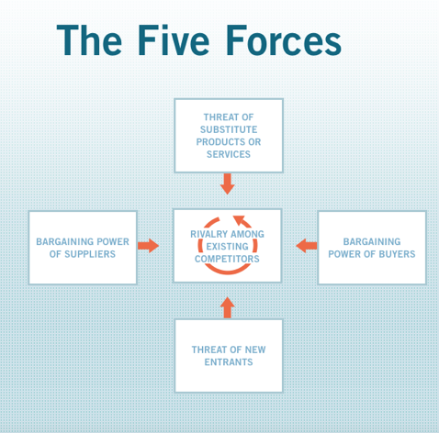
According to Harvard Business School (2020) “A Five Forces analysis can help companies assess industry attractiveness, how trends will affect industry competition, which industries a company should compete in—and how companies can position themselves for success”. Looking at BA’s unrivalled customer proposition aspect of its strategic plan where it lists key points of its plans which include the following according to IAG (2020)
- That all companies under IAG deliver and to fulfil customer’s needs across all aspects required that are unchallenged by other competing organisations.
- “Use consolidation and develop organic options to differentiate the Group from
its competitors and ensure customer demands are met where they are currently under- served.”
- “Deepen customer centricity to win a disproportionate share in each customer segment”.

Bargaining power of buyers

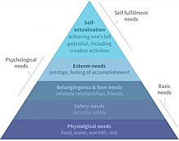
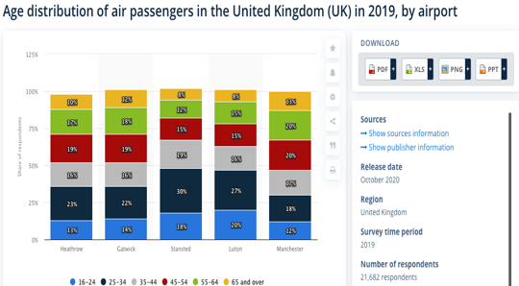
By analysing IAG’s model for customer care with porters five forces, the first point would be looking at customer needs and expectations of BA. According to Which.co.uk (2019) they surveyed over 6500 passengers to rate the best and worst airline which is composed of a variation of attributes such as price, comfort, satisfaction, boarding, food and drink and punctuality. BA came in the bottom three in the survey. This correlates to behaviour in consumers which relates to Maslow’s hierarchy of needs and wants. According to Stoi͡anov, S. (2017) Maslow’s theory shows that people’s needs change depending on where they are based in life, it also explains why consumers travelling with BA were not satisfied with the services this can be referred back to McKinsey (2020) which explains that to better these services you need the right people through the door which have the right skills set in theory this shows that consumers are in charge of the type of people who are hired. looking at the demographic of tourists that fly from the UK according to date given by statista.com (2020) it’s the younger demographic that are more likely to travel and when looking at info given by marketingweek.com (2020) explains Social media influence can influence the trend on the type of consumer that flies and with what company. when looking at BA’s latest social media campaign which is on the Marketingweek.com (2020), which shows BA celebrating 100 years was filled with celebrities and showing first class sections of planes and including some shots of what they believe is a “normal society”. This does not meet the demographic age that are travelling and are currently the buyers.
This Photo by Unknown Author is licensed under CC BY-SA

Industry rivals

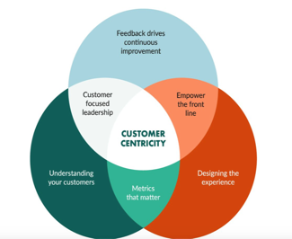
Looking at info given by the dailymail.co.uk (2017) on average BA charged more than EasyJet and Ryanair on similar flights with roughly a 121% average increase for flights from Heathrow to Ireland and on other most flights and holiday packages during peak times in 2017. According to the independent.co.uk (2019) only 55% of consumers were satisfied with BA, this was 11% more then Ryanair. Taking into account that BA (2020) themselves explained they had invested £6.5 billion to improve facilities and other products on their flights. According to strategy&.pwc.com (2016) leading expert in aviation travel and aerospace Alessandro Borgogna explained that “airlines need to be closer to customers, they need to increase their understanding of consumer behaviour is changing”. Businesses such as BA need to look at developing partnerships with other parts of the industry such as providers in the technology and content sector such as Expedia, Facebook, Instagram to create customer centric strategies based on trends. Customer centric strategies explained by superoffice.com (2020) is built of many components which can be seen in the picture on the left-hand side. According to BA (2020) they do use A centric strategy, if BA are actually using this as part of their strategy questions must raise on why they are not more competitive by the information given from above. This correlates to the threat of entrance and every other force.

Threats of new entrants

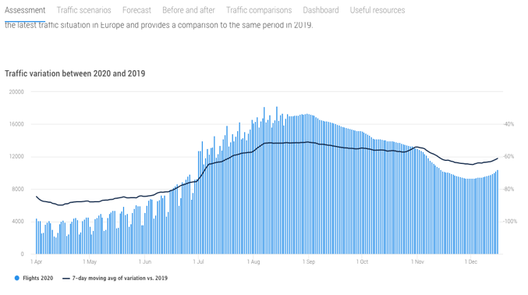
The threats of new entry are lower in the airline industry, in 2020 this changed due to government policies and advice because of global pandemic. Advice given by gov.uk (2020) is that they do not recommend travelling internationally, but in some cases if needed, customers need to look at the countries that are high risk. There are also guidelines given if travel is needed then safety measures need to be put in place such as 2 meters distance and face masks. This means that airlines must reduce the number of flights but also the number of passengers that are allowed to travel on board aircrafts. When looking at figures given by eurocontrol.int (2020) shows a bleak scenario due to the guidelines and protocols created by the government, statistics shows that the airline industry will take years to recover. The graph shows the difference between 2019 and 2020 and flight traffic drastically decreased which explains the decrease of flights in operation. In turn this is something that is out of the hands of BA and other airlines. In turn this will lead to many organisations competing with each other to gain income, when these issues is related with the force of buyers, they will dictate what organisation they will use.

Threats of substitute products

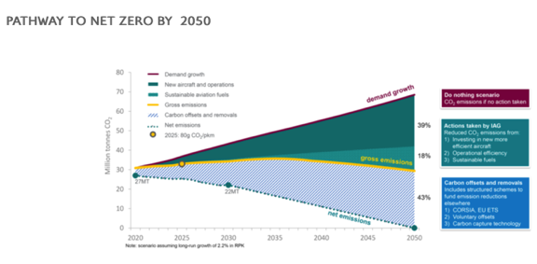
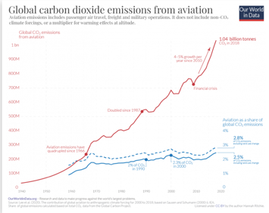
There are many threats of different products to the airline industry and the main focus is sustainability as the growth of concern over global warming caused by the rise CO2 level which the industry is contributing to drastically. Looking ourworldindata.org (2020) the graph shows that the number is increasing. One option which most companies are looking at is sustainability which not only relates to how sustainable consumers, also how they travel and if they can become carbon neutral. According to BA (2020) they are committed to become carbon neutral by 2050, investing £400 million within the next 20 years for this to happen. they are using aircraft that are 25% - 40% more fuel efficient and have stopped airliners that produce severely high CO2 emissions. By information given by EasyJet (2020) explain “they use newer aircraft, they fly from point to point and have lowered they CO2 emission by a third since 2000”. In comparison BA (2020) have given a plan on how they expect to achieve zero carbon by 2050 plan. The plan explains how both IAG and BA hope to achieve by the diagram above. With many organisations becoming more aware the competition is at a high and this influences consumers decisions also.

Bargaining powers of suppliers

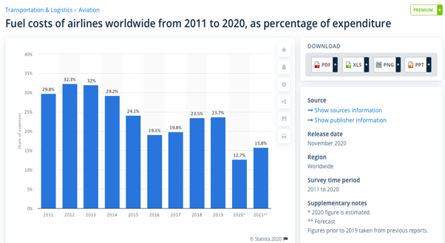
The power of suppliers vary every day with such costs as fuel for airlines and the cost of new aircraft which needs to be sustainable. Fuel cost change yearly as demand for flights change with trends, this has happened in 2020 due to the pandemic as there is less demand and means that suppliers according to Chai, Jian et al. (2014) research shows that fuel demand has driving factors such as growth. There are also reducing factors such as consumption, emissions and aviation technology. Factoring in the evidence by statista.com (2020) which shows the consumption of fuel expenditure which fluctuates every year. In 2020 it has dropped because of the lack of demand from Covid. This is why it is at its lowest and in this scenario the bargaining powers of suppliers are flipped to the organisation. The other demand in the airline industry is aircrafts like fuel this has dropped of significant in 2020 because of Covid- 19. This shows by the info given by IAG (2020) which explains that in 2019 there were new orders of Airbus 350 will replace older aircraft, there is no information given for 2020 which could explain that due to Covid-19 that there is no plans to buy new aircraft because of demand of flights.

Summary for porters 5 forces

Porters five forces as a strategic model / tool is effective to outline the key issues and information that is needed to create a new strategic model for BA, overall, the model will be biased such as the survey by Which.com (2019) this was taken by 6500 consumers which might have not even flown with all airlines to have a definitive comparison. The information given through-out will be available to make a final decision, but it is down to BA and how they examine the information. As it can be seen by Porter’s model there are negative and positive for BA to take from this and adapt to see where things need to change.

Swot & Pestle Analysis

Swot analysis

The Swot analysis table can be seen in appendices 1.1. There are four key components to a SWOT analysis which are strengths, weaknesses, opportunities and threats.

Strengths

Looking at strength BA have strong branding the focus is on a type of consumer which is higher class which means a richer cliental, this comes through from Forbes (2020) BA had a special feeling and how it interacted with different classes of its service brands and delivering brand promises. International networks is a strength as it is a large network around the world which connects consumers to a fast majority of the world. Technological capabilities which links with sustainability which focuses on global warming by using efficient planes designed by the best technology and BA (2020) have explained they are focused being carbon neutral by 2050. Partnerships BA are part of One World Alliance which connects 13 airlines to provide highest level of service to 1000 destinations according to oneworld.com (2020).

Weaknesses

Customer satisfaction has been an issue for a long time by info given by which (2019) which is also mentioned in Porter’s five forces that BA have not performed well, and it needs to look at Mckinsey (2020) explains there are many avenues to increase customer satisfaction with such things as assessments, reskill employees and monitor individuals. Other issues were problems with Rolls Royce engines which lead to cutting capacity for flights from Heathrow to Miami because of a design flaw in the engine according to Simplyflying.com (2019). In turn this would create even more customer issues as it would mean either changing flights or delays.

Opportunities

Expansion internationally would benefit BA but looking at low cost flights internationally as it follows trends with in the last few years according to information from statista.com (2020) with the demographic age lowering which means not as much disposable income this could be a market that BA could look to expand and challenge other airlines which interlinks with expansion of services such as new flight destinations, quicker check in via digital boarding passes which looks at the digital innovation which could be used all over the company by using digital marketing platforms to reach a wider audience.

Threats

Looking at threats currently it would be Covid-19 which has brought the airline industry to a halt because of demands by the gov.uk (2020) which explains that to slow the pandemic down they needed to suspend as much international flights as possible unless really needed. Correlating to government issues are regulations which are updating constantly to make aviation safe from a number of aspects such as terrorism, safety, consumer rights. This will also change when Brexit finally happens and will see policy and regulation changes after Brexit happens.

Pestle Analysis

Political

Looking at the pestle analysis table which is in the appendices 1.2 political is very controversial as government issues with BALPA (British Airline Pilots Association) cause issues such as strikes to the airline industry because if pay, pension and other benefits were reduced and job redundancies according to TheGuardian.com (2019). In turn this cost BA roughly £40 million a day. This could lead to many customers to very unhappy because of possible delays. Other issues are Brexit and the main concern according to IATA (2018) is the issue of wet leasing between UK and EU according to Simplyflying.com (2019) explains that wet leasing is when an airline borrows not only its aircraft but pilots and air crew and all aircraft papers. The issue is mainly to do with the papers that is needed for the aircraft. Covid is another issue as there are restrictions there have been issues with refunding customers and in turn lowers consumer trust on BA according to The BBC (2020) there have been reports of BA refusing a customer a refund and no mention of voucher because of BA cancelling flights because of covid, this leads back consumer satisfaction survey done by Which (2019) this would only make customers and their opinions worse and will mark BA’s reputation.

Economic
There have been many discussions of possibility of Heathrow gaining a third runway this would have a positive increase on economic impacts on BA which in turn BA (2020) explains that it would an economic boost for the industry of around £37 billion and making Heathrow an international hub, this in turn means that there would be more flights and more customers for BA. The price of fuel will change which will affect the cost of a ticket as the increase on price will be passed onto the customers. BA have announced a partnership with Shell which is a Dutch company which will produce a commercial waste site that transforms waste to jet fuel and reduce CO2 that is generated by BA. This can be related to Kouzes & Posner (2012) because BA are trying to overcome a challenging process and taking opportunities to grow and to innovating, this will be more attractive to customers who are at a lower demographic age and sustainability is one of many factors on decision making.

Social

As previously mentioned about social impacts of BA regarding in Porter’s five forces with awareness and marketing strategies that BA have used the type of customer, they target is mainly higher class and celebrities which was a perception of their video celebrating their 100 years it was not targeting a demographic age who a mainly the customer who spends on average more on flying.

Technological

BA as part of technological improvements could use the latest technologies to their advantage which helps customers to check in quicker which reduces time and also reduces costs on employees who need to check customers in as usual. Technology can also be used for health and safety for the maintenance of aircraft which in turn will keep the aircraft in operation for longer and keep consumers safer. There is even a chance to use AI which according to futuretravelexperience.com (2020) one of BA’s competitor Air Asia used and explains that the AI can adapt and learn quicker and make smarter operational decisions.

Legal

Legality of money has come down to COVID for 2020, The Guardian (2020) mentions that the airline industry and car makers benefitted from a support scheme from the government that has gone over a billion pound and estimates it is now £1.8 billion, in respect of this IAG have discussed of raising more than 2.75 billion euros according to The Guardian (2020) which explains that IAG are asking investors to back the 2.75 billion in equity to support its largest shareholder including Qatar airways which has a $600 million stake in IAG. This explains that IAG trying to use the power of the brand to try and save many of its companies such as BA, but with all this borrowing the question of Will the consumers pay the price after restrictions have ended? And if so, how much consumers will be put off and simply go to another airline, this will come down to brand loyalty and if consumer needs have changed which most average would after COVID which relates to Maslow’s Hierarchy and if what is needed first. This can also be linked to MCKINSEY (2020) which explains that in times of crisis “adapting the core to meet shifting customer needs” is something that all organizations need to do by identifying, re-evaluating and building a foundation for postcrisis growth. These are things will see a demand of fall in services needs by consumers for BA and they need to act fast.

Environmental

There are so many issues that involve the environment especially the airline industry such as pollution permits, and contingency plans such as the 2050 carbon neutral plan. BA have a plan to become carbon neutral by 2050 BA (2020) go on and mention that they are investing in more fuel-efficient aircraft, carbon offset growth and sustainable aviation fuels. According to Brian Leavy (2014) explains in an article that to succeed first BA need show awareness on the 2050 plan, they need support from Executives and stakeholders such as staff, in turn staff would promote the plan by engaging with consumers. which in turn will grow the initiative this is how BA will see demand grow as sustainability has been an issue with younger demographics as previously mentioned they dictate the market.

Ansoff Matrix

The Ansoff matrix can be seen in appendices 1.3. the matrix has many useful ways of creating new strategies.

Market Development

Starting with Market Development, there are many ways BA can develop products in the market such as creating new routes to new destinations. This in turn will create more jobs for stakeholders, it will also reach new exciting destinations for consumers which in turn will be beneficial for BA and consumers. One option would be looking at trends according to the guardian (2019) China had the most 143 million international journeys. After possible expansion in China and other rising popularity destinations BA could look at existing products in markets and create a new product that is not available such as a holiday package that looks at culture as mentioned by Dragonetail.com (2020) explains that more visitors want to experience culture. BA can target different segments of tourism. By creating products such as packages or even a consumer based built by the consumer can provide a better and new experience for both parties.

Diversification

When looking at diversity BA need to look at new destinations that are growing in popularity and create routes that will supply the growing demand for the destination. The demographical age of tourism is decreasing and becoming more influential on the market, when looking at stats given by statista.com (2020) explains that age demographic is having a more influential influence on the market which means there are more segmentation on the type of tourist. According to Smith, W. (1956) segmentation can be defined as a strategy that looks at heterogeneous market demand, which is characterized by divergent demand, it also looks at other factors such as demographics, behaviour variables and psychographic variables. This explains that consumers are more likely to be motivated by actions and variables at a lower demographic age. After creating new routes and products BA need to look at the type of aircraft that would be needed, a younger demographic is more aware of how important sustainability is and BA need to look at newer aircraft that is more carbon neutral or more sustainable hat current models. BSR.org (2018) explains “that Gen Z will account for 40% of all consumers globally by 2020 and are the generations that believes companies should address urgent social and environmental issues.” This in theory shows that Wells, W. (2007) who looks at Peter Drucker’s theories which includes corporation social responsibility and organizational culture, it explains that organisations need to be part of a wider social community which has the responsibility to make decisions that are beneficial for that larger social community. This is “created from the top” as it shapes the dynamics of the organisation all the way down to the consumer. This is what BA should be looking at and it starts with the CEO of BA.

Market penetration

Marketing is one of the biggest tools that an organization has got, according to Deloitte.wsj.com (2016) explains that consumer services sector usually use around 15% of revenue for marketing. This would include marketing new products in the UK and other operating destinations for BA. Another obstacle is brand attractiveness this would relate to promoting products such as loyalty schemes which according to BA they have a scheme called Avios, which you can collect points to use on covering. Flight costs, car rentals and hotels. One downside to Avios is the number of points accumulated on a flight is dependent on which class you are sitting in and increases the better the class. Some consumers would argue as it’s the same flight why don’t all consumers have the same amount of points as the there is no cost to join the scheme. Attractiveness is looked at by the value of the ticket and the value of service, which is provided, as mentioned previously which (2019) mentions BA did not score well in the survey and ranked in the bottom three. This was partly down to factors such as service, ticket costing just to name a few, in theory this is an opportunity for BA to rectify issues by looking at McKinsey (2020) which explains that staff assessments could take place to expand knowledge by using a coaching programme which can lead to reskilling employees and once ready putting it into practise these are simple steps that BA could use to increase consumer attraction awareness by focusing on the staff to perform better.

Product development

BA like any other business are always looking to expand in new destinations with new products, one way of creating new products in a new destination could be looking at the market and adapt products already on sale. According to McDonald, R. et al (2020) trying to differentiate can lead a business down a blind alley, “a more effective approach we argue, is to treat other companies in the space as peers rather than competitors.” In theory this means that BA should work closely and or monitor what products are to offer and look at how other businesses are achieving this and offer similar products that meet the demands of trends of consumers. This could also work for expanding current products that are on offer and adapt for new emerging trends to target consumers for the near future. As the UK’s biggest airline, it is even more vital for BA to achieve this as to guarantee that consumers keep using their airlines which brings millions of potential consumers to the UK or using a UK airline.

Conclusion

To conclude after analysing a variation of models, there a many options BA could look at to enhance consumer service. With the models discussed there is a slight bias opinion as if the report was created by anyone else there would be different answers to the models and how it affected customer services. One of the services that could be looked at is on board service and how customers are treated on board BA could use McKinsey (2020) to guide them with customer service and the options that are available to enhance performance and service, for instance options for food, comfort, cabin crew interaction and also the value for money consumers have. BA are the UK’s biggest airline and previously down the years you can see why, now as there are more and more options for customers to travel for cheaper this is an issue that BA have to overcome if not in lowering price then the services and products that are included. Like so many other organisations BA have found it very difficult in 2020 because of COVID. The way BA adjust to the pandemic will be pivotal on the success of the business afterwards, they need to stick to measures that are in place by government and legislation. BA also need to bring back customer reassurance to start running back to capacity. By looking at the analysis that has been created there is a strong possibility that BA can do this if they take information from the analysis and focus on major issues that can be seen throughout such as new products, new destinations, meeting expectations of consumers and differentiation in demographics of age of consumers and their needs.

Recommendations

- First recommendation would be looking at how BA could look at providing a better customer experience through out their trips. One option would be looking possible employee growth and development according to McKinsey (2020) there are many ways of developing employees, first of all BA would need to assess what key components of the experience for customers that are not reach expectations. After assessing if would be deciding what type of development is needed for example “creating more formal opportunities for development and career progression”, reskilling employees so they can use their abilities better in the right part of the business. When looking at companies such as Apple, JetBlue and Toyota they mainly look at Customer centric according to Cortese, C. (2019) she explains that the power of marketing and sales has moved from business power to consumer power which in theory explains that consumers have the power to change how successful the company is by the power of social media and other digital outputs. Laseter. T & Bennett. J (2013) further explains that companies need to move to a flywheel shape business mission statement where customers are the key focus as they are surrounded by three main objectives deliver the best customer service, this links to many aspects of the models analysed as it takes key information and focuses on the customer.

- Second recommendation would be looking to expand products that follow the latest trends with consumers as it shows the awareness of BA and how they are in touch within the tourism industry. With Demographic age dictating the latest trends as the age of the average customer is lowering. BA need to provide products and services that keep up to date. One of many ways to look at trends are through social media and how the use of social media impacts the decisions that lead to new trends. According to Shaw, C, et al. (2010) there are three factors that influence trends and can be related to travel which include Social media, Psychology and neuro experience. These factors influence the decisions that people make subconsciously and consciously. In reality Shaw, C (2010) explains that businesses need broadcast themselves by using social media by being involved and marketing towards those on-going trends by creating products and services designed off the information given by social media.

- Third recommendation would be looking at information on sustainability given through all models in this report. Sustainability is a big issue for not only companies but everyone as it’s an obstacle that will affect futures of businesses and people. One way BA could be more sustainable is not only looking at being carbon neutral but also look at the 17 sustainable goals by sdgs.un.org (2020). These goals look at global warming and other factors such as industry innovation, sanitation, partnerships just to name a few. These goals are there to make the world we live in better for everyone, these goals are included in the 1992 agenda and 2030 agenda, where several nations agree that everyone including businesses. These strategy goals are based on political, historical cultural, ecological circumstances according to sdgs.un.org (2020). With BA explaining they have a plan to offset carbon by 2050, sustainability is becoming a key issue and by working with companies that look at the 17 goals and nations that are included in the 1992 and 2030 agendas is it possible that BA by creating new partnerships could lower the 2050 plan to 2040 or if possible 2030.

Appendices

1.1 Swot Analysis

Strengths | Weaknesses | Opportunity | Threats
- Strong branding  - Technological capabilities  - International networks (route)  - Sustainability focus  - Partnerships | - Customer issues  - Market dependant  - Plane issues (rolls Royce) | - Expand more internationally  - Digital innovation  - Expand services | - Competition  - Regulations  - Brexit  - COVID

Political | Economic | Social | Technological | Legal | Enviro mental
- Strikes  - Brexit  - Covid 19 | - Potential 3rd runway at Heathrow  - Fuel prices | - Awareness  - Marketing | - Investment in technological advancements such as AI  - Quicker check in  - Maintenance | - Settle payments borrowed because of covid | - Pollution permits  - 2050 carbon neutral plan

1.2 PESTEL Analysis

1.3 Ansoff matrix

Market development | Diversification
- Create new routes to new destinations  - Target new segments in its existing markets which offer product differentiation | - New products in new markets  - New aircraft on new routes.  - Diversify
Market penetration | Product development
- Marketing products in UK and other operating destination.  - Attractiveness by promoting products and attractive ticket prices.  - Loyalty schemes | - New products in new markets.  - Expanding current products.  - Improve flight experience.

Reference List

- Airlineportal.org (2020). UK airlines. https://www.airlineportal.org/british-airways.htm
- BA (2020). Sustainability at British Airways. https://mediacentre.britishairways.com/factsheets/details/86/Factsheets-3/208
- BA. (2020). About the club, https://www.britishairways.com/en-gb/executive-club/about-the-club
- BA. (2020). Heathrow runway key to boosting Britain's economy. https://www.britishairways.com/runways/speech04.html
- BA.com (2020). Explore our past. https://www.britishairways.com/en-gb/information/about-ba/history-and-heritage/explore-our-past
- BSR.org. (2018). Millennials, Gen Z, and the future of Sustainability. https://www.bsr.org/en/our-insights/blog-view/millennials-generation-z-future-of-sustainable-business
- Chai, Jian et al. (2014). Aviation fuel demand development in China. Energy economics, 46, pp.224–235.
- Cortese, C. (2019). Companies with the Best Customer Service. https://www.bluleadz.com/blog/companies-with-the-best-customer-service
- Deloitte.wsj.com. (2016). Marketing Budgets Vary by Industry. https://deloitte.wsj.com/cmo/2017/01/24/who-has-the-biggest-marketing-budgets/
- EasyJet. (2020). Leading the industry of sustainable travel. https://www.easyjet.com/en/sustainability
- eurocontrol.int (2020). Traffic variation between 2020 and 2019. https://www.eurocontrol.int/covid19
- Forbes. (2020). British Airways Needs to Revitalize Its Brand. https://www.forbes.com/sites/larrylight/2020/08/14/british-airways-needs-to-revitalize-its-brand/?sh=62c82d31747e
- futuretravelexperience.com. (2020). 12 technology trends for airlines and airports to focus on in 2020. https://www.futuretravelexperience.com/2020/01/12-technology-trends-for-airlines-and-airports-to-focus-on-in-2020/
- gov.uk (2020). Travelling safely during coronavirus pandemic guidance public. https://gov.wales/travelling-safely-during-coronavirus-pandemic-guidance-public-html#section-43975
- Harvard Business School (2020). Porters five forces. https://www.isc.hbs.edu/strategy/business-strategy/Pages/the-five-forces.aspx
- IAG (2020). Business model. https://www.iairgroup.com/en/the-group/business-model-and-strategy
- IAG (2020). Our Fleet. https://www.iairgroup.com/en/the-group/our-fleet
- IATA.org. (2018). The Industry Affairs Committee of
The International Air Transport Association – IATA. https://www.iata.org/contentassets/e22c55cf063a47d5915886f6675c1f39/iata-brexit-study.pdf
- Kouzes & Posner. (2012). The five practises of exemplary leaders
- Laseter. T & Bennett. J. (2013). Strategy + business. Building a Flywheel Business. issue 71.
- Leavy. B. (2014),"Venkat Ramaswamy – how value co-creation with stakeholders is transformative for producers, consumers and society", Strategy & Leadership, Vol. 42 Iss 1 pp. 9 – 16
- Marketing News. (2004). AMA adopts new definition of marketing. Marketing News, 38, 1.
- marketingweek.com (2019). British Airways writes ‘love letter to Britain’ in first brand campaign since 2012. https://www.marketingweek.com/british-airways-centenary-brand-campaign/
- McDonald, R. et al (2020). The new – market conundrum in emerging industries the usual rules of strategy don’t apply.
- Mckinsey. (2020). customer care: the future talent factory.
- MCKINSEY. (2020). Innovation in a crisis: Why it is more critical than ever
- oneworld.com. (2020). 13 world-class airlines. One bright alliance. https://www.oneworld.com
- ourworldindata.org (2020). Climate change and flying: what share of global CO2 emissions come from aviation? https://ourworldindata.org/co2-emissions-from-aviation
- Pichère, P. et al. (2015). Maslow's hierarchy of needs
- re Concept of the Corporation. By Peter Drucker. New Brunswick, N.J.: Transaction Publishers, 1993. Third Edition. 329 pp. Paper, $24.95. ISBN: 1-560-00625-0. Business history review, 81(1), pp.142–145.
Reference list
- Shaw, C, et al. (2010). Customer Experience, London: Palgrave Macmillan UK.
- Simplyflying.com. (2019). Ongoing Trent 1000 Issues Cause British Airways To Cut Miami Capacity. https://simpleflying.com/british-airways-trent-1000-miami/
- Simplyflying.com. (2019). What Is Aircraft Wet Leasing? Why Is It Important.? https://simpleflying.com/what-is-aircraft-wet-leasing/
- Smith, W. (1956). Product Differentiation and Market Segmentation as Alternative Marketing Strategies. Journal of Marketing, 21(1), 3-8
- statista.com (2020). Age distribution of air passengers in the United Kingdom (UK) in 2019, by airport. https://www.statista.com/statistics/304641/age-distribution-of-air-passengers-by-airport-uk/
- statista.com (2020). Passengers uplifted by British Airways plc 2008-2019. https://www.statista.com/statistics/309349/british-airways-uk-passenger-numbers/
- Statista.com. (2020). Fuel costs of airlines worldwide from 2011 to 2020, as percentage of expenditure. https://www.statista.com/statistics/591285/aviation-industry-fuel-cost/
- Stoi͡anov, S. (2017). An analysis of Abraham Maslow's A theory of human motivation
- strategy&.pwc.com (2016). Airlines need to change how they market and sell to customers. https://www.strategyand.pwc.com/gx/en/about/media/press-releases/airlines-should-transform-business-models.html
- superoffice.com (2020). Customer centric strategy. https://www.superoffice.com/blog/how-to-create-a-customer-centric-strategy/
- The BBC. (2020). British Airways accused of snubbing refund request. https://www.bbc.co.uk/news/business-54160376
- The Guardian. (2019). British Airways pilots to strike for three days in September. https://www.theguardian.com/business/2019/aug/23/british-airways-pilots-to-strike-for-three-days-in-september
- The Guardian. (2019). Global tourism hits record highs - but who goes where on holiday? https://www.theguardian.com/news/2019/jul/01/global-tourism-hits-record-highs-but-who-goes-where-on-holiday
- The Guardian. (2020). Airlines and carmakers benefit from UK Covid relief scheme. https://www.theguardian.com/world/2020/jun/04/airlines-and-carmakers-benefit-from-uk-covid-relief-scheme
- The Guardian. (2020). British Airways owner IAG to raise €2.75bn after record loss. https://www.theguardian.com/business/2020/jul/31/british-airways-owner-iag-record-loss-covid-19
- the independent.co.uk (2019). BRITISH AIRWAYS NAMED AS SECOND WORST AIRLINE IN NEW RANKING. https://www.independent.co.uk/travel/news-and-advice/worst-airlines-ryanair-british-airways-which-survey-a9251656.html
- Thedailymail.co.uk (2017). How British Airways is charging 120% more than its rivals for the half term getaway despite cutting frills. https://www.dailymail.co.uk/news/article-4528576/How-British-Airways-charging-120-rivals.html
- Webster, F. E., Jr. (1992). The changing role of marketing in the corporation. Journal of Marketing, 56, 1–17.
- Which.co.uk (2019). Best and worst airlines, https://www.which.co.uk/reviews/airlines/article/airlines/best-and-worst-airlines-a5EhC8N851et - Which?

