Georgia Cole
P number: 1700663
Graphic Design

Introduction:
In this essay I will be outlining three key words which will help lead me to my final dissertation question for third year, with close reference to imagery and artists, again to help guide me towards my final dissertation question and to help visualise each key word. The key words I will be using for my essay will be:

- Perfectionism
- Social media
- Body image

Keyword: Perfectionism
The first key word I will be exploring is Perfectionism. I chose this key word as it is something that affects many of us and it’s something that is also personal to me. Weather it will be about work, appearance, or performance, we are all critical of ourselves in certain circumstances, set ourselves high standards or fear failure in one way or another. However, perfectionism can become a danger and have a burnout on our mental well-being, often causing depressive episodes, anxiety or eating disorders. Perfectionism is not a real thing, it is a belief, if there is no such thing as ‘perfection’, why do we seek to be perfect? Why do we have to be the best at everything or have the best of everything? In reality ‘perfectionism’ is an impossibility, as stated by Salvador Dali “have no fear of perfection, you’ll never reach it” (Harris, 1994)

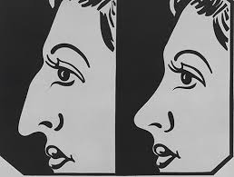
Key image:
‘Before and After 3’ (Warhol, 1962).

The image that I have chosen to link in with my key word ‘perfectionism’ is Andy Warhol’s pop art painting ‘Before and After 3’ (Warhol, 1962). Warhol based this painting on an advertisement for surgeries, aimed at people who want to change their body and what the effects are of plastic surgery. It represents two women and tries to express through the painting that women look younger and happier once they have had plastic surgery. This highlights the theme of perfectionism and leaves you to wonder, does the definition of perfect mean altering a natural element of your body to fit societies expectations?

Warhol suffered a lot of anxiety about his own appearance. He had plastic surgery done to reshape his nose and even wore wigs because of his receding hair line. Warhol stated “I believe in low light and mirror tricks. I believe and plastic surgery” (Warhol, 2007)

In this painting Warhol was communicating a transition period where an individual felt they had found happiness in the way they look, so it was an ideal perception of what is means to be perfect. The fact that Warhol had a close relationship with Jewish people, implies that this painting could resemble a Jewish person. Jewish people were considered as outsiders to American people, he knew how it felt to want to be like everybody else. Warhol aspired to look a certain way, in the same way Jewish people wanted to fit in.

I think this painting had a lot to do with Warhol’s own appearance and he wanted to convey a message about the issue of perfectionism. Warhol knew that “the greatest curse of consumerism was the aspiration to be like somebody, and ultimately, like everybody” (Distinguished Magazine, 2019) This again proves that my key word “perfectionism” is something that affects everyone in everyday life. The painting is now a part of “my perfect body”, in a show at the Andy Warhol Museum in Pittsburgh, which is curated by Jessica Beck. The painting highlights the aspirations to want the perfect body and life. It allows its audience to question the concept of external and internal fulfilment

Key thinker: Winnie Harlow

My key thinker to support my keyword perfectionism is Winnie Harlow, a model, spokeswoman and activist who battles with her own body image and a skin condition called vitiligo. Her skin condition doesn’t stop her from posting on her social media, it doesn’t ruin her life. She is known to be a role model to other girls, her skin condition proves that you don’t have to be flawless or perfect to be a successful person. Her childhood was miserable, with class mates calling her names such as zebra and she was in fact forced to drop out of school to be home schooled. Years down the line and Harlow’s has over 2.7 million followers on Instagram, she has been on front covers of magazines such as Elle and has regained her confidence. “I’m not a monster. I’m a sweet girl who likes pink. It’s not all a big deal. People have exzema and stuff like that and are afraid to show their skin. It’s you, embrace it” (Ismail, 2019) this quote by Harlow highlights the issue that not everyone is perfect, and you can still be successful even with flaws. She goes on to state “I learned to love who I am despite what anyone would say or about me. This gave me the courage to really stand up to anyone or any obstacle in my life” (Ismail, 2019) I find it really refreshing to know how at peace Harlow is with herself despite her skin condition, rather than trying to meet a certain standard of beauty, she is embracing her imperfections. Perfectionism is characterized as “striving for flawlessness, setting excessively high standards for performance, and evaluating one’s own behaviour overly critically” according to (Flett, G. L & Hewitt, P. L. 2002) this proves that perfectionism is a characteristic and that if you train your mind to be positive about your imperfections, then your mindset will be different.

Key word: Social media

I chose the keyword social media because it is a platform used for many useful things, such as marketing, advertising, promoting businesses and connecting with the world. However, it is also considered one of the main sources of unhappiness, due to there being such high expectations of how to live your life. Social media has had a huge impact on the world whether it be for the good or bad. For example, Instagram is used for posting photos that represent you as a person. Instagram models, modelling agencies or celebrities often edit their photos on this platform in order to seek the perfect skin, makeup, hair or body. This leading to people who have flaws to question their own idea of perfection.

Key image:

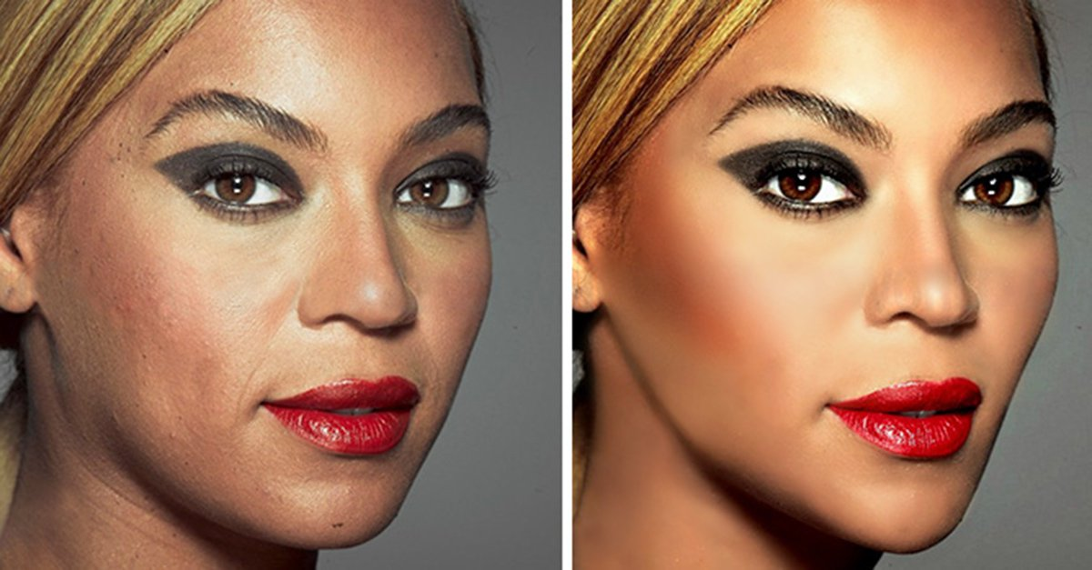
(Bored Panda, 2019)

I picked these before and after photoshop images of one of the world’s most idolised women, Beyoncé. I wanted to use this image because it shows that no matter how successful or beautiful you are, you still have flaws like everybody else. I also think that celebrities like her are made to look good through their social media and music videos by hair, makeup and editing. When in reality “Ideal Beauty is ideal because it does not exist” (Wolf, 1995.) Nowadays, people live through they’re cameras and phones or make themselves look like something they are not through the use of social media, this conveys that social media is in fact a very dangerous tool in terms of people’s mental state. In addition to that, celebrities can also afford to pay for surgeries to correct they’re flaws. However, not all people can afford to change their appearance in this way, which could lead to a decrease in mental well-being and negative thoughts about one’s self.

“Some women enjoy examining media depictions of extremely slender models, while others find such depictions produce feelings of inadequacy” (Wilcox and Laird, 2000)
Which again proves that social media plays a huge role in influencing our ideas of beauty. According to a study done when women are shown images of flawless models, slender looking models, or images about body image there was a shift towards negative moods. (Pinhas et al., 1999)

Key thinker: Richard Prince

I chose Richard prince to talk about social media because the exhibition that he made conveyed a powerful message. Prince is an American artist who designed an exhibition called “new portraits” whereby he placed blown up versions of screenshots off his Instagram feed of other Instagram user’s photos. These photos are all of women posing seductively in vulnerable poses. They were enlarged to six foot in height each and Richard prince then edited the photos so that it looked like he was commenting on them. Here is an example of his artwork:
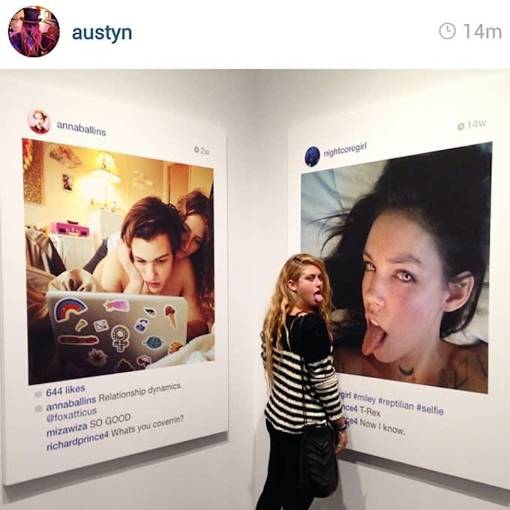
(Complex, 2019)

Each of these artworks were sold at an asking price of $90,000, these artworks were displayed at Frieze art fair in New York. He was later sued for copyright by a photographer as he was using these images without permission from the users on Instagram. This conveys how easily accessible social media platforms can be and how social media has made a noticeable impact upon the art market. This also challenges people’s perception of what they put online is actually safe and that anyone could steel your photo and use it.
“Applied to social media and body image, the uses and gratifications approach suggests that individuals who are vulnerable to body image disturbances will seek different gratifications from social media than their less vulnerable counterparts. “ (Blumler, J.G. and Katz, E., 1974). This statement by blumler and Katz conveys that social media can in fact have a more negative affect on someone who already has issues with their body. The fact that all the images Prince took off Instagram were about women and their beauty shows that the majority of photos are in fact about body image. Therefore, it is more likely to have an impact on user’s body image.

Key word: Body image

I decided to choose this keyword as it is something that I personally find important. Similar to perfectionism, being obsessed with body image can have harmful effect. Everyone has different ideas of body image in today’s society, people live up to societies idea of ideal body image rather than living the body they are happy with.

]

Key image: Jenny Saville, vile bodies (1998)

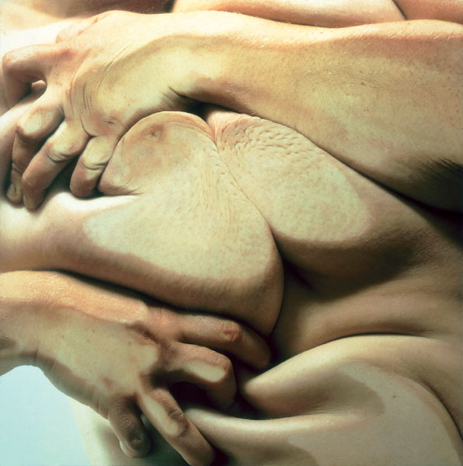
(jgcphotographysite, 2019)

After watching a documentary ‘Vile Bodies- part 1 naked’ (IMDb, 2019)
three photographers photograph naked bodies. The photographs they took reveal that our bodies can be both intriguing and difficult to look at from different perspectives. Jenny Saville and John Colpans photograph themselves naked from different angles to show us that our bodies can be seen in different ways if we allow it and that we shouldn’t take them for granted. The third photographer Joel Peter Witkin captures people who have disabilities to again show that not all bodies are the same. These aren’t the usual photographs you expect showing a perfect or ideal body type, they are in fact more real and break society’s stereotypes of what is considered normal. I was particularly interested in Jenny Saville’s work. Saville mentioned in the documentary that “our bodies have become like a commodity because a surgeon can offer us different parts to be added or taken away at which we can buy” (IMDb, 2019) and she was trying to push the limits on her own body to show how easily distorted our bodies actually are. Another statement made by Saville in the documentary to prove this was “what I was doing was no different to women who go into surgery, the process of being operated on was the same sort of process I was involved in on the sheet of glass”

She also mentioned that in the photographs she was trying to make herself “look more unattractive on the scale of normality’’ (IMDb, 2019)These statements open up ideas about stepping into a territory you were not meant to go to, an example of this would again, be plastic surgery. You are altering your natural body shape and her work shows this in a very different way. Jacqueline tellalian, the disabled model for Joel Peter Witkin’s photos, stated that “there are fewer people who are perfect than not perfect, so it is easier to except yourself” (IMDb, 2019)This statement was not only powerful but supports the reason that this project was made in the first place.

Key thinker: Michelle Obama
The last person I would like to talk about to back up my key word for body image would be Michelle Obama. Michelle Obama often talks about body image to the public, especially on interview shows. She opens up about how being a young girl, there were moments where she felt inadequate and invisable. She talks about being one of the only black girls in her class at high school where her class mates would make her feel invisible and less beautiful than everyone else. When asked When asked about how she talks to her daughters about body image so that they don’t go through the same experience, on an interview by ‘today show’ she states:

"We don't talk about weight. We don't talk about physical appearance. We talk about health. We talk about what's on the inside. We spend so much more time talking about being kind and treating others well, and being passionate and respectful,"
(TODAY.com, 2019)

The fact that Obama needs to educate her daughters not to care about body image and physical appearance while being so high profile, due to Barak Obama being president, suggests how powerful the subject body image is and that it can actually have monumental effects on one personal and mental well-being.
Barak Obama also spoke in an interview related to his wife’s discussions on the issue of body image, he stated that when he was young, he “didn’t realize as much, the enormous pressure that young women are placed under in terms of looking a certain way” (HelloGiggles, 2019.) He went on to explain that he had only noticed this since having his daughters and that “sometimes girls can be just as tough on each other about how they’re supposed to look.”. (HelloGiggles, 2019)

Conclusion:
To conclude, my key words perfectionism, social media and body image and are very closely related to one another. The key words I have researched have helped lead me closer to my dissertation question ready for third year. I wanted to research key words that are personal to me to keep me diligent throughout my research. I will therefore be more interested in my dissertation. I have found that the media has a profound negative impact on women in particular and I would like to explore this in further detail in my dissertation. I would like to explore the negative effects that social media has on the female mind and body throughout my dissertation.
Research Question:
The power of social media and its profound negative effect on the female mind and body.

Bibliography:
Harris, N. (1994). The life and works of Dali. New York: Shooting Star Press, Inc.

Andy, W. (2019). Andy Warhol / Before and After, 3 / 1962. [online] Davidrumsey.com. Available at: http://www.davidrumsey.com/amica/amico66332-125153.html [Accessed 9 May 2019].

Warhol, A. (2007). The philosophy of Andy Warhol. London: Penguin.

Distinguished Magazine. (2019). Before and After and Andy Warhol’s Anxiety - Distinguished Magazine. [online] Available at: https://www.distinguished-mag.com/andy-warhols-anxiety/ [Accessed 9 May 2019].

Ismail, J. (2019). How Winnie Harlow found true self-confidence by embracing who she is. [online] Kulture Hub. Available at: https://kulturehub.com/winnie-harlow-self-confidence/ [Accessed 9 May 2019].

Flett, G. L., & Hewitt, P. L. (2002). Perfectionism and maladjustment: An overview of theoretical, definitional, and treatment issues. In G. L. Flett & P. L. Hewitt (Eds.), Perfectionism: Theory, research, and treatment (pp. 5-31). Washington, DC, US: American Psychological Association.

Bored Panda. (2019). 57 Celebrities Before And After Photoshop Who Set Unrealistic Beauty Standards. [online] Available at: https://www.boredpanda.com/before-after-photoshop-celebrities/?cexp_id=439&cexp_var=0&_f=featured [Accessed 9 May 2019].
(Wolf, 1995)

Wolf, N. (1995). The beauty myth. North Rocks, N.S.W.: Royal N.S.W. Institute for Deaf and Blind Children.

Complex. (2019). The Art World Responds to Richard Prince's "New Portraits" Exhibition at Gagosian Gallery With More Instagram #ArtSelfies. [online] Available at: https://www.complex.com/style/2014/10/art-world-responds-to-richard-princes-new-portraits-exhibition-at-gagosian-gallery-with-selfies [Accessed 9 May 2019].

Blumler, J.G. and Katz, E., 1974. The uses of mass communications: Current perspectives on gratifications research (Vol. 1974). Sage Publications, Inc.

IMDb. (2019). Vile Bodies (TV Mini-Series 1997) - IMDb. [online] Available at: https://www.imdb.com/title/tt7154970/ [Accessed 9 May 2019].

TODAY.com. (2019). Michelle Obama to Jenna Bush Hager: 'We don't talk about weight'. [online] Available at: https://www.today.com/allday/michelle-obama-jenna-bush-hager-we-dont-talk-about-weight-2D12186659 [Accessed 9 May 2019].

HelloGiggles. (2019). https://hellogiggles.com. [online] Available at: https://hellogiggles.com/news/michelle-obama-body-image-role-model/ [Accessed 9 May 2019].

jgcphotographysite, V. (2019). Vile Bodies – Jenny Saville. [online] Professional practice. Available at: https://jgcphotographysite.wordpress.com/2017/12/04/vile-bodies-jenny-saville/ [Accessed 9 May 2019].

