University of Wales Trinity Saint David
Birmingham Learning Centre
Module code: BMSW 5104 Managing Projects in the workplace
Lecturer: Sujeewa Herath

Project Management Plan
Dilyana Fileva-Nikolova (Student number: 1920825)

Table of Contents
Table of Contents 1
Project outline 2
Project Life Cycle 2
Scope Management Plan 4
Quad chart 6
Stakeholder Analysis 7
Work Breakdown Structure (WBS) 8
Budget Plan Management 9
Risk Management 11
References 11

Project outline

According to Lester (2007), “project management is a specific number of actions with a clear beginning and ending points that are taken by a person or a group of people to accomplish a given goal within budget, time, and performance requirements”. Project management emphasises changes; therefore, it is a proactive type of management. Project management techniques are equally applicable for small and large projects, such as building a hotel or moving house.
A project is a series of specific, detailed, and related tasks with a clear objective and must be finished by a particular date, schedule, and within the allocated budget (Wysocki, 2010). An initiative must achieve a specific set of requirements to be referred to as a project. If a project satisfies these requirements, it must adhere to the project management approach established by the business. Project management includes the application, use, and performance of tools and resources together with skilful planning, implementation, and management of operations to reach and fulfil the desired set of corporate goals. It is also a results-driven management approach that depends on creating strategic and collaborative business alliances between a diverse cast of people who work as an organisation to accomplish a target (Larson and Drexler, 2010).

This document is based on a case study and aims to present a project management plan for building six new blocks of hostel accommodation for the UWTSD. The University recently increased student intake and wants to invest heavily in constructing new buildings to increase students’ living and learning satisfaction. This Project Plan paper will introduce the project management plan for building new hostel blocks. It contains a Quad chart, Scope Analysis, Work Breakdown Structure (WBS), Budget plan, Stakeholder Analysis and Risk Assessment Analysis.

Project Life Cycle

There are four steps in the project life cycle: defining, planning, carrying out, and completing (Larson and Drexler, 2010).
Defining Stage: The project's objectives are established before the project's requirements are developed. Major tasks are assigned when teams are created.
Planning stage: The effort level grows throughout the planning stage as plans are created for the project, timelines are projected for its progress and completion, and quality is maintained.
Executing Stage: Most of the project's work is done at this stage, which also involves comparing predicted and achieved goals.
Closing Phase: This phase comprises completing the project while reallocating resources and conducting a post-project evaluation. It involves client education and document transfer, project equipment assignment to a new project, performance evaluation of the recently completed project, and learning the lessons for the subsequent project (Larson and Drexler, 2010).
Regarding the case study scenario subject to this paper, as a project contractor, our company ensured the project's objectives were clear in the Defining stage. Further communication with UWTSD has been initiated to identify the requirements regarding the location of the new hostel blocks, the living and learning accommodation requirements, the time to complete the block requirements and the funding availabilities and expectations of the University as project recipient stakeholder. The communication included emails and face-to-face meetings with staff members of the university. Furthermore, a survey among the students was held to ensure their needs and requirements are considered in the defined objects subject of this Project Plan.
During the planning stage, the project team members were determined based on the tasks that needed to be completed. A team of three staff members of our company were working on the Project. During the planning stage, all requirements were defined. To ensure the project management is sufficient and the project objectives are met, our team of professionals used project management tools to create a well-balanced and reliable Project Plan to construct six new blocks of hostel accommodation. These tools are Scope Management, Quad chart, Stakeholder Analysis, Work Breakdown Structure (WBS), Budget Plan Management and Risk Management.
Executing stage – The locations of the new blocks are secured, all the required legal permissions are met, the budget is agreed upon with the University also the time for completing the project. The contractors of the project are secured. The planning process is done, and building the blocks is ongoing.
Closing stage – The building process is done, and the legal certifications regarding the safety of the building are ready to be handled by the University.

Every project has specified starting and finishing points, but also it must meet specific criteria regarding Time, Cost and Quality Performance. These criteria are represented by the project triangle (Lester, 2007). Time means the project must be completed on time. Cost – the project must be completed within the budgeted price. Quality Performance – the project's final product must adhere to the prescribed quality requirements.
To classify the project as successful or failure, we need to consider whether we are finishing the buildings at the time specified by the University and within the budget set. Regarding the quality performance, building the blocks needs to meet the safety requirements and satisfy students living and learning needs.
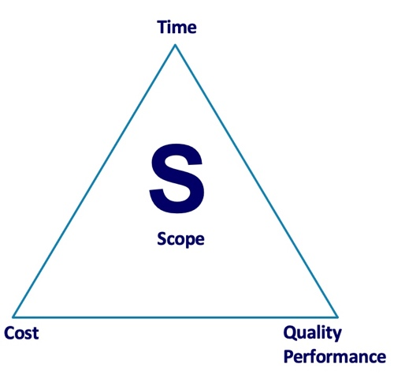
Project triangle

Scope Management Plan

A scope management plan outlines how the scope will be determined, verified, and controlled. To establish project and product scope requirements, stakeholders would be interviewed to get the necessary information. The scope then needs to be specified, clearly indicating what is in scope and what is not (Cockfield, 1987). The scope needs to be regulated after validation to ensure that any deviation from the baseline is tracked.
The Scope for this Project Plan is illustrated in the diagram below, and it includes all the necessary steps and activities to complete the building of the blocks subject of this project. It includes planning and researching activities regarding:
- Finding the best locations for the new blocks that satisfy the objectives set during the defining stage of the Project planning by the UWTSD.
- Researching and contacting engineers and building companies to get quotations regarding the price, time requirements, and availability.
- Arrange engineer and building company contractors after consideration and comparison of the quotes received.
- Ensure building materials supplier and schedule the deliveries.
- Arraigning an Interior disdainer contractor.
- Getting insurance quotes.
- Buying Insurance policies.
- Hiring and maintaining staff.
- Arranging plumbers’ services.
- Research for gas and electricity suppliers' quotes and contracts.
- Buying bathroom equipment.
- Buying electrical equipment.
- Buying computers and printers.

The Scope Diagram

Quad chart

A quad chart is a one-page visual and descriptive summary of a project which outlines the purpose of a project. It can be helpful to break a concept or idea into digestible bits to identify what you do before you begin (Ford and Wei, 2015). It is typically employed to introduce new products or provide solutions to issues.
The Quad chart is the second tool used for this Project Plan. It contains four essential categories: the purpose or goal of the project, stakeholders, result and measures of success.

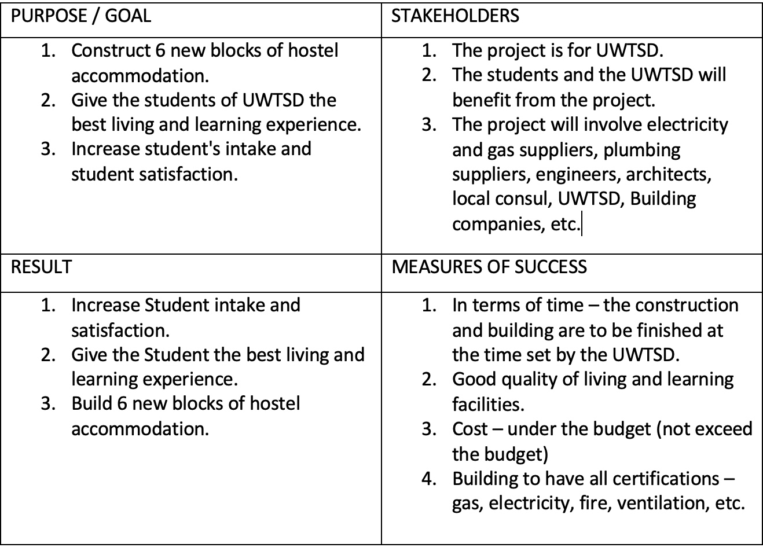

As it looks simple and easy to read, it is an effective and helpful tool that helps present the essentials of the project.
The purpose of the project is to fulfil the construction of six new hostels for the UWTSD to provide the students with the best learning and living accommodation which will increase their satisfaction furthermore will lead to an increase in student intake for the UWTSD.
Stakeholders for the project are UWTSD, the students of UWTSD, gas and electricity suppliers, the local council, plumbers, engineers, building companies, Insurance companies, building material suppliers, etc.
The result of the project is the successful completion of six new buildings of hostel accommodation accomplished with the best learning and living environment for the students of UWTSD. Furthermore, a result of the project is also an increase in student satisfaction and, therefore, a further increase in student intake in the UWTSD.
Measures of success as described above considering the project triangle, are:
- Regarding the time, the project must be completed within the time frame agreed.
- Cost criteria – the budget set and agreed upon with the UWTSD must be adhered to and not exceeded.
- In terms of quality, the buildings must comply with the health and safety regulations and meet all legal and local requirements. Therefore, the facility must have all necessary certifications. That includes but is not limited to fire safety regulations, earthquake safety regulations, gas and electricity safety regulations, etc.

Stakeholder Analysis

Stakeholder analysis is another analytical technique (Savage et al., 1991). Any individual or organisation that may be impacted by the activities or decisions made by a business is considered a stakeholder. Therefore, a stakeholder analysis is the research of all the people who will be impacted by any decisions the firm makes, particularly when establishing a new strategy. It is an examination that must be carried out early in the planning phase so that the company can ensure all the necessary individuals and proposals are included from the start.
How well a project or planning strategy will be successful or not depends on the results of a stakeholder study. The project will be crippled later by a poor stakeholder analysis, and if the initiative is eventually discontinued, funding that has already been paid may be lost. The stakeholders are reassured that the project will be successful by a well-done stakeholder study.
On the diagram below is the Stakeholder Analysis for the Project Plan subject of this document. In the higher interest and higher power quadrant, we have the UWTSD, the stakeholder the project result is for. The UWTSD as a stakeholder has the power to decide whether the project will be executed or not. In the quadrant with high strength and low interest is the Government, which can stop or limit the project with the need to follow specified legal regulations. The government's interest in the project's competition is low, as it will only complement the university and the students.

Stakeholder analysis

With low interest and low power is the local community, as it would not benefit the hostels but also has not the ability to affect the project completion. Finally, in the fourth quadrant with low power and high interest are the students, who will benefit from the project's completion but do not have control over the process.

Work Breakdown Structure (WBS)

A work breakdown structure for the project would be written and evaluated to ensure that deliverables are acceptable to stakeholders. WBS would help prevent scheduling and communication errors by providing a visual framework of the actions to be completed on a project and showing the project's schedule from start to finish (Cockfield, 1987). Establishing the critical path would be better to manage risk and schedule restrictions on the project because it would be evident which tasks had no float or slack.
The diagram below shows the WBS for the construction Project Plan prepared for the UWTSD. It is separated into two essential parts: planning and realisation. Under the planning process part of the WBS, we have the activities that need to be completed to plan and prepare the project for the realisation state. Every segment of the planning process is separated and listed on steps and critical points that need to follow each other for mistakes and errors to be avoided.

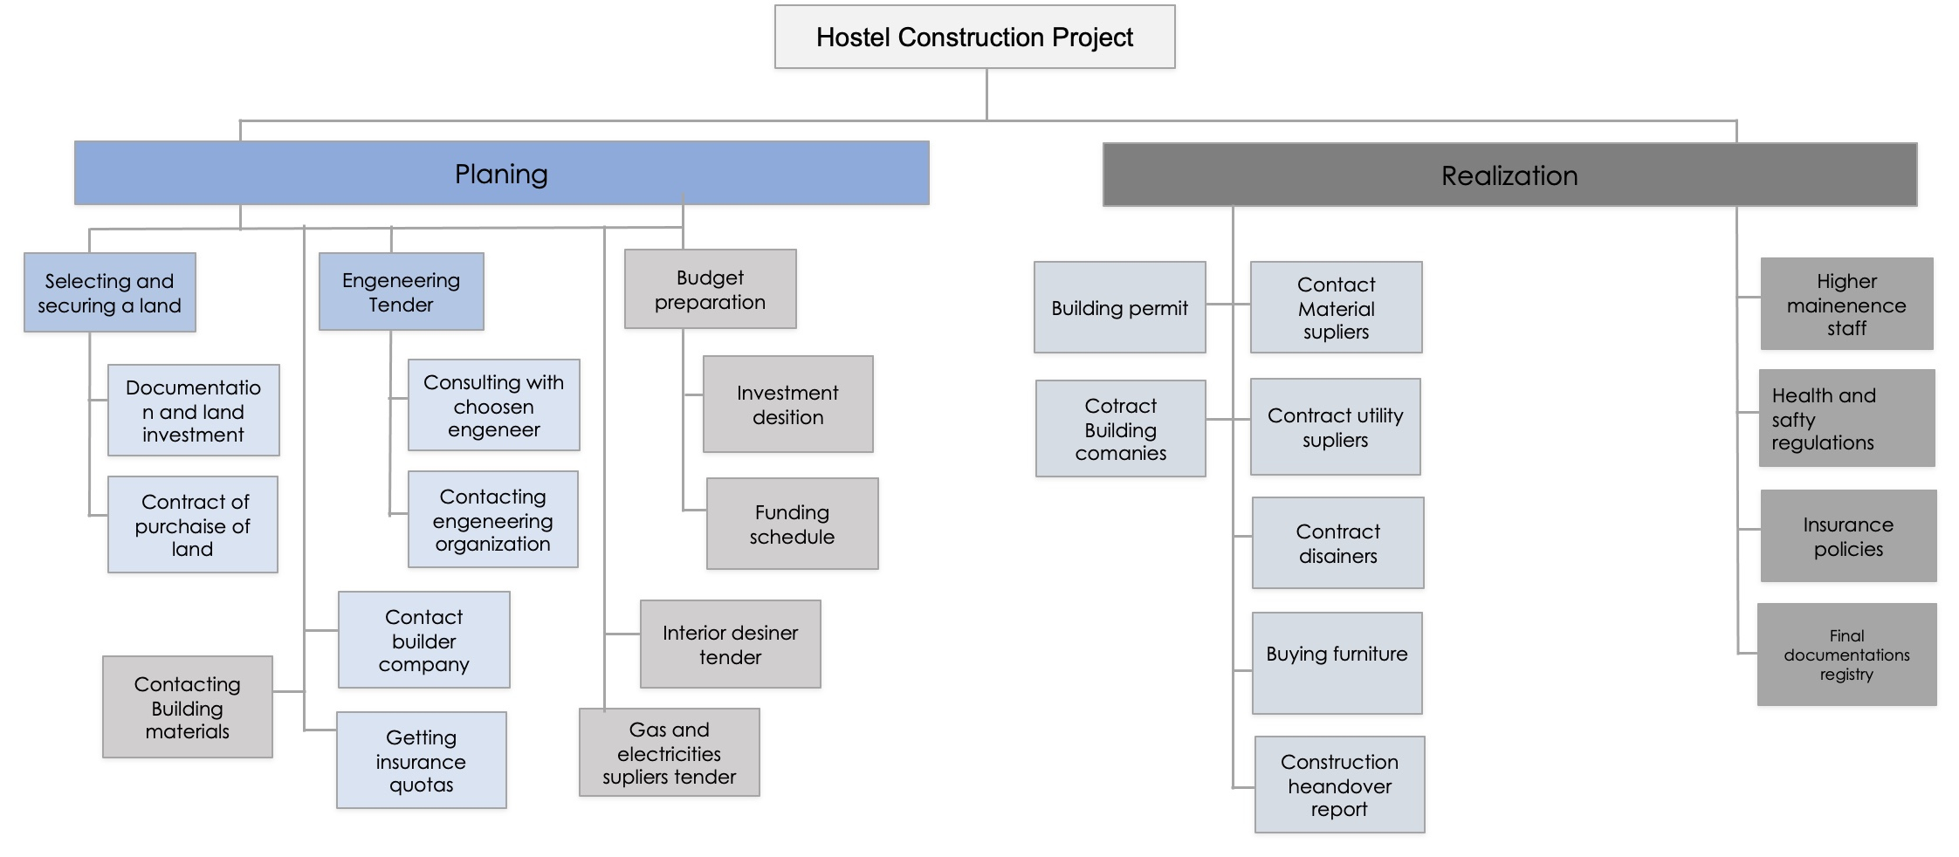
Work Breakdown Structure (BWS)

Budget Plan Management

The idea of cost planning and cost control, especially during the building project tendering process, is used to get the most value for the project budget. It involves assigning costs to the various types of labour, materials, and other components to determine how much the project will ultimately cost (Matthew, 1981). In addition to estimating the project's likely cost, this strategy is also used to evaluate if the project achieved the best value for money.
The Cost Analysis Plan outlines how a project's expenses will be handled over the project's lifecycle. It establishes the format and requirements for recording, reporting, and controlling project expenses. The cost management plan determines who oversees managing expenses.

The Budget plan as part of this Project Plan covers the time frame of the project life cycle and follows the activities that need to be funded monthly. It shows how the Opening Cash Balance or the funding from UWTSD will cover the project expenses and costs during the planning and realisation process.

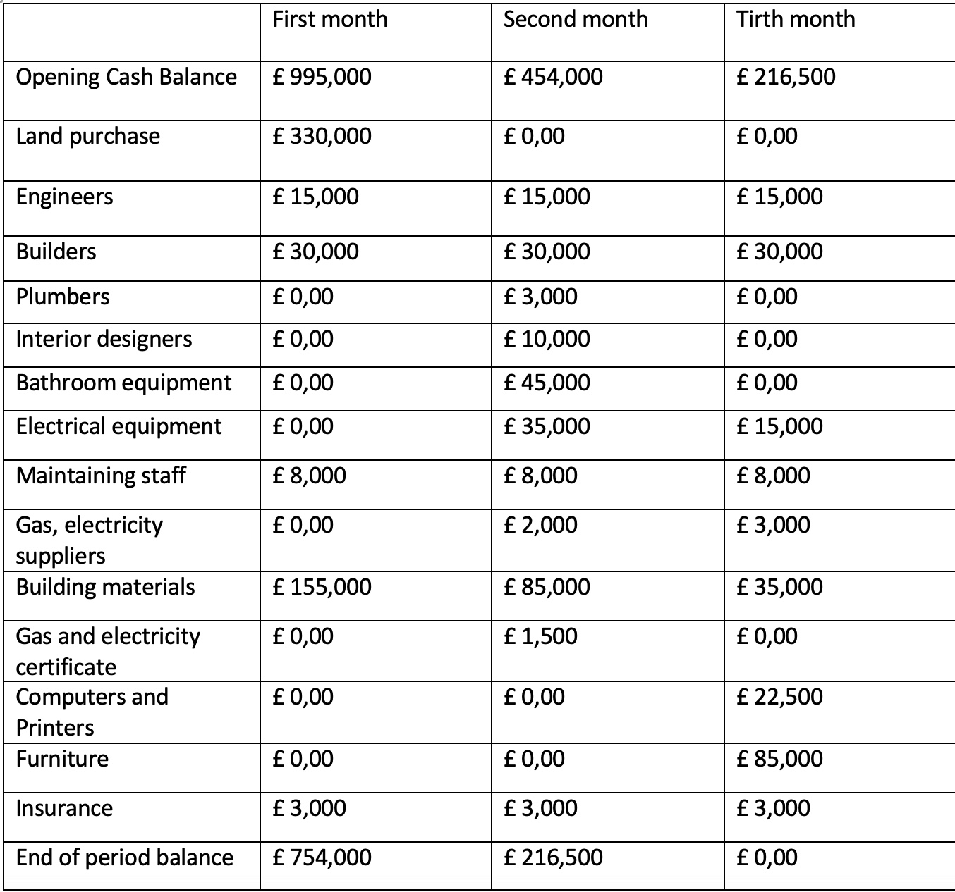

Project Budget Plan

Risk Management

Assessing project risk involves simply thinking about the risks likely to be there, how important they are to the project, what they might mean, and how likely they are to happen. To compile a thorough list of project risks (Hillson, 2014) that will be recorded on the risk register, potential risks will be discovered via planning sessions and discussions with stakeholders and subject matter experts. Both qualitative and quantitative analysis approaches would be used to evaluate and rate the risk, and a probability and effects analysis would be produced to rank risk based on its probabilities and effects (Hillson, 2014). Sensitivity analysis would also be used.
The main risk categories that need to be considered for this project are poor communication, errors in the construction schemes, changes in the prices and suppliers’ disruptions, administrative delays, incidents, weather conditions and disasters and national or regional strikes. All those categories will be monitored and evaluated if needed.

References

Cockfield, R. W. (1987) ‘Scope Management’, PM Network, 1(3), 12–15.

Ford, J. D. and Wei, T. (2015) ‘Quad Charts in the Classroom to Reinforce Technical Communication Fundamentals’, Journal of Technical Writing and Communication, 45(3), pp. 275–284. DOI: 10.1177/0047281615578848.

Hillson, D. (2014) ‘Managing overall project risk’, Paper presented at PMI® Global Congress 2014—EMEA. Dubai, United Arab Emirates. Newtown Square. Available at: https://www.pmi.org/learning/library/overall-project-risk-assessment-models-1386 (Accessed: 03 August 2022)

Larson E and Drexler, J.A. (2010) ‘Project Management in Real Time: A Service-Learning Project, Journal of Management Education, 34(4), pp. 551-573. doi:10.1177/1052562909335860

Lester, A. (2007) Project Management, Planning and Control. 5th edn. Oxford: Elsevier Ltd.

Matthew, J. L. (1981) ‘An Incremental Approach for R&D Project Planning and Budgeting, Research Management, 24:2, 17-20, DOI: 10.1080/00345334.1981.11756656

Savage, G. et al. (1991) ‘Strategies for assessing and managing organisational stakeholders’, Academy of Management Perspectives, 5(2). DOI: https://doi.org/10.5465/ame.1991.4274682

Wysocki, R. (2010) Effective Project Management: Traditional, Agile, Extreme. 5th edn. Chichester: John Wiley & Sons Ltd.

