Student name: Desislava Markova

Programme: MSc Public Health and Social Care in Practice

Module: Community Care and Management of Longer-term Conditions

Module code: LCHS7003

Lecturer: Dr Raheela Shaikh

Assignment title: Component 1 Information Booklet oof Long-term Condition Management

Booklet for Cardiovascular disease (CVD) among South Asians in UK

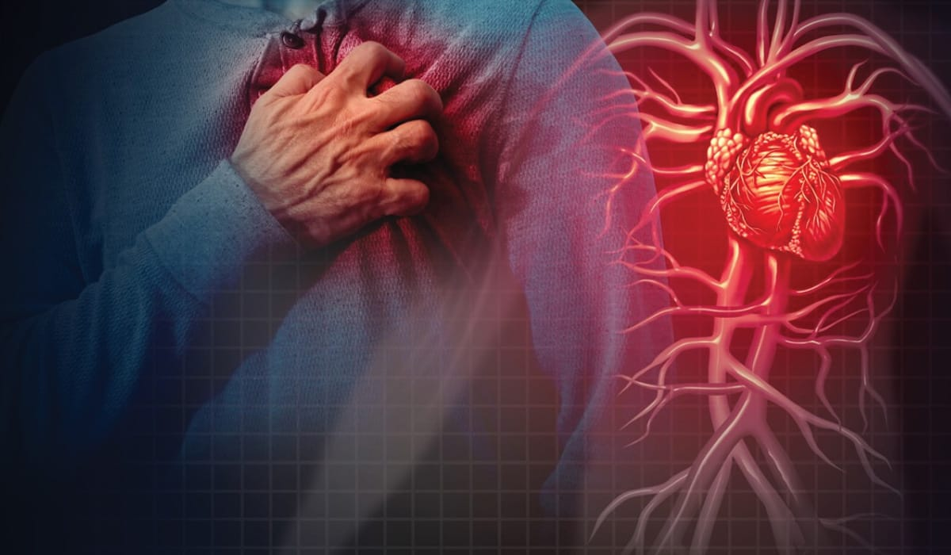 (the health suite, 2025)

The word ‘cardiovascular’ originated from the Greek word kardia which is the heart, and the Latin word vascula representing the vessels (Dahal, 2023).

Content
Introduction....................................................................................................................
Defenition ......................
fisck factors
Sign and symptoms
Diagnosis
Treatment and management
Disability
Action from NHS
House of model
Cronic conditions care model
Key findings
National Organisations for further support

Introduction
Cardiovascular disease (CVD) is the leading cause of disability, mortality, and morbidity; however, this can be prevented (Raleigh, Jefferies, and Wellings, 2022). CVD is a term that encompasses various disorders, including diseases of the vascular systems supplying the brain, heart, and other vital organs (Gaziano, 2006, p.1).
In UK the CVD is responsible for one in four deaths and millions are living with burdens such as heart disease, high blood pressure and the consequences of stroke (Brithish Hearth Fondation, cited at Health Suite, 2025). Furthermore, in subnational locations such as the UK and the US, there is a rise in age-standardised rates of CVD over the past 5 years, suggesting a need for interventions (Roth, Mensah and Fuster, 2020). For example, in England, approximately 64% are living with obesity, which is one of the main risk factors for CVD (The Health Suite, 2025).
There are racial health disparities in relation to CVD among South Asians, both as immigrants and in their native countries, where they experience higher rates of the disease compared with any other ethnic group (Kawano, 2022). The South Asian population includes people from India, Sri Lanka, the Maldives, Bangladesh, Bhutan and Pakistan, who face double the risk of heart attack compared to the white population (Rohatgi, 2022). Furthermore, according to Baichwal (2020), stroke and heart attack are four times more common in comparison to any other population, where the risks of acquiring these diseases include stress, diet, and genetics.
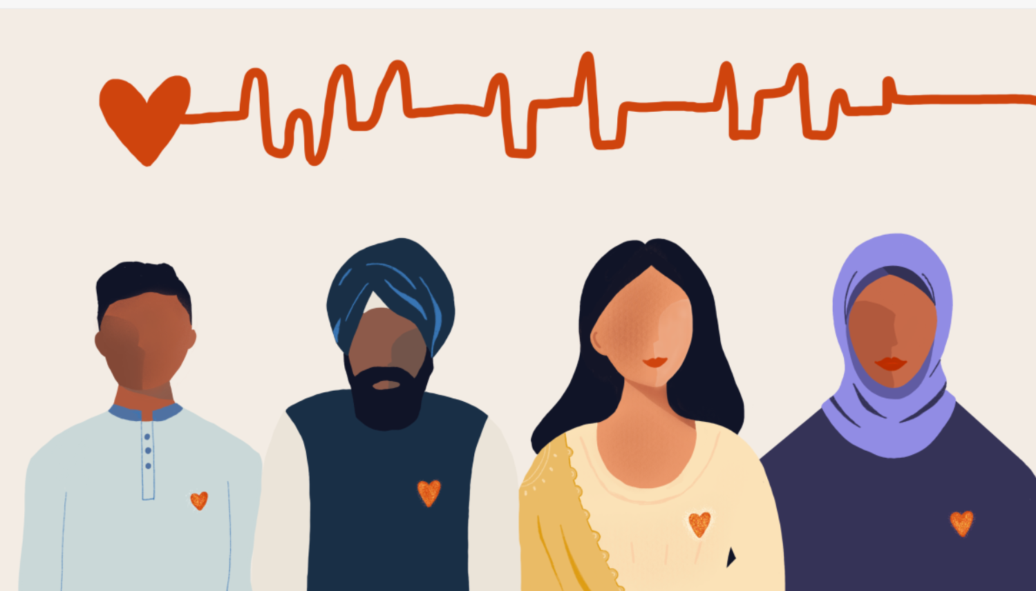 (Kogulan, 2022)
For example, Dr Sitafalwalla (Baichwal, 2020) states that the clarified butter known as ghee and the coconut oil are traditional fats which are considered healthy for South Asians, which is a myth, as science proves the opposite. Population in middle- and low-income counties has less access to appropriate health care services, resulting in late detection of the CVD which can lead to people dying at a younger age (WHO, 2025).

Definition
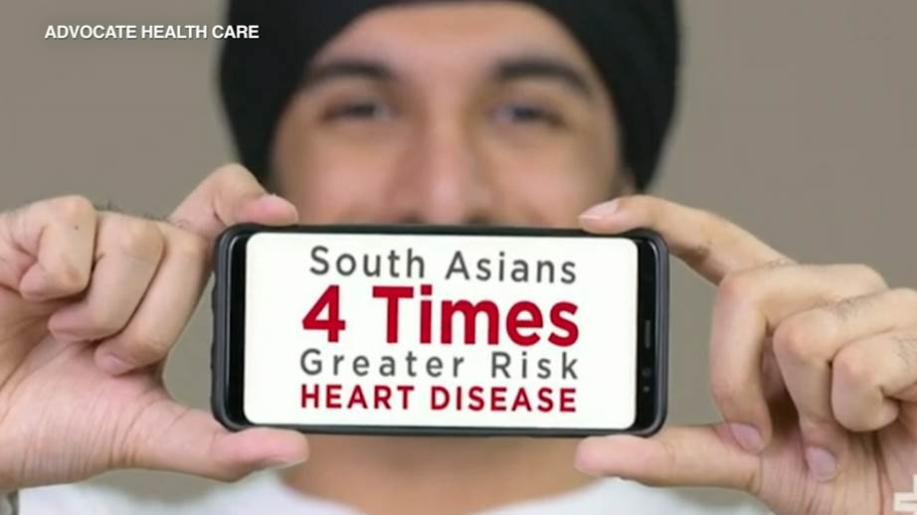(Baichwal, 2020)
World health organisation estimated that 17.9 million people die yearly from conditions that affects the blood vessels and the heart which is the nearly third of all global deaths whereas the CVD is the global number one killer (WHO, 2025).
CVD is also called heart and circulatory disease, it is the general term for conditions related to circulation and the heart, including stroke, vascular dementia and high blood pressure (British Heart Foundation, 2024). The conditions also block or narrow the blood vessels (coronary heart disease), leading to angina, some strokes and heart attack. Moreover, heart disease encompasses conditions that damage the heart's valves, the heart's muscle, or cause abnormal heart rhythms, also known as arrhythmias (British Heart Foundation, 2024).
Strokes and heart attacks are mainly acute events which are caused from having a blockage that stops the blood flow to the brain or heart. Prevalently the reason is the build-up of fatty deposits on the inner walls of the blood vessels which supply the brain or heart (WHO,2025). The stroke is a result of blood clots or from blood vessel bleeding in the brain (WHO, 2025).
CVD different diagnosis
- Myocarditis
- Kawasaki disease
- Hypertension
- Hypertensive heart disease
- Giant cell arteritis
- Dilated cardiomyopathy
- Coronary artery vasospasm
- Atherosclerosis
- Acute pericarditis
- Angina pectoris (Lopez, Ballard and Jan, 2023)
CVD different group of disorders
- coronary heart disease
- Deep vein thrombosis and pulmonary embolism
- Congenital heart disease
- Rheumatic heart disease
- Peripheral arterial disease (WHO, 2025)

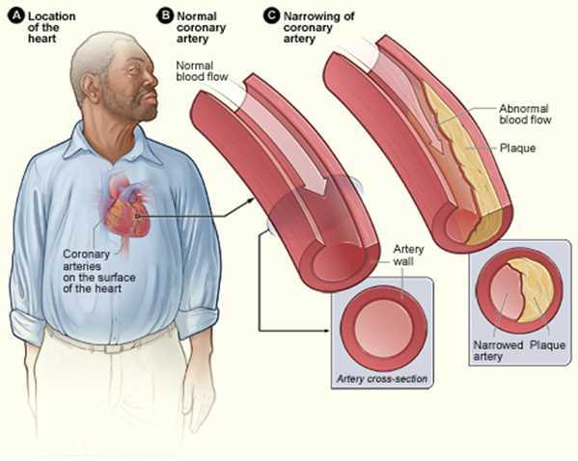

Atherosclerosis because of coronary heart disease. Contributed by National Heart, Lung and Blood Institute (Loprs, Ballard, and Jan, 2023).
In South Asian individuals, atherosclerotic cardiovascular disease (ASCVD) is more likely to be diagnosed compared to other ethnicities (Stefil et al., 2023). Reasons for this include insulin resistance, dyslipidaemia, metabolic syndrome and visceral adiposity (excessive accumulation of visceral fat) (Stefil et al., 2023). Therefore, regular screening of this population and the development of interventions are needed to address modifiable risk factors. Moreover, the BMI thresholds need to be reduced to identify higher cardiometabolic risk, and the threshold for screening insulin resistance needs to be lowered (Stefil et al., 2023).

Risk factors
Generally, according to WHO (2025), some CVDs can be prevented by changing environmental and behavioural risk factors, such as air pollution and an unhealthy diet (excessive sugar, fat, and salt). Other risk factors include:
- Physical inactivity
- Smoking
- Having irregular blood pressure
- Obesity
- Diabetes
- Problems with glucose and cholesterol levels (Loprs, Ballard, and Jan, 2023).
- Ethnic group
- Sex (men are more likely to get CVD earlier the women)
- Age (later in life the changes of CVD increase)
- Alcohol
- Stress
- Family history of heart disease (BHF, 2024).
Up to 80% are preventable by managing the risk factors, for example: obesity, diabetes, and inadequate physical exercise (Raleigh, 2023). Globally studies show a higher prevalence and mortality in South Asian groups in coparenting with other population. Also, in South Asia the CVD mortality is rising, as elsewhere is less prevalent. Although the body mass index is lower in this ethnic group, the rates of insulin resistance and excess abdominal fat are higher. Another risk for this group is low physical activity especially among women, even that the smoking rates are lower (Raleigh, 2023). Furthermore Joshi (2018) state that South Asian are listed in the updated cholesterol guidelines as it is one of the recognized risk factors.

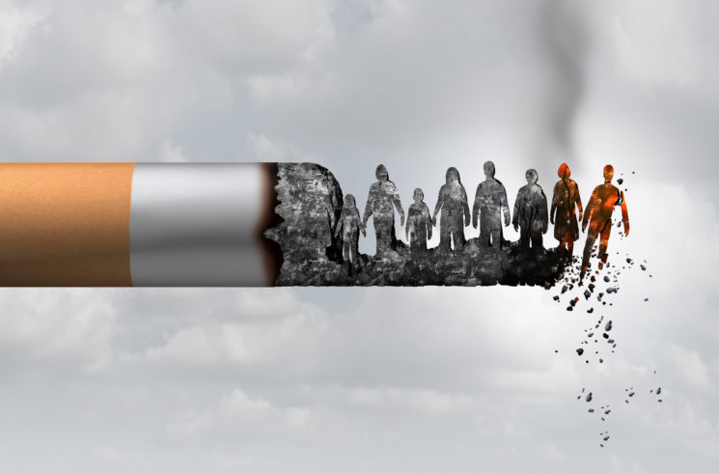 (Nelincs, 2024)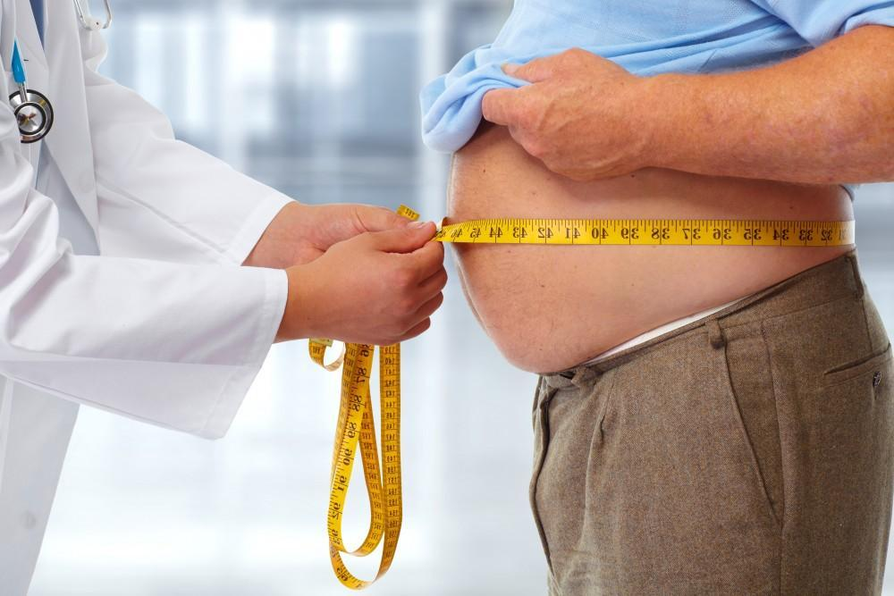 (optimum endocrine care, no date)

Symptoms
(Joshi, 2019)
Symptoms can significantly affect the quality of life and clear understanding of the sign and symptoms is critical for effective diagnosis and treatment (Walter, 2022).

Symptoms of heart attacks and strokes
Unfortunately, usually the stroke or the heart attack is the first sign of a blood vessels disease and once any of these are symptoms are experiences an immediate medical attention needs to be seek.
The symptoms of heart attack:
- Discomfort or pain in the centre of the chest and/or left shoulder, arms, jaw, elbows or back;
- Difficulty in breathing, shortness of breath, vomiting, nausea, light-headedness or faintness, turning pale, having a cold sweat (WHO, 2025 and Walter, 2022).
The symptoms of stroke:
- Sudden weakness and numbness of the face, leg, arm likely on one side of the body;
- Difficulty speaking, understanding speech and being confused;
- Difficulty in seeing;
- Loss of balance, coordination and dizziness;
- Not known reason of severe headache;
- Unconsciousness and fainting (Walter, 2022 and WHO, 2025).
Heart failure symptoms
- Dyspnea (shortness of breath);
- gastrointestinal issues;
- Insomnia;
- Fatigue;
- pain in the chest and elsewhere;
- mood changes;
- anxiety or depression (prevalent in women) (Jurgens et al., 2022).

Heart valve disease symptoms
- Many of the heart failure symptoms;
- Exercise intolerance and frail (more commonly experiences in women then man);
- Chest pain (more commonly experiences in man) (Walter, 2022).
Symptoms of rheumatic heart disease
- Fatigue;
- chest pain;
- Fainting;
- irregular heartbeats;
- shortness of breath (WHO, 2025).

Symptoms of rheumatic fever include:

- swelling and pain in the joints;
- stomach cramps;
- Vomiting;
- Fever;
- Nausea (WHO, 2025).

Diagnosis
This depends on symptoms, doctor decisions and family history, the methods include:
- Blood tests;
- Electrocardiogram (ECG);
- CT scan;
- Echocardiogram;
- MRI scan;
- Chest X-rays (BHF, 2024).
Treatment and management
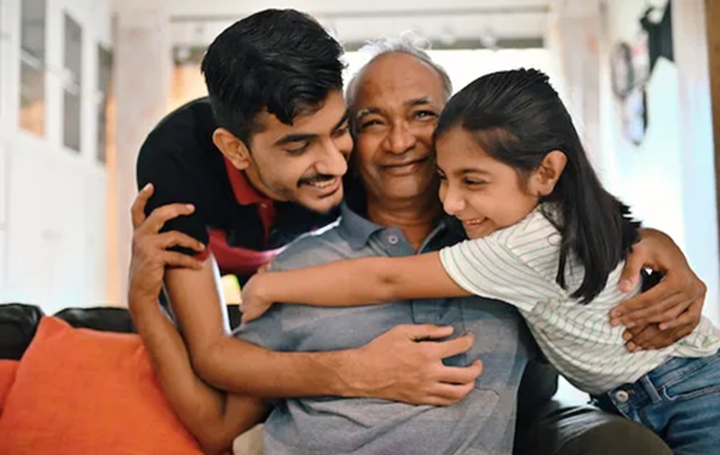
The management of CVD depends on the clinical situation, and patients who know the type of their CVD must be educated on secondary prevention through risk factors and lifestyle modification. As the different CVDs require different clinical situations, for instance, angioplasty for peripheral vascular disease, catheter-directed thrombolysis for acute ischemic stroke, and coronary stenting for CHD (Lopez, Jan, 2025). The treatment could include:
- Medication, such as statin which is used to protect the insides of the artery walls and lower cholesterol level in the blood (BHF, no date);
- Heart surgery – they can be few types for example –aortic surgery, heart valve replacement or repair and heart transplant (BHF, 2025d)
- A device such as pacemaker or implantable cardioverter defibrillator (a small electrical device which is used to treat ventricular arrythmias – dangerously abnormal heart rhythms (BHF, 2025a);
- Lifestyle changes (BHF, 2024)
- Coronary artery bypass surgery (CABG) generally known as heart bypass surgery, this type of procedure is aimed to treat coronary heart disease (BHF, 2025b).
- Coronary angioplasty with stenting (stents)– treatment which assist the blocked blood vessels to open when the blood is not flowing properly (BHF, 2025c).
- balloon angioplasty – a balloon-like device which treads through the affected artery to stop the blockage (WHO, 2025);
- valve replacement and repair (WHO, 2025);

There are many ways people can improve their health for example:
- Giving up smoking and any other forms of tobacco, which will also benefit the surrounding people, help is available at GPs and pharmacies (Birmingham City Council, no date). Furthermore, national free resources include:
NHS quit-smoking app;
NHS free personal quit plan
NHS smoking cost calculator
The “Smokefree Quit Smoking” Facebook support group (Birmingham City Council, no date)
- Eating health food can make person healthier by:

eating locally available food;
drink more water than sugary drinks;
have 3 meals equally spaced per day;
consume less fat/ ghee
Have minimum of 5 vegetables or fruit per day
Avoid fast food and ready meals, cook from fresh ingredients where possible (Health education leaflet, 2013).
 (Medfood, no date)
- A way of reducing stroke and coronary heart disease is by implementing hypertension programmes at the primary care level. Moreover, CVD patients should take advantage of the medications and technologies available. Medications include:
- beta-blockers
- Angiotensin-converting enzyme inhibitors
- aspirin
- diuretics
- calcium channel blockers
- Statins (WHO, 2025).
- Be active
At least 30 minutes physical activity which can increase your heat beat and take you out of breath, for instance: cycling, fast walking, use stairs than lift, sports, manual work e.g. farming (Health education leaflet, 2013);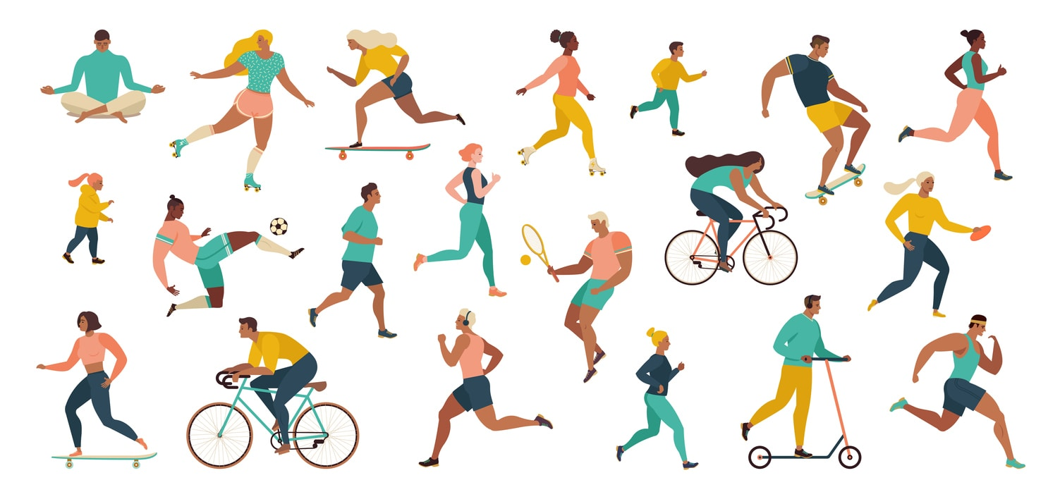 (Yearwood, 2022)
- Drink less alcohol than 3 units such as 1 large glass of wine, 1.5 pints of beer and 75ml of spirits. Additionally, if the individual as diabetes the alcohol will lead to feeling ill with low blood sugar (especially if sulphonylurea tablets or insulin are used) (Health education leaflet, 2013).

Disability
CVDs are long-term and chronic conditions, for example, heart disease and heart failure, which can cause shortness of breath, making work impossible (Raleigh, Jefferies and Welling, 2022). Furthermore, according to NHS England (2019b, cited at Raleigh, Jefferies and Wellings, 2022), stroke is the leading cause of disability, where 2/3 stroke survivors leave the hospital disabled.
Action from NHS
Early detection and treatment of CVD will support patients towards healthier and longer lives. In England, many people are suffering from raised cholesterol, high blood pressure and atrial fibrillation (AF). Therefore, working with people's ABC (AF, Blood pressure and cholesterol) through digital technology and working with NHS staff in the public sector. employers and the voluntary sector will bring progress (NHS, 2025).
The multidisciplinary teams are part of the primary care network, which supports people with heart valve disease and heart failure. For example, even if the patient is not on a cardiology ward, the heart failure nurses will be available to provide specialist advice and care (NHS, 2025). Moreover, better personalised planning for the patients can reduce drug spend and nights spent. Additionally, the echocardiography in primary care can early detect valve disease and heart failure (NHS, 2025).
When people experience cardiac arrest outside of the hospital, the chances of survival increase when a great energy electric shock to the heart using a defibrillator is used with immediate resuscitation (CPR). The NHS plan is to educate the general public and the school-age young people to identify and respond to out-of-hospital cardiac arrest. Working with partners such as the British Heart Foundation to ensure that the emergency services and the public can rapidly locate a defibrillator to save lives and reduce disability (NHS, 2025).
There is a new GoodSAM app that allows people who can deliver Cardiopulmonary Resuscitation (CPR) alongside a defibrillator to receive alerts from individuals who need urgent assistance. It has a crowdsourced map of defibrillators (even those in vehicles) (NHS, 2025).
Improving marketing and scaling up cardiac rehabilitation will prevent up to 50,000 acute admissions and 23,000 premature deaths over 10 years (NHS, 2025).
Health Care Models for long-term conditions
The House of Care model outlines a holistic approach to the care of long-term conditions. It puts in place each resource and expertise of the community and the patient to ultimately improve outcomes (Wittington NHS, 2025).

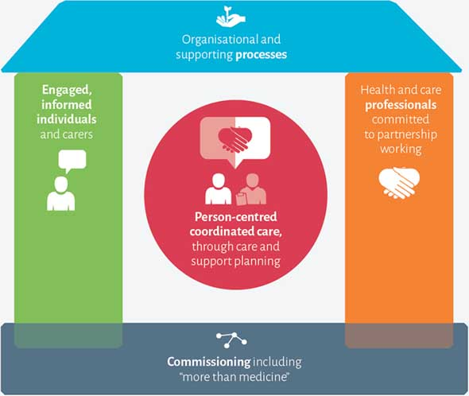
(Wittington NHS, 2025)
The House of Care (HoC) is a coordinated service which assists clinicians and patients with long-term conditions (LTCs) and works together to develop and mould their care in a way in which the patients can live well while having their long-term condition (Year of care, 2011 cited at Coulter, et al., 2016). To create this care model, the Chronic Care Model (Wagner, 1998, cited at Coulter, et al., 2016) is used; however, it is designed to be able to apply with UK primary care. The term 'house' is used as a metaphor to easily explain the components that can make care planning coordinated and personalised (Coulter, Roberts and Dixon, cited in Coulter et al., 2016).The House of Care model comprises four main components with the common aim at the centre of the house to plan a working parentships between patients and clinician to improve health outcomes and deliver person-centric, coordinated and high-quality care. These include:
- Commissioning – this is a problem-solving and a system-improvement support from vountary and statutory organisations, peers and community groups (foundation)
- individuals and carers who are informed and fully engaged and empowered – this allows individuals to self-manage and be aware of how to access the services they require (left wall)
- Organisational and clinical processes – this is co-designed with patients where possible to meet their needs in structured and evidence-based processes (roof)
- Health and care professionals working in partnership – to create continuity of care which supports, collaborates and listens (right wall) (Wittington NHS, 2025 and Mathers and Paynton, 2015, cited at Coulter, et al., 2016).

According to Coulter et al. (2015, cited in Coulter et al., 2016), when individuals collaborate with health care professionals to articulate their needs and set goals and priorities, they will feel more competent and confident, which will also lead to improved health outcomes. However, if they are left alone, they could struggle if their skills and confidence level of self-care are not enough to manage their long-term condition, for example, a disability gained from a CVD.

Chronic Care Module
The Chronic Care Module is an approach to systems and care teams that uses a disease management and patient-centred way of working to advance a goal-oriented care approach, e.g., focusing on what matters most to the individual at the centre of the care (Grudniewicz, et al., 2023). This module is widely adopted in the United States and worldwide. An article published since 2000 shows that it still needs improvement in terms of cost-effectiveness; nevertheless, patient care and health outcomes have improved (Coleman et al., 2009).
Davy et al. (2015) found in their study that there is no optimal combination of the elements (self-management support and delivery system design) in the chronic care model; however, of 77, only 2 showed no improvement in health outcomes or healthcare practice, which supports the effectiveness of the Chronic Care Model.
The CCM was created by Wagner and colleagues for Health Care Innovation; it proposes policy, resources, and organisational conditions to improve the quality of care for chronic illness (Chin et al., 2007, cited in Davy, 2015). This model highlights the patient's role to self-manage and on evidence-based chronic illness management (Chin et al., 2004, cited in Davy, 2015)

Key findings
The CVDs are widely common, and it can be easily missed in the early simptoms, which can lead to heart attack or stroke. Therefore, people with compromised immune system must take extra carful especially if they are from the South Asia origin. NHS as implemented ways to tackle the problem by educating more people regarding CPR and defibrators in the country and adapting the people's ABC testing and preventing CVDs. Furthermore, each individual has the opportunity to change their lifestyle in order to lower his chances of getting CVD.

National Organisations for further support
- British Heart Foundation (2024) provide support for people experiencing CVDs, for example they can be contacted on their Heart Helpline, speak to their cardiac nurses (online chat, email, phone or callback). Furthermore, complaints and comments can be raised with their customer care advisors. Moreover, people are welcomed to join support group or an online community, and they can sign up to their magazine- Heart Matters (BHF, 2024).
- Hearth research UK (2026) – This charitable organization provides prevention programmes and accessible health checks resources to live healthier and longer
- Heart UK – They created a program where people can get together and raise funds for people with high cholesterol start by challenging them to do 10,000 steps if you want to join them, please scan the bar code which will sign you up (Heart, 2026).

