Curriculum Design: policy understanding within the context of Curriculum for Wales.

2113432 Yvonne Roberts-Ablett

ECDE7013

Contents:

Glossary………………………………………………………………………………………...4

List of Tables…………………………………………………………………………………..5

List of Figures………………………………………………………………………………….5

1.0: Introduction……………………………………………………………………………..6

2.0: Literature Review………………………………………………………………………7

2.1: Introduction…………………………………………………………………………7

2.2: Research Aim……………………………………………………………………….8

2.3: Positionality and researching the literature……………………………………..8

2.4: Key definitions………………………………………………………………………9

2.41: Curriculum……………………………………………………………...10

2.42: Curriculum Design……………………………………………………..10

2.5: Curriculum Design within Curriculum for Wales……………………………..11

2.6: International perspectives on Curriculum Design……………………………14

2.7: Conclusions: Implications of Research Gaps for Policy to Practice in Successful Realisation of Curriculum for Wales…………………………………..17

3.0: Research Design and Methodology…………………………………………….17

3.1 Research Paradigm……………………………………………………………….18

3.2 Research Design…………………………………………………………………..18

3.3 Approach to Sampling…………………………………………………………….20

3.4 Research Tools…………………………………………………………………....21

3.5 Approach to Data Analysis……………………………………………………….22

3.6 Ethical Considerations…………………………………………………………...24

3.7 Reflexivity…………………………………………………………………………..25

4.0: Data Analysis and Discussion…………………………………………………..26

4.1: The Role of the CfW Framework Guidance in Outlining Expectations for Curriculum Design……………………………………………………………………27

4.2: Use and Meaning of Curriculum Design………………………………………36

4.3: The understanding of Curriculum Design amongst policy makers…………37

4.31: Collective Responsibility and Shared Sensemaking …………..…39

4.32: Accurate use of the CfW Framework in identifying purposeful learning ……………………………………………………….…………….44

4.33: Responding to the needs of learners……………………….………47

4.34: Coherent local leadership…………………………………………….51

5.0: Conclusions……………………………………………………………………………54

6.0: References……………………………………………………………………………..56

7.0: Appendices…………………………………………………………………………….64

Glossary
Area – Area of Learning and Experience
CfW – Curriculum for Wales – rollout from September 2022
CWRE – Careers and Work Related Experience
EOTAS – Education other than at school
Estyn – Education and training inspectorate for Wales
H&W – Health and Wellbeing Area of Learning and Experience
LLC – Languages, Literacy and Communication Area of Learning and Experience
NC – National Curriculum England and Wales from 1991. Updated in Wales from 2008
Practitioners – qualified teachers in Wales working with children aged 3-16
RSE – Relationships and Sexuality Education
RVE – Religion, Values and Ethics
Schools – all maintained schools and settings in Wales with children age 3-16 on roll
SCS – Senior Civil Service
Senedd Cymru – Welsh Parliament
UWTSD – University of Wales Trinity Saint David

List of Tables
Table 1: Deductive coding method used to analyse the CfW Framework
Table 2: Extract from H&W Framework analysis using De Almieda and Viana framework (2022)
Table 3: Extract from Designing your Curriculum CfW Guidance
Table 4: Outcomes of participant questionnaires

List of Figures
Figure 1: Outline of Research Methods
Figure 2: Curriculum Design Theoretical Framework (De Almieda and Viana, 2022)
Figure 3: Outcome of CfW Framework analysis using De Almieda and Viana framework (2022)
Figure 4: Outcome of detailed linguistic analysis of CfW Framework using component parts of De Almieda and Viana framework (2022)
Figure 5: Analysis of themes within CfW Framework that did not fit within Almieda and Viana (2022) model.
Figure 6: Suggested theoretical framework for Curriculum Design within CfW (Roberts-Ablett, 2024)

1.0: Introduction
Donaldson’s (2015) Successful Futures review has initiated significant curriculum and assessment reforms in Wales. Resulting in a co-construction process involving education stakeholders, such as practitioners, international curriculum experts, school improvement services, Qualifications Wales, and Estyn (the inspectorate for Wales). Together, they developed the Curriculum for Wales (CfW) Framework and influenced the Curriculum and Assessment (Wales) Act 2021 (Egan and Roberts-Ablett, 2023; Welsh Government, 2021a, 2021b). The term curriculum design reflects the expectation in these documents that headteachers and governing bodies will design curriculum and assessment arrangements aligning with this national CfW Framework, ensuring learners realise the four purposes the broad aims of education for all learners between the ages of 3-16 in Wales (See Appendix 1).
Accepting all 68 recommendations from Successful Futures, the concept of subsidiarity was introduced, granting practitioners (all qualified teachers of children between age 3-16) in Wales the agency to make classroom-based decisions using the national CfW guidance (Donaldson, 2016). While some practitioners embrace this agency, others express concerns about their training to date, challenging the professional identity of practitioners in Wales (Gatley, 2018, Kneen, 2020, Duggan et al., 2023). With CfW still in its infancy, since rollout began for all primary schools (for the purposes of this project, schools will refer to all maintained schools and settings responsible for learners between ages 3-16) and up to Year 8 pupils (age 13) in all secondary schools from September 2023, there remains a significant research gap in analysing the use and subsequent execution of curriculum design within the context of CfW (Roberts-Ablett, 2023a; 2023b).Practitioners accustomed to the product orientation of the National Curriculum (NC) (Kelly, 2009) find it challenging to transition to CfW’s process orientation (Makara-Fuller et al., 2023). No jurisdiction has fully implemented a process-oriented curriculum (McKernon, 2008), with politics, established cultures, and institutional memory often cited as barriers (Ozga, 2000; Biesta, 2021; Priestley, 2022).
Whilst ongoing research within Wales seeks to better understand progression within CfW (Morrison Love et al., 2023; Makara-Fuller et al., 2023), this project focuses on the phenomenon of curriculum design, examining the coherence between policy ambitions and classroom expectations. Using a hermeneutic phenomenological approach, it aims to determine the shared understanding of curriculum design within CfW guidance and among Welsh Government policy officials, seeking to secure the successful realisation of CfW. The next section reviews the relevant literature.

2.0: Literature Review

2.1: Introduction
As outlined above, Wales is in the process of widespread systemic curriculum reform. What is presented as unique in the Welsh context, is the co-construction process that has created the CfW guidance (Egan and Roberts-Ablett, 2023; Welsh Government, 2021a; 2021b). In its commitment to iterative curriculum design, Welsh Government has made a commitment in guidance to support ongoing co-construction in refining the CfW framework in response to its enactment in practice, through such processes as the National Networks: a permanent feature of practitioners being able to influence policy decisions (Welsh Government, 2021a). The Curriculum for Wales Implementation Plan (Ibid) outlines a definition of co-construction as agreed ways of working in Wales with a commitment to:
‘sharing problems and jointly developing solutions. If we want real, sustainable change at the school and setting level, then schools and settings and their practitioners need to own this process of change...Co-construction should bring equity between different voices in a team or in the system rather than one voice giving direction. It should recognise that every voice within the process brings a valid contribution. It should be separate from management and responsibility hierarchies, allowing everyone to challenge and be challenged.
Ibid
In this policy-making context, this project seeks to establish the extent to which the phenomenon of curriculum design is coherently understood in both CfW policy guidance and in the work of policy makers within Wales who are responsible for the ongoing realisation of CfW. Building on previous literature reviews (Roberts-Ablett, 2023a; 2023b), the project focuses on policy expectations for curriculum design within CfW. As this is a new research area, it will also include literature from other regions to understand the role of policy in curriculum design.

2.2 Research Aim
This research aims to:
- Understand the phenomenon of curriculum design within the CfW guidance.
- Address a research gap identified by Roberts-Ablett (2023b) regarding curriculum design in the CfW context.
- Inform coherent policy making and future iterations of the CfW framework.
- Support policy decisions that empower Welsh practitioners to approach curriculum design confidently, comprehend its expectations, and ensure successful transition from a product-oriented NC to the process-oriented CfW.
- Identify potential risks to the successful implementation of CfW by assessing any emerging gaps between policy and practice in understanding curriculum design within the context of ongoing curriculum reform.
- Establish a theoretical framework for CfW that articulates the role of curriculum design in a process-oriented, purpose-led curriculum.
The next section outlines my position in this research and the literature review methodology.

2.3 Positionality and Researching the Literature
As a seconded Professional Advisor and civil servant since January 2024 within the Curriculum and Assessment Division of Welsh Government, I have unique access to policy officials responsible for curriculum design. My practitioner role since January 2017 involved co-constructing the CfW. I participated in the drafting group for the Languages, Literacy, and Communication Area (LLC) and Relationships and Sexuality Education (RSE), contributing to both the CfW guidance and its practical application in my secondary school, local authority, and region. As Head of Curriculum Strategy in Welsh Government, I have led Curriculum and Assessment Design National Network conversations for two years, co-constructing national discussions with practitioners to support understanding of curriculum design policy into classroom practice.
As an insider (as both established practitioner and policy lead) within this research (Mercer, 2007), my aim is to ensure that I am consciously reflective of my place within this research and taking a reflexive approach (Braun and Clarke, 2022).
Building on previous literature reviews (Roberts-Ablett, 2023a; 2023b), this review focuses on identifying the role of curriculum design in existing literature. I conducted a search of the UWTSD library database, including JSTOR, EBSCO, SAGE Journals Online, and The Curriculum Journal abstracts. Using a snowball approach from references in seminal curriculum theory works, I devised a research plan around my research questions. This focused the 'browse journal' function on key terms: "curriculum design", "curriculum making", “curriculum work”, "teacher curriculum development", "policy", "professional identity", "process curriculum", and "education".
Comparing abstracts with my research questions and reform context in Wales, I narrowed down relevant journal articles. This led to including ‘curriculum work’ to enhance the literature review, as ‘curriculum making’ and ‘curriculum design’ were limited in a CfW context. Defining these terms is crucial to understand the relationship between curriculum design in Wales and similar principles in other jurisdictions undergoing similar reforms.

2.4 Key Definitions
Researching curriculum design theory reveals terms like curriculum making and development used over the last century (Tyler, 1949; Bruner, 1977; Deng, 2020). It is therefore essential to understand why Welsh Government chose curriculum design to determine if their expectations differ from those in other jurisdictions undergoing similar reforms or if the principles are equally applicable to CfW.

2.41 Curriculum
Although definitions of curriculum vary, this project adopts the CfW framework's definition: "everything a learner experiences in pursuit of the four purposes. It is not simply what we teach, but how we teach and crucially, why we teach it" (Welsh Government, 2021a). From a curriculum theory perspective, the Camau i’r Dyfodol publication on the Welsh Government Hwb website indicates that CfW is a purpose led process-orientated curriculum (Welsh Government, 2023a; Egan and Roberts-Ablett, 2023; Makara-Fuller et al, 2023). This project views curriculum through a process-orientated lens, emphasising the intrinsic value of learning for learner development, as identified in the seminal work of Bruner (1977) and Stenhouse (1979) and subsequent experts in the field of curriculum theory (Kelly, 2009; McKernon, 2008).

2.42 Curriculum Design
The CfW framework uses curriculum design 120 times regarding school expectations for designing learning (Welsh Government, 2021a). The Curriculum and Assessment (Wales) Act, 2021 (Welsh Government, 2021b), places a duty on headteachers to design a curriculum. However, the CfW legislation and guidance fails to articulate what is specifically expected from headteachers or practitioners within Welsh schools when realising curriculum design. The concept of principles as opposed to strict definitions is coherent with the process orientation curriculum (McKernon, 2008) whereby the CfW seeks to outline the expectations for curriculum design within the national CfW framework (Welsh Government, 2021a), however does not aim to provide granular detail of how or what should be designed as it is also based on the principles of subsidiarity, where decisions are taken closest to the classroom (Donaldson, 2016; Newton, 2020; Evans, 2023b). Therefore, for the purposes of this project, the understanding of the term curriculum design will utilise the principles within the CfW framework.

2.5 Curriculum Design within the Curriculum for Wales
Since September 2023, CfW has been a legal requirement for all schools in Wales (Welsh Government, 2021a; 2021b). Whilst various evaluations have sought to evaluate the quality of curriculum rollout in Wales (Evans, 2023a; Duggan et al., 2022a; 2023), many have been commissioned by Welsh Government as impact assessments of policy or confined to the critiques offered by private enterprises or third sector organisations with significant social media presence. However, whether the opinion of an individual practitioner or profit-making group, these insights from those who claim to represent the views of the teaching profession in Wales do provide useful sources of information around the lived experiences of practitioners in Wales seeking to make sense of CfW (Impact Wales, 2023; Curriculum for Wales, 2023).
It is within this policy context that this research project operates, seeking to understand the policy intentions that will determine the acceptable level of tolerance in the way curriculum design is interpreted in practice by Welsh practitioners. Online discussions, such as those on the CfW Facebook group, reveal differing understandings among Welsh practitioners (Ibid). The term curriculum design, although less frequent in curriculum theory compared to other terms, encompasses principles like curriculum making and development (Biesta, 2021; Priestley, 2022). This study seeks to assess the risks posed by the interchangeable use of these terms to the successful implementation of CfW.
Discussions on CfW occur in various settings, including government-facilitated National Network conversations, regional consortia professional learning, and social media (Welsh Government, 2023b; Regional Consortia Education, 2023). Building on the work of Luke et al. (2013), Teese and Pelesel (2013) and Connell (1985), such discussions, using both official and unofficial sources, are part of the "curriculum work" that practitioners engage in during the curriculum-making process (Riddle et al., 2022). Riddle (2023) noted that Australian practitioners found the term "curriculum work" less intimidating than curriculum design, which positively impacted their curriculum reform journey, suggesting a possible reconsideration of terminology within CfW.
Policy colleagues have expressed that using curriculum design signals innovation and a departure from the previous prescriptive NC. However, criticisms of Welsh Government being fearful of overstepping on their commitment to subsidiarity as part of the CfW reform (Newton, 2020; Evans, 2023b), present a leadership gap around expectations for Welsh practitioners when designing their curriculum, with calls for further specificity by practitioners and school leaders. A recent public consultation on curriculum guidance revealed practitioners' concerns about their roles as curriculum designers and a lack of training (Andrews et al., 2024). Newton's study (2020) found similar trends, identifying an emerging divide between pioneer school participants and other practitioners, with the latter seeking clarity on policy and autonomy in decision-making.
While some practitioners welcome the departure from a "teacher-proof" curriculum (Priestley, 2023), others feel unprepared for the role of curriculum designers or reject it, especially amid a recruitment and retention crisis (Evans, 2023b). The professional identity of practitioners is a common feature of much work around curriculum design or making (Riddle et al., 2023; McKernon, 2008; Sinnema, 2023), and one where Beauchamp et al. (2023) discuss the need for practitioners to reflect on their own beliefs and experiences to be much more habitual in the way they reflect on their pedagogy and practice when taking increasingly responsibility for curriculum design.
Newton's work should be approached with caution, as it reflects research conducted before CfW's realisation and the publication of curriculum documentation. Drawing on a survey of 600 teachers and 10 in depth semi-structured interviews, the study draws on the etymology of the term subsidiarity but its use in relation to the history of the Catholic Church is questionable in its relevance to curriculum reform and the meaning utilised in Wales because of Successful Futures and its author (Donaldson, 2015; 2016). Newton comments that the pioneer leads received ‘considerable training’ as part of the pioneer process, however as one of those practitioners, this was not my experience. The pioneer schools process saw my school being funded for my release to contribute to the drafting of the CfW framework, the pioneer schools process was not a training programme for those involved. However, if the definition used by Riddle et al. (2023) of curriculum work is used, then those individuals involved in the pioneer process were engaged in professional learning by utilising their practitioner experience when working with others in the sector to support policy (Egan and Roberts-Ablett, 2023). It is certainly the case that this experience influenced my desire to better understand curriculum design and the design of the national CfW framework has been the result of this work. Methodological concerns in Newton's study, such as sample size and generalisability, further complicate its findings. An initial stage of both individual and small group semi-structured interviews were conducted, risking the consistency of emerging themes, when some group interviews are at risk of social desirability bias. The experiences of pioneer leads may vary, and the proportion of individual to group interviews may not be an accurate reflection of the reform process of the pioneer schools the lead claimed to represent. The second stage refers to survey responses of 634 teachers working in 81 different pioneer schools but makes no reference to the suitability of this sample size or the extent to which its findings are generalisable across Wales. With 126 pioneer schools listed by Welsh Government and over 26,000 teachers registered in Wales (Welsh Government, 2018), the ability to generalise this study of the pre-reform period in Wales as being reflective of the reform journey in Wales is dubious. Some of the claims have since been superseded by more recent evaluations such as the Camau i’r Dyfodol project (Makara-Fuller et al., 2024) or the early insights reports (Duggan et al., 2022b; 2023), although these government funded reports must be treated with equal caution around confirmation bias when utilising practitioner voice on behalf of Welsh Government, given the ongoing concerns around accountability within the Welsh system (Evans, 2023a).
Despite these concerns, Newton's study reveals practitioners' fears and highlights the need for a theoretical framework in CfW design. The Camau i’r Dyfodol project also noted practitioners' uncertainty about curriculum design due to unclear theoretical underpinnings (Makara-Fuller et al., 2023). While it may be too early to fully evaluate the equitable implementation of CfW across Wales, a review of the literature in Wales does reveal the fears that can be generated when practitioners are involved in interpretations of policy and therefore it is the purpose of this study to establish the levels of tolerance of different approaches through this interpretation that policy makers can permit, when responsible for a coherent reform.

2.6 International Perspectives on Curriculum Design
With limited academic research on curriculum design specifically within the context of the CfW, the experiences of other jurisdictions undergoing similar curriculum reforms provide valuable insights. De Almeida and Viana (2022) discuss the necessary knowledge for practitioners in Portugal to be effective curriculum designers. They note a trend where practitioners are increasingly involved in curriculum reforms, emphasising the importance of classroom enactment alongside policy instruction. This aligns with CfW's principle of subsidiarity, where teachers balance the national framework requirements with their local contexts.
Drawing on the work of Ben-Peretz (1990), De Almeida and Viana's study, focusing on the macro level (see Appendix 2) of curriculum design in Portugal, parallels the pioneer schools process in Wales, where teachers co-constructed the national framework. However, this study aims to explore expectations at the meso and micro levels of curriculum design (Priestley et al., 2022) and the conditions and expertise needed for practitioners to design effective curriculum within the 3-16 learning continuum outlined by CfW. Despite similarities in the macro level process, there remains a gap in the literature regarding specific support for practitioners at the meso level, a critique also noted by Newton (2020) within the CfW context. As a practitioner involved in creating the CfW framework, I now recognise my initial lack of understanding of curriculum design. Nonetheless, the co-construction process in Wales highlighted the importance of equity in voices, utilising expertise from academics, international experiences, and classroom practitioners to ensure the framework's viability across diverse classrooms. This approach is supported by various curriculum experts (Sinnema et al., 2023; Handelzalts, 2019; Priestley et al., 2023).
De Almeida and Viana’s methodological approach is relevant to this study, including similarities in approach to early studies of CfW (Kneen et al.,2020; Hughes et al., 2020). Taking an interpretive approach, the authors have used their literature review to construct a theoretical model of curriculum design based on the work of Huizinga et al. (2014) before testing this with focus groups of equivalent participants in the macro creation of the Portuguese curriculum as those participants within the pioneer schools process of creating CfW. Their model, incorporating generic curriculum design expertise, subject matter expertise, pedagogical content knowledge, and curriculum consistency expertise. This framework will be used to code the CfW framework and identify relevant features for Welsh practitioners. Whilst this article is useful to a Welsh context in offering a theoretical framework for curriculum design at the macro level and useful in supporting future curriculum refinement of the national framework, it is limiting in its utility for the current concern in Wales in identifying the key features required for practitioners to be curriculum designers in translating this national framework into local school level curriculum design,
Professional identity is again a recurring theme, with Portuguese teachers' self-identification as curriculum designers dependent on their perceived expertise. The contexts and cultures at the local level influence how these features operate in practice. Policymakers must consider the implications of broader initiatives on school cultures to successfully implement CfW, addressing concerns of "reform fatigue" (Donaldson, 2015; Evans, 2021; 2023b).
Both de Almeida and Viana and Riddle et al. emphasise the importance of shared sense-making among practitioners, a key principle in CfW policy (Welsh Government, 2021a). Within the context of Finland, Pyhalto et al. (2018) outline the importance of ‘constructing a collective understanding of the meaning for reform’ (p. 181) and such expectations remain clear within CfW policy, in particular when outlining the ministerial direction for a shared understanding of progression (Welsh Government, 2021a). However, many Welsh practitioners, especially headteachers with legislative responsibility for curriculum design, cite a lack of resources for meaningful implementation (Makara-Fuller et al., 2023; Duggan et al., 2022a; 2023; Senedd Cymru, 2023). However, where this commitment has been part of government expectations around curriculum reform, this type of shared sense making is presenting real success in supporting practitioners to design effective curriculumr (MacDonald et al., 2016; Handelzalts, 2019; Sinnema et al., 2023).
The Finnish experience is particularly useful, to the Welsh context as Finland were an early adopter of a curriculum reform process that sought to provide increased agency to practitioners with its focus on combining subject-based and competence-based learning, similar to CfW (Soini et al., 2021). In this longitudinal study, Pyhalto et al. (2018) describe the positive impact of investing in shared sense-making at a municipal level, noting the need for "bi-directional resilience" (p. 194) in curriculum reform. This resilience involves commitment from both authorities and classroom practitioners, requiring time and purposeful resource use rather than power struggles.
The focus on achieving a shared understanding that sustains curriculum reform helps to create new and shared knowledge together, a similar feature to the work of Sinnema et al. (2023) in New Zealand and the emerging findings of Makara-Fuller et al. (2023) in Wales. However, it is worth noting that in Finland, schools are not asked to create their own curriculum as in Wales, but practitioners are expected to contribute to district level curriculum. It is not clear as to whether this is an expectation of all practitioners or just a selection of those involved.
This rationale supports the aim of this study to understand curriculum design within CfW guidance and policy makers’ perspectives. Comparing this with the theory of change model commissioned by Welsh Government for CfW implementation (Duggan et al., 2022b) will be beneficial.

2.7 Conclusions: Implications of Research Gaps for Policy to Practice in Successful Realisation of Curriculum for Wales
The literature review highlights several critical research gaps that are essential to address for the successful implementation of the CfW. While much research advocates for a process-oriented curriculum (Stenhouse, 1979; McKernon, 2008), few jurisdictions have established the necessary conditions, such as coherent assessment and accountability systems, to design it. Despite the Welsh Government's clarity regarding CfW's policy ambitions, there remains significant confusion among the teaching profession responsible for designing the curriculum. This confusion is partly due to the professional identity of practitioners and the lingering influence of the product-oriented NC, which is entrenched in key bodies across the sector, including sections of the Welsh Government, the inspectorate and school improvement services. This legacy hampers a unified approach to professional learning (Evans, 2023b).
Moreover, Welsh practitioners report receiving conflicting messages from various parts of the Welsh Government, particularly regarding the articulation of accountability structures (Makara-Fuller et al., 2023). This lack of clarity discourages school leaders from embracing bold reforms due to fears of non-compliance, potentially resulting in a compliance-based approach rather than a faithful adoption of CfW's policy ambitions.
International experiences with similar curriculum reforms suggest the importance of supporting practitioners' understanding as curriculum designers and providing specific professional learning on curriculum design. This indicates a need for further investigation within the Welsh context. The absence of academic literature specifically addressing the meaning of curriculum design within CfW highlights a significant research gap that must be addressed to ensure the successful realisation of CfW.
In light of these identified gaps, this research project will address the following two research questions:
- How is the term ‘curriculum design’ used within Curriculum for Wales guidance?
- How is the term ‘curriculum design’ understood by policy officials within the Welsh Government?
The following section will detail the research design and methodology to explore these questions comprehensively.

3.0 Research Design and Methodology
This section outlines the research paradigm influencing my research design, including the justification and ethical considerations for the chosen methodology and research tools.

3.1 Research Paradigm
Mouly (1978) suggests that understanding complex phenomena can be classified through three interconnected categories: ‘experience, reasoning, and research’ (p.6). My own experience and research within education suggest that curriculum design can be conceived in various ways, yet the reasoning and experiences of the teaching profession in Wales is challenging this contention, seeking a simpler understanding. Many educators seek clear leadership from Welsh Government on their roles within this new policy landscape (Evans, 2023; Makara-Fuller, 2023).
The aim of my project is to understand, through a qualitative approach, the policy expectations of the phenomenon of curriculum design within the context of CfW.
Cohen et al. (2018) describe an emerging paradigm in education known as complexity theory, recognising that organisations such as schools are ‘complex, adaptive systems’ (Kaufman, 1995). This aligns with my experiences as a practitioner and policy official responsible for curriculum design in Wales. The interconnected nature of education as a complex ecosystem aligns with my view on how knowledge and understanding are created (epistemology), resulting in a complex understanding of curriculum design driven by the lived experiences of those in the sector. In Wales, this currently involves engaging in the relational space of curriculum realisation (Sinnema et al., 2023). In my view, the education sector in Wales should embrace this complexity, as previous reductionist attempts to understand curriculum design simply, have been inadequate, often resulting in ideologically driven methods of design (Apple, 2009), contrary to the coherence of a process-oriented curriculum sought by CfW.
This study lends itself to a qualitative approach, as my view of the world (ontology) sees it as a series of complex systems, especially in the interconnected nature of education. There is no expectation to see a direct causal link between the understanding of curriculum design in policy and practice. Instead, the interpretivist nature of how individuals within the Welsh education sector view policy and guidance, alongside the contextual factors of their schools and their personal beliefs and professional identity, shapes their conception of curriculum design. There is no single truth expected, as individual interpretations and cognition of the phenomenon will differ and evolve as the realisation of CfW develops. This complex landscape does not require a reductionist approach; the complexity itself is a positive reflection of the system.
In a professional conversation with Graham Donaldson (2022), he expressed a preference for the word ‘agency’ over ‘autonomy’ when discussing the policy expectations for practitioners to design curriculum in Wales. The expectation is not for practitioners to have free rein but to have the agency to design curriculum within the boundaries of the national CfW framework, with leaders stepping in when needed. This agency invites an interpretivist approach to policy, relevant to understanding how this phenomenon will continue to evolve within the ongoing curriculum reform in Wales, lending itself to a qualitative approach (Al-Ababneh, 2020).

3.2 Research Design
This research adopts a hermeneutic phenomenological approach to explore the shared understanding of curriculum design within CfW policy guidance and the coherence of this understanding amongst policy officials responsible for directing policy in this area. This approach is chosen to delve into the lived experiences of those in Wales engaging with curriculum design. Cresswell (2017) argues that this approach is more relevant than an ethnographic or narrative enquiry that seeks to understand the phenomenon from just an individual’s perspective, because this phenomenological approach aims to understand the lived experience of curriculum design from several perspectives of policy makers alongside that presented in guidance.
Building on Moustakas’ (1994) theoretical framework for phenomenological research (see Appendix 3), this project focuses on the phenomenon of curriculum design within the context of CfW. Initially, an interpretative hermeneutic linguistic analysis was conducted on the Introduction, Summary of Legislation, Designing Your Curriculum, Assessment Arrangements, Continuing the Journey, and Designing Your Curriculum sections within each Area of the CfW framework (Welsh Government, 2021a). This analysis aimed to answer the first research question and identify themes associated with curriculum design.
These themes informed the development of questions for the questionnaire and semi-structured hermeneutic interviews, which were conducted with six policy officials working within the curriculum and assessment policy unit of the Welsh Government. The research design, originating from the literature review, is illustrated in Figure 1 below:
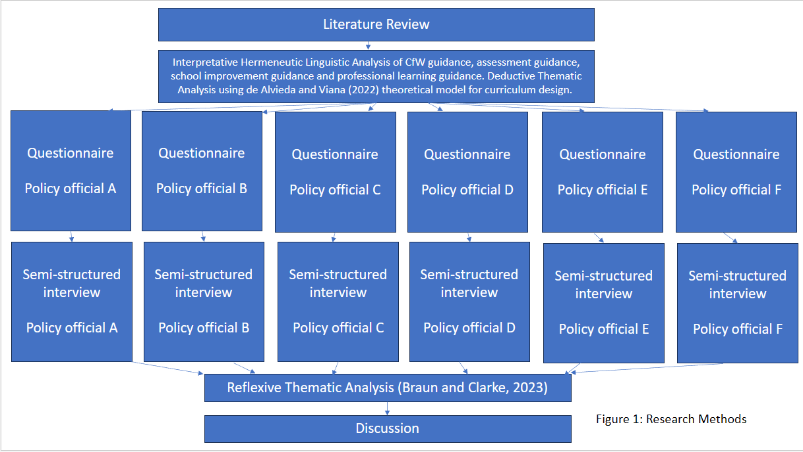
This approach ensures a comprehensive understanding of curriculum design within CfW, incorporating multiple perspectives and aligning with the hermeneutic phenomenological methodology.

3.3 Approach to Sampling
Choosing a purposive sampling approach (Cohen et al., 2018) I utilised the views of 6 policy officials working within the curriculum and assessment division in Welsh Government. From my work during the co-construction phase of CfW and my subsequent role as Professional Advisor within Welsh Government, I identified policy officials with responsibility for CfW policy and responsible for policy decisions that directly influence the lived experience of curriculum design in Wales.
I sought gatekeeper consent from Senior Civil Service (SCS) members responsible for curriculum and assessment. An initial invitation was emailed to 45 policy officials in the curriculum and assessment division. To maintain professional boundaries and ensure ethical considerations, I sent these invitations from my university email address. The email (see Appendix 4) included consent from their SCS, an information sheet (see Appendix 5) detailing the research purpose, and a request for informed consent to participate. Despite the potential risks of interviewing known participants (Mercer, 2007), this provided a unique opportunity to gather valuable policy perspectives on curriculum design, leveraging my insider status as a Welsh practitioner working within the Welsh Government.
Out of the nine responses consenting to participate, I used a boosted sample approach (Gorard, 2003) to select officials who had been actively involved in co-constructing the CfW Framework and guidance with pioneer schools from 2017 to 2021. This ensured that the participants had relevant and extensive experience with the CfW development process, enhancing the depth and relevance of the data collected.

3.4 Research Tools
Questionnaires were utilised to gather information on participants' professional history, current roles, working contexts, experiences co-constructing the CfW framework, and their understanding of the phenomenon. This preliminary data helped direct the interview questions and establish rapport with the interviewees. Participants were asked to complete and submit the electronic questionnaire, provided via Microsoft Form, before attending a semi-structured hermeneutic interview (see Appendix 6 & 7). Upon submission, all responses were anonymised as Participant A, B, etc., as shown in Figure 1.
Following consent to participate in interviews, convenient times were scheduled for each participant. The hermeneutic interview method was selected to gain a deeper understanding of the phenomenon of curriculum design, as opposed to merely capturing immediate reactions typical of phenomenological interviews. Semi-structured hermeneutic interviews allowed policy officials to answer set questions while also exploring emerging topics. Each interview was conducted via the UWTSD Teams App, lasted no more than 1.5 hours, and was recorded and transcribed. Transcriptions were anonymised and returned to participants for member checking, ensuring accuracy and validity. Each participant received a direct email containing only their relevant data.

3.5 Approach to Data Analysis
Maurice Blanchot (1986) in focusing on literary phenomenology noted that writing and language can provide clarity and insights into reality, similar to artistic objects. This study employed a two-step thematic analysis: deductive linguistic analysis followed by inductive reflexive analysis of questionnaire and interview data. The aim was to compare the reality presented in the CfW guidance with the perspectives of policy makers on curriculum design.
A deductive thematic analysis approach was chosen for the CfW Framework. Using the literature on curriculum design, a deductive coding method based on De Almeida and Viana’s (2022) theoretical model was applied (Figure 2). This model, building on Huizinga’s (2004) work, identifying four features of effective curriculum design: existing expertise, subject matter knowledge, pedagogical understanding, and expertise in creating curriculum consistency. The CfW guidance was coded to assess alignment with these categories.
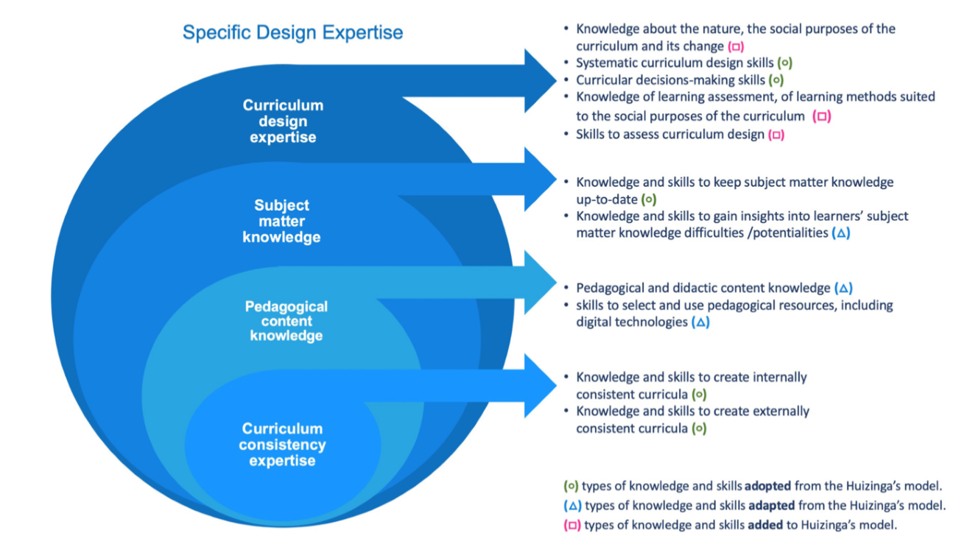
Figure 2: Specific Design Expertise De Almieda and Viana (2022)
As an insider researcher, who had drafted elements of this guidance, I opted for a holistic reading approach to avoid confirmation bias. Using De Almeida and Viana’s framework helped maintain objectivity in identifying relevant themes within the CfW guidance.
Subsequent data, including a reflexive journal and analysis document, were analysed via a reflexive thematic analysis inspired by Braun & Clarke (2022) (see Appendix 8). This approach involved coding and thematic mapping of questionnaire and interview data, followed by thematic synthesis to identify high-level themes relevant to the research questions. Themes from interviews were compared with the deductive themes from the CfW guidance to evaluate their alignment with the established theoretical framework.
This research aimed to provide a comprehensive understanding of how curriculum design is perceived within the CfW policy framework. The intention is to support Welsh practitioners by clarifying expectations and offering guidance on effective curriculum design.

3.6 Ethical Considerations
This project strictly adhered to the ethical guidelines approved by the UWTSD Ethics Committee in January 2024 (see Appendix 9). The research followed the British Educational Research Association’s Ethical Guidelines for Educational Research (BERA, 2018; 2024). Although the project did not involve sensitive personal data, it did engage with participants' professional roles and responsibilities, and all participants were subject to the Civil Service Code (2015). As a civil servant myself, I ensured that the principles of neutrality and anonymity within the Civil Service Code were always upheld.
Initial steps included obtaining gatekeeper consent from the SCS member responsible for the team (see Appendix 4). To avoid any perception of coercion, plain language information sheets and questionnaires were used (see Appendices 5 and 6), and interviews were scheduled at times convenient for participants. Interviews were conducted online via UWTSD MS Teams, recorded securely, and transcribed. Participants were able to choose a neutral venue in which they felt comfortable.
Member checking of interviews was conducted within five days to ensure accuracy and reinforce participants' right to withdraw at any stage. Anonymity was maintained by assigning pseudonyms (e.g., Participant 1) and removing any identifiable references, except for public figures relevant to the project, such as Professor Graham Donaldson, the author of Successful Futures.
All data exchanges with participants were stored electronically on a UWTSD cloud-based server in compliance with GDPR guidelines. Initial personal data were securely stored and password-protected. Paper-based data, including field notes and a reflexive journal, were kept in a locked safe in my home office. During the analysis stage, all data wes anonymised and viewed privately. No data was transported, and no breaches occurred throughout the project.

3.7 Reflexivity
As a practitioner involved in drafting the CfW guidance and the co-construction process since 2017, I am acutely aware of my dual role as both a practitioner and co-policy advisor to those I interviewed. I aimed to leverage my insider expertise to enrich the interview phase, but also followed Moustakas' (2004) recommendation for ‘bracketed’ phenomenology during analysis, striving to minimise the influence of my insider knowledge when identifying emerging themes.
At times, maintaining objectivity was challenging, and my reflexive journal proved invaluable for reflecting on and refining my interview approach, ensuring a focus on the research questions. Interviews were conducted over three weeks, with two interviews on the same day on three occasions. To avoid biases from sequential interviews, I reflected on each interview individually and more deeply on pairs in weekly intervals. During coding, I deliberately avoided analysing data in the order of collection, using anonymised coding to mitigate recognition bias. Although specific phrases occasionally recalled individual interviews, focusing on the research questions during coding helped counteract this bias.
My familiarity with the participants, having worked closely with them, introduced additional challenges. References to our professional relationships surfaced during interviews, highlighting the co-construction process' influence on practitioners' understanding of curriculum design.
The political context also influenced my reflexive process. A new First Minister and Cabinet Secretary for Education had been appointed between data collection and analysis, bringing renewed scrutiny to the CfW reform and providing a different insight to the pressures on the civil service. It had become apparent during the interview stage how unusual it was to be talking to policy officials who all, had not only been in the civil service for over ten years, but all had also been involved in CfW since the start. In talking passionately about this reform, I felt it was important to be mindful throughout the coding process to not become emotionally involved in a reform that I equally care about. I also had to ensure that I remained neutral at analysis stage, avoiding sympathising too much with participants who I work closely with. Returning to the Civil Service Code was important at this stage, to be reminded of the importance of neutrality in particular, to protect the anonymity of the public servants who had agreed to be part of this project.
Reflecting on my enjoyment of some interviews more than others, I noticed early on that my engagement varied. The first interview deviated into discussions about the government's role in education, which, while interesting, was not central to the study. The second interview felt too brief and insufficiently informative. Recognising these differences helped me recalibrate my interview techniques, body language, and affirmations to maintain focus and balance. Pre-interview reflections and post-interview reviews helped me stay aligned with the study’s objectives.
During initial coding, I observed themes emerging in my reflexive journal that risked biasing my analysis. To counter this, I spaced out each stage of Braun and Clarke’s (2022) thematic analysis (see Appendix 8). The familiarisation and initial coding stages were separated by two weeks, and final theme refinement took an additional three weeks. Revisiting Braun and Clarke’s methodology, including example processes, helped ensure that my reflections were grounded in the overarching research questions rather than my initial interview impressions. This disciplined approach to reflexivity will inform and improve my future research practices.

4.0: Data Analysis and Discussion
This section provides a detailed analysis of the data collected throughout this project. The findings are organised into two sections to address the research questions and the project’s aim:
- The role of the CfW Framework guidance in outlining expectations for curriculum design.
- The understanding of curriculum design amongst policy makers

4.1: The Role of the CfW Framework Guidance in Outlining Expectations for Curriculum Design

Within the analysed sections of the CfW Framework, curriculum design appears 120 times, indicating schools' responsibility to design a local curriculum for their learners. The term 'curriculum development' is mentioned 16 times in the same sections, usually in the context of how schools should approach curriculum creation. For example, the CWRE section states:

‘CWRE provision should continually evolve over the long term with ongoing curriculum development’

(Welsh Government, 2021a).

Conversely, in the RVE section, curriculum design is used:

‘The statements of what matters in this Area allow learners to explore and critically engage with a broad range of religious and non-religious concepts, which should be carefully considered and underpin curriculum design’

(Welsh Government, 2021a).

Though there's no clear distinction between the two terms, their inconsistent use risks confusing practitioners, especially those who find the term 'design' daunting. However, it can also be argued that the terms are interchangeable, as their use in the Framework serves a similar purpose. Riddle et al. (2023) advocate for avoiding unhelpful dichotomies in favour of 'curriculum work,' which includes all interactions with curriculum theory, policy, or practice to support learners. They recommend shared sense-making of policy to practice, emphasising placing learners 'at the centre of their own learning' (Ibid).

In a conversation with Stuart Riddle (2024), he noted that using 'curriculum work' instead of curriculum design helped reduce anxiety amongst teachers, making the concept more approachable. This shared sense-making is central to moving curriculum forward, as highlighted in the principle of subsidiarity within CfW policy.

The methodology section detailed the analysis of CfW Framework sections relevant to curriculum design in Wales, using De Almieda and Viana's (2022) theoretical framework, adapted from Huizinger et al. (2014). This framework aimed to determine if Welsh practitioners' roles as curriculum designers align with the framework or if a unique approach is needed for Wales.

Each element of their model (Figure 2) was broken down to code each sentence of the CfW Framework's relevant sections (Figure 3).
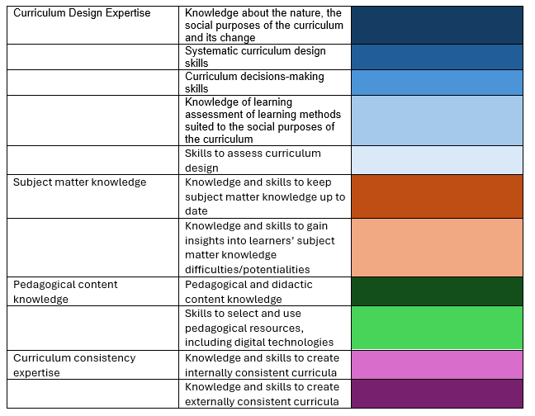
Table 1

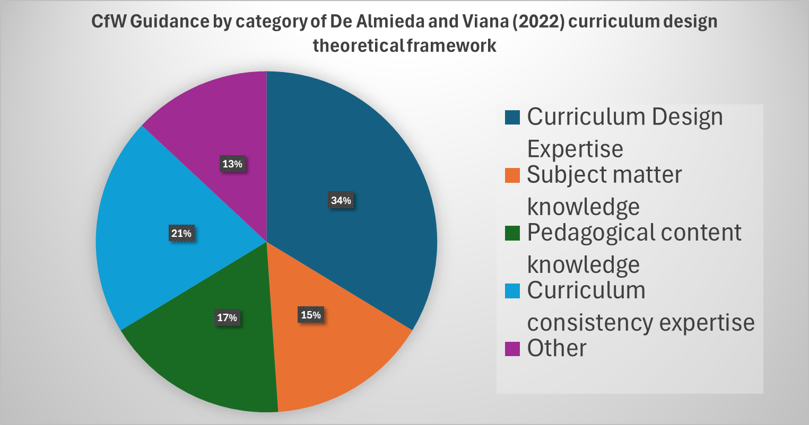
Figure 3

In analysing each sentence of the CfW Framework, I applied my interpretation of the theoretical framework descriptions of effective curriculum design to the document (Figure 4). Recognising my own role in the co-construction of the CfW Framework, I endeavoured to use the exact wording of the CfW Framework and the explanations from De Almieda and Viana's (2022) article, in line with Moustakas' (1994) recommendations for bracketed phenomenology during analysis. For example, Figure 5 shows that while the Health and Wellbeing guidance aligned with De Almieda and Viana's model, it lacked references to curriculum design being determined by accurately assessing learner needs.
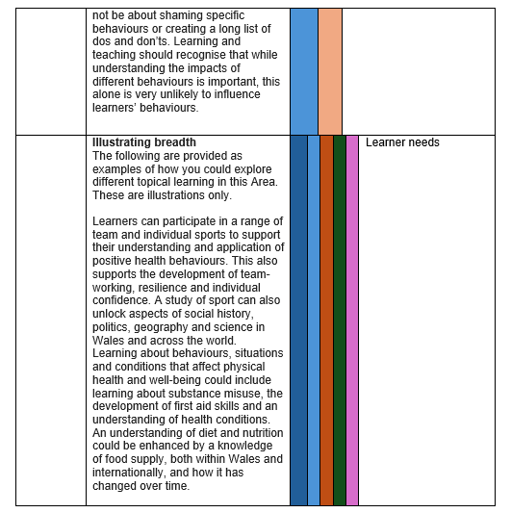
Table 2
My primary interest was to determine how well the overarching categories reflected the expectations for Welsh practitioners to design curriculum in accordance with CfW. Although there are significant synergies between the two frameworks, notable differences also exist. The CfW guidance includes extensive descriptions of what De Almieda and Viana call ‘curriculum design expertise’ and ‘curriculum consistency expertise.’ For instance, many sections outline the overarching purposes of the CfW and the decisions required of school leaders to design their curriculum. While this is expected from a legal government document, it assumes that school leaders can achieve this based on the guidance alone.
Early evaluations of curriculum implementation by Duggan et al. (2022b, 2023) and Morrison-Love et al. (2023) suggest that many Welsh educators are uncomfortable with and unclear about curriculum design, having received no specific training in this area. Additionally, Evans (2023) argues that a lack of understanding among those responsible for professional learning in Wales hampers a coherent understanding of curriculum design within the CfW framework. This issue challenges the successful transition from policy to classroom practice and warrants further exploration.
I then conducted a more detailed linguistic analysis of the CfW framework's component parts to examine the specific demands on Welsh practitioners (Figure 4).
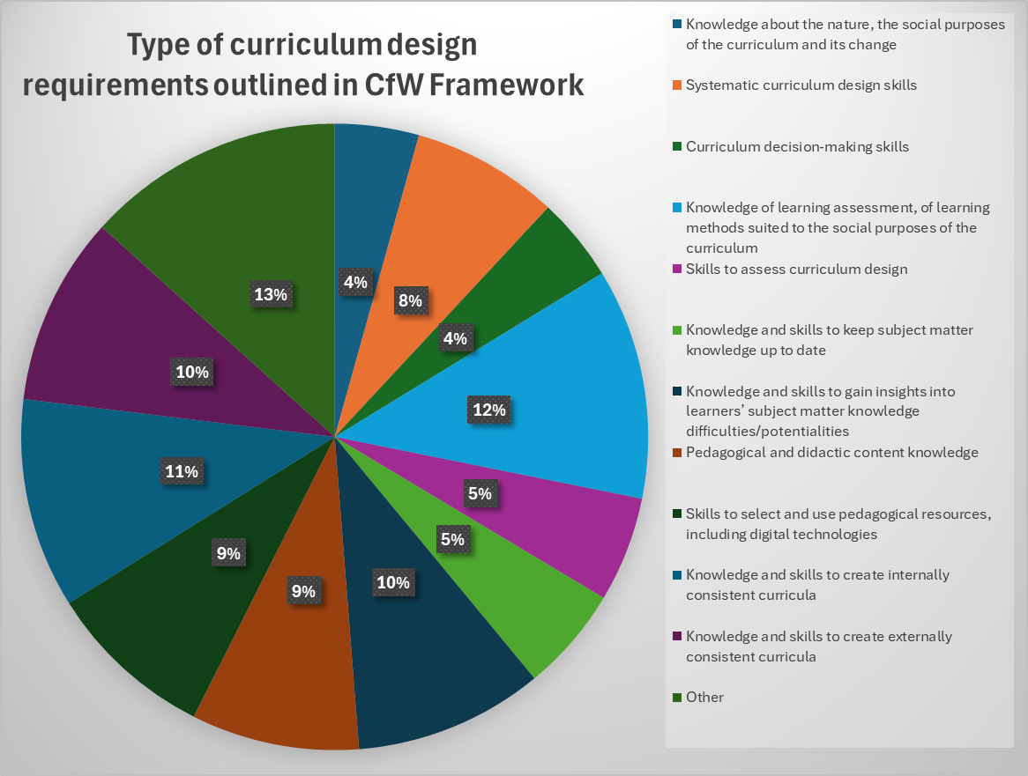
Figure 4
In the analysis, 12% of the CfW Framework sections referenced 'knowledge of learning assessment and methods suited to the curriculum’s social purposes.' This category's significance lies in the varied understandings practitioners must assimilate, highlighting current challenges in Wales (Duggan et al., 2023). For instance, the Camau i’r Dyfodol Phase 2 report by Makara-Fuller et al. (2023) identifies issues faced by organisations in transitioning from the product-oriented NC to the emerging understandings of the process-oriented CfW. This shift challenges long-standing habits and beliefs within the sector. The report recommends that messaging and guidance on CfW be "efficient, clear, and coherent" (p. 72), emphasising the need for a shared understanding of curriculum design to ensure consistent application in classrooms under a process-oriented CfW.
Additionally, 13% of the sections analysed did not align with the theoretical framework, necessitating further exploration. Applying this framework was sometimes challenging due to language differences between the process-oriented CfW and the product-oriented models used in Portugal and the Netherlands. For instance, the emphasis on 'consistency' in the original models aims for locally consistent experiences through a product-oriented curriculum. This contrasts with the CfW’s goal of a consistent national framework, applied coherently within local contexts to meet specific learner needs. Given the agency granted to school leaders to design their curriculum to meet the needs of their learners, achieving the same realised curriculum in each school (Eisner, 1994) is impractical for Wales. This realisation highlighted the difficulties in adopting this product-oriented curriculum design model for Welsh practitioners' experiences. While the model offers useful elements to categorise Welsh practitioners' expectations, it is insufficient in its current form. Whole sections of the CfW Framework did not fit De Almieda and Viana's (2022) categories, as illustrated in Table 2 and Figure 4. Therefore, I focused on identifying themes within the 13% of the CfW Framework sections that did not fit this model (Figure 5).
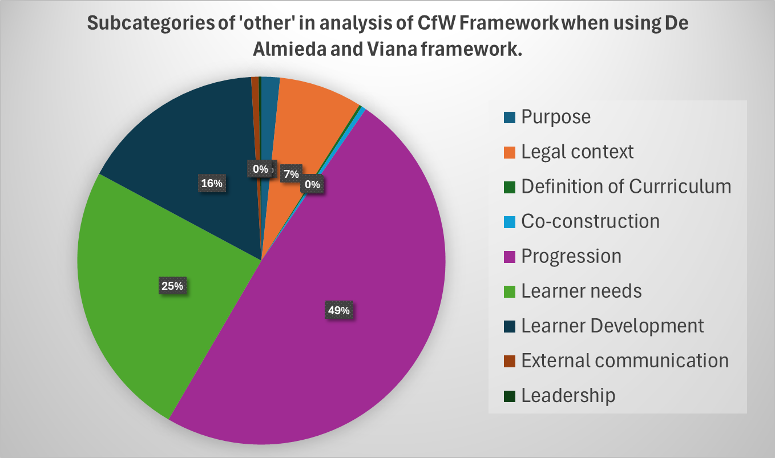
Figure 5
Themes such as purpose, legal content, and the need for schools to communicate effectively with parents and carers are articulated within the CfW Framework, though these are less emphasised compared to the expectations for practitioners. The primary focus is on understanding the needs of learners, understanding child development to design a developmentally appropriate curriculum, and understanding the impact of curriculum on learner progression.
For instance, the Designing Your Curriculum section of the CfW Guidance (Welsh Government, 2021a) specifically highlights the need for practitioners to understand their learners, design curriculum experiences that build on existing knowledge, skills, and experiences, and support the next steps in learning (Table 3).
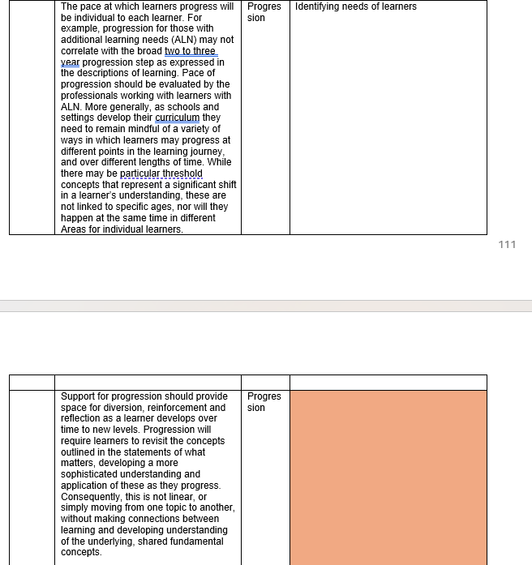
Table 3

The extract in Table 3 illustrates that designing a curriculum within CfW’s mandatory requirements necessitates understanding learners’ needs to determine appropriate pace and content. This learner-focused approach aligns with the process-oriented CfW, which expects curriculum to allow for ‘space for diversion, reinforcement and reflection as a learner develops over time to new levels’ (Welsh Government, 2021a). This is a stark contrast to the social efficiency model of a product-oriented curriculum described by Kelly (2009), where curriculum goals are predetermined, and practitioners aim to guide learners through these goals as quickly and efficiently as possible.
While De Almieda and Viana’s model refers to the ‘social purposes of the curriculum’ (2022), the learner-centred approaches in Wales differ from those in Portugal and the Netherlands, where political influences have pushed curriculum design back toward a product orientation (Leeman et al., 2020). In Portugal, for example, the ‘subject matter knowledge’ and ‘pedagogical content knowledge’ expected from practitioners are largely predetermined in policy. Leeman et al. (2020) noted that Dutch practitioners required support not only in designing curriculum but also in mastering the subject matter to design effectively. This contrasts with the CfW, where one criticism is the lack of detailed content guidance (Evans, 2023b), which challenges practitioners to design coherent learning experiences and risks the equitable experience of learners (Newton, 2020).
The additional expectation for Welsh practitioners to understand developmental needs alongside subject and pedagogical knowledge may seem daunting. However, insights from Portugal (De Almieda and Viana, 2022), the Netherlands (Leeman et al., 2022), and New Zealand (Sinnema et al., 2023) suggest that with sufficient support, Welsh practitioners can gain confidence and design curriculum that fulfil the purposes of CfW. These models emphasise the need for time and shared sense-making over many years. It must be remembered that CfW is in its infancy and early confidence issues are not a predeterminant of success, but the additional support that is provided during this next stage of implementation will be crucial to its successful realisation of CfW.
However, I do feel that this theoretical framework from De Almieda and Viana, in its current form and originally designed for a product orientated curriculum, insufficiently encapsulates what curriculum design means within CfW and therefore the next section outlines the view of policymakers in this area with a view to designing a theoretical framework for curriculum design within CfW.

4.2: Use and Meaning of Curriculum Design
In the CfW Framework, both ‘curriculum development’ and ‘design’ are used. It was crucial to understand why ‘design’ is the predominant term and the reasoning behind its consistent use. According to interviewed policy officials, the term curriculum design originates from its initial use in the Successful Futures report (Donaldson, 2015) and has been subsequently adopted in the CfW Framework.
From the questionnaire responses and interviews conducted with Participants 1-6 (P1-6), several reasons for this term's use were identified. There was no significant debate or conflict about its use during the co-construction phase. Instead, the use of design was a deliberate choice to move away from terms like development or planning associated with the previous NC. This shift reflects the CfW's different purpose and direction, emphasising creativity and the agency given to practitioners to tailor learning experiences to their specific learners and contexts.
Participants' comments highlight the deliberate choice and reasoning behind using design:
‘Reflects better, the nature of the added value that practitioners and school leaders bring to the process under Curriculum for Wales when compared to what they were expected to do under the previous curriculum’
Participant 3
‘Design does incorporate a huge number of elements, whereas planning is something maybe quite linear... it's not just the planning or timetabling [of] it or how you would put this into your school context? You know learners' needs, what do we need to teach? How do we teach it, etc. etc. So it's, you know, it's truly bringing everything together’
Participant 2
Participant 3 noted that there was more debate around the term ‘curriculum’ itself during the early stages of co-construction. As highlighted above, there is a danger that without understanding curriculum as ‘everything a learner experiences in pursuit of the four purposes’ (Welsh Government, 2021a) as opposed to its often defined term from the Latin as a ‘course of study’ (OED, 2024), that practitioners in Wales will continue to search for the programmes of study familiar to them in the previous NC, and miss the opportunity afforded to them to put various elements together to design learning for their own learners, making their education more purposeful than ‘covering the course’. What was explored in greater depth, however, was what this expectation for curriculum design meant in practice for various elements of the sector, the key themes of which are explored below.
In conclusion, the term curriculum design in the CfW Framework signifies a fundamental shift from the traditional, prescriptive approach of the NC to a more creative, flexible, and holistic approach. This change is intended to empower practitioners to design educational experiences that are more relevant and responsive to their learners' needs and contexts.

4.3: The understanding of curriculum design amongst policy makers.
The following section outlines key findings from questionnaires sent to all officials within the Curriculum and Assessment Division of the Welsh Government. Based on the questionnaire outcomes, I utilised a boosted sampling approach to interview six policy officials involved in the co-construction phase of CfW. These officials, due to their experiences in supporting the design of the national CfW Framework, likely had increased insight into the meaning of curriculum design. Participants 1-6 (P1-6) participated in 1.5-hour hermeneutic semi-structured interviews over three weeks.
The data from the questionnaires and interviews were anonymised and analysed together using Braun and Clarke’s (2022) reflexive thematic analysis (Appendix 8). To protect the anonymity and adhere to the civil service code (2015), no further details about the participants will be shared beyond Table 4 to avoid the risk of identifying their role descriptions or responses, especially those also made in the public domain.
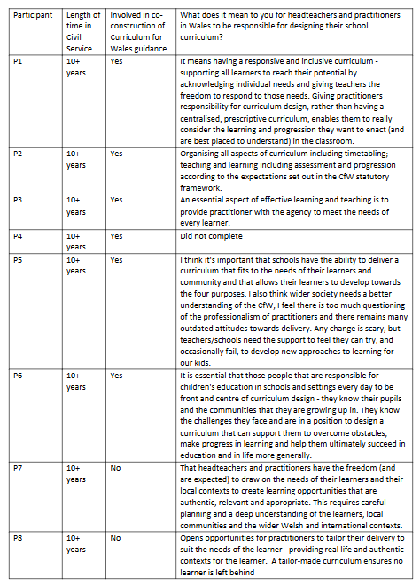
Table 4
On the analysis of this data, the following themes were identified as policy makers understanding of curriculum design in CfW.

4.31: Collective Responsibility and Shared Sensemaking
In the CfW Framework, collective responsibility is a cornerstone of effective curriculum design. All participants highlighted the importance of engaging the entire sector in a genuine co-construction process to establish a shared understanding of practical curriculum design. This is reminiscent of the bi-directional approach found to be crucial in Finland by Pyhalto et al. (2019). This collective approach ensures that the diverse challenges facing the education sector in Wales are addressed through ‘sharing problems and jointly developing solutions’ (Welsh Government, 2021a).
The CfW Framework guidance underscores the expectation that the entire Welsh education system is collectively responsible for learner progress. This responsibility extends beyond individual organisations and involves a cooperative effort across various agencies. Successive education ministers, advised by policy officials, have recognised the complexity of the issues in the education sector and the need for multifaceted solutions that everyone must jointly own (Miles, 2024; Neagle, 2024).
It was acknowledged by several participants that this has as much an implication for the ways of working for Welsh Government, as it does for practitioners in Wales. Whilst it is beyond the scope of this study, the impact of co-construction on the professional identity of civil servants was a reoccurring theme, as the development of CfW and subsequent education policy is different to previous ways of developing policy. Whilst it was acknowledged that this was not necessarily an embedded way of working within the entirety of Welsh Government, all participants concluded that education policy has modelled the expectations for the ways of working established in the Wellbeing of Future Generations Act (Welsh Government, 2015).
In many ways the same can be said of those administering the system at a government level or middle tier colleagues who have also only worked in the previous accountability system. Indeed, Makara-Fuller et al. (2023) outlined a range of implications of the process orientated CfW for future policy direction and system support. However, all participants were positive of the impact of co-construction to date in developing the critical mass needed to realise CfW.
‘Curriculum for Wales has been a catalyst on a number of different levels...raising the level of debate about what learning is...changing how we view and go about our business...engaging with practitioners and bringing them into the heart of a process, before legislation has been started, it is a fundamental departure from what I’ve previously experienced.’
Participant 3
Participants discussed the need for active involvement in the curriculum design process, stressing that shared understanding is achieved through hands-on engagement rather than passive explanation, with one participant commenting that the easiest way to achieve this is:
‘Not to explain it to them, but to walk them through it, to hold their hand and show them...this is how we do things and expose them to that. And over a very short period of time...they recognise the benefit.’
Participant 3
This view was supported by several other participants who highlighted that for those who have not been engaged with this type of working to date, potentially feel as if they have ‘missed out on the product [that other] schools have got out of it’ (Participant 6), with this being seen as the priority of future support in realisation.
A significant cultural shift was felt to be needed to foster genuine trust and equity of voice in co-construction spaces. Prior to the implications of the Covid-19 pandemic, there was a feeling of momentum that was gained during the pioneer schools process: ‘what we had with the pioneers were a critical mass of people who got the policy, who owned it, and could then take this forward’ (Participant 4). All participants talked about the power of bringing a very broad range of experiences together, being mindful that the role of government within the process of co-construction will remain to provide policies that are suitable across the whole of Wales. The role of policy officials then becomes the effective facilitation that seeks to ensure that everyone has someone or something that they can relate to, a regular call for worked examples from the profession (Duggan et al., 2022b; 2023)
‘it’s a really convenient excuse that...“what they do isn’t going to suit us here”. Whereas by including all these different types of schools and all these different types of geographical and linguistic conditions, there’s going to be someone out there who’s similar to me. If I can find that somebody who’s similar to me and they tell me, “yes, this works well, I’ll give it a go then”.
Participant 6
The commitment to co-construction has continued beyond the initial CfW development phase, with several participants also referring to the National Networks as a mechanism ‘building that capacity and understanding across the system’ (Participant 4) and the completion of other guidance including the addition of more detailed RSE and Education Other than at School (EOTAS) guidance. Participants commented on the need to remember the challenge ahead for the system and the inevitable time that it would take to embed, when referring to the practitioners that are in the system undertaking this work:
‘they’ve been taught in the national curriculum, and they trained in the national curriculum. They’re now teaching in the national curriculum. It is going to be challenging.’
Participant 2
The implication of this on curriculum design is a stark contrast to expectations of CfW and recognised by policy officials:
‘we are asking a lot. We’re expecting a lot of people [to move from] a quite prescriptive system where flexibilities within the old programmes of study were basically the voids in them...it was flexibility where we don’t tell you that you have to do something’
Participant 2
The systemic shift required by the CfW necessitates patience and long-term commitment. The transition from a prescriptive system to one that allows more flexibility and creativity will take time, highlighting the need for patience and ongoing support:
“There is a bit of a waiting game because obviously we are talking about starting at age 3 and finishing at age 16 and whether the system is willing to wait that long...but the greatest results are when these young people are grown up and are happy, well-adjusted adults...we have to share those messages far and wide so that we create confidence in what we are doing.”
Participant 6
The social realisation model presented by Sinnema et al. (2023) in New Zealand promotes the idea that achieving a shared understanding of curriculum design is an ongoing process, suggesting that the ship has not sailed in Wales. Whilst it may feel that this is taking longer (within a difficult period for capacity in the system), it is also worth remembering that the NC required schools to design their own curriculum, and yet 30 years later, the conversation continues, and the product orientated NC has failed to raise standards of learning in Wales (Evans, 2024). Overcoming misunderstandings about the co-construction of the CfW Framework is crucial, as some believe that those involved in the pioneer process had advantages not available to others in the sector (Newton, 2020). One participant highlighted a persistent challenge regarding pioneer schools:
‘They’re ahead of us because they had this, without realising that it's not a product; it is a process. It is often quite a painful process of reflection, introspection, and being open-minded enough to go, “Okay, you know what? Things aren’t working, let’s change them up.” Or, “This won’t work for this cohort” or recognising that some content is outdated. We talked about the science and maths stuff; some of it is just comforting to use because you’ve done it for 20 years. But if you talk to industry, they’re telling us it’s decades old.’
Participant 1
The commitment to the profession to continue to support them in successfully designing curriculum was palpable throughout the data gathering process. As a previous practitioner turned policy official known to each of the participants throughout the co-construction process, there is a high chance of confirmation bias. However, it is also this close relationship that provides me with confidence that this is a genuine commitment from this team to continue curriculum design through the process of co-construction, despite its increased cost and time resource from other ways of developing policy more familiar to their training. It is highly unusual for policy officials to remain in role more than two years but the commitment from team members, where it is common to have worked on this policy since its inception and an ongoing commitment to seeing it work in practice, confirms my belief that there is a strong commitment to this way of working as demonstrated in Appendix 10.
The collective responsibility and shared sensemaking embedded in the CfW Framework was a common reflection amongst all policy officials, reflecting a commitment to a collaborative, co-constructive approach to curriculum design. This approach not only fosters a more inclusive and flexible educational system but also supports the professional development of educators and policymakers, ensuring that the curriculum evolves to meet the diverse needs of learners across Wales. However, it was also acknowledged by all that this requires effective communication of this process and a clear understanding of the CfW Framework that is an output of it.

4.32: Accurate use of the CfW Framework in identifying purposeful learning
Calls for increased specificity in school-level curriculum design (Evans, 2024; Crehan, 2024) highlight the misunderstanding of the role of the national CfW Framework in guiding practitioners. Policy officials identified that understanding curriculum design through the CfW principles is crucial, as misunderstandings persist about the Framework's purpose compared to the previous NC guidance. Many participants emphasised that the CfW Framework should be viewed as a starting point for local curriculum design, rather than a ‘monolithic thing’ because the ‘profession are not monolithic’ (Participant 1), needing a range of different entry points to support them. They also recognised that the diverse practitioner body in Wales requires policies that respond to various needs during implementation.
‘You can't just take what is in the national Curriculum for Wales Framework and say 'there,' it’s not some magical thing that you can just take and there's your lesson. It's not. You have to work through it. You have to do the design, the planning design, and then the teaching and learning that comes below that. It is what it says, it's a framework, it's framework guidance.’
Participant 6
There is a clear expectation that practitioners use the Framework alongside their professional expertise to design a curriculum for their learners. Participant 5 highlighted in their questionnaire response (Table 4) the agency given to qualified practitioners to make changes within the reform's safe space. The collective responsibility across the sector supports the underlying principles of agency and subsidiarity from Successful Futures (Donaldson, 2015). This responsibility allows for more purposeful and relevant learning but it is reliant on those practitioners wanting, and feeling able, to do this.
‘I feel there is too much questioning of the professionalism of practitioners and there remain many outdated attitudes towards delivery. Any change is scary, but teachers/schools need the support to feel they can try, and occasionally fail, to develop new approaches to learning for our kids.’
Participant 5
Previous NC programmes of study provided broad content lists for various key stages. However, understanding how to use the principles of progression and conceptual understanding in the CfW Framework is a different process. This is reflective of what various curriculum theorists have highlighted as the challenge of moving from a product curriculum to a process curriculum (Stenhouse, 1979; Kelly, 2009; Makara-Fuller et al., 2023) and the ingrained habits that practices within the NC may have conditioned practitioners in Wales to move away from when trying to use the CfW Framework in the same way, misusing for example the descriptions of learning as the closest looking item to the previous NC levels (Welsh Government, 2024).
‘If you take the descriptions of learning in that way, you end up with a totally unimaginable curriculum with lots of small bits pointing towards individual descriptions of learning, which was never what they were designed to do. You end up with an overloaded curriculum, which was the whole point [of the change]’
Participant 4
The 1991 NC also emphasised that schools would design their curriculum in various ways, reflecting individual values, policies, and contexts (CCW, 1991). However, a report to the Secretary of State for Wales later identified weaknesses in curriculum planning (ACAAC, 1999). Whilst it is possible that the requests for increased specificity reflect early teething problems of understanding the CfW Framework, other types of support may be needed to understand how to use the CfW Framework, as previous lessons have taught us that greater detail is not necessarily a prerequisite for successful curriculum design.
‘I think curriculum design wise; I think what is there is sufficient without being prescriptive. However, I think that it’s that ability to use it effectively, which may be the missing piece... it’s not just content...if people are able to spend the time to not only read it, but consider it and analyse it, I think it’s relatively clear to be honest. But that’s me reading something that I had a hand in writing and also, I was intimately involved in that process myself for several years.’
Participant 3
A gap in the CfW Framework emerged, discussing the support mechanisms needed moving forward. The De Almieda and Viana model emphasises the need for subject matter expertise (2022), however, the accurate use of the framework was difficult if the specialist subject expertise was not present, and this was a reoccurring theme of those participants who discussed the framework’s development stage.
‘In an ideal world...people who were specialists...to go through that process, who were secure in their knowledge, secure in their confidence...that’s not a criticism of the workforce, especially primary schools where you’re not specialists...but let’s have that conversation of what do you really need? What’s your real context? What are your barriers and how could we work with you to help you get to where you want to be...if they are not supported to do so, that’s a failure of the state, in my opinion, that is not a failure of the profession’
Participant 1
Several participants questioned whether the framework alone is sufficient, given the challenges practitioners face in understanding and using it as intended.
‘Where you have extra questions around things like non-specialist teachers, around disciplinary knowledge, I think sometimes where the framework maybe falls down a bit is you’re expecting ... for people to come to it and go “ohh, I get this.'"
Participant 1
The question then becomes what happens when practitioners don’t 'get this'. The conversation shifted back to collective responsibility and the role of communication and opportunities for further co-construction becoming increasingly important, hence the introduction of the National Networks and maintaining a proximity to the profession because it becomes more important for policy makers to:
‘understand the need and being able to direct resources to meeting that need... the needs of the profession [are] going to be variable as...people are on very different points on that change curve...we’re talking about a long-term change programme and therefore you need to take a longer-term view’.
Participant 3
With the role of co-construction playing an increasing part in supporting accurate use of the CfW Framework, the next aspects of curriculum design were then moving towards the role of practitioners in the system and what is needed from a local leadership perspective.

4.33: Responding to the needs of learners
A prominent theme amongst participants was the significant focus on practitioners' ability to identify and respond to learner needs through their curriculum design. Unlike the previous NC, CfW aims to empower practitioners with the agency to decide what and how to teach, tailored to the unique needs of their learners. The framework provides mandatory elements that are an entitlement for all learners. The onus of local curriculum design also has a role for practitioners closest to their learners, being able to respond effectively to their needs and support the next steps in their progression.
‘There has to be a ground-up level, where practitioners are looking at, and understanding what progression means, and bringing their specialism and their creativity and understanding of their learners in identifying and sharpening content that is pointing towards that progression’
Participant 4
This approach underscores the importance of practitioners using their professional judgement and expertise to shape the learning experience, ensuring it is meaningful and relevant to their learners. Participants emphasised that effective curriculum design should be a collaborative process. Practitioners are expected to understand and utilise the CfW Framework in line with their school's vision and context, working together within and across schools. This collaborative approach ensures that no teacher should be isolated in the curriculum design process. Indeed, the professional standards for Wales (Welsh Government, 2020) has a particular focus on collaboration with a view to sharing effective pedagogy, and therefore a coherent policy expectation for all practitioners to be provided for this opportunity by their school leadership.
The agency of the practitioner to meet the needs of their learners was deemed crucial in this process and the use of the framework in supporting this was seen as a prerequisite for coherent curriculum design. When discussing the flexibility afforded by the statements of what matters to support this, one participant commented that:

‘I think they’re far more helpful in a sense to be able to take those component parts of learning, those different contexts, different content and draw them together into something that’s much more meaningful for the learner and not just in terms of content, but the way that you approach it, the way you communicate it…curriculum design means it’s a careful deliberate ability to create flexible and meaningful learning’
Participant 4
However, there are a series of steps within this expectation that policy leads were aware are challenging for the sector, especially in the climate of a considerable change programme, affected by diminishing budgets. In particular, the requirement of subject specialisms to make purposeful choices around content selection for learners is not equitably available across the 3-16 continuum. Whilst the expectation around collaboration is admirable, especially around the ministerial direction of school to school working to achieve a shared understanding of progression (Welsh Government 2021a), many schools are reporting capacity and expertise barriers being insufficient to instil confidence in this process as opposed to specificity within the CfW Framework itself (Duggan et al, 2022b; 2023). Without a sound understanding of the disciplinary progression that is possible, there is an increasing concern that practitioners cannot make decisions around what is purposeful to include in their school level curriculum design and that more support is needed.
‘We’re taking a long-term culture shift and it's going to be uncomfortable...what is clear is we need to provide more...and tools to help people see what this looks like...what we're trying to do is [give] people the scope and agency to use their professional skills’
Participant 4
However, the question of selecting content is not the only prerequisite of the process orientated CfW. Within the Continuing the Journey guidance (Welsh Government, 2024), it is made clear that the content selected within school level curriculum design process are only part of the process and act and ‘vehicles’ to realising the four purposes. Indeed, in addition to identifying the needs of learners the whole school curriculum is a key expectation of CfW. What Eisner (1994) refers to as the ‘hidden curriculum’ was references by numerous participants and the expectation of each learning experience children will benefit from because of school level design.
‘When you have a system that just says as long as you deliver what’s on this page, we’ll just tick it off and say learners can do it...talk about healthy eating, but healthy eating isn’t just we’re going to have a lesson...it’s pointless if you go to the cafeteria and it’s all chips...there’s no outside space...we’re not taking them outdoors...they’ve attained healthy eating...[if] they don’t have the tools to put any of it into practice...it’s thinking about how what is the most optimal way for the learners in front of me’
Participant 1
Each participant acknowledged the need of the profession to understand child development as a prerequisite for designing progressive curriculum. The habits of the previous NC to work the way through content has hampered the confidence of practitioners to decide what is both purposeful and progressive in their school level design. The analysis of the Framework demonstrated this as a gap in the De Almieda and Viana model when applied to CfW, and also a clearly identified element of policy expectations of curriculum design. Reflective of the deliberate change from the NC to CfW, one participant outlined that:
‘There’s part here about child development and what progression is...when you’re designing your curriculum, you’re not trying to achieve outputs, you’re trying to understand what the development of the learner looks like, and using that to understand where that learner is in relation to that and what support they need to make their next steps.’
Participant 4
Whilst there is an admirable commitment to provide agency to practitioners to identify and respond to the needs of their learners, there is also a responsibility for those in positions of leadership to support when necessary. In a professional conversation with Professor Donaldson (2022), he said the word ‘agency’ is much more useful than ‘autonomy’ as the profession are not being left to their own devices, but rather are bound within a mandatory framework, that as highlighted above, they need to understand to design curriculum effectively. Whilst the notion of subsidiarity expects decisions to be taken closest to the classroom, he also emphasised the expectation to ‘step in’ when things were faltering. This was a common feature of all policy officials’ responses, that their role is to ensure that the appropriate support is put in place when needed but ultimately the education sector were in a better position to decide what their own learners needed to make progress.

4.34: Coherent local leadership
A recurring theme among policymakers is the focus on a locally designed curriculum within the CfW Framework. One of the criticisms of CfW has been its expectation on practitioners to be curriculum designers without specific training. However, it was noted by several participants that the legal duties for curriculum design rest with the headteacher and governing body/management committee of a school. It therefore begs the question as to what the role of leadership is within curriculum design when the principles set out in the Designing your Curriculum and Continuing the Journey sections of the CfW Framework, articulate the need for a vision and enactment of a school level curriculum coherent with the expectations in the national CfW Framework.
Doyle (1977) argues that many educational changes have been stunted by not getting to the classroom level, that real educational change happens in our classrooms. Similarly, Donaldson’s view of subsidiarity is an expectation that decisions should be taken closest to the classroom (2022). The relationship between the leadership of curriculum design within a school and the fidelity to that vision within each classroom is a clear component of coherent curriculum design. Indeed, one participant noted that for each practitioner to have responsibility for curriculum design could be a risk to coherence if they acted independently of the leadership and vision of curriculum design within a school; the relationship between the two is crucial.
‘That wider complex web of where curriculum sits in that wider space, especially around things like health and wellbeing...literacy, numeracy and accessing the curriculum...that wider social context, the attitude and the social contract between parents, learners, and schools...so it has to be coordinated at a school level, it has to be conceived as a school thing’
Participant 1
This is also reflected within the requirements of Designing your Curriculum section of CfW guidance, where the audience is school leaders. It seems therefore logical that local leadership of curriculum design must reach to leadership of every classroom in Wales. However, there is a clear expectation in policy that this is aligned to the National CfW Framework, coherently led at a school level and not an expectation from Welsh Government that every practitioner needs to be a curriculum designer on their own, but within a coherent team that fulfils the needs of their learners and local context. Doyle (1977) argued that there is a danger that classroom practitioners publicly comply with leadership protocols, but the moment classroom doors are shut, existing habits continue, resulting in an ever-chasing policy to practice loop that does not go beyond public compliance.

‘there’s the curriculum design at school or cluster level, but then you’ve also got...designing your curriculum from day to day because that is not new to any teacher...this concept of curriculum design is something you identify with because it is something you are doing in your classroom...there is a need to support them to consider the purpose of that learning and teaching in their classroom, that is curriculum design’
Participant 6
The role of each practitioner is to therefore ensure that the needs of the learners in front of them are coherently met, but there are different leadership levels that this understanding should come from, again because we are all collectively responsible for the learners in Wales.

5.0: Conclusions

5.1: How is the term ‘curriculum design’ used within Curriculum for Wales guidance?
As outlined in section 4.1, the CfW Framework does not provide a specific definition of curriculum design but rather outlines the legal expectations and principles to consider in local curriculum design. However, there are concerns that this guidance is too complex and fragmented for practitioners to effectively use. While the curriculum design model by Almieda and Viana (2022) was somewhat helpful, it did not fully capture all the expectations of curriculum design within CfW.

5.2: How is the term ‘curriculum design’ understood by policy officials within the Welsh Government?
The data analysis reveals a strong alignment between the CfW Framework and policymakers' understanding of curriculum design. Both highlight the importance of a coherent approach that prioritises practitioner agency to identify learners' developmental needs within their local and national contexts. While the framework offers clear structure, it is not yet fully understood by all practitioners in Wales, necessitating more practical exemplification. Both the Framework and policymakers call for consistent interpretation and application through shared sensemaking and ongoing co-construction. There is consensus on the need for professional learning to equip practitioners with the skills for effective curriculum design under the CfW, acknowledging the transition from the previous product-oriented NC will take time. Policymakers are committed to creating a lasting impact beyond administrative changes.

5.3: Contribution to knowledge and recommendations
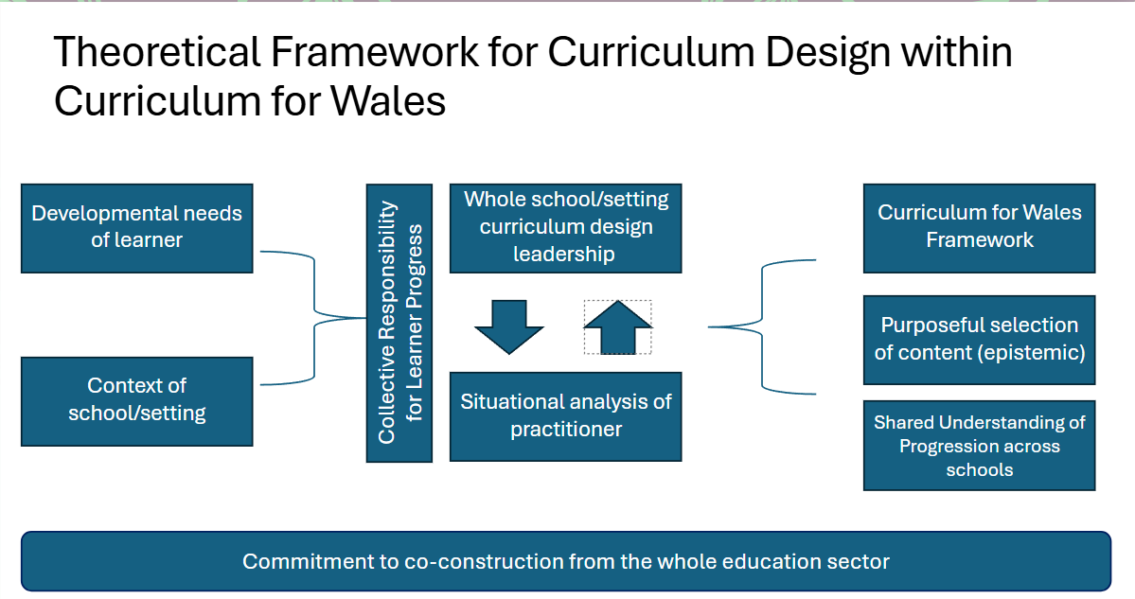
Figure 6
With no other contributions outlining the meaning of curriculum design within the context of CfW, this project offers a unique perspective. Using a hermeneutic phenomenological approach, Figure 6 presents a theoretical framework for curriculum design within CfW policy. Policy officials emphasise co-construction, requiring collective responsibility across the sector to ensure curriculum genuinely encompasses "everything a learner experiences" (Welsh Government, 2021a). This involves practitioners closest to learners accurately identifying their developmental needs, understanding their school context, and utilising the CfW Framework as intended. Practitioners can then purposefully select content and test its rigour with peers within and across schools. Day-to-day curriculum design manifests as this understanding is coherently applied within schools, with leadership quality-assuring the process and practitioners designing learning to support learner progress.
It is recommended that this theoretical framework is tested with a range of practitioners to see if it accurately reflects the experience of curriculum design in Welsh classrooms. As a current policy official there are several recommendations that this study has led to for future policy design in this area and can be found in Appendix 11.

6.0: References
Al-Ababneh, Mukhles. (2020) 'Linking Ontology, Epistemology and Research Methodology', Science & Philosophy Volume 8(1), pp. 75-91.

Andrews, G. et al. (2024) Curriculum for Wales Framework Guidance – Journey to Rollout Consultation Final Report. Available at: Curriculum for Wales Framework Guidance - Journey to Rollout Consultation: final report (gov.wales) (Accessed 31st January 2024).

Apple, Michael.W. (2009) Ideology and Curriculum. Abingdon: Taylor and Francis.

Beauchamp, G., Adams, D. and Smith, K. (2023) Pedagogies for the Future. Oxon: Routledge.

Ben-Peretz, M. (1990) The teacher-curriculum encounter: Freeing teachers from the tyranny. New York: University of New York Press.

Biesta, G. (2021) World Centred Education. London: Routledge.

Blanchot, M. (1986) The Writing of Disaster. Lincoln: University of Nebraska Press.

Braun, V and Clarke, V. (2022) Thematic Analysis: A Practical Guide. London: Sage.

British Educational Research Association (BERA) (2018) Ethical Guidelines for Educational Research (4th edition). Available at: https://www.bera.ac.uk/publication/ethical-guidelines-for-educational-research-2018-online (Accessed on 2nd April 2022).

British Educational Research Association (BERA) (2024) Ethical Guidelines for Educational Research (5th edition). Available at: Ethical Guidelines for Educational Research, fifth edition (2024) | BERA (Accessed on 10th April 2024).

Bruner, J. (1977) The Process of Education. London: Harvard University Press.

Civil Service Commission (2015) The Civil Service Code. Available at: The Civil Service code - GOV.UK (www.gov.uk) (Accessed 1st January 2022).
Cohen, L, Manion L and Morrison, K, (2018) Research Methods in Education, 8th edition (Routledge: Abingdon).

Collins English Dictionary [online] Available at: CURRICULUM definition and meaning | Collins English Dictionary (collinsdictionary.com) Accessed 2nd June 2024.

Connell, R.W. (1985) Teachers’ work. Sydney: George Allen and Unwin.

Crehan, L. (2024) ‘Raising standards of attainment across Wales: Lucy Crehan, International Education Consultant, Crehan & Co. Friday 26th April, 2024 [Online conference speech] Policy Forum for Wales keynote seminar: Next steps for curriculum reform and implementation in Wales. Available at: Westminster Forum Projects | Next steps for curriculum reform and implementation in Wales (policyforumforwales.co.uk) (Accessed: 26th April 2024).

Creswell, J.W. and Poth, C.N. (2017) Qualitative Inquiry and Research Design, 4th edition. Sage: London.

Curriculum Council for Wales, (1991) The Whole Curriculum 5-16 in Wales: principles and issues for consideration by schools in curriculum planning and implementation. Cardiff: Curriculum Council for Wales.

Curriculum for Wales (2023) [Facebook]. Available at: https://www.google.co.uk/url?sa=t&rct=j&q=&esrc=s&source=web&cd=&ved=2ahUKEwjyk8WS-cuDAxX0h_0HHRN5DakQFnoECBQQAQ&url=https%3A%2F%2Fwww.facebook.com%2Fgroups%2F686606212084229%2F%3Flocale%3Den_GB&usg=AOvVaw22sRM194QHq0OcmQ95XTL_&opi=89978449n (Accessed 7th January 2024).

De Almieda S. and Viana, J. (2022) 'Teachers as curriculum designers: What knowledge is needed?'. The Curriculum Journal, 34, pp. 357-374.

Deng, Zongyi. (2020) Knowledge, Content, Curriculum and Didaktik. Abingdon: Routledge.

Donaldson, G. (2015) Successful Futures. Available at: https://gov.wales/sites/default/files/publications/2018-03/successful-futures.pdf (Accessed: 21st April 2015).

Donaldson, G. (2016) 'A Systematic Approach to Curriculum Reform in Wales', Wales Journal of Education, 18(1), pp. 7-20.

Donaldson, G. (2022) Professional conversation discussing the definition of curriculum and curriculum design within CfW, 18th November 2022.

Doyle, W. (1977) The practicality ethic in teacher decision-making. Interchange 8, pp. 1–12.

Duggan, B; Thomas, H; Davies-Walker, M; Sinnema, C; Stewart, S; Cole-Jones, N; Glover, A; Griffiths, M (2022a). Scoping study for the evaluation of the curriculum and assessment reforms in Wales: final report. Cardiff: Welsh Government, GSR report number 50/2022.

Available at: https://gov.wales/scoping-study-evaluation-curriculum-and-assessment- reforms-wales (Accessed: 13th July 2022).

Duggan, B, Thomas, H, Davies-Walker, M, Sinnema, C, Cole-Jones, N, Glover, A. (2022b) Qualitative research with practitioners on preparations for curriculum and assessment reforms, 2022. Cardiff: Welsh Government, GSR report number 8/2022. Available at: Qualitative research with practitioners on preparations for curriculum and assessment reforms, 2022 | GOV.WALES (Accessed: 28th June 2022).

Duggan, B; Thomas, H; McAlister-Wilson, S; Roberts, L; Sinnema, C; Cole Jones, N; Glover, A (2023). Research with schools on the early implementation of Curriculum for Wales: Wave 1 report. Cardiff: Welsh Government, GSR report number 49/2023. Available at: Research with schools on the early implementation of Curriculum for Wales: Wave 1 report (gov.wales) (Accessed 27 April 2023).

Egan, D and Roberts-Ablett, Y (2023) ‘Wales’, CIDREE Yearbook 2023: The Core Curriculum, pp. 67-76. Available at: CIDREE Yearbook 2023 – Cidree – Consortium of Institutions for Development and Research in Education in Europe. (Accessed: 19th November 2023).

Eisner, E. (1994) Cognition and Curriculum Reconsidered. New York, Teachers College Press.

Evans, G. (2021) ‘Back to the Future? Reflections on three phases of education policy reform in Wales and their implications for teachers’, Journal of Educational Change, 23 (3), pp. 371-398.

Evans, G. (2023a) ‘Scratching beneath the surface: Using policy archaeology to better understand education reform in Wales’, Management in Education. ISSN 1741-9883.

Evans, G. (2023b) ‘A new dawn or false hope? Exploring the early implementation of Curriculum for Wales, Education Inquiry, pp. 1-15.

Evans, G. (2024) ‘Utilising curriculum reform to improve standards across Wales and narrow the inequality gap’: Dr Gareth Evans, Director of Education Policy, University of Wales Trinity Saint David. Friday 26th April, 2024 [Online conference speech] Policy Forum for Wales keynote seminar: Next steps for curriculum reform and implementation in Wales. Available at: Westminster Forum Projects | Next steps for curriculum reform and implementation in Wales (policyforumforwales.co.uk). (Accessed: 26th April 2024).

Gatley, J. (2020) 'Can the New Welsh Curriculum achieve its purposes?', The Curriculum Journal, 31(2), pp. 202-214.

Gorard, S. (2003) Quantitative Methods in Social Science. London: Continuum.

Handelzalts, A. (2019) ‘Collaborative Curriculum Development in Teacher Design Teams’, in Pieters, J. Voogt, J. and Pareja Roblin, N. (eds), Collaborative Curriculum Design for Sustainable Innovation and Teacher Learning. Available at: https://link.springer.com/content/pdf/10.1007/978-3-030-20062-6.pdf (Accessed 27th June 2023).

Hughes, S and Lewis H. (2020) 'Tensions in current curriculum reform and the development of teachers' professional autonomy', The Curriculum Journal, 31 (2), pp. 290-302.

Huizinger, T., Handelzalts, A., Nieveen, N. & Voogt, J. (2014) ‘Teacher involvement in curriculum design: Need for support to enhance teachers’ design expertise, Journal of Curriculum Studies, 46(1), pp. 33-57.

Impact Wales (2023) [Twitter]. Available at: https://x.com/impactwales?s=21&t=9ATOY_6qeNSihcdmIO9iGQ (Accessed 7th January 2024).

Kaufman, S.A. (1995) At home in the Universe: the search for the laws of self-organization and complexity. Oxford: Oxford University Press.

Kelly, A.V. (2009) The Curriculum Theory and Practice (6th Edition). London: SAGE.

Kneen, J et al. (2020) 'Curriculum integration: the challenges for primary and secondary schools in developing a new curriculum in the expressive arts', The Curriculum Journal, 31 (2), pp. 258-275.

Leeman, Y, Nieveen, N, de. Beer, F and van der Steen, J. (2020) 'Teachers as curriculum makers: the case of citizenship education in Dutch schools', The Curriculum Journal, Vol 31(3), pp.495-516.

Luke, A., Woods, A. and Weir, K. (2013) ‘Curriculum design, equity and the technical form of the curriculum’, in A. Luke, A. Woods and K. Weir (eds), Curriculum design and equity: a primer and model. New York: Routledge, pp. 7-39.

MacDonald, A. et al. (2016) ‘Teachers’ Curriculum Stories: Perceptions of preparedness to enact change’, Educational Philosophy and Theory, 48(13), pp. 1336-1351.

McKernon, J. (2008) Curriculum an Imagination: Process theory, pedagogy and action research. Oxon: Routledge.

Mercer, Justine. (2007) ‘The Challenges of insider research in educational institutions: wielding a double-edged sword and resolving delicate dilemmas’, Oxford Review of Education, 33(1), pp. 1-17.

Morrison- Love, D et al. (2023) Camau i'r Dyfodol Curriculum for Wales: Evolving understandings of progression in learning. Phase 1 report: December 2022. Available at: Camau i'r Dyfodol | University of Wales Trinity Saint David (uwtsd.ac.uk) (Accessed 8th May 2023).

Makara-Fuller, K et al. (2023) Camau I'r Dyfodol : Building practical understandings of Curriculum for Wales. Phase 2 report: December 2023. Available at: Camau i'r Dyfodol | University of Wales Trinity Saint David (uwtsd.ac.uk) (Accessed 14th December 2023).

Miles, J. (2024) ‘Statement by the Minister for Education and the Welsh Language: Tackling the impact of poverty on attainment’, 23 January, 2024. Available at: Plenary 23/01/2024 - Welsh Parliament (senedd.wales) (Accessed 23rd January 2024).

Mouly, G. (1978) Educational Research: the art and science of investigation, Allen and Bacon: Boston.

Moustakas, C. (1994) Phenomenology Research Methods, California: Sage Publications.

Neagle, L. (2024) ‘The Welsh Government’s “national mission” for education: In Brief’, 14 May, 2024. Available at: Senedd.tv - Plenary - 14/05/2024 (Accessed 14th May 2024).

Newton, N. (2020) ‘The rationale for subsidiarity as a principle applied within curriculum reform and its unintended consequences’, The Curriculum Journal, 31(2), pp. 215–230.

Ozga, Jenny. (2000) Policy Research in Educational Settings. Buckingham: Open University Press.

Priestley, Mark. (2022) 'Curriculum Unlocked: Professor Mark Priestley', National Academy for Educational Leadership Wales. Available at: Curriculum Unlocked: Professor Mark Priestley - National Leadership Wales (Nael. Cymru) (Accessed: 20th December 2022).

Priestley, M and Shapira, M. et al. (2023) Choice, Attainment and Positive Destinations: Exploring the impact of curriculum policy change on young people. Available at Choice, Attainment and Positive Destinations: Exploring the impact of curriculum policy change on young people (nuffieldfoundation.org) (Accessed 20th February 2023).

Priestley, M. (2023) ‘Keynote Speaker ECER 2023’ 4 December. Available at: https://youtu.be/uNlvtEj0FOo?si=Tf4TbGL0KOJPZi4r (Accessed 29th December 2023).

Pyhältö, K., Pietarinen, J. & Soini, T. (2018) ‘Dynamic and shared sense-making in large-scale curriculum reform in school districts’. The Curriculum journal, 29, 2, p. 181-200.

Qualifications, Curriculum and Assessment Authority for Wales (1999), Wales Curriculum 2000: An Agenda for Action, (Cardiff, ACCAC).

Regional Consortia Education (2023) Available at: https://sites.google.com/hwbcymru.net/welsh-education-consortia-eng/home (Accessed 29th December 2023).

Riddle, S. and Mills, M and McGregor, G. (2023) ‘Curricular justice and contemporary schooling: Towards a rich, common curriculum for all students’, Curriculum Perspectives, 43, pp. 137-144.

Riddle, S. (2023) Professional conversation discussing the difference between curriculum design and curriculum work, 11th December, 2023.

Roberts-Ablett, Y. (2023a) Curriculum Design: the impact of policy to practice in Welsh secondary schools. Unpublished.

Roberts-Ablett, Y. (2023b) Curriculum Design: practitioner understanding in Welsh secondary schools. Unpublished.

Senedd Cymru (2023) Petitions Committee (Hybrid) – Monday, 13 November 2023 14.00, Senedd TV, 13 November 2023, 14.00. Available at: https://business.senedd.wales/mgCommitteeDetails.aspx?ID=744 (Accessed 13th November 2023).

Sinnema, C. et al. (2020) Improving the Relational Space of Curriculum Realisation: Social Network Interventions, Leeds: Emerald Publishing Ltd.

Soini T. and Pyhalto, K and Pietarinen, J. (2021) ‘Shared Sensemaking as Key for Large Scale Curriculum Reform in Finland’, in Priestley, Mark, Alvunger, Daniel, Philippou, Stavroula, Soini, Tiina (2021) Curriculum Making in Europe. Croydon: Emerald Publishing, pp. 247-272.

Stenhouse, L. (1979) An Introduction to Curriculum Research and Development. London, Heinemann Educational Books Ltd.

Teese, R. and Polesi, J. (2013) Undemocratic schooling: Equity and quality in mass secondary education in Australia, Melbourne: Melbourne University Press.

Thijs, A. & van den Akker (2009). Curriculum in development. SLO: Enschede, the Netherlands.

Tyler, R. W. (1949) Basic principles of curriculum and instruction. Chicago: University of Chicago Press.

Von Manen, M. (2014) Phenomenology of Practice, London: Routledge.

Welsh Government (2015) Wellbeing of Future Generations (Wales) Act 2015. Available at: Well-being of Future Generations (Wales) Act 2015 (legislation.gov.uk) (Accessed: 18th January, 2024).

Welsh Government (2018) List of Pioneer Schools – leading on curriculum design and development. Available at: https://www.gov.wales/sites/default/files/inline-documents/2018-11/170109pioneerschoolsen.pdf (Accessed: 29th December 2023).

Welsh Government (2019) Education Wales [blog] Available at: https://educationwales.blog.gov.wales/2019/10/07/the-new-curriculums-external-advisory-group-whats-it-thinking-during-this-refinement-phase-part-1/ (Accessed 18th October 2019).

Welsh Government (2020) Professional Standards. Available at: Identifying professional learning needs - Hwb (gov.wales) (Accessed: 12th March 2020).

Welsh Government (2021a) Curriculum for Wales. Available at: https://hwb.gov.wales/curriculum-for-wales (Accessed: 19th February 2021).

Welsh Government (2021b) Curriculum and Assessment (Wales) Act 2021. Available at: https://www.legislation.gov.uk/asc/2021/4/contents/enacted (Accessed: 21st April 2021).

Welsh Government (2023a) Understanding curriculum in practice: Camau I'r Dyfodol. Available at: Understanding curriculum in practice: Camau i'r Dyfodol - Hwb (gov.wales) (Accessed: 1st August 2023).

Welsh Government (2023b) National Network for Curriculum Implementation. Available at: https://hwb.gov.wales/curriculum-for-wales/national-network-for-curriculum-implementation/ (Accessed: 7th January 2024).

Welsh Government (2024) Curriculum for Wales: Continuing the Journey. Available at: Curriculum for Wales: continuing the journey - Hwb (gov.wales) (Accessed: 31st January 2024).

7.0: Appendices
Appendix 1:

The four purposes should be the starting point and aspiration for schools’ curriculum design. Ultimately, the aim of a school’s curriculum is to support its learners to become:
- ambitious, capable learners, ready to learn throughout their lives
- enterprising, creative contributors, ready to play a full part in life and work
- ethical, informed citizens of Wales and the world
- healthy, confident individuals, ready to lead fulfilling lives as valued members of society
All our children and young people will be supported to develop as:
ambitious, capable learners who:
- set themselves high standards and seek and enjoy challenge
- are building up a body of knowledge and have the skills to connect and apply that knowledge in different contexts
- are questioning and enjoy solving problems
- can communicate effectively in different forms and settings, using both Welsh and English
- can explain the ideas and concepts they are learning about
- can use number effectively in different contexts
- understand how to interpret data and apply mathematical concepts
- use digital technologies creatively to communicate, find and analyse information
- undertake research and evaluate critically what they find
and are ready to learn throughout their lives
enterprising, creative contributors who:
- connect and apply their knowledge and skills to create ideas and products
- think creatively to reframe and solve problems
- identify and grasp opportunities
- take measured risks
- lead and play different roles in teams effectively and responsibly
- express ideas and emotions through different media
- give of their energy and skills so that other people will benefit
and are ready to play a full part in life and work
ethical, informed citizens who:
- find, evaluate and use evidence in forming views
- engage with contemporary issues based upon their knowledge and values
- understand and exercise their human and democratic responsibilities and rights
- understand and consider the impact of their actions when making choices and acting
- are knowledgeable about their culture, community, society and the world, now and in the past
- respect the needs and rights of others, as a member of a diverse society
- show their commitment to the sustainability of the planet
and are ready to be citizens of Wales and the world
healthy, confident individuals who:
- have secure values and are establishing their spiritual and ethical beliefs
- are building their mental and emotional well-being by developing confidence, resilience and empathy
- apply knowledge about the impact of diet and exercise on physical and mental health in their daily lives
- know how to find the information and support to keep safe and well
- take part in physical activity
- take measured decisions about lifestyle and manage risk
- have the confidence to participate in performance
- form positive relationships based upon trust and mutual respect
- face and overcome challenge
- have the skills and knowledge to manage everyday life as independently as they can
and are ready to lead fulfilling lives as valued members of society.
Welsh Government, 2021a

Appendix 2:

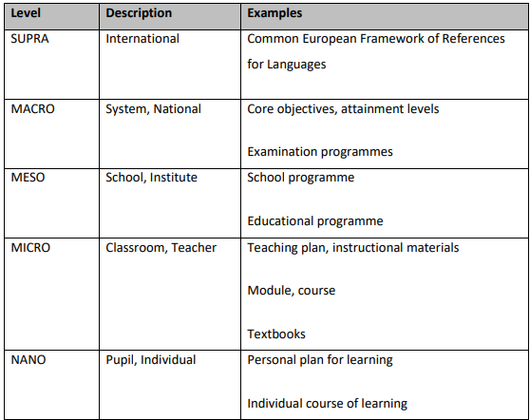
Curriculum levels and curriculum products (Thijs & van den Akker, 2008, p.9. Used within Priestley et al., 2022, p. 21).

Appendix 3:

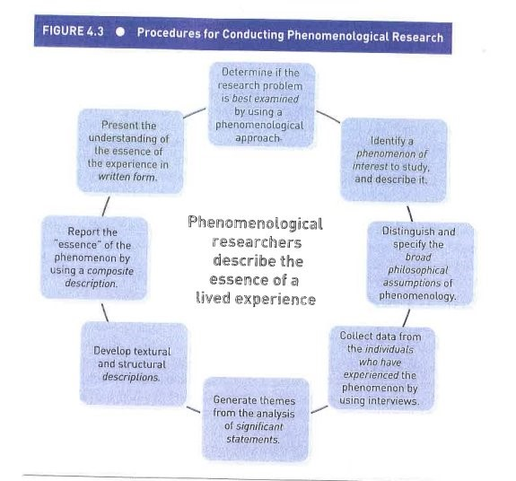
(Moustakas, 1994, p.34)

Appendix 4

Gatekeeper consent:

I am a doctoral student within the University of Wales, Trinity Saint David. My area of interest is curriculum design within the context of Curriculum for Wales, aiming to understand what is meant by this term within CfW policy.
I am seeking your permission to approach members of the Curriculum and Assessment Unit in Welsh Government. As well as evaluating the CfW guidance, I wish to carry out interviews with six policy officials currently working with CfW guidance and policy decision making.
Policy officials will be asked to complete a short questionnaire around their role and understanding of curriculum design, before taking part in one interview between February and March. The interviews will be no longer than 90 minutes long and arranged at a time to suit the policy official.

Appendix 5

Information sheet

Title of Project: Curriculum Design:

Name of Researcher: Yvonne Roberts-Ablett, Doctoral Student: Athrofa, University of Wales. Trinity Saint David.

Thank you for considering taking part in this research project conducted by Yvonne Roberts-Ablett as part of a doctoral research project for the fulfilment of the requirements of the Doctorate in Education (EdD) at Athrofa, University of Wales, Trinity St David (UWTSD).
This research project is looking at how the term ‘curriculum design’ is understood within Curriculum for Wales (CfW) policy. This information leaflet will provide you with the necessary information about the practical demands of this research project, including how to provide informed consent for participation in this study should you wish to participate. Please take time to read the following information carefully. It is important for you to understand what the research will involve. If there is anything that is unclear, or if you would like more information please contact me using the details provided at the end.
Purpose of the project
Early evaluations of the Curriculum for Wales (CfW) (Duggan et al., 2023; Makara-Fuller et al., 2024) suggests that many teachers in Wales are struggling to design curriculum, having only worked within the previous prescriptive National Curriculum.
The purpose of this research is to establish an understanding of the term ‘curriculum design’ within the context of CfW.
What will the project involve?
This project intends to see how the term ‘curriculum design’ is understood within CfW policy. This project aims to evaluate the use of the term within the current CfW guidance, including school improvement and professional learning guidance available to schools on Hwb, and the extent to which it is used consistently within policy guidance to support practitioners to be effective in designing curriculum for their learners.
This will be compared with the understanding from a sample of policy officials within the Curriculum and Assessment Unit in Welsh Government. Through a short questionnaire and interview, this will be compared with the understanding presented in the CfW guidance to assess the extent to which a policy implementation gap exists in Welsh schools through any potential disconnect between policy and school practice.

If a gap in understanding is identified, this research aims to present a model for how practitioners in Wales can be supported to understand what is meant by ‘curriculum design’ in CfW guidance and practically meet the expectations of CfW policy when designing their curriculum.
Participation in this study will involve participants completing a short questionnaire via Microsoft Forms, on their role and areas of responsibility related to curriculum design, and an interview with the researcher (Yvonne Roberts-Ablett). These will be arranged at a convenient time for each participant and will be conducted online using Microsoft Teams. Connection during the sessions will be via UWTSD cloud based Microsoft software. All interviews will be recorded and transcribed for participants to agree the content. The UWTSD Microsoft platform complies with the EU GDPR regarding personal data regulations. The interviews will focus on the policy official’s experiences of ‘curriculum design’ within the context of Curriculum for Wales.
During the interview participants will be asked a series of open-ended questions to help share their understanding of the term ‘curriculum design’ and its practical application in Welsh classrooms by practitioners. The researcher (Yvonne Roberts-Ablett) will record their answers or, if anyone is not comfortable with being recorded, take notes of the information provided. The transcription of the interview will be returned to the participant to ensure that it is a fair and accurate reflection of the interview conversation. All the information provided will be anonymised and a pseudonym/code name will be given. The interview should last approximately 60-90 minutes.
What happens to the information?
The information that will be provided will be securely stored and only the researcher (Yvonne Roberts-Ablett) will have access to them.
Microsoft Teams allows recordings of video files with image and audio or only with audio to be made during the interview. The recordings of the interviews made via Microsoft Teams will be stored in the cloud of UWTSD, which complies with GDPR. Any hard copies of the notes made during interviews will be digitalised immediately after the interviews and saved in the UWTSD secure cloud. Any hard copies of notes made during interview will be safely stored in a locked safe at the office of the doctoral researcher Yvonne Roberts-Ablett. The data will be digitalised, encrypted and stored securely on the UWTSD cloud system.
Once the interview recordings, notes, background information from the questionnaire have been analysed, Yvonne Roberts-Ablett will destroy the digital and hard copies of these documents. The digitalised data will be stored securely in line with the University’s data storage policies and then deleted at the end of the project. The transcribed interview documents will also be stored securely in line with the University’s data storage policies and then deleted at the end of the project.

Are there any risks to policy officials in taking part?

No risks to policy officials are anticipated as a result on taking part in this study. The individual participants taking part in the interviews will share personal data such as their name (a pseudonym/code name will be given), role and areas of responsibility, and there is a small chance that this might lead to identification of the participants by people familiar with the civil service. Although the risk of this happening is low, preventative measures will be taken to ensure the data of the participants are protected. That is why the data related to this study will be treated as highly confidential at all times and the necessary measures will be taken to ensure prevention of loss or damage, and prevention of anyone besides the researcher in this project gaining access to these data.

There is a requirement of policy officials to provide a certain amount of time to answer the interview questions, which could be a small time burden, but this will be counterbalanced by the opportunity offered to them to share their experiences at a time most convenient to them.
Do I have to take part in the study?
Your participation is completely voluntary.
If you decide to participate in the study, you will need to sign a consent form confirming your informed consent for participation in the study.
You will have the right to withdraw from this study at any point without the need to provide a reason for withdrawing. You will be informed of this right at each stage of the project.
What do I do if I have questions about the study?
If you have any questions and/or would like further information about this study, or if you would like to express any concerns, please contact either me (Yvonne Roberts-Ablett) or my supervisor (Dr Catherine Morgan).
- Researcher (Yvonne Roberts-Ablett ): 2113432@student.UWTSD.ac.uk (mobile: 07961425060)
- Dr Catherine Morgan (Supervisor): C.Morgan@uwtsd.ac.uk
What will happen to the results of this study?
The data collection is expected to commence in February 2024 and is expected to be completed by March 2024. The data analysis is scheduled to be conducted as soon as the data collection is completed, and the interviews are transcribed and anonymised. Once the data analysis is completed, the research project write-up will take place. Results of the study are planned to be submitted for marking in June 2024. Results may also be presented at conferences, and workshops, and for teaching purposes. No identifiable information about the officials will be reported, and any such data will be anonymised, and pseudonyms/code names will be used in any reports of the results of this study.

Will it be possible to identify officials in the report or any papers published?
No, any identifiable information related to the individual participants that will be provided will be anonymised, and officials participating will be given a pseudonym/code name, so that their data remains confidential. All the information you will provide during your participation will be treated as highly confidential.

The data reported about this project in articles, conferences, written reports and for teaching purposes will not include any identifiable information about officials.
Who has reviewed the study?
This study has been reviewed and approved by the UWTSD Ethics Committee.
If you would like to ask any questions about this research project or if you would like to discuss any aspects of the study further, please feel free to contact me (please find contact details above).
Who should I contact if I wish to make a complaint?
Any complaint about the way you have been dealt with during the study or any possible harm you might have suffered will be addressed. Please address your complaint to Dr Catherine Morgan, UWTSD at the email address above.
Thank you for considering taking part in this research project.

Yours sincerely

Yvonne Roberts-Ablett
Doctoral researcher at Athrofa, University of Wales, Trinity St David.

Appendix 6:

Participant questionnaire
Introduction:
The purpose of this questionnaire is to get to know you and your role better in preparation for the interview stage. If there are any questions that you do not feel comfortable answering, you can leave them blank. All responses will be anonymised as part of a coding system with no answer being attributable to you.
(Copy of the information sheet provided again)
Informed Consent:
By answering yes/no to each of the following statements you are indicating that you have read and understood the information provided in agreeing to take part in this research project. The data collection for this study is within two parts:
- Participant questionnaire
- Semi-structured interview
You do not have to take part in both stages and can withdraw your consent at any time, prior to the data being anonymised. If you change your mind about taking part in the questionnaire and/or the interview, all data collected to that point will be destroyed. You will be provided with a copy of your responses to the questionnaire and a transcript of the interview. Interview questions will be provided before taking part and participants are welcome to request clarification of any questions proposed. You will be able to clarify any responses if the data is captured incorrectly.

Consent information:  Each question will be on a different screen with. Agree/Disagree | Agree/Disagree
I confirm that I have read and understood the information provided to me and I have had the opportunity to consider the information and ask any questions.
I understand that personally identifiable information will only be stored for the purposes of initial data organisation, after which my data will be anonymised via a coding system and not used for any purpose other than this project.
I understand that any analysis may be shared as part of research publications or conference talks, but that the information I provide will not be traceable to me in any way.
I understand that I can request that my data be deleted at any time until the data is anonymised by contacting 2113432@student.uwtsd.ac.uk or 07961425060.
I agree to take part in this research project.

Debrief
Please do not close your browser yet. To submit your answers, you must click ‘Submit’ at the end of this questionnaire.
Many thanks for taking the time to complete this questionnaire. The aim of this questionnaire is to get to know your role and responsibilities that are relevant to curriculum design within the context of Curriculum for Wales.
Confidentiality
Your data will be replaced with a random code as soon possible after data collection ends, ensuring your personal anonymity. You will not be identifiable in any dissemination activity.
Withdrawal
You can withdraw your answers from this questionnaire now by closing the browser window prior to clicking the ‘Submit’ button at the bottom of this page. After you submit your responses, you will have up until 31st March 2024 to withdraw your responses. After this time, your data will be analysed. If you wish to withdraw your data after you submit your responses, but before 31/3/24, you can do so by emailing 2113432@student.uwtsd.ac.uk and including the response ID will be provided after you submit
Feedback
If you wish to see the results from this questionnaire or any of the outputs (e.g., reports or journal articles) or discuss your responses, please contact Yvonne Roberts-Ablett 2113432@student.UWTSD.ac.uk
Complaints
If you have any concerns or complaints about the conduct of a research study, please contact : Dr Catherine Morgan C.Morgan@uwtsd.ac.uk
Data Collection: (There will be no compulsory questions)

Questionnaire:

Questions | Question type | Options if relevant
Name | Short text
Job Title | Short text
Areas of responsibility | Short text
Length of time in civil service | Options | Less than 1 year  1-5 years  6-10 years  10+ years
Were you involved in the construction of CfW during the pioneer process? | Options | Yes  No
If yes, what was your role during this period? | Short text
Have you been involved in co-construction of CfW guidance? | Options | Yes  No
What does it mean for headteachers in Wales to be responsible for designing their school curriculum? | Short text

Participants’ Consent Form for Interview

I confirm that I am willing to be interviewed by Yvonne Roberts-Ablett for the purpose of research for her doctoral thesis. I am aware that I may withdraw from the study at any point should I so wish and that any data collected relating to me will be withdrawn from the study.

I also understand that any data used in the research will remain anonymous.

Name:

Signed:

Date:

Appendix 7:

Semi-structured Interview Schedule
It is anticipated that the semi structured interview will start with the following key questions and then the interview will develop according to the participants’ responses and any relevant details from the participant questionnaire.
- Why do you think the term Curriculum Design is used in the Curriculum for Wales framework?
- What do you see as the role of practitioners as curriculum designers? How is this thinking being communicated to the teaching profession?
- Research suggests that some practitioners in Wales are struggling to see their role as curriculum designers. How do you expect future policy decisions to support them?
- The co-construction of the Curriculum for Wales legislation and guidance has resulted in a different way of designing curriculum at a national level. How is this being understood by the teaching profession?
- The co-construction of the Curriculum for Wales legislation and guidance has resulted in a different mode of policy creation. How is this being understood amongst officials who were not part of this process?

Further questions will follow linked to the original research questions.

Appendix 8:

Phase 1: | Familiarising yourself with the dataset. | Here, you become deeply and intimately familiar with the content of your dataset, through a process of immersion. Practically, this involves reading and re-reading your data (and, if working with transcripts of audio data, listening to the recordings at least once), and making (brief) notes about any analytical ideas or insights you may have, both related to each data item and the data set as a whole.
Phase 2: | Coding | Here, you work systematically through your dataset in a fine-grained way. You identify segments of data that appear potentially interesting, relevant or meaningful for your research question, and apply pithy, analytically-meaningful descriptions (code labels) to them. Your focus is specific, and detailed, with coding aimed at capturing single meanings or concepts. In reflexive TA, you can code at a range of levels -from the very explicit or surface meaning (we and many others term this semantic), through to the more conceptual or implicit meaning (we and others term this latent). Coding isn’t just about summarising and reducing content, it’s also about capturing your ‘analytical take’ on the data. You code the entire data set, systematically and thoroughly. When done, you collate your code labels and then compile the relevant segments of data for each code.
Phase 3 | Generating Initial Themes | Here, you aim to start identifying shared patterned meaning across the dataset. You compile clusters of codes that seem to share a core idea or concept, and which might provide a meaningful ‘answer’ to your research question. Although we originally identified this phase as searching for the themes, that language can be misleading; the process is not like an excavation, where meaning is lying there, waiting to be uncovered and discovered through the right search technique. Rather, theme development is an active process; themes are constructedd by the researcher, based around the data, the research questions, and the researcher’s knowledge and insights. Where codes typically capture a specific or a particular meaning, themes describe broader, shared meanings. Once you’ve identified potential or candidate themes that you feel capture the data and address your research question, you collate all coded data relevant to each candidate theme.
Phase 4 | Developing and reviewing themes | Here, your task is to assess the initial fit of your provisional candidate themes to the data, and the viability of your overall analysis, by going back to the full data set. Development and review involves checking that themes make sense in relation to both the coded extracts, and then the full dataset. Does each theme tell a convincing story about an important pattern of shared meaning related to the dataset? Collectively, do the themes highlight the most important patterns across the dataset in relation to your research question? Radical revision is possible; indeed, it’s quite common. Certain candidate themes may be collapsed together; one or more may be split into new themes; candidate themes may be retained; some or all may be discarded. You have to be prepared to let things go! In review, you need to think about the character of each individual theme – its core focus or idea (the central organizing concept) – and its scope. You also need to start considering the relationship between the themes, and existing knowledge, and/or practice in your research field, and the wider context of your research.
Phase 5 | Refining, defining and naming themes | Here you fine tune your analysis – ensuring that each theme is clearly demarcated, and is built around a strong core concept or essence. Ask yourself ‘what story does this theme tell?’ and ‘how does this theme fit into my overall story about the data?’ Key activities in this phase involve writing a brief synopsis of each theme. You also decide on a concise, punchy and informative name for each theme. In this phase, you still need to be prepared to let the analysis go, if your refining process indicates more development is needed.
Phase 6 | Writing Up | Writing is an integral phase of the analytical process for TA, as it is for many qualitative analytical approaches, so you start writing early on. In reflexive TA, formal analytical writing often starts from Phase 3; the more informal (just for you) writing you do from the start of the process – familiarisation notes and reflexive journaling – can feed into more formal writing. In writing up, you finesse and finish the writing process. Ultimately, you’re aiming to weave together your analytical narrative and compelling, vivid data extracts, to tell your reader a coherent and persuasive story about the dataset that addresses your research question. Final write up also involved producing the introduction, method and conclusion sections of a research report. And a lot of editing. Never underestimate the importance and value of editing.

Introducing six phases of reflexive thematic analysis (Braun and Clarke, 2022, pp. 35-35)

Appendix 9

APPLICATION FOR ETHICAL APPROVAL

RESEARCH STUDENTS
This form is to be completed by the student within SIX months for full-time students and TWELVE months for part time students, after the commencement of the research degree or following progression to Part Two of your course.

Once complete, submit this form via the MyTSD Doctoral College Portal at (https://mytsd.uwtsd.ac.uk).

This document is also available in Welsh.

RESEARCH STAFF ONLY
All communications relating to this application during its processing must be in writing and emailed to pgresearch@uwtsd.ac.uk , with the title ‘Ethical Approval’ followed by your name.

STUDENTS ON UNDERGRADUATE OR TAUGHT MASTERS PROGRAMMES should submit this form (and receive the outcome) via systems explained to you by the supervisor/module leader.

In order for research to result in benefit and minimise risk of harm, it must be conducted ethically. A researcher may not be covered by the University’s insurance if ethical approval has not been obtained prior to commencement.

The University follows the OECD Frascati manual definition of research activity: “creative work undertaken on a systematic basis in order to increase the stock of knowledge, including knowledge of man, culture and society, and the use of this stock of knowledge to devise new applications”. As such this covers activities undertaken by members of staff, postgraduate research students, and both taught postgraduate and undergraduate students working on dissertations/projects.

The individual undertaking the research activity is known as the “principal researcher”.

Ethical approval is not required for routine audits, performance reviews, quality assurance studies, testing within normal educational requirements, and literary or artistic criticism.

Please read the notes for guidance before completing ALL sections of the form.

This form must be completed and approved prior to undertaking any research activity. Please see Checklist for details of process for different categories of application.

SECTION A: About You (Principal Researcher)
1 | Full Name: |  | Yvonne Roberts-Ablett
2 | Tick all boxes that apply: |  | Member of staff: | ☐ | Honorary research fellow: | ☐
 | Undergraduate Student | ☐ | Taught Postgraduate Student | ☒ | Postgraduate Research Student | ☐

3 | Institute/Academic Discipline/Centre: | UWTSD
4 | Campus: | Swansea
5 | E-mail address: | 2113432@student.uwtsd.ac.k
6 | Contact Telephone Number: | 07961425060
 | For students:
7 | Student Number: | 2113432
8 | Programme of Study: | EdD
9 | Director of Studies/Supervisor: | Catherine Morgan

SECTION B: Approval for Research Activity
1 | Has the research activity received approval in principle?  (please check the Guidance Notes as to the appropriate approval process for different levels of research by different categories of individual) |  | YES | ☒ | NO | ☐
 |  |  |  |  | Date
2 | If Yes, please indicate source of approval (and date where known): Approval in principle must be obtained from the relevant source prior to seeking ethical approval | Research Degrees Committee |  | ☐
2 |  | Institute Research Committee |  | ☐
2 |  | Other (write in)  Catherine Morgan |  | ☒ | 21.10.23

SECTION C: Internal and External Ethical Guidance Materials
 | Please list the core ethical guidance documents that have been referred to during the completion of this form (including any discipline-specific codes of research ethics, location-specific codes of research ethics, and also any specific ethical guidance relating to the proposed methodology). Please tick to confirm that your research proposal adheres to these codes and guidelines. You may add rows to this table if needed.
1 | UWTSD Research Ethics & Integrity Code of Practice | ☒
2 | UWTSD Research Data Management Policy | ☒
3 | BERA Guidelines Ethical Guidelines for Educational Research (2018) | ☒
4 | EWC Professional Standards for all School Practitioners | ☒
5 | The Civil Service Code | ☒

SECTION D: External Collaborative Research Activity
If there are external collaborators then you should gain consent from the contact persons to share their personal data with the university. If there are no external collaborators then leave this section blank and continue to section E.
1 | Institution
2 | Contact person name
3 | Contact person e-mail address
4 | Is your research externally funded? |  | YES | ☐ | NO |  | ☐
5 | Are you in receipt of a KESS scholarship? |  | YES | ☐ | NO |  | ☐
6 | Are you specifically employed to undertake this research in either a paid or voluntary capacity? | Voluntary | YES | ☐ | NO | ☐
7 |  | Employed | YES | ☐ | NO | ☐
8 | Is the research being undertaken within an existing UWTSD Athrofa Professional Learning Partnership (APLP)? | If YES then the permission question below does not need to be answered. | YES | ☐ | NO |  | ☐
9 | Has permission to undertake the research has been provided by the partner organisation? | (If YES attach copy)  If NO the application cannot continue | YES | ☐ | NO |  | ☐

Where research activity is carried out in collaboration with an external organisation
10 | Does this organisation have its own ethics approval system? | YES | ☐ | NO | ☐
 | If Yes, please attach a copy of any final approval (or interim approval) from the organisation (this may be a copy of an email if appropriate).

SECTION E: Details of Research Activity
1 | Indicative title: | Curriculum Design: policy understanding within the context of Curriculum for Wales
2 | Proposed start date: | 4.1.24 | Proposed end date: | 24.6.24
Introduction to the Research (maximum 300 words per section)
Ensure that you write for a Non-Specialist Audience when outlining your response to the points below:
- Purpose of Research Activity
- Proposed Research Question
- Aims of Research Activity
- Objectives of Research Activity
Demonstrate, briefly, how Existing Research has informed the proposed activity and explain
- What the research activity will add to the body of knowledge
- How it addresses an area of importance.
3 | Purpose of Research Activity  Since the publication of Successful Futures (Donaldson, 2015) (Welsh Government independent review of curriculum and assessment arrangements in Wales), Wales has been on a journey of reforming its curriculum, from design and legislation in 2021 to first teaching in September 2022, creating the Curriculum for Wales (Welsh Government, 2021a). Through a process of co-construction, the design of a national curriculum framework has been developed with the teaching profession, inspectorate, school improvement services, international curriculum experts and government. With the focus on shared responsibility to collectively solve system problems together, practitioners have been given the agency to design school level curriculum that meet the needs of the learners in their care (Welsh Government, 2021b). However, having worked within the previous government created National Curriculum since 1988 (Curriculum Council for Wales, 1991), many in the sector are unfamiliar with how to design curricular, especially in the secondary sector where high stakes accountability at age 16 has dominated the purpose of designing learning (Roberts-Ablett, 2023).  The purpose of this research is to establish the understanding of ‘curriculum design’ within the context of Curriculum for Wales (CfW) and the extent to which a policy implementation gap exists in Welsh schools through a disconnect between policy direction and how the agency for school level curriculum design is being realised.  (this box should expand as you type)
4 | Research Question  How is the term ‘curriculum design’ used within Curriculum for Wales guidance?  How is the term ‘curriculum design’ understood by policy officials within Welsh Government?  (this box should expand as you type)
5 | Aims of Research Activity  The aims of this research is to:  - Establish an understanding of the phenomenon ‘curriculum design’ within Curriculum for Wales guidance.  - Fulfil an identified research gap (Roberts-Ablett, 2023) in understanding the phenomenon ‘curriculum design’ within the context of Curriculum for Wales.  - To identify any potential risks to successful implementation of Curriculum for Wales through assessing any emerging gap between policy and practice in understanding the phenomenon ‘curriculum design’ within the context of Curriculum for Wales and ongoing curriculum reform.  - To establish a theoretical framework for Curriculum for Wales that articulates the place of curriculum design within a process-orientated, purpose-led curriculum.  (this box should expand as you type)
6 | Objectives of Research Activity  Through a hermeneutic phenomenological approach, this project will establish the extent to which a shared understanding of the phenomenon ‘curriculum design’ is used within Curriculum for Wales policy guidance and coherently understood by policy officials responsible for directing policy in this area. The objective is to identify any gaps in policy coherence that pose a risk to the coherent realisation of Curriculum for Wales within Welsh secondary schools. With increasing early insights reports (Thomas et al., 2022; 2023; Morrison-Love et al., 2023, Priestley et al., 2023) identifying threats to coherence originating in the secondary sector through the potential backwash¹ effect on curriculum design inherent in qualifications and accountability concerns, this research fulfils an identified gap in focusing specifically on how current guidance reflects the policy ambitions of Curriculum for Wales.  (this box should expand as you type)
Proposed methods (maximum 600 words)
Provide a brief summary of all the methods that may be used in the research activity, making it clear what specific techniques may be used. If methods other than those listed in this section are deemed appropriate later, additional ethical approval for those methods will be needed. You do not need to justify the methods here, but should instead describe how you intend to collect the data necessary for you to complete your project.
7 | - Interpretive hermeneutic analysis of Curriculum for Wales guidance including assessment guidance, professional learning guidance and school improvement guidance published by Welsh Government since 2019. This will be an analysis of Welsh Government published documents available online using a reflexive thematic analysis method (Braun and Clarke, 2022). Key themes associate with ‘curriculum design’ will be identified to support the questioning of the semi-structured interview. Data will be collected and stored in electronic form and stored in UWTSD cloud-based server.  - Questionnaire: to include participant professional history, current role, the context in which they work, experiences of curriculum design and understanding of the phenomenon. Participants will be asked to complete and submit this electronic questionnaire prior to attending a semi-structured interview. This will be sent to participants via email prior to interview in the form of a MS Form. This will provide an opportunity to anonymise participant returns. I will create participant A, B etc. and code responses. All returns will be collected and stored electronically within UWTSD cloud-based server. The returns will include personal data that will be collected and stored securely under GDPR guidance.  - Semi-structured interview: participants will participate in at least one semi-structured interview outlining their lived experiences of the phenomenon of curriculum design alongside discussions around the elements above. A 1.5-hour semi-structured interviews will be conducted with each participant. Each interview will be conducted via UWTSD Teams App. Each interview will be recorded and transcribed. All subsequent data will be stored on the UWSTD cloud-based server. The returns will include personal data that will be collected and stored securely under GDPR guidance.  - Member-checking will be conducted via email from my UWTSD account to the participant’s email address with password protected encryption of data being shared to enable participants to confirm their accurate participation and informed consent. Each member will receive a direct email containing only data relevant to their participation in the project. The returns will include personal data that will be collected and stored securely under GDPR guidance.  - All subsequent electronic data, including documents of my own analysis (log files) will be analysed via a reflexive thematic analysis method (Braun & Clarke, 2022), seeking to identify key themes via a coding thematic mapping method from each element of the data collection above and then triangulated to respond to each research question. I will then complete a thematic synthesis method to identify high level themes relevant to the research questions. This process will be a mixture of electronic data and paper-based data, for example post it notes and drawn diagrams. I will take photographs of the paper-based data to create electronic data from it. Any paper-based data will be stored securely in my home office within a locked safe.  - I will also keep a reflective journal that is a paper-based notebook that will be kept within my home office within a locked safe.  - All data will be destroyed at the end of the project – both paper and electronic forms.  (this box should expand as you type)
Location of research activity
Identify all locations where research activity will take place.
8 | All data collection and analysis will be conducted online via Office 365 apps available via UWTSD and stored securely on UWTSD cloud-based server. MS Teams provided by UWTSD will be used to arrange online semi-structured interviews. These will be recorded online with recordings stored within the cloud-based server of UWTSD.  (this box should expand as you type)
Research activity outside of the UK
If research activity will take place overseas, you are responsible for ensuring that local ethical considerations are complied with and that the relevant permissions are sought. Specify any local guidelines (e.g. from local professional associations/learned societies/universities) that exist and whether these involve any ethical stipulations beyond those usual in the UK (provide details of any licenses or permissions required). Also specify whether there are any specific ethical issues raised by the local context in which the research activity is taking place, for example, particular cultural and/or legal sensitivities or vulnerabilities of participants. If you live in the country where you will do the research then please state this.
9 | N/A  (this box should expand as you type)

10 | Use of documentation not in the public domain: Are any documents NOT publicly available? | NO | ☒
10 |  | YES | ☐
11 | If Yes, please provide details here of how you will gain access to specific documentation that is not in the public domain and that this is in accordance with the current data protection law of the country in question and that of England and Wales.  (this box should expand as you type)

 | Does your research relate to one or more of the seven aims of the Well-being of Future Generations (Wales) Act 2015? | YES | NO
12 | A prosperous Wales | ☒ | ☐
13 | A resilient Wales | ☒ | ☐
14 | A healthier Wales | ☒ | ☐
15 | A more equal Wales | ☒ | ☐
16 | A Wales of cohesive communities | ☒ | ☐
17 | A Wales of vibrant culture and thriving Welsh language | ☒ | ☐
18 | A globally responsible Wales | ☒ | ☐
19 | If YES to any of the above, please give details:
The focus of the research is to better understand the phenomenon of curriculum design within Curriculum for Wales. Curriculum for Wales is a Welsh Government policy area intended to support the education directorate in Wales to achieve the Future Generations (Wales) Act objectives and, therefore, is directly related to achieving its aims.

(this box should expand as you type)

SECTION F: Scope of Research Activity
 | Will the research activity include: | YES | NO
1 | Use of a questionnaire or similar research instrument? | ☒ | ☐
2 | Use of interviews? | ☒ | ☐
3 | Use of focus groups? | ☐ | ☒
4 | Use of participant diaries? | ☐ | ☒
5 | Use of video or audio recording? | ☒ | ☐
6 | Use of computer-generated log files? | ☒ | ☐
7 | Participant observation with their knowledge? | ☐ | ☒
8 | Participant observation without their knowledge? | ☐ | ☒
9 | Access to personal or confidential information without the participants’ specific consent? | ☐ | ☒
10 | Administration of any questions, test stimuli, presentation that may be experienced as physically, mentally or emotionally harmful / offensive? | ☐ | ☒
11 | Performance of any acts which may cause embarrassment or affect self-esteem? | ☐ | ☒
12 | Investigation of participants involved in illegal activities? | ☐ | ☒
13 | Use of procedures that involve deception? | ☐ | ☒
14 | Administration of any substance, agent or placebo? | ☐ | ☒
15 | Working with live vertebrate animals? | ☐ | ☒
16 | Procedures that may have a negative impact on the environment? | ☐ | ☒
17 | Other primary data collection methods. Please indicate the type of data collection method(s) below. | ☐ | ☒
 | Details of any other primary data collection method:  (this box should expand as you type) | ☐ | ☒
If NO to every question, then the research activity is (ethically) low risk and may be exempt from some of the following sections (please refer to Guidance Notes).

If YES to any question, then no research activity should be undertaken until full ethical approval has been obtained.

SECTION G: Intended Participants
If there are no participants then do not complete this section, but go directly to section H.

 | Who are the intended participants: | YES | NO
1 | Students or staff at the University? | ☐ | ☒
2 | Adults (over the age of 18 and competent to give consent)? | ☒ | ☐
3 | Vulnerable adults? | ☐ | ☒
4 | Children and Young People under the age of 18? (Consent from Parent, Carer or Guardian will be required) | ☐ | ☒
5 | Prisoners? | ☐ | ☒
6 | Young offenders? | ☐ | ☒
7 | Those who could be considered to have a particularly dependent relationship with the investigator or a gatekeeper? | ☐ | ☒
8 | People engaged in illegal activities? | ☐ | ☒
9 | Others. Please indicate the participants below, and specifically any group who may be unable to give consent. | ☐ | ☒
 | Details of any other participant groups:  (this box should expand as you type) | ☐ | ☒

Participant numbers and source
Provide an estimate of the expected number of participants. How will you identify participants and how will they be recruited?
10 | How many participants are expected? | Maximum of 6 participants to take part in a maximum of 3 semi-structured interview or no more than 1.5 hours each.  (this box should expand as you type)
11 | Who will the participants be? | Policy Officials at Welsh Government with responsibility for curriculum reform.  (this box should expand as you type)
12 | How will you identify the participants? | As a Professional Advisor currently working within Welsh Government, I have access to a range of policy officials working with Curriculum for Wales.  I will request gatekeeper consent from the Deputy Directors across the curriculum, assessment and school improvement and professional learning teams at Welsh Government for permission to approach their policy officials. I will email an invitation to 20 policy officials working within the curriculum assessment, school improvement and professional learning division of Welsh Government. I will then email 6 who have consented to take part with a briefing notice outlining the purpose of the research and requesting informed consent to take part. In the event of more than 6 responding I will create a reserve list and inform participants that they may be called upon at a later stage. At the end of the data collection phase, I will inform all participants, including those who may not be included in the second and third stage of data collection, that the project has finished, and no further contact will be made. I will aim to include a maximum of 6 participants across these three areas (3 x 2 from each team) of work to complete the questionnaire, again clearly explaining the aims of the research and ethical considerations and establishing informed consent. I will then email each participant to arrange a convenient time to carry out the semi-structured interview, providing a reminder of informed consent.  (this box should expand as you type)

 | Information for participants: | YES | NO | N/A
13 | Will you describe the main research procedures to participants in advance, so that they are informed about what to expect? | ☒ | ☐ | ☐
14 | Will you tell participants that their participation is voluntary? | ☒ | ☐ | ☐
15 | Will you obtain written consent for participation? | ☒ | ☐ | ☐
16 | Will you explain to participants that refusal to participate in the research will not affect their treatment or education (if relevant)? | ☒ | ☐ | ☐
17 | If the research is observational, will you ask participants for their consent to being observed? | ☐ | ☐ | ☒
18 | Will you tell participants that they may withdraw from the research at any time and for any reason? | ☒ | ☐ | ☐
19 | With questionnaires, will you give participants the option of omitting questions they do not want to answer? | ☒ | ☐ | ☐
20 | Will you tell participants that their data will be treated with full confidentiality and that, if published, it will not be identifiable as theirs? | ☒ | ☐ | ☐
21 | Will you debrief participants at the end of their participation, in a way appropriate to the type of research undertaken? | ☒ | ☐ | ☐
22 | If NO to any of above questions, please give an explanation
 | (this box should expand as you type)

 | Information for participants: | YES | NO | N/A
24 | Will participants be paid? | ☐ | ☒ | ☐
25 | Is specialist electrical or other equipment to be used with participants? | ☐ | ☒ | ☐
26 | Are there any financial or other interests to the investigator or University arising from this study? | ☐ | ☒ | ☐
27 | Will the research activity involve deliberately misleading participants in any way, or the partial or full concealment of the specific study aims? | ☐ | ☒ | ☐
28 | If YES to any question, please provide full details
 | (this box should expand as you type)

SECTION H: Anticipated Risks

Outline any anticipated risks that may adversely affect any of the participants, the researchers and/or the University, and the steps that will be taken to address them.

If you have completed a full risk assessment (for example as required by a laboratory, or external research collaborator) you may append that to this form.
1 | Full risk assessment completed and appended? |  | Yes | ☐
1 |  |  | No | ☒
2 | Risks to participants  For example: sector-specific health & safety, emotional distress, financial disclosure, physical harm, transfer of personal data, sensitive organisational information
 | Risk to participants:  - Participants will be reflecting on their own values and dispositions related to curriculum design during the questionnaire and semi-structured interview stage.  - Wellbeing of participants may be at risk due to research demands on participant time to conduct semi-structured interviews.  - Avoiding participants feeling any undue pressure to take part or social desirability bias affecting responses as a result of my insider researcher status.  (this box should expand as you type) | How you will mitigate the risk to participants:  - I will use BERA guidelines to obtain informed consent at each stage of data collection. I will include a plain language questionnaire to inform participants of the purpose, collection, and use of data at each stage. I will ensure that all data (both questionnaire and interview recordings) will be stored securely and anonymised. Data will not be shared. I will remind participants that they can withdraw consent for any constituent elements or overall participation at any point.  - Mitigations will ensure that research methods are carried out at times to suit participants. I will carry out all interviews on a one-to-one basis online where participants can freely express themselves within a confidential environment. I will ensure all interview recordings are stored securely and I will facilitate member-checking of transcripts. I will remind all participants of their informed consent and right to withdraw at each stage.  - I will ensure that participants are invited to volunteer to take part via UWTSD student email address to avoid affiliation with any other organisation that I represent in my professional life. I will remind all participants of their informed consent and right to withdraw at each stage. I will ensure that all data is anonymised and secured in accordance with university procedures and ethical guidelines.  (this box should expand as you type)
3 | If research activity may include sensitive, embarrassing or upsetting topics (e.g. sexual activity, drug use) or issues likely to disclose information requiring further action (e.g. criminal activity), give details of the procedures to deal with these issues, including any support/advice (e.g. helpline numbers) to be offered to participants. Note that where applicable, consent procedures should make it clear that if something potentially or actually illegal is discovered in the course of a project, it may need to be disclosed to the proper authorities
Whilst not intended to cause harm or distress, curriculum design is a relatively new phenomenon in Wales and may impact the professional identity of participants. Support and wellbeing helplines relevant to each participant will be shared if this arises.

(this box should expand as you type)
4 | Risks to the investigator  For example: personal health & safety, physical harm, emotional distress, risk of accusation of harm/impropriety, conflict of interest
 | Risk to the investigator:  - Risk to professional reputation and perceived conflict of interest as a member of secondary school leadership team and seconded professional advisor to Welsh Government.  - Participants may wish to withdraw and risk sample size of research.  - A confidentiality breach due to data from questionnaire or semi-structured interviews being released accidentally.  - Participants may accuse me of falsifying data as a result of the analysis of questionnaire or semi-structured interviews.  (this box should expand as you type) | How you will mitigate the risk to the investigator:  - Research will be carried out within the advice and supervision of UWTSD and not as a professional representing any other professional organisation that I belong to. Participants will be required to complete informed consent within these parameters utilising a plain language explanation of the purpose of this research project.  - I will remind participants of their informed consent and right to withdraw from any component elements of the research. If time allows, another participant may be used although multiple data sources can mitigate this as part of research. I will inform my supervisor if the research becomes unviable.  - I will ensure that all data is collected and stored securely as outlined in the UWTSD guidelines, including password protected cloud storage on UWTSD systems. I will inform UWTSD data protection officer is informed of any data breach and follow GDPR guidelines of UWTSD.  - I will share transcripts of all interview recordings and questionnaire returns with participants for member-checking. I will ensure that I offer a debrief to all participants with a reminder of aims and purpose of research. I will remind participants of their informed consent and right to withdraw at each stage of the research. Participants will be informed via a debriefing notice at the end of the questionnaire stage as to how the data will be used to inform the semi-structured interview. At the beginning of the interview, I will remind participants of their informed consent and right to withdraw elements of their data. Participants will be provided with an email address where they can request a summary of findings relevant to them.  (this box should expand as you type)
5 | University/institutional risks  For example: adverse publicity, financial loss, data protection
 | Risk to the University:  - Risk of adverse publicity or loss of data.  - Reputational damage as a result of complaint made against the researcher.  (this box should expand as you type) | How you will mitigate the risk to the University:  - I will ensure that BERA ethical guidance and university ethical guidance will be followed. I will ensure that all data will be collected and stored securely as outlined in the UWTSD guidelines. I will inform UWTSD data protection officer is informed of any data breach and follow GDPR guidelines of UWTSD.  - I will ensure that BERA ethical guidelines and university ethical guidance is followed. I will ensure that all data is collected and stored securely a per the UWTSD data storage regulations and security procedures. I will ensure that the research methods used are robust and communicated effectively to participants. I will ensure regular debriefs for participants at each stage of data collection, reminding participants of their informed consent and right to withdraw at any stage of the research.  (this box should expand as you type)
6 | Environmental risks  For example: accidental spillage of pollutants, damage to local ecosystems
 | Risk to the environment:  - Use of paper  - Carbon footprint  (this box should expand as you type) | How you will mitigate the risk to environment:  - I will be using electronic methods of data collection and storage.  - I will not be travelling for research - it will be conducted online.  (this box should expand as you type)

 | Disclosure and Barring Service
 | If the research activity involves children or vulnerable adults, a Disclosure and Barring Service (DBS) certificate must be obtained before any contact with such participants. | YES | NO | N/A
7 | Does your research require you to hold a current DBS Certificate? | ☐ | ☒ | ☐
8 | If YES, please give the certificate number. If the certificate number is not available please write “Pending”; in this case any ethical approval will be subject to providing the appropriate certificate number.

SECTION I: Feedback, Consent and Confidentiality

1 | Feedback  What de-briefing and feedback will be provided to participants, how will this be done and when?
At the end of the questionnaire stage, I will provide a debriefing message thanking participants for their responses and informing them that I will be emailing them to arrange a mutually convenient time to conduct the semi-structured interview.

Please do not close your browser yet. To submit your answers, you must click ‘submit’ at the bottom of this page.

You can withdraw your answers from this questionnaire now by closing the browser window prior to clicking the submit button at the bottom of this page. After you submit your responses, you will have until 31st January 2024 to withdraw your responses. After this time, your data will be analysed. If you wish to withdraw your data after you submit your responses, but before 31st January 2024, you can do so by emailing (email address to be set up) and including the response ID you are provided after you submit the questionnaire.

If you wish to see the aggregated results from this questionnaire or any of the outputs (e.g., reports or journal articles) or discuss your responses, please contact (email address will be provided for this specific purpose).

Participants will be reminded of their informed consent (below) at the beginning of the semi-structured interview and their ability to withdraw at any stage.

You can withdraw your answers from this interview now by informing the researcher now with all recordings destroyed. Transcripts of the interview will be sent to you for checking. You can request any changes up to 31st March 2023. After you submit your responses, you will have until 31st March 2024 to withdraw your responses. After this time, your data will be analysed. If you wish to withdraw your data after you submit your responses, but before 31st March 2024, you can do so by emailing (email address to be set up) and including the response ID you are provided at questionnaire data collection stage.

(this box should expand as you type)
2 | Informed consent  Describe the arrangements to inform potential participants, before providing consent, of what is involved in participating. Describe the arrangements for participants to provide full consent before data collection begins. If gaining consent in this way is inappropriate, explain how consent will be obtained and recorded in accordance with prevailing data protection legislation.
At the beginning of the questionnaire and prior to each semi-structured interview, the following consent will be requested:

Please read each statement and check each box by the statement to confirm that you understand and consent to taking part in this study.

Consent Q1: I confirm that I have read and understood the information provided to me and I have had the opportunity to consider the information and ask questions.

Consent Q2: I understand that my data may be used in research outputs within the researchers EdD project only. All data used will be anonymised.

Consent Q3: I understand that personally identifiable information will only be stored for the purposes of initial data organisation, after which my data will be anonymised.

Consent Q4: I understand that I can request that my data be deleted at any time up until the data is anonymised by contacting the email address provided in the questionnaire. I also understand that I can opt out of potentially participating in further research at any time by contacting the same email address, which will result in my data being anonymised.

Consent Q5: I agree to take part in the above study.

(this box should expand as you type)
3 | Confidentiality / Anonymity  Set out how anonymity of participants and confidentiality will be ensured in any outputs. If anonymity is not being offered, explain why this is the case.
All participants will be assured that their data will be held securely to ensure confidentiality of any personal data shared at the questionnaire and interview stage. Participants will be informed of how their personal data will be anonymised with the following message:

Your data will be aggregated with other participants who complete the questionnaire and interviews for the purposes of statistical analyses and reporting. Your name and any identifiable personal details will be replaced with a random code as soon possible after data collection ends, ensuring your personal anonymity. Recordings and transcripts of your interviews will be coded and aggregated for the purposes of analysis and reporting. You will not be identifiable in any dissemination activity.

(this box should expand as you type)

SECTION J: Data Protection and Storage

 | Does the research activity involve personal data (as defined by the General Data Protection Regulation 2016 “GDPR” and the Data Protection Act 2018 “DPA”)? | YES | NO
1 | “Personal data” means any information relating to an identified or identifiable natural person (‘data subject’). An identifiable natural person is one who can be identified, directly or indirectly, in particular by reference to an identifier such as a name, an identification number, location data, an online identifier or to one or more factors specific to the physical, physiological, genetic, mental, economic, cultural or social identity of that natural person. Any video or audio recordings of participants is considered to be personal data. | ☒ | ☐
 | If YES, provide a description of the data and explain why this data needs to be collected:
2 | Name and professional role will be collected as part of the questionnaire. An outline of areas of responsibility and professional history could identify participants. This data will be stored securely within the cloud-based server of UWTSD and anonymised using random coding as soon after collection as possible.  The recordings of the interviews will include participant faces and their log in details to the call. Participants can have the option to turn their cameras off for the duration of the interview if they choose. Recording will be stored securely within the cloud-based server of UWTSD and anonymised using random coding as soon after collection as possible.  (this box should expand as you type)
 | Does it involve special category data (as defined by the GDPR)? | YES | NO
3 | “Special category data” means sensitive personal data consisting of information as to the data subjects’ –  (a) racial or ethnic origin,  (b) political opinions,  (c) religious beliefs or other beliefs of a similar nature,  (d) membership of a trade union (within the meaning of the Trade Union and Labour Relations (Consolidation) Act 1992),  (e) physical or mental health or condition,  (f) sexual life,  (g) genetics,  (h) biometric data (as used for ID purposes), | ☐ | ☒
 | If YES, provide a description of the special category data and explain why this data needs to be collected:
4 | (this box should expand as you type)

 | Will data from the research activity (collected data, drafts of the thesis, or materials for publication) be stored in any of the following ways? | YES | NO
5 | Manual files (i.e., in paper form)? | ☒ | ☐
6 | University computers? | ☐ | ☒
7 | Private company computers? | ☐ | ☒
8 | Home or other personal computers? | ☒ | ☐
9 | Laptop computers/ CDs/ Portable disk-drives/ memory sticks? | ☒ | ☐
10 | “Cloud” storage or websites? | ☒ | ☐
11 | Other – specify: | ☐ | ☐
12 | For all stored data, explain the measures in place to ensure the security of the data collected, data confidentiality, including details of backup procedures, password protection, encryption, anonymisation and pseudonymisation:
All paper-based data including reflective journal and analyses conducted via paper will be stored within a safe of my home office.
All electronic data will be kept in a password protected UWTSD cloud-based storage. All participants will be given a unique code to ensure confidentiality. Only cloud-based storage within the Office 365 suite provided by UWTSD will be used. The data will be stored until the completion of the research project and deleted thereafter. Participants will be reminded of their right to access their own data and will be deleted if requested by the participant and not used as part of this research. Any data stored on a personal device or external USB or hard drive will be password protected and data encrypted. These devices will be stored in locked safe in home office. All data related to this project will be destroyed after completion.

(this box should expand as you type)

 | Data Protection
 | Will the research activity involve any of the following activities: | YES | NO
13 | Electronic transfer of data in any form? | ☒ | ☐
14 | Sharing of data with others at the University outside of the immediate research team? | ☐ | ☒
15 | Sharing of data with other organisations? | ☐ | ☒
16 | Export of data outside the UK or importing of data from outside the UK? | ☐ | ☒
17 | Use of personal addresses, postcodes, faxes, emails or telephone numbers? | ☒ | ☐
18 | Publication of data that might allow identification of individuals? | ☐ | ☒
19 | Use of data management system? | ☐ | ☒
20 | Data archiving? | ☐ | ☒
21 | If YES to any question, please provide full details, explaining how this will be conducted in accordance with the GDPR and Data Protection Act (2018) (and any international equivalents, where appropriate):
I will securely store electronic personal data of participants gained from the questionnaire or interview using an anonymous coding method. This data will only be used for contacting participants and destroyed after the research project. Participants will be reminded of their right to withdraw consent at each stage of the data collection process with any data being subsequently destroyed if requested and not used a part of the research analysis. Transcripts and any requested personal data will be sent via email to participants via email where password encryption will be used at both ends.

(this box should expand as you type)
22 | List all who will have access to the data generated by the research activity:
Participants (for member-checking purposes)
The researcher
UWTSD cloud-based storage manager

(this box should expand as you type)
23 | List who will have control of, and act as custodian(s) for, data generated by the research activity:
The researcher

(this box should expand as you type)
24 | Give details of data storage arrangements, including security measures in place to protect the data, where data will be stored, how long for, and in what form. Will data be archived – if so how and if not why not.
Paper based data will be securely stored within a locked safe within my home office.
Electronic data will be securely stored using the Office 365 suite provided by UWTSD in line with its data collection and storage guidelines. Any data stored on a personal device or external USB or hard drive will be password protected and data encrypted. These devices will be stored in locked safe in home office. All data related to this project will be destroyed after completion.

(this box should expand as you type)
25 | Please indicate if your data will be stored in the UWTSD Research Data Repository (see https://researchdata.uwtsd.ac.uk/ ). If so, please explain. (Most relevant to academic staff)
No

(this box should expand as you type)
26 | Confirm that you have read the UWTSD guidance on data management (see https://www.uwtsd.ac.uk/library/research-data-management/) | YES | ☒
27 | Confirm that you are aware that you need to keep all data until after your research has completed or the end of your funding | YES | ☒

SECTION K: Declaration
The information which I have provided is correct and complete to the best of my knowledge. I have attempted to identify any risks and issues related to the research activity and acknowledge my obligations and the rights of the participants.

In submitting this application, I hereby confirm that I undertake to ensure that the above-named research activity will meet the University’s Research Ethics and Integrity Code of Practice which is published on the website: https://www.uwtsd.ac.uk/research/research-ethics/
1 | Signature of applicant: | YM Roberts-Ablett | Date:  22.10.23

For STUDENT Submissions:
2 | Director of Studies/Supervisor: | Catherine Morgan | Date:
3 | Signature: |  | Date:

For STAFF Submissions:
4 | Academic Director/ Assistant Dean: |  | Date:
5 | Signature: |  | Date:

Checklist: Please complete the checklist below to ensure that you have completed the form according to the guidelines and attached any required documentation:
☒ | I have read the guidance notes supplied before completing the form.
☒ | I have completed ALL RELEVANT sections of the form in full.
☒ | I confirm that the research activity has received approval in principle
☐ | I have attached a copy of final/interim approval from external organisation (where appropriate)
☐ | I have attached a full risk assessment (where appropriate) ONLY TICK IF YOU HAVE ATTACHED A FULL RISK ASSESSMENT
☒ | I understand that it is my responsibility to ensure that the above named research activity will meet the University’s Research Ethics and Integrity Code of Practice.
☒ | I understand that before commencing data collection all documents aimed at respondents (including questionnaires, consent forms, questionnaires, interview schedules etc.) must be confirmed by the DoS/Supervisor, module tutor or Academic Director.

RESEARCH STUDENTS ONLY
Once complete, submit this form via the MyTSD Doctoral College Portal at (https://mytsd.uwtsd.ac.uk).

RESEARCH STAFF ONLY
All communications relating to this application during its processing must be in writing and emailed to pgresearch@uwtsd.ac.uk , with the title ‘Ethical Approval’ followed by your name.

STUDENTS ON UNDERGRADUATE OR TAUGHT MASTERS PROGRAMMES should submit this form (and receive the outcome) via systems explained to you by the supervisor/module leader.
Braun, V and Clarke, V. (2022) Thematic Analysis: A Practical Guide. Sage: London.

British Educational Research Association (BERA) (2018) Ethical Guidelines for Educational Research (4th edition) Available at: https://www.bera.ac.uk/publication/ethical-guidelines-for-educational-research-2018-online (Accessed on 2nd April 2022).

Curriculum Council for Wales. (1991) The Whole Curriculum: 5-16 in Wales. Cardiff, Curriculum Council for Wales.

Donaldson, G (2015) Successful Futures. Available at: https://gov.wales/sites/default/files/publications/2018-03/successful-futures.pdf (Accessed 21st April 2015).

Miles, J. (2023) 'I'm really pleased that over half of secondary schools will start teaching their new curricula to year 7 from September.' [Twitter] 16 May 2022. Available at: Jeremy Miles on Twitter: "I'm really pleased that over half of secondary schools will start teaching their new curricula to year 7 from September. From September 2023, all schools in Wales will be teaching the new Curriculum to years 7 &amp; 8. (3/4)" / Twitter (Accessed 16 May 2022).

Morrison- Love, D et al. (2023) Camau I’r Dyfodol Curriculum for Wales: Evolving understandings of progression in learning. Phase 1 report: December 2022. Available at: Camau ir Dyfodol | University of Wales Trinity Saint David (uwtsd.ac.uk) (Accessed 8 May 2023).

Priestley, M and Shapira, M. et al. (2023) Choice, Attainment and Positive Destinations: Exploring the impact of curriculum policy change on young people. Available at Choice, Attainment and Positive Destinations: Exploring the impact of curriculum policy change on young people (nuffieldfoundation.org) (Accessed 20 February 2023).

Thomas, H, Duggan, B, Davies-Walker, M, Sinnema, C, Cole-Jones, N, Glover, A. (2022) Qualitative research with practitioners on preparations for curriculum and assessment reforms, 2022. Cardiff: Welsh Government, GSR report number 8/2022. Available at: Qualitative research with practitioners on preparations for curriculum and assessment reforms, 2022 | GOV.WALES (Accessed: 28th June 2022).

Thomas, H; Duggan, B; McAlister-Wilson, S; Roberts, L; Sinnema, C; ColeJones, N; Glover, A (2023). Research with schools on the early implementation of Curriculum for Wales: Wave 1 report. Cardiff: Welsh Government, GSR report number 49/2023. Available at: Research with schools on the early implementation of Curriculum for Wales: Wave 1 report (gov.wales) (Accessed 27 April 2023).

Roberts-Ablett, Y. (2023) Curriculum Design: practitioner understanding in Welsh secondary schools. Unpublished.

Welsh Government (2021a) Curriculum and Assessment (Wales) Act 2021. Available at: https://www.legislation.gov.uk/asc/2021/4/contents/enacted (Accessed: 21st April 2021).

Welsh Government (2021b) Curriculum for Wales. Available at: https://hwb.gov.wales/curriculum-for-wales (Accessed: 19th February 2021).

Appendix 10

‘It was one of the best things I've been involved in in my professional life because I was genuinely astounded at some of the things people said about that process...We had comments like this is the best professional learning I've done ever...before this I didn't really know what I was doing as a teacher anymore, I'd lost the spark...this just changed my professional life, this has restored my love for teaching...I still find it quite incredible, really, that something that was as simple as coming together to talk about our aspirations and to develop something that really tested those professionals, we put them through their paces...it stretched them professionally, in a way that I think a lot of them had never been stretched because it wasn't asking about compliance, it was asking them to think and to reason and to understand and to loop it back to the earlier questions surely that is the critical bit about curriculum design...We've got to find, you know, we know what worked and why it worked. How do we build those principles in them? Perhaps...going back to those eight things, ways of working that came directly out of that evaluation and say are we doing those things today? Are we asking people why? Are we giving people an equitable and shared level playing field on which to challenge each other in a safe space? It's harder to do where you don't have the same people for 3-4 years, but it's not impossible’
Participant 4

Appendix 11

Recommendations for Welsh Government
- Welsh Government should ensure that school leaders and Governing Bodies understand the purpose of the CfW guidance and the implications this has for curriculum design within the sphere of national responsibilities, the sphere of school level responsibilities and the relationship between these two spheres.

It is evident from the alignment of CfW to a process-orientated curriculum and from the data collected from policy officials within this project, that the role of the CfW framework has been deliberately designed to be different to that of the previous National Curriculum. Part of this is to allow the space for local agency to determine the immediate needs of the diverse range of learners and contexts that the education system in Wales transcends. The shared responsibilities for curriculum design between policy and practical enactment rest on this understanding of how to practically use the CfW Framework to determine the responsibilities of school leaders (in particular, Headteachers as named legal bodies) and Governing Bodies/School Management Boards at a local level, to respond effectively to the needs of their learners and local context. Without a clear direction on this, that is coherently understood and regularly evaluated, there is a risk that the CfW Framework will be used in the same way as previous curriculum documentation, with school leaders looking for increasing direction from government and ‘curriculum’ being seen as the ‘content for delivery’ as per the hallmark of the product orientated National Curriculum as opposed to ‘everything a learner experiences in pursuit of the four purposes’ (Welsh Government, 2021a) as the aim of CfW. It would be helpful to consistently use the same term when referring to curriculum design, removing references to curriculum development if the aim is to signal a distinction between the previous NC and CfW.

- Welsh Government should develop additional support for schools that supports local level curriculum design coherent with CfW, including clear direction and capacity for effective school to school working.

The analysis of the CfW Framework highlights a range of issues with the Framework lacking specificity with the expectations for curriculum design at a national level, school leadership level and classroom practitioner level. A range of evaluations of the rollout of CfW and reflections from policy officials, highlight that guidance in its current form is insufficient for practical realisation of CfW. Whilst criticisms of case studies and a lack of exemplification has been laid at the door of Welsh Government (Evans, 2023b), it must be noted that a ‘one size fits all approach’ is the antithesis of a process orientated CfW and arguably unachievable without a determined effort to understand the problems practitioners are having in the system. With a burdening attendance, behaviour and recruitment crisis across the education sector, I would question that a range of worked examples around curriculum content would sufficiently support the issues schools face. Rather, there is a need for increased capacity in the system that provides a range of support, including placement of individuals with a coherent understanding of CfW to support groups of schools for prolonged periods of time. A reoccurring theme of this project is the need to demonstrate the tolerance levels of the Welsh education system for difference. There is a risk that without coherent curriculum design at a school level, multiple curriculums could operate within classrooms within the same school, risking coherent school level design and a learner experience that is coherent with the aims of CfW. There is an additional risk that without effective support for school-to-school working, that the differences in approach for curriculum design, between schools will prevent coherence of approaches with the CfW Framework.

- Welsh Government should refine its internal learning and development opportunities for policy makers to ensure a coherent understanding of co-construction and its role in supporting legislative responsibilities in Wales.

The CfW Framework articulates collective responsibility for the progress of learners in Wales. It also outlines in The Future Generations Act the agreed ways of working, with co-construction at the heart of a range of Welsh Government policies. It is beyond the scope of this study to go into too much detail, but expectations for co-construction in the CfW Framework is different from consultation or co-design of products. Whilst all participants within this study have been involved with the co-construction of CfW at various levels, all also commented that this is not necessarily the experience of those outside of the Education Directorate of Welsh Government, and therefore there is a risk to coherent policy design that remains coherent with CfW. Interestingly each participant also commented on the need to ensure civil servants have opportunity to be directly involved in these processes, experiencing them first hand. With co-construction as a central feature of curriculum design at both a national and local level, there is an opportunity for coherence in approach here at all levels, reiterating the need to support recommendation 2 above in a similar way for both practitioners and policy makers.
It is worthy of note that evidence presented internationally around curriculum design (or indeed making or development as evaluated in the literature review above) is not a unique problem for Wales. Neither is it a unique problem for process orientated curriculars such as CfW. In fact, the fidelity of policy to practice of any reform is a consistently challenging problem, one that the role of co-construction plays an important role in supporting to overcome. However, the often-reported ideological swings in education does often result in those of us who have been in education for a long time, seeing similar initiatives come around time and time again. It is also the case that ideologically motivated attacks on CfW at politically volatile times, such as changes in Ministers or forthcoming elections both in Wales and across the UK, can create a lot of noise in the system. We are aware of change fatigue in the Welsh education system (OECD, 2021). There is a duty on policy makers within Welsh Government to truly understand the aims of CfW and ensure that when scrutiny does become difficult, that co-constructing solutions together and supporting policies that can work on the ground remains the cornerstone of supporting approaches, else the natural lag of policy to practice will see multiple ideological positions being taken across the country and coherence remaining a pipe dream.

