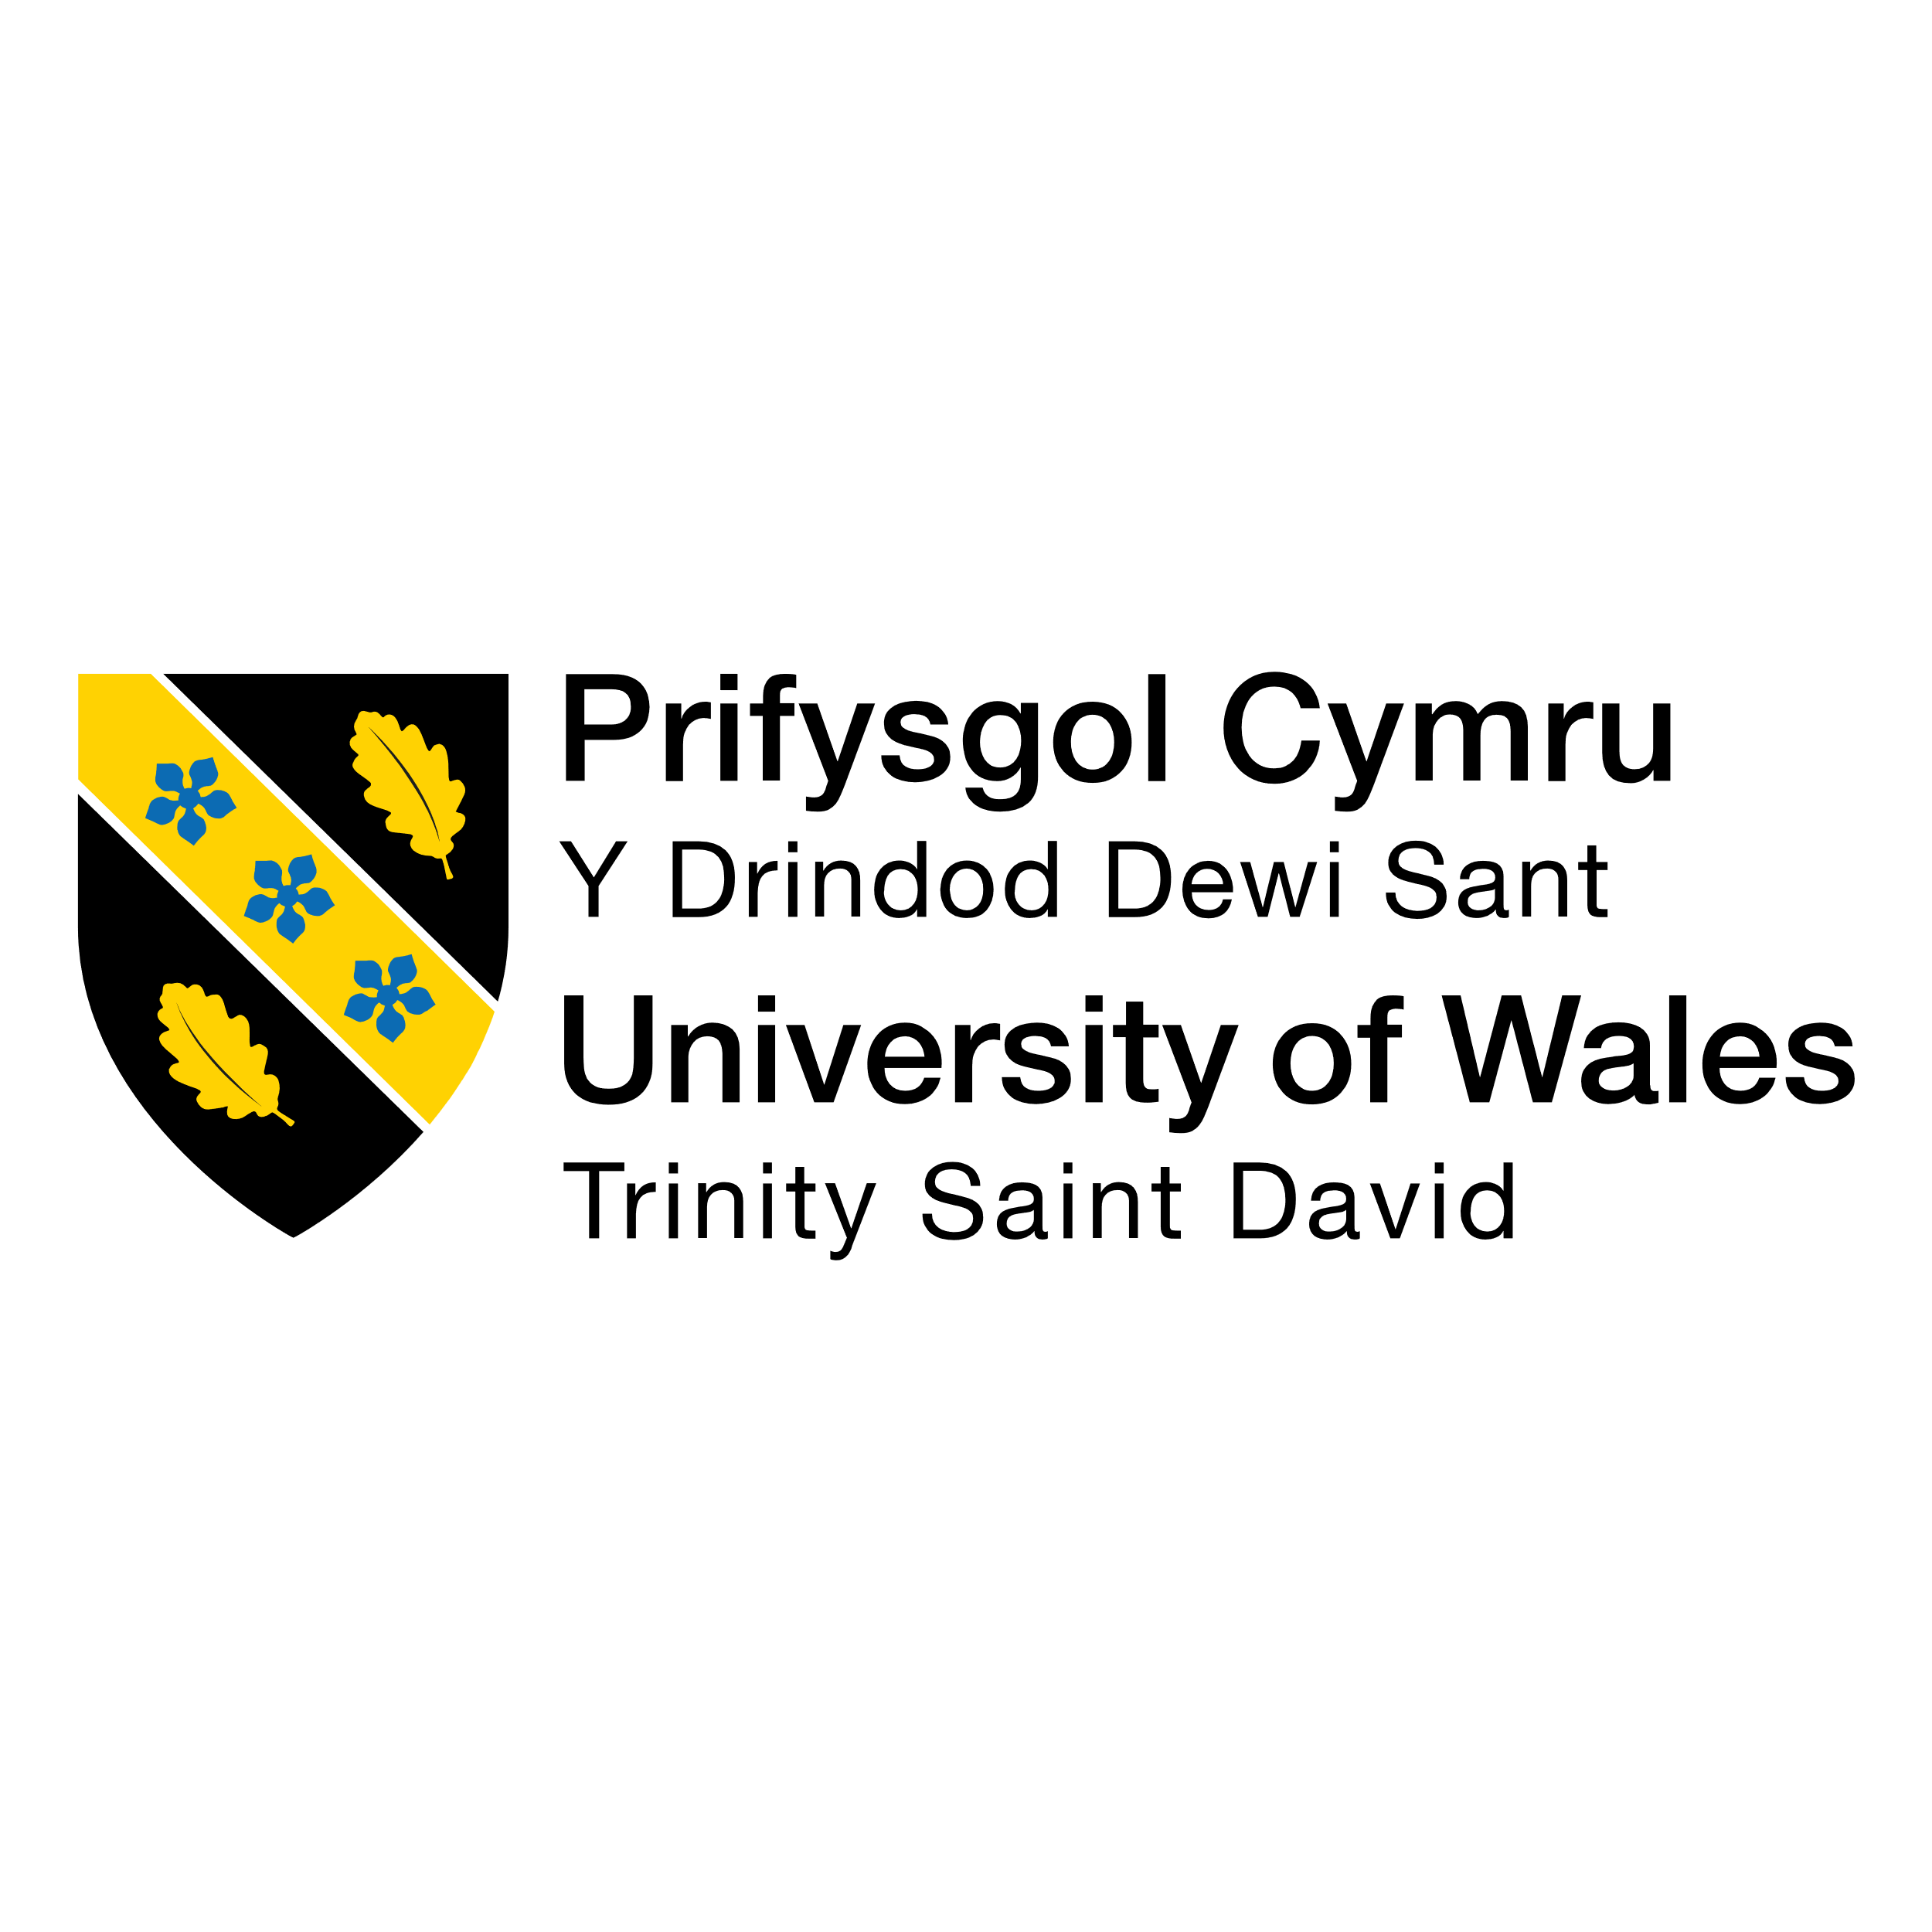

Module Name: Business Research
Module Code: BMMB7028

Assignment Title: Consumer Behavior and Purchase Intentions Towards Sustainable Textiles in Emerging Markets: Business Perspective from Bangladeshi Market

Lecturer/Tutor’s Name: Helen Evans

Student Name: Sabbir Hossain
Student ID: 2420704
Word Count: 7156

Submission Date: 2nd May 2025

Contents
Introduction: 3
1.1: Introduction and Background 3
1.2: Rationale of the research 4
1.3: Research Aim 4
1.4: Research Objectives 4
1.5: Research Questions 5
1.6: Purpose of the research 5
1.7: Significance of the Research 6
Literature Review: 7
2.1 Introduction 7
2.2: Key factors influencing consumer preferences for sustainable textile 10
2.3: Role of price sensitivity, brand perception, and environmental awareness 14
2.4: Marketing strategies for Sustainable textile market 15
2.5: Barriers to adopt 17
2.6: Theoretical and Conceptual framework 18
Research Methodology 21
3.1: Philosophical stance 21
3.2: Research approach 21
3.3: Data Collection and Analysis 22
3.4: Question design and testing 24
3.5: Planned Delivery: 25
3.6: Ethical Consideration 26
Bibliography & References 27
Appendix 1: Survey Question: 36

Introduction:

1.1: Introduction and Background
Bangladesh is eight most populated country in the world (worlometer.com). It is a developing country who mostly dependent on import from overseas. However, its textile industry is one of the leading exporters in the world (The Business Standard, 2025). Over the last few decades, textile industry is one of the major sources to develop Bangladeshi economy. It always draws attention from both industry and Bangladeshi government as textile sector contribute a significant role in Bangladeshi economy. That’s why Sustainable textile is one of the core topics for Bangladesh textile industry. It has huge customers base in the world market as well as in local market. To meet these demands textile industries are booming in Bangladesh adopting modern mechanism. To make a sustainable practice, Bangladeshi textile faces both challenges and opportunity from consumer’s behaviors and their purchase intentions (Tahzibul et el, 2024). It is important for industries to know the consumer’s behavior toward sustainable textile.
People of Bangladesh are becoming more concern about environment and they are like to involve in the eco-friendlier procedures. Environmental awareness and social responsibility are driving consumers to choose more green products. However, consumer may be aware of sustainable textile, their purchase intention still may be limited by sustainable consumption (Harris, Roby, and Dibb, 2016). It is important to find out whether this idea is applicable to Bangladesh or not, then industries may need to work on effective activities to connect consumer with sustainable industries. In this regards, textile industries or brand may deploy creative marketing campaign that will associate sustainable cloth emotionally.

1.2: Rationale of the research
Consumer behavior is as a complex process and it may influence purchase decision toward sustainable textile (Kumari Panitapu, 2013). There are various factors that may influence customer’s buying decision even though consumer is willing to buy sustainable textile. This concern may come from brand perception, design, and fashion trend or price of that products. Brand reputation and fashion can influence consumer’s buying decision by providing aesthetic value or higher brand perception. This study is aim to find out the impact of key factors that influence consumer’s behavior toward buying sustainable textile in Bangladesh.

1.3: Research Aim
This research is intended to find out consumer behavior and their purchase intentions toward sustainable textile. That’s why this research is aimed to find out key factors that influence customer buying decision for sustainable textile.

1.4: Research Objectives
The objectives for this research are given below.
- To analyze the key factors influencing consumer preferences for sustainable textile products in Bangladeshi markets.
- To examine the role of price sensitivity, brand perception, and environmental awareness in shaping purchasing decisions.
- To explore the impact of marketing strategies on consumer trust and adoption of sustainable textile brands.
- To provide recommendations for businesses to enhance market penetration and consumer engagement in sustainable textiles in Bangladesh.

1.5: Research Questions
This study will try to find out consumer’s behavior and purchase intention for sustainable textile product in Bangladesh. In this regard, below research questions have been developed.
- What are the key factors that influence consumer’s purchase intention for sustainable textile products?
- What is the view point of Bangladeshi people toward sustainable textile?
- How marketing communication can motivate consumer to buy sustainable textile?
- What are the barrier customer face to purchase sustainable products?

1.6: Purpose of the research
This study is aim to find out the impact of key factors that drives consumer’s behavior toward sustainable textile industry in Bangladesh. Price, brand perception and environment corner have impact on sustainable textile and it is important to find out their role in order to make effective planning and execution. This study also intends to find out how marketing activities can influence consumer’s perception and buying decision for sustainable textile. It is assumed that this study will able to get insight of consumer’s perception toward substantiable textile in Bangladesh and will able to explore opportunity and threat and will recommend necessary action in order to improve sustainable textile industry in Bangladesh.

1.7: Significance of the Research
Industries need to make people understood that consumer can participate with textile industries in order to create sustainable environment by choosing sustainable textile. After getting consumer’s perception, industries can take initiatives to motivate customer toward sustainable textile. To find out the reality in Bangladesh, this study will help to understand consumer’s perception toward sustainable textile and their level of desire to consumer sustainable textile in Bangladesh.

Literature Review:

2.1 Introduction
Sustainability concept not only include production process but also includes consumption as well (Norum, 2013). Sustainable textile can be gain by engaging raw materials, production process, distribution process that will create longer usable lifespan. Sustainable textile can also indicate less laundering and apparel mending that will be done in manufacturing process (Lapolla and Sanders, 2015).
Sustainability concept can be drawn with three spheres which are economic, social and environmental. Textile industry can gain sustainability if it can practice all these aspect through a positive collaboration. Organization uses sustainability concept is their all part of operational process (Rena, Goyal, Sharma, 2024). Reducing carbon waste, raw material waste, packaging waste, water and other natural resources usage are the part of Environment. These portion not only save environment but also provide positive impact on company’s finance sheet. Environmental sustainability starts from sourcing materials, then manufacturing process, products at shelves, and ended at consumption by consumer and disposal of that product (Karambir , Shruti , Rohit , Anil Kumar, 2024). Employee, stakeholders, and consumer of that community build up social spheres. These elements can help business to gain sustainability when organization can successfully implement sustainable employment policy, improving organizational and intraductal risk management system (Monika, 2023). Economic sphere indicates textile industry practices that earn long term economic growth by giving positive impact on social, cultural and environmental issue. These three spheres play a vital role in influence customer, organizations, social and government, in sustainability process.
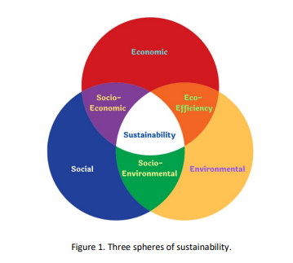
Figure-1, Three Spheres of sustainability. Adopted from Adil & Nawawi, (2015)
The role of consumer in sustainable industry is becoming important part in order to make production and consumption process (Schiaroli, Fraccascia & Dangelico, 2024). So, it is important to find out consumer’s behavior toward sustainable industry in order to create proper blueprint for sustainable textile. Consumer behavior can be influence by many factors. Those may drive consumer’s buying intention positively or negatively.
For any product and services, price is one of the major attributes that directly influence consumer’s purchase decision. If sustainable products can offer more durability and higher product quality which will incur low cost per wear for product lifetime then initial high cost can be ignorable (Pires & et el. 2024). It is also assumed that if more organizations or brands adopt sustainable textile then price may go down. Sustainable product consumption is derived by consumer’s decision-making process that comes from social responsibly. (Vermeir and Verbeke, 2006). A report from “pwc.com (2024)” stated that consumer who are concern about climate change are willing to pay 9.7% more for sustainability products. Although consumers are aware of the importunate of sustainable product, their purchase decision still can be influence by key factors where attributes may conflict with each other’s (Wang, Lee, Li, Yingjio 2021).
Brand perception and marketing communication gives competitive advantages to organization and brand. It will start from core marketing design where industries need to identify what customers need and want. Designers can play a significant role in designing product, emphasizing quality, ethics toward sustainable product. (Can Cui & Nazlina, 2023). This will create positive brand image for that product to customers. Product’s attributes, customer’s behavioral intention including demographics variable can expose possible sustainable product buyer (Nirbhay Rana, 2024). In Bangladesh market textile industries and brands like Aarong, Bibiana are doing marketing communication and campaign to attract sustainable product to customers (Shafayet Ullah, 2023).
Many environmental issues may arise from textile industries. Textile industries are often criticized for dumping harmful waste which are generated textile manufacturing process. Textile industries are reported to emit 8 to 10% of global CO2 emission (Max, 2024). This criticism led consumer to be aware of environmental concern toward textile industries. To make sustainable textile industry, positive perception and behavioral attitude need from government, organization and consumer (Silina, Dabolina & Lapkovska, 2024)
Objectives of this study is to investigate key factors that influence consumer’s behavior for deciding sustainable textile products in Bangladesh. Aim of this research is to assist future research to provide understanding for Bangladeshi customer’s behavior toward sustainable textile and draw recommendations in order to improve sustainable strategy for Bangladeshi market.

2.2: Key factors influencing consumer preferences for sustainable textile
Several studies have explored factors that influence sustainability on an organization. In textile industry, several factors influence the sustainability of an organizations.
Product Quality and Materials:
For every product and service, quality is a key factor that drives customer’s decision in buying procedures. For sustainable textile product quality starts form sourcing raw materials, environmental product processing and disposal of product. It is very important for textile organization to focuses on product quality as well. Failure to give quality product may not attract consumer for long run and the total sustainable process may fall. (Javed & Alam, 2024)
Consumer behavior:
From study from Niinimaki (2010), it is seen that in developed country consumer has a greater knowledge of environmental effect and so it is very easy to drive their purchasing decision toward sustainable textile. However, this attribute may be smaller in developing country and there might be an opportunity to researchers to study in this subject. Consumer behavior may be driven by a society’s buying power and behavior. There are some aspects which may drive consumer’s behavior.
Koca, E., & Koc, F. (2016) have stated that purchasing behavior depends on gender and female buys more apparel than man. With differentiated design and marvelous outlook attract more customers in Bangladesh (Md Nurunnabi, 2016) In Bangladesh especially boutique design implemented sustainable design where customers are easily attracted. Young generation are usually more first mover to adopt new concept as Ripon Kumar, Arifuzzaman (2016) have stated that fashion attributes for particular products affect fashion trends. When consumers are more knowledgably and has more choice to spend money then they want to experience a product that will satisfy their emotional needs (Solomon, M.R. Rabolt N. J. 2007). Consumer’s positive attitude towards green products and consumer’s purchasing behavior are divided by noticeable gap. A study from Zhao et al., (2021) indicates that although 67% consumers expressed positive decision to purchase organic food, only 4% of them actually purchased those organic products. Again, emotional connection to brand, perceived risk of products and perception of value can influence consumer preference.
Brand Reputation:
If a product comes from a reputed brand, then it is very easy to get picked up by consumer. Brand reputation is an extra layer in product’s attribution. In case of sustainable textile, it is expected that branded textile will come forward. In Bangladesh Aarong is a very reputed brand who always focuses on society’s value and recognition by promoting traditional cloth which represent sustainable textile (Shaila Afroj, 2012). People will definitely give more trust to Aarong for sustainable textile than an unknown brand. So, brand reputation will enhance textile’ sustainability practices which will lead to improved brand loyalty and customer’s purchase intention.
Fashion and Style:
Fashion, consumer’s consumption pattern, consumer’s phycological behavior can determine buying decision. Fast fashion may require textile organization to hire sub vendor to match the pace of fashion( Evelyn Matsapola, 2021). Bangladesh is well aware of fashion and people always follow current trend. In Eid time and Puja other religious festival and Pohela boishakh are the main time for mass cloth purchase, though there are regular purchase happen occasionally.
Price:
Price may draw initial attention to maintain sustainability. Sometimes it plays a vital role in consumer’s purchasing decision. Bangladesh is a developing country and its people’s purchasing intention mostly reserve on their buying ability. Sometimes people may not think of getting eco-friendly cloth is it does cost more than their buying capability (Javed & Alam, 2024). Price may affect negatively in consumer’s choice toward sustainable textile if product’s price is higher which may incur limited demand. Technological advancement may reduce the production process and reduce waste in order to make cost effective products. Making durable and repairable cloth may increase sustainable consumer to customer and customer may consider pricing issue. Innovation can play an important role in sustainable textile industries by enabling new design and technology to scaling up and implementing recycling and reuse in order to reduce waste and production cost (Awais Jabed & Alam, 2024). So, it is very necessary to get sustainable pricing in textile industry in order to get sustainably. ( Mostafiz Uddin, 2018)
Brand Perception:
Brand preference plays a vital role in customer’s buying decision. The influence of brand awareness may arise at retail point when customer take purchasing decision (Li and Green, 2011). As Bangladesh has a population of over 180 million and most people live between middle class to lower class, brand preference seldom give an ideal characteristic in customer’s buying decision. Most of the people in Bangladesh buys what they think that is suitable for both of their body and wallet. (Tanzibul and et el. 2024)
It is not necessary that brand preference may come at shop or retail point rather brand preferences may influence buyer from the start of purchase funnel. Before going to retail shop, people may get determined to prefer their brand at home. Although it may require a good presence of marketing activities from respective brand. In this regards brand loyalty is needed from consumer’s end. Keller (2009) has suggested that when a buyer is devoted to purchase of a product of a specific brand over the time without considering other brand or product in the same market, then the brand loyalty occur. For sustainable issue in textile sectors, brand preference is important as it drives consumer understanding of a product’s characteristics and satisfaction. Another interesting point is industries are often using celebrity endorsement to influence consumer’s buying behavior (Zipporah & Mberia, 2004).
Environmental Awareness:
In Oxford Dictionary, Eco-friendly is given as “Not harmful to environment” which also referred as “Green Product” (Islam et al., 2020). In various manufacturer process, textile industries are continuously adopting sustainability measurement due to pressure from consumers and stakeholders who are becoming educated by the rising environmental awareness. Textile industries are trying to focus on materials and quality that improved longevity to reduce environmental hazardous which leads to organization to incorporate sustainable product design. The adaptation starts from raw material supply and then produce eco-friendly products. In the manufacturing process organizations are using modern technology to reduce various types of waste. Sometimes organizations are taking certified textile materials in their production. All these processes led to make eco-friendly managerial process where designer, raw materials supplier, engineers, logistics department as well as customers are interrelated to accomplish sustainability. All the drives for environmental issue are giving some benefits such as reducing water consumption, reducing air pollution and water pollution, providing sustainable textile. Organizations are becoming more socially responsible as they are adopting more sustainability practice by using materials, technology to save the environment.
Availability and Accessibility:
It is important to have elements that is necessary to build sustainability. Textile organization need proper raw materials, need to get proper technology to utilize raw materials and reduce waste. According to Saha (2025) Bangladesh lacks proper infrastructure for sustainable textile development. If there is no proper design for making such products then final products may not contain eco-friendly materials or products will not be long lasting or even it might be harmful for environment while disposed. It will bring nothing if textile industry cannot access resources and materials to conduct sustainably practices. Again, this process may not work if products are out of reach or price is too high to get for customer.
Social responsibility:
Social responsibility can be described the concern of environmental and social influence organization’s supply chain can be seen. Consumer can get positive feedback over a textile organization if that organization show their devotion toward environment and show their transparency toward social ethics (Muhammad Abid & et el, 2018). Creating CRS activity can give positive impression to customer’s buying behavior (Margereta Nadanyiova, 2021). CSR activities also can encourage customers to move from traditional product to green product in Bangladesh (Appel Mahamud, 2024).

2.3: Role of price sensitivity, brand perception, and environmental awareness
Consumer’s price sensitivity may be manipulated by environmental and social awareness (Imran, Nazia, Imran, Ali, (2024)). This positive reasoning may decrease as Rahayu et al. (2015) have stated in their study that consumer mostly look at price and brand name more than environment friendly issue. And consumer who are very much price sensitive, they may totally overlook environmental issue even though having proper environmental knowledge (Sawithri & Rahanatha, 2019). This might be an opportunity to study Bangladeshi consumer’s perception. Sometimes environmental behaviors may go missing which is referred as culture-specific factors (Saleem, Lynne, Asif, Low, 2018). A consumer with high price sensitive might still purchase green product at higher price if that product offers significant benefits and advantages, long term value and poses high social responsibility (Khan Et el, 2024).

2.4: Marketing strategies for Sustainable textile market
Textile industries can take some marketing activities to draw customer attention and get competitive advantage. Some are given below.
Green marketing:
The rise of consumer awareness is forcing textile industries to adopt the green marketing as one of their sustainable strategies (Nazlina, Zainal Abendin, Mohd Ali 2025). To gain advantages in sustainable business growth, textile industries are trying to categorized green marketing as marketing endeavor to integrate environmental concern for both industries and customers (Haque et el. 2024). Industries who has adopted green technology in their production process and communicate them to consumer get internal competitive advantages and from both rational and emotional side.
Transparency from Organization:
Jestratijevic & Rana, (2024) have stated that transparency is the first step for sustainable textile industries. Transparency provides cleaning understanding about the impact of social and environmental of textile industries’ supply chain process, production process and their waste management process to consumer. Transparency also provides social and environmental impact of textile organization to consumer which also portrays the consequences of production of textile industries. By accessing textile industries information consumer can make brand accountable which may direct textile industries to practices sustainable process. Transparency also gives clear information of products that will motivate consumer’s purchase behavior. Because of transparency both textile brand, supplier, weaker, stakeholders and customer come to a collaboration in order to gain sustainable business and environment.
Emotional connection:
In marketing there two major ways that marketers use to promote; emotionally or rationally. Rationally refers the idea of using a product or service basic attribution and demonstration to consumer (Schiaroli, Fraccascia, Dangelico, 2024). For example, an organization can show their product’s quality, attribution and demonstration how to use their cloths. In the other way in emotionally ad organization does not focuses on products or services directly. Rather it attached social or emotional issue with the product. Textile industry can easily bind up with environment, society and cultural value. Being sustainable textile brand can give competitive advantages to organization. They can easily communicate that they are eco-friendly which may give competitive advantages over other organization.
Enhance Brand Loyalty:
Nothing is more beneficiary than Brand Loyalty in competitive market. Loyal customers not only buy an organization’s products or services but also spared word of mouth. Organization needs to promote their activities of their commitment to the environment and society. They need to create campaign that will help them to demonstrate their production process and products in order to attract consumer (Mishra, M.; Kushwaha, 2024). They need to feel their customer proud that they are using eco-friendly products and this will lead customer think that they are saving the environment and society. This will help them to be create brand loyalty.
Creating Positive image:
Making positive publicity and clear communication for their effort for sustainability would attract consumer’s attention. In sustainability process, organization should use more eco-friendly material to produce their product, they need to reduce waste, make easily disposable products that is not harmful to environment and also use ethical labor standard. All these processes have to be shown to customer.

2.5: Barriers to adopt
Throughout the years businesses are trying to maintain sustainability by balance between natural harmony and industrial infrastructure. It encompasses both human and environment in order to get better future. (ref). It seems mandatory in textile industry to maintain sustainability as it is defined as manufacturing company where various natural resources are used. These includes water, energy, various chemicals. These resources may also posed threat to environment as these mixtures produces waste which is sometimes very toxic and harmful for environment (Tahzibul and et el., 2024). In this regards it is obvious that textile industries are enforced to practic sustainability(Sehnem, Troiani, Lara, Crizel 2023). Sustainability is a process of maintaining balance between various controllable and uncontrollable force. It has economic force, social force, environmental force (Phi-hung, Lan-Anh, The-Vu, Tra-Giang, 2025). Each force is directly or indirectly related with one-another. Some of these possess short term effect and some possess long term effect in an organization’s sustainability. Internal barrier also consists of age, education, values of consumer. In the other hand external barriers are price of raw materials, price of products, shortage of infrastructure, social norms and culture.

2.6: Theoretical and Conceptual framework
Sustainable textile industry is a collaboration of consumer, organization, society, government where each play their role. The proposed study will use “Planned behavioral theory” as their purchase decision is influenced by consumer’s behavior toward sustainable textile (Ajzen, 1991). Consumer’s purchase decision is derived by phycological factors, social factors, cultural factors, personal factors and economic factors. Consumer’s awareness and knowledge about sustainable textile can set organization to plan and execute for consumer-bound activities. Environmental awareness and product perceive quality need to determine as these factors can lead consumer to make positive or negative attitude toward organization. In Bangladesh a major portion of population live middle class and lower class. It would be interesting to see whether this groups of people are aware of sustainability and has the intention to adopt sustainability.
Consumer’s decision-making process is also need to be evaluated as there are factors that influences consumers understanding, awareness and purchase intention. Sometimes customer’s decision-making process can be influenced instantly by fashion trend. As there are concern for society and environment, Value-Belief-Norm’s theory will be followed (Stern, 1999). It will enable this research to conduct study on environment and ethical concern that impact purchasing decision.
In Bangladesh Aarong, Bibiana,Yellow are very popular textile brand. As there are multiple brands operating in Bangladesh market, they can either gain leverage by adopting sustainable textile procedures (Danskin, et el., 2005). Their competitive advantages can be drawn by analysis Porter’s Five Forces (1979). Stakeholder theory will enable this research to show how business can offer balance between consumer, supplier, society and regulation (Freeman, 1984).
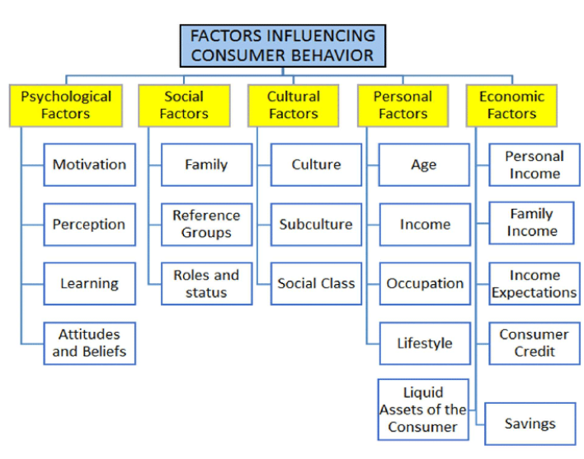
Figure-2, Factors influencing consumer behavior: Adopted from- Duc & Trong (2018)
Consumer’s attitude and awareness directly influence consumer’s purchase decision in relation with industries pricing, branding, moderating value. Here organization and consumer can interact with each-other and impact on consumer’s purchase and organization’s sustainability. Both parties can offer each other unique requirements that can work for gaining sustainability.

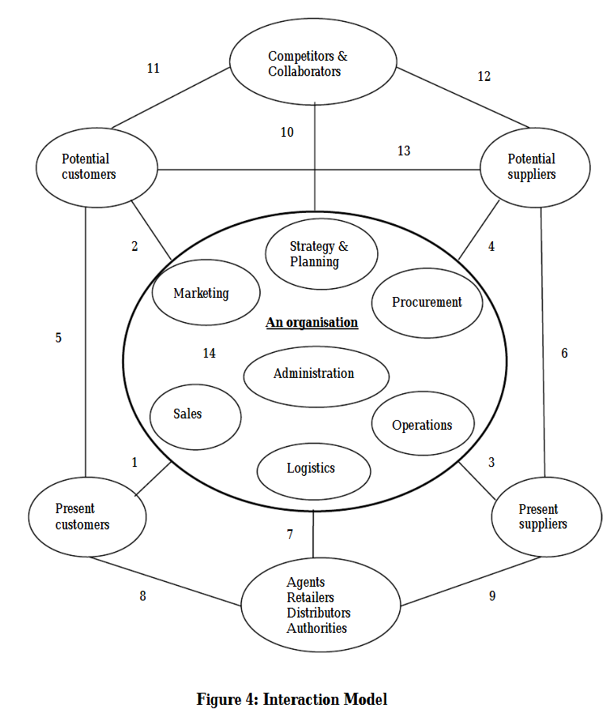
Figure-3: Interaction Model, Adopted from Malcom (2004).
The given model suggests that elements that is required for organization’s sustainability are related to each other. This consumer business model suggest that organization can take leverage from consumer’s attitude and behavior in order to enhance sustainability.

Research Methodology

3.1: Philosophical stance
This study will follow interpretivist stance as this study will requires in-depth measurement of key factors that influences consumer buying decision for sustainable textile. As the topic sustainably textile is a wider stance in current global market, so it is assumed that this study will limit the usefulness of this study because intense sample size and more in-depth analysis would make this study to use in border perspective. There are some previous studies where sustainability of textile business and purchase intensions of consumer are found. So, blending sustainable textile and consumer’s behavior and purchase intention in Bangladesh will give a meaningful stance.

3.2: Research approach
This study will go through deductive-inductive theory by illustrating the consumer’s behavior toward sustainable textile in Bangladesh. For this stance this thesis will be viewed through the theoretical lens using consumer’s behavior theory and social cognitive theory. These theories are expected to guide the data collection process from which consumer’s knowledge and behavior toward sustainable textile will emerge, thus making it inductive reasoning to develop the knowledge and understanding of sustainable textile Fereday and Muir-Cochrane 2006).
A quantitative approach will be taken for this study to understand phenomena and draw conclusion (Saunders, Lewis, Thornhill, 2019). It is important to get the effect of consumer’s behavior and to know how their behavior play a role in buying intention of sustainable textile in Bangladesh. It is also important to know how these key factors associate with the delivery from textile industries to implement sustainability. The effect of marketing activities and branding toward unstable textile also may found and their competitive advantage may derive form this study. Previous studies of sustainable textile have identified co-relation of consumer’s behavior with consumer’s buying decision. A survey of questionnaire derived from social research method will be used to find out real world issue of Bangladeshi consumer (Bickman, & Rog, D. J. 2009).
The survey interview will likely be conducted via online form and in-person interview to get maximum respondent. Online form will give the respondent the freedom to fill up in a given timeline. Research and data analysis will be subjective so it is accepted that researcher’s own beliefs and value will be exist (Saunders, Lewis, Thornhill, 2009). This process is backed by Almeida (2017) as he viewed “the researcher” as “Primary instrument” in data collection process.
This research may get criticism as it is objective and this may contain lack of in-depth understanding of a consumer. Because of structured questions and contextual limitation this study may not conclude some other context of behavior. However, enhancing more contextual understanding and improving the sampling technique can add validity of the findings.

3.3: Data Collection and Analysis
This study is intended to use both primary and secondary sources of data in order to make this study comprehensive, reliable and impactful.
Secondary Data Source
For secondary data source, academic journal will be used to determine literature review which will help to get idea about past research. Government reports and website will be used to examine the current status of Bangladeshi population, certification and compilation, past govt research on environment etc. Another good source for secondary reports will be BGMEA (Bangladesh Garment Manufacturers and Exporters Association), EPB (Export promotion Bureau), BTMA (Bangladesh Textile Mills Association) from where industry sustainability reports, export and trade policy report will be taken. Current newspaper of Bangladesh will be another legitimate source for any current impact of textile industry or consumer behavioral change. Some special newspaper like “Business Standard” and “Bangladesh Textile Journal” may add more information. Apart from these source academic library and online magazine and journals will be a good source of secondary data. There are some blogs from where we may get cultural information of Bangladeshi people.
They are some limitations in secondary data. The information is needed may be outdated or it may not perfectly align with research purpose. Sometime secondary data may face reliability issue if data that are collected are not from reliable source. In this study researcher will combined secondary data with primary data and cross-checking with multiple sources in order to get the best possible outcome for this study.
Primary Data source and sample size:
To collect primary data structured questionnaire will be used. As the term “sustainable textile industry” needed some basic knowledge, research will try to get the data who has moderate education knowledge. In this process demographic information of target sample will be studies prior to provide final survey questionnaire in order to reduce survey failure.
The sample size will be 240 for this survey where 60% participators will be students, who will be at least high school graduate. Teens are early adopter for new technology and tread (Tobbin & Adjei, 2014). So, this generation will define mostly the acceptance of sustainable textile. 30% participators will be taken from mid age people who are working or housewife. Rest 20% participators will be taken from those people who are currently working in textile industry. Due to time constrains of data collection and to access the sample who are living in Bangladesh an online survey questionnaire will be given by google form. To ensure all objectives are met that has been given in this study, a pilot interview will be conducted.

3.4: Question design and testing
The questionnaire will be structed and closed-ended which will include predefined options in order to analyze data easily. This process will also help responded to be quantified and it will help to compared data statistically.
Question will be divided into 5 sections although respondents will not notice these as they will get the question in a structured form. These are
- Demographics information of respondent.
- Awareness and attitude
- Purchase intention for sustainable textile
- Respondent’s buying preference
- Recommendations

3.5: Planned Delivery:
After taking the survey data will be collected and gather and then analyze in excel form. Answer will be categorized and will be presented in graph to make the report more sensible. As this study some questionnaire will be given in online it is expected that some information may not be answered by the respondent. For this reason, respondent might be asked again to provide missing information. This project plan is made created after getting the requirements form the University. This project plan has included realistic timeframe for each task and allocated revision and changes considering research survey and data collection.
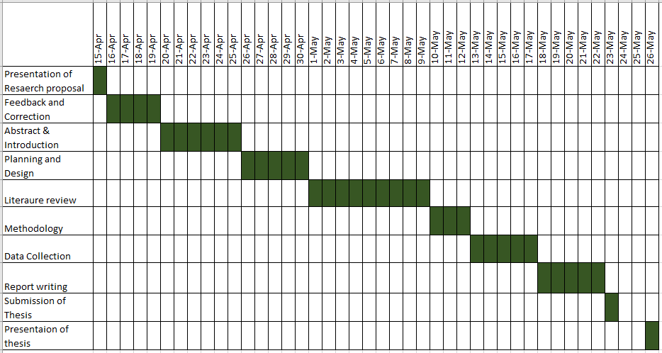

3.6: Ethical Consideration
As this research is intendent to make both online and offline, there might be some potential risk for respondent. If the survey interview takes places in respondent premises, the respondent might not give proper attention because s/he may face psychological or emotional risk even if the risk is very minimal. This research will not ask any personal question to respondent and no personal information will be collected even if respondent want to provide. While collecting data from textile correspondent person, their responses will be treated as general as others. Missing information will not be taken into account but can be send to respondent to provide again. One’s response will not share will others. And most important part is no data will be misinterpreted from researcher.

Bibliography & References

- Adil & Nawawi, (2015), “Investigation of the Philosophy Practised in Green and Lean Manufacturing Management”, Online, Accessed on- 8 April 2025
- Ajzen I. (1991). “The theory of planned behavior. Organizational Behavior and Human Decision Processes”, 50(2): 179-211. doi: 10.1016/0749-5978(91)90020-T
- Al Imran, Nazia, Imran, Ali, (2024), “Consumer Behavior and Sustainable Marketing Practices in the Ready-Made Garments Industry”, Online, Accessed on 7 April
- Almeida, Faria, Queirós (2017), “Strengths and Limitations of Qualitative and Quantitative Research Methods”, Online, Accessed on-7 April
- Appel Mahamud, (2024), “How and when consumer corporate social responsibility knowledge influences green purchase behavior: A moderated-mediated model”, Online, Accessed on- 5 April 2025
- Bickman, & Rog, D. J. (2009). “The SAGE handbook of applied social research methods” (2nd edn.). SAGE
- Can Cui, Nazlina, (2023), “Consumer in Sustainable Textiles: A Scientometric Review”, Textile & Leather Review 6:559-581
- Danskin, et el., (2000), “Internationalization of born global and gradual globalizing firms: The impact of the manager, Online, Accessed on 7 April 2025
- Duc & Trong (2018), “The Impacts of Culture on Vietnamese Consumer Behavior Towards Foreign Products”
- Evelyn Matsapola, (2021), “Consumer behaviour towards sustainable clothing, Online, Accessed on 5 April 2025,
- Fereday, J. and Muir-Cochrane, E. (2006) Demonstrating Rigour Using Thematic Analysis: A Hybrid Approach of Inductive and Deductive Coding and Theme Development, International Journal of Qualitative Methods, 5(1), 80-92
- Freeman, (1984), “A Stakeholder Approach to Strategic Management”, Online- https://shorturl.at/AzvEK, Accessed on- 7 April 2025
- Haque et el. (2024), “Investigating the Present Condition of the Textile Industry in Bangladesh on Sustainability Practices”, ISSN: 2327-7971 (Print), SSN: 2327-915X (Online) Volume 31, Issue 1, 2024
- Haque, Ibrahim, Ismail, Khalilullah, Bayezid, (2024), “Investigating the Present Condition of the Textile Industry in Bangladesh on Sustainability Practices”, Online, Accessed on 7 April
- Harris, Roby, and Dibb, (2016), “Sustainable clothing: challenges, barriers and interventions for encouraging more sustainable consumer behaviour”, International Journal of Consumer Studies, Accessed on 10 April 2025
- Iva Jestratijevic, Rana, (2024), “Transparency of sustainability disclosures among luxury and mass-market fashion brands: Longitudinal approach”, online, https://www.sciencedirect.com/science/article/abs/pii/S0959652623046395, Accessed on 5 April 2025
- Javed, Alam, (2024), “Price sensitivity and sustainable shopping: A study of Bangladeshi consumers”, Online, Accessed on 7 April
- Karambir , Shruti , Rohit , Anil Kumar, (2024), “Green energy innovation initiatives for environmental sustainability: current state and future research direction”, Environmental Science and Pollution Research
- Keller, (2009), “Building strong brands in a modern marketing communications environment”, Journal of Marketing Communications, online, accessed on 6 April 2025
- Khan, O.; Varaksina, N.; Hinterhuber, (2024), “A. The influence of cultural differences on consumers’ willingness to pay more for sustainable fashion”. J. Clean. Prod. 2024, 442, 141024.
- Koca, E., & Koc, F. (2016), “A Study of Clothing Purchasing Behavior By Gender with Respect to Fashion and Brand Awareness”, European Scientific Journal 12(7):234 -248
- Kumari Panitapu, (2013), “Consumer Complex Buying Behavior”, SSRN Electronic Journal DOI:10.2139/ssrn.2275391
- Lapolla and Sanders, (2015), “Using Cocreation to Engage Everyday Creativity in Reusing and Repairing Apparel,” Clothing and Textiles Research Journal 33(3)
- Li and Green, (2011), “A Mediating influence on customer loyalty: The role of perceived value”, DOI:10.1163/ej.9789004202269.i-228.5
- Malcom (2004), “Developing a Business Interaction Model for e-business Requirements Analysis”.
- Margereta Nadanyiova, (2021), The perception of corporate social responsibility and its impact on consumer buying behaviour in the process of globalization”, SHS Web of Conferences 92, 06024 (2021)
- Mark NK Saunders, P Lewis, A Thornhill, (2009), “Understanding research philosophies and approaches”
- Max, (2024), “The environmental impact of the textile sector”, www.hhc.earth/knowledgebase/articles/the-environmental-impact-of-the-textile-sector, Accessed on 9 April 2025
- Md Nurunnabi, (2016), “Buying Behavior of Young Customers in Bangladesh - A Movement towards Investigation of Their Fashion Attributes, https://zt.ms/YZgT, accessed on 5 April 2025
- Michael E. Porter, (1979), "How Competitive Forces Shape Strategy", Harvard Business Review, May 1979 (Vol. 57, No. 2), pp. 137–145.
- Mishra, M.; Kushwaha, R.; Gupta, N., (2024), “Impact of sales promotion on consumer buying behavior in the apparel industry”. Cogent Bus. Manag. 2024, 11, 2310552.
- Monika, 2023, The role of stakeholders in sustainable development, Organizing Sustainable Development (pp.203-217)
- Mostafiz Uddin, (Sept 17, 2018), www.thedailystar.net/opinion/perspective/news/sustainable-pricing-crucial-our-apparel-industry-1634638, online, Accessed on 5 April 2025
- Muhammad Abid Saleem, Lynne Eagle, Asif Yaseen, David Low, (2018) “The power of spirituality: Exploring the effects of environmental values on eco-socially conscious consumer behavior", Asia Pacific Journal of Marketing and Logistics, https://doi.org/10.1108/APJML-10-2017-0259
- Muhammad Awais Javed, Mahfuz Alam, (2024), Price sensitivity and sustainable shopping: A study of Bangladeshi consumers, , 2379-106X, www.aijbm.com Volume 07, Issue 05 (May-2024), PP 54-68
- Nazlina, Zainal Abendin, Mohd Ali (2025), “Sustainable Style: Unraveling the Trends and Future of Green Marketing in the Textile and Apparel Industry, Online- https://www.mdpi.com/2071-1050/17/1/292, Accessed on- 5 April 2025
- Niinimaki ,(2010), Eco-Clothing, Consumer Identity and Ideology, Sustainable Development 18(3):150-162
- Nirbhay Rana, (2024), “Green Marketing Strategies for Sustainable Fashion: Educating and Engaging Consumers, https://l1nq.com/XfMFh, accessed on 10 April 2025
- Norum, (2013), Examination of Apparel Maintenance Skills and Practices: Implications for Sustainable Clothing Consumption, https://doi.org/10.1111/fcsr.12047
- Phi-hung, Lan-Anh, The-Vu, Tra-Giang, (2025), “Mapping Barriers to Sustainable Fashion Consumption: Insights from Neutrosophic-Z Number and Delphi-DEMATEL Integration”, Online, Accessed on 6 April 2025.
- Pires, Morais, Delgado, Santos, (2024), Intention to Purchase Sustainable Fashion: Influencer and Worth-of-Mouth Determinants, Social Media and Online Consumer Decision Making in the Fashion Industry (pp.160-185)
- pwc.com (2024), https://encr.pw/Wb2TW accessed on 9th April
- Rahayu et al. (2015), Determinant Factors of E-commerce Adoption by SMEs in Developing Country: Evidence from Indonesia, Procedia - Social and Behavioral Sciences
- Rena, Goyal, Sharma, (2024), Sustainability Initiatives in the Asian Textile Industry, Consumption and Production in the Textile and Garment Industry (pp.175-189)”
- Saha, S kumar, (2025), “Embracing the future: Bangladesh's path to sustainable Man-Made Fiber industry, Online- www.textiletoday.com.bd/embracing-the-future-bangladeshs-path-to-sustainable-man-made-fiber-industry, Accessed on 5 April 2025
- Saunders, Lewis, P., & Thornhill, A. (2019). Research methods for business students, 8th edn. Pearson.
- Sawitri, I. G. A. T. D., & Rahanatha, G. B. (2019). Pengaruh Green Marketing Dan Brand Image Terhadap Loyalitas Pelanggan. E-Jurnal Manajemen Universitas Udayana, 8(8), 5267. https://doi.org/10.24843/ejmunud.2019.v08.i08.p22
- Schiaroli, Fraccascia, Dangelico, (2024), “How can consumers behave sustainably in the fashion industry? A systematic literature review of determinants, drivers, and barriers across the consumption phases”, Online- www.sciencedirect.com/science/article/pii/S0959652624036813, Accessed on 6 April 2025
- Schiaroli, Fraccascia, Dangelico, (2024), How can consumers behave sustainably in the fashion industry? A systematic literature review of determinants, drivers, and barriers across the consumption phases, Journal of Cleaner Production 483(1):144232
- Sehnem, Troiani, Lara, Crizel, (2023), Sustainable fashion: challenges and barriers for advancing the circular economy, Environment Development and Sustainability 26(4) DOI:10.1007/s10668-022-02872-9
- Shafayet Ullah, (2023), “Sustainable Fashion for Aarong: The impact of fashion upcycling, chief branding officer & fashion e-commerce experience on the Bangladeshi consumers’ brand equity”,
- Shaila Afroj, (2012), “Investigating the Potential to Incorporate Bangladeshi Textile Crafts into a Global Supply Chain”
- Silina, Dabolina, Lapkovska, (2024), Sustainable textile industry – wishful thinking or the new norm: A review, Journal of Engineered Fibers and Fabrics
- Solomon, M.R. Rabolt N. J. (2007), Consumer Behavior: Buying, Having, and Being (8th ed.)20091Michael R. Solomon. Consumer Behavior: Buying, Having, and Being (8th ed.). Upper Saddle River, NJ: Pearson Education 2009., ISBN: ‐13: 978‐0‐13‐515336‐9 ‐10: 0‐13‐515336‐0
- Stern, (1999), “A Value-Belief-Norm Theory of Support for Social Movements: The Case of Environmentalism”, Human Ecology Review, Vol. 6, No. 2, 1999
- Tanzibul and et el. (2024), Investigating the Present Condition of the Textile Industry in Bangladesh on Sustainability Practices, The International Journal of Science, Mathematics and Technology Learning 31(1):2024
- The Business Standard, (17 January 2025), https://www.tbsnews.net/economy/rmg/rmg-exports-reach-3848b-2024-strong-growth-non-traditional-markets-1045286, Accessed on 5 April, 2025
- Tobbin & Adjei, (2014), Understanding the Characteristics of Early and Late Adopters of Technology: The Case of Mobile Money, International Journal of E-Services and Mobile Applications
- Vermeir and Verbeke, (2006), Sustainable Food Consumption: Exploring the Consumer “Attitude – Behavioral Intention” Gap, Journal of Agricultural and Environmental Ethics, 19(2):169-194
- Wang, Lee, Li, Yingjio, (2021), “Preferred Product Attributes for Sustainable Outdoor Apparel: A Conjoint Analysis Approach”, Sustainable Production and Consumption 29(10)
- Worldometer.com, https://www.worldometers.info/world-population/population-by-country/” Accessed on 12 April 2025
- Zhao et al., (2021), Productivity as a measure of performance: ABARES perspective, Online, accessed on 5 April 2025
- Zipporah & Mberia, (2004), “The Effects OF Celebrity Endorsement in Advertisements, International Journal of Academic Research in Economics and Management Sciences

Appendix 1: Survey Question:

Dear sir/Madam,
I would like to request you to fill-up the given questionnaire that is conducted for academic purpose only. Your given information will not be shared with anywhere else.

- Your Age:
  - [ ] Under 18
  - [ ] 18-24
  - [ ] 25-34
  - [ ] 35-44
  - [ ] 45+
- Gender:
  - [ ] Male
  - [ ] Female
  - [ ] Non-binary / Prefer not to say
- Your Monthly Income (In BDT):
  - [ ] Below 20,000
  - [ ] 20,000 - 50,000
  - [ ] 50,000 - 100,000
  - [ ] Above 100,000
- Education Level:
  - [ ] Secondary school
  - [ ] Undergraduate degree
  - [ ] Postgraduate degree
  - [ ] Other
- How familiar are you with sustainable textiles?
  - [ ] Very familiar
  - [ ] Somewhat familiar
  - [ ] Not familiar
- How important is sustainability when buying clothing?
  - [ ] Extremely important
  - [ ] Moderately important
  - [ ] Neutral
  - [ ] Not important
- What factors influence your clothing purchases? (Select all that apply)
  - [ ] Price
  - [ ] Brand reputation
  - [ ] Fabric quality
  - [ ] Eco-friendliness
  - [ ] Trend & fashion appeal
- Would you be willing to pay more for sustainable clothing?
  - [ ] Yes
  - [ ] No
- Have you ever purchased a sustainable textile product (organic cotton, recycled fabric, eco-friendly materials)?
  - [ ] Yes
  - [ ] No
- What would encourage you to buy sustainable textiles? (Select all that apply)
  - [ ] Lower price
  - [ ] More availability in local stores
  - [ ] Better quality & durability
  - [ ] Awareness campaigns
  - [ ] Social responsibility of brands
- Where do you usually buy clothing?
  - [ ] Local markets
  - [ ] Online stores
  - [ ] Shopping malls
  - [ ] Boutique stores

- Which sustainable textile brands do you recognize?
  - [ ] None
  - [ ] Aarong
  - [ ] Artisan Hut
  - [ ] Other (please specify) _____________
- Would you prefer renting or buying sustainable clothing?
  - [ ] Renting (temporary use, lower cost)
  - [ ] Buying (owning long-term, higher cost)
  - [ ] Neutral / No preference
- What barriers prevent you from buying sustainable textiles? (Select all that apply)
  - [ ] High price
  - [ ] Limited options in Bangladesh
  - [ ] Lack of awareness
  - [ ] Style / Fashion concerns
- What initiatives should brands take to promote sustainability? (Select all that apply)
  - [ ] Lower prices
  - [ ] More marketing campaigns
  - [ ] Transparent sourcing & ethical manufacturing
  - [ ] Collaborations with local artisans

