DISSERTATION-PROPOSAL
LCBB6000

The importance of digital marketing for SME’s for hairdressing industry in the UK

Student name: Cornelia-Roxana Rad
Student ID: 2023709
Submission date:

Supervisor Name: Tushara Balendran

Table of Contents
INTRODUCTION 3
Rationale of the study 3
Aim of Research 3
Objectives research 3
Research Questions 4
LITERATURE REVIEW 4
Brand Loyalty 5
SME’s and Customers in the hairdressing industry 7
Race Model 9
RESEARCH METHODOLOGY 12
Research Philosophy 13
Research approach 13
Research strategy 14
Type of investigation 14
Choices 15
Time Horizons 16
Data collection and analysis 16
Sample type 17
Sampling method 17
Data Collection Methods 17
Analysis of Data 17
Research Ethics 18
Planning 19
References 20

INTRODUCTION

In today's digital age, it has become increasingly important for small and medium-sized enterprises (SMEs) in the hairdressing industry to embrace digital marketing strategies. With the rise of online platforms and the growing reliance on the internet for information and services, SMEs need to establish a strong online presence to remain competitive in the market. This proposal aims to highlight the importance of digital marketing for hairdressing SMEs in the UK and provide recommendations for effective implementation.

Rationale of the study

The rationale for studying the use of SMS’s marketing in the hairdressing industry is to understand its effectiveness and benefits in reaching and engaging with customers. By examining its impact on customer retention, customer satisfaction, and business growth, the study aims to provide insights into the value of SMS’s marketing as a digital marketing strategy for hairdressing businesses in the UK.

Aim of Research

The main aim of this research is to assess the effectiveness and the importance of SME’s marketing in the hairdressing industry in the UK.

Objectives research

- To determine the current digital strategies marketing utilised by SME’s for hairdressing companies in the UK.
- To investigate the impact of digital marketing strategies on the brand loyalty of hairdressing customers.
- To analyse the advantages and disadvantage of SEM’s hairdressing companies in implementing digital marketing.

Research Questions

- What are the preferences of customers in the hairdressing industry regarding SME’s marketing?

- How do customers perceive and respond to different types of SME’s messages promotional offers, appointment reminders, and other communication efforts?

- What are the key factors that influence the success of SME’s marketing campaigns in the hairdressing industry?

- What is the impact of digital marketing strategies on the brand loyalty of hairdressing customers?

LITERATURE REVIEW

Digital marketing is the process of promoting goods, services, or brands via digital platforms and tools. It includes a range of online marketing tactics and strategies that are intended to connect with and interact with a target audience via electronic devices including computers, smartphones, tablets, and other digital platforms.

Utilising digital channels, such as websites, search engines, social media platforms, email, mobile apps, and online advertising, digital marketing connects with potential customers, develops brand awareness, increases website traffic, creates leads, and ultimately achieves business objectives. (Deiss & Henneberry, 2020).

Brand Loyalty

Brand loyalty, in the context of a salon or hairdressing business, refers to the continued patronage and preference of customers to a particular salon over its competitors. It is a measure of the customer's strong attachment, trust, and satisfaction with the salon's brand, services, and overall experience.

The reasons why customers continue to come to the same salon, demonstrating brand loyalty, can include:

- Consistent Quality

The salon consistently delivers high-quality hairdressing services, ensuring that customers are satisfied with their results. This consistency builds trust and confidence in the salon's expertise and ability to meet the customer's expectations.

- Positive Experience:

Customers have positive experiences during their visits to the salon, including factors such as a welcoming and friendly atmosphere, attentive and skilled staff, personalized service, and attention to detail. These positive experiences create a sense of comfort, enjoyment, and loyalty towards the salon.

- Relationship Building:

The salon has developed a strong relationship with its customers, going beyond the transactional aspect of the services provided. This can involve personalized interactions, remembering customer preferences, offering tailored recommendations, and providing a sense of familiarity and connection. Building relationships fosters loyalty and an emotional bond with the salon.

- Special Offers and Rewards:

The salon may offer loyalty programs, discounts, special promotions, or rewards for repeat customers. These incentives provide added value to customers and encourage them to continue choosing the salon over competitors.

- Brand Reputation:

The salon has established a positive reputation in the industry and among its customers. This reputation could be based on factors such as expertise, professionalism, innovation, customer satisfaction, and positive word-of-mouth referrals. A strong brand reputation contributes to customer trust and loyalty.

- Convenience and Accessibility:

The salon may have a convenient location, flexible appointment scheduling, online booking options, or other features that make it easy and convenient for customers to visit regularly. This convenience factor can contribute to customer loyalty.

- Emotional Connection:

Customers may have developed an emotional connection with the salon, associating positive emotions, memories, or personal significance with their experiences there. This emotional bond strengthens brand loyalty and makes it more likely for customers to continue choosing the same salon.

Overall, brand loyalty in the context of a salon is driven by consistent quality, positive experiences, relationship building, special offers, brand reputation, convenience, and emotional connections. By delivering exceptional services and experiences, salons can foster long-term loyalty and retain customers in a highly competitive industry. Yes, digital marketing is important for hairdressers and other professionals in the beauty industry.

SME’s and Customers in the hairdressing industry

Customers in the hairdressing industry have various preferences when it comes to the marketing efforts of SMEs (Small and Medium-sized Enterprises). While preferences can vary among individuals, here are some common preferences that hairdressing customers may have:

- Personalized Communication:

Customers appreciate personalized communication from hairdressing SMEs. This can include personalized emails, text messages, or social media interactions that address them by name and provide tailored offers, recommendations, or reminders based on their preferences, past purchases, or appointment history.

- Mobile-Friendly Experience:

With the increasing use of smartphones, customers prefer hairdressing SMEs that offer a mobile-friendly experience. This includes having a responsive website that is easy to navigate on mobile devices, mobile apps for appointment booking or loyalty programs, and mobile-friendly communication channels.

- Online Booking and Convenience:

Customers value the convenience of online booking systems that allow them to schedule appointments easily and quickly. Hairdressing SMEs that offer online booking platforms or integrate with popular salon appointment apps make it more convenient for customers to book appointments at their preferred time and avoid waiting times.

- Social Media Presence:

Many customers in the hairdressing industry prefer hairdressing SMEs that have an active presence on social media platforms. They look for businesses that share engaging and relevant content, showcase their work through before-and-after photos, respond to customer inquiries promptly, and provide updates on promotions or new services.

- Positive Online Reviews and Testimonials:

Customers often rely on online reviews and testimonials to make decisions about which hairdressing SME to choose. They appreciate businesses that have positive reviews and testimonials on platforms like Google, Yelp, or social media. It instills confidence in the quality of service provided and helps customers make informed choices.

- Value for Money:

Customers in the hairdressing industry appreciate hairdressing SMEs that offer value for money. They look for competitive pricing, special promotions, loyalty programs, or package deals that provide discounts or additional services. Customers want to feel that they are getting quality service at a fair price.

- Communication and Transparency:

Clear communication and transparency are essential to customers in the hairdressing industry. They appreciate businesses that communicate openly about pricing, services, and any potential limitations or requirements. Being transparent about the process, products used, and any additional charges helps customers make informed decisions and fosters trust.

- Engagement and Interaction:

Customers enjoy engaging with hairdressing SMEs that actively interact with them. This can include responding to comments and messages on social media, asking for feedback or suggestions, and involving customers in contests or interactive campaigns. Engagement creates a sense of community and connection with the brand.

It's important to note that these preferences can vary among customers, and not all customers may have the same preferences. Therefore, hairdressing SMEs should consider their target audience, conduct market research, and gather customer feedback to understand and cater to the specific preferences of their customer base.

Race Model

The RACE model is a framework commonly used in marketing and communication to guide the development and execution of digital marketing strategies. Each letter in the acronym RACE represents a different stage of the customer journey (Chaffey, 2022):

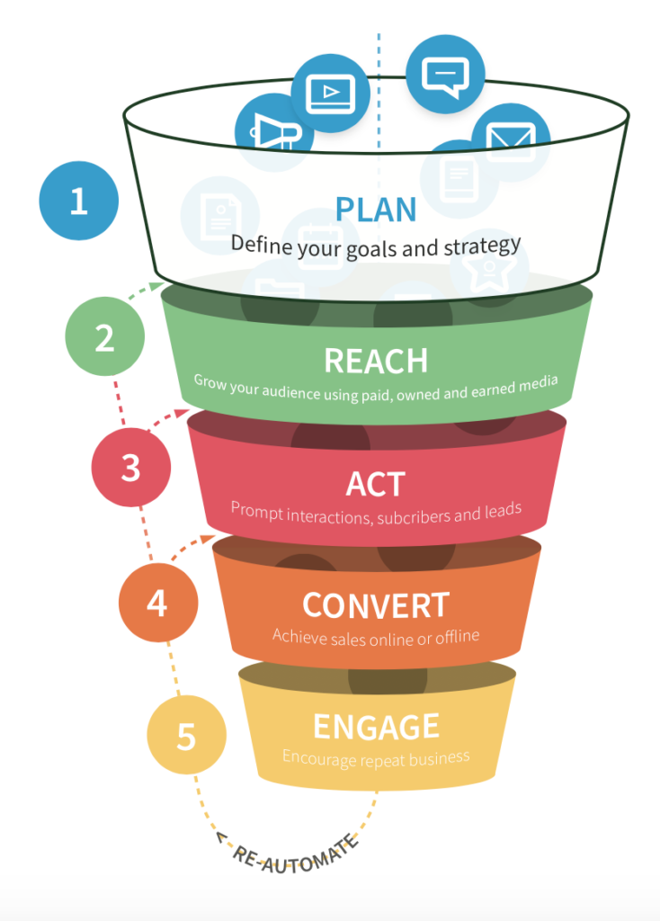Fig.1 RACE MODEL Sources internet
- Reach:

The first stage focuses on reaching and attracting your target audience. It involves increasing brand visibility, driving traffic to your website or other digital platforms, and expanding your online presence. Search engine optimisation (SEO), paid advertising, social media marketing, content marketing, and influencer collaborations are typical methods for connecting with your target audience. (2023).

- Act:

The second stage is about encouraging your audience to act and engage with your brand. This could involve actions such as signing up for a newsletter, downloading a whitepaper, making a purchase, or filling out a contact form. The goal is to convert visitors into leads or customers. Strategies to encourage action may include optimizing landing pages, improving user experience, creating compelling calls-to-action (CTAs), and implementing lead capture mechanisms.

- Convert:

The third stage is focused on converting leads or website visitors into customers. It involves nurturing and building relationships with potential customers, providing valuable content, addressing their concerns, and guiding them through the buyer's journey. Effective tactics at this stage include email marketing, personalized messaging, retargeting campaigns, and marketing automation.

- Engage:

The final stage of the RACE model is all about fostering long-term engagement and loyalty with your customers. It aims to turn customers into repeat buyers, brand advocates, or promoters. Strategies for customer engagement include personalized communication, customer loyalty programs, social media engagement, customer reviews and testimonials, and ongoing customer support.

The RACE model provides a structured approach to digital marketing, ensuring that marketers cover all stages of the customer journey and have a clear focus on their goals and desired outcomes at each stage. By implementing strategies and tactics aligned with each stage, businesses can effectively plan, execute, and optimize their digital marketing efforts.

RESEARCH METHODOLOGY

Research methodology is the concept of how research should be conducted, taking into account the philosophical and theoretical foundations on which research is based as well as what these assumptions mean for the method used. (Saunders, et al., 2019).

The research onion is a metaphorical representation of the layers of research methodology. It was developed by (Melnikovas, 2018) ,as a framework to illustrate the different stages or levels of research and the interrelationships between them. The research onion helps researchers understand the complexity and progression of research design and provides a structured approach to conducting research (Phair & Warren, 2021).

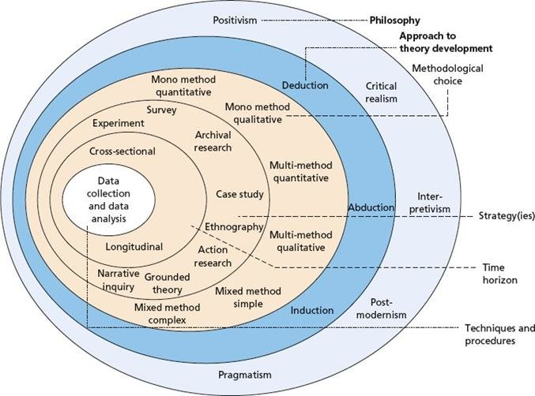
Figure 2 Research Onion Source internet

Research Philosophy

The outermost layer represents the researcher's philosophical stance or worldview, which guides their approach to knowledge and the research process. This layer includes philosophical perspectives such as positivism, interpretivism, critical theory, or pragmatism. The chosen research philosophy influences the selection of research methods and the interpretation of research findings. Positivism will serve as the overarching philosophical framework for this study to answer the research objectives that were set in the introduction. By employing positivism in this study, the researcher will be able to collect scientific data and information, examine it to accept or reject the research hypothesis, and then develop explanations based on the commonly accepted worldview (Sahay, 2016).

Research approach

“According to Saunders (2019), the deductive approach is a method for developing theories that also involves evaluating a theoretical claim using a research plan created specifically for that purpose”. To determine the value of digital marketing for SME's in the UK hairdressing business, the researcher will use a deductive methodology in this study. The research study on the importance of digital marketing for SMEs in the hairdressing industry in the UK will utilize a deductive approach. This approach involves starting with a general theory or hypothesis related to digital marketing and its significance for small and medium-sized enterprises (SMEs) in the hairdressing industry. The theory may be based on existing literature, industry trends, or expert opinions.
From this general theory, specific predictions or hypotheses will be derived. These predictions might include statements such as "Hairdressing SMEs that effectively implement digital marketing strategies will experience increased customer engagement and higher sales." These predictions will serve as the foundation for the research study (Stainton, 2021).

Research strategy

A survey consists of a set of questions and the procedure for gathering, combining, and evaluating answers from a target population. The researcher will employ a survey questionnaire as part of this study's research method to gather information from users of social media platforms. The goal of using a survey questionnaire is to gather quantitative data that is rich, trustworthy, and generally simple to interpret in relation to the study's problem statement.

Type of investigation

Primary and secondary research will be used to investigate this study.

Primary Research:

Primary research is the gathering and examination of authentic information straight from the source. To meet certain research aims or respond to research questions, it includes gathering first-hand data. Surveys, interviews, observations, experiments, and focus groups are examples of primary research techniques. Researchers gather new and unique data through primary research, allowing them to tailor the research design and data collection process to their specific needs. Primary research is often time-consuming and requires careful planning and execution, but it provides fresh and directly applicable insights.

- Secondary Research:

Secondary research involves the use of existing data and information that has been collected and analyzed by others for purposes other than the researcher's current study. It involves reviewing and analyzing data from sources such as academic journals, books, reports, government publications, industry databases, and online sources. Researchers extract and synthesize relevant information from these sources to gain insights, understand existing knowledge, and support their own research objectives. Secondary research is cost-effective, less time-consuming, and provides a broader perspective by leveraging existing data and knowledge. However, it is important to critically evaluate the quality, reliability, and relevance of the secondary sources used.

Choices

Quantitative research is a systematic and structured approach that focuses on numerical data and statistical analysis. It involves collecting data through methods such as surveys, experiments, or observations and analysing the data using statistical techniques to identify patterns, relationships, and trends. The aim of quantitative research is to quantify variables, test hypotheses, and generalize findings to a larger population. It provides objective and measurable data that can be analysed statistically, allowing for precise and replicable results. By employing quantitative research, the study aims to gather numerical data to investigate the importance of digital marketing for hairdressing SMEs in the UK and assess its impact on customer engagement and business performance.
On the other hand, if the chosen research approach is qualitative, it would involve collecting and analysing non-numerical data such as interviews, focus groups, observations, or textual analysis. Qualitative research focuses on exploring and understanding complex phenomena, capturing participants' perspectives, and generating in-depth insights. It involves interpreting and analysing data in a descriptive and interpretive manner, often using thematic analysis or content analysis. Qualitative research provides rich, detailed, and context-specific information and allows for a deeper understanding of individuals' experiences, motivations, and behaviours. By utilizing qualitative research, the study would aim to explore the perceptions, experiences, and challenges of hairdressing SMEs regarding digital marketing and gain a nuanced understanding of its importance in their industry (Merriam & Tisdell, 2015).
For the research approach, the researcher has chosen the mono method, specifically quantitative data will be collected.

Time Horizons

The research study will adopt a cross-sectional time horizon. A cross-sectional design involves collecting data from a sample of participants at a specific point in time. It provides a snapshot of the research variables and their relationships at that moment, allowing for comparisons and analysis.
Furthermore, the survey for this study will be conducted over a period of 10 weeks. During this timeframe, the survey questionnaire will be administered to the selected participants to collect data on their digital marketing practices, customer engagement levels, and business performance. The 10-week duration allows for a reasonable timeframe to reach out to the target sample, gather responses, and ensure an adequate sample size for analysis.
By using a cross-sectional time horizon and conducting the survey over a 10-week period, the study aims to obtain a comprehensive snapshot of the digital marketing landscape and its impact on hairdressing SMEs within a specific timeframe (Sahay, 2016).

Data collection and analysis

Sample size

In this study, the sample will have a size of 50 respondents who are the customers of various hairdressing salons.

Sample type

The online survey will be conducted on social media platform users influenced by luxury brands both male and female, as well as intersex (or others), aged over 18 and belonging to various social statuses.

Sampling method

The method chosen for this study is the non-probability convenience sampling and the method is sampling.

Data Collection Methods

Microsoft Forms will be used to create a online survery. The survey will contain ten closed ended questions with multiple choice. The time allocated to answer the survey will be ten minutes.

Analysis of Data

Microsoft Excel will be used to assess the study's quantitative data and to produce tables and graphs.

Research Ethics

The term "research ethics" refers to the values and standards that direct the use of sensitive data or the conduct of research involving human subjects. It entails preserving the rights, welfare, and privacy of participants as well as upholding the study process' integrity, honesty, and transparency. Research ethics encompass various aspects, including informed consent, confidentiality, data protection, minimizing harm, and ensuring the integrity and validity of research findings.

The researcher conducting this study will adhere to strict ethical guidelines. Specifically, the researcher will not disclose any information obtained from participants to third parties. This means that the data collected during the research process, including primary data from the survey will remain private and confidential. Participant identities and personal information will be kept anonymous and securely stored.

By maintaining confidentiality, the researcher aims to uphold the trust and privacy of the participants, ensuring that their information is handled responsibly and in accordance with ethical standards. Respecting confidentiality helps create a safe and comfortable environment for participants to share their experiences and opinions openly, without fear of their information being disclosed without their consent.

Planning

Planning | WEEK  1 | WEEK  2 | WEEK  3 | WEEK  4 | WEEK  5 | WEEK  6 | WEEK  7 | WEEK  8 | WEEK  9 | WEEK  10
Introduction
»Rationale of the study
»Aims
»Research objectives
»Research questions

Literature review
Research Methodology
Findings of the data from survey
Analysis of the data using Microsoft Forms analysis
Conclusion
Recommendation
Formulation of Draft
Submission

References

Deiss, R. & Henneberry, R., 2020. Digital Marketing for dummies A Wiley Brand. New Jersey: Jhon Wiley & Sons.
Chaffey, D., 2022. RACE marketing model. [Online]
Available at: https://www.davechaffey.com/digital-marketing-glossary/race-marketing-planning-model/
Saunders, M., Lewis, P. & Thornhill, A., 2007. Research Methods for Business Students. Harlow: Pearson.
Saunders, M., Lewis, P. & Thornhill, A., 2019. Research Methods for Business Students. 8th edition Harlow: Pearson.
Phair, D. & Warren, K., 2021. GRADCOACH. [Online]
Available at: https://gradcoach.com/saunders-research-onion/
Melnikovas, A., 2018. Towards an Explicit Research Methodology: Adapting Research Onion Model for Futures Studies. Journal of Futures Studies, pp. 1-16.
Sahay, A., 2016. Peelig Saunder's Research Onion. Research Onion, pp. 1-5.
Stainton, D. H., 2021. The Research Onion Made EASY! Simple Research Methods Template For Your Methodology Chapter. [Online]
Available at: https://www.youtube.com/watch?v=HSPwTdMn6_c
Merriam, S. B. & Tisdell, E. J., 2015. Qualitative Research: A Guide to Design and Implementation, 4th Edition. England: Jossey-Bass.
Anon., 2023. Oxford college of Marketing. [Online]
Available at: https://blog.oxfordcollegeofmarketing.com/2018/08/06/using-the-race-framework/

