


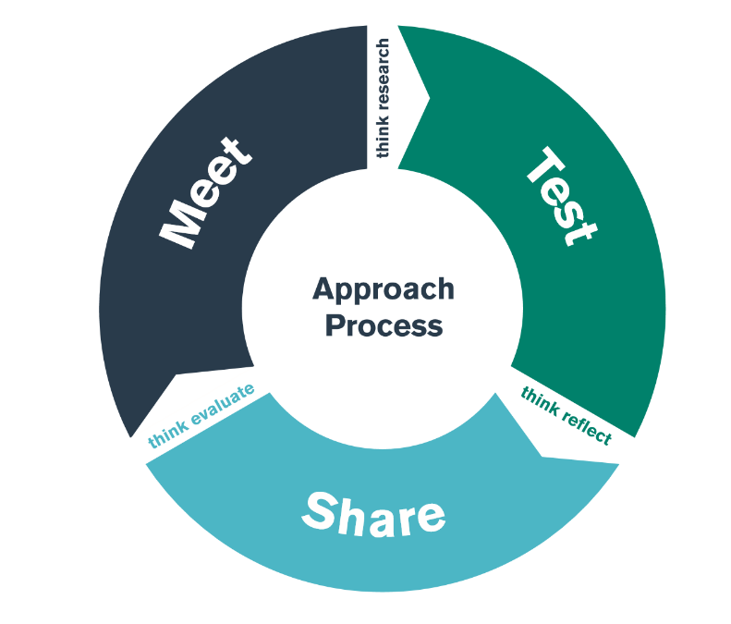

Schools and Parents/Carers
TEST Day 2

Student-Teacher Enquiry Evidence Record

22nd November 2023

What is the purpose of the ‘Supporting Learners’ focus’ bridging activity?

By the end of the ‘supporting learners’ focus’ TEST day, the students should have an understanding of some of the strategies, policies and approaches that schools use to ensure the cognitive development of their learners, especially within Foundation Learning.

During Bridging, note aspects of interest in the following areas:

Task 1

Make notes here from the overview you were given about how the school works with parents, carers and the community.

Task 2

Make notes about what you were told about how the school works with families before a child starts school.

Task 3

Make notes here about how the school encourages families to support the different areas of learning.

Task 4

Make notes here about the how the school engages with the community to support learning.

You can start planning how you are going to work as a group to make an information sheet about the school’s family and community engagement.

PERSONAL TARGET

As a result of what you have learnt/reflected upon during the meet, test and share days of this bridge, please set yourself a target to improve your own practice.

TARGET

What area do you want to develop in your own practice?
TIMESCALE

When do you want to achieve this by?
RESOURCES

What do you need to help you achieve this? Who do you need to talk to/observe? What do you need to research?
SUCCESS CRITERIA/
OUTCOME

How will you judge whether it has been successful or not? What impact do you hope to see in teaching and learning?
MONITORING/
EVALUATION

How will you check that you have successfully achieved your target? Lesson observation? Book scrutiny? Pupil voice?

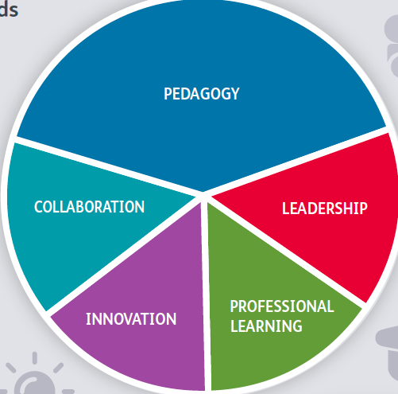
PLP AND LINKS TO PROFESSIONAL STANDARDS

- Complete Tab 4 (Research) of your PLP for this bridge.
- Use the table below to indicate where and how you have addressed the any of the standards if relevant or appropriate to this enquiry. Add assets to the relevant section of Tab 7 (Standards) if appropriate.
Please note: you will not necessarily hit all five standards in any one bridge.

PEDAGOGY

Involving partners in learning -
The importance of positive involvement of parents/carers and other partners is understood and opportunities taken to observe and evaluate process.

COLLABORATION

Seeking Advice and Support - as student teacher, you will be expected to seek advice and support
and work with colleagues to develop understanding and strategies.
INNOVATION

Evaluating the impact of changes in practice –
The teacher actively seeks support and advice from colleagues in developing innovative approaches within the classroom so that their impact can be evaluated, analysed and shared.

PROFESSIONAL LEARNING

Wider research and Findings - Through researching and observing physical skills in action, you will develop an increasing understanding of child development and learning.

LEADERSHIP

Leading colleagues, projects and programmes –
The teacher’s understanding of, commitment to, leading learning is demonstrated through collaborative experiences in schools and other contexts.

