The Importance of employee engagement in developing a talented workforce
BA DEGREE ASSIGNMENT SPECIFICATION
SCHOOL OF TOURISM & HOSPITALITY
Student name: |  | Student number:
Programmes: | BA (Hons) International Hotel Management
Module: | Personnel Resourcing and Development | Module Level (4, 5, 6): | 5
Module code: | BMIH5005 | Contribution to Overall Module Assessment (%): | 50%
Lecturer: | Emily Williams | Internal Verifier:
Assignment Title: | Research Project Proposal | Assignment No: | 2 of 2
Hand Out Date: | 15th January 2021 | Submission deadlines: Return date of provisional marks & written feedback: | 26th March 2021  23rd April 2021

Table of contents
Introduction 1
Training needs analysis for two departments of The Berkeley Hotel 1
Service providing department of hospitality management 2
Sales and promotion department 3
Critical analysis of current training needs within these departments compares and impacts for Training needs analysis 4
Impact of engagement by training needs analysis 4
Current trending strategy to train hospitality departments 5
Conclusion 6
Reference 6
Table of Figures
Figure 1: Multiple service division of hotels 1
Figure 2: Steps of training needs analysis 2
Figure 3: Marketing strategy needs 3
Figure 4: Employee engagement needs 4
Figure 5: Hospitality management training needs 5

Introduction
Training needs analysis is a process by which the company identifies the development needs of its employees and arranges training programs based on the needs so that the employees can give the best service. This training program needs to be completed in a certain period as effectively as possible for the progression and the growth of the company (London and Mone, 2015). The training program helps the employees to understand the difference between ‘what is’ and ‘what should be’. So many companies or business institutes have their experts who can train the employees on various aspects to improve the employees’ knowledge and skills. Mismanagement of training conducted will lead the whole team of service into the cluster and this will badly impact the future development of the organisation. for the sake of company goal and maximising its wealth, reputation and goodwill the training should have a good method in planning as well. The Berkeley hotel is one of such five-star hotels from the UK that has a global chain in many countries and reputedly conduct their business all over the world.

Training needs analysis for two departments of The Berkeley Hotel
In this competitive business world, a group of well-trained employees plays a vital role to sustain in the business industry. Training is the only to get a team of well-skilled employee for the organisation. This helps them to understand and take enough preparation to cope with the environment (Gatewood, Feild and Barrick, 2017). Nowadays, the hotel business is known as the most profitable business all over the world. For example, The Berkeley Hotel is such a well-known hotel. It has arranged a training program for two of its department as the authority noticed some lacking and immediately the want to work on them to achieve the desired goal.
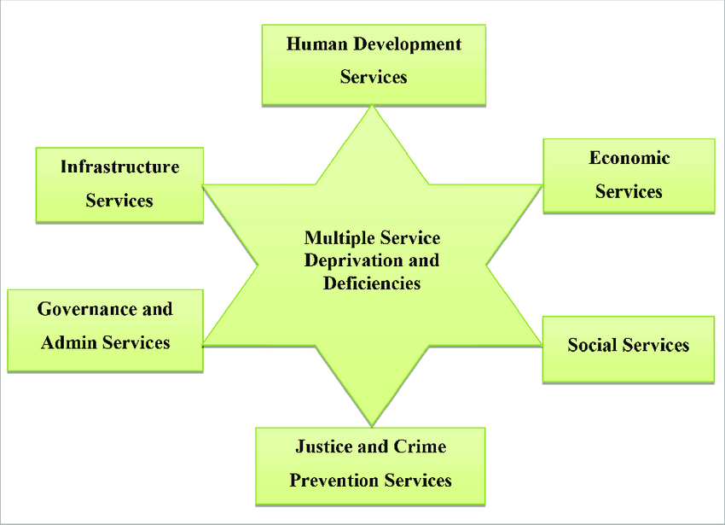
Figure 1: Multiple service division of hotels
Source: (Mills, Pace and Peterson, 2018)

Service providing department of hospitality management
As the Berkeley Hotel authority has identified that it needs some improvement in the room service division department to get the best outcome in client feedback, it needs to arrange a training session. In the hotel business, the most important department among other departments is the room service division department (Wilson, 2012). Hospitality and tourism management has always a single-way relationship with its client because without tourists this business cannot be operated. The hotel authority must have to identify the specific sections based on monitoring the room services and importantly the feedback of the clients. It is helpful to set the desired goal and it also helps to throw the training program (Baker, 2014). This room service department training includes certain topics, such as- to prioritize the training needs, determine the training method, choose the best trainer to get the best outcome, idea for the training evaluation, explore the employees’ progress report and find the least limitations and so on.
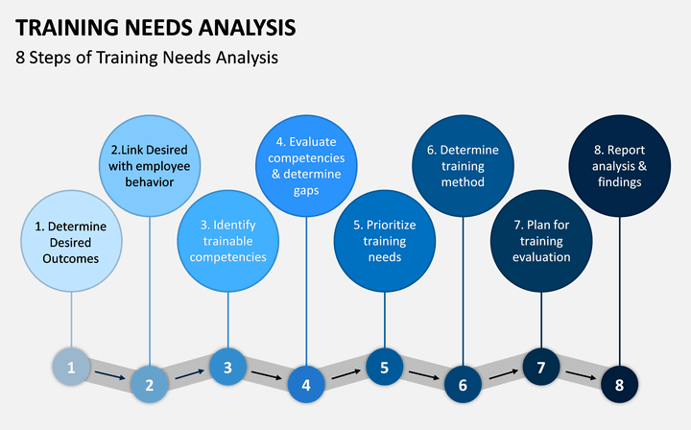
Figure 2: Steps of training needs analysis
Source: (Viardot, 2016)
As the Berkeley Hotel authority has the data sheets based on the room service assistants’ performances, the authority noticed the lacking of attentiveness of the employees. Sometimes the employees are not able to cope with the changing demands of clients and that is why they failed to serve the best sometimes (Bradley, 2019). Prioritizing all these, the hotel authority has arranged the training program where the employees get to know the latest hotel business strategies, how to face the challenges in work, how to cope with the latest client demand, how to provide the best service to satisfy the guest, how to make them feel comfortable. Then according to the progression of the employees they can serve the duties to ensure the best room service. Because most of the time, the best room service can assure the guest to choose a particular hotel again and again.

Sales and promotion department
Training needs analysis is an important part of the marketing and sales department in which one can learn in detail about the prospective client's demands to provide the best service. Training in the sales and marketing section is a central and important part to make goodwill and grab more new clients or guests. As Berkeley Hotel authority tries to provide the best service to the guests and it wants to keep pace with the rapidly changing business world, the authority has the concern in every department (Peter and Olson, 2014). The marketing and sales department is one of the most important departments as it has the responsibilities to keep the guest updated with the latest services, to generate new advertising ideas to grab new clients, to keep an updated analysis report base on the market competition, and so on. The marketing and sales department represents business. It is this department that works for increasing the reach of the business.
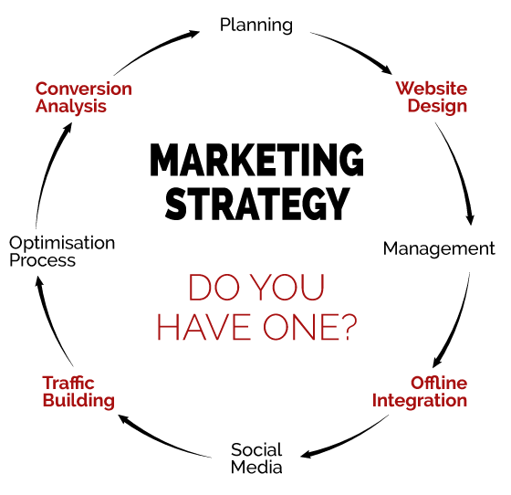
Figure 3: Marketing strategy needs
Source: (Wearmouth, 2015)
It attracts clients by eye-catching advertisements and showing them the latest provided facilities. It knows about the competition of the rapidly changing business style and that is why this department can compare the market position of the business as it keeps the data updated (Cohn, Salmon and Stobo, 2016). As the Berkeley Hotel authority identifies some flaws to improve in the marketing and sales department, the authority feels the need to provide the department with a helpful training session. The marketing and sales department of the Berkeley Hotel was facing problems to keep pace with the current business opportunity and that brought the hotel down in the hotel business competition. So, to regain the desired position in the market, the authority has arranged a training program to train the department focusing on every single flaw (Hahm and Ommaya, 2018). A successful training program will bring some positive changes in service attitude and which is going to reflect as revenue for the company.

Critical analysis of current training needs within these departments compares and impacts for Training needs analysis

Impact of engagement by training needs analysis
According to Holliday (2018), to enhance long-term competitiveness in the hotel business, one business institute should enhance the human resource to get the best business performance and service quality. Singh (2013) said, to serve the best hospitality in the hotel business, if the training is not arranged systematically, it will fail to achieve the desired result. As we discussed the training needs analysis for the two departments, now we can analyse their current training needs, also a comparison between these two departments improvement can be discussed. On the other hand, Baum (2015) stated, the room service department and the marketing and sales department are the two most important departments for not only the Berkeley Hotel but also for all the hotels which competent in this hotel business sector.
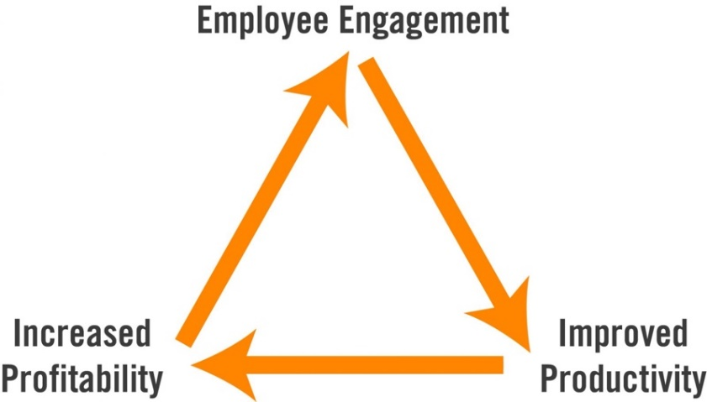
Figure 4: Employee engagement needs
Source: (London and Mone, 2015)
Both are equally important to grab or retain existing clients. Different division like these will have different purpose and strategy to serve. Pitts (2016) mentioned, the room service department provides services after getting a client or tourist but the marketing and sales department plays a vital role in grabbing the clients by attracting them through the advertisements and its marketing capacity. Franceschet, Krook and Piscopo (2014) said, if any is lacking in any of these two departments, the hotel will face a great loss in this competitive hotel business world. As the room service department and the marketing and sales department were being failed in some sections to serve the guests the best services, the hotel management felt the need to have a training needs analysis. After the training session, according to the progress report of the employees, now we can analyse the improvement of them.

Current trending strategy to train hospitality departments
According to, Cascio, Fink and Boudreau, (2019), this is to be mentioned that there were some reasons behind their employee flaws such as- the proliferation rate of hotels and their new strategies, changes in guest taste, change in marketing trends, irregular cash flow, and so on. A successful training needs analysis and after conducted training provides the opportunity to learn where to improve. Holliday (2018) mentioned, having the training session completed, the room service department has started working with a new working strategy. Now they give their best effort to understand the clients’ phycology and their demand first to serve the finest service. On the other hand, Singh (2013) stated that it surely can be said that when the service associates get to know what exactly the client demand, they can adapt every single attempt to satisfy them. If it comes to the department of marketing and sales, they are the representatives of a hotel business. Baum (2015) opined that this section of the Berkeley Hotel was facing some problems as it could not keep pace with some problems like the constantly growing hotel business, change in marketing trend, irregular cash flow, and so on. So, after finishing the training session arranged by the Berkeley Hotel management, the marketing and sales department associates have adapted some new strategies.
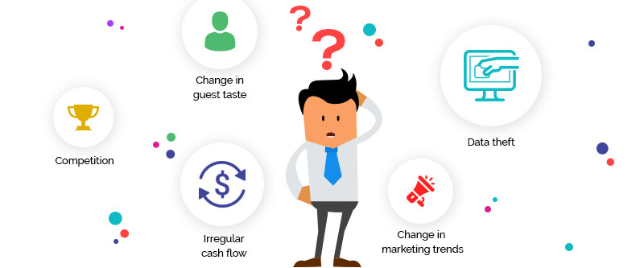
Figure 5: Hospitality management training needs
Source: (Peter and Olson, 2014)
According to Pitts (2016), the marketing plan is the most important to reach a good number of clients and retain existing clients. The marketing and sales department can play a very smooth strategy if they know basic about convincing by offering the best interest to the customers. Franceschet, Krook and Piscopo (2014) said that the marketing and sales department now comes up with so many brand-new offers, discounts, membership plans, new features to provide the best client service. The competitive market needs always advance and moderated content to overcome others. On the other hand, Cascio, Fink and Boudreau (2019) said in a comparison of the work progress of these two departments, it can be said that the marketing and sales department has to give a bit extra effort as it has to focus on so many sections to keep the client updated. For a hospitality organisation, both the marketing and service division has dependable relation with each other to provide the best interest to its client and customers.

Conclusion
To boost up the working flow of any business or to keep pace with the proliferation rate of hotels in the world business, it is needed to adapt necessary initiatives. Training needs analysis is the name opportunity that calculates and identify future development (Cohn, Salmon and Stobo, 2016). There are some most important steps of this training session which include- identifying the desired goal, creating a link with the employee behaviour, identifying the trainable competencies, evaluating the competencies and determining the gaps, prioritizing the training needs, analysing the reports, and finding problems and so on. If a business institute arranges such a systematic training program, it will get the most efficient human resource which can help a business to grow rapidly.

Reference
Baker, M., 2014. Marketing strategy and management. New York: Palgrave Macmillan.
Baum, T., 2015. Hospitality management strategy. Los Angeles, Calif.: SAGE.
Bradley, F., 2019. International marketing strategy. Harlow: Financial Times Prentice Hall.
Carbonara, S., 2017. Manager's Guide to Employee Engagement. New York: McGraw-Hill.
Cascio, W., Fink, A. and Boudreau, J., 2019. Investing in human resource. Alexandria: Society for Human Resource Management.
Cohn, F., Salmon, M. and Stobo, J., 2016. Confronting chronic neglect. Washington, DC: National Academy Press.
Franceschet, S., Krook, M. and Piscopo, J., 2014. The impact of employee development. New York: Oxford University Press.
Gatewood, R., Feild, H. and Barrick, M., 2017. Human resource selection. Mason, OH: South-Western, Cengage Learning.
Hahm, J. and Ommaya, A., 2018. Opportunities to address clinical research workforce diversity needs for 2010. Washington, D.C.: National Academies Press.
Hirsh, I. and Stobo, J., 2014. Meeting the nation's needs for biomedical and behavioural scientists. Washington, D.C.: National Academy Press.
Holliday, S., 2018. Hospitality management. [Sheffield]: Sheffield Hallam University, School of Leisure and Food Management.
London, M. and Mone, E., 2015. Career growth and human resources strategies. New York: Quorum Books.
Mills, G., Pace, R. and Peterson, B., 2018. Analysis in human resource training and organization development. Reading, Mass.: Addison-Wesley.
Mitchell, G., 2016. The trainer's handbook. New York: AMACOM.
Peter, J. and Olson, J., 2014. Consumer behaviour & [and] marketing strategy. New York: McGraw-Hill.
Pitts, S., 2016. Impact of engagement by training needs analysis. New York: Oxford University Press.
Singh, S., 2013. Hospitality management. New Delhi: Random Publications.
Viardot, E., 2016. Successful marketing strategy for high-tech firms. Boston: Artech House.
Wearmouth, J., 2015. A beginning teacher's guide to special educational needs. Maidenhead, Eng.: Open University Press.
Wilson, J., 2012. International human resource development. London: Kogan Page.

