
Skills for the Workplace
Module Assignment Submission
Student Name: | Ceri Wiggins
Student Number: | 2116978
Module No: | BMSK5007
Module Title: | Changemakers: Creativity and Value Creation

Statement of Confirmation of Authenticity
By the act of making this submission, the student declares that this is the work of the student named above. The work has not, in whole or in part, been knowingly presented elsewhere for assessment, or where assessment has been built on a previous assessment, this has been identified. Where materials have been used from other sources it has been properly acknowledged. If this statement is untrue, the student acknowledges that an assessment offence has been committed.
Attention is drawn to the plagiarism and unfair practice policies of both the University and of ILM.

Table of Contents
Introduction 3
Description 3
IT systems 5
Questionnaire 5
Stakeholders 5
Evaluation 7
Gibbs 10
Conclusion 12
Appendix A 14
References 24

Introduction

“One of the things that we have in a post-industrial society is that we've got a lot more people who are working on problem solving”, Be More Creative - Mind Tools Expert Voices and as a mother, work coach, and executive board member I wear many different hats and my roles involve lots of problem-solving and decision-making. I have identified several problems that I have experienced in the workplace and have looked at ways I could potentially solve them.

Description

I decided to create a mind map first which would give me insight into what problems I had encountered and ways I could solve them, who I would need to work with and report back to. This identified that some were possibly out of my scope such as reducing staff turnover and others such as notifying work coaches that claimants were there for their appointments were partially solved and any issues would be down to staff error (forgetfulness) and any IT issues were something that occur at any point so I or anyone else could not control this.

I focused on a problem that I knew frustrated myself and other work coaches as it wasted resources and was a monotonous process - The Failure to Attend Process. If a claimant did not attend an appointment we would have to go through a series of actions – creating to-do’s and copying information from that and sending messages and then waiting for a response, I came up with a potential fix for this which would change the process slightly with no effect to the claimant but it would benefit work coaches, work coach team leaders, quality checkers and our other stakeholders.

The idea I have is to automate the failure to attend process so that when a claimant hasn’t attended, I select the option claimant did not attend the appointment, this will generate a to-do asking has the claimant provided reasons for not attending if the answer is no, it will send a message to the claimant asking for them to provide the reasons.

If we already have the reasons or within 7 days of the claimant responding we get a notification and we can complete this to-do, we then need to decide if we accept the reasons or case conference with a work coach team leader to decide if we agree to send to a decision maker if this is the case when we click this option then a refer, to decision maker to-do will be generated and we just wait for the outcome and a notification will be received by on our dashboard
This new process will mean if we are working on another work coach caseload or the work coach team leader is checking our caseload, they will be able to see exactly what stage the process is at. This will also help with quality checking as the to-do must be completed before they are cleared.

IT systems

As the UC application is an evolving system, we can make good use of the technology available to us to implement a fix to the system and Hiatt’s ADKAR Model shows several steps to change and update our systems.
A—Awareness of the need for change which recognizes why change is necessary.
D—Desire to participate in and support the change.
K—Knowledge of how to change and what the change looks like.
A—Ability to implement the change on a day-to-day basis.
R—Reinforcement to sustain the change.

Questionnaire

I looked at ways I could gauge the need for this and decided to conduct a survey with my colleagues but only a small number took part due to various reasons due to time, sickness and leave within the dept.

Stakeholders

I discovered who my stakeholders were, and these were union, work coach team leaders, HR, Taxpayers, government, claimants, and work coaches. Using The Eden and Ackerman theory (Ackermann & Eden, 2011) I created my version to See what power and interest they had and how important they were to my planning.

I also looked at what financial or emotional interests they would have within my plan and established that even though the claimant is central to the process they would have very little financial interest in the change as it would not affect them or their claims and that there isn’t any need to communicate this as the change would happen behind the scenes, and would not have any influence so I wouldn’t need to engage with them.

With other stakeholders such as government, HR and change team, work coaches and work coach team leaders I felt that they would need a great deal of communication at different stages of the process so the contact required would be varied – work coaches and work coach team leaders more so at the start for input and end of the process to learn the new processes and HR and the change team during the changes and implementing them.

The union (pcs) would be someone who would need contact without the process so they could give their input. They would want to know time scales, costs and how the
The change would impact claimants and staff, and they would influence any health and safety aspects or implications to staff and our union PCS one of their objectives is to ”gain much-needed, long-term investment into public services” Our vision and goals PCS website.

Power | High | Work Coaches | Changes design team
Power |  | Work coach team leaders | Government
Power |  | Union
Power |  | Taxpayer | HR
Power | Low | Claimants | Claimants
 |  | High | Low
 |  | Level of interest

Evaluation

The results I have collated from the survey show 9 out of 10 work coaches agreed that the current process was too long and 9 out of 10 would like it automated and 8 out of 10 work coaches indicated that the process would usually take them around 10 minutes, 1 in 10 it would take them 5 minutes and a 1 in 10 they took 15 minutes, my survey showed no one took longer than 15 minutes.

I also left a section for the participant’s ideas or comments, and many didn’t leave any and the ones did say “Once the appointment is marked as not attended all actions such as to-dos and journal messages should be sent by the system” – the other suggestions I received were “a one-click system,” and “click the FTA and the system does all the work”. Quantify the work these open-ended questions where the work coaches had the chance to provide their thoughts perhaps rewording the question to - If you had the opportunity, what would you most like to change about the Failure to attend process?

I could also use Kolb’s experimental learning cycle to help reflect on the process and observe colleagues and time them, develop my idea by using research, networking and focus groups, and test the new system by asking the changes team to try it on the test system so we could see if would work and if not fix any potential issues before going live on the universal credit full-service system and this would give me concrete evidence then that my idea works and the benefits it would bring to all.
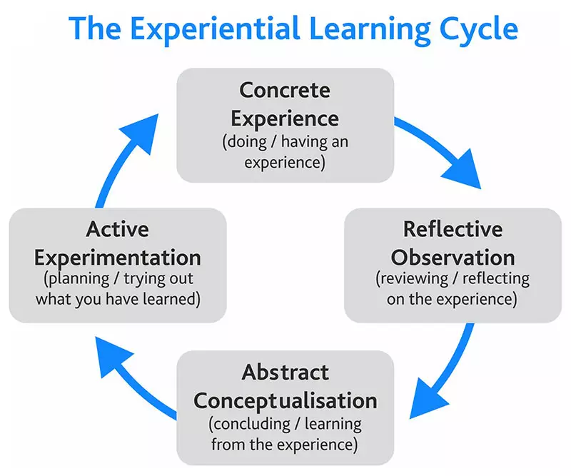
Kolb’s Learning Cycle (1984)

Kubler-Ross Change Curve model could help explain why some do not give any suggestions or have said that the process isn’t too long, as per the gov. uk website (2021) “Our communications will be designed to help people on that journey but gaining their understanding and buy-in will take time”.

“Qualitative research can help researchers access the thoughts and feelings of the research participants” Sutton and Austin 2015, 226, The data I have collected is only from a small selection of work coaches from a busy job centre who have recently had a shortage of staff, they have been working with a full diary so not much free time for administration time. If we were to expand and send surveys to all work coaches across the Southwest Wales region this would give me more reliable data to work from and may change the figures to where there isn’t a need for me to automate the failure to attend process or I could receive suggestions that perhaps were better than my idea to automate it and improve the idea I have.

The wording/questions on the survey sheet could be looked at and re-worded to such on average how long does the Failure to attend process take you or I could look at ways we could time this process using a work management tool however this could cause additional work for work coaches in the short term whilst I collect and collate the results but this I would believe be very minimal and would reply on work coaches recording this information.

Gibbs

Gibbs (1988)

Using the Gibbs model, I can look at ways I could develop my solution, the research I made into my problem wasn’t sufficient, I needed to know the exact timings the current process took and how long the new process would take, I feel this would allow me and my stakeholders what the savings would be on the change.

Holding a focus group would have allowed me to explain my idea fully before the survey was sent out, it would allow me to build my networks with peers who could help me with my research and help build my idea, and It would also allowed me to research my participants as per the Kubler-Ross Change Curve model not everyone would be at the same stage of change and maybe unwilling to changes hence their answers in the survey.

My research on the costs of overtime led me to the gov.uk website to
research what the UK government was spending on overtime costs for
DWP, the figures were only available for DWP as a whole and
not an individual department that I needed for work coaches, In April 2023 alone DWP whole spent £5,373,753.52, in overtime, gcs.civilservice.gov.uk.

As the process is not timed at present it cannot be costed accurately but based on the average of 8 out 10 work coaches taking 10 minutes per failure to attend, we could give an estimate which would be the Work coaches’ hourly salary divided by 60 minutes x 10 minutes which would be roughly £2.40 per failure to attend actions minus any additional overheads, electricity, premises, and ICT. If we could reduce the time to say 2 minutes, then the costs would significantly change and be 0.48p.

This would bring substantial benefits to the department and stakeholders.

Conclusion

In conclusion, my idea is to simplify the failure-to-attend process by creating an automated process where you use technology to do the work for us. We would simply click a button to show the system that the claimant had not attended an appointment, this then auto generates a to-do where we can give the reasons why they haven’t attended if we know them in advance and if not, the system will send a message for the claimant to provide them.

Once received or at the 7-day mark the system notifies us through our dashboard and we then decide if the reasons provided can be accepted or if needs a case conference with a work coach team leader, if required to go to a decision maker the system will generate this once the work coach clicks the option.

The process itself will reduce costs, and time and improve the process to reduce errors and repetition.

Appendix A

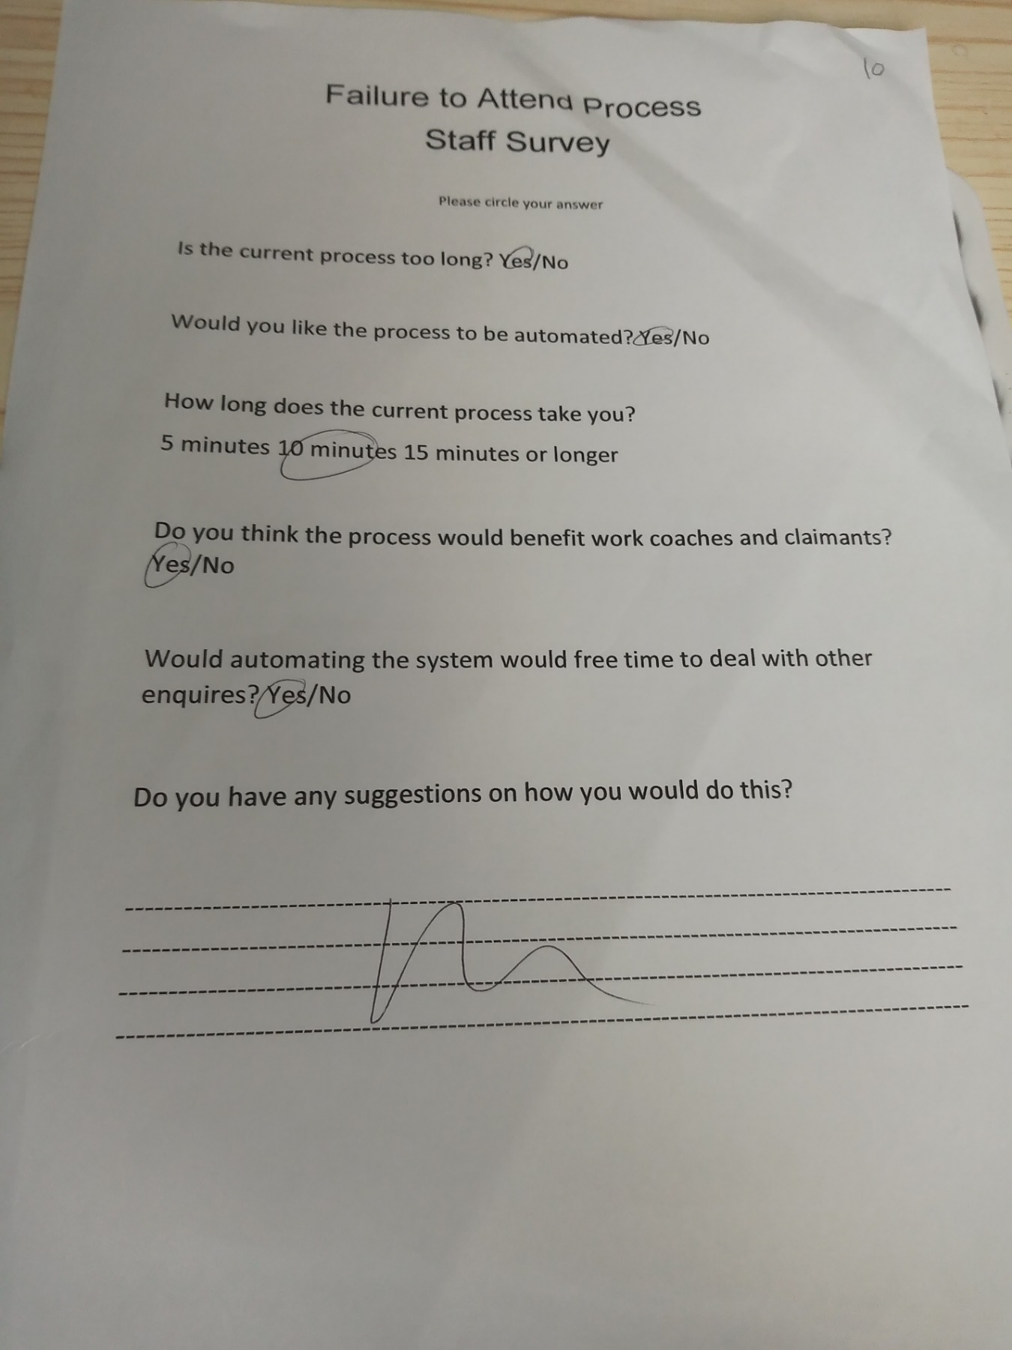

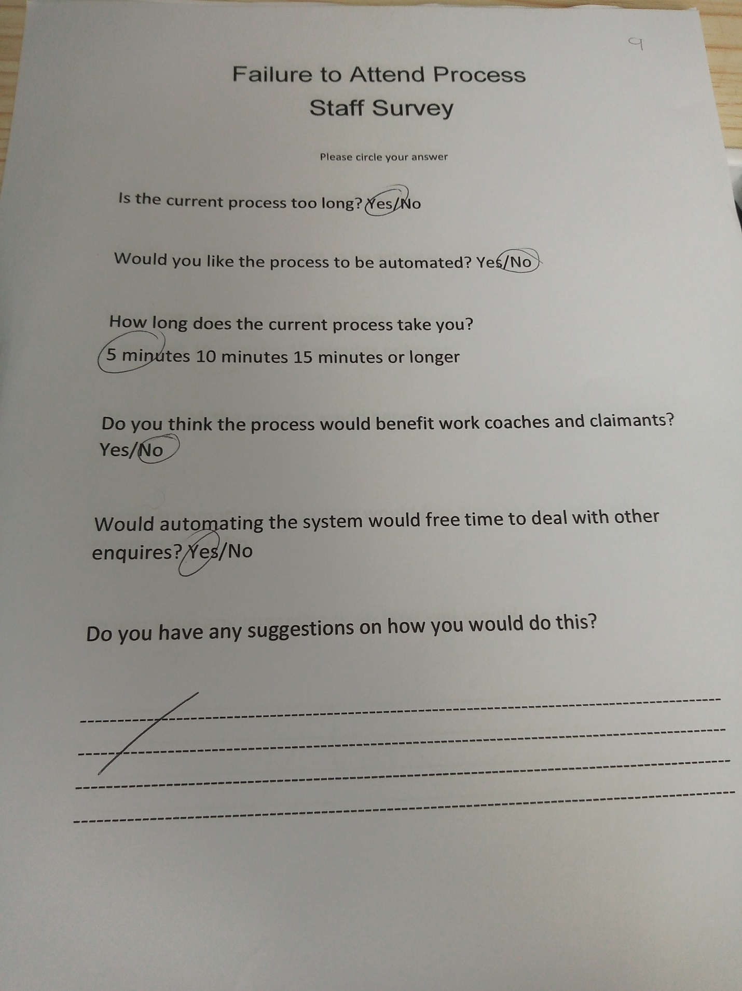

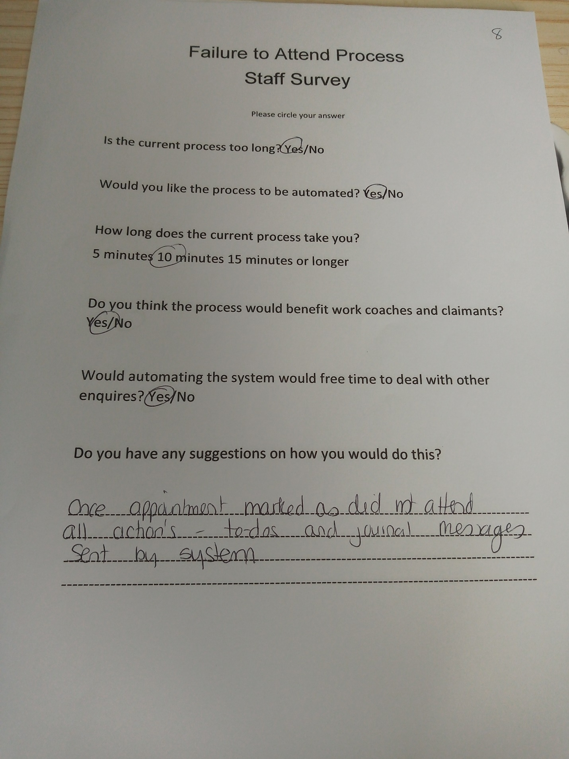

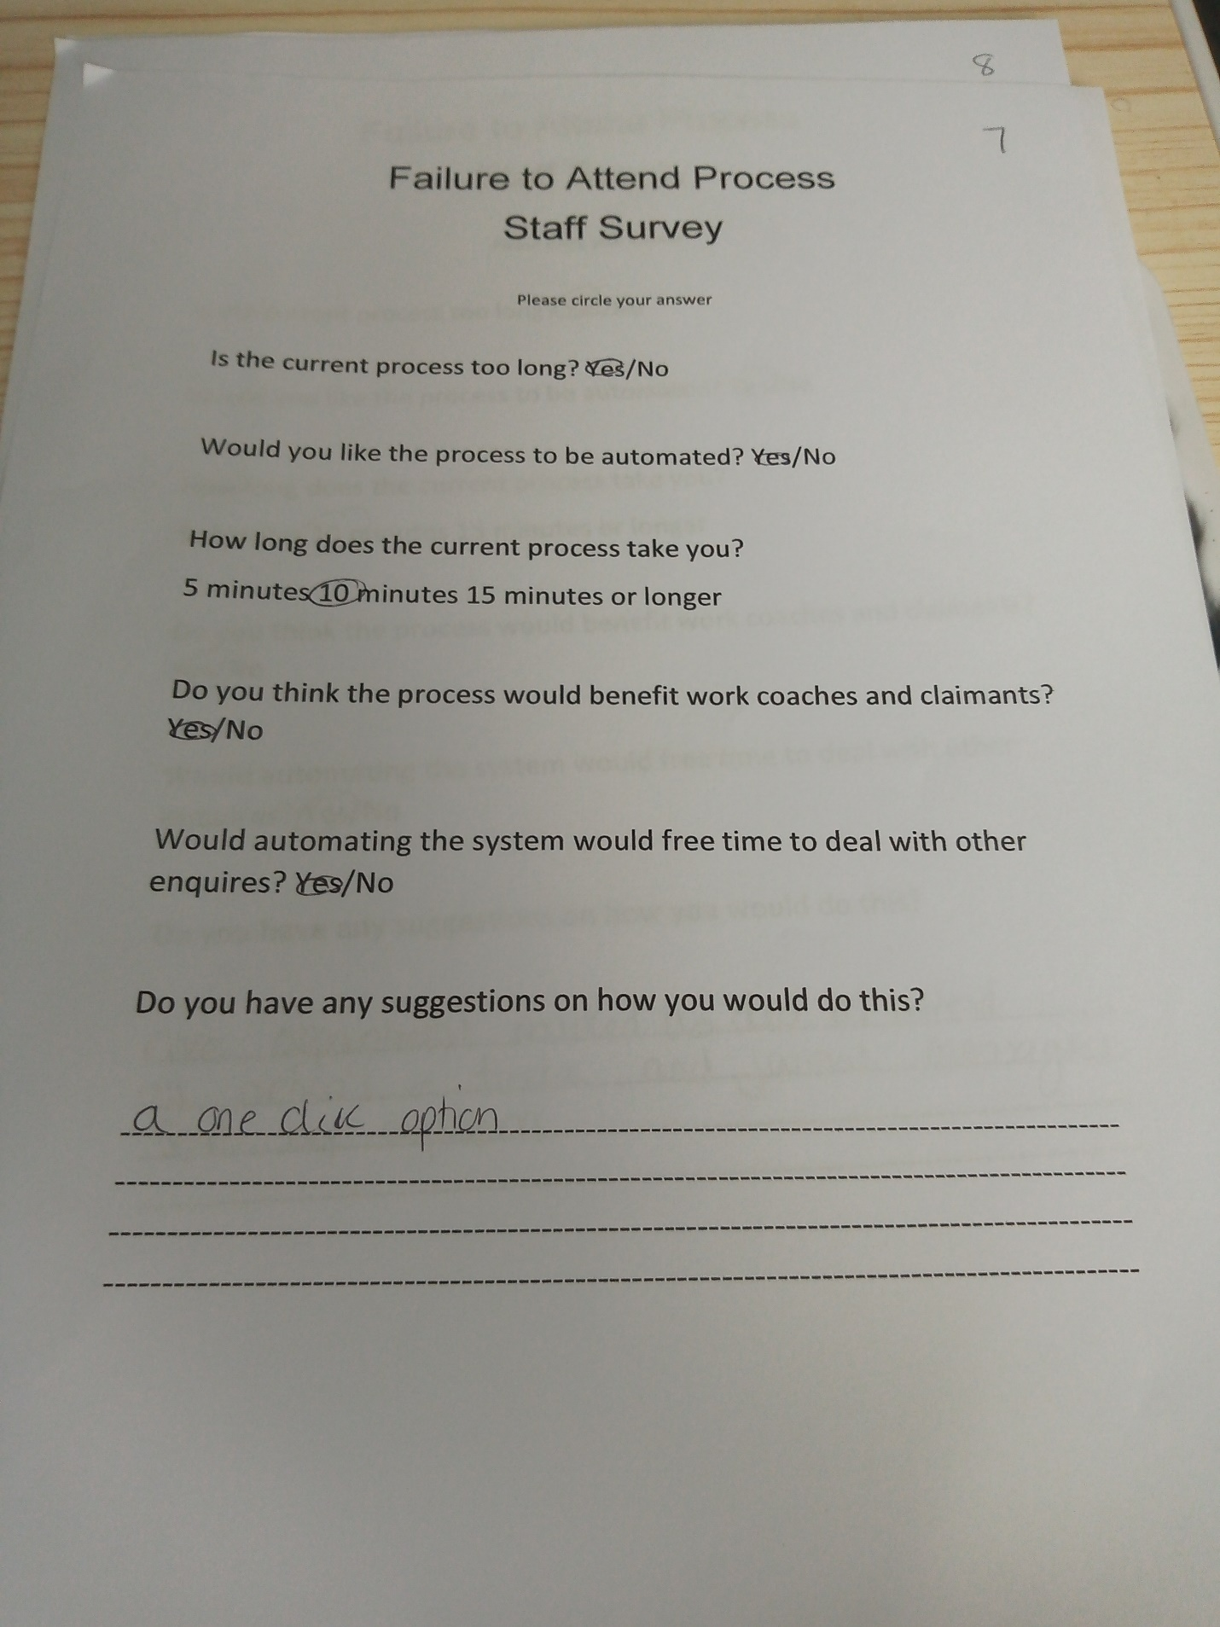

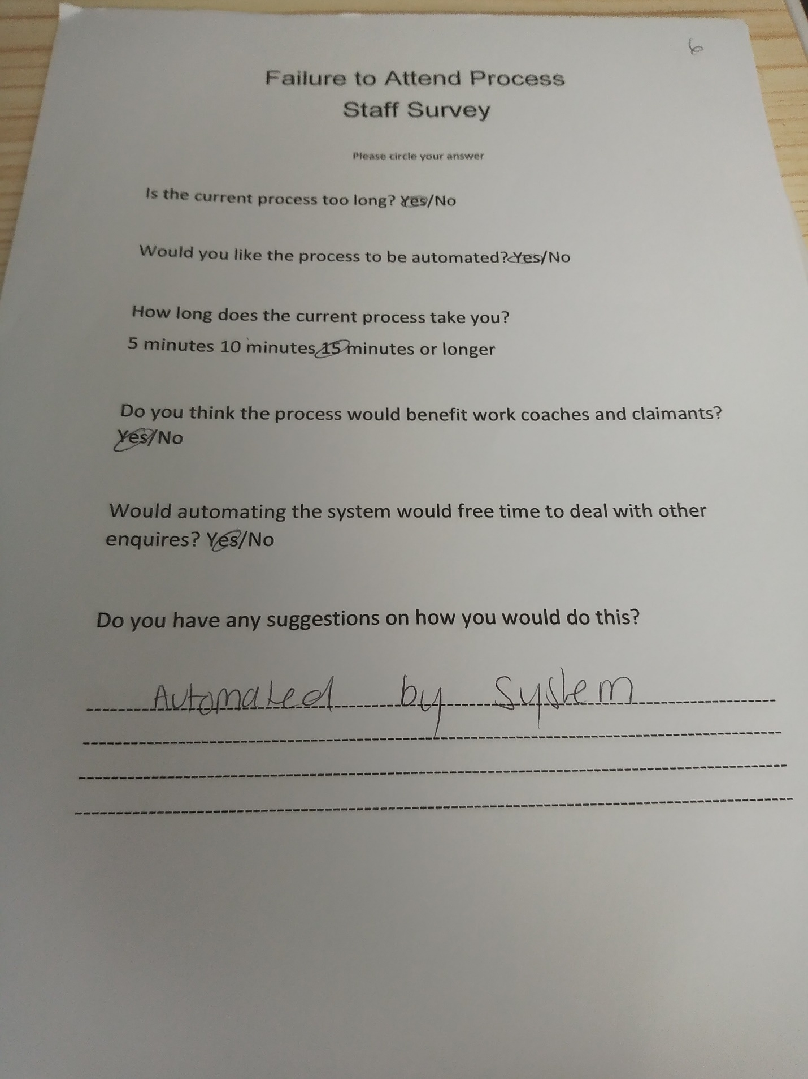
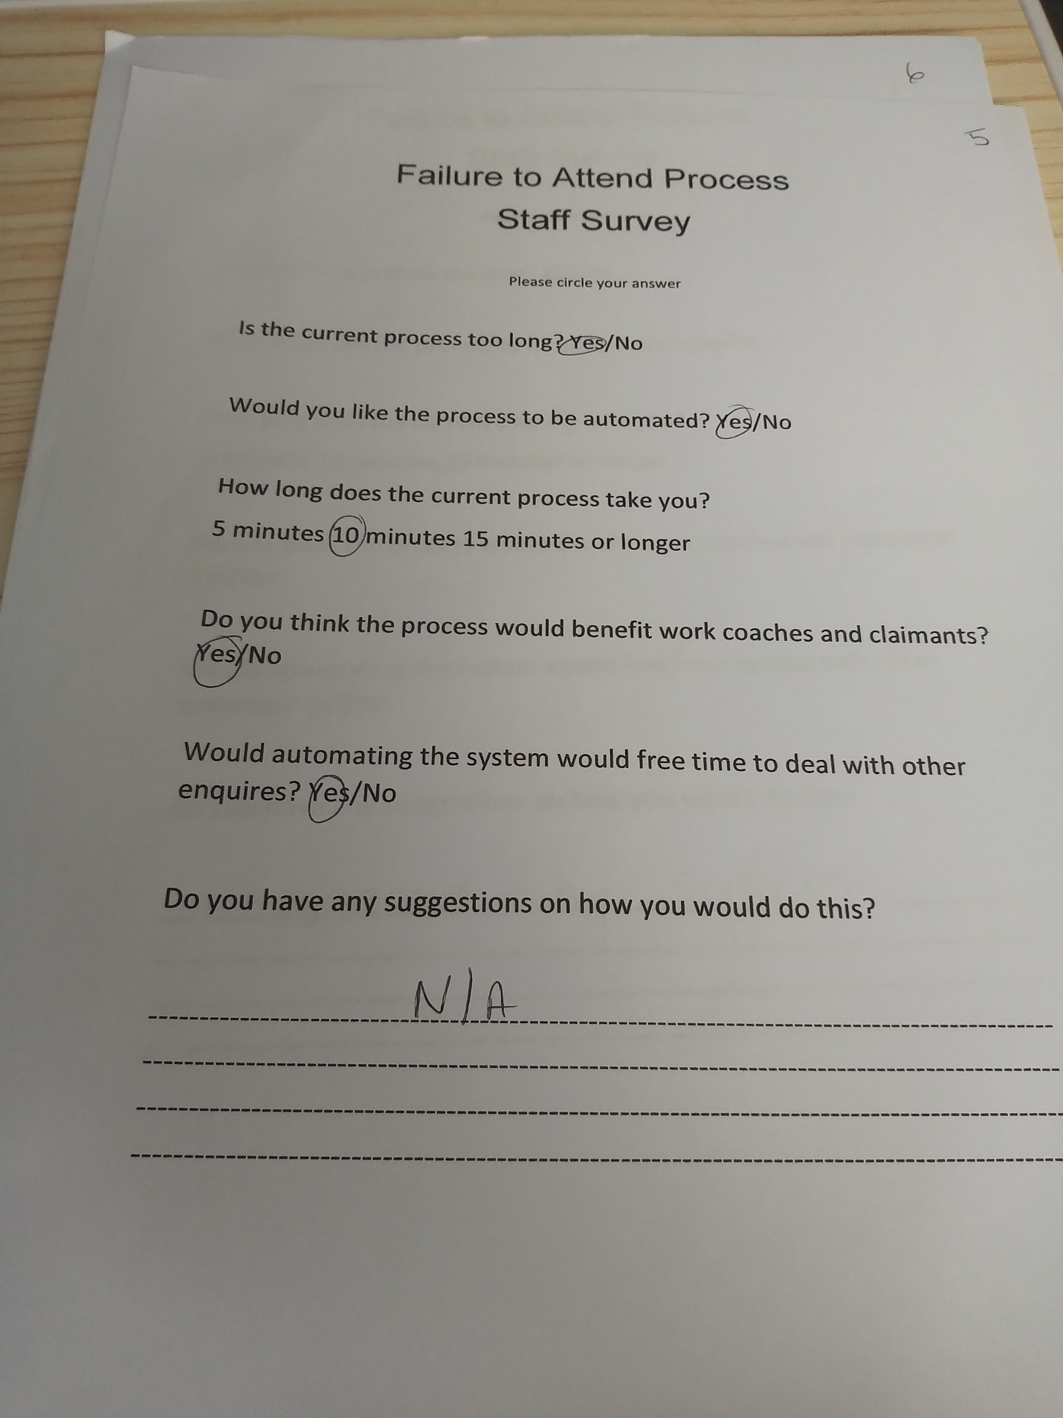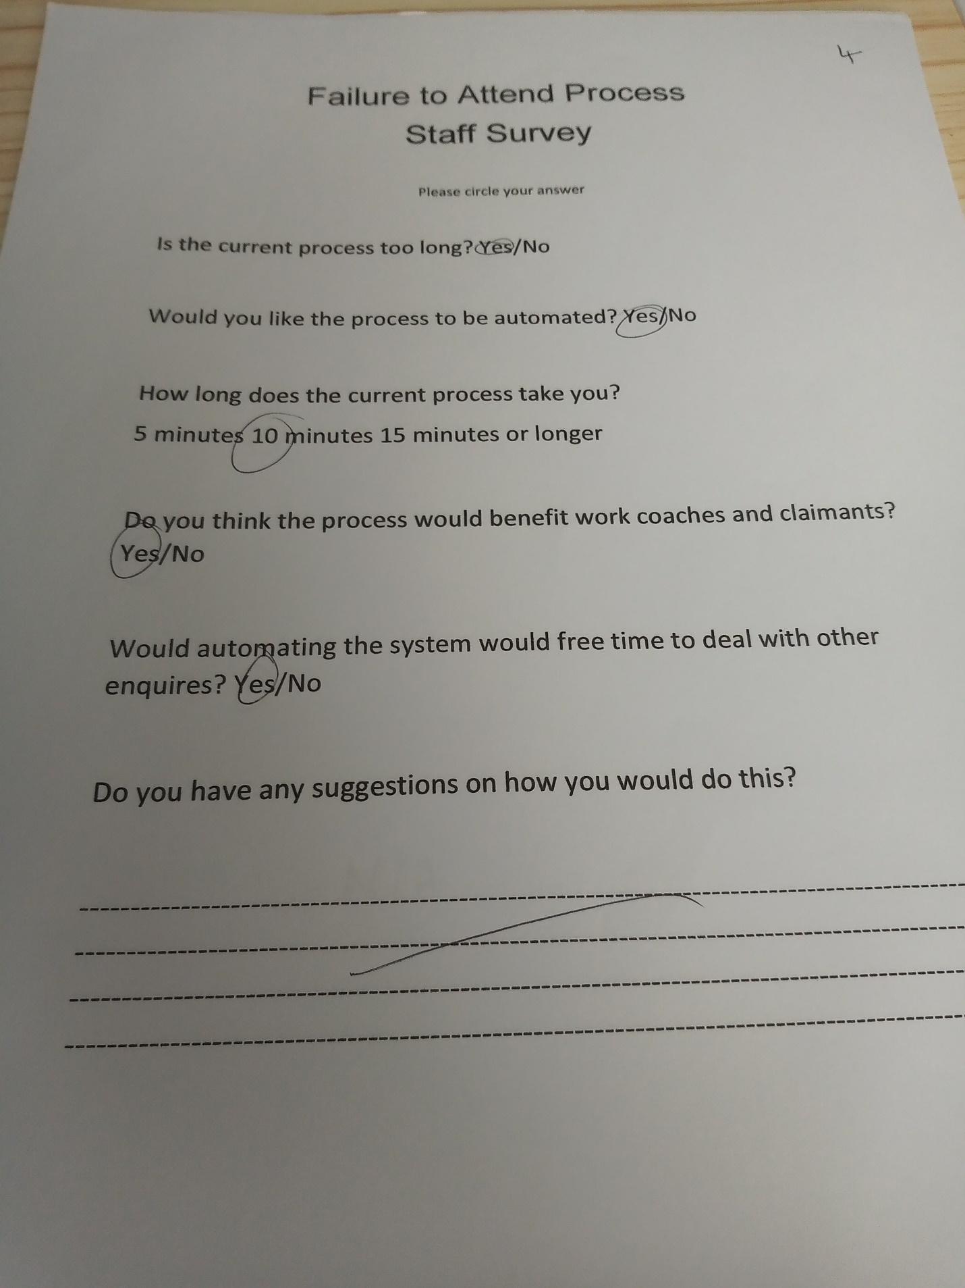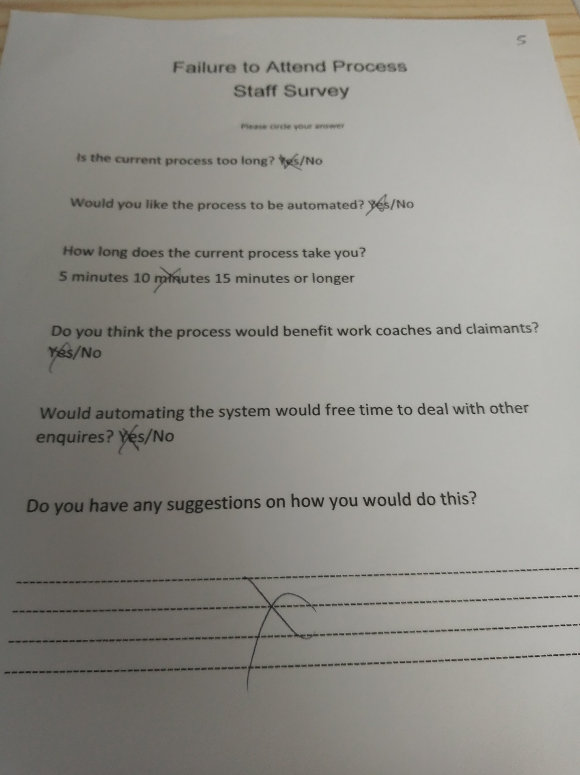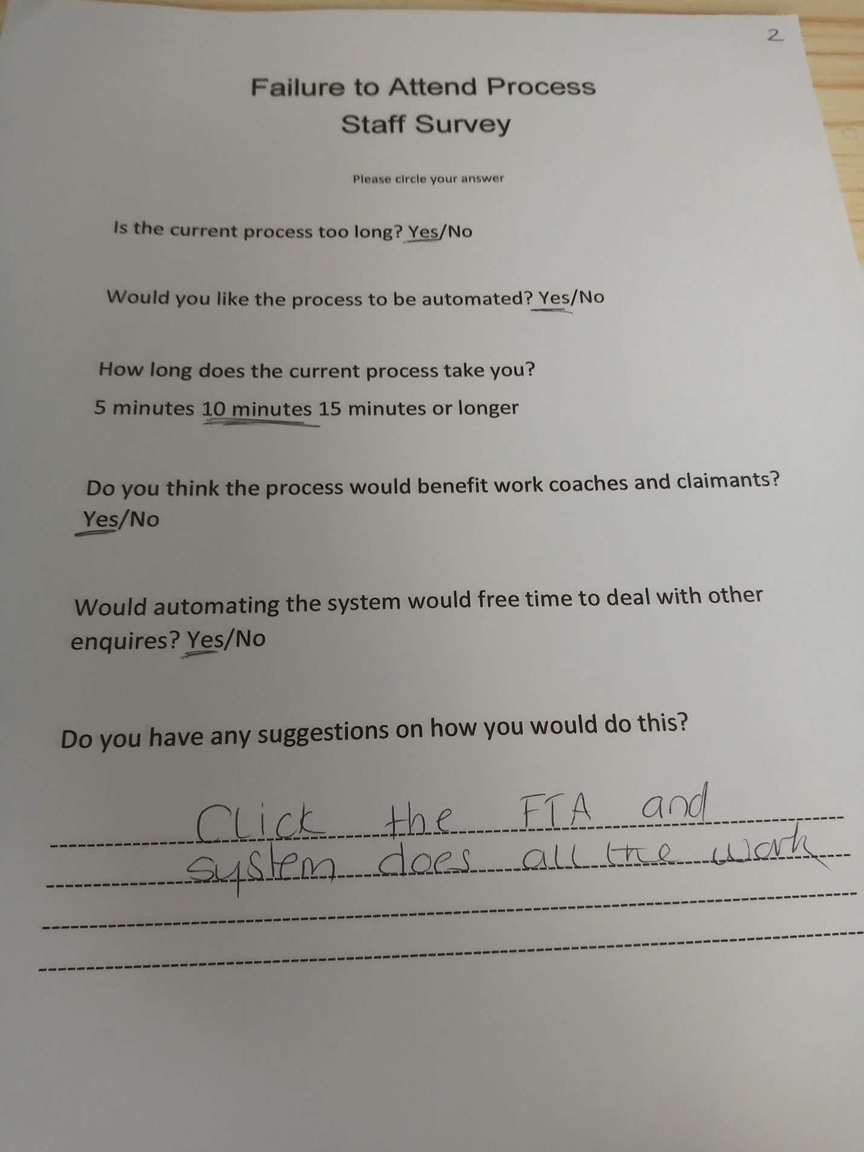

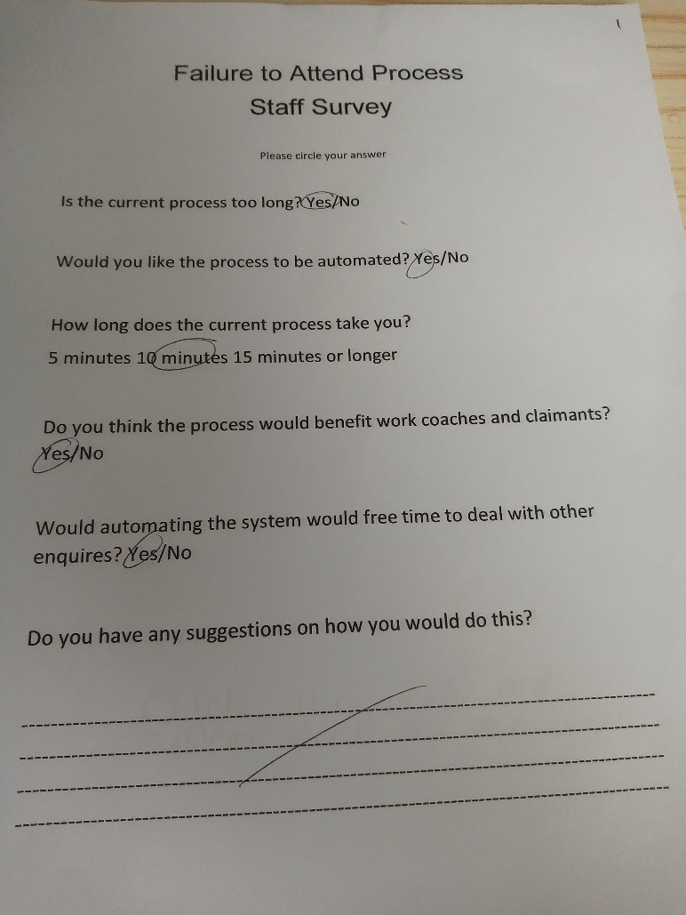

References

By the Mind Tools Content Team. (n.d.). Home. MindTools. https://www.mindtools.com/abgmh20/be-more-creative accessed 16/06/2023.

DWP: Workforce Management Information April 2023. GOV.UK. (n.d.). https://assets.publishing.service.gov.uk/government/uploads/system/uploads/attachment_data/file/1158815/dwp-workforce-managemen-information-april-2023.csv/preview

Eden, C. and Ackermann, F. (1998) Making Strategy: The Journey of Strategic Management, London: Sage Publications, pgs 343 - 347.
Gibbs, G. (1988) Learning by doing; A guide to teaching and learning methods. London: FEU

Hiatt J. ADKAR: A model for change in business, government and our community. Loveland: Prosci; 2006.

Kolb, D (1984) Experimental learning: Experience as the source of learning and development. Englewood Cliffs, NJ: Prentice Hill.

Our vision and goals. Public and Commercial Services
Union.(n.d.).https://www.pcs.org.uk/who-we-are/our-vision-goals accessed 16/06/2023

Stakeholder matrix - key matrices for stakeholder analysis https://www.stakeholdermap.com/stakeholder-matrix.html

Sutton, Jane and Austin, Zubin. 2015. Qualitative Research: Data
Collection, Analysis, and Management. CJHP, 68 (3), 226 –231.

Using internal communications to support change. GCS. (2021, May 18). https://gcs.civilservice.gov.uk/guidance/internal-communication/using-internal communications-to-support-change/

