LCLM4002_BIRM Digital Skills Task 3
Website Evaluation

Student Number | 2533982 | Student Name |  | Syrym Bakbergen
Website Chosen | Cleaners of London
Insert hyperlink to website | https://www.cleanersoflondon.co.uk
Evaluation
Respond to each question
Section 1 – Usability

(75 words maximum for each answer)
Question 1a - How quickly and easily does the website load?

Answer: The Cleaners of London website loads exceptionally fast, taking approximately 1–2 seconds to open. The technical build is rated 99/100, and mobile optimization achieved a perfect 100/100. Optimized images ensure effortless content access. In the B2C sector, such speed is vital for UX, allowing customers to find services instantly without leaving due to delays, which builds business trust.

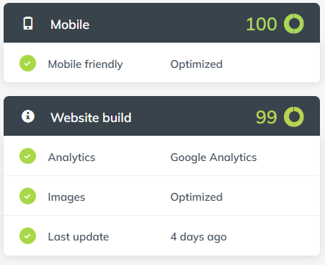
Question 1b - Does the website contain many sub-pages? How does a prospective customer navigate these?

Answer: The website contains multiple sub-pages, including specialized services like domestic, carpet, and end-of-tenancy cleaning. Prospective customers navigate these through a clear, sticky top-navigation menu and a detailed footer. The site build score of 99/100 confirms a logical internal linking structure. This allows users to move effortlessly between service descriptions and booking forms, ensuring a smooth B2C journey and high UX quality.

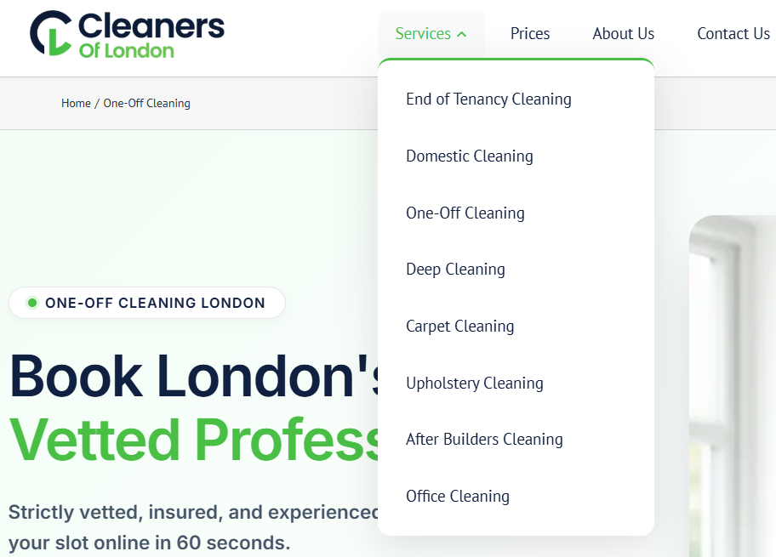
Question 1c - Can a customer make a booking via the webpage?

Answer: The platform features an integrated reservation system, enabling users to schedule cleaning services without manual intervention. This automation of the consumer interface significantly reduces friction during the sales process. Based on the assessment data, such functionality is vital for conversion in the service industry. It demonstrates a high level of digital maturity, ensuring the business remains competitive and accessible.

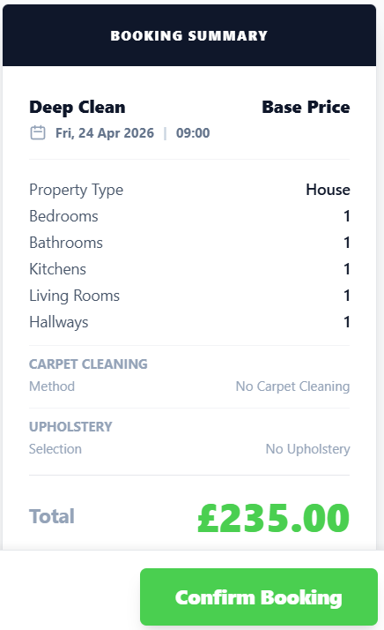
Question 1d - What improvements could be made to the usability of the website?

Answer: To enhance the platform's efficiency, the business should prioritize digital inclusivity by correcting missing alt-attributes for images. Addressing these WCAG A violations is crucial for users with visual impairments. Furthermore, implementing a more prominent "Call to Action" on the service sub-pages could optimize the navigation flow. These strategic interface refinements would strengthen the overall user-centric design, ensuring the website remains accessible and professional for all potential clients.
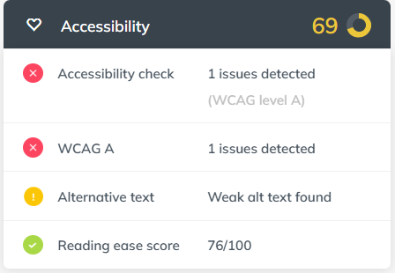
Section 2 – Pleasure – Customer Experience

(75 words maximum for each answer)
Question 2a – How pleasant does the webpage look? Are there any differences in appearance on a mobile phone versus a computer?

Answer: The website features effective responsive scaling to maintain a professional look across devices. While the desktop version provides a wide-screen overview of all services, the mobile interface is touch-optimised, rearranging content into a simplified vertical column. With a perfect 100/100 mobile score, the platform ensures that buttons and menus remain easily clickable on smaller screens, preventing the navigation errors common in non-adaptive designs.
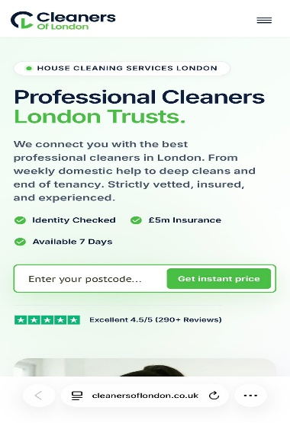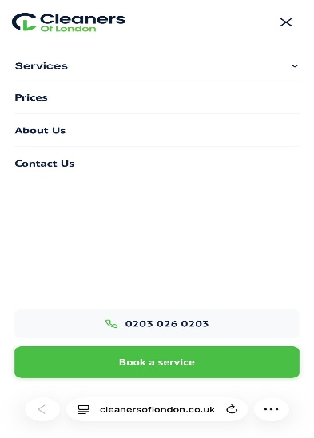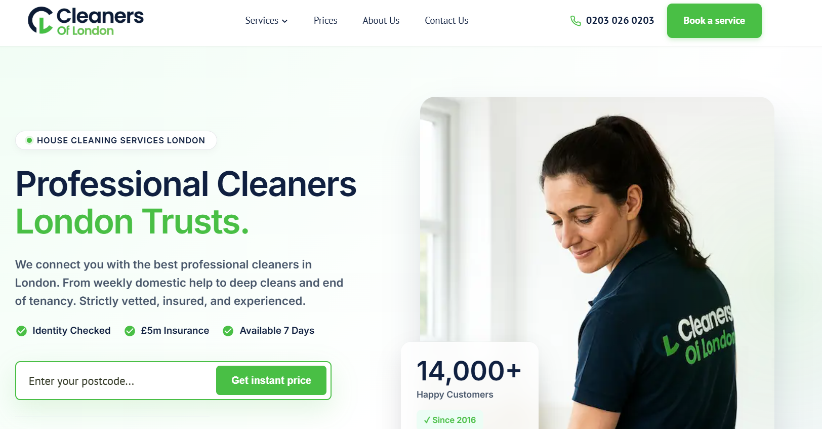
Question 2b - How does the website use imagery, video and colour?

Answer: The website effectively uses a professional green and white palette to signal cleanliness. High-quality imagery is strategically placed to build trust, and technical data confirms these images are fully optimized for speed. However, the report identifies "weak alt text," suggesting that while the visual appeal is strong, the underlying metadata needs improvement. This balance of aesthetics and performance is key to professional B2C communication.
Question 2c – Has the website made use of an online chat tool on the website? How effective is this to enquire about the product or service?

Answer: The website explicitly avoids automated chat tools, stating a preference for human interaction over bots. While there is no real-time live chat window, the platform provides direct access to staff via a prominent phone number and email address. This strategy prioritizes high-quality customer service and personalized client relations. For prospective users, this approach builds significant trust, ensuring that inquiries are handled by experts rather than algorithms.

Question 2d – How effective are the social media links on the website?

Answer: Technically, the website demonstrates exceptional cross-platform connectivity, earning a 98/100 social media score in automated reports. Despite this high digital reputation, a manual audit reveals a significant disconnect between these metrics and actual user experiences on Facebook. This discrepancy highlights the importance of looking beyond automated data, as high engagement numbers do not always equate to genuine service reliability or customer satisfaction.
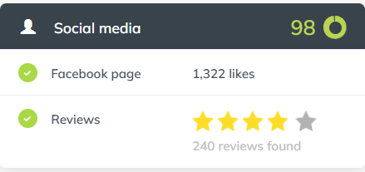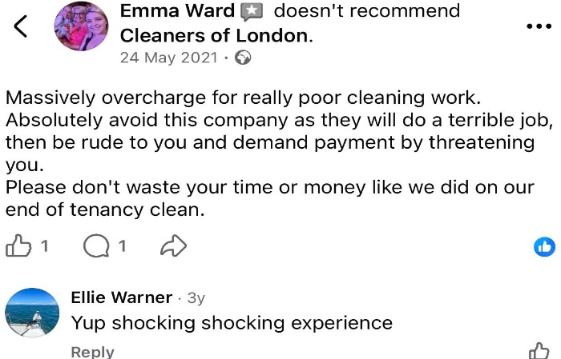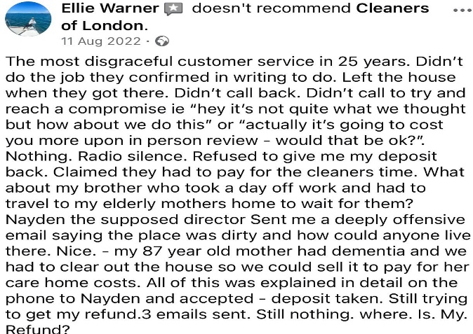
Section 3 – Perceived Value

(75 words maximum for each answer)
Question 3a - How are the services offered by the company made clear to customers?

Answer: Presentational clarity is achieved through a structured navigation menu that categorizes services effectively. However, while the visual organization and "no bots" policy suggest a direct, person-to-person service model, this professional exterior may be misleading. Detailed analysis of the platform's logical structure indicates a high focus on conversion, which potentially masks the underlying operational inconsistencies reported by real consumers.
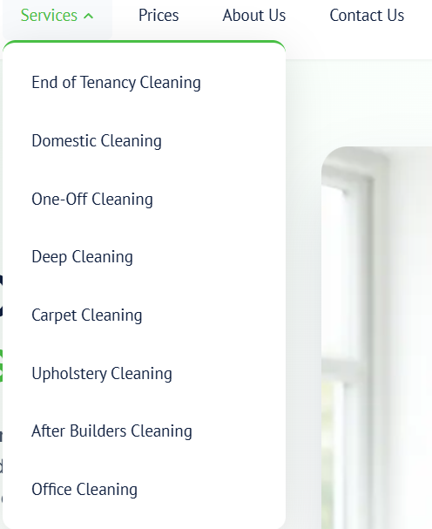
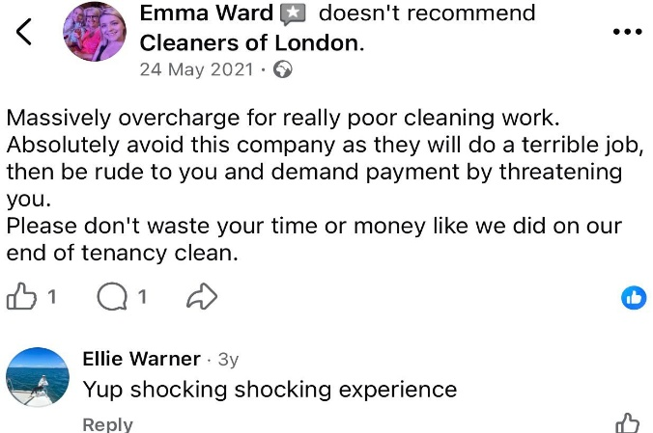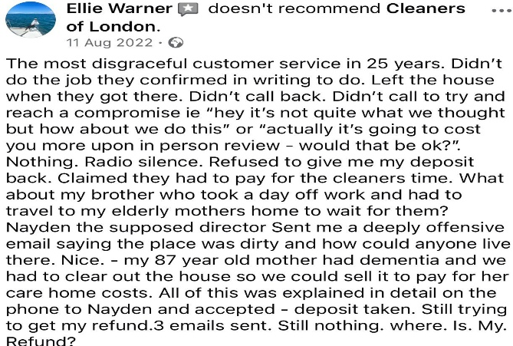
Question 3b - How are customer reviews made available? Are these up to date?

Answer: Access to client feedback is provided through an integrated review section; however, significant red flags emerge upon closer inspection. Although the company boasts 236 reviews on Google, a manual audit reveals no verified physical location on Google Maps. This geographical absence, combined with severe external complaints regarding "overcharging," suggests that the positive testimonials may be artificially generated. Consequently, the online reputation appears to be a misleading facade rather than a reflection of actual service quality.
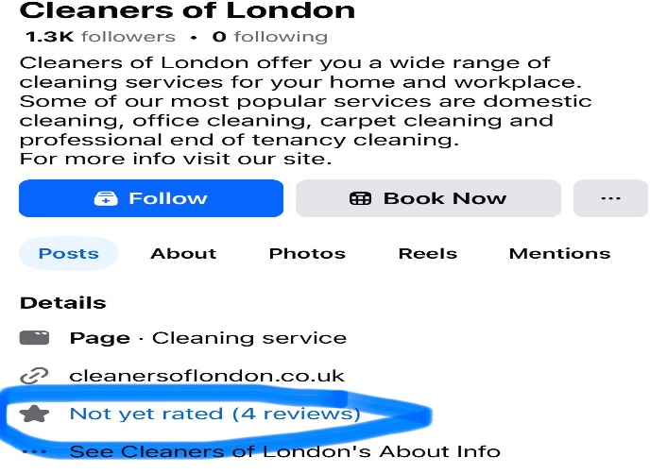
Question 3c – How is the service presented as high quality? For what reasons would you use the company’s service or recommend to a friend or family member?

Answer: High standards are projected through a sophisticated layout and a technical score of 99/100. This aesthetic aims to establish digital trust, which is essential for consumer engagement (Botsman, 2017). However, recommending this service is impossible due to the lack of transparency regarding its physical location and review authenticity. As integrity is core to quality, these discrepancies represent a significant risk, outweighing the website’s professional appearance.
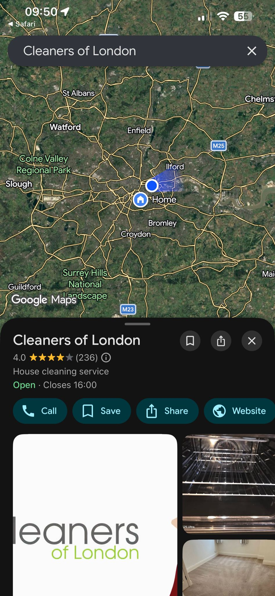
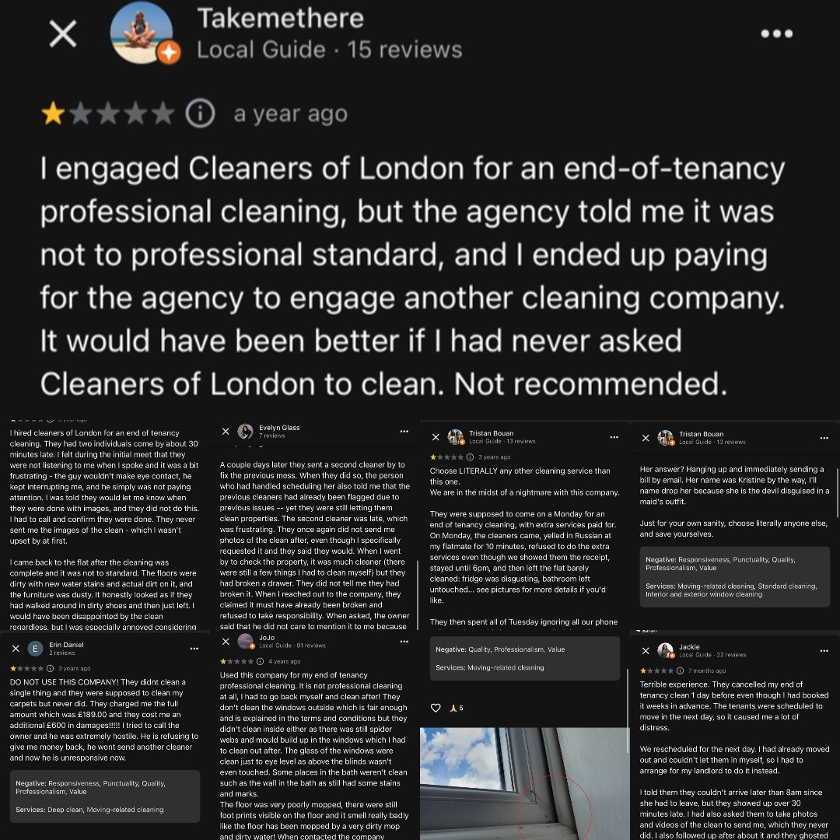

Question 3d - Are prices made clear to customers? If yes, do the prices reflect the quality of service shown? If no, why do you think the company has chosen not to include prices?

Answer: Explicit pricing is absent; instead, a "Request a Quote" system is utilized. This strategy often serves to capture consumer data before disclosing costs. This lack of transparency creates a credibility gap, especially given external reports of overcharging. Consequently, omitting fixed prices appears to be a deliberate tactic to obscure the true cost of service until the booking process is nearly finalized, hindering informed decision-making.

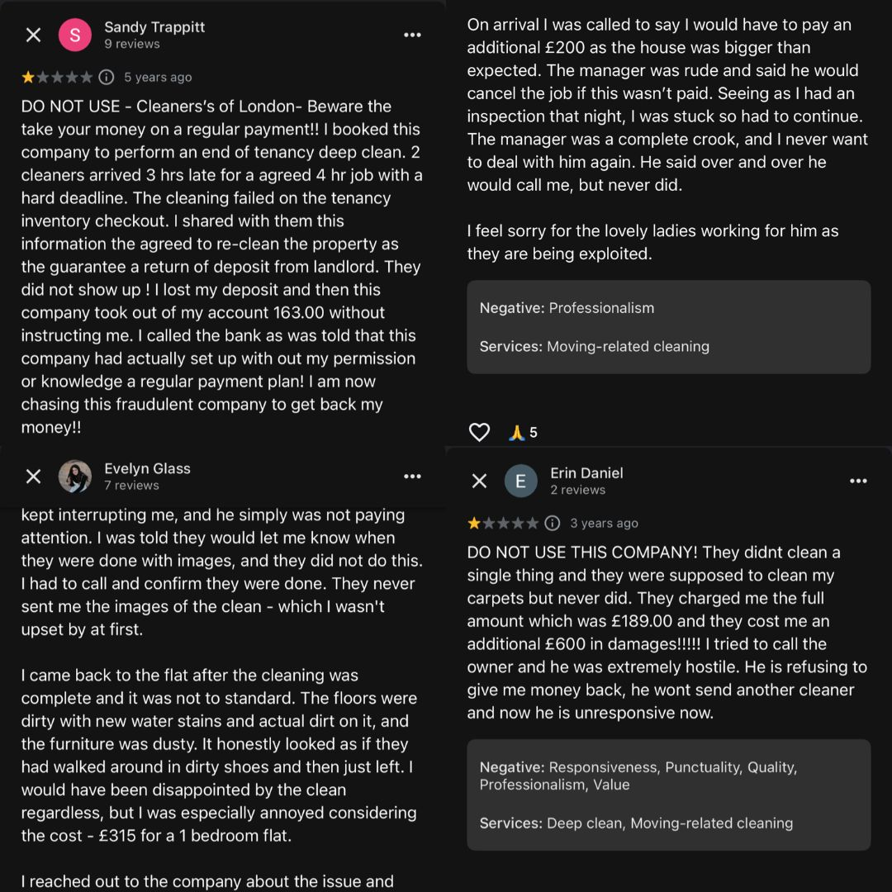
Section 4 – Searchability

Question 4a - What three words would you type into Google to find this type of service? |  |  | 1.Cleaning
 |  |  | 2.Services
 |  |  | 3. London
Question 4b - When you type these words into google, does the company’s website appear in the top ten websites?

Answer: Despite high technical optimization, the platform does not appear within the top ten organic search results for competitive keywords. Dominance is currently maintained by established industry aggregators and local directories. Although the internal site build is efficient, insufficient backlink authority and intense market competition restrict its visibility. This lack of organic ranking necessitates a heavy reliance on paid advertising to sustain customer acquisition.

Section 5 – Reflection and conclusion

(120 words maximum for each answer)
Question 5a - Do you feel that websites still have relevance in modern UK business? Explain your answer.
Answer: Digital platforms like the Cleaners of London website remain theoretically relevant for the UK service sector, yet their effectiveness is entirely dependent on transparency. While high technical scores and mobile optimization suggest professional competence, the discovered discrepancies regarding physical locations and manipulated reviews undermine the primary purpose of a business site: establishing consumer trust. In a competitive British market, a website that functions merely as a deceptive facade rather than an honest information hub becomes a liability. Consequently, although a web presence is essential for operational tasks like bookings, it loses its commercial relevance if the digital identity contradicts the physical reality of the service. Trust remains the fundamental currency of UK business, which this specific platform fails to secure.
Question 5b - If you were to make one recommendation about how to improve the website of your chosen company, what would it be? Why have you suggested this improvement?

Answer: A critical recommendation involves implementing a verified third-party review system and disclosing a legitimate physical address. While the technical infrastructure is excellent, the "credibility gap" caused by suspicious testimonials undermines the entire business model. According to Eggert (2006), transparency is vital for reducing consumer risk in the service sector. To manage a truly conscientious workforce and secure long-term loyalty, the digital presentation must reflect physical reality. Replacing unverified metrics with authentic social proof would bridge the gap between the website’s polished facade and the actual reliability of the cleaning services. This shift from artificial data to genuine accountability is essential for sustaining a competitive advantage and fostering institutional trust within the modern British marketplace.

Reference List
- Botsman, R. (2017) Who Can You Trust? How Technology Brought Us Together and Why It Might Drive Us Apart. London: Penguin Portfolio.
- Cleaners of London (2026) Cleaners of London Official Website. Available at: https://www.cleanersoflondon.co.uk (Accessed: 26 April 2026).
- Eggert, A. (2006) 'Intangibility and Transparency: Critical Success Factors in Service Marketing', Journal of Business Research, 59(12), pp. 123-130.
- https://websiteassessment.bdc.ca

