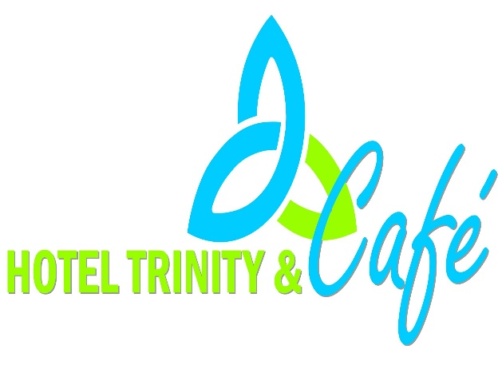  Ordering  For takeout please telephone  or order online on the website at  trinity.food.co.uk  Tel: 01615554474  we are also on Uber eats, Deliveroo and Just Eats.  Contactless payment only  for collections guests will need to wait  in the sitting area at the front of the restaurant, hand sanitizers and masked must be used. | Trinity Hotel Takeaout Menu  - 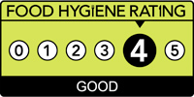
Menu availability  Monday to Sunday  11:00 till 22:00  Bank holiday  09:00 till 21:00 | Hotel Trinity  Seaside  Swansea  trinity.food.co.uk  Tel: 01615554474  we are also on Uber eats, Deliveroo and Just Eats.  Contactless payment only  for collections guests will need to wait  in the sitting area at the front of the restaurant, hand sanitizers and masked must be used.
Main Dishes  Freshly made seafood and mains.  Smoked salmon Fillet £19.99  This amazing dish is served with garlic, baby potatoes, green beans and topped with salsa verde. It is highly recommended with the Sauvignon Blanc, the lightness of the win complements the Salmon nicely and the grassy notes work really well with all the flavors and herbs.  Pan fried sea bass fillet £17.99  Served with a fresh broccoli, red chilies, potatoes gratin. This dish goes perfectly well with Alsace Riesling, this wine will go really well with the sea bass by providing a perfectly balanced ratio to the spices and soy in the dish.  Trinity vegan burger £9.69  Homemade burger mayonnaise and vegan mozzarella cheese, served with fries or house salad.   This Photo by Unknown Author is licensed under CC BY-SA  Dessert  Vanilla Ice cream £3.50  Homemade ice cream  New York cheesecake £5.50  Our very own freshly made cheesecake  Please note: Some dishes may have the following allergens, if concerned please mention, so that we can recommend.  – Vegan  This Photo by Unknown Author is licensed under CC BY-SA | Soups  Mushroom and garlic £4.99  Delicious warm home-made mushroom soup with a hint of garlic  Tomato and basil £4.99  Warm tomato soup with basil  Sides  House salad £4.99  Our very own mixture of fresh salad and herbs in a bowl.  Skin on fries £3.99  Fries made from fresh patotoes.  Creamy Mash £2.99  Drinks  Alsace Riesling £15.99  This wine will go really well with the sea bass due to its dryness.  Sauvignon Blanc £28.99  The lightness of the win complements the Salmon nicely.  Coke, Fanta, Sprite, Ribena and fresh orange juice £2.49  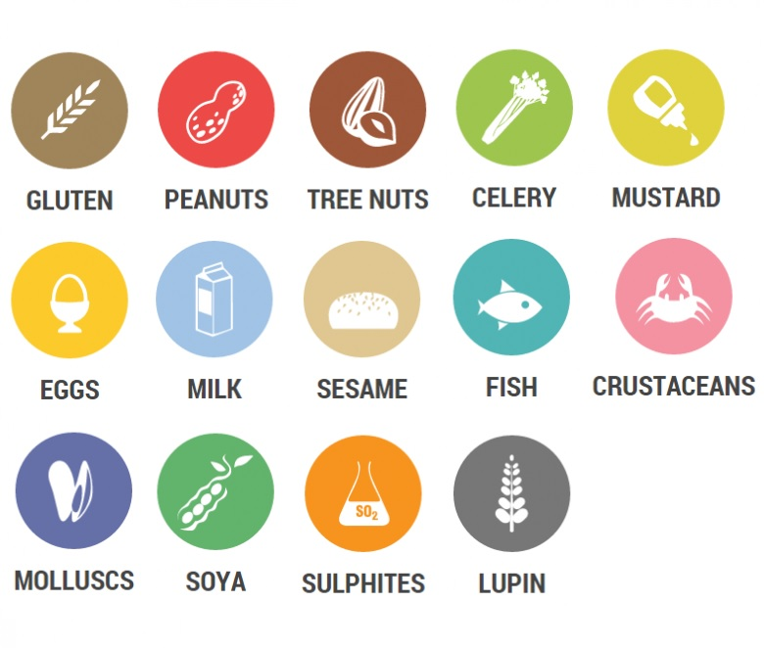

Reference

Clownsnursery.co.uk. 2021. [online] Available at: <https://www.clownsnursery.co.uk/wp-content/uploads/2018/11/List-of-Allergens.jpg> [Accessed 2 November 2021].

Trinityhotelcafe.com. 2021. Hotel Trinity & Cafe – Hospitality with better services. [online] Available at: <http://www.trinityhotelcafe.com/> [Accessed 2 November 2021].

Agency, F., 2021. Check out the food hygiene rating for Haozhan Restaurant. [online] Ratings.food.gov.uk. Available at: <https://ratings.food.gov.uk/business/en-GB/412634> [Accessed 2 November 2021].

