Permition form the comany


Dissertation
MODULE CODE: LCBB6000
Title: Effective communication as a strategy for changing organisation performance in BIG BUS
Supervisor name: Mary March
Student: Hristiyan Parvanov

ID: 1817604
Words: 7797

Acknowledgement
I am very grateful to my research supervisor Mary March who has assisted me through the research and provided me feedback whenever I needed. Completing the research would have been impossible without the help of my seniors and fellow classmates who have helped me to provide useful tips regarding the research methods. I also want to express my gratitude for my family members who have been a constant source of motivation for me to complete the dissertation.
Abstract
Introduction: Big Bus is the business organization that provides sightseeing tour services to various international destinations. The organization operates in tourism industry and faces various communication issues. The research focuses on identification of those communication issues and providing solutions by application of proper communication strategies in order to mitigate those issues.
Methodology: The research potentially follows mixed methodology and thus uses pragmatism philosophy in this research. It also applied deductive approach as the research is developed on existing theories for testing the hypothesis. Primary data have been collected both qualitative and quantitatively and data collected has also be analysed through both the qualitative and quantitative methods. 20 employees of Big Bus has been taken for the survey and 2 managers for interview.
Findings: For the strategies undertaken by Big Bus, both through the interview and the survey it has been seen that the company undertakes mainly three means of communication with its employees that are regular meetings, regular feedback to the employees and also training and development programmes for training the employees to handle the new means of communication system including the online communication platform in a better way.
Conclusion: The tourism industry has been badly affected by the loss of communication in the pandemic situation. The industry faced severe downfall in revenue as compared to that of 2019 and to the forecasted revenue of 2020. Therefore due to this the company Big Bus has been seen to undertake various communication strategies for maintaining an effective flow of information in the company and thus result in better performance of the company.

Table of Contents
Chapter 1: Introduction 6
1.1 Background of the topic 6
1.2 Significance 6
1.3 Research Rationale 7
1.4 Aim, Objectives and Questions of the Research 7
1.4.1 Research Aim 7
1.4.2 Research Objectives 7
1.4.3 Research Questions 8
1.5 Structure of the dissertation 8
Chapter 2: Literature Review 9
2.1 Understanding effective communication in business organisation 9
2.2 Different types of Communication 9
2.3 Models of Communication 10
2.4 Advantages of using technological tools as a means of communication in organisations 11
2.5 Barriers to effective communication 11
2.6 Consequences related to ineffective communication in business organisations 12
2.7 Importance of communication in enhancing employee and customer retention 13
2.8 Overview of Tourism Sector across the world and Big Bus Company 13

Chapter 3: Methodology 15
3.1 Research Philosophy 15
3.2 Research Approach 15
3.3 Research methodology 16
3.4 Research Strategy 16
3.5 Sampling methods 16
3.6 Ethical Consideration 17
Primary data 17
3.7 Gantt Chart 18
Chapter 4: Findings and Discussion 19
4.1 Primary Quantitative Analysis 19
4.2 Primary Qualitative Analysis 25
4.3 Discussion 26
Chapter 5: Conclusion and recommendations 28
References 30
Appendix 34
Ethical Approval Form 37
Participation Consent Form 59
Participant Information Sheet 61

Chapter 1: Introduction

1.1 Background of the topic
Communication is an essential element in any business organization and plays a vital role in driving organization success. It potentially ensures the development of commitment and loyalty of the employees and the customers (Nădrag and Buzarna-Tihenea, 2018). Big Bus is the organisation that operates as a company that conducts sightseeing tours (BIG BUS TOURS LTD, 2018) The Company is owned by Exponent LLC and its destinations of tours include Hong Kong, Dubai, Las Vegas Miami, Paris, Philadelphia, Shanghai, San Francisco, Washington and London (LinkedIn, 2022). The company was founded in the month of May of the year 2011 and is headquartered in London UK. The business organisation deals with diverse employees and customers from different culture and background and having different needs and preferences. It deals with more 7 million customers on and annual basis and is one of the largest bus tour operators (Freshworks, 2021).

1.2 Significance
Communication as mentioned as an important component for the business organisations as it plays a vital role in development and maintenance of relationship with the customers and the employees. Communication plays a vital role in providing guidance to the employees and in helping them to algin their work with the culture of the organisation. It also enables the business to understand the preferences of the customer as well as the needs of the employees (Bucăţa and Rizescu, 2017). Thus communication serves as the foundation of the business organisation. There are various business communication strategies and choosing the right strategy is very important for business communication strategies and choosing the right strategy is very important for business organisation in order to maintain a proper balance between the employees and the customers. Communication potentially helps the business to enhance its productivity and positive brand name in the business market. This thereby drives the business success and helps the organisation to accomplish the business aim and goals (Nădrag and Buzarna-Tihenea, 2018). This particular research potentially focuses on identifying different communication issues that exists in Big Bus in order to solve them by application of the most suitable communication strategy in the business organisation. This would further help the business to stay ahead of the competitors and to accomplish the mission and goals by driving success and growth of the business.

1.3 Research Rationale
Big Bus is the organization that operates in the tourism industry across various international regions and delas with diverse customers and employees (BIG BUS TOURS LTD, 2018). These individuals have different preferences, needs and way of communication and thus it is important for the business to understand them in order satisfy the needs of the customers and the employees. The Covid 19 pandemic has potentially affected the tourism sector and the businesses that operate in it (Uğur and Akbıyık, 2020). The communication has been mostly disrupted owing to the social distancing aspects, lockdowns and work from home norms (Longmuir, 2021). Thus it is essential to choose the proper communication strategy to keep the employees and the customers engaged in the business. This research potentially focuses on identification of the communication issues that exists in the business and formulation the solutions to mitigate those issues. The research thus emphasize on enabling Big Bus to apply the most appropriate communication strategy in order to maintain the efficiency and improve the productivity of the business. This would help the organisation to progress towards the business mission and vision and accomplish the business aims and goals. Thus this states the purpose or the reason behind conduction of the research.

1.4 Aim, Objectives and Questions of the Research

1.4.1 Research Aim
The aim is to understand the importance of having effective communication in a business organization named as Big Bus Company.

1.4.2 Research Objectives
- To identify the strategies applied by Big Bus company for managing communication within the working environment.
- To investigate the problems faced by the company due to ineffective communication.
1.4.3 Research Questions
- What problems are being faced by the Big Bus Company in terms of communication with the customers?
- What strategies have been implemented for having an effective communication both with the staff or employees as well as with the customers?
- 1.5 Structure of the dissertation
The dissertation comprises of 5 sequential chapters and these are namely Introduction, Literature Review, and Methodology, Fundings & discussions and Conclusion. The first chapter is Introduction that provides an overview of the research topic. The concerned chapter enables to understand the background and significance of the research as well as rationale behind conducting the research regarding the particular topic. This chapter also represents the formulated aim, objectives and research questions. In this particular chapter the entire structure of the research report is also presented. The next chapter is literature review that is based secondary data regarding the variables of the research. This chapter is about methodology and this chapter presents different components of methodology that is opted by the researcher while conducting the research. This chapter is about justification of the methodologies that are opted and applied by the researcher while conducting the research. This chapter comprises of research philosophy, approach, methodology, data collection and data analysis as well as ethical considerations. The chapter also presents the research timeline in the form of Gantt chart. The fourth chapter that is findings and discussions and this comprises of the data that is the conclusion comprises of three aspects that are conclusion of the entire research topic, recommendations and limitations of the research.

Chapter 2: Literature Review

2.1 Understanding effective communication in business organisation
Communication is defined as the exchange of ideas as well as concepts for providing information, instructions, guidance and influence within the organization. The managers in the business organization are responsible for development of most appropriate environment of communication and for establishing as well as maintaining proper communication channels. Effective communication is two way process and thus the sender and receiver are both responsible for the success of appropriate understanding and interpretation of the information that are communicated (Singh, 2015). The effective communication channels is ensured by opting for the correct medium through which the sender sends the message. It is a process that involves various sequential steps along with the need and knowledge of the receiver who receives the message. The message that is communicated must be properly transferred, actions and reactions must be considered and feedbacks must be given (Thompson, 2018). In an organisation the communication is done in three ways that are upward, diagonally and downward. It is nearly impossible to be perfect in communication but it is essential to keep focus on improvement to be near to getting ideal results and this determines the effectiveness of communication. The effective communication mostly follows the path that begins with sender who sends the message that is received by the receiver who interprets it and provides feedback to the sender. Communication is used for various purposes in business organisations such as advising, guiding, counselling, marketing, providing information, raising morale, decision making, staffing and development of a proper image of the business (OSMANOVIĆ et al., 2021). Effective communication ensures that all these aspects are maintained so that the workflow is also maintained in the organisation.

2.2 Different types of Communication
Communication can take place in different manner and this divides it into distinct types. The different types of communication that exists are Verbal Communication, Non verbal communication, Interpersonal communication, Intrapersonal Communication, Mass communication and Media communication. Verbal Communication is defined as the way of communication where it is spoken or written and thus it is further divided into two categories that are oral communication and written communication. Oral communication is the interaction between two individuals in a face to face manner. It involves presentations, speeches, discussions, interviews and so on. Written Communication is the way where messages are transferred in a written manner and this involves emails, reports, and handbooks (Rocci and de Saussure, 2016). Non verbal communication is the way of communication where no words are used and this involves paralinguistic features such as voice modulation, pitch, volume and articulation and body language such as facial expressions, eye contact, gestures, and personal appearance (Mehrabian, 2017). Interpersonal Communication involves two or more individuals who communicate in a direct, written and via oral communication. Intrapersonal communication is about reflection of the individual about own self for understanding and identifying own strengths and weaknesses (Lane, 2016). Mass Communication is about conveying message to the entire group of people or the entire population. Media Communication is the way of communication that involves electronic devices and technological tools (Singh, 2015).

2.3 Models of Communication
The three most significant models of communication are linear, interactional and transactional. The linear model of communication depicts that communication is a one way process where the sender codifies a message and utilises a particular channel for sending the codified message to the receiver who finally decodes or interprets the message to obtain the information. This is a form of straight line communication and the greatest benefit of this model is that the message is unambiguous and clear that enables the audience to interpret it in such a way without changing the content of the message or its style. The disadvantage of this model is that no feedback is provided to the sender for the receiver so that they can use it for improving their communication ability (Sauter, 2021). The interactional model of communication is the process where the participants who are involved in communication have the ability to alternate their positions that is the sender can be the receiver and the receiver can be the sender. This involves both the aspects of sending codified messages as well as receiving the feedbacks within the psychological and physical contexts. The model is best for communicating sensitive information and also allows both the sides to provide opinions. The sender and receiver in this model are equally active and the feedback that is obtained makes it easier to interpret the success and effectivity of the communication. The model also offers certain disadvantages such as it is a complex process and it does not deal with multiple communication levels. The messages that are sent and received as per the model have the risk to get interpreted in a different way (Llopis-Lorente et al., 2017). Transactional model of Communication is the way where the individuals who are the communicators potentially develop social realities in the social, relational and cultural situations. The main motive of this communication model is to develop and maintain relationships (McQuail and Windahl, 2015).

2.4 Advantages of using technological tools as a means of communication in organisations
With the advancement in technology and rise of digital communication, there are various technological tools that are used as a means of communication in business organisations. These are mails, emails, social networking, online collaborations, telephones, computers, laptops, video conferencing and so on. The utilisation of these tools for communication potentially helps individuals to reach out to wide range of audiences in a time effective and efficient manner. It also helps in strengthening the communication skills. These tools help in communicating with diverse group of individuals across the world and thus support the organisation to enhance their customer base (Cascio and Montealegre, 2016). The technological tools also help in real time communication and potentially support remote working in the organisation. It also improves customer relationships and helps in making decisions in a quick manner. It also provides competitive advantages to the organisation by reducing frictions and time loss and also enables to maintain regular follow ups and task collaborations. It potentially improves the aspect of multitasking, collaborations and automations and thus also enhances internal communications (Colbert et al., 2016).

2.5 Barriers to effective communication
There are number of aberrations and disturbances that contribute to misinterpretation and corporate communication breakdown. There are several form of obstacles to corporate communications, suck as psychological, cognitive, physical, and cultural issues. Among the most major hurdles of efficient business communications is language difficulties. One might think of it as an important medium of communication. However, diverse accents and tongues in various locations might make communication difficult. Another factor to consider is emotional obstacles (Kapur, 2018). When opposed to someone wo is not emotionally stable, an individual with strong impulses would be good at communication. To support effective corporate communication, there ought to be a proper combination of emotions. Another important factor in this regard is cultural barriers. Cultural barriers are caused due to the varying cultural differences among the various employees and stakeholders of a business from various parts of the world. These cultural gaps and differences cause barriers to effective communication (Khairuddin, 2021). Organisational structure obstacles arise as a result of a company’s different organisational hierarchies. Incorrect information, misunderstanding, and a lack of disclosure are all caused by various system and settings. Physiological impediments, such as illnesses or illnesses, can also obstruct effective business communications. Each day, technology evolves, and it is vital to stay up with the changing landscape. However, not every individual is computer adept (Dutta et al., 2022). Furthermore, technical innovation frequently raises the cost of doing business. All of these factors combine to create technical hurdles to commercial communication. Physical obstacles play a role in this as well. Locked doors, defective equipment, noise, and enclosed chambers are examples of such obstacles. Physical impediments like these might stifle commercial communication.

2.6 Consequences related to ineffective communication in business organisations
Ineffective communication not only acts as a barrier to maintain the workflow but also is harmful for the organisation. It potentially leads to misunderstandings and confusions in the workplace and leads to conflicts and hostility among the employees. It potentially damages the relationship between the employees forming the workforce and limits the ability of the business organisation in terms of their team performance and productivity (Wu et al., 2017). It also reduces opportunities and develops mistrust within the organisation. It also leads to demotivation and reduces employee engagement and dedication. Ineffective communication enhances the frustration among the employees and enhances confusion and this affects their loyalty and deteriorates their performance and their ability to serve the customers (Odine, 2015). This further affects the brand reputation and also enhances dissatisfaction of the customers. The ineffective communication also impacts the customer relationships owing to the lack of information regarding their needs, preferences and demands and thus it remains unaccomplished. This thereby affects the business organisation’s productivity and workflow and often leads to poor organisational performance (Atambo and Momanyi, 2016). Thus ineffective communication is a major problem for the business organisation as it hampers both the employee relationships and performance and customer satisfaction and loyalty towards the business organisation.

2.7 Importance of communication in enhancing employee and customer retention
Communication plays a vital role in enhancing employee and customer retention within the business organization. Effective communication improves the employee relationship and potentially helps the managers to guide the employees within the organization. This enhances the employee engagement and also plays a vital role in fostering their dedication. Communication also plays a vital role in motivating the employees within the organization it improves their morale and helps them to align to the organization culture. It also fosters trust and bonding among the employee retention by reducing the employee turnover in the organisation (Cloutier et al., 2015). Communication not only acts as a beneficiary aspect for the employee relationships but also plays a vital role in fostering customer retention. Communication potentially helps in understanding customer needs and preferences and also helps in gaining feedbacks from them. This thereby ensure that the employees work in an effective way to meet the needs and demands of the customers. This enhances customer satisfaction and thus fosters customer retention within the business organization (Kurdi et al., 2020).

2.8 Overview of Tourism Sector across the world and Big Bus Company
The tourism industry cannot be defined in a simple way as other industries because it comprises of various small industries. It involves transport, lodging, travel organisations, attractions and so on. Tourism is defined as travelling and staying of the individuals or families in different places outside their regular environments. It involves travelling for leisure, business or health purposes. In the year 2020, the travel and tourism sector contributed approximately an amount of 4.7 trillion dollars in the global GDP. Almost 399 million international tourist arrives took place across the world and the spending of leisure travels across the globe amounted to more than 2.3 trillion dollars. In the early period of the year 2020, the tourism industry was severely affected by the pandemic owing to the lockdowns and travel restrictions (Lock, 2021). The pandemic has potentially transformed the travel and tourism globally. The industry faced severe downfall in revenue as compared to that of 2019 and to the forecasted revenue of 2020. The global revenue of the tourism industry amounted to 396 billion dollars in the year 2020 and this showed a reduction of more than 42% from that of revenue of 2019 that amounted to more than 685 billion dollars. The forecasted revenue that was expected in the year 2020 was approximately 712 billion dollars and thus the pandemic has been the major reason of downfall of the travel and tourism industry across the world (Lock, 2022). Big Bus Tours operate in the travel and tourism industry as the largest operator of sightseeing tours across the world. It operates in 19 famous cities across the 4 continents. The revenue of the business amounted to 256 million dollar. The company have 1863 employees at present from across the world (ZoomInfo, 2022).

Chapter 3: Methodology

3.1 Research Philosophy
The research philosophy depicts the ideology and the belief behind conducting the research. Among the four different types of philosophy namely pragmatism, interpretivism, realism and positivism, this particular research is based on pragmatism as it is based on mixed methodology. The pragmatism philosophy is suitable for this concerned research as the research utilises both qualitative and quantitative data for formulating the results (Mitchell, 2018). Positivism philosophy is applied to the researches that is entirely based on factual data only and thus is not suitable for this research. Interpretivism is suitable for those researches that is based on secondary data and thus is not opted by the researcher for this concerned research. Realism is applied to the research that portrays data via human observation and senses and thus is not suitable for this research (Kumar, 2018). Thus the researcher applied pragmatism as it is most suitable for interpretation of qualitative and quantitative data.

3.2 Research Approach
The research approach depicts the pathway that is followed by the researcher to obtain the data regarding the research topic in order to address the objectives and accomplish the aim of the research. The research approach is mainly of three types deductive, inductive and abductive and among these three the researcher opted for deductive approach. This is suitable for this research as it is based on established theories and this would help the researcher to test the hypothesis for reaching the aim of the research. The inductive and abductive approach is not suitable for this particular research. The deductive approach enables the researcher to develop results based on the theories that already exists but it do not applies to those researches that is about development of new theories. Inductive approach is applied to those researches that is based on empirical observations only and focuses on seeking patterns. Abductive approach is applied to those researches that are based on aspects which are not being researched completely before (Pandey and Pandey, 20210). Thus both the research approaches are not suitable for this concerned research and thus is not applied.

3.3 Research methodology
Both the qualitative and quantitative research methodologies have been applied to the research, since both survey and interview and survey is conducted. Qualitative research methods are the process of obtaining the data and information through open-ended and conversational communication. This can be in the form of interviews and helps to understand not on the ‘what’ but also the ‘why’ for any question. On the other hand the quantitative research methods being another primary research method are the systematic investigation by gathering quantifiable data and performing mathematical, statistical and or even computational techniques. Through this research method information is collected from the potential and existing customers by selecting through different sampling methods and gaining the data through online polls, surveys, questionnaires etc. The quantitative data analysis that has been conducted has helped the researcher to measure the different variables collected from the data, whereas the qualitative data analysis has helped the researcher to explore new concepts and theories in a much detailed manner (Pandey and Pandey, 2021).

3.4 Research Strategy
A research strategy is the step-by-step action plan that gives direction to the thoughts and efforts of the researchers and enables them to conduct the research in a systematic and scheduled way. This results in the production of quality results and also detailed reporting in the research. The strategy of the research introduces the important components of the research projects such as the perspective of the research, the focus and the topic area of the research, the research design and the methods that have been undertaken for the research. There are four types of the research strategy including case studies, Quantitative survey, Qualitative interviews and action-oriented research or action research. In this research the researcher has used Quantitative surveys and Qualitative interviews as the research strategy (Oliva, 2019).

3.5 Sampling methods
The sampling method that is used in the research is the purposive sampling method. This sampling technique helps the researcher to rely on his or her own perception while choosing the members of population for the sample to participate in the study. In order to conduct the survey 10 employees of the Big Bus organisation has been chosen for collecting data through the questionnaires formed by the researcher. For conducting the interview for the qualitative data collection, 2 managers of the company will be interviewed. 10 question will be asked to each of the participants. The purposive strategy has been an appropriate strategy for selecting the sample members for the research and since the selected members are of the organisation the Big Bus, undertaking the research through the strategy is suitable (Campbell et al., 2020).

3.6 Ethical considerations
The researcher has maintained all the ethical rules for keeping the data protected and secured. The principles mentioned under the “Data Protection Act” of 2018 have been considered carefully (Gov, 2022). Even during the interviews the researcher has maintained positive body languages without commenting on the answers received. The confidentially and privacy of the responses collected were valued by the researcher. Research ethics gives several benefits to the researcher. As collaboration between researcher and groups are very important in a research work, therefore, showing that the research has been carried out with fairness and mutual respect will enhance the quality of the work. To protect the data subjects, the GDPR Act has been followed in this research work (Cornock, 2018).

Primary data

Primary data has been collected in this research work through interviews and responses have been recorded from two managers of the company. Strategies of effective communication is the focus of the Big Bus Company therefore, this data collection method is the most suitable one (Nassaji, 2015). As the information and data are collected from authentic sources this increase the research validity and reliability. Up-to-date information can be collected that is not always possible in secondary researches.

3.7 Gantt Chart
Activities | Week 1 | Week 2 | Week 3 | Week 4 | Week 5 | Week 6 | Week 7
Research topic selection
Formation of aims, objectives and research questions
Review of scholarly literatures
Selection of research methods
Data collection process
Interpretation of the data
Concluding it
Final submission

Chapter 4: Findings and Discussion

4.1 Primary Quantitative Analysis
Q1. What is your age?

Q2. What is your gender?

Q3. Communication is important for better performance of an organisation.

Analysis: Through the responses gathered from the respondents it has been seen that maximum of them agreed to the fact that communication is important for better performance of an organisation. This shows that the employees of the organisation, the Big Bus are inclined towards better performance of the company and thinks that communicating in a better way would result in enhancement of their performance.
Q4. What are the most preferred types of communication that should be undertaken by an organisation according to you?

Analysis: According to most of the respondents the most preferred type of communication that any organisation should follow is verbal communication. According to the respondents verbal communication would result in maintaining a successful business relationship and also helps in decreasing any error that might occur while conveying a message within the organisation. The verbal communication has therefore been preferred by the respondents in order to increase the productivity of the organisation and thus make the operations smoother and effective.
Q5. What is the type of communication that is undertaken by your organisation?

Analysis: According to the respondents, Big Bus follows the verbal communication system to communicate and convey their messages to the employees and other departments of the company. The respondents have stated that the organisation follows the verbal communication which has enabled the company to maintain proper passage of information avoiding any error that might become the reason for reduced customer service efficiency. The communication method that is undertaken by the organisation has helped the company to serve its customers in a better way.
Q6. When there is a perceived error in the information that has been passed on to you, what do you do?

Analysis: When asked this question most of the respondents responded to discussing the problem with the colleagues and also asking questions in order to ensure that the information conveyed is free of any unintentional error, and that in turn does not puts an impact on the performance of the company. Through the responses it can be seen that the employees of the company are very much focused on maintaining the quality of the services provided by their organisation and also about their individual performance as an employee of the company.
Q7. What are the means of communication that Big Bus uses for communicating with its employees?

Analysis: Through the survey it has been seen that the organisation, the Big Bus undertakes team meetings, training and development modules and feedbacks for communicating in a better with its employees. Team meetings have been an essential part of the company and are a great way of achieving the team’s objectives while building a proper team. This helps in communicating the necessary information from employees to the head management and vice-versa, so that the organisation performs in a synchronised way. Through the training and development programmes, the organisation is able to communicate the right processes and ways in which services should be extended to the customers. Through the feedbacks the employees are able to gain a proper insight of the things in which they should improve and gain efficient skills to serve the customers the right way. Moreover, the feedbacks are essential part of communication for understanding that the right message has been received by the recipients.
Q8. Do you think that the environment of the organisation affects communication?

Analysis: In response to the question, the most of the employees responded positively stating that the environment of an organisation affects the communication carries out within it. The environment of an organisation has both the negative and positive impact on the communication of the organisation. The negative impact of the environmental barriers results in ineffective communication and thus affects the performance of the overall organisation and its services. Therefore, the respondents of the company the Big Bus have mostly opted positively on the impact of the external environment on the communication within the workplace. There are some of the respondents who are not sure about the impacts that the environment might have on the communication system, showing that there might be a good communication system prevailing in the company that employees do not feel the need to think of the environmental impacts.
Q9. Please rate your listening ability.

Analysis: Through the data collected for this question it can be seen that most of the respondents has rated their listening skills quiet averagely. Listening being the most crucial skill in effective communication has been seen to be well incorporated in the employees of the Big Bus. The self-rating of the respondents also shows that they are willing to enhance their skills and are well aware of the extent they contain a certain skill. This self-awareness of the employees is very important for the success of the organisation and results in better productivity of the company.

4.2 Primary Qualitative Analysis
Q1. What are the different problems faced by your organisation due to ineffective communication?
Through the interview taken from the two managers of the Big Bus, it can be seen that the main issues the company have faced or faces, is the misunderstanding that ineffective communication creates in the company. As stated by Manager 1, “Misunderstandings are the biggest problems that we face due to the lack of proper communication.” Another problem that the Big Bus has been facing is from the communication that the organisation has to undertake through the online platforms due to the prevailing situation of pandemic. This has resulted in the improper communication and various other problems due to the disturbances in the online communication system, thus disrupting the proper communication flow in the company and resulting in inefficient customer service. As stated by Manager 2, “Sometimes the employees are unable to properly handle the communication means and the nuances in the tone of voice over the online communication platform have created much tension in the workplace.”
Q2. What are the different strategies that your organisation has undertaken for maintaining effective communication in the working environment?
As seen through the interview of the two managers, it can be said that the company Big Bus makes use of regular meetings, training and development modules and regular feedbacks for maintaining effective communication in the working environment. According to Manager 1 the regular meetings are held weekly and even monthly that helps the employees to get a better idea about the goals and tasks. As stated by manager 1, “Weekly and even monthly meetings are held for properly communicating the business processes to the employees.” According to another manager the company has undertaken the use of training and development modules for ensuring that the employees are well aware of the ways in which the new technologies that is the online communicating platforms are used. This helps the managers of Big Bus to mitigate the issues faced by them and the employees to communicate through the hindrances caused by the online platforms. As said by Manager 2, “we make sure to train the employees to handle the online communicating platforms for better interaction and communication.” Finally the third manager agreeing to the other strategies stated by the colleagues added the use of regular feedbacks as one of the most effective communication strategy they follow, and that has helped the company to perform effectively to serve the customers.

4.3 Discussion
Through the entire analysis of the data collected from both the qualitative and quantitative sources, it can be said that the organisation the Big Bus implements effective communication strategies for enhancing its performance in the market. Through the survey and the responses gained from the 20 respondents, it is quite clear that the organisation has very well incorporated and importance of proper communication in the opinions and activities of the employees of the company. The employees of Big Bus understand the importance of effective communication very well and they take the activity as strategic for the achievement of organisational goal. This is because ineffective communication in an organisation might result in the apprehension, uncertainty and dissatisfaction and therefore resulting in the overall poor productivity of the company. Thus, the managers and the employees of the organisation communicate effectively. Among the various communication types the verbal communication has been recognised as the most preferred type of communication for the employees and the Big Bus follows the same. Through verbal communication they have been able to maintain proper passage of information avoiding any error that might become the reason for reduced customer service efficiency and thus provide better customer service. Many costly mistakes and wastes have been generated due to the gaps in communication and the lack of proper communication has been the major reason leading to poor planning and confusion in many organisations. This is because the communication is the main source of information that is used by the managers in the decision making that would affect the performance of the organisation. Through the survey it has also been seen that the employees of the company are well trained for clarifying any query related to the information conveyed with the departments in order to ensure that no error passes through line of information conveying, thus showing the importance given by the company to proper and effective communication. As for the strategies undertaken by Big Bus, both through the interview and the survey it has been seen that the company undertakes mainly three means of communication with its employees that are regular meetings, regular feedback to the employees and also training and development programmes for training the employees to handle the new means of communication system including the online communication platform in a better way.

Chapter 5: Conclusion and recommendations
The research that has been undertaken has provided an in-depth insight of the importance of effective communication strategies for better performance in the context of the company Big Bus. The objectives and questions of the research have been formulated by the researcher and the research conducted in order to fulfil and answer the questions that have been set for the research. Through the research it can be said that there are various business communication strategies and choosing the right strategy is very important for business organisation in order to maintain a proper balance between the employees and the customers. Therefore, Big Bus has also been seen to know this and implement various communication strategies for actively interacting with its employees and thus ensuring better and quality performance in serving its customers. The need for proper communication has been most crucial in the business organisation especially after the emergence of the COVID-19 pandemic that has mostly disrupted various business sector and their operations due to the loss of proper communication. The communication has been mostly disrupted owing to the social distancing aspects, lockdowns and work from home norms. In an organisation the communication is done in three ways that are upward, diagonally and downward. There are also various models of communication that most of the companies undertake in order to maintain a proper and efficient workflow throughout the organisation. Some of the models include the linear model of communication, the interaction model of communication, and the transactional model of communication. Different communicating tools like mails, emails, social networking, online collaborations, telephones, computers, laptops, video conferencing and so on helps the companies to strengthen the communication of their employees. This is very important because ineffective communication enhances the frustration among the employees and enhances confusion and this affects their loyalty and deteriorates their performance and their ability to serve the customers. The tourism industry has been badly affected by the loss of communication in the pandemic situation. The industry faced severe downfall in revenue as compared to that of 2019 and to the forecasted revenue of 2020. Therefore due to this the company Big Bus has been seen to undertake various communication strategies for maintaining an effective flow of information in the company and thus result in better performance of the company.

Recommendations:
- Apart from undertaking the different communication strategies by the Big Bus, the company should also make more use of visuals more than just verbal communication. Oral along with visual communication would result in enhanced flow of information and better understanding among the employees.
- The feedback provided by the management to the employees should be more one-on-one. This would help the employees of the company to better understand their weaknesses and also feel a sense of being important for the company.
Limitations:
The only limitation of the research is the use of small number of sample data for conducting the research. Taking more than the 20 employees for conducting the survey could have provided the researcher a better and in-depth knowledge and understanding of the company Big Bus and the communication strategies and challenges faced by them.

References
Atambo, W.N. and Momanyi, D.K., (2016). Effects of internal communication on employee performance: a case study of Kenya power and lighting company, South Nyanza Region, Kenya. Imperial Journal of Interdisciplinary Research (IJIR), 2(5), pp.328-340.
BIG BUS TOURS LTD, (2018). About Big Bus Tours - International | English. [online] BIG BUS TOURS LTD. Available at: <https://www.bigbustours.com/about-big-bus-tours/> [Accessed 13 January 2022].
Bucăţa, G. and Rizescu, A.M., (2017). The role of communication in enhancing work effectiveness of an organization. Land Forces Academy Review, 22(1), pp.49-57.
Campbell, S., Greenwood, M., Prior, S., Shearer, T., Walkem, K., Young, S., Bywaters, D. and Walker, K., (2020). Purposive sampling: complex or simple? Research case examples. Journal of Research in Nursing, 25(8), pp.652-661.
Cascio, W.F. and Montealegre, R., (2016). How technology is changing work and organizations. Annual Review of Organizational Psychology and Organizational Behavior, 3, pp.349-375.
Cadence, (2019). What is quantitative research? . Available at: https://kadence.com/what-is-quantitative-research/ [Accessed on: 14 April, 2022]
Cornock, M., (2018). General Data Protection Regulation (GDPR) and implications for research. Maturitas, 111, pp.A1-A2.

Cloutier, O., Felusiak, L., Hill, C. and Pemberton-Jones, E.J., (2015). The importance of developing strategies for employee retention. Journal of Leadership, Accountability & Ethics, 12(2).
Colbert, A., Yee, N. and George, G., (2016). The digital workforce and the workplace of the future. Academy of management journal, 59(3), pp.731-739.
Cornock, M., (2018). General Data Protection Regulation (GDPR) and implications for research. Maturitas, 111, pp.A1-A2.
Freshworks, (2021). How Big Bus Tours built a unified support hub with Freshdesk Omnichannel. [online] Freshworks Inc. Available at: <https://freshdesk.com/resources/case-study/big-bus-tours#:~:text=7%20million%20customers%20a%20year,7%20million%20customers%20per%20year.> [Accessed 13 January 2022].
Gov, (2022). The Data Protection Act. Available at: https://www.gov.uk/data-protection[ Accessed on: 14 April, 2022]
Kent, R., (2020). Data construction and data analysis for survey research. Bloomsbury Publishing.
Kent, R., (2020). Data construction and data analysis for survey research. Bloomsbury Publishing.
Kumar, R., (2018). Research methodology: A step-by-step guide for beginners. Sage.
Kurdi, B., Alshurideh, M. and Alnaser, A., (2020). The impact of employee satisfaction on customer satisfaction: Theoretical and empirical underpinning. Management Science Letters, 10(15), pp.3561-3570.
Lane, S.D., (2016). Interpersonal communication: Competence and contexts. Routledge.
LinkedIn, (2022). Big Bus Tours. [online] LinkedIn. Available at: <https://www.linkedin.com/company/big-bus-tours/> [Accessed 13 January 2022].
Llopis-Lorente, A., Díez, P., Sánchez, A., Marcos, M.D., Sancenón, F., Martínez-Ruiz, P., Villalonga, R. and Martínez-Máñez, R., (2017). Interactive models of communication at the nanoscale using nanoparticles that talk to one another. Nature communications, 8(1), pp.1-7.
Lock, S., (2021). Global tourism industry - statistics & facts. [online] Statista. Available at: <https://www.statista.com/topics/962/global-tourism/> [Accessed 13 January 2022].
Lock, S., (2022). Forecasted change in revenue from the travel and tourism industry due to the coronavirus (COVID-19) pandemic worldwide from 2019 to 2020. [online] Statista. Available at: <https://www.statista.com/forecasts/1103426/covid-19-revenue-travel-tourism-industry-forecast> [Accessed 13 January 2022].
Longmuir, F., (2021). Leading in lockdown: Community, communication and compassion in response to the COVID-19 crisis. Educational Management Administration & Leadership, p.17411432211027634.
McQuail, D. and Windahl, S., (2015). Communication models: For the study of mass communications. Routledge.
Mehrabian, A., (2017). Nonverbal communication. Routledge.
Mitchell, A., (2018, July). A review of mixed methods, pragmatism and abduction techniques. In Proceedings of the European Conference on Research Methods for Business & Management Studies (pp. 269-277).
Nădrag, L. and Buzarna-Tihenea, A., (2018). The Importance of Business Communication in an Organization. International Journal of Innovation in the Digital Economy (IJIDE), 9(2), pp.40-56.
Nassaji, H., (2015). Qualitative and descriptive research: Data type versus data analysis. Language teaching research, 19(2), pp.129-132.
Nassaji, H., (2015). Qualitative and descriptive research: Data type versus data analysis. Language teaching research, 19(2), pp.129-132.

Odine, M., (2015). Communication problems in management. Journal of Emerging Issues in Economics, Finance and Banking, 4(2), pp.1615-1630.
Oliva, R., (2019). Intervention as a research strategy. Journal of Operations Management, 65(7), pp.710-724.
OSMANOVIĆ, N., OSMANOVIĆ, N. and STOJANOVIĆ, I., (2021). BUSINESS ORGANISATION THROUGH EFFECTIVE COMMUNICATION. University of Mostar/Volume 3, No 1, 2021, p.45.
Pandey, P. and Pandey, M.M., (2021). Research Methodology Tools and Techniques.
Pandey, P. and Pandey, M.M., (2021). Research Methodology Tools and Techniques.
Pandey, P. and Pandey, M.M., (2021). Research Methodology Tools and Techniques.
Rocci, A. and de Saussure, L. eds., (2016). Verbal communication (Vol. 3). Walter de Gruyter GmbH & Co KG.
Sauter, W., (2021). Linear Concepts of Communication. The Oxford Handbook of Politics and Performance, p.363.
Singh, M., (2015). Effective Organization Communication. International Journal of Research and Development, 3.
Thompson, N., (2018). Effective communication: A guide for the people professions. Macmillan International Higher Education.
Uğur, N.G. and Akbıyık, A., (2020). Impacts of COVID-19 on global tourism industry: A cross-regional comparison. Tourism Management Perspectives, 36, p.100744.
Wu, G., Liu, C., Zhao, X. and Zuo, J., (2017). Investigating the relationship between communication-conflict interaction and project success among construction project teams. International Journal of Project Management, 35(8), pp.1466-1482.
ZoomInfo, (2022). Big Bus - Overview, News & Competitors. [online] ZoomInfo. Available at: <https://www.zoominfo.com/c/big-bus-tours-ltd/4637339> [Accessed 13 January 2022].

Appendix
Questionnaire
Q1. What is your age?

Q2. What is your gender?

Q3. Communication is important for better performance of an organisation.

Q4. What are the most preferred types of communication that should be undertaken by an organisation according to you?
Q5. What is the type of communication that is undertaken by your organisation?

Q6. When there is a perceived error in the information that has been passed on to you, what do you do?

Q7. What are the means of communication that Red Bus uses for communicating with its employees?

Q8. Do you think that the environment of the organisation affects communication?

Q9. Please rate your listening ability.

Interview:
Q1. What are the different problems faced by your organisation due to ineffective communication?
Manager 1 | Manager 2
“Our company the Big Bus is very much dependent on the feedbacks and the preferences of the customers and therefore, ineffective communication becomes a great challenge for us as a manager of the company. Misunderstandings are the biggest problems that we face due to the lack of proper communication.” | “Given the present day situation we have started communicating through the online platforms and this has been a major challenge for maintaining the effective communication. Sometimes the employees are unable to properly handle the communication means and the nuances in the tone of voice over the online communication platform have created much tension in the workplace.”

Q2. What are the different strategies that your organisation has undertaken for maintaining effective communication in the working environment?
Manager 1 | Manager 2
“Our company make use of different communication strategies especially meetings for communicating with our employees. Weekly and even monthly meetings are held for properly communicating the business processes to the employees.” | “Since we are implementing online means of communicating with the employees, we make sure to train the employees to handle the online communicating platforms for better interaction and communication.”

Ethical Approval Form

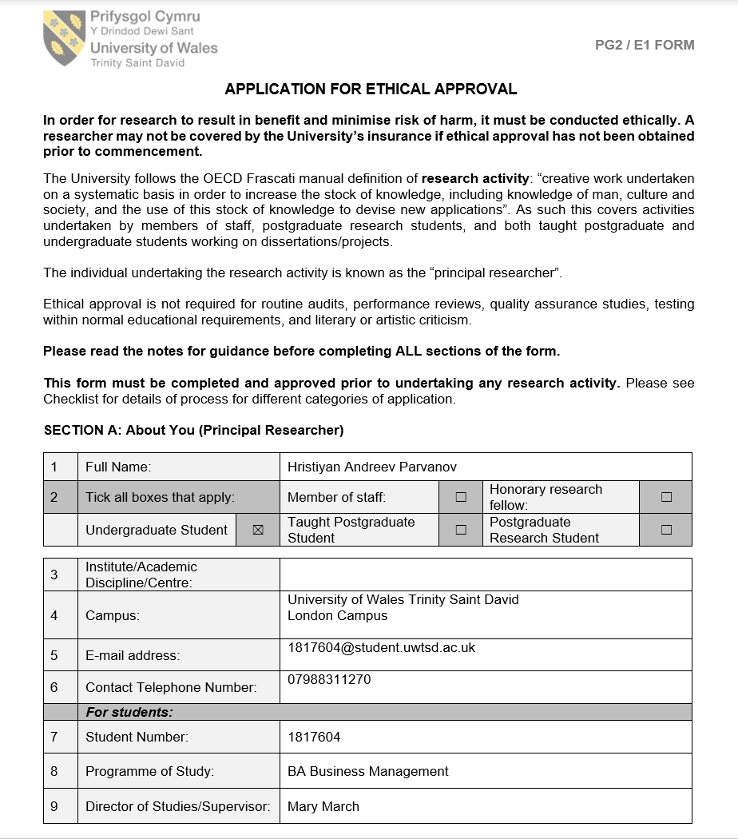
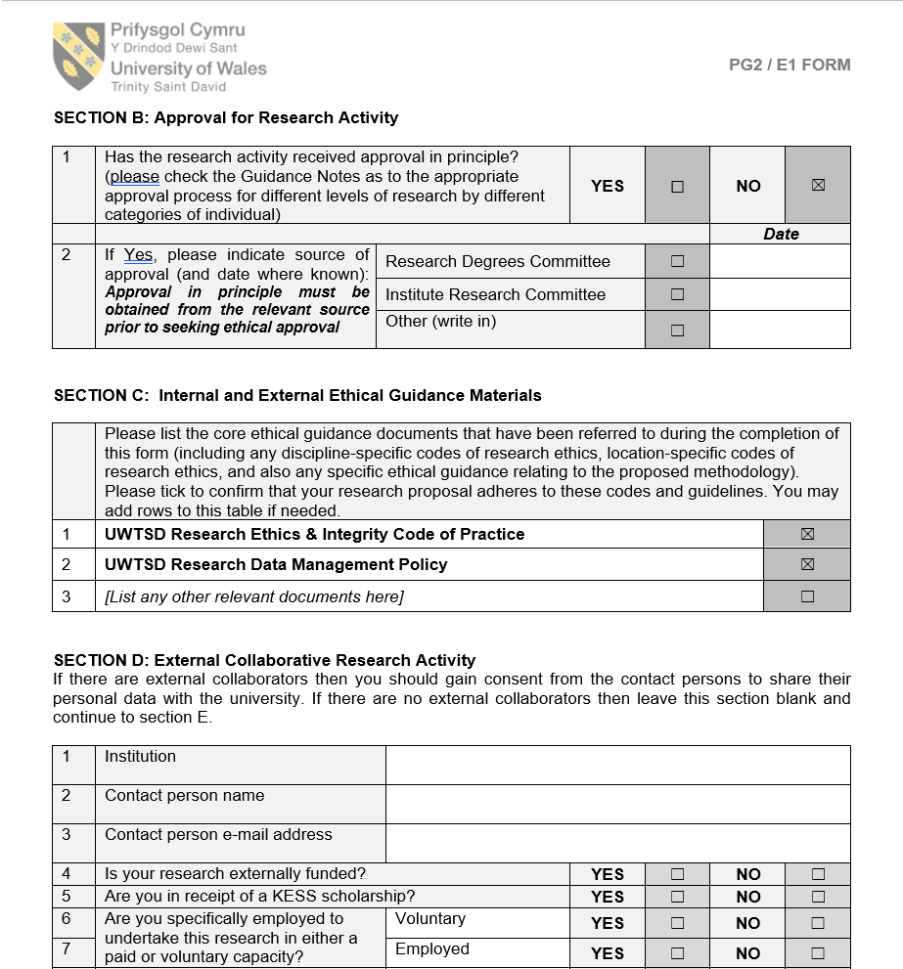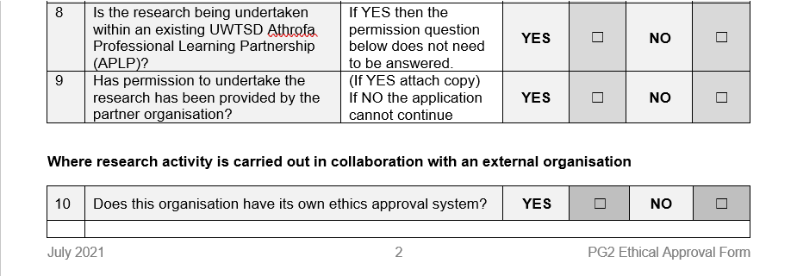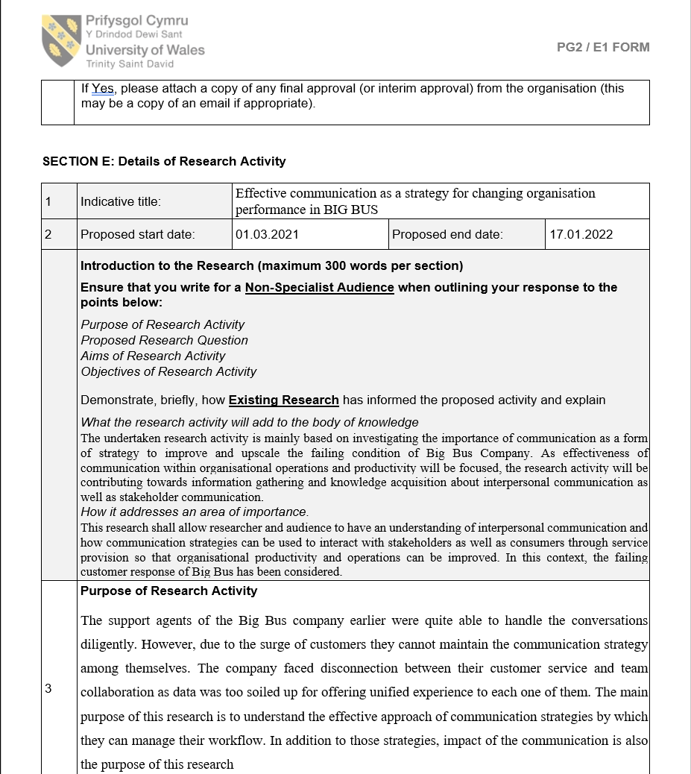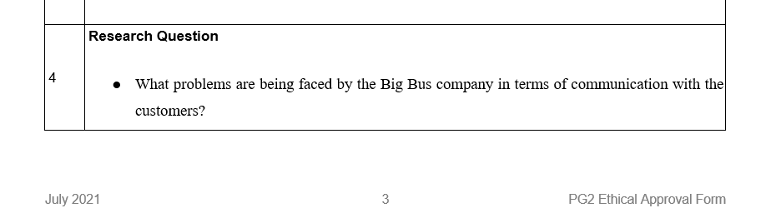
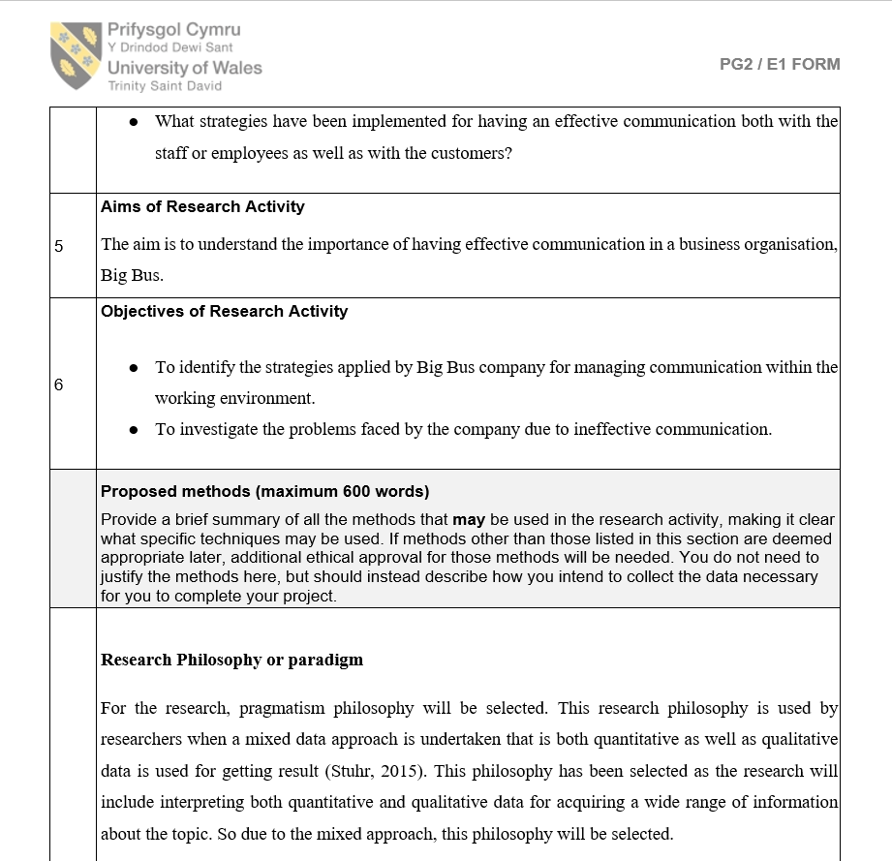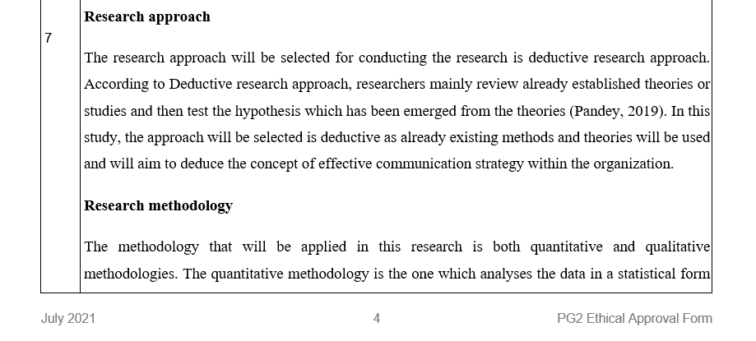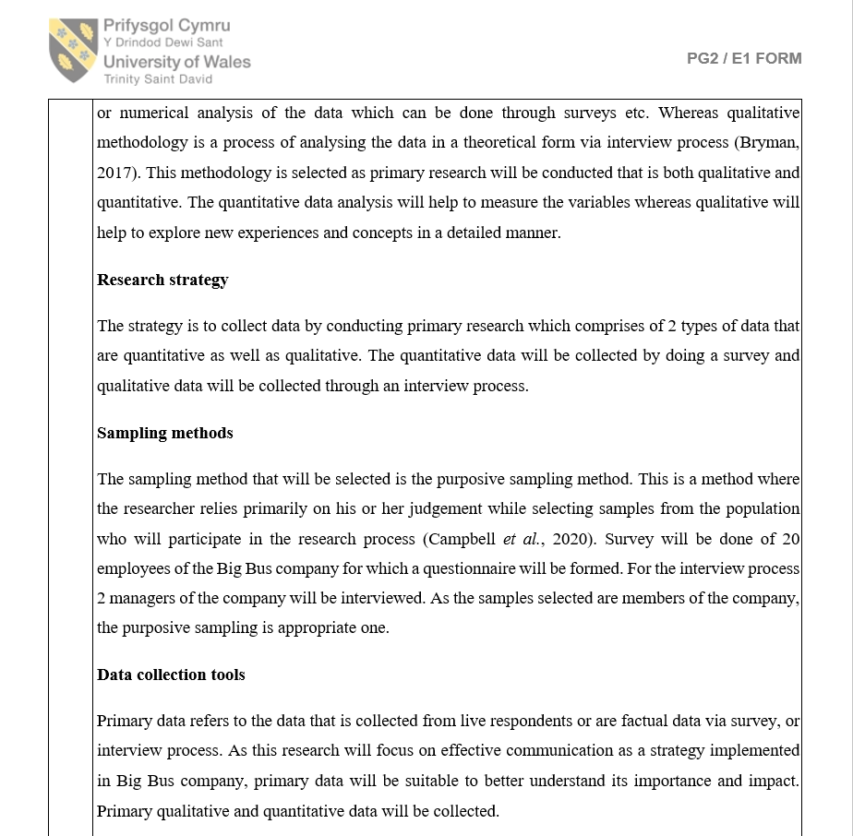
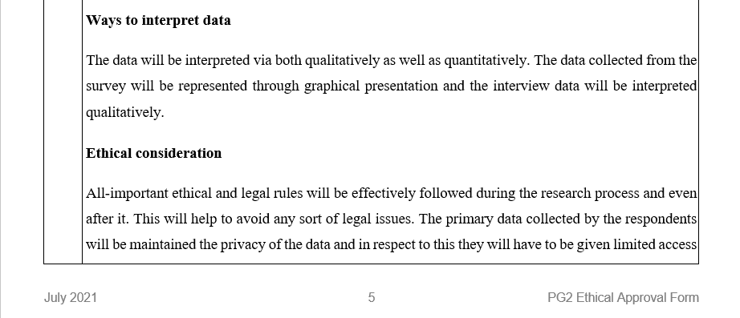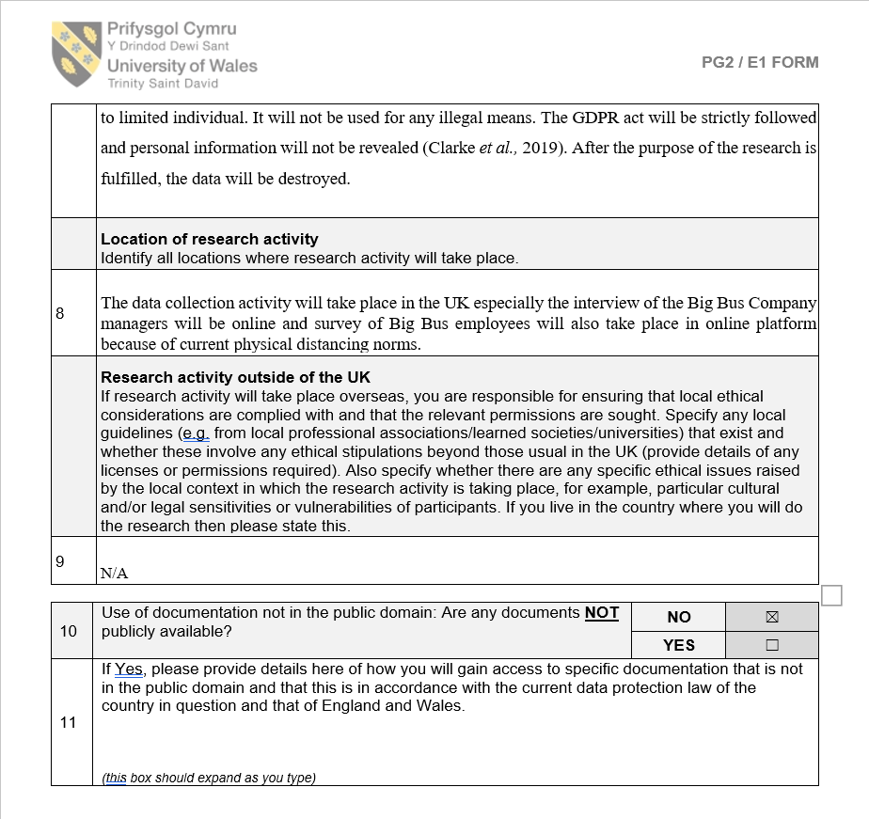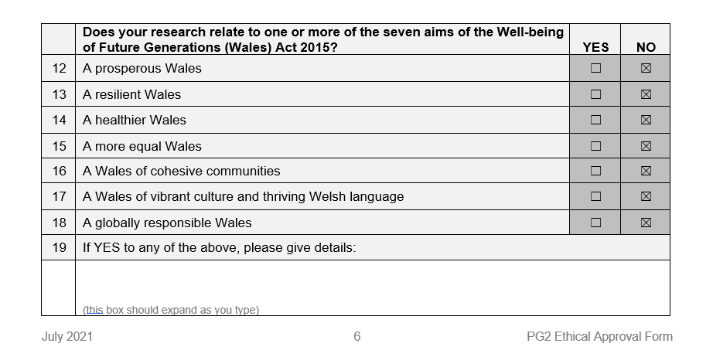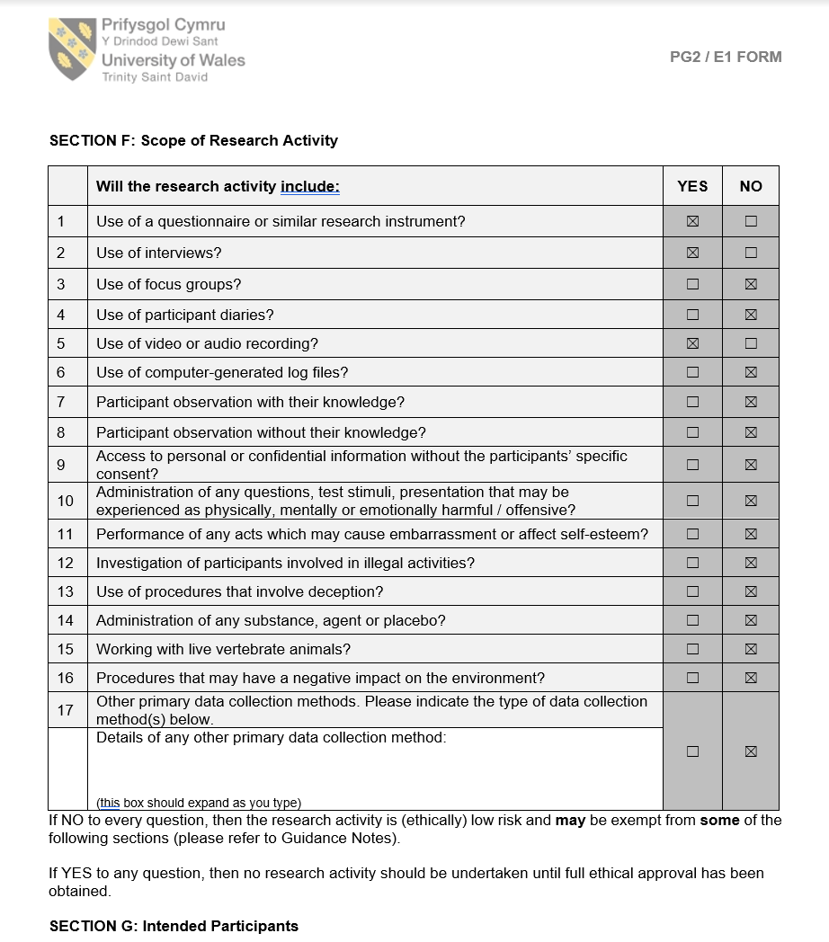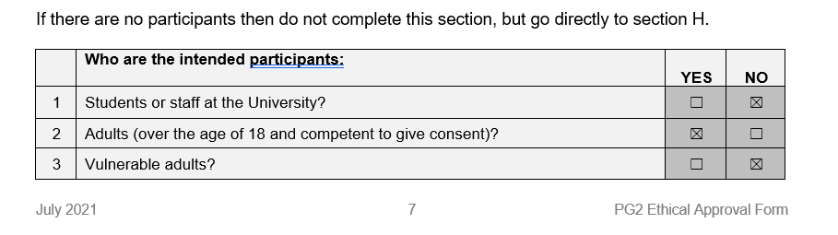
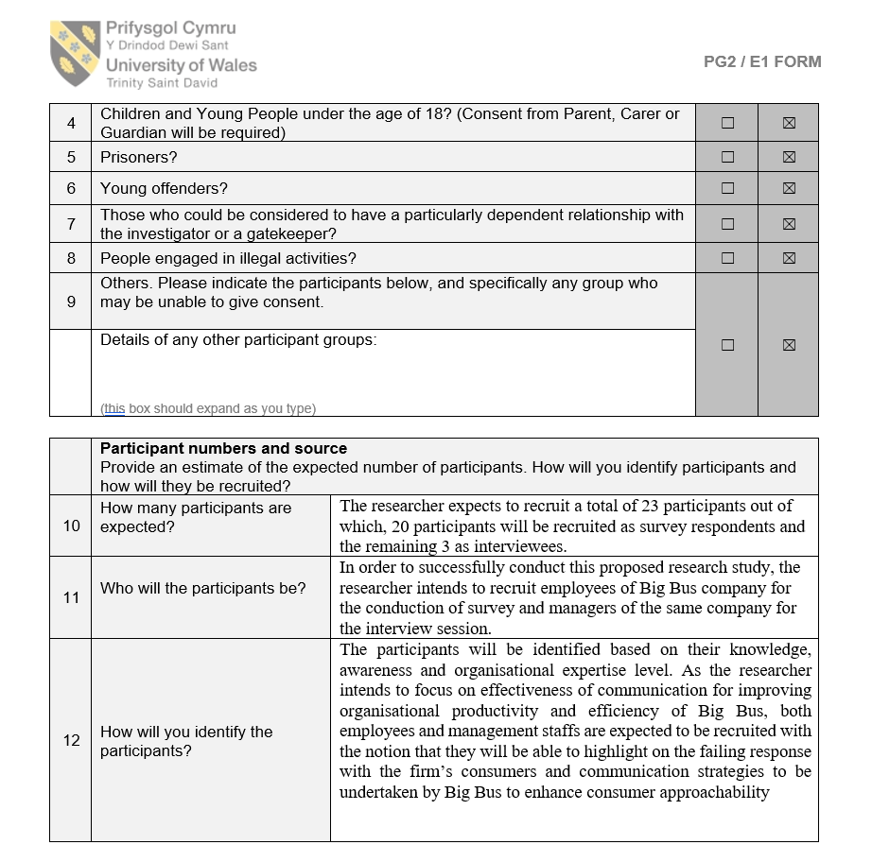
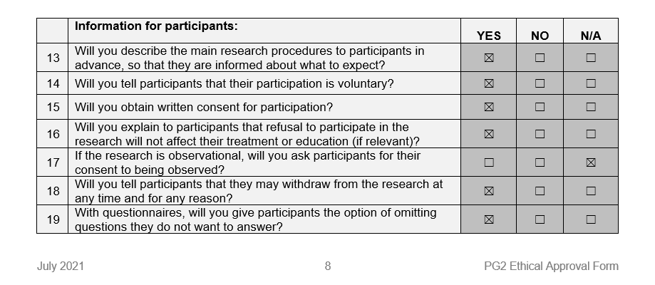
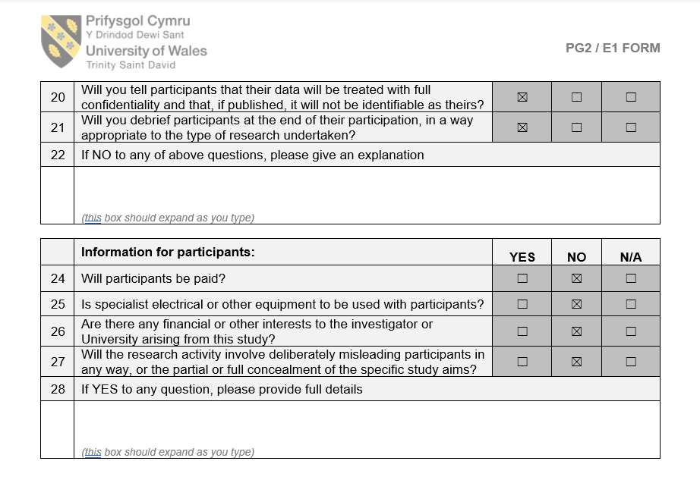
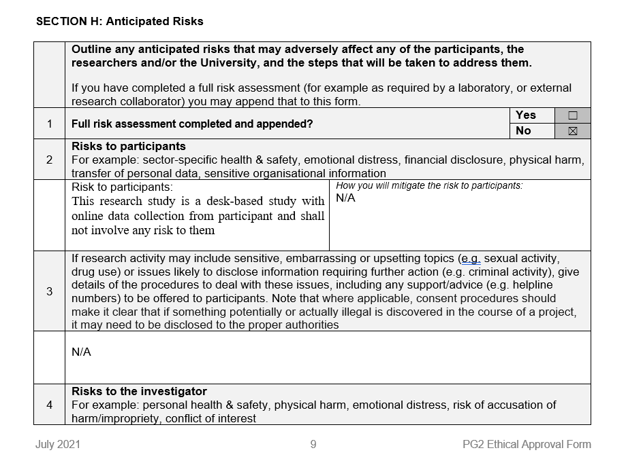
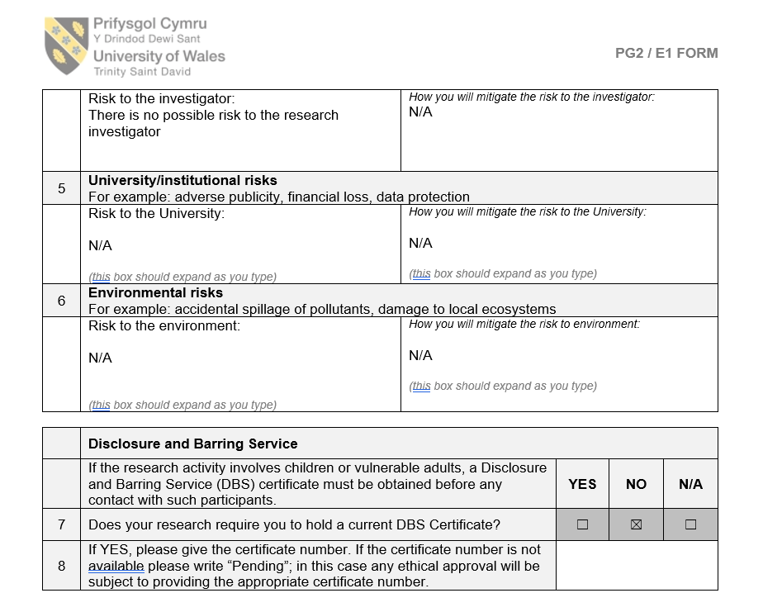
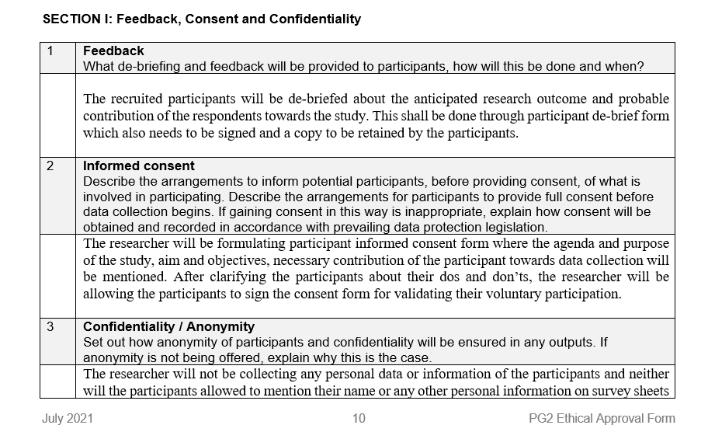
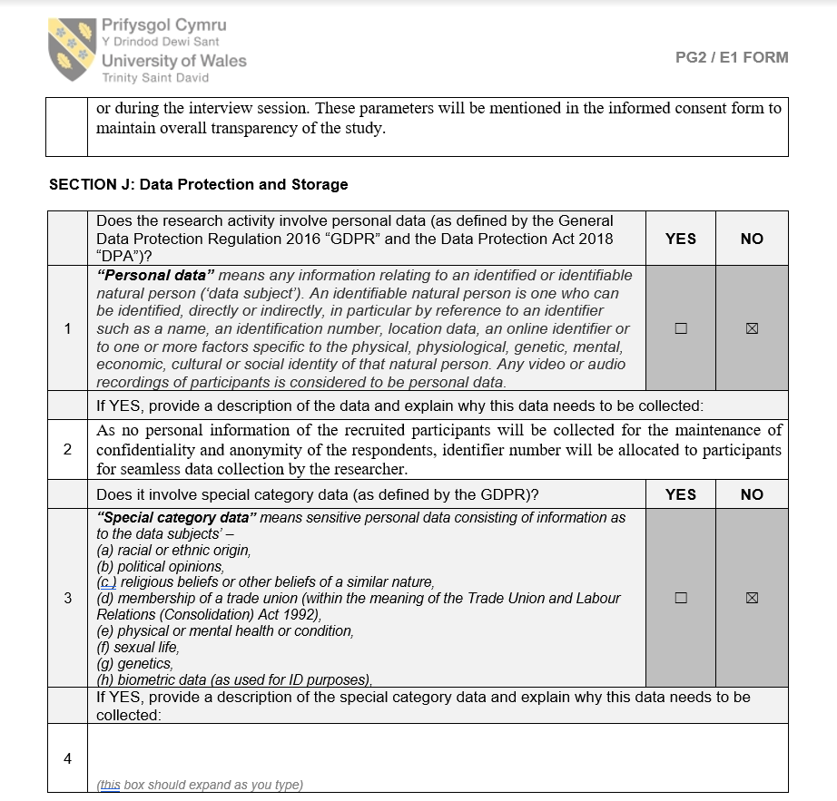
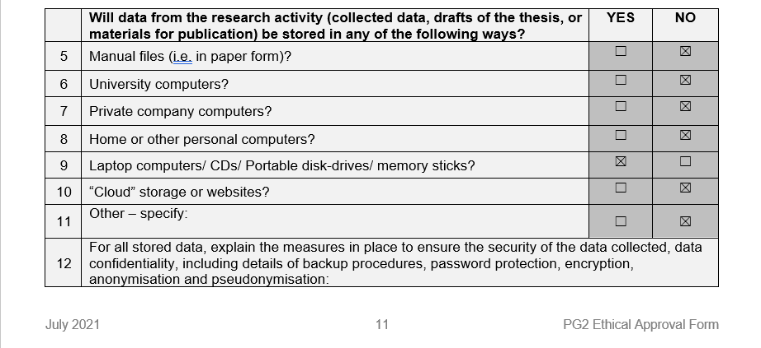
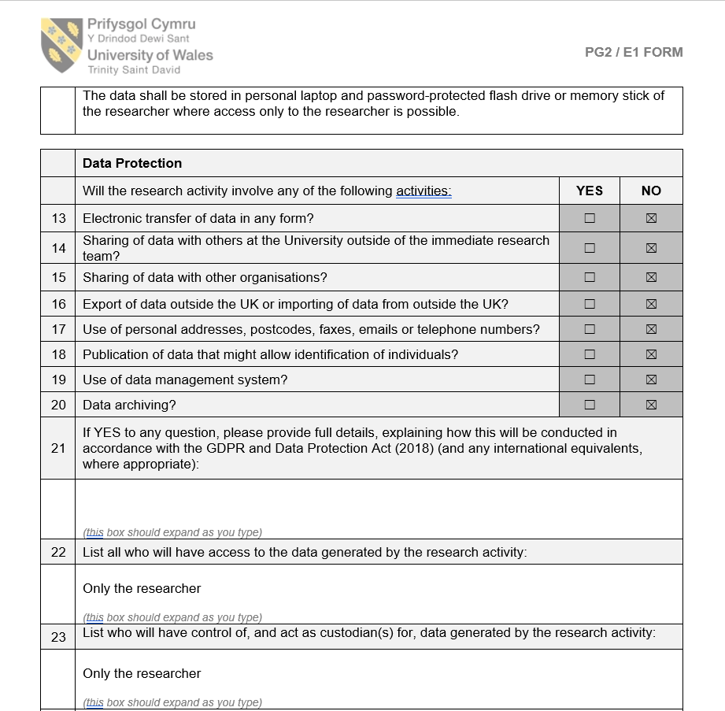
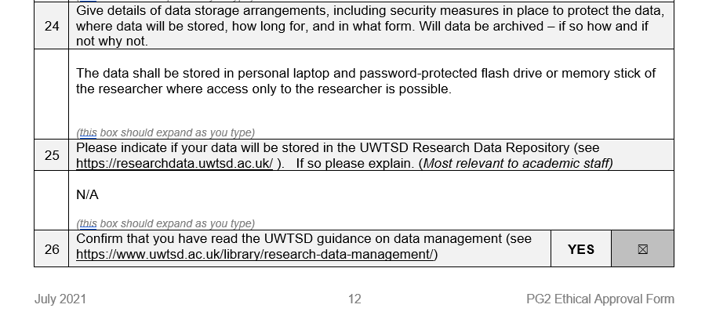
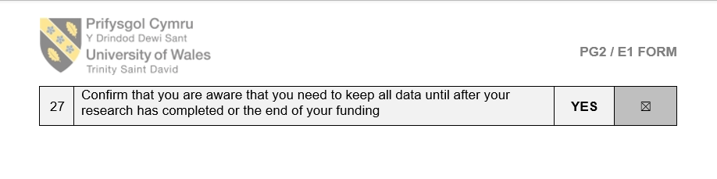
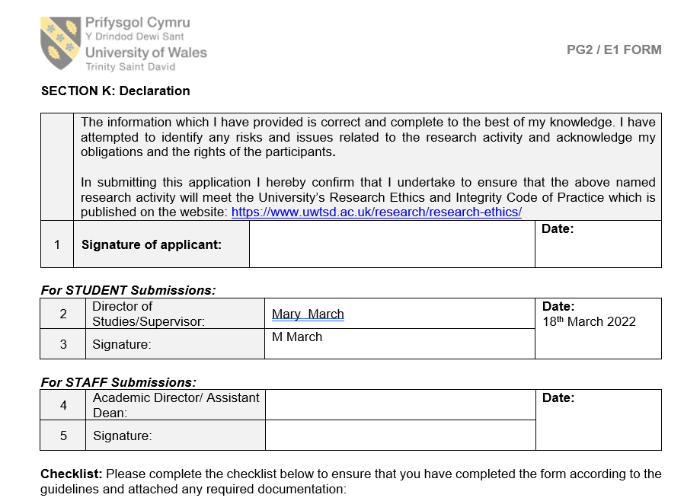
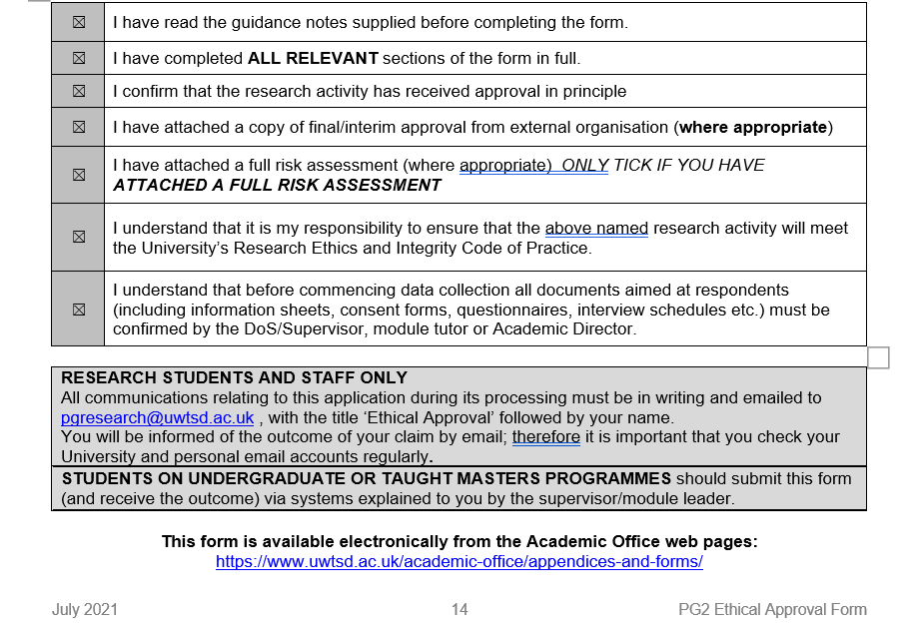

Participation Consent Form
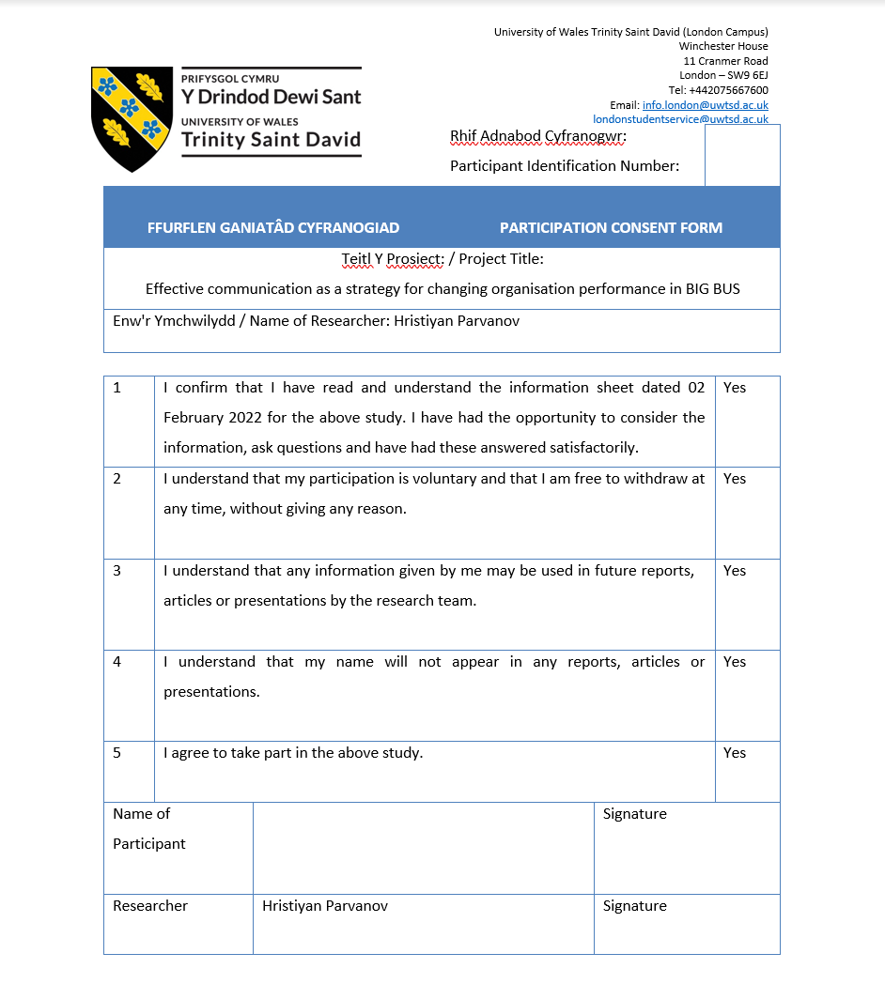
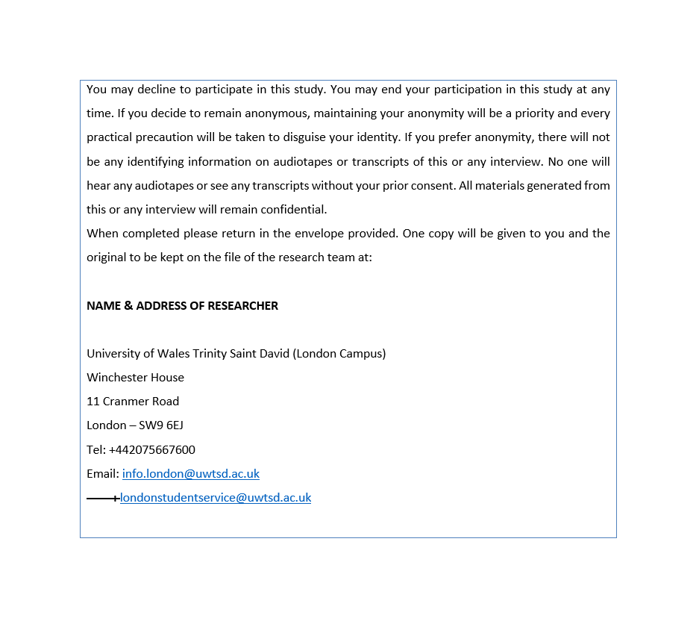

Participant Information Sheet



