

Electrical and Electronic Engineering
Electronic System Design
Buthaina Al-jarrah
2020- 2021
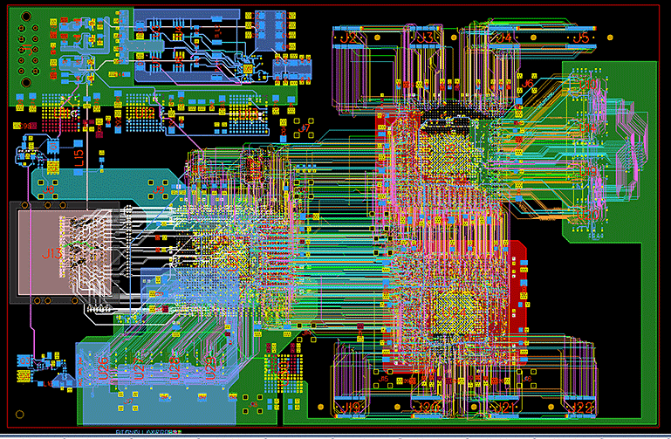
[1]

Table of Contents
1
Electrical and Electronic Engineering 1
Introduction 3
Weather stations 4
Bresser Weather Station 4
SBS-WS-200 5
WS-2902C 6
WS-WH2900-1 7
Comparing between the stations 8
Sensors 9
Temperature and humidity sensors 10
Wind speed 11
Wind direction 13
Sunlight Brightness 15
UV levels 16
Air borne particle count 17
VOC level 18
MQ135 18
GPS Position 19
Connectors 20
LED 23
SD Card 24
Battery calculation 25
Case selection 26
Microcontroller selection 27
Block diagram 28
Price list 29
Proteus design 30
VOC level 30
Sun brightness 31
Battery voltage regulator 31
Wind speed and direction 32
Temperature, humidity, and dust sensors 32
Easy-pc design 33
References 35

Introduction

In this assignment as part of L6 BEng Electrical and Electronic I asked to create a weather and air quality logger which take the measurements over 14 days.
In the beginning, I will start searching about the weather stations that is available on the market and create a datasheet including the specifications of the data logger which is used by amateur weather forecasters to aid in their predictions, in order to compare between the data loggers that available on the market and the one that I am going to design.
I am going to look up for sensors to sense the following data over 14 days:
- Temperature
- Humidity
- Wind speed
- Wind direction
- Air borne particle count
- Sunlight brightness
- UV levels
- GPS position
- VOC level
For more details, I am going to choose different sensor type that can handle operation in its intended environment, chosen one sensor from one type creatin specification for each sensor.
Also, I will be looking for electrical connectors and choose depending on the specifications. After chosen all the sensors I will e chose a pic.
In addition, I am going to use proteus as well as easy pc to design my sensor circuit and translate it to PCB and taking snapshoot to add I the report.

Weather stations

Bresser Weather Station
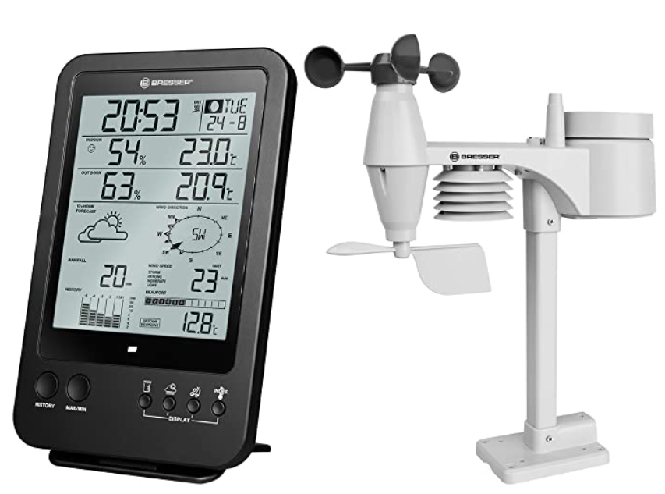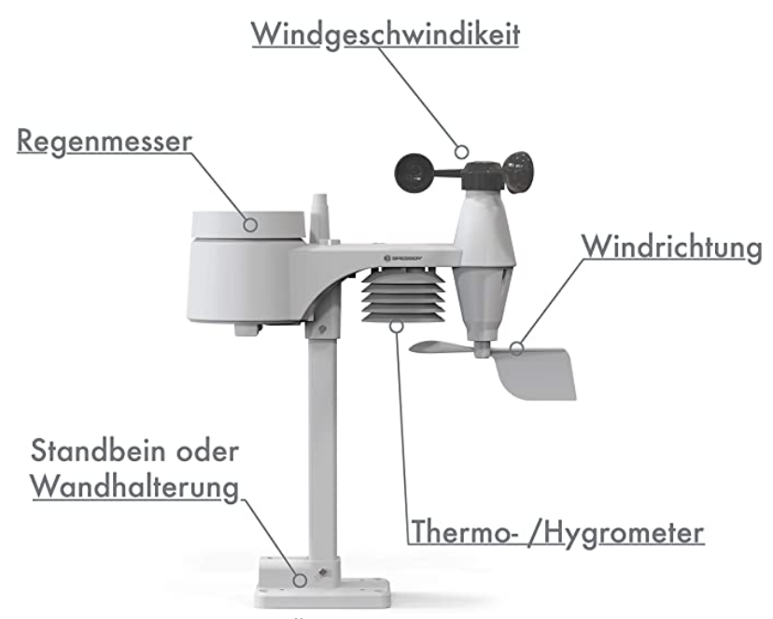

This is a station made up with 5 different sensors and it display on LCD screen more than 10 measurements. Also, it has manual stime setting. Furthermore, it displays the hour on LCD screen. It Weight 310 g.

SBS-WS-200

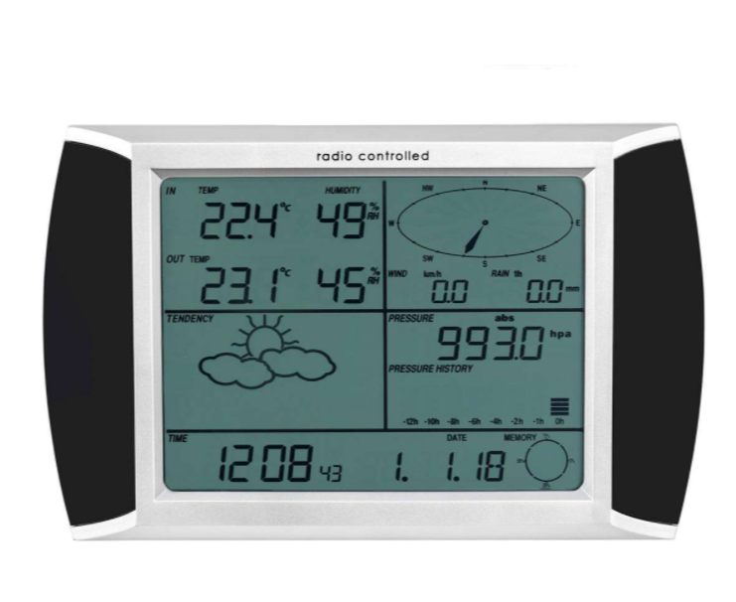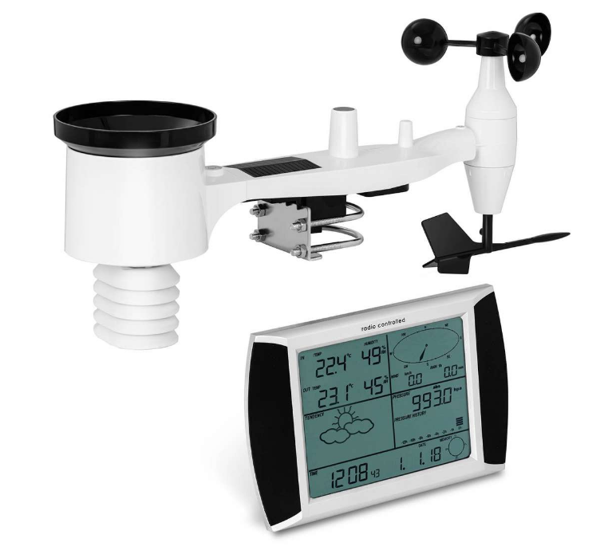
On the easy-to-read touch panel, all the calculated values are clearly illustrated. At a very stable frequency of 860 MHz up to a distance of 100 m, the digital weather station reliably receives all values from an outdoor sensor which transmits the data to the measurement unit. The data can be read straight from the monitor or transferred to a device for processing using a USB interface. For this reason, a programme CD is included for distribution. A solar panel is powered by the outdoor sensor, which is sponsored [2]

WS-2902C
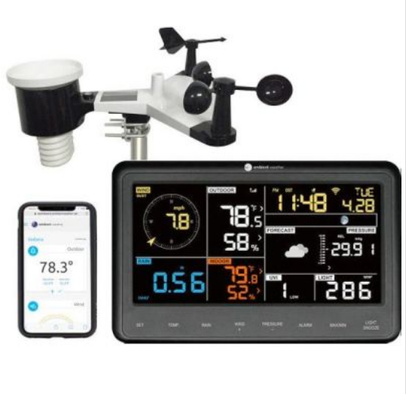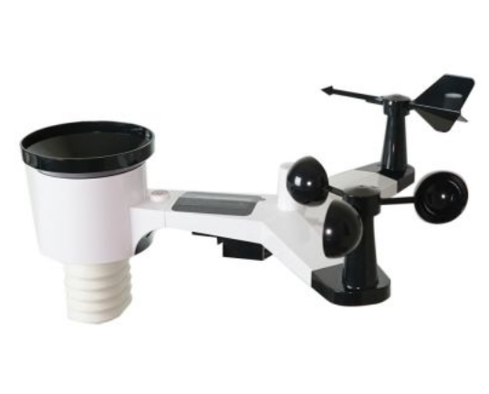

It is Professional Weather Station helps you to track your home and backyard weather conditions with the brilliant, easy-to-read LCD colour display. Track weather indoors and outdoors, including wind speed, wind direction, precipitation, UV, solar radiation, barometric pressure, temperature indoors/outdoors (F and C), humidity indoors/outdoors, dew point, heat index, wind chill, and more.

WS-WH2900-1

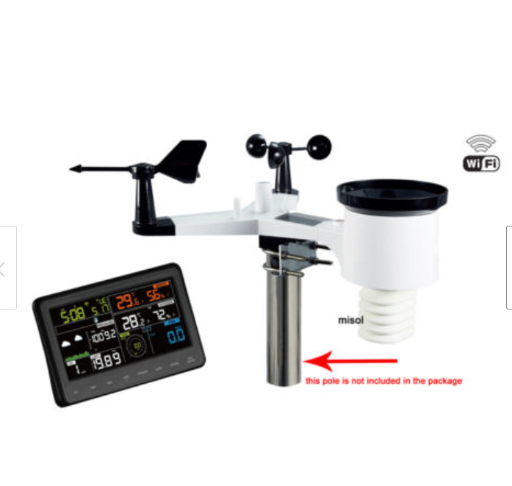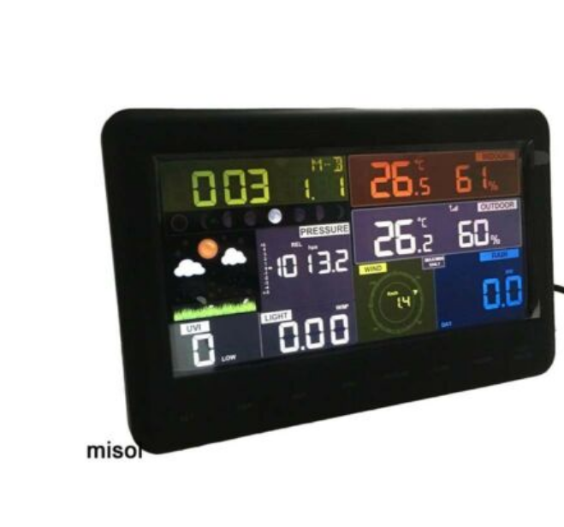
It has coloured display and touch panel. It has to be connected to the wifi. Also it can read indor and outdoor temperature and humidity as well as wind speed and dirction. Furthermore, it reads time from interentet. [3]

Comparing between the stations
Description | WS-WH2900-1 | SBS-WS-200 | WS-2902C | Bresser Weather Station
Image | 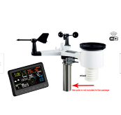
Description | Wireless weather station connects to WiFi | Wireless Weather Station - touch display - USB | Ambient Weather WS-2902C Smart Weather Station with WiFi Remote Monitoring and Alerts | Bresser Weather Station 5-in-1 with Outdoor Sensor and German DCF Radio Control Clock and Manual Mode For UK, Black
Temperature range/ accuracy | -40～+60°C/ +/- 1˚C | -40 to +60 °C/ ± 1°C | / | /
Humidity range/ accuracy | 10%～99%/ +/- 5% | 10 % to 95 % (1 % resolution)/ ± 5 % | / | /
Wind speed/ accuracy | 0-50m/s (0~100mph)/ +/- 1m/s (wind speed< 5m/s), +/-10% (wind speed > 5m/s) | 0 - 50 m/s/ 10 % (> 5m/s) | / | /
Measure period | / |  |  | Over 24 Hrs
Measurement frequency | / | 860 MHz up to distance of 100 m | 915 MHz
Dimensions | / | 45.5 x 15 x 21 cm | 7.5" x 4.5" x 0.75 DISPLAY / 15" x 11" x 10" ARAY | 38.8 x 15 x 28 centimetres
Rainfall accuracy | +/-10%
Disapply | LCD | LCD | LCD | LCD
Power supply | Base station: 5V DC adaptor (included)  Or 3XAAA 1.5V batteries (not included in the package) Remote sensor: 3 x AA 1.5V batteries (not included in the package) | 5 AA batteries- 3 for display & 2 for sensor | 3 x AAA batteries/ 5V DC Adaptor | 6 x AA batteries
Advantages | - Touch and coloured screen  - Alarm for temperature and humidity  - Alarm for rain  - Alarm for wind speed  It displays date and time | - Touch LCD screen  - Easy to transfer the data to PC through USB  Min to mix values will be shown on the screen as well as the date and time | - Provide a coloured LCD display  - The WIFI availability make it easier to transmit its data wirelessly | - There is a special alarm when the weather gets -3 and below  It features a radio gives time and date
Disadvantages | Does not come with batteries | Price is higher |  | Number of batteries
Price | £92.99 | £116.00 | 127.78 | £68.75
References | [3] | [3] [2] | [4] | [4]

Sensors
I will be starting to search up about different sensors that meet with requirement and can work best for the project.
The same sensor will be using for the temperature and humidity as it relates to each other For a certain volume of sealed gas, the higher the temperature, the lower the relative humidity, and the lower the temperature, the higher the relative humidity. [5]

Temperature and humidity sensors
In this task there will be different sensors adding with its specification and one of them will be using for the application.
Image | 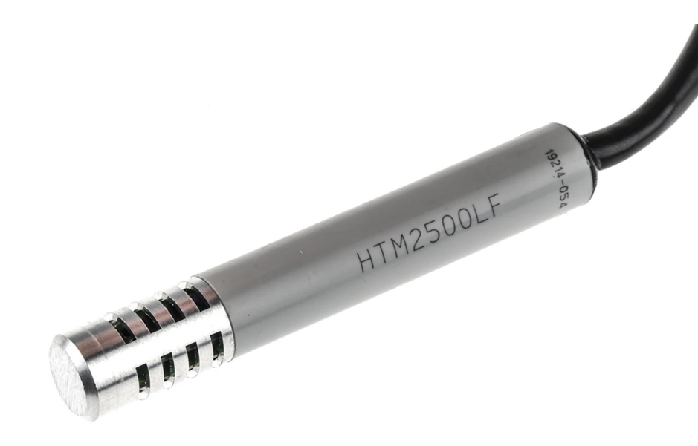 | 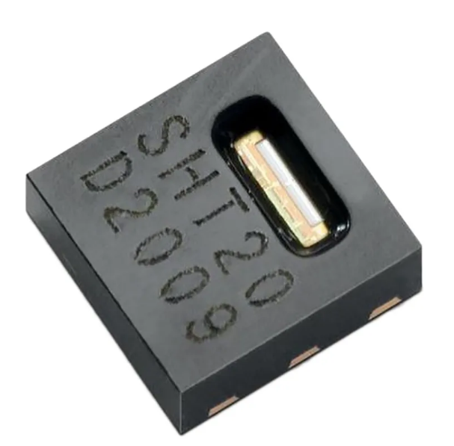 | 
Description | TE Connectivity HPP809A031 | Sensirion SHT20 | DHT22
Supply voltage | 3 to 10 V dc | 2.1 to 3.6 V | 3 – 6 V DC operating voltage
Output | linear voltage output | Digital output
Current supply |  |  | 1 – 1.5 mA
Accuracy | ±5%RH | ±3 (Humidity) %RH, ±3 (Temperature) °C
Operating Temperature and humidity Range | -40 → +85 °C | -40 → +125 °C | -40 to 80 ºC ^{+/-0.5ºC}  0%RH ~ 99.9%RH
Pin count |  | 6 | 4 pins
Dimensions | 11.6 x 76.3mm | 3 x 3 x 1.1mm
Advantages | - designed for OEM applications  - reliable  - Not affected by water immersion  - The temperature range is good | - Low cost  - The temperature range is suitable | - Temperature range is suitable
Disadvantages | Expensive | High range of pins | - Recommended for storage condition  - Its accuracy is not known
Price (with VAT) | £78.48 | £5.694 | £11.33
Reference | [6] | [7] | [8]

The Sensirion SHT20 was chosen to be used for the temperature and humidity sensor as it is in low cost comparing with TE Connectivity HPP809A031 and DHT22 as well as the operating voltage is suitable for the case of the project.

Wind speed
Type | [9]Cup Anemometer | Ultrasonic Wind speed and direction Sensor | Ultrasonic Wind speed and direction Sensor
Image | 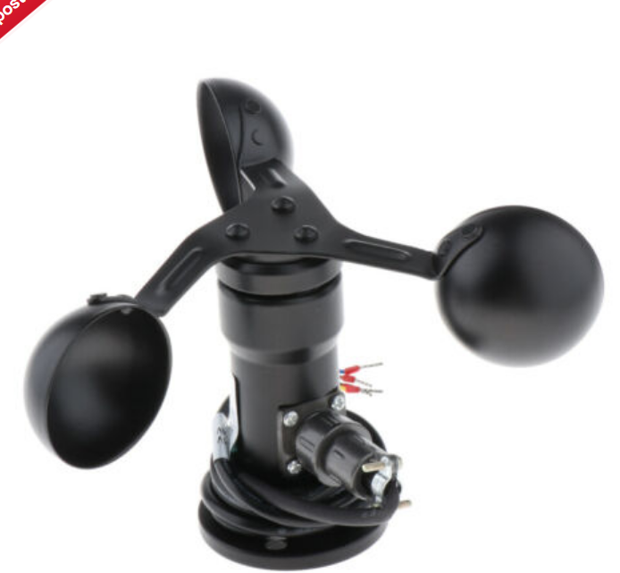 | 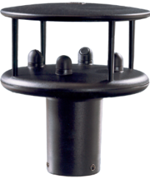
Description | Wind Speed Sensor Three Cup Anemometer Direction Sensor | Wind speed and direction sensor | WindSonic1
Supply voltage | 12-24 VDC | 5-30 VDC | 9 to 30 Vdc
Output | 0-10V | 2 x Analogue Outputs: 0-5V, 0-20mA or 4-20mA | ~15 Ma/ RS-232
Accuracy |  | ±2% @ 12m/s | ±2% (@ 12 m s⁻¹)
Measuring range | 0-30 m/s | 0-60m/s | 0 to 60 m/s
Protection |  | IP66
Current respond |  | 2mA @ 12V | ~15 Ma
Pins | three-wire system
Operating temperature |  | -35ºC to +70ºC | -35° to +70°C
Advantages | made of aluminium alloy material, which has good anti-dressing and high strength characteristics  Widely used in meteorology, ocean, environment, airport, port, laboratory, industry and agriculture, and transportation | - use in harsh environmental conditions and  is particularly suited to marine & offshore (ships, data buoys) and land based  installations
Disadvantages |  | - Complicated  - Expensive
Dimensions | 18x10cm/7.09x3.94inch | 142mm x 16mm
Price | £39.70 | £684.00
Reference | [10] | [11]

The Cup Anemometer because that the full specification was found. Also, ultrasonic it is very complicated to use. Furthermore, it is made of aluminium so it can resist the harsh environment.

Image |  | 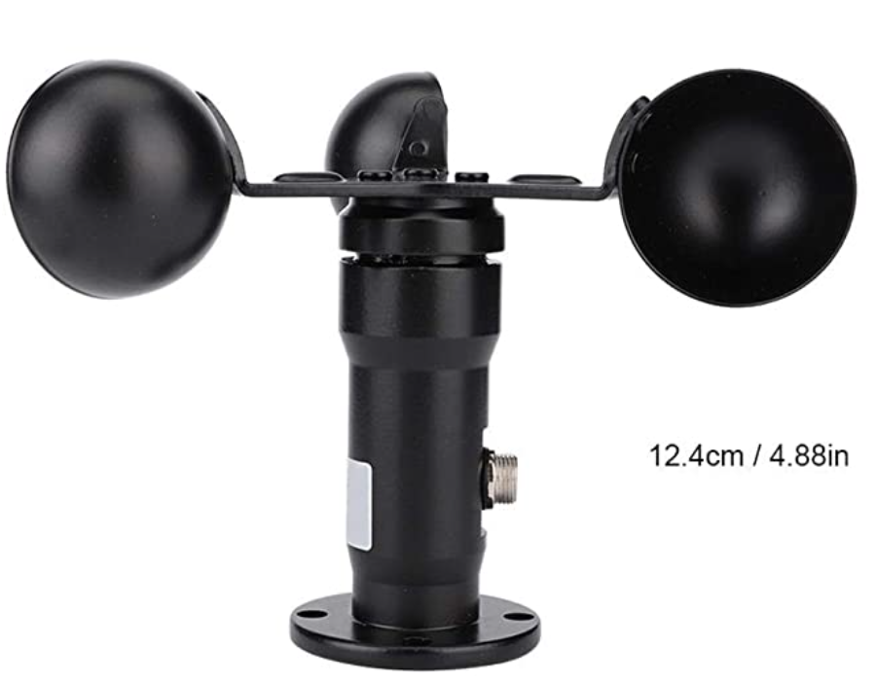 | 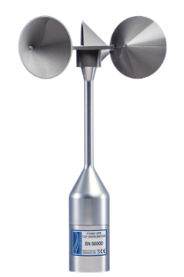
Description | Wind Speed Sensor Three Cup Anemometer Direction Sensor | MAGT Cup Anemometer | IEC 61400- 12
Supply voltage | 12-24 VDC | 12 - 24VDC
Output signal | 0-10V | 0-10V
Accuracy
Measuring range | 0-30 m/s | 0 to 30 m/s | 0 to 75 m/s
Protection |  | IP45
Current respond |  |  | 10mA
Resolution | 0.1 m/s
Pins | three-wire system
Operating temperature |  | -30-80℃ | -40° to +60°C
Working environment |  | Temperature: -40℃- 50℃  Humidity: ≤100%RH
Advantages | made of aluminium alloy material, which has good anti-dressing and high strength characteristics  Widely used in meteorology, ocean, environment, airport, port, laboratory, industry and agriculture, and transportation | 1. Made of premium ABS material, which is durable and practical.  2. Premium plug is corrosion-resistant, safe to use.  3. It give wonderful performance and strong stability.
Disadvantages
Dimensions | 18x10cm/7.09x3.94inch | 1 x 1 x 1 cm; 550 Grams
Price | £38.73 | £38.82
Reference | [10] | [12] | [13]
The Three Cup Anemometer will be using to sense wind speed and this because the output voltage is known as well as its stability and its good price

Wind direction
Type | Wind Transducer | Voltage output | Current type
Image | 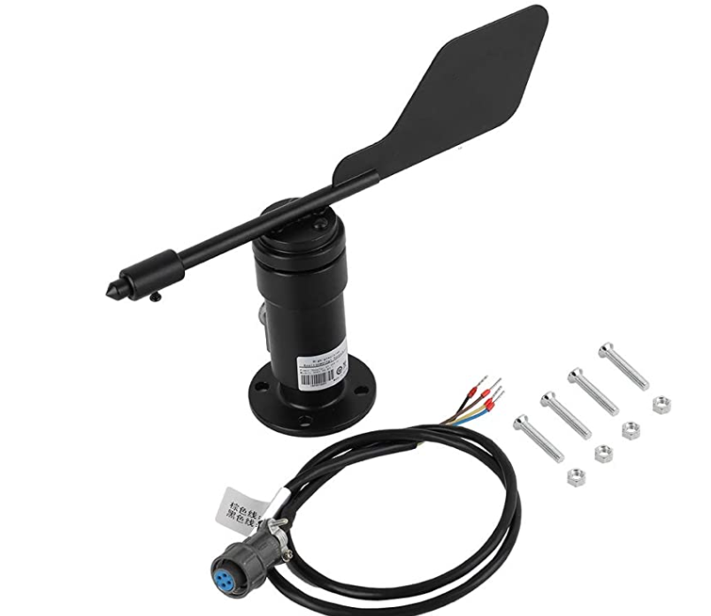 | 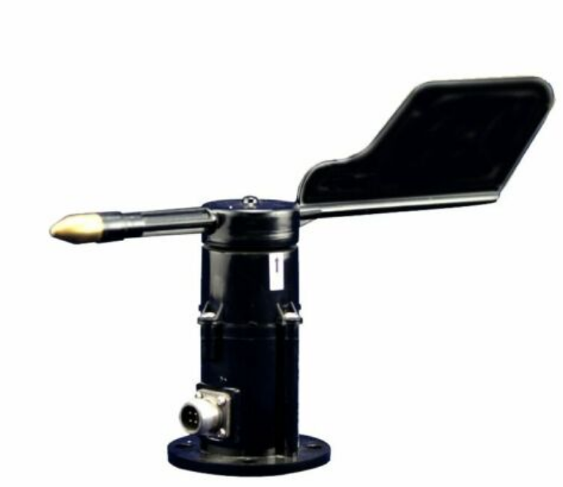
Description | AUNMAS Black Sensor | Wind direction sensor 485 output wind direction meter 16 azimuth wind direction
Voltage supply | 9-24V DC | 7V ~ 24V DC | 12V-24V DC
Output | 0-10v/ 4-20mA | 0.4 ~ 2V/ 16mA | 4-20mA/ 1-5v
Output impedance | ≥1KΩ
Wind direction value |  | (output voltage -0.4) / 16 * 360 | (Output current -4) / 16 * 360
Operating range | 0 to 360° | 16 directions (360 degrees)
Protection | IP45
Accuracy | ±3° | ± 5%
Operating temperature range | -30-80 ° C
Dimensions | 16x23cm/6.3x9.1in(H x L)
Advantages | - It is in small size  - It has high measurement accuracy  - Made of aluminum alloy and polycarbonate material, anti-corrosion, acid and alkali resistance, anti-rust, oxidation resistance and has a long sevice life. | It can measure the wind direction outdoor environment.
Disadvantages |  | It could be high cost because it is used to measure 16 directions including east, west, south, north, southeast southwest northwest and northeast
Price | £49.99 | £59.99 | £49.48
Reference | [14] | [15] | [15]

Sunlight Brightness
Image | 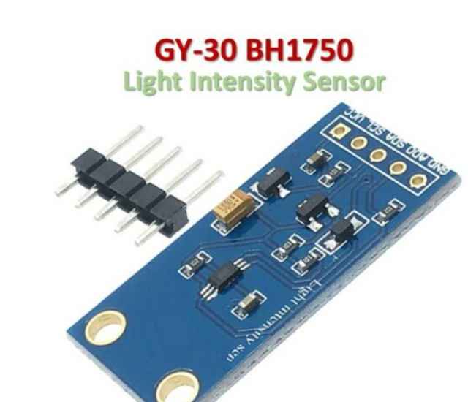 | 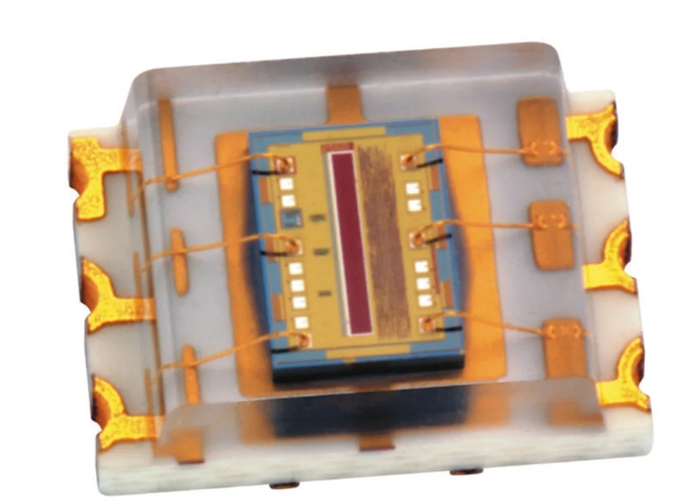 | 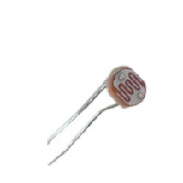
Description | BH1750 | TSL2561T | LDR
Supply voltage | 3-5 v |  | - +250V
Voltage |  | . −0.5 V to 3.8 V
Current | 300μA
Operating temperature |  | −40 °C to 85°C | -30°C + 70°C.
Lux |  |  | 400-600 Lux
Pins | 5 | 6 | 2
Dimensions | 13.9mm * 18.5mm | 1.25 x 0.4 x 1.398mm
Features | 1. Sensor built-in 16bit AD converter.  2. Direct digital output, bypassing the complicated calculation, omit calibration.  3. Close to the visual sensitivity of characteristics.  4. For a wide range of brightness for high measurement.  5. It adopts the original BH1750FVI ROHM chip.  6. There is no need to distinguish the ambient light sources | Approximates Human Eye Response Programmable Interrupt Function with User-Defined Upper and Lower Threshold Settings 16-Bit Digital Output with SMBus (TSL2560) at 100 kHz or I2C (TSL2561) Fast-Mode at 400 kHz Programmable Analog Gain and Integration Time Supporting 1,000,000-to-1 Dynamic Range Automatically Rejects 50/60-Hz Lighting Ripple Low Active Power (0.75 mW Typical) with Power Down Mode RoHS Compliant
Price | £3.09 | £2.36 | £3.00
Reference | [16] | [17] | [18]
LDR will be using for the sun brightness. The LDR its resistance change depending on the light intensity that fall to it, so it will be perfect to detect the brightness of the sun by the resistance. [19]

UV levels
Image | 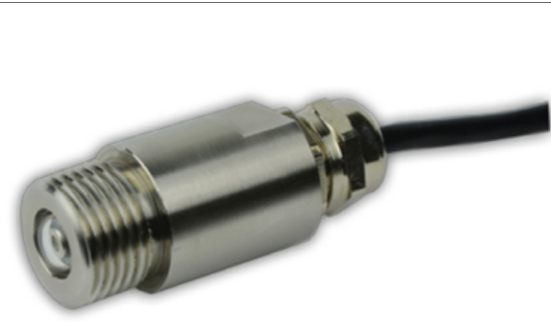 | 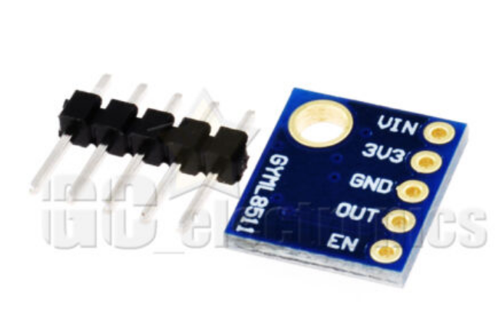 | 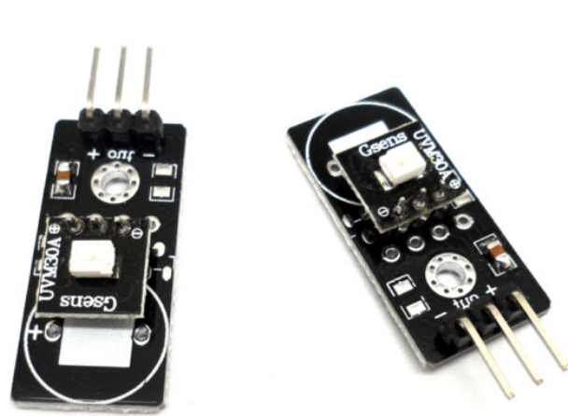
Sensor name | UV2-U | ML-8511 | UVM-30A UV
Voltage input | 5V DC | 2.7 TO 3.6V | DC 3-5 v
Voltage output | - 5 V | 0.95 TO 1.05V | Dc 0-1
Measuring range | 20mW/cm²
Operating Temperature range | 0-60℃ | -20- 70℃ | - 20 Degrees Celsius to 85 Degrees Celsius
Supply current |  | 300μA | 0.06 mA 0.1 mA
Advantages | Robust and it is used as long time stable measurement | Analog voltage output • Low supply current  • Small and thin surface mount package (4.0mm x 3.7mm x 0.73mm, 12-pin ceramic QFN)
Disadvantages | Expensive
Price | £136.16 | £9.92 [20] | £14.14
Reference | [21] | [22] | [23]

ML-8511 will be used to detect the UV level according to the output voltage as will as its low current consumption adding to its cheap price.

Air borne particle count
Type | Optical sensor | HPM Series
Image | 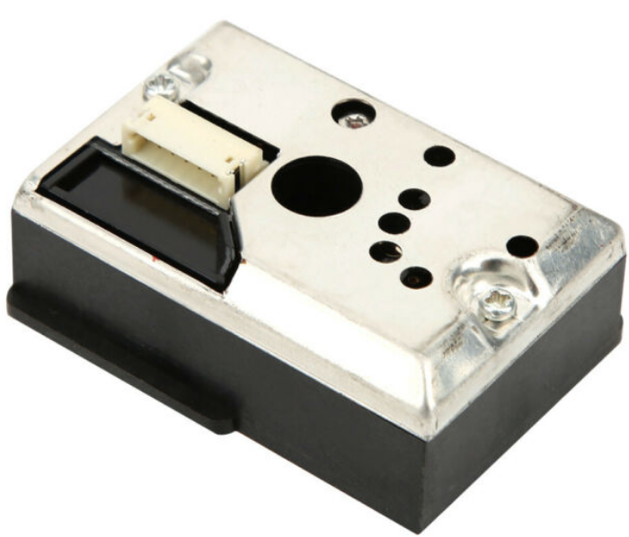 | 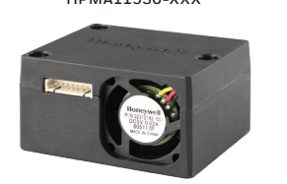 | 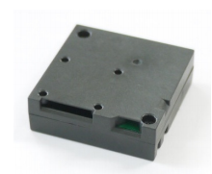
Description | GP2Y1014AU0F | HPMA115S0-XXX | SN-GCJA5
Supply voltage | 5- 7V | 5 V ±0.2 V | 5V
Power out |  | (+3.3 V/100 mA) | I2C
Working temperature | -10 ℃ to 65 ℃ | -20°C to 50°C
Current Consumption | 20mA | 80mA (supply current) | 0.40
Dimensions | 46.0 x 30.0 x 17.6mm | 43 mm x 36,00 mm x 23,7 mm | 37×37×12mm
Features | - It is able to detect very fine particles.  - It has an LED and phototransistor reflect the light that comes from dust.  - Low power consumption  - Strict quality control and quality assurance, high safety factor, can be used with peace of mind | Long life | - Small sized  - The respond time in 1 sec
Price | £7.36 | £21.67 | £25
Reference | [24] | [25] | [26]

VOC level
Image | 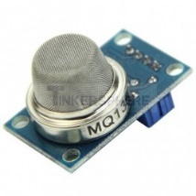 | 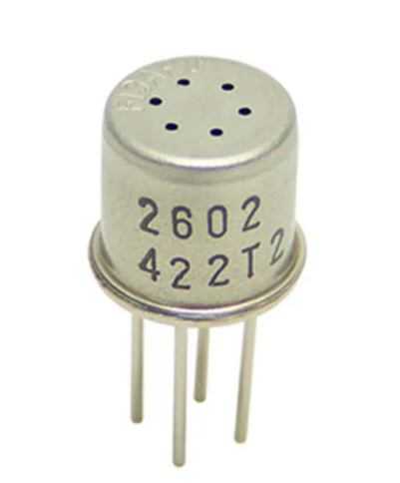 | 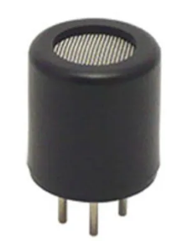 | 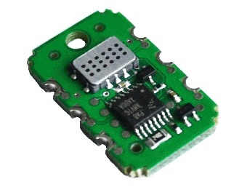
 | MQ135 | TGS2602/ Air Contaminants | TGS6812-D00 | SGX Sensortech
Detection | 10 - 1000ppm
Operating voltage | 5Vcc | 5.0±0.2V DC | 3.0±0.1V AC/DC | 3.0 V DC
Operating temperature | -10℃～+45℃ |  | -10 °C TO +70 °C
Output |  |  |  | I2C
Detection range |  | 1 ~ 30ppm of EtOH
Current requirement |  | 56mA
Dimensions |  | 9.2 (Dia.) x 7.8mm | 12 (Dia.) x 13mm
Advantages | Useful for detecting harmful gases in the environment including ammonia, sulfide, benzene vapor, smoke, etc | Small size  Long life | - Long life  - Small sensitivity to alcohol | Has good operating voltage as well as the output signal is
Price |  | £19.34 | £30.69 | £20.75
Reference | [27] | [28] | [29] | [30]

The SGX Sensortech is chosen because of the output voltage as well as the output signal which is I2C that is preferred.

GPS Position
Type | Leaner position sensor | SparqEE GPS v1-0 | Position
Image | 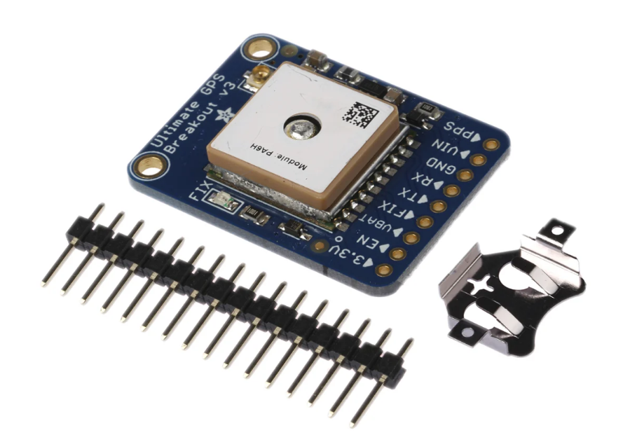 | 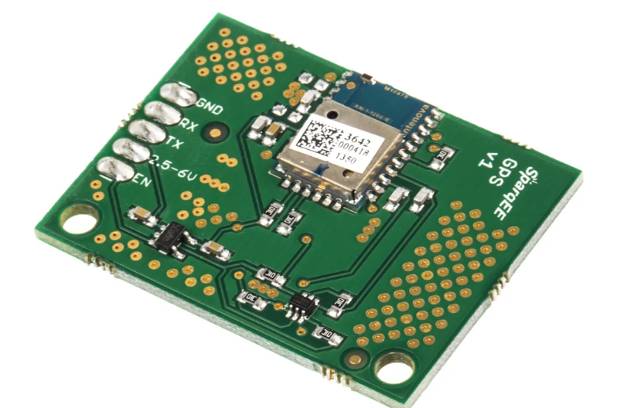 | 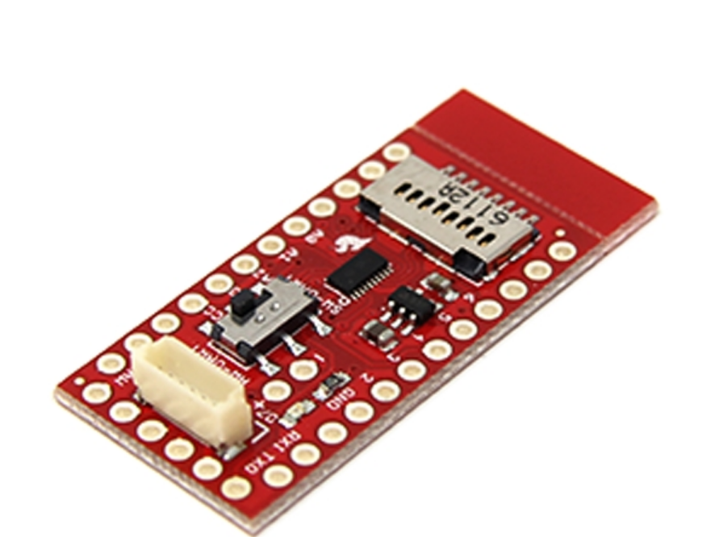
Description | 746 GPS Module | SparqEE GPS v1-0  M10478 | GPS-14030
Supply voltage | 3.3-5VDC | 2.5 V to 6 V | 3.3...5V DC
Output voltage |  | 3.3V
Current | 20mA
Operating temperature | -40°C to +85°C | -40°C to +85°C
Dimensions |  | 23 x 40 mm
Protection | IP65
Price | £30.46 | £17.88 | £20.42
Reference | [31] | [32] | [33]

746 GPS Module is chosen as GPS although is more expensive than the others. Also, because it has IP65 rating which makes it resist for the bad environment.

Connectors
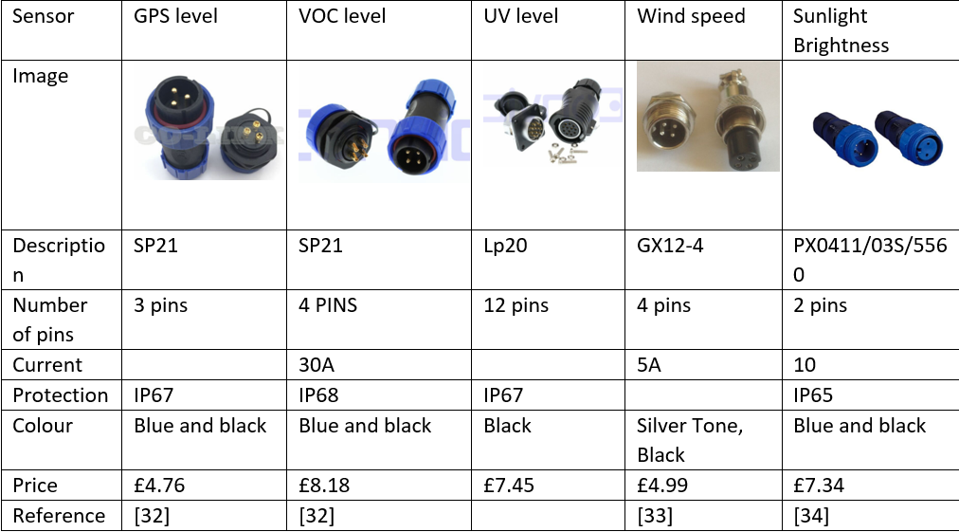
 | [32] | [32] | [34] | [33] | [34]

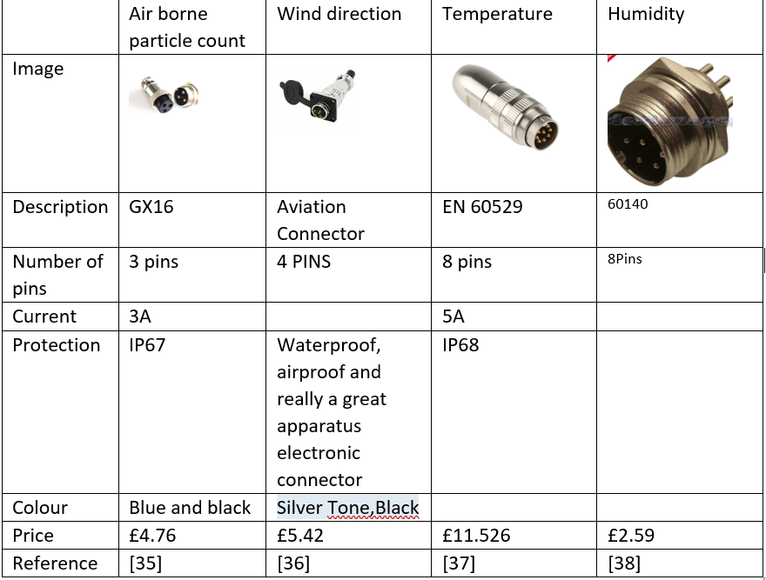
 | [35] | [36] | [37] | [38]

measures | Type of the signals | Logging rate | The sum of bytes | Readings in a record | Total bytes
Temp | I2C | 15s | 2 Bytes | 1 | 2
Humidity | I2C | 15s | 2 Bytes | 1 | 2
Wind speed | Analogue | 200ms | 2 Bytes | 75 | 150
Wind direction | Analogue | 200ms | 2 Bytes | 75 | 150
Air borne particle count | I2C | 1s | 2 Byte | 15 | 30
Sunlight brightness | Analogue | 3s | 2 Bytes | 5 | 10
UV levels | Analogue | 3s | 2 Byte | 5 | 10
GPS position | UART | Once every 14 days | 2 Byte |  | 100
VOC level | Analogue | 0.5s | 2 bytes | 30 | 60
TOTAL |  |  |  | 414

Total bytes in 14 days= 1209600
1209600/15 = 80640
80640 * 414 = 34,212960
34,212960 + 100= 34213060 this is the number of bytes for 14 days

34213060 bytes = 0.03421306 GB So any SD card from 1 GB will be suitable.

LED
Image | 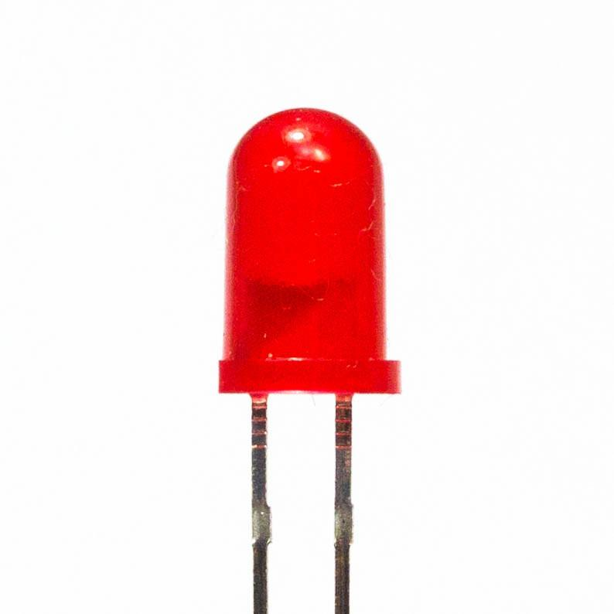
Description | Red LED/ 20mA
Price | £1.20
Reference | [35]

SD Card
The SD card that is going to be used is 4GB memory for £3.46. This card was chosen because of its price which quite cheap as well as its memory capacity that enough for the task. [36]
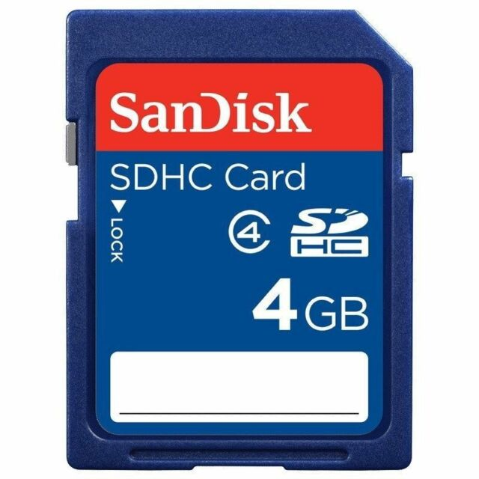
[33]

Battery calculation
The table below going to contain the maximum current that was found on each sensor’s datasheet.
In the following table the following calculation will be used to get the battery capacity; $sensor current x 336 hours =total current in 336hours+current in 336 hours /2$ calculation will be:
Temp& humidity | 0.3mA
Wind speed | 10mA
Wind direction | 20mA
Air borne particle count | 0.40mA
Sunlight brightness | 10mA
UV levels | 20mA
GPS position | 20mA
VOC level | 56mA
Total | 136.7x 336 = 45,931.2 = 68,896.8mA

Name | Pack Battery | EXIDE EB705 Excell | Yuasa YBX3096
Image | 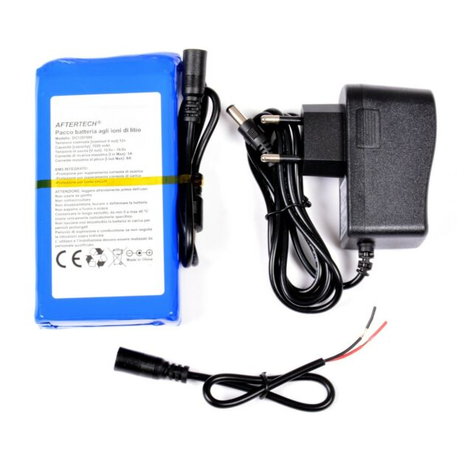 | 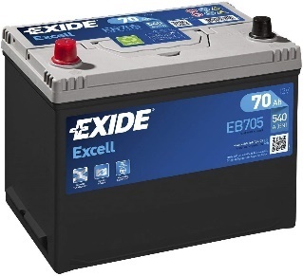 | 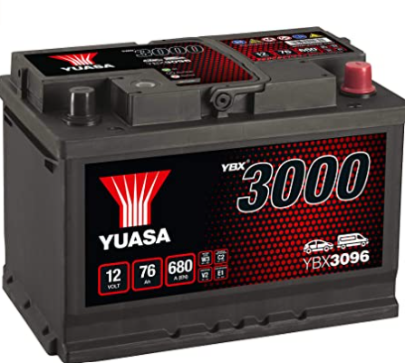
Input voltage | 12.6v
Output voltage | 12V | 12V | 12 Volts
Capacity | 7000mAh | 70Ah | 76Ah
Dimension | 130x65x24 mm | Length: 270mm Width: 173mm Height: 222mm | 27.8 x 19 x 17.5
Price | £39.03 | £66.03 | £64.50
Reference | [37] | [38] | [39]

EXIDE EB705 Excell will be using and this because the capacity of the battery which is 70Ah as well as the voltage.

Case selection
Image | 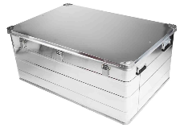 | 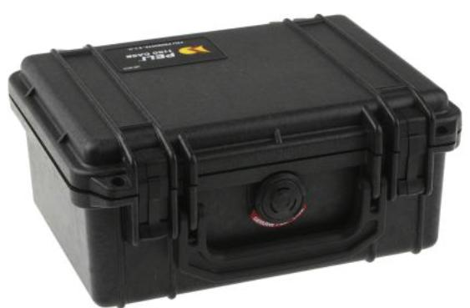 | 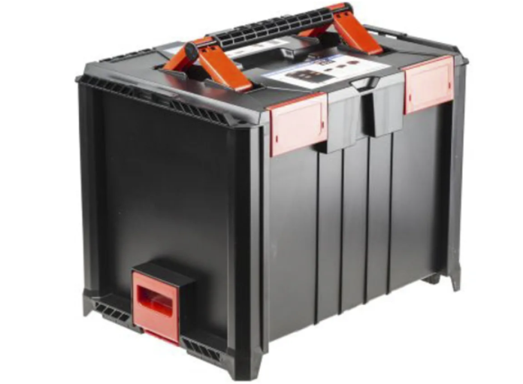
Name | RS PRO | Peli 1150 | RS PRO
Price | £93.80 | £39.81 | £78.49
Dimensions | 510 x 1180 x 785mm | 111 x 232 x 192mm | 362 x 464 x 335mm
Reference | [40] | [41] | [42]

RS PRO Waterproof Plastic Equipment case, 362 x 464 x 335mm is chosen because of the size although the price is high.

Components | Pin count
Temp& humidity | 2
Wind speed | 1
Wind direction | 1
Air borne particle count | 2
Sunlight brightness | 1
UV levels | 1
GPS position | 2
VOC level | 1
SD card | 3
Start button | 1
Digital tell | 1
Power | 1
ground | 1
Total | 18

Microcontroller selection
The microcontroller will be chosen depending on the specification that was provided on the datasheet of each sensor using [43]

 | PIC18F65J50 | PIC18F66J50 | PIC18F25K50
Image |  |  | 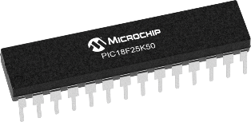
Program memory size | 32 | 64 | 32
SRAM Bytes | 3904 | 3904 | 2048
Pin count | 64 | 64 | 28
Max CPU Speed MZ | 48 | 48 | 48
ADC Input | 8 | 8 | 14
Max ADC Resolution (Bites) | 10 | 10 | 10
UART | 2 | 2 | 1
SPI | 2 | 2 | 1
I2C | 2 | 2 | 1
Number of USB Modules | 1 | 1
Price |  |  | 2.00
Reference |  | [44] | [45]

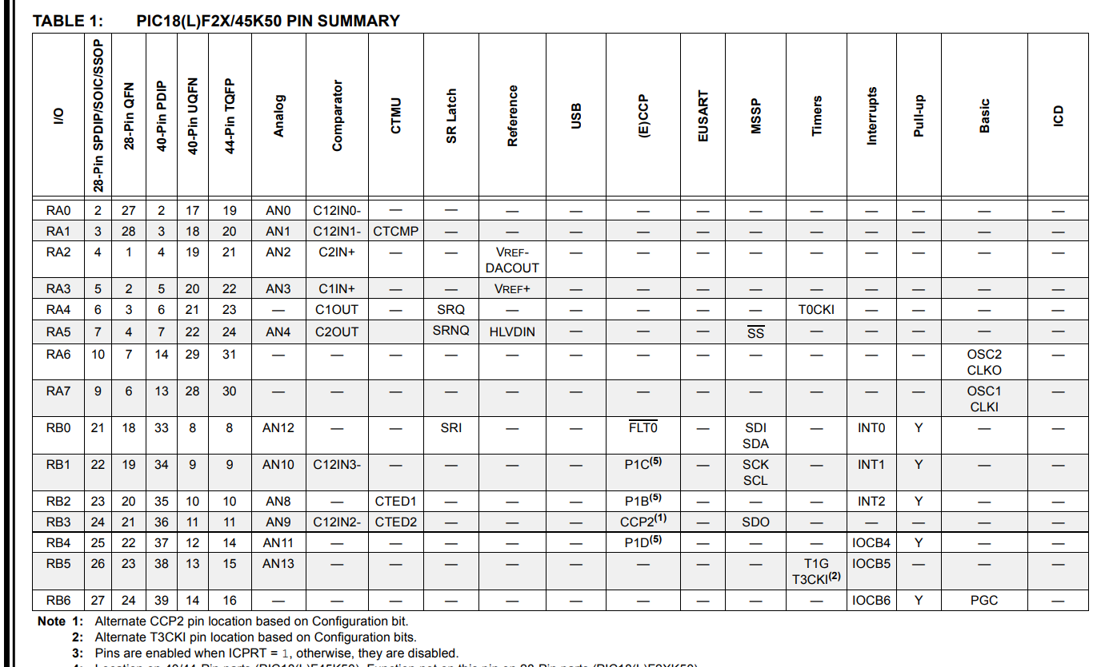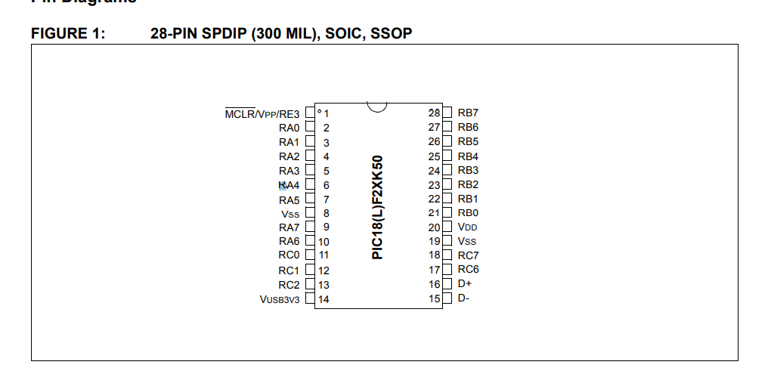

Block diagram
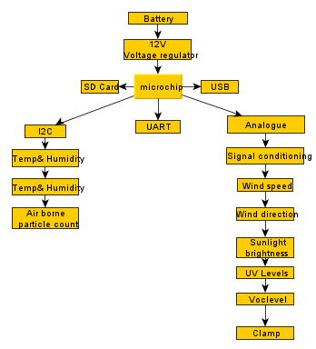

Price list
Components | Costs
Temp & humidity | £5.69
Three cup anemometer | £38.73
Aunmas black sensor (wind direction) | £49.99
LDR | £3.00
UV | £136.16
Dust sensor | £25
VOC level | £19.34
GPS | £30.46
Connectors | £57
LED | £1.20
SD card | £3.46
Battery | £66.03
Case | £78.49
Microchip | £2.00
220r ohms | £1.16
100R x 3 | £2.40
10k ohms x 4 | £0.02
33k ohms | 0.95
100uF | £2.36
100nF x 4 | £20
47uF | £2.26
Diode x 3 | £13.80
PCB board | £124.72
Total Cost | £684.22

Proteus design
The picture below shows the proteus designing for the microchip, as well as the USB, SD card, UART and the start button connecting to the microchip and the connection of other components.
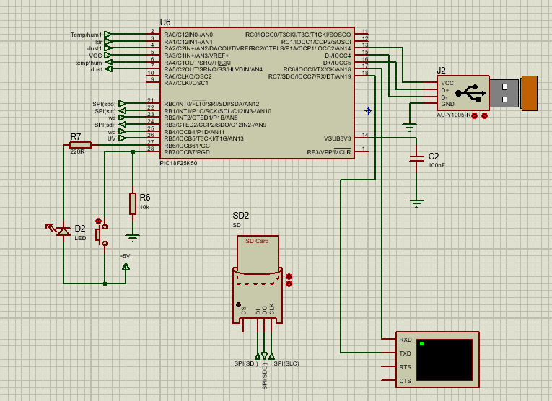

VOC level
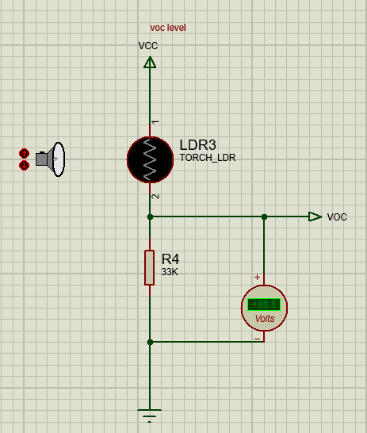

Sun brightness
The picture below shows the circuit that was designed for the sun brightness. Practically, when the light change the resistance of the LDR will change and the voltage.
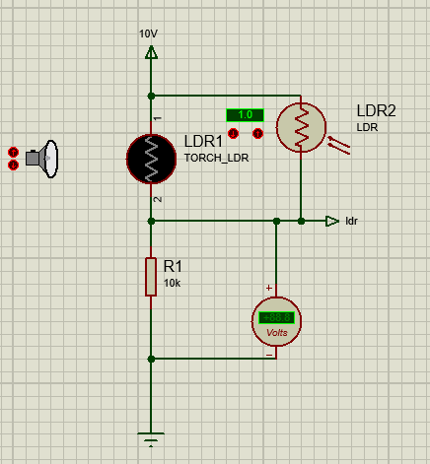

Battery voltage regulator
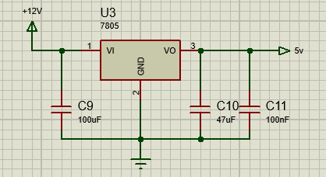

Wind speed and direction
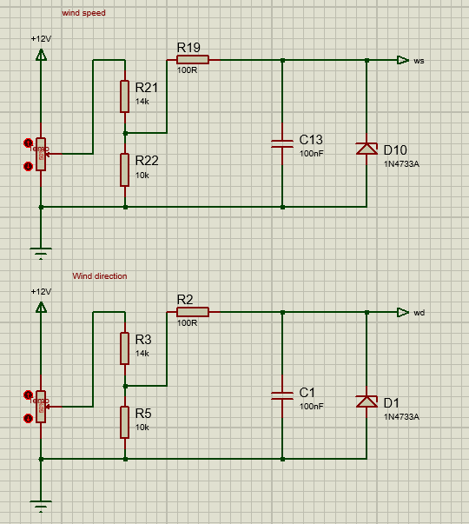
UV levels
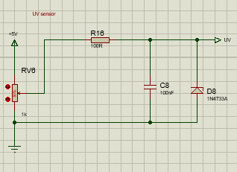

Temperature, humidity, and dust sensors
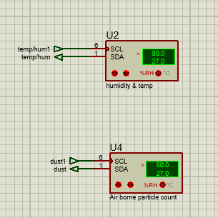

Easy-pc design
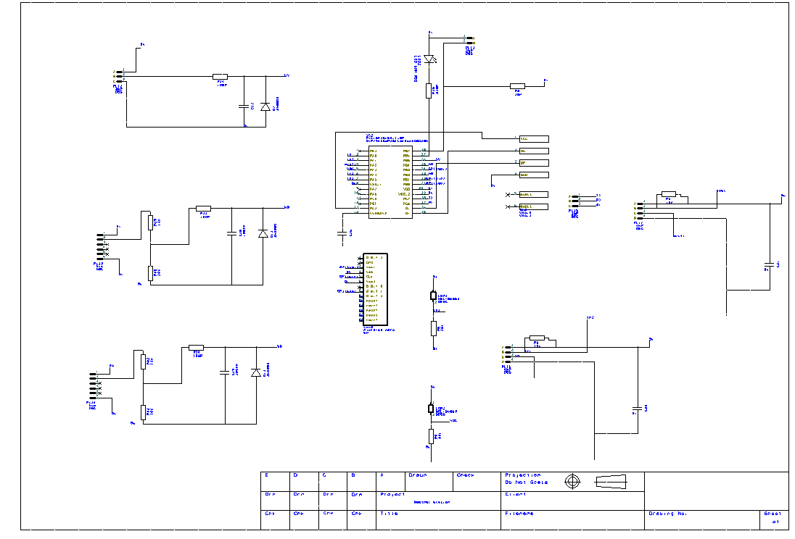

3D designing
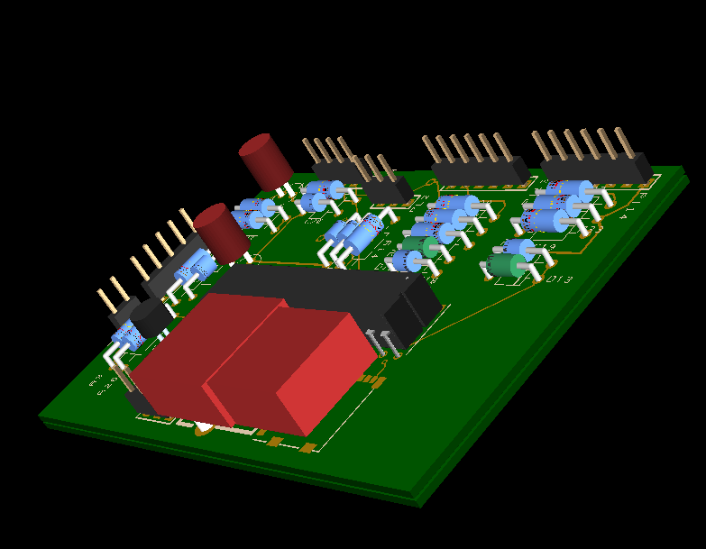

Conclusion
In conclusion, there will be a screen that displays all the figures from the sensor with a local timing by using radio as well as the date.
I would like to say that, although with all the stress I have enjoyed doing it and get more knowledge about what is already available on the market and what can I add to it.
In this assignment, there will be a full designing simple microcontroller-based weather and air quality monitor/logger which takes measurements and logs the data over a 14-day period.

References

[1] | “robotics and automation news,” robotics and automation news, 2020. [Online]. Available: https://roboticsandautomationnews.com/2017/09/27/electronic-design-automation-industry-sees-revenues-increase-by-almost-10-per-cent/14286/. [Accessed 4 12 2020].
[2] | expondo, 2007-2020. [Online]. Available: https://www.expondo.co.uk/steinberg-systems-wireless-weather-station-touch-display-usb-10030452. [Accessed 2020].
[3] | eBay , 1995-2020. [Online]. Available: https://www.ebay.com/itm/Wireless-weather-station-connect-to-WiFi-upload-data-to-web-wunderground/273618813125?_trkparms=aid%3D1110006%26algo%3DHOMESPLICE.SIM%26ao%3D1%26asc%3D20160323102634%26meid%3Dce6838875154474c9d05cb5b1c25cf6a%26pid%3D100623%26rk%3D. [Accessed 05 12 2020].
[4] | “Amazon.com,” Amazon, 1996-2020. [Online]. Available: https://www.amazon.co.uk/Bresser-Weather-Station-Control-German/dp/B0170A47DI/ref=zg_bs_376325011_6?_encoding=UTF8&psc=1&refRID=7GZK6MFGY1WEP6SCS15X. [Accessed 5 12 2020].
[5] | “.seeedstudio,” .seeedstudio, [Online]. Available: https://www.seeedstudio.com/blog/2020/04/07/how-to-pick-the-best-temperature-and-humidity-sensor-for-your-arduino-project/#how-to-select-the-best-one-suit-for-your-project. [Accessed 05 12 2020].
[6] | “temperature-sensors-humidity-sensors,” RS Components Ltd, 2020. [Online]. Available: https://uk.rs-online.com/web/p/temperature-sensors-humidity-sensors/8937373/. [Accessed 5 12 2020].
[7] | “RS Components Ltd,” RS Components Ltd, 2020. [Online]. Available: https://uk.rs-online.com/web/p/temperature-sensors-humidity-sensors/1237351/. [Accessed 05 12 2020].
[8] | “Bigupgadgets.com,” Bigupgadgets.com, 2014-2017. [Online]. Available: https://bigupgadgets.com/uk/waveshare-dht22-temperature-humidity-sensor-06-zy16356276.html. [Accessed 05 12 2020].
[9] | [Online].
[10] | “eBay,” eBay, 1995-2020 . [Online]. Available: https://www.ebay.co.uk/itm/Wind-Speed-Sensor-Three-Cup-Anemometer-Direction-Sensor-Output-0-10V-/123903523378. [Accessed 06 12 2020].
[11] | “Gill Instruments Limited,” Gill Instruments Limited, 2020. [Online]. Available: http://gillinstruments.com/products/anemometer/windsonic.htm. [Accessed 7 12 2020].
[12] | “Amazon,” Amazon , 1996- 2020. [Online]. Available: https://www.amazon.co.uk/MAGT-Anemometer-Aluminum-Alloyed-Practical/dp/B08BNHM2PN/ref=asc_df_B08BNHM2PN/?tag=bingshoppinga-21&linkCode=df0&hvadid=&hvpos=&hvnetw=o&hvrand=&hvpone=&hvptwo=&hvqmt=e&hvdev=c&hvdvcmdl=&hvlocint=&hvlocphy=&hvtargid=pla-458372655. [Accessed 8 12 2020].
[13] | “Campbell Scientific Europe,” Campbell Scientific Europe, 2020. [Online]. Available: https://www.campbellsci.eu/p2546d-l. [Accessed 12 8 2020].
[14] | Amazon , 1996-200. [Online]. Available: https://www.amazon.co.uk/AUNMAS-Aluminium-Transmitter-Transducer-Direction/dp/B082MJCGBR/ref=sr_1_7?crid=KQ9G7ALG91SA&dchild=1&keywords=wind+direction+indicator&qid=1607445472&quartzVehicle=93-1261&replacementKeywords=direction+indicator&sprefix=wind+d%2C. [Accessed 08 12 2020].
[15] | eBay , 1995-2020. [Online]. Available: https://www.ebay.co.uk/itm/Wind-direction-sensor-485-output-wind-direction-meter-16-azimuth-wind-direction-/324140026146?var=. [Accessed 12 08 2020].
[16] | eBay, 1995-2020. [Online]. Available: https://www.ebay.co.uk/i/114493190633?chn=ps&norover=1&mkevt=1&mkrid=710-153316-527457-8&mkcid=2&itemid=114493190633&targetid=4584894773047612&device=c&mktype=&googleloc=&poi=&campaignid=398226962&mkgroupid=1300722490880837&rlsatarget=pla-4584894773047612. [Accessed 10 12 2020].
[17] | RS Component, 2020. [Online]. Available: https://uk.rs-online.com/web/p/ambient-light-sensors/6424367/. [Accessed 10 12 2020].
[18] | RS Component ltd , 2020. [Online]. Available: https://docs.rs-online.com/7c8b/0900766b8156674b.pdf. [Accessed 15 12 2020].
[19] | Kitronik Ltd, 2020. [Online]. Available: https://kitronik.co.uk/blogs/resources/how-an-ldr-light-dependent-resistor-works#:~:text=A%20light%20dependant%20resistor%20or%20LDR%20is%20a,for%20different%20light%20levels%20and%20some%20example%20applications.. [Accessed 12 12 2020].
[20] | Amazon , 1996-2020. [Online]. Available: https://www.amazon.co.uk/Sensor-Module-Ultraviolet-GY-ML8511-Arduino/dp/B07D11TNHD/ref=asc_df_B07D11TNHD/?tag=bingshoppinga-21&linkCode=df0&hvadid=&hvpos=&hvnetw=o&hvrand=&hvpone=&hvptwo=&hvqmt=e&hvdev=c&hvdvcmdl=&hvlocint=&hvlocphy=&hvtargid=pla-45838639. [Accessed 9 12 2020].
[21] | uvebay, 2013. [Online]. Available: http://uvebay.com/productinfo2248.html. [Accessed 9 12 2020].
[22] | sparkfun., 2020. [Online]. Available: https://cdn.sparkfun.com/datasheets/Sensors/LightImaging/ML8511_3-8-13.pdf. [Accessed 09 12 2020].
[23] | eBay , [Online]. Available: https://www.ebay.co.uk/i/253959615098?chn=ps&norover=1&mkevt=1&mkrid=710-153316-527457-8&mkcid=2&itemid=253959615098&targetid=4585032211933600&device=c&mktype=&googleloc=&poi=&campaignid=398226948&mkgroupid=1302921513642151&rlsatarget=pla-4585032211933600. [Accessed 9 12 2020].
[24] | eBay , 1995-2020. [Online]. Available: https://www.ebay.co.uk/i/164358906957?chn=ps&norover=1&mkevt=1&mkrid=710-153316-527457-8&mkcid=2&itemid=164358906957&targetid=4584894773047612&device=c&mktype=&googleloc=&poi=&campaignid=398226962&mkgroupid=1300722490880837&rlsatarget=pla-4584894773047612. [Accessed 9 12 2020].
[25] | honeywell international INC , 2019. [Online]. Available: https://sensing.honeywell.com/honeywell-sensing-particulate-hpm-series-datasheet-32322550.pdf. [Accessed 9 12 2020].
[26] | digikey, 2020. [Online]. Available: https://media.digikey.com/pdf/Data%20Sheets/Panasonic%20Electronic%20Components/SN-GCJA5.pdf.
[27] | “eBay,” 1995-2020. [Online]. Available: https://www.ebay.co.uk/itm/Useful-MQ135-Air-Quality-Sensor-Hazardous-Gas-Detection-Module-For-Arduino-US/132456862634?_trkparms=aid%3D1110006%26algo%3DHOMESPLICE.SIM%26ao%3D1%26asc%3D20160323102634%26meid%3Dc64f069a63d6413281b96cee8e7788ce%26pid%3D100623%. [Accessed 8 12 2020].
[28] | RS components LTD , 2020. [Online]. Available: https://uk.rs-online.com/web/p/air-quality-sensors/1346671/. [Accessed 8 12 2020].
[29] | “RS Components LTD,” 2020. [Online]. Available: https://uk.rs-online.com/web/p/air-quality-sensors/1346660/. [Accessed 8 12 2020].
[30] | Amphenol Corporation, 2020. [Online]. Available: https://www.amphenol.com/node/5359. [Accessed 18 12 2020].
[31] | docs.rs, 2020. [Online]. Available: https://docs.rs-online.com/c562/0900766b814beeb7.pdf. [Accessed 10 12 2020].
[32] | RS components , [Online]. Available: https://uk.rs-online.com/web/p/communication-wireless-development-tools/8110732/?cm_mmc=UK-PLA-DS3A-_-bing-_-PLA_UK_EN_Raspberry_Pi_%26_Arduino_%26_Development_Tools_Whoop-_-Communication+%26+Wireless+Development+Tools_Whoop-_-PRODUCT_GROUP&matchtype=e&pl. [Accessed 10 12 2020].
[33] | eBay , 1995-2020. [Online]. Available: https://www.ebay.co.uk/i/203025000272?chn=ps&norover=1&mkevt=1&mkrid=710-153316-527457-8&mkcid=2&itemid=203025000272&targetid=4584826053363458&device=c&mktype=&googleloc=&poi=&campaignid=398226951&mkgroupid=1299622978767076&rlsatarget=pla-4584826053363458. [Accessed 10 12 2020].
[34] | eBay , 1996-2020. [Online]. Available: https://www.ebay.co.uk/itm/Lp20-Connector-2-3-4-5-6-7-8-9-10-12-Pin-Waterproof-500V-25A-Panel-Socket-Plug/123058094491?_trkparms=aid%3D1110006%26algo%3DHOMESPLICE.SIM%26ao%3D1%26asc%3D20160323102634%26meid%3Dba4490c759a344039f2cb834a8fe94b8%26pid%3D100623. [Accessed 2020].
[35] | pimoroni, “pimoroni,” [Online]. Available: https://shop.pimoroni.com/products/led-5mm-pack-of-10?variant=485734417. [Accessed 2020].
[36] | eBay , 1995-2020. [Online]. Available: https://www.ebay.co.uk/i/273544811036?chn=ps&norover=1&mkevt=1&mkrid=710-153316-527457-8&mkcid=2&itemid=273544811036&targetid=4584894773047612&device=c&mktype=&googleloc=&poi=&campaignid=398226962&mkgroupid=1300722490880837&rlsatarget=pla-4584894773047612. [Accessed 17 12 2020].
[37] | eBay , 1995-2020. [Online]. Available: https://www.ebay.co.uk/i/162837903152?chn=ps&norover=1&mkevt=1&mkrid=710-153316-527457-8&mkcid=2&itemid=162837903152&targetid=4585375809051351&device=c&mktype=&googleloc=&poi=&campaignid=398226936&mkgroupid=1308419072120972&rlsatarget=pla-4585375809051351. [Accessed 2020].
[38] | Amazon, 1996-2020. [Online]. Available: https://www.amazon.co.uk/EXIDE-EB705-Excell-Performance-Battery/dp/B07HQF8S3N/ref=pd_lpo_263_img_2/258-4342823-5944261?_encoding=UTF8&pd_rd_i=B07HQF8S3N&pd_rd_r=c5426fdc-c546-4c62-8c67-7c8486885c50&pd_rd_w=53pZh&pd_rd_wg=CroWU&pf_rd_p=7b8e3b03-1439-4489-a. [Accessed 2020].
[39] | Amazon , 1996-2020. [Online]. Available: https://www.amazon.co.uk/Yuasa-YBX3096-SMF-Starter-Battery/dp/B00JGOTYEO/ref=psdc_303654031_t1_B006TE4CW8. [Accessed 2020].
[40] | RS components , 2020. [Online]. Available: https://uk.rs-online.com/web/p/transit-cases/9144089/. [Accessed 18 12 2020].
[41] | rs components, 2020. [Online]. Available: https://uk.rs-online.com/web/p/transit-cases/2974874/. [Accessed 18 12 2020].
[42] | rs components , 2020. [Online]. Available: https://uk.rs-online.com/web/p/transit-cases/1368884/. [Accessed 2020].
[43] | “ParamChartSearch/,” Microchip , 2020. [Online]. Available: https://www.microchip.com/ParamChartSearch/chart.aspx?branchID=1005. [Accessed 23 11 2020].
[44] | microchip technology , 1998. [Online]. Available: https://www.microchip.com/wwwproducts/en/PIC18F66J50.
[45] | microchip, “microchip,” 2020. [Online]. Available: https://www.microchip.com/wwwproducts/en/PIC18F25K50. [Accessed 2020].
[46] | expondo, 2007- 2020. [Online]. Available: https://www.expondo.co.uk/steinberg-systems-wireless-weather-station-touch-display-usb-10030452?msclkid=c725e78a32261daa7559b840fce27379&utm_source=bing&utm_medium=cpc&utm_campaign=(uk)%20_shopping%20%5bbing%5d%20%5bpla%5d&utm_term=4576511001397624&utm_co. [Accessed 05 12 2020].
[47] | propix, “propix,” propix, 2020. [Online]. Available: https://propix.com.pl/pl/p/LM-35-analogowy-czujnik-temperatury-LM35/736. [Accessed 05 12 2020].
[48] | “Gill Instruments Limited,” Gill Instruments Limited, 2020. [Online]. Available: http://gillinstruments.com/products/anemometer/windobserver-65.html. [Accessed 12 07 2020].
[49] | Premier Farnell Limited, 2020. [Online]. Available: https://cpc.farnell.com/seeed-studio/101020012/grove-dust-sensor/dp/MK00579?mckv=gm8u9elY_dc|pcrid|74835529372544|kword||match||plid||slid||pid|MK00579|&CMP=KNC-MUK-CPC-SHOPPING&msclkid=506cf269347b1596def1adb817df3121&utm_source=bing&utm_medium=cpc&utm_c. [Accessed 9 12 2020].
[50] | A, ABB, 2020. [Online]. Available: https://new.abb.com/plc/programmable-logic-controllers-plcs/ac500. [Accessed 05 12 2020].
[51] | “Nielsen-Kellerman Co,” Nielsen-Kellerman Co, 2020. [Online]. Available: https://ambientweather.com/amws2902.html. [Accessed 10 12 2020].
[52] | eBay , 1995- 2020. [Online]. Available: https://www.ebay.com/itm/SP21-4-Pin-Connector-IP68-Waterproof-Circular-Cable-Plug-Panel-Mount-Socket-30A/122581089583?_trkparms=aid%3D1110006%26algo%3DHOMESPLICE.SIM%26ao%3D1%26asc%3D20200520130048%26meid%3Dd308df4359f3484e9dc2e6871d23e70a%26pid%3D100005%. [Accessed 12 12 2020].
[53] | eBay , 1995-2020. [Online]. Available: https://www.ebay.com/itm/SP21-4-Pin-Connector-IP68-Waterproof-Circular-Cable-Plug-Panel-Mount-Socket-30A/122581089583?_trkparms=aid%3D1110006%26algo%3DHOMESPLICE.SIM%26ao%3D1%26asc%3D20200520130048%26meid%3Dd308df4359f3484e9dc2e6871d23e70a%26pid%3D100005%. [Accessed 12 12 2020].
[54] | eBay , 1995-2020. [Online]. Available: https://www.ebay.com/itm/IP68-3pin-Waterproof-Connector-SP21-Screw-Crimp-Aviation-Power-Cable-Connector/272841151153?_trkparms=aid%3D1110012%26algo%3DSPLICE.SOIPOST%26ao%3D1%26asc%3D20200420083544%26meid%3Dd0e42305c57a43e18ac0f9df20b04717%26pid%3D100008%2. [Accessed 12 12 2020].
[55] | eBay , 1995-2020. [Online]. Available: https://www.ebay.co.uk/i/112119564762?rt=nc&_trkparms=aid%3D1110006%26algo%3DHOMESPLICE.SIM%26ao%3D2%26asc%3D20160908110712%26meid%3D3e002e4512594d6c85c63a3e9d792056%26pid%3D100677%26rk%3D5%26rkt%3D30%26mehot%3Dag%26sd%3D362591329427%26itm%3D112119564762%. [Accessed 15 12 2020].
[56] | RS Components ltd , 2020. [Online]. Available: https://www.mouser.co.uk/ProductDetail/Bulgin/PX0411-03S-5560?qs=xh6E4zEJdPnb8oA%252BISu0FQ==&vip=1&gclid=EAIaIQobChMIiN3mwaWX7QIVhO3tCh3QhQraEAQYAyABEgIdzvD_BwE. [Accessed 15 12 2020].
[57] | eBay , 1995-2020. [Online]. Available: https://www.ebay.com/itm/GX16-16mm-3-Pin-Screw-Type-Electrical-Aviation-Plug-Socket-Connector-New/283317748823?hash=item41f70dc457:g:AIUAAOSwP8dcJETm. [Accessed 15 12 2020].
[58] | eBay , 1995-2020. [Online]. Available: https://www.ebay.co.uk/i/362591329427?chn=ps&norover=1&mkevt=1&mkrid=710-153316-527457-8&mkcid=2&itemid=362591329427&targetid=4584894773047612&device=c&mktype=&googleloc=&poi=&campaignid=398226962&mkgroupid=1300722490880837&rlsatarget=pla-4584894773047612. [Accessed 15 12 2020].
[59] | RS components ltd , 2020. [Online]. Available: https://uk.rs-online.com/web/p/din-connectors/1705568/. [Accessed 15 12 2020].
[60] | eBay , 1995-2020. [Online]. Available: https://www.ebay.co.uk/itm/3-8-Pins-Microphone-Chassis-Sockets-Plugs-Male-Female-CB-Ham-Radio/231359930831?_trkparms=ispr%3D1&hash=item35de2061cf:g:SRAAAOSwbkVbsG38&amdata=enc%3AAQAFAAACcBaobrjLl8XobRIiIML1V4Imu%252Fn%252BzU5L90Z278x5ickkai8xCwosGKpC0NWj8. [Accessed 15 12 2020].
[61] | M. T. Inc, “Microchip Technology Inc,” Microchip Technology Inc, 1998-2020. [Online]. Available: https://www.microchip.com/wwwproducts/en/PIC18F2550.
[62] | microchip, “microchip,” 2020. [Online]. Available: https://www.microchip.com/wwwproducts/en/PIC18F24K50. [Accessed 27 11 2020].
[63] | .microchip technology , 1998-2020. [Online]. Available: https://www.microchip.com/wwwproducts/en/PIC18F66J55. [Accessed 17 12 2020].
[64] | microchip technology , 1998-2020. [Online]. Available: https://www.microchip.com/wwwproducts/en/PIC18F67J50. [Accessed 17 12 2020].
[65] | S. C. Ltd, “S Components Ltd,” 2020. [Online]. Available: https://uk.rs-online.com/web/p/transit-cases/9144121/. [Accessed 2020].
[66] | R. C. Ltd, “RS Components Ltd,” RS Components Ltd, 2020. [Online]. Available: https://uk.rs-online.com/web/p/transit-cases/2974874/. [Accessed 2020].

