EFFECTIVE TEAMWORK COMMUNICATION

Table of Contents
INTRODUCTION 3
MODELS OF COMMUNICATION 4
SHANNON AND WEAVER MODEL OF COMMUNICATION 4
DAVID BERLO MODEL OF COMMUNICATION 5
COMMUNICATION SKILLS 6
ACTIVE LISTENING 6
INTERPERSONAL COMMUNICATION 7
ASSERTIVENESS 7
POOR COMMUNICATION IN WORKPLACE 8
SUGGESTIONS FOR IMPROVEMENT 8
CONCLUSION 9
REFERENCES 10

INTRODUCTION
Communication is seen as the process of transmitting information, thoughts, opinions, messages, facts, ideas or emotions and understanding from one person, place, or things to another person, place or thing (Manage, 2005). Communication is an essential act carried out by humans during their daily activities because it enables interaction and information exchange in the form of speeches, gestures, writing and electronic mediums in which useful ideas and information are shared between the senders and receivers. Communication models are the structures and key elements in the communication process that determines how the message is transmitted from the sender to the receivers and the model shows the external factors that affect the process which could be disturbance such as noise.
The work would evaluate the different communication models like the Shannon-Weaver model and Berlo’s Model of communication in order to highlight their importance and difference in the workplace. The work would also analyze an existing poor communication problem in the workplace in which the causes of the problem would be identified and suggestion would be recommended in order to improve the communication process using one of the communication theories,

MODELS OF COMMUNICATION

SHANNON AND WEAVER MODEL OF COMMUNICATION
This model of communication that was developed by Shannon and Weaver in order to improve and enhance the communication between the sender and receiver by ensuring the messages are accurately transferred to the receiver using smart codes and simplify the process. According to (Cade, 2004), the Shannon and Weaver Model of communication was initially developed with the main aim of transmitting signals from a relative source to the destination through a transmitter and receiver across a channel with minimal interference or error. The model was designed to ensure that the communication process between the receiver and senders was efficient and effective by properly utilizing a secured device that acts as a transmitter that decodes the messages for easy assimilation by the receiver and eliminating the interference that could affect or cause miscommunication during the process. This model of communication was mainly designed to separate the noise from the signals carrying useful information for easy decoding or decryption by the receiver.
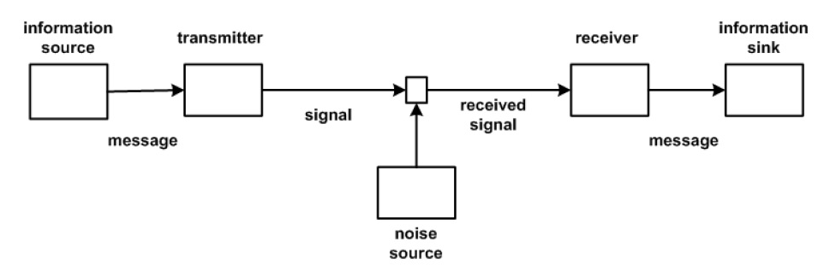
Figure 1: Shannon and Weaver's Model of Communication
The image above shows the communication process of the Shannon and Weaver’s model of communication. The message is generated from the source and it is transformed into either a discrete or continuous signals using a transmitter. The signal is transferred to the receiver through a channel that would be modeled in a way that is easily decodable by the receiver. The noise source is used to detect and eliminate any noise in the system that could interrupt the proper transmission of the message from the sender to the receiver and deter the completion of the communication process. However the model was heavily criticized for its static nature because the model supports a person to person communication process than a group or mass audience in which there would be more than one listener or receiver of the message. The model also lack feedback that would enable the receiver to send back his/her reaction to the message received because communication is complete when the receiver produces a response to the sender.

DAVID BERLO MODEL OF COMMUNICATION
The model of communication was developed by David Berlo who expanded the Shannon and Weaver’s Linear Model of communication by creating the Sender - Message – Channel – Receiver (SMCR) which provided details about how the different factors affect the communication process and the message received. The model ensures that the communication process involves both the sender and the receiver unlike the Shannon and Weaver Model because it equalizes all the components by taking into the account the different aspects of the message that is being transmitted such as the content, elements, treatments, structure and code.
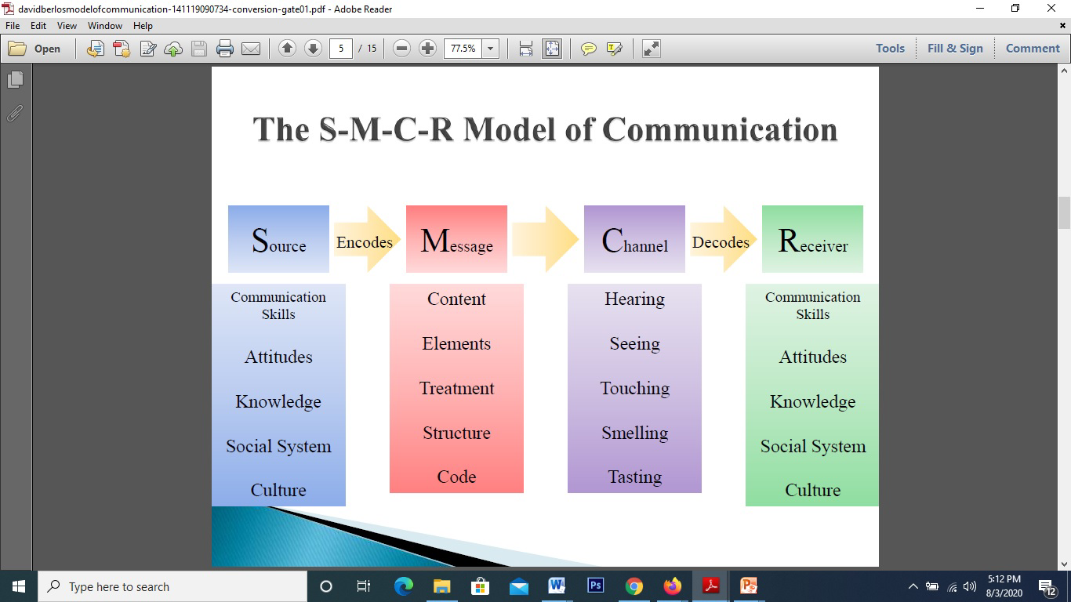
Figure 2: The Berlo's Model of Communication
The figure 2 above shows the design of the Berlo’s Model of communication and the components of the model. The message is generated at the source who is expected to have a good communication skills that would ensure the message is correctly transferred and easily decoded. The source sends the message with an attitude which gives the message a different meaning and effect. In order to send a clear message to the receiver, it is essential that the sender is very familiar with the subject matter because it would make it easier for the receiver to understand the transmitted message. The social system and culture are also important because when both the sender and receiver are in the same social circle and cultural group, they would be able to use codes, signs and symbols that are used in conveying the message. The next component is the message which contains the elements, contents, treatment, structure and code. The message is usually encoded in a particular way that is familiar to the receiver because messages are transmitted in order to be decoded by the receiver and complete the process of information transfer. The channel refers to the medium used to send the message and during communication process the five senses are the channel for the communication flow and it affect the effectiveness of the channel. The receiver is the final component and it is comprised of the same factors that affect the sender. The receiver decodes the message sent through the channel by taking into accounts the attitude or tune of the message, the codes, culture and belief when deciphering the message. According to (Andris & Iikhom, 2016), the main drawback of the model is that the model omits the usage of sixth sense as a channel and both individuals involved in the process must be familiar with each other and should be on same level of communication in order to successfully complete the communication process. The model is not applicable in real life due to its linear nature and there is no concept of noise or barriers in the communication process which is unnatural.

COMMUNICATION SKILLS

ACTIVE LISTENING
This is a type of communication skill that ensures that the information shared and transferred is properly assimilated by the receiver by actively listening not with only the ears but with the other senses or channels in the communication process. According to (Canpolat et al., 2015), they explained that active listening is different from passive listeners who seek solely to retain ideas in their minds but active listeners both produce thoughts and share their own thoughts by expressing them in a verbal and nonverbal ways. Active listening ensures that the listeners extract unspoken information during communication process and this enable the complete transmission of the message because the listener would be able to detect change of tune and body language in order to react appropriately to the sender. The case study by (Quintanilla & Wall, 2017) showed the negative impact of lack of active listening by the leader in the Enemy lines and friendly fire case study because the leader did not actively listen to Sam before asserting a new group relationship. If the leader used all five senses to listen to Sam, he would have been able to retrieve unspoken information and detail that would have enabled better decision that would have saved the group.

INTERPERSONAL COMMUNICATION
Interpersonal communication is a skill that ensures colleagues in a workplace are able to communicate and share resources in order to successfully implement the objectives of the organization. This skill is essential in the modern workplace because being able to collaborate with colleagues would ensure that the members recognize the importance of the collaboration and the need to work as a team. The Apprentice case study in (Maund, 2017) showed the effects of lack of interpersonal communication in a workplace because the competing groups had internal rivalries among their members which deterred the success of the groups. During the project, the Versacorp team alienated one of the members due to ineffective and poor work ethics but the leader was also at fault for not establishing ways and culture that would unify the group as they seek to explore more ideas that would lead them to success. The poor interpersonal communication exhibited by both the leader and members was detrimental to the success and it would have been beneficial if the leader implemented a proper line of communication that would have guided the group.

ASSERTIVENESS
This was defined as the ability to express ideas, feelings and boundaries while respecting other’s rights, maintaining positive affect in the receiver and considering potential consequences of the expression (Pfafman, 2017). This is communication skill that would ensure that during the communication process the sender takes into account the listeners feelings, beliefs and opinions and asserts themselves without disrespecting the others. This skill was seen to be lacking in the Apprentice show case study where the Leader Jason was not able to assert the right form of leadership by respecting the demands of Sam during the project. The members of the groups were not able to express themselves freely that would have ensured they all shared and applied themselves to the completion of the project. There were blames from the members towards the group leader who was accused of not carrying out proper research on the subject matter before commencing the project and this feeling was not expressed during the group meetings. Assertiveness would have been beneficial to the success of the team because the members would have expressed their opinions and that would have assisted the leader in making an effective decision for the project.

POOR COMMUNICATION IN WORKPLACE
An example of poor communication in a workplace was an incident that happened in my place of work that caused a colleague to be terminated from their job due to their poor interpersonal relationship with the patients and their family. During a ward round, I was working with my senior colleague on a particular patient who was recovering from a serious illness. My colleague administered the basic care and took the vital readings but the patient could be seen to be uncomfortable and he was trying to explain how he felt about the treatment but my colleague did not listen to his questions and request. The patient reported to the senior management after the patient’s health deteriorated drastically and the management reprimanded the colleague for the bad attitude towards the patient. My colleague defended herself by stating that the patient had a foreign accent which she did not understand and the patient tried to demean her because of her gender.

SUGGESTIONS FOR IMPROVEMENT
These types of problem exist in every healthcare center because people of different races and backgrounds get admitted to the hospital daily. Therefore it is imperative that employees are patient and actively listen to the patients in order to understand their needs and fears properly. My colleague would have informed the management about their problem with the patient’s accent and provisions for an interpreter could have been made that would have facilitated a better understanding between the colleague and the patient. The management could also have changed her duty post and allocated a nurse that would have been able to administer better care to the patient. The colleague should have been more assertive in stating their challenges and she needs to improve their interpersonal skills because she did not pay attention to the subtle changes in the behavior of the patient and his health.

CONCLUSION
In conclusion, the work was able to evaluate the different communication models that exist and their components. Communication which is an everyday process for human in required in order to transfer and share information that is used during the day to day activities and it is deemed complete when the receiver of the message is able to decode the encoded message sent by the sender and the receiver is able to send back a response which is known as feedback. Communication is important for the success of the organization and professionals are able to explore different ideas when they communicate properly by asserting and active listening.

REFERENCES
Andris, P. & Iikhom, K., 2016. Communication Models and Common Basis for Multicultural Communication in Latvia. Society Integration Education Proceedings of the International Scientific Conference.
Cade, J., 2004. [Online] Available at: http://members4.boardhost.com/mick_underwood/msg/125.html [Accessed 13 August 2021].
Canpolat, M., Kuzu, S. & Yildirim, B.C.S., 2015. Active Listening Strategies of Academically Successful University Students. Eurasian Journal of Educational Research , (60), pp.163-80.
Manage, 2005. Training Program on Effective Communication. Manage.
Maund, A., 2017. Communication. Certificate in Higher Education: Skills for the Workplace Student Yearbook.
Pfafman, T., 2017. Assertiveness. Encyclopedia of Personality and Individual Differences.
Quintanilla, K..M. & Wall, S..T., 2017. Verbal and Non-Verbal Communication. In Maund, A. Certificate in Higher Education: Skills for the Workplace. Sage Publications. pp.67-85.

