The impact of the newly constructed alex building, on the exisitng grade II listed Old swansea library.

Student: 1910146
Building Conservation, Asset and Facilities Management. ACBA 6006

Table of contents
Table of figures ……………………………………………………………………………………………………………… pg. 2
- Introduction ……………………………………………………………………………………………………....pg. 3
- Heritage impact statement ………………………………………………………………………………... Pg. 4
  - Objective …………………………………………………………………………………………………………... pg. 4
  - Understanding significance ………………………………………………………………………………… pg. 5
  - Historic information ……………………………………………………………………………………….. pg. 5-6
  - Evidential value …………………………………………………………………………………………….…… pg. 6
  - Interior ………………………………………………………………………………………………………………. pg. 6
  - Exterior …………………………………………………………………………………………………………… pg. 7-9
  - Historical value ………………………………………………………………………………………………… pg. 10
  - Aesthetic value …………………………………………………………………………………….……. pg. 11 -14
  - Communal value ……………………………………………………………………………………………... pg. 14
  - Overall significance ……………………………………………………………….………… pg. 14-15
- Identifying changes ………………………………………………………………………………….……… pg. 15
- Assessing the impact of the proposals ………………………………………………………… pg. 15-17
- Summary table …………………………………………………………………………………………… pg. 18-19
- Conservation principles …………………………………………………………………………………… pg. 20
- Maintenance and retrofitting ……………………………………………………………………... pg. 20-26
- Managing assets …………………………………………………………………………………………. pg. 26-28
Conclusion …………………………………………………………………………………………………….... pg. 29
References ……………………..………………………………………………………………………….. pg. 30-33

Table of figures
Figure 1. Swansea central library 1996 ………………………………………………………………………..… pg. 5
Figure 2. Swansea central library 1890 ………………………………………………………………………….. pg. 5
Figure 3. Swansea central library 1901 ………………………………………………………………………….. Pg. 6
Figure 4. Damp wall …………………………………………………………………………………………………….… pg. 8
Figure 5. Damp on ceiling of reading room ………………………………………………………………….… pg. 8
Figure 6. Damp on ceiling of reading room …………………….……………………………………………... pg. 8
Figure 7. Possible wood rot to wall cladding in reading room ……………………………………….. pg. 9
Figure 8. Rotting window sill …………………………………………………………………………………………. pg. 9
Figure 9. Marking on brickwork …………………………………………………………………….……………… pg. 10
Figure 10. Repaired stonework …………………………………………………………………….……………… pg. 10
Figure 11. Doctor who during filming in the reading room …………………………………………... Pg. 11
Figure 12. Working man’s club ………………………………………................................................. pg. 12
Figure 13. Glynn Vivian Art Gallery …………………………………………………………………………….… pg. 13
Figure 14. Central Police Station ……………………………………………………………………………….…. pg. 13
Figure 15. Old Library Building …………………………………………………………………………………..…. pg. 16
Figure 16. Side elevation of the Alex building …………………………………………………………….… pg. 17
Figure 17. Retrofit process for traditional buildings ………………………………………………….….. pg. 22
Figure 18. Partially blocked rain water run off drain …………………………………………………….. pg. 25
Figure 19. Damaged mortar joints ………………………………………………………………………………. Pg. 25
Figure 20. Blocked gutters ………………………………………………………………………………………….. pg. 25

1. Introduction
The following report will investigate the impact of a newly built glazed atrium to the side of an existing historic, grade II listed building. It will firstly consider the significance of the listed building through a heritage impact assessment by taking into account its historic value, communal value, aesthetic value and evidential value. Once these have been considered an overall significance rating will be concluded. Following this an impact assessment will be discussed.
The second part of the report will then look in to how a building of this type may go about its maintenance and suggest possible maintenance plans that would be best suited. The report will also consider the implications of retrofitting a listed building and how or if it can be achieved.
There will be further considerations following a site visit and a non-invasive assessment, defects will be highlighted and possible causes for these defects.

Task 1
2. Heritage Impact Statement

2.1 Objective
The purpose of this heritage impact statement is to assess the change on the existing grade II listed building previously used as a library and Swansea’s college of art, for the proposed new glass facade extension. In order for the proposed extension to go ahead, firstly listed building consent will be required to demolish the existing 1936 two storey side extension to pleasant street, which houses the former caretaker’s house on Alexandra road and the former kitchen/ toilet space to the north facing courtyard, shown below (Fig 1, outlined in red).
The aim of the proposed new building is to improve the experience of the students and to protect the long term future of the building for the residents of Swansea. This will be achieved by providing a creative environment for the students to thrive and develop in a state of the art development. The ability to install modern features in to the new building that are not able to be done in the original listed building, such as adding lifts will also make it more accessible and favourable to all that desire to use it.
As part of the development, additional works will be carried out to the existing building to the requirement of the listed elements, including the domed reading room which will then be accessible for public meetings and events, the reinstatement of the missing pavilion dome on the central tower of the existing building which was lost during world war II will also be carried out.
Also as part of the development, it is planned to make the building more economically sustainable by improving the environmental systems and controls, while the use of double skin glass walls will also contribute to energy saving.

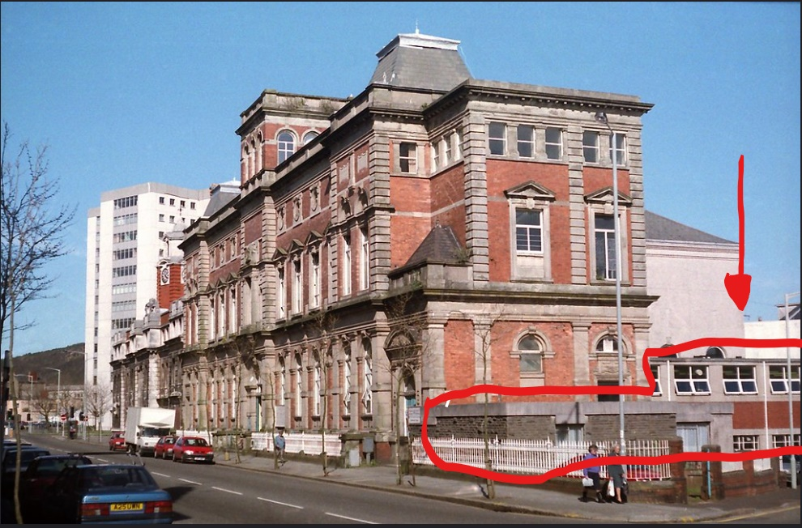
Fig 1. Swansea central Library in 1996 outlining buildings to be demolished. (Thomson, 1996)

2.2 Understanding significance
2.3 Historic information
The building is said to be designed by Henry Holtom of Dewsbury and based upon the Italian classical style. It was constructed in 1886-7 and opened by the then future Prime Minister William Ewart Gladstone (Coflein, 2021. Tuner, 2015). Below (Fig 2), shows the building in 1890 just three years after it was opened, and (fig 3) shows the building in 1901.
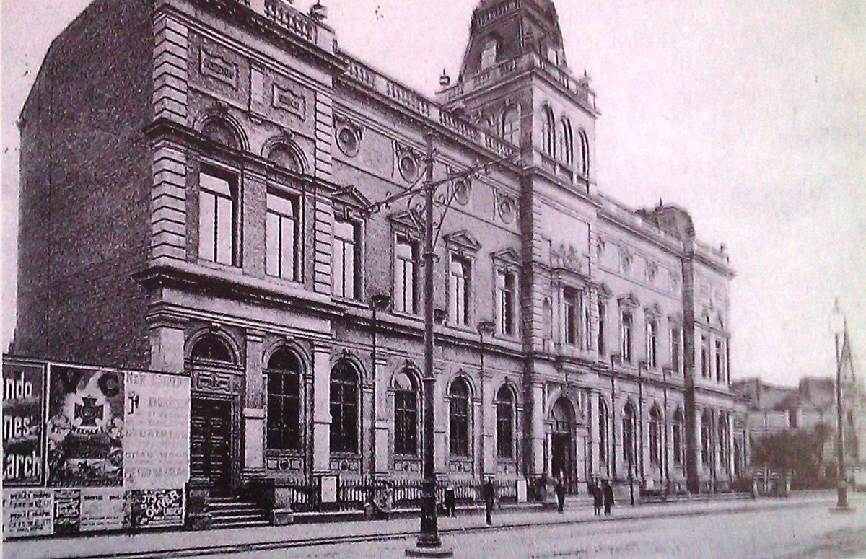Fig 2. Image of Swansea central Library in 1890 (World press 2012)

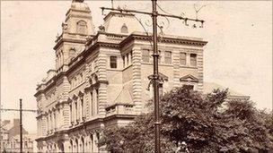
Fig. 3 Image of Swansea central library 1901 (Prior, 2011)

The building is set in the conservation area of Alexandra Road, Swansea, National Grid Reference SS 6545093400 (City and County of Swansea, 1987), and is a grade II listed building (Swansea Council, 2021), firstly designated as a listed building in 1987 (Cadw, 2022). It was also one of just a few city centre buildings in Swansea to survive the Blitz of World War II (Prior, 2011).

2.4 Evidential value
The interior and exterior features of the building as suggested by Cadw (1987) are:
2.5 Interior
- Grade II listed domed reading room
- Interior of entrance hall has paired doorways up steps, arched coffered ceiling to vestibule, and elaborate timber pedimented door cases with lunettes over, arched and pilastered treatment to lateral corridors.
- Aisled, circular rear Reading classical detailing.

- Cast iron columns with rich acanthus capitals and radiating timber bookcases with guilloche ironwork balconies support entablature.

2.6 Exterior

- Monumental, symmetrical classical design; red brick facings with pale freestone dressings. 2-storey, attic and basement.

- Advanced centre and end bays with slate pavilion roofs (centre roof destroyed in Second War), tower to centre with tripartite arched windows.

- Main dentilled cornice with solid parapets and plain frieze. Banded quoins to upper floor, angle and fluted pilasters below.

- Swagged and fluted oculi to inner bays over pedimented and key blocked studio windows.

- Oriel treatment to central aedicule flanked by niches and elaborate overthrow with reclining figures.

- Arched and key blocked ground floor windows with linked impost bands and panelled aprons. Segmental, key blocked basement windows behind area railings.

- Mostly T-frame glazing.

- Set-back bay on far right, similar style with glazed top storey and 2-bay return elevation. Porch to street with segmental pedimented door case, panelled pilasters and carved tympanum.

- Main arched and pilastered door case has foliage carving to spandrels and key block, sliding double doors, quadrant parapets to steps up.

- Smaller door case to far left with guilloche surround, inscribed over door under glazed lunette, flying platform to steps, 6-panel doors.
During a site visit it was noted that the majority of the listed components above still remain, though some changes are visible, the windows seem to have been updated at some point in time and light fittings in the building are assumed to be updated due to their modern look. There are also signs of deterioration throughout the building such as damp patches in quite a few of the rooms (fig 4). Notably the round reading room is showing substantial signs of water ingress with possible dry rot occurring on the tongue and grooved cladded wall, (Figs 5, 6, 7). There are also signs of the window sills around the building beginning to rot, (See fig 8).

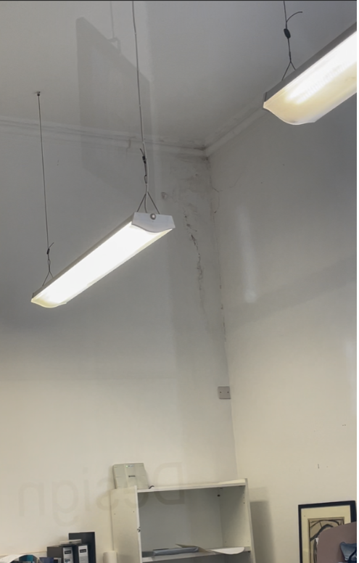

Fig 4. Damp in one of the buildings rooms. (Jones, 2022)
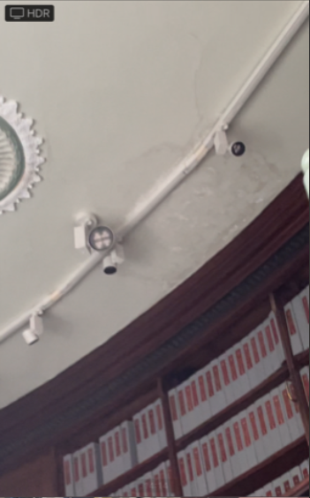
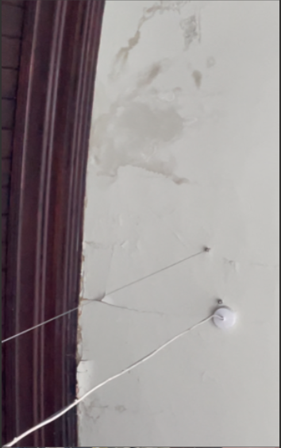
Fig 5. Damp patch on ceiling of reading room. (Jones, 2022) Fig 6. Damp patch on ceiling of reading room. (Jones, 2022)

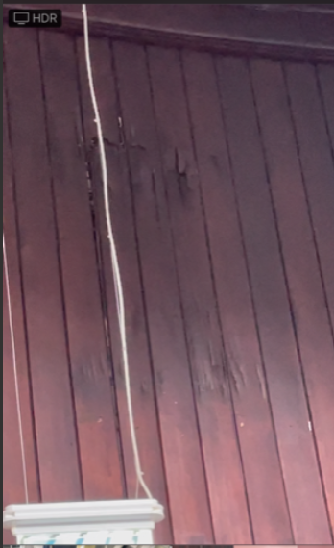

Fig 7. Possible wood rot to tongue and groove cladding to reading room. (Jones, 2002)
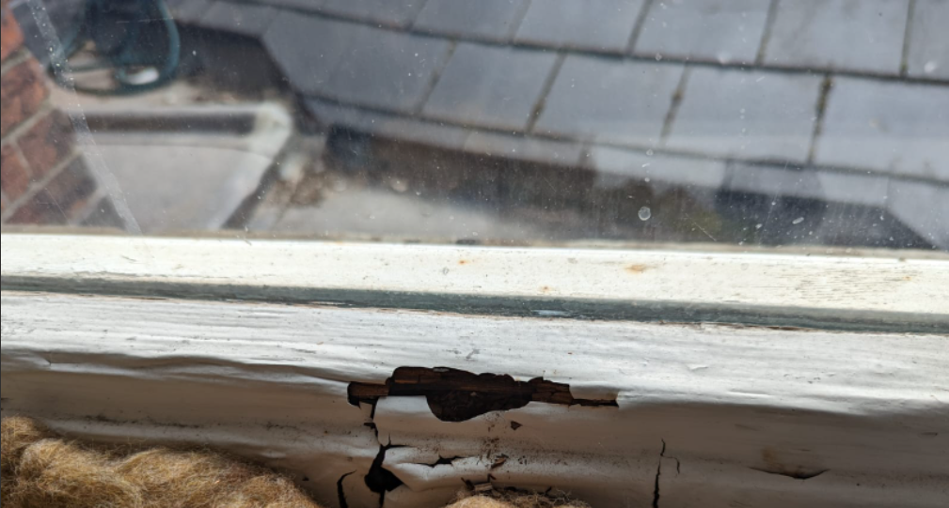

Fig 8. Rotting window sill. (Jones, 2022)

The outside of the building remains largely unchanged, the only item of note is slight marking to the brickwork (fig 9), previous damage to the stonework which looks to have been rectified (fig 10), and as previously mentioned the missing pavilion dome. The roof however does look as though it has been changed at some point, though the look is in keeping with the buildings design.

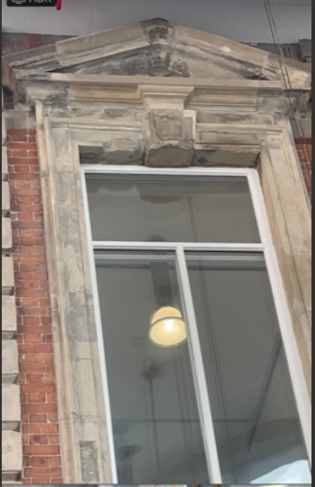
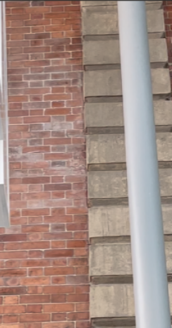

Fig 9. Marking to brickwork. (Jones, 2022) Fig 10. Repaired stonework. (Jones, 2022)

2.7 Historical value
As previously stated the building was first opened in 1887 by the future Prime Minister William Ewart Gladstone, and started its life as a public lending and reference library (GPS my city, 2022. Hey Libraries, 2022). Also since the opening, the upper floors of the building were occupied by Swansea’s college of Art (Prior, 2011).
It was a favorable place for famous Welsh poet Dylan Thomas to retreat (Turner, 2015) and in the 1950s the Dylan Thomas collection was established there, with over 3,000 books and articles written by or about the Swansea born poet (Hey libraries, 2022).
It has been used numerous times for filming scenes, firstly in the 1960s for the movie Only Two Can Play starring Peter Sellers (Turner, 2015), and more recently following the buildings closure in 2007, scenes for two episodes of Doctor Who were filmed there for several days in 2008 (BBC, 2014), making use of the iconic reading room. (Fig 11)
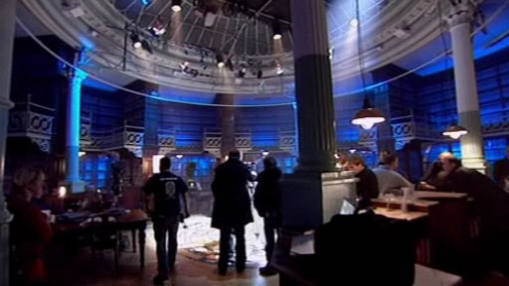
Fig 11. Doctor Who during filming in 2008. (BBC, 2014).

2.8 Aesthetic value
As previously mentioned the ‘Old Swansea central library’ and college of arts building is set in the conservation area of Alexander road as a grade II listed building. It is not the only listed building along Alexander road hence the reason it is a conservation area.
Alexandra road was created between 1876 -1880, though it was originally named Yeo Street after a councillor who was responsible for clearing up the area. The subsequent name Alexander road was adopted two years later 1881, after the visit of the Prince of Wales and Princess Alexandra. The other now listed ‘very fine public buildings’ were developed between 1885 and the First World War, this was decided because it was seen to be shortfall of existing premises there, the idea of the new buildings was to be designed as a ‘Grand Boulevard’. (City and County of Swansea, 1986) The buildings constructed were:
- Working Men’s Club and Institute (1885), (Fig 12)
- The Central library (1887)
- The BBC building (1899). Formerly known as the Dylan Thomas house but was destroyed during the Second World War and rebuilt by the BBC in the 1950s (Youle, 2021). Also not a listed building.
- Glynn Vivian Art Gallery (1909-11). (Fig 13)
- Central Police Station (1913). (Fig 14)
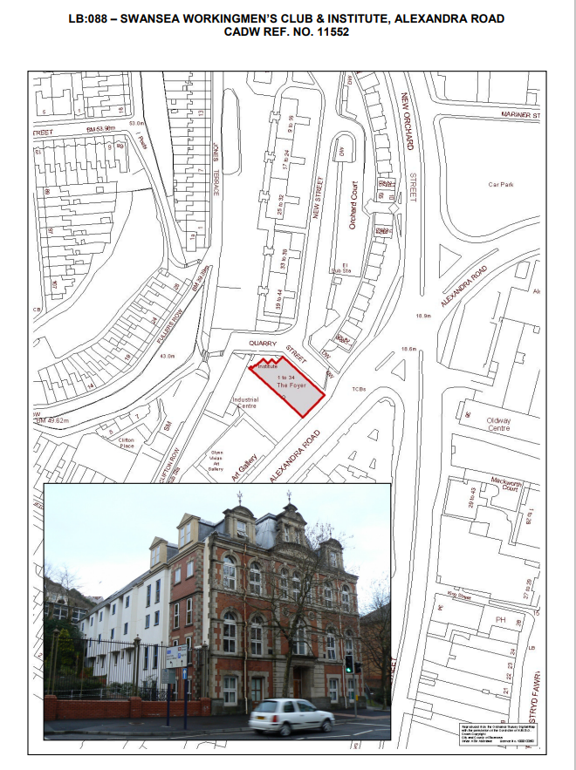
Fig 12. Working man’s club. Swansea Council (2021)
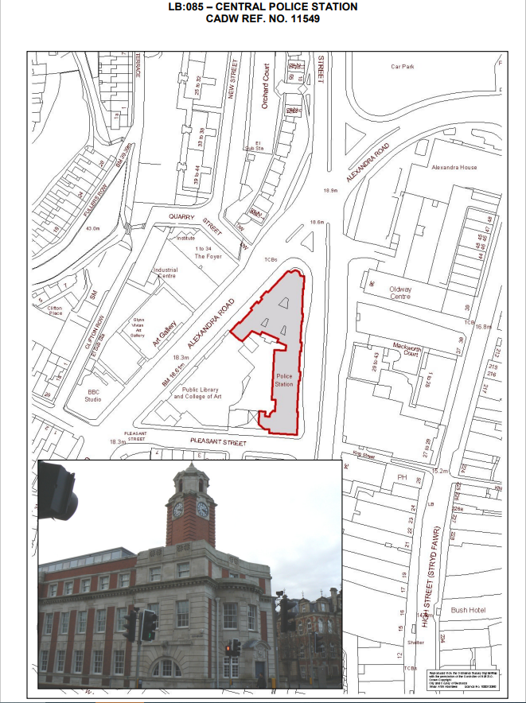
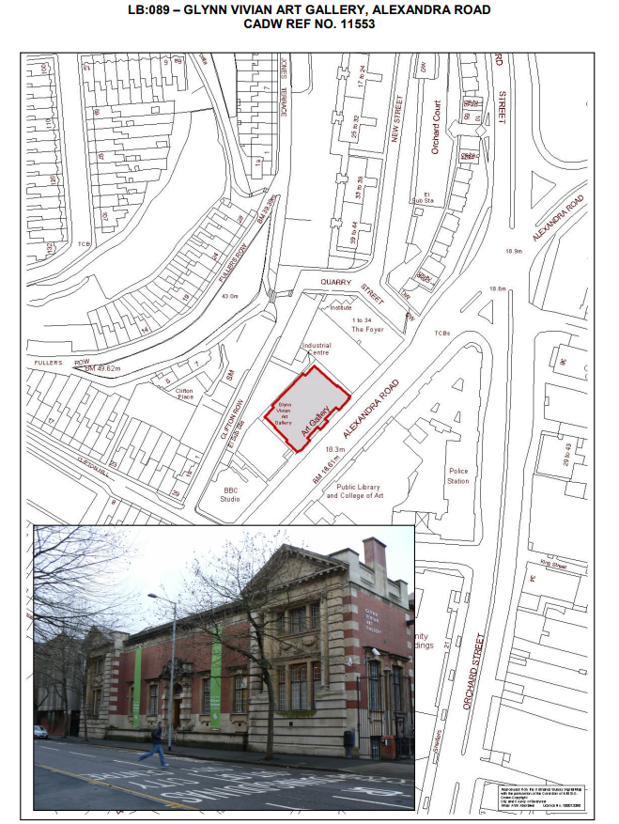
Fig 13. Glyn Vivian Art Gallery. Swansea Council (2021
Fig 14. Central Police Station. Swansea Council (2021)
It is suggested these buildings formed an impressive looking and a striking urban space. Due to the destruction of the area during the War a lot of the original character is absent, leaving just these few historic buildings as a reminder of what once was (City and County of Swansea).
From the site visit carried out it is clear to see the significance the historic buildings have on the area, there is remanence of War damage on many of the buildings, a reminder of how they survived this and the history and stories they hold, therefore it is imperative that any alterations do not take away from this significance.
The road driving past these buildings are of relatively new construction and not in fitting with the historic building designs and it can be judged as rather busy road, as it gives access to the main city centre.

2.9 Communal value
The building in its original state could be seen to have had significant communal value, as previously mentioned it was a public library. A place that may hold many fond memories for a lot of the local residents. It is worth noting though, it is no longer used as a library and all the reading materials were moved to the civic centre (new library) and can be used there. The ‘iconic’ reading room has not been changed and is available to be used by the public for meetings and events. The building is still used as an art college as it always has done. Prof David Warner was quoted as saying since the building was opened ‘it has served as a beacon of educational enlightenment for the people of Swansea’ (Prior, 2011).
The proposed development of the new extension could go towards ensuring a first class education in the heart of Swansea.

2.10 Overall significance
From the information gathered in this report it is clear as to why the building is of high significance. It has many great historical memories for the local community and Swansea, from the famous poet Dylan Thomas, to being used for scenes in movies and more notably the Dr Who episodes. The reading room is clearly one of the main features of the building and from the site visit it is clear to see why. Having survived during the World Wars, the original reason for the construction of the building to bring a more cultured look and presence to the area, it is vital that any new construction is carried out tastefully and does not impede on the look or historic nature of the building. Taking these reasons in to account it could be judged that the greatest significance to the building is the historical and communal value.

3. Identifying Changes
The proposed change for the grade II listed building previously used as a library, is to construct a new glazed atrium and extension to side of the building. This will provide greater student facilities and accommodation. The innovative design, though modern in look will ensure very little impact in terms of altering the existing building, by using a fully glazed construction method it will still allow the ability to see the entirety of the existing building through the glass.

4. Assessing the Impact of the proposals
The impact on evidential value is seen as minimal, as the new structure is fully glazed therefore still allowing a view to original building. As the front elevation could be seen as the most significant elevation and this will remain largely unchanged. The new extension is to be set back from the front of the original building and also lower than the existing building. Therefore when looking down to the street the overall impact on the aesthetic will be minimal. (Fig 15).
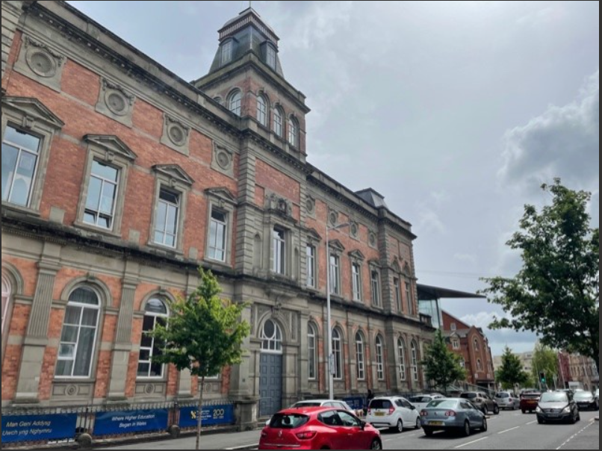
Fig 15, view of Old school library looking down the street. (Jones, 2022).

In contrast to the appearance at the front of the building, the side elevation where the new glaze building is to be situated will be effected on a larger scale. Though as this side elevation is not of as great a significance as the front and the glazed design is light weight in appearance, it does not massively effect the aesthetic or quality of existing building, or does not take away from the look or dominate over the original style. (See fig 16)

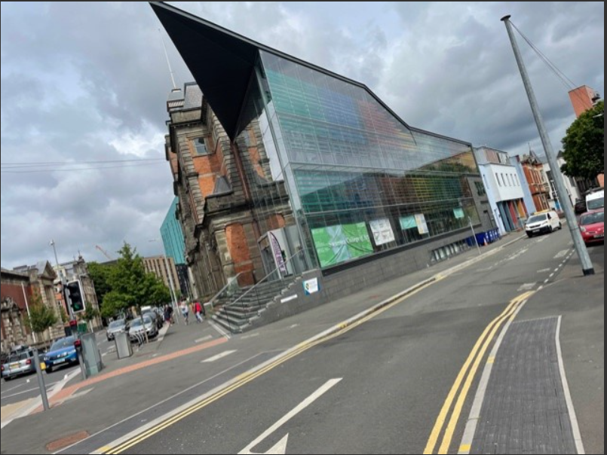
Fig 16. View of side elevation of extension (Jones, 2022).

The new extension and modern features will give greater and easier access to the buildings entirety with greater disabled access. Though the building was originally a library this use will not be affected or lost as it was already closed and moved in 2007. The new extension along with the plan to carry out remedial works to the existing building can also only be seen as a positive step in protecting the listed building for the future.
The risks of the new building are seen as minimal as it should only have a minimal effect on appearance, though this could be down to personal preference. The new building is a lot less invasive than if a stone building was to be constructed. With that in mind and the benefits this new building will bring, such as making the overall building more economically sustainable, with greater energy efficiency and protecting the original buildings future are seen to outweigh the minimal risk.
5. Summary table
Proposed Work | Objective | Significance of affected fabric | Assessing beneficial impact | Assessing harmful impact | Proposed solution
Demolition of existing 1936 two-storey side extension to pleasant street. | To make way for new extension | N/A | Allows for new improved building | Possible minor damage to existing envelope during demolition | Design and plan work to minimise damage.
Build new glazed extension to side of building | To make the overall site more sustainable, economical. | Side elevation part of original building | Gives the building a more economic use | Changes appearance of the side elevation | Roofline to be kept lower and front elevation set back. So minimal impact to existing buildings front elevation
Opening up of existing building walls to incorporate new building through access | To access old building through new extension | Removal of some existing fabric | Allowing overall greater access to the building | Change of appearance | To design work to minimise impact and ensure any significant detail are not effected
Installation of Lifts | To make overall site more accessible for disabled users | Not in keeping with original fabric. (Installed in new building) | Allows overall access to site available for all users | Structural changes | Design work to minimise structural damage to existing building and installed in such a way as to minimise changes to the aesthetics.
Installation of Fans and vents | Minimises the effect on ventilation | Not in keeping with traditional design | Ensures the free flow of air through the building | Could affect natural ventilation | Ensure the design only helps with natural ventilation not hinder

Conclusion
The overall effect of the new glazed extension can be seen as a major change to the Old Swansea library building as its design is much different and modern in comparison. However it will be done in such a way that the effect does not take away from the original buildings significance. The benefits the new extension will bring to local community and the fact it should help ensure the historical building is maintained correctly and protect its long term future should be seen as a positive step going forward for not just the building but the local community also.

Task 2.
6. Conservation principles.
Historic England (2022) have set out 6 high level principles of conservation, these are:
- The historic environment is a shared resource
- Everyone should be able to participate in sustaining the historic environment
- Understanding the significance of places is vital
- Significant places should be managed to sustain their values
- Decisions about change must be reasonable, transparent and consistent
- Documenting and learning from decisions is essential
This report will aim to consider these principles mentioned when considering the maintenance and retrofitting of the historical listed building being discussed.
7. Maintenance and Retrofitting
Maintenance can be seen as any task that is carried out through a planned cycle and regular inspections such as cleaning painting and minor repairs, it could be argued that this is the most important act to protect a listed building or any building, it could negate the need for expensive repairs and avoid serious damage. (Cadw, 2017), this stand point is also echoed by Maintain our heritage, (2004), that suggest the maintenance of historical buildings could be seen as extremely beneficial in terms of conservation when preventative and intended to limit or eradicate the need for repairs.
The maintenance of the college of art building could be seen as a challenging prospect as it is of historical importance and a grade II listed building, with the contrasting new modern glazed extension attached. It is therefore imperative that the way each building works and how the maintenance of each building is carried out is fully understood and applied in the correct manor. In order to achieve this it may be important to understand the structure, condition and performance of the building types, (Cadw, 2017)
By understanding the structure of the buildings ensures that any proposals put forward are compatible with the existing materials.
As a minimum a maintenance plan for the building should include:
- Consideration to how the building is constructed, if any changes have been made and the overall condition
- Identifying any weak points in the building so it can be anticipated where any issues may occur
- Considering the building as a whole, including the interior structure as well as M+E services and systems. This could discover issues such as surface water, drainage and proximity of trees.
- Be mindful of the buildings position and exposure to the natural elements.

In terms of performance, the original listed building and new glazed extension could be assumed to perform differently. The original building was arguably built using methods of traditional construction, where the use of solid walls using materials as stone, brick and lime based mortars would have been used. This method allows the building to breathe so that moisture is able to be absorbed and evaporated.
In contrast the new glazed building was constructed using more modern methods of construction, which is designed to keep moisture out, therefore when considering a maintenance plan for the building in question any repairs or alterations must be done so by using the original construction techniques and materials, the use of modern materials on traditionally constructed buildings could cause defects such as trapping of moisture and reduced permeability (Cadw, 2017)
Retro fitting of traditional buildings can bring about more risks and challenges opposed to modern buildings (Gori et al, 2021). This is suggested because of many factors such as, conservation requirements, limited reliable information of these buildings, the varied types of materials used and the complexity of moisture and heat behaviour of the buildings (Akkurt et al, 2020). The incorrect retrofitting of traditional buildings can lead to consequences such as, overheating (Shrubsole et al, 2014) and failure of solid-wall retrofit programmes due to excess moisture (BRE, 2016). This along with a lack of knowledge and understanding of solid wall insulation (Hansford, 2015) makes for the retro fitting process of traditionally constructed buildings difficult.
Though it is seen as difficult there is growing acknowledgment of the need to improve thermal efficiency of buildings. The undertaking of these kinds of measures if carried out correctly and with the correct use of materials for the building, such as water vapour-permeable materials and that adequate ventilation is maintained, a positive effect can be had (Cadw, 2017).
Due to the history, design and look of the school of art building, the option of external wall insulation would not be of consideration as it could be seen to negatively change the look of the building and it would also require planning permission for this to be carried out.
The option of using internal wall insulation (IWI) may sound like a more appropriate option but as already mentioned this can be very difficult to be done correctly due to moisture build up. This could not only damage the building and cause poor performance but also lead to the growth of mould and cause health implications for the buildings residents. Martel et al (2021), also argues that IWI has not only been found to increase moisture content of the exterior wall but also increases the temperature variation of the external face which could lead to issues with frost and moving the dew point for condensation closer to the internal surface, creating increased wetting of the assembly. The author also argues that solid walls with IWI are one of the most hazardous retrofit build-ups. Price et al (2021) also has the same view point, as they suggest that when IWI is fitted, the hygrothermal characteristics of the building can change, therefore moisture management becomes a major consideration.
Though if the thermal performance of the building can be accurately determined and analysed, it is possible to the design and implement appropriate measures with reduced risk of harm to the building and using guidance such as the retrofit process for traditional buildings from the Institute of Historic Building Conservation. (Fig 17)
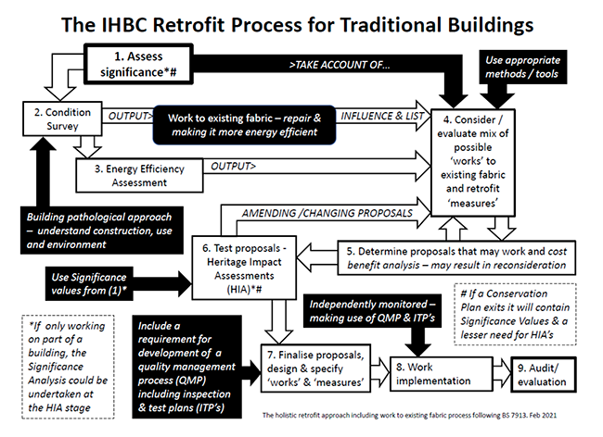
Fig 17. Retrofit process for traditional buildings. Institute of Historic Building Conservation (2021)

Due to the difficulties in insulating traditional buildings like the old college of art as discussed in this report, especially during the winter months when it can be a particular tricky time in trying to keep a traditionally built building warm, there may be alternative measures with less impact that could be carried out,
Such measures as visual inspections of the property such as looking for damp patches on the masonry, this may indicate rain water is not efficiently being cleared.
Ensuring the gutters are checked regularly to check there is no build-up of leaves and debris that could cause blockages also leading to the masonry becoming saturated.
Checking of the roof slates would be advised especially after any adverse weather conditions such as storms to ensure there is no damage of any slates or missing slates and leaving the building open to the elements.
Check there is sufficient roof/loft insulation as this is where a lot of heat can be lost in a building, it must be done correctly though to ensure the building still ventilates effectively.
Checking all external walls for damage or for repairs and check that the material used for repair are correct for the building type, such as lime mortar as modern cements can have negative effects on traditional buildings.
Other measures may include improving or upgrading the heating system, draught proofing and repairing or changing windows.
During the site visit, it was evident that some form of a retro fit has been previously carried out. The windows have been upgraded to double glazing, the radiators looked new though in keeping with the style of the building, modern light fittings were very apparent and not in keeping with the style of the building. Around the domed roof above the reading room the slate tiles looked like they may have been changed at some point. What was very noticeable during the visit and as previously mentioned and seen in figs 4, 5, 6, 7, and 8, was the damp and deterioration around the building, though it was unclear if this was due to any of the retro fitting previously carried out, but what was clear is that the maintenance and regular inspections seemed to be lacking as during the visit the possible causes of the defect were discovered, these included what looked like blocked gutters, partially blocked run of drain on the roof above the domed reading room and also damage to the mortar of the brickwork with weeds penetrating through (see fig’s 17, 18 19). Or it may be down to financial implications why these problems have not been corrected.

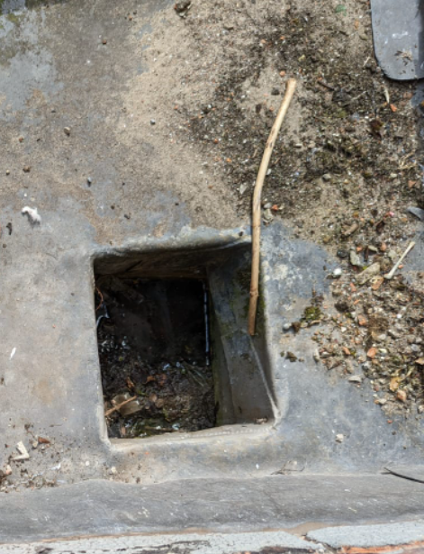

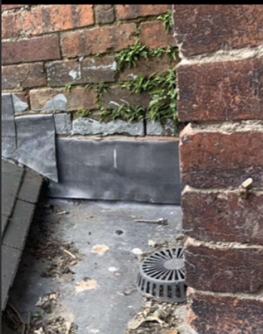

Fig 18. Partially blocked rain water run off drain. (Jones, 2022)

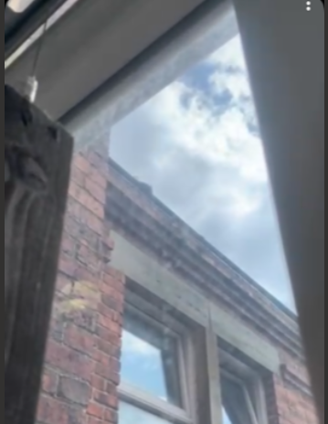

Fig 19. Damaged mortar joints. (Jones, 2022)

Fig 20. Blocked gutters (Jones, 2022)

The possible dry rot in the reading room is of great concern due to the history and relevance of the room in itself, indicating that there is damp in that room. Though it was not clear to see it looked as though the water run off point on the roof around the domed ceiling and above the reading room looked to be blocked with debris, also the guttering around that area appeared to be blocked as moss was pushing through the joints and over the top of the guttering. There was also damaged mortar joints with weeds protruding through and inside the building there was wall where paint was peeling off, this could indicate that either the wall was damp when freshly painted or the temperature in the building is now higher and drawing moisture out of the walls.
In Contrast to the old school of art building the new glazed extension has been built to keep the water out and be highly energy efficient. This is achieved by the use of double skin inner glass walls. The south facing glass facade which receives high sun exposure acts as a thermal flask and the use of solar shading through the use of coloured glass sheets all go towards the high efficiency. It has also been designed to keep maintenance as straight forward as possible (Design 2e, 2015).
The traditional type of ventilation in historic buildings would have been natural ventilation through window openings and infiltration through air leakage (Rieser et al, 2021). This is no different in the old college of art school. To ensure this was not affected by the new building and to assist with the airflow through the building, part of the new design included the installation of fans at the top of the building and vents to the bottom.

8. Managing Heritage Assets
Heritage assets can range from a building to an area or landscape that has a degree of significance that warrants attention in planning decisions due to its heritage interest. (Historic England, 2015).
Asset management can be seen as improving the operation of asset in terms of service benefits and financial returns or as stated by the British Standard Institute ‘a process in which assets are managed so that they support business delivery of the organization that owns or occupy them’.
In terms of improving the operation of the buildings, if a caretaker was to be part of the maintenance of the buildings it may be seen as critical that the caretaker understands the difference between how the two buildings work, their different systems and what to look out for when carrying out daily/weekly checks with use of a maintenance plan and schedule. Not only is it recommended that the caretaker is aware of these systems but it would also be advised that they are aware of the buildings value to the local heritage, understands the special qualities of the building and why it is important to preserve these special qualities.
Guidance on how to best care for the historic asset should be provided such as ‘Maintenance Matters’ on the Cadw website, and general principles included about how routine maintenance should be carried out and what is classed as routine maintenance that does not require further considerations or permissions, before repair alterations or changes are made.
If maintenance managers were part of the maintenance team for the buildings, ideally they would firstly have back ground knowledge of historic buildings and the principals involved, as well as experience in maintaining historic and modern buildings. Dependent on what experience and qualifications they had it may be necessary for them to develop their knowledge and understanding further through relevant courses and qualifications such as online training and webinars that are offered through Historic England. Again it is seen as critically important they understand the special qualities of the building and the importance of preserving those qualities, as Maintain our Heritage (2003) suggest, a greater understanding of the significance of retaining cultural heritage and the importance of maintenance needs to be combined and developed.
As a listed building it would be recommended they make use of a systematic preventative maintenance and regular directed inspection approach with data collection. Training in the management of information may also be of benefit as it could be seen as a key aspect of maintenance management, and that this information is easily accessed. As the original part of the building is listed and the new extension added is now part of the building it could be classed as mixed stock, in this instance any maintenance management plan should develop policies and processes that suit this.
Another recommendation when it comes to maintenance of the building is the financial considerations and the need for the maintenance managers to carry out long term financial planning and budgets as this could determine if the maintenance management systems are successful.
Having to change a fixture or fitting in a listed building can be seen as very complex, even for what may be deemed as a minor change such as replacing external doors, painting the interior or exterior of the building may require building consent if it was to change the buildings features that contribute to the buildings special or historical background. In the case of advising the maintenance mangers for the building if they need to replace fixtures or fittings would be to firstly advise them that as a general rule that they should try and preserve or restore historical form, fabric and details while respecting them in all new work, and any changes that may result in a loss to historical form should be kept to a minimum. If they are unsure they should check with the guidance available such as Cadw or even speak to a listed building specialist.
Routine repairs or like-for-like repairs however do not usually require building consent, though like-for-like repairs should be quite exacting with the look and type of material so seeking advice might be the best appropriate action. For any demolition works building consent will always be needed. (Cadw, 2022)
A well planned asset management plan and effective maintenance plan can go a long way in ensuring the buildings sustainability and energy efficiency, as the most effective way to ensure this is through good repair in order to prolong the buildings life, therefore do not need replacing and avoiding major issues that would require energy to fix. Though Rieser et al (2021) argues that moving away from natural ventilation to mechanical ventilation with heat recovery is the best way to improve indoor conditions and energy performance, this could change the look of the building and therefore not advised. Whereas BSI (2013) recommends continuing with natural ventilation that respects the buildings characteristics.
The damp seen on the site visit would need to be dealt with and find the source of the problem, as damp in walls can reduce the energy efficiency of the building and increase heat loss by up to 30%. Other sustainability measures that could be taken is the selection of materials and methods of work as these can effect weather resistance and thermal performance, also sourcing of building materials should be obtained in a sustainable way. It may also be worth mentioning that the new glazed extension aim is to also contribute with energy efficiency.

Conclusion
This report has identified the significance of the grade II listed old Swansea library building and identified why is it of the upmost importance to not be altered in such a way that detracts from its historic significance. It has also identified how and what effect the new glazed Alex building would have upon it. Though it could be seen as big change, the good most definitely outweighs the bad in what the new building will bring to the community and prolonging the future of the old library.
The report has also identified the difficulties in maintaining an historic building especially in terms of retrofitting. That the best option may be through non-invasive maintenance that can go a long way in protecting the building. Though it has been recognised that more studies and research is being taken to account for these difficulties and with the right conditions, philosophies and approaches it is possible.

References
Akkurt, G.G., Aste, N., Borderon, J., Buda, A., Calzolari, M., Chung, D., Costanzo, V., Del Pero, C., Evola, G., Huerto-Cardenas, H.E. and Leonforte, F., (2020). Dynamic thermal and hygrometric simulation of historical buildings: Critical factors and possible solutions. Renewable and Sustainable Energy Reviews, 118, p.109509.

Archives Swansea, (2021). LB: 085 – CENTRAL POLICE STATION CADW REF. NO. 11549. Available at: C:/Users/marty/Downloads/LB085_-_Map%20(1).pdf. [Accessed 09 May 2022]

Archives Swansea, (2021). LB: 089 – GLYNN VIVIAN ART GALLERY, ALEXANDRA ROAD CADW REF NO. 11553. Available at: C:/Users/marty/Downloads/LB089_-_Map%20(1).pdf. [Accessed 09 May 2022]

Archives Swansea, (2021). LB: 088 – SWANSEA WORKINGMEN’S CLUB & INSTITUTE, ALEXANDRA ROAD CADW REF. NO. 11552. Available at: C:/Users/marty/Downloads/LB088_-_Map%20(1).pdf. [Accessed 09 May 2022]

BBC, (2014). Wales Arts. Old Swansea Central Library. Available at: https://www.bbc.co.uk/wales/arts/sites/doctor-who-wales/allocations/swansea-library. [Accessed 10 May 2022].
BRE. (2016). Post installation performance of cavity wall and external wall insulation. Constructing Excellence in Wales. Available at: http://www.cewales.org.uk/files/3014/7671/0110/Post_Installation_Performance_of_Cavity_Wall__External_Wall_Insulation.pdf. [Accessed 24 May 2022]

British Standards Institute, (2013). Guide to the conservation of historic buildings. BS 7913:2013.

Cadw, (1987). Full report for listed buildings. Available at: https://cadwpublic-api.azurewebsites.net/reports/listedbuilding/FullReport?lang=&id=11551. [Accessed 09 May 2022]

Cadw, (2022). Listed building consent. Available at: https://cadw.gov.wales/advice-support/historic-assets/listed-buildings/listed-building-consent. [Accessed 25 May 2022]

Cadw, (2017). Managing change to listed buildings in Wales. Available at: https://cadw.gov.wales/sites/default/files/2019-05/20170531Managing%20Change%20to%20Listed%20Buildings%20in%20Wales%2024303%20EN.pdf. [Accessed 24 May 2022].

City and County of Swansea, (1986). Alexandra Road. Available at: C:/Users/marty/Downloads/CA022_-_Alexandra_Road.pdf. [Accessed 09 May 2022].

City and County of Swansea, (1987). School of Art, Alexander Road. Available at: C:/Users/marty/Downloas/LB087_-_School of Art.pdf

Design 2e, (2015). Alex building. Available at: https://www.design2e.co.uk/projects/designing-energy-saving-inner-glass-walss-for-an-university-building/. [Accessed 24 May 2022].

Coflein, (2021). Site record. Central library and school of art. Available at: https://coflein.gov.uk/en/site/31763?term=Swansea%20central%20library. [Accessed 10 May 2022].

Gori, V., Marincioni, V. and Altamirano-Medina, H., (2021). Retrofitting traditional buildings: a risk-management framework integrating energy and moisture. Buildings and Cities, 2(1), pp.411-424.

GPS MY CITY, (2022). Old Swansea Library, Swansea. Available at: https://www.gpsmycity.com/attractions/old-swansea-library-41733.html. [Accessed 09 May 2022].

Hansford, P. (2015). Solid wall insulation: Unlocking demand and driving up standards. Department for Business Innovation and Skills. Available at: https://assets.publishing.service.gov.uk/government/uploads/system/uploads/attachment_data/file/476977/BIS-15-562-solid-wall-insulation-report.pdf. [Accessed 24 May 2022].

Historic England, (2015). Inclusion of Heritage in Asset Management Plans (stage 2 – Case Study Report). Available at: https://historicengland.org.uk/images-books/publications/inclusion-heritage-asset-management-plans/inclusio-heritage-asset-management-plans-stage2-case-study-report/. [Accessed 24 May 2022].

Hey Libraries, (2022). Old Swansea Central Library. Available at: https://heylibraries.co.uk/03540555/Old_Swansea_Central_Library. [Accessed 09 May 2022]

Institute of Historic Building Conservation, (2021). Retrofitting of Traditional Buildings. Available at: https://ihbconline.co.uk/toolbox/guidance_notes/retrofit.html. [Accessed 26 May 2022].

Maintain our Heritage (2003). Maintaining value. Available at: https://www.maintainourheritage.co.uk/wp-content/uploads/2017/07/module-1-2-3-pdf. [Accessed 25 May 2022].

Maintain our heritage (2004). Putting it off. How lack of maintenance fails our heritage. Available at: https://www.maintainourheritage.co.uk/wp-content/uploads/2017/07/putting-it-off-final-report.pdf. [Accessed 24 May 2022].

Martel, T., Rirsch, E., Simmonds, A. and Walker, C., 2021. The monitoring of wall moisture in a property retrofitted with Internal Wall Insulation. Case Studies in Construction Materials, 14, p.e00520.

Price, S., Andreou, E., Wilcockson, T., Megagiannis, K., Lopez, N. (2021). Retrofit internal wall insulation. Guide to best practice. Available at: https://assets.publishing.service.gov.uk/government/uploads/system/uploads/attachment_data/file/1019707/iwi-guidance.pdf. [Accessed 27 May 2022].

Prior, N. (2011). Swansea Metropolitan University buys library building. Available at: https://www.bbc.co.uk/news/uk-wales-13719371. [Accessed 09 May 2022].

Rieser, A.; Pfluger, R.; Troi, A.; Herrera-Avellanosa, D.; Thomsen, K.E.; Rose, J.; Arsan, Z.D.; Akkurt, G.G.; Kopeinig, G.; Guyot, G. (2021). Integration of Energy-Efficient Ventilation Systems in Historic Buildings—Review and Proposal of a Systematic Intervention Approach. Sustainability, 13, 2325. https:// doi.org/10.3390/su13042325

Shrubsole, C. et al. (2014) ‘100 Unintended consequences of policies to improve the energy efficiency of the UK housing stock’, Indoor and Built Environment, 23(3), pp. 340–352. doi: 10.1177/1420326X14524586.

Swansea Council, (2021). Listed building index. Available at: https://archive.swansea.gov.uk/listedbuildingsindex. [Accessed 09 May 2022].

Tink, V., Porritt, S., Allinson, D. and Loveday, D., 2018. Measuring and mitigating overheating risk in solid wall dwellings retrofitted with internal wall insulation. Building and Environment, 141, pp.247-261.

Turner, R. (2015). Swansea’s former library building refurbishment nearly £5m over original budget – but university defends the spend. Available at: https://www.walesonline.co.uk/news/wales-news/swanseas-former-library-building-refurbishment-8968562. [Accessed 09 May 2022].

Youle, R. (2021). Wales Online. Former BBC studios in Swansea to be upgraded with ‘acoustics unmatched in Wales. Available at: https://www.walesonline.co.uk/news/dylan-thomas-house-bbc-studios-20423623. [Accessed 10 May 2022].

World press, (2012). Alexandra Road. Available at: https://ididitthisway.worldpress.com/2012/02/29/alexandra-road/#jp-carousel-2263. [Accessed 09 May 2022].

