DFD diagrams assessment – Information engineering
Semester 1 assessment

Cameron Churchill

Top Process
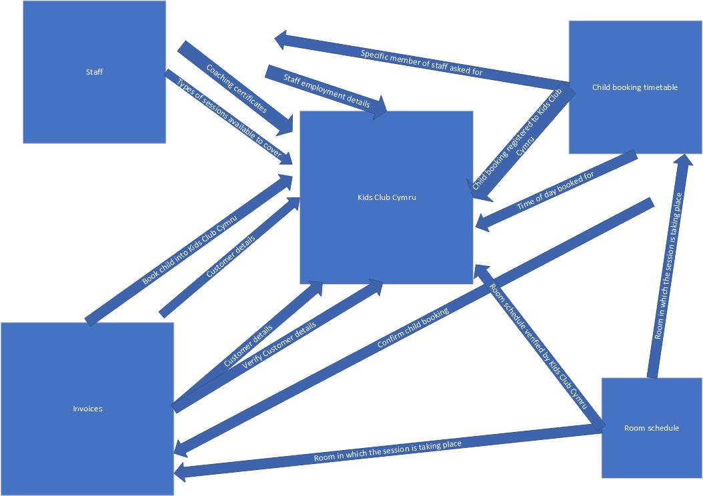

DFD Level 0
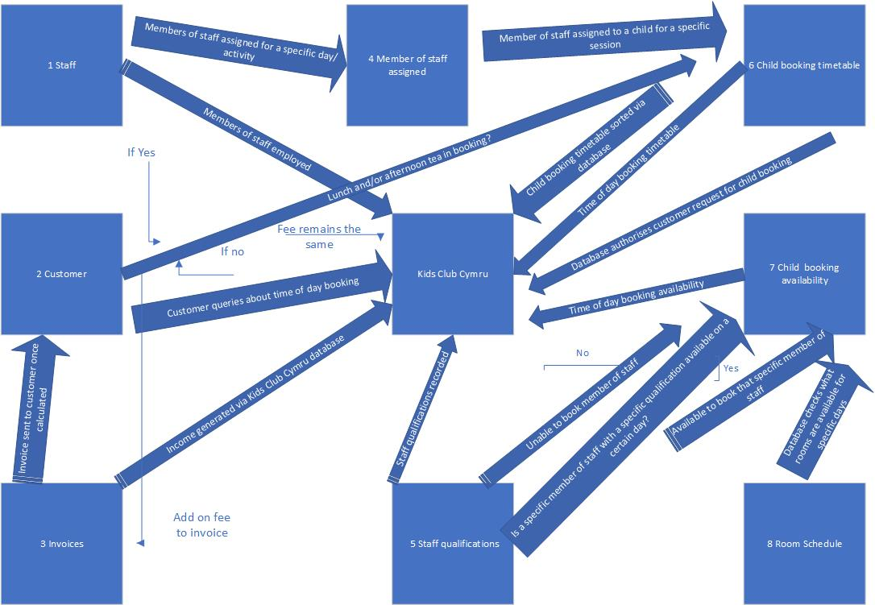

DFD Level 1
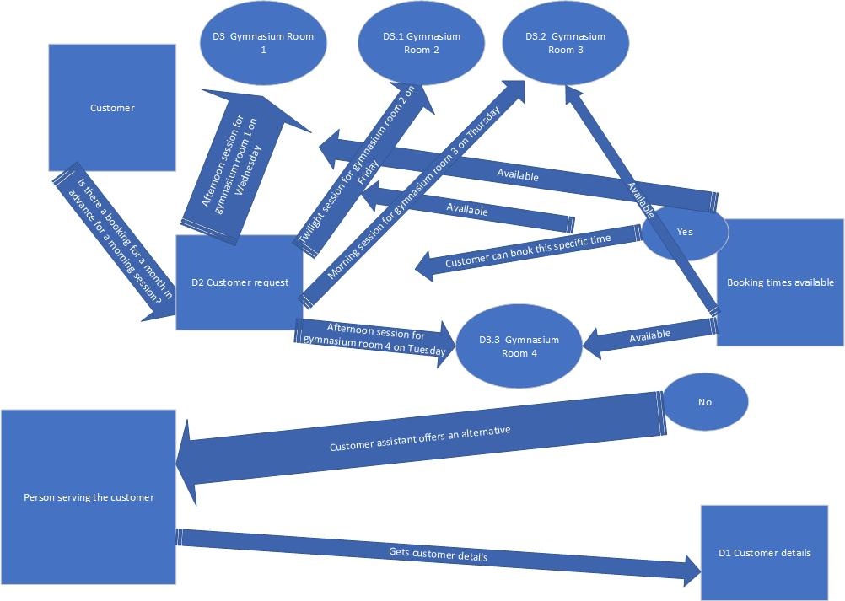

DFD Invoice


