Element 2 Reflective log
Brief description of the activity (no more than 50 words)
Maths activity where children were given the numbers 8,4,3,2 and were to use only these numbers to work out which numbers added up to 9,10,11,12,13,14 & 15. This was with a lower ability group who would usually need supporting in an activity such as this.

Aim/Objective of the activity
To aid the accusation of the concept of numbers, adding numbers and problem solving skills to work out which numbers added up would equal the number that they are given.

Your role
A guide for the activity. Introduce the activity and support the children in understanding the activity and aid in them understanding the concept of adding numbers together to get the required number through trial and error.

Positive aspects – why?
Children worked out 13,14 & 15 on their own without any assistance.

Challenging aspects – why?
Children struggled with the abstract concept of numbers.

What knowledge was demonstrated?
Due to the children struggling with the abstract concept of the numbers as purely numbers and nothing to relate them to, here I implement using pencils in groups of 8,4,3,2 so that the children had something that they could relate the numbers to and use these as props to group together and work out if the ones that they had chosen would add up to the required number. This lead to the children using their problem-solving skills by trying different combinations of the groups of pencils to get to the required number.

What skills were demonstrated?
Problem solving by myself to find a way to help the children understand the concept of the numbers that we were using in the activity.

Which values were demonstrated?
I respected the children to give them the opportunity to attempt the task without any additional aids at first but listened to them when they told me that they didn’t understand. While looking beyond the answers they were giving because they were clearly guessing and had admitted to guessing the answer to me.

What could have been done differently? Why?
For this group, I would in future have pre-made props for them to use to help them add up these numbers to solve the problems. It was very evident that when the props were introduced that they understood the concept of the numbers that they were using and trying to get to and achieved quite well in working out parts of the activity themselves.

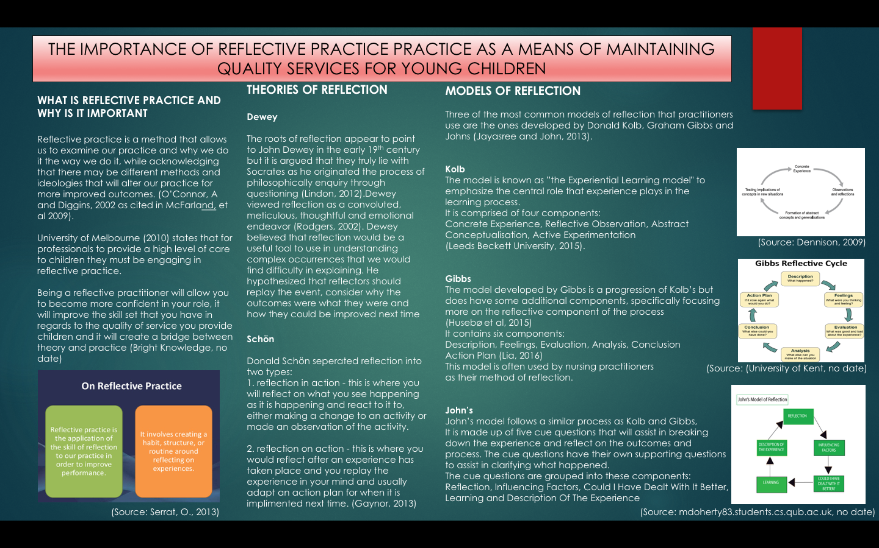

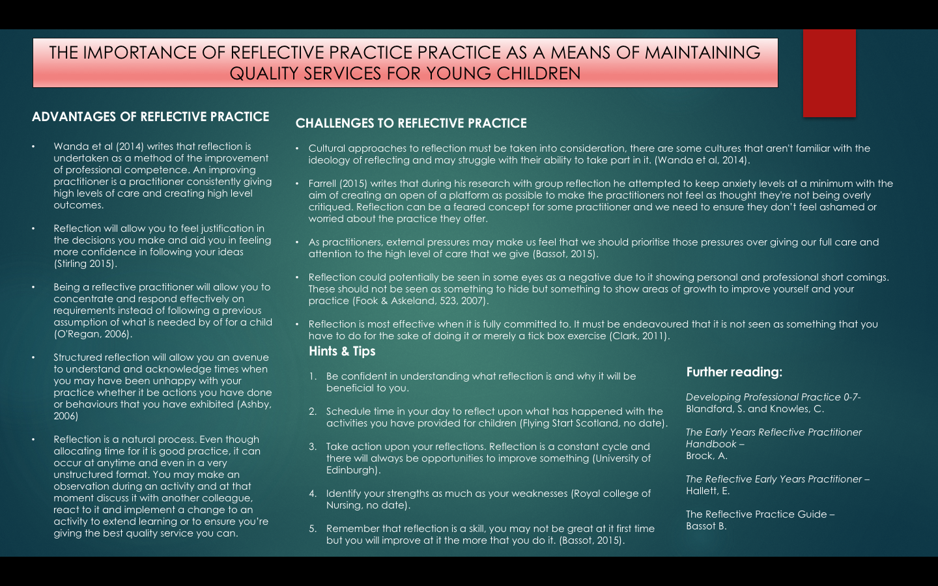

Element 4 Personal Development Plan

GOAL | Area for further development (provide further details) | Why? | How? | Who/Where? | When?
Confidently remember every child’s name within my setting.. | Knowledge  Remembering names of the children in my setting is something that I can be less than perfect on. | Building bonds with the children is vitally important, I feel that confidently using their names to them directly is a key to doing this and not thinking twice about selecting groups of children or handing out books during activities. | Spending downtime seeing children and in my head putting their names to them.  Always hand out named items to children to gain the experience of finding them and remembering who is who | Myself and children within setting.  Completed on a constant basis whenever I am in placement. | End of February 2018
Confidently communicate in five additional languages other than English and Welsh. | Skill:  I would want to learn  - hello,  - goodbye,  - how are you?  - thank you  - please  In these languages  - Chinese,  - Spanish  - Polish,  - Arabic  - Portuguese | Personal development – These are helpful to know and could be used by myself.  Professional development – This would be a highly beneficial skill to have when welcoming new children and parents into a setting, the language familiarity will build early bonds and create an opening for parents to feel more positivity towards myself and the setting. | Learn from more knowledgeable others, this could be children who are already bi-lingual who speak both English and the language that I am trying to learn the phrases from,  Online resources or smart phone apps can help in the pronunciation and is potentially a more time effective way to practice due to being able to practice anywhere that I am | Online resources – Rosetta Stone programme, using itranslate to change words to understand spellings of them  Attending classes outside of school.  Learning from friends/family members who are speakers of the languages  Arranging sessions for staff within a setting to all acquire the terms that we hope to learn | End of March 2018
Achieve football  leaders award from Football Association of Wales (FAW) | Skill  Take football leaders course, start developing my skills on a sporting front to aid the provisions that I can provide children. | This will allow me to be able to lead sporting sessions in guidance with the FAW guidelines.  It will give me an added sense of confidence in my abilities to lead a group of children in the best manner possible. It will also be a starting point for me to add sporting activities into my practice to increase the play aspect of roles and to assist in making the most of physical activity time that the children have. | Find out when and apply to attend a grading day where the FAW run these courses. | Sophia Garden, Cardiff  February 23 is the next available course | End of June 2018

Reference List
Ashby, C. (2006) 'The Benefits of reflective practice' Practice Nurse, Volume 32, Issue 9, pp. 35-37. [On-line]. Available at: http://web.b.ebscohost.com.ezproxy.uwtsd.ac.uk/ehost/detail/detail?vid=0&sid=8f1cf714-2fec-4b6d-94c5-0f2bb9bc683d%40pdc-v- [Accessed: 25th January 2018].
Bassot, B. (2015) The Reflective Practice Guide. London: Routledge. [e-book]. Available at: https://www-dawsonera-com.ezproxy.uwtsd.ac.uk/abstract/9781315768298 [Accessed: 25th January 2018].
Bright Knowledge. (no date) 'What is reflective practice?' https://www.brightknowledge.org/medicine-healthcare/what-is-reflective-practice [Accessed: 24th January 2018].
Clark, J. (2011) 'Let's reflect: what is the point?' British Journal of General Practice, Volume 61, December. [On-line]. Available at: https://www.ncbi.nlm.nih.gov/pmc/articles/PMC3223767/ [Accessed: 25th January 2018].
Dennison, P. (2009) 'Reflective practice: The enduring influence of Kolb’s Experiential Learning Theory' https://journals.gre.ac.uk/index.php/compass/article/view/12/28 [Accessed: 23rd January 2018].
Flying Start Scotland. (no date) 'Top tips for reflecting' www.flyingstart.scot.nhs.uk/learning-programmes/reflective-practice/top-tips-for-reflecting/ [Accessed: 24th January 2018].
Farrell, T. S. C. (2016) 'Surviving the transition shock in the first year of teaching through reflective practice' System, Volume 61, Octover, pp. 12-19. [On-line]. Available at: https://www-sciencedirect-com.ezproxy.uwtsd.ac.uk/science/article/pii/S0346251X16300847 [Accessed: 25th January 2018].
Fook, J and Askeland, G. A. (2007) ' Challenges of Critical Reflection: 'Nothing Ventured, Nothing Gained', Social Work Education, Volume 26, Issue 5, August, pp. 520-533. [On-line]. Available at: http://web.b.ebscohost.com.ezproxy.uwtsd.ac.uk/ehost/detail/detail?vid=0&sid=845e8144-eb8b-4a37-99eb-005d0d043854%40pdc-v-sessmgr01&bdata=JnNpdGU9ZWhvc3QtbGl2ZQ%3d%3d#db=eue&AN=25727743 [Accessed: 24th January 2018].
Gaynor, A (2013) 'Schön’s (1983) Reflection-in-action and reflection-on-action' https://hhs.hud.ac.uk/lqsu/Sessionsforall/supp/Schön reflection-in and -on action.pdf [Accessed: 25th January 2018].
Husebø, S. E., O'Regan, S. and Nestel, D. (2015) 'Reflective Practice and Its Role in Simulation' Clinical Simulation in Nursing, Volume 11, Issue 8, August, pp. 368-375. [On-line]. Available at: https://www-sciencedirect-com.ezproxy.uwtsd.ac.uk/science/article/pii/S1876139915000389#! [Accessed: 25th January 2018].
Jayasree, R and John, S. S. (2013) 'Learning to Become a Nurse: Nursing Student's Perceptions on Reflective Practice' International Journal of Nursing Care, Volume 1, Issue 1, January - June, pp. 33-38. [On-line]. Available at: https://search-proquest-com.ezproxy.uwtsd.ac.uk/docview/1370349628?accountid=130472&rfr_id=info%3Axri%2Fsid%3Aprimo [Accessed: 24th January 2018].
Leeds Beckett University (no date) 'Content Preview: Models for structuring reflection' http://skillsforlearning.leedsbeckett.ac.uk/preview/content/models/02.shtml [Accessed: 25th January 2018].
Lia, P, 'Using Gibbs' Reflective Cycle' (2016) https://www.kcl.ac.uk/campuslife/services/disability/onlineresources/StudyGuides/USING-GIBBS-REFLECTIVE-CYCLE-IN-COURSEWORK-DEC-2016-P-LIA.pdf [Accessed: 25th January 2018].
Lindon, J. (2012) Reflective Practice and Early Years Professionalism, 2nd Edition Linking Theory and Practice. London: Hodder Education. [e-book]. Available at: https://www-dawsonera-com.ezproxy.uwtsd.ac.uk/readonline/9781444167214 [Accessed: 24th January 2018].
McFarland, L., Saunders, R. and Allen, D. (2009) 'Reflective Practice and Self-Evaluation in Learning Positive Guidance: Experiences of Early Childhood Practicum Students', Early Childhood Education Journal, Volume 36, Issue 6, June, pp.505-511. [On-line]. Available at: https://link-springer-com.ezproxy.uwtsd.ac.uk/article/10.1007/s10643-009-0315-2 [Accessed: 23rd January 2018].
Mdoherty83.students.cs.qub.ac.uk (no date) 'John's Model of Reflection' mdoherty83.students.cs.qub.ac.uk/024U/johnsmodel.html
O'Regan, H. (2006) 'Learning to nurse: reflections on bathing a patient' Nursing Standard, Volume 20, Issue 46, July to August, pp. 60-64. [On-line]. Available at: https://search-proquest-com.ezproxy.uwtsd.ac.uk/docview/219841994?accountid=130472&rfr_id=info%3Axri%2Fsid%3Aprimo [Accessed: 23rd January 2018].
Rodgers, C. (2002) 'Defining Reflection: Another Look at John Dewey and Reflective Thinking' Teachers College Record, Volume 104, Issue 4, pp. 842-866. [On-line]. Available at: http://www.bsp.msu.edu/uploads/files/Reading_Resources/Defining_Reflection.pdf [Accessed: 24th January 2018].
Royal College of Nursing. (no date) 'Eight ways to improve your reflection' https://www.rcn.org.uk/professional-development/revalidation/eight-ways-to-improve-your-reflection [Accessed: 24th January 2018].
Serrat, O. (2013) 'Reflective Practice' https://www.slideshare.net/Celcius233/reflective-practice-27714069 [Accessed: 23rd January 2018].
Stirling, L. (2015) 'Students' and tutors' perceptions of the use of reflection in post-registration nurse education' Community Practitioner, Volume 88, Issue 4, pp. 38-41. [On-line]. Available at: https://search-proquest-com.ezproxy.uwtsd.ac.uk/docview/1672169137?accountid=130472&rfr_id=info%3Axri%2Fsid%3Aprimo [Accessed: 25th January 2018].
University of Edinburgh. (no date) 'Tips for effective reflection' www.docs.hss.ed.ac.uk/iad/Learning_teaching/Academic_pastoral/Reflect/Effective_ reflection_tips.pdf [Accessed: 24th January 2018].
University of Kent (no date) 'Reflective learning' https://www.kent.ac.uk/learning/PDP-and-employability/pdp/reflective.html [Accessed: 23rd January 2018].
University of Melbourne. (2010) ‘The Victorian Early Years Learning and Development Framework’ http://www.education.vic.gov.au/Documents/childhood/providers/edcare/evidpaperreflective.docx [Accessed: 24th January 2018].
Wanda, D., Wilson, V. and Fowler, C (2014) 'East meets West in reflective practice' Nurse Education Today, Volume 34, Issue 12, December, pp. 1417-1419. [On-line]. Available at: https://www-sciencedirect-com.ezproxy.uwtsd.ac.uk/science/article/pii/S0260691714002706 [Accessed: 25th January 2018].

