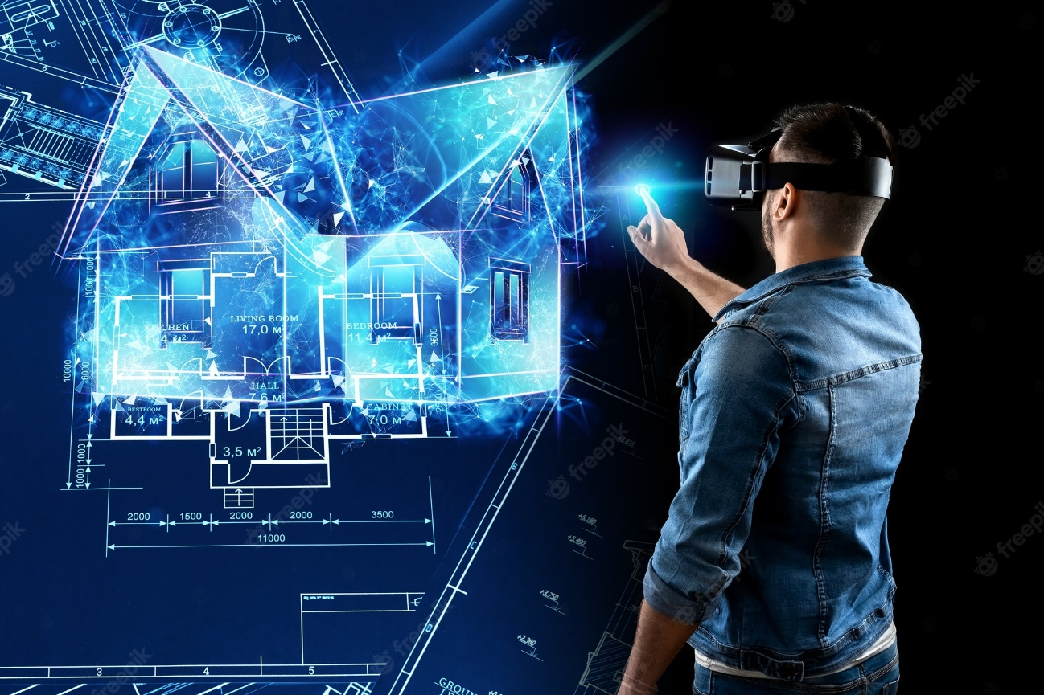
Dissertation synopsis.
The potential future of Virtual reality in architecture.

I chose the topic for my dissertation “the potential future of virtual reality in architecture” because one of the main challenges I struggle with as a student of architecture is the use of 3D planning programs like Revit, this program allows the user to see how the building will look like before is built, so with this in mind, I started wondering: What else can we do in architecture with the use of the virtual reality? How can architects take full advantage of virtual reality? Or how architects can improve the education system through VR?

To find information for my dissertation, with the help of my tutor, I will try to contact architects and professionals from the digital world to be able to interview. I will also create a survey to get an idea of ​​what people think about virtual reality and architecture. In addition, I will access articles written on the subject, both in magazines, books or on the internet, and I will also investigate papers from previous years written on the subject.
The objective of this research is to be able to understand how the world of virtual reality works and to be able to use it in all its power in the world of architecture.
The dissertation will address the following objectives: Thorough knowledge of what virtual reality is. What do architects think about the use of virtual reality in their firms? Or how, with the use of virtual reality, architects can improve their future designs and communication with clients.

Some of the references that I will use during my research will be scientific magazines, architectural magazines, papers written on the subject from years past, as well as surveys and interviews.
Some of the limitations that I may face during my research will be the lack of responses to my surveys and interviews, another limitation that I may encounter will be the lack of information on the subject in the aforementioned magazines.
In interviews there is always a risk of privacy, the person you interview will not want their identity to be revealed, therefore, with the permission of the interviewee, and false names will be used.
To have a better performance in the research and writing of the dissertation, it will be more productive to set short-term goals, for example:
Have all the questions for the interviews ready and send them to the interviewees no later than mid-November.
Prepare and send the survey questions no later than mid-November.
Hopefully, I will be able to get all the answers to the surveys and interviews by the beginning of January, to be able to organize the information that will later help me in writing the dissertation.
In a conclusion, it can be described how useful virtual reality can be in the world of architecture, and how it can be improved.

I will like to choose Ryan Stuckey as my tutor for my dissertation.

