DIGITAL SKILLS AND RESEARCH METHODS
BMSW4003
University of Wales TDS
Leturer:Ejiro Esohwode
06/05/2021
Mateo Cavaliere (2018575)

Executive Summary
Throughout the methodology of digital skills, it has been seen that students are highly interested about their new learning methods. They are satisfied with their colleges and it enhances their digital performance as well. Students are getting adaptable towards this new learning environment which help them to get comfortable with the new work culture.

Table of Contents

Introduction 4
Discussion 4
Research Aim 4
Research Objectives 4
Literature Review on “effects of VLE on the University’s student” 4
Methodology 5
Primary Data collection (Survey) 5
Quantitative Data Analysis 5
Secondary Data Collection 15
Concept of VLE 15
Effects of VLE on student’s Learning experience 15
Benefits and challenges of VLE from a student’s perspective 16
Importance of VLE in current situation 16
Approach of VLE improving the learning experience of students 17
Application of learning from VLE into a workplace 17
Conclusion 17
Reference list 18

Introduction
Virtual Learning Environment (VLE) was launched to initiate and encourage students for active learning rather than studying passively. This research talks about the significant effects of Virtual Learning Environment at University of Wales and how it has helped the students to learn during this pandemic situation. This research paper will also contain discussion about various aspects of virtual learning which will improve the online skills of the students at their workstations in near future.

Discussion

Research Aim
This research mainly aims to find out how the Virtual Learning Environment (VLE) has an impact on the students of the University of Wales, and how it has helped the students to improve their digital skills effectively in their workplace and also how efficiently they can translate that information into knowledge.

Research Objectives
- To identify the help obtained from VLE in the improvement of the digital skills of the students
- To evaluate the guidance offered by the University to the students, thus they effectively analyse the information and transform it into knowledge.
- To identify the approach through that the VLE (Virtual Learning Environment) created an impact on the learning experience of the students associated with the University of Wales.
- To collect primary data from surveying the respective university’s students on the aspects of VLE
- To gather secondary information by researching secondary sources such as database of scholar

Literature Review on “effects of VLE on the University’s student”
According to Peterson-Ahmad et al., (2018), the environment for virtual learning is a combination of virtual and real worlds to give the users a feeling about the digital environment. VLE plays a very important role for improving the development skills in the digital industry mainly for the University’s students. Virtual learning these days is combined with educational organizations. So, it is great for virtual learning systems to improve the performance of the students. Virtual learning process mainly deals with teaching the students in formal style and processes of learning and interrogating their abilities on the basis of their known features. This study also identifies how digital learning methods have motivated the students of the University of Wales to learn new things. It also suggested that all the teaching staff of the University should use these virtual learning techniques to make learning more interesting and attractive to the students. However, there are also many disadvantages, as the students sometimes feel that it is highly challenging for using some forms of digital technologies meant for educational purposes. On the other hand, Budai and Kuczmann, (2018) stated that the main disadvantages for using digitized laboratories is that there is lack of stability in the laboratories mainly in the graphical user interfaces Besides the internet connection, the capacity of the computers and laboratories can be a threat for implementation of VLE. However, besides all these obstructions, Virtual Learning Environment has emerged to be quite satisfactory for the students as in case for the students of Wales University. Papanastasiou et al., (2019) commented that Virtual Learning Environment acts as a tool which is mainly used for educational purposes. It indicates that this method is highly encouraging for the students and it gives feelings of positiveness and a sense of enthusiasm among them to learn new things.

Methodology

Primary Data collection (Survey)

Quantitative Data Analysis

Quantitative-Data directs the researcher to involve the students of the respective university regarding effects of VLE on their growth, development, and current experience. Thus, the researcher involves a total number of 60 students belonging to the same university for being surveyed in order to achieve the objectives of this report.

Q1: Which kind of response do you get from the Wales University on Virtual Learning ambience during Covid-19 pandemic situation?
Options | Percentage | Responses | Total number of respondents
Highly responsive | 41.66% | 25 | 60
Moderate Responsive | 33.33% | 20 | 60
Below average | 16.66% | 10 | 60
Unresponsive | 8.33% | 5 | 60

Table 1: Student’s response on virtual-learning

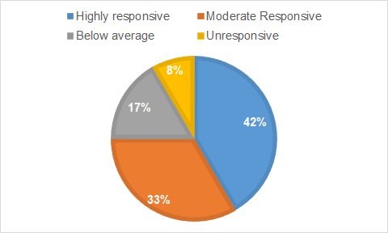
Figure 1: Student’s response on virtual-learning

Analysis:
Students have responded well regarding the matter of virtual learning during covid-19 pandemic. According to their opinion the university has a great impact on their virtual learning. A large number of students are satisfied by the virtual communication of their university. It is an indication that the next generation of the modern world is upgrading them by the new version of information technology. They are active to learn this new way of learning education.
Q2: How does Virtual Learning help you to gain digital skills helping you to be effective at your workplace?

Options | Percentage | Responses | Total number of respondents
Helpful | 50% | 30 | 60
Moderate | 16.66% | 10 | 60
Unhelpful | 20% | 12 | 60
No comment | 13.33% | 8 | 60

Table 2: Student’s response on adapting digital platform
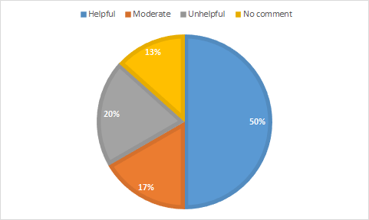

Figure 2: Student’s response on adapting digital platform

Analysis: In the era of digitalization students are aware about their own performance on digital skills. They know that it increases their chances to get better work in future although some of them are still abound by the stereotype. More than the average number of students believe that digital learning skills is going to help them in the future enormously.

Q3: What changes that virtual learning brings to you on the time management behavioural approach?

Options | Percentage | Responses | Total number of respondents
Efficient enough | 51.66% | 31 | 60
Handling stress easily | 33.33% | 20 | 60
Focused and attentive | 8.33% | 5 | 60
No changes at all | 6.66% | 4 | 60

Table 3: Student’s response on effective time management
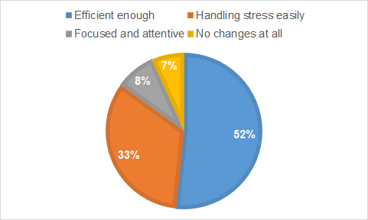

Figure 3: Student’s response on effective time management

Analysis: During the pandemic situation of Covid-19 students have experienced a lot of things. According to their perception, time management is one of the best things among others. Virtual learning methods teach them how to maintain professional life even when the person is at home. Discipline is mandatory to achieve success in life. As per student’s time management behaviour helps to understand the value of time.

Q4: Does virtual learning help you to translate the information you gather from different sources, into knowledge?

Options | Percentage | Responses | Total number of respondents
Yes, effectively | 30% | 18 | 60
Helps in only specific manner | 45% | 27 | 60
No | 11.66% | 7 | 60
Do not know | 13.33% | 8 | 60

Table 4: Student’s response on information gathering via virtual learning
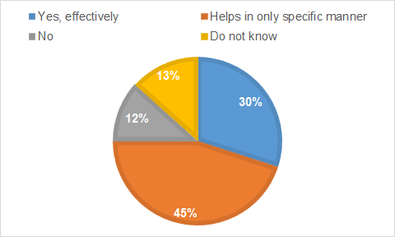

Figure: Student’s response on information gathering via virtual learning

Analysis: Students get to know lot of things apart from learning via digital learning skills. It develops their interest on information technology.

Q5: Does Online test help you to evaluate your knowledge properly through virtual learning?

Options | Percentage | Responses | Total number of respondents
Yes, helpful | 50% | 30 | 60
Average helpful | 16.66 | 10 | 60
Neutral | 20% | 12 | 60
Unresponsive | 13.33% | 8 | 60

Table 5: Student’s opinion on online examination
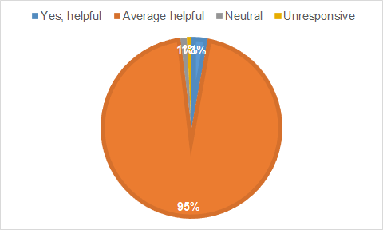

Figure 5: Student’s opinion on online examination

Analysis: Digitalization has a great impact on online examination. They are loving it because it gives them comfort to learn in a better way.

Q6: As per your opinion, how would you rate your current digital skills after being a part of VLE offered by your University?
Options | percentage | Responses | Total number of respondents
5 | 58.33% | 35 | 60
4 | 25% | 15 | 60
3 | 8.33% | 5 | 60
Below 3 | 8.33% | 5 | 60

Table 6: Student’s rating about digital skills of virtual learning
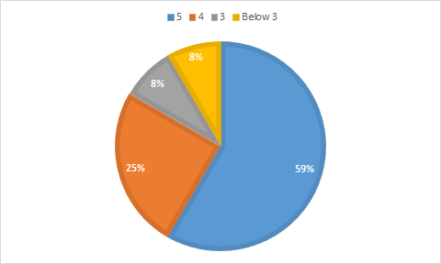

Figure 6: Student’s rating about digital skills of virtual learning

Analysis: As per rating students are happy to learn in this new digital era. They are getting habituated with it.
Q7. Do you agree with the statement that “VLE is a catalyst for enhancing yourself to highly be adaptive towards digital skills”?

Options | Percentage | Responses | Total number of respondents
Highly agreed | 36.66% | 22 | 60
Agreed | 31.66% | 19 | 60
Neutral | 18.33% | 11 | 60
Disagreed | 15% | 9 | 60

Table 7: Student’s view on virtual learning environment as a adaptive digital skill

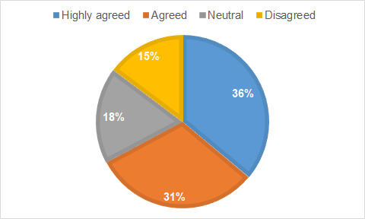

Figure 7: Student’s view on virtual learning environment as a adaptive digital skill

Analysis: Student’s view is satisfactorily on the selective issue. Virtual learning experience is the first time experience for the students and they are trying to learn every day. It takes time to become tech-savvy for students.

Q8. How does your university enhance digital skills on effective virtual learning according to your opinion?

Options | Percentage | Responses | Total number of respondents
Engaging Activities | 16.66% | 10 | 60
Games | 66.66% | 40 | 60
Treasure Hunt, | 13.33% | 8 | 60
Fast-Facts | 3.33% | 2 | 60

Table 8: Student’s review on their university’s performance about effective digital skills

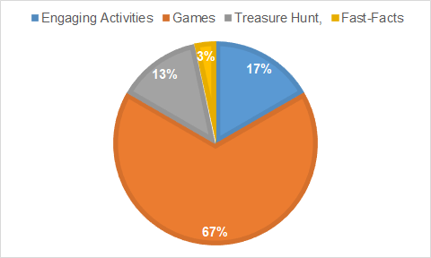
Figure 8: Student’s review on their university’s performance about effective digital skills

Analysis: University has performed well according to students on digital field. They are always there to help students if students are facing any kind of problems.

Q9. Is your university able to meet your expectations through virtual learning?

Options | Percentage | Responses | Total number of respondents
Yes | 58.33% | 35 | 60
No | 16.66% | 10 | 60
Do not know | 16.66% | 10 | 60
No comment | 8.33% | 5 | 60

Table 9: Student’s response on their expectations meet by the selective university

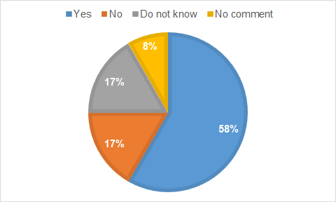
Figure 9: Student’s response on their expectations meet by the selective university

Analysis: As per students they are happy with the online learning procedure of their college. This satisfaction helps to increase their better performance day by day.

Q10. Would you like to continue with the current system of education (VLE)?

Options | Percentage | Responses | Total number of respondents
Yes, completely | 41.66% | 25 | 60
No-good for sometimes only | 50% | 30 | 60
Never- physical learning was better | 6.66% | 4 | 60
Do not know | 1.6% | 1 | 60

Table 10: Student’s opinion on current virtual learning system of education

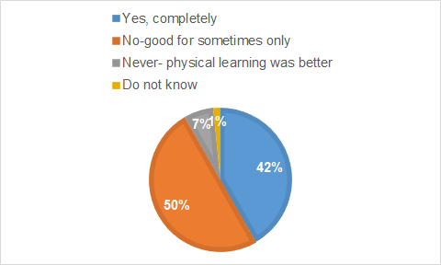

Figure 10: Student’s opinion on current virtual learning system of education

Analysis: According to the students they would like to continue the current status as it enhances their technological skills as well.

Secondary Data Collection

Concept of VLE
The concept of virtual or online learning environment is about a package of learning and educational tools. This software is mainly made to improve a student’s experience in learning. This learning environment includes desktops and facilities of the internet connection. Some main and essential provisions of this software are tracking of students, virtual support for educators and learners and digital communication between learners and educators. Generally users of this online learning environment software’s are given either an ID of teachers or learners. The educator has some added benefits as it enjoys the fundamental rights of the user to make or change the structure of the content and they can also check the performance of a student. Some general tools of VLE are blackboard, COSE and Web CT. In VLE interaction happens face to face and it initiates virtual conferences (Hamid et al., 2018).

Effects of VLE on student’s Learning experience
Recently, VLE software is in use in most of the educational institutions of the UK to promote and encourage several styles of learning. Learning in a virtual environment currently evolved as a significant factor in the theory of education. It is an integral and useful software for the students who are learning from distance or working in an organization on a part time basis. A good VLE software, gives learners various styles of learning so that they can get the best education from it.
Experience of a learner in a real classroom mainly depends upon the style of teaching which can easily fit into the learning style of an individual. Same with the virtual environment of learning experience that is there should be the existence of various styles of education for better understanding of the course. Tools of administration is an added advantage for the tutors as students who are learning from a distance, can be easily tracked by an educator. Students also have a facility for assessment submission virtually. Usage of this online reality in theory of education giving several researchers an opportunity to form an environment of learning with features that are not possible to implement in the actual world ( Peng et al., 2019).

Benefits and challenges of VLE from a student’s perspective
A virtual learning environment comprises advanced educational tools that provides easy virtual learning. This software consists of a mechanism of delivery, tutors can easily track learners and students can easily access the information. This system of learning is made to create, focus on learning activities of students with added benefits. The most desirable provision of this software is that it allows learners and educators to communicate remotely. Thus, they don't need to go for classroom coaching which is a very important and useful mode of education in this current situation of pandemic. This software also consists of an email facility which is an essential app for communication. It also encourages active involvement of the students where they can participate in virtual discussion, which helps the learners to involve actively with a subject and also in the process of learning. This system also includes tracking of students where teachers can check the frequency of accessibility of a learner for a course. But it has one drawback that is found, that most of the students look up to resources of VLE as digital versions of a lecture. But they don't use it for additional data for getting better knowledge of the course. The advancement of technology has enabled them to adopt electronic footprints in learning methods for using VLE (Nguyen et al., 2017).

Importance of VLE in current situation
Today, due to the emergence of covid-19 pandemic, digital learning technology is growing at a rapid rate. As people today are confined at home, they mainly depend on digitized technology. Many schools, colleges and universities are closed due to the pandemic situation. So most of them depend on Virtual Learning Technology for educational purposes. Most of the educators today are providing online learning materials for children to continue their studies by sitting at home. Though taking online classes might be a new idea for the Indian colleges and Universities, but the concept today is increasing at a rapid rate. Moreover, making online classes interesting and attractive for the students mainly depends on the creativity of the teachers.

Approach of VLE improving the learning experience of students
Today, the Virtual Learning Environment is becoming popularized day by day. It helps to improve the learning techniques of the students. The students today can sit together beside their computer screens and attend the lectures given by their teachers. They can also attend different meetings, read documents and many others. They can do all these by sitting at home at the comfort of their own mobiles and laptops. Thus the students can concentrate on their studies more and it helps to provide a better learning experience.

Application of learning from VLE into a workplace
The opportunities of virtual learning techniques have been seen in the workplace today. Due to online learning technology, the students are becoming technologically advanced as they have adapted themselves to this new normal situation where work from home is in current trend. This will help them in future to get a better job opportunity.

Conclusion
From research it is found that Virtual learning Environment software playing an integral part in this current scenario of pandemic. Students are getting adaptable towards this new learning method and hopefully in future. VLE software will help the students to get comfortable with the new work culture

Reference list

Budai, T. and Kuczmann, M., 2018. Towards a modern, integrated virtual laboratory system. Acta Polytechnica Hungarica, 15(3), pp.191-204.
Hamid, Z., Peng, C.F., Shaharom, M.S.N., Ter, T.C. and Raman, K., 2018. The concept and use of the virtual learning environment in teaching: a literature review. International Journal of Academic Research in Business and Social Sciences, 8(6), pp.1293-1301.
Nguyen, Q., Rienties, B. and Toetenel, L., 2017, March. Unravelling the dynamics of instructional practice: A longitudinal study on learning design and VLE activities. In Proceedings of the seventh International learning Analytics & knowledge conference (pp. 168-177).
Papanastasiou, G., Drigas, A., Skianis, C., Lytras, M. and Papanastasiou, E., 2019. Virtual and augmented reality effects on K-12, higher and tertiary education students’ twenty-first century skills. Virtual Reality, 23(4), pp.425-436.
Peng, H.H., Lin, Y.T. and Wu, T.L., 2019, December. The Effects of Virtual Learning Environment on High School Students’ English Learning Performance and Attitude. In International Conference on Innovative Technologies and Learning (pp. 815-824). Springer, Cham.
Peterson-Ahmad, M.B., Pemberton, J. and Hovey, K.A., 2018. Virtual learning environments for teacher preparation. Kappa Delta Pi Record, 54(4), pp.165-169.

