

Chris Atkinson – 1603207

Level 6. BSc (Hons) Construction Management

Module: Advanced Construction and Civil Engineering Construction
Assignment Title: Urban Renewal.

Table of Content
Ref No | Content | Page No
1. | Introduction | 3
2. | Objective | 3
3. | Location | 3
4. | Walk Over Survey | 4
5. | Radon Gas | 4
6. | Mining Report | 4
7. | Basement Construction | 5
7.1 | Bottom-Up Method | 5
7.2 | Diaphragm Wall | 6
7.3 | Basement Waterproofing | 7-8
7.3.1 | Basement Performance Levels | 7
7.3.2. | Waterproofing Systems | 7-8
7.3.2.1. | Cementitious Coatings | 7-8
7.3.2.2. | Cavity Drain Membranes | 8
8. | Structural Steel Frame | 9-10
9. | External Envelope | 10-11
9.1. | Rainscreen Cladding | 10-11
9.1.1 | Interlocking Cladding System | 11 - 12
9.2 | Roof Coverings | 12 -13
10. | Conclusion | 13
11. | References | 14
12. | Appendices | 15-22

Table of Tables
Table No. | Content | Page No
1 | Basement Performance Levels | 7

Table of Figures.
Figure No. | Content | Page No
1 | Location of Site | 3
2 | Location of Site | 3
3 | Boundary of Site | 4
4 | Radon Map | 4
5 | Mining Map | 4
6 | Bottom-up Method | 5
7 | Diaphragm Walling | 6
8 | Basement Construction | 6
9 | Cementitious Coatings | 8
10 | Cavity Drain Membranes | 8
11 | Steel Column Base Detail | 9
12 | Intermediate Floor Detail | 10
13 | External Cladding System | 11
14 | Roof Covering Detail | 12

  - Introduction.
The construction of a significant mixed used tower block built in St Mary’s Street in Cardiff City Centre. The proposed site is of a dated office/retail structure, an existing 1970’s structure that links Westgate Street and St Mary’s Street.
  - Objective.
There is a requirement to create flexible office accommodation, recreation/leisure and residential serviced apartments with two story retail units near ground level. The building should have a maximum height above the existing ground level of 16 floors together with a four-story basement that will house building services, three floors of multi-story car parking and a gymnasium/spa. Floors 0 to 6 are to designated for use as offices, with serviced apartments above that can be rented on a flexible, short-term basis by visitors to Cardiff.
  - Location
The Proposed site is to be located in the heart of Cardiff City Centre, St Mary’s Street. The Site is set in a Conservation Area and surrounded by many listed buildings. The proposed new structure is to be a significant marker as to how twenty first century buildings can make a positive contribution to the landscape.
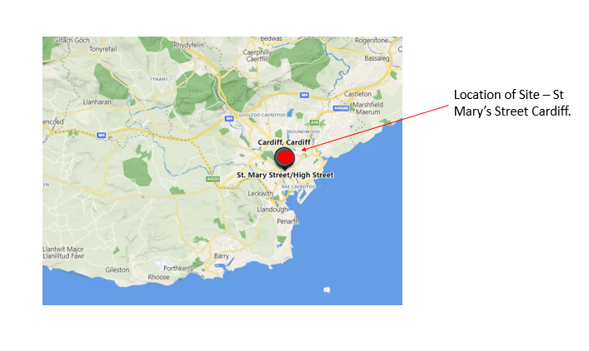Fig 1. Location of Site
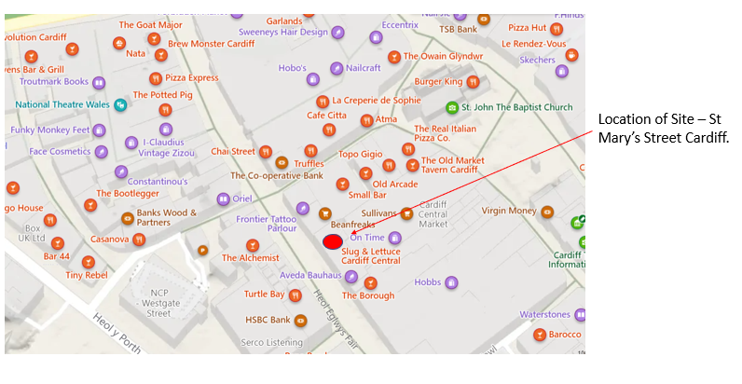Fig 2. Location of Site
  - Walk over Survey.
The site is currently a brown field site which will require demolition prior to the construction works commence. The structures currently sit on the site parameters therefore demolition and construction will need to be well planned, designed and risk assessed well in advance.
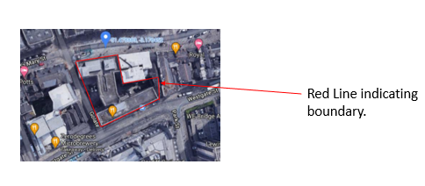Fig 3. Boundary of Site.
  - Radon Gas
The Radon Gas report shows that the Site Location in Central Cardiff is at low risk to Radon Gas Exposure. The map below indicates the darker shaded areas are more at risk to high levels of Radon Gas Exposure (UK – Uk maps of Radon, 2022.)
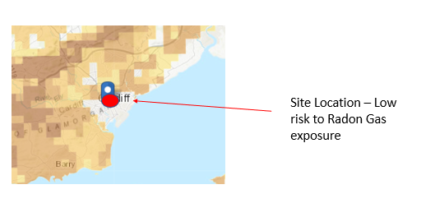 Fig 4. Radon Map.
  - Mining Report
The Mining Report Map below indicates the mining area outlined in black. This clearly shows that Central Cardiff historically is not located in Mining areas. (Coal Mining Information, 2022)

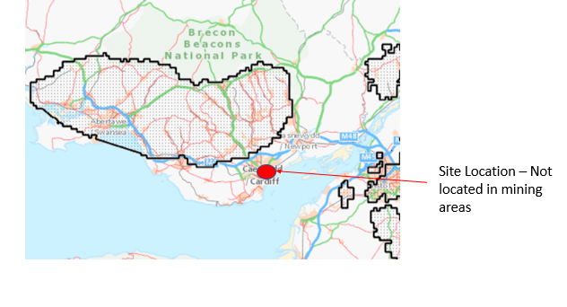 Fig 5. Mining Map.

  - Basement Construction.
7.1. Bottom-Up Method.
The majority of major construction projects involve digging large excavations in the ground and different types of excavations could have a large consequence on Programme and Costs. A lot of large schemes have adopted the approach of ‘bottom-up’ method. With the location and the proposed scheme being constructed on the perimeters of the site, the construction of the Basement will need to carefully designed, managed and constructed to ensure safety of surrounding buildings and general public.
To construct using a ‘bottom up’ method, retaining structures will need to be in place before excavation can begin. This method entails installing piles into the ground to the depth required. Then the requirement to excavate and remove soil. Whilst excavating the soil, strutting would be required to brace and hold the retaining structures in position. The excavation and removal of soil would continue this process until the required depth is reached and at this level is where a concrete slab would be installed as a base.
Using this construction, the design can often be easier, if this is the case the costs can be found to be lower than other methods such as the ‘top-down’ approach. The bottom up approach is also often quicker to design. A heavy construction foundation, like piled foundations for hire rise structure are required and are constructed/driven into the ground floors before excavation.

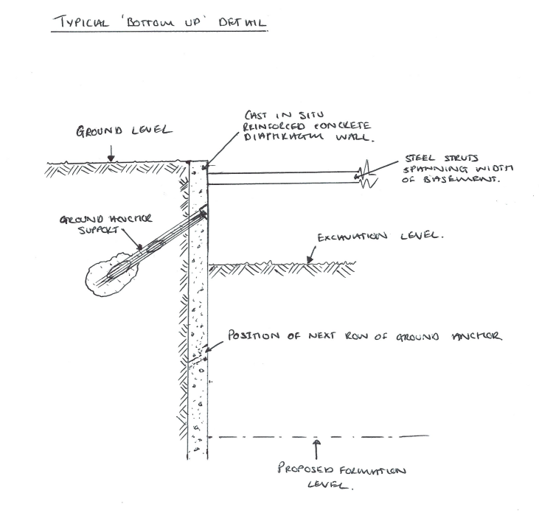 Fig 6. Bottom-Up Method.

7.2. Diaphragm wall.
A concrete structure wall which is known as a diaphragm wall is a large concrete wall constructed in a deep/large trench excavation. This is either concrete pour cast in situ or installing precast concrete components. A Diaphragm wall are often used in tight sites where there is not much room for movement and excavation and where the proposed constructed building is close to existing structures or where the excavation is very deep and a great volume of soils will need to be excavated out.

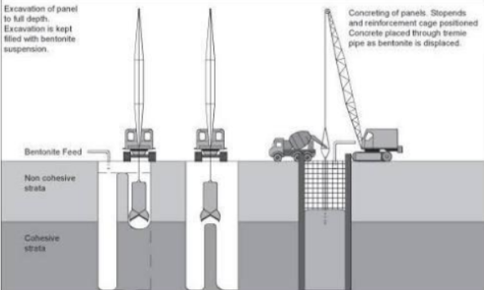 Fig 7. Diaphragm Walling
Diaphragm walls can be and suitable in most subsoils and to install the diaphragm walls there is not a great deal of vibration and noise therefore it improves its suitability to be used and installation method near existing buildings. To add to this concrete slab connections and formwork can be easily used/connected to the walls. Generally, the walls range from 500mm to 1500mm in thickness and can be excavated to a depth of over 50m. There is a high cost when it comes to diaphragm walling which can make them unviable and not economic unless they are constructed into and part of the building. They are best used and suited in underground carparks and basements. (Diaphragm Wall – an overview, 2022)
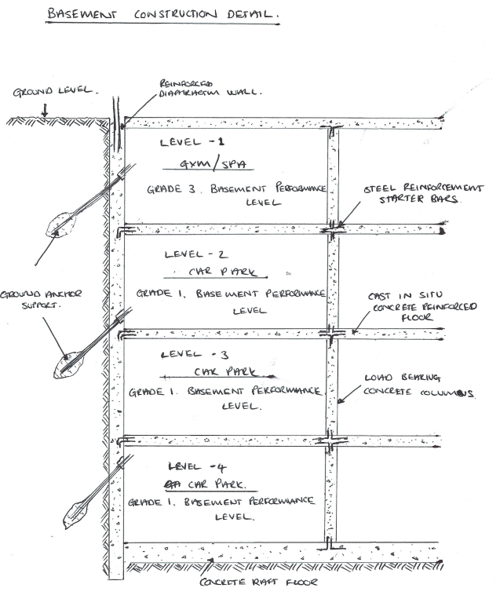 Fig 8. Basement Construction

7.3. Basement Waterproofing.
For basements to function in the correct way for its use, they will need to reach a level a dryness compliance for its use. No basement is completely dry. Water, will always be present in materials in buildings and in air. However, buildings will be known as dry if the ‘water’ present does and is not become a problem for the people or contents of that building. Underground car parks are at 75% relative humidity and will/could have a number of no issue damp areas, they also ,ay be condensation on the walls and this would be considered to be dry. Unlike offices, and office could have no signs of damp appearing on any walls a no visibility of condensation but does have a relative humidity of 75% could be seen as being damp. (Basement Waterproofing, 2022)

7.3.1. Basement Performance Levels.
Grade | Basement Usage | Performance Level
1 | Car Parking, Plant Rooms (excluding electrical equipment) workshops | Some seepage and damp patches tolerable.
2 | Workshops and Plant rooms requiring drier environment, retail storage areas. | No water penetration but moisture vapour tolerable.
3 | Ventilated residential and working areas, including offices, restaurants, leisure centers. | Dry environment.
Table 1. Basement Performance Levels. (Basement Waterproofing, 2022)

7.3.2. Waterproofing systems.
7.3.2.1. Cementitious coatings.
A Cementitious Coating is ready mixed compounds which are fine graded aggregates, chemical additives and cement. This is supplied in a powdered material and is mixed with water on site. Once mixed the Cement based material can be applied by a spray machine, by brush or trowel to form a coating. This can be applied directly onto the wall make up e.g blockwork/concrete or can be applied to a render basecoat which has already been applied to the substrate. The Cementitious Coating can also be modified with polymer to improve workability, flexibility, elasticity and adhesion onto the substrate. The Cementitious Coating can be installed straight onto concrete walls which would achieve an viable waterproofing system.
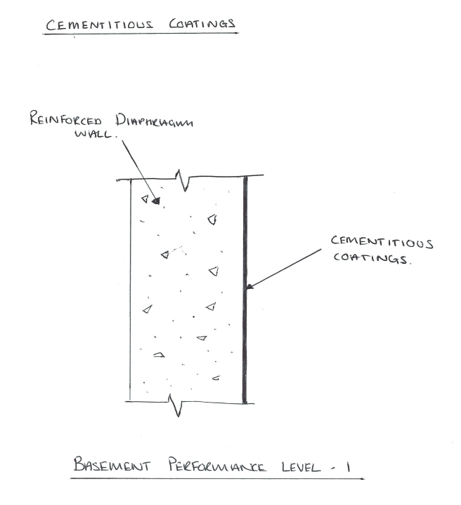 Fig 9. Cementitious Coatings
7.3.2.2. Cavity drain membranes
A Cavity drain membrane is a thick sheet material which is made from Polyethylene. This is vaccum formed to make domes, which when the polyethylene sheet is installed to the wall or floor, it creates cavaties between the sheet and the wall or floor. Any water that would be leaking through the retaining structure would be designed and diverted through the cavity to preconstructed drains or sump. The water can then be mechanically pump away or allowed to naturally drain away. (Basement Waterproofing, 2022)
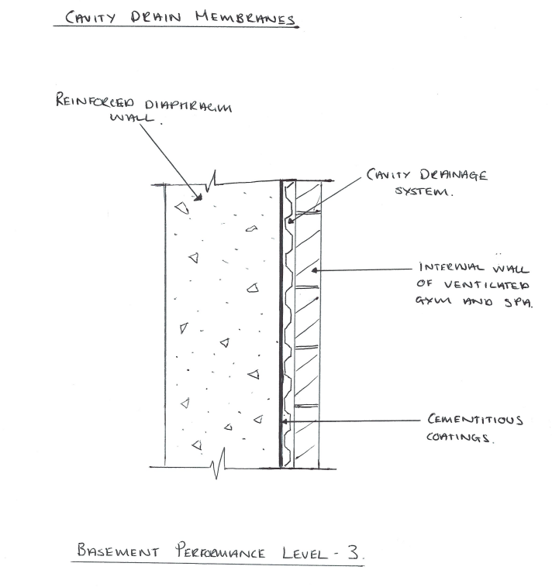 Fig 10. Cavity Drain Membranes

  - Structural Steel Frame.
The construction of Steel Frame is often used in high-rise buildings. The Steel frame is often used as the ‘skeleton’ of the building, these are generally and typically vertical columns, horizontal beams which tend to be bolted, riveted or welded together in a rectangular shape for strength. The Steel beam is a horizontal member that is structural and resists/takes the loads that are applied to it laterally. The Steel column is a vertical member that is structural and transfers comprehensive loads.
Advantages of Steel Frame:
- High in strength
- Relatively low in weight
- Its ability to span large distances
- Ease of installation
- Off-site fabrication
- Adaptability to any kind of shape
- Ability to be clad with a wide variety of materials
- Suitability to a wide range of joining methods.
- The ability to adapt if the use of the building requires it to.
Assuming the material is properly maintained, steel can last for a long time and can exceed timber or concrete structures. Steel will not split or crack like timber, is not vulnerable to insect attack either. Steel will also not expand when it is exposed to an excessive amount of moisture like timber. However, steel having contact with water is an issue and must be prevented. Corrosion may be a result. A coating of fire-resistant material must be applied.
Steel is a very strong material. Bays in the steel structure can have wider spacings which also creates wider bays. If the bays are wider, this allows for more flexible floor designs and adaptions and alteration can be made easier at a later date and can make the most the available space. Although concrete construction is strong, the design is limited as well as the floor-to-floor construction height as well as the wider spanning needed. As mentioned above a great advantage steel construction has is that it is easily adaptable to sudden designs changes. Steel frame - Designing Buildings
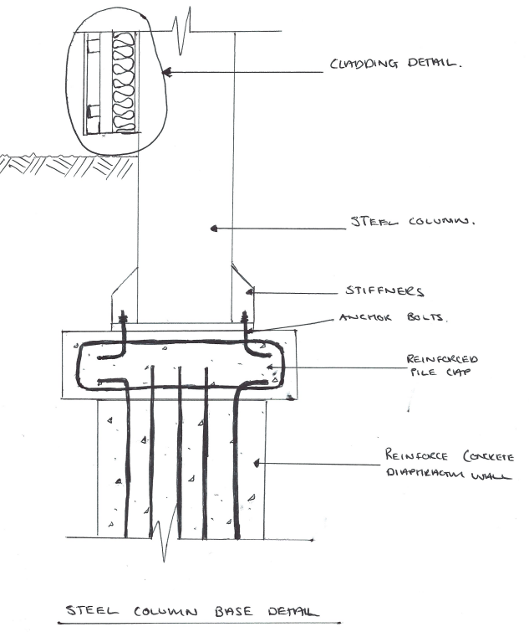 Fig 11. Steel Column Base Detail
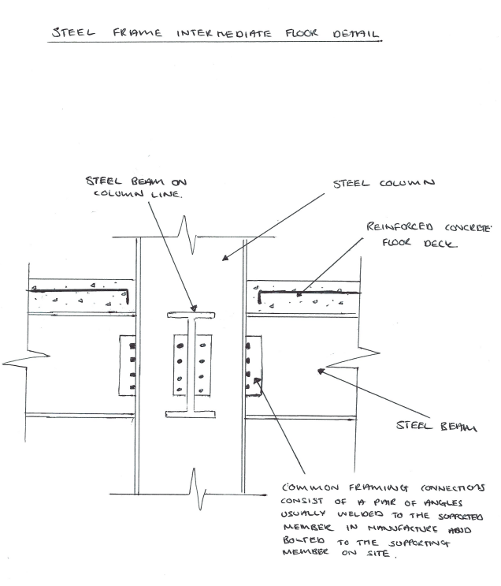 Fig 12. Intermediate Floor Detail

  - External Envelope.
9.1. Rainscreen Cladding.
Rainscreen Cladding is used as a two wall construction and are used and constructed as the exterior wall of buildings.
The Centre for window and cladding technology (CWTC) defines rainscreen cladding system as ‘a wall compromising and outer skin if panels and an airtight insulated backing wall separated by a ventilated cavity. Some water may penetrate inti the cavity but the rainscreen is intended to provide protection form direct rain.’
Usually, rainscreens are constructed of relatively thin, factory manufactured panels. The term ‘Rainscreen’ means that the material is to stop a significant amount of water driving into the main structural part of the wall construction.
There are two basic types of rainscreen;
- Drained and ventilated rainscreen cladding systems. This system allows any penetrating rain to drain or evaporate and vent to the outside. In this system it is vital that the detail to the façade is that any water that penetrates through cannot cross the gap/cavity which sits between the cladding and the internal wall make up
- Pressure-equalized rainscreen cladding system. This system allows air movement between the inside and the outside of the rainscreen. This allows the pressure across the rainscreen to be equal and that water is not driven or sucked through the joints.
Rainscreen claddings can be made from various materials, Copper, aluminum, stainless steel, zinc etc. Terracotta, brick slips, stone panel and timber are a number of materials that can be used as a rainscreen cladding option also.
Rainscreen Cladding is a cost effective, easy to install and lightweight component. Its is easy to maintain and easy to replace. In some cases, the cladding system can simply be clicked onto support rails without needing any further fixing detail.
9.1.1. Interlocking Cladding System.
A fully engineered cladding system developed to provide a format module to cover various faces of a building from walls to ceilings and feature areas. An economical system that uses small gauge thickness of material whilst achieving a structurally robust performance. The panels are formed into planks creating a clean, crisp and contemporary lineal affect. The system holds the correct certification which has undergone tests for water tightness, wind resistance and hard/soft body impact. This system, helps to maximize the buildings thermal efficiency because of its double wall construction and provides ventilation between the cladding and the structure. The proposal is to use a Copper finish interlocking cladding system to enhance on the regeneration of St Mary’s Street. (Technical Information, 2022)
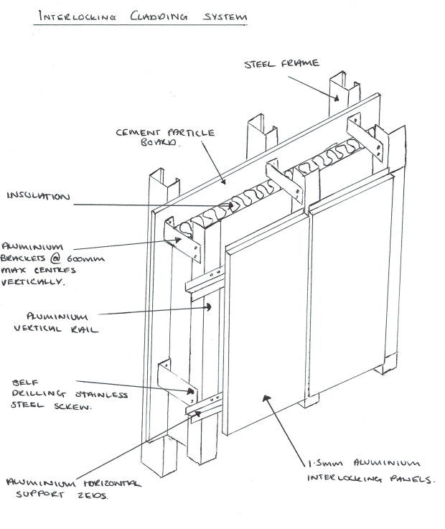 Fig 13. External Cladding System
9.2. Roof Coverings - Single Ply Membrane Systems
The use of single ply membrane has expanded greatly in the past 40-50 years. It is considered to be a reliable commercial roofing material. With its extended service life, single plies require considerably low maintenance. Single ply roofing systems are all generally back by a manufacturer’s warranty. This roofing system gives reliability on its strength, flexibility and durability. This pre-fabricated sheet has the advantages of consistency in quality of manufactured product, the versatility in their fixing methods and their wider applicability. Thermosets and Thermoplastics are the two major categories of ply membranes in the industry.
Thermoset membranes are manufactured from rubber polymers. The most popular one used in the market is EPDM also known as Ethylene Propylene Diene Monomer. This roofing material is a strong and durable rubber roofing material. EPDM and other thermoset membranes are good for the use of roofing material as they are and been proven to withstand the potentially damage effects of sunlight and chemicals that can generally be found on roofs.
Thermoplastic membranes are made from polymers which soften when heated and harden when cooled. The sheets that are factory made are installed on site use a normal standard method for sheet membrane systems – this technique is fully adhered, mechanically attached or ballasted. This method is repeated but provided the material is not over heated and damaged beyond repair. These membranes can be fixed together by using heat or solvents. When the product is welded, it develops a bond strength which is equal to or greater than the strength of the base material. (Iko.Com
EPDM, With a great record of long term service and a very low carbon footprint among other single ply roofing systems, also with a variety of options for installation and assembly reflectivity with the ability to recycle the membrane at the end of its service makes EPDM a great roofing material choice.) (EPDM: Todays Choice, 2022)
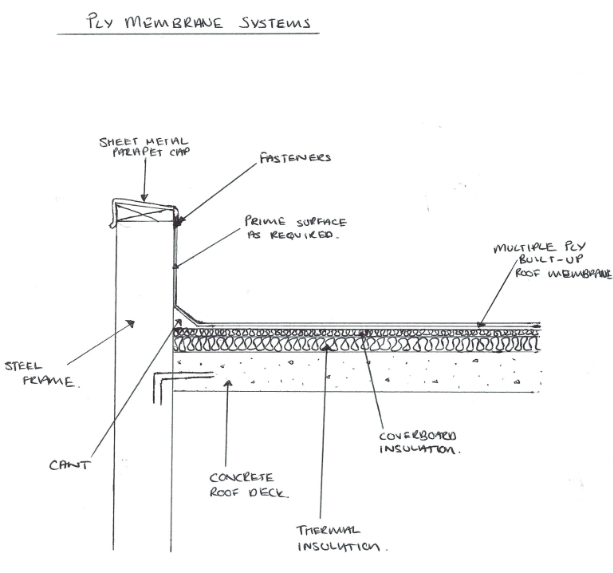 Fig 14. Roof Covering Detail.

  - Conclusion.
To conclude matters the proposals would be as follows;
- Basement Construction proposals are to use the ‘bottom up method’, installing retaining structure in the first instance to enable the excavation of the deep basement to finish floor level and installing a concrete slab floor. The basement wall construction is to be concrete diaphragm walls which will allow for floors and column connections. Car parking areas level -2, -3, -4 are to have grade 1 basement performance level which consists of cementitious coatings. Gymnasium/Spa level -1 is to have grade 3 basement performance level which will consist of a cavity drain membrane system to allow for a ‘dry’ habitable space.
- Construction above ground is proposed to be a steel frame structure which allows for large spans and the flexibility for alternations and design changes at a later stage. Special consideration is to be made for the connection detail from the concrete basement structure to the steel frame structure.
- Rainscreen Cladding is proposed is to be an interlocking copper cladding system to enhance the regeneration the of St Mary’s Street.
- Roof Coverings Proposal is to use an EPDM single ply membrane, which with an outstanding durability, hard wearing, long lasting, and low on carbon footprint and the flexibility to recycle after use – this product is leading in its market today.

  - References;
- Ukradon – UK Maps of Radon, 2022, https://www.ukradon.org/information/ukmaps (Access date 22nd of March 2022)
- Coal Mining Information, 2022, GOV.UK, https://www.gov.uk/guidance/using-coal-mining-information (Access date 22nd of March 2022)
- IASL – Annual Conference Proceedings, Ross J. Todd, 2021. (Access date 23rd of March 2022)
- Diaphragm Wall – an overview, Moon.clickhere.selfip.org, 2022, https://moon.clickhere.selfip.org/topics/engineering/diaphragm-wall (Access date 23rd of March 2022)
- Basement Waterproofing, Designingbuildings.co.uk, 2022, https://www.designingbuildings.co.uk/wiki/Basement_waterproofing (Access date 24th of March 2022)
- Geoffrey White, The Advantages and Disadvantages of Steel Frame Construction, Blog.glwengineering, 2022, https://blog.glwengineering.co.uk/the-advantages-disadvantages-of-steel-frame-construction (Access date 27th of March 2022)
- Technical Information, AMA, 2022, https://architecturalmetal.co.uk/technical/ (Access date 25th of March 2022)
- Iko.com, 2022, https://www.iko.com/comm/complete-guide-commercial-flat-roofing-systems-materials/ (Access date 27th of March, 2022
- EPDM: Today’s Choice – EPDM Roofing Association, EPDM Roofing Association, 2022, https://epdmroofs.org/epdm-todays-choice/ (Access date 27th of March 2022.

  - Appendices



