

Programme: MSc Public Health and Social Care in Practice
Module: Population Health and Digital Health Promotion
Module code: LCHS7009
Assignment Title: Component 1 (2 Blogs)
Lecturer: Diola Bijlhout
Student Name: Solanki Yashkumar
Student ID: 2525952

Table of Contents
Blog 1: Fighting Obesity Digitally: A critical evaluation of the Second Nature app in UK health promotion 3
Discussion on the Obesity 3
Influences of the Second Nature app in addressing and curing Obesity 4
Usage of Second Nature in health promotion and addressing obesity 5
Impact of the Second Nature app in health promotion 5
Mitigation Strategy 6
References 7
Addressing Obesity within the UK 9
Description of a SmartWeight AI 10
How SmartWeight AI will be used in health promotion and address obesity 10
The impact of SmartWeight AI in health promotion 11
Mitigation Strategy 12
References 13

Blog 1: Fighting Obesity Digitally: A critical evaluation of the Second Nature app in UK health promotion

Discussion on the Obesity
Obesity is a chronic and multifactorial disease within the UK, characterised by excessive body fat accumulation that increases the risk of non-communicable diseases, including type 2 diabetes, cardiovascular disease and certain cancers (Ahmed and Mohammed, 2025).
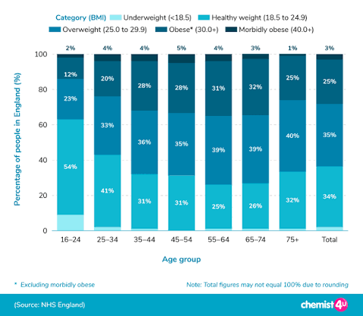
(Source: NHS England Digital, 2026)
According to the Health Survey for England, 30% of the adults in England were living with obesity, while 66% were overweight or living with obesity, demonstrating the scale of the problem in 2024 (NHS England Digital, 2026). Lifestyle factors, including unhealthy diets, physical inactivity and sedentary behaviours, have continued to drive obesity, highlighting the requirement for effective digital health promotion interventions (NHS England Digital, 2026).

Influences of the Second Nature app in addressing and curing Obesity
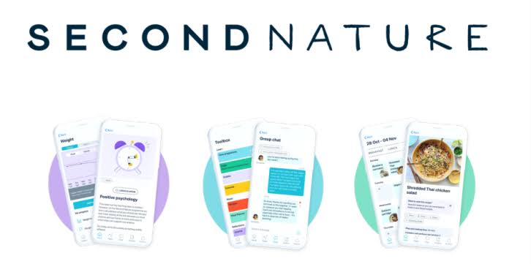
- The Second Nature app is an AI-integrated UK digital weight management intervention that supports adults living with obesity through personalised lifestyle coaching, invented by Mike Gibbs and Chris Edson (Second Nature, 2026).
- The app combines one-to-one health coaching, meal and activity tracking, and educational modules for encouraging a healthy lifestyle (Know Diabetes, 2026).
- This app aligns with the COM-B model, which promotes behaviour change by improving users' capability through education and opportunity by providing digital support (Brown et al., 2024).
- Thus, the app can improve long-term adherence to healthy behaviours, making the app an effective digital health promotion intervention for obesity management in the UK.


Usage of Second Nature in health promotion and addressing obesity
The Second Nature app promotes health and addresses obesity by delivering a structured digital weight management programme that supports healthier eating, increased physical activity and sustainable behaviour changes. Moreover, through the app, patients with obesity receive personalised health coaching, food and activity logging, educational lessons, goal setting and peer-group support (NHS Fife). Additionally, the intervention also applies evidence-based behaviour change techniques, including self-monitoring, feedback and habit formation for improving long-term adherence to healthy lifestyles (Second Nature, 2023).

Impact of the Second Nature app in health promotion
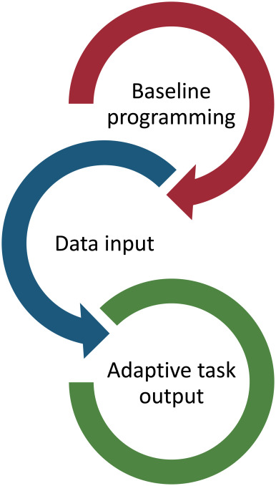
Advantages
- The AI-integrated Second Nature app combines one-to-one health coaching, self-monitoring, goal setting and educational content to encourage obese patients to adopt healthier eating habits and sustainable weight management (Second Nature, 2023).
- As a smartphone-based intervention, the app allows users for receiving personalised feedback, improve engagement and make obesity management more convenient and accessible (NHS Lothian, 2026).
Disadvantages
- The app needs a smartphone and internet access, which may exclude obese patients from disadvantaged backgrounds (Kalu et al., 2025).
- During the weight loss journey, some of the patients can experience declining motivation and engagement over time, leading to reduced sustainability of behaviour change (Ngo et al., 2025).

Mitigation Strategy
- By providing simplified app features and alternative offline guidance, accessibility for the users can be improved (Apostolidou and Fokaides, 2023).
- Through personalised reminders, gamification, and regular health coaching, motivation and healthy behaviours can be sustained (Bai et al., 2025).

References
Ahmed, SK. and Mohammed, R. A. (2025). Obesity: Prevalence, causes, consequences, management, preventive strategies and future research directions. NIH. Available at: https://pmc.ncbi.nlm.nih.gov/articles/PMC12486175/ (Accessed: 18 July 2026).
Apostolidou, E., and Fokaides, P. A. (2023). Enhancing accessibility: a comprehensive study of current apps for enabling accessibility of disabled individuals in buildings. Buildings, 13(8), 2085. Available at: https://www.mdpi.com/2075-5309/13/8/2085 (Accessed: 18 July 2026).
Bai, B., Liu, X., & Li, H. (2025). Federated multimodal AI for precision-equitable diabetes care. Frontiers in Digital Health, 7, 1678047. Available at: https://www.frontiersin.org/journals/digital-health/articles/10.3389/fdgth.2025.1678047/pdf (Accessed: 18 July 2026).
Brown, C. E., Richardson, K., Halil-Pizzirani, B., Atkins, L., Yücel, M., and Segrave, R. A. (2024). Key influences on university students’ physical activity: a systematic review using the Theoretical Domains Framework and the COM-B model of human behaviour. BMC Public Health, 24(1), 418. Available at: https://link.springer.com/content/pdf/10.1186/s12889-023-17621-4.pdf (Accessed: 18 July 2026).
Kalu, K., Ataguba, G., Onifade, O., Orji, F., Giweli, N., and Orji, R. (2025). Application of artificial intelligence technologies as an intervention for promoting healthy eating and nutrition in older adults: a systematic literature review. Nutrients, 17(20), 3223. Available at: https://www.mdpi.com/2072-6643/17/20/3223 (Accessed: 18 July 2026).
Know Diabetes, (2026). Second Nature. Available at: https://www.knowdiabetes.org.uk/learning-zone/find-a-programme/type-2/second-nature/ (Accessed: 18 July 2026).
Ngo, K., Mekhail, S., Chan, V., Li, X., Yin, A., Choi, H. Y., ... and Chen, J. (2025). The use of artificial intelligence (AI) to support dietetic practice across primary care: a scoping review of the literature. Nutrients, 17(22), 3515. Available at: https://www.mdpi.com/2072-6643/17/22/3515 (Accessed: 18 July 2026).
NHS Engaland Digital, (2026). HEalth Surevy for Engalnd, 2024. Available at: https://digital.nhs.uk/data-and-information/publications/statistical/health-survey-for-england/2024 (Accessed: 18 July 2026).
NHS Fife (2025). Second Nature. Available at: https://www.nhsfife.org/services/all-services/nutrition-and-clinical-dietetics/weight-management-and-type-2-diabetes-prevention-service/second-nature/ (Accessed: 18 July 2026).
NHS Lothian, (2026). Second Nature – Adult Weight Management and Available at: ...https://services.nhslothian.scot/awmt2d/second-nature/ (Accessed: 18 July 2026).
Second Nature (2026). A whole-person approach to health not just weight loss. Available at: https://www.secondnature.io/?srsltid=AfmBOoo9FBFwVL7NZzB1kA1YUF4pDHRCi1WdZYF63l_6CwVBSJGpdWVc (Accessed: 18 July 2026).
Second Nature, (2023). Second Nature launches new AI health coaching tool. Available at: https://www.secondnature.io/blog/coachgpt-ai-health-coach?srsltid=AfmBOorq35Bkt5oB2WlkGe7XBWZ6Xbwx2mxCcUemheIWC4GCsw0ugiKv (Accessed: 18 July 2026).

Blog 2: Designing SmartWeight AI: An intelligent Digital Health Promotion Intervention for Obesity Management in the UK.

Addressing Obesity within the UK
Nowadays, within the UK, obesity has become a rapidly growing public health priority, as it is associated with reduced quality of life, premature mortality and increasing demand for health and social care services (Roy-Highley, 2023).
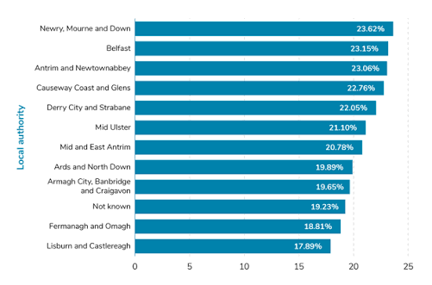
(Source: Bashir, 2026)
According to the reports, around 30% of UK adults are living with obesity, while almost 36% are overweight or obese, making the UK one of the most affected countries in Europe (Stiebahl, 2026). Additionally, the GOV.UK (2026) has estimated that obesity has imposed an annual economic burden of up to £107 costs/year, including £19.2 billion in NHS healthcare costs. These growing health and financial pressures have demonstrated that conventional weight management approaches are insufficient; therefore, there is a significant requirement for innovative AI-enabled digital interventions that support long-term behaviour change and healthier lifestyle choices.

Description of a SmartWeight AI

- SmartWeight is an AI-powered digital wearable device, specifically designed for supporting adults who are living with overweight and obesity within the UK.
- Additionally, it includes an AI virtual health coach, real-time physical activity and sleep tracking, barcode-based food logging, customised meal planning and nutrition analysis.
- The device also generates weekly progress reports and adaptive recommendations based on the users’ lifestyle and weight-loss goals, and ultimately improves long-term obesity management.

How SmartWeight AI will be used in health promotion and address obesity
SmartWeight AI will promote health by offering customised dietary advice, recommendations for physical activity and real-time feedback, based on the users' daily activities. In addition, the platform will continuously analyse lifestyle data of obese patients for encouraging healthier eating, regular exercise and sustained weight management through personalised goals and AI-driven reminders.
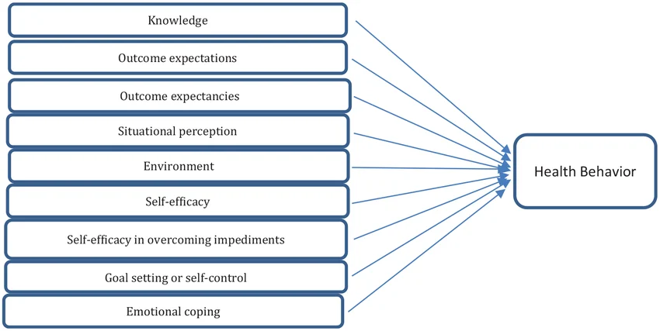
(Source: Yari et al., 2023)
This intervention significantly aligns with Social Cognitive Theory, suggesting that behaviour change is mainly impacted by self-efficacy and continuous feedback (Chou et al., 2024). Thus, by strengthening users' confidence in adopting healthier habits, SmartWeight AI can support long-term obesity management.

The impact of SmartWeight AI in health promotion
Advantage
- SmartWeight AI will provide customised recommendations on diet, physical activity and weight management by allowing obesity patients for adopting healthier behaviours (Teke et al., 2025).
- The wearable device will utilise predictive AI analytics for monitoring lifestyle behaviours and detecting obesity-related health risks early, for supporting long-term health promotion (Huang et al., 2025).
Disadvantage
- The device can raise data privacy and cybersecurity concerns, as it will collect and store sensitive personal health information (Shojaei et al., 2024).
- Also, the device’s long-term user engagement may decline due to reduced adherence to health behaviours and limited sustained weight management outcomes (Eaton et al., 2024).

Mitigation Strategy
- By implementing robust encryption and by complying with GDPR, users’ personal health data can be protected (Vanin et al., 2022).
- Through the utilisation of personalised reminders, gamification and regular AI coaching, long-term user engagement and motivation can be maintained (Costa et al., 2024).

References
Bashir, A. (2026). Obesity Statistics Report 2025. UK Parliament. Available at: https://www.commonslibrary.parliamentguides/weight-loss/obesity-statistics/ (Accessed: 18 July 2026).
Chou, S. W., Hsieh, M. C., and Pan, H. C. (2024). Understanding the impact of self-regulation on perceived learning outcomes based on social cognitive theory. Behaviour & Information Technology, 43(6), 1129-1148. Available at: https://www.researchgate.net/profile/Shih-Wei-Chou-5/publication/369934239_Understanding_the_impact_of_self-regulation_on_perceived_learning_outcomes_based_on_social_cognitive_theory/links/64e912cb434d3f628c4d50d7/Understanding-the-impact-of-self-regulation-on-perceived-learning-outcomes-based-on-social-cognitive-theory.pdf (Accessed: 18 July 2026).
Costa, C. J., Aparicio, J. T., Aparicio, M., and Aparicio, S. (2024). Gamification and AI: Enhancing user engagement through intelligent systems. arXiv preprint arXiv:2411.10462. Available at: https://arxiv.org/pdf/2411.10462 (Accessed: 18 July 2026).
Eaton, C., Vallejo, N., McDonald, X., Wu, J., Rodríguez, R., Muthusamy, N., ... and Riekert, K. A. (2024). User engagement with mHealth interventions to promote treatment adherence and self-management in people with chronic health conditions: systematic review. Journal of medical Internet research, 26, e50508. Available at: https://www.jmir.org/2024/1/e50508/ (Accessed: 18 July 2026).
GOV.UK, (2026). Obesity Healthcare Goals. Available at: https://www.gov.uk/government/publications/life-sciences-healthcare-goals/obesity-healthcare-goals (Accessed: 18 July 2026).
Huang, L., Huhulea, E. N., Abraham, E., Bienenstock, R., Aifuwa, E., Hirani, R., ... and Etienne, M. (2025). The role of artificial intelligence in obesity risk prediction and management: approaches, insights, and recommendations. Medicina, 61(2), 358. Available at: https://www.mdpi.com/1648-9144/61/2/358 (Accessed: 18 July 2026).
Roy-Highley, E. (2023). A clinician's guide to obesity prevention in the UK - PMC – NIH. NIH. Available at: https://pmc.ncbi.nlm.nih.gov/articles/PMC10541055/ (Accessed: 18 July 2026).
Shojaei, P., Vlahu-Gjorgievska, E., and Chow, Y. W. (2024). Security and privacy of technologies in health information systems: A systematic literature review. Computers, 13(2), 41. Available at: https://www.mdpi.com/2073-431X/13/2/41 (Accessed: 18 July 2026).
Stiebahl, S. (2026). Obesity statistics. UK Parliament. Available at: https://commonslibrary.parliament.uk/research-briefings/sn03336/ (Accessed: 18 July 2026).
Teke, J., Msiska, M., Adanini, O. A., Egbon, E., Osborne, A., and Olawade, D. B. (2025). Artificial intelligence for obesity management: a review of applications, opportunities, and challenges. Obesity Medicine, 100657. Available at: https://www.sciencedirect.com/science/article/pii/S2451847625000776 (Accessed: 18 July 2026).
Vanin, F. N. D. S., Policarpo, L. M., Righi, R. D. R., Heck, S. M., da Silva, V. F., Goldim, J., and da Costa, C. A. (2022). A blockchain-based end-to-end data protection model for personal health records sharing: a fully homomorphic encryption approach. Sensors, 23(1), 14. Available at: https://www.mdpi.com/1424-8220/23/1/14 (Accessed: 18 July 2026).
Yari, A., Hassani, L., Ziapour, A., Toghroli, R., Mohammadkhah, F., and Yazdi, F. (2023). Prediction of self-care behaviors among diabetic patients based on social cognitive theory. Journal of public health research, 12(1), 22799036221150330. Available at: https://journals.sagepub.com/doi/pdf/10.1177/22799036221150330 (Accessed: 18 July 2026).

